National Park Service  U.S. Department of the Interior | Mammoth Cave  National Park  Use the complete site name here (e.g. Palo Alto Battlefield Historic Site). |  | P.O. Box 7  Mammoth Cave, KY  42259  270 758-2192 phone  270 758-9297 fax
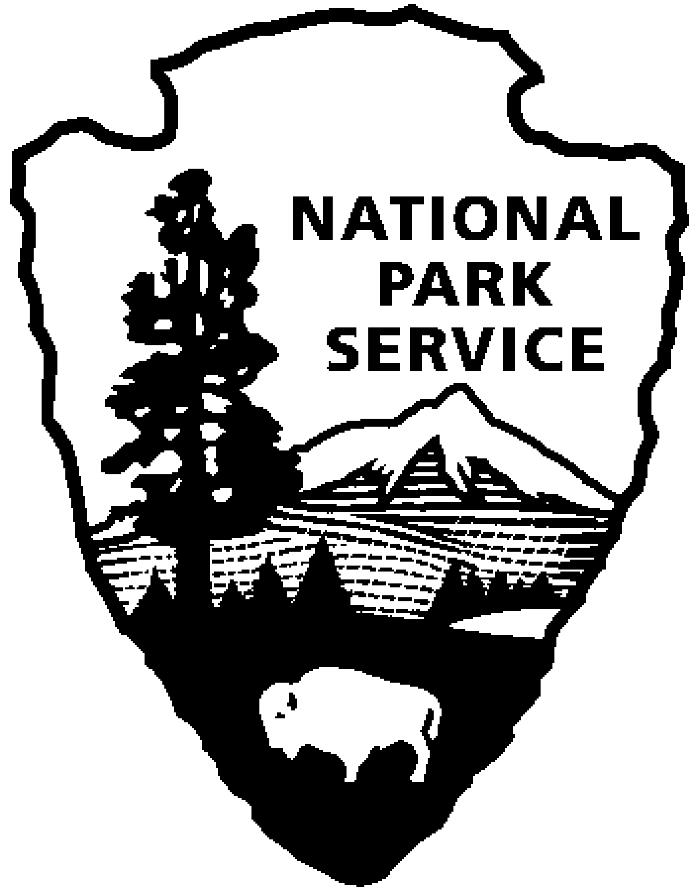
Mammoth Cave National Park News Release
Use a “short-hand” version of the site name here (e.g. Palo Alto Battlefield not Palo Alto Battlefield National Historical Site).
For Immediate Release
Vickie Carson, 270/758-2192

National Park Week – Earth Day Celebration
April 16-23, 2005

MAMMOTH CAVE NATIONAL PARK (April 1, 2005) – Come enjoy your national park during National Park Week, April 16-23, 2005, with special Earth Day activities at Mammoth Cave. The park is a partner with the Kentucky Environmental and Public Protection Cabinet in promoting good outdoor stewardship.

“National Park Week commemorates what has been called ‘the best idea America ever had,’” said Acting Superintendent Bruce Powell. “Earth Day came about in 1970 to draw attention to the environment and its care. We invite the public out to the park for walks and talks that celebrate both National Park Week and Earth Day.”

Daily events at Mammoth Cave for the public center on the theme, Be Kind to Our Planet; It’s Good for Our Health.

Saturday, April 16 Wildflower Day
A day full of walks, hikes, exhibits, and presentations.

Sunday, April 17 11:00 & 2:15 Folk Stories

Monday, April 18 11:00 Ecology of Mammoth Cave
2:15 Birds Of Prey

Tuesday, April 19 11:00 Exploration of Mammoth Cave
2:15 Cedar Sink Wildflower Hike

Wednesday, April 20 11:00 Wildland Fire Suppression
2:15 Scientists At Mammoth Cave

Thursday, April 21 11:00 History of the National Park Service
2:15 Cedar Sink Wildflower Hike

- more -

Friday, April 22 Earth Day
11:00 Edible Wilds and Folk Medicinals
2:15 Birds Of Prey
2:15 Green River Bluffs Hike
8:00 Night Shift Evening Program

Saturday, April 23 9:00 Sierra Club Volunteer Park Clean-Up
11:00 Kids’ Program On Exotic Plants
8:00 Myths and Mysteries Evening Program

Staff and volunteers are in the conservation spirit as well. Park staff are planning a backcountry trails workday on April 22, and Cave Research Foundation volunteers will gate a cave on April 23-24 in the park to protect a maternity colony of Rafinseque's Big-eared Bats, a species of special concern.

For further information, call the park at 270/758-2180, or go online at www.nps.gov/Events.html. Visit the state Earth Day Web site at www.environment.ky.gov/earthday to learn more about Kentucky's Earth Day celebration.

-- NPS --

