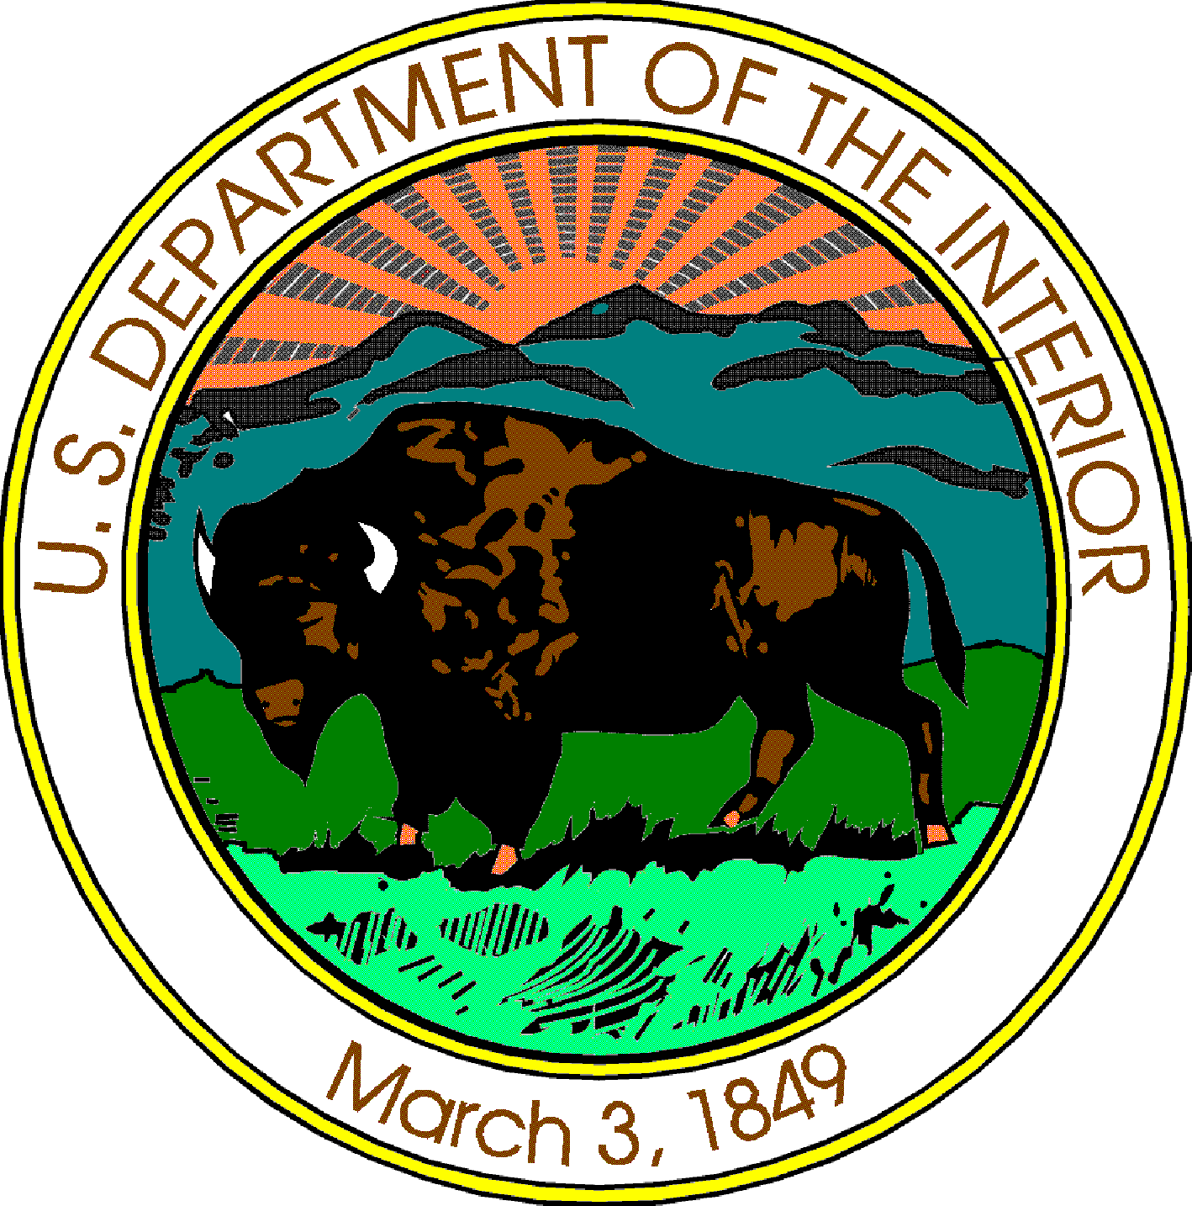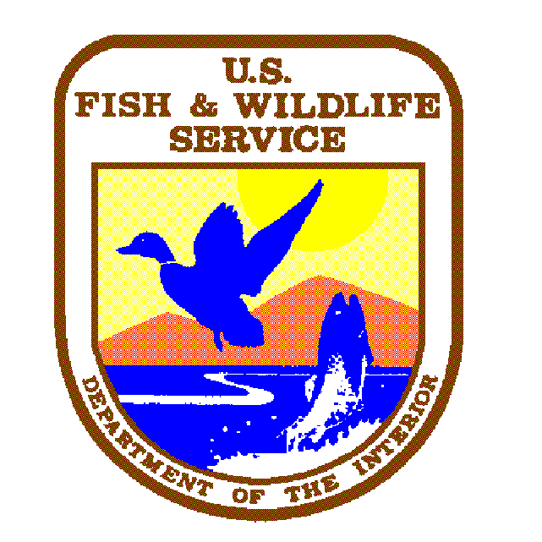United States Department of the Interior
U.S. FISH & WILDLIFE SERVICE
Willamette Valley NWR Complex
26208 Finley Refuge Road
Corvallis, Oregon 97333-9533
Phone (541) 757-7236
Fax (541) 757-4450

2007 Hunting Information

William L. Finley National Wildlife Refuge

This packet contains information that we think will be helpful to you in preparing for your hunt.

- There are two hunting season on Finley Refuge: Archery Deer Season and Shotgun Deer Season. All hunters must check in and out of self-service hunter permit stations daily. Season dates are listed below.

Open Season  All Dates Inclusive | Daily Bag Limit | Possession  Limit | Restrictions
Archery: Deer  Aug. 25 – Sept. 23 | 1 Deer Either Sex | 1 Deer | All State Regulations  Apply
Shotgun: Deer  Sept 29 – Oct. 31 | 1 Buck having not less  than a forked antler | 1 Deer | Only Shotguns Using  Buckshot or Slugs  are Allowed

*Permit (Self Check-In) Required

- Two self-service permit stations are located on the Refuge. Each hunter must go to a permit station, fill out the top half (“A” portion) of the permit and deposit it in a box on the stand. The bottom half (“B” portion) of the permit is to be signed and carried by the hunter while hunting. The back of the permit has a map showing the hunting area and other information. At the end of the hunt, the hunter must fill in the appropriate information of the “B” portion that they have been carrying and drop it in the station box before leaving the Refuge.

- Self-service permits entitle a hunter to hunt only those species that are in season (deer). No other kind of hunting is permitted including waterfowl (ducks, geese, and coots), elk, rabbit, dove, pigeon, snipe, grouse, etc.

- Hunting is permitted seven days a week from sunrise to sunset for deer.

- You must have a current State hunting license and self-service Refuge permit on your person in order to hunt. Hunters under 18 must have their hunter safety card on their person. Deer hunters must also possess a State deer tag.

- No overnight camping or parking is permitted on the Refuge.

- All vehicles must be parked and remain in designated parking areas.

For more information, contact:

Willamette Valley National Wildlife Refuge Complex
26208 Finley Refuge Road
Corvallis, OR 97333-9533

Phone: (541) 757-7236
Fax: (541) 757-4450



