SAP Minutes No. 2004-06

A Set of Scientific Issues Being Considered by the
Environmental Protection Agency Regarding:

FUMIGANT BYSTANDER EXPOSURE MODEL REVIEW: PROBABILISTIC EXPOSURE AND RISK MODEL FOR FUMIGANTS (PERFUM) USING IODOMETHANE AS A CASE STUDY

AUGUST 24 and 25, 2004
FIFRA Scientific Advisory Panel Meeting,
held at the Holiday Inn - National Airport,
Arlington, Virginia

NOTICE

These meeting minutes have been written as part of the activities of the Federal Insecticide, Fungicide, and Rodenticide Act (FIFRA), Scientific Advisory Panel (SAP). The meeting minutes represent the views and recommendations of the FIFRA SAP, not the United States Environmental Protection Agency (Agency). The content of the meeting minutes does not represent information approved or disseminated by the Agency. The meeting minutes have not been reviewed for approval by the Agency and, hence, the contents of these meeting minutes do not necessarily represent the views and policies of the Agency, nor of other agencies in the Executive Branch of the Federal government. Nor does mention of trade names or commercial products constitute a recommendation for use.

The FIFRA SAP is a Federal advisory committee operating in accordance with the Federal Advisory Committee Act and established under the provisions of FIFRA as amended by the Food Quality Protection Act (FQPA) of 1996. The FIFRA SAP provides advice, information, and recommendations to the Agency Administrator on pesticides and pesticide-related issues regarding the impact of regulatory actions on health and the environment. The Panel serves as the primary scientific peer review mechanism of the EPA, Office of Pesticide Programs (OPP), and is structured to provide balanced expert assessment of pesticide and pesticide-related matters facing the Agency. Food Quality Protection Act Science Review Board members serve the FIFRA SAP on an ad hoc basis to assist in reviews conducted by the FIFRA SAP. Further information about FIFRA SAP reports and activities can be obtained from its website at http://www.epa.gov/scipoly/sap/ or the OPP Docket at (703) 305-5805. Interested persons are invited to contact Myrta R. Christian, SAP Designated Federal Official, via e-mail at christian.myrta@.epa.gov.

In preparing the meeting minutes, the Panel carefully considered all information provided and presented by the Agency presenters, as well as information presented by public commenters. This document addresses the information provided and presented by the Agency within the structure of the charge.
CONTENTS

PARTICIPANTS 5
INTRODUCTION 7
PUBLIC COMMENTERS 8
SUMMARY OF PANEL DISCUSSION AND RECOMMENDATIONS 9
PANEL DELIBERATIONS AND RESPONSE TO CHARGE 12
REFERENCES
39

SAP Minutes No. 2004-06

A Set of Scientific Issues Being Considered by the
Environmental Protection Agency Regarding:

FUMIGANT BYSTANDER EXPOSURE MODEL REVIEW: PROBABILISTIC EXPOSURE AND RISK MODEL FOR FUMIGANTS (PERFUM) USING IODOMETHANE AS A CASE STUDY

AUGUST 24 and 25, 2004
FIFRA Scientific Advisory Panel Meeting,
held at the Holiday Inn - National Airport,
Arlington, Virginia

Myrta R. Christian, M.S. Stephen M. Roberts, Ph.D.
Designated Federal Official FIFRA SAP, Session Chair
FIFRA Scientific Advisory Panel FIFRA Scientific Advisory Panel
Date: November 9, 2004 Date: November 9, 2004

Federal Insecticide, Fungicide, and Rodenticide Act
Scientific Advisory Panel Meeting
August 24 and 25, 2004

FUMIGANT BYSTANDER EXPOSURE MODEL REVIEW: PROBABILISTIC EXPOSURE AND RISK MODEL FOR FUMIGANTS (PERFUM) USING IODOMETHANE AS A CASE STUDY

PARTICIPANTS

FIFRA SAP Chair
Stephen M. Roberts, Ph.D., Professor & Program Director, University of Florida, Center for Environmental & Human Toxicology, Gainesville, FL

Designated Federal Official
Myrta R. Christian, M.S., FIFRA Scientific Advisory Panel Staff, Office of Science Coordination and Policy, EPA

FIFRA Scientific Advisory Panel Members

Steven G. Heeringa, Ph.D., Research Scientist & Director for Statistical Design, University of Michigan, Institute for Social Research, Ann Arbor, MI

Kenneth M. Portier, Ph.D., Associate Professor, Statistics, Institute of Food and Agricultural Sciences, University of Florida, Gainesville, FL

FQPA Science Review Board Members

Daniel C. Baker, Ph.D., Senior Consultant, Environmental Computing Shell Global Solutions US, Houston, TX

Paul W. Bartlett, M.A., Research Associate, Center for the Biology of Natural Systems
Queens College, City University of New York, N.Y.

Adel F. Hanna, Ph.D., Research Professor, Carolina Environmental Program, University of North Carolina at Chapel Hill, Chapel Hill, NC

Michael S. Majewski, Ph.D., Research Chemist, US Geological Survey, Sacramento, CA

David R. Maxwell, M.P.A., M.B.A., C.C.M., Environmental Specialist/Air Quality Monitoring Specialist, National Parks Service, Denver, CO

Li-Tse Ou, Ph.D., Scientist, Soil & Water Science Department, University of Florida, Gainesville, FL

James N. Seiber, Ph.D., Director, U.S. Department of Agriculture /ARS/, Western Regional Research Center, Albany, CA

Frederick M. Shokes, Ph.D., Center Director and Professor, Tidewater Agricultural Research and Extension Center, Virginia Tech University, Suffolk, VA

Mitchell J. Small, Ph.D., H. John Heinz III Professor of Environmental Engineering
Carnegie Mellon University, Pittsburgh, PA

Thomas O. Spicer, III, Ph.D., Professor and Head, Department of Chemical Engineering, University of Arkansas, Fayetteville, AR

Dong Wang, Ph.D., Associate Professor, Department of Soil, Water & Climate, University of Minnesota, St. Paul, MN

Eric D. Winegar, Ph.D., QEP, Applied Measurement Science, Fair Oaks, CA

Scott R. Yates, Ph.D., Interim Research Leader, U.S. Department of Agriculture/ARS/
GEBJr, Salinity Lab., Soil Physics & Pesticides Research Unit, Riverside, CA

INTRODUCTION

On August 24-25, 2004, August 26-27, 2004, and September 9-10, 2004, the Federal Insecticide, Fungicide, and Rodenticide Act (FIFRA), Scientific Advisory Panel (SAP) held three separate meetings to consider and review three fumigant bystander exposure models. These meeting minutes focus on the FIFRA SAP meeting held August 24-25, 2004 to review the Probabilistic Exposure and Risk model for FUMigants (PERFUM) using iodomethane as a case study. The FIFRA SAP also met on August 26-27, 2004 to review the Fumigant Exposure Modeling System (FEMS) using metam sodium as a case study and on September 9-10, 2004 to review the SOil Fumigant Exposure Assessment System (SOFEA©) using telone as a case study. Minutes from each of these FIFRA SAP meetings are available from the FIFRA SAP website at http://www.epa.gov/scipoly/sap/ or the OPP Docket at (703) 305-5805.

Advance notice of the August 24-25, 2004 meeting was published in the Federal Register on July 23, 2004. The review was conducted in an open Panel meeting held in Arlington, Virginia and was chaired by Stephen M. Roberts, Ph.D. Mrs. Myrta R. Christian served as the Designated Federal Official.

EPA's Office of Pesticide Programs is engaged in pesticide tolerance reassessment activities as mandated by the Food Quality Protection Act (1996). As part of that process, the Agency is currently involved in the development of a comparative risk assessment for six soil fumigant pesticides that include chloropicrin, dazomet, iodomethane, methyl bromide, metam-sodium, and telone. Each of these chemicals has a degree of volatility associated with it which is a key characteristic needed to achieve a satisfactory measure of efficacy. This volatility, however, can contribute to human exposures because these chemicals can travel to non-target receptors, such as nearby human populations. Commonly referred to as bystander exposure, it is considered by the Agency to be the primary pathway through which human exposure to fumigants may occur.

In order to address bystander exposures, the Agency developed a method based on a deterministic use of the Office of Air model entitled Industrial Source Complex Short Term Model (ISCST3) that is routinely used for regulatory decisions. ISCST3 is publicly available from the following Agency website (http://www.epa.gov/scram001/tt22.htm#isc. In this approach, the Agency uses chemical-specific measures of volatility to quantify field emission rates for modeling purposes. Additionally, the Agency uses standardized meteorological conditions which represent a stable atmosphere and unidirectional wind patterns that provide conservative estimates of exposure.

Stakeholders expressed concern that the conditions represented by the current approach provide results that are not sufficiently refined for regulatory actions such as risk mitigation. In response, the Arvesta Corporation, the registrant for iodomethane, has submitted a model entitled Probabilistic Exposure and Risk model for FUMigants (PERFUM) for consideration as a possible refinement to the Agency's approach. The Agency believes that this model also may have the potential to be used generically to calculate risks for the six soil fumigants being evaluated in the current risk assessment. The key differences between PERFUM and the current Agency approach are that it incorporates ranges of both field emission rates and 5 years of meteorological data from stations in areas where iodomethane is used.

The purpose of this meeting of the FIFRA Scientific Advisory Panel (SAP) was to evaluate the approaches contained in PERFUM for integrating actual meteorological data into ISCST3 analyses. Additionally, the Agency was seeking a specific evaluation of the methods used pertaining to field emission rates, statistical approaches for data analysis, receptor locations, and defining the exposed populations. Finally, the Agency was seeking a determination as to the scientific validity of the overall approach included in PERFUM. The agenda for this SAP meeting involved an introductory overview of the current risk assessment approach by the EPA provided by Mr. Jeffrey Dawson (Health Effects Division, Office of Pesticide Programs). On behalf of the Arvesta Corporation, a detailed presentation of the PERFUM model was given by Dr. Richard Reiss of Sciences International, Inc., located in Alexandria, Virginia. Dr. Terri Barry and Dr. Randy Segawa from California Department of Pesticide Regulation also participated with EPA in this SAP meeting. Mr. James J. Jones (Director, Office of Pesticide Programs) and Ms. Margaret Stasikowski (Director, Health Effects Division, Office of Pesticide Programs) offered opening remarks at the meeting.

In preparing these meeting minutes, the Panel carefully considered all information provided and presented by the Agency presenters, as well as information presented by public commenters. This document addresses the information provided and presented at the meeting, especially the response to the charge by the Agency.

PUBLIC COMMENTERS

Oral statements were presented as follows:

Ms. Shelley Davis, on behalf of the California Rural Legal Assistance Foundation and the Farmworker Justice Fund

James Platt, Ph.D. on behalf of the Arvesta Corporation

SUMMARY OF PANEL DISCUSSION AND RECOMMENDATIONS

- The Panel commended the Agency for convening this scientific review of the PERFUM bystander exposure assessment model. The Agency is addressing concerns voiced by stakeholders that the conditions represented in the current EPA approach for exposure assessment modeling provide results that are not sufficiently refined to make fair and accurate regulatory actions such as risk mitigation. By its design, PERFUM addresses a number of these concerns. PERFUM uses standard EPA-approved regulatory models in a manner that can: utilize historical meteorological datasets to more fully characterize potential downwind concentrations, determine the upper percentile of the distribution of buffer-zone distances, provide a distribution of margins of exposure (MOEs) for a user-supplied buffer zone, and incorporate emission profiles from a variety of sources (i.e., constant, variable strength, point, or area sources).

- The description of the model components was considered to be scientifically sound and a reasonably skilled user could replicate the calculations. The algorithms in the code appear to perform the function intended in the documentation. However, the discussion on how margins of exposure and exceedance probabilities are computed for buffer zone lengths should be presented more clearly, additional documentation of the field trials is needed, and the direct flux measurements and data reduction techniques should be better documented.

- PERFUM estimates period flux rates using an indirect (back calculation) method. However, large variations in period flux rates have been observed from different approaches to calculate flux, even when the same experimental data (i.e., air concentration, wind speed, temperature) is used for each approach. The Panel thought that direct methods, such as the aerodynamic gradient methods, need to be investigated to determine if they are more accurate. The Panel also thought that additional concentration data in the vertical dimension are needed (along with the 1.5 meter data) to improve the estimate of the emission flux obtained from the indirect method. The availability of vertical concentration profiles may be one other way to improve the calibration of the model.

- The Panel thought that representing emission flux as a probability distribution to address uncertainty and real variation is a worthy objective. There should be a distinction between uncertainty arising from measurements, uncertainty from the limited sampling, uncertainty from measuring emission flux from back calculations by the dispersion model, and uncertainty from the actual variability of emissions.

- PERFUM accounts for variability in the period flux measurement by calculating the standard error between the measured and model concentrations. This gives a measurement of the error/variability for only that field study. However, total emissions tend to be more accurately measured compared to short-interval emissions and variability within a study tends to be smaller than the variation between studies. This could make the implementation of PERFUM problematic.

- It is unlikely that generalizing the use of PERFUM to a regional or state scale will be appropriate if the emission data were collected at a single (or relatively few) location(s). To fully capture the variability/uncertainty in emission and concentrations, an extensive data set is needed to account for soil and environmental conditions, differences in meteorology, and seasonal effects.

- The Panel members expressed concern with the manner in which PERFUM selects the uncertain emission rates in sequential time periods. Since many of the causes of variability are likely to persist over time, sampling the uncertain emission rates in sequential time periods independently of the previous time periods will create unrealistic patters in the daily emission rate, and may also underestimate the frequency of high-end emissions and associated high-end buffer zone lengths. A method is needed to incorporate temporal persistence into the estimate of flux rate.

- Several Panel members suggested that soils-based mechanistic models should be investigated and, potentially, incorporated into PERFUM. Models of this type can integrate soil moisture, temperature, organic matter, and other soils factors into the prediction of fumigant fate, soil transport and volatilization. A stand-alone model could be used to obtain period-averaged emission rates for use with PERFUM. The flexibility to incorporate period-flux measurements from other sources is desirable.

- The PERFUM modeling system uses a traditional square grid instead of radial grid. A more adaptive grid approach that allows coarse grid information to be used to suggest additional grid points to improve buffer zone estimates should be examined. A nested grid might significantly improve the computational efficiencies, while maintaining equivalent accuracy. The Panel supported any effort that would increase computational efficiency and recommended consideration of irregularly shaped fields.

- The primary source of meteorological data should be in the following order: (1) National Weather Service (NWS); (2) ASOS (FAA) data (ASOS came on line in early 1990, a very rich data source that covers the country); (3) State climatology or agricultural weather stations (e.g., CIMIS, FAWN, SCAN, ECONet, etc.); and (4) meteorological data selected from regulatory agency sites or industrial sites if the data are quality assured. The NWS has cloud cover data as one of its measured parameters, and cloud cover data are required by the Turner method for calculating atmospheric stability. Observational networks from Florida and California do not include this parameter.

- Filling in missing data is tricky, especially for cloud cover, which is one of the parameters used by the ISCST3 model to designate a stability index. The EPA recommendations are to use data within a few hours of the missing period. While this might be a reasonable approach for parameters such as temperature, a highly variable and uncertain parameter such as cloud cover will be much less accurate when using the interpolation approach.

- The report describes various sources of uncertainty in the study and provides an initial assessment of the sensitivity of model predictions to selected alternative model assumptions and parameter values. The factors discussed include: the flux emission estimate/profile, meteorological data and sources of datasets, anemometer height, calms processing, non-meteorological environmental factors, “Gaussian formulated” model-model comparisons, indoor exposure, human activity patterns, coincidental temporally/spatially close multi-field applications, seasonality, and horizontal placement of monitors during field studies for flux estimation. The uncertainty associated with these factors should be considered in an integrated manner.

- The Panel thought that many of the limitations in the ISCST3 model (the core of PERFUM) would be alleviated when the Agency adopts AERMOD. The Panel thought approving the AERMOD model should be a high priority of the Agency.

PANEL DELIBERATIONS AND RESPONSE TO CHARGE

The specific issues addressed by the Panel are keyed to the Agency's background documents, references, and the Agency’s charge questions.

Charge

Critical Element 1: Documentation

Question 1: The background information presented to the SAP Panel by the PERFUM developers provides both user guidance and a technical overview of the system.

a) Please comment on the detail and clarity of this document. Are the descriptions of the specific model components scientifically sound?

Response

The report presented to the FIFRA SAP appears to be preliminary because there is an indication that additional field-testing was conducted, but has yet to be included in the report. Dr. Richard Reiss discussed the added field test information as part of his presentation. Also, Dr. Reiss discussed other minor modifications made to the model in the time between preparation of the report and the meeting such as a modification of the method for calculating random deviations in the flux. In his presentation to the Panel, Dr. Reiss discussed details concerning how flux data were obtained from the field tests on iodomethane. Dr. Reiss indicated that the documentation would be updated to reflect the added content included in his presentation, including background information on the physical and chemical properties of iodomethane. The report and presentation were well received by the Panel. Some Panel members voiced concern as to whether supporting documentation would be published in a peer-reviewed journal article and Dr. Reiss indicated that there were plans to do this.

Other details that should be addressed with regard to documentation include:

- Because PERFUM is built around ISCST3, it was suggested that a flow diagram be included in the documentation that outlines the simulation process in PERFUM, including details of ISCST3.

- It was observed that parts of the PERFUM system have been extensively validated, and the report would benefit from referencing this peer-reviewed work.

- The discussion on how margins of exposure are computed and how exceedance probabilities are computed for buffer zone lengths should be presented more clearly.

- Additional documentation of the field trials is needed, including information about soil characteristics (i.e., soil type, organic matter content, soil moisture, etc.), meteorological data, and field preparation methods.

- ISCST3, as used in PERFUM was not shown in the documentation to include processes of atmospheric degradation, deposition, or interaction with atmospheric moisture, (e.g., fog and rain). The effects of complex terrain were not included in the documentation, but should be since hilly, uneven terrain often requires fumigant treatment. Even though photodegradation would not be expected to affect the buffer zone distances for iodomethane because this process is relatively slow in comparison to the travel times to buffer zone distances, an example of this would be useful. Examples of ISCST3’s capability of including the effects of deposition and interaction with atmospheric moisture (e.g., fog) would also be useful.

- The direct flux measurements and data reduction techniques should be documented.

- Example simulations using PERFUM to address irregularly shaped fields would be useful.

- Discussion regarding terrain and obstacle effects should be included.

- The discussion of how PERFUM deals with calm wind conditions in simulations (predictive mode) as well as flux determination from field tests should be more extensive.

The description of the model components was considered to be scientifically sound and a reasonably skilled user could replicate the calculations. The algorithms in the code appear to perform the function intended in the documentation with the exceptions of the suggested report revisions discussed above.

b) Do the algorithms in the annotated code perform the functions as defined in this document? Please discuss any difficulties encountered with respect to loading the software and evaluating the system, including the presented case study.

Response

Comments varied widely depending on a Panel member’s level of expertise with computers and programming, and the amount of time they invested with the program running the example cases provided before the meeting. Each of the following was reported by at least one Panel member: not being able to access the files because of file attribute problems (files copied from a CD are set as “read-only” by default); getting an error message after following the instructions in the README file included on the CD; having sorted out the problems to execute PERFUM but could not execute PERFUM_MOE in the time available; and being able to execute PERFUM and PEFUM_MOE. Some problems seemed to be caused by file name discrepancies. Other comments with regard to the software include:

- There were some minor FORTRAN issues that may limit portability between compilers. A few lines of program code used tabs to align with column 7, suggesting a limitation with previous FORTRAN standards. This may lead to substandard performance on some compilers. MAX and MOD functions are presently coded for use with the Lahey compiler, which may be incompatible with other compilers. It was noted that implementation of a GUI interface may be more easily accomplished with other compilers such as the Digital Visual FORTRAN compiler.

- PERFUM is presently executed in a (DOS) command window. Some Panel members thought that using this interface may hinder inexperienced users from successfully utilizing PERFUM, and that a windows-based GUI would help future users.

- The format of the PERFUM input file was generally found to be quite usable, particularly because each line had a single input parameter, and documentation about the input value could be included on the same line after its value. Some Panel members thought experienced users may prefer the present interface to a GUI interface.

- Some Panel members suggested that PERFUM should be modified to allow for different simulation durations.

- Some Panel members recommended that model output be tailored to a standard graphical output package. Dr. Reiss responded that such a project might be considered in the future, but that the market may not support an extensive effort.

Critical Element 2: System Design/Inputs

Question 2: In Section 2.3: Development of the PERFUM Modeling System of the background document, a series of detailed individual processes and components included in PERFUM are presented. The key processes include (1) incorporation of ISCST3 into PERFUM, (2) probabilistic treatment of flux rates; and (3) development of a receptor grid.

a) Please comment on these proposed processes, the nature of the components included in PERFUM and the data needed to generate an analysis using PERFUM.

Response

(1) Incorporation of ISCST3 into PERFUM

ISCST3 is a dispersion model required by the USEPA for use in applications intended for air quality regulation. ISCST3 is run within PERFUM as a callable subroutine. There are additional program manipulations to extract necessary information that ISCST3 would otherwise not provide as output. The Panel agreed that this is very desirable since additional, valuable information is obtained compared to using the ISCST3 output alone. The approach is appropriately described in the documentation and increases the overall usefulness for estimating buffer zone distances around fields fumigated with iodomethane. The approach also yields reduced output file sizes, reduced run times, allows for 24-hour average concentration estimates for time periods other than midnight to midnight, and provides hourly flux values as a probabilistic variable.

Although ISCST3 was developed for use with emissions from industrial-source complexes, some justification should be provided showing that it is appropriate to use ISCST3 to predict the movement of agricultural fumigants down-wind from treated fields.

Data required by PERFUM include a source flux term along with various meteorological data. The source flux term was obtained through calibration using measured data from six field studies (five conducted in California and one in Florida). An Indirect Flux Method was used to estimate the source-flux term. For each period, this involves selecting a default source-flux term, running ISCST3, plotting the measured vs. modeled air concentrations at all the sample locations, and fitting a regression line to the plotted values. The slope of the regression line is the best estimate of the emission rate. In one experimental study, the Indirect Flux Method was compared to a flux estimate obtained using the Aerodynamic Gradient Method (a direct flux method), with good results. For the experiments considered, the first 24-h period after application was found to be the most important in terms of the highest downwind air concentrations, and the model output focuses on determining the buffer zone based on this time period.

Although the actual field emission flux depends on a variety of factors such as the application method, injection depth, tarp type and thickness, soil properties, and the physical/chemical properties of iodomethane, the model obtains flux values independently of these important variables. Many soil, environmental, and application factors have a significant effect on volatilization rates. The Panel had concerns that results obtained using data from only a few similar studies may not be appropriately applied in other geographic areas, at other times, or for other fumigant application methods. It may be appropriate to estimate buffer zones for the particular application method, location, and time for which data are available. The Panel recommended more field tests to increase confidence in the model output.

If iodomethane is approved for use, it is possible that concurrent applications in high-use areas may increase the background concentrations and may affect the buffer zone estimate. The Panel agreed that, initially, the background levels would be low compared to the source term and may not affect the buffer zone boundary. As the fumigant use increases, however, concurrent applications might occur and the model should be configured to allow multiple source inputs.

The ISCST3 model is always run in the rural mode, even for applications of iodomethane occurring near homes, urban areas, or in areas with trees or other topography/obstructions that might cause deviations from rural conditions. For situations that produce increased turbulence, running the model in the rural mode gives longer buffer zones that might be needlessly conservative.

The buffer zone estimates were calculated using hourly meteorological data from three data sets containing five years of records – NWS (nationwide), CIMIS (California), and ASOS (FAA) or FAWN (Florida). These networks provide usable data, but only the NWS data are taken at the heights used by standard methods for estimating atmospheric stability. The Panel considers the NWS network to be the most complete and have the best data quality control; therefore, these data are the preferred source of meteorological data.

Overall, the modeling results using the 5-year meteorological data from these stations were relatively similar. The Panel recommended that the meteorological data from the station(s) near to the actual application area should be used in the buffer zone estimations even though there were no statistically significant differences found between the coastal and inland stations or stations in agricultural regions compared to more urban stations. Also, since wind can vary dramatically in more complex situations, e.g., narrow valleys, it may be appropriate to install weather stations in these areas to obtain data needed to improve the estimation of buffer zones.

(2) Probabilistic Treatment of Flux Rates

PERFUM estimates period flux using an indirect (back calculation) method. Direct methods, such as the Aerodynamic Gradient Methods need to be investigated to determine if this approach is accurate, and more comparisons should be provided in the PERFUM documentation. The uncertainty in flux estimates can be obtained for both approaches, but only accounts for experimental and model errors. Uncertainty due to differences in soil types, environmental factors, and regional and temporal translocation are not included.

There is a need for a clear discussion on the estimation of standard error of the predicted flux rate (slide 22 error and relationship to slide 43{SAP Presentation: PERFUM Probabilistic Exposure and Risk Model for FUMigants by Dr. Richard Reiss in EPA, OPP Docket, Document ID # OPP-0240-0015}). A Panel Member questioned whether this standard error includes projection bounds (for future values) rather than confidence bounds (expected value of estimate).

Agricultural fields tend to be large in area and are treated with pesticides one row or segment at a time. At the beginning of the application process, the segment first treated begins to emit while other segments, not yet treated, do not. Thus during application, the field is not a uniform emitting source. There is a need for further discussion about how this might affect or skew the flux term calculation during the application period. An example is needed showing how PERFUM responds (i.e., how sensitive it is) to a temporally and spatially varying area source.

The Panel thought that representing emission flux as a probability distribution to address uncertainty and real variation is a worthy objective. The characterization, "measurement uncertainty," can be confusing and should be clarified. There should be a distinction between uncertainty arising from measurements, uncertainty from the limited sampling, uncertainty from measuring emission flux from back calculations by the dispersion model, and uncertainty from the actual variability of emissions. There should also be a discussion of the physical-chemical processes of emission that the probability distribution represents.

(3) Development of a Receptor Grid

The PERFUM modeling system uses a traditional square grid instead of a radial grid. Although this is easier to generate using GIS, there is no reason why an irregular grid could not be used around irregularly shaped fields. The Panel was assured that PERFUM could handle irregular shaped source fields; an example should be included in the documentation. The obvious benefit of the grid structure as presented is that when the wind direction is into a corner, the traditional radial grid has fewer points available for interpolation. The resulting receptor points are concentrated at each corner and the side-by-side distance increases for each receptor ring away from the field. This doesn’t happen with the receptor points associated with the sides of the field. This results in much of the computation occurring in close proximity to the field, yet the threshold boundaries may be further out. A more adaptive grid approach that allows course grid information to be used to suggest additional grid points to improve boundary estimates should be examined. A nested grid might significantly improve the computational efficiencies, while maintaining equivalent accuracy.

b) Are there any other potential critical sources of data or methodologies that should be considered?

Response

Models that correlate flux with vapor pressure and surface type, (e.g., Woodrow et al., 2001) as well as mechanistic models, (e.g., Jury et al., 1983; Baker et al., 1996; Wang et al., 1997; Yates et al., 2002), should to be considered and discussed in terms of their applicability to PERFUM. There are a wide variety of environmental factors that affect emission rates. Several Panel members suggested that soils-based mechanistic models (such as CHAIN_2D) should be investigated and, potentially, incorporated into PERFUM. This type of model can integrate the soil moisture, temperature, organic matter, and other soils factors into the computation of fumigant fate, soil transport and volatilization. Although the authors state that a soils-based emission model could not be directly incorporated into the PERFUM system, a stand-alone model could be used to obtain period-averaged emission rates. The flexibility to incorporate period-flux measurements from other sources would be desirable.

The Panel suggested that meteorological data produced by meteorological model simulations may be considered for use in PERFUM. Such data sources will help in filling data gaps for areas where credible meteorological measurements or observations are not available. An example of such models are the National Center for Atmospheric Research (NCAR), Mesoscale Model version 5 (MM5), and the Colorado State Regional Atmospheric Modeling System (RAMS). Compared to the integrity of meteorological data from other models, such as the wind field models, MM5 and RAMS have broader interpretability.

The meteorological preprocessor for handling FAWN and CIMIS station data to develop ISCST3-ready input and the emissions preprocessor should be made available.

Question 3: The determination of appropriate flux/emission rates is critical to the proper use of the PERFUM model as these values define the source of fumigants in the air that can lead to exposures. Upon its review of how flux rates can be calculated, the Agency has identified a number of questions it would like the Panel to consider. In PERFUM, flux rates were treated as a probabilistic variable with an uncertainty developed from the statistical bounds of the flux calculation. For each measurement period a standard error is generated that reflects the measurement uncertainty of the flux rate. PERFUM then perturbs the concentration estimates within each period by the standard error using Monte Carlo methods to simulate the uncertainty in the flux estimates.

a) What, if any, refinements are needed for this process including the manner in which flux values were calculated for each monitoring period to generate the standard error estimates?

Response

The calculation of the fumigant emission rate using the “indirect method” (i.e., where observed downwind ambient concentrations following an application are used with ISCST3 to back-calculate the aerial emission rate) is appropriate for estimating emissions at a given time, for a given application, and at the given site. Furthermore, the method presented in the PERFUM documentation for fitting the emissions rate and characterizing its uncertainty is statistically sound and reasonable as a first approximation.

Uncertainty in emission rates is generated in the model by randomly sampling the estimated slope (and inferred value of E) based on a t-distribution (now a normal distribution) with a standard deviation defined by the standard error of the slope estimate. While appropriate in concept, the method is susceptible to error for a number of reasons. Furthermore, it cannot capture the predominant uncertainty that is present when it is applied in an extrapolation mode, for new conditions or at different sites.

A second concern expressed by Panel members is the way that the method is implemented. This involves the random selection of uncertain emission rates in sequential time periods. Since the causes of variability are likely to persist over time, sampling the uncertain emission rates in sequential time periods independently from each other will likely underestimate the uncertainty variance of the daily emission rate, and also underestimate the frequency of high-end emissions and associated high-end buffer zone lengths. A method is needed to incorporate the temporal persistence of the uncertainty in the flux estimate.

Some Panel members thought that improvements could be achieved by utilizing more advanced methods such as mechanistic approaches that incorporate physical/mass-balance constraints and consider the effects of chemical properties (vapor pressure, solubility and soil adsorption coefficient), soil properties (porosity, organic matter fraction, and tortuosity), application method, and atmospheric conditions (wind speed, atmospheric stability, temperature, and pressure). Such a procedure could be used with confidence at the tested site for the varying (e.g., 5-year) meteorological conditions, and would provide a better basis for prediction at other times and at other locations with different soil, environmental, and topographic properties.

b) How appropriate is it to use a flux/emission factor from a single monitoring study (or small number of studies) and apply it to different situations such as for the same crop in a different region of the country?

Response

It is unlikely that generalizing the use of PERFUM to regional or state scale will be appropriate if the emission data were collected at a single (or relatively few) location(s). To fully capture the variability/uncertainty in the measurements, model, soil and environmental conditions, differences in meteorology, and seasonal effects will require the availability of an extensive data set. This is not a failing of the model, rather, the data supporting the model. As is true with all models, the quality of the output information is directly related to the quality of the input information.

The developers and users of PERFUM need to develop a more robust data set of emissions of iodomethane under different field/environmental conditions (e.g., soil type, temperature, atmospheric and soil moisture, application type, etc.). Additional information will increase reliability of the method.

c) Please comment on PERFUM’s capability to adequately consider multiple, linked application events as well as single source scenarios. Does PERFUM appropriately address situations where data are missing?

Response

A simplified example of the effect of multiple fields was presented to the Panel. It is not clear from the presentation if more complex field patterns could be evaluated (e.g., arbitrary arrangement, varying field sizes, varying application rates, arbitrary orientation of field boundaries with respect to North and South). In reality, multiple sources or fumigated fields tend to cluster around the receptor areas and be of varying size and source strength (i.e., flux rates may differ). The developers of PERFUM should elaborate on the capability of simulating multiple linked sources, especially by considering several combinations of spatial distribution of the fumigated fields versus the receptor points.

PERFUM authors should be encouraged to develop generalized routines applicable to emissions from multiple fields. ISCST3 and CALPUFF have previously been shown to be adaptable to this situation (See P. S. Honaganihalli and J.N. Seiber. 2000). PERFUM should be applicable as well, and thus should be adapted to this fairly realistic scenario of emissions contributions from more than one field.

d) In the back-calculation approach used for estimating emission rates, the regression of measured versus modeled values can be forced through the origin or not. Which approach does the Panel prefer and what are the implications of each approach?

Response

One of the issues raised by the Panel involves the way that the intercept is treated in the analysis of the flux using the indirect method. In the regression model, the intercept has a physical meaning – it corresponds to a “background” concentration at the receptor (i.e., if emissions are 0). A key issue is the assessment of whether there is a reason to believe that a background concentration could or should be present at the site, so that a non-zero intercept does (or does not) make sense. This issue has not been addressed in an adequate manner in the PERFUM documentation.

Modeled concentrations that are zero at locations where measured concentrations are non-zero give rise to the non-zero intercept. When the background concentration is known to be zero, such a situation indicates that the real plume extends outside the predicted plume behavior. This behavior is likely caused by inadequately predicting the plume direction or the dispersion coefficients.

- Since atmospheric stability is used to predict dispersion coefficients, and atmospheric stability is expressed as a category number, the predicted dispersion coefficients may be in error because true dispersion coefficients behave in more of a continuous fashion.

- Furthermore, atmospheric stability may be improperly inferred from measurements especially around sunset or sunrise when stability is rapidly changing. Periods around sunset are of most concern because the transition to stable conditions will cause near-surface concentrations to be largest.

- Regardless of the cause of the discrepancy, there is a flux of material in the real plume unaccounted for by the modeled plume even if the modeled concentrations are fit to the measured concentrations within the modeled plume boundary. The flux estimates so determined will underestimate the actual values. Put another way, having a non-zero intercept indicates that the flux will be underestimated because there is a flux of material in the real plume that cannot be captured in the modeled plume.

- In the iodomethane case study, sensors were located fairly close to the source at a uniform height. At distances close to the source, it is important to check the vertical concentration distribution to ensure that larger concentrations are not present at lower elevations.

A second issue addressed as part of the model development is whether the data should be log-transformed prior to the regression. Log-transformation could be motivated by the positively-skewed, non-negative nature of measured air concentrations, which tend to be lognormally distributed. One Panel member stated that the log-transform/linear regression approach is not recommended since it violates the linear, mass-balance assumptions.

PERFUM accounts for variability in the period flux measurement by calculating the standard error between the measured and model concentrations. This gives a measurement of the error/variability for only that field study. There are a number of considerations to this approach:

- Total emissions tend to be more accurately measured compared to short-interval emissions. The range of total emissions from several methyl bromide experiments is high with a mean total emission of about 50% and a standard deviation of approximately 35% (see Slide 1). The bounding lognormal distributions shown in this slide demonstrate the variability among these studies. To capture other sources of variability (e.g., variations in local conditions and seasons), it might be better to sample from a distribution similar to the one shown in Slide 1. A beta distribution offers a potentially useful parametric form for the distribution of fraction emitted, since it is bounded by zero and one.

- The error bars on the results from two experiments shown in Slide 1 suggest that intra-study variability would be smaller than the variation between studies.

- Slide 2 shows the period emission (2 or 4 hours) for 8 days after application of methyl bromide. Three methods were used to obtain emission values: aerodynamic, theoretical profile shape, and the instantaneous horizontal flux methods. Slide 2 shows that there is large variation in period emissions between these approaches to calculate emission rates, even though the same experimental data (i.e., air concentration, wind speed, temperature) are used by each approach. Also, note that the three methods give nearly equivalent cumulative emissions.

- The use of flux chambers also shows large differences in the period emission values compared to the other flux estimation approaches (Slide 3). These data suggest a need to include regional variability into a PERFUM assessment.

- For flat-fume applications, the plastic film can be a dominant factor controlling emissions and the permeability depends on fumigant chemical and ambient temperature. Slide 4 shows that high-density polyethylene (HDPE) is more permeable to iodomethane than methyl bromide. This suggests that, everything else held constant, emissions of iodomethane through HDPE will be greater than methyl bromide.

- Slides 5-7 show that a numerical model may provide a good description of the volatilization process when atmospheric data are available. The numerical model describes water, heat and chemical transport following the equations shown in Slide 5. Slide 6 shows two volatilization boundary conditions that were used. The mass transfer boundary condition used in CHAIN-2D is coupled to processes occurring in the atmosphere and provides an overly simplified flux history (see Slide 3, solid lines). Even adding temperature dependence to these boundary conditions is insufficient in characterizing the variation in the flux rate (Slide 3). Utilizing a mass transfer boundary condition (SOLUTE.EXE) that is directly coupled to atmospheric processes (Baker et al., 1996), (i.e., wind and stability), provides a much more accurate flux history (see Slide 7). Also, the variation in the predicted flux more closely matches the variability in the measured values. A model like this offers the potential to determine the period flux values at a new location (or fumigation methodology, etc.) easily and less expensively. This might be one way to obtain input data and avoid expensive, time-consuming, and possibly cost-prohibitive studies.

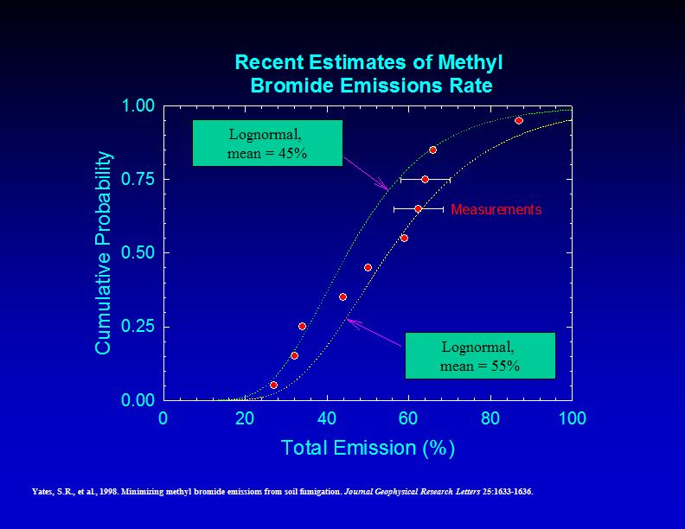
Slide 1
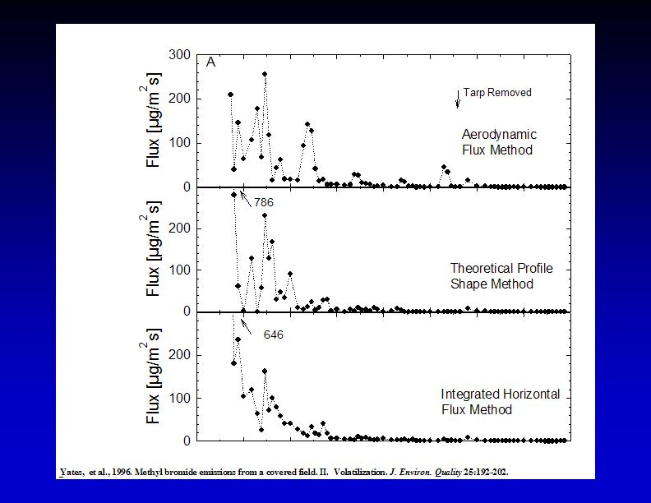
Slide 2
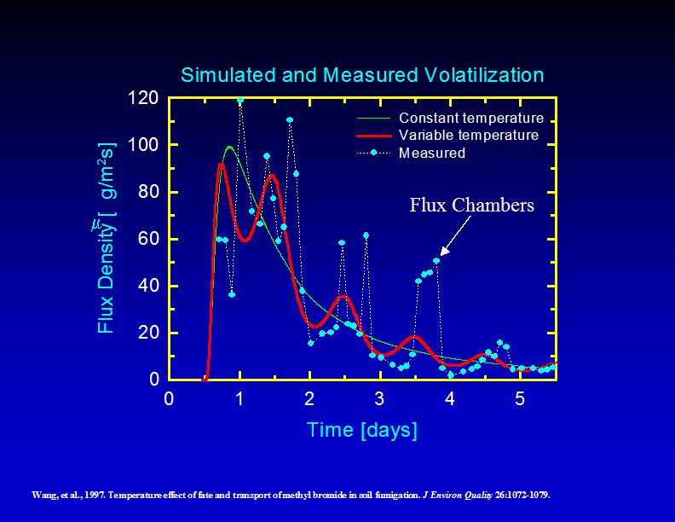
Slide 3

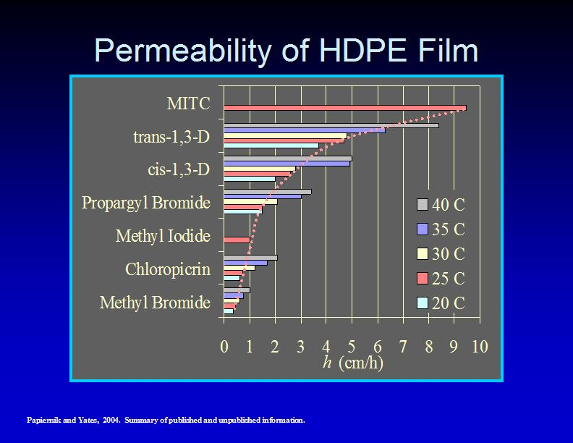
Slide 4

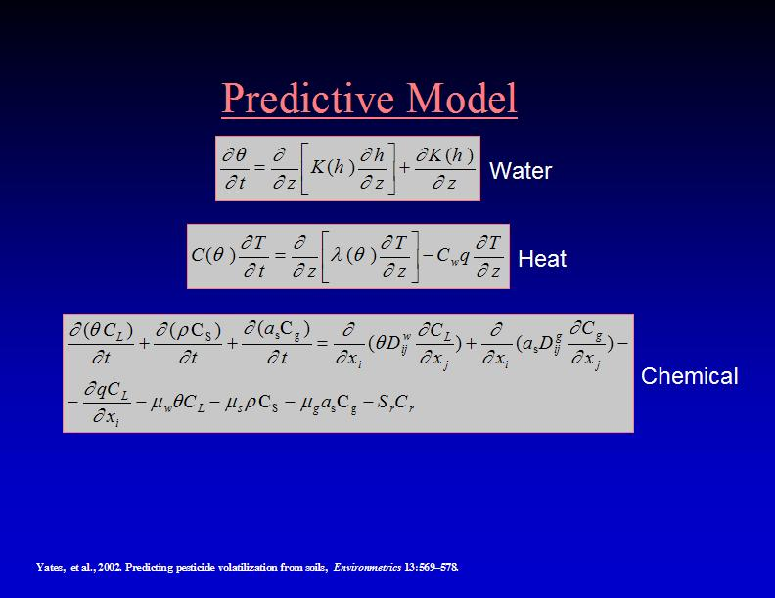
Slide 5
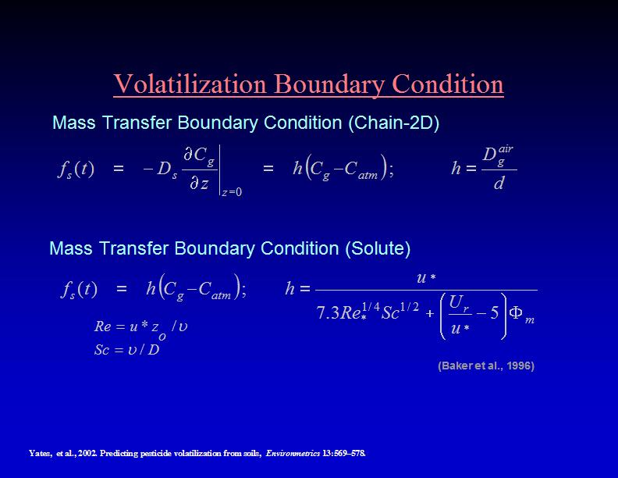
Slide 6

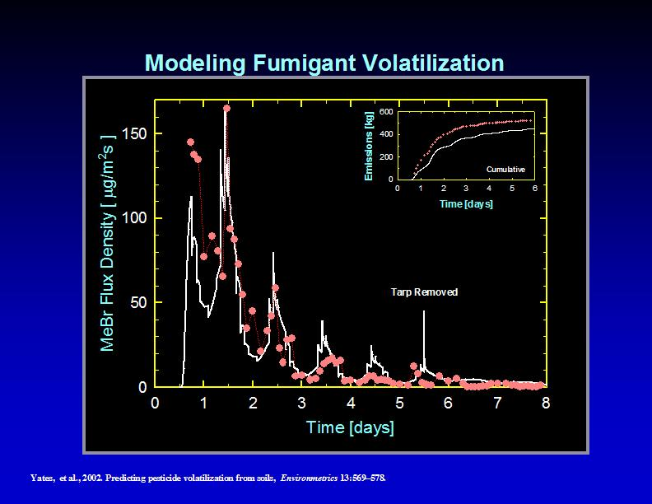
Slide 7

Question 4: The integration of actual time-base meteorological data into ISCST3 is one of the key components that separate the PERFUM methodology from that being employed by the Agency in its current assessment. There are several potential sources of these data including the National Weather Service, Federal Aviation Administration, California Irrigation Management Information System (CIMIS), and the Florida Automated Weather Network (FAWN). The Agency is also aware that there are several approaches that can be used to process meteorological data, and acknowledges that PERFUM used PCRAMMET, which is a standard Agency tool for this purpose, as well as other techniques in some cases (e.g., for the FAWN & CIMIS data). Various datasets from both California and Florida were used as the basis for the PERFUM case study.
a) Please comment on the methods used to select monitoring station locations.

Response

Terrain effects (topography) need to be addressed when selecting station locations.

The Panel recommended a review of state climatological agricultural weather stations {see examples in response 4 (c)} for potential sources of rural meteorological data. In the current study CIMIS data from California may meet these criteria, but FAWN data in Florida are not very reliable.

b) What criteria should be used to identify meteorological regions for analysis and how should specific monitoring data be selected from within each region?

Response

When selecting monitoring stations we should consider inland as well as coastal regions. We should also consider areas with complex terrain. Those locations usually have different meteorological conditions. For example, the diurnal wind cycle in coastal and near water areas exhibits an opposite wind direction during day and night associated with the land and sea breeze phenomena triggered by the gradient in temperature between land and sea.

c) What criteria should be used to identify meteorological regions for analysis?

Response

Precipitation (linked to cloud cover).

Precipitation not only contributes to the removal of pollutants, but also to moisturizing the soil, which might be an issue in post precipitation application.

Temperature field.

The flux rate of emissions is affected by ambient and land (skin) temperature. Temperature profiles at several regions in the country show a temperature inversion during the early morning hours. These inversion events are associated with very stable atmospheric conditions and the occurrence of early morning fog. Relative humidity is typically very high during these morning hours until the lifting of the inversion by the daylight heating.

Locality (terrain, physical characteristics of the land surface, etc.).

Terrain and topography may affect the dispersion of the plume, both horizontal and vertical. The current structure of the ISCST3 model does not handle terrain very well. The AERMOD approach seems to be more adequate. It is the understanding of the Panel that the Agency is moving toward the adoption of AERMOD as an approved regulatory model. This could then be integrated into PERFUM.

The primary source of meteorological data should be in the following order: (1) National Weather Service; (2) ASOS (FAA) data (ASOS came on line in early 1990, a very rich data source that covers the country); (3) State climatology or agricultural weather stations (e.g., CIMIS, FAWN, SCAN, ECONet, etc.); (4) meteorological data selected from regulatory agency sites or industrial sites if the data are quality assured.

The closest quality-assured data source should be used for model input. The data source should be well documented.

d) Please comment on the manner that data from the selected various stations were processed.

Response

Processing the data followed the normal procedure. Missing data however is the tricky part, especially for cloud cover, which is one of the parameters used by the ISCST3 model to designate a stability index (letter). When filling gaps of missing data, the EPA recommendations are to use data within a few hours of the missing period. This might be a reasonable approach for parameters such as temperature. However a highly variable and uncertain parameter such as cloud cover will be much less accurate when using the interpolation approach.

As was reported, the NWS data seem to have the highest accuracy, with quality control and quality assurance procedures being implemented. Data from the three other data sources seem to be less accurate; especially the Florida database. The lack of quality control in the Florida system could increase uncertainty in the system. Also while the NWS has cloud cover data as one of its measured parameters, observational networks from Florida and California do not include this parameter. The Turner method for calculating stability requires information on the cloud cover. An alternative method was used to calculate the stability parameter. That diminishes consistency when comparing the results.

The Panel suggested the use of other meteorological data sources for appropriate regions in the country. Many state climate offices have good collections of weather data. For example, the State Climate Office of North Carolina maintains the CRONOS/ECONet database. The ECONet network is a part of the CRONOS Database. Data from 216 stations are archived in this database for retrieval. The primary focus is on North Carolina stations, but data are also archived from stations in portions of South Carolina, Georgia, Virginia, and Tennessee. The FAA, NWS, or other government agencies maintain most stations. A total of 24 stations (ECONet) are maintained directly by the State Climate Office of NC.

Soil Climate Analysis Network (SCAN) stations focus on the agricultural areas of the United States. Maintained by the National Resources Conservation Service, the SCAN sites are used to monitor drought development, for soil classification and moisture assessment, for input into global circulation models, and for various water table assessments that are important to local crops, woodlands, and wetlands. There are 6 SCAN stations in the NC CRONOS Database. Portable weather stations can be deployed at the SCAN site or at specific locations within the SCAN network for a particular case study.

Other sources of data include the AmeriFlux network (http://public.ornl.gov/ameriflux) established in 1996 to provide continuous observations of surface and weather parameters, and the Peanut/Cotton Infonet in southeastern Virginia.

The Panel also suggested the use of meteorological simulation modeling as another source of meteorological information. Models such as the Regional Atmospheric Modeling System (RAMS) of Colorado State University and the NCAR Mesoscale Model Version 5 (MM5) have been run on a fine resolution (4km or less) over the continental US for a period of a year or more. Information based on those models can be used to supplement data when measurements are not available. Data from these models could be used for scanning, screening and comparisons among areas to determine where different site data might be needed for PERFUM.

Having mentioned various meteorological data sources, the main point is to identify the biases and errors in each dataset in order to truly understand its limitations.

The Panel noted that different types of data are needed if PERFUM is used in developing national and/or regional buffer zone strategies compared to the use of PERFUM in helping with decision-making at the local level; for example in decisions regarding permitting of a proposed iodomethane application in the vicinity of subdivisions, schools, etc. If PERFUM is used in the latter situation, site-specific meteorological data should be collected that are as close as possible to the proposed application site and taken near the time of application. Meteorological data collected over a few months, or even weeks or days that are proximate to the proposed application might be more relevant in this situation than 5-year historical data.

e) Data quality and uncertainty associated with these data vary with the source. Does the Panel agree with the approaches used to characterize these factors?

Response

Generally, the National Weather Service data are preferred since cloud cover is identified and thus Turner Stability Class can be determined. In addition, the data are collected at 10 meters above ground level.

f) Anemometer sampling height has been identified as a concern by the Agency in preparation for this meeting. What are the potential impacts of using data collected with different anemometer heights in an analysis of this nature?

Response

Some of the observational data used in PERFUM are at 10 meters heights; the NWS measurements are typically between 6 and 10 meters. Wind data from California are at 2 meters. What are the differences? Are they important? The surface layer is defined as the lowest 10% of the boundary layer height, typically the lowest 100 meters above the surface. In general there are differences between the wind speeds and directions measured at different heights. The magnitudes of those differences depend on the stability conditions of the atmosphere. For example, in the daytime over land during clear weather conditions, vertical wind profiles will have less speed and wind direction changes than during stable night time conditions. Plume centerlines would vary with data collected at 2 meters as opposed to 10 meters. Winds are more variable at lower heights above ground level, which impacts stability class determination in the ISCST3 model. Surface roughness factors (roughness length) must be considered for data collected at 2 meters elevation. The roughness length varies widely depending on the physical characteristics of the surface. The friction velocity sets the level of the velocity fluctuations in the surface layer. In describing the relationship between the 2 meters and 10 meters wind measurements, a logarithmic wind profile might be considered with the following cautionary remark.

At 2 meters the air could be more stable with lower wind speeds leading to underestimation if the 10 meters data would be used. In some areas the differences between 2 and 10 meters could be quite large. There is a great source of uncertainty when adjusting from 2 to 10 meters using the power formula for sites where both heights are measured. Note that the ISCST3 model does not make adjustments below 10 meters. Uncertainty in the wind speed measurement below 10 meters is greater than measurements taken at 10 meters. Wind direction is more variable at lower heights, increasing uncertainty, another reason to try to use the NWS data when possible.

In summary, there are differences between 2 meters and 10 meters wind speed and wind direction but it might not be easily addressed. It will be better to standardize on one height (in the case of ISCST3). Or, even better, to have multiple height measurements, at the same time and location, to more accurately account for turbulence (using AERMOD).

g) Does PERFUM treat stability class inputs appropriately?

Response

Apparently PERFUM treats stability class inputs appropriately. There is not much difference between the major ways to estimate stability class via the Turner, Sigma Theta, and Delta Temperature/Solar Radiation methods. However, stability class in ISCST3 is fixed during the one-hour simulation and cannot be altered.

h) Does PERFUM appropriately calculate boundary air concentration estimates by concurrently using upper-bound meteorological and emission/flux inputs?

Response

The PERFUM model apparently incorporates “worst-case” emission flux with five years of meteorological data where poor dispersion hours could coincide with “worst-case” emission flux hours.

The horizontal dispersion, Sigma-Y, and vertical dispersion coefficient, Sigma-Z, need to be examined probabilistically. Uncertainty related to horizontal and vertical dispersion may be included in model formulation by randomly selecting a multiplier to Sigma-Y and Sigma-Z in the ISCST3 model code. The multiplier can be introduced on an hourly or daily basis. This multiplier is based on the use of a cumulative distribution function (CDF) to represent the uncertainty (based on the difference between measurements at field experiments and the model calculated Sigmas).

There is a need to keep variability and uncertainty separate in the runs of PERFUM. The 5 years of climate data are used to examine the effect of variability on the results. The changes to the flux rate (question 3) address uncertainty. Typically in a Monte Carlo analysis, one set of flux rates would be run for the full 5 years and the results stored, then a new set of flux rates for each period generated and the 5 years re-run. The runs associated with uncertainty are there to add confidence intervals to the probability statements. The current PERFUM runs confound the uncertainty and variability, something that will have to be decoupled when the model is used to develop management tables. There are other “parameters” that have associated uncertainty that would have to be looked at in the 2D Monte Carlo format as well. There are a number of agencies that tried to incorporate variability and uncertainty into the ISCST3 model.

Question 5: The Agency model, ISCST3 is the basis for the PERFUM approach. This model has been peer reviewed and is commonly used for regulatory purposes by the Agency. PERFUM also uses other Agency systems such as PCRAMMET.

a) Please recommend any parameters that should be altered to optimize the manner that they are used in PERFUM.

Response

The Panel did not have any specific recommendations with respect to PCRAMMET. The Panel recommended that meteorological pre-processors developed within the PERFUM project for other meteorological datasets besides NWS stations (ASOS, CIMIS, FAWN, etc.) should be made available.

It was noted that precipitation during the summer in Florida could wash the material out of the atmosphere. Inclusion of precipitation would require inclusion of a separate database, which is not very complete. Special consideration of precipitation may not be warranted given that fumigant application is not planned/recommended if precipitation is forecast. This clarification led to a discussion on sorting, and the idea of eliminating days for which precipitation occurs was discussed. Again, the database is limited and the added value of this sorting was not obvious. Decreases in barometric pressure (potentially enhancing the fumigant flux) were also discussed, but its potential significance was debatable.

Winter versus summer differences, for example, could be explored with real data from the same sites. Related Panelist experience doing this at the same site showed very different conditions in soil climate. The use of flux rates from one season for the whole year introduces uncertainty.

b) Does the Panel agree with the manner in which the receptor grid was developed, and if not, please provide suggestions for improving this approach?

Response

The Panel agreed with the development of the receptor grid for the example of the square field, but also supported any effort that would increase computational efficiency. In addition, the Panel recommended consideration of rectangular fields and other irregularly shaped fields – both from a gridding consideration and for better representation of these field geometries.

c) ISCST3, as integrated into PERFUM, was run assuming rural, flat terrain which would be typical of treated farm fields but might not be typical of surrounding residential areas. Does the Panel concur with this approach? What are the implications of such an approach? What improvements can be made to this approach?

Response

The Panel agreed that within the ISCST3 framework, the selection of rural mode would yield the highest predicted downwind concentrations for this source type. However,

- Outside the ISCST3 model framework, it was noted that the fumigant air plume from this type of ground level emission source, in the event that it encounters a dense obstacle field (subdivision housing was specifically mentioned), may have reduced horizontal flow and reduced dispersion within the obstacle field even though turbulence is enhanced above the obstacle field.

- Wind breaking through the use of a row of trees or high bushes was discussed, particularly for eastern locations. This would increase the atmospheric turbulence and reduce concentrations beyond the break in wind. Dense obstacle field effects, if they were realized due to the windbreak, would be contained within an area under owner control to exclude exposure.

- A somewhat similar comment was made regarding atmospheric turbulence introduced due to tall crops like corn in neighboring fields.

d) ISCST3, as integrated into PERFUM, was run in regulatory mode which includes the use of the “calms” processing routine. Does the Panel concur with this approach? If not, please suggest a suitable alternative.

Response

The Panel supported the use of calms processing as being consistent with traditional regulatory practice. The calm periods that have been captured in field studies used in the calibration of ISCST3, as well as calm periods captured in the fumigant field studies, if any, should be largely self-correcting for the limitations of the Gaussian formulation that is inherent in ISCST3. The Panel supported consideration of additional field studies, which should further improve this situation. However, not all Panel members were confident in the degree of self-correction. Some Panel members expressed concern for calm periods not being fully captured in the calibration of ISCST3, thus an under-prediction of the buffer zone was implied. Also, some Panel members expressed concern for how calm periods affect the concentration data collected during the fumigant field studies and the implication this has for emission flux estimates. Issues on the back-calculation method of the fumigant flux, when calm periods were encountered in the field studies, somewhat overlap with similar issues on the intercept (and the cluster of data near the intercept) during regression analysis.

Critical Element 3: Results

Question 6: Soil fumigants can be used in different regions of the country under different conditions and they can be applied with a variety of equipment.

a) Please comment on whether the methodologies in PERFUM can be applied generically in order to assess a wide variety of fumigant uses.

Response

PERFUM and its associated components (back-calculation of flux, ISCST3 model, and MOE calculation) appeared to the Panel to be generally applicable, and could be applied (with minimal adaptation/modification) to most growing regions in the U.S.

PERFUM could probably be applied generically to evaluate other fumigants in other regions but in its present configuration is probably best for highly volatile fumigants with high initial emission from the soil. To use the model in other areas it certainly will be essential to use regional or local weather data as close to the area of concern as possible.

Calibration and/or validation studies will need to be done to fit regions and sites, in other words, applicability will need to be demonstrated when moving from one cropping system to another, or from one growing region to another. Such studies should be designed to address variables that might influence flux rates, downwind residue fate, and unusual atmospheric conditions. Making the States aware of the need for certain types of data will likely bring about improvement in some of the data development. Data are frequently available today through local weather networks, e.g., Peanut/Cotton Infonet in southeastern Virginia.

Since PERFUM was developed based on the methodologies of the California DPR model for methyl bromide, PERFUM should accurately predict methyl bromide exposure. But the three liquid fumigants 1,3-D, chloropicrin, and MITC have much lower vapor pressure than methyl bromide and the case study chemical, iodomethane. Therefore, validation should be conducted for these liquid fumigants.

b) What considerations with regard to data needs and model inputs should be considered for such an effort?

Response

A statement was made in the PERFUM report (“A Probabilistic Exposure and Risk Model for Fumigant Bystander Exposures Using Iodomethane as a Case Study”) that the flux rate is likely dependent on factors such as soil type, soil temperature, organic matter content, etc. Yet it is noted that effects of each of these factors have not been quantified for fumigants at field scale and that it would be difficult to do so. A robust model should include factors or variables that are known to be important in the fate and transport of fumigants. For example, the following are considered to be important:

- Temperature (Air and Soil). Air temperature can affect atmospheric stability terms, and (along with atmospheric moisture—humidity or fog) such things as sampling efficiency of iodomethane through charcoal adsorbent. Soil temperature can influence flux rates and soil degradation rates, including microbial degradation. Microbial degradation needs to be considered for iodomethane, particularly in fields that are treated more than once (microbial adaptation and enhanced degradation).

- Water evaporation rate. In future studies, consideration should be made of compiling and potentially correlating water evaporation rate (pan evaporation) data. There may be a correlation between flux of iodomethane, other fumigants, and water flux.

- Atmospheric Moisture. Rain and fog should be taken into account in terms of their influence on PERFUM modeling. Rain can reduce flux if rainwater accumulates on the surface of a tarp or at the soil surface by plugging the soil pores and reducing vapor phase diffusion. Later, rainwater can increase flux as moisture competes for adsorptive sites on or in soil, and by providing a mass transport mechanism to the surface under evaporative conditions. Rain can also wash out downwind residues before they reach receptors. The effect of fog on fumigant airborne residues, if any, will need to be determined.

- Obstructions to airflow. Trees planted as windbreaks, as ornamentals or in forested wooded areas can affect surface roughness and could potentially subtract residues from the air by absorptive deposition. Downwind crop cover, corn for example, might similarly affect conditions around a field subject to fumigation, or downwind residue content.

- Application variables. Type of irrigation (sprinkler, drip, and flood), use or not of tarps, types of tarps, and depth and methods of injection, might differ between crops and growing regions.

- Efficacy considerations and using the model in a predictive mode. It seems likely that if a model incorporates soil parameters as well as characteristics of the fumigant, then the proper conditions for safest and most effective application might be ascertained.

- Airshed considerations. Ambient residue levels may be of increasing concern in airsheds where iodomethane might be used frequently. PERFUM could potentially be adapted to help address this by extending its use to longer distances from the treated field, and to situations where more than one field is applied simultaneously or in close proximity.

- Other considerations. The range of flux values might be different in differing soil types and with differing application methods used in various growing regions. Timing of applications could differ. Topography will differ, affecting the use of the ISCST3 dispersion model.

It is noted that the model adequately considers the atmospheric stability and computes the buffer zones. The fact that it does not consider soil type, soil moisture, organic matter, etc., may be of little consequence with other fumigants as volatile as iodomethane. However, these factors could be significant with other fumigants, especially in the initial fumigation process. These parameters might affect the efflux of fumigant gases from the soil. Without some way of accounting for these 'uncertain' factors, errors might occur in calculating the buffer zones. These factors should be investigated and incorporated, if possible, into the model to improve its usefulness for other fumigants in other environments.

There are significant uncertainties associated with PERFUM because soil factors are not taken into account in the model. Some of these factors could affect the rate of flux of some fumigants. Another factor is windrows, tree barriers, etc., a common occurrence in many areas in the southeastern U.S. A Panel member mentioned that such barriers would increase the turbulence and could affect the size of buffer zones. Rain is also a factor that could mitigate downwind atmospheric concentrations.

A Panel member mentioned that a model is being developed that will address some of these effects. It seems likely that if a model incorporates soil parameters as well as characteristics of the fumigant, then the proper conditions for the safest and most effective application might be ascertained. This could work positively toward reducing the dose, increasing the efficacy, and decreasing the atmospheric concentration at any given point in time. This could work favorably toward decreasing calculated buffer zones. It seems that the use of large buffer zones would increase the safety of bystander exposure but does suggest some problems with marking and enforcing those zones. Such zones might preclude many areas from agricultural use because of the proximity of houses, etc. While having buffer zones to ensure safety of people certainly seems wise, it appears that anything that can be done to minimize such zones would be practical.

Question 7:

a) Please comment on whether PERFUM adequately identifies and quantifies airborne concentrations of soil fumigants that have migrated from treated fields to sensitive receptors.

Response

The ISCST3 model has been tested/validated and is therefore considered to be as accurate as other EPA-approved models subject to the limitations of its design. The application of the ISCST3 model to compute ambient concentrations is appropriate for regulatory purposes. However, as noted in the Panel’s response to Question 3, the uncertainty in emission rates for new sites and conditions is likely underestimated by the procedures used for characterizing the uncertainty in fluxes for a test site and data set.

The question of the accuracy of this model is dependent on the dispersion code that is incorporated into it. PERFUM has been described as having the source code for ISCST3 incorporated into its computational routines, making it equivalent to ISCST3. ISCST3 has been validated by a number of field studies, and it has been used to accurately predict airborne concentrations in a variety of physical situations. Therefore, to the extent that ISCST3 is accurate for a given dispersion scenario, PERFUM follows suit.

Since air samplers were installed at distances that were much smaller than typical buffer zones, new more-rigorous studies are needed that test the accuracy of the buffer zone calculation using samplers installed at 500 to 1500 m. This would allow evaluation of the model reliability at the lower concentrations.

Little information is available to determine the accuracy of the flux and down-wind concentration estimates. Nothing in the report addresses this directly. It may be possible to test PERFUM’s ability to quantify airborne concentrations at sensitive receptors by using the emission rate data from one experiment as an input parameter to determine the appropriate buffer zones using meteorological data appropriate for another experiment. Once the analysis is completed, the “predicted” buffer zone could be compared to the measured air concentration data that were not used in the buffer zone calculation, to determine the accuracy of PERFUM. This kind of cross-site validation is needed and does not require any additional data.

Flux studies using direct flux methods could be performed to better parameterize the PERFUM model and to determine the variability in emission rate as a function of soil type, region, and timing. This information would also help in determining if the indirect method is accurately estimating flux rates.

Although the Panel thought that direct flux measurements would probably be more accurate, the use of the indirect flux method assists in calibrating the modeling system to a particular application site. This would improve the accuracy for a particular field study. The appropriateness of model input parameters to risk assessment was addressed in Dr. Reiss’ presentations on August 24, 2004 and also in some of the other Panel members’ responses to questions.

Several studies have compared ISCST3-based model predictions with measured downwind air concentrations of fumigants. These include studies for methyl bromide, telone, metam sodium, and possibly others. The PERFUM developers should add these comparative data, or at least reference it, in the documentation. Some of the studies can be found in Symposium Proceedings by J.N. Seiber, J.A. Knuteson, J.E. Woodrow, N.L. Wolfe, M.V. Yates and S.R. Yates, 1996.

The indirect flux method bypasses the use of more sophisticated, but data-intensive, physical models that potentially would be able to predict emissions from fundamental soil properties such as soil type, moisture content, sorption rate, etc. The use of the indirect flux method allows the ISCST3 model to be tied to a physical situation (one field location and time) without having to resort to additional data collection and a different model to predict emissions. Although the use of soil-based models may prove difficult, users of PERFUM face equal challenges in obtaining high-quality emissions data that represents conditions over a large region and throughout the year. It may be useful to have the ability to use more detailed models that handle soil, temperature, and the soil-atmosphere interface. Such a model can provide probabilistic analysis for risk assessment, and may prove more reliable predicting flux at new locations or for new conditions.

b) The Agency is particularly concerned about air concentrations in the upper ends of the distribution. Are these results presented in a clear and concise manner that would allow for appropriate characterization of exposures that could occur at such levels?

Response

PERFUM and the incorporated methodology assume that the ISCST3 model can accurately predict atmospheric concentrations at receptor points with accuracy, including rare events. Once a buffer zone has been determined in a study area, a post-analysis of the PERFUM model would be useful. Without such information it is difficult to determine how well PERFUM quantifies the upper ends of the distribution.

As with the first question, the accuracy of any output of the model is dependent on the accuracy of the internal computational engine, ISCST3. Therefore, based on the above factors, both low and high-end concentrations should be as accurate as the limitations of ISCST3.

Another concern that must still be addressed in order to estimate the high-end probability distribution of ambient concentrations and exposures is the treatment of calm-wind periods in the simulation procedure. Since the model is intended for risk management for a procedure that could be repeated often at different sites, reducing the probability of a serious exposure at any one of many sites, e.g., in a given year, will require a much lower probability of occurrence at each individual site. In particular, to keep the probability of one or more serious exposures at N sites in a given year below P_{N}, then (assuming independence) the probability of a serious exposure at each site must be kept below P₁, where 1- P_{N} = (1- P₁)^{N}, so that P₁ = 1 - (1- P_{N})^{1/N}. For example, if P_{N} = 0.05 and N = 100, then P₁ = 0.000513, that is, you must be 99.95% confident of no serious exposure at each of the 100 sites. As such, very high-end (e.g., 99%, 99.5%, or higher) protection should be sought for individual applications.

Some Panel members were concerned that the field studies sometimes seemed to show some experimental weaknesses. Some of the studies lost the first 24 hours of data, the most important time period. The studies seemed to have only one set of downwind samples, which may not allow a complete characterization of the downwind environment. Other Panel members have mentioned the possible need for a vertical placement of samplers to test that component.

c) The PERFUM model calculates the concentration distributions both in all directions and for only the maximum concentration direction. Can the Panel comment on how accurately the model approximates both of these distributions?

Response

Some Panel members suggested that allowing only the maximum concentration distribution introduces unnecessary conservatism into the model output. Therefore, it is recommended that the entire distribution of wind directions be used in order to maintain an appropriate physical representation of the emission distribution and exposure at the receptors. However, it may be useful for PERFUM to allow the option of an analysis based on the maximum concentration direction as a tool for examining potential impacts.

In addition, it is recommended that the output of PERFUM be modified so that GIS or graphics programs can access the output for visualization. Better decisions regarding the buffer zones can be made through examining the physical impact of buffer zones to actual field configurations.

The use of portable air quality samplers using charcoal filters was performed in all directions within a range of 30 feet to 140 feet from the application area. However, there are significant uncertainties in predicting buffer zones and concentrations at those locations.

An additional concern regarding the accuracy is the use of meteorological data sets that are not associated with the flux at a particular location. It is recommended that additional work be performed to provide assurance that the appropriate wind data are used in the eventual model.

Question 8: A sensitivity/uncertainty analysis has been conducted and is described in the PERFUM background document.

a) What types, if any, of additional contribution/ sensitivity analyses are recommended by the Panel to be the most useful in making scientifically sound, regulatory decisions?

Response

The report includes a reasonable discussion of the various sources of uncertainty in the study and provides an initial assessment of the sensitivity of model predictions to selected alternative model assumptions and parameter values. Several factors were considered on an individual basis, but not on a comprehensive basis; however, this seems appropriate for the current stage of model development. The factors discussed include: the flux emission estimate/profile, meteorological data and sources of datasets, anemometer height, calms processing, non-meteorological environmental factors, (Gaussian formulated) model-model comparisons, indoor exposure, human activity patterns, coincidental temporally/spatially close multi-field applications, seasonality, and horizontal placement of monitors during field studies for flux estimation.

The Panel recommended separating out emissions related issues from meteorological/air dispersion model issues; and then, to the extent possible, separating out uncertainty and variability. The discussion of emission rate uncertainty needs more clarification in the report.

Comparing vertical concentration profiles may be one other way to improve the calibration of the model. Currently, only data in the horizontal direction are being collected and used.

b) What should be routinely reported as part of a PERFUM assessment with respect to inputs and outputs?

Response

One of the variations considered around the flux estimation includes the use of a higher coefficient of variation for emission rates (47%) and the use of higher base-case (mean) emission rate, corresponding to the 75th percentile of the estimated value. As noted in the Panel’s response to Question 3, the use of the 47% CV, while more likely representative of site-to-site variation than the smaller CV determined by fitting a single flux study at a single site, the assumption that uncertainties in sequential simulation periods are random and independent could underestimate the variation associated with persistent meteorological conditions (that affect the emission rate) and systematic error in the model.

More mechanistic investigation of the emission flux (soil temperature, tarp parameters, etc.) could guide additional data collection, analysis, and reporting. The state-of-development of mechanistic soil fumigant flux modeling is such that the need for field studies will not be eliminated; however, it may be mutually beneficial to explore what can be done in a complimentary fashion.

In the final presentation of the PERFUM model it would be important to clearly articulate whether an input is a “random input” or an “uncertain input” (i.e., flux rate).

c) Are there certain tables and graphs that should be reported?

Response

No analysis was presented to address the implications of upset or unusual conditions in fumigant handling and application that could lead to especially high exposures.

The tables and graphs in the report should be provided for most of the user’s needs.

d) What types of further evaluation steps does the Panel recommend for PERFUM?

Response

A simple relationship is anticipated between the ground level emission source and the 1.5 m collection cartridges during the field studies. Nevertheless, the absence of any concentration data collected in the vertical dimension precludes challenging this assumption. Additionally, concentration data in the vertical dimension can be used along with the 1.5 m concentration data to improve the emission flux estimation obtained from back-calculation -- similar to the additional placement of monitors in the horizontal dimension being planned for a future field study.

The discussion of the calibration of ISCST3 to the robust highest concentration (measured) using meteorological datasets that include calm conditions, and have been processed for calm conditions, was not adequate to convince all Panelists that calm periods have been accounted for.

A meteorological sensitivity run was briefly suggested for crops with specific windows of application time in specific regions (i.e., January and February applications for strawberries in Florida). The monthly sensitivity runs captured a component of this, though the region specific feature may not be captured.

Concluding Discussions of the Panel

A number of issues not directly related to the Agency questions were introduced and discussed at the end of the meeting.

The PERFUM technical documentation should include descriptions of the canister sampling methods. Whether the charcoal canisters were evacuated was not clear to some of the Panel members. A query of the developers indicated that indeed they were attached to a vacuum pump. This led to a discussion of potential alternative sampling devices. One such methodology, Suma Canisters (Compendium Method TO-15, EPA/625/R-96/010b (http://www.epa.gov/ttn/amtic/airtox.html), involving the use of evacuated spheres as quick air samplers, was described to the Panel and the effectiveness of these devices briefly discussed.

There were several references to charcoal canisters used in the field studies. The word “canister” implies some other technology that is commonly used in air sampling as described above, so a mis-application of this nomenclature is misleading and should be clarified.

It appears that the field studies made use of charcoal sorbent tubes. These tubes consist of a small glass tube filled with a specially prepared charcoal sorbent material. A calibrated pump pulls air through the sorbent tube at an appropriate rate, after which the adsorbed material is chemically desorbed in the laboratory and analyzed, typically by gas chromatography. This technique is very commonly used, but may suffer from relatively high detection limits, particularly for short sampling times, as the sensitivity of the method is dependent on the amount of air that is pulled through the sorbent tube. The implication for the flux studies is that the use of this approach may limit the duration of the sampling periods to times longer than might be advantageous for a more detailed examination of the flux behavior. For example, hourly samples that correlate with the hourly meteorological data collection and the hourly output of ISCST3 might be useful to more fully characterize the first important 24 hours post-application.

An alternative sampling method based on evacuated canisters, called Summa canisters as referenced above, can provide from very short sampling periods (1-2 minutes) to 24 hours or more. This method may prove useful for future flux validation studies.

There was discussion of whether and how field-sampling layouts (sampling design) might be modified to improve the results from the back calculation of flux. It was suggested that different layouts could be examined using expectations from the fitted model. Clearly, if there were cheaper measurement instruments, even if they were less precise, their use in conjunction with the expensive instruments would greatly increase the information available for flux estimation. The cheap and expensive could be used together at a few locations and the relationship between the two used to calibrate the cheap method values to the expensive method values. There is a need to consider standardization of the sampling design if the methodology is to be established as useful for other regions of the country.

The use of alternative sampling designs, such as the single point design, or designs that include samples taken in different vertical positions (gradient methods) was discussed. Some of the Panel thought there was a need for alternative designs, and that the back calculation method applied to single height data was not adequate for the purposes to which the results of the PERFUM model are to be used. Gradient methods have some appeal but there are significant field constraints that limit their use, often resulting in too few measurement locations. None of the measurement methods would be useful for the very low concentrations that might be observed at, e.g., 1 km.

One Panel member justified the need for vertical data based on recent experiments that generated more data than was available for this study. The reason for observing zero concentrations in locations where the model says there should be concentration can partially be explained with these vertical data. Typically, zero concentrations are the result of input factor levels, for example stability, affecting the dispersion parameters of the model. By using the predicted dispersion coefficients, even slight changes in elevation are shown to be able to make big differences. In reality, dispersion coefficients are not step functions but are continuous and it is not a trivial task to determine how to establish sufficient vertical samples to get useful data for estimation.

The Panel discussed the use of log transformations in the back calculation of flux and its relationship to the mass balance assumptions made in the model. The decision to use a regression line that is forced through the origin (the ratio model) versus an intercept linear model cannot be justified simply on statistical terms, especially in light of the relatively small sample sizes typically seen. It would be best if there were a physical interpretation for the intercept term (for example, nonlinearity of relationship between observed and expected concentrations close to zero). If no physical reason can be found, it makes sense to force the intercept to zero. It is possible that some of the studies that have been done on other fumigants could shed light on this issue.

There was discussion about the practical limitations of laying cover tarps and the impact of non-uniform tarp cover on directional changes in concentrations. Imperfections may allow emission concentrations in situations where the model says the concentrations should be zero. Some of this is lost when the data are averaged over an hour (or longer) to allow use in the ISCST3 model.

Finally, there was some discussion that the research on methyl bromide had indicated that degradation of the chemical is a simple process. The PERFUM model seems to assume that this will be the same for other chemicals as illustrated by the case study using iodomethane. The Panel wondered if this assumption is warranted and whether there are data to support this assumption.

REFERENCES

Baker, J.M., W.C. Koskinen and R.H. Dowdy. 1996. Volatilization of EPTC: simulation and measurement. J. Environ. Qual. 25: 169-177.

Compendium of Methods for the Determination of Toxic Organic Compounds in Ambient Air: Method TO-15, Determination of Volatile Organic Compounds (VOCs) in Air Collected in Specially-Prepared Canisters and Analyzed by Gas Chromatography/Mass Spectrometry (GC/MS). Second Edition. U.S. Environmental Protection Agency, Office of Research and Development, OH. EPA/625/R-96/010b. January 1999. (http://www.epa.gov/ttn/amtic/airtox.html)

Honaganahalli, P.S. and J.N. Seiber. 2000. Measured and predicted air shed concentrations of
methyl bromide in an agricultural valley and applications to exposure assessment. Atmos.
Environ. 34:3511-3523.

Jury, W.A., W.F. Spencer and W.J. Farmer. 1983. Behavior assessment model for trace organics in soil: 1. Model description. J. Environ. Qual. 12: 558-564.

Seiber, J.N., J.A. Knuteson, J.E. Woodrow, N.L. Wolfe, M.V. Yates and S.R. Yates (Eds.). 1996. Fumigants: Environmental fate, exposures, and analysis. ACS Symposium Series 652, American Chemical Society, Washington, D.C. pp135-153.

Wang, D., S.R. Yates and J. Gan. 1997. Temperature effect of fate and transport of methyl bromide in soil fumigation. J. Environ. Qual. 26: 1072-1079.

Woodrow, J.E., J.N. Seiber and C. Dary. 2001. Predicting pesticide emissions and downwind concentrations using correlations with estimated vapor pressures. J. Agric. Food Chem. 49:3841-3846.

Yates, S.R., D. Wang, S.K. Papiernik and J. Gan. 2002. Predicting pesticide volatilization from soils, Environmetrics. 13:569–578.
Appendix 1.

Information on the indirect flux estimation method provided by Dr. Mitchell J. Small following the meeting.

The indirect method for estimating emissions from ambient concentrations is based on the relationship:

$C = b_{1} + E×T$ (A.1)

where C is the ambient concentration, E is the emission rate, b₁ is a background concentration that would be present even if there were no emission sources at the site (the
background concentration could be present as result of emissions from other
local or regional sources), and T is a linear source-receptor transfer coefficient between the emission source and the receptor. This equation assumes a linear fate-and-transport process (as is assumed for most applied atmospheric dispersion models) and is applicable either at a particular time or over some averaging period. The parameters of the equation relating C to T (the intercept b₁ and the slope E) are estimated in the PERFUM methodology by regressing observed concentrations (Y_{meas}) at many locations following a fumigant application vs. the concentrations (X_{ISC}) predicted by the ISCST3 model for a unit or nominal emission (Flux_{nominal}):

$Y_{\text{meas}} = b + m×X_{\text{ISC}}$ (A.2)

The intercept obtained with this method, b, is equivalent to b₁ in the equation above, while the slope, m, allows E to be calculated as follows:

$E ={\text{Flux}}_{\text{est}} = m×{\text{Flux}}_{\text{no}\text{min}\text{al}}$ (A.3)

The indirect approach for emissions estimation is, in general, appropriately formulated and implemented in the PERFUM model.

One of the issues raised as part of the third question to the Panel involves the way that the intercept, b, in equation A.2 is treated in the analysis. As noted above, the intercept in equation A.1 and A.2 has a physical meaning – it corresponds to the “background” concentration that would be present at the receptor, for the time period of interest, had no emission been present, i.e., E = 0. Since ideally, when a fumigant is introduced at a site, it should be the only significant source of the chemical, there is a preference expressed that the intercept, b, be equal to zero. In previous and the PERFUM-proposed approaches, when the estimated slope is not significantly different from zero, this is considered an “acceptable” result and the estimated slope m that is used to estimate the emissions, can be used directly. However, when b is significantly different from zero, the data are processed further, by matching the rank order of the model predictions with that of the observed data and/or the regression is repeated with the intercept forced to be zero, in order to provide a “more appropriate” estimate of the slope and associated emission flux rate.

It should be noted that the opposite inference and estimation procedure could be (and often is) used by statisticians and scientists, given the result that an estimated slope in a linear regression is, or is not, significantly different from zero. In this alternative approach, the result that an estimated intercept is not significantly different from zero implies that, since there is not sufficient confidence that the intercept is different from zero, the intercept term should be deleted from the model and the equation re-estimated with the intercept set equal to zero. In contrast, when an intercept is found to be significantly different from zero, this indicates that the non-zero intercept term is “real”, and should be left in the model. A key issue in these alternative interpretations and approaches is, the assessment of whether there is physical reason to believe that a background concentration could or should be present at the site, so that a non-zero intercept does (or does not) make physical sense. Has the fumigant been applied previously at the site or at nearby sites (this would especially be the case if a sequence of test applications were conducted at a site for the purpose of model calibration)? Has the fumigant been used for a long-enough time so that a regional (or perhaps even a global) background is present in the environment? Furthermore, depending on how very low, below-detection-limit concentration measurements are determined and reported (e.g., at the detection limit, at one-half the detection limit, or at zero), an apparent background concentration could be inferred as a result of the way the data are treated. These issues have not been addressed in an adequate manner in the PERFUM documentation, and should provide the motivation for seeking either to “leave the intercept term in the model,” in the case where there is a physical basis for a non-zero background concentration at the site, or preferring to “remove the intercept term from the model,” in the case where physical arguments and evidence (e.g., monitoring upwind of the site) suggest that the background term is indeed zero.

A second issue addressed as part of the model development is whether the data should be log-transformed prior to the regression. This approach could be motivated by the positively-skewed, non-negative nature of measured air pollution concentrations, which tend to be lognormally distributed. The log-transform/linear regression approach is not recommended, since it violates the linear, mass-balance assumptions inherent to equation A.1. However, it may be the case that the errors in the regression are non-normal, perhaps lognormal, especially when these errors are large and/or for very low observed and predicted concentrations, since negative concentrations could be inferred for these cases when a normal error structure is assumed. The assumption of a non-normal error structure for predicted concentrations would require the regression model to be estimated using advanced numerical methods, rather than with standard linear regression procedures available in common spreadsheet and statistical packages. Since, as noted below, the major source of error and variability associated with the use of the PERFUM model does not involve its use to estimate emissions at a given site and time where ambient concentrations have been measured, but rather its use to predict emissions under different conditions and for different sites, the extra effort needed to pin down emissions and their uncertainty for a particular set of experiments places the emphasis in the wrong place. As such, unless there is strong evidence of large, highly-skewed regression errors, the use of these advanced methods, in conjunction with a non-normal error assumption for predicted concentrations in the indirect method for emissions estimation is not recommended.

Uncertainty in emission rates is generated in the model by randomly sampling the estimated slope (and inferred value of E) based on a t-distribution (now a normal distribution) with a standard deviation defined by the standard error of the slope estimate. While appropriate in concept, the method is susceptible to error for a number of reasons. Furthermore, it cannot capture the predominant uncertainty that is present when it is applied in an extrapolation mode, for new conditions or at different sites. First, in the case where the error in observed and predicted concentrations is non-normal and a small sample of predicted-observed concentration pairs are used to fit the model, the error structure of the estimated slope and inferred flux rate will likewise be non-normal (nor like a t-distribution, which is also symmetric). Again, consideration of this possibility would require the use of advanced statistical procedures that, given the overall uncertainty in the models, observations, and approach, do not seem warranted. A second concern with the way that the method is implemented involves the random selection of uncertain emission rates in sequential time periods, which in the applications described to the Panel involves time steps of a few hours up to 12 hours, with typically ~ 4 h time periods used for a 1-day simulation. Since the variable and uncertain factors that could make the flux rate higher (or lower) for a given field and time period than that estimated from the nominal slope – e.g., high (or low) winds and/or temperature, site-specific soil or application conditions, or a systematic error in the overall estimation procedure – are likely to persist over time for that field (or, beyond that, be applicable to all of the time periods for that field), sampling the uncertain emission rates in sequential time periods as independent from each other will underestimate the uncertainty variance of the daily emission rate, and therefore also underestimate the frequency of high end emissions and associated high-end buffer zone lengths. Indeed, this may be one of the reasons that the uncertainties in the model estimates for these outputs appear to be small, in this case, for an inappropriate reason. A method is needed to incorporate the temporal persistence, or whole-period nature, of the uncertainty in the flux estimate. Alternatively, if shorter averaging times are used to compute exposure concentrations for the buffer zone calculation (i.e., concentration averaging times that are of the same duration as the period for which the uncertainties in emission rates are sampled within the model), then this would obviate the need to consider serial persistence in emission rate uncertainty.

The current model basis predicted emission rates at a site on the profile of measured emissions, indexed by time of day. While the time of day does provide a first surrogate for atmospheric processes that affect emission rates – typically stability and wind speed conditions – it is only a partial surrogate. Direct consideration of these conditions would provide a more robust approach. Furthermore, it creates confusion when the application in the test case occurs at different times of the day, since the emission rate is pinned only to that time of day, and not to the amount of time that has elapsed since the application was made. A “first-morning” emission will be very different if it occurs immediately following an early morning application, as opposed to the case where it occurs on the day after an early afternoon application, since in the latter case a significant portion of the mass will have already been lost by the time this “first morning” occurs. As such, some procedure for considering the amount of time that has elapsed (and the amount of mass that has been lost) since the application is needed. This again highlights the advantage of a more-mechanistic, mass-balance based approach for predicting emissions.

A mechanistic model for emissions for a field would consider the mass of fumigant applied to the field, the mass balance of the fumigant on or in the soil, and that which is lost to the atmosphere. It might also consider an explicit equation relating the emission rate to the soil properties, chemical properties (if multiple chemicals are considered), and the meteorological conditions, especially wind speed and possibly stability, pressure, and temperature. The effects of these meteorological factors on the emission rate are now implicitly included by consideration of the time-of-day in the flux rate used in the model, but a direct functional fit of the estimated emission rate to the wind speed (and possibly the other meteorological variables) present at the time of the experiment, would allow a more robust emission relationship to be determined. The wind speed and stability conditions are already considered in computing the atmospheric transport of the fumigant once it is emitted. The effects of these factors on the estimated flux rate should also be explored. The resulting emissions function could be applied to other sites and time periods with different meteorological conditions with more confidence than the current method that is based on the time-of-day alone.

While it is clear that a mechanistic model that incorporates mass balance is preferred and should be explored for eventual Agency use, this type of model may not be available to meet the Agency’s near-term needs for risk management. In the interim, an empirical approach that considers the constraints of mass balance and the reality of site-to-site variability could be explored for capturing the key uncertainties – those that occur under new (un-monitored) atmospheric and site conditions. A possible approach is to focus on the fraction of the applied mass that is emitted, either over the entire duration of an experiment, or during the first day. Since this fraction is constrained to be between zero and one, a beta distribution could be used to characterize and simulate the variability and uncertainty of this emission fraction. Once the total mass emitted has been simulated (calculated as the product of the applied mass and the fraction emitted), a temporal distribution of the emission rate over the day that is consistent with this total mass emission could be generated. Simulation should consider overall exponential decay in the average emission rate with time (consistent with a first-order loss process), the time of day (as a surrogate), or atmospheric conditions in the PERFUM-accessed meteorological file (preferably). Random errors of the type that have been observed in (direct or indirect) flux studies from the literature should be added to the emission rate for each of the time periods (but still be constrained so that the sum yields the desired mass fraction). When the model is applied at new sites or for use in determining generally-applicable rules (e.g., minimal buffering zone lengths designed to be protective of all sites), the beta distribution for the fraction of the applied mass that is emitted should have a variance that reflects the (large) variation observed in emitted mass fractions estimated in previous studies at different sites and under different weather conditions. For use at a given site, previous studies at that site (i.e., direct or indirect flux estimation studies) could be used to determine the (smaller) variation that is appropriate for use at that site.

The PERFUM model developers indicate that the LOD data are assumed equal to zero in the regression method, so this could lead to a minor underestimation of the intercept.
If this is done, care should be taken to ensure that the high-end emission rates determined in this way do not yield total emissions that exceed 100% of the applied fumigant. This concern would be addressed with the use of a model that ensures that mass balance is maintained, as discussed later.

