Enhancing Elder Chronic Care Through Technology and Care Coordination

Rita Kobb MS, MN, ARNP, BC-address all correspondence and reprint requests
Lead Care Coordinator
Rural Home Care Project (08)
North Florida/South Georgia Veterans Health System
801 South Marion Street
Lake City, Florida 32025
386-754-6412
Fax 386-754-6416
rita.kobb@med.va.gov

Nannette Hoffman MD
Chief, Geriatrics & Extended Care Service
North Florida/South Georgia Veterans Health System (11F)
1611 SW Archer Road
Gainesville, Florida 32608

Robert Lodge MSW
Care Coordinator
North Florida/South Georgia Veterans Health System
Lake City, Florida

Sheri Kline MSN, ARNP, BC
Care Coordinator
North Florida/South Georgia Veterans Health System
Gainesville, Florida
Abstract

The Rural Home Care Project is one of eight clinical demonstration pilots in an expansive technology initiative implemented in the Veterans Health Administration (VHA) Sunshine Network in Florida and Puerto Rico. Three care coordinators consisting of two nurse practitioners and a social worker collaborate with primary care providers in the management of high-risk, high-cost veterans with multiple chronic diseases such as diabetes and heart failure. The project staff uses home telehealth devices to proactively monitor and educate patients to prevent healthcare crises. The evaluation methodology is a quasi-experimental design that uses a group of usual care veterans for comparison. The methodology includes interviews with surveys, and statistical analysis through a series of repeated-measure of covariance modeling designed by a Health Economist and his research team from the University of Maryland. Results for 281 patients show that care coordination enhanced by technology reduced hospital admissions, bed days of care, emergency room visits, and pharmacy prescriptions while showing high patient and provider satisfaction. Veterans also had improved perception of physical health as evidenced by a standardized functional status measure.
Over the past century, medical and technological advances have dramatically altered healthcare delivery and improved longevity. Concordantly, the prevalence of chronic diseases in our aging population has grown in part due to this increased longevity. Today, chronic illnesses such as heart disease and diabetes are among the most predominant and costly. More than 1.7 million Americans die annually from chronic disease. The frail and elderly are particularly at risk. When calculating the burden of chronic disease, we significantly underestimate the severity of this national health problem if we fail to consider the additional strain of accompanying disability.^{1,2} One of ten people in the United States has a chronic disabling condition that has significantly limited activity and the ability to enjoy life.^{2,3} In the year 2000, 17% of the population was over age 65. In twenty years, that percentage will rise to 25%.¹ These demographics are very germane to the Veterans Health Administration (VHA). The VHA is one of three major branches of the Department of Veterans Affairs and the VHA provides a comprehensive healthcare system for the nation’s veterans. The VHA has about 1,300 care facilities, including 163 hospitals, 850 ambulatory care and community-based outpatient clinics, 206 counseling centers, 137 nursing homes, and 43 domiciliary facilities. Due to technology and changes in national and VA health care trends, the VHA has evolved from a hospital-based system to a primary outpatient-focused system over the past five years.⁴
Within the VHA, the numbers of veterans seeking care from the system has doubled since 1995. Currently, there are over 6 million enrolled veterans consuming $23 billion in healthcare resources. Many of these are over age 65 and the total veteran population continues to age rapidly.⁵ In an effort to manage chronic disease, healthcare organizations frequently try harder to make current mechanisms of care delivery work instead of putting efforts toward changing the manner in which care is provided.⁶ Given the importance of preventive care and coordinating services to enhance access to primary care, finding cost-effective methods for managing chronic conditions becomes a healthcare challenge we must confront.
Background
The Veterans Health Administration (VHA) in Florida and Puerto Rico examined some concerning trends. Among its users of services, it found that 4% of the population consumed 41% of the total available resources.⁷ This four percent was comprised of chronically ill and disabled veterans. Based upon the above resource utilization traditional care may have been inadequately addressing the older chronically ill population’s complex medical needs in a cost efficient manner. To address this issue a task force was formed to develop a novel care delivery system for chronically ill and disabled veterans in Florida and Puerto Rico. From this task force, the Community Care Coordination Service (CCCS) evolved in October 1999. The CCCS received funding from the VHA for eight clinical demonstration pilots. These demonstration projects used innovative technology to enhance the care coordination for chronically ill veterans that were considered high-risk, high-use, and high-cost. This article is about one of these successful pilots, the Rural Home Care Project (RHCP).
The RHCP began April of 2000 as a population management initiative combining expert care coordination with home telehealth technology to proactively manage complex chronically ill older veterans. The RHCP is based in the North Florida/South Georgia Veterans Health System (NF/SG VHS) that is part of the VHA in Florida and Puerto Rico. The service area of the system includes nineteen counties in southern Georgia and thirty-seven counties in north Florida. The project staff members’ main goal was to work collaboratively with primary care providers to reduce veterans’ hospitalizations, unscheduled clinic and emergency room visits, and prescription medication costs. The RHCP has two geriatric nurse practitioners, a social worker, and a program support assistant.
For technology use, the RHCP team selected home telehealth equipment to meet the specific needs of project patients and to enhance the care coordinator’s effectiveness. They did this after reviewing the home telehealth literature.⁸ This equipment included an in-home messaging device, the Health Buddy from Health Hero Network, American Telecare’s audio-video units, the Aviva 1010SLX with peripheral vital sign monitoring, Wind Currents TeleVyou 500 videophone, and the telephone. All equipment used plain old telephone service (POTS) and was consistently reliable in the rural environment. All veterans had to have telephone service for enrollment.

Methods
The evaluation methodology was a prospective, quasi-experimental design with periodic data collection at 6-month intervals. A series of repeated-measure analysis of covariance modeling was used. A Health Economist and his research team from the University of Maryland developed a database, with an Intranet interface for staff to enter survey and demographic data. Veterans were identified as potential project enrollees due to their high-cost (> $25,000) and high-use (two or more hospital admissions, frequent emergency room visits, many unscheduled walk-in visits, and 10 or more prescriptions) in the year preceding enrollment. In this group the most common chronic disease diagnoses were hypertension, heart failure, emphysema, coronary artery disease, and diabetes.
Veterans were risk-stratified into three levels based upon their disease severity, functional and cognitive status, caregiver presence in the home, and type of residence. RHCP staff members developed a technology decision tree to help appropriately match the technology to the patient. (Figure 1) This decision tree was largely based upon the literature review as no veterans in the NF/SG VHS had ever used home telehealth technology and staff did not know if this technology would work or be accepted by the patients. It was understood that this decision tree would be modified as needed based upon the data collected over the pilot demonstration.
A group of usual care veterans (n=1120) with similar diagnoses, clinical outcomes, health care resource consumption, and health care expenses, were compared to those enrolled in the RHCP. The usual care group was randomly selected through one of the VHA data sources, the decision support system (DSS) and was enrolled in the NF/SG VHS. The decision support system is the VHA’s large computerized cost allocation system that merges clinical, utilization, and cost information for individual as well as groups of patients.⁹ Veterans in the RHCP also were compared to themselves pre and post enrollment. The sample included in this article (n=281) represents those veterans with 12 months pre and post enrollment data. Twelve percent of the total number of veterans contacted for enrollment declined participation. More than 90% of those who declined did so due to discomfort with the technology. Patient and provider satisfaction surveys were conducted at 6-month intervals. Functional status data were also collected using the SF 36V, a validated tool for assessing function and perceived health in the veteran population.¹⁰ Patients completed the tool at baseline during face-to-face interviews. After baseline, all interviews were conducted by phone follow-up that provided an efficient cost-effective approach for feedback of results to project team members. In addition, cost and resource utilization data was reviewed from several VHA sources including (DSS) and the computerized patient record system (CPRS). CPRS is the VA’s comprehensive computerized patient record that employs a graphical interface mimicking the sections of a paper medical record allowing clinicians anywhere in the VHA system to access patient-related information and disseminate findings. Project team members can send progress notes to any clinician for co-signature. This improves communication and information management efficiency.
Results
Over 425 veterans have been enrolled in the project since implementation. Outcome data presented is for the 281 patients with 12-months of pre-and-post enrollment data. The usual care group consisted of 1120 veterans, a comparison of demographics with project patients is provided. (See table 1) Project patients showed a greater improvement in healthcare resource consumption as compared to the usual care group. (See table 2) Patient and provider satisfaction surveys about the technology and the project were completed every 6 months. Patients reported high levels of satisfaction with both project team members and technology. They reported the technology was easy to use and helpful in managing their chronic conditions. (See Figure 2) Providers also responded very positively in the surveys. (See Figure 3) Satisfaction data related to technology usage and care coordination was only collected on project patients’ as the usual care group did not have these interventions. Because hypertension was the number one diagnosis noted in the target population, medication compliance in this group was tracked. Medication compliance was monitored every quarter this included reviewing prescription refill patterns, CPRS for notes related to medication issues, and talking directly with veterans and caregivers. Project patients started out with 68% compliance in the first quarter of enrollment and rates steadily rose to maintain themselves consistently over the target goal of 78%. Current compliance rates are 93%. Compliance data on immunization administration was also collected. Target goals were set by CCCS staff to reflect VA performance measure standards for project patients, for hypertensive medication compliance, influenza, and pneumoccacal vaccines. Panel patients’ compliance rates were 83% for flu and 84% for pneumovax. Usage compliance was collected for one of the technologies used-the Health Buddy. Veterans answered questions daily and compliance was based upon how many sessions they received and how many they actually answered. Compliance rates for project patients have been between 90-92%. This was considered to be a positive outcome because the population has been labeled as non-compliant and some non-compliance with the technology was anticipated. The authors believe the high compliance rates were due in part to the diligent monitoring by the care coordinators and the unexpected high acceptance of the technology.
Functional status data collected by the SF 36V also showed improvement from baseline. At one year from enrollment, patients demonstrated a positive change in their perceptions of physical health, social functioning, and mental health with no decline in perception about bodily pain, vitality, or emotional status. (See Figure 4) Veterans selected for enrollment had multiple chronic health conditions that negatively impacted their quality of life. Reporting no decline represented the perception of maintaining current functional ability. Therefore having no decline was also seen as a positive outcome by the project team.

Discussion
Chronic disease imposes a heavy financial and emotional burden on patients and the healthcare system. The Rural Home Care project used a novel approach that blended expert care coordination with home telehealth technology to promote independence, compliance, and to maintain the chronic disease patient in the least restrictive environment-the home. Rural Home Care staff strongly relied upon primary care provider collaboration with the new role of care coordinator. Technology was employed to enhance the achievement of project goals and needed to be user friendly for both patient and care coordinator. We believe the project results demonstrate the success of partnering technology with skilled professional intervention.
In addition veterans readily responded to the technology. An example of this was a 78-year old WW II veteran who had 5 admissions, 15 bed days of care, 3 emergency room visits, and 18 clinic visits in the
6 months prior to enrollment. He was using the Health Buddy disease management tool for monitoring his heart failure. He was compliant with answering his daily questions. He reported that the device gave him back stability in his life. He had no healthcare consumption in the 6 months after enrollment.
Even though patients were readily accepting the technology, there were some initial hurdles from providers in believing the technology could be useful. Staff was able to change providers’ perceptions about technology building a strong foundation for collaboration. The Rural Home Care Project proved that chronic disease veterans could benefit from a new way of delivering care and that by coordinating services resource utilization could be reduced without a subsequent loss of quality.
A healthcare system seeking to improve the management of chronic diseases must accept the need for radical change. Focusing on keeping people as healthy and active as possible in the context of chronic illness will transform any system from reactive to proactive. Home telehealth technology can be a tremendous asset in managing chronic illness because it helps the clinician to be proactive. This requires not only determining what care or service is needed but making sure the patient gets it at the right time, and in the right place.
Acknowledgements

Juanita Bradley
Program Assistant
Rural Home Care Project

Dr. Douglas Bradham DrPh
University of Maryland, Baltimore

References

1. Centers For Disease Control. National Diabetes Facts and Figures, 2000.
www.cdc.gov.
2. Robert Wood Johnson Foundation. www.improvingchroniccare.org
3. Federal Interagency Forum on Aging Related Statistics. www.agingstats.gov
4. Veterans Health Administration Intranet. vaww.va.gov/med.
- Roswell Sworn in as VA Under Secretary for Health April 2002. vaww.visn8.med.va.gov
- Institute of Medicine. Crossing the quality chasm: a new health system for the 21st century. Washington, DC: National Academy press, 2001.
- Florida-Puerto Rico Veterans Integrated Service Network. VISN 8 Network Plan. April 2001.
- Hersh, W., Helfand, M., Wallace, J., Kraemer, D., Patterson, P., Shapiro, S., & Greenlick, M. (2000). Clinical outcomes resulting from telemedicine interventions: a systematic review. BMC Medical Informatics and Decision Making, 1(5). Available at http://www.biomedcentral.com/1472-6947/1/5
- Health Economist Research Center. www.herc.research.med.va.gov
- Kazis, L., et al. Health-Related Quality of Life in patients Served by the Department of Veterans Affairs. Arch Intern Med. Vol. 158. March 1998. Pp 82-88.

Figure 1 Rural Home Care Technology Decision Tree
Patient reviewed and selected for enrollment

Stable chronic illnesses,

psychosocial issues impacting health

LEVEL ONE

If criteria met –Videophone equipment installed

If not met see below

Frequent hospitalizations/stable chronic illnesses
Private residence
Able to read or has caregiver who can

LEVEL TWO

If criteria met –Health Buddy installed
If not met see below

Frequent hospitalizations, congregate or private setting, able to handle peripherals or has caregiver who can
diagnoses such as heart failure and emphysema

LEVEL THREE

If criteria met –Aviva equipment installed
If not met see below

Care Coordinators reassess for changes

Visits documented
- Weekly for TM
- Daily for HB in iCare
- Monthly for no-tech
- Quarterly for everyone
- Significant changes PRN

Unable to handle technology
asks to be without technology
followed by telephone
“No-tech” patients

Figure 2 Patient Satisfaction

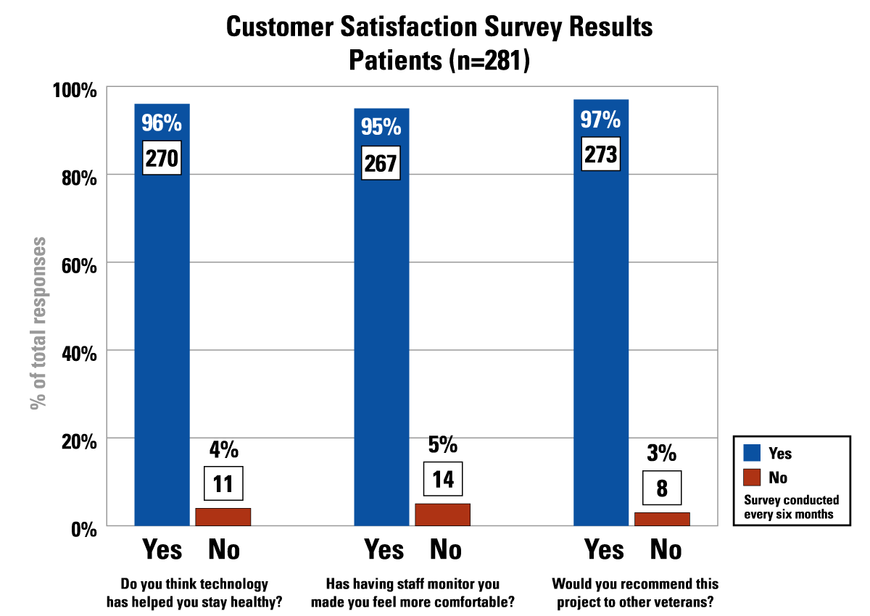

Graph above indicates: Customer Satisfaction Survey Results, Patients (n=281). Survey conducted every six months. Question: Do you think technology has helped you stay healthy? 270 respondents (96%) stated “yes”, 11 respondents (4%) stated “no”. Question: Has having staff monitor you made you feel more comfortable? 267 respondents (95%) said “yes”, while 14 (5%) said “no”. Question: Would you recommend this project o other veterans? 273 respondents(97%) replied “yes”, while 8 respondents (3%) indicated “no”.
Figure 3 Provider Satisfaction

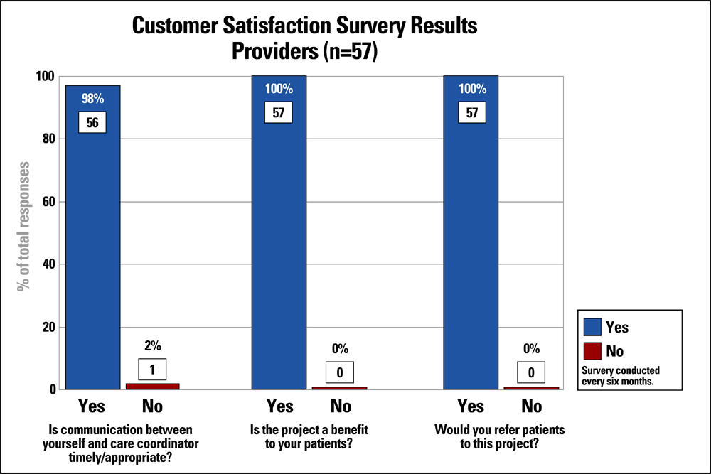

Graph above indicates: Customer Satisfaction Survey Results, Providers (n=57). Survey conducted every six months. Question: Is communication between yourself and care coordinator time/appropriate? 56 respondents (98%) indicated “yes”, 1 (2%) indicated “no”. Question: Is the project a benefit to your patients? All 57 (100%) of the respondents indicated “yes”. Question: Would upi refer patients to this project? 57 respondents (100%) indicated “yes”.

Figure 4 SF 36V Results at Baseline and 12 months

Graph above indicates: Physical Function has increased from 28 to 40. Role Physical has increased from 27 to 37. Bodily Pain has not changed. General Health has increased from 47 to 49. Vitality has remain the same. Social Function has increased from 49 to 60. Role Emotional remains unchanged. Mental Health increased from 72 to 85.
Table 1 Demographics Comparison Usual Care to Rural Home Care (RHCP)

 | Avg Age | Gender | War Period | Marital Status | Race | Insurance  Coverage | Top 5  DRGs
Usual Care  N = 1120 | 70 | M  (98%) | WW II  (35%) | Married  (53%) | C  (70%) | None  (60%) | HTN  CHF  COPD  Diabetes  Atrial Fibrillation
RHCP  N = 281 | 72 | M  (98%) | WW II  (43%) | Married  (52%) | C  (65%) | None  (55%) | HTN  CHF  Diabetes  COPD  Cardiac Arrhythmias

Table 2 Resource Utilization Comparison Usual Care to Rural Home Care (RHCP)
Percentage Change (- = decrease; + = increase)

 | Admissions | BDOC | NH Admissions | NH  BDOC | ER visits | Clinic visits | Pharmacy
Usual Care  N = 1120 | +27% | +32% | +11% | +18% | +22% | +19% | +37%
RHCP  N = 281 | -60% | -68% | -81% | -94% | -66% | -4% | -59%

