Radiocommunication Study Groups | 
Source: Document 5-6/TEMP/26  Subject: WRC-11 Agenda item 1.17,  Resolution 749 (WRC-07),  Administrative Circular CA/171 | Annex 7 to  Document 5-6/53-E
 | 19 November 2008
 | English only
Annex 7 to Joint Task Group 5-6 Chairman's Report
Preliminary Draft methodologies (including interference objectives) for sharing studies between the mobile service, on the one hand, and the terrestrial broadcasting,
fixed and aeronautical radionavigation services,
on the other hand, in the band 790-862 mhz

The objective of this document is to provide methodologies for sharing studies for Regions 1 and 3 in the band 790–862 MHz between the mobile service, on the one hand, and the terrestrial broadcasting, fixed and aeronautical navigation services, on the other hand, in order to respond to the requirements of Resolution 749 (WRC-07).
It is noted that materials imported from ITU-R Reports have to be agreed by JTG 5-6.
The methodologies are provided in three Annexes, as indicated below:
Annex 1: Methodologies (including interference objectives) for sharing studies between the mobile service, on the one hand, and the terrestrial broadcasting service, on the other hand, in the band 790–862 MHz (Document Temp/16).
Annex 2: Methodologies (including interference objectives) for sharing studies between the mobile service, on the one hand, and the fixed service, on the other hand, in the band 790–862 MHz (Document Temp/17).
Annex 3: Methodologies (including interference objectives) for sharing studies between the mobile service, on the one hand, and the aeronautical radionavigation service, on the other hand, in the band 790–862 MHz (Document Temp/14).
[NOTE 1: The material contained in this document needs to be verified and if necessary made consistent with the decisions made by the JTG 5-6 (e.g. Section 6.3 of Annex 1)]
[NOTE by the Chairman JTG 5-6: Annex 4 is included following the remarks made by the SWG-2 Chairman at the JTG 5-6 plenary meeting with regard to some pending issues in the methodology. This information was not presented to and, thus, was not considered by the meeting; however, it is intended to provide further assistance to the participants in applying the methodology developed.]

Annex 1
Methodologies (including interference objectives) for sharing studies between the mobile service, on the one hand, and the terrestrial broadcasting
Service, on the other hand, in the band 790-862 MHz

Introduction
The objective of this document is to provide methodologies for sharing studies for Regions 1 and 3 in the band 790–862 MHz between BS and MS in order to respond to the requirement of Resolution 749.
This work follows from the decision of JTG 5-6 to organize its work in term of six distinct Steps. Methodologies are to be dealt with in Step 3 which reads:
“Development of methodologies (including interference objectives) for sharing studies between the mobile service, on the one hand, and the terrestrial broadcasting, fixed and aeronautical radionavigation services, on the other hand, in the band 790-862 MHz.”

2 Definitions

2.1 Protection Ratio
The Radio Regulations (RR. 1.170) define the protection ratio as “the minimum value of the wanted-to-unwanted signal ratio, usually expressed in decibels, at the receiver input, determined under specified conditions such that a specified reception quality of the wanted signal is achieved at the receiver output.”
Thus, the protection ratio reflects the ability of a receiver to discriminate the wanted signal against interfering signals. It is a function of frequency offset between the useful and interfering signals. Protection ratios are defined over a frequency range. It is usual practice to measure the protection ratios at 3 dB above the sensitivity of the receiver under test this indicates clearly when interference affects the receiver’s sensitivity.

Overloading Threshold
The receiver blocking is the effect of non co-channel strong signals, at frequencies at or beyond adjacent channels, on the receiver’s ability to detect a low-level useful signal. The blocking response of a receiver is defined as the maximum interfering signal level (in dBm) reducing the specified receiver sensitivity by a certain number of dB's (usually 3 dB).The overloading threshold (or receiver front-end overloading threshold) is the maximum interfering signal level (in dBm) where above that level, the receiver starts to lose its ability to discriminate against interfering signals at frequencies at or beyond adjacent channels Under these conditions, the deterioration in receiver performance is mostly due to the intermodulation products, generated at the receiver front-end, falling into the useful channel.

2.3 Location Probability
Location probability is the probability that within a given (small) area a field strength level is exceeded at a required percentage of points.

2.4 Coverage Area Definitions
The coverage area of a station, or a group of stations (for example in the case of a single frequency network), is the area within which the wanted field strength is equal to or exceeds the usable field strength defined for specified reception conditions. In defining the coverage area for each reception condition, a three-level approach is taken. Figure 1 sketches the different levels of coverage.
Figure 1
Different levels of coverage
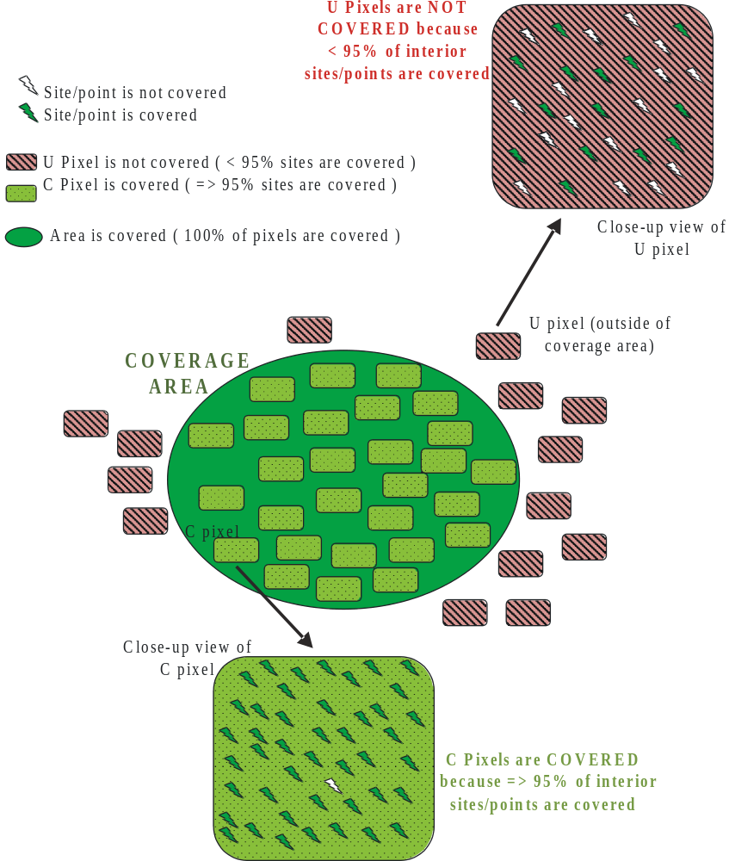

2.4.1 Receiving Location
The smallest unit is a receiving location; optimal receiving conditions will be found by moving the antenna up to 0.5 m in any direction.
A receiving location is regarded as being covered if the level of the wanted signal is high enough to overcome noise and interference for a given percentage of the time.

2.4.2 Small Area (Pixel) Coverage
The second level is a “small area” or “pixel” (typically 100 m by 100 m). In this small area the percentage of covered receiving locations is indicated. A pixel is called covered if a given percentage is reached. Typical values are 70%, 95% or 99%.

2.4.3 Coverage Area
The coverage area of a station, or a group of stations, is made up of the sum of the individual small areas in which a given percentage (e.g. 70% to 99%) of coverage is achieved. In other words, the coverage area is the set of covered pixels.

2.5 Interference Probability
Report ITU-R SM.2028-1 refers to “probability of interference” as “the probability that reception capability of the receiver under consideration is impaired by the presence of an interferer”.
Based on that concept interference probability (or probability of interference) will refer here generally to the additional probability of reception impairment that a new source of interference may introduce at reception locations. It is generally assumed that the interfering source is located outside the coverage area.

2.6 Coverage Area Loss
Coverage area loss describes the loss of covered area if an additional interfering source is added. The coverage area loss represents the percentage of lost area relative to the originally covered area. An interference probability can be mapped into a corresponding coverage area loss.

2.7 Coverage Holes
A coverage hole is an area within an existing broadcast coverage area which is no longer covered due to the introduction of a new interference source (such as mobile uplink or downlink transmitters). An area is no longer covered when, due to the introduction of an additional source of interference, the reception location probability within that area no longer reaches (or exceeds) 95%, the limit used within the GE06 Plan for defining DVB broadcast coverage.

3 Systems and Networks Parameters
This section may need to include material from the output developed by SWG1 of JTG5-6.

3.1 Digital Terrestrial Broadcasting

3.1.1 DVB-T

3.1.1.1 Location probabilities
For fixed reception, a location probability of 95% shall be used.
For portable indoor and outdoor reception, a location probability of 95% shall be used.
For mobile reception of DVB-T, a location probability of 95% shall be used.

3.1.1.2 Protection Ratios
To be defined using the output of SWG1 of JTG 5/6 on Broadcasting characteristics, including Protection Ratios.

3.1.2 DVB-H

3.1.2.1 Protection Ratios

3.1.3 ISDB-T

3.1.3.1 Protection Ratios

3.1.4 ATSC

3.1.4.1 Protection Ratios

3.1.5 China DTV

3.1.5.1 Protection Ratios

3.1.6 DVB-T2

3.1.6.1 Protection Ratios

3.2 Analogue Television

3.2.1 Protection Ratios

3.3 Mobile Service

3.3.1 Protection Ratios

4 Reference Compatibility Scenarios

4.1 Digital Terrestrial Broadcasting

4.1.1 DVB-T

4.1.1.1 Reference Study Parameters
Values of representative broadcast parameters are provided for fixed reception in Table 4.1, and for mobile/portable outdoor reception in Table 4.2, and for portable indoor reception in Table 4.3. [NOTE – the values in square brackets are to be confirmed as reference values by the JGT 5-6]
Table 4.1
Fixed reception broadcast parameters1 | ERP (kW) | [0.1, 1, 10, 100]
2 | Operational Frequency (MHz) | [470-862]
3 | Reference frequency | 790 MHz
4 | Transmit antenna height (m) | [75, 150, 300]
5 | Transmit antenna pattern | [Omni-directional or see Figure]
6 | Receive antenna height (m) | [10]
7 | Receive antenna gain (dBd) | [12]
8 | Polarisation | [V, H]
9 | Receive antenna feeder loss (dB) | [5]
10 | Receive antenna pattern | [Rec. ITU-R BT.419-3; see Fig.1]
11 | Median coverage-edge field strength at [10] m (dBV/m) | [58]
12 | E_{min}: Minimum equivalent field strength at reception place (this is the minimum value needed at the antenna input, and thus includes rx antenna gain) | [49]
13 | Location probability (%) | [95]
14 | Building penetration loss (dB) | [0]
15 | Building penetration loss standard deviation (dB) | [0]
16 | Environment | [Urban, suburban, rural]
17 | Coverage radius (km) | [Determined by #s 1, 2, 4, 10, 11, ]
Note that polarisation discrimination can be taken into account, where applicable, with a combined discrimination value of [16] dB for all angles of azimuth.
Table 4.2
Mobile and portable outdoor reception broadcast parameters
1 | ERP (kW) | [0.1, 1, 10, 100]
2 | Operational Frequency (MHz) | [470-862]
3 | Reference frequency | 790 MHz
4 | Transmit antenna height (m) | [75, 150, 300]
5 | Transmit antenna pattern | [Omni-directional or see Figure]
6 | Receive antenna height (m) | [1.5]
7 | Receive antenna gain (dBd) | [0]
8 | Receive antenna feeder loss (dB) | [0]
9 | Receive antenna pattern | [Omni-directional]
10 | Median coverage-edge field strength at [10] m (dBV/m) | [81]
11 | Median coverage-edge field strength at [1.5] m (dBV/m) | [63]
12 | E_{min}: Minimum equivalent field strength at reception place (this is the minimum value needed at the antenna input, and thus includes rx antenna gain) | [54]
13 | Height loss (dB) for use with GE06 | [18 dB]
14 | Location probability (%) | [95]
15 | Building penetration loss (dB) | [0]
16 | Building penetration loss standard deviation (dB) | [0]
17 | Environment | [urban, suburban, rural]
18 | Coverage radius (km) | [Determined by #s 1, 2, 3, 9, 10, ]
Table 4.3
Portable indoor reception broadcast parameters
1 | ERP (kW) | [0.1, 1, 10, 100]
2 | Operational Frequency (MHz) | [470-862]
3 | Reference frequency | 790 MHz
4 | Transmit antenna height (m) | [75, 150, 300]
5 | Transmit antenna pattern | [Omni-directional or see Figure]
6 | Receive antenna height (m) | [1.5]
7 | Receive antenna gain (dBd) | [0]
8 | Receive antenna feeder loss (dB) | [0]
9 | Receive antenna pattern | [Omni-directional]
10 | Median coverage-edge field strength at [10] m (dBV/m) | [91]
11 | Median coverage-edge field strength at [1.5] m (dBV/m) | [73]= 91 -18
12 | E_{min}: Minimum equivalent field strength at reception place (this is the minimum value needed at the antenna input, and thus includes rx antenna gain) | [52]
13 | Location probability (%) | [90, 95]
14 | Building penetration loss (dB) | [8]
15 | Building penetration loss standard deviation (dB) | [5.5]
16 | Environment | [Urban, suburban, rural]
17 | Coverage radius (km) | [Determined by #s 1, 2, 3, 9, 10,11, 12]
Note that the reference building penetration loss, where applicable, is taken to be [8] dB with a [5.5] dB standard deviation.

Reference antenna patterns for broadcasting

4.1.1.2.1 Transmit antenna
The reference broadcast transmit antenna is omni-directional for a ‘central’ transmitter, or has [-6/-12] dB attenuation beyond 120°[, with a sharp cut-off] for a ‘vertex’ transmitter in an SFN; see the Figure.
Figure 4.1
Transmit antenna pattern for broadcast
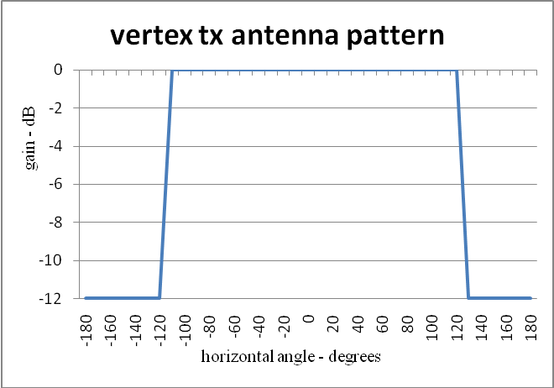

4.1.1.2.2 Receive antenna
Reference receive antenna for portable and mobile reception are omni-directional. The reference fixed receiving antenna pattern is given in the following Figure (for Band V):
Figure 4.2
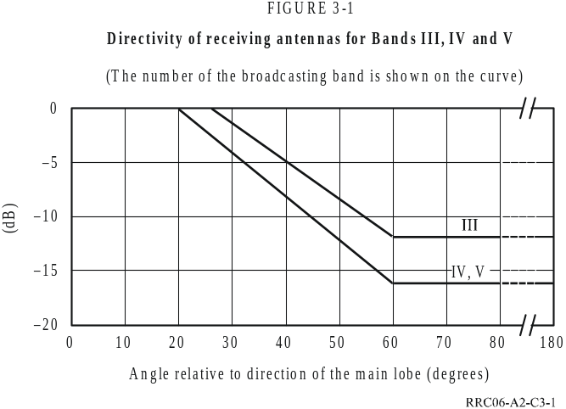Broadcast Receive Antenna Characteristics (Rec. ITU-R BT.419-3)

The curves in Figure 4.2 are valid for signals of vertical or horizontal polarization, when both the wanted and the unwanted signals have the same polarization.

Polarisation
Broadcast transmissions may use horizontal, vertical, or mixed polarisation. Fixed reception may be with horizontal or vertical polarisation.
In the case of orthogonal polarization the combined discrimination provided by directivity and orthogonality cannot be calculated by adding together the separate discrimination values. A combined discrimination value of [16] dB is to be applied for all angles of azimuth.

Network topology (Reference network configurations)
The simplest broadcast reference configuration consists of a single broadcast transmitter: this gives rise to a circular coverage area (CA) of radius ‘r’. Various reference coverage areas (effective antenna heights, ERPs, etc.) are:
Table 4.4
Network parameters for different broadcast reference network configurations
Coverage | ERP | h_{tx} | Reception/h_{rx} | E_{ref} | r
CA₁ | [] | [] | F/10 m | [] | []
CA₂ | [] | [] | M&PO/1.5 m | [] | []
CA₃ | [] | [] | PI/1.5 m | [] | []
CA₄ | [] | [] | … | [] | []

Single frequency networks (SFNs) may also be considered. They have stuctures as shown in the Figures below. The distances d between transmitters, and the network diameters D depend on the reference parameters used, e.g. effective antenna height, ERP, antenna patterns, median field strength, etc. Single frequency networks can be configured as open (O) or closed (C) networks reflecting the usage of omni-directional antenas at the periphery of the networks or antennas directed towards the centre of the coverag area, respectively.
Table 4.5
Network parameters for open and closed networks
Network | ERP | h_{tx} | Pattern | E_{ref}/h_{rx} | d/D
O₆ | [] | [] | ND | []/[] | []
C₆ | [] | [] | ND/[-12 dB] | []/[] | []
O₃ | [] | [] | ND | []/[] | []
C₃ | [] | [] | ND/[-6 dB] | []/[] | []

Figure 4.3  Open hexagonal network, 6 transmitters: O₆ | Figure 4.4  Closed hexagonal network, 6 transmitters: C₆
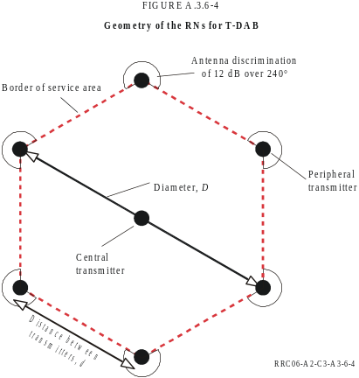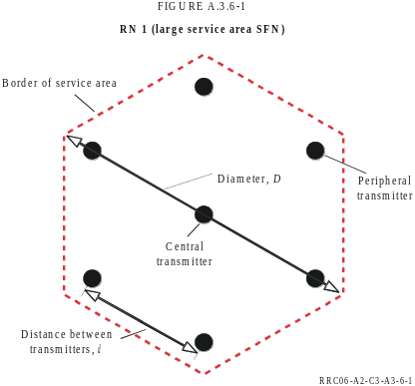

Figure 4.5  Open hexagonal network, 3 transmitters: O₃ | Figure 4.6  Closed hexagonal network, 3 transmitters: C₃
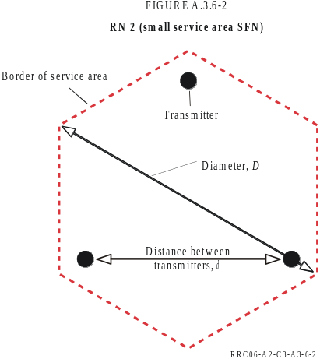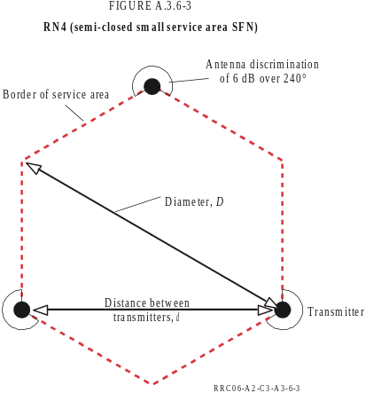

4.1.2 DVB-H

4.1.3 ISDB-T

4.1.4 ATSC

4.1.5 China DTV

4.1.6 DVB-T2

4.1.7 Analogue Television

Mobile Service

Reference Parameters
Values of representative mobile base station (downlink) parameters are provided in Table 4.6; corresponding values for mobile reception (uplink) are given in Table 4.7.
[NOTE: ACLR/ACS parameters should be provided as well, and standard UMTS (CDMA and LTE) channel configurations and characteristics need to be reviewed and confirmed. Furthermore, information is needed about the so-called activity factor of handheld which corresponds to a temporal statistic.]
Table 4.6
Base station (downlink) parameters
1 | EIRP (dBm) | [35, 43, 50]
2 | Frequency (MHz) | [790-862]
3 | Transmit/receive antenna height (m) | [30, 50, 100]
4 | Transmit/receive antenna gain (dBi) | [15]
5 | Transmit/receive antenna feeder loss (dB) | [3]
6 | Transmit/receive horizontal antenna pattern | [Omnidirectional or tri-sector, see Figure x]
7 | Transmit/receive vertical antenna pattern | [Rec. ITU-R F.1336-1 or see Figure below]
8 | Transmit/receive antenna downward tilt (°) | [3]
9 | Polarisation | [V, H, M]
10 | Receive sensitivity (dBm) | [-122]
11 | Effective receive sensitivity (dBm) | [= #10 – #4 + #5]
12 | Noise floor (dBm) | [-103]
13 | Allowed noise rise (dB) | [6]
14 | Location probability (%) | [90, 95]
15 | Building penetration loss (dB) | [0]
16 | Building penetration loss standard deviation (dB) | [10]
17 | Environment | [urban, suburban, rural]
18 | Cell radius (km) | [Determined by #s 1, 2, ]
Table 4.7
Mobile station (uplink) parameters
1 | Maximum EIRP (dBm) | [21 - 24]
2 | Frequency (MHz) | [790-862]
3 | Transmit/receive antenna height (m) | [1.5]
4 | Transmit/receive antenna gain (dBi) | [-6]
5 | Transmit/receive antenna feeder loss (dB) | [0]
6 | Transmit/receive horizontal antenna pattern | [Omni-directional]
7 | Transmit/receive vertical antenna pattern | [Omni-directional]
8 | Body loss (dB) | [3-9]
9 | Receive sensitivity (dBm) | [-117]
10 | Effective receive sensitivity (dBm) | [= #9 – #4 + #5 + #8]
11 | Power control algorithm | See section 4.2.1.1
12 | Power control dynamic range (dB) | [70]
13 | Location probability (%) | [90, 95]
14 | Building penetration loss (dB) | [15]
15 | Building penetration loss standard deviation (dB) | [10]
16 | Environment | [urban, suburban]

[NOTE: mobile community is invited to provide the correct structure of the tables above as well as proposals for the values of the parameters → SWG1 ???]

Power Control Algorithms
The following power control equation can be used for simulations:
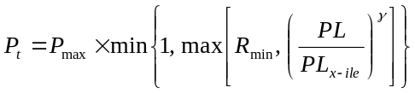 (4.1)
where P_{max} is the maximum transmit power, R_{min} is the minimum power reduction ratio to prevent UEs with good channels to transmit at very low power level, PL is the path loss for the UE and PL_{x-ile} is the x-percentile path loss value. With this power control equation, the x percent of UEs that have the highest pathloss will transmit at P_{max}. Finally, 0 < γ <= 1 is the balancing factor for UEs with bad channel and UEs with good channel.
The parameter sets for power control are specified in table 4.8.
Table 4.8
Power control algorithm parameter
Parameter set | Gamma | PLx-ile (E-UTRA and 3.84 Mcps TDD UTRA) |  |  |  | PLx-ile (LTE)
Parameter set | Gamma | 20 MHz bandwidth | 15 MHz bandwidth | 10 MHz bandwidth | 5 MHz bandwidth | 10 MHz bandwidth | 5 MHz bandwidth
Set 1 | 1 | 109 | 110 | 112 | 115 | 112 | 115
Set 2 | 0.8 | TBD | TBD | 129 | 133 | 129 | 133
For LTE, P_{max} = 24 dBm, R_{min} = -54 dB if UE minimum power is -30 dBm (or R_{min} = -64 dB if UE minimum power is -40 dBm).
[NOTE: The information in this section might need to be revised at a later stage. The algorithm above has been used when deriving information that was submitted to be included in this methodology document.]

Antenna Related Parameters

Base Station Antenna Patterns (transmit and receive)
The base station transmit and receive antenna is assumed to have a directional, tri-sector, character. The effective antenna gain taken here is [12 = 15 - 3] dB.

Horizontal Pattern
The horizontal pattern (for transmission and reception) is taken to be:
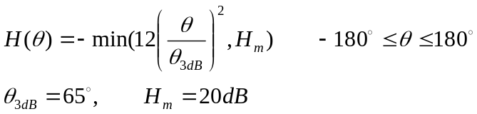 (4.2)
This pattern is displayed in the Figure 4.7.
Figure 4.7
Horizontal receive antenna radiation pattern: H()
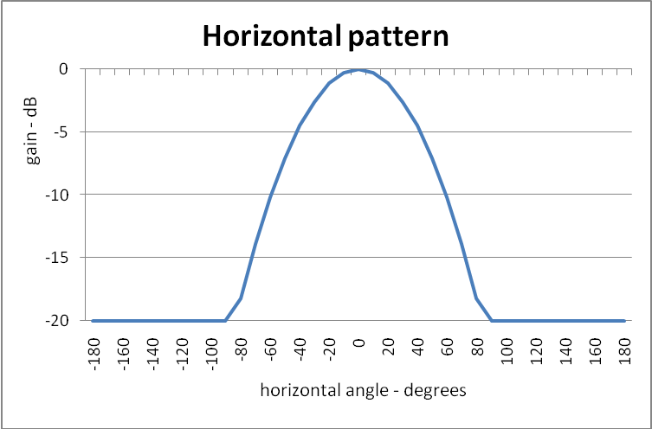

Vertical Pattern
The vertical pattern (for transmission and reception) is taken to be:
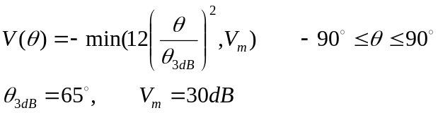 (4.3)
This pattern is displayed in the Figure 4.8.
Figure 4.8
Vertical receive antenna radiation pattern: V()
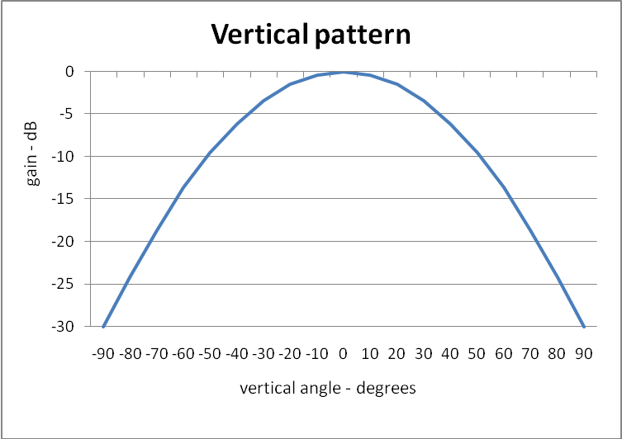

Polarisation
Mobile base station antennas may have horizontal, vertical or mixed polarisation. Polarisation of mobile handsets will not be taken into account.

Network Topology (Reference Cellular Network Configurations)

Single Cell
Figure 4.9
Single cell configuration
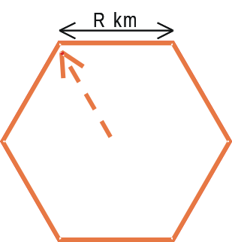

Tri-sector mobile cell structure
In a tri-sector mobile network structure (see Figure 4.10), base stations serve 3 contiguous hexagonal cells with three directional antennas; their respective antenna patterns are given above in Figures 4.7 and 4.8.
Figure 4.10
Tri-sector cell Configuration
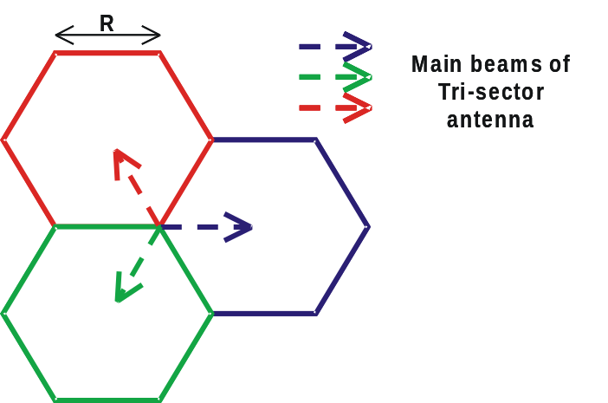

Within a larger grouping of cells the base stations are situated as in the following Figure 4.11:
Figure 4.11
Extended tri-sector cell configuration

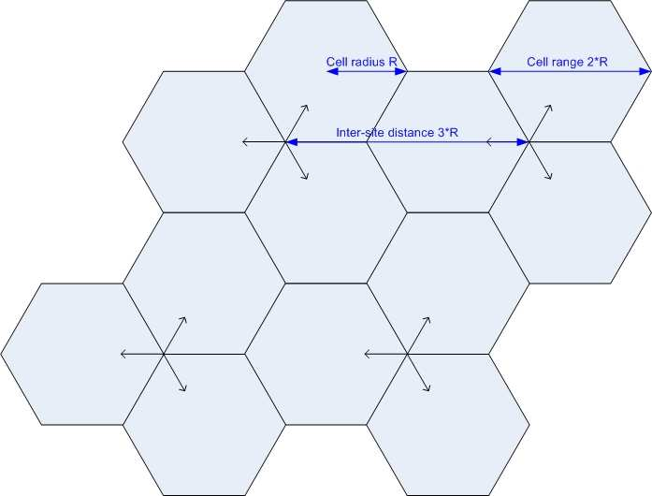

Basic network
The basic network unit used is a cluster of 19 cells, see Figure 4.12.
Figure 4.12
The basic mobile reference network unit, a cluster of 19 cells

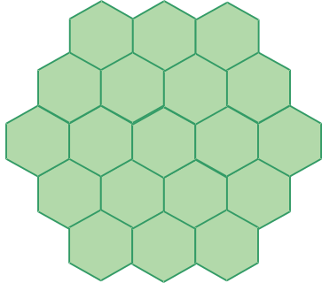

There are N_{U} active users per cell, giving 19N_{U} active users per cluster. The active users are randomly distributed throughout the cluster of 19 cells. This cluster is then ‘mirrored’ onto a surrounding layer of identical clusters, see Figure 4.13.
Figure 4.13
The basic mobile reference network unit, a cluster of 19 cells
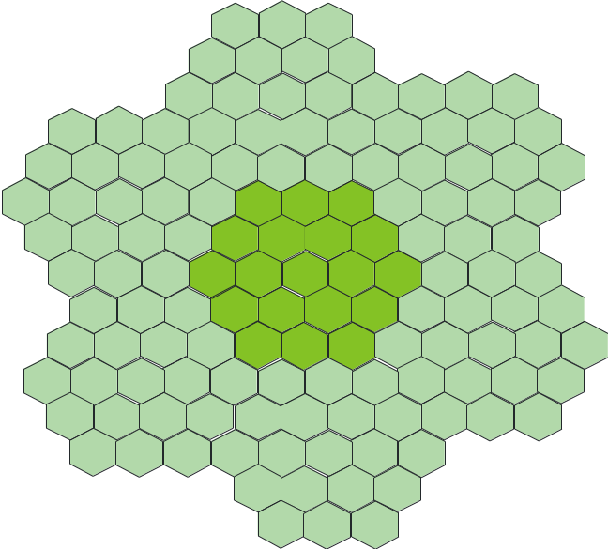

Network parameters
Table 4.9
Mobile network parameters
Cell | EIRP (dBm) |  | h_{eff} (m) |  | Active users/cell | R
Cell | up | down | up | down | Active users/cell | R
S | [21] | [] | [1.5] | [30] | [] | [0.5]
M | [21] | [] | [1.5] | [30] | [] | [1.0]
L | [24] | [] | [1.5] | [30] | [] | [5.0]
VL | [24] | [] | [1.5] | [30] | [] | [10.0]

[NOTE: S (small), M (medium), L (large) VL (very large), some text is missing, the same for R]

5 Compatibility Assessment

5.1 Propagation Model
There’s a need for a propagation model that may cover distances from few meters to distances up to the coverage radius, and beyond, of broadcasting high power transmitters.
There are common, or at least agreed, models within the telecom (Hata model) and broadcasting (Rec. ITU R P-1546-3) communities but each community has its own propagation tool; this fact is due to the specificity of the intended coverages which are also different. In order to conduct sharing studies which have to be agreed by both parties, an amalgamation of those models is proposed here.
The propagation model is based on a set of reference parameters, and a prescription (‘algorithm’) for propagation predictions based on an application of the Hata model for short distances (0 km to 0.1 km), the Rec. ITU-R P.1546-3 for long distances (1.0 km to 1 000 km), and a means to interpolate between the predictions at 0.1 km and those at 1.0 km.
A set of ‘reference’ values for transmitter and receiver antenna height and reference frequencies is presented in Appendix A.1. The ‘algorithm’ for propagation predictions is presented in section Appendix A.2.
The proposed method addresses the reciprocity of the predictions; the predictions of the Hata model are generally reciprocal with respect to designations of the transmitting/base station and the receiver/mobile station terminal while Rec. ITU-R P.1546-3 does not follow the reciprocity principle.

5.2 Field Strength Aggregation Methods

5.2.1 Analytic Methods

Field Strength Aggregation by Means of the Power Sum Method
The power sum is the logarithmic value of the sum of the individual field E_{i} strengths expressed as arithmetic powers:
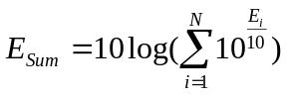 (5.1)
where E_{i} represents the individual field strengths in dBμV/m.

5.2.2 Statistical Methods

Field Strength Aggregation by Means of Monte-Carlo-Simulation
The Monte Carlo Technique is a statistical technique that functions by considering many independent instants in time. For each instant, or simulation trial, a scenario is built up using a number of different random variables. The random variables will be mainly the positions of the uplinks in the system, the channels and services required by the users. If a sufficient number of trials are considered then the probability of a certain event occurring (such as for example the probability that a user is interfered) can be calculated with a high level of accuracy.

5.2.3 Mixed Methods

Field Strength Aggregation by Means of the Log-Normal-Method
The log-normal method is an approximation method for the statistical computation of the sum distribution of several log-normally distributed variables. The method uses analytical formulas and is based on the assumption that the resulting sum distributions of the wanted and unwanted fields are also log-normal. To some extent, the LNM is able to cope with different standard deviations of the single field distributions.

5.3 Overall calculation procedures

Basics
Broadcast coverage area is defined in section 2.4. This definition includes, implicitly, a reception location probability of the wanted signal. In the presence of a potential interference source, the location probability of the interference must also be taken into account. The location probability value usually used for planning DVB is taken to be 95%; an area with a reception location probability less than 95% is considered to be not covered.
The concept of location probability introduces a statistical element into the compatibility calculations: simple deterministic calculations can be carried out, but these need to include statistical (‘random’) considerations. Broadcast reception is possible at a point where the wanted signal field strength is sufficiently large compared to the combined interfering signals (including noise). To ensure reception throughout a small area (i.e., coverage of that small area), the required difference between the wanted field strength and the interferences must be achieved (or exceeded) for at least 95% of the locations within that small area.
An example of possible calculations is the following. The calculation of the location probability of broadcast coverage of a certain small area may be, say, 98 % or more in the presence of a given set of interferers. When an additional interferer is introduced, this coverage location probability may drop to, say, 96 %.
The statistics can be treated in at least two manners, either by using a Monte Carlo approach where the parameter probability distributions are used to determine random ‘simulations’ (representing reception ‘events’), or by using probabilistic formulas in an analytic (‘deterministic’) approach. The analytic approach is described in section 5.2.1, and the Monte Carlo approach is described in section 5.2.2.

Analytic/deterministic method/approach

General overview
An analytic/deterministic approach to doing calculations involving statistical distributions is described in the following.
In compatibility calculations, the wanted and interfering field strengths are statistical values varying around a median value (usually this is taken as a ‘log-normal’ distribution, involving a 5.5 dB standard deviation location variation). Because broadcast coverage is determined in terms of a location probability these probability distributions must be taken into account.
The location probability distribution for the field strength is taken to be ‘log-normal’ and follows the following formula:
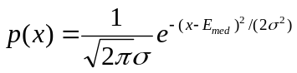. (5.2)
“p(x)” is the probability density for the field strength x (dBV/m), where E_{med} is the median value, and  is the standard deviation of the field strength distribution.
Then the field strength that can be expected to be exceeded for P% of the location can be expressed by
E(P%) = Emed – (P%)•, (5.3)
where (P%) is the probability factor for P% location probability. This can be represented pictorially as follows, for a 95% and for a 99% location probability:
Figure 5.1
Location Probability Density
(95% field strength level as a function of Emed)
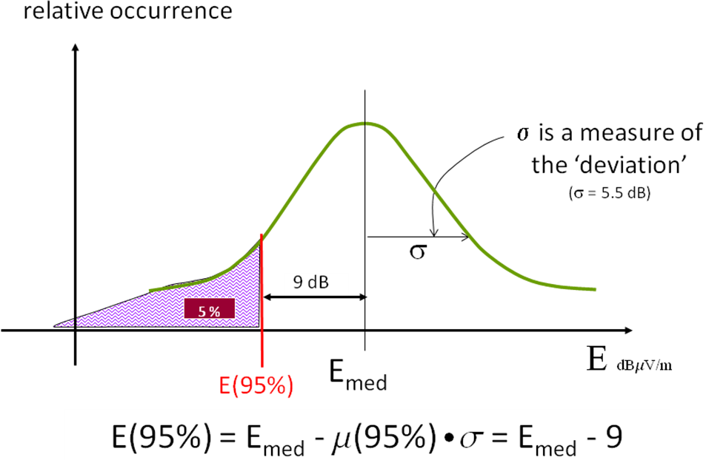

figure 5.2
Location Probability Density
(99% field strength level as a function of Emed)
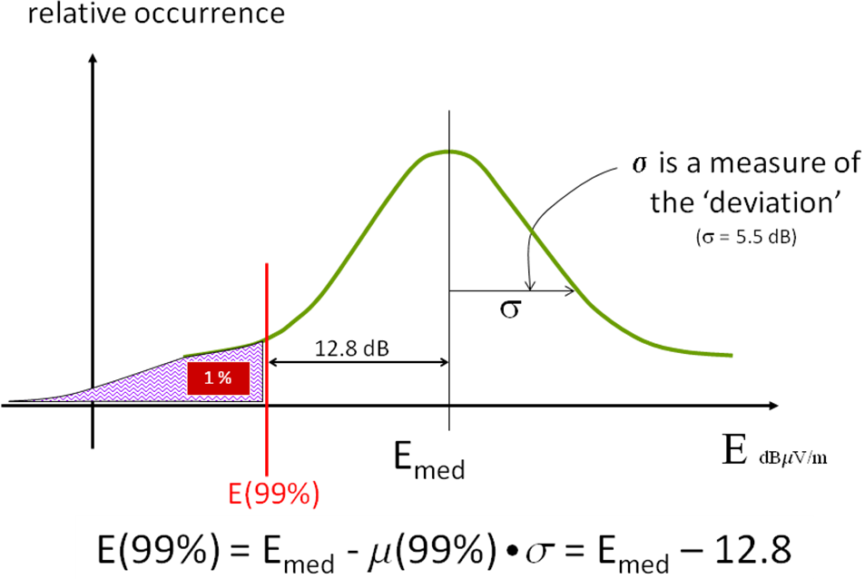

For example, (95%) = 1.64, (99%) = 2.33 which means that if E_{med} = 50 dBV/m, then
E(95%) = Emed - (95%)• = 50 – 1.64•5.5 = 41.0 dBV/m, (5.4)
E(99%) = E_{med} - (99%)• = 50 – 2.33•5.5 = 37.2 dBV/m. (5.5)
In other words, if the median field strength is 50 dBV/m, a field strength of 41.0 dBV/m will be met or exceeded at 95% of the nearby locations, and a field strength of 37.2 dBV/m will be met or exceeded at 99% of the nearby locations.
Because the predicted field strength follows a log-normal type of distribution with respect to location probability, the dB difference between two fields can also be described as above for a single field:
[E_{W} – E_{I}](P%) = (E_{Wmed} – E_{Imed}) – (P%)•(_{W}² + _{I}²)^{1/2}. (5.6)
Unfortunately the probability distribution of the power is not log-normal, so the power sum of two fields does not follow such a simple rule. For example, if two wanted signals in an SFN are power summed (or two interfering fields are power summed) the resultant power also deviates from a log-normal behaviour, the mean value of the composite signal is larger than the arithmetic sum of the individual means, and the standard deviation of the resultant is less than that of the original. This means that for very accurate deterministic power sum calculations more complex methods are required. A simple approximation for power summing may be to assume that the resultant median is equal to the sum of the medians (i.e., is smaller than it really is and therefore ‘optimistic’), and the standard deviation remains the same (i.e. is larger than it really is and therefore ‘pessimistic’); the two effects may tend to cancel each other a bit.
In the case of potential interference coming from two or more co-sited mobile base stations, the interfering signals could be considered to be 100% correlated, and then the resultant median would in fact be the sum of the medians, and the standard deviation would remain unchanged.

Wanted signal and noise only
In the simplest case, with no interfering sources present, the wanted signal, E_{W}, at a reception point must equal or exceed the minimum field strength (that field strength which exceeds the noise level by the relevant C/N ratio), E_{Wmin}:
E_{w} ≥ E_{Wmin}. (5.7)
In order that an area can be considered as covered, the wanted field strength must exceed E_{Wmin} at 95 % of the locations within the area, and this will be achieved when the median wanted field strength, E_{Wmed}, within the area has the value:
E_{Wmed} = E_{Wmin} + (95%)• (5.8)
where (95%) is the statistical distribution factor (for 95% of the locations) and  is the location standard deviation of the wanted field strength. This can be represented pictorially as follows:
figure 5.3
Location Probability Density
(Emed as a function of Emin to ensure 95% location probability)
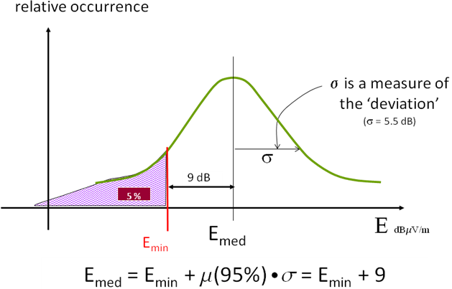

For example, this means that if E_{min} = 45 dBV/m, E_{med} = 45 + 9 = 54 dBV/m. In this case, if a median field strength of 54 dBV/m is achieved in a given small area, then the minimum field strength E_{min} = 45 dBV/m will be achieved (or exceeded) at 95% of the locations within that small area.
5.3.2.2 Wanted signal and one interferer
In the next simplest case, with one interfering source E_{I}, the wanted signal, E_{W}, at a reception point must equal or exceed the interfering field strength by the relevant protection ratio, PR:
E_{w} ≥ E_{I} + PR. (5.9)
Once again, to ensure protection within the small covered area (i.e. at 95 % of the locations), the median wanted field strength (E_{Wmed}) must exceed the median interfering field strength (E_{Imed}) as in the following expression:
E_{Wmed} ≥ E_{Imed} + PR + (95%)•(_{W}² + _{I}²) (5.10)
The last term in the preceding expression is the location correction factor, which takes into account the statistical location variations of both the wanted and interfering signals (i.e., _{W} and _{I}).

Wanted signal and one (or more) interferer plus noise
When dealing with more than one source of interference in a given calculation, it is useful to introduce and use the concept of ‘nuisance field’.
The noise nuisance field, E_{noise} is simply the value of E_{Wmin}: N_{noise} = E_{Wmin}. Note that the standard deviation of the noise nuisance field is _{N} = 0 dB (because the noise is assumed to have a constant, i.e., non-varying, value).
The i^{th} nuisance field, N_{Ii}, of any given interferer, I_{i}, is: N_{Ii} = E_{Iimed} + PR_{i}, where E_{Iimed} is the median interfering field strength of the i^{th} interferer, and PR_{i} is the relevant protection ratio for the wanted signal with respect to the i^{th} interferer.
Two approaches are possible if noise and one interferer are to be protected against: either
– protect against noise and the interferer individually
E_{Wmed} ≥ N_{noise}, and also
E_{Wmed} ≥ N_{I1} + (95%)•(_{W}² + _{I1}²)
– protect against noise and the interferer collectively
E_{Wmed} ≥ (N_{I1}  N_{noise}) + (95%)•(_{W}² + _{I1}²)
where “” represents the power sum of the interferer and noise nuisance fields.
A similar treatment can be followed with n interfering sources (n > 1):
– protect against noise and the interferers individually
E_{Wmed} ≥ N_{noise},
E_{Wmed} ≥ N_{Ii} + (95%)•(_{W}² + _{Ii}²), i = 1, 2, …, n
– protect against combined noise and interferers individually
E_{Wmed} ≥ (N_{Ii}  N_{noise}) + (95%)•(_{W}² + _{Ii}²), i = 1, 2, …, n.
As mentioned before, it is difficult to treat a cumulative power sum of interfering effects for two or more (non co-sited) interferers using the ‘easy’ log-normal statistics.

Treatment of overload threshold
If, at any given reception point, any given interfering field strength exceeds the overload threshold, O_{th}, the above calculations become more complicated. See Figure 5.1.
In general, for an interfering signal, I_{U}, which is not too high, the maximum interfering signal I_{Umax}, for any given wanted signal level, C_{W}, is:
I_{Umax} = C_{W} + PR. (5.11)
That is, I_{U} ≤ I_{Umax} to avoid interference. See Cases 1 and 2 in Figure 5.1.
Figure 5.1
Different interference cases
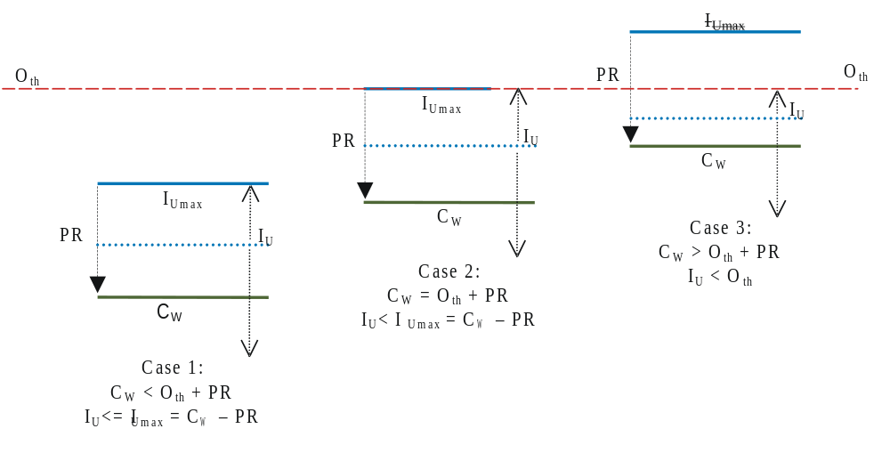

However, when the resulting value of I_{Umax} is larger than O_{th}, the actual maximum interfering field strength is O_{th} < I_{Umax}, and therefore I_{U} < O_{th}. See Case 3 in Figure 5.1.
Thus, the treatment described in the above section must be modified in cases where the interfering signal(s) reaches very high values.
The overload threshold may vary with frequency offset. So for a given wanted signal, each ‘adjacent channel’ (N  m_{i}, m_{i} ≥ 1) may have its ‘own’ corresponding protection ratio, PR_{i}. At least two calculations must be made for each interfering signal:
E_{Wmed} ≥ N_{Ii} + (95%)•(_{W}² + _{Ii}²) (the usual protection condition) (5.12)
E_{Iimed} < O_{thi} – (95%)•(_{W}² + _{Ii}²) (the overload protection condition). (5.13)
The second indent implies that the overload condition should not occur with more than a 5 % location probability.
If we define an ‘overload nuisance field’ as:
N_{Othi} = O_{thi} + PR (5.14)
then the second condition is equivalent to
N_{Iimed} < N_{Othi} – (95%)•(_{W}² + _{Ii}²), (5.15)
i.e. the median i^{th} nuisance field must be less than the i^{th} ‘overload nuisance field’ with a 95 % location probability.
If desired, the cumulative effects in the case of ‘normal’ (i.e., not too large) interfering fields, can still be considered using an approximate power sum approach (if the sources are not co-sited), or without approximation (if the sources are co-sited), as before. Whether the ‘overload nuisance fields’ should be power summed to provide a cumulative interference effect must still be investigated with measurements.

Monte Carlo method/approach

General overview
A Monte Carlo method can be used to solve a complicated problem with many variables (represented by a suitable ‘model’) by generating appropriate random numbers representing the ‘model’ parameters. Each set of randomly chosen parameter values is called a ‘simulation’. Results are obtained by observing that fraction of the numbers obeying some property or properties calculated throughout a large number of ‘simulations’. I.e., a calculation using a Monte Carlo method/approach is based on the overall results of a large number of individual analytic/deterministic calculations performed during each ‘simulation’.The method is useful for obtaining numerical solutions to problems which are too complicated to solve analytically. Two common properties of Monte Carlo methods are:
– the computation's reliance on good random numbers to reflect the probabilistic nature of the problem,
– its slow convergence to a better approximation as more data points are sampled
The basis of each individual analytic calculation is chosen randomly according to some distribution (e.g., uniform, log-normal, etc) of the parameters involved in the model being studied. As there is no single Monte Carlo method/approach, it is necessary to specify precisely the approach to be followed for the purposes of the JTG 5-6 compatibility studies.
The Monte Carlo method may be considered as following a set of ‘steps’.
– In the first step, the ‘domain’ of possible inputs must be established. For example, when calculating compatibility of a mobile base station (or uplink) interfering with broadcast reception, the mobile base station (or uplink) may be located inside the broadcast coverage area.
– In the second step, within this ‘domain’ the relative position of the mobile base station (or uplink) within the broadcast coverage area can be selected among many possibilities, ranging from ‘close to’ to ‘far from’ the broadcast transmitter. In the case of the mobile uplink, the position of the uplink interferer can also be treated as a random variable, sited relative to the corresponding base station.
– In the third step, for each relative positioning of wanted and interfering transmitter(s), there are many points of reception/interference to be considered within the intended coverage area: points close to (or far from) the interferer, close to (or far from) the wanted transmitter, etc; these can be randomly chosen (in a uniform manner, for example). At each selected reception/interference point, the wanted broadcast field strength and the base station interfering field strength may have a very large number of possible different values, corresponding to the location probability distribution of the propagation prediction model. In the case of the mobile uplink, the uplink EIRP may be determined statistically, as a function of its distance to its base station, and the corresponding interfering field strength calculated statistically based on that value of EIRP and the relative position of the uplink and the broadcast reception point. For specific wanted signal and interfering signal(s) at a given point, an analytic determination can be made as to whether reception is possible or not.
– In a fourth step, when many such determinations are made for many points, the aggregate results of these individual computations can yield an end result for the particular configuration of wanted transmitter site relative to the interfering transmitter site(s).
Thus a Monte Carlo approach follows a particular pattern:
– Define a domain of possible inputs.
– Generate inputs randomly from the domain, and perform a deterministic computation on them.
– Aggregate the results of the individual computations into the final result.
It may be said that some of the statistical analytic formulas used in a deterministic approach are ‘replaced by’ the probabilistic distribution of points, field strength values, etc, used in each deterministic calculation of a Monte Carlo approach. The needed analytic calculations for various interference situations are listed below.

Wanted signal and noise only
At a given point, a median wanted field strength (E_{Wmed}) and a median interfering field strength (E_{Imed}) are provided by the propagation prediction method (according to the relevant parameters). To obtain a value of wanted field strength, E_{W}, or interfering field strength, E_{I}, at a given point in a particular simulation, it is necessary to use a randomising process, related to the statistics of the propagation prediction method, to obtain the relevant distribution of field strength. Thus a specific value for the deviation (_{W} or _{I}) of the (wanted or interfering) field strength from the corresponding median field strength (E_{Wmed} or E_{Imed}) for each particular simulation must be determined. In this way, a value of E_{W} is found as E_{W} = E_{Wmed} + _{W}, and E_{I} is found as E_{I} = E_{Imed} + _{I}, at any given point in any given simulation.
To determine whether a small area is covered in the presence of a wanted signal and a noise interference only, a sampling of the wanted field strength at a large number of uniformly distributed points within the small area is calculated. The wanted field strength, E_{W}, is a function of the distance between the wanted transmitter and the point in question, as well as of the various parameters (e.g. transmitter antenna height, ERP, receiver antenna height, etc); it is also a statistically distributed variable at each point.
For reception at any given point, the wanted signal, E_{W}, at a reception point must equal or exceed the minimum field strength (that field strength which exceeds the noise level by the relevant C/N ratio), E_{Wmin}:
E_{w} ≥ E_{Wmin}. (5.16)
In order that the small area can be considered as covered, the wanted field strength, E_{W}, must exceed E_{Wmin} at 95 % of the points (locations) within that area. The number of points within the small area where E_{w} ≥ E_{Wmin} divided by the total number of points considered gives a reception location probability for the small area: a value ≥ 95 % means that the small area is covered.
It is seen that the statistics of the result (covered or not covered), depend on the statistics of the input (the wanted field strength in this case).

Wanted signal and one interferer
In the next simplest case, with one interfering source I₁, the wanted signal, E_{W}, and the interfering signal, E_{I1}, must be determined at the reception point. For acceptable reception, E_{W}, the wanted field strength, must equal or exceed E_{I1}, the interfering field strength, at that point by the relevant protection ratio, PR₁:
E_{w} ≥ E_{I1} + PR₁. (5.17)
The wanted (E_{W}) and interfering (E_{I1}) field strength, values are again determined, as before, from the propagation model, using the appropriate parameters, including the median field strength prediction and the statistical location probability distribution.
In order that the small area can be considered as covered, the wanted field strength, E_{W}, must equal or exceed E_{I1} + PR₁ at 95 % of the points (locations) within that area. The number of points within the small area where E_{w} ≥ E_{I1} + PR₁, divided by the total number of points considered gives a reception location probability for the small area: a value ≥ 95 % means that the small area is covered.
It is seen that the statistics of the result (covered or not covered), depend on the statistics of the input (the wanted field strength and the interfering field strength in this case).

Wanted signal and one (or more) interferer plus noise
When dealing with more than one source of interference (I_{i}, i = 1,. 2, …, n) in a given calculation, it is useful to introduce and use the concept of ‘nuisance field’.
The noise nuisance field, E_{Nnoise} is simply the value of E_{Wmin}: N_{noise} = E_{Wmin}. Note that the standard deviation of the noise nuisance field is _{N} = 0 dB (because the noise is assumed to have a constant, i.e., non-varying, value).
The i^{th} nuisance field, N_{Ii}, of any given interferer, I_{i}, is: N_{Ii} = E_{Ii} + PR_{i}, where E_{Ii} is the interfering field strength of the i^{th} interferer, and PR_{i} is the relevant protection ratio for the wanted signal with respect to the i^{th} interferer.
The wanted (E_{W}) and interfering (E_{Ii}) field strength, values are again determined, as before, from the propagation model, using the appropriate parameters, including the median field strength prediction and the statistical location probability distribution. The corresponding nuisance fields can be determined: N_{Ii} = E_{Ii} + PR_{i}.
Two approaches are possible if noise and one interferer are to be protected against. Either
– protect against noise and the interferer individually
E_{W} ≥ N_{noise}, and also
E_{W} ≥ N_{I1} or
– protect against noise and the interferer collectively
E_{W} ≥ N_{I1}  N_{noise}
where “” represents the power sum of the interferer and noise nuisance fields.
A similar treatment can be followed with n interfering sources (n > 1):
– protect against noise and the interferers individually
E_{W} ≥ N_{noise},
E_{W} ≥ N_{Ii}, i = 1, …, n
– protect against noise and also against the cumulative effects of the interfering sources
E_{W} ≥ N_{noise},
E_{W} ≥ N_{I1}  N_{I2}  …  N_{In}.
– protect against noise and the interferers collectively
E_{W} ≥ N_{I1}  N_{I2}  …  N_{In}  N_{noise}.
By using the Monte Carlo approach, it is possible to use power summing of several interfering signals without introducing the problems associated with a pure analytic approach. This is because the statistics are built into the selection of the points, field strengths, etc., after which the analytic (non-statistical) calculations are carried out.
Note that it is assumed that there is no correlation between the wanted and interfering signals.
In order that the small area can be considered as covered, the wanted field strength, E_{W}, must satisfy whichever set of the above conditions at 95 % of the points (locations) within that area. The number of points within the small area where the conditions are met divided by the total number of points considered gives a reception location probability for the small area: a value ≥ 95 % means that the small area is covered.
It is seen that the statistics of the result (covered or not covered), depend on the statistics of the input (the wanted field strength and the interfering field strength(s) in this case).

5.3.3.5 Treatment of overload threshold
If, at any given reception point, any given interfering field strength exceeds the overload threshold, O_{th}, the above calculations become more complicated as discussed in section 5.3.2.4.Thus, the treatment described in the above section must be modified in cases where the interfering signal(s) reaches very high values, although they still might be within the normal protection ratio range of the wanted signal (i.e., E_{W} > E_{I} + PR).
The overload threshold may vary with frequency offset. So for a given wanted signal, each ‘adjacent channel’ (N  m_{i}, m_{i} ≥ 1) may have its ‘own’ corresponding protection ratio, PR_{i}. At least two calculations must be made for each reception point to determine the wanted field strength and the interfering field strengths (or nuisance fields). The individual conditions, with respect to each interferer, for acceptable reception are:
E_{W} ≥ N_{Ii} (the usual protection condition) (5.18)
E_{Ii} < O_{thi} (the overload protection condition). (5.19)
If we define an ‘overload nuisance field’ as:
N_{Othi} = O_{thi} + PR_{i} (5.20)
then the second condition is equivalent to
N_{Ii} < N_{Othi}. (5.21)
The cumulative effects in the case of ‘normal’ (i.e., not too large) interfering fields, can still be found using a power sum approach, as before. Whether or not the ‘overload nuisance fields’ should be power summed to provide a cumulative interference effect must still be investigated and confirmed with measurements.

Calculations Scenarios
In order to carry out sharing studies between broadcasting and mobile service all relevant parameters and settings have to be specified. This defines a calculation scenario.

MFN or SFN Topology of Broadcasting Network
Digital terrestrial broadcasting networks can be deployed either in terms of MFNs or a set of transmitters is configured as a SFN. This has an impact on the number of signal contributions to be taken in to account at a given point of reception. Clearly, this is relevant both for wanted as well as for unwanted contributions. The consideration of more than one transmitter requires the use of appropriate field strength aggregation methods described above in order to evaluate their joint impact.
In practice, quite often a wanted signal is interfered by signals stemming not only from one but several networks. Therefore, an interference assessment might need to take into account several networks operated in SFN mode leading to a multitude of transmitters to be taken into account.

Network Topology of the Mobile Service

Downlink
Mobile service networks are deployed in terms of many small-sized cell (small compared to typical broadcasting coverage areas). When evaluating the interference of the downlink part of a mobile network the impact of several cells onto the broadcasting service needs to be taken into account. As in the case of a SFN structure of a broadcasting network, field strength aggregation of several signal contribution has to be properly accounted for.

Uplink
The uplink in a mobile service may be used at random times and be in operation only for limited periods of time. In addition, its position will be randomly situated within the mobile network cell.
Knowing the number of active uplinks within a cell, N, it is possible to generate a very large number of sets of N randomly chosen sites within each cell. Each set can be called an interference scenario.
The EIRP of each active uplink, within each scenario, can be calculated in a statistical manner using its position, and the positions of the surrounding base stations, the appropriate propagation model and (its statistical aspects).
The incidences and the distributions of the uplink parameters can be used to determine interference statistics, either in a Monte Carlo manner (calculating interferences for each scenario and determining cumulative statistics) or else using statistical formulas to give overall results immediately. In addition, deterministic calculations based on individual situations/circumstances can also provide useful interference information.

Frequency differences between signals
The mutual impact between broadcasting and mobile service networks crucially depends on the frequencies used by them. Usually, a distinction is made between co-channel and adjacent channel cases. Co-channel refers to a case where the spectrum ranges occupied by both networks overlap entirely or partially.
Adjacent channel usage generally refers to spectrum usage where the upper occupied band edge of one system is below (or equal to) the lower occupied band edge of the other system. The corresponding centre frequencies thus show a certain frequency offset. In terms of TV-channels, adjacent channel usage refers to both the first adjacent channels (N±1) and beyond (N±M, M>1).

Geographical Layout
Sharing of spectrum between broadcasting and mobile service is subject to the geographical layout of the corresponding coverage areas. Three cases need to be distinguished, namely non-overlapping, adjacent and overlapping areas. In the first case interferers are always located outside the coverage area to be protected, while in the last case some interfering transmitters are located inside the protected area.

Protection Ratios and Overloading Thresholds
In the presence of interfering signals the ratio between the wanted signal and the sum of all interfering components must exceed the protection ratio for the interaction of services at hand in order to allow proper reception. If this protection ratio is not reached degradation of the service quality is the consequence. Furthermore, very strong interfering signals lead to overloading of the receiver front end.
At the victim receiver input, for a given frequency offset between useful and interfering signals
– the protection ratio applies unless the interfering signal level is higher than the receiver overloading threshold; or
– if the interfering signal level exceeds the overloading threshold, the receiver is considered interfered with by the interfering signal whatever is the protection ratio.

6 Method for Sharing Studies
Sharing studies between the broadcasting and the mobile service have to treat one service as the interfering service and the other as the interfered-with service in one scenario, and vice-versa in another scenario. In any case, the decision whether a service is interfered by the other has to be based on the network planning methodologies of the interfered service.

Compatibility Analysis
Based on the input data described in the previous section a macro algorithm for compatibility analysis is proposed below. The different calculations (propagation, field strength sums, protection ratio, networks and UE topologies) are considered defined before.
In addition, we consider that there is no transition state between the linear (constant protection ratio) and the non-linear (overloading) behaviour of the receiver. An alternative could be identifying the transition state and adding an additional margin to the protection ratio when the interfering signal level reaches this state.
Depending on the type of calculation to be carried out, for each point of the coverage area of the wanted system the following quantities need to be calculated and analyzed:
– Calculation of the cumulative wanted field strength of the wanted system Ew_c
If the wanted signal results from a single transmitter E_{w_c} = E_{w}; in an SFN, E_{w_c} is calculated as the ‘sum’ of the contributions of the individual transmitters in the network (as described in section 5.3).
– Calculation of the cumulative interfering field strength of the intra-service interferer Ei_intra
In the case of the broadcasting service, the individual interferences are due to other co-channel broadcast transmissions, and E_{i_intra} is calculated as the ‘sum’ of these individual contributions (as described in section 5.3).
– Calculation of the cumulative interfering field strength inter-service interferers for each frequency offset: Ei_extra
In the case of the broadcasting service, the inter-service interferences are due to other co-channel or non co-channel non-broadcast transmissions, and E_{i_intra} is calculated as the ‘sum’ of these individual contributions (as described in section 5.3). The calculations must take proper account of the different values of the protection ratios (as a function of frequency offset, for example) and/or overload thresholds, using the concept of nuisance field.
– Calculation of the probability P( Ew_c > Ei_intra) that the cumulative wanted signal is larger than the cumulative intra-service interference level, and the probability P( E_{w_c} > E_{i_extra}) that the cumulative wanted signal is larger than the cumulative inter-service interference level.
In some cases, it may be easier to assume a given level of location probability in a given small area, i.e. assuming a median wanted signal and a median level of initial interference (Ei_intra). The additional calculation with Ei_extra can be done in more detail, with the ‘addition’ of the interferences (Ei-extra and or noise) (to the extent possible).
As the calculations are carried out inside the broadcasting coverage area, P( Ew_c > Ei_intra) is higher than the location probability, 95% for DVB-T for example. If ( Ei_extra > Overloading_threshold) : blocking; Reception is blocked if this condition is met at any given frequency offset. Blocking as a function of location probability is also indicated in section 5.3.2.4 and 5.3.3.4.
Else
Calculation of the probability P( Ew_c > (Ei_intra+Ei_extra) ) taking into account the relevant protection ratio.
From the calculation, we can identify the reduction of the coverage area due to both phenomena (interference and blocking).

Reference Calculations

Broadcasting
Using the broadcast reference parameters and network configurations, the median wanted field strength can be calculated at any given point within the coverage area, and the median interfering field strength can be calculated at any given point within the interfered-with service area. The basic parameters used are the ERP, transmitter antenna height, receiver antenna height, antenna patterns and polarisation discrimination (if any), building penetration loss (if relevant), field strength height loss (if relevant), path distance, etc.
The statistical nature of the propagation predictions will be taken into account for the determination of the location probability. DVB should be protected for an overall [95] % location probability
Interfering signals will be combined using one of the methods described in sections 5.2 above; wanted signals in an SFN will also be using one of the methods described in sections 5.2 above.

Mobile Service
(At least) two different calculation procedures must be made to determine mobile interference to broadcasting – one for the base station (downlink) and another for the mobile handsets (uplink).
– Downlink
With respect to downlink interference, the interference field strength calculations would be similar to those used to determine broadcast-caused interference (as discussed in section 5.2 above).
– Uplink
With respect to uplink interference, the situation is more complicated due to the mobility and intermittent usage of the handsets - that is, the time and place of uplink usage is random. Power control is also a complicating aspect. Using specific reference parameters, calculations could be based on worst case or ‘average’ case situations, for example. On the other hand, Monte Carlo techniques could be used if reception probabilities and coverage losses are to be determined.
Because base stations will tend to be ‘close’ together (say, of the order of 1 to 10 km apart), and the density of active handsets will be even higher, cumulative interference effects will probably need to be taken into account. This aspect will be compounded if adjacent and ‘near adjacent’ channel interference will be significant (which is yet to be determined by JTG 5-6 studies) – several mobile networks, using nearby adjacent channels, might be operating within or near any given broadcast coverage area; the cumulative interference due to each network and the combined effect of all interfering networks must be evaluated using one of the methods described in sections 5.2 above. The nuisance fields would be the method used to calculate cumulative interference.

Interaction
In general, for DVB protection, a reference median wanted field strength is to be protected at [95] % of the locations. This means, among other things, that the propagation statistics of both the wanted and interfering signals must be taken into account as well as the building penetration (see section 5.3).
E_{ref} > E_{I} + PR + μ(%) (_{W}² + _{I}² + _{BP}²) } (6.1)

Studies to be carried out
The following (additional) studies are proposed:
1) Protection of DVB-T networks in the presence of mobile networks in the same or neighbouring geographical areas. These studies should consider various DVB coverage and network structures, for various reception modes, and various mobile network sizes and structures (i.e., using the reference parameters and reference network structures).
– Protection ratios (co-channel, N1, N2, …, N9) to protect DVB from mobile uplink and downlink; with and without power control.
– Overload levels for DVB receivers
This includes the possible cumulative effects of multiple near-overloads (methods mentioned in section 5.2)
– Impact of uplink and downlink on fixed, mobile, portable (outdoor and indoor) DVB reception:
- for 1 mobile network (uplink/downlink), size and extent of coverage holes within DVB coverage area, as a function of frequency difference and proximity of DVB transmitter;
- for multiple mobile networks, size and extent of coverage holes within DVB coverage area, as a function of frequency difference and proximity of DVB transmitter;
- amount/extent of coverage area loss of DVB, as a function of frequency difference, in the presence of 1 or more mobile networks;
- mathematical treatment of cumulative interference.
Expected results for protection of DVB:
– Establishment of guard bands for uplink and downlink.
- Establishment of mobile service EIRP limits (uplink and downlink) within or near DVB-T coverage areas, as a function of frequency difference.
- Establishment of separation distances (as a function of frequency difference) between DVB and mobile services (uplink and downlink), as a function of frequency difference.
2) Protection of uplink against DVB-T in the same or neighbouring geographical areas.
TBD {A sufficient frequency separation between a DVB-T channel and an IMT-2000 uplink channel may be needed in order not to exceed the out of band blocking level of an IMT-2000 base station receiver...}
3) Protection of downlink against DVB-T in the same or neighbouring geographical areas
TBD {The frequency separation required between a DVB-T channel and an IMT-2000 downlink channel to minimize the impact on loss of capacity may need to be studied}.
Appendix A to Annex 1
Proposed prediction methodology to conduct sharing studies

[Editor’s Notes:
- The structure of the wave propagation model has been agreed, therefore any future modifications should be based on the text presented here.
- The model given here provides those elements that are needed to start sharing studies. Participants of JTG5-6 are therefore invited to use this information to carry out their studies and submit their results to the next JTG5-6.
- It is has to be noted that different climatic situations in different parts of Regions 1 and 3 need to be taken into account by the sharing studies.]

A.1 Simplifying assumptions for compatibility studies: broadcast vs. mobile uplink and downlink

A.1.1 General
Sharing studies are required for urban and/or for suburban conditions. For coverage and interference calculations, a flat land surface will be the reference; this means that the effective antenna height is the same as the height of the antenna above ground level. The reference receiver/mobile antenna height, R, as defined in Rec. ITU-R P.1546-3 is taken to be 10 m in a suburban environment, and 20 m in an urban environment. The frequencies of interest lie in the 800 MHz range, approximately; so two reference frequencies will be specified, 600 MHz and 2 000 MHz (as done in Rec. ITU-R P.1546-3), between which the relevant frequencies yet to be decided (e.g. 800 MHz, 850 MHz, …) can be found by suitable interpolation (described in section A.2). In short, the first assumptions are
– Clutter height R = 10 m (suburban area), 20 m (urban area).
– Flat surfaces are assumed for all propagation paths: all effective antenna heights are assumed to be the height of the antenna above ground level.
– Land paths only.
– Reference frequencies 600 MHz and 2 000 MHz.

A.1.2 Urban area: R = 20 m
The following reference values of the antenna height (receiver and transmitter) are representative in an urban environment:
– Mobile service transmitter antenna height: H_{TMS} = 1.5 m (handset), H_{TMS} = 20 m, 30 m (Base station)
– Mobile service receiver antenna height: H_{RMS} = 1.5 m (handset), H_{RMS} = 20 m, 30 m (Base station)
– Broadcast service transmitter antenna height: H_{TBC} = 20 m, 37.5 m, 75 m, 150 m, 300 m
– Broadcast service receiver antenna height: H_{RBC} = 1.5 m (mobile/portable), 20 m (fixed)
The following combinations of transmit and receive antenna are used as reference combinations in an urban area:
– Broadcast to broadcast:
Table A.1.1
Receiving and transmitting antenna reference parameters for R = 20 m
Receive  H_{RBC} (m) | Transmit H_{TBC} (m)
Receive  H_{RBC} (m) | 20 | 37.5 | 75 | 150 | 300
1.5
20

– Broadcast to mobile:
Table A.1.2
Receiving and transmitting antenna reference parameters for R = 20 m
Receive  H_{RMS} (m) | Transmit H_{TBC} (m)
Receive  H_{RMS} (m) | 20 | 37.5 | 75 | 150 | 300
1.5
20
30

– Mobile to mobile:
Table A.1.3
Receiving and transmitting antenna reference parameters for R = 20 m
Receive  H_{RMS} (m) | Transmit H_{TMS} (m)
Receive  H_{RMS} (m) | 1.5 | 20 | 30
1.5
20
30

– Mobile to broadcast:
Table A.1.4
Receiving and transmitting antenna reference parameters for R = 20 m
Receive  H_{RBC} (m) | Transmit H_{TMS} (m)
Receive  H_{RBC} (m) | 1.5 | 20 | 30
1.5
20

A.1.3 Suburban area: R = 10 m
The following reference values of the antenna height (receiver and transmitter) are representative in a suburban environment:
– Mobile service transmitter antenna height: H_{TMS} = 1.5 m (handset), H_{TMS} = 10, 20, 30 m (Base station)
– Mobile service receiver antenna height: H_{RMS} = 1.5 m (handset), H_{RMS} = 10, 20, 30 m (Base station)
– Broadcast service transmitter antenna height: H_{TBC} = 20 m, 37.5 m, 75 m, 150 m, 300 m
– Broadcast service receiver antenna height: H_{RBC} = 1.5 m (mobile/portable), 10 m (fixed)
The following combinations of transmit and receive antenna are used as reference combinations in a suburban area:
– Broadcast to broadcast:
Table A.1.5
Receiving and transmitting antenna reference parameters for R = 10 m
H_{RBC} (m) | H_{TBC} (m)
H_{RBC} (m) | 20 | 37.5 | 75 | 150 | 300
1.5
10

– Broadcast to mobile:
Table A.1.6
Receiving and transmitting antenna reference parameters for R = 10 m
H_{RMS} (m) | H_{TBC} (m)
H_{RMS} (m) | 20 | 37.5 | 75 | 150 | 300
1.5
20
30
– Mobile to mobile:
Table A.1.7
Receiving and transmitting antenna reference parameters for R = 10 m
H_{RMS} (m) | H_{TMS} (m)
H_{RMS} (m) | 1.5 | 20 | 30
1.5
20
30

– Mobile to broadcast:
Table A.1.8
Receiving and transmitting antenna reference parameters for R = 10 m
H_{RBC} (m) | H_{TMS} (m)
H_{RBC} (m) | 1.5 | 20 | 30
1.5
10

A.2 Propagation Prediction Algorithm
Elements of the Hata model will be used for short (i.e. ≤ 0.1 km) distance propagation predictions and elements of Rec. ITU-R P.1546-3 for long (i.e. ≥ 1 km) distances, with logarithmic interpolation connecting the two in a transition range.
Rec. ITU-R P.1546-3 provides propagation predictions in terms of ‘field strength’ as a function of distance. The Hata model provides propagation predictions in terms of ‘propagation loss’ as a function of distance. In order to be consistent with the units when using the Hata model at ‘short’ distances and Rec. ITU-R P.1546-3 at ‘large’ distances, with an interpolation between ‘short’ and ‘large’ distances, the formula for the conversion between these two parameters, field strength and propagation loss, is the following (assuming a 0 dBkW ERP for the Rec. ITU-R P.1546-3 tabulated predictions):
E(dBV/m) = 139.3 + 20 log f(MHz) – Loss (A.2.1)
To be consistent throughout this contribution, field strength values (dBV/m units) will be specified, converting from calculated propagation loss, using equation (A.1), in the cases where the Hata model is applied.
A limited set of elements, formulas, etc. of ITU-R Rep. SM.2028 (in section A.2.2) and of Rec. ITU-R P.1546-3 (in section A.2.3) build a calculation basis for propagation prediction for the purposes of the JTG 5-6 sharing studies.

A.2.1 Reciprocity

A.2.1.1 General
The predictions of the Hata model are generally reciprocal with respect to designations of the transmitting/base station and the receiver/mobile station terminal. Rec. ITU-R P.1546-3 does not follow the reciprocity principle.
Although Rec. ITU-R P.1546-3 is not reciprocal with respect to those designations, the Recommendation can still be used in a reciprocal manner as specified in Rec. ITU-R P.1546-3, and as described here, and it is proposed to use reciprocity in those few cases where it is useful, e.g. to facilitate the transition between Rec. ITU-R 1546-3 predictions at long distances and those of the Hata model at short distances.
Guided by section 1.1 of Annex 5 of Rec. ITU-R P.1546-3, three reference cases are treated.

A.2.1.1.1 Both terminal heights are ≤ R
If both terminal heights are < R (e.g., when h₁ = h₂ = 1.5 m) (for example, for a given frequency, time percentage, distance) calculate E_{1.5→1.5} from E_{10→10} using the following steps:
– calculate E_{10→10} for h_{tx} = 10 m, h_{rx} = 10 m
– add receiver height correction for h_{rx}: 10 m→1.5 m to calculate E_{10→1.5} from E_{10→10}
– use reciprocity to determine E_{1.5→10} (= E_{10→1.5})
– add receiver height correction for h_{rx}: 10 m →1.5 m to calculate E_{1.5→1.5} from E_{1.5→10}

A.2.1.1.2 Both terminals heights are ≥ R
If both terminals heights are ≥ R, then the terminal with the greatest effective height is treated as the transmitter, the other as the receiver. For example, if R = 10 m or 20 m, and the base station receiver antenna height is h_{rxBS} = 30 m, while the interfering broadcast transmitter antenna height is h_{txBC} = 20 m:
– treat the base station as the transmitter (thus h_{tx} = 30 m) and the broadcast station as the receiver (thus h_{rx} = 20 m) (but this situation will probably not occur often, except for the sharing studies).

A.2.1.1.3 Only one terminal is ≥ R
If only one terminal height is ≥ R, then that one is treated as the transmitter, the other as the receiver. For example, R = 10 m or 20 m, and the base station receiver antenna height is h_{rxBS} = 30 m, while the mobile handset transmitter antenna height is h_{txMS} = 1.5 m:
treat the base station as the transmitter (thus h_{tx} = 30 m) and the mobile handset as the receiver (thus h_{rx} = 1.5 m).

A.2.1.1.4 Further possible cases
Further possible cases where reciprocity may be needed:
Urban area: R = 20 m:
i) h_{rxBC} = 1.5 m, h_{txMS} = 1.5 m: case a)
ii) h_{rxBS} = 30 m, h_{txBC} = 20 m: case b)
iii) h_{rxBS} = 20 m or 30 m, h_{txMS} = 1.5 m: case c)
iv) h_{rxBC} = 20 m, h_{txMS} = 1.5 m: case c)
Suburban area: R = 10 m
i) h_{rxBC} = 1.5 m, h_{txMS} = 1.5 m: case a)
ii) h_{rxBS} = 20 m or 30 m, h_{txBC} = 10 m: case b)
iii) h_{rxBS} = 20 m or 30 m, h_{txMS} = 1.5 m: case c)
iv) h_{rxBC} = 10 m, h_{txMS} = 1.5 m: case c)

A.2.1.2 Reciprocity application
Because Rec. ITU-R P.1546-3 is not reciprocal, it is important to specify uniquely the sequence of the steps of the calculation procedure for distances 1 km and more.
Two environments are being investigated, urban and suburban. The parameter R is used to distinguish between an urban environment (R = 20 m) and a suburban environment (R = 10 m). Using the reference transmitter and receiver antenna heights, H_{t} and H_{r}, respectively, only the following cases need be examined:
H_{t} > R, H_{t} = R, H_{t} < R (A.2.2)
H_{r} > R, H_{r} = R, H_{r} < R. (A.2.3)
Only the following Combinations of transmitter and receiver antenna heights need be examined:
C1: (H_{t} > R, H_{r} > R); C2: (H_{t} > R, H_{r} = R); C3: (H_{t} > R, H_{r} < R) (A.2.4)
C4: (H_{t} = R, H_{r} > R); C5: (H_{t} = R, H_{r} = R); C6: (H_{t} = R, H_{r} < R) (A.2.5)
C7: (H_{t} < R, H_{r} > R); C8: (H_{t} < R, H_{r} = R); C9: (H_{t} < R, H_{r} < R). (A.2.6)
According to sections A.1.2 and A.1.3 above, the only reference antenna height possible less than R is 1.5 m.
In the following prescription/recipe, “h₁” will represent a transmitter antenna height, and “h₂” will represent a receiver antenna height. When reciprocity is invoked, these are sometimes interchanged.

A.2.1.2.1 Combinations C1, C2 and C5
Combinations C1, C2 and C5 are treated directly using the relevant Rec. ITU-R P.1546-3 tables and procedures specified in section A.2.3; cases where H_{t} = 30 m, or H_{r} = 30 m are interpolated between 20 m an 37.5 m using equation (A.2.17) below.

A.2.1.2.2 Combinations C3 and C6
Combinations C3 and C6 are treated as follows:
– H_{r} < R means H_{r} = 1.5 m;
– the field strength E_{Ht→R} for (h₁ = H_{t}, h₂ = R) is calculated directly;
– the receiving antenna height correction, CORR_{R→1.5}, for h₂ = R reduced to h₂ = H_{r} = 1.5 is calculated according to section A.3.3e below;
– the desired field strength is E_{Ht→1.5} = E_{Ht→R} + CORR_{R→1.5}.

A.2.1.2.3 Combination C4
Combination C4 is treated as follows:
– H_{t} < H_{r} means using reciprocity;
– the values for H_{t} and H_{r} are interchanged and the procedure for Combinations C1, C2, and C5 is followed.

A.2.1.2.4 Combinations C7 and C8
Combinations C7 and C8 are treated as follows:
– H_{t} < H_{r} means using reciprocity;
– H_{t} < R means H_{t} = 1.5 m;
– the values for H_{t} and H_{r} are interchanged and the procedure for Combinations C3 and C6 is followed.

A.2.1.2.5 Combination C9
Combination C9 is treated as follows:
– H_{t} < R, H_{r} < R means H_{t} = 1.5 m, H_{r} = 1.5 m;
– the field strength E_{R→R} for (h₁ = R, h₂ = R) is calculated directly;
– the receiving antenna height correction, CORR_{R→1.5}, for h₂ = R to h₂ = H_{r} = 1.5 is calculated according to section A.2.3 below;
– the field strength E_{R→1.5} for (h₁ = R, h₂ = 1.5) is calculated: E_{R→1.5} = E_{R→R} + CORR_{R→1.5};
– by reciprocity, the field strength E_{1.5→R} for (h₁ = 1.5, h₂ = R) is obtained: E_{1.5→R} = E_{R→1.5};
– the receiving antenna height correction, CORR_{R→1.5}, for h₂ = R reduced to h₂ = H_{r} = 1.5 is calculated according to section A.2.3 below;
– the desired field strength E_{1.5→1.5} for (h₁ = 1.5, h₂ = 1.5) is calculated:
E_{1.5_1.5} = E_{1.5→R} + CORR_{R→1.5}.

A.2.2 Basic Propagation loss formula from the Hata Model
The formulas for the propagation loss presented in this section are extracted from ITU-R Rep. SM.2028, for the reference conditions.

A.2.2.1 Urban environment
For distances from 0 km to 0.1 km, the Hata model is used (as prescribed in ITU-R Rep. SM.2028)

A.2.2.1.1 d ≤ 0.04 km
The loss for distances less than 0.04 km is free space loss:
L(d) = 32.4 + 20 log f + 10 log [d² + (H_{b} – H_{m})²/10⁶] (A.2.7)

A.2.2.1.2 0.04 km < d ≤ 0.1 km
For distances between 0.04 km and 0.1 km, log interpolation is used, between free space at 0.04 km and Hata at 0.1 km.
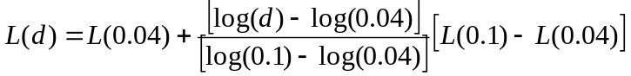 (A.2.8)

A.2.2.1.3 d = 0.1 km
For d = 0.1 km, the Hata formulas are used: H_{m} = min(h₁,h₂), H_{b} = max(h₁,h₂);  = 1
(A.2.9)
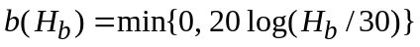 (A.2.10)
For f = 150 MHz to 1 500 MHz:
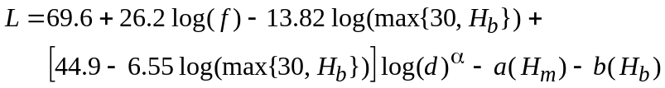 (A.2.11)
For f = 1 500 MHz to 2 000 MHz:
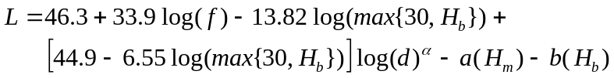 (A.2.12)
Note that both formulas, for f = 600 MHz and 2 000 MHz, respectively, are used to provide the basis for an interpolation between Hata at 0.1 km and Rec. ITU-R P.1546-3 at 1 km. For frequencies between 600 MHz and 2 000 MHz the interpolation formula, A.2.16, given in section A.2.3 b is used.

A.2.2.1.4 0.1 km < d < 1 km
For distances between 0.1 km and 1.0 km, log interpolation is used, between Hata at 0.1 km and Rec. ITU-R P.1546-3 at 1.0 km.
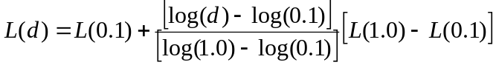 (A.2.13)

A.2.2.1.5 d = 1 km
For 1 km distances, the Rec. ITU-R P.1546-3 field strength curves/tables (for an ERP = 0 dB kW), being functions of distance, frequency, time percentage (not a significant parameter at 1 km distance), transmitter and receiver antenna heights, are used to calculate field strength. The corresponding loss can be calculated using a re-write of the equation (A.2.1):
L(d) = 139.3 + 20 log f – E₁₅₄₆₋₃(d,f,%,h_{t},h_{r}). (A.2.14)

A.2.2.2 Suburban environment
The propagation Loss in a suburban environment is related to that in an urban environment (as in section A.3.1) via the following equation, for any given frequency, f:
L_{suburban} = L_{urban} – 2{log[min(max(150,f),2000)/28]}² – 5.4 (A.2.15)

A.2.2.3 Standard deviation
Field strength values calculated for Mobile Service transmitted or received signals (i.e. base station or handset) are subject to statistical variations.
The standard deviation for these variations, for the Mobile Service signals, is taken from the Hata model as follows:
For the standard deviation (below and above roof level):
Table A.2.1
Definition of standard deviations
⬧ (below roof level) dB | ⬧ (above roof level) dB | dist km
3.5 | 3.5 | d ≤ 0.04
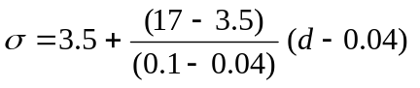 | 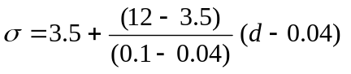 | 0.04 < d ≤ 0.1
17 | 12 | 0.1 < d ≤ 0.2
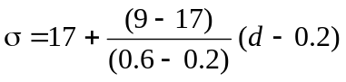 | 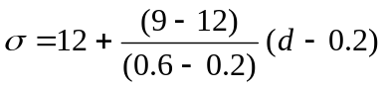 | 0.2 < d ≤ 0.6
9 | 9 | 0.6 < d

According to the Hata model, propagation “below roof” means that both Hm and Hb are below the height of the roofs (i.e. less than R); propagation is “above roof” in other cases (Hb above the height of roofs, larger than R).
In principle, when the Hata approximation is being used for distances less than (or equal to) 0.1 km, the standard deviation of 5.5 dB should be used when calculating interference to broadcast.

A.2.3 Basic field strength prediction from Rec. ITU-R P.1546-3
The parameter R takes the values 10 m for a suburban environment and 20 m for an urban environment, respectively. The numbers in the parentheses following the equations are the equation numbers as given in Annex 5 of Rec. ITU-R P.1546-3.
a) The tables of Rec. P.1546-3 are used for distances between 1 km and 1 000 km, for the frequencies 600 MHz and 2 000 MHz, land paths, relevant reference transmitter and receiver antenna heights, and time percentages.
b) For frequencies, f, between the two frequencies 600 MHz and 2 000 MHz), the following formula can be applied (eqn. 14 of section 6 of Annex 5 of Rec. ITU-R P.1546-3)
E = E₆₀₀ + ( E₂₀₀₀ – E₆₀₀ ) log( f / 600 ) / log( 2 000 / 600 ) dB(V/m), (A.2.16)
with E₆₀₀ and E₂₀₀₀ the field strength values at 600 MHz and 2 000 MHz, respectively.
c) For transmitter antenna heights between the Rec. ITU-R P.1546-3 reference heights (e.g. h_{a} = 30 m), the corresponding field strength is found by interpolating between adjacent (upper and lower, e.g. 37.5 m and 20 m, respectively) reference heights (h_{u} > h_{a} > h_{l}), using the following formula (eqn. 8 of section 4.1 of Annex 5 of Rec. ITU-R P.1546-3):
E = E_{l} + (E_{u} – E_{l} ) log( h_{a} / h_{l} ) / log( h_{u} / h_{l} ) dB(V/m) (A.2.17)
d) For distances between the Rec. ITU-R P.1546-3 reference distances (e.g., d_{a} = 22 km), the corresponding field strength is found by interpolating between adjacent (upper and lower, e.g. 25 km and 20 m, respectively) reference distances (d_{u} > d_{a} > d_{l}), using the following formula (eqn. 13 of section 5 of Annex 5 of Rec. ITU-R P.1546-3):
E = E_{l} + (E_{u} – E_{l} ) log( d_{a} / d_{l} ) / log( d_{u} / d_{l} ) dB(V/m) (A.2.18)
e) Section 9 of Annex 5 of Rec. ITU-R P.1546-3 will be used for receiver height correction:
Receiver height correction H_{rx} < R (10 or 20 m):
For example, for cases: H_{txBC}, H_{txBS} ≥ R (10 m or 20 m); h₁ = H_{txBC} = [10 m], 20, …, 300 m, or h₁ = H_{txBS} = 20, 30 m, h₂ = H_{rxBC} = 1.5 m, H_{rxBS} = 1.5 m
- calculate (eqn. 26 of section 4.1 of Annex 5 of Rec. ITU-R P.1546-3)
R′ = (1000dR – 15h₁)/(1000d – 15) m (A.2.19)
where h₁ and R (m) and distance d (km)
- calculate (eqns. 27d, 27e, 27g, 27c,27f, of section 4.1 of Annex 5 of Rec. ITU-R P.1546-3):
h_{dif} = R′ − h₂ m (A.2.20)
θ_{clut} = arctan(h_{dif} /27) degrees (A.2.21)
K_{nu} = 0.0108 f^{1/2} (A.2.22)
■ = K_{nu} ( h_{dif} θ_{clut} )^{1/2} (A.2.23)
K_{h2} = 3.2 + 6.2log ( f ) (A.2.24)
where f: frequency (MHz)
- calculate (eqn. 12a of section 4.1 of Annex 5 of Rec. ITU-R P.1546-3) :
J() = 6.9 + 20log{ [( − 0.1)² + 1]^{1/2} +  − 0.1 } (A.2.25)
iv) When the receiving/mobile antenna is in an urban environment, the correction is given by (eqn. 27a, 27b of section 4.1 of Annex 5 of Rec. ITU-R P.1546-3):
CORR_{R’≥10} = 6.03 − J () dB for h₂ < R′ (A.2.26)
CORR_{R’≥10} = K_{h2} log( h₂ / R’) dB for h₂ ≥ R’ (A.2.27)
v) If R' is less than 10 m, the correction given by equation (27a, b) should be reduced by K_{h2} log(10/R′)
CORR_{R’<10} = CORR_{R’≥10} – K_{h2} log(10/R′) dB for R’ < 10 m. (A.2.28)
f) The standard deviation for broadcast signals is taken to be  = 5.5 dB

A.3 Explicit Field strength values at 0.1 km
The Hata model as described in section 3.2 above is used here to derive field strength values at 0.1 km. Note that the free space field strength at 0.1 km is 126.9 dBV/m, which is the limiting value for the Hata model.
Values for f = 600 MHz and for 2 000 MHz are calculated to correspond to the reference frequencies of Rec. ITU-R P.1546-3.

A.3.1 Urban environment (R = 20 m)
Table A.3.1
Field strength (dBV/m) at 0.1 km for 600 MHz and R = 20 m
Tx (m) | Rx (m)
Tx (m) | 1.5 | 20 | 30
1.5 | 82.09 | 104.59 | 108.11
20 | 104.59 | 126.9 | 126.9
30 | 108.11 | 126.9 | 126.9
37.5 | 108.82 | 126.9 | 126.9
75 | 111.00 | 126.9 | 126.9
150 | 113.20 | 126.9 | 126.9
300 | 115.38 | 126.9 | 126.9
Table A.3.2
Field strength (dBV/m) at 0.1 km for 2000 MHz and R = 20 m
Tx (m) | Rx (m)
Tx (m) | 1.5 | 20 | 30
1.5 | 76.78 | 99.28 | 102.80
20 | 99.28 | 126.9 | 126.9
30 | 102.80 | 126.9 | 126.9
37.5 | 103.51 | 126.9 | 126.9
75 | 105.69 | 126.9 | 126.9
150 | 107.88 | 126.9 | 126.9
300 | 110.07 | 126.9 | 126.9

A.3.2 Suburban environment (R = 10 m)
Table A.3.3
Field strength (dBV/m) at 0.1 km for 600 MHz and R = 10 m
Tx (m) |  | Rx (m)
Tx (m) | 1.5 | 10 | 20 | 30
1.5 | 91.04 | 107.51 | 113.54 | 117.06
10 | 107.51 | 126.9 | 126.9 | 126.9
20 | 113.54 | 126.9 | 126.9 | 126.9
30 | 117.06 | 126.9 | 126.9 | 126.9
37.5 | 117.76 | 126.9 | 126.9 | 126.9
75 | 119.95 | 126.9 | 126.9 | 126.9
150 | 122.14 | 126.9 | 126.9 | 126.9
300 | 124.32 | 126.9 | 126.9 | 126.9
Table A.3.4
Field strength (dBV/m) at 0.1 km for 2000 MHz and R = 10 m
Tx (m) |  | Rx (m)
Tx (m) | 1.5 | 10 | 20 | 30
1.5 | 89.05 | 105.53 | 111.55 | 115.08
10 | 105.53 | 126.9 | 126.9 | 126.9
20 | 111.55 | 126.9 | 126.9 | 126.9
30 | 115.08 | 126.9 | 126.9 | 126.9
37.5 | 115.78 | 126.9 | 126.9 | 126.9
75 | 117.97 | 126.9 | 126.9 | 126.9
150 | 120.16 | 126.9 | 126.9 | 126.9
300 | 122.35 | 126.9 | 126.9 | 126.9

A.4 Explicit Field strength values at 1 km
The reference field strength values at 1 km are calculated using Rec. ITU-R P.1546-3 as described in section 2.3 above. The reference frequencies 600 MHz and 2 000 MHz are used. For each effective transmitter antenna height, the difference between 1%- and 50%-time field strength values is generally less than 0.1 dB at 1 km, both for 600 MHz and for 2 000 MHz frequency. Thus, only one value, valid for both 1% and 50% time, need be specified at 1 km for each pair of transmitter and receiver antenna heights.
Note that the free space field strength at 1 km is 106.9 dBV/m, which is the limiting value for Rec. ITU-R P.1546-3.
The designation “nn” is given in the tables below; this indicates that the values are not explicitly needed, but are included for completeness. The asterisks indicate those values which are derived directly by reciprocity.

A.4.1 Urban (R = 20 m)

A.4.1.1 600 MHz
Table A.4.1
Field strength (dBV/m) at 1 km for 600 MHz and R = 20 m
Tx (m) | Rx (m)
Tx (m) | 1.5 | 20 | 30
1.5 | 48.15 | 71.57 * | 73.06 *
20 | 71.57 | 94.87 | 96.29 *
30 | 73.06 | 96.29 | [99.95; nn]
37.5 | 73.88 | 97.07 | 100.79
75 | 76.76 | 99.70 | 103.68
150 | 79.94 | 102.35 | 106.87
300 | 83.30 | 104.59 | 106.9
Note that the Hata model gives 72.89 dBV/m for (h_{b} = 30 m, h_{m} = 1.5 m), 69.37 dBV/m for (h_{b} = 20 m, h_{m} = 1.5 m), and 46.87 dBV/m for (h_{b} = 1.5 m, h_{m} = 1.5 m).

A.4.1.2 2 000 MHz
Table A.4.2
Field strength (dBV/m) at 1 km for 2 000 MHz and R = 20 m
Tx (m) | Rx (m)
Tx (m) | 1.5 | 20 | 30
1.5 | 39.29 | 67.96 * | 69.41 *
20 | 67.96 | 96.51 | 97.90 *
30 | 69.41 | 97.90 | [102.14; nn]
37.5 | 70.22 | 98.66 | 102.97
75 | 72.96 | 101.15 | 105.76
150 | 75.84 | 103.51 | 106.9
300 | 78.84 | 105.32 | 106.9

Note that the Hata model gives 67.58 dBV/m for (h_{b} = 30 m, h_{m} = 1.5 m), 64.05 dBV/m for (h_{b} = 20 m, h_{m} = 1.5 m), and 41.56 dBV/m for (h_{b} = 1.5 m, h_{m} = 1.5 m).

A.4.2 Suburban (R = 10 m)
Table A.4.3
Field strength (dBV/m) at 1 km for 600 MHz and R = 10 m
Tx (m) | Rx (m)
Tx (m) | 1.5 | 10 | 20 | 30
1.5 | 58.57 | 75.69 * | 77.88 * | 79.32 *
10 | 75.69 | 92.69 | 94.87 * | 96.29 *
20 | 77.88 | 94.87 | 101.02 | 102.44 *
30 | 79.32 | 96.29 | [102.44, nn] | [106.03, nn]
37.5 | 80.11 | 97.07 | 103.22 | 106.81
75 | 82.80 | 99.70 | 105.85 | 106.9
150 | 85.60 | 102.35 | 106.9 | 106.9
300 | 88.33 | 104.59 | 106.9 | 106.9
Note that the Hata model gives 81.83 dBV/m for (h_{b} = 30 m, h_{m} = 1.5 m), 78.31 dBV/m for (h_{b} = 20 m, h_{m} = 1.5 m), 72.28 dBV/m for (h_{b} = 10 m and h_{m} = 1.5 m), and 55.81 dBV/m for (h_{b} = 1.5 m, h_{m} = 1.5 m).
Table A.4.4
Field strength (dBV/m) at 1 km for 2 000 MHz and R = 10 m
Tx (m) | Rx (m)
Tx (m) | 1.5 | 10 | 20 | 30
1.5 | 49.70 | 72.03 * | 74.30 * | 75.69 *
10 | 72.03 | 94.23 | 96.51 * | 97.90 *
20 | 74.30 | 96.51 | 103.63 | 105.02 *
30 | 75.69 | 97.90 | [105.02, nn] | [106.9, nn]
37.5 | 76.45 | 98.66 | 105.78 | 106.9
75 | 78.92 | 101.15 | 106.9 | 106.9
150 | 81.29 | 103.51 | 106.9 | 106.9
300 | 83.34 | 105.32 | 106.9 | 106.9
Note that the Hata model gives 79.85 dBV/m for (h_{b} = 30 m, h_{m} = 1.5 m), 76.33 dBV/m for (h_{b} = 20 m, h_{m} = 1.5 m), 70.31 dBV/m for (h_{b} = 10 m and h_{m} = 1.5 m), and 53.83 dBV/m for (h_{b} = 1.5 m, h_{m} = 1.5 m).
Annex 2
Methodologies (including interference objectives) for sharing studies
between the mobile service, on the one hand, and the Fixed Service,
on the other hand, in the band 790-862 MHz
[It has to be noted that there was no contribution from administrations on this issue for the second meeting of JTG5-6.]

1 Introduction
The objective of this document is to provide methodologies for sharing studies for Regions 1 and 3 in the band 790–862 MHz between FS and MS in order to respond to the requirement of Resolution 749.

2 Definitions

2.1 Interference Probability / Interference Objective

2.1.1 Fixed Service
[Step 3
A criterion of -6dB is given in Recommendation ITU-R F.1670 (see recommend 3): “that, for this case, an interference criterion I/N = –6 dB may be applied in these bands (see Note 1).”, see also Appendix A]

2.1.2 Mobile Service
[Step 3]

3 Systems Parameters

3.1 Fixed Service
[See Annex 7 to Doc. 5-6/25]

3.2 Mobile Service
[See Annex 5 to Doc. 5-6/25]

4 Methodology
[General method: Recommendation ITU-R M.1635
Protection ratio:
- GE06 sections dealing with the development of the Plan or dealing with coordination.
- Recommendation ITU-R SM.851.
Separation distances
- Recommendation ITU-R F.1402 (see Annex 2 which provides an example of calculation at 800 MHz).
- Recommendation ITU-R M.687 (see Annex 2 section 4.1).
Guard band: Recommendation ITU-R SM.851
List to be further developed…]
[For aggregated case Monte-Carlo-Simulation (see JTG 5-6 Doc. 27)]

5 Compatibility Assessment

5.1 Propagation Model
Okumura-Hata curve (Rec. ITU-R F.1402)
Rec. ITU-R P.452
Rec. ITU-R P.1546-3
Rec. ITU-R P.1812
Others…
[NOTE: The propagation model has to be aligned with the model used in other cases, i.e. Annex 1 and 3]

5.2 Calculation Methods

5.2.1 Deterministic Methods
Separation distances (Rec. ITU-R F.1402)

5.2.2 Statistical Methods
Monte Carlo: Report ITU-R SM.2028
[Editor’s note: Material extracted from ITU-R Report needs to be agree by JTG5-6]

5.2.3 Mixed Methods

5.3 Calculations Scenarios

6 Guidelines to Carry out Sharing Studies
[To be developed]

Annex
List of relevant documents (to be completed)

GE06 Agreement | Final Acts of the Regional Radiocommunication Conference for planning of the digital terrestrial broadcasting service in parts of Regions 1 and 3, in the frequency bands 174-230 MHz and 470-862 MHz (RRC-06)
Rec. ITU-R F.1402 | Frequency sharing criteria between a land mobile wireless access system and a fixed wireless access system using the same equipment type as the mobile wireless access system
Rec. ITU-R M.687 | International Mobile Telecommunications-2000 (IMT-2000).
Rec. ITU-R M.1635 | General methodology for assessing the potential for interference between IMT-2000 or systems beyond IMT-2000 and other services.
Rec. ITU-R P.452 | Prediction procedure for the evaluation of microwave interference between stations on the surface of the Earth at frequencies above about 0.7 GHz
Rec. ITU-R P.1546-3 | Method for point-to-area predictions for terrestrial services in the frequency range 30 MHz to 3 000 MHz
Rec. ITU-R P.1812 | A path-specific propagation prediction method for point-to-area terrestrial services in the VHF and UHF bands
Rec. ITU-R SM.851 | Sharing between the broadcasting service and the fixed and/or mobile services in the VHF and UHF bands
Report ITU-R SM.2028 | Monte Carlo simulation methodology for the use in sharing and compatibility studies between different radio services or systems.

[Appendix A to Annex 2
Interference criterion for Fixed Service

A.1 Table 3 in Recommendation ITU-R F-758-4
Table 3 in Recommendation ITU-R F.758-4 provides some value for the long term interference criterion corresponding to I/N of -1dB.
However, it has to be noted that the long term interference may not be consistent with the details on the characteristics given in ITU-R F.758-4 as provided below:
“A table can be constructed showing system parameters to be used when considering sharing between the FS and other services, and this should include the information discussed above.
…
The nominal long-term interference criteria specified in the Tables provide some guidance to the results that would be obtained from detailed calculations and can be used for information for the time being. However, for detailed sharing studies accurate criteria must be derived in accordance with the information in Annex 1, and these may differ slightly from those in the Table.
By referencing interference to the receiver thermal noise level the problem is greatly simplified, since the permitted interference PSD so derived will be dependent solely on receiver noise figure and independent of the modulation scheme of the victim system. It may be shown that, independent of the normal received carrier level, the degradation in fade margin with interference set to a given level relative to receiver thermal noise level is as follows:
Table A.1.1
Fade Margins

Interference level relative to receiver  thermal noise  (dB) | Resultant degradation in  fade margin  (dB)
–6 | 1
–10 | 0.5

Within the Tables, the choice of an interference to thermal noise I/N value of –6 dB or –10 dB is selected to match the typical requirements of individual systems. For detailed sharing analyses, the interference criteria must be derived in accordance with Annex 1, to match the individual, specific, sharing scenario under consideration, and will need to be agreed between the parties concerned.
… “

A.2 GE06 Threshold
For those cases where no value is available in the table, the coordination trigger field-strengths as given in the GE06 Agreement may be considered:
Table A.2.1
Coordination trigger field-strength values to protect systems of the fixed service from DVB-T
Note: Table A.2.1 may be revised for the case mobile service.
Service, system to be protected | System type code  (see Annex 2, Chapter 4) | Frequency range  (MHz) | Trigger field strength  (dB(μV/m)) | Height of the receiving antenna (m)
Fixed system FF (transportable, 1.2 MHz) | FF | 790-862 | 24⁽¹⁾ | 37.5
Fixed system FH | FH | 790-862 | 13⁽¹⁾ | 37.5
Generic fixed system FK | FK | 470-862 | See equation (A.1.2) and Table A.1.8 | 37.5
⁽¹⁾ The trigger field-strength values are related to the DVB-T bandwidth.
For the generic case (type code FK), i.e. when there is no value of protection ratio available, the following equation should be used:

(A.2.1)
where:
F: receiver noise figure of the FS station receiver (dB)
B_{i}: the bandwidth of the terrestrial broadcasting station (MHz)
G_{i}: the FS station receiver antenna gain (dBi)
L_{F}: antenna cable feeder loss (dB)
f: centre frequency of the interfering broadcasting station (MHz)
P_{o}: man-made noise (dB) (typical value is 1 dB for VHF band and 0 dB for UHF band)
I/N: interference to noise ratio, which must not exceed the threshold (margin) applicable when developing the plan (I/N = –6 dB).

Based on the information in Recommendation ITU-R F.758-4, ITU-R F.1670-1 and ITU-R SM.851-1, the following typical values of F, G_{i}, L_{F} and P_{o} to be used are provided in Table A.2.2.:
Table A.2.2
Typical values of the parameters when applying equation (A.1.2) to derive trigger field-strength values to protect the stations for the generic case (type code FK)
of the fixed service from DVB-T
Frequency (MHz) | 500 | 600
F (dB) | 5 | 5
G_{i} (dBi) | 14 | 16
L_{F} (dB) | 5 | 5
P_{o} (dB) | 0 | 0
F - G_{i} + L_{F} + P_{o} | -4 | -6

A.3 Recommendation ITU-R F.1670
Alternatively, a criterion of -6 dB is given in Recommendation ITU-R F.1670 (see recommend 3):
“that, for this case, an interference criterion I/N = –6 dB may be applied in these bands (see Note 1).”
]
Annex 3
Methodologies (including interference objectives) for sharing studies between the mobile service, on the one hand, and the Aeronautical Radionavigation Service, on the other hand, in the band 790-862 MHz

1 Introduction
The objective of this document is to provide methodologies for sharing studies for Regions 1 and 3 in the band 790–862 MHz between ARNS and MS in order to respond to the requirement of Resolution 749.

2 Definitions

2.1 Interference objective

2.1.1 Aeronautical radionavigation

Interference objectives for ARNS systems could be generally defined on the basis of Recommendation ITU-R M.1461. Recommendation provides guidance and procedures for determining the potential for interference between radars operating in the radiodetermination service and systems in other services.

3 Systems and Networks Parameters

3.1 Aeronautical radionavigation

3.1.1 Primary and secondary radars in ARNS

Output developed by SWG1 of JTG5-6 needs to be included in this section.

3.2 Mobile service
See Section 4.2 of Annex 1.

4 Compatibility Scenarios

4.1 Interference into ARNS airborne receivers
This interference scenario is shown on Figure 4.1. Its specific feature is as follows:
- the MS service area shifted at a certain distance from the point of the aircraft projection on the Earth surface.
Scenario 1 calculation results refer to distance between the boundary of the ARNS stations operation area and that of the MS stations service areas for different ERP of the MS stations and different densities of their deployment.

Figure 4.1
Scenario 1
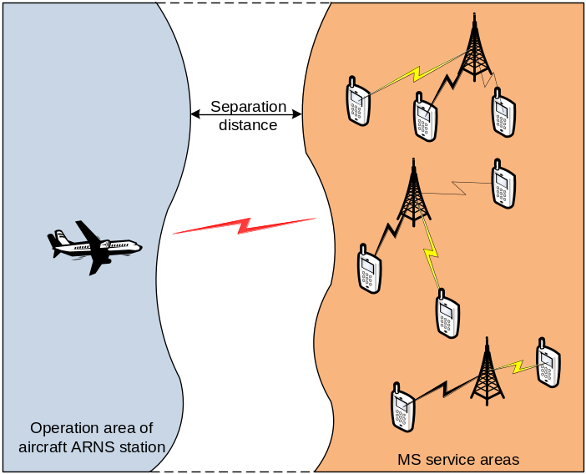

4.2 Interference into ARNS ground receivers
This interference scenario 2 is shown on Figure 4.2. Its specific features are as follows:
- the aggregate interference field strength estimation should take the Earth surface and propagation path characteristics into account. Water areas in the propagation path would result in increasing the aggregate interference field strength to be taken into consideration;
- since the ARNS ground-based receivers use directional antennas the aggregate interference field strength estimation may take into account only those MS stations which fall into the ARNS antenna main lobe.
Figure 4.2
Scenario 2
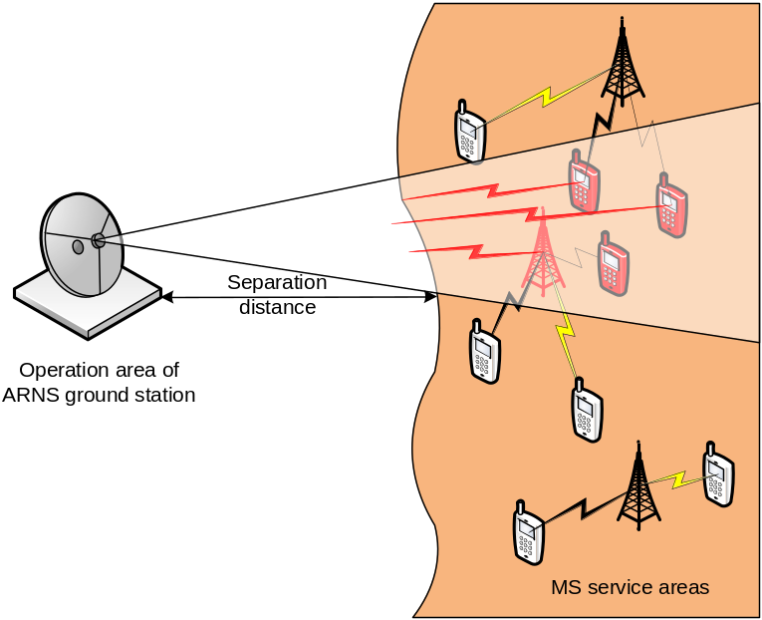

4.3 Impact from ARNS airborne transmitters

4.4 Impact from ARNS ground transmitters

5 Compatibility Assessment

5.1 Propagation Model

5.1.1 Ground-to-ground propagation
Recommendation ITU-R P.1546-3: Method for point-to-area predictions for terrestrial services in the frequency range 30 MHz to 3 000 MHz.
[NOTE: the propagation model has to be aligned with the model used in other cases, i.e. Annex 1 and 2]

5.1.2 Air-to-ground/ground-to-air propagation
Recommendation ITU-R PN.525-2: Calculation of free space attenuation.

5.2 Calculation Methods

5.2.1 Deterministic Methods
These methods are used for assessments of the values of the interference field strength in vicinity of ARNS station antenna. Abovementioned Scenarios are based on application of these methods.
Scenario 1
This scenario uses the free space propagation model for estimation of the value of the interference field strength. It permits to define the necessary protection distance between the boundary of the ARNS stations operation area and that of the MS stations service areas for different ERP of the MS stations and different densities of their deployment.
Calculation of the interference field strength needs to specify following parameters:
- aircraft height;
- airborne receiver antenna gain;
- averaging density of MS stations;
- averaging height of MS station antennas.
Interference field strength from the single mobile station is calculated by following equation:
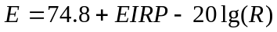; (A.5.1)
where
Е – interference field strength (dB(μV/m));
EIRP – effective isotropically radiated power (dBW);
R – distance between aircraft and mobile station in km.
Total interference field strength in vicinity of aircraft antenna Е_{sum} (dB(μV/m)) is calculated by following equation:
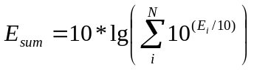 (A.5.2)
where
Е_{i} (dB(μV/m)) – interference field strength from the mobile service station with number i;
N – total number of mobile stations that are taking into account
Scenario 2
This scenario uses the propagation model from Recommendation ITU-R P.1546-3. It permits to define the necessary protection distance between the ARNS terrestrial station receiver and that of the MS stations service areas for different ERP of the MS stations and different densities of their deployment.
Calculation of the interference field strength needs to specify following parameters:
- height of ARNS ground-based station antenna;
- ground-based station antenna gain;
- beamwidth of ground-based station antenna;
- ground-based station antenna side-lobe level;
- averaging density of MS stations;
- averaging height of MS station antennas.
If Recommendation ITU-R P.1546-3 (see section 5.1.1) is to be used the interference field strength from single mobile station Е (dB(μV/m) ) is calculated for 1% or 10% of time and 50% of location.
Total interference field strength in vicinity of aircraft antenna Е_{sum} (dB(μV/m)) is calculated by following equation:
(A.5.3)
where
Е_{i} (dB(μV/m)) – interference field strength from the mobile service station with number i;
N – total number of mobile stations that are taking into account
All mobile stations that fall in the sector of the main lobe of ground-based antenna are taking into account in this calculation. In the special cases the width of this sector could be expanded. The maximum distance between ground-based ARNS station and mobile station does not exceed 1000 km.

5.2.2 Statistical Methods

5.2.3 Mixed Methods

5.3 Calculations Scenarios

6 Guidelines to Carry out Sharing Studies

6.1 Guidance to compatibility calculation for airborne ARNS stations and MS stations service
Estimations related to the abovementioned scenario 1 use the following general assumptions:
- As the ARNS air-borne antenna is omnidirectional, then the angle of the ARNS receiver antenna pattern sector where the interference effect is accounted for is 360 degrees.
- Constant terrain features in the propagation path.
- Height of the MS user terminal is constant and equals to [1.5] m with the MS base stations height of [40] m.
- Distance between the simultaneously co-frequency operating MS stations varies:
- for the user terminals between [100 m] and [2] km;
- for the base stations between [2 km] and [20] km.
5. - radius of the air-borne receiver reception area is defined by aircraft altitude and antenna height of interference sources;
6. - the area to be accounted when estimating the interference is defined by intersection of MS service area and an ARNS reception area;
7. - a free-space propagation model should be used for interference estimation.
[NOTE: the parameters given here need to be aligned with section 4.2 of Annex 1]
Table 6.1
Scenario 1 calculation results- The maximum ERP (dBW in the 4 MHz frequency band) of the terrestrial mobile service transmitters for which the interference level at the
air-borne receiver do not exceed the required protection level
Distance from the border, km | For distances between user terminals, m
 | [100] | [400] | [1000] | [1600] | [2000]
[0]
[50]
[100]
[150]
[200]
[250]
[300]
[350]
[400]
[420]
Distance from the border, km | For distances between the base stations, m
 | [5000] | [10 000] | [15 000] | [18 000] | [20 000]
0
50
100
150
200
250
300
350
400
420

6.2 Guidance to compatibility calculation for the ARNS terrestrial station receiver and that of the MS stations service areas
The Scenario 2 calculation results refer to distance between the ARNS terrestrial station receiver and that of the MS stations service areas for different ERP of the MS stations and different densities of their deployment. Considering the worst scenario when ARNS stations are located at the national boundaries, the distance indicates the required distance at which MS stations needs to be moved away from the border in order to provide the compatibility with an ARNS station.
Estimations related to the abovementioned scenarios use the following general assumptions:
1. The ARNS receiver antenna pattern sector in which interference effect is accounted for is:
- [8] degrees for the ARNS ground-based receiver.
2. Constant terrain features in the propagation path.
3. Height of the MS user terminal is constant and equals to [1.5] m with the MS base stations height of [40] m.
4. Distance between the simultaneously co-frequency operating MS stations varies:
- for the user terminals between [100] m and [2] km;
- for base stations between [2] km and [20] km.
5. EIRP of the MS user terminals varies between [0] dBm and [30] dBm and that of the MS base stations varies between [45] dBm and [65] dBm.

[NOTE: The parameters should be aligned with section 4.1 of Annex 1, furthermore the usage of units for powers need to be aligned throughout the documentation of JTG5-6 → SWG1!!!]
Table 6.2
Estimation results for Scenario 2 - The separation distance (km) for which the interference level at the ground based receiver do not exceed the required protection level
MS stations ERP, dBW |  | The distance between the MS user stations, (m)
 |  | [100] |  | [500] |  | [1 000] |  | [1 500] |  | [2 000]
[0]
[5]
[10]
 |  | The distance between the MS base stations, (m)
 | [2 000] |  | [5 000] |  | [10 000] |  | [15 000] |  | [20 000]
[15]
[20]
[25]
[30]
[35]

Annex 4
Treatment of power (ERP vs. EIRP; dBm vs. dBkW), antenna gain (dBi vs. dBd), and propagation prediction (field strength vs. propagation loss)

The broadcasting service deals with transmitter powers in terms of ERP (dBkW), antenna gain relative to a dipole (G_{d}, dBd), and propagation prediction in terms of field strength (E, dBV/m). The mobile service deals with powers in terms of EIRP (dBm), antenna gain relative to an isotropic antenna (G_{i}, dBi), and propagation prediction in terms of propagation loss (Loss, dB). In order to deal in a consistent manner with both sets of parameters in the JTG 5-6 studies, it is necessary to be clear about the connection and the conversion between the two sets of parameters/units. The sections below provide the clarification required.

1 Definition of EIRP and ERP
EIRP (‘effective isotropic radiated power’) and ERP (‘effective radiated power’) are defined as follows:
EIRP = P_{T} – L_{f} + G_{i}
ERP = P_{T} – L_{f} + G_{d}
where P_{T} is the actual transmitter output power (either dBm or dBkW), L_{f} is the feeder (cable) loss (dB), G_{i} is the isotropic antenna gain (expressed in dBi, relative to a (theoretical) isotropic reference antenna), and G_{d} is the dipole antenna gain (expressed in dBd, relative to a dipole reference antenna).

2 Conversion between dBkW and dBm units
Powers, expressed in dBkW (P_{dBkW}) and dBm (P_{dBm}), are related as follows (the subscripts indicate the units):
P_{dBkW} = P_{dBm} – 60; P_{dBm} = P_{dBkW} + 60.
3 Conversion between G_{i} and G_{d}
Isotropic antenna gain (G_{i}, dBi) and dipole antenna gain (G_{d}, dBd) are related via the antenna aperture, A_{a}, and the wavelength, , as follows:
A_{a} = G_{i} + 10 log (λ²/4π) = G_{d} + 10 log (1.64 λ²/4π)
So
G_{i} = G_{d} + 2.15; G_{d} = G_{i} – 2.15.

4 Conversion between EIRP and ERP
Absolute values of EIRP and ERP are related as follows (the subscripts indicate the units):
EIRP_{dBkW} = ERP_{dBkW} + 2.15 ; ERP_{dBkW} = EIRP_{dBkW} – 2.15
EIRP_{dBm} = ERP_{dBm} + 2.15 ; ERP_{dBm} = EIRP_{dBm} – 2.15
EIRP_{dBm} = ERP_{dBkW} + 60 + 2.15 ; ERP_{dBkW} = EIRP_{dBm} – 60 – 2.15.

5 Conversion between field strength and propagation loss
The field strength, E₁₅₄₆⁰, directly predicted by Rec. ITU-R P.1546-3, assumes a transmitter ERP = 0 dBkW; E₁₅₄₆⁰ is expressed in units of dBV/m. For an arbitrary ERP_{dBkW}, the predicted field strength, E₁₅₄₆, expressed in units of dBV/m, is
E₁₅₄₆ = E₁₅₄₆⁰ + ERP_{dBkW}
The propagation loss (‘LOSS’) predicted by the Hata model is expressed in dB (i.e., independent of transmitter power).
The relationship between predicted field strength, E₁₅₄₆⁰ (i.e., for ERP = 0 dBkW), and the predicted propagation loss, LOSS_{dB}, for a given frequency (f_{MHz}) measured in MHz, is the following:
E₁₅₄₆⁰ = 139.3 + 20 log f_{MHz} – Loss_{dB};
Loss_{dB} = 139.3 + 20 log f_{MHz} – E₁₅₄₆⁰.
For any given ERP_{dBkW}, the corresponding relationship between E₁₅₄₆ and the predicted propagation loss, for a given frequency (f_{MHz}), is the following:
E₁₅₄₆ = 139.3 + 20 log f_{MHz} – Loss_{dB} + ERP_{dBkW};
Loss_{dB} = 139.3 + 20 log f_{MHz} – E₁₅₄₆ + ERP_{dBkW}.______________

That is, for a small area to be considered as ‘covered’, acceptable reception must be guaranteed at a large percentage (e.g. 95 %) of the points within that area.
For example, the log-normal method (LNM) is an approximation method for the statistical computation of the sum distribution of several log-normally distributed variables, but is not considered necessary to be used in the context of JTG 5-6 compatibility studies.
This combined power sum ‘works’ for probability considerations, because the noise has a constant value, i.e., the location standard deviation is 0.
Note that the single interference and the noise can be power summed and still result in a log-normal distribution because the noise has standard deviation 0 dB, i.e., is constant.
Note that it is assumed that the relevant protections ratios, PR_{i}, will refer to ‘adjacent channels’ (N  m_{i}, m_{i} ≥ 1), and will thus be negative. Therefore, don’t be misled by the appearance of Figure 1: I_{Umax} = C_{W} – PR really is larger/higher than C_{W}, because PR is negative.
In order to select a given set of parameter values a ‘pseudo-random’ number generator is used, to make easy usage and repeatability. To make appropriate (i.e. ‘good’) simulations, the pseudo-random sequence must be "random enough" in the sense that the numbers are uniformly distributed or follow another desired distribution when a large enough number of elements of the sequence are considered.
10’s of thousands of data points may be necessary during each simulation, and 10’s of thousands of simulations may be needed to provide acceptable results.
The distinction between ‘close to’ and ‘far from’ is important for the JTG 5-6 compatibility studies because ‘far from’ is a far more sensitive broadcast reception region as compared to ‘close to’. For this reason, ‘small area’ investigations are necessary, in order not to camouflage local problems by a seemingly satisfactory result averaged overall.
In other words, this wanted field strength value is determined from the propagation model, including a standard deviation ‘correction’ derived from the assumed location variation statistics. The standard deviation, _{W}, is taken to be 5.5 dB for broadcast signals.
Note that the standard deviations for the wanted and interfering signals, _{W} and _{I}, may have different values.
That is. A  B  10 log₁₀ (10^{A/10} + 10^{B/10}).
It may be sufficient to consider only H_{TMS} = 30 for the mobile base station.
It may be sufficient to consider only H_{RMS} = 30 for the mobile base station.
It may be sufficient to consider only H_{TBC} = 75, 150, 300 m.
It may be sufficient to consider only H_{TMS} = 30 for the mobile base station.
It may be sufficient to consider only H_{RMS} = 30 for the mobile base station.
It may be sufficient to consider only H_{TBC} = 75, 150, 300 m.
The reference receiving/mobile antenna at a height, R (m) is representative of the height of the ground cover surrounding the receiving/mobile antenna, subject to a minimum height value of 10 m. Examples of reference heights are 20 m for an urban area, 30 m for a dense urban area and 10 m for a suburban area. For sea paths the notional value of R is 10 m.
Actually, ITU-R Report SM.2028 uses, incorrectly, the word “above” instead of the correct word “below”.
The unit ‘dBkW’ expresses power in dBs relative to 1 kW (kilowatts); the unit ‘dBm’ expresses power in dBs relative to 1 mW (milliwatts).
If the power unit ‘dBW’ (dB relative to 1 W (watts)) is also of interest, the corresponding conversions are: P_{dBkW} = P_{dBW} – 30; P_{dBm} = P_{dBW} + 30.
For convenience, the factor ‘2.15’ is rounded up from the more precise value ‘2.1484…’ (= 10 log 1.64).

