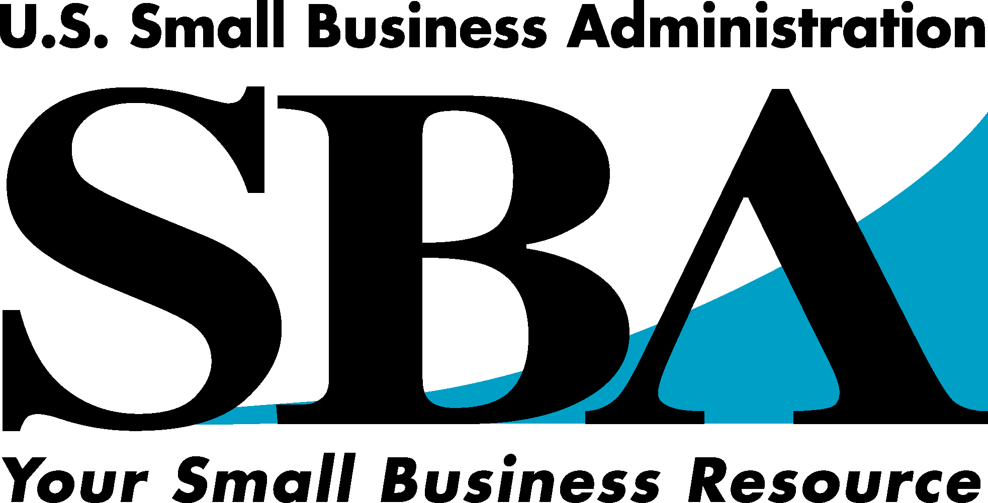

Need money to start or expand your small business?
Try the SBA’s CommunityExpress Loan Program.
SBA CommunityExpress Loan Program

The SBA recognizes that many segments of the small business community continue to have difficulty in accessing capital from traditional lending markets. These businesses are generally newer, smaller businesses that need small size loans and equity investments. They are often comprised of small businesses owned by minorities, women, and veterans and by businesses located in Low and Moderate Income urban and rural areas. The SBA developed Community Express for these businesses.

Under The Community Express Loan Program, designated lenders are authorized to make quick loans to target businesses. The SBA’s New York District Office participating lenders currently offer loans of up to $50,000.

The SBA recognizes Technical Assistance as often crucial to the success of these businesses. As a result, the Community Express program includes a specific technical assistance component. Borrowers must receive pre- and post-loan closing technical and management assistance from participating Technical Assistance providers. These TA providers work to make the applicant as attractive to participating lenders as possible.

The process begins with the identification of qualified and committed TA providers. The focus then shifts to the Community Express applicant and the TA provider’s development of a business plan (as appropriate) and an assessment of the applicant’s management and technical assistance strengths and weaknesses. Borrowers must receive pre- and post-loan closing technical and management assistance from local non-profit providers and/or from participating lenders, with that assistance coordinated, arranged and, when necessary, paid for by Community Express lenders. Community Express lenders may also consider this technical assistance as a collateral enhancement.

SBA is continually looking to add qualified TA Providers in order to improve access to the program. Those interested in applying to become a Community Express TA Provider should call 212-264-9494 to obtain an application.

Who is eligible? _________________________________________________________________
Business owners in low to moderate income areas Minorities
Women Veterans

Loan features ___________________________________________________________________
Loan amounts of $5K to $50K No or low collateral required
Quick turn around Minimal paperwork

What can loan be used for? _______________________________________________________
Purchase of equipment/machinery Working capital
Expansions Purchase of inventory, & more.

For Additional Information Please Contact any of the Approved Technical Assistance Providers Listed Below:

MARKET AREA | TA PROVIDER | Contact Name | PHONE | ADDRESS | CITY
5 Boroughs of NYC | Brooklyn Economic Development Corp. | Angel Garcia | 718-522-4600 ext. 35 | 175 Remsen St Suite 350. | Brooklyn, NY  11201
East Harlem (Community Board 11) | East Harlem Business Capital Corporation | Nelson Garcia, Jr., Executive Director | 212-427-6590 | 2261-63 First Avenue, 3rd Floor | New York, NY  10035
East Brooklyn | Women's Bus. Resource Center | Laura Sanzel, Director | 718-385-6700 ext. 18 | 80 Jamaica Ave. | Brooklyn, NY  11207
Long Island, Queens, Brooklyn, Bronx, & Manhattan | The Holley Group, Inc. | Henry Holly | 516-485-4344 | 20 Sterling Place | Hempstead, NY 11550
5 Boroughs of NYC & Westchester | Accion NY | Jennifer Spaziano | 212-387-0377 ext. 305 | 115 East 23rd Street-7th Floor | New York, NY  10010
Tri State NY Area | Chinatown Manpower Project, Inc. | Pearl Chin | 212-966-7328 ext. 23 | 125 Canal Street, Suite 302 | New York, NY  10002
Tri State NY Area | Regional Alliance for Small Contractors | Sioan Bethel | 212-268-0284 | 625 8th Ave., North Wing 2nd Floor | New York, NY  10018
Long Island & The 5 Boroughs of NYC | The Better Business Builders, LLC | James A. Nemley, CEO | 516-483-3124 | 175 Fulton Ave., Suite 211A | Hempstead, NY 11550
Bronx | Bronx Women's Business Resource Center (HPEDC) | Elisa Balabram, Director | 718-842-8888 | 866 B Hunts Point Ave. | Bronx. NY  10474
Westchester | Score #306 | Joseph Brakl, Bob Dagostino | 914-948-3907 | c/o Dept of Labor 120 Bloomingdale Road | White Plains, NY 10605
Queens | Queens Economic Development Corp. | Spencer Ferdinand | 718-263-0546 | 120-55 Queens Blvd. Suite 309 | Kew Gardens, NY 11424

MARKET AREA | TA PROVIDER | Contact Name | PHONE | ADDRESS | CITY
NY City | Score #1000 | Robert Moses | 212-264-4507 | 26 Federal Plaza, Rm 3100 | New York, NY 10278
Queens | Score #588 | Alvin Roselin | 718-263-8961 | 120-85 Queens Blvd., Rm 333 | Kew Gardens, NY 11424
Brooklyn | Score #684 | Priscilla Maddox | 718-623-7010 | 280 Cadman Plaza West | Brooklyn, NY 11201
Staten Island | Score #476 | Allan Tamarkin Eileen Sullivan | 718-727-1221 | 1550 Richmond Road c/o the Staten Island Bank & Trust | Staten Island, NY 10304
Long Island | Score #694 | Mel Springer | 631-454-0771 | 35 Pinelawn Road, Rm. 207W | Melville, NY 11747
5 Boroughs of NYC | Brooklyn (Kings County) Hispanic Chamber of Commerce | Rick Miranda | 718-788-0224 | 255 18th Street  Suite 209 | Brooklyn, NY 11215
NY City & Long Island | Isa Abdur-Rahman, Esq. | Atty. Isa Abdur-Rahman | 212-920-5221 | 90-04 161st Street Suite 308 | Jamaica, NY 11432
Bronx | Small Business Development Center | Clarence Stanley, Director | 718-960-8806 | Lehman College, Old Gym Building, Room 007, 250 Bedford Park Boulevard W | Bronx, NY 10468
Brooklyn | Small Business Development Center | Angel Roman, Director | 718-963-4112 ext. 563 | Boricua, College, 9 Graham Ave. | Brooklyn, NY 11206
Dutchess | Small Business Development Center | Al Randzin, Business Advisor | 845-339-0025 | Marist College Extension,400 Westage Business Center | Fishkill, NY 12524
Dutchess | Small Business Development Center | John Moriarity, Business Advisor | 845-454-1700 | SBDC Poughkeepsie Satellite Office, Chamber of Commerce Office, 1 Civic Plaza Center, 4th Floor | Poughkeepsie, NY 12601
Manhattan | Small Business Development Center | Ira Davidson, Director | 212-618-6655 | Pace University, 163 William St., 16th Floor | New York, NY 10038
Manhattan | Small Business Development Center | James Daley, Assistant Director | 646-312-4784 | Baruch College, 55 Lexington Ave., (E 24th St.) Suite 2140 | New York, NY 10010
Nassau | Small Business Development Center | John W. Steinhoff, Business Advisor | 516-299-2095 | C. W. Post Campus, LIU, Lorber Hall-Room 306 | Brookville, NY 11548
Nassau | Small Business Development Center | Lloyd Clark, Assistant Director | 516-564-8672 | Hempstead Outreach Center, EOC Farmingdale College, 269 Fulton Ave. | Hempstead, NY 11550
Orange | Small Business Development Center | Don Dods, Certified Business Advisor | 845-567-2702 | 33 Airport Center Drive, Rm. 201, Stewart Airport | New Windsor, NY 12553
Queens | Small Business Development Center | Alfred J. Titone, Director | 718-262-2880 | York College, 94-50 159th St., Rm. 107 | Jamaica, NY 11451
Queens | Small Business Development Center | Brian Gurski, Interim Acting Director | 718-482-5098 | La Guardia Community College, 29-10 Thompson Ave., 9th Floor, Rm. C916 | Long Island City, NY 11101
Rockland | Small Business Development Center | Jerry Kobre, Assistant Director | 845-356-6065 | Rockland Community College, 185 North Main St. | Spring Valley, NY 10977
Staten Island | Small Business Development Center | Dean Balsamini, Director | 718-982-2560 | College of Staten Island, 2800Victory Blvd., Bldg 2A, Rm. 300 | Staten Island, NY 10314
MARKET AREA | TA PROVIDER | Contact Name | PHONE | ADDRESS | CITY
Suffolk | Small Business Development Center | Edward Fritz, Director | 631-632-9070 | State University at Stony Brook, Harriman Hall, Rm. 103 | Stony Brook, NY 11794
Suffolk | Small Business Development Center | Edward Fritz, Director | 631-632-9070 | Long Island Business & Technology Center, 3500 Sunrise Highway | Great River, NY 11739
Suffolk | Small Business Development Center | Lucille Wesnofske, Director | 631-420-2765 | Farmingdale State University of NY, Campus Commons Bldg., 2350 Route 110 | Farmingdale, NY 11735
Suffolk | Small Business Development Center | Vincent Triolo, Advisor | 631-344-2393 | Brookhaven National Laboratories, Centre Street Bldg 179 B, P.O. Box 5000 | Upton, NY 11973
Sullivan | Small Business Development Center | Myriam Bouchard, Assistant Director | 845-356-6065 | Sullivan County Community College, 196 Broadway | Monticello, NY 12701
Ulster | Small Business Development Center | Arnaldo Sehwerert, Director | 845-339-0025 | Mid-Hudson SBDC, 1 Development Court | Kingston, NY 12401
Westchester  (Also Serves Putnam & Rockland Counties) | Small Business Development Center | Thomas Morley, Director | 914-375-2107 | Mercy College i-Park, 28 Wells Ave., Bldg. #3, 5th Floor | Yonkers, NY 10701
Westchester | Small Business Development Center | Thomas Morley, Director | 914-674-7485 | Mercy College Outreach Center, 555 Broadway | Dobbs Ferry, NY 10522
Westchester | Small Business Development Center | Warren Weill, Advisor | 9149482110 | Business Council of Westchester, 108 Corporate Park Drive, Suite 101 | White Plains, NY 10604
Long Island | CW United, LLC | Michael Cho | 516-610-4582 | 20 Elderberry Road | Syosset, NY  11791
The 5 Boroughs of NYC | The G-Net Group | Toxie Givens | 718-670-6714 | 167 Waverly Ave., Suite 3 | Brooklyn, NY  11205

