U.S. LHC Accelerator Research Program

LHC Commissioning Task Force Report

July 2005

Contents

- Introduction 1
  - Resources missing for the LHC commissioning 1
  - LHC commissioning organization within LARP 2
  - Benefits to the U.S. 4

- Findings 5
A. Possibilities at FNAL 5
B. Possibilities at BNL 7
C. Possibilities at LBNL 7
D. Possibilities at SLAC 8
E. Toohig fellowships 9
F. Funding U.S. participation in LHC commissioning 10
G. Schedules 10
H. Traveling and living-abroad issues 10

3. Recommendations 11

Appendices 13

- CTF organization and charge letter 13
- LARP organization chart 15
- Memo on long-term assignments to CERN (B. Jurkiw) 16
- CMS compensation and relocation guidelines 18
- Long-term assignments of green card holders (B. Jurkiw) 19
- CERN Director-General letter and DOE response 20

1. Introduction

This document summarizes work performed by the U.S. LARP (LHC Accelerator Research Program) Commissioning Task Force (CTF). The CTF was initiated by the LARP Program Leader, Dr. S. Peggs, in his letter of February 16, 2005 (see Appendix A), which presents the charge and membership of the task force. Release of this report is a response to the charge. This document is not meant to be an exhaustive plan for the LHC commissioning organization that addresses all possible details. Rather, it discusses general considerations, ideas, issues and guidelines reflecting the position of the U.S. HEP accelerator community.

Members of the CTF are from major U.S. national laboratories participating in LARP: FNAL (M. Lamm, V. Shiltsev), BNL (G. Ganetis, W. Fischer), LBNL (A. McInturff, M. Zisman), and SLAC (T. Raubenheimer). They have approached middle and top management of their respective Accelerator and Engineering/Magnet Divisions/Departments and presented and discussed LHC commissioning goals, procedures and needs. Input came both from the management and from CTF members. All issues were discussed during regular CTF video conferences, LARP collaboration meetings, and several in-person meetings at other conferences. This report contains general conclusions and recommendations that represent the consensus of the CTF members.

A. Resources Missing

The LHC commissioning task consists of two parts, a hardware commissioning (HC) task, which starts after component installation, followed by a beam commissioning (BC) task, which aims at gradually bringing the machine to its design parameters.

Hardware commissioning is scheduled to begin during calendar year 2005, with a goal of providing circulating beam in the second half of 2007. The allocated duration for this hardware commissioning is very short and involves several time- and resource-linked activities. Thus, detailed planning and coordination are essential.

The hardware commissioning planning and coordination have been organized through CERN’s Hardware Commissioning working group (HCWG), which is chaired by Roberto Saban, and includes members from the CERN AB, AT, and TS groups involved in LHC operation and commissioning. The HCWG has produced a comprehensive plan for the execution of this task. The commissioning is divided into numerous subtasks, each of which is the responsibility of a specialized commissioning team. The procedures for each subtask are spelled out in LHC project documents. Required time, personnel resources, and subtask interdependencies have been studied and discussed in various reports and presentations summarized below.

As explained in the November, 2004 “Resources for Hardware Commissioning” document, and Roberto Saban’s Chamonix XIV presentation, commissioning is organized around even-number IPs (for example sectors 7–8 and 8–1 surrounding IP8 are the first commissioning areas). The possibility to start a staggered second “even-IP front” exists, as long as work by a particular team is not required to happen in parallel in two even IPs. This November document was written in a general way so that it could be adapted to various installation and HC scenarios. Each scenario has different personnel resource requirements. For example, completing the HC task in 20 months requires 143 persons, of which 46 are missing from the present CERN staff.

Since the November 2004 report, the plan to start with the commissioning at IP8 has been refined. The new plan calls for an initial commissioning of the long straight section LSS8, including the inner triplet, followed by a 3-month shutdown, followed by a 14-month period to commission the entire LHC. Compressing the schedule to this extent, while maintaining the constraint of powering only two parallel fronts at a time (two shifts per day, 5 days per week) has been deemed possible. Although some commissioning teams have sufficient personnel resources to accommodate this compressed schedule, others will need to provide additional commissioning teams. Thus, the revised plan requires an additional 41.5 people (beyond the 46 mentioned above).

Of the additional 87.5 people required to accommodate a compressed 14-month commissioning period, approximately half of them are at the level of engineer or physicist. A detailed description of the task is outlined in the references below. The following technical expertise is needed:

- cryogenic instrumentation/process control
- quench protection
- machine interlocks
- electrical engineering for power converters
- commissioning coordination
- accelerator instrumentation controls

References:
Management Report on Resources for Hardware Commissioning, LHC Project Document LHC-PM-MR-0002 rev 1.0
“Hardware Commissioning: The resources, the programme for 2005,” Roberto Saban, Chamonix XIV 050119
“Resources for Hardware Commissioning for LHC in 14 months,” Sergio Pasinelli, Hardware Commissioning Working Group Minutes, March 17, 2005

B. Organization of Commissioning within LARP

The U.S. LHC Accelerator Research Program enables U.S. accelerator specialists to take an active and important role in the LHC accelerator during its commissioning and operations phases, and to be a major collaborator in LHC performance upgrades. In particular, LARP will support U.S. institutions in LHC commissioning activities and accelerator science, in accelerator instrumentation and diagnostics, and in superconducting magnet R&D. The goals of the LARP commissioning effort are:

- to help bring the LHC up to its design luminosity quickly
- to help establish robust operation
- to improve and upgrade LHC performance

To reach these goals, the work LARP does must be at the technological frontier, and will thereby improve the capabilities of the U.S. accelerator community in accelerator science and technology to more effectively operate our domestic accelerators, and to position us to be able to lead in the development of the next generation of high-energy colliders.

Overall LARP goals are to:

- Advance international cooperation in high-energy accelerators
- Advance high-energy physics by bringing the LHC on, and up to its design performance, quickly; by improving LHC performance through advances in accelerator understanding and instrumentation; by using the LHC as a tool to gain deeper knowledge of accelerator science and technology; and by extending the LHC as a frontier HEP instrument with a timely luminosity upgrade.
- Advance U.S. accelerator science and technology by keeping our skills sharp while helping to commission the LHC; by conducting forefront accelerator physics R&D; by advancing U.S. capabilities to improve the performance of our own machines; by preparing U.S. scientists to design next-generation colliders; and by developing technologies necessary for next-generation collider construction

LARP is the umbrella organization for U.S. HEP involvement in the LHC commissioning. It is properly funded, has an established organizational structure, and has already earned a reputation among CERN and U.S. laboratory managements.

The present LARP Organization chart is shown in Appendix B. Commissioning is currently part of the “Accelerator Physics and Commissioning” led by M. Syphers. There are several commissioning coordinators assigned (E. Harms, FNAL; A. Drees, BNL). Most of the recent activities of the Accelerator Physics and Commissioning group have concentrated on understanding schedules for the LHC commissioning, identification of key people on both sides, and preliminary recruitment of U.S. personnel.

There are several components of LARP commissioning. The Hardware Commissioning (HC) task consists of :

Interaction Region Commissioning: As presently conceived, this relatively modest and well defined Task refers to non-beam commissioning of hardware built in the U.S.-LHC Construction Program, such as interaction region magnets, and feed boxes.

Hardware Commissioning: Strong verbal support has been expressed by the DOE and U.S. lab directorates for additional hardware commissioning assistance to CERN, and for the idea that LARP is a natural vehicle through which this activity could be organized. Any additional hardware commissioning scope inside LARP would go beyond “following through on U.S.-built deliverables,” to participation, mainly by engineers, with more general commissioning. Effort required for this new activity is not included in the current LARP funding envelope.

The Beam Commissioning (BC) task consists of :

Commissioning of LARP Deliverables: This includes the commissioning and exploitation of beam instrumentation developed with LARP funds, such as luminometers, tune feedback, and phase 2 collimators. Detailed planning has not yet been carried out—in part because of uncertainties with the LHC schedule—but is becoming urgent.

Generic Beam Commissioning: This includes participation in beam startup, various beam studies, and exploitation of beam instrumentation other than that developed with LARP funds. Some 30 topics for possible U.S. contributions were listed by CERN Beam Commissioning leaders and presented at the LARP collaboration meetings in 2005.

At present (July 2005), some components (Commissioning of Deliverables and Interaction Region Commissioning) are relatively well established, and are included in the present LARP scope and budget. Generic Beam Commissioning is taking shape now and not planned in detail yet. The Hardware Commissioning is not yet well defined, nor, as noted already, is it currently within the LARP program.

C. Benefits to the U.S. HEP program

In justifying the LARP commissioning effort in support of the LHC project, it is appropriate to consider its benefits to the U.S. accelerator physics program. Clearly, there is an overall benefit to the U.S. high-energy physics program if the LHC turns on rapidly and successfully. Our experimental physics groups have invested heavily in the LHC project, and the science produced there thus represents a return on the U.S. investment. Moreover, a healthy and strong HEP activity at LHC will surely be necessary to secure future accelerator-based HEP projects in the U.S. Thus, contributing to a prompt and successful turn-on of LHC is clearly in the interests of the U.S. accelerator community and justifies involvement in the effort.

An obvious initial benefit of rapidly commissioning the LHC is that the information gained will be available in a timely manner and thus have maximum positive effect on U.S. plans for LHC upgrades. A specific example of the longer-range benefits of U.S. involvement in LHC commissioning can be found in the large 2 K cryogenics system. The International Linear Collider—potentially the next large accelerator project—will require an equivalent cryogenics system. The experience gained at LHC will give U.S. staff invaluable experience in the design, fabrication, and operation of such a system for ILC.

To take full advantage of such potential future opportunities, however, it is critical that U.S. accelerator physicists and engineers make use of this relatively rare opportunity to train younger staff members on a real—and very technically challenging—machine. This implies that we plan on “pairing” our experienced senior personnel with junior scientists who can be trained during the commissioning process. Proper placement within CERN groups and pairing our junior people with experienced CERN scientists should be beneficial as well. Such an approach will give lasting benefits to the U.S. accelerator physics and engineering communities by enhancing our pool of trained staff. If we do not take this approach, the benefits of our commissioning activity would be greatly diminished. Therefore, in this plan we assume that our effort will – when possible - include pairs of people, with the junior people likely being the longer-term visitors to CERN and the senior members making repeated, but shorter duration, visits.

2. Findings

Possibilities at FNAL

At Fermilab, people with the skills needed for LHC commissioning reside in the Accelerator Division (AD) and Technical Division (TD). Active participation in the design, development, and construction of LHC IR accelerator components puts Fermilab in a good position to support the commissioning of the LHC.

Fermilab’s AD plans for FY06–10 include support for the Tevatron Run II operation until 2009, support for the neutrino program (NuMI and MiniBOONE experiments), construction of the Superconducting Module Test Facility (SMTF), and R&D on the Proton Driver and International Linear Collider. These projects will need all the engineering resources available, and most of the physicists. Nevertheless, there is strong interest in participation in LHC commissioning at all levels: scientists and engineers consider it as a natural application of the skills and expertise gained at the Tevatron during the Run II preparation, startup and luminosity upgrade. The LARP program has been widely advertised within the AD by several enthusiasts, including John Marriner, Mike Syphers, and Elvin Harms. Several AD people are already involved in LARP activities. AD physicists—led by N. Mokhov and T. Sen—worked closely with the magnet builders and cryogenic engineers to understand the effect of the expected radiation loads on the inner triplet components. These studies estimated the radiation damage to magnet components as well as the expected heat loads on the cryogenic system. As a result of these studies, cooling channels were introduced in the magnet designs, and absorbers were placed strategically into the IR layout. Studies performed on the alignment of the inner triplet components were instrumental in defining their required mechanical alignment tolerances. A group led by R. Pasquinelli has proposed use of 4.5-GHz Schottky detectors as non-destructive LHC tune and chromaticity diagnostics. C. Y. Tan is collaborating with P. Cameron of BNL on development of the LHC phase-locked loop tune meter, developing including tests at the Tevatron. Several Tevatron operational experts and scientists participated in reviews of the LHC subsystems, including machine interlocks, collimation system, and the reference magnet system.

Many FNAL AD people ideally fit the LHC BC requirements and show great interest in visiting CERN for that purpose. The estimated total number of people interested and available for long-term visits (½–1 year) for Beam Commissioning ranges from 5–12. Indeed, more than 12 people would be interested in participating in BC activities via short (few week to few month) visits.

As for Hardware Commissioning, AD engineers are in high demand for FNAL’s own programs (Run II, ILC, and Proton Driver). Nevertheless, there are two candidates for long-term visits to CERN: one is a computer specialist from the AD/Controls Department, and the other an engineer from the AD/Cryogenics Department.

The Technical Division (TD) at Fermilab, through its history of design, construction, and testing of superconducting magnets, is in a good position to support the LHC Hardware commissioning. It is uniquely qualified to support the IR commissioning of U.S. deliverables through its contributions to the U.S. LHC accelerator project. Fermilab, with help from LBNL, designed the Q2 element cross section, and was responsible for the construction and testing of all Q2 elements. Fermilab was responsible for the design of the Inner Triplet cryogenic system as well as the bus work and instrumentation wiring. The Q1/Q3 elements from Japan (KEK/Toshiba), as well as the Fermilab Q2, were packaged into Fermilab-designed cryostats.

Most of the proposed TD Hardware Commissioning is supported through the LARP IR Hardware commissioning task. Here, participation will be supported by a combination of short term (2–3 week) and longer term (6–12 month) commissioners. In one case (Peter Limon), the support for a longer term commissioner has been accomplished outside of the IR commissioning task.

For the longer term IR commissioners, there are four candidates in the TD: Sandor Feher, Roger Rabehl, Mike Tartaglia and Peter Limon. Each person has a unique set of experiences with the commissioning of the Tevatron, the commissioning of the Fermilab superfluid test facility, or the testing of U.S. supplied LHC magnets, which could be of immediate use to the commissioning of the inner triplets. This expertise is particularly important in the compressed commissioning schedule, which does not leave much time for training.

As part of this LARP IR Commissioning task we propose to send Sandor Feher and Roger Rabehl for one year during FY05. The third person available for this program is Michael Tartaglia. Our present plan is to send Tartaglia to CERN later, schedule and funding permitting, perhaps after Rabehl or Feher have returned. We judged that having three people missing from our test facility would put a strain on our ability to carry out our responsibilities to the ILC, Proton Driver and High-Field magnet projects. The fourth person, Peter Limon, will live at CERN starting in the fall of 2005. He will be the U.S. point person at CERN during the fall hardware commissioning period.

There are perhaps 10 other TD people who could, in principle, go to CERN and who would fit one or more of the CERN profiles for hardware commissioners. However, of those 10 people, we estimate that only 3 or 4 could actually go due to family constraints.

B. Possibilities at BNL

Expertise for hardware and beam commissioning reside in the Accelerator Division of the Collider-Accelerator Department, and the Superconducting Magnet Division. Brookhaven has designed the nonlinear interaction region correction scheme for the LHC, built superconducting dipole magnets for the interaction regions, and collaborates with CERN on a number of issues including collimation, phase-locked loop tune measurements, electron cloud issues, and beam-beam issues. Collaborations based on these topics have already been fruitful to both CERN and BNL. Angelika Drees coordinates the accelerator physics activities at BNL, and Peter Cameron works on the phase-locked loop tune measurement.

There are a number of people at Brookhaven with experience in hardware and/or beam commissioning at a superconducting machine. However, the experimental program at the Relativistic Heavy Ion Collider (RHIC) is an ongoing effort, and long absences of key personnel during a RHIC run are likely to have an adverse impact on the program. The RHIC running time is typically 30 weeks per year, but run times can vary due to changes in funding. During longer shutdowns it is easier to support activities other than RHIC if funding is provided for these activities. While 1–2 people may participate in the LHC commissioning under these circumstances, a final decision can only be made year-by-year, after the budget and the RHIC operating time are known. If new junior staff can be hired with LARP funds, it is possible to have those at CERN for longer time periods. To support research in the areas of interest to both CERN and BNL, short-term visits will be useful.

C. Possibilities at LBNL

LBNL staff are already involved in the commissioning of the hardware provided as part of the LHC construction project. In particular, the cryogenic feed boxes for the LHC IRs are an LBNL responsibility. Particular activities needed include fit-up work on the first unit (already under way), commissioning planning, supervision of the installation work, and eventually participating in the commissioning of the hardware with beam. This primarily engineering task will be handled by Joseph Rasson and Jon Zbasnik, with the aid of a junior engineer yet to be identified. One possibility being explored is to take advantage of the intern program of the LBNL Engineering Division to provide a suitable junior engineer.

A second LBNL activity will be to commission the instrumentation provided as part of the LARP program, such as the bunch-by-bunch luminosity monitor. The present vision is to make the hardware functional during FY06, make the device operational with initial beam in FY07, and participate in luminosity improvements in FY08 and possibly beyond. This activity will include a mixture of physicist(s) and engineer(s), who will make multiple short trips, along with a post-doctoral physicist resident at CERN.

The third activity will be to participate in general commissioning activities, particularly focusing on electron-cloud studies, beam-beam effects, and instabilities. Miguel Furman will be the senior person in this endeavor, augmented by a resident post-doctoral physicist at CERN. A number of senior physicists have expressed interest in participating in this activity at some level, including John Byrd, Stefano De Santis, John Corlett, Mike Zisman, and possibly Sasha Zholents. It is likely that most of these people would opt for short-term visits due to personal and professional constraints. Several others have expressed an interest in longer-term visits to CERN for this purpose, including Christoph Steier and Ina Reichel.

Zisman, Zholents, Byrd, Steier, and Reichel have had considerable experience at machine commissioning at PEP-II.

D. Possibilities at SLAC

SLAC is committed to participating in the beam tests of the prototype phase II secondary collimator it will provide to CERN by early 2008. Additionally, we assume that SLAC staff will participate in any Phase I commissioning of the collimator system. Regardless of the technology choice of the Phase II collimator that is eventually installed, that proposed by SLAC or some other, SLAC plans to participate in the final collimator commissioning. Participants among the SLAC senior staff will likely include Tor Raubenheimer, Tom Markiewicz and Andrei Seryi. A still-to-be-hired postdoc should also be available for extended commissioning shifts.

Mauro Pivi of SLAC participated in e-cloud studies in 2004. It is anticipated that this effort will continue as need requires. Further participation in general beam commissioning activities is less well defined. Nonetheless, it is anticipated that SLAC will contribute to the commissioning effort at the level of 1-2 FTEs per year; topics of particular interest include collective effects, non-linear dynamics and beam instrumentation.

Summary:

Lab | HC  Long-term FTEs |  | BC  Long-term FTEs |  | BC  Short-term visitors
Lab | min | max | min | max
FNAL | 4 | 7.5 | 5 | 12 | 12
BNL | 0 | 0 | 0 | 1^{a)} | 10
LBNL | 1+1^{a)} | 2+2^{a)} | 2^{a)} | 2+2^{a)} | 8
SLAC | 0 | 0 | 1 | 2 | 2
Total | 6 | 11.5 | 8 | 19 | 22
^{a)}Junior engineer or post-doc, to be hired with LARP funds

E. Toohig Fellowships

Toohig Fellowship program should provide an excellent opportunity to recruit young physicists and engineers for LHC commissioning. The Fellowship is named in honor of the late Dr. Timothy Toohig, a physicist and Jesuit priest, who devoted his life to promoting accelerator science and increasing understanding, communication and collaboration among scientists of all nations and religions. The Fellows are expected to study and improve the operation of the LHC by helping with commissioning activities, by actively participating in accelerator research on the collider, and by pursuing R&D on instruments, magnets, and other equipment to facilitate a luminosity upgrade. LARP has recently announced postdoctoral research positions in accelerator science for recent PhDs in physics or engineering. These positions are explicitly for studies and activities concerning CERN’s Large Hadron Collider. The term of the Fellowship is two years extendable to three, approximately half of which will be spent at CERN and the remainder at a U.S. DOE laboratory involved in the LARP collaboration. The choice of resident laboratory for each Fellow will be negotiated, and will depend on each individual’s chosen and approved research interest. The present activities of LARP include accelerator instrumentation and diagnostics, advanced superconducting magnet R&D, and beam physics calculations and simulations. Together with LARP scientists, engineers and postdocs, Toohig Fellows will participate in the equipment and beam commissioning of the LHC as well as in the present activities of LARP, which include accelerator instrumentation and diagnostics, advanced superconducting magnet R&D, and beam physics calculations and simulations.

A selection committee has been formed, chaired by Dr. P. Limon of FNAL. A web site http://www.toohigfellowship.org has been launched, and a poster was created and distributed at PAC2005 (Knoxville, TN), at the 2005 U.S. Particle Accelerator School (Cornell), and among major U.S. accelerator laboratories. Several candidates have sent in their applications already. It is anticipated that the first candidate(s) will be selected by the end of CY2005. Subsequently, one or two candidates will be selected each year for several years ahead.

F. Funding U.S. Participation in LHC Commissioning

There are three sources of funds for participation of U.S. scientists and engineers in LHC commissioning. LARP has funds available for about 7 FTEs of long-term visits for each year of the LHC beam commissioning. LARP also can support several (maximum 4–6) Toohig Fellowships. Short-term visits to participate in beam commissioning can also be partially supported by LARP, though the scale and conditions of such support are not determined yet. CERN is willing to give the status of “Project Associate” to all participants in the hardware commissioning effort. Besides the local benefits of staying in the Geneva area, such a status assumes a financial support of 5000CHF per month for people with families and 4000CHF per month for those without families. Possibilities to get additional support for the HC from U.S. Laboratories or from U.S. DOE directly are currently being explored.

G. Schedules

LHC HC will start at the last quarter of CY2005 and will end sometime in the summer of 2007. Beam commissioning stages will tentatively start as follows:

- Pre-beam: Spring-Summer 2007
- Beam start-up: Fall 2007 – Spring 2008
- Luminosity commissioning: Spring – Fall 2008
- High-luminosity regime: after Fall 2008

Recent schedules of the LHC hardware installation and commissioning can be found at http://indico.cern.ch/conferenceDisplay.py?confId=a053; beam commissioning schedules are presented in detail at http://indico.cern.ch/conferenceDisplay.py?confId=044.

H. Traveling and Living-Abroad Issues

Issues of living abroad were addressed in detail by the CMS collaboration in the “Guidelines for Compensation of U.S. LHC Personnel Working at CERN” (Jan 2004) for the similar purpose of long- and short-term visits to CERN for detector commissioning and operation. The considerations relevant to U.S. lab employees are fully applicable to LARP scientists and engineers who will take part in LHC commissioning. An overarching principle is that one should not suffer economic hardship as a consequence of being stationed at CERN, nor should one reap a financial bounty. The basic idea is that reasonable costs should be compensated, and that doing physics research at the LHC should be roughly cost-neutral for the researchers. It was noted that the cost of living is higher in the Geneva area than in the U.S. and, at present exchange rates, a positive differential of about 20% is appropriate.

There are different concerns or issues related to relocation that depend on the length of the visit. Compensation for costs incurred during a brief visit is covered by established travel policy at most U.S. institutions. Long-term (> 1 year) assignment issues include base salary level, housing, transportation, food, medical and disability insurance, and other benefits such as retirement contribution and costs of schooling for an employee’s children. Tax issues can also strongly affect an individual’s disposable income. General issues of living abroad are summarized in Appendix C. A relocation benefits guide for each category of employee is given in Appendix D. The base salary of an employee on long-term assignment may or may not reflect a cost-of-living differential. If it does not, the employee may receive a cost-of-living allowance (COLA) to compensate for both fluctuation in the exchange rate and differences in the actual cost of living. If an employee’s base salary includes a cost-of-living differential, the COLA would protect only against fluctuations in the exchange rate. Different institutions use different means of calculating the COLA. An illustrative numerical example (see Appendix D) is that adopted at Fermilab, where COLA applies to 100% of take-home pay (excluding fringe benefits), and is activated when the exchange rate falls below 1.4 CHF per USD.

Another issue associated with long-term visits of U.S. LARP experts to CERN relates to the fact that many accelerator physicists potentially available for the LHC commissioning are not U.S. citizens and usually either are permanent-resident aliens (“green card” holders) or are in the U.S. on various types of visas. The issue is considered in some detail in the memorandum from Fermilab’s Human Resources Department (see Appendix E). In brief, staying longer than 1 year at CERN should not pose problems for “green card” holders, although proper paperwork exchange with the U.S. Citizenship and Immigration Services Department must be done by the corresponding U.S. home lab officials prior to the visit.

Finally, we note that short-term LHC commissioning visits to CERN would not be very effective if foreign travel permission from the U.S. DOE is not given promptly. Currently, the foreign travel approval process at Fermilab takes as much as 45–60 days after application. Upon consultation with Fermilab’s Associate Director for Administration, Bruce L. Chrisman, it was revealed that application processing on-site takes most of the time, while the approval process at the DOE itself takes only 3–4 working days. By CY2007, there is a plan to reduce local processing time at Fermilab to some 7 days, which should make the approval process more acceptable. Approval of similar follow-up visits of the same person for the same purpose should take even less time. Approval times at the other LARP collaborating institutions are already reasonably short, and should provide no impediment to LHC commissioning activities.

3. Recommendations

- We endorse the idea that LARP be used for organization of the U.S. involvement in LHC commissioning. For that purpose, we recommend forming a Machine Commissioning Project (MCP) within LARP.
- The goal of the MCP will be to plan and organize participation in LHC commissioning, including arrangements for long-term and short-term visits
- The MCP should include both hardware commissioning (if the funding issues are resolved) and beam commissioning
- The MCP leader(s) should be charged with approaching individuals in the U.S. labs. Members of the Commissioning Task Force at the corresponding institutions could provide assistance if needed.

- U.S. participation in LHC hardware installation and commissioning is desirable: CERN and the U.S. share common goals for hardware commissioning. It is in everyone’s best interest to bring the LHC to a full operating state as quickly as possible in order to maximize its physics potential and provide feedback to the accelerator and magnet communities for upgrades at the LHC and elsewhere.
- A formal request letter from the CERN Director-General has recently been received by the U.S. DOE and all four U.S. National Laboratories involved in LARP. This letter, along with a response from DOE, can be found in Appendix F.
- Funding and scheduling HC activities must be addressed as soon as possible. Possibilities of supplemental funds from LARP, from DOE, and from CERN should be explored as well.
- There is a certain urgency to organize the HC in such a way that U.S. experts will become available for the LHC commissioning in the first half of FY’06

- Involvement of junior staff in the LHC commissioning should be one of the priorities of the LARP MCP. Providing training of junior staff will give lasting benefit to the U.S. National Laboratories. In principle, this applies equally to both the HC and BC tasks. Thus, while there are definite possibilities for doing this during Beam Commissioning, we should strive to make it apply equally to the HC task.
- We recommend “pairing” with more experienced people. This will require LARP support of short-term visits of experienced researchers to CERN in order to collaborate/supervise younger staff effectively
- We believe that Remote Access Rooms in the U.S. will be useful to ensure more frequent and closer contact between junior staff and their more experienced colleagues/supervisors in the U.S.
- We strongly support the idea of Toohig fellowships. To become effective, the program should be launched in 2005. We note that some issues have yet to be addressed, e.g., special care should be taken to ensure that the process is impartial in terms of Laboratory affiliation.

- Several issues should be further explored by the LARP MCP leaders, including:
- how to combine commissioning of LARP deliverables with participation in “generic” beam commissioning
- balance between short- and long-term visits
- possibilities to get U.S. universities involved

Appendices

Appendix A: CTF Organization and Charge Letter

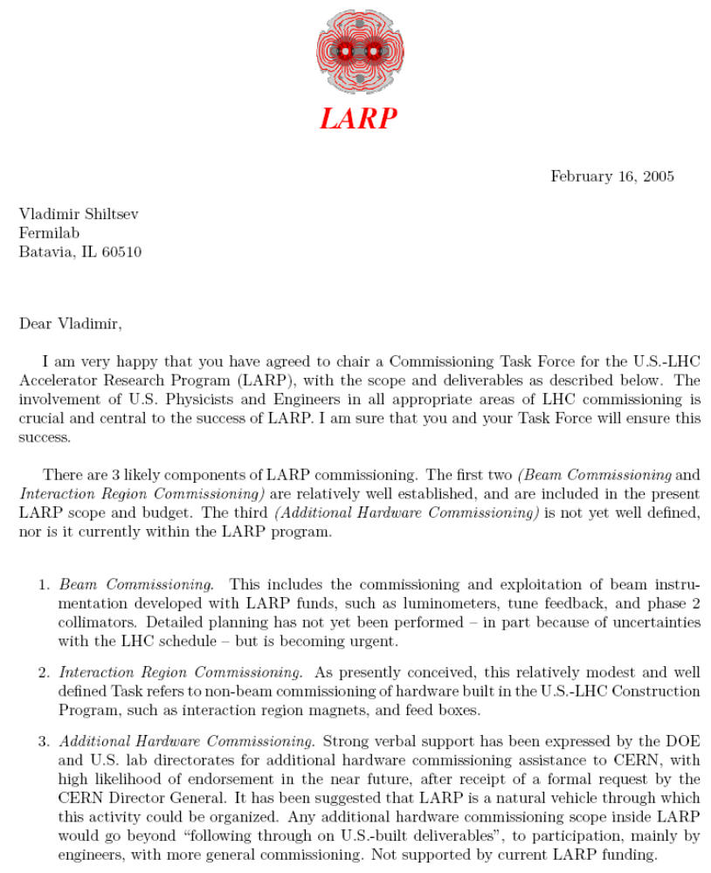
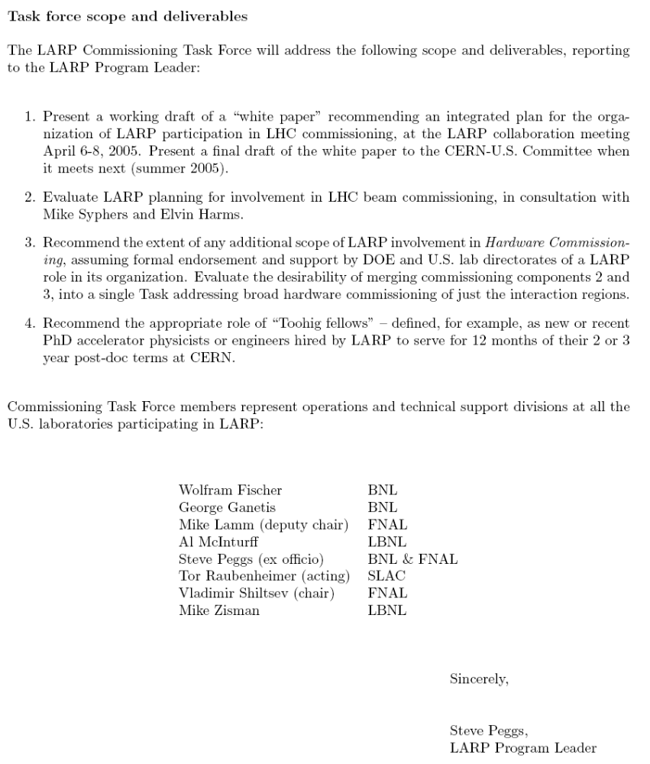
Appendix B: LARP Organization Chart as of July 2005

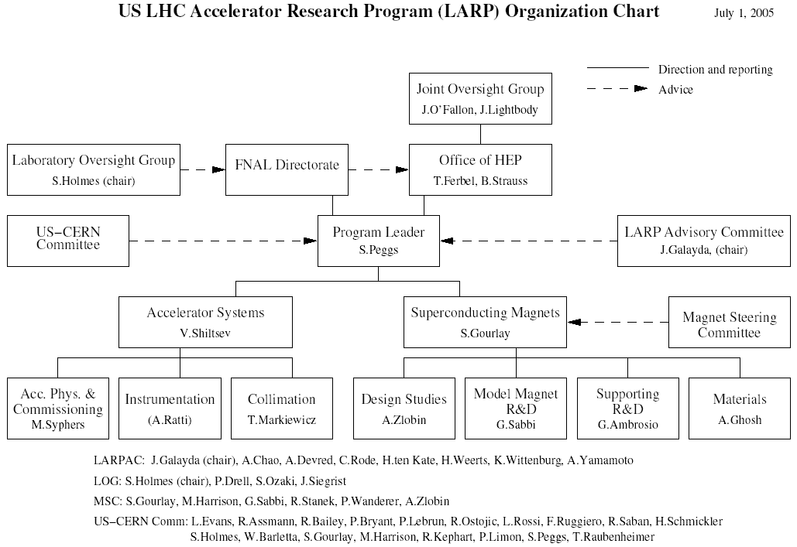

Appendix C: Memo on Long-Term Assignments to CERN (B. Jurkiw)

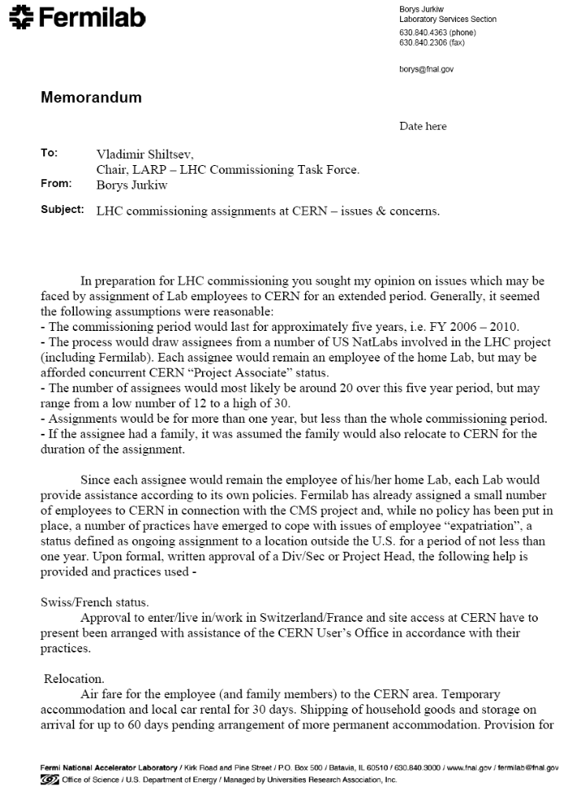

Appendix D: CMS Compensation and Relocation Guidelines (January 2004)

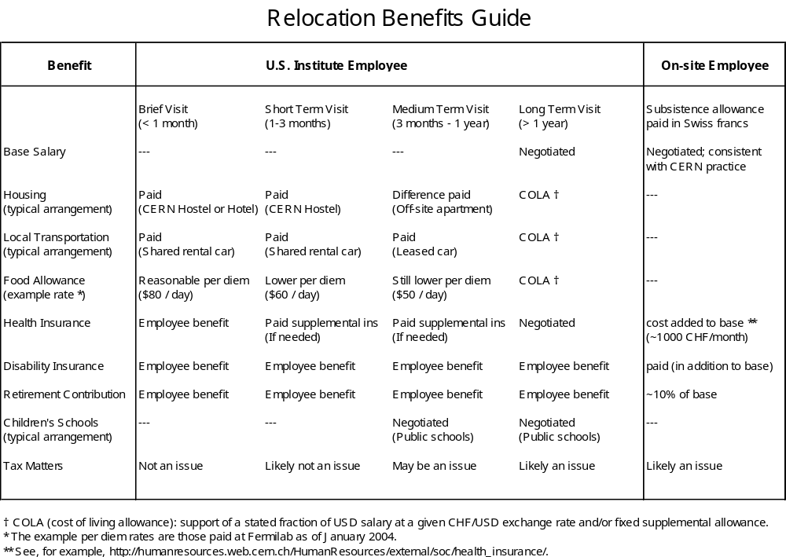
The amount of the U.S. CMS Project COLA is calculated based on a supported CHF-USD exchange rate of 1.4 CHF per USD, a cost of living differential of 20% at the supported exchange rate, and a supported salary fraction of f = 0.9235 (because Social Security is taken out of one's salary first):

COLA = S×f×(1.4×1.2–R_{ave})

where S = base salary. The average CHF-USD exchange rate, R_{ave}, is obtained from http://www.x-rates.com/d/CHF/USD/hist2005.html. (For foreign nationals who do not pay Social Security, the supported salary fraction would be f = 1.) The Fermilab benefits office is also paying 918CHF per month for Fermilab staff people to be part of the CERN Health Insurance Scheme run by UNIQA, as U.S. HMOs don't provide coverage over there.
As an example, taking R_{ave} = 1.266 for June 2005 from the web page and S = $100,000 base salary:

COLA = $100,000×0.9235×(1.4×1.2–1.266) = CHF38,233 additional money.
Appendix E: Memo on Green Card holders (B. Jurkiw)

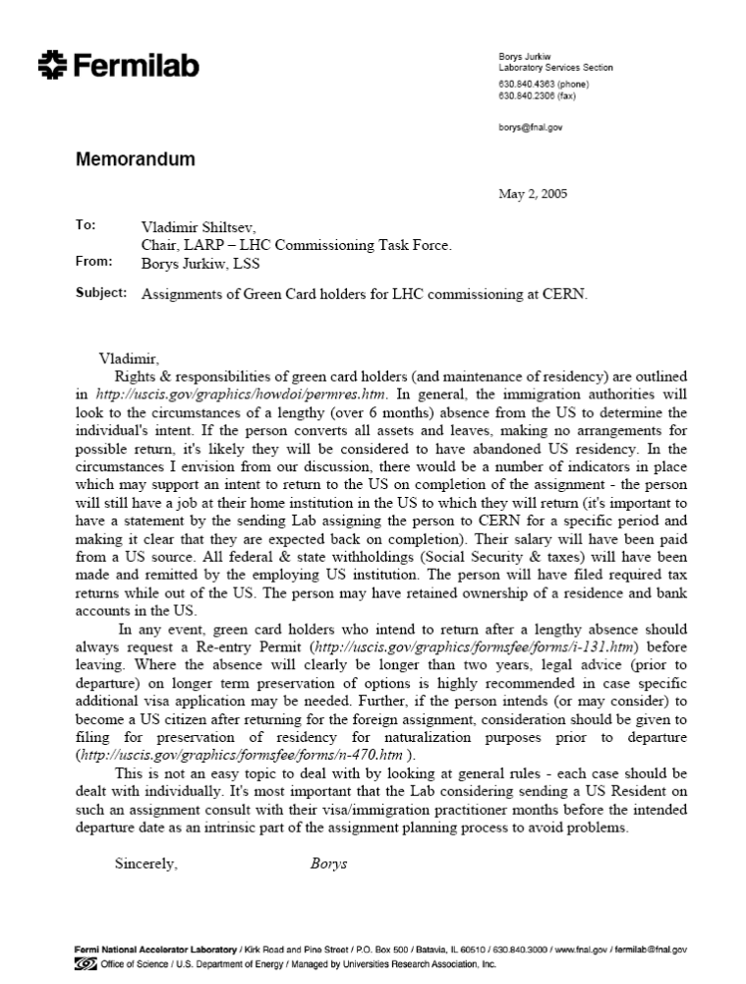

Appendix F: CERN DG Letter and DOE Response



