3.2.1 Collection Level Cataloging (CLC)

Example 1. Pamphlet collection


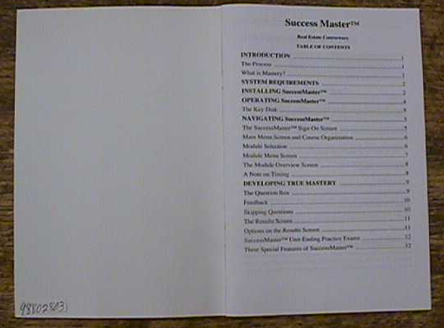
Piece label
Item barcode/ accession label
Property stamp (secondary location)


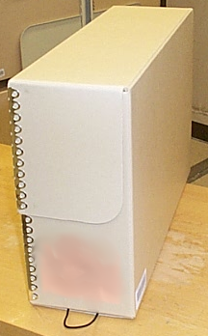
Front of folder
Folder label
Inside front cover
Front of envelope
Envelope label
Front of piece
Back of piece
Box title label
Box item
barcode
label
Box
Library of Congress

3.2.1 CLC continued
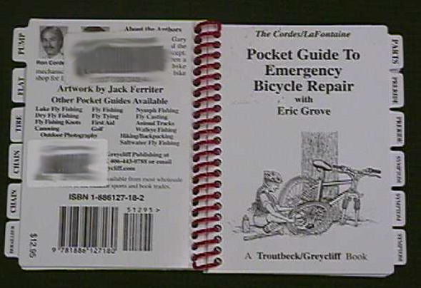
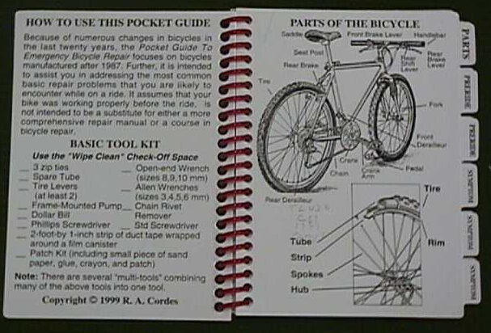
Library of Congress
Back
cover
Front
cover
Item barcode/
accession label
Piece label
Box title label
Box item barcode label
Box
Inside
front cover
Property stamp
Library of Congress
Example 2. Miniature books

Collection level cataloging (CLC)
Miniature book
Playscript
Pamphlet collection
Uncataloged sheet music

Label applied | Content | Size | Production method and composition | Location
Item barcode/  accession label | LIBRARY OF CONGRESS  Acquisition  source/method  Date of receipt  PIN (symbology +  eye-legible  number) | 1½“ W x 1” H | Thermal transfer  Pres. specs  700-712 | Back cover, upper  right quadrant of  piece
Edge stamp | LIBRARY OF CONGRESS | 1¼” W x ½” H | Manual stamp  Archival ink (red) | Head (top edge of text block) – 1st  OR  Inside front cover,  center – 2nd
Piece label | Collection name  Shelving number  Piece number | Variable | Thermal transfer  Pres. specs 700-712,  700-714 | Front page or cover  of piece, upper right  corner
Folder/  envelope label | Collection name  Shelving number | Variable | Thermal transfer  Pres. spec 700-711,  700-714 | Tab of folder; OR,  Upper right of  envelope
Box title label | Assignment  Collection name Shelving number  Box number in  series  Number of pieces | 2” W x 2” H | Thermal transfer  Pres. spec 700-711 | Side of box or lid,  lid opening to the  right
Box item barcode label | LIBRARY OF CONGRESS  PIN (duplicate of  PIN on first  piece) | 1½” W x ¾” H | Thermal transfer  Pres. spec 700-711 | Side of box, under  box label

3.2.2 Serial ssue


Back and front cover of issue
Item barcode/accession label
Serial shelving label
1

Serial issue

Label applied | Content | Size | Production method and composition | Location
Item barcode/ accession label | LIBRARY OF CONGRESS  Acquisition  source/method  Date of receipt  PIN (symbology +  eye-legible  number) | 1½“ W x 1” H | Thermal transfer  Pres. spec  700-712 | Back cover,  upper right  quadrant, below  shelving label
Serial shelving label | Title  Assignment  Classification  Cutter number  Enumeration  Chronology  Set number | 1½” W x 1” H | Thermal transfer  Pres. spec  700-714 | Back cover,  upper quarter

3.2.3 Newspaper

Item barcode/
accession label
Masthead page

Newspaper

Label applied | Content | Size | Production method and composition | Location
Item barcode/ accession label | LIBRARY OF CONGRESS  Acquisition  source/method  Date of receipt  PIN (symbology +  eye-legible  number) | 1½“ W x 1” H | Thermal transfer  Pres. spec  700-714 | Front cover, left  corner of  masthead,  above the  title

3.2.4 Copyright comic book collection
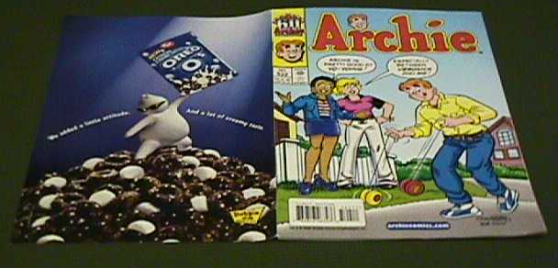
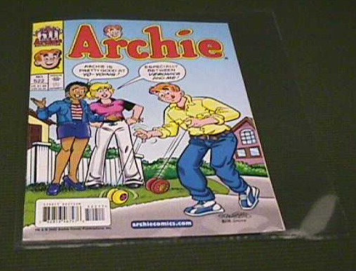
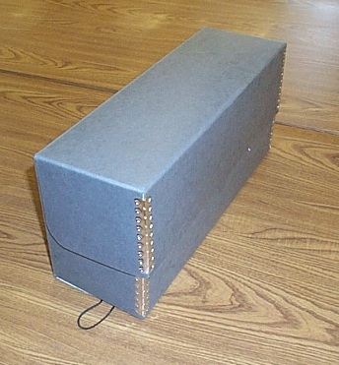
Item barcode/accession label
Back cover
of comic book
Front cover
of comic book
Front of
polyester sleeve
Sleeve shelving number label
Box
Box item barcode label
Box title label

Copyright comic book collection

Label applied | Content | Size | Production method and composition | Location
Item barcode/ accession label | LIBRARY OF CONGRESS  Acquisition  source/method  Date of receipt  PIN (symbology +  eye-legible  number) | 1½” Wx1” H | Thermal transfer  Pres. spec  700-712 | Back cover, upper  right ¼” below top  and 2” left of spine  — if significant data  obscured, may  move label left/right,  but no lower than  top ¼ of back cover
Sleeve shelving number label | Title  Shelving number  Assignment  Enumeration  Chronology  Copy number | Variable | Thermal transfer  Pres. spec  700-713 | Front of polyester sleeve, upper left corner
Box title label | Assignment  Collection name  Range of  enumeration/  chronology  Shelving number | 3” W x 2” H | Thermal transfer  Pres. spec 700-711 | Side of box lid, lid  opening to the  right
Box item barcode label | LIBRARY OF CONGRESS  PIN (unique) | 1½” W x ¾” H | Thermal transfer  Pres. spec 700-711 | Side of box,  just below lid,  upper right  side

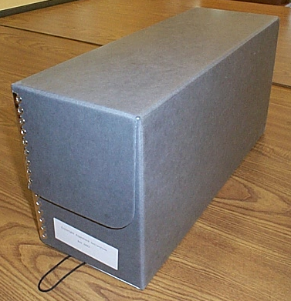
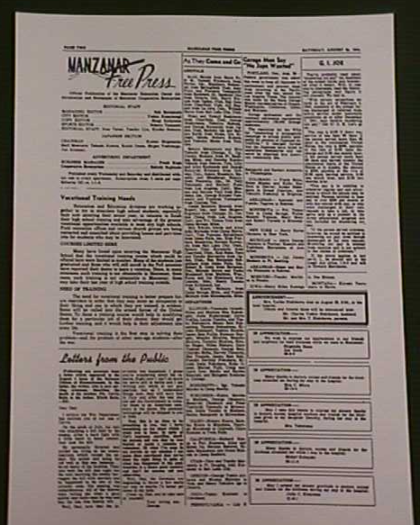

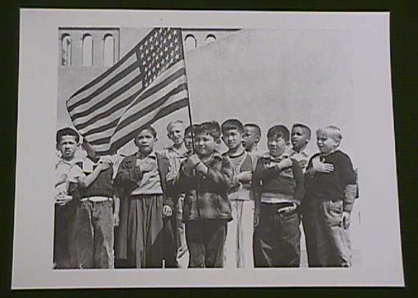


Box
Box title label
Box item barcode label
Front cover of text
Shelving number label
Property stamp
Front of folder
Folder label
Back cover of text

Item barcode accession label
barcode/
Back cover of image
Image shelving
number label
Image item barcode label
Front cover of image
3.2.5 Copyright moving image descriptive material
3.2.5 Copyright moving image descriptive material

Label applied | Content | Size | Production method and composition | Location
Text item barcode/ accession label | LIBRARY OF CONGRESS  Acquisition  source/method  Date of receipt  PIN (symbology + eye-legible number) | 1½” W x 1” H | Thermal transfer  Pres. spec  700-714 | Upper right-hand  corner of back  cover of text
Property stamp | LIBRARY OF CONGRESS | 1¼” W x ½” H | Manual stamp  Archival ink (red) | Front cover or 1st  page of text,  bottom center
Text shelving number label | Assignment  Collection name  Title  Shelving number  Enumeration  Chronology | 1” W x ½” H | Thermal transfer  Pres. spec  700-714 | Upper right-hand  corner of front  cover of text
Image item barcode label | LIBRARY OF CONGRESS  PIN (symbology + eye-legible number) | 1½” W x ¾” H | Thermal transfer  Pres. spec  700-714 | Back of piece,  bottom right-hand  corner
Image shelving number label | Assignment  Collection name  Title  Shelving number  Enumeration  Chronology | 1” W x ½” H | Thermal transfer  Pres. spec 700-714 | Back of piece,  Bottom left-hand  corner
Vertical folder label | Shelving number(s) | Variable | Thermal transfer  Pres. spec 700-711 or 700-713 (if polyester) | Front, top edge
Box title label | Assignment  Collection name  Box number in  series | 3” W x 2” H | Thermal transfer  Pres. spec 700-711 | Side of box below  lid, center, lid  opening to the  right
`

Local practice and application of box title labels may vary.
When cumulated into a bound volume, the call number label and security strip device are located as per 3.1.1. The binder also stamps author/title information onto the spine or front cover, duplicates the item barcode and places it on the back cover in the standard position. Because printed endpapers serve as a property mark an edge stamp is not needed.
Accession and label newspapers only if submitted under section 408 of copyright law for copyright registration.
Posters or other material, which is stored separately are not included in this description.

