MODIS Atmosphere QA Plan
for Collection 005

Version 3.0
June 2005

by
Paul A Hubanks1

based on previous version by
Allen Chu,7 Bill Ridgway,1 Kathy Strabala,2 Steve Platnick,3
Shana Mattoo,4 Eric Moody,4 Michael D King,5 Rich Hucek6

1 NASA Goddard Space Flight Center, Code 613.2/SSAI, Greenbelt, MD 20071;
2 NOAA CIMSS/SSEC University of Wisconsin-Madison, Madison, WI 53719;
3 NASA Goddard Space Flight Center, Code 613.2, Greenbelt, MD 20071;
4 NASA Goddard Space Flight Center, Code 613.2/L3 Communications, Greenbelt, MD 20071;
5 NASA Goddard Space Flight Center, Code 610, Greenbelt, MD 20071;
6 MODIS SDST/DSTI, Seabrook, MD 20706;
7 NASA Goddard Space Flight Center, Code 613.2, Greenbelt, MD 20071/JCET-UMBC
Table of Contents
1.0 Introduction 1
1.1 QA Approach 2
2.0 Level 2 Runtime QA Flag Structure/Information Content 3
2.1 Types of Runtime QA Flags 3
2.2 Reading and Interpreting Runtime QA Flags 5

Appendix A: Runtime QA Flags of Atmosphere Products 9
Aerosol (04_L2) 10
Water Vapor (05_L2) 16
Cloud (06_L2) 19
Cloud Optical Properties 19
Cloud Top Properties 23
Atmospheric Profile (07_L2) 27
Cloud Mask (35_L2) 32
Joint Atmosphere (ATML2) 36

Appendix B: Inventory Metadata of Atmosphere Products 40
Introduction 41
ECS (or Core) Inventory Metadata 41
QA Inventory Metadata 43
Aerosol (04_L2) 44
Water Vapor (05_L2) 45
Cloud (06_L2) 46
Atmospheric Profile (07_L2) 47
Cloud Mask (35_L2) 48
Joint Atmosphere (ATML2) 49

Appendix C: Archive Metadata of Atmosphere Products 51
Introduction 52
Aerosol (04_L2) 53
Water Vapor (05_L2) 54
Cloud (06_L2) 55
Atmospheric Profile (07_L2) 56
Cloud Mask (35_L2) 57
Joint Atmosphere (ATML2) 58
Daily Global (08_D3) 59
Eight Day Global (08_E3) 59
Monthly Global (08_M3) 59
Note: New and rewritten text (changed from the previous version (v2.2) of the QA Plan), along with Collection 005 updates to QA Flag assignments and definitions, are written in blue color (orange color for Appendix Notes) to help alert users to changes.

1.0 Introduction
This document describes the QA (quality assessment or quality assurance) plan for all MODIS Atmosphere products. Topics covered include: quality evaluation approach and scenarios, Level 2 (L2) runtime QA structure and information content, types of L2 runtime QA flags, a primer on reading and interpreting L2 runtime QA flags, detail on how Level 2 (L2) confidence flags impact Level 3 (L3) product statistics, and finally a thorough breakdown of the structure and information content of L2 Runtime QA (in Appendix A).
Also included at the end of this document is information on Inventory and Archive Metadata structures that apply to both L2 and L3 products (in Appendix B and C).
It should be noted that within MODIS Atmosphere, the term “QA” is loosely defined to include a wide variety of flags that detail (1) confidence or quality, (2) retrieval processing path, (3) retrieval status or outcome, (4) retrieval method, (5) data or scene characteristics, and (6) metadata or ancillary input source.
Quality assessment is an important element in the sequential data reduction from Level 0 (L0) raw counts to Level 1B (L1B) calibrated radiance, and continually to Level 2 (L2) orbital swath granules and Level 3 (L3) global gridded products. Level 2 MODIS Atmosphere products, retrieved from MODIS instrument and ancillary data, are grouped into user-friendly Hierarchical Data Format (HDF) files based upon the general categories of aerosol, column water vapor, cloud, atmospheric profiles, cloud mask, and joint atmosphere. Level 3 Atmosphere products, which contain hundreds of 1°x1° global gridded parameters/statistics derived from the L2 products, are grouped into HDF files by temporal period: daily, eight-day, and monthly.
MODIS atmosphere products are grouped as follows (Earth Science Data Type (ESDT) names, used to identify each product by their HDF filename, are provided in parentheses):
Level 2 Products
- Aerosol (04_L2)
- Water Vapor (or Precipitable Water) (05_L2)
- Cloud Properties (06_L2)
- Atmospheric Profiles (07 _L2)
- Cloud Mask (35_L2)
- Joint Atmosphere (ATML2)

Level 3 Products

- Daily Global (08_D3)
- Eight-day Global (08_E3)
- Monthly Global (08_M3)
Each Level 2 atmospheric parameter is retrieved at a spatial resolution determined by the sensitivity of retrieval, not necessarily on a single field of view (FOV) basis. Resolutions typically range from 1x1 km to 10x10 km. Level 3 atmospheric parameters are computed at 1x1 degree spatial resolution.
There are two main types of flags described in this document: (1.) Runtime QA Flags and (2.) Metadata (either Inventory or Archive).
Runtime QA Flags (which are only computed and stored for Level 2 products) are designed to convey information on retrieval processing path, input data source, scene characteristics, and the estimated quality of the physical parameters retrieved. In addition, this broad group of flags also includes Cloud Mask QA flags (initially derived at 1×1 km resolution) that may be recomputed at the spatial resolution of the retrieval for the determination of cloudy and clear pixels, land surface type, sunglint, day/night, and snow/ice.
Metadata, on the other hand, are to report high-level granule characteristics and calculated statistics in the broad catagory of either Inventory or Archive Metadata. Inventory Metadata are searchable, whereas the Archive Metadata are for archival (documentation) only.
1.1 QA Approach
The (automatic) operational approach forms the key to the QA process of MODIS atmosphere products. This encompasses the Runtime QA flags and Metadata produced in each product as well as the operational procedures performed in real time at the GDAAC (Goddard DAAC) or MODAPS (MODIS Data Processing System).
The Runtime QA flags produced in Level 2 products are the central piece of this Quality Assurance (QA) Plan. They are designed not only to report success or failure of criteria being used in retrieval but also to estimate the data quality. These resolution-level QA flags provide much more detailed information and thus provide better information to produce Level 3 global products. The MODIS atmosphere Level 3 products are produced to include various statistical quantities (e.g., mean, standard deviation, histogram and regression). Theoretically, in evaluating the quality of the retrieval, the quality of the inputs should also be considered. Thus, the Level 2 QA flags are to reflect only the product itself, with input sources flagged for later evaluation.
Introductory information on the type and structure of Runtime QA Flags, along with a primer on reading and interpreting QA Flags, can be found in Section 2. The key portion of this document is the detailed tabulation of Runtime QA Flags in Appendix A.

2.0 Level 2 Runtime QA Structure/Information Content
The quality of Level 2 product can be (1) inherited from the L1B radiances, or (2) associated with the retrieval process. The pixel-based L1B validity flags comprising information on dead and saturated detectors, calibration failure, etc., are examined by L2 algorithms for determination of the radiometric status of each pixel. This information can prevent further calculations from being performed if the “valid input data” criteria is not met by the given algorithm. The granule-level L1B QA metadata provides summary information for valid and saturated Earth view observations, and can be useful in screening a granule of data. Details about MODIS L1B QA flags can be found in the MODIS L1B QA plan. The structure and information content of MODIS Atmosphere runtime QA are detailed in the following sections.
It should be noted that Runtime QA flags are only found in Level 2 (L2) Atmosphere products. Level 3 (L3) Atmosphere products contain no Runtime QA flags (bit-string SDS’s); however L2 runtime QA flags are used to compute (aggregate and weight) statistics in L3.

2.1 Types of Runtime QA Flags
The SDS run time QA flags are stored based upon product resolution. For convenience, the run time QA flags can be divided into three parts: (1) cloud mask flags, (2) product quality flags, and (3) retrieval processing flags.
Cloud Mask Flags are constructed using the Cloud Mask (35_L2). Typically they are based on the flags from the first byte only, however it may contain additional flags read from subsequent bytes. The first byte of the Cloud Mask is shown below:

Bits | Flag Name | Bit Values | Bit Value Definitions
0 | Cloud Mask  Status Flag | 0  1 | Undetermined  Determined
1-2 | Cloud Mask  Cloudiness Flag | 0  1  2  3 | Confident Cloudy (or Fill, if Status Flag = 0)  Probably Cloudy  Probably Clear  Confident Clear
3 | Day / Night Flag | 0  1 | Night (or Fill, if Status Flag = 0)  Day
4 | Sunglint Flag | 0  1 | Yes (or Fill, if Status Flag = 0)  No
5 | Snow / Ice Flag | 0  1 | Yes (or Fill, if Status Flag = 0)  No
6-7 | Surface Type Flag | 0  1  2  3 | Ocean or Deep Lakes and Rivers (or Fill)  Coast or Shallow Lakes and Rivers  Desert  Land
For L2 products at 1×1 km resolution, the first byte of the cloud mask will be written and stored, exactly as detailed above. For coarser resolution products (5x5 or 10x10 km), the information for each QA Flag will be determined by science team members based upon the retrieval method (it may be subsampled or averaged). To avoid duplication in products that are built from more than one retrieval algorithm, cloud mask QA flags will be stored only once in each product (HDF file). The only exception is the Cloud Product (06_L2), where the cloud mask QA flags will be stored at both 1×1 and 5×5 km resolutions.
Product Quality Flags are used to indicate the quality of each parameter retrieved at the product spatial resolution. The first bit indicates usefulness of the parameter, followed by two or three bits for the confidence level. Even though one can store a number from 0 to 7 (corresponding to 8 confidence levels) when three bits are allocated for the Confidence Flag, the Atmosphere L3 production processing software was develped to handle only 4 confidence levels (see table below), which can be adequately stored in only two bits. Usefulness Flags should always be read in tandum with Confidence Flags to differentiate between No Confidence but valid data vs. Fill (missing) data.
An example of the typical format for Product Quality Flags is shown below:

Flag Name |  | Bit Values |  | Bit Value Definitions |  | L3 QA-weighting
Example Parameter  Usefulness Flag | 0  1 |  | Not useful  Useful |  | Not used in L3  Used in L3
Example Parameter  Confidence Flag | 0  1  2  3 |  | No Confidence (or Fill)  Marginal  Good  Very Good |  | 0x  1x  2x  3x

The MODIS Atmosphere L3 processing software makes use of the L2 Usefulness and Confidence flags by creating L3 QA-weighted mean and standard deviation statistics. The QA weighting is performed by weighting each L2 input pixel by its Confidence flag, so that non-fill no confidence data has a weight of 0x, marginal data has a weight of 1x, good data has a weight of 2x, and very good data has a weight of 3x in the statistical computation within the L3 one-degree grid box.
It should be noted that L3 “regular” (non QA-weighted) mean and standard deviation statistics are not weighted by L2 Confidence flags and will include all non-fill L2 input pixels that have their Quality/Confidence flags set to 0; while the QA-weighted mean and standard deviation statistics will exclude these pixels. This technique allows for the creation of L3 (QA-weighted) statistics that can selectively exclude no confidence (or experimental) L2 results.
Finally, users should note that (in addition to regular simple statistics) L2 QA Confidence flags are also ignored in the L3 computation of pixel count, histogram, joint histogram, and regression statistics.
Retrieval Processing Flags are used for miscellaneous purposes. The bit length and information content are determined by the responsible science team member. In general, it may contain:

- Physical, algorithm, climatological constraints
- Atmospheric correction (Rayleigh scattering, gaseous absorption)
- Input resource of ancillary data or MODIS product
- Spectral band and detector status (L1B)
- Occurrence of contamination by thin cirrus
Two common retrieval processing flags are the processing path flag and the input data resource flag. The former indicates the retrieval path, the correction due to Rayleigh scattering and gaseous absorption, or the occcurrence of error during retrieval. The latter is to indicate the source of input data sets, such as other MODIS products, ancillary data from other satellites, model assimilated data from GMAO (Goddard Modeling and Assimilation Office), or NCEP (National Centers for Environmental Prediction), or climatology.

  - Reading and Interpreting Runtime QA Flags
All Level 2 (L2) MODIS Atmosphere HDF data products contain one or more “bit flag”“ Scientific Data Set (SDS) arrays. Bit flag SDS names may contain the string “Quality_Assurance”“ or may have a more descriptive name like “Cloud_Mask”. However, they all have one common attribute — bit flag (or bit string) arrays contain multiple flags stored in particular (fixed) bit positions of the array.
Bit and Byte Array Indexing Convention: “Zero-based”
The convention for indexing arrays varies from language to language. Array indexing in FORTRAN typically starts at 1; and array indexing in C typically starts at 0. However, almost all tools used for bit extraction (in both FORTRAN and C) use an index start convention of 0 for both bits and bytes. In addition, the HDF interface is based in the C (0-based) language. Therefore a 0-based start convention for indexing (numbering) the bits and bytes is always used. In summary, the first byte is always called byte 0, and the first bit is always called bit 0.

HDF Bit and Byte Array Ordering Convention: “Big Endian”
Background on “endian” nomenclature and its impact on bit string dumps
There are two schemes of byte (or bit) ordering used in computers: big endian and little endian.
- Little endian means that the low-order byte (or bit) is stored in memory at the lowest (leftmost) address, and the high-order byte (or bit) at the highest (rightmost) address (in other words, the “little end” comes first.). Intel processors (those used in Windows PCs) use the little endian convention. This group also includes HP-UX and PC-based Linux.
- Big endian means that the high-order byte (or bit) is stored in memory at the lowest (leftmost) address, and the low-order byte at the highest (rightmost) address (in other words, the “big end” comes first.). Motorola processors (those used in Macintosh OS) use the big endian convention. This group also includes Sun OS and SGI/Irix.
If one uses a tool that dumps (displays) bit registers (e.g., 01001001) of an HDF bit flag SDS array, one needs to keep in mind that standard HDF data products (including all MODIS HDF data) are dumped (displayed) using the big endian referencing scheme.
Since HDF is designed to be platform-independent, if the platform being used is little endian, the HDF library will (automatically) convert the bit and byte order of bit flag SDS arrays to big endian. On big endian platforms, the HDF library will perform no byte-order conversion since the array already in the correct form by default. Therefore, when “stripping bits”“ from bit flag SDSs (Quality Assurance or Cloud Mask arrays, for example) using bit manipulation tools, the bits will always be numbered from right (bit index #0) to left (bit index #7). That is, the least significant bit (20) is on the right and most significant bit (27) is on the left. A visual example of this format is offered below.

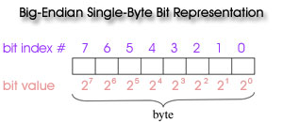

Numerical Whole-Byte Dumps
Users should note that if one uses the HDF utility, ncdump, or other tools to dump full-byte values (numbers from 0 to 255) from bit flag SDS arrays; one can recreate the bit flags using either the big or little endian convention. One simply converts the numbers to 8 bit registers of 0 or 1, where the bit tagged as the first bit (bit index #0) is the lowest order (or least significant) bit (20); and the bit tagged as the last bit (bit index #7) is the highest order (or most significant) bit (27). In this case, it doesn’t matter which end (left or right) one places the least significant (20) bit.

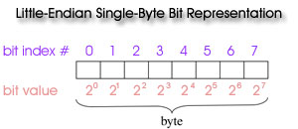

To decode individual flags, one queries groups of sequential bits (matching the length of each flag) in the proper bit order from 0 to 7 and interprets the value of those bits (using the same least significant to most significant convention) to obtain the correct flag value. An example of both of these (bit flag decoding) methods is detailed below.

Example: Interpreting the Cloud_Mask SDS (1st byte only)

Consider the first byte of the (commonly used) Cloud_Mask SDS:

Bits | Flag Name | Bit Values | Bit Value Definitions
0 | Cloud Mask  Status Flag | 0  1 | Undetermined  Determined
1-2 | Cloud Mask  Cloudiness Flag | 0  1  2  3 | Confident Cloudy (or Fill, if Status Flag = 0)  Probably Cloudy  Probably Clear  Confident Clear
3 | Day / Night Flag | 0  1 | Night (or Fill, if Status Flag = 0)  Day
4 | Sunglint Flag | 0  1 | Yes (or Fill, if Status Flag = 0)  No
5 | Snow / Ice Flag | 0  1 | Yes (or Fill, if Status Flag = 0)  No
6-7 | Surface Type Flag | 0  1  2  3 | Ocean or Deep Lakes and Rivers (or Fill)  Coast or Shallow Lakes and Rivers  Desert  Land

Suppose the following flags were set:
- Cloud Mask Status = 1 (Determined)
- Cloud Mask Cloudiness = 2 (Probably Clear)
- Day/Night = 0 (Night)
- Sunglint = 1 (No)
- Snow/Ice = 1 (No)
- Surface Type = 3 (Land)

Bit-String Dump
Stripping the bits using a bit manipulation tool would yield the results shown below. Flags are then counted (positioned) from the right (big endian convention); and least to most significant bits are ordered from right to left for each flag.
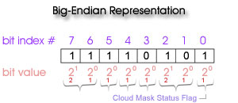

Numerical Whole-Byte Dump
However if one uses the HDF dump utility, ncdump, or another tool to dump the full-byte numeric value from the array, one gets a byte value of 245 (for this particular case). One can then recreate the individual bit flags using either the big or little Endian convention, as long as one starts counting (indexing) the bits (and assigning flags) from the least significant to the most significant bit.

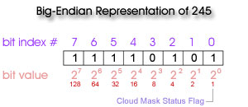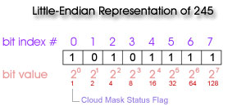

Appendix A:

Runtime QA Flags

of

Atmosphere Products

Aerosol Product: MOD04_L2 (Terra) & MYD04_L2 (Aqua)
For the Aerosol product, the Runtime QA flags are stored in three Scientific Data Sets (SDSs): Cloud_Mask_QA, Quality_Assurance_Land, and Quality_Assurance_Ocean. Cloud_Mask_QA is a single byte SDS that contains several cloud mask QA flags recomputed on a 10x10 km grid. This recomputation is performed using specific numerical threshholds of percentages of 1 km Cloud Mask pixels that meet certain criteria within the Aerosol 10x10 km retrieval area (see “Bit Value Definitions” column in the table below). So for each 10x10 km pixel, up to one hundred 1 km Cloud Mask pixels are queried. It should be noted that in the previous version of the QA Plan, the 2nd flag in sequence below was incorrectly documented, it is now correctly specified as being “Spares.” All other flags provide information on the processing (logic) path taken in the aerosol retrieval algorithm.
Quality_Assurance_Land and Quality_Assurance_Ocean are five byte SDSs that contain product quality flags, retrieval processing flags, and input data resource flags designed separately for land and ocean because of differences in the retrieval algorithms. All Aerosol QA Flag arrays have the following characteristics:
- Spatial resolution: 10x10 km
- Processing mode: Daytime only

Scientific Data Set (SDS) Name: “Cloud_Mask_QA”
Description: Cloud mask QA flags recomputed at 10x10 km resolution
Length: 1 byte (8 bits)
Flag Name |  | Number of Bits |  | Bit Values |  | Bit Value Definitions
Cloud Mask  Status Flag | 1 |  | 0  1 |  | Undetermined (< 100% cloud mask determined pixels)  Determined (100% cloud mask determined pixels)
Spares | 2 |  |  |  | TBD
Day / Night Flag | 1 |  | 0  1 |  | Night (< 100% daytime pixels)  Day (100% daytime pixels)
Sunglint Flag | 1 |  | 0  1 |  | Yes (100% cloud mask sunglint pixels)  No (< 100% cloud mask sunglint pixels)
Snow / Ice Flag | 1 |  | 0  1 |  | Yes (≥ 90% snow / ice pixels)  No (< 90% snow / ice pixels)
Surface Type Flag | 2 |  | 0  1  2  3 |  | Ocean (≥ 90% ocean or deep lakes and rivers)  Coast (other criteria not met)  Desert (100% desert)  Land (100% land and < 100% desert)

Scientific Data Set (SDS) Name: “Quality_Assurance_Land”
Description: Product quality and retrieval processing flags over Land
Length: 5 bytes (40 bits)
Flag Name |  | Number of Bits | Bit Values | Bit Value Definitions
 | 0.47 µm Aerosol Optical Thickness  Usefulness Flag | 1 | 0  1 | Not useful  Useful
 | 0.47 µm Aerosol Optical Thickness  Confidence Flag | 3 | 0  1  2  3 | No Confidence (or Fill)  Marginal  Good  Very Good
 | 0.66 µm Aerosol Optical Thickness  Usefulness Flag | 1 | 0  1 | Not useful  Useful
 | 0.66 µm Aerosol Optical Thickness  Confidence Flag | 3 | 0  1  2  3 | No Confidence (or Fill)  Marginal  Good  Very Good
 | processing path flags
 | Dark Target Criteria  used in retrieval | 3 | 0  1  2  3  4  5 | not met (Fill Value)  0.01 < Ref (2.1 µm) ≤ 0.05  0.05 < Ref (2.1 µm) ≤ 0.10  0.10 < Ref (2.1 µm) ≤ 0.15  0.15 < Ref (2.1 µm) ≤ 0.25  0.25 < Ref (2.1 µm) ≤ 0.40
 | Error Code  (when Fill Values are assigned) | 3 | 0  1  2  3  4  5  6 | No error  Solar and illumination angles out-of-bounds in look-up table  Apparent reflectance out-of-bounds in look-up table  Number of cloud and water free pixels not met  Thresholds of 2.1 µm not met  Thresholds of 3.8 µm not met  Thin cirrus detection not met
 | High Solar Zenith Angle  ( > 72° ) | 1 | 0  1 | No  Yes
 | Increased Spatial Resolution  ( 5x5 km ) | 1 | 0  1 | No  Yes
 | Aerosol Type  (over Land only) | 2 | 0  1  2  3 | Mixed  Dust  Sulfate  Smoke
 | Thin Cirrus or  Stratospheric Aerosol Index | 2 | 0  1  2  3 | 0 < ρ (1.38 µm) < 0.01; Correction is done  ρ (1.38 µm) < 0; No correction  ρ (0.66 µm) < 0.04; No correction  ρ (1.38 µm) > 0.01; No correction
 | input data resource flags
 | Total ozone | 2 | 0  1  2  3 | TOVS  TOMS  Climatology  GMAO
 | Total Precipitable Water | 2 | 0  1  2  3 | NCEP / GDAS  MOD05* NIR (MODIS Near-IR Water Vapor Retrieval)  Climatology  GMAO
 | Snow Cover | 2 | 0  1 | MOD35* (MODIS Cloud Mask)  MOD10* (MODIS Eight-day Snow Cover)
 | Spares | 6 |  | TBD
 | Spares | 8 |  | TBD
- MOD prefix denotes MODIS/Terra (PM overpass) data -- MYD prefix should be substituted for MODIS/Aqua (AM overpass) dat

Scientific Data Set (SDS): “Quality_Assurance_Ocean”
Description: Product quality and retrieval processing flags over Ocean
Length: 5 bytes (40 bits)
Flag Name |  | Number of Bits | Bit Values | Bit Value Definitions
 | Aerosol Parameters (Best Soln.)  Usefulness Flag | 1 | 0  1 | Not useful  Useful
 | Aerosol Parameters (Best Soln.)  Confidence Flag | 3 | 0  1  2  3 | No Confidence (or Fill)  Marginal  Good  Very Good
 | Aerosol Parameters (Avg. Soln.)  Usefulness Flag | 1 | 0  1 | Not useful  Useful
 | Aerosol Parameters (Avg. Soln.)  Confidence Flag | 3 | 0  1  2  3 | No Confidence (or Fill)  Marginal  Good  Very Good
 | processing path flags
 | Part I: Aerosol over Ocean Retrieving Condition  when inversion is NOT performed.  Note: τ (550 nm) fill value  will be output on conditions  1 through 10. | 4 | 0  1  2  3  4  5  6  7  8  9  10 | Retrieval is performed  Glitter is present  Cloudy  R (0.865 µm) too low for retrieving optical thickness  Total number of available VIS / SWIR wavelength bands (from 550 to 1240 nm) is insufficient  Total number of available wavelengths < 3  Angles Out-of-Bounds  Land present in 10 x 10 km box  τ (550 nm) < -0.01; algorithm found negative values of optical thickness (there is a problem)  τ (550 nm) > 5.0; out of bounds in lookup table  All Channels do not have valid data
 | Part II: Aerosol over Ocean Retrieving Condition  when inversion IS performed.  Note: τ (550 nm)  retrieved value  will be output.on conditions  0 through 10.  Confidence Flag Notes:  - If Retrieving Condition = 0, then Confidence. Flag is set to Very Good.  - If = 7, then Confidence Flag is set to Good.  - If = 1, 3, 4, 6, 8 or 10, then Confidence Flag is set to Marginal.  - If = 2, 5, or 9, then Confidence Flag is set to No Confidence. | 4 | 0  1  2  3  4  5  6  7  8  9  10  11 | Retrieval performed normally  Number of useful pixels within 10 x 10 km box is < 10%  R (0.865 µm) low but large enough for retrieving optical thickness; the size distribution is questionable;  η = fill value  1.65 µm channel not used  2.13 µm channel not used  1.65 and 2.13 µm channels not used  Aerosol type as well as aerosol content are variable  There is variability in aerosol content but the spectral dependence is stable  The best value of ε is larger than the threshold value (5%)  τ (550 nm) < 0 to avoid bias in level 3 product  Glint angle between 30° and 40°  Glint; Store only Refl., SD, and Number of Pixels Used
 | input data resource flags
 | Total Ozone | 2 | 0  1  2  3 | TOMS  TOVS  GMAO  Climatology
 | Total Precipitable Water | 2 | 0  1  2  3 | NCEP  MOD05* NIR (MODIS Near-IR Water Vapor Retrieval)  GMAO  MOD05* IR (MODIS IR Water Vapor Retrieval)
 | Snow Cover | 2 | 0  1  2  3 | No snow detected  MOD35* (MODIS Cloud Mask)  MOD10* (MODIS Eight-day Snow Cover)  Other
 | Spares | 2 |  | TBD
 | Spares | 8 |  | TBD
 | Spares | 8 |  | TBD
* MOD prefix denotes MODIS/Terra (PM overpass) data -- MYD prefix should be substituted for MODIS/Aqua (AM overpass) data

Sample Runtime QA Flag Images

from the Aerosol Product
Reference L1B Image of Scene 12 Feb 2001 15:10  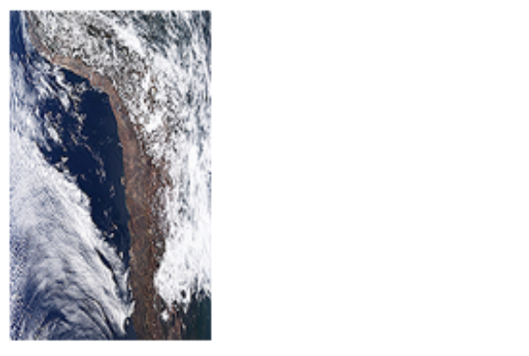  MODIS Terra (AM) R:G:B = Band 1 : Band 4 : Band 3 |  | Flag = “Aerosol Optical Thickness (0.47 µm) Usefulness”  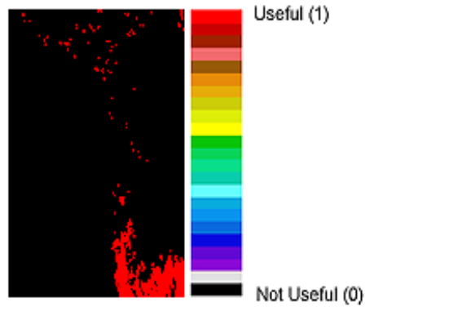  SDS = “Quality_Assurance_Land” (Aerosol over Land)
Flag = “Surface Type Flag”  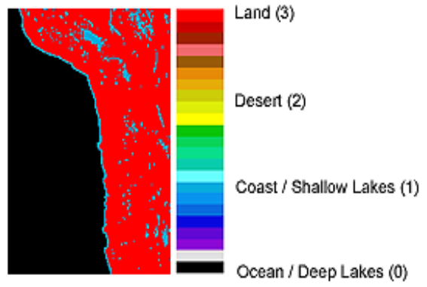  SDS = “Cloud_Mask_QA” (Cloud Mask) |  | Flag = “Aerosol Type Flag (over Land only)”  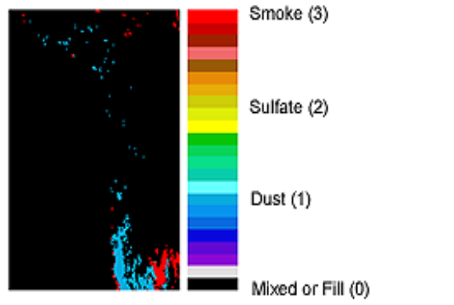  SDS = “Quality_Assurance_Land” (Aerosol over Land)
Flag = “Sunglint Flag”  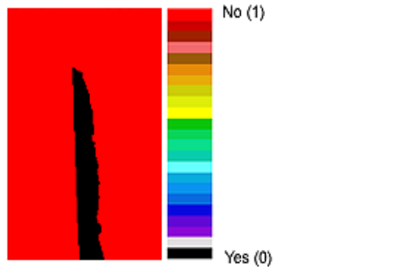  SDS = “Cloud_Mask_QA” (Cloud Mask) |  | Flag = “Part I: Aerosol over Ocean Retrieving Condition”  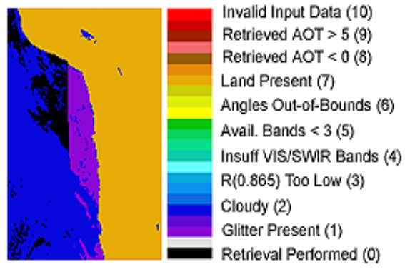  SDS = “Quality_Assurance_Ocean” (Aerosol over Ocean)
Note: Images were created by “bitflag_visualizer”, available at http://modis-atmos.gsfc.nasa.gov/tools_bitflag_visualizer.html.
Water Vapor Product: MOD05_L2 (Terra) & MYD05_L2 (Aqua)

The Water Vapor (or Total Precipitable Water) product combines results from both the NIR (1×1 km) and IR algorithms (5 × 5 km). For near infrared (NIR) total precipitable water, the first byte contains cloud mask QA (1 × 1 km), and the second byte (a separate array from the cloud mask QA) contains NIR product quality and retrieval processing flags. For the five bytes of IR total precipitable water results, only product quality and retrieval processing flags are stored. Since IR total precipitable water results are copied from 07_L2, the cloud mask related QA flags can be retrieved from 07_L2, and therefore it will not be duplicated here in the 05_L2 product. All Water Vapor QA Flag arrays have the following characteristics:
- Spatial resolution: 1 × 1 km (NIR) and 5 × 5 km (IR)
- Processing mode: Daytime only (NIR) and Both Day and Night (IR)

Scientific Data Set (SDS): “Cloud_Mask_QA”
Description: Cloud mask QA flags at 1x1 km
Length: 1 byte (8 bits)
Flag Name |  | Number of Bits |  | Bit Values |  | Bit Value Definitions
Cloud Mask  Status Flag | 1 |  | 0  1 |  | Undetermined  Determined
Cloud Mask  Cloudiness Flag | 2 |  | 0  1  2  3 |  | Confident Cloudy (or Fill, if Status Flag = 0)  Probably Cloudy  Probably Clear  Confident Clear
Day / Night Flag | 1 |  | 0  1 |  | Night (or Fill, if Status Flag = 0)  Day
Sunglint Flag | 1 |  | 0  1 |  | Yes (or Fill, if Status Flag = 0)  No
Snow / Ice Flag | 1 |  | 0  1 |  | Yes (or Fill, if Status Flag = 0)  No
Surface Type Flag | 2 |  | 0  1  2  3 |  | Ocean or Deep Lakes and Rivers (or Fill)  Coast or Shallow Lakes and Rivers  Desert  Land

Scientific Data Set (SDS): “Quality_Assurance_Near_Infrared”

Description: Product quality and retrieval processing flags for Precipitable Water (Near IR) at 1x1 km
Length: 1 byte (8 bits)
Flag Name |  | Number of Bits |  | Bit Values |  | Bit Value Definitions
Total Precipitable Water (NIR)  Usefulness Flag | 1 |  | 0  1 |  | Not useful  Useful
Total Precipitable Water (NIR)  Confidence Flag | 3 |  | 0  1  2  3 |  | Bad (or Fill)  Marginal Confidence  Good Confidence  Very Good Confidence
Inversion Method Used (NIR) | 2 |  | 0  1  2 |  | Two channel ratio  Three channel ratio  No retrieval
Surface Type | 2 |  | 0  1  2  3 |  | Bright Land  Clear Ocean  Cloud  Sunglint

Scientific Data Set (SDS): “Quality_Assurance_Infrared”
Description: Product quality and retrieval processing flags for Precipitable Water (IR) at 5x5 km
Length: 5 bytes (40 bits)
Flag Name |  | Number of Bits |  | Bit Values |  | Bit Value Definitions
Total Precipitable Water (IR)  Usefulness Flag ^{n} | 1 |  | 0  1 |  | Not useful  Useful
Total Precipitable Water (IR)  Confidence Flag ^{n} | 3 |  | 0  1  2  3 |  | Bad (or Fill)  Marginal Confidence  Good Confidence (not currently used)  Very Good Confidence (not currently used)
Spares | 4 |  |  |  | TBD
Number of Cloudy Pixels | Int 8 |  | 0-25 |  | Number of 1 km Cloudy pixels n 5x5 retrieval area
Number of Clear Pixels | Int 8 |  | 0-25 |  | Number of 1 km Clear pixels in 5x5 retrieval area
Number of Missing Pixels | Int 8 |  | 0-25 |  | Number of 1 km Missing pixels in 5x5 retrieval area
IR Water Vapor Retrieval Method Used | 2 |  | 0  1  2  3 |  | Split Window (11-12 µm) Technique  Integration of Moisture Profile  Other  No Retrieval
Spares | 6 |  |  |  | TBD
^{n} Flag is not reliable in Not Useful / Bad regions (i.e. Not Useful pixels are incorrectly tagged as Useful, etc. about ½ the time.)

Sample Runtime QA Flag Images
from the Water Vapor Product
Reference L1B Image of Scene 12 Feb 2001 15:10  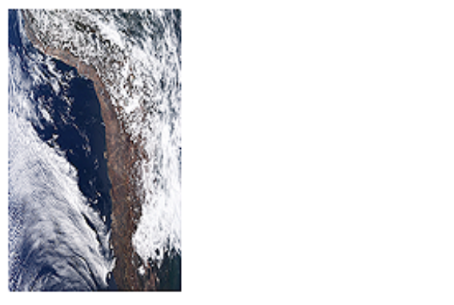  MODIS Terra (AM) R:G:B = Band 1 : Band 4 : Band 3 |  | Flag = ”Surface Type Flag (NIR Retrieval)”  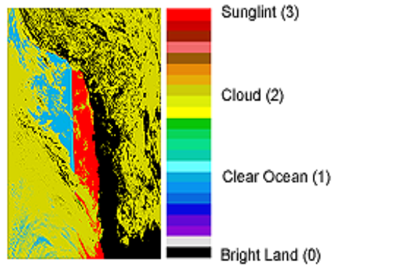  SDS = “Quality_Assurance_Near_Infrared” (NIR Water Vapor)
Flag = “Cloud Mask Cloudiness Flag”  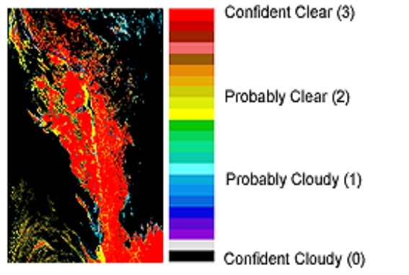  SDS = “Cloud_Mask_QA” (Cloud Mask) |  | Flag = “Total Precipitable Water (IR) Usefulness Flag” ¹  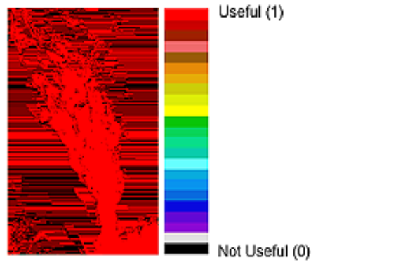  SDS = “Quality_Assurance_Infrared” (IR Water Vapor)
¹ TPWIR Flags are copied from the 07_L2 Atmospheric Profile product - - and all 07_L2 Atmospheric Profile Usefulness
and Confidence Flags are noisy.
Note: Images were created by “bitflag_visualizer”, available at http://modis-atmos.gsfc.nasa.gov/tools_bitflag_visualizer.html.
Cloud Product: MOD06_L2 (Terra) & MYD06_L2 (Aqua)

The MODIS Cloud product consists of both a 1 km set of parameters derived from solar reflectance channels (Cloud Optical Properties and Cirrus Reflectance) and a 5 km set of parameters determined from thermal emitted channels (Cloud Top Properties). It should be noted that only the Cloud Optical Property and Cloud Top Property parameter sets have QA flags associated with them.
Cloud Optical Properties
Cloud Optical Property QA flags are stored in 2 separate QA arrays (SDS’s). The first SDS (Cloud_Mask_1km, 2 bytes in length) contains cloud mask QA flags, which are copied from the 35_L2 Cloud Mask product. The second SDS (Quality_Assurance_1km, 5 bytes in length) contains the product quality flags, retrieval processing flags, and scene characteristic flags. Detail on the content of these two arrays is provided below. All Cloud Optical Property QA Flag arrays have the following characteristics:
- Spatial resolution: 1 x 1 km
- Processing mode: Daytime only

Scientific Data Set (SDS): “Cloud_Mask_1km”
Description: Cloud mask QA flags at 1x1 km
Length: 2 bytes (16 bits)
Flag Name | Number of Bits | Bit Value | Bit Value Definitions
Cloud Mask  Status Flag | 1 | 0  1 | Undetermined n,ƒ  Determined
Cloud Mask  Cloudiness Flag | 2 | 0  1  2  3 | Confident Cloudy (or Fill, if Status Flag = 0)  Probably Cloudy  Probably Clear  Confident Clear
Day / Night Flag | 1 | 0  1 | Night n,ƒ (or Fill, if Status Flag = 0)  Day
Sunglint Flag | 1 | 0  1 | Yes (or Fill, if Status Flag = 0)  No
Snow / Ice Flag | 1 | 0  1 | Yes (or Fill, if Status Flag = 0)  No
Surface Type Flag | 2 | 0  1  2  3 | Ocean or Deep Lakes and Rivers (or Fill)  Coast or Shallow Lakes and Rivers  Desert  Land
Heavy Aerosol Flag | 1 | 0  1 | Yes n,ƒ (or Fill, if Status Flag = 0)  No
Thin Cirrus Flag (Based on low threshold using 1.38 µm band.) | 1 | 0  1 | Yes (or Fill, if Status Flag = 0)  No
Shadow Flag | 1 | 0  1 | Yes n,ƒ (or Fill, if Status Flag = 0)  No
Spares | 5 |  | TBD
n Cloud Optical Property retrieval not attempted
ƒ fill values used for Cloud Optical Property retrieval

Scientific Data Set (SDS): “Quality_Assurance_1km”
Description: Cloud Optical Property product quality and retrieval processing QA flags at 1x1 km
Length: 5 bytes (40 bits)
Flag Name | Number of Bits | Bit Values | Bit Value Definitions
Cloud Optical Thickness (τ)  Usefulness Flag | 1 | 0  1 | Not useful  Useful
Cloud Optical Thickness (τ)  Confidence Flag | 2 | 0  1  2  3 | No Confidence or Fill  Marginal Confidence  Good Confidence  Very Good Confidence
Cloud Optical Thickness (τ)  Out-of-Bounds Flag | 2 | 0  1  2 | Within bounds (0 < τ ≤ 100) or Fill  100 < τ ≤ 150  τ > 150
Cloud Effective Radius  Usefulness Flag | 1 | 0  1 | Not useful  Useful
Cloud Effective Radius  Confidence Flag | 2 | 0  1  2  3 | No Confidence or Fill  Marginal Confidence  Good Confidence  Very Good Confidence
Cloud Water Path  Usefulness Flag | 1 | 0  1 | Not useful  Useful
Cloud Water Path  Confidence Flag | 2 | 0  1  2  3 | No Confidence or Fill  Marginal Confidence  Good Confidence  Very Good Confidence
1.6 / 2.1 μm Cloud Retrieval  Phase Flag  Note: Retrieval performed only over ocean, snow, & ice. Cloud phase determined by Cloud Mask, IR, & SWIR-based decision tree. | 3 | 0  1  2  3  4 | Cloud Mask Undetermined or Non-Snow Land n,ƒ  Not Processed (typ. clear) over Ocean, Snow, Ice ƒ  Liquid Water Cloud  Ice Cloud  Undetermined Phase Cloud
1.6 / 2.1 μm Cloud Retrieval  Outcome | 1 | 0  1 | 1.6 / 2.1 μm retrieval not attempted or unsuccesful ƒ  1.6 / 2.1 μm retrieval successful
Spare | 1 |  | TBD
Primary Cloud Retrieval  Phase Flag  Note: Cloud phase determined by Cloud Mask, IR, & SWIR-based decision tree. | 3 | 0  1  2  3  4 | Cloud Mask Undetermined n,ƒ  Not Processed (typically clear) ƒ  Liquid Water Cloud  Ice Cloud  Undetermined Phase Cloud
Primary Cloud Retrieval  Outcome | 1 | 0  1 | Retrieval not attempted or unsuccesful ƒ  Retrieval successful
Rayleigh Correction | 1 | 0  1 | No  Yes
Atmospheric Correction | 1 | 0  1 | No  Yes
Band Used for Primary Optical Thickness Retrieval | 2 | 0  1  2  3 | Retrieval not attempted ƒ  0.645 µm (land)  0.858 µm (water)  1.24 µm (snow / ice)
1.6 / 2.1 μm Cloud Optical Thickness (τ)  Usefulness Flag | 1 | 0  1 | Not useful  Useful
1.6 / 2.1 μm Cloud Optical Thickness (τ)  Confidence Flag | 2 | 0  1  2  3 | No Confidence or Fill  Marginal Confidence  Good Confidence  Very Good Confidence
1.6 / 2.1 μm Cloud Effective Radius  Usefulness Flag | 1 | 0  1 | Not useful  Useful
1.6 / 2.1 μm Cloud Effective Radius  Confidence Flag | 2 | 0  1  2  3 | No Confidence or Fill  Marginal Confidence  Good Confidence  Very Good Confidence
Clear Sky Restoral | 2 | 0  1  2  3 | Not Restored  Restored via Edge Detection  Restored via Spatial Variance  Restored via 250 m Tests
1.6 / 2.1 μm Cloud Water Path  Usefulness Flag | 1 | 0  1 | Not useful  Useful
1.6 / 2.1 μm Cloud Water Path  Confidence Flag | 2 | 0  1  2  3 | No Confidence or Fill  Marginal Confidence  Good Confidence  Very Good Confidence
Primary Cloud Retrieval  Multilayer Cloud &  Phase Flag | 3 | 0  1  2  3  4  5  6  7 | Cloud mask undetermined n,ƒ  Not Processed (typically clear) ƒ  Single Layer Liquid Water Cloud  Multi Layer Liquid Water Cloud  Single Layer Ice Cloud  Multi Layer Ice Cloud  Single Layer Undetermined Phase Cloud  Multi Layer Undetermined Phase Cloud
Primary Cloud Retrieval Outcome  (flag duplicated from 3rd byte) | 1 | 0  1 | Retrieval not attempted or unsuccesful ƒ  Retrieval successful
Spare | 1 |  | TBD

n Cloud Optical Property retrieval not attempted
ƒ fill values used for Cloud Optical Property retrieval

Cloud Top Properties
Cloud Top Property QA flags are stored in 2 separate QA arrays (SDS’s). The first SDS (Cloud_Mask_5km, 1 byte in length) contains cloud mask QA flags, which are subsampled (every 5th line, every 5th pixel) from the Cloud Mask (35_L2) product. The second SDS (Quality_Assurance_5km, 10 bytes in length) contains the product quality flags, retrieval processing flags, and and input data resource flags. Detail on the content of these two arrays is provided below. All Cloud Top Property QA Flag arrays have the following characteristics:
- Spatial resolution: 5 × 5 km
- Processing mode: Both Day and Night

Scientific Data Set (SDS): “Cloud_Mask_5km”
Description: Cloud mask 1 km QA flags subsampled at 5 km (every 5th line, every 5th pixel)
Length: 1 byte (8 bits)
Flag Name | Number of Bits | Bit Values | Bit Value Definitions
Cloud Mask  Status Flag | 1 | 0  1 | Undetermined  Determined
Cloud Mask  Cloudiness Flag | 2 | 0  1  2  3 | Confident Cloudy (or Fill, if Status Flag = 0)  Probably Cloudy  Probably Clear  Confident Clear
Day / Night Flag | 1 | 0  1 | Night (or Fill, if Status Flag = 0)  Day
Sunglint Flag | 1 | 0  1 | Yes (or Fill, if Status Flag = 0)  No
Snow / Ice Flag | 1 | 0  1 | Yes (or Fill, if Status Flag = 0)  No
Surface Type Flag | 2 | 0  1  2  3 | Ocean or Deep Lakes and Rivers (or Fill)  Coast or Shallow Lakes and Rivers  Desert  Land

Scientific Data Set (SDS): “Quality_Assurance_5km”
Description: Cloud Top Property product quality and retrieval processing QA flags at 5x5 km
Length: 10 bytes (80 bits)
Flag Name | Number of Bits | Bit Values | Bit Value Definitions
Cloud Top Pressure  Usefulness Flag | 1 | 0  1 | Not useful  Useful
Cloud Top Pressure Confidence Flag | 3 | 0  1  2  3 | Fill  Marginal Confidence (not currently used)  Good Confidence (not currently used)  Very Good Confidence
Cloud Top Temperature  Usefulness Flag | 1 | 0  1 | Not useful  Useful
Cloud Top Temperature Confidence Flag | 3 | 0  1  2  3 | Fill  Marginal Confidence (not currently used)  Good Confidence (not currently used)  Very Good Confidence
Cloud Fraction  Usefulness Flag | 1 | 0  1 | Not useful  Useful
Cloud Fraction  Confidence Flag | 3 | 0  1  2  3 | Fill  Marginal Confidence (not currently used)  Good Confidence (not currently used)  Very Good Confidence
Cloud Effective Emissivity  Usefulness Flag | 1 | 0  1 | Not useful  Useful
Cloud Effective Emissivity Confidence Flag | 3 | 0  1  2  3 | Fill  Marginal Confidence (not currently used)  Good Confidence (not currently used)  Very Good Confidence
Cloud Phase Infrared  Usefulness Flag | 1 | 0  1 | Not useful  Useful
Cloud Phase Infrared Confidence Flag | 3 | 0  1  2  3 | Fill  Marginal Confidence (mixed or undetermined phase)  Good Confidence (not currently used)  Very Good Confidence (ice or liquid water phase)
processing path flags
“Cirrus” Flag  (CTP ≤ 700 hPa & CEE ≤ 0.95)  Note: This Flag was NOT working prior to Collection 005. | 2 | 0  1  2 | 0 - Missing  1 - No cirrus found  2 - Cirrus found
“High Cloud” Flag  (CTP < 400 hPa) | 2 | 0  1  2 | 0 - Missing  1 - No high cloud found  2 - High cloud found
Number of Cloudy Pixels | Int 8 | 0-25 | Number of 1 km cloudy pixels in 5x5 km retrieval area
Number of Clear Pixels | Int 8 | 0-25 | Number of 1 km clear pixels in 5x5 km retrieval area
Number of Missing Pixels | Int 8 | 0-25 | Number of 1 km missing pixels  in 5x5 km retrieval area
input data resource flags
Spares | 6 |  | TBD
Clear Radiance Origin | 2 | 0  1  2 | MOD35* (MODIS Cloud Mask)  Forward calculation from model (NCEP GDAS)  Other
Moisture Profile | 2 | 0  1  2  3 | NCEP GDAS  GMAO  AIRS / AMSU  Other
Temperature  Profile | 2 | 0  1  2  3 | NCEP GDAS  GMAO  AIRS / AMSU  Other
Surface Temperature  Over Land | 2 | 0  1  2  3 | NCEP GDAS  GMAO  MOD11* (MODIS Land Surface Temperature)  Other
Surface Temperature  Over Ocean | 2 | 0  1  2  3 | Reynolds blended  GMAO  MOD28* (MODIS Sea Surface Temperature)  Other
Surface Pressure | 2 | 0  1  2 | NCEP GDAS  GMAO  Other
Topography | 2 | 0  1 | EOS DEM  Other
Surface Emissivity | 2 | 0  1 | CERES  MOD11* (MODIS Land Surface Temperature)
Surface Type | 2 | 0  1  2  3 | Loveland 1 km NA  Olson Ecosystem  MOD12* (MODIS Land Cover)  Other
Spares | 8 |  | TBD
* MOD prefix denotes MODIS/Terra (PM overpass) data -- MYD prefix should be substituted for MODIS/Aqua (AM overpass) data.

Sample Runtime QA Flag Images
from the Cloud Product
Reference L1B Image of Scene 12 Feb 2001 15:10  MODIS Terra (AM) R:G:B = Band 1 : Band 4 : Band 3 |  | Flag = “Clear Sky Restoral”  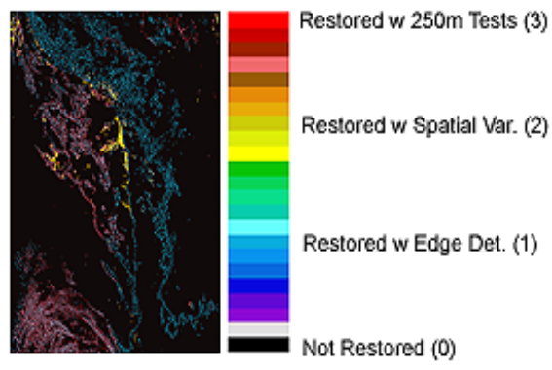  SDS = “Quality_Assurance_1km” (Cloud Optical Properties)
Flag = “Thin Cirrus Flag” ¹ (Low Threshold using 1.38 µm)  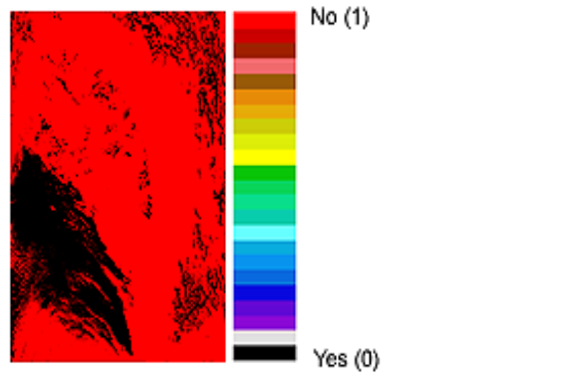  SDS = “Cloud_Mask_1km” (Cloud Mask) |  | Flag = “Cirrus Flag” (CTP ≤ 700 hPa & CEE ≤ 0.95)  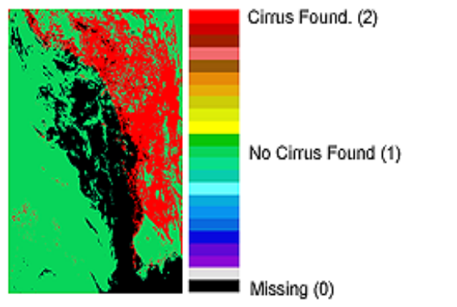  SDS = “Quality_Assurance_5km” (Cloud Top Properties)
Flag = “Multilayer Cloud and Phase Flag”  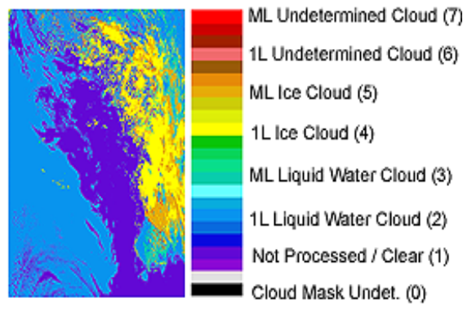  SDS = “Quality_Assurance_1km” (Cloud Optical Properties) |  | Flag = “High Cloud Flag” (CTP < 400 hPa)  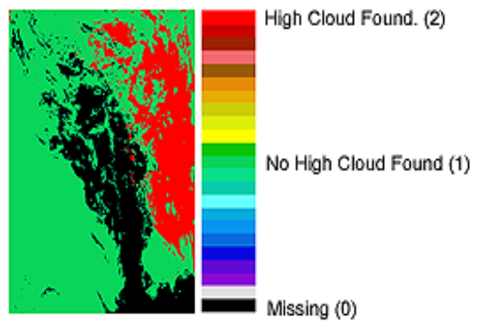  SDS = “Quality_Assurance_5km” (Cloud Top Properties)
¹ Note: “Thin Cirrus Flag” from Cloud Mask is suspect (due to 1.38 µm test limitations) for portions of this granule.
Note: Images were created by “bitflag_visualizer”, available at http://modis-atmos.gsfc.nasa.gov/tools_bitflag_visualizer.html.

Atmospheric Profile Product: MOD07_L2 (Terra) & MYD07_L2 (Aqua)
Atmospheric Profile QA flags are stored in 3 separate QA arrays (SDS’s). The first SDS (Cloud_Mask, 1 byte in length) contains cloud mask QA flags, which are subsampled (every 5th line, every 5th pixel) from the Cloud Mask (35_L2) product. The second SDS (Quality_Assurance, 10 bytes in length) contains the product quality flags, retrieval processing flags, and and input data resource flags for all products except Water Vapor. The third SDS (Quality_Assurance_Infrared, 5 bytes in length) contains the product quality flags, retrieval processing flags, and and input data resource flags for Water Vapor (using the IR method). Detail on the content of these three arrays is provided below. All Atmospheric Profile QA Flag arrays have the following characteristics:
- Spatial resolution: 5 × 5 km
- Processing mode: Both Day and Night

Scientific Data Set (SDS): “Cloud_Mask”
Description: Cloud Mask QA flags subsampled at 5 km (every 5th line, every 5th pixel)
Length: 1 byte (8 bits)
Flag Name | Number of Bits | Bit Values | Bit Value Definitions
Cloud Mask  Status Flag | 1 | 0  1 | Undetermined  Determined
Cloud Mask  Cloudiness Flag | 2 | 0  1  2  3 | Confident Cloudy (or Fill, if Status Flag = 0)  Probably Cloudy  Probably Clear  Confident Clear
Day / Night flag | 1 | 0  1 | Night (or Fill, if Status Flag = 0)  Day
Sunglint Flag | 1 | 0  1 | Yes (or Fill, if Status Flag = 0)  No
Snow / Ice Flag | 1 | 0  1 | Yes (or Fill, if Status Flag = 0)  No
Surface Type Flag | 2 | 0  1  2  3 | Ocean or Deep Lakes and Rivers (or Fill)  Coast or Shallow Lakes and Rivers  Desert  Land

Scientific Data Set (SDS): “Quality_Assurance”
Description: Atmospheric Profile product quality and retrieval processing QA flags at 5x5 km
Length: 10 bytes (80 bits)
Flag Name | Number of Bits | Bit Values | Bit Value Definitions
Retrieved Temperature Profile Usefulness Flag ^{n} | 1 | 0  1 | Not useful  Useful
Retrieved Temperature Profile Confidence Flag ^{n} | 3 | 0  1  2  3 | Bad (or Fill)  Marginal Confidence  Good Confidence (not currently used)  Very Good Confidence (not currently used)
Retrieved Moisture Profile  Usefulness Flag ^{n} | 1 | 0  1 | Not useful  Useful
Retrieved Moisture Profile Confidence Flag ^{n} | 3 | 0  1  2  3 | Bad (or Fill)  Marginal Confidence  Good Confidence (not currently used)  Very Good Confidence (not currently used)
Total Ozone Burden  Usefulness Flag ^{n} | 1 | 0  1 | Not useful  Useful
Total Ozone Burden  Confidence Flag ^{n} | 3 | 0  1  2  3 | Bad (or Fill)  Marginal Confidence  Good Confidence (not currently used)  Very Good Confidence (not currently used)
Stability Indices (Lifted Index) Usefulness Flag ^{n} | 1 | 0  1 | Not useful  Useful
Stability Indices (Lifted Index) Confidence Flag ^{n} | 3 | 0  1  2  3 | Bad (or Fill)  Marginal Confidence  Good Confidence (not currently used)  Very Good Confidence (not currently used)
Stability Indices (K Index)  Usefulness Flag ^{n} | 1 | 0  1 | Not useful  Useful
Stability Indices (K Index) Confidence Flag ^{n} | 3 | 0  1  2  3 | Bad (or Fill)  Marginal Confidence  Good Confidence (not currently used)  Very Good Confidence (not currently used)
Stability Indices (Total Totals) Usefulness Flag ^{n} | 1 | 0  1 | Not useful  Useful
Stability Indices (Total Totals) Confidence Flag ^{n} | 3 | 0  1  2  3 | Bad (or Fill)  Marginal Confidence  Good Confidence (not currently used)  Very Good Confidence (not currently used)
processing path flags
Number of Cloudy Pixels | Int 8 | 0-25 | Number of 1km cloudy pixels in 5x5 km retrieval area
Number of Clear Pixels | Int 8 | 0-25 | Number of 1km clear pixels in 5x5 km retrieval area
Number of Missing Pixels | Int 8 | 0-25 | Number of 1km missing pixels in 5x5 km retrieval area
Method of Profiles Retrieval | 2 | 0  1  2  3 | Statistical  Physical  Other  No retrieval
Method of Ozone Retrieval | 2 | 0  1  2  3 | RTE Perturbation  Upper and Lower stratospheric ozone method  Other  No retrieval
Spares | 4 |  | TBD
input data resource flags
Guess Moisture profile | 2 | 0  1  2  3 | NCEP GDAS  GMAO  AIRS / AMSU  Other
Guess Temperature  Profile | 2 | 0  1  2  3 | NCEP GDAS  GMAO  AIRS / AMSU  Other
Surface Temperature Over Land | 2 | 0  1  2 | NCEP GDAS  GMAO  MOD11* (MODIS Land Surface Temperature)
Surface Temperature Over Ocean | 2 | 0  1  2  3 | Reynolds blended  GMAO  MOD28* (MODIS Sea Surface Temperature)  Other
Surface Pressure | 2 | 0  1  2 | NCEP GDAS  GMAO  Other
Ozone First Guess Profile | 2 | 0  1  2  3 | TOMS  TOVS  GMAO  Other
Spares | 4 |  | TBD
Spares | 8 |  | TBD
* MOD prefix denotes MODIS/Terra (PM overpass) data -- MYD prefix should be substituted for MODIS/Aqua (AM overpass) data.
^{n} Flag is not reliable in Not Useful / Bad regions (i.e. Not Useful pixels are incorrectly tagged as Useful, etc. about ½ the time.)

Scientific Data Set (SDS): “Quality_Assurance_Infrared”
Description: Product quality and retrieval processing flags for Precipitable Water (IR) at 5x5 km
Length: 5 bytes (40 bits)
Flag Name |  | Number of Bits |  | Bit Values |  | Bit Value Definitions
Total Precipitable Water (IR)  Usefulness Flag ^{n} | 1 |  | 0  1 |  | Not useful  Useful
Total Precipitable Water (IR)  Confidence Flag ^{n} | 3 |  | 0  1  2  3 |  | Bad (or Fill)  Marginal Confidence  Good Confidence (not currently used)  Very Good Confidence (not currently used)
Spares | 4 |  |  |  | TBD
Number of Cloudy Pixels | Int 8 |  | 0-25 |  | Number of 1 km Cloudy pixels n 5x5 retrieval area
Number of Clear Pixels | Int 8 |  | 0-25 |  | Number of 1 km Clear pixels in 5x5 retrieval area
Number of Missing Pixels | Int 8 |  | 0-25 |  | Number of 1 km Missing pixels in 5x5 retrieval area
IR Water Vapor Retrieval  Method Used | 2 |  | 0  1  2  3 |  | Split Window (11-12 µm) Technique  Integration of Moisture Profile  Other  No Retrieval
Spares | 6 |  |  |  | TBD
^{n} Flag is not reliable in Not Useful / Bad regions (i.e. Not Useful pixels are incorrectly tagged as Useful, etc. about ½ the time.)

Sample Runtime QA Flag Images
from the Atmospheric Profile Product
Reference L1B Image of Scene 12 Feb 2001 15:10  MODIS Terra (AM) R:G:B = Band 1 : Band 4 : Band 3 |  | Flag = ”Retrieved Temperature Profile Usefulness Flag” ¹  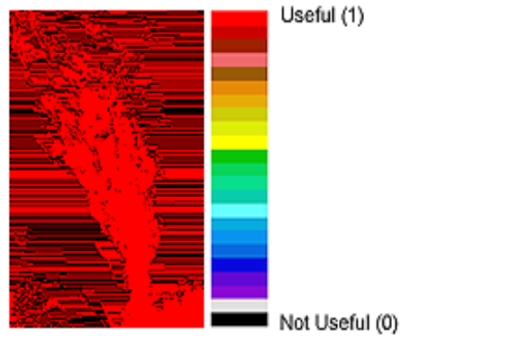  SDS = “Quality_Assurance” (Atmospheric Profile)
Flag = “Cloud Mask Cloudiness Flag”  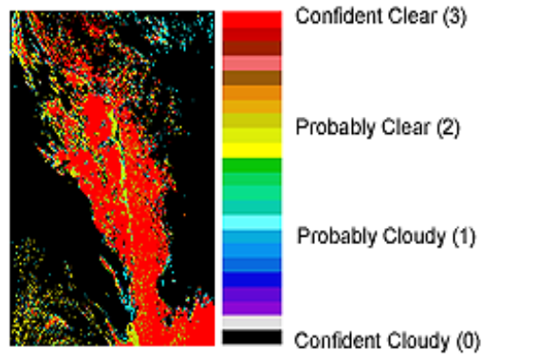  SDS = “Cloud_Mask” (Cloud Mask) |  | Flag = “Method of Ozone Retrieval”  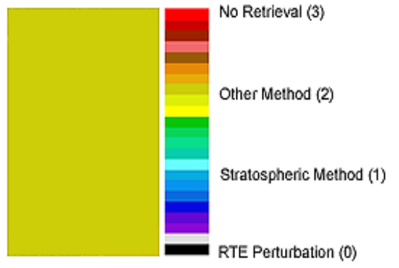  SDS = “Quality_Assurance” (Atmospheric Profile)
¹ All 07_L2 Atmospheric Profile Usefulness (and Confidence) Flags are noisy.
Collection 006 Suggestion: Remove noise from all Usefulness and Confidence Flags in the 07_L2 Atmospheric Profile product.
Note: Images were created by “bitflag_visualizer”, available at http://modis-atmos.gsfc.nasa.gov/tools_bitflag_visualizer.html.
Note: The local version of the Cloud Mask QA flags in the 07_L2 Atmospheric Profile product are stored in an SDS named “Cloud_Mask.” Users should note that this array is different from the primary “Cloud_Mask” array stored in 35_L2 Cloud Mask product, which has the same name.
Cloud Mask Product: MOD35_L2 (Terra) & MYD35_L2 (Aqua)

For the Cloud Mask product, the QA flags are stored in a single ten byte SDS (called Quality_Assurance) containing the product quality flags, retrieval processing flags and input data resource flags. The Cloud Mask QA Flag array has the following characteristics:
- Spatial resolution: 1 × 1 km and 250 × 250 m
- Processing mode: Both Day and Night

Scientific Data Set (SDS): “Quality_Assurance”
Description: Cloud Mask QA flags at 1 km and 250 m
Length: 10 bytes (80 bits)
Flag Name | Number of Bits | Bit Values | Bit Value Definitions
Cloud Mask (1 km)  Usefulness Flag | 1 | 0  1 | Not useful  Useful
Cloud Mask (1 km)  Confidence Flag | 3 | 0  1  2  3 | No Confidence or Fill  Marginal Confidence  Good Confidence  Very Good Confidence
Spares | 4 |  | TBD
individual test application flags
Non Cloud Obstruction (NCO) Test (Spectral tests for fire, smoke, & dust) | 1 | 0  1 | Not Applied  Applied
Thin Cirrus (Solar) Test | 1 | 0  1 | Not Applied  Applied
Shadow Detection Test | 1 | 0  1 | Not Applied  Applied
Thin Cirrus (IR) Test | 1 | 0  1 | Not Applied  Applied
Cloud Adjacency Test | 1 | 0  1 | Not Applied  Applied
IR Threshold Test | 1 | 0  1 | Not Applied  Applied
High Cloud  (CO2) Test | 1 | 0  1 | Not Applied  Applied
High Cloud  (6.7 µm) Test | 1 | 0  1 | Not Applied  Applied
High Cloud  (1.38 µm) Test | 1 | 0  1 | Not Applied  Applied
High Cloud  (3.7-12 µm) Test | 1 | 0  1 | Not Applied  Applied
IR Temperature Difference Test | 1 | 0  1 | Not Applied  Applied
3.7-11 µm Test | 1 | 0  1 | Not Applied  Applied
0.68 µm Reflectance Test | 1 | 0  1 | Not Applied  Applied
Visible Ratio Test | 1 | 0  1 | Not Applied  Applied
Near IR Reflectance Ratio Test | 1 | 0  1 | Not Applied  Applied
3.7-3.9 µm Test | 1 | 0  1 | Not Applied  Applied
Temporal Consistency Test | 1 | 0  1 | Not Applied  Applied
Spatial Variability Test | 1 | 0  1 | Not Applied  Applied
Spares | 6 |  | TBD
250 m Visible Tests  (Repeated 16 times) | 1 (16) | 0  1 | Not Applied  Applied
input data information flags
Number of bands used to generate cloud mask | 2 | 0  1  2  3 | None  1-7  8-14  15-21
Number of spectral tests used to generate cloud mask | 2 | 0  1  2  3 | None  1-3  4-6  7-9
Spares | 4 |  | TBD
input data resource flags
Clear Radiance Origin | 2 | 0  1  2 | MOD35* (MODIS Cloud Mask)  Forward calculation from  NCEP GDAS model  Other
Surface Temperature Over Land | 2 | 0  1  2  3 | NCEP GDAS  GMAO  MOD11* (MODIS Land Surface Temperature)  Other
Surface Temperature Over Ocean | 2 | 0  1  2  3 | Reynolds blended  GMAO  MOD28* (MODIS Sea Surface Temperature)  Other
Surface Winds | 2 | 0  1  2 | NCEP GDAS  GMAO  Other
Ecosystem Map | 2 | 0  1  2  3 | Loveland NA 1 km  Olson Ecosystem  MOD12* (MODIS Land Cover)  Other
Snow Mask | 2 | 0  1  2 | MOD33* (MODIS Snow Cover)  SSMI product  Other
Ice Cover | 2 | 0  1  2 | MOD42* (MODIS Sea Ice)  SSMI product  Other
Land/Sea Mask | 2 | 0  1  2 | USGS 1 km 6 level  USGS 1 km binary  Other
Digital Elevation Model | 1 | 0  1 | EOS DEM  Not used
Precipitable Water | 2 | 0  1  2 | NCEP GDAS  GMAO  MOD07* (MODIS Atmospheric Profile)
Spares | 5 |  | TBD
* MOD prefix denotes MODIS/Terra (PM overpass) data -- MYD prefix should be substituted for MODIS/Aqua (AM overpass) data.
Note: All Cloud Mask Tests are described in the Cloud Mask Algorithm Theoretical Basis Document (ATBD).

Sample Runtime QA Flag Images
from the Cloud Mask Product
Reference L1B Image of Scene 12 Feb 2001 15:10  MODIS Terra (AM) R:G:B = Band 1 : Band 4 : Band 3 |  | Flag = ”Shadow Detection Test”  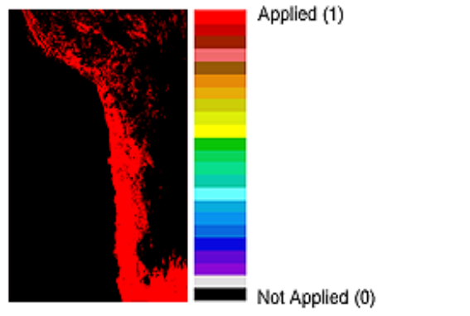  SDS = “Quality_Assurance” (Cloud Mask)
Flag = “Non Cloud Obstruction (NCO) Test”  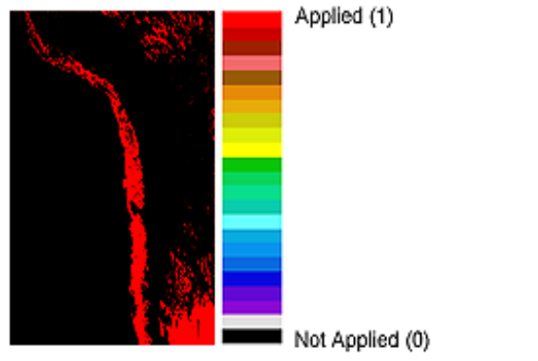  SDS = “Quality_Assurance” (Cloud Mask) |  | Flag = “IR Threshold Test”  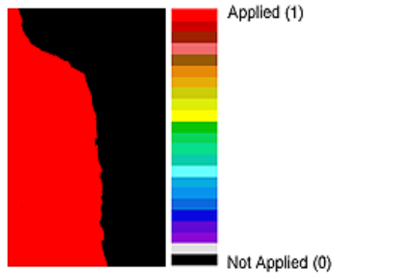  SDS = “Quality_Assurance” (Cloud Mask)
Flag = “Thin Cirrus (Solar) Test”  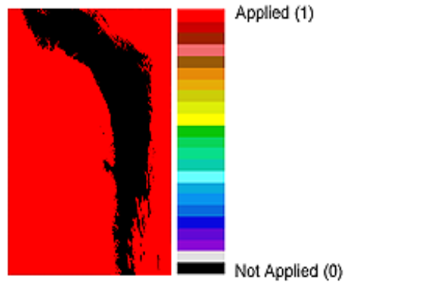  SDS = “Quality_Assurance” (Cloud Mask) |  | Flag = “Ecosystem Map”  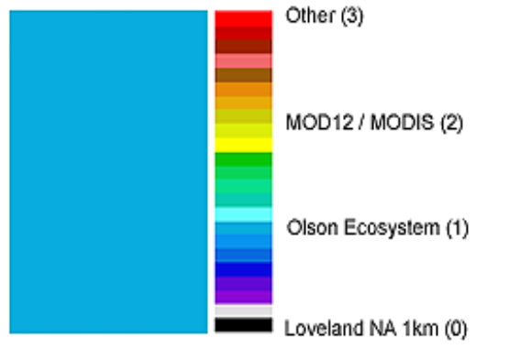  SDS = “Quality_Assurance” (Cloud Mask)
Note: Images were created by “bitflag_visualizer”, available at http://modis-atmos.gsfc.nasa.gov/tools_bitflag_visualizer.html.
Joint Atmosphere Product: MODATML2 (Terra) & MYDATML2 (Aqua)
The post-launch Level 2 (L2) Joint Atmosphere product contains a spectrum of key parameters gleaned from the complete set of standard at-launch L2 products: Aerosol, Water Vapor, Cloud, Profile, and Cloud Mask. The L2 Joint Atmosphere product was designed to provide a convenient way to obtain the “greatest hits”“ of MODIS Atmosphere within a single HDF file — small enough to minimize data transfer and storage requirements, yet robust enough to be useful to a significant number of MODIS data users. Scientific data sets (SDS’‘s) contained within the L2 Joint Atmosphere product are stored at 5 km and 10 km (at nadir) spatial resolutions.
It should be noted that standard L2 parameters, which are retrieved at 1 km resolution, are subsampled at 5 km (every 5th line, every 5th pixel) for inclusion in the L2 Joint Atmosphere Product. This means that the Cloud_Quality_Assurance SDS (detailed below) matches exactly the Quality_Assurance_1km SDS contained within the Cloud (06_L2) product, except that it is sub-sampled at 5 km resolution. The Aerosol_Quality_Assurance array (also detailed below) is stored at its native resolution of 10 km, however it only contains a small subset of the flags found within the source Quality_Assurance_Land and Quality_Assurance_Ocean SDS’s in the Aerosol (04_L2) product. All Joint Atmosphere QA Flag arrays have the following characteristics:
- Spatial resolution: 5x5 km (Cloud Optical Properties) & 10x10 km (Aerosol)
- Processing mode: Daytime only

Scientific Data Set (SDS): “Cloud_Quality_Assurance”
Description: Cloud Optical Property QA flags subsampled at 5 km resolution
Length: 5 bytes (40 bits)
Flag Name | Number of Bits | Bit Values | Bit Value Definitions
Cloud Optical Thickness (τ) Usefulness Flag | 1 | 0  1 | Not useful  Useful
Cloud Optical Thickness (τ) Confidence Flag | 2 | 0  1  2  3 | No Confidence or Fill  Marginal Confidence  Good Confidence  Very Good Confidence
Cloud Optical Thickness (τ)  Out-of-Bounds Flag | 2 | 0  1  2 | Within bounds (0 < τ ≤ 100) or Fill  100 < τ ≤ 150  τ > 150
Cloud Effective Radius  Usefulness Flag | 1 | 0  1 | Not useful  Useful
Cloud Effective Radius  Confidence Flag | 2 | 0  1  2  3 | No Confidence or Fill  Marginal Confidence  Good Confidence  Very Good Confidence
Cloud Water Path  Usefulness Flag | 1 | 0  1 | Not useful  Useful
Cloud Water Path  Confidence Flag | 2 | 0  1  2  3 | No Confidence or Fill  Marginal Confidence  Good Confidence  Very Good Confidence
1.6 / 2.1 μm Cloud Retrieval  Phase Flag  Note: Retrieval performed only over ocean, snow, & ice. Cloud phase determined by Cloud Mask, IR, & SWIR-based decision tree. | 3 | 0  1  2  3  4 | Cloud Mask Undetermined or Non-Snow Land n,ƒ  Not Processed (typ. clear) over Ocean, Snow, Ice ƒ  Liquid Water Cloud  Ice Cloud  Undetermined Phase Cloud
1.6 / 2.1 μm Cloud Retrieval Outcome | 1 | 0  1 | 1.6 / 2.1 μm retrieval not attempted or unsuccesful ƒ  1.6 / 2.1 μm retrieval successful
Spare | 1 |  | TBD
Primary Cloud Retrieval  Phase Flag  Note: Cloud phase determined by Cloud Mask, IR, & SWIR-based decision tree. | 3 | 0  1  2  3  4 | Cloud Mask Undetermined (missing) n,ƒ  Not Processed (typically clear) ƒ  Liquid Water Cloud  Ice Cloud  Undetermined Phase Cloud
Primary Cloud Retrieval  Outcome | 1 | 0  1 | Retrieval not attempted or unsuccesful ƒ  Retrieval successful
Rayleigh Correction | 1 | 0  1 | No  Yes
Atmospheric Correction | 1 | 0  1 | No  Yes
Band Used for Primary Optical Thickness Retrieval | 2 | 0  1  2  3 | Retrieval not attempted ƒ  0.645 µm (land)  0.858 µm (water)  1.24 µm (snow / ice)
1.6 / 2.1 μm Cloud Optical Thickness (τ) Usefulness Flag | 1 | 0  1 | Not useful  Useful
1.6 / 2.1 μm Cloud Optical Thickness (τ) Confidence Flag | 2 | 0  1  2  3 | No Confidence or Fill  Marginal Confidence  Good Confidence  Very Good Confidence
1.6 / 2.1 μm Cloud Effective Radius  Usefulness Flag | 1 | 0  1 | Not useful  Useful
1.6 / 2.1 μm Cloud Effective Radius  Confidence Flag | 2 | 0  1  2  3 | No Confidence or Fill  Marginal Confidence  Good Confidence  Very Good Confidence
Clear Sky Restoral | 2 | 0  1  2  3 | Not Restored  Restored via Edge Detection  Restored via Spatial Variance  Restored via 250 m Tests
1.6 / 2.1 μm Cloud Water Path Usefulness Flag | 1 | 0  1 | Not useful  Useful
1.6 / 2.1 μm Cloud Water Path Confidence Flag | 2 | 0  1  2  3 | No Confidence or Fill  Marginal Confidence  Good Confidence  Very Good Confidence
Primary Cloud Retrieval  Multilayer Cloud &  Phase Flag | 3 | 0  1  2  3  4  5  6  7 | Cloud mask undetermined (missing) n,ƒ  Not Processed (typically clear) ƒ  Single Layer Liquid Water Cloud  Multi Layer Liquid Water Cloud  Single Layer Ice Cloud  Multi Layer Ice Cloud  Single Layer Undetermined Phase Cloud  Multi Layer Undetermined Phase Cloud
Primary Cloud Retrieval Outcome  (flag duplicated from 3rd byte) | 1 | 0  1 | Retrieval not attempted or unsuccesful ƒ  Retrieval successful
Spare | 1 |  | TBD

n Cloud Optical Property retrieval not attempted
ƒ fill values used for Cloud Optical Property retrieval

Scientific Data Set (SDS): “Aerosol_Quality_Assurance”
Description: Aerosol QA flags (a small subset of flags only) at 10x10 km resolution
Length: 1 byte (8 bits)
Flag Name | Number of Bits | Bit Values | Bit Value Definitions
Aerosol Optical Depth Land 0.47 µm Confidence Flag | 2 | 0  1  2  3 | No Confidence or Fill  Marginal Confidence  Good Confidence  Very Good Confidence
Aerosol Optical Depth Land 0.66 µm Confidence Flag | 2 | 0  1  2  3 | No Confidence or Fill  Marginal Confidence  Good Confidence  Very Good Confidence
Aerosol Optical Depth Ocean Avg. Solution Confidence Flag | 2 | 0  1  2  3 | No Confidence or Fill  Marginal Confidence  Good Confidence  Very Good Confidence
Spares | 2 |  | TBD

Appendix B:

Inventory Metadata

of

Atmosphere Products

Introduction
This appendix describes the Inventory Metadata for all MODIS Atmosphere products. Inventory Metadata are searchable strings, stored within each HDF file, that can be used to assist users to select granules that meet predetermined criteria. Inventory Metadata are stored in the HDF global attribute "CoreMetadata.0".
There are two main types of Inventory Metadata:
- ECS (or Core) Inventory Metadata that can be found, in the same format, in all MODIS Atmosphere products. This includes strings that specify Date/Time Range and Bounding Rectangle (geolocation). Note that ECS stands for EOSDIS Core System.
- QA Inventory Metadata, which is product-specific (i.e.: varies from product to product), and typically provides more scientifically revealing information about a granule.
The primary data archive and ordering system that utilizes the full set of both ECS and QA Inventory Metadata to search and sort MODIS HDF granules is the EOS Data Gateway (EDG, http://redhook.gsfc.nasa.gov/ims-bin/pub/nph-ims.cgi).
Other data archive and ordering systems utilize only a small subset of the ECS (Core) Inventory Metadata. This subset of Core Inventory Metadata utilized typically includes only the Date/Time Range and Bounding Rectangle (geolocation) strings. These less powerful, but perhaps more user-friendly, data archive and ordering systems include the MODIS Multiple Data Ordering Page (MDOP, http://disc.gsfc.nasa.gov/daac-bin/MODIS/Data_order.pl?PRINT=1) and the Atmosphere Archive and Distribution System - Web interface (AADSWeb, http://aadsweb.nascom.nasa.gov).

ECS Inventory Metadata
ECS (or Core) Inventory Metadata is high-level information that can be used to help sort MODIS HDF data files based on basic user requirements. Shown in the table below is the Core Inventory Metadata implemented in all (both Level 2 and Level 3) MODIS Atmosphere products. It includes information on granule location, collection day and time, orbit information, percent missing data, science quality and automatic (operational) quality flags specifically defined to be associated with the measured parameters of a product.
The automatic quality flag is set by the MODIS processing facility (either the Goddard DAAC (Distributed Active Archive Center) or MODAPS) at the time the granule is produced. The science quality flag is assigned initially by the science team, and then updated through an update utility, if desired. Both of these flags are associated with a particular retrieval algorithm and apply to all derived SDSs.

All MODIS Atmosphere Products

ECS (or Core) Inventory Metadata
ECS Core Attribute Name | Sample Value (shown for a L2 Joint Product)
LOCALGRANULEID | “MODATML2.A2001043.1510.005.2005105195411.hdf”
PRODUCTIONDATETIME | “2005-04-15T19:54:11.000Z”
DAYNIGHTFLAG | “Day”
LOCALVERSIONID | “005”
REPROCESSINGACTUAL | “processed once”
REPROCESSINGPLANNED | “further update is anticipated”
SHORTNAME | “MODATML2”
VERSIONID | “5”
PGEVERSION | “5.1.0”
INPUTPOINTER † | “MOD03.A2001043.1510.005.2005105143551.hdf,  MOD04_L2.A2001043.1510.005.2005105193145.hdf,  MOD05_L2.A2001043.1510.005.2005105193042.hdf,  MOD06_L2.A2001043.1510.005.2005105195333.hdf,  MOD07_L2.A2001043.1510.005.2005105171354.hdf,  MOD35_L2.A2001043.1510.005.2005105171245.hdf”
Date / Time Range
RANGEBEGINNINGTIME | 15:10:00.000000
RANGEENDINGTIME | 15:15:00.000000
RANGEBEGINNINGDATE | 2001-02-12
RANGEENDINGDATE | 2001-02-12
Bounding Rectangle
EASTBOUNDINGCOORDINATE | -58.4177095990599
WESTBOUNDINGCOORDINATE | -85.5363614515652
NORTHBOUNDINGCOORDINATE | -11.9871990497647
SOUTHBOUNDINGCOORDINATE | -33.0740234458278
Orbit Calculated Spatial Domain
ORBITNUMBER.1 | 6149
EQUATORCROSSINGLONGITUDE.1 | -66.1949490630604
EQUATORCROSSINGDATE.1 | 2001-02-12
EQUATORCROSSINGTIME.1 | 15:06:12.273251
Measured Parameter
PARAMETERNAME.1 | “Cloud_Top_Pressure” (example)
SCIENCEQUALITYFLAG.1 | “Not Investigated”
SCIENCEQUALITYFLAGEXPLANATION.1 | “See http://modis-atmos.gsfc.nasa.gov/validation.html for more details on MODIS Atmosphere data quality.”
AUTOMATICQUALITYFLAG.1 | “Passed”
AUTOMATICQUALITYFLAGEXPLANATION.1 | “Passed: >10% useable; Failed: <10% useable”
QAPERCENTMISSINGDATA.1 # | 23
† MODIS product input files # Pertains to Measured ParameterName and refers to 23% of granule being clear (no CTP retrieval)

QA Inventory Metadata
In addition to the ECS (or Core) Inventory Metadata described above, product-specific QA Inventory Metadata is used to accommodate the QA needs of each specific Level 2 (only) MODIS Atmosphere product. There is no QA Inventory Metadata defined or stored for Level 3 Atmosphere products.
The QA Inventory Metadata includes statistics reported by either the MODIS cloud mask algorithm or by the product generation algorithm itself. For all L2 MODIS atmosphere products, the QA Inventory Metadata may include:
- % successful rate of retrieval
- % low confidence clear sky
- % various cloud types
- % non-cloud obstruction
- % day processed
- % night processed
- maximum solar zenith angle
- minimum solar zenith angle

- % land processed
- % water processed
- % snow background processed
- % shadow processed
- % sunglint processed

An important feature of QA Inventory Metadata is its searchability. A user can skip an entire granule of data if the requested criteria are not satisfied, or can examine the granule in more detail if criteria are satisfied. Detailed descriptions of product-specific QA Inventory Metadata for each MODIS Atmosphere product follows.

Aerosol Product: MOD04_L2 (Terra) & MYD04_L2 (Aqua)
QA Inventory Metadata (Note: Denominator in all Percentages = Total Pixels in entire Granule)
Field Name | Field Description | Sample Value ^
Aerosol Retrieval
AdditionalAttributeName.1 | SuccessfulRetrievalPct_Land 1 | 9.10
AdditionalAttributeName.2 | SuccessfulRetrievalPct_Ocean 2 | 15.77
Cloud and Non Cloud Obstructions
AdditionalAttributeName.3 | LowConfidentClearPct m | 69.15
AdditionalAttributeName.11 | ThinCirrusSolarFoundPct m | 22.56
AdditionalAttributeName.12 | ThinCirrusIR_FoundPct m | 3.48
AdditionalAttributeName.13 | NonCloudObstructionFoundPct m | 0.25
Day/Night
AdditionalAttributeName.4 | DayProcessedPct m | 100.00
AdditionalAttributeName.5 | NightProcessedPc m | 0.00
Solar Zenith Angle
AdditionalAttributeName.14 | MaxSolarZenithAnglem | 40.53
AdditionalAttributeName.15 | MinSolarZenithAnglem | 14.10
Scene Surface Type
AdditionalAttributeName.8 | LandProcessedPct m | 51.99
AdditionalAttributeName.9 | WaterProcessedPct m | 48.01
AdditionalAttributeName.7 | Snow_IceSurfaceProcessPct m | 0.00
AdditionalAttributeName.10 | ShadowFoundPct m | 0.08
AdditionalAttributeName.6 | SunglintProcessPct m, i | 48.07
1 For the Aerosol over Land algorithm, only clear-sky, dark-surface land pixels are retrieved.
2 For the Aerosol over Ocean algorithm, only clear-sky, non-glint ocean pixels are retrieved.
m Fields are COPIED from the Cloud Mask QA Inventory Metadata and apply to a 1x1 km resolution analysis of granule.
i Incorrectly computed (based on solar and viewing geometry only -- did not consider whether the pixel is over land or water).
^ Sample Values from MODIS/Terra 12 Feb 2001 15:10
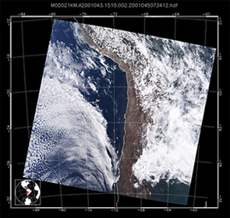
Water Vapor Product: MOD05_L2 (Terra) & MYD05_L2 (Aqua)
QA Inventory Metadata (Note: Denominator in all Percentages = Total Pixels in entire Granule)
Field Name | Field Description | Sample Value ^
Water Vapor Retrieval
AdditionalAttributeName.1 | SuccessfulRetrievalPct_NIR 1 | 99.62
AdditionalAttributeName.2 | SuccessfulRetrievalPct_IR 2 | 30.75
Cloud and Non Cloud Obstructions
AdditionalAttributeName.3 | LowConfidentClearPct m | 69.15
AdditionalAttributeName.11 | ThinCirrusSolarFoundPct m | 22.56
AdditionalAttributeName.12 | ThinCirrusIR_FoundPct m | 3.48
AdditionalAttributeName.13 | NonCloudObstructionFoundPct m | 0.25
Day/Night
AdditionalAttributeName.4 | DayProcessedPct m | 100.00
AdditionalAttributeName.5 | NightProcessedPct m | 0.00
Solar Zenith Angle
AdditionalAttributeName.14 | MaxSolarZenithAngle m | 40.53
AdditionalAttributeName.15 | MinSolarZenithAngle m | 14.10
Scene Surface Type
AdditionalAttributeName.8 | LandProcessedPct m | 51.99
AdditionalAttributeName.9 | WaterProcessedPct m | 48.01
AdditionalAttributeName.7 | Snow_IceSurfaceProcessPct m | 0.00
AdditionalAttributeName.10 | ShadowFoundPct m | 0.08
AdditionalAttributeName.6 | SunglintProcessPct m, ^{i} | 48.07
1 For the Near IR Water Vapor algorithm, all non-missing pixels are retreived (but only bright-land & ocean-glint pixels are reliable).
Collection 006 Suggestion: Fix SuccessfulRetrievalPct_NIR computation so the numerator = “reliable (useful) retrievals only”.
2 For the IR Water Vapor algorithm, only clear-sky pixels (over both land and ocean) are retreived.
m Fields are COPIED from the Cloud Mask QA Inventory Metadata and apply to a 1x1 km resolution analysis of granule.
i Incorrectly computed (based on solar and viewing geometry only -- did not consider whether the pixel is over land or water).
^ Sample Values from MODIS/Terra 12 Feb 2001 15:10

Cloud Product: MOD06_L2 (Terra) & MYD06_L2 (Aqua)
QA Inventory Metadata (Note: Denominator in all Percentages = Total Pixels in entire Granule)
Field Name |  | Field Description |  | Sample Value ^
Cloud Top Property Retrieval
AdditionalAttributeName.1 |  | SuccessCloudTopPropRtrPct_IR 1 |  | 77.12
AdditionalAttributeName.2 |  | SuccessCloudPhaseRtrPct_IR 1 |  | 76.75
AdditionalAttributeName.4 |  | LowCloudDetectedPct_IR |  | 19.77
AdditionalAttributeName.5 |  | MidCloudDetectedPct_IR |  | 38.91
AdditionalAttributeName.6 |  | HighCloudDetectedPct_IR |  | 18.44
AdditionalAttributeName.8 |  | ThickCloudDetectedPct_IR |  | 28.21
AdditionalAttributeName.7 |  | ThinCloudDetectedPct_IR |  | 6.44
 |  |  |  | 42.47
AdditionalAttributeName.9 |  | OpaqueCloudDetectedPct_IR |  | 42.47
AdditionalAttributeName.10 |  | CirrusCloudDetectedPct_IR |  | 34.65
AdditionalAttributeName.12 |  | WaterCloudDetectedPct_IR |  | 49.69
AdditionalAttributeName.11 |  | IceCloudDetectedPct_IR |  | 13.05
 |  |  |  | 9.15
AdditionalAttributeName.13 |  | MixedCloudDetectedPct_IR |  | 4.86
AdditionalAttributeName.14 |  | CloudPhaseUncertainPct_IR |  | 9.15
Cloud Optical Property Retrieval
AdditionalAttributeName.3 |  | SuccessCloudOptPropRtrPct_VIS (succsesful retrievals only) |  | 64.32
AdditionalAttributeName.18 |  | CloudCoverFractionPct_VIS (successful & unsuccessful) |  | 67.56
AdditionalAttributeName.19 |  | WaterCloudDectectedPct_VIS (successful & unsuccessful) |  | 45.54
AdditionalAttributeName.20 |  | IceCloudDetectedPct_VIS (successful & unsuccessful) |  | 20.86
Scene Surface Type
AdditionalAttributeName.16 |  | LandCoverFractionPct m |  | 51.99
AdditionalAttributeName.15 |  | OceanCoverFractionPct m |  | 48.01
AdditionalAttributeName.17 |  | SnowCoverFractionPct m |  | 0.00
1 Only 5x5 km grids determined to be cloudy are retrieved. CTP algorithms “detect” more clouds than Cloud Mask and Optical Prop. algorithms due to 5x5 avg’ing. CloudTopPropertyIR and CloudPhaseIR pcts. are different due to different bands being used.
m Fields are COPIED from the Cloud Mask QA Inventory Metadata and apply to a 1x1 km resolution analysis of granule.
^ Sample Values from MODIS/Terra 12 Feb 2001 15:10

Atmospheric Profile Product: MOD07_L2 (Terra) & MYD07_L2 (Aqua)
QA Inventory Metadata (Note: Denominator in all Percentages = Total Pixels in entire Granule)
Field Name | Field Description | Sample Value ^
Atmospheric Profile Retrieval
AdditionalAttributeName.1 | SuccessfulRetrievalPct 1 | 30.75
Cloud and Non Cloud Obstructions
AdditionalAttributeName.2 | LowConfidenceClearPct m | 69.15
AdditionalAttributeName.10 | ThinCirrusSolarFoundPct m | 22.56
AdditionalAttributeName.11 | ThinCirrusIR_FoundPct m | 3.48
AdditionalAttributeName.12 | NonCloudObstructionFoundPct m | 0.25
Day/Night
AdditionalAttributeName.3 | DayProcessedPct m | 100.00
AdditionalAttributeName.4 | NightProcessedPct m | 0.00
Solar Zenith Angle
AdditionalAttributeName.13 | MaxSolarZenithAngle m | 40.53
AdditionalAttributeName.14 | MinSolarZenithAngle m | 14.10
Scene Surface Type
AdditionalAttributeName.7 | LandProcessedPct m | 51.99
AdditionalAttributeName.8 | WaterProcessedPct m | 48.01
AdditionalAttributeName.6 | Snow_IceSurfaceProcessPct m | 0.00
AdditionalAttributeName.9 | ShadowFoundPct m | 0.08
AdditionalAttributeName.5 | SunglintProcessPct m, i | 48.07
1 For the Atmospheric Profiles algorithm, only clear-sky pixels (either land or ocean) are retreived.
m Fields are COPIED from the Cloud Mask QA Inventory Metadata and apply to a 1x1 km resolution analysis of granule.
i Incorrectly computed (based on solar and viewing geometry only -- did not consider whether the pixel is over land or water).
^ Sample Values from MODIS/Terra 12 Feb 2001 15:10
Cloud Mask Product: MOD35_L2 (Terra) & MYD35_L2 (Aqua)
QA Inventory Metadata (Note: Denominator in all Percentages = Total Pixels in entire Granule)
Field Name | Field Description | Sample Value ^
Cloud Mask Retrieval
AdditionalAttributeName.1 | SuccessfulRetrievalPct 1 | 100.00
Cloud and Non Cloud Obstructions
AdditionalAttributeName.7 | ClearPct250m | 34.90
AdditionalAttributeName.6 | CloudCoverPct250m | 65.10
AdditionalAttributeName.2 | VeryHighConfidenceClearPct | 23.78
AdditionalAttributeName.3 | HighConfidenceClearPct | 5.09
AdditionalAttributeName.4 | UncertainConfidentClearPct | 1.98
AdditionalAttributeName.5 | LowConfidentClearPct | 69.15
AdditionalAttributeName.15 | ThinCirrusSolarFoundPct | 22.56
AdditionalAttributeName.16 | ThinCirrusIR_FoundPct | 3.48
AdditionalAttributeName.17 | NonCloudObstructionFoundPct | 0.25
Day/Night
AdditionalAttributeName.8 | DayProcessedPct | 100.00
AdditionalAttributeName.9 | NightProcessedPct | 0.00
Solar Zenith Angle
AdditionalAttributeName.18 | MaxSolarZenithAngle | 40.53
AdditionalAttributeName.19 | MinSolarZenithAngle | 14.10
Scene Surface Type
AdditionalAttributeName.12 | LandProcessedPct | 51.99
AdditionalAttributeName.13 | WaterProcessedPct | 48.01
AdditionalAttributeName.11 | Snow_IceSurfaceProcessPct | 0.00
AdditionalAttributeName.14 | ShadowFoundPct | 0.08
AdditionalAttributeName.10 | SunglintProcessPct i | 48.07
1 For the Cloud Mask algorithm, all non-missing L1B pixels are retrieved.
i Incorrectly computed (based on solar and viewing geometry only -- did not consider whether the pixel is over land or water).
Collection 006 Suggestion: Fix the SunglintProcessPct computation (noted above). Fix will propagate to other L2 products.
^ Sample Values from MODIS/Terra 12 Feb 2001 15:10
Joint Atmosphere Product: MODATML2 (Terra) & MYDATML2 (Aqua)
QA Inventory Metadata (Note: Denominator in all Percentages = Total Pixels in entire Granule)
Field Name | Field Description | Sample Value ^
Aerosol Retrieval
AdditionalAttributeName.18 | SuccessfulRetrievalPct_Land 1 | 9.10
AdditionalAttributeName.19 | SuccessfulRetrievalPct_Ocean 2 | 15.77
Water Vapor Retrieval
AdditionalAttributeName.20 | SuccessfulRetrievalPct_NIR 3 | 99.62
AdditionalAttributeName.21 | SuccessfulRetrievalPct_IR 4 | 30.75
Cloud Top Property Retrieval
AdditionalAttributeName.22 | SuccessCloudTopPropRtrPct_IR 5 | 77.12
AdditionalAttributeName.23 | SuccessCloudPhaseRtrPct_IR 5 | 76.75
Cloud Optical Property Retrieval
AdditionalAttributeName.24 | SuccessCloudOptPropRtrPct_VIS (succsesful retrievals only) | 64.32
AdditionalAttributeName.25 | CloudCoverFractionPct_VIS (successful & unsuccessful) | 67.56
AdditionalAttributeName.26 | WaterCloudDectectedPct_VIS (successful & unsuccessful) | 45.54
AdditionalAttributeName.27 | IceCloudDetectedPct_VIS (successful & unsuccessful) | 20.86
Cloud Mask Retrieval
AdditionalAttributeName.1 | SuccessfulRetrievalPct m | 100.00
Cloud and Non Cloud Obstructions
AdditionalAttributeName.12 | VeryHighConfidentClearPct m | 23.78
AdditionalAttributeName.13 | HighConfidentClearPct m | 5.09
AdditionalAttributeName.14 | UncertainConfidentClearPct m | 1.98
AdditionalAttributeName.15 | LowConfidentClearPct m | 69.15
AdditionalAttributeName.16 | ThinCirrusSolarFoundPct m | 22.56
AdditionalAttributeName.17 | ThinCirrusIR_FoundPct m | 3.48
AdditionalAttributeName.9 | NonCloudObstructionFoundPct m | 0.25
Day/Night
AdditionalAttributeName.2 | DayProcessedPct m | 100.00
AdditionalAttributeName.3 | NightProcessedPct m | 0.00
Solar Zenith Angle
AdditionalAttributeName.10 | MaxSolarZenithAngle m | 40.53
AdditionalAttributeName.11 | MinSolarZenithAngle m | 14.10
Scene Surface Type
AdditionalAttributeName.4 | LandProcessedPct m | 51.99
AdditionalAttributeName.5 | WaterProcessedPct ^{m} | 48.01
AdditionalAttributeName.6 | Snow_IceSurfaceProcessedPct m | 0.00
AdditionalAttributeName.7 | ShadowFoundPct m | 0.08
AdditionalAttributeName.8 | SunglintProcessedPct m, i | 48.07
1 For Aerosol over Land algorithm, only clear-sky, dark-surface land pixels are retrieved.
2 For Aerosol over Ocean algorithm, only clear-sky, non-glint ocean pixels are retrieved.
3 For Near IR Water Vapor, all non-missing pixels are retreived (but only bright-land & ocean-glint pixels are reliable).
4 For IR Water Vapor, only clear-sky pixels (land and ocean) are retreived. (Note: This number matches Atm Profile SuccessPct).
5 Only 5x5 km grids determined to be cloudy are retrieved. CTP algorithms “detect” more clouds than Cloud Mask and Optical Prop. algorithms due to 5x5 avg’ing. CloudTopPropertyIR and CloudPhaseIR pcts. are different due to different bands being used.
m Fields are COPIED from the Cloud Mask QA Inventory Metadata and apply to a 1x1 km resolution analysis of granule.
i Incorrectly computed (based on solar and viewing geometry only -- did not consider whether the pixel is over land or water).

^ Sample Values from MODIS/Terra 12 Feb 2001 15:10

Appendix C:

Archive Metadata

of

Atmosphere Products

Introduction
This appendix describes the Archive Metadata for all MODIS Atmosphere products. Archive Metadata, stored in the HDF global attribute "ArchiveMetadata.0", are designed to report summary statistics and information pertaining to a granule for documentation purposes only.
Archive metadata is stored (archived) along with science data sets of each granule. These values are not searchable. Archive Metadata is defined in both Level 2 and Level 3 MODIS Atmosphere products.
Arguably, the two most useful pieces of information in the Archive Metadata are the LocalInputGranuleID and ProductionHistory strings.
- The LocalInputGranuleID contains a full list of input files used to create the HDF product file in question. Input files can include other MODIS HDF product files (typically L1B Calibrated Radiances and/or L2 Cloud Mask) and additional ancillary files (such as algorithm specific look-up libraries, and/or snow, albedo and ecosystem maps) needed to run the L2 product algorithm.
- The ProductionHistory contains the program executable (PGE) version that was used to produce the HDF product file. This allows users to trace the maturity and quality of HDF data products. Specific changes incorporated into various versions of PGEs can be found in the Products section of the MODIS Atmosphere web site at http://modis-atmos.gsfc.nasa.gov/products_calendar_pge03.html (Note that the link specified is for PGE03, which produces the Cloud Mask and Atmospheric Profiles products. All other MODIS Atmosphere PGE’s can be selected through the menu on the left hand side of this page).
The complete set of archive metadata for each MODIS Atmosphere product is described below.

Aerosol Product: MOD04_L2 (Terra) & MYD04_L2 (Aqua)
Archive Metadata
Field name | Sample Value
LONGNAME | “MODIS/Terra Aerosol 5-Min L2 Swath 10km”
PROCESSINGENVIRONMENT | “Linux minion5027 2.4.20-37.7.legacysmp #1 SMP Mon Sep 27  21:38:15 EDT 2004 i686 unknown”
ALGORITHMPACKAGEACCEPTANCE DATE | “June-1997”
ALGORITHMPACKAGEMATURITYCODE | “at-launch”
ALGORITHMPACKAGENAME # | “ATBD-MOD-02”
ALGORITHMPACKAGEVERSION | “2”
INSTRUMENTNAME | “Moderate Resolution Imaging Spectroradiometer”
LOCALINPUTGRANULEID † | “MOD03.A2001043.1510.005.2005105143551.hdf,  MOD021KM.A2001043.1510.005.2005105163716.hdf,  MOD35_L2.A2001043.1510.005.2005105171245.hdf”
EXCLUSIONGRINGFLAG | “N”
GRINGPOINTLATITUDE | (-11.9657643150703, -15.1127398445589, -33.2616100115919,  -29.5206668804633)
GRINGPOINTLONGITUDE | (-79.8034155352806, -58.1828178475367, -61.0282026524014,  -85.5445842551903)
GRINGPOINTSEQUENCENO | (1, 2, 3, 4)
VERYGOODQUALITYDATAPCT_LAND | 0.00
GOODQUALITYDATAPCT_LAND | 100.00
MARGINALQUALITYDATAPCT_LAND | 0.00
BADQUALITYDATAPCT_LAND | 0.00
VERYGOODQUALITYDATAPCT_OCEAN | 64.65
GOODQUALITYDATAPCT_OCEAN | 3.80
MARGINALQUALITYDATAPCT_OCEAN | 15.96
BADQUALITYDATAPCT_OCEAN | 17.00
ALGORITHMSOFTWAREVERSIONLAND | 2
ALGORITHMSOFTWAREVERSIONOCEAN | 2
DESCRREVISION | 5.0
PRODUCTIONHISTORY | PGE04:5.1.0
# Refers to Algorithm Theoretical Basis Document (ATBD) reference number

† MODIS product input files
Water Vapor Product: MOD05_L2 (Terra) & MYD05_L2 (Aqua)
Archive Metadata
Field name | Sample Value
LONGNAME | “MODIS/Terra Total Precipitable Water Vapor 5-Min L2 Swath  1km and 5km”
PROCESSINGENVIRONMENT | “Linux minion5027 2.4.20-37.7.legacysmp #1 SMP Mon Sep 27  21:38:15 EDT 2004 i686 unknown”
ALGORITHMPACKAGEACCEPTANCEDATE | “June 1997”
ALGORITHMPACKAGEMATURITYCODE | “at-launch”
ALGORITHMPACKAGENAME # | “ATBD-MOD-03”
ALGORITHMPACKAGEVERSION | “2”
INSTRUMENTNAME | “Moderate Resolution Imaging Spectroradiometer”
LOCALINPUTGRANULEID † | “MOD03.A2001043.1510.005.2005105143551.hdf,  MOD021KM.A2001043.1510.005.2005105163716.hdf,  MOD35_L2.A2001043.1510.005.2005105171245.hdf,  MOD07_L2.A2001043.1510.005.2005105171354.hdf”
EXCLUSIONGRINGFLAG | “N”
GRINGPOINTLATITUDE | (-11.9657643150703, -15.1127398445589, -33.2616100115919,  -29.5206668804633)
GRINGPOINTLONGITUDE | (-79.8034155352806, -58.1828178475367, -61.0282026524014,  -85.5445842551903)
GRINGPOINTSEQUENCENO | (1, 2, 3, 4)
ALGORITHMSOFTWAREVERSION_NIR | 2
ALGORITHMSOFTWAREVERSION_IR | 2
DESCRREVISION | 5.0
PRODUCTIONHISTORY | PGE04:5.1.0
# Refers to Algorithm Theoretical Basis Document (ATBD) reference number

† MODIS product input files
Cloud Product: MOD06_L2 (Terra) & MYD06_L2 (Aqua)
Archive Metadata
Field name | Sample Value
LONGNAME | “MODIS/Terra Clouds 5-Min L2 Swath 1km and 5km”
PROCESSINGENVIRONMENT | “Linux minion5027 2.4.20-37.7.legacysmp #1 SMP Mon Sep 27  21:38:15 EDT 2004 i686 unknown”
ALGORITHMPACKAGEACCEPTANCE DATE | “June-1997”
ALGORITHMPACKAGEMATURITYCODE | “at-launch”
ALGORITHMPACKAGENAME # | “ATBD-MOD-04 and ATBD-MOD-05”
ALGORITHMPACKAGEVERSION | 2
INSTRUMENTNAME | “Moderate Resolution Imaging Spectroradiometer”
LOCALINPUTGRANULEID † | “MOD021KM.A2001043.1510.005.2005105163716.hdf,  MOD03.A2001043.1510.005.2005105143551.hdf,  MOD35_L2.A2001043.1510.005.2005105171245.hdf,  Library_water.hdf.v1,  Library_ice.hdf.v2,  Transmittance.hdf.v2,  AlbMap.WS.vb1.0.2001.033.0.659.hdf,  AlbMap.WS.vb1.0.2001.033.0.858.hdf,  AlbMap.WS.vb1.0.2001.033.1.24.hdf,  AlbMap.WS.vb1.0.2001.033.1.64.hdf,  AlbMap.WS.vb1.0.2001.033.2.13.hdf,  AlbSnwSts.ByNISE.W90.D90.WS.Lats.70.40.2000-2004.Oct.Jan.hdf,  IGBP.EcoMap.NtoS.2004.149.v004.hdf”
EXCLUSIONGRINGFLAG | “N”
GRINGPOINTLATITUDE | (-11.9657643150703, -15.1127398445589, -33.2616100115919, -29.5206668804633)
GRINGPOINTLONGITUDE | (-79.8034155352806, -58.1828178475367, -61.0282026524014, -85.5445842551903)
GRINGPOINTSEQUENCENO | (1, 2, 3, 4)
ALGORITHM_VERSION_CLOUD_TOP_PROPERTY_IR | 1
ALGORITHM_VERSION_CLOUD_PHASE_IR | 1
ALGORITHM_VERSION_CLOUD_PROPERTY_VIS | 1
DESCRREVISION | 5.0
PRODUCTIONHISTORY | PGE06:5.3.0
# Refers to Algorithm Theoretical Basis Document (ATBD) reference number

† MODIS product input files
Atmospheric Profile Product: MOD07_L2 (Terra) & MYD07_L2 (Aqua)
Archive Metadata
Field name | Sample Value
LONGNAME | “MODIS/Terra Temperature and Water Vapor Profiles  5-Min L2 Swath 5km”
PROCESSINGENVIRONMENT | "“Linux minion352 2.4.18-27.7.xsmp #1 SMP Fri Mar 14  05:52:30 EST 2003 i686 unknown"”
INSTRUMENTNAME | “Moderate Resolution Imaging Spectroradiometer”
ALGORITHMPACKAGEACCEPTANCE DATE | “June 1997”
ALGORITHMPACKAGEMATURITYCODE | “at-launch”
ALGORITHMPACKAGENAME # | “ATBD-MOD-07”
ALGORITHMPACKAGEVERSION | “2”
LOCALINPUTGRANULEID † | "“MOD021KM.A2001043.1510.005.2005105163716.hdf,  MOD03.A2001043.1510.005.2005105143551.hdf,  MOD35_L2.A2001043.1510.005.2005105171245.hdf,  gdas1.PGrbF00.010212.18z,  MODIS_REGCOEF_FACTORS.terra.v5,  MODIS_senzen.bin,  terra_bias.dat.v2,  terra_det.dat.v2"”
EXCLUSIONGRINGFLAG | “N”
GRINGPOINTLATITUDE | (-11.9657643150703, -15.1127398445589, -33.2616100115919,  -29.5206668804633)
GRINGPOINTLONGITUDE | (-79.8034155352806, -58.1828178475367, -61.0282026524014,  -85.5445842551903)
GRINGPOINTSEQUENCENO | (1, 2, 3, 4)
PROFILES_ALGORITHM_VERSION_NUMBER | 1
STABILITY_INDICES_ALGORITHM_VERSION_NUMBER | 1
TOTAL_OZONE_ALGORITHM_VERSION_NUMBER | 1
DESCRREVISION | 5.0
PRODUCTIONHISTORY | PGE03:5.1.5
# Refers to Algorithm Theoretical Basis Document (ATBD) reference number

† MODIS product input files
Cloud Mask Product: MOD35_L2 (Terra) & MYD35_L2 (Aqua)
Archive Metadata
Field name | Sample Value
LONGNAME | “MODIS/Terra Cloud Mask and Spectral Test Results  5-Min L2 Swath 250m and 1km”
PROCESSINGENVIRONMENT | "“Linux minion352 2.4.18-27.7.xsmp #1 SMP Fri Mar 14 05:52:30 EST  2003 i686 unknown"”
INSTRUMENTNAME | "“Moderate Resolution Imaging Spectroradiometer”
ALGORITHMPACKAGEACCEPTANCE DATE | “June-1997”
ALGORITHMPACKAGEMATURITYCODE | “at-launch”
ALGORITHMPACKAGENAME # | “ATBD-MOD-06”
ALGORITHMPACKAGEVERSION | “2”
LOCALINPUTGRANULEID † | "“MOD03.A2001043.1510.005.2005105143551.hdf,  MOD021KM.A2001043.1510.005.2005105163716.hdf,  MOD02QKM.A2001043.1510.005.2005105163716.hdf,  goge1_2_img.v1,  ecosystem.img.v1,  thresholds.dat.terra.v13,  gdas1.PGrbF00.010212.18z,  oisst.20010214,  eng.010213,  NISE_SSMIF13_20010212.HDFEOS”
EXCLUSIONGRINGFLAG | “N”
GRINGPOINTLATITUDE | (-11.9657643150703, -15.1127398445589, -33.2616100115919,  -29.5206668804633)
GRINGPOINTLONGITUDE | (-79.8034155352806, -58.1828178475367, -61.0282026524014,  -85.5445842551903)
GRINGPOINTSEQUENCENO | (1, 2, 3, 4)
CLOUD_MASK_ALGORITHM_VERSION_NUMBER | 1.00
DESCRREVISION | 5.0
PRODUCTIONHISTORY | PGE03:5.1.5
# Refers to Algorithm Theoretical Basis Document (ATBD) reference number

† MODIS product input files
Joint Atmosphere Product: MODATML2 (Terra) & MYDATML2 (Aqua)
Archive Metadata
Field name | Sample Value
LONGNAME | “MODIS/Terra Aerosol, Cloud and Water Vapor Subset 5-Min L2 Swath 5km and 10km”
PROCESSINGENVIRONMENT | “Linux minion5027 2.4.20-37.7.legacysmp #1 SMP Mon Sep 27 21:38:15 EDT  2004 i686 unknown”
INSTRUMENTNAME | “Moderate Resolution Imaging Spectroradiometer”
EXCLUSIONGRINGFLAG | “N”
GRINGPOINTLATITUDE | (-11.9657643150703, -15.1127398445589, -33.2616100115919, -29.5206668804633)
GRINGPOINTLONGITUDE | (-79.8034155352806, -58.1828178475367, -61.0282026524014, -85.5445842551903)
GRINGPOINTSEQUENCENO | (1, 2, 3, 4)
DESCRREVISION | 5.0
PRODUCTIONHISTORY | PGE83:5.1.0
Collection 006 Suggestions:
1.) Include a string of PGE’s (reflecting the L2 MODIS Atmosphere input products), as was done for L3
(e.g., PRODUCTIONHISTORY = "PGE03:5.1.5; PGE06:5.3.0; PGE04:5.1.0; PGE83:5.1.0")
2.) Add LocalInputGranuleID string and populate with the four L2 MODIS Atmosphere input product HDF file names, as is done for all other products. (Note that “InputPointer” in ECS (Core) Inventory Metadata duplicates this info.)

Daily Global Product: MOD08_D3 (Terra) & MYD08_D3 (Aqua)
Archive Metadata
Field name | Sample Value
LONGNAME | “MODIS/Terra Aerosol Cloud Water Vapor Ozone Daily L3 Global 1Deg CMG”
PROCESSINGENVIRONMENT | “IRIX64 mtvs2 6.5 10070055 IP35”
LOCALINPUTGRANULEID | †
DESCRREVISION | 5.0
PRODUCTIONHISTORY | PGE03:5.1.5;PGE06:5.3.0;PGE04:5.1.0;PGE69:5.1.1;PGE56:5.1.1
† MODIS product input files (nearly 1200 L2 MODIS HDF file names)

Eight Day Global Product: MOD08_E3 (Terra) & MYD08_E3 (Aqua)
Archive Metadata
Field name | Sample Value
LONGNAME | “MODIS/Terra Aerosol Cloud Water Vapor Ozone Eight Day L3 Global 1Deg CMG”
PROCESSINGENVIRONMENT | “IRIX64 mtvs2 6.5 10070055 IP35”
LOCALINPUTGRANULEID | †
DESCRREVISION | 5.0
PRODUCTIONHISTORY | PGE03:5.1.5;PGE06:5.3.0;PGE04:5.1.0;PGE69:5.1.1;PGE56:5.1.1;PGE70:5.1.0
† MODIS product input files (up to 8 L3 Daily MODIS HDF file names)

Monthly Global Product: MOD08_M3 (Terra) & MYD08_M3 (Aqua)
Archive Metadata
Field name | Sample Value
LONGNAME | “MODIS/Terra Aerosol Cloud Water Vapor Ozone Monthly L3 Global 1Deg CMG”
PROCESSINGENVIRONMENT | “IRIX64 mtvs2 6.5 10070055 IP35”
LOCALINPUTGRANULEID | †
DESCRREVISION | 5.0
PRODUCTIONHISTORY | PGE03:5.1.5;PGE06:5.3.0;PGE04:5.1.0;PGE69:5.1.1;PGE56:5.1.1;PGE57:5.1.0
† MODIS product input files (up to 31 L3 Daily MODIS HDF file names)

