0 Disaster News
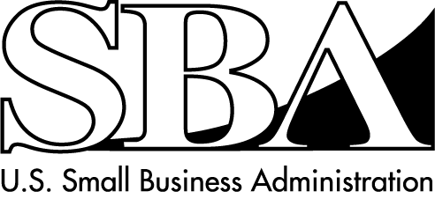
Economic Injury Loans for Small Businesses

SBA Disaster Assistance – Field Operations Center- East - One Baltimore Place, Suite 300 - Atlanta, GA 30308
_____________________________________________________________________________________________________________________________________

Release Date: September 7, 2007 Contact: Michael Lampton
Release Number: 07-682, VT 11025 Phone: (404) 347-3771

SBA Offers Disaster Assistance To Vermont Businesses
Economically Affected By Fire

WASHINGTON – Steven Preston, Administrator of the U.S. Small Business Administration (SBA) announced that low-interest disaster loans are available in the county of Orange and the adjacent counties of Addison, Caledonia, Washington and Windsor in the State of Vermont and Grafton County in the State of New Hampshire for businesses affected by the fire on May 7, 2007. Administrator Preston took this action following an August 30, 2007 letter from Vermont Governor James H. Douglas requesting a SBA disaster declaration.

“We look forward to working with the State of Vermont in making our loans available to small businesses that sustained economic injury due to the fire,” said Administrator Preston. “We will be swift in our efforts to help the business owners with their working capital needs.”

Eligible small businesses may qualify for loans up to $1.5 million. Interest rates are available at 4 percent with loan terms up to 30 years. SBA determines eligibility for the loans based on the size and type of the business and its financial resources. Loan amounts and terms are set by SBA and based upon each applicant’s financial condition.

“SBA can help these small businesses overcome their economic losses by offering these working capital loans, but the help cannot start until they submit an SBA Disaster Loan application to us,” said Darcy U. Carter, SBA’s Vermont Acting District Director.

Applications and program information are available by calling the SBA’s Customer Service Center at
1-800-659-2955 (1-800-877-8339 for the hearing-impaired), Monday through Friday from 8 a.m. until 9 p.m.; Saturday from 9 a.m. to 5:30 p.m. EDT. Business loan applications can also be downloaded from the SBA website at www.sba.gov/services/disasterassistance. Completed applications should be mailed to: U.S. Small Business Administration, Processing and Disbursement Center, 14925 Kingsport Road, Fort Worth, TX. 76155.

Completed loan applications must be returned to SBA no later than June 6, 2008.

###

For more information about the SBA’s Disaster Loan Programs, visit our website at www.sba.gov/services/disasterassistance

