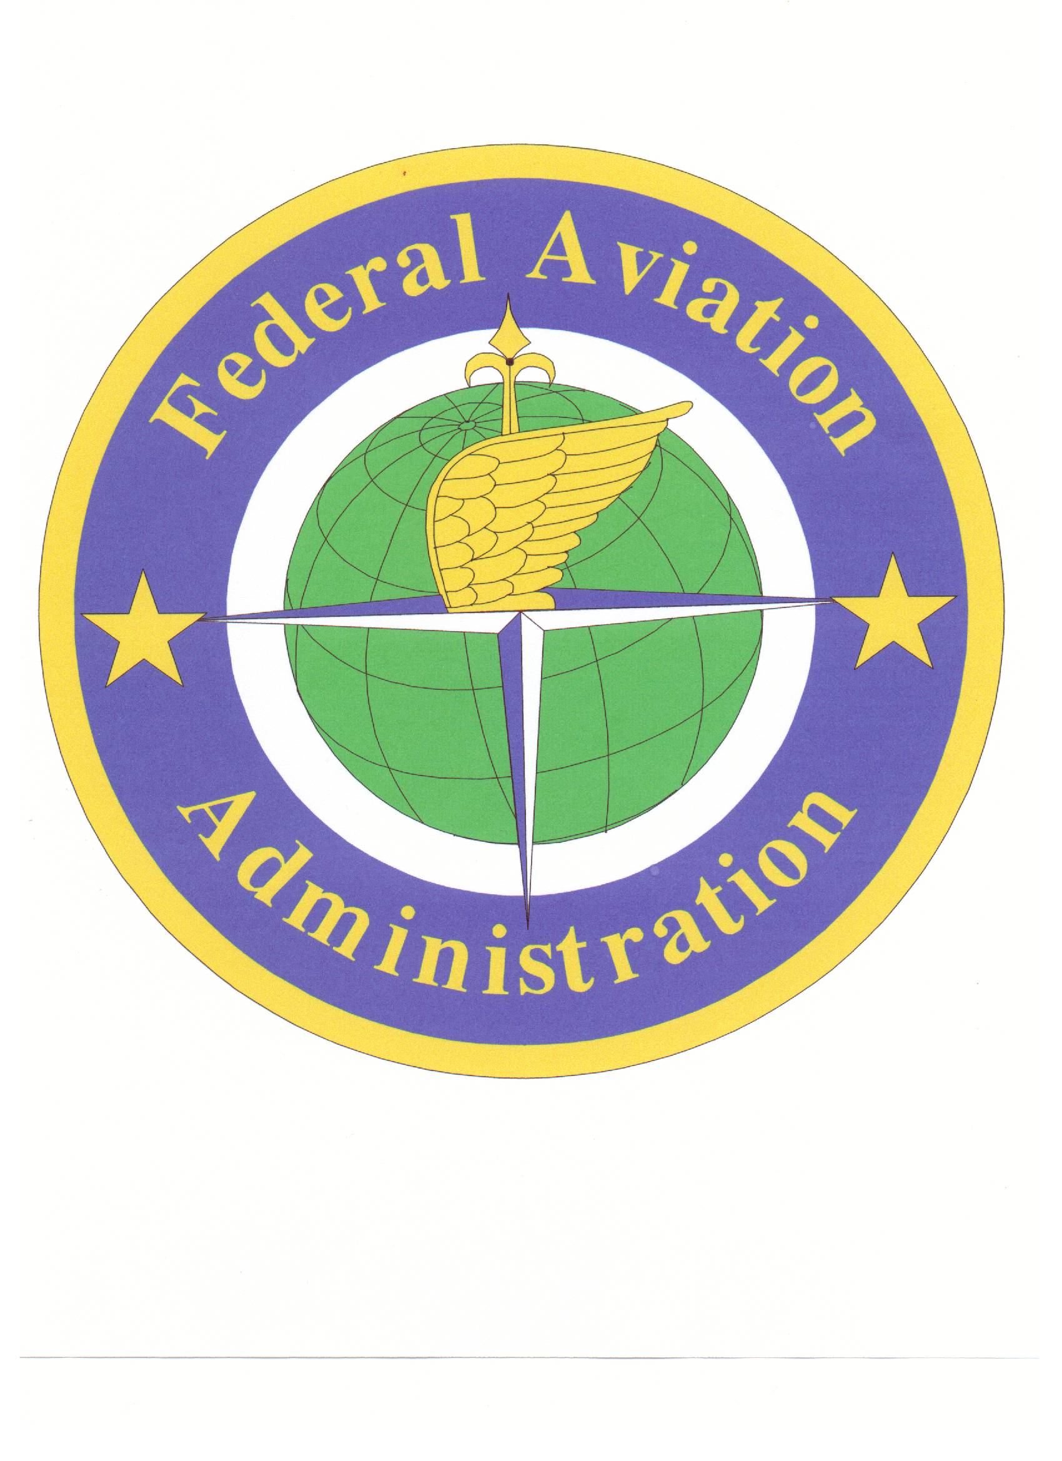
2007 PACIFIC AVIATION DIRECTORS’ WORKSHOP

Fostering Aviation Safety & Infrastructure Development Thru Government & Industry Partnerships

March 26 – 29, 2007

Bai ra Chamayong, Koror, Palau

Conference Registration Form

Please fax this registration form to (680) 587-3502 – Attention Sicely Tadao

Registration is also available via email: airport@palaunet.com
(Note: If registering by email, please be sure to include all of the information shown below.)

If you have any questions regarding registration or need additional information, please call (680) 587-3539.

No registration fee will be charged for this workshop. Please submit registration form no later than March 5, 2007.

Future correspondence will be sent to the below address, fax number and/or email address.

Please indicate dates attending: Monday, 3/26__________ Tuesday, 3/27__________
Wednesday, 3/28 ________ Thursday, 3/29_________

Nickname for Badge_________________________ email Address_________________________

Full Name_______________________________________________________________________

Title___________________________________________________________________________

Airport/Company________________________________________________________________

Address________________________________________________________________________

City/State/Zip/Country____________________________________________________________

Telephone Number____________________________ Fax Number________________________

Please indicate if you require special accommodations (i.e. large print, accessible parking, taped material, etc.) and attach a description of your needs.

Confirmation will be faxed (or emailed upon request). An information packet will be provided to each participant at the beginning of the Workshop.

