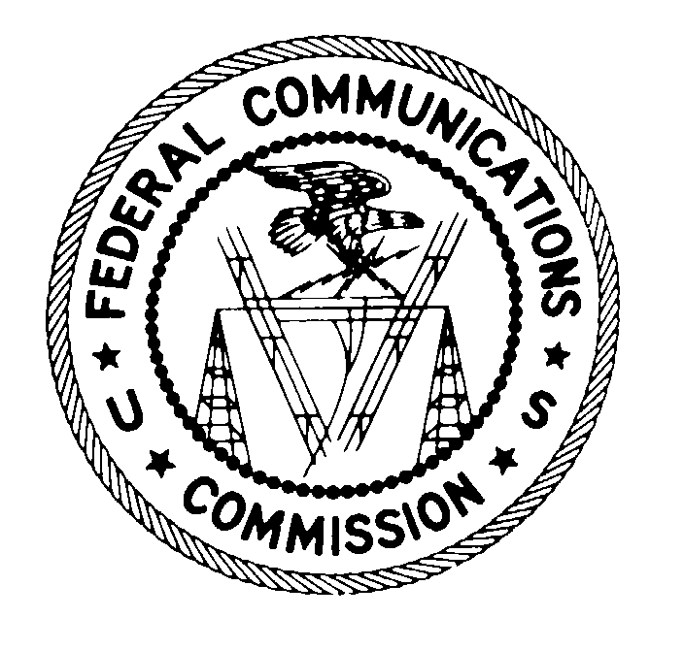
FEDERAL COMMUNICATIONS COMMISSION
WASHINGTON, D.C. 20554

June 12, 2007

VIA CERTIFIED MAIL
RETURN RECEIPT REQUESTED

Best Buy Store # 581
100 Consumer Square
Hamilton Mall
Mays Landing, NJ 08330

Best Buy, Inc.
7601 Penn Avenue South
Richfield, MN 55423
Attn.: Joseph M. Joyce
Senior Vice President and General Counsel

Re: File No. EB-07-PA-153
Citation No.: C20073240025

Dear Retailer:

This is an official CITATION, issued pursuant to Section 503(b)(5) of the Communications Act of 1934, as amended (“Act”), 47 U.S.C. § 503(b)(5), to Best Buy Store # 581 and Best Buy, Inc. (collectively “Best Buy”) for failure to provide appropriate Consumer Alert disclosures on analog tuner only television receiving equipment in violation of Section 15.117(k) of the Commission’s Rules (“Rules”), 47 C.F.R. § 15.117(k). As explained below, future violations of the Commission’s rules in this regard may subject your company to monetary forfeitures.

On June 5, 2007, agents from the Enforcement Bureau’s Philadelphia Office visited Best Buy Store # 581 and observed that Best Buy did not have the proper Consumer Alert label displayed on equipment that contained an analog tuner but not a digital tuner at the point of sale.

Section 15.117(k) of the Commission’s Rules states:

(k) The following requirements apply to all responsible parties, as defined in §2.909 of this chapter, and any person that displays or offers for sale or rent television receiving equipment that is not capable of receiving, decoding and tuning digital signals.

(1) Such parties and persons shall place conspicuously and in close proximity to such television broadcast receivers a sign containing, in clear and conspicuous print, the Consumer Alert disclosure text required by subparagraph (3). The text should be in a size of type large enough to be clear, conspicuous and readily legible, consistent with the dimensions of the equipment and the label. The information may be printed on a transparent material and affixed to the screen, if the receiver includes a display, in a manner that is removable by the consumer and does not obscure the picture, or, if the receiver does not include a display, in a prominent location on the device, such as on the top or front of the device, when displayed for sale, or the information in this format may be displayed separately immediately adjacent to each television broadcast receiver offered for sale and clearly associated with the analog-only model to which it pertains.

(2) If such parties and persons display or offer for sale or rent such television broadcast receivers via direct mail, catalog, or electronic means, they shall prominently display in close proximity to the images or descriptions of such television broadcast receivers, in clear and conspicuous print, the Consumer Alert disclosure text required by subparagraph (3). The text should be in a size large enough to be clear, conspicuous, and readily legible, consistent with the dimensions of the advertisement or description.

(3) “CONSUMER ALERT
This television receiver has only an analog broadcast tuner and will require a converter box after February 17, 2009, to receive over-the-air broadcasts with an antenna because of the Nation’s transition to digital broadcasting. Analog-only TVs should continue to work as before with cable and satellite TV services, gaming consoles, VCRs, DVD players, and similar products. For more information, call the Federal Communications Commission at 1-888-225-5322 (TTY: 1-888-835-5322) or visit the Commission’s digital television website at: www.dtv.gov.”

Accordingly, it appears that Best Buy has violated Section 15.117(k) of the Rules by failing to place conspicuously and in close proximity to the following equipment, in clear and conspicuous print, the required Consumer Alert label:

Manufacturer | Device | Model # | Number of Units
Magnavox | 20” TV/DVD Combo | 20MF251W | 1

We caution you that failure to display an appropriate Consumer Alert label on any television receiving equipment that is not capable of receiving, decoding and tuning digital signals would constitute a further violation of Section 15.117(k) of the Rules.

If, after receipt of this citation, Best Buy engages in conduct of the type described herein, in violation of the Communications Act or the Commission’s rules, the Commission may impose monetary forfeitures not to exceed $11,000 for each such violation or each day of a continuing violation up to $97,500 for a single continuing violation.

If you choose to do so, you may respond to this citation within 10 days from the date of this letter either through (1) a personal interview at the Commission’s Field Office nearest to your place of business, or (2) a written statement. Your response should specify the actions that Best Buy is taking to ensure that it does not violate Section 15.117(k) of the Commission’s rules in the future.

If you choose to request a personal interview, the closest FCC Office is Federal Communications Commission, Philadelphia Office, One Oxford Valley Building, Suite 404, 2300 East Lincoln Highway, Langhorne, Pennsylvania 19047. You should contact this office by telephone, (XXX) XXXX-XXXX to schedule this interview, which must take place within 10 days of this Citation. Alternatively, as noted above, Best Buy may submit a written statement to the above address within 10 days of the date of this Citation. Any written statements should specify what actions have been taken to correct the violation outlined above. Please reference file number EB-07-PA-153 when corresponding with the Commission.

Under the Privacy Act of 1974, 5 U.S.C. § 552a(e)(3), we are informing you that the Commission’s staff will use all relevant material information before it, including information that you disclose in your interview or written statement, to determine what, if any, enforcement action is required to ensure your compliance with the Communications Act and the Commission’s rules.

The knowing and willful making of any false statement, or the concealment of any material fact, in reply to this citation is punishable by fine or imprisonment under 18 U.S.C. § 1001.

Thank you in advance for your anticipated cooperation.

Sincerely,

FEDERAL COMMUNICATIONS COMMISSION

Gene J. Stanbro
District Director
Philadelphia Office
Northeast Region
Enforcement Bureau

See 47 C.F.R. § 1.80(b)(3).
? 47 U.S.C. § 503(b)(5).

