0BHEAVY USE AREA PROTECTION

1BPRACTICE INTRODUCTION

USDA, Natural Resources Conservation Service―Practice Code 561

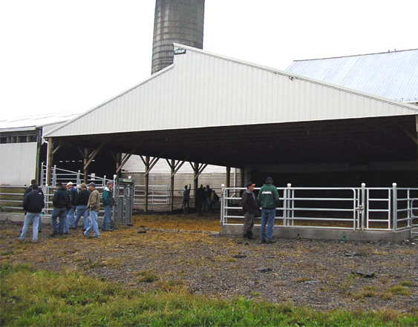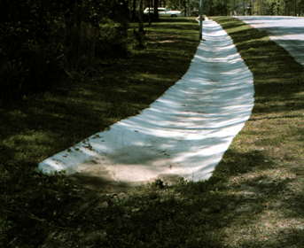

2BHEAVY USE AREA PROTECTION
Heavy use area protection is the establishment of a stable surface with suitable materials and any needed structures to protect areas heavily impacted by livestock, vehicles or development.

3BPRACTICE INFORMATION
This practice is usually applied on agricultural land or developed land used intensively by livestock, vehicles, and people. Treatment provided by this practice is primarily for erosion control, but also addresses other types of natural resource degradation including aesthetics.
The prescribed surface treatment is designed to accommodate the specific type of traffic expected to occur. Surface treatment may involve pavement for vehicle traffic, or vegetation may provide sufficient protection for people and animal traffic.
Impermeable surfaces such as pavement increase runoff. Therefore, provision for drainage is always considered when planning this practice.

4B

COMMON ASSOCIATED PRACTICES
Heavy Use Area Protection is commonly used in a Conservation Management System with practices such as Prescribed Grazing (528), Vegetated Treatment Area (635), Nutrient Management (590), Waste Storage Facility (313), Roof Runoff Structure (558), Filter Strip (393), and practices for erosion and sediment control.
For further information, refer to the practice standard in the local Field Office Technical Guide and associated job sheets.

Start
Note: Effects are qualified with a plus (+) or minus (-). These symbols indicate only an increase (+) or a decrease (-) in the effect upon the resource, not whether the effect is beneficial or adverse.

LEGEND
#. Created by practice
D. Direct effect
I. Indirect effect
C. Cumulative effect
Pathway
(+) increase; (-) decrease
Mitigating practice or activity
Associated practice
I.4 (+/-) Nutrients, organics and pathogens to ground and surface waters
I.5 (-) Contaminated runoff to ground and surface waters: nutrients, pathogens, and organics
C.2 (+) Stream fauna, e.g., fish, invertebrates
D.4 (+) Collectable manure for treatment
I.2 (-) Downslope deposition

Heavy Use Area Protection
4/2007
I.1 (-) Erosion
C.4 (+) Public/private health, safety, and aesthetics
Nutrient Management (590)
Waste Utilization (633)
Waste Storage Facility (313)
C.1 (+) Water quality and aquatic habitats
I.3 (-) On- and offsite maintenance costs
C.3 (+/-) Income and income stability (individuals and community)
I.16 (+) Recreational opportunities
D.2 (+) Cost of installation, operation and maintenance
I.9 (+/-) Net return
I.14 (-) Inorganic fertilizer inputs/costs
1. Develop appropriate foundation and protect area by establishing vegetative cover, surfacing with suitable materials, and/or installing needed structures
Heavy Use Area Protection (561)
Initial settings:
1. Established AFO needing a stable surface area for livestock, equipment or vehicles; or
2. Intensively used development area needing treatment to address an erosion or water quality problem
Roof Runoff Structure (558)
Filter Strip (393)
Wastewater Treatment Strip (635)
D.3 (+) Trafficability
I.10 (+) Livestock health
I.12 (-) Wear and tear on equipment
I.11 (+) Productivity, and potential income
I.13 (-) Maintenance costs
D.1 (+) Controlled runoff from area
I.15 (-) Odors
I.8 (+) Dissolved oxygen in surface waters
I.6 (-) Cost of future regulatory compliance
I.7 (-) Noxious algal and weed growth
(-)
(+)
Other treatment measures

