Weekly Report - Snowpack / Drought Monitor Update Date: November 15, 2007

SNOTEL SNOWPACK AND PRECIPITATION SUMMARY

Snow: Although very early into this year’s snowfall season, the majority of higher SNOTEL sites over Wyoming (Fig. 1) show the greatest above normal snow water equivalent values in the West. The remainder of the West is essentially without snow cover except for the highest peaks in the Northwestern States.

Temperature: During the past seven days, temperatures were up to 10 degrees F above normal across the Central Rockies to near normal over the Northern Cascades (Fig.2).

Precipitation: For the past week, scattered precipitation fell across the Western States with the exception of Arizona, New Mexico, Colorado, and east-central Montana where little if any occurred (Fig. 3). For the 2008 Water Year that began on October 1, 2007, precipitation (rain and snow water equivalent) is above normal over the Intermountain West (Idaho and Northern Nevada) and over Wyoming’s Rockies and Bighorn Mountain Ranges. Dryness increases the further south one travels across the West (Fig. 3a).

WESTERN DROUGHT STATUS
The West: Light to moderate precipitation spread across much of the West outside of the arid Southwest and the mountains of Colorado. Temperatures averaged 4 to 8 degrees or more above normal over the interior West. With 60-day precipitation well above normal, D3 drought was eliminated from eastern Idaho. D2 transitioned to D1 in north-central Idaho. D2 receded in eastern Oregon. The moisture eliminated the D3 areas in Montana, and D1 improved to D0 in southwestern Montana. Author: Douglas Le Comte, Climate Prediction Center, NOAA/NWS
A comprehensive narrative describing drought conditions for the nation can be found at the end of this document.

DROUGHT IMPACTS DEFINITIONS (http://drought.unl.edu/dm/classify.htm)
The possible impacts associated with D4 (H, A) drought include widespread crop/pasture losses and shortages of water in reservoirs, streams, and wells creating water emergencies. The possible impacts associated with D3 (H, A) drought include major crop/pasture losses and widespread water shortages or restrictions. Possible impacts from D2 (H, A) drought are focused on water shortages common and water restrictions imposed and crop or pasture losses likely. The possible impacts associated with D1 (H, A) drought are focused on water shortages developing in streams, reservoirs, or wells, and some damage to crops and pastures (Figs.4, 4a, and 4b).

SOIL MOISTURE
Soil moisture (Fig.5), is simulated by the VIC macroscale hydrologic model. The detailed, physically-based VIC model is driven by observed daily precipitation and temperature maxima and minima from approximately 2130 stations, selected for reporting reliably in real-time and for having records of longer than 45 years (and various other criteria).

OBSERVED FIRE DANGER CLASS
The National Interagency Coordination Center provides a variety of products that describe the current wildfire status for the U.S. - http://www.nifc.gov/information.html. The latest Observed Fire Danger Class is shown in Figs. 6and 6a shows the current active wildfires across the West - http://geomac.usgs.gov/.

U.S. HISTORICAL STREAMFLOW

This map, (Fig. 7) shows the 7-day average streamflow conditions in hydrologic units of the United States and Puerto Rico for the day of year. The colors represent 7-day average streamflow percentiles based on historical streamflow for the day of the year. Thus, the map shows conditions adjusted for this time of the year. Only stations having at least 30 years of record are used. Sub-regions shaded gray indicate that insufficient data were available to compute a reliable 7-day average streamflow value. During winter months, this situation frequently arises due to ice effects. The data used to produce this map are provisional and have not been reviewed or edited. They may be subject to significant change.

http://water.usgs.gov/cgi-bin/waterwatch?state=us&map_type=dryw&web_type=map.

VEGETATION HEALTH
The images (Fig. 8) are color-coded maps of vegetation condition (health) estimated by the Vegetation and Temperature Condition Index (VT). The VT is a numerical index, which changes from 0 to 100 characterizing change in vegetation conditions from extremely poor (0) to excellent (100). Fair conditions are coded by green color (50), which changes to brown and red when conditions deteriorate and to blue when they improve.
http://www.orbit.nesdis.noaa.gov/smcd/emb/vci/usa.html.

STATE ACTIVITIES
State government drought activities can be tracked at the following URL: http://drought.unl.edu/mitigate/mitigate.htm. NRCS SS/WSF State Office personnel are participating in state drought committee meetings and providing the committees and media with appropriate SS/WSF information - http://www.wcc.nrcs.usda.gov/cgibin/bor.pl. Additional information describing the products available from the Drought Monitor can be found at the following URL: http://drought.unl.edu/dm/

FOR MORE INFORMATION
The National Water and Climate Center Homepage provide the latest available snowpack and water supply information. Please visit us at http://www.wcc.nrcs.usda.gov. This document is available from the following location on the NWCC homepage - http://www.wcc.nrcs.usda.gov/water/drought/wdr.pl

This report uses data and products provided by the Interagency Drought Monitor Consortium members and the National Interagency Fire Center.

/s/ NOLLER HERBERT
Director, Conservation Engineering Division

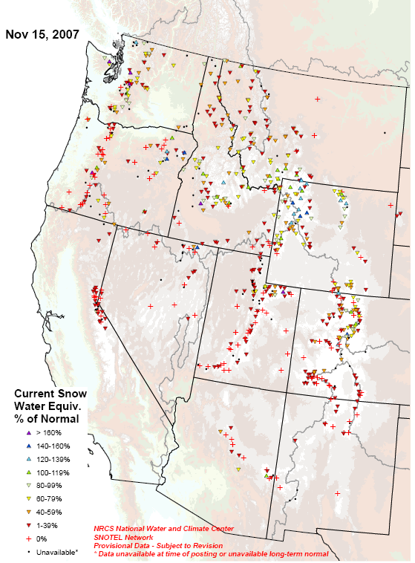

Fig 1. Very early season snow water equivalent percent of normal for the 2008 Water Year that began on October 1, 2007. Ref: ftp://ftp.wcc.nrcs.usda.gov/data/water/wcs/gis/maps/WestwideSWEPercent.pdf

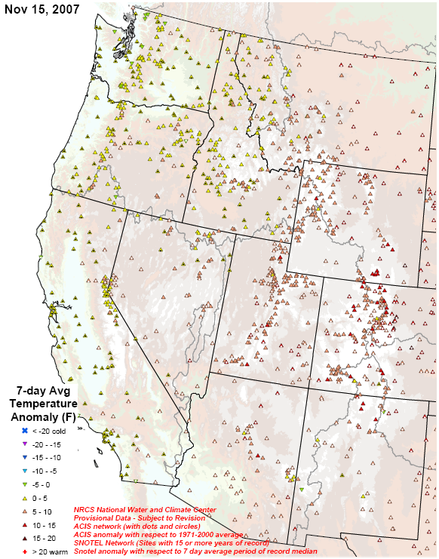

Fig.2. SNOTEL and ACIS 7-day average temperature anomaly.
Ref: ftp://ftp.wcc.nrcs.usda.gov/data/water/wcs/gis/maps/WestwideTavg7dAnomalyAcis.pdf
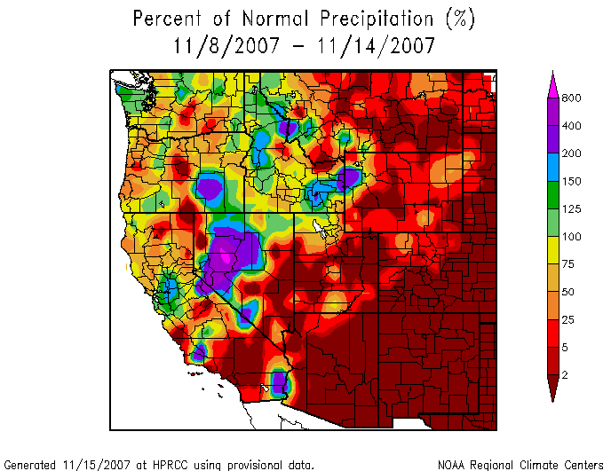
Fig. 3. Preliminary precipitation totals for the 7-day period ending 14 November 2007 shows no significant precipitation across Arizona, New Mexico and much of Colorado. Ref: http://www.hprcc.unl.edu/maps/index.php?action=update_product&product=PNorm

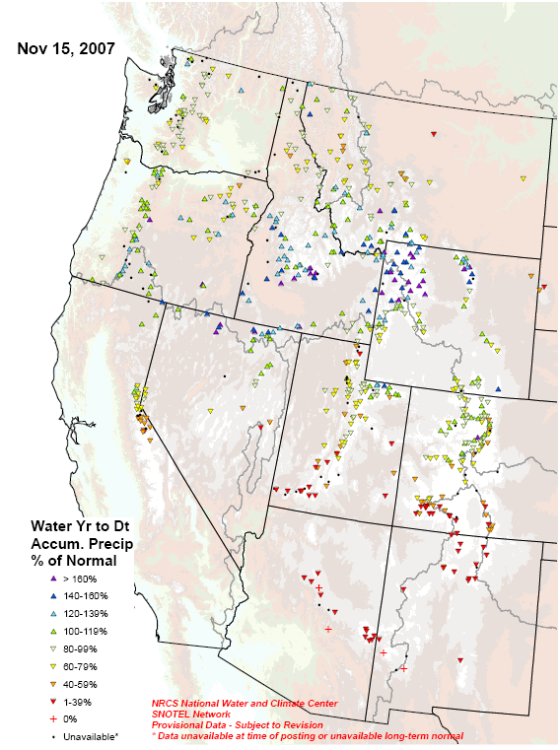

Fig 3a. Very early season precipitation (rain & snow water equivalent) as a percent of normal for the 2008 Water Year that began on October 1, 2007. Ref: ftp://ftp.wcc.nrcs.usda.gov/data/water/wcs/gis/maps/WestwideWYTDPrecipPercent.pdf
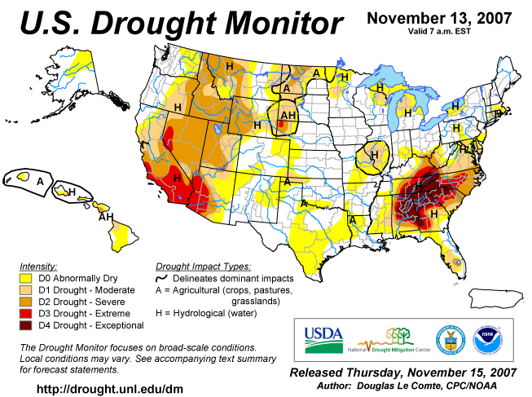

Fig. 4. Current Drought Monitor weekly summary and classification changes over several time periods. Ref: National Drought Mitigation Center (NDMC) - http://www.drought.unl.edu/dm/monitor.html
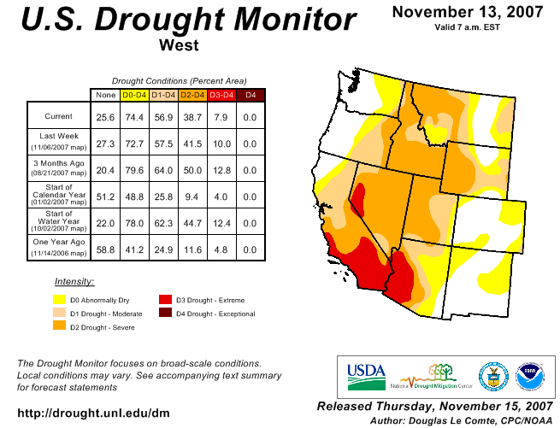
Fig. 4a. Drought Monitor for the Western States with statistics over various time periods. Note slight improvement since last week’s map. Ref: http://www.drought.unl.edu/dm/DM_west.htm
Fig. 4b. Drought Monitor for Tennessee and the Southeastern States with statistics over various time periods shows some of the severest drought conditions in the US. Note some worsening over the Southeast during the past week.
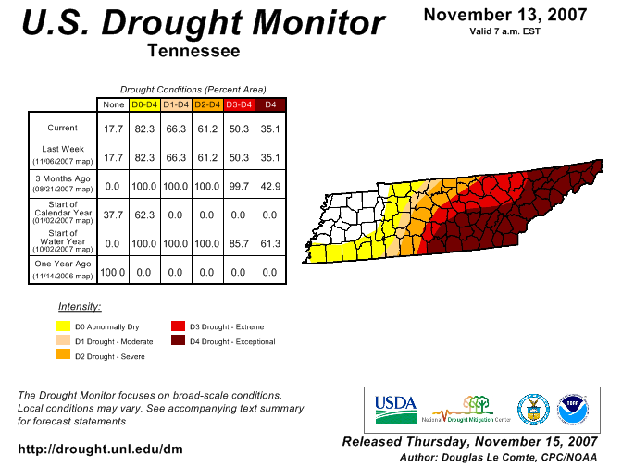

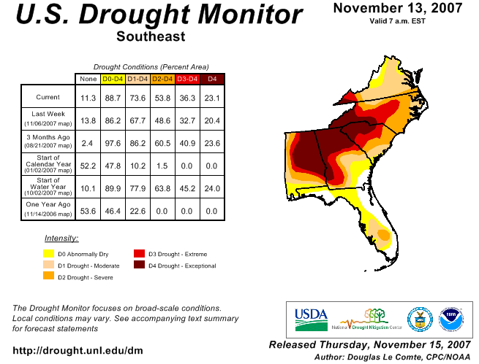

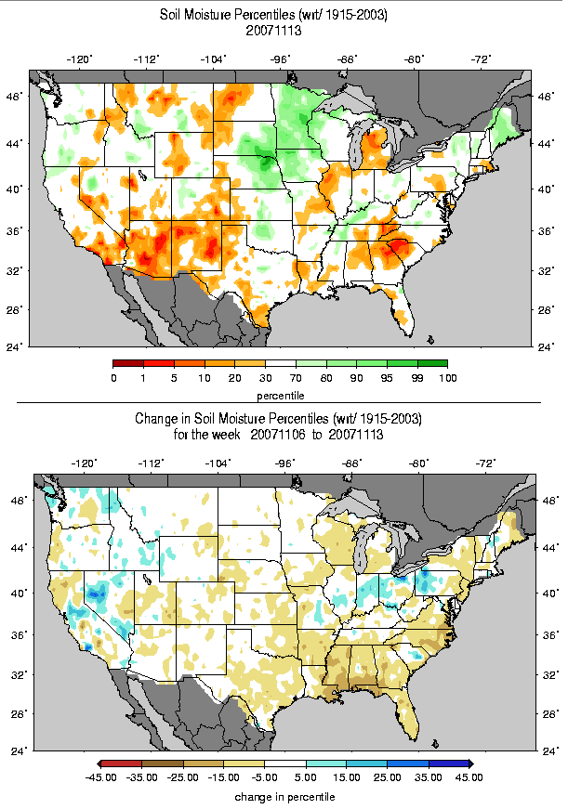
Figs. 5 & 5a: Soil Moisture Ranking Percentile based on 1915-2003 climatology. Note significant deterioration over much of the eastern Gulf Coast and mid-Atlantic Coast since last week. Ref: http://www.hydro.washington.edu/forecast/monitor/curr/CONUS.sm_qnt.gif & http://www.hydro.washington.edu/forecast/monitor/curr/CONUS.sm_qnt.1wk.gif.

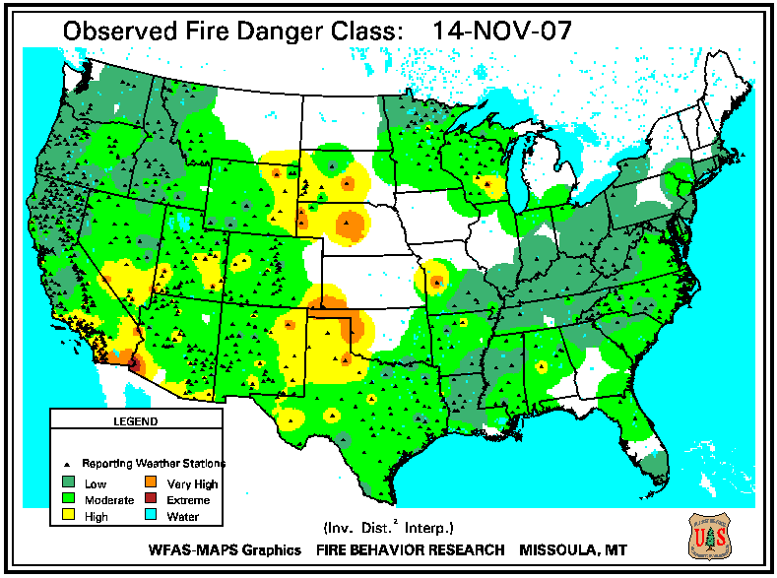

Fig.6. Observed Fire Danger Class. Conditions have improved somewhat over Wyoming, Colorado, and Arizona since last week. Source: Forest Service Fire Behavior Research – Missoula, MT. Ref: http://www.fs.fed.us/land/wfas/fd_class.gif

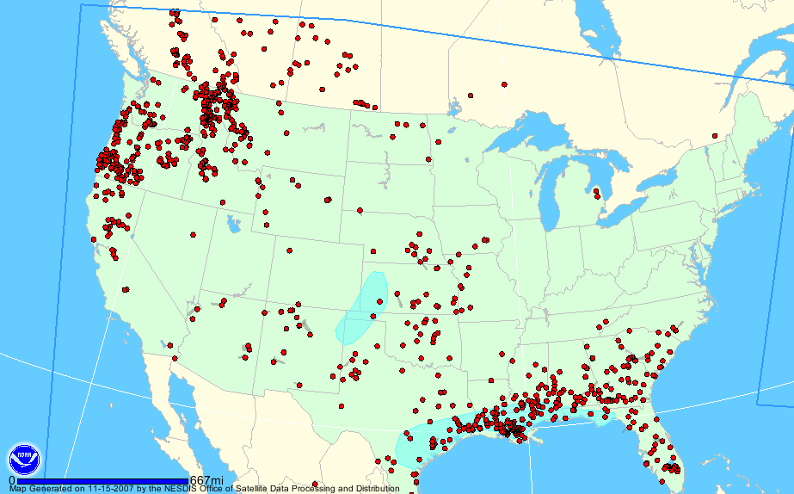

Fig. 6a. Location of active wildfires as detected from satellite across the U.S. as of 15 November 2007. Gray areas depict smoke and blue areas depict fire potential. Ref: http://www.firedetect.noaa.gov/viewer.htm

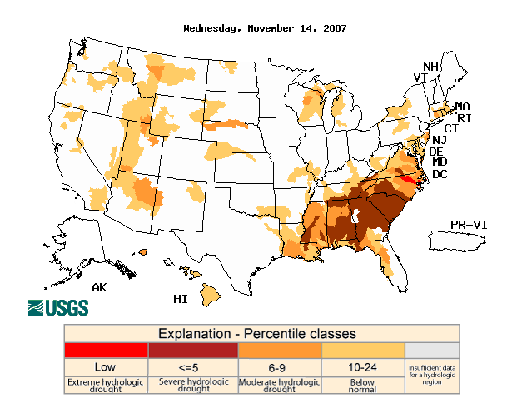

Fig. 7. This week’s map shows somewhat lower stream flows over much of the western slope of the Rockies but severe to extreme conditions over portions of the Southeastern and
Mid-Atlantic States. Ref: USGS http://water.usgs.gov/waterwatch/?m=dryw&w=map&r=us

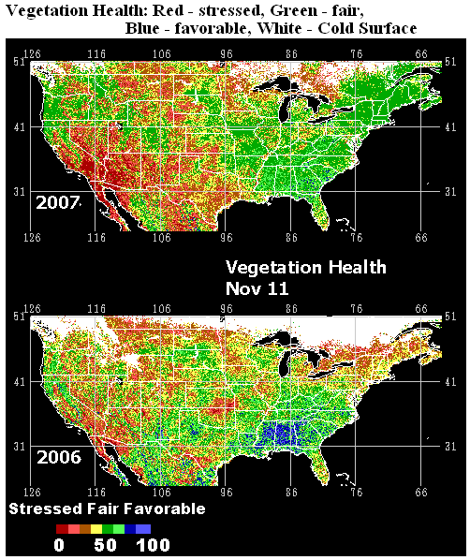

Fig. 8: This remote satellite AVHRR map shows stressed vegetation as compared to last year. Recent precipitation has helped to green-up areas of Southeast but the underlying drought remains firmly entrenched. Note: Plants in the northern regions tend to show die-off as first freeze occurs. Ref: http://www.orbit.nesdis.noaa.gov/smcd/emb/vci/usa.html).
National Drought Summary -- November 13, 2007
The discussion in the Looking Ahead section is simply a description of what the official national guidance from the National Weather Service (NWS) National Centers for Environmental Prediction is depicting for current areas of dryness and drought. The NWS forecast products utilized include the HPC 5-day QPF and 5-day Mean Temperature progs, the 6-10 Day Outlooks of Temperature and Precipitation Probability, and the 8-14 Day Outlooks of Temperature and Precipitation Probability, valid as of late Wednesday afternoon of the USDM release week. The NWS forecast web page used for this section is: http://www.cpc.ncep.noaa.gov/products/forecasts/.
The Southeast, Mid-Atlantic, Ohio and lower Missouri valleys: This was a mostly dry week over the D4 (Exceptional) drought areas in the Southeast. In fact, Alabama, Georgia, and South Carolina have been virtually rainless so far this month. With temperatures below normal in the Southeast, and little evaporation, the lack of rain did not have a major impact on the drought, but drought intensity did expand by about one category over southern parts of Alabama and Georgia due to dropping stream flows. In addition, the D4 area increased in western South Carolina, and the D2/D3/D4 areas expanded slightly in North Carolina. Nearly 60 percent of the streams in Georgia reported record lows for this time of the year on November 13. More than one-half of the streams in South Carolina measured record lows, as did more than one-third in Alabama. In North Carolina, 283 water systems are under restrictions - nearly 80% of the state population, the most since record-keeping began. Due to low streamflows, D1 drought expanded into central Virginia. D0 and D1 also edged westward in Mississippi.
The Northeast: Over one-half inch rain fell in southern New England and western Pennsylvania, but this was not enough to significantly affect the dry areas, although the moisture reduced some of the western flank of the D0 area in Pennsylvania. D1 drought lingered in southern New England.
The Plains: Short-term dryness resulted in southward expansion of D2 drought in western North Dakota. Continued dryness also led to some expansion of D2 and D1 in the Nebraska Panhandle and D0 in eastern Colorado, northwest Kansas, and southwest Nebraska. With many locations reporting less than 25 percent of normal rainfall during the past 60 days, D0 dryness expanded into southern and central parts of Texas. Soil moisture is a concern with the winter wheat crop there. Southeast of the Panhandle, for example, the Northern Low Plains area reported topsoil moisture at 62 percent very short. Temperatures in the High Plains averaged 4 to 8 degrees or more above normal for the week.
The West: Light to moderate precipitation spread across much of the West outside of the arid Southwest and the mountains of Colorado. Temperatures averaged 4 to 8 degrees or more above normal over the interior West. With 60-day precipitation well above normal, D3 drought was eliminated from eastern Idaho. D2 transitioned to D1 in north-central Idaho. D2 receded in eastern Oregon. The moisture eliminated the D3 areas in Montana, and D1 improved to D0 in southwestern Montana.
Alaska, Hawaii, and Puerto Rico: Drier weather took hold over most of Hawaii following the heavy rains of the prior week, but moderate rains over the Big Island contributed to the D1 drought pulling back to northern parts of the island. A reassessment shows that a sliver of D1 remains over east Oahu due to ongoing mandatory restrictions for users of irrigation water from the Waimanalo system.
Looking Ahead: Weather that could affect dry or drought areas over the next 2 weeks includes: 1) ongoing rains from a frontal system tracking eastward through the East, resulting in 0.5 to 1 inch of rain during November 14-16 from northern parts of Alabama and Georgia through Tennessee and Kentucky and Virginia. More than 1 inch is forecast from Pennsylvania to New England. 2) Over 1 inch of rain during November 14-19 in Idaho and western Montana, with slightly lower totals in eastern Oregon and central Montana. 3) Abnormally dry, warm weather over the Southwest and Colorado during November 14-19, but above-normal precipitation forecast for the Rockies and central states during November 20-24 and for the Great Plains to the Ohio and Tennessee valleys for November 22-28.
Author: Douglas Le Comte, Climate Prediction Center, NOAA/NWS
Dryness Categories
D0 ... Abnormally Dry ... used for areas showing dryness but not yet in drought, or for areas recovering from drought.
Drought Intensity Categories
D1 ... Moderate Drought
D2 ... Severe Drought
D3 ... Extreme Drought
D4 ... Exceptional Drought
Drought or Dryness Types
A ... Agricultural
H ... Hydrological

Updated November 14, 2007

