New MILSPRAY Camouflage Touch-up Applicators, Type 2, MIL-DTL-64159

GSA has assigned 37 NSNs for a group of CARC touch-up applicators. These items are manufactured by MILSPRAY and are approved for use by the Army Research Laboratory. They are equipped with aerosol, brush, or roller applicators, and are available in a variety of camouflage colors. Each applicator contains 70 ml of coating material; they are issued 12 per box. All units are free of lead, chromates, hexavalent chromate, benzene and hazardous air pollutants. All Brush and Roller application units below are considered “Low-Volatile Organic Compound (Low-VOC)” and are compliant with California South Coast Air Qualify Management District.

NSN | Applicator | Color | Chip #
8010-01-546-7709 | Aerosol | Brown | 30051
8010-01-547-1917 | Aerosol | Sand | 33303
8010-01-546-7711 | Aerosol | Tan | 33446
8010-01-547-1919 | Aerosol | Yellow | 33538
8010-01-547-1920 | Aerosol | Olive Drab | 34088
8010-01-546-7712 | Aerosol | Green | 34094
8010-01-547-1921 | Aerosol | Gray | 36231
8010-01-547-1922 | Aerosol | Gray | 36300
8010-01-546-7713 | Aerosol | Black | 37030
8010-01-547-1923 | Aerosol | White | 37875
8010-01-546-8093 | Aerosol | Green/Black/Brown | 34094/37030/30051
8010-01-546-7589 | Brush | Brown | 30051
8010-01-546-7591 | Brush | Aircraft Red | 31136
8010-01-547-1876 | Brush | Sand | 33303
8010-01-546-7587 | Brush | Tan | 33446
8010-01-547-1878 | Brush | Yellow | 33538
8010-01-547-1880 | Brush | Olive Drab | 34088
8010-01-546-7585 | Brush | Green | 34094
8010-01-546-7592 | Brush | Aircraft Insignia Blue | 35044
8010-01-547-1882 | Brush | Gray | 36231
8010-01-547-1884 | Brush | Gray | 36300
8010-01-546-7588 | Brush | Black | 37030
8010-01-547-1888 | Brush | White | 37875
8010-01-546-7590 | Brush | Green/Black/Brown | 34094/37030/30051
8010-01-546-7595 | Roller | Brown | 30051
8010-01-546-7598 | Roller | Aircraft Red | 31136
8010-01-547-1906 | Roller | Sand | 33303
8010-01-546-7594 | Roller | Tan | 33446
8010-01-546-7700 | Roller | Aircraft Yellow | 33538
8010-01-547-1908 | Roller | Olive Drab | 34088
8010-01-546-7593 | Roller | Green | 34094
8010-01-546-7599 | Roller | Aircraft Insignia Blue | 35044
8010-01-547-1910 | Roller | Gray | 36231
8010-01-547-1913 | Roller | Gray | 36300
8010-01-546-7596 | Roller | Black | 37030
8010-01-546-7699 | Roller | Aircraft White | 37875
8010-01-546-7597 | Roller | Green/Black/Brown | 34094/37030/30051
New MILSPRAY Camouflage Touch-up Applicators

Type 2, MIL-DTL-64159

These products were developed to provide an exact and precise match to today’s military camouflage colors. MILSPRAY’s FED-STD-595 touch-up applicators are concentrated, heavily pigmented and provide military-grade wear, chip and mar resistance. They may be applied to equipment surfaces that were previously painted with Type 2, MIL-DTL-64159 approved coating.

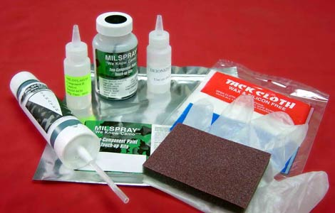

Features: Self contained aerosol kit containing pre-portioned amounts of all material in order to maintain correct ratios; each kit contains an aerosol dispenser, two-sided sanding block, chemical resistant gloves, and a tack cloth.

Volume: 70 ml

Coverage: 2-3 square feet at 1 mil DFT

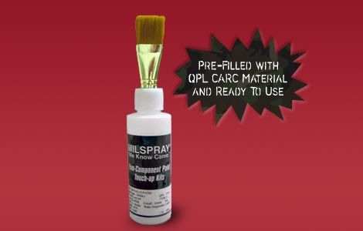

Features: The brush head allows for the safe application of CARC material without atomization or the use of any aerosol propellants. To use, simply squeeze the bottle and the coating material travels through the delivery tubes to the brush head.

Volume: 70 ml

Coverage: 2-3 square feet at 1 mil DFT

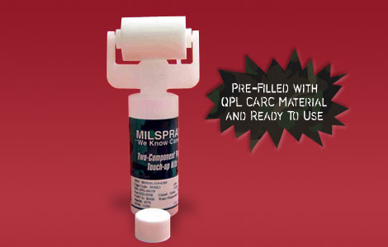

Features: The specially designed roller allows for the safe application of CARC material without atomization or the use of aerosol propellants. To use, simply squeeze the bottle and the coating material dispenses directly onto the foam roller. Simply roll out the material onto any substrate.

Volume: 70 ml

Coverage: 2-3 square feet at 1 mil DFT

