Livestock Marketing Information Center

655 Parfet, Suite E310
Lakewood, Colorado 80215-5517
(720) 544-2941
FAX (720) 544-2973

August 21, 2007

Dr. Warren P. Preston
Chief, Livestock and Grain Market News Branch
USDA – Agricultural Marketing Service
1400 Independence Ave, SW
Room 2619 - South Building
Washington, D.C. 20250-0242

Dear Dr. Preston,

We are sending you this letter on behalf of the members of the Livestock Marketing Information Center (LMIC). The LMIC is a cooperative effort involving 26 Land Grant Universities from across the U.S., major livestock associations and a number of USDA agencies. The primary role of the LMIC is to gather data, perform economic analysis and disseminate information related to the livestock industries.

The LMIC strongly supports the proposed rule to reestablish and amend the Livestock Mandatory Price Reporting (MPR) regulations. Timely and unbiased market data are critical for effective decision making by market participants and quantitative evaluations of market performance. All aspects of the livestock and meat industries support MPR. We greatly appreciate the efforts to maintain a price reporting system by the USDA’s Agricultural Marketing Service (AMS) during the extended period of time when MPR legislation was allowed to lapse. Future disruptions in enabling legislation must be avoided. The MPR system as implemented by AMS has proven to be effective and timely. Importantly, this rule should be reestablished as soon as possible.

Regarding the specifics of the proposed rule, we find the modifications regarding definitions for swine and lamb are positive adjustments. We strongly encourage the proposed reduction in reporting requirements for cow and bull packers. That adjustment will not reduce the quality or quantity of important data. Definitional and reporting changes regarding boxed beef will also be beneficial, although AMS must maintain consistency with the valuable historical data. Overall, the proposed amendments to revise the reporting definitions would improve and enhance the data being reported by AMS. In particular, the proposed revisions in the MPR regulation would allow for a larger amount of timely market related data to be reported than is currently available and the changes reflect industry developments since the initial MPR legislation.
Beyond the current reauthorization, additional improvements to MPR are still needed. The program at USDA’s Agriculture Marketing Service must be allowed to evolve along with the markets. The highest priority is to include wholesale pork items as part of MPR.

Sincerely,
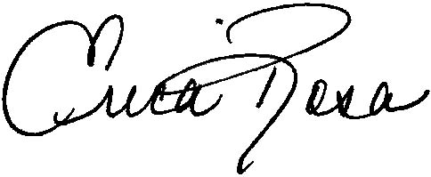
Erica Rosa
Agricultural Economist

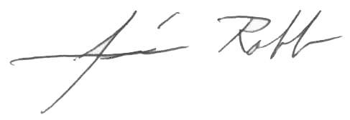
James Robb
Center Director

