Report of Surface Pressure Working Group (SPWG) for AOPC-XII, April 2006

Rob Allan and David Parker, Hadley Centre, Met Office, U.K.

Gil Compo, NOAA-CIRES Climate Diagnostics Center

The GCOS AOPC/OOPC Working group on surface pressure has set up a web site at http://www.cdc.noaa.gov/Pressure/Reports/index.html. From this site, climate time series and gridded datasets can be downloaded, as well as the Group’s Terms of Reference and administrative information.

Significant activities during the year were:

- Consolidation of plans for a 20th Century Reanalysis Project, led by Gil Compo at the U of Colorado CIRES and NOAA Earth System Research Laboratory's (ESRL) Physical Sciences Division. A paper on the feasibility of such a Reanalysis, back to the beginning of the 20th Century, was published in Bulletin of the American Meteorological Society (Compo,G.P., J.S. Whitaker,and P.D. Sardeshmukh, 2006: Feasibility of a 100 year reanalysis using only surface pressure data. Bull. Amer. Met. Soc., 87, 175-190.) The project may be funded as part of a NOAA Fiscal Year 2007 initiative “Explaining Climate Conditions to Improve Predictions”. Stated GCOS support for the project as part of this initiative is requested.
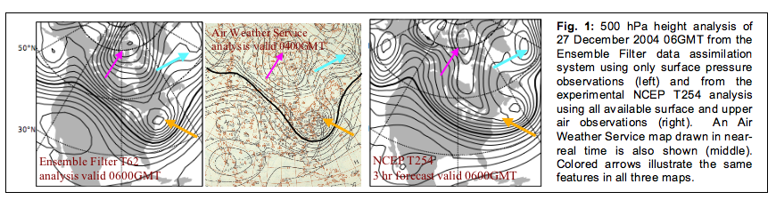
- Submission of the MACE (Monitoring and Assessment of Climate change and Extremes) project for funding by the European Union (EU) 6th Framework Programme. MACE is a five year Integrated Project (IP) designed to fulfil much of the European component of the GEOSS. Mean sea level pressure (MSLP) is designated as one of the Essential Climate Variables (ECVs) to be focussed on in MACE, which will also support and link with the 20th Century Reanalysis Project through the joint development of an historical sub-daily gridded MSLP data set over the Northern Hemisphere back to the mid-late 1800s. If successful, MACE would begin around January 2007, and is looking for funding support from the EU of the order of 7 million Euros over the lifetime of the IP.
- A one-day workshop was held at the Met Office, Exeter on the 21st October 2005 as part of the MARCDAT II workshop. The minutes of this meeting can be found on the GCOS AOPC/OOPC Surface Pressure Working Group’s WWW site (http://www.cdc.noaa.gov/Pressure/Minutes/index.html). Several themes were addressed:

1 The GCOS AOPC/OOPC SPWG WWW site (http://www.cdc.noaa.gov/Pressure/)
2 International Surface Pressure Data bank (ISPD)
3 Data archaeology, digitisation
4 Extension and reconstruction of long MSLP series and indices
5 Gridded historical MSLP products
6 Historical reanalysis
7 Discussion of inclusion of winds in our remit
8 Some recent analyses using MSLP data
9 Work plan based on the above themes.

Salient points from the above meeting are as follows, and form the basis of the Work Plan 2005-2007

* We need to co-ordinate the digitising of data. Digitisation of UK log books for the WW2 period is going ahead. When new data sources are located, we will aim to digitize all variables.
* Group asked AOPC to change terms of reference to include winds. We should include winds to improve MSLP analyses
* We encourage the development of a sub-daily MSLP dataset over the Northern Hemisphere. We need to know what corrections have been applied to daily averaged data. Sub daily data for 20th Century analysis and reanalysis should be sent to Gil Compo.
* We decided to keep the main data bank for raw data only and have a separate section for analyses and indices (where corrections have been applied (e.g. Utrecht/DeBilt, Reykjavik/Stykkisholmur). While these series (e.g. regional average series) are not suitable for the reanalysis, they are good for other applications (i.e. climatological applications). The HDF5 data format will be used for the ISPD
* We need to address the possibility of getting funds, possibly from GCOS, to support the website and future meetings of the SPWG.
* Next workshop to be held in 2 years time, hopefully with full funding.

Other Actions and Recommendations

* Gil Compo has changed the starting date of the Azores series on the SPWG web site to 1865.
* All regional co-ordinators have been requested to consider their role and confirm involvement in the acquisition of data for the ISPD and ESRL’s 20th Century Reanalysis Project
* All members and regional co-ordinators were asked to help locate data sources from Northern Hemisphere charts (table of sources was provided).
* Gil Compo, Alexey Kaplan, and Rob Allan are recovering pressure observations from Byrd Antarctica
Expeditions and will work with NOAA Hollings scholar summer interns to digitize the observations from the several expeditions, and to include them into the ISPD.
* Rob Allan and Gil Compo invited Gareth Marshall (BAS) to be a regional coordinator for the Antarctic region.
* Feedback on priorities for Canadian digitisation was to be sent to Val Swail
* The Group formally asked KNMI for access to data collated as part of ENSEMBLES
* Shawn Smith sent information on winds and pressure work at COAPS to co-convenors.
* Since the meeting, and as a result of the development of the MACE IP, the SPWG has begun to work with the International Environmental Data Rescue Organisation, Ltd (IEDRO) (http://www.iedro.com/) in all aspects of data archaeology, rescue and digitisation



