Final Report

Management Assessment and Organizational

Analysis for the

Office of the Deputy Chief for Management



March 7, 2005



3441 Commission Court, Suite A
Woodbridge, VA 22192
Tel: (703) 492-0880
Fax: (703) 492-6336
http://www.compubahn.com

Executive Summary

Compubahn, Inc. took a comprehensive and critical look at the functionality and performance factors of the Office of the Deputy Chief for Management of the Natural Resources Conservation Service at USDA. The open access and cooperation of the Deputy Chief for Management and the division managers reporting to that office allowed the project team to inquire freely. The key objectives of this organizational assessment are borne out of the desire of the Deputy Chief for Management to make strategic decisions based on the overall effectiveness of the divisions and staffs that report to his office. Compubahn’s “organizational evaluations, measurements, and determined effectiveness of the divisions and staffs reporting to the Deputy Chief for Management” and the identified dependencies between the divisions under the Deputy Chief for Management and the other deputy chief areas would be addressed through series of prioritized recommendations for improvements. With the guidance of the COTR (Director of the Information Technology Division) and the Executive Sponsor (Deputy Chief for Management), Compubahn reviewed and compared the customer feedback with service provider expectations for the entire organization.

The methodology for the study included an initial analysis, prioritization, current state, desired state, and gap analysis. An initial analysis of the organization was performed, with information given to us during initial meetings and other documentation provided to us. Because of constraints both in time and resources, the prioritization phase was accomplished with an initial set of interviews with key personnel of the NRCS. Once the priorities were determined, an assessment of the current state of the selected Business Processes would be made in a series of follow-up and additional interviews. We determined the desired state for NRCS through a series of more detailed interviews. The final gap analysis revealed the recommendations necessary for change. The interview groups included department level personnel responsible for implementing and defining policy; NRCS division managers as top-level service providers and consumers; NRCS deputy chiefs as top-level consumers of services; NRCS mid-level service providers who are users, process owners, and service providers; and senior staff of the field service agency partners, Rural Development and the Farm Service Agency.

There is an organizational and cultural dissociation between the administrative management functions housed in the Office of the Deputy Chief for Management and the program offices and the Office of the Chief of NRCS. This leadership system observation by the Compubahn project team may be the strongest underlying factor contributing to the “separateness” generally felt by the senior management team of the Deputy Chief for Management. The lack of visionary and strategic integration between administrative and program subunits are not uncommon and they are not insurmountable organizational barriers. However, if the vision and strategic objectives of the enterprise do not integrate the roles of administrative and program subunits, the disconnection may fuel the development of separate and contrary cultures.

Several of the over-arching generalized issues were earmarked by customer and service provider comments. Those issue areas include the need for service level agreements, improved customer service, assuring there is personal accountability, heavily investing in staff training and development, making leadership teambuilding a top priority, and setting clear standards for performance. The principal findings in the review of current business processes verify the results of an ad-hoc approach to processes that have led to a higher level of organizational ineffectiveness and inefficiency. The findings include a lack of assessment ability or accountability, no formal means of tracking the progress of requests, and overly stressed employees who lack clearly assigned tasks and responsibilities to their customers.

This study concludes with 25 recommendations that are grounded in the findings. At the top of the list is the recommendation to develop an integrated implementation plan for the recommendations. Without a coherent plan that balances co-dependent or inter-dependent recommendations, resource availabilities, and time constraints, the individual recommendations may have merit but they will have less value.

The effects of recent organizational restructuring at NRCS and OMB’s government-wide initiatives to streamline administrative management functions over the last decade have put pressure on organizations to undergo business process reviews, re-engineering, and automation, or in some cases, the elimination of certain functions. Although NRCS has not shown evidence of having been engaged in an enterprise process review, there have been documented process reviews and re-engineering efforts on a micro-basis in the information technology division. It appears that two factors inhibit the accommodation of new business processes in the administrative management functions under the Deputy Chief for Management: 1) the lack of documented business processes; and 2) the lack of resources for staffing and training for existing staff.

The Compubahn project team has given focused attention to the underlying factors affecting the quality of service concerns that were expressed by customers and process owners. Among the many comments that reflected frustration on the part of customers and service providers were “shining stars” of dedicated employees who were trying to meet the expectations of their customers, although unwritten. Based on strong positive comments from customers, the IT help desk, applications development, the Employee Development Center in Ft. Worth, and certain individual efforts in space planning and other isolated functions are highly regarded. This point is gladly noted for this report. However, these accolades are often hidden by the frequency of customer complaints and the level of general frustration in the divisions under the Office of the Deputy Chief for Management.

It is difficult for operations and service organizations to turn its attention to process improvements when the “way we’re doing it” works. The pursuit of best practices in any organization requires a cadre of staff or consultants to review and document how the work is getting done and how it can be improved. If the business processes are not documented, the ease of accommodating service efficiencies through business process re-engineering and automation is hampered.

Table of Contents

1 Introduction 1
2 Key Objectives 1
3 Findings 2
3.1 General Overview 2
3.2 Principal Findings 4
3.3 Human Resources Management Division 6
3.4 Management Services Division 8
3.5 Information Technology Division 10
3.6 Financial Management Division 14
3.7 Other Divisions 15
3.8 Cross-cutting issues 16
4 Recommendations 17
4.1 Implementation Planning 17
4.2 Strategic Approach the Enterprise 18
4.3 Organizational Communications 19
4.4 Deputy Chief for Management Task Tracking System 19
4.5 Delegated Authority 19
4.6 Customer Relations – Training 20
4.7 Personnel Management Issues 20
4.8 Leveraging Innovative Technologies 21
4.9 Business Process Documentation 21
4.10 Provide Funding to Enhance Functionality of ICAMS 21
4.11 Document Business Processes for Personnel Action 22
4.12 Automate SF-52 22
4.13 Acquisition Processes for Real and Personal Property 22
4.14 Facilities Management (Space) 22
4.15 Contract Initiation and Administration 23
4.16 Integrate with FFIS 23
4.17 Generate a Process to Provide an Accurate “Snapshot” of Financial Data at any Time 23
4.18 Develop a Process to Prioritize Software Certification 23
4.19 Establish a Structured Process for Managing Information Systems through System Life Cycle Management (SLCM) Process 24
4.20 Review and Evaluate the Reporting Structure of the CIO 24
4.21 Update and Improve IT Employee Skill Sets to Support the CIO Function and Agency Mission 24
4.22 Refine Correspondence Approval Process and Make Sure you Have Alternatives 25
4.23 Implement Electronic “Tracking and Approval” for Correspondence 25
4.24 Service Level Agreements (SLA’s) 25
4.25 Add Staff for Retirement Counseling and HR Specialist for Staffing/Classification 25
5 Annexure 26
5.1 Methodology of Study (Annexure 1) 26
5.2 Questionnaires (Anexures 2a-2g) 30
5.3 Management Study Interview List (Annexure 3) 37
5.4 Reference Documents (Annexure 4) 39
5.5 Organization Charts (Annexure 5) 40
5.6 Progress Reports (Annexure 6) 45
5.7 Acronyms (Annexure 7) 57

Introduction

Compubahn, Inc. was retained by the Office of the Deputy Chief for Management at the United States Department of Agriculture’s (USDA) Natural Resource Conservation Service (NRCS) to assess the current management apparatus under the Deputy Chief’s responsibility. The study commenced on June 23, 2004. The initial study design for the assessment and organizational analysis began with the assumption that process-based systems for service delivery were verifiable by oral presentations or written documentation. Compubahn’s earliest interviews revealed a general lack of standard processes and a prevalent practice of relying upon informal methods of completing tasks. Compubahn redesigned the study to accommodate the new landscape and address basic organizational needs as expressed by systems owners, service providers, and customers.

The Deputy Chief for Management expressed that “this study is not a cost cutting initiative. If there are cost savings as a result of automation or other changes, we will need to redirect those savings for organizational improvements.” Compubahn considers this study to be a “bold management initiative to refine the understanding of the customer’s concerns, employee frustrations, and organizational inertia” that prevents meaningful change. The Compubahn Project Team was impressed with the open-door allowances for this study. The Deputy Chief for Management provided open access to all of the areas requested by Compubahn and approved of the directness of the assessment. The Team established an investigative approach that considered costs savings but gave more comprehensive assessments to customer service and organizational processes. It became apparent that customer concerns about poor timeliness in service delivery reflected a lack of standardized processes, human resource deficits, and an inability to accommodate innovation and technology for service improvements.

The NRCS is one of USDA’s three field service agencies. Along with Rural Development (RD) and the Farm Service Agency (FSA), NRCS forms the locally based, principal service delivery structure to America’s farmer, ranchers, and rural communities. Federal statutes mandate that these three agencies coordinate their information technology and other administrative functions at the field service level in order to streamline and simplify service delivery. NRCS and the other agencies are located in nearly every county or parish in the United States.

NRCS provides leadership in a partnership effort to help people conserve, maintain, and improve our natural resources and environment. NRCS puts nearly 70 years of experience to work in assisting owners of America's private land with conserving their soil, water, and other natural resources. Local, state and federal agencies and policymakers also rely on NRCS expertise. They deliver technical assistance based on sound science and suited to a customer's specific needs. NRCS also provides cost sharing and financial incentives in some cases. The Deputy Chief for Management has 140 employees who provide direct services to nearly 500 people and supportive services to fourteen thousand (14,000) employees nation-wide.

Key Objectives

The open access and cooperation of the Deputy Chief for Management and the division managers reporting to that office allowed the project team to inquire freely. The key objectives of this organizational assessment are borne out of the desire of the Deputy Chief for Management to make strategic decisions based on the overall effectiveness of the divisions and staffs that report to his office. Compubahn’s “organizational evaluations, measurements, and determined effectiveness of the divisions and staffs reporting to the Deputy Chief for Management” and the identified dependencies between the divisions under the Deputy Chief for Management and the other deputy chief areas would be addressed through series of prioritized recommendations for improvements. The findings are presented in Section 4.

With the guidance of the COTR (Director of the Information Technology Division) and the Executive Sponsor (Deputy Chief for Management), Compubahn reviewed and compared the customer feedback with service provider expectations for the entire organization. Priority focus was given to four major organizational divisions: Management Services, Human Resources, Financial Management, and Information Technology.

In the context of the general scope for the study and in meeting these objectives, Compubahn reviewed:

- Integration of management processes with internal and external programs and policies.
- Organizational representation and liaison to customer units.
- Direction and guidance of customer units.
- Administration and control of financial and material resources.
- General implementation and results.

Findings

General Overview

The principal findings in the assessment are in eight (8) separate but inter-related categories. There are findings that pervade the organization with a broad underlying impact and there are more specific findings that are tied to certain business lines or services. The principal findings of this report are in the categories of: leadership issues, business processes, ethos and culture, accountability, the “fire fighting” approach to operations, resource controls, communication, and limited focus on innovation and technology.

Issues related to staffing and training needs, business process standardization, the need for financial resources, and the development of leadership systems permeated the study and were not tied only to the senior levels of the Deputy Chief for Management. The NRCS senior management team that include the NRCS Chief and those who report to the Chief have a critical role in demonstrating to the enterprise-organization that all of its areas and subunits comprise the corporation. Without a sense of relationship to the corporate identity, any area or subunit will lack a sense of mission that is tied to the enterprise goals. Although there were weaknesses that resulted from the organizational disconnect between the Office of the Deputy Chief for Management and the program offices, branches such as the Information Technology Center in Fort Collins, CO and the National Employee Development Center in Fort Worth, Texas, received consistently positive comments from customers. There were also a number of individuals who were named as excellent service providers. But these positive mentions were drowned-out by more frequently lodged complaints.

Compubahn’s findings reflect a lack of documented and definable business processes. The most frequently expressed notion of a business process was the “that’s-how-we’ve-always-done-it” syndrome. The lack of standard processes for frequently executed tasks weakens the ability of the organization to implement broad process improvements, accommodate technology, and enhance the work environment of its employees.

The ethos and culture of the Deputy Chief for Management’s area are indicative of an organization that operates on an “informal” business model rather than operating with service level agreements and assurances of accountability. The multiplier effect of not having documented processes and no service level agreements pushes individual performers and can subordinate organizational goals and teamwork. The “informal” business model may work well at a local neighborhood store or between family members, but the pressure and constant demands on service providers makes it essential to establish standardized processes and service level agreements for their own measurable performance improvements. The work environment for customers and service providers will improve when the expectations of each are better understood through these agreements and processes.

A noted issue of no delegated resource controls to the division managers reporting to the Deputy Chief for Management seemed contrary to the general management policies of NRCS. At the senior management or supervisory level, one of the principal performance measures is tied to the appropriate allocation of resources in completing assigned tasks or objectives and preparing for future needs. The issue of fiscal accountability for the managers is called into question because they lack delegated control of their resources. In a number of cases, managers have expressed that their employees need training or retraining and if funding were within their immediate control, they would authorize it. In a different case, a resource that is in limited supply is office space. It appears that managers are at a loss for assuring their employees that appropriate office space can be allocated. In some cases, this resource is difficult to determine: How many square feet is my office? Do I get a window? Is there conference room space for privacy? The full range of resources for oversight and accountability does not reside in the division managers.

Compubahn found that communications within the organization of the Deputy Chief for Management were compartmentalized. The best level of communication was within subdivision performance teams. However, it was not uniform throughout the organization. There was very little investment in the internal communications process of the Deputy Chief for Management. The concept of corporate communications has developed and expanded rapidly in recent years. Technology and the “want to know” behavior of workers in the information age have forced this change. The residual benefits of a well-designed and thoughtfully implemented intra-organizational communications strategy can be highlighted by stimulating a corporate culture of better-informed employees. Between customers and service providers, the informal communications channels appeared to be working well. The only weakness in this practice is that tasks, assignments, and status reports were not routinely captured for performance measurement.

The overall operating nature of the principal divisions reporting to the Deputy Chief for Management reveals that an informal relationship takes precedence over business protocols or processes. In this case, the squeaky wheel gets the grease. But even when there are no squeaky wheels, without standard processes the individuals, teams, and organizations frequently find themselves in the “firefighting” mode of service delivery. One customer said, “I get knots in my belly when I know I have to make a request to that office. I don’t know what to expect and I don’t think they do either.” The high anxiety for customers and service providers is created by a “firefighting” mentality that is grounded in an informal business model that lacks a foundation for expectations on the part of the customer or service provider.

Principal Findings

Leadership Issues

The principal role of leadership is to articulate and communicate a vision for the organization and to direct the organization toward its objectives. The organizational objectives for the enterprise and its units or divisions will precede the formation of “functional statements”. The “functional statements” describe what tasks needs to be completed in order for the enterprise to meet its objectives and carryout its mission. Clearly defining the purpose of NRCS in an organizational strategic plan is the responsibility of the Chief of NRCS. In leading this developmental process, the Chief integrates the authorities of law and regulations to set the enterprise in a direction that meets its prescribed mission.

The Deputy Chief for Management reports to the Chief of NRCS. The results of the Compubahn management assessment revealed that there is little reflection of an integrated strategic plan at the Deputy Chief level. The linkages between the management functions and the ultimate customer, the American people, has not been articulated and made a part of the “core values” that guide the organization. As much as this organizational guidance is lacking for the deputy chief, it is not uncommon in administrative management operating organizations. If fact, it is generally uncommon to find administrative operations that are guided by an internal vision, mission, and a set of strategic objectives.

Many administrative operating units are driven by customer demands and timely task responses rather than lofty visions. In the case of NRCS, the managers reporting to the deputy chief expressed that it would be a “luxury to pause, step back, and develop a thoughtful vision for what our organization could be.”

In the NRCS General Manual, Title 330, Operations Management, Part 400, Functions of Management states, “The management process seeks to effectively and efficiently integrate the functions of planning, organizing, staffing, directing, and evaluating.” Furthermore, “these functions interrelate to achieve the Natural Resources Conservation Service (NRCS) mission and objectives. Line officers and program managers who effectively use these management functions prevent deficiencies in the delivery of services, increase support for programs, and improve the morale of employees.”
In Part 400.1- Policy, of the General Manual, it emphasizes that “it is NRCS policy that the five management functions of planning, organizing, staffing, directing, and evaluating be used in a continuous process in all NRCS organizational units. All NRCS personnel are to fully utilize the management functions in managing resources under their control to attain the maximum amount of high quality work in support of the NRCS mission and objectives. This responsibility is carried out in close cooperation and coordination with conservation district activities, plans, and priorities.”
The findings regarding leadership issues resonate throughout the study and raise concerns regarding the top level of the NRCS enterprise and its business relationship to its administrative management arm. The disconnection between the program offices and the supporting administrative management offices was apparent in the interviews with customers and service providers. However, this disconnect appears to be an historical organizational phenomenon that has persisted. In the current NRCS Strategic Plan, there are few references to the mission or enterprise relationship between the Deputy Chief for Management’s area and the rest of NRCS. Although the NRCS program customers of the administrative management divisions conveyed their essential need for the services in order to complete their missions and goals, the Deputy Chief for Management’s area has not been appropriately integrated into the NRCS vision and strategic plans.

NRCS, as an enterprise, has an excellent relationship with its customers in the field. For the Deputy Chief for Management in Washington, DC, this does not translate into customer satisfaction among program offices. It is true that overall services are provided by the management area day-in and day-out but there are serious chronic “pain points” that take its toll on staff and employee morale.

The principal findings under the category of leadership are reflected in the following “pain point” quotes expressed by customers and service providers. The leadership of the NRCS management divisions believes these “pain points” are symptomatic of the “systematic de-emphasis” of administrative management functions at NRCS.

- Regarding service level agreements: “Poor, poor, poor service. It’s known to everyone. Service agreements? We don’t get to those kinds of things. We don’t have time to get to SOPs.”
“It would be good to have service level agreements in writing. It would be good for providers and customers regarding expectations.”

- Customer service: “The attitude is poor, rude, discourteous, and nasty. Customer service training is necessary for Dwight Holman’s area. All management employees need it. Do it by division. It might be that professional standards need to be elevated. “

- Accountability: “A lack of timeliness drives my folks crazy. If it is important to us, we hand-walk a document through the system. There is no accountability because there’s no tracking.”

- Staff training and development: “I observe a lack of staff resources, multi-tasking by staff, and poor direction from supervisors. They have a shortage in the amount of people with the right skills. They have poor skill sets that are matched with the offices (they’re in), and they are trying to meet service needs.”

- Leadership teambuilding: “People trying to do too much, too fast contributes to the problems. Trying to do too much with too few people. But there is a lack of teamwork. There is an issue of attitude and skills.”

- Performance: “There is marginal functioning. High achievers are finding it hard to perform. They get dragged down.”
“Attrition of well-trained, good staff especially in HR is a problem. Working conditions are better elsewhere and promotion potential might be the same.”

Business Processes

We have found that there are few business activities within the NRCS management office that are explicitly defined, and success depends on individual efforts and heroics. The staff is working on day-to-day operations and do not have time to improve processes.

The principal findings in the project team’s review of current business processes verify the results of an ad-hoc approach to processes that lead to:

- Lack of assessment: There are no mechanisms to assess or measure the performance of the business processes.

- No Accountability: Many tasks have not been formally assigned to agents, for example in personnel, and frequently there are no expectations for when tasks have to be completed or who is supposed to complete them. In addition there are no formalized Service Level Agreements (SLAs) between different parts of the organization. This also leads to a lack of responsiveness to requests from different agents.

- No tracking: The lack of explicit processes does not allow for the tracking of progress or status. It is up to the individual to track the progress of requests through the organization.

- Stressed Employees: The lack of clearly assigned tasks and responsibilities to agents (employees), the reliance on individual efforts and heroics leads to overworked and stressed employees, which in turn leads to poor morale.

Human Resources Management Division

The principal findings in HRMD are:

- Insufficient resources in some areas
- Lack of tracking systems, SLAs, strategic plan, automated processes.
- Some customers are confused by inconsistent HR procedures.
- Some staff is lacking skills in classification and retirement /benefits area.

The HRMD is responsible for providing policy nationwide as well as the full range of operational servicing activities to the NRCS headquarters staff. There are three principal branches: Employee and Labor Relations; Employment and Classification; and, Human Resources Servicing. There is also a small HR services staff located in Fort Worth Texas.

The division is still somewhat in flux adjusting to the NRCS reorganization which impacted the division staff in terms of changing assignments and movement of staff to new positions. It appears that the biggest issue is insufficient resources to do the job. In addition to the regular day-to-day work, the staff struggles with other major assignments such as Congressional mandates, competitive sourcing i.e. outsourcing, and Presidential and Secretarial initiatives.

As a result, there are several common themes that are evident throughout the division. There is no strategic plan for the division. There are no service level agreements, or business processes other than informal agreements. There is policy guidance available to help with providing advice and guidance to NRCS staff, but generally no standard operating procedures that would significantly aide staff or customers. Further, there are no automated processes, and very little in the way of tracking capabilities. Thus, there is no reliable data available upon which to base resource decisions.

Customers complain that they don’t know what to do to get certain requests into the system. They are often given different advice depending on with whom they spoke.

There is positive feedback as well. Some HRMD staff felt that most of the comments they received from customers were very favorable. For example, in the area of the ERT (Employee Relations Team) there is favorable feedback. In this area, customers are usually dealing with difficult employee issues and problems. When the issues are handled competently, their satisfaction level tends to be high. Interviewers did receive one negative comment regarding this area. That complaint related to handling grievances when civil rights issues are involved. Allegedly, this matter was not handled in the proper sequence. It was not determined if there was a pattern of dealing with these type cases in a similar fashion.

The HR Servicing Team has several concerns. The long-term detail of a personnel specialist from this team has adversely impacted service to HQ (Headquarters) customers. There are not enough Personnel Specialists to handle the workload. The specialists on the team provide staffing and classification advisory services but due to the lack of experience and training they are not proficient in classification, although staffing is the bulk of their work. The Team Leader is the only skilled classifier on the team. When requests come in, the Team Leader is the only person who can respond. The Team Leader has recently accepted a position elsewhere in NRCS.

The hiring process generates some customer concerns. There are different procedures depending on how a position is being filled; e.g. merit promotion versus outside recruitment. Either method is time consuming. In addition, the procedures for both are not well understood by customers. Even the Request for Personnel Action (SF-52) process is not documented which often results in requests being sent to the wrong office for action.

There is also a lack of coordination between the Management Services Division (MSD), and the Financial Management Division (FMD), with respect to employee relocation. Personnel action that result in the movement of an employee from one location to another must have well coordinated procedures to avoid personal hardship to the employee involved and disruption and or financial disaster to the respective offices. Comments from interviewees indicated that this is a recurring problem.

The HR servicing team also lacks adequately skilled resources to provide professional retirement counseling and guidance as well as competent benefits counseling. This deficiency causes employees not to have confidence in seeking guidance in what is a highly personal and sensitive area. Employees are in the uncomfortable position of seeking help outside the Agency, or trusting the advice they are given.

The National Employee Development Center in Fort Worth appears to be well organized, and focused on its mission. They have a formal business process for managing their work throughout the training cycle. The limitations result from lack of funds, and lack of control over NRCS staff that provide the principal source of subject matter trainers. The Director would also like to provide much more inventory, but is limited by the above-mentioned impediments.

Management Services Division

The principal findings of MSD are summarized as follows:

- Generally negative feedback from customers concerning reliability, attitudes and competence.
- Poor coordination with HRD and FMD.
- No accountability for poor performance
4. No business processes.

Management Services Division (MSD) is responsible for Grants and Agreements management, Contracts management, Facilities management, Real and Personal property management, Mail management, Records and Directives management, and Acquisition management. It provides national leadership for a comprehensive management services program. Internal and external customers require these administrative management support services to complete their duties. Internal customers include each organization established within NRCS at all levels, down to local level. External customers include farmers, ranchers, municipalities, contracting communities and grantees (universities, for profit or non profit organizations). Without these vital services, all customers would find it difficult to do their jobs and operate in the system.

The customers assess the delivery of these management services with these criteria: (i) Complete customer service (ii) Promptness i.e. timely factual answers (iii) Solid, clear and consistent policy and (iv) Politeness in dealing with customers. The staff providing services generally does not adopt these criteria in meeting the needs of its customers. There was widespread negative feedback from customers concerning reliability, attitudes and professional competence. There are no performance standards in place and no one is accountable for poor performance. There are some who feel that the system is broken, dysfunctional and has no credibility. Although these findings readily site the weaknesses in MSD, there were noted pockets of high performers, such as in space planning.

There are no formal service level agreements for service delivery so that customers know in advance what they are getting. Most employees work on the basis of informal understandings and functional requirements. The informal nature by which the divisions get their tasks and functions accomplished do not allow for a consistent standard of service and therefore does not appear to engender performance accountability. In addition, MSD, HRD and FMD do not work as an integrated team to provide optimal management services to NRCS. In a recent reorganization, some staff were transferred to Headquarters from outside the Washington, DC area. They reported for duty but there was no office space, telephones, furniture and personal computers available for them. HRD was responsible for transferring the staff to NHQ; MSD was responsible for space allocation and providing telephones and computers and FMD was responsible for providing budgetary resources. Due to a lack of communication and advance planning and coordination, the transferred staff was not operational for several weeks. It is therefore vital that these divisions should proactively work together rather than working independently and waiting for the other to respond.

Generally, there are no written or well-defined business processes to follow in providing services. The work is done sometimes on the basis of guidelines or standard operating procedures or as directed by the supervisors. However, they are using (i) Acquisition system for procurement (ii) New property management system and (iii) Mail management system. Customers still want to know the acquisition process for real and personal property. No one seems to know what happens to their requests and there is no feedback from the service provider. Space allocation is a big issue among staff and the issue causes resentment. There should be well-defined processes for allocating space as per standard guidelines in a timely fashion. ProTracts which is a Web-enabled application that streamlines the application and contracting process is being used. Steps are being taken to improve ProTracts with additional functionality and to simplify Program Contracts and Application Process. There is a need for contract initiation and administration process for clearance and tracking. These examples illustrate that there is no mechanism for developing and regularly updating business processes within MSD. According to MSD, business process development, documentation and communication to customers is not done due to lack of adequate staff. With availability of more staff, MSD intends to document business processes. There is a realization that the current way of doing work is not efficient and needs improvement.

One of the reasons generally given for not being able to provide customer service is “a staff that is overworked and stressed”. The workload has increased over the years without a corresponding increase in staff. It appears that MSD does not have adequate human resources with the right skills in several areas. The present staff strength and requirements of various teams in MSD is as follows: Grants and Agreements team have 2 but need 7, Records and Directives have 7 but need 10, Facilities, Property and Mail Management have 6 but need 11, Acquisition Policy have 5 but need 11, and Acquisition Operations have 0 but need 11. There is no data available to quantify the workload. Therefore, it is not possible to determine whether poor customer service is due to a shortage of staff, inadequate skill sets, non-utilization of technology tools, worker attitude issues or inefficiency. It could be any or all of these reasons.

There are communication problems between some staff and team leadership. The staff feels that team leadership does not have knowledge and relevant experience and does not respect the authority of the officer. Sometimes management makes decisions without communicating to the officer working on the issue/project and sometimes the officer gets mixed signals from management. This creates tense interactions and a difficult work environment. There is also a feeling of unfairness and special treatment for certain individuals. The staff morale is negatively affected when they do not get support for grade advancement.

The Electronic Directive System provides employees immediate access to the most current manuals, handbooks, bulletins, technical notes, and user guides issued by NRCS. This system is maintained by ITC. There is no dedicated person in ITC for directives work. Records management is not recognized as an important function in MSD. Due to insufficient funding and staff, the needs of customers are not fully met. There is room for improvement in the record management process.

Information Technology Division

The principal findings of ITD are summarized as follows:

- IT project portfolio management is good. However, ITD should develop a structured process to manage systems initiation, integration, development and maintenance of applications and software development initiatives with formal sign off.
- Business application development by ITC is excellent. Contractors are not providing documentation as per federal life cycle process mandated by OMB. Put in place a process to provide documentation for ITC developed software including user guides, tutorials, system administration guides, and technical reference manuals.
- ITD should set up a process to prioritize and streamline software submission for Certification.
- IT support services considered excellent by customers. Service Level Agreement’s (SLA) are in place. This function is being transferred to ITS.
- The data reflects an inadequate organizational structure and management span of control. ITD being reorganized to provide better IT management
- IT employee skill set need updating and improvements to support the CIO function and the Agency mission.
- Review and evaluate the reporting structure of the CIO.
- No documented business processes available. Set up a mechanism for developing and regularly updating business processes.

The NRCS IT mission is to provide leadership, vision, and advice on the strategic and tactical use of information technologies to the Chief, Associate Chief, Deputy Chiefs and other NRCS senior managers in order to support core business processes and to help the agency achieve its mission, critical goals and objectives. NRCS is a progressive agency in its information technology approach and methodologies and strives to continually improve its processes, procedures, and policies to ensure the integrity, confidentiality, and availability of information resources.

The NRCS Chief Information Officer (CIO) has overall leadership, responsibility and accountability for the NRCS Information Technology (IT) Program. The NRCS CIO is charged not only with meeting the assigned duties and responsibilities within NRCS, but also with supporting department level initiatives such as eGovernment implementation, Co-Chair, USDA Telecommunications Advisory Subcommittee, and USDA CIO/IT Leadership Council member. The CIO is explicitly responsible for promoting improvements in agency work processes to ensure that work is done effectively prior to making IT investments.

The National IT staff is under the leadership of the NRCS Chief Information Officer (CIO). The national information technology and management functions are conducted by two divisions that are under the auspices of the CIO, the Information Technology Division and the Information Technology Center. The Information Technology Division (ITD) is located in Beltsville, Maryland. ITD is primarily responsible for policy development and guidance, operational review and analysis, budget management and capital planning, and security standards and implementation. The Information Technology Center (ITC) is located in Ft. Collins, Colorado. The ITC is primarily responsible for agency software development and documentation, and information systems certification and accreditation (C&A).
The NRCS IT support structure was highly decentralized and each state had IT staff to provide help desk support and provide assistance with agency unique applications. State IT support covered all offices in a state. On November 28, 2004, support for all common IT infrastructure support and services was transferred to the USDA OCIO for the Service Center Agencies (Rural Development, Farm Services Agency, and NRCS). The new organization, Information Technology Services (ITS) is responsible for ensuring that all agency applications are tested and certified prior to placement on Common Computing Environment (CCE) equipment and then ensuring timely deployment of the software.

Information technology plays an enabling role in all management and program areas. All deputy chief areas utilize information technology in some form or another to perform most of their core work. Without IT service it would be extremely difficult to function and fulfill NRCS mission requirements. Information technology infrastructure is the means by which NRCS delivers its services to its customers at all organizational levels. Having a fully functional infrastructure impacts how field, state and national staff conduct their business operations. ITD is responsible for the delivery of these IT services and equipment. The Information Technology Center (ITC) builds and maintains most of the corporate business applications in the NRCS IT investment portfolio. It is responsible for coordinating all business application development and maintenance in the agency. Until convergence, the ITC has also been responsible for IT infrastructure operations, including IT acquisitions, help desk, and network operations. The ITC Director and staff team leaders have led key Service Center Modernization Initiative IT working groups, including Common Computing Environment (CCE), telecommunications strategy and data management.

The Information Technology Division has put in place a structure that will help convey the needs of its customers. The National Information Technology Project Coordination Committee (NITPCC) is primarily responsible for looking at IT development needs, requirements, and issues to determine the impacts and effects within the Division and across Deputy Chief areas. The NRCS CIO Co-Chairs the National Information Technology Project Coordinating Committee (NITPCC) along with the Director of the Resources Inventory and Assessment Division (RIAD).

A sub-group the Budget Core Team (PCC-BCT) performs much of the review and initial analysis and prepares a report to the NITPCC for approval and then it gets vetted through all of the Deputy Chief’s and top management for future analysis and support. The NITPCC is responsible for IT projects prioritization leading to the development of the National IT Project Slate. Ongoing communications throughout the year also benefits the group by enhancing the coordination of more immediate issues that arise on a day-to-day basis affecting the agency’s key business objectives. Though this is a good structure, there is room for improvement. Sometimes events and actions occur and ITD is not in the loop. Although the decisions are valid, ITD should be informed, even when a problem status is remedied. This loop must be closed. ITD should establish a structured process to manage systems initiation, integration, development and maintenance of applications and software. This would include formal sign off by Deputy Chiefs and the designated program representatives that there is a legitimate requirement and that further analysis is required by ITD/ITC.

The ITC develops, deploys and maintains business applications that meet the needs of the divisions in all Deputy Chief areas. The Application Development Team contains software project managers, and developers. This team works with a “cross-cutting” project team to ensure that applications are designed and developed according to standards, integrate efficiently and perform to specifications. The ITC is in the process of migrating to an agile development model where users are engaged on bi-weekly intervals through design, construction and testing of the applications. The current migration will be documented in a NRCS Business Application Development Handbook, which ITC expects to produce by mid-January. The ITC holds the key project management and technical lead positions and contractors provide the remaining skills needed to build and deploy the product (programmers, technical writers, database administrators, system analysts, testers, etc). There is a need to train IT software project managers and delegate more responsibility and authority for the projects they oversee. Many products are built by contractors however the documentation and other products required as part of the federal life cycle process were not written by these contractors until OMB mandated that this be done. It is therefore important to put in place a process to provide documentation for ITC developed software including user guides, tutorials, system administration guides, and technical reference manuals.

The ITC Application Testing and Support team develops software installation packages for software that has been developed by NRCS employees, other agencies, universities and partners. Additionally, the Test Lab tests these applications to ensure that they can be installed and run on CCE computers without damaging the computer environment or other applications. These software packages are tested efficiently and effectively and the overall database that tracks these activities is well maintained.

About 150 software applications were tested during FY04. After these applications are tested and CCE certified, they are put on a website located in Kansas City. A Software Application Testing and Certification Policy was developed about five years ago and is generally being followed. Presently, workload comes in from other agencies, COTS vendors, field and state offices, national offices, centers and institutes etc. without any centralized coordination. Before applications are sent to the ITC test lab for CCE Certification, they should go through a business driven clearinghouse that coordinates and insures that the software meets business needs and is supported for use. In order to optimally utilize limited resources for this work at ITC, ITD should set up a process to prioritize and streamline software submission for certification.

IT support services are provided by teams located at NHQ, ITC, Fort Collins, CO and Fort Worth, Texas. These teams are responsible for providing help desk support, installation, operation and support of the information technology infrastructure that is used at all NRCS organizational levels to deliver services and programs to NRCS and USDA customers. With an increased reliance on automation by the agency, it is more important than ever that IT support services provide reliable and capable services to all NRCS offices. The NHQ team uses tracking software to know the closeout of help desk request and is also following a priority system to respond to service requests. Internal customers are satisfied with the response of the support service team in resolving their problems in a timely fashion. They have given accolades for the services provided by the NHQ help desk. The ITC support team is having a single database where all the requests for assistance are logged to determine how many calls are received and what areas they cover. In general, customers consider support services from all of the teams to be excellent.

There are service level agreements (SLA’s) in place for help desks in DC/Beltsville, Fort Worth Texas and Fort Collins, CO. These SLA’s are critical for responding to end user needs and assistance. IT support services were transferred to Information Technology Services (ITS) on Nov 28, 2004. Convergence of IT support services of three agencies is a challenging task and some are concerned about the support during transition period to address the unique needs of NRCS customers and programs

NRCS has historically recognized and supported development opportunities (succession planning, career opportunities/ladders etc.) within many of the traditional disciplines (soil scientist, engineers, agronomist etc). It seems, however, that although IT is the common denominator and the business enabler for all agency work, it has not been afforded the same “fanfare”, accolades or support as other resource based disciplines. There is a perception that this cultural enigma has served to erode the IT discipline and minimize its importance in the agency and work environments. At this point the organization is reporting directly to the NRCS CIO. The data reflects an inadequate organizational structure and management span of control for the ITD. In order to improve overall IT management, Director, ITD has planned to establish a revised IT organization with a deputy director and supervisory team or branch leaders.

The CIO reports directly to the Deputy Chief for Management. However, this structure has proven to be, in some instances, ineffective and potentially undermines the best interests of the agency. A recent OIG audit of the Water and Climate Information System revealed that some IT functions are beyond the span of control of the CIO and the reporting structure isn’t effective for implementing best management practices. Further, because the CIO reports to the Deputy Chief for Management and not directly to the Chief, IT projects, IT needs, and critical information are not always communicated in a timely manner up and down the chain of command which results in “gaps” or delays in addressing IT needs effectively and efficiently.

The ITD has been reorganized several times over the last 15 years. People have been moved back and forth from line programs to IT. Some of these people do not have proper IT skill sets. Due to inadequate funding, there is no organized and structured way for systematic employee development and training to raise the IT skill levels. Therefore, it is important to establish an IT training curriculum and program for shoring up IT skills and ensuring regular refresher training for all employees. Almost all of the software development skills are invested in contractors and only a few employees have the capability to build software. ITD and ITC should consider building and strengthening its in-house IT project management and software development skills. ITD has a web modernization team and they must be trained in the latest web technology to keep the NRCS web sites dynamic and looking its best.

ITD does not have a mechanism for developing and regularly updating business processes. The work structure is organized for people because there are no business processes. However, there is a realization that business processes will be helpful. They certainly understand the benefits of documenting their business processes. ITD needs to assess and analyze their strengths and weaknesses and adopt a TQM (Total Quality Management) approach to get at the desired outcome of better service delivery, better management controls, documented business processes and a more integrated organization. ITD has not been able to concentrate on these issues due to human resource constraints.

Financial Management Division

The principal findings of FMD are summarized as follows:

- Lack of budget dissemination
- No process for budget development, execution, and implementation
- Lack of delivery of reports/info to other organizations
- Employee attrition
- Fire fighting mode
- “System” is not integrated with FFIS
- Unfilled positions (27)

Financial Management Division is responsible for overall financial management for the agency including ownership of financial system, processes, reporting and results. The director of FMD serves as the agency’s Chief Financial Officer (CFO). The CFO also provides leadership, coordination, and technical advice for developing and maintaining an accounting system capable of: (a) providing complete, reliable, consistent, timely and useful information; (b) integrating accounting and budgeting information; (c) generating data that can be used to measure various aspects of the agency’s performance; and (d) providing data for agency integrated accountability system.

The customers expect FMD to provide fund availability assessment (Certification Process), bill payment services (contractor and grantee payment), budget development and approval in a timely manner, payment of vouchers and up to date financial reports to track expenditure. There are no service level agreements to provide these services. FMD does have an agreement with National Finance Center for accounting and payroll support. FMD leadership has clear understanding of customer expectations and is able to provide some of these services, but not all. They realize that they can do better.

Financial and Management Services must have close working relationship. The information generated by MSD when using IAS, CPAS, PROTRACT flows into the financial system. FMD is supporting MSD in developing procedures and training for grants and agreements and is also providing help in implementation and conversion of CPAS.

Budget information is not disseminated in a timely fashion. There is no information on process for budget development, approval and implementation. There is one person at present working from home and happens to be responsible for the process reviews. This employee is tasked to consolidate all memos from the last three years and update all procedures and communications. Business process reengineering is the responsibility of this employee.

FMD is not able to deliver accurate financial reports upon the random request of customers and other organizations such as the USDA CFO, OMB or Congressional committees. FMD does not have adequate human resources to provide timely or quality customer service. They have 52 positions and 25 people. There are 27 unfilled positions. Due to shortage of staff and pressure to meet deadlines, they are always in a firefighting mode. As a result of recent reorganization, 17 positions from field were moved back to headquarters, but people did not come with the positions and functions. The grade levels were too low for people to come to headquarters.

At present NRCS financial system is not integrated with Foundation Financial Information System (FFIS). As a result budget allocation and spending reports to monitor spending are not reconciled. There is urgent need to link NRCS financial system to FFIS for financial reconciliation. This will lead to increased efficiency and improved quality of information reporting.

Other Divisions

Correspondence Management

The functions of the correspondence management staff are process and priority driven. The review and editing of correspondence and the efficient circulation of the documents for approval are demanding and time sensitive. There is a manual tracking process to follow the progress of documents, however, it is frequently circumvented. In a number of cases, documents are lost.

The number of staff to accomplish the workload may be inadequate. There is concern about the grade structure for the employees. When viewing the correspondence management staff, one person observed that everyone appeared to be in jobs that are dead-ended. This lack of upward mobility in grade structure may contribute to low morale. The manager of the correspondence management staff has requested a “desk audit” but it has not been approved.

Ethics

The work of the ethics staff appears to be meeting its objectives of counseling, education, and prevention. The major objective is to prevent ethical violations. Urging employees to seek advice on matters that may seem inappropriate requires that the ethics staff build trust and communicate effectively and frequently with guidance. The ethics staff is fortunate to have the active support of the NRCS senior management team.

Outreach

The outreach division works closely with the program areas of NRCS is providing support for the national scholars programs and keeping working relationships with Historically Black Colleges and Universities (HBCUs), Hispanic American Colleges and Universities (HACUs), the developing Asian American Serving Institutions, and American Indian Serving Institutions. The outreach division see themselves as the “program conscience of NRCS”.

A business plan serves as an organizational guide for the outreach division. The development modeling for the scholars programs has a written pilot but they do not have a manual for guidance. In the effort to improve the message of outreach and consolidate resources at conferences, the outreach office coordinates conference displays with other NRCS program areas.

Cross-cutting issues

An analysis of the major crossing-cutting issues that will require the Office of the Deputy Chief for Management to weigh the value and place priorities on the elements of management improvements are: leadership and strategic direction; business processes and innovation and technology; and organizational structure and resources. Any implementation plan must consider these discussions and decisions.

The leadership and the development of a strategic direction for the organization is ill fated if they are not well integrated and coordinated. This effort would include leadership development (executive coaching, training, team-building). In the process of developing a strategic direction for the organization, a model of teambuilding is frequently a desired by-product of the exercises. The basic principle is that an organization that does not have a clearly stated vision of the ideal environment it wants to help create; or what it will do to contribute to its creation; or how each division or unit will achieve its tasks, will wander and expend time, energy, and other resources seeking “corporate purpose”. Once the leadership team has developed a thoughtful vision and strategic direction, communicating this vision to the organization in a coordinated fashion with “common language” and timetables is the first step toward fulfilling a corporate need. This particular need goes unmet in the enterprise of the Deputy Chief for Management.

Business processes and the use of innovation and technology are divorced from the role of leadership, but must be embrace by leadership. All change efforts whether at the division, team, or corporate level must have executive sponsorship to help drive the effort with the allocation of money, human resources, and visibility. The changes in business processes or the development of new, documented processes are resource intensive and focused. As stated in Section 4.1 General Findings above, “The lack of standard processes for frequently executed tasks weakens the ability of the organization to implement broad process improvements, accommodate technology, and enhance the work environment of its employees.”

If the business processes of the service delivery employees and staff are well understood but not documented, it is easy to convert this process to a document for future modifications or for conversion to automation. The link between efficiency and technology is easily recognized but the “implementation of technology must be based on clearly defined business requirements”. The documentation of business processes is the foundation for accommodating innovation and technology.

The organizational structure of the Office of the Deputy Chief for Management is relatively flat with broad and over-extended spans of control. Not only at the senior executive level but also at the division level and below. Any complications that are related to span of control are compounded by the “scattered” sites of the offices. This is a complicating factor but can be addressed with intentional efforts in communications and setting a clear vision and strategic mission for the organization. The essence for a strategic planning and direction is to set corporate goals and directions and have every division, branch, and employee feed into those goals. When managers and employees have performance elements based on the goals of the organization, this accountability will breed ownership.

The organizational structure of the Office of the Deputy for Management has practical issues with space and resources. The physical space issues can be better addressed with a comprehensive approach to space planning. The realization of a limited amount of physical space must be acknowledged, and the management and methodology for space controls can be shared. Just as the physical resource controls can be shared in a comprehensive plan, the financial and personnel controls for managers can delegated to them. An organizational structure that seeks to supports personal accountability and performance may be better positioned when decision-making and resource controls are pushed lower toward the service delivery levels.

Recommendations

- Implementation Planning
- Strategic approach for the enterprise
- Organizational Communications
- Deputy Chief for Management Task Tracking System
- Delegated Authority
- Customer relations – training
- Personnel Management Issues
- Leveraging innovative technologies
- Business Process
- Provide funding to enhance functionality of ICAMS
- Document business processes for personnel action
- Automate SF-52
- Acquisition processes for real and personal property
- Facilities Management (Space)
- Contract initiation and administration
- Integrate with FFIS
- Generate a process to provide an accurate “snapshot” of financial data at anytime
- Develop a process to prioritize software certification
- Establish a Structured Process for Managing Information Systems through System Life Cycle Management (SLCM) Process
- Review and evaluate the reporting structure of the CIO
- Update and improve IT employee skill sets to support the CIO function and Agency mission
- Refine Correspondence Approval Process and make sure you have alternatives
- Implement electronic “Tracking and Approval” for correspondence
- Service Level Agreements (SLA’s)
- Add staff for retirement counseling and HR specialist for staffing/classification

Implementation Planning

The list of recommendations (Sections 4.1 to 4.25 below) will be meaningless without a comprehensive implementation plan that addresses each of them. It is highly recommended that an implementation plan be developed. Without a plan for implementation, an effort to implement the recommendations on an ad hoc basis would surely create organizational imbalance. The plan should provide a timeline, priorities, integration of related business functions, and an assignment of measured resources for each task. It is critically important that the plan explicitly describe some of the interdependencies that each of these recommendations entails.

It was obvious during our interviews that there is a level of frustration among NRCS personnel. The level of expectation that is generated as a result of this study is high and it is advisable to take advantage of the momentum created by these expectations. A set of well-delineated findings and recommendations that are presented without an action plan, may compromise any credibility generated by this organizational analysis and study effort.

It should be clearly stated that since some of these actions are sweeping and broad, they should be endorsed and supported at the highest level of the organization (NRCS). Without that reasonable support, the likelihood of a successful enterprise transition is very low. The organizational development and change management disciplines are emphatic on this point.

Strategic Approach the Enterprise

The development of a strategic approach to business and service delivery by the Office of the Deputy Chief for Management would focus the organization on its vision and mission as the administrative support to the program offices of NRCS. Although there is a strategic plan for NRCS, the Office of the Deputy Chief for Management is not a featured sub-organization nor does it appear to have an intended integration with NRCS programs.

The strategic approach is based on the development of a vision statement, mission statement, strategic objectives, core values and a set of operating principles. This would serve the Office of the Deputy Chief by focusing the enterprise in a direction that is based on the legally mandated mission of NRCS. It is the executive management team that establishes a strategic plan with its origin in a set of core values: the essential values of the organization. A vision statement is a brief comment that articulates an ideal image of the world of the organization. The mission statement describes what an organization must accomplish in order to move toward its vision. The strategic objectives or goals are well-delineated outcomes that further the mission of the organization. Also within the strategic plan are the principles of operation that guide and govern the behavior of employees toward one another and toward their customers in the commission of their responsibilities. The principles of operation are based on the organization’s core values.

It is recommended that all of the divisions and branches (teams) of the Office of the Deputy Chief for Management develop strategic plans that feed into the Deputy Chief’s strategic plan. Furthermore, from the enterprise standpoint, it is the individual employee who is responsible for the achievement of organizational objectives and goals. Frequently, every employee has performance elements (tasks) that are tied directly to the organization’s strategic plan.

Communicating the vision, mission, and strategic objectives to the organization in an orderly fashion insures clarity and attention to the importance of the message. The communication plan must reflect a corporate roll out and provide an avenue for employee feedback and questions. In many organizations, repetition has been an effective strategy for gaining greater familiarity with the strategic plan. Another important learning principle is associating the strategic plan to the specific work of each employee or staff through their performance plans.

Organizational Communications

Based on the findings in each division and in many subunits, regular staff meetings appear needed for a number of reasons. It is recommended that the Deputy Chief for Management conduct regular staff meetings with direct reports in order to assign specific tasks and to receive in-person reports on the status of these assignments. This is also an opportunity for the “senior management team” to assess the general progress of the organization in relation to its strategic objectives and goals. The regular meetings would allow for immediate feedback from the senior executive to the direct reports providing further clarifications, support, and correction where needed. The regularity and standard process for the meetings will lead to more effect and fruitful sessions.

The direct reports meetings are not limited to the senior management team of the Office of the Deputy Chief for Management. It is recommended that the same meeting regime be executed at the division and team level of the organization.

As an integral part of the organizational communications strategy, “all-employee meetings” are recommended. It is recommended that these meetings occur on a quarterly basis during intensive “organizational change” efforts. Frequent communications via real time, in-person settings give importance and value to the events. When the senior management team provides helpful and timely information to employees during stressful times, it reinforces the principle of “valuing employees”.

Deputy Chief for Management Task Tracking System

The number of tasks undertaken by the divisions reporting to the Deputy Chief for Management varies in urgency, priority, and complexity. The clearinghouse for task status and knowledge is in the mind of the Deputy Chief for Management. It is impressive. This “business intelligence” can be captured in an “electronic dashboard” tracking and notification system. The concerns expressed by division managers and principal customers reflect that the Deputy Chief for Management should implement a task tracking system. The Deputy Chief for Management’s expressed concern for the lack of time in following up on projects’ status and having too many tasks to follow further supports this recommendation. An automated system of tracking major projects, assignments, and tasks may have an advantage over a manual approach.

The manual approach requires a person to interact with the Deputy Chief for Management and serve as an intermediary to the division managers or “assignees”. This approach is more time-consuming and may introduce misunderstandings or confusion thereby defusing accountability. The automated system is purely time-line and status reporting until the task is accomplished. The Deputy Chief for Management easily initiates direct contact with staff if it is required.

Delegated Authority

It is highly recommended that the Deputy Chief for Management delegate authority for budgeting, acquisition, and personnel to the division managers. This delegated authority further enhances the responsibility and accountability that rests in the duties ascribed to each division manager.

The full authority and exercise of that authority truly makes the division manager’s full team members in carry out the functions and responsibilities of the Office of the Deputy Chief for Management. Full accountability for resource management will then rest in the managers.

Customer Relations – Training

One of the most often raised concerns by interviewees was the lack of good customer-relations skills in certain divisions within the Deputy Chief for Management. Comments included: “lack of follow up; unhelpful attitudes; rude behavior; inaccurate advice and guidance”. While the vast majority of these complaints were attributed to one division (Management Services), some were also directed to the Human Resources Management Division, particularly those areas providing direct service to program areas.

Because of the obvious dependencies that exist between the various divisions under the Deputy Chief for Management in providing services to other Deputy Chiefs, there is a multiplier effect in terms of the negative impact resulting from these behaviors. Specifically, poor service between divisions creates friction and increases office-wide negativity while at the same time it impedes prompt and efficient service to other Deputy Chiefs. This affects mission accomplishments, and exacerbates perceptions of poor service provided by the Deputy Chief for Management.

At the heart of this problem, is the lack of business processes, documented operating procedures, and service level agreements that would help everyone to communicate and understand necessary information. These issues must be addressed as part of the overall strategy to improve customer relations.

Another factor affecting good customer relations is the matter of poor performance among employees. Many interviewees felt that management has not effectively dealt with this issue. Some poor behaviors cited by employees are not necessarily related to a lack of established business processes but a matter of “poor professional standards and poor attitudes”. Holding individual supervisors and employees accountable is essential to improving this situation.

A specific training plan needs to be developed to address this issue. If the Employee Training Center does not have something appropriate in its inventory, it is recommended that this task be contracted out if funds are available.

Personnel Management Issues

HRMD should reassess the process of identifying training needs for its employees. Currently, Individual Development Plans (IDPs) are in place for each employee, but funds are generally not available to fully execute the plan. In addition, IDPs are not developed within the context of strategic goals.

It is recommended that NRCS comply with the recent Office of Personnel Management requirement to replace the two level performance appraisal system with a multilevel plan that includes two levels above fully successful.

Leveraging Innovative Technologies

Web portal technology has proven over time to improve organizational efficiency through streamlined business processes, more effective communications and a higher level of collaboration. A portal is essentially a central repository for data and knowledge so that information can be shared across the organization. It combines “intranet” and “extranet” technologies to put vital information at the fingertips of employees regardless of their location or the location of the information. They help empower employees to better perform their tasks by solving their day-to-day business problems through enhanced communications, collaborations and accelerated information dissemination and access. Because portals leverage the existing information system infrastructure, they deliver these benefits in a cost effective manner.

At present there is no portal that can provide consolidated information about services provided by divisions under Deputy Chief for Management. It is recommended that this web portal be developed that can provide information on organizational structure, standard operating procedures, key staff to contact for each service, standard forms, self help, business process descriptions and other enabling contents. This web portal should be regularly updated with additional contents based on customer feedback. It is felt that this portal will act as a catalyst in improving overall performance of the NRCS management organization.

Business Process Documentation

It is recommended that the Deputy Chief for Management charge each of the reporting divisions to identify its core functions and begin documenting the business processes that drive the functions. A business process describes the “Why, How, Who and When” and the relationship between the tasks that make up the process. Without these questions clearly defined and responded to, the enterprise will operate as a “fire-fighting” organization, with low levels of productivity, and it will depend upon personnel that are operating under constant stress.

Defining the business process is a first step. Personnel must be trained appropriately so that every person understands their role in executing the process. Users of the process (Customers) must understand what the process does for them and what it does not do and when to expect results. Since processes rarely function in isolation, interaction with other processes or organizations must also be clearly defined through Service Level Agreements (SLA’s).

It is important to understand that the main advantage of having business processes is that these can be improved and optimized. The first round of business processes and their implementation will likely contain errors, shortcomings and inefficiencies; however, the important thing to remember is that by having a foundation of documented processes allows the first steps toward business improvements.

Provide Funding to Enhance Functionality of ICAMS

ICAMS, or Integrated Combined Administrative Management System, is a processing system for three agencies; (RD, NRCS, and FSA). The system is used for processing performance appraisals, training, and awards. The National Finance Center (NFC) is supposed to take over handling this system in the near future. The existing development team located in Beltsville, MD, should continue to work with the participating agencies to further develop its capabilities, and to prioritize enhancements to the system. The leadership of the three agencies involved should provide the support and direction to move this project forward.

Document Business Processes for Personnel Action

There are no established procedures for initiating requests for personnel action. Submitting organizations often do not know what is involved in the process or where to submit the request. Interviewees reported that Requests for Personnel Action (SF-52) are often sent to the wrong place for action, e.g. the Deputy Chief’s office or the Division Director’s office and other offices because people aren’t sure where they are supposed to go. This results in unnecessary delays that can affect mission accomplishment. Significant personnel actions such as a new recruitment to fill a vacant position also lack documentation of the process involved. There are many steps in the recruitment process, each with its own time line. The HR servicing team has some internal tracking of these steps for status purposes, but they do not have standard operating procedures documented for submitting offices to follow. Documenting this process would standardize procedures for customers, reduce the time involved in obtaining service, and avoid mistakes in submitting requests.

Automate SF-52

The SF-52 is the basic government wide document for initiating a host of personnel actions from promotions and reassignments to recruit actions etc. Automation of this form, especially in conjunction with documentation of the business process would provide many benefits. Among them: faster submission of the request; certainty that the request is going to the right place; electronic approval from supervisors; an electronic record which can track progress and provide data for the evaluation of request patterns; and, elimination of paper.

A survey should be done to determine what systems are available elsewhere in USDA and the rest of the Federal government that can be used in NRCS, or whether this can be an ICAMS enhancement.

Acquisition Processes for Real and Personal Property

Some members of leadership feel procurement is the “weakest area of all”. Procurement is a mystery to them and observed that they don’t know how to get anything anymore. They want to know the process for procurement. They also want to know what happens to their requests or want to know one contact person for follow up. These requests get lost in the system. As there is no feedback from MSD, almost all have to follow up to get the status. At present there is no well-defined documented process for procurement. It is therefore recommended that the acquisition process for real and personal property be developed, disseminated and used.

Facilities Management (Space)

Physical space management and moving staff offices is a difficult process. MSD will move staff but it does not provide phone service or requisition phone. This service is incongruent. Space is a sensitive issue for scientists and “there is so much dissatisfaction with the outcome”. Sometimes there are factors beyond the control of the space management office. NRCS has to follow GSA space allocation formulae. It is therefore recommended that MSD develop a process to allocate space as per standard guidelines and develop a comprehensive plan for space management.

Contract Initiation and Administration

Getting contract documents through the process is cumbersome. There is no process for clearance and tracking. Sometimes documents get lost. One customer says the mystery should be removed from contracting: “They should tell the dollar threshold value. They should provide guidance to be a Contracting Officer Technical Representative (COTR). What is expected from COTR? What does it take in education or training COTR? There are no sample contracts to learn from.” MSD needs to address all these issues. In addition it is recommended that a contract initiation and administrative process for clearance and tracking be put in place for implementation.

Integrate with FFIS

At present NRCS financial system is not integrated with Foundation Financial Information System (FFIS). As a result budget allocation and spending reports to monitor spending are not reconciled. There is urgent need to link NRCS financial system to FFIS for financial reconciliation. This will lead to increased efficiency and improved quality of information reporting. It is therefore recommended that NRCS financial system be integrated with FFIS for financial reconciliation.

Generate a Process to Provide an Accurate “Snapshot” of Financial Data at any Time

FMD is not able to deliver accurate financial reports on a “snapshot” basis when requested by senior management within NRCS, USDA, or to other agencies. These reports or data should be delivered whenever requested within minutes. This timely delivery is crucial for decision-making. It is therefore recommended that FMD generate a process to provide an accurate “snapshot” of financial data at any time.

Develop a Process to Prioritize Software Certification

The ITC Testing and Field Support Team develops Software Installation Packages for software that has been developed by NRCS employees, other agencies, universities and partners. The Test Lab also tests these applications to ensure that these can be installed and run on Common Computing Environment (CCE) computers without damaging the computer environment or other applications. If these software packages are not tested efficiently and effectively, then there is a negative impact to services provided by all business areas. At present workload comes in from other agencies, COTS vendors, field offices, state offices, national offices, centers/institutes, etc. There is no centralized or coordinated effort to control the software submissions. It is therefore desired that all software applications sent to ITC Test Lab for CCE Certification should go through a business driven clearinghouse that coordinates and ensures that the software meets business needs and is supported for use. It is therefore recommended that a process to clear and prioritize software submission for certification be developed.

Establish a Structured Process for Managing Information Systems through System Life Cycle Management (SLCM) Process

The ITD has put in place a structure for Capital Planning and Investment Control for information technology projects. The National Information Technology Project Coordination Committee and Budget Core Team is primarily responsible for understanding IT development needs/requirements/issues, initial analysis and approval for future analysis and support. Though this is a good structure for initiating development of information technology projects but the System Life Cycle Management process is not followed. The purpose of this process is to ensure that information systems are planned, implemented, modified and maintained in a manner that meets the program and business needs with a high degree of reliability, effectiveness, security and cost efficiency. The seven basic steps in the system life cycle namely: (i) Conceptual planning phase (ii) Planning and requirements definition phase (iii) Design phase (iv) Development and test phase (v) Implementation phase (vi) Operations and maintenance phase and (vii) Disposition phase needs to be consistently followed along with development of associated documentation. It is therefore recommended that ITD establish a structured process for managing information systems through System Life Cycle Management process. ITD should develop a SLCM manual for use by all NRCS and contractor personnel, who develop, acquire or manage new systems or make modifications or enhancements to existing systems. System developers, users and all levels of NRCS management across all functional areas must adhere to this manual.

Review and Evaluate the Reporting Structure of the CIO

The CIO function needs to be elevated in the organization to a level commensurate with other federal agencies (as was recommended in the Clinger-Cohen Act of 1996). Not having the CIO at the table with the top leadership also serves to undermine the information technology discipline and its functional importance as well as making the desired outcomes (project, program, budget, integration, and performance, etc.) more difficult to achieve. The placement of the CIO at the proper organizational level will achieve the authority and status to integrate IT with the overall organization strategic efforts. It is therefore recommended that ITD Director/CIO report to the NRCS Chief and the position be elevated to the senior executive level grade as in FSA and RD.

Update and Improve IT Employee Skill Sets to Support the CIO Function and Agency Mission

The ITD has been reorganized several times over the last 15 years. People have been moved back and forth from programs to IT. Some of these people do not have proper IT skill sets. In addition there is continuous generation of new technologies. Due to inadequate funding, there is no organized and structured way for employee development and training to raise their IT skill levels. Therefore, it is important to establish an IT training curriculum and program for updating IT skills and ensuring regular refresher training for all employees. It is recommended that plan be developed with adequate financial resources to update and improve IT employee skill sets to support the CIO function and agency mission.

Refine Correspondence Approval Process and Make Sure you Have Alternatives

Many individuals write to the Secretary of the Department of Agriculture (USDA), as well as the Chief of the Natural Resources Conservation Service (NRCS) to find out answers on specific program information, discuss employee issues, or to obtain general comments regarding agency and services. There is an approval process in place before the final edited letter goes to NRCS Chief. Sometimes not all of the steps are fully operational and letters are not signed in accordance with the process. No one wants to break the guidelines and letters get delayed. It is therefore recommended that the correspondence approval process be refined with alternatives at each step in the process. This will enable the process to move smoothly and avoid unnecessary delays. It is further recommended that the service provider be proactive on behalf of the customer in delivering this service.

Implement Electronic “Tracking and Approval” for Correspondence

The correspondence management division serves as the central office for editing, formatting and writing correspondence for NRCS offices. Their customers are Division Directors and their staff, Deputy Chief’s, Chief and the Office of Executive Secretariat (OES) in USDA. They keep record of all the correspondence and manage approval process manually. In order to bring efficiency to this process it is recommended that correspondence division implement electronic “tracking and approval” for all correspondence.

Service Level Agreements (SLA’s)

The development of Service Level Agreements is recommended in order to formally describe and formalize the interaction between two or more organizations. As a general rule they contain:

- A description of what the organization needs and only what it needs.
- Definition of terms and how to monitor compliance with those terms
- A description of the best-case scenario. What is the ideal situation?
- A description of the worst-case scenario. What will happen if the organization fails for perform satisfactorily?
- What are the penalties for poor performance? Make the punishment fit the crime.
- Demand continuous improvement
- Reward carefully

Add Staff for Retirement Counseling and HR Specialist for Staffing/Classification

As discussed in the findings section, the retirement and benefits area is lacking real program content as well as the necessary employee skill sets to manage a full service effort. It is recommended that NRCS assess whether or not they should contract this program out to another agency, (preferably in USDA), or hire additional staff and provide more extensive training.

The shortage in staffing and classification specialist in the HR servicing team is in part due to the long-term detail of one of the staff. This individual should either be reassigned permanently, or returned to the unit. There is insufficient data available to determine if additional staff beyond returning the detailed employee is warranted.

Annexure

Methodology of Study (Annexure 1)

Purpose and Approach

The purpose of this section is to explain the methodology followed in the NRCS Management Study and the process used in implementing it. Our main assumption is that any task performed by the NRCS office of management can be viewed as a System and therefore can be analyzed using Systems Analysis.

The study was divided into five main phases:

1. Initial Analysis.
An initial analysis of the organization was performed, with information given to us during initial meetings and other documentation provided to us. Based on this, six different groups were broadly classified, as follows:

- Department Level Personnel
In charge of implementing and defining policy
- Division Managers Personnel
The top-level service providers. This group is also a consumer of services from other parts of the organization.
- Deputy Chiefs
From the point of view of the NRCS management office, members of this group are consumers of services.
- Midlevel Service Providers Personnel
This group of users report to the Division Management. They are the main operational service providers. This group is also a consumer of services from other parts of the organization.
- Field Service Partners Personnel
From the point of view of the NRCS Management office, this group is viewed as consumers of Services
- Other Key personnel

For the purposes of this study, we generated a relationship diagram between these groups as such:
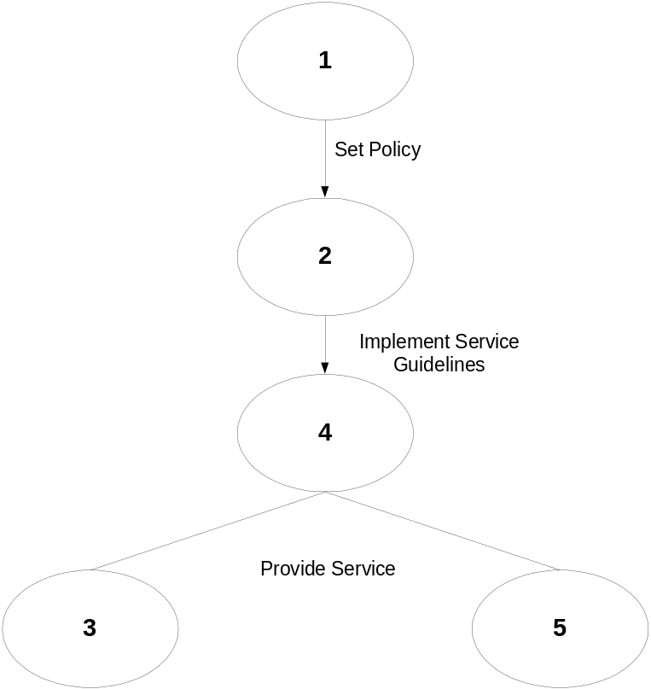

- Prioritization.
Because of constraints both in time and resources, the second phase determined which Business Processes to focus on. We accomplished this with an initial set of interviews with key personnel of the NRCS.
- Determination of the current state for NRCS.
Once the priorities were determined, we followed by assessing the current state of the selected Business Processes, with a series of follow up and additional interviews.
- Determination of the desired state for NRCS.
Based on the information gathered from the interviews, we assessed where the organization needs to go.
- Perform a gap analysis between the current state and the desired state.

Systems Analysis

Systems Analysis is defined as the study of an activity, procedure or process to determine the desired end and the most efficient method of obtaining this end. We have used this definition to characterize the process and methodology performed in this study.

It is our understanding that the purpose of these processes is to service requests both from external and internal users of the organization. From a Systems Analysis point of view a System consists of procedures, agents and constraints. Each can be defined as:

- Procedures are the set of steps followed by the organization to perform the series of specific tasks for which it is responsible.
- Agents are people, computer systems, equipment or any entity assigned to perform a specific task.
- Constraints are the set of rules, regulations and laws that guide and regulate what and how the agency is supposed to perform its function.

The purpose of analyzing NRCS in this light is to allow us to understand how NRCS processes are performed from a abstract level, to focus on its most important elements, to determine how it is currently executing its assigned responsibilities, to look for opportunities for improvement and to determine how to achieve those opportunities.

Determination of Priorities

Because of the limitation in time and constraints for this study it was decided that the first priority in our study was to determine a set of business processes to analyze. This was achieved by performing an initial set of interviews with the objective of determining “end user” priorities and input. The project team gave high value to the input of the “process users.”

Determination of Current State

With the understanding of what processes to focus on, we performed a series of interviews with both users and providers of services in order to understand how these were implemented and performed. The focus of this step was to determine some of the following:

- Are the processes adequate?
- Are the agents (people, systems, equipment) adequate for the tasks assigned to them?
- Are there any obvious bottlenecks?
- Have decision points been adequately identified?
- Have the agents been empowered to appropriately perform their tasks?

Determine where NRCS wants to be

The purpose of this phase was to determine what are the expressed goals and vision for the NRCS. This was necessary to understand the direction the organization is going. The project team looked for these elements during our interviews with top management and others in order to determine if senior and mid-management, both users and service providers, understood the goals and vision of the organization.

Gap analysis

After determining the list of priorities to focus on, determining the current state and deciphering a vision and a set of goals, the gap analysis was performed to understand the disparities between the current state and where the organization wants to be.

What is a business process?

Business Process has been defined as “a group of business activities undertaken by an organization in pursuit of a common goal.” It usually depends upon several functions for support, such as IT, personnel, and space planning. Very seldom does it operate in isolation. It is interdependent with other business process agents.

Office of the Deputy Chief for Management Organizational Structure

There is a Chief of NRCS and there is one Associate Chief and 5 deputy chiefs. Immediately below the Chief is the Associate Chief, who serves with the Chief in the planning and development of projects. The Associate Chief has oversight responsibility for management, programs, and accountability issues.
The Deputy Chief for Management is responsible for the development of national policies; establishment and promulgation of procedures, guidelines and standards; and providing agency and operational leadership for management services, human resources management, financial management, information technology, outreach activities, alternative dispute resolution (civil rights, employee rights) and ethics programs, correspondence management, and headquarters administrative support. The Deputy Chief also assesses emerging legislation, policy, and operations issues and conditions, and develops management options and plans for managing NRCS.
Compubahn dedicated its study resources on the divisions reporting to the Deputy Chief. These principal areas of responsibility for the Deputy Chief for Management are:
- Management services. (Director), including headquarters administrative support.
- Human resources management. (Director)
- Financial management. (Director/Chief Financial Officer)
- Information technology. (Director/Chief Information Officer)
- Outreach activities. (Director)
- Alternative dispute resolution (civil rights, employee rights) and ethics programs. (Acting Director)
- Correspondence management. (Director)
A director level staff heads each functional area listed above and reports directly to the Deputy Chief for Management.

Questionnaires (Anexures 2a-2g)

Annexure 2a

NRCS Management Study
Types of Questionnaires

- Level 1: Department level interviews to assess the policy compliance and adherence to guidance from the Department’s administrative management policy offices.
- Level 2: NRCS Management Office, Division Directors who are the service providers.
- Level 3: NRCS Deputy Chief’s who are primary customers of the Management Office. Civil Rights Office is also a customer of the Management Office.
- Level 4: Team leaders and others under Division Directors who implement the delivery of service.
- Level 5: Field Service Partner agencies, Rural Development and Farm Service Agency who can provide feedback on the general working relationships of the agencies.
- Others 6: Questionnaire Acting Associate Deputy Chief for Management and Questionnaire for Support Staff.

Annexure 2b
NRCS Management Study
Questionnaire: Level 1

- What are your expectations of the administrative management functions (i.e. civil rights, human resources, procurement, information technology, financial) in each agency?

- How do you insure that they do what you expect of them?

- Does the performance or compliance of the Management Office of NRCS raise any concerns for your office?

- Do you communicate or acknowledge the successes of the NRCS Management Office to the Deputy Chief for Management or others?

Annexure 2c
NRCS Management Study
Questionnaire: Level 2

A: As Customer of Services

- What are the three most important services you receive from each Division under NRCS management Office and place them in order of priority?
  - Management Services Division
  - Human Resources Management Division
  - Financial Management Division
  - Information Technology Division
  - Outreach Division
  - Administrative Support Division
  - Special Projects Division

- Do you have formal Service Level Agreements or work on the basis of informal understanding between divisions?
- Are the service level expectations clear?
- Explain if there are any “pain points” among service elements you receive.

B: As Provider of Services

- Do you know who your customers are?
- Do you know what your customers need?
- Are there services that you receive from other divisions that are required for you to deliver your own services?
- Which divisions do you believe work as an integrated team to provide best management services to NRCS?
- What policy or regulating guidelines do you feel are difficult to comply with? Why?
- Do you have adequate resources (manpower, systems, equipment etc) to provide expected quality customer service?
- Do you have a fully outlined organizational chart in your division and a clear job description for each position?
- Do you have a mechanism for developing and regularly updating business processes in your division?
- Are these business processes followed in providing services?
10. Do you have a backup plan for providing time sensitive services?
11. How do you rate the level of services you provide? (Scale: 1-10, 1Lowest and 10 Highest)

Annexure 2d
NRCS Management Study
Questionnaire: Level 3

- What do you feel are the four most important services you receive from the NRCS Management Office?
- Please place these four services in priority order?
- How do you assess the benefits of each service you receive?
- How do you assess the quality of each service you receive?
- Do you have formal Service Level Agreements?
- Are the service level expectations clear?
- Are there “pain points” among the service elements you receive?
- Is there a demonstration of “nearly pure” effectiveness in the services you receive? Explain.

Annexure 2e
NRCS Management Study
Questionnaire: Level 4

- What services do you or your team or division provide?
- Do you measure the effectiveness of services provided by your division or team?
- Are you able to meet the needs of your internal and external customers?
- What impact does the service you provide have on the services provided by the other divisions or Deputy Chief areas?
- Are your services integrated or coordinated with internal (within the Deputy Chief for Management area) and external programs (other NRCS Deputy Chief areas)?
- Does your division or team have representation or liaison with your customers in groups or working teams to insure customer guidance?
- Do you conduct an assessment of the administration of financial and material resources, utilization of human resources and review of implementation and results? How do you do this?
- Do you have adequate resources (human capital, systems, equipment, etc.) to execute your service objectives?
- What are the structure, staffing, workload and budget of your division/team?
- How effective is your division or team in meeting it’s stated goals and planned objectives in the following areas?
- How effective you are in communicating with agency and department offices?
12. Are there weaknesses in the decision-making processes in your team or division?
13. Do you have a mechanism for developing and regularly updating business processes in your division/team? How do you develop your business process?
14. What business processes are currently being followed in providing services? Are these business processes documented? Please provide details?
15. How you would like to improve your current business processes in getting your work done?
16. How would you like to improve the services provided by the divisions under the Deputy Chief of Management (e.g. streamlining procedures, elimination of functions, consolidation, position restructuring, co-location, workflow improvement, removal of impediments etc.)?

Annexure 2f
NRCS Management Study
Questionnaire: Level 5

- What do you believe are the three most important business relationships between Farm Service Agency/Rural Development and NRCS?
- What do you believe are the three most important program relationships farm Service Agency/Rural Development has with NRCS in serving the public?
- How do you assess the success of the business relationship?
- How do you assess the success of the program relationship?
- Among the elements in the business relationship, what do you think are the biggest barriers or challenges to success?
- Are there “pain points” in the business relationship? What are they?
- Are there demonstrations of “nearly pure” effectiveness in the business relationship? What are they?

Annexure 2g
NRCS Management Study
Questionnaire: Level 6

A: Questionnaire for Acting Associate Deputy Chief for Management
- What do you feel are the four most important services you receive from the NRCS management Office and place them in order of priority?
- How do you assess the benefits of each service you receive?
- Do you have formal service level agreements?
- Are the service level expectations clear?
- Are there “pain points” among the service elements you receive? Explain.
- Is there a demonstration of “nearly pure” effectiveness in the services you receive? Explain
- Which divisions do you believe work as an integrated team to provide best management services to NRCS?
- Do you think there are adequate resources (human capital, systems, equipment, etc) available with these divisions to meet their goals and planned objectives?
- Do you have a strategic plan for Deputy Chief for Management?
- How would you like to improve the services provided by the divisions under the deputy Chief of Management (e.g. streamlining procedures, elimination of functions, consolidation, position restructuring, workflow improvement, removal of impediments etc)

B: Questionnaire for Support Staff
- What are the most important services you receive from the various divisions of NRCS Management Office? Please place them in priority order?
- How would you describe the effectiveness of the services you receive?
- Are there agreed upon expectations of service with the Management Office Divisions?
- Are there specific written procedures available to follow in requesting service, or is everything informal?
- Are there any “pain points” among the services you receive?
- What suggestions do you have for improving the service provided to you from the Management Office?

Management Study Interview List (Annexure 3)

Name | Title/Office | Meeting Date/Interviewed By
Level 1 (Policy Offices)
Ruthie Jackson | Director, OHRM, Human Resources | (Omitted)
Russ Ashworth/Glenn Haggstrom | Director, OPPM, Property and Procurement | 9/22/04/WT
Clyde Thompson | Deputy Asst. Secretary, Office Civil Rights | 9/20/04/WT
Alma Hobbs | Director, Outreach, OCR | 9/22/04/WT
Patricia Healy | Deputy Chief Financial Officer, OCFO | 9/27/04/WT
Scott Charbo | Chief Information Officer, OCIO | 9/21/04/WT
Mary Ann Swigart | OES, Executive Secretariat | (Omitted)
Priscilla Carey | Deputy Asst Secretary for Administration | 9/20/04/WT
Rich Roberts | Director, IT Convergence, OCIO | 9/22/04/WT
Level 2 (Division Directors)
Joe O' Leska | Director, Financial Management Division, NRCS | 10/13/04/WT/AJ
Ed Biggers | Director, Management Services Division | 10/08/04/WT/AJ& 10/12/04/AJ
Karen Karlinchak | Director, Human Resources Management Division | 10/05/04/WT/CW
Mary Thomas | CIO/Director, Information Technology Division | 10/13/04/WT/AJ
Larry Holmes | Office of Outreach, NRCS | 10/06/04/WT/AJ
Stephanie Edelen | Correspondence Management Staff, NRCS | 10/05/04/WT/AJ
Andrew Johnson | Director, Civil Rights, NRCS | 10/06/04/WT/AJ
Level 3 (Deputy Chiefs)
Dwight P Holman | Deputy Chief for Management, NRCS | 11/23/04/WT
Jose Acevedo | Deputy Chief for Programs, NRCS | 09/28/04/WT
Maurice Mausbach | Deputy Chief for Soil Survey and Resource Assessment, NRCS | 09/28/04/WT
Lawrence Clark | Deputy Chief for Science and Technology, NRCS | 09/29/04/WT
Kathy Gugulis | Deputy Chief for Strategic Planning and Accountability, NRCS | 09/29/04/WT
Level 4 (Service Providers)
Charles Adams | National Emply Devlop Staff , Texas | 10/20/04/CW
Caryl Butcher | Ethics Staff Leader, Beltsville, MD | 10/6/04/WT
Vera Carey | Contract Officer | 10/21/04/AJ
Sheila Leonard | Grants and Agreements | 10/19/04/AJ
Yvonne Campbell | Records Manager | 10/14/04/AJ
Phyllis Williams | Directives Manager | 10/14/04/AJ
Elizabeth Pigg | IT, Planner | 10/14/04 &10/19/04/AJ
Anita Byrd | IT, Planner | 10/14/04/AJ
Ken Carpenter | Software Testing Lab, ITC,FTC | 10/20/04/AJ
Scott Snover | Manages CCE, ITC, FTC | 10/25/2004/AJ
Wendall Oaks | SW project Manager, ITC,FTC | 10/22/04/AJ
Bob Langan | HR Team Leader | 10/14/04/CW
Cynthia Barnes | HR Specialist | 101804/CW
Cynthia Beasley | Employee Relations Team Lead | 10/14/04/CW
Valerie Smith | HR Specialist | 10/18/04/CW
Perry Rios | IT Support Service Team Leader | 10/19/04/AJ
Don Kapalka | IT Support Service Team Leader, TX | 10/22/04/AJ
Jack Carlson | Director, ITC | 11/19/04/AJ
Level 5 (Partner Agency)
Sherie Hinton Henry | Rural Dev, Dy Chief for Management | 09/20/04/WT
John Williams | FSA, Dy Administrator for Management | 09/21/04/WT
Level 6 (Others)
Michael Gonzales | Acting Associate Dy Chief for Mgmt | 11/24/04/AJ
Joyce Morgan | Support Staff | 1126/06/CW (Written only)
 | WT: Wardell Townsend
 | AJ: Ashok Jain
 | CW: Charles Warrick

Reference Documents (Annexure 4)

- General Manual, National Headquarters, Office of the Chief.
- General Manual, Sect. 404.77 Deputy Chief for Management.
- Reorganization Functional Statements: Sect. 404.10 Office of the Chief.
- NRCS Streamlining Cost-Savings Initiative – July 13, 2004
- USDA Service Center Modernization Initiative – Information Technology
- Final Report – NRCS Information Resources: “Realizing Future Directions”, September 2001
- The Correspondence Management Staff Procedures Reference Guide.
- Natural Resources Conservation Service Strategic Plan 2003 Update.
- Fiscal Year 2003: NRCS Performance Report.
- Information Technology Division Organization Chart
- Human Resources Management Division Organization Chart
- Financial Management Division Organization Chart

Organization Charts (Annexure 5)

OCIO-ITD & ITC Staffing Chart
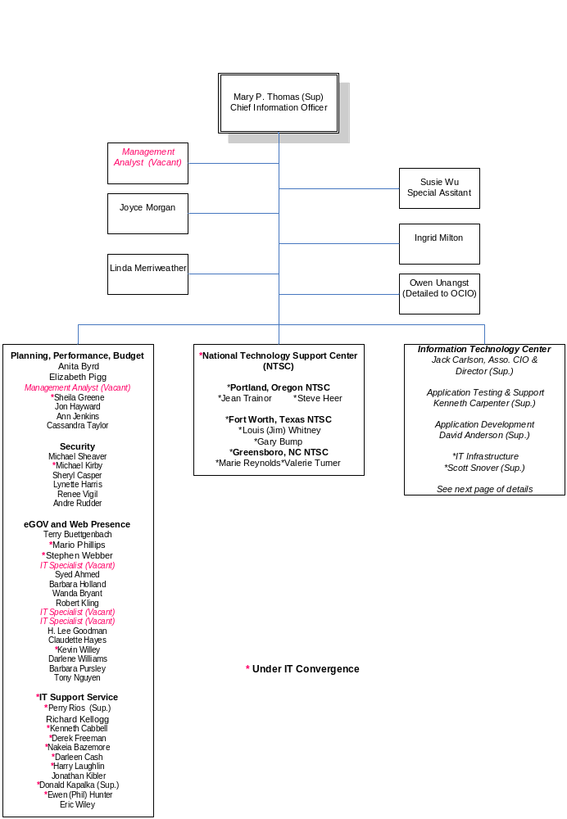
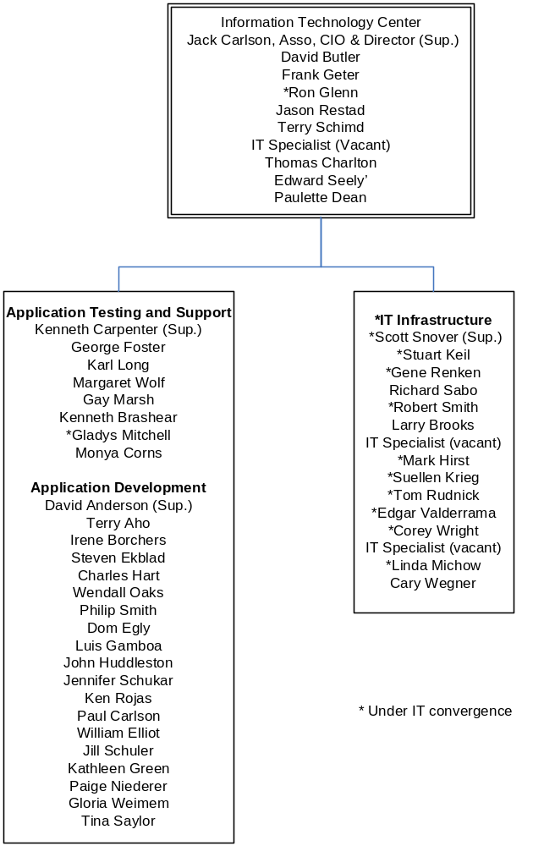

Human Resources Management Division

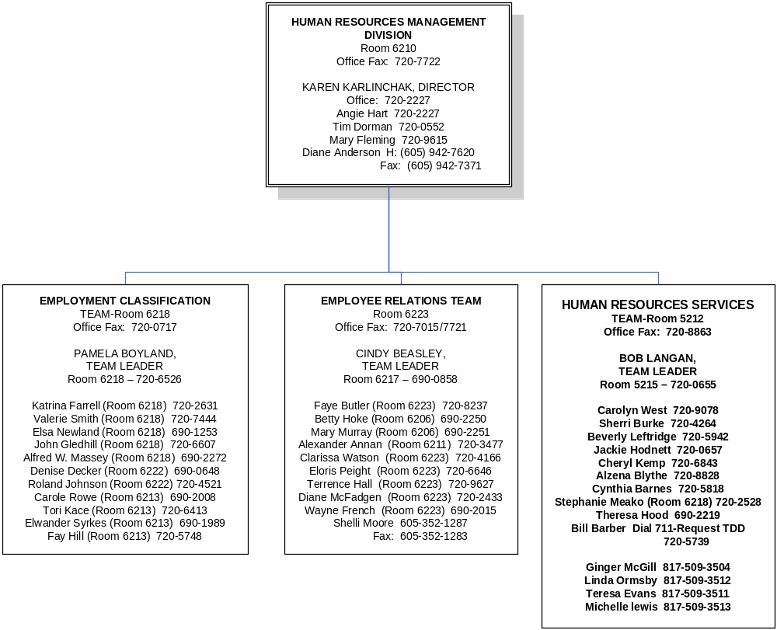

Management Services Division

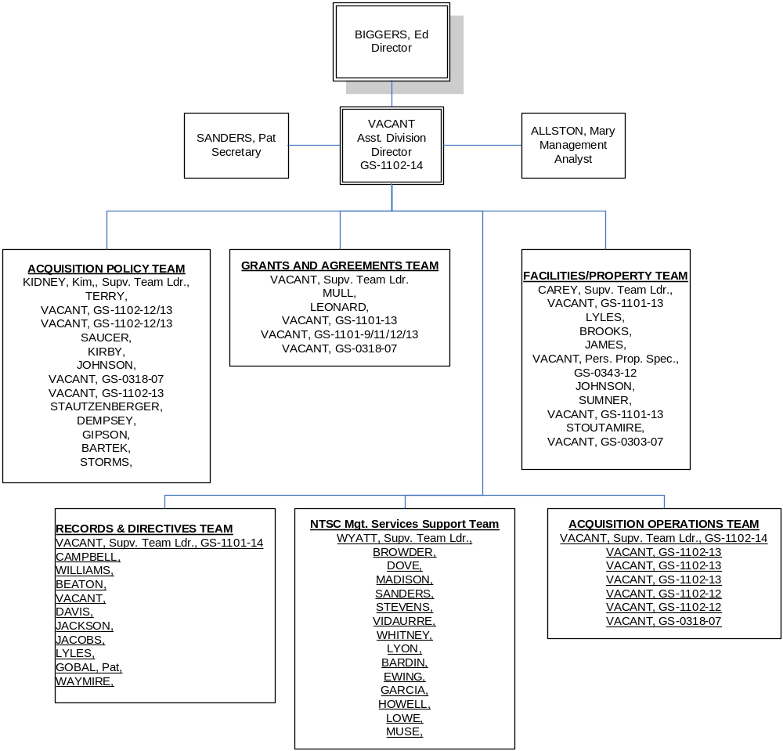

Financial Management Division

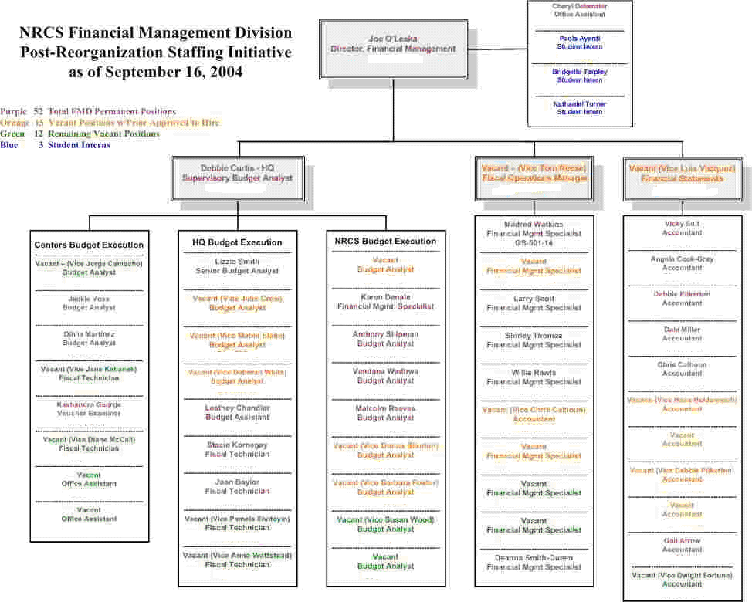

Progress Reports (Annexure 6)

Report #1, June 23-July 31, 2004

The first official meeting between the Natural Resources Conservation Service (NRCS) COTR (Contracting Officers Technical Representative), Mary Thomas, Wardell Townsend, Project Leader with Compubahn, Inc., and Bob Terry, contracts officer, was on June 29, 2004. This “Pre-award meeting” was an informal review of the Statement of Work (SOW) that had been awarded on May 7, 2004. It was agreed that NRCS would provide areas of focus for the management assessment and any existing documents that provided analytical background on the strategic and operational aspects of the Office of Management.

Compubahn’s team (CT) began review the NRCS government website for background information on the mission of the agency, its organizational structure and geographical scope, and recent organizational changes mandated by Congress or Executive Order.

The CT began preparing for the “kick-off” meeting scheduled for July 17 at the NRCS Beltsville offices. At the meeting on July 17, based on a series of questions by CT and responses by the NRCS executive sponsor, Deputy Chief for Management, Dwight Holman, the COTR and members of the NRCS project team (Bob Terry, Elizabeth Pigg and Suzie Wu), areas of focus for the assessment became clear: information technology division; management services division; financial management division; human resources division; and correspondence management. CT will devote greater granularity of study in these business areas of the Office of Management; however, the remaining business areas will be reviewed appropriately.

There are specific reviews that were suggested by the customer for certain divisions. Process reviews that will answer “bottlenecks”; skill-set assessments for specific functions; customer expectations. Furthermore, CT will establish which issues or improvements will take highest priority with the guidance of the customer.

CT prepared for the July 29 meeting at USDA South Building. Those attending were:
Dr. Rajeev Aggarwal, President; Wardell C. Townsend, Jr., Senior Vice President (Project Leader); Dr. Ashok Jain, Manager R&D; Amalio Escobar, Program Manager
The NRCS Management Division Directors, Mary Thomas, CIO, Information Technology Division; Stephanie Edelen, Director, Correspondence Management;
Carole Butcher, Ethics Manager; Susie Wu, Special Assistant to the CIO, Information Technology Division; Edward Biggers, Director, Management Services Division; Vera Carey, Administrative Officer; Cindy Beasley, Acting for Karen Karlinchak, Director, Human Resources Management Division; and those conferenced by phone were Dave Anderson, Acting for Jack Carlson (Ft. Collins); Fred Reeves, Acting for Larry Holmes, Director, Outreach Division (Beltsville); Patty Brown, National Competitive Sourcing Team Leader; Joe O'Leska, Director, Financial Management Division.
The July 29 meeting was a formal presentation of the purpose, philosophy, and methodology for the management study. The purpose: Assess the priority functions of the Office of Management for process, personnel, and operating efficiency and effectiveness. Recommend the best use of resources to function at a higher level. The philosophy: The service agency must accommodate its customers and manage and meet their expectations with honest inquiry and feedback. The methodology: A principled and organized method of Systems Analysis, a dominant process of business process re-engineering. In essence, “people, processes, and equipment” are viewed as agents and the analysis focuses on the quality and the interaction and relational practices between agents.

The meeting concluded with next steps: Establish a date for the NRCS Office of Management all-employee orientation in the second week of September. Setting up interviews with deputy chiefs, field service agencies, and division directors in the Office of Management.

Wardell Townsend
Project Leader, NRCS Management Study
Compubahn, Inc.
July 31, 2004

Report #2, August 1-15, 2004

During the period of August 2 to August 13, the Compubahn project leader was on summer leave. Staff support for the project continued background research in reviewing a host of documents provided by NRCS COTR. Although the review of the documents will continue, the pertinent sections for further development of the details (i.e., priorities and questions) have been thoughtfully reviewed. The Compubahn team will continue its group consultations in refining the analysis of the information.
During this two-week period, the project leader resolved administrative issues and invoice questions.

Wardell Townsend
Project Leader, NRCS Management Study
Compubahn, Inc.
August 15, 2004

Report #3, August 16-31, 2004

The Compubahn team conferred on the list of documents provided by the NRCS COTR. The most recent documents received were the NRCS Management Office organizational directories.

- ITD organizational chart (schematic)
- Strategic Assessment for Information Technology (September 2001)
- General Manual, National Headquarters, Office of the Chief
- General Manual, Sect. 404.77 Deputy Chief for Management
- Reorganization Functional Statements: Sect. 404.10 Office of the Chief
- NRCS Streamlining Cost-Savings Initiatives-July 13, 2004
- Service Center Modernization Initiative-Information Technology
- Office of the Deputy Chief for Management Organizational Directory

An impromptu meeting with Sam Thornton, special assistant to the Deputy Chief, on August 31 provided helpful overview of the atmosphere for the study at the division level of NRCS.

In communications on August 31, the NRCS COTR has asked that only high-level interviews be held with the Rural Development (RD) and Farm Service Agency (FSA) rather than detailed interviews. She highlighted the focus on the program executive level and management organization of NRCS. She also saw a benefit in interviewing the departmental policy offices for the administrative management functional areas of NRCS. These offices include human resources, chief information officer (and field service administrative convergence), chief financial officer, property and procurement, civil rights (and office of outreach), and executive correspondence. Each of these offices provides policy guidance and directions to all of the agencies in the Department of Agriculture.

The next step is to set a date and time for NRCS orientation regarding the study; secure interviews with selected departmental staff, deputy chiefs of NRCS, division directors in the NRCS Management Office.

Wardell Townsend
Project Leader, NRCS Management Study
Compubahn, Inc.
August 31, 2004

Report #4, September 1-15, 2004

Compubahn secured office space at the NRCS Beltsville offices and worked with the IT technical staff to get access to the intra-net. The informal meetings have proven very helpful in further understanding the atmosphere and culture of ITD. Our discussions with Susie Wu on introducing the Department level staff and NRCS deputy chiefs to Compubahn for the study and setting up the interviews would allow Compubahn to make the interview appointments and keeping the process flexible.

The Compubahn team began drafting interview questions for the appropriate levels of interviewees. Compubahn identified department level policy compliance and regulators; field service agency partners (FSA and RD); NRCS principal customers (program deputy
chiefs); service provider managers (division manager in the office of the deputy chief for management); and process owners (mid-level within the divisions).

The list of proposed interviewees and the rationale was submitted to the COTR for review. Mary Thomas augmented the list with 18 more possible interviewees and provided rationale. Compubahn concurs with the reasoning and is preparing a contract change order.

The Compubahn team gave further review and edited the interview questions appropriate for the study approach and the category of interviewee. The detailed project plan will be completed and submitted to the COTR after the first series of interviews with the principal customers in NRCS (deputy chiefs). The Compubahn team received confirmation that the all-employees orientation session for the management study would be held on September 16 by audio-conference. The team reconstructed the slide presentation for an audio presentation.

Wardell Townsend
Project Leader, NRCS Management Study
Compubahn, Inc.
September 15, 2004

Report #5, September 16-30, 2004

The Compubahn team (Wardell Townsend and Dr. Ashok Jain) met in the offices of NRCS in Beltsville on September 16 to conduct the all-employee audio-orientation. The slides for the presentation were forwarded to all supervisory personnel the day before and they then forwarded it to line staff. According to Susie Wu, there would be approximately 100 people on-line participating in the conference call. There were 19 people present in the conference room in Beltsville. Mary Thomas opened the session and Dwight Holman made opening remarks. There were thirteen questions asked and answered. There were three questions asked in private after the close of the open session. Most of the questions related to scheduling of interviews; who would be interviewed; confidentiality; and feedback during the course of the study.

COTR, Mary Thomas, committed that Compubahn would prepare feedback for the staff at the mid-point of the study. Mary Thomas provided feedback to Compubahn after the orientation and said that she and Mr. Holman thought the session went very well and they were pleased.

Scheduling interviews began immediately after the all-employee orientation. The first levels of interviews occurred with Department-level policy and regulatory overseers (#1s) and senior management executives of the partnering field service agencies (#5s). By the end of September all of these interviews were completed and the notes transcribed for analysis.

As the #1 and #5 interviews were completing, interviews with the NRCS Deputy Chiefs (#3s) were being scheduled and conducted. The #5s are considered high level customers who provided interviewers with insights and specifics on how they and their offices are being served and what service expectations they had. These interviews were completed by the end of September and preliminary analysis had allowed more accurate development of interview questions for division managers under (#2s) the Deputy Chief for Management and an augmenting list of 18 interviewees (#4s) requested by NRCS.

Compubahn’s review of the list of 18 additional interviewees and its findings concurred with the justifications presented by NRCS. These individuals (#4s) will offer greater insights and granularity as process owners and service deliverers. There is also important institutional knowledge among these interviewees.

Interviews with #2s begin during the first week in October. Compubahn is aggressively approaching the timetable for completing the interviews and then narrowing the assessment on the highest four priority processes for business process analysis. Compubahn is on schedule to complete all of its initial interviews by the end of October.
Wardell Townsend
Project Leader, NRCS Management Study
Compubahn, Inc.
September 30, 2004

Report #6, October 1-15, 2004

After receiving the list of 18 additional interviewees from Mary Thomas on October 4, in order to meet the December 30 completion date and to develop the questions and integrate the data, the Compubahn Project Team began assignments and timetables for completing the additional interviews. Compubahn submitted its contract modification to NRCS on October 4. The project team labeled this new group of interviewees as Level 4 (process owners and service deliverers). On October 13, the Level 4 list of interviewees was adjusted to 20; however, on October 17, the list was further adjusted by NRCS to 21. In each instance, the project team made easy accommodations for the changes.

By October 13 the project team had completed all of its Level 1, 2, 3, and 5 interviews that included the following 22 interviews:

- Ruthie Jackson, OHRM, Human Resources*
- Russ Ashworth and Glenn Haggstrom, OPPM, Property and Procurement
- Clyde Thompson, Civil Rights
- Alma Hobbs, Outreach
- Patricia Healy, OCFO, Finance
- Scott Charbo-policy, OCIO, Information Technology
- Rich Roberts-admin. Convergence, CIO
- MaryAnn Swigart, OES, Executive Secretariat**
- Sherie Hinton Henry, Deputy Administrator for Management, RD
- John Williams, Deputy Administrator for Management, FSA
- Dana York, Associate Chief, NRCS***
- Jose Acevedo, Deputy Chief for Programs
- Maurice Mausbach, Deputy Chief for Soil Survey and Res. Assessment
- Lawrence Clark, Deputy Chief for Science and Technology
- Kathy Gugulis, Deputy Chief for Strategic Planning and Accountability
- Joe O’Leska, Financial Management
- Ed Biggers, Management Services
- Karen Karlinchak, Human Resources
- Mary Thomas, Information Technology
- Larry Holmes, Outreach,
- Stephanie Edelen, Correspondence Management,
- Andrew Johnson, Civil Rights

*Replaced by Priscilla Carey, Deputy Assistant Sec. for Administration
** Did not respond to 3 calls and 2 e-mails.
*** Removed on 9/28/04

The strategic approach of the project team was to complete a review of the transcripts of the Level 1, 2, 3, and 5 interviews before drafting an appropriate set of questions for the Level 4 (process owners and service deliverers). Preliminarily, the basic elements for developing the questions were completed on October 10 and needed only minor adjustments prior to dissemination.

On Wednesday, October 13, Susie Wu sent an introductory message to the Level 4 interviewees, and it included the list of questions for the interviews.

October 13, 2004 Level 4 Interviewees

- Charles Adams, National Employee Development Staff, Fort Worth, Texas
- Vera Carey, Contract Officer
- Sheila Leonard, Grants & Agreements
- Yvonne Campbell, Records Manager
- Phyllis Williams, Directives Manager
- Jack Carlson, Assoc CIO
- Elizabeth Pigg, IT Planner
- Anita Byrd, IT Planner
- Ken Carpenter, Software Testing Lab
- Scott Snover, manages CCE, ITC FTC
- Wendall Oaks, SW Project Manager, ITC
- Bob Langan, HR Team Leader
- Cynthia Barnes, HR Specialist
- Cynthia Beasley, Employee Relations team lead
- Valerie Smith, HR specialist
- Perry Rios, IT Support Service Team Leader
- Robert Terry, Contracting Officer
- Don Kapalka, IT Support Services Team Leader
- Joyce Morgan, Program Assistant, ITD
- Sharon Kidney, Program Assistant, AH and CW Division

Wardell Townsend
Project Leader, NRCS Management Study
Compubahn, Inc.
October 16, 2004

Report #7, October 15-31, 2004

The Compubahn Project Team has considered two additional interview lists for Level 4 as it commenced with the interview process. Susie Wu, assistant to the COTR, sent an introductory message to the interview list on October 13. This courtesy introduction for the Project Team was very helpful. The team began scheduling and conducting interviews. There were several adjustments to the contract modification for the additional interviewees with the final modification submitted on October 28, 2004. The final list for Level 4 was as follows:

- Charles Adams, National Employee Development Staff, Fort Worth, Texas
- Caryl Butcher, Ethics Staff Leader, Beltsville, MD
- Vera Carey, Contract Officer
- Sheila Leonard, Grants & Agreements
- Yvonne Campbell, Records Manager
- Phyllis Williams, Directives Manager
- Elizabeth Pigg, IT Planner
- Anita Byrd, IT Planner
- Ken Carpenter, Software Testing Lab
- Scott Snover, manages CCE, ITC FTC
11. Wendall Oaks, SW Project Manager, ITC
12. Bob Langan, HR Team Leader
13. Cynthia Barnes, HR Specialist
- Cynthia Beasley, Employee Relations team leader
- Valerie Smith, HR specialist
- Perry Rios, IT Support Service Team Leader
- Don Kapalka, IT Support Service Team Leader, TX

By the end of October, all of the Level 4 interviews had been conducted and a systematic analysis of the findings based on those interviews revealed clear consistencies in service issues raised by customers and providers. The Project Team has identified both thematic problems and service delivery problems in several divisions under the Deputy Chief for Management. Thematically, the “informal” nature by which the divisions get their tasks
and functions accomplished do not allow for a consistent standard of service performance and therefore does not appear to engender performance accountability. The culture of “informality” has strong beneficial aspects for human relations but may be a serious barrier for business relationships and standards.

In general, where there are “pain points” in service deliveries that are consistently identified by customers or service providers, there appears to be human capital inadequacies and business process deficiencies that negatively affect service delivery.

The Project Team has assessed that three divisions have principal problems that require immediate attention. The Management Services Division, Financial Services Division, and Human Resources Division have teams or branches suffering from “human capital inadequacies and business process deficiencies”. The data also reflects an inadequate organizational structure and management span of control for the Information Technology Division.

The Project Team will meet with Dwight Holman and Mary Thomas to discuss in more detail the findings of the study at this point and set a date and time in the near future for the all-employee audio conference to give an over view of the findings.

Wardell Townsend
Project Leader, NRCS Management Study
Compubahn, Inc.
November 1, 2004

Report #8, November 1-15, 2004

The Compubahn Project Team jointly began reviewing the data received during the course of interviews and documents forwarded by customers and those available among public documents. At the end of the last reporting period (October 16-31), the project team proposed interviewing three specific employees who were on a list provided by COTR. The project team recommended to the Compubahn CEO that the cost for incorporating three additional interviews be absorbed by the company. It was agreed to and NRCS finalized its selection of:
Joyce Morgan
Mike Gonzalez
Jack Carlson

The date for the all-employee’s audio conference update on the status was put off until the NRCS management team completed planning and off-site conferencing between November 8 and 19. According to Susie Wu, that period would be devoted to this internal project. The Compubahn project team devoted time to team meetings in preparing the final report outline, preliminary recommendations, all-employee presentation strategy, and the executive sponsor’s briefing.

Wardell Townsend
Project Leader, NRCS Management Study
Compubahn, Inc.
November 16, 2004

Report #9, November 16-30, 2004

The Compubahn Project Team completed the last three interviews and began group-drafting sessions on the broad elements of the study’s findings. A preliminary list of recommendations was based on these findings. Several basic assumptions related to organizational vision and individual performance plans for the deputy chief and the direct reports required verification from the Deputy Chief for Management.

As a result of the 105-minute interview with the Deputy Chief for Management on November 23, the project team incorporated the data provided and moved forward with drafting.

During the course of the November 23 interview with the Deputy Chief, the full list of recommendations were accepted and appeared to reflect organizational needs. The issue of prioritization would be an important issue for the Compubahn Project Team. The anticipated, but not yet scheduled, all-employee audio conference providing an update on the study was cancelled. Compubahn offered to provide a general update for the COTR for circulation to the employees if desired.

At the end of November, there were several promised documents from employees that had not yet been received by the project team. This data would be ancillary but important background information.

The project team is targeting December 13 as the date for a rough draft of the report for the COTR and Executive Sponsor.

Wardell Townsend
Project Leader, NRCS Management Study
Compubahn, Inc.
December 2, 2004

Acronyms (Annexure 7)

Acronym | Definition
BCT | Budget Core Team
CCE | Common Computing Environment
CEO | Chief Executive Officer
CFO | Chief Financial Officer
CIO | Chief Information Officer
COTR | Contracting Officer Technical Representative
COTS | Commercial off-the Shelf Software
CPAS
CT | Compubahn Team
FFIS | Foundation Financial Information System
FMD | Financial Management Division
FSA | Farm Service Agency
GSA | General Service Administration
HACU | Hispanic American Colleges and Universities
HBCU | Historically Black Colleges and Universities
HR | Human Resources
HRMD | Human Resources Management Division
IAS | Integrated Acquisition System
ICAMS | Integrated Combined Administrative Management System
IT | Information Technology
ITC | Information Technology Center
ITD | Information Technology Division
ITS | Information Technology Services
MSD | Management Services Division
NFC | National Finance Center
NHQ | National Headquarters
NITPCC | National Information Technology Project Coordination Committee
NRCS | National Resource Conservation Service
NTSC | National Technology Support Center
OCIO | Office of CIO
OIG | Office of the Inspector General
OMB | Office of Management and Budget
OPM | Office of Personnel Management
PROTRACT
RD | Rural Development
RIAD | Resources Inventory & Assessment Division
SLA | Service Level Agreement
SLCM | System Life Cycle Management
SOP | Service Operating Procedures
SOW | Statement of Work
USDA | United States Department of Agriculture

