BROOKHAVEN NATIONAL LABORATORY  GENERAL CLINICAL RESEARCH CENTER POLICY | GCRC POLICY: IC-10 | PAGE 1 OF 1
 | PREPARED BY: B. Pyatt Infection Control
SUBJECT: Potable Water | REVIEWED BY: W.Gunther GCRC Manager
SUBJECT: Potable Water | APPROVED BY: G. J. Wang Medical Dept. Chair
SUBJECT: Potable Water | EFFECTIVE DATE: 3-10-08
SUBJECT: Potable Water | REVISION HISTORY: 8

1.0 PURPOSE AND SCOPE

This document defines the policies and procedures regarding the potable water sources in the Dept.

2.0 POLICIES & PROCEDURES

2.1 Water Testing Program
The water potability testing program in the Medical Department applies only to fountains and sinks. See also BNL 2000 Collection of Potable Water Samples (Attachment 1).
a) Potable water analysis (tests and sampling locations listed below) will be performed by Plant Engineering (PE) Division per PE Policies and Procedures document O&M-WTF-006 (Attachment 2).
Tests:
bacteriological
inorganic chemicals
asbestos
nitrate/nitrite
organic contaminants/vinyl chloride and MTBE
radiological
organic chemical and pesticides
lead
"water quality"
Sampling Locations (within the Medical Dept.):
January, March, May, July, September and November.
Out-Patient Clinic - Rm. 7-15, men's room.
Block 11, Rm. 12-101, men's room.
February, April, June, August, October and December.
Block 1, Ambulatory Care Facility, Rm. 1-112.
Block 4, Medical Research Center, Rm. 4-103.

b) PE results are forwarded to the Dept. Infection Control Practitioner (ICP)
c) ICP retains results for use by Dept. staff (i.e., BLAF)
d) Any additional water quality testing results (i.e., SEP testing) received by the Dept. ESH Coordinator or other Dept. personnel are forwarded to the ICP.
e) The ICP shall present reports to the Quality Assurance, Care and Safety Committee monthly.

2.2 Bottled Water Dispensers
a) Bottled water supply and dispenser problems are managed by the Building Manager. Bottled water is available and empty bottles are returned to room 9-203E (bldg. 490 stock room).
b) Custody/Maintenance of individual bottled water dispensers are the responsibility of designated staff members (Attachment 3). Upon each change of water bottle the following should be done:
1) Wipe the neck of the new water bottle with 10% bleach solution
NOTE: Bleach solution must be prepared within 30 days of use
Follow the Environment Management Systems “Drinking Water” Managing and Maintaining Bottled Water Systems procedure.

- ATTACHMENTS
  - BNL 2008 Potable Water Sampling Plan IC10-Attachment 1
  - PE Policies and Procedures document O&M-WTF-006 IC10-Attachment 2
  - Individuals responsible for water bottles IC10-Attachment 3

The only official copy of this file is the one online at the Medical Department website under “Clinical Research Center Policy Manual.” Before using a printed copy, verify that it is the most current version by checking the document effective date on the website.
Attachment 1
IC-10/08
BNL 2003 Potable Water Sampling Plan

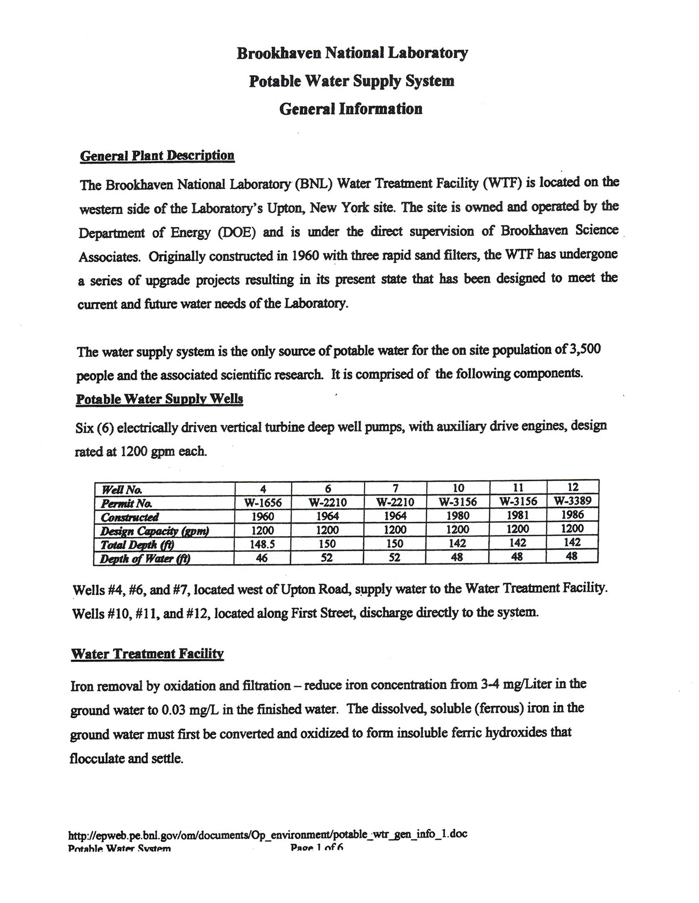

Attachment 1
IC-10/08

BNL 2003 Potable Water Sampling Plan
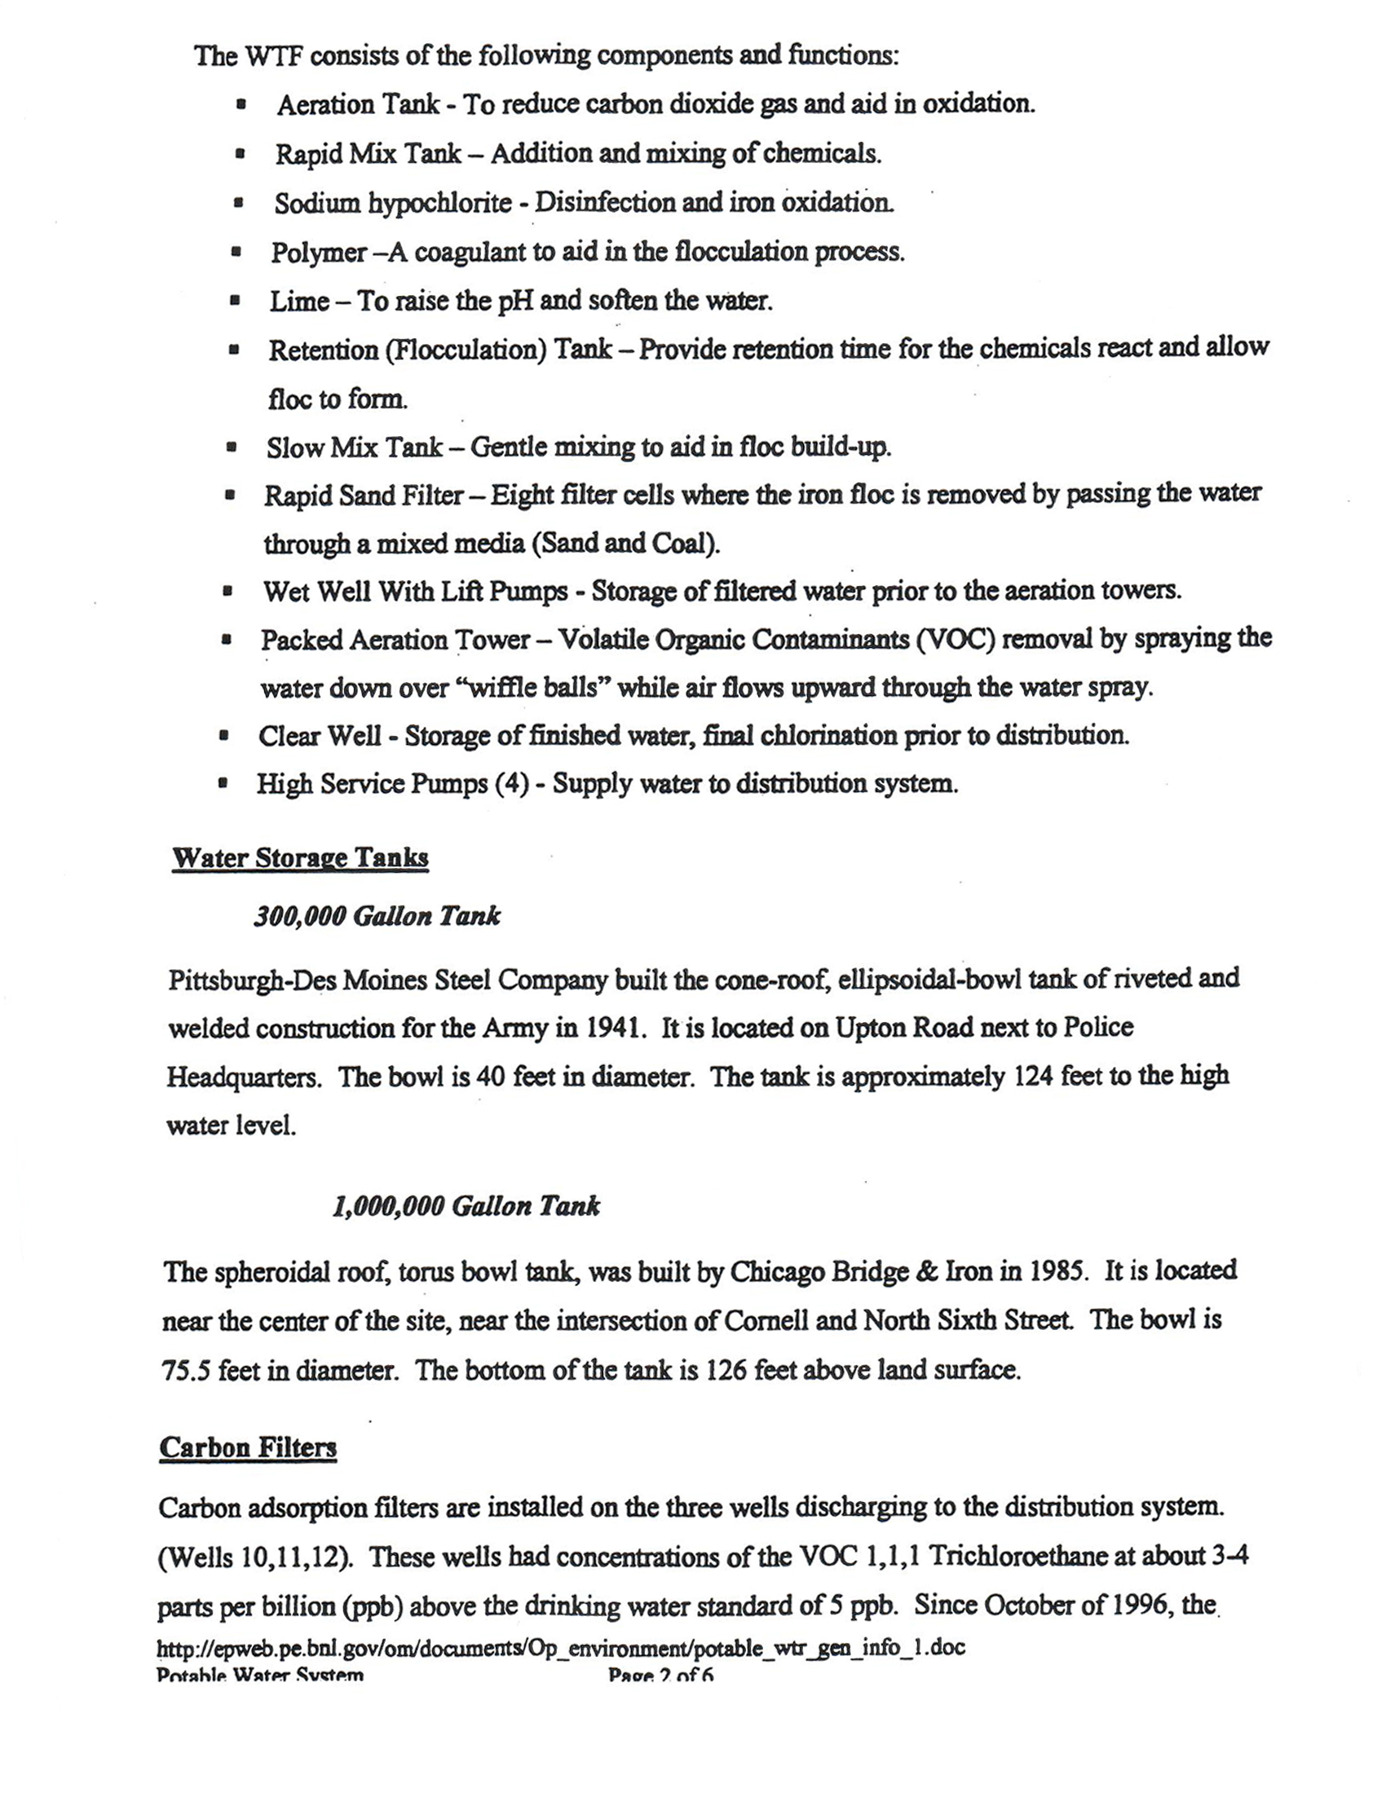

Attachment 1
IC-10/08
BNL 2003 Potable Water Sampling Plan

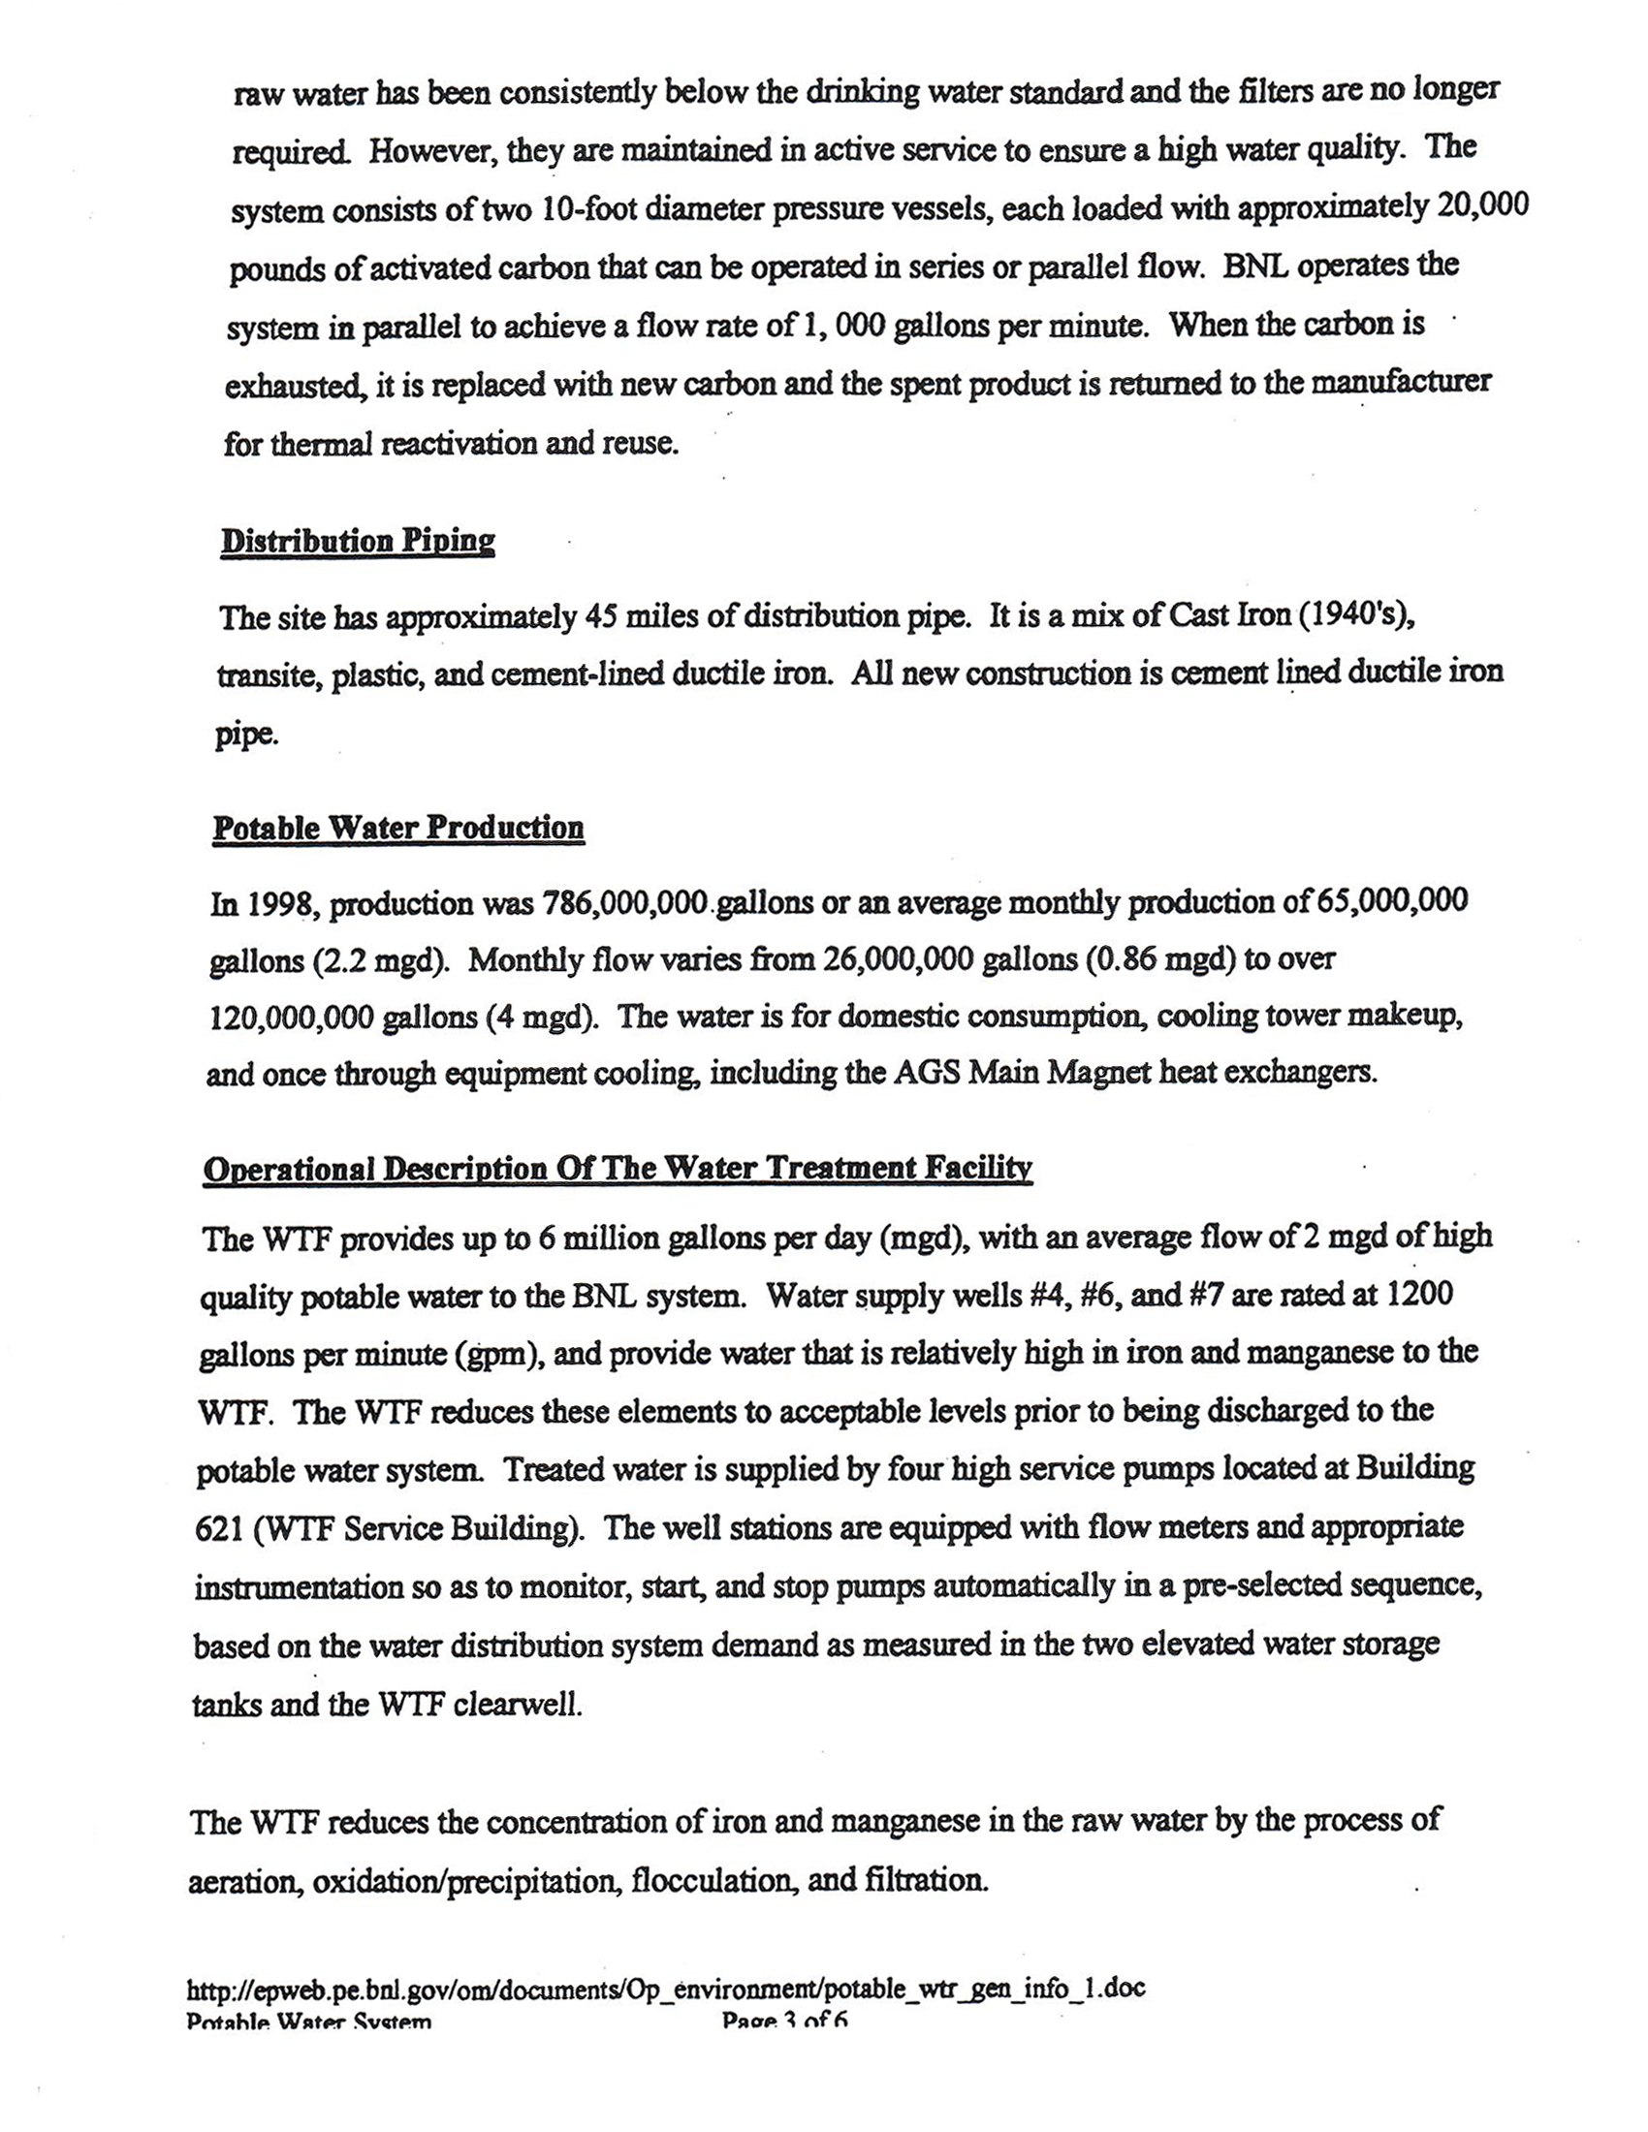

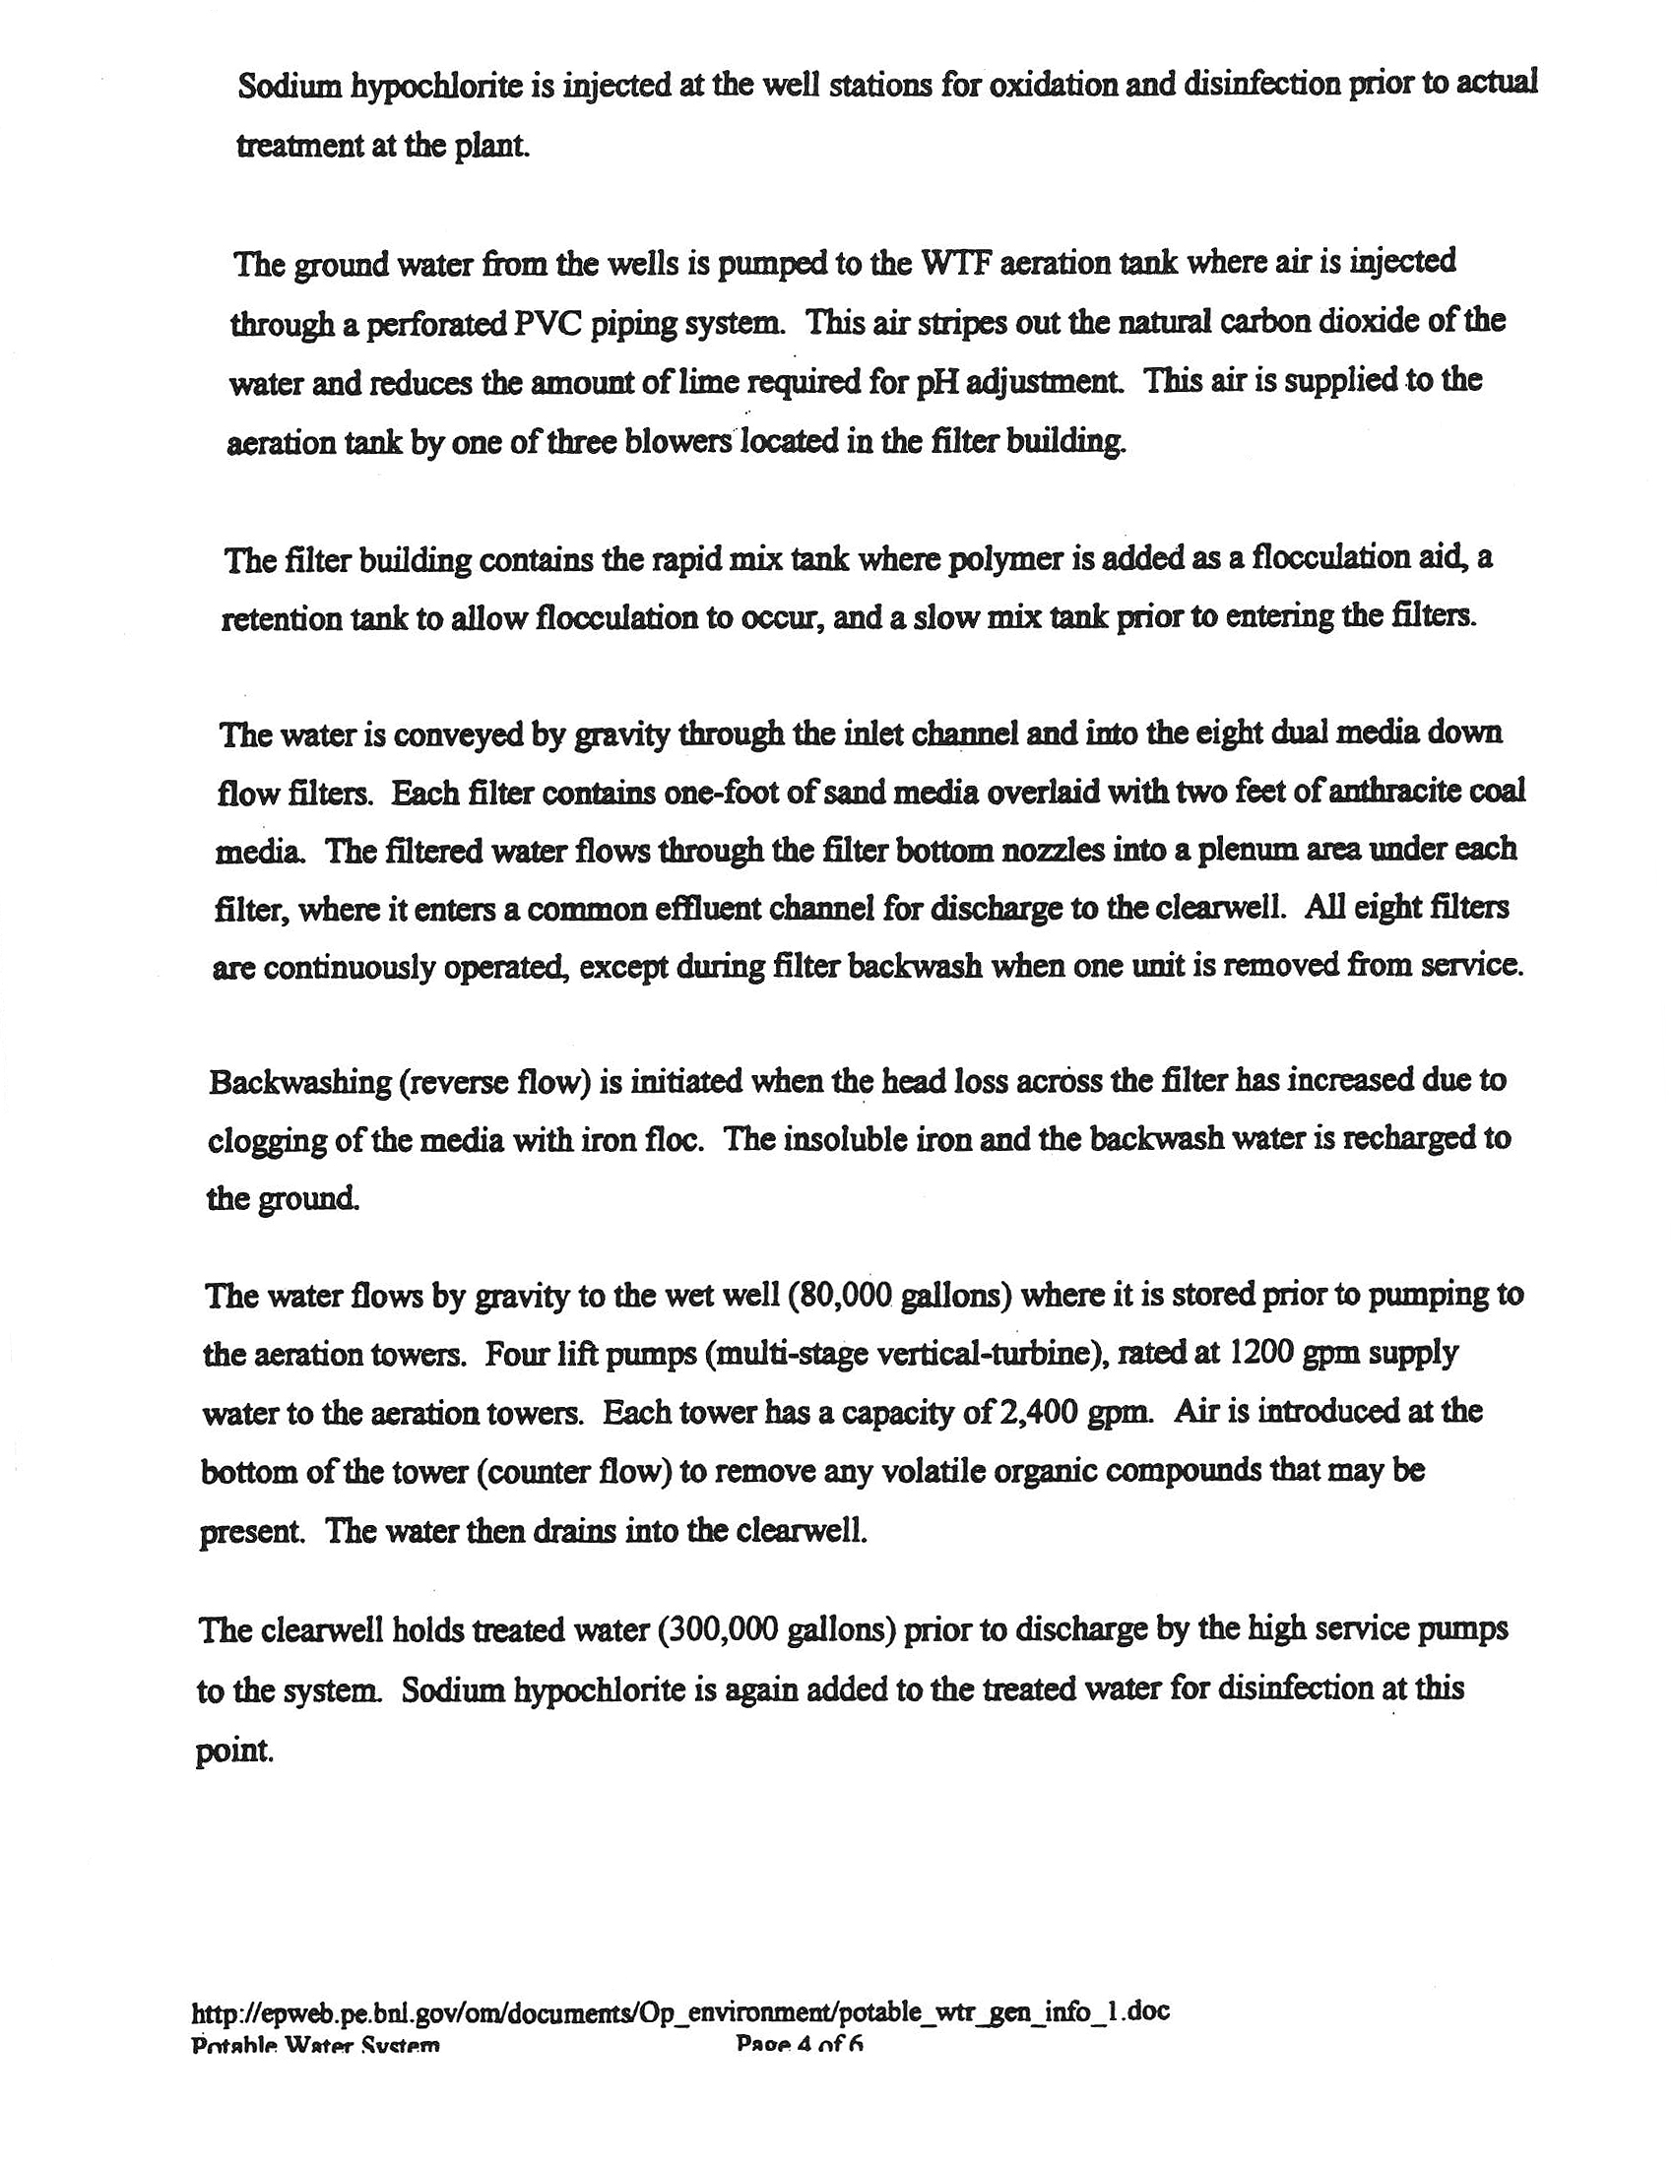

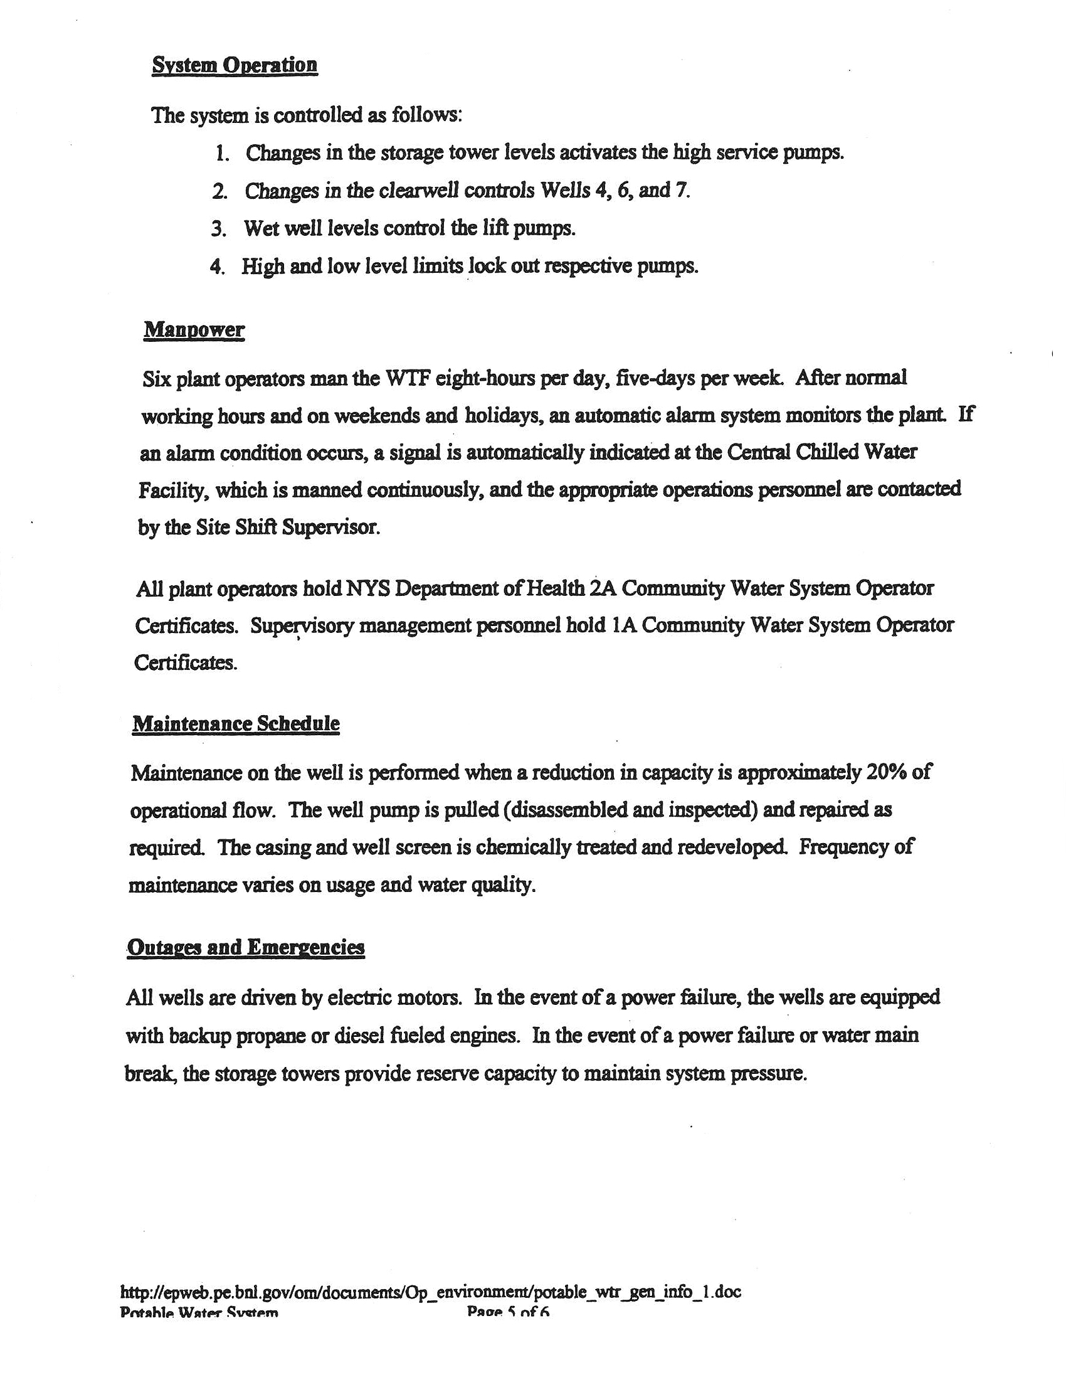

Attachment 1
IC-10/08
BNL 2003 Potable Water Sampling Plan

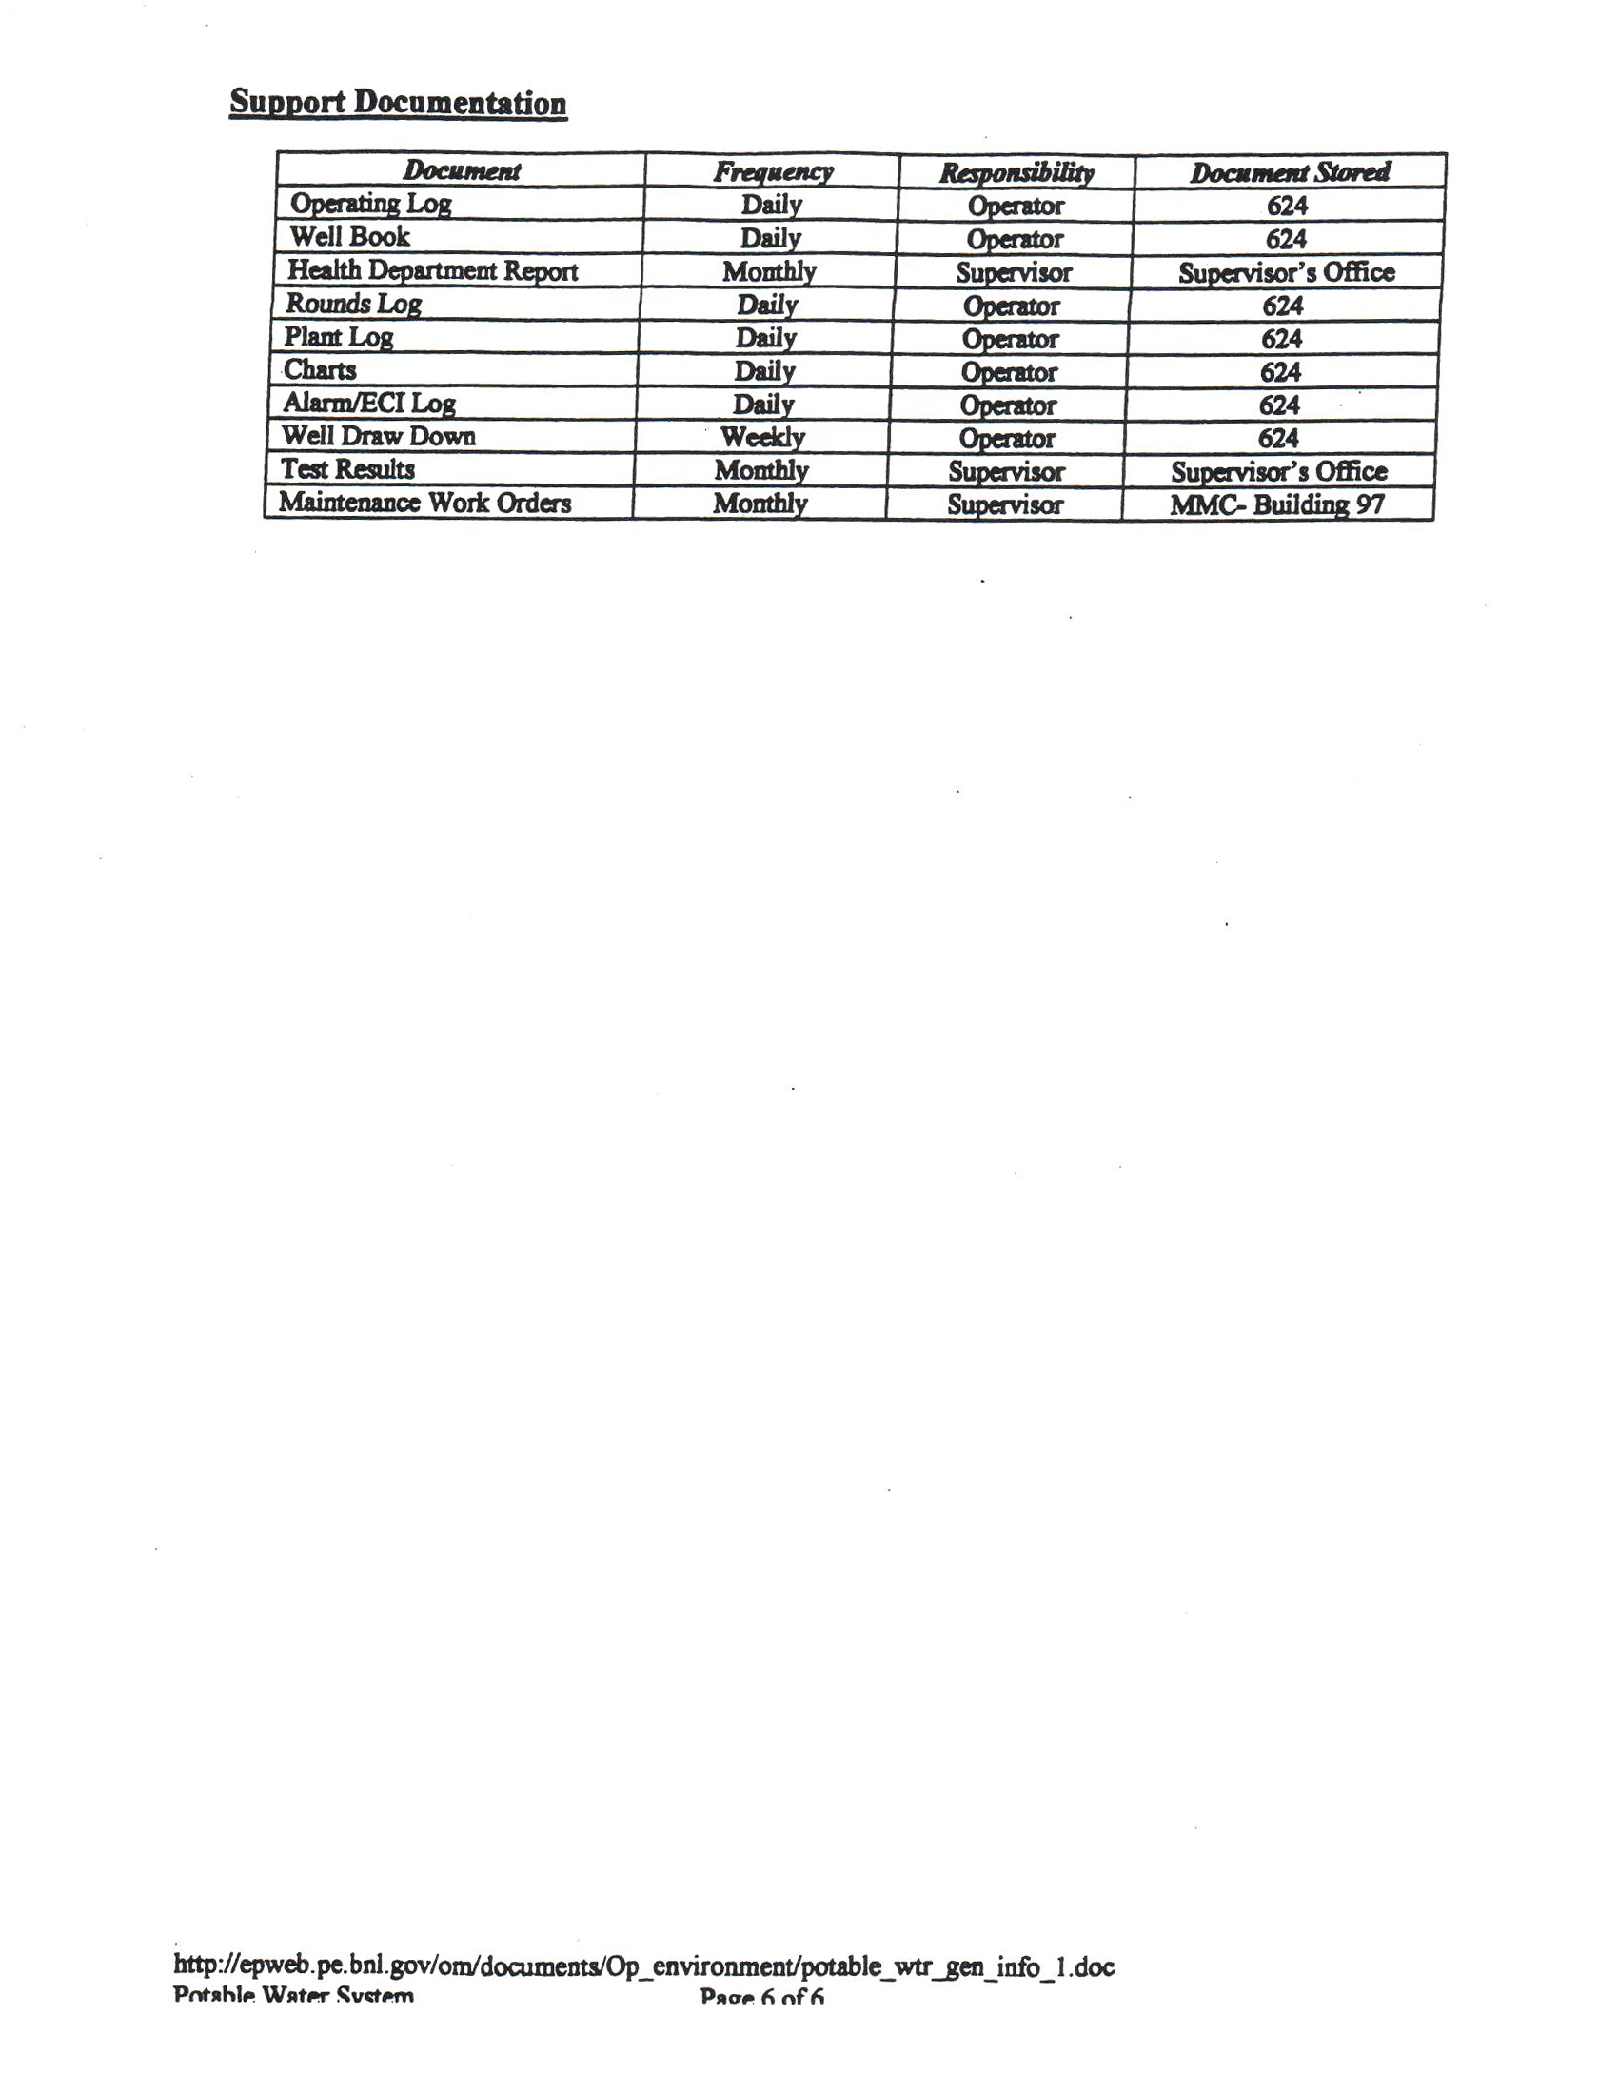

Attachment 1
IC-10/08
BNL 2003 Potable Water Sampling Plan

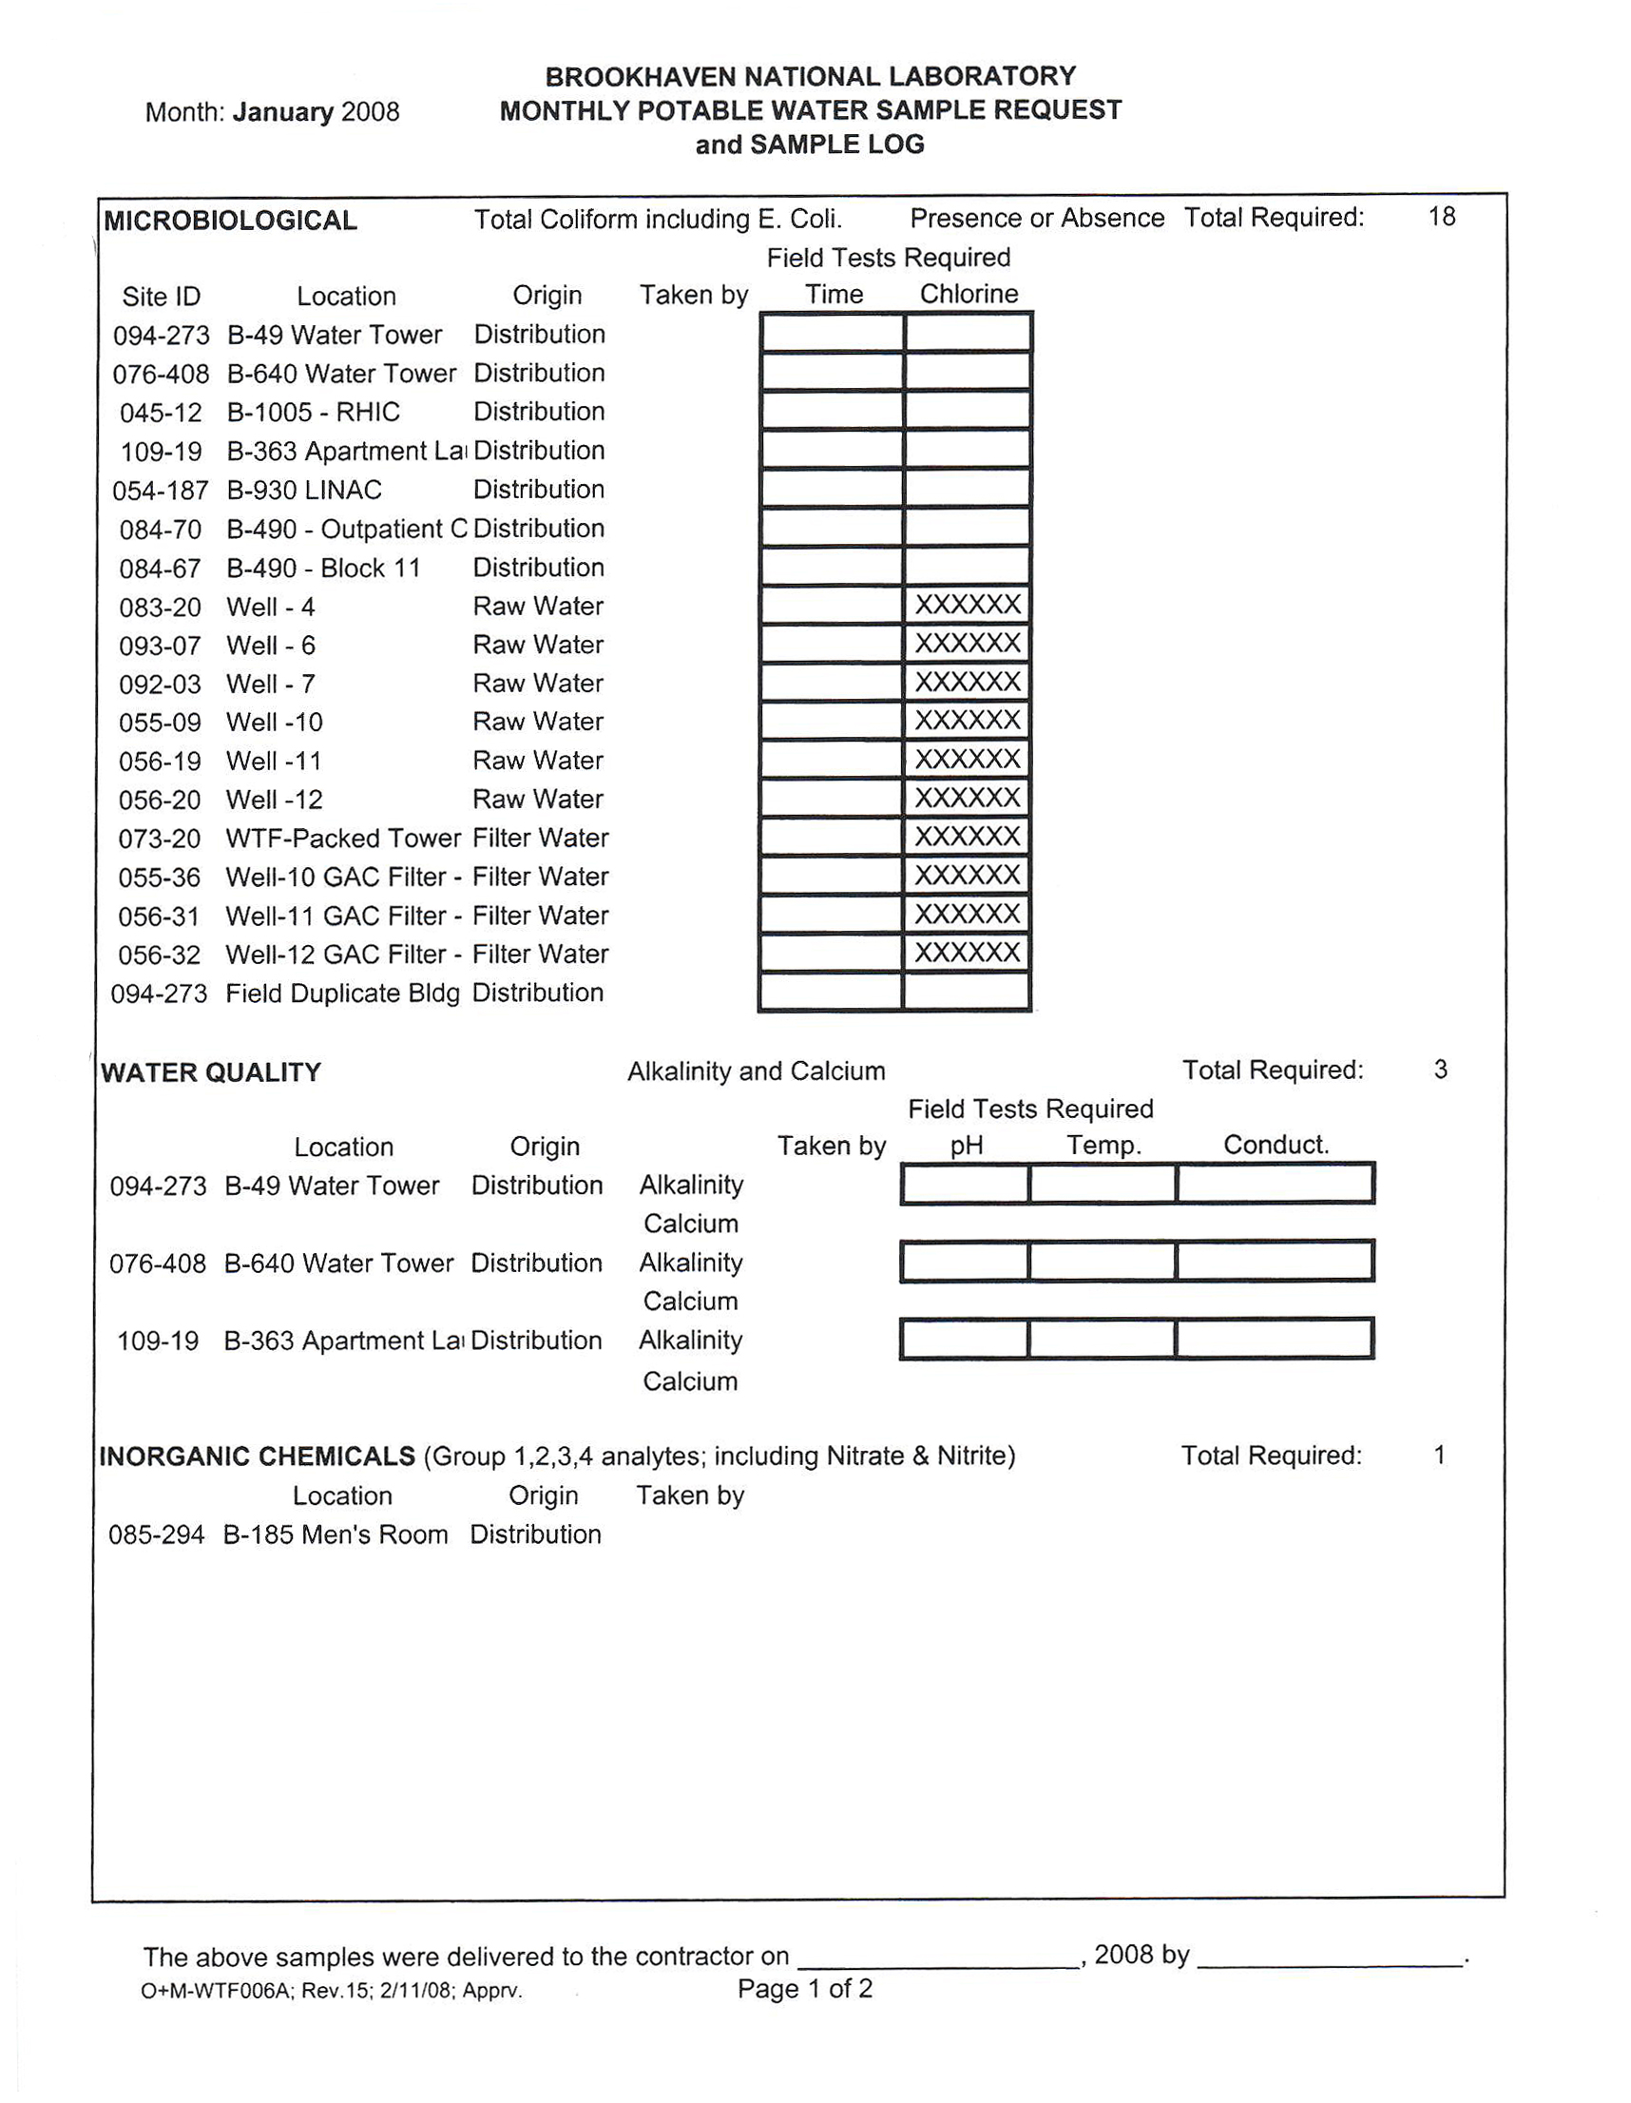
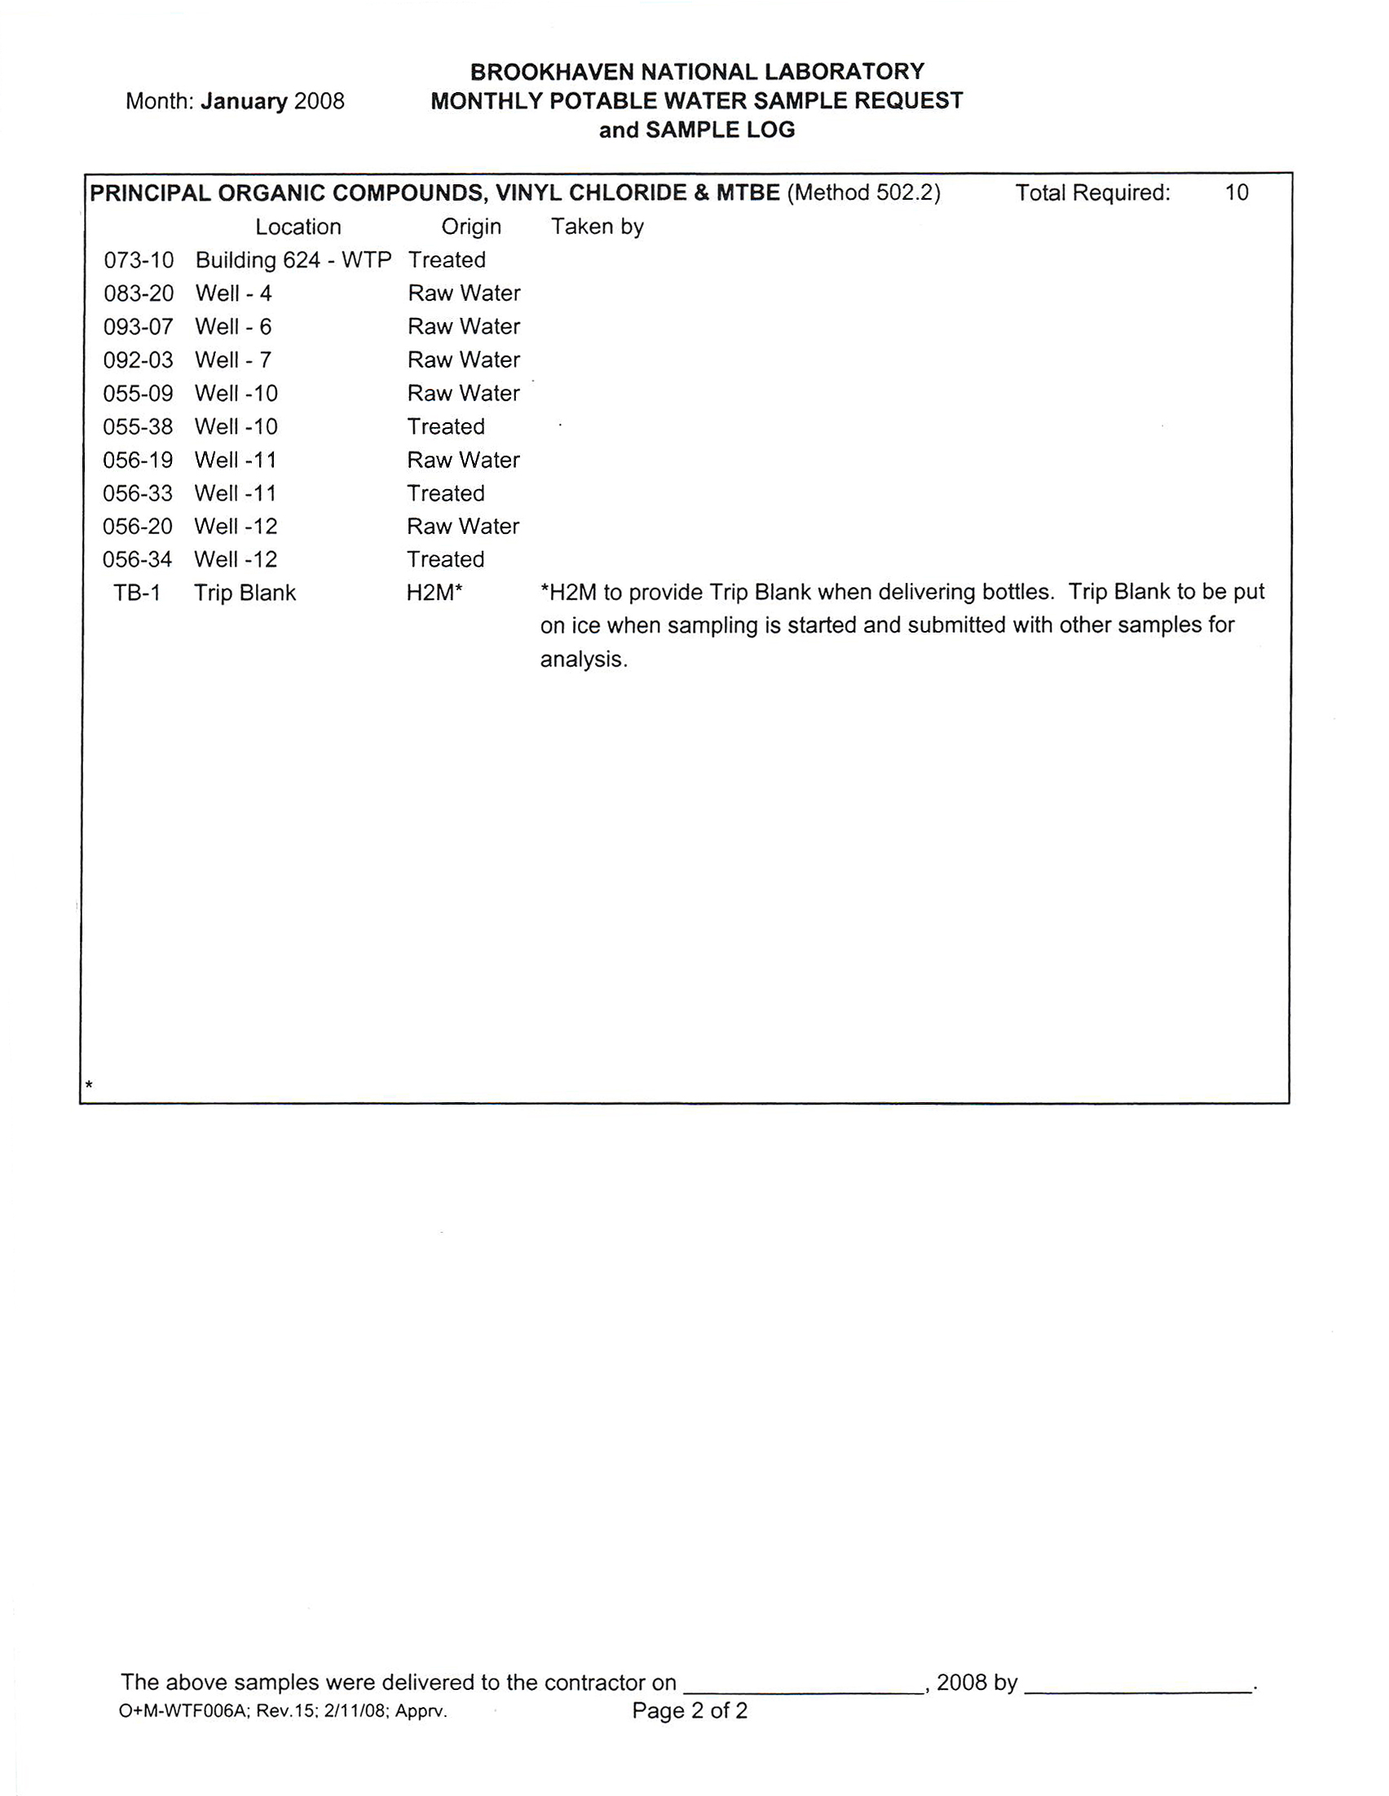

Attachment 2
IC-10/08
PE Policies and Procedures document O&M-WTF-006
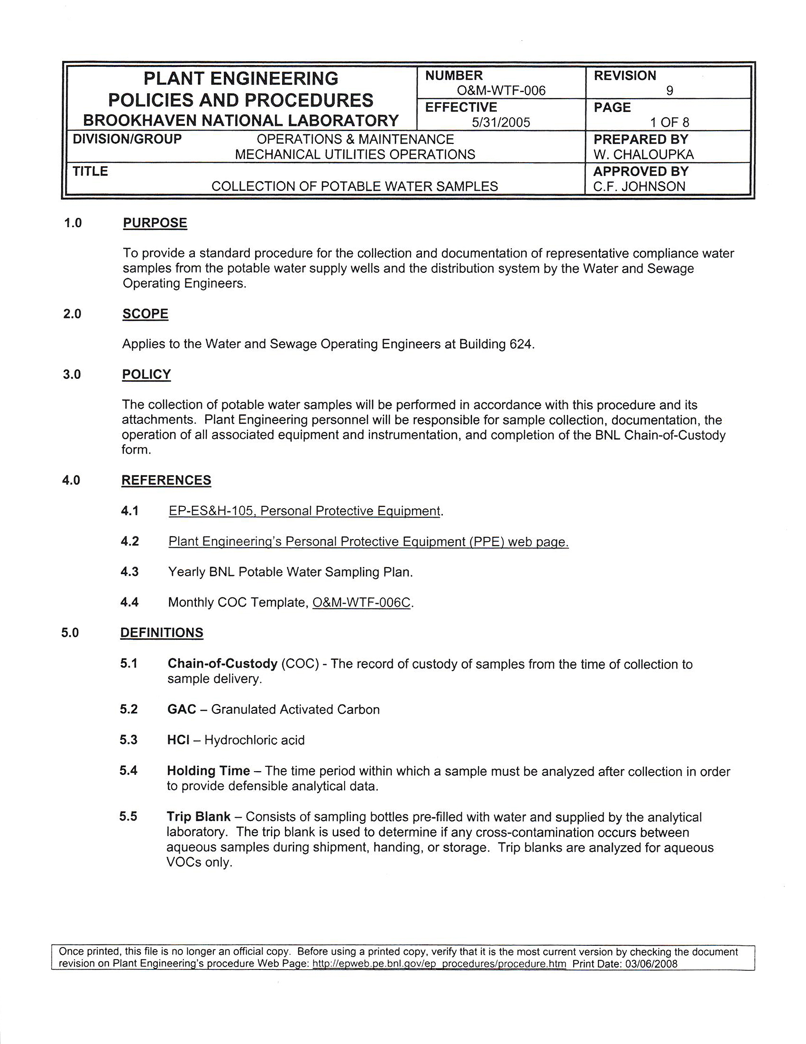

Attachment 2
IC-10/08
PE Policies and Procedures document O&M-WTF-006
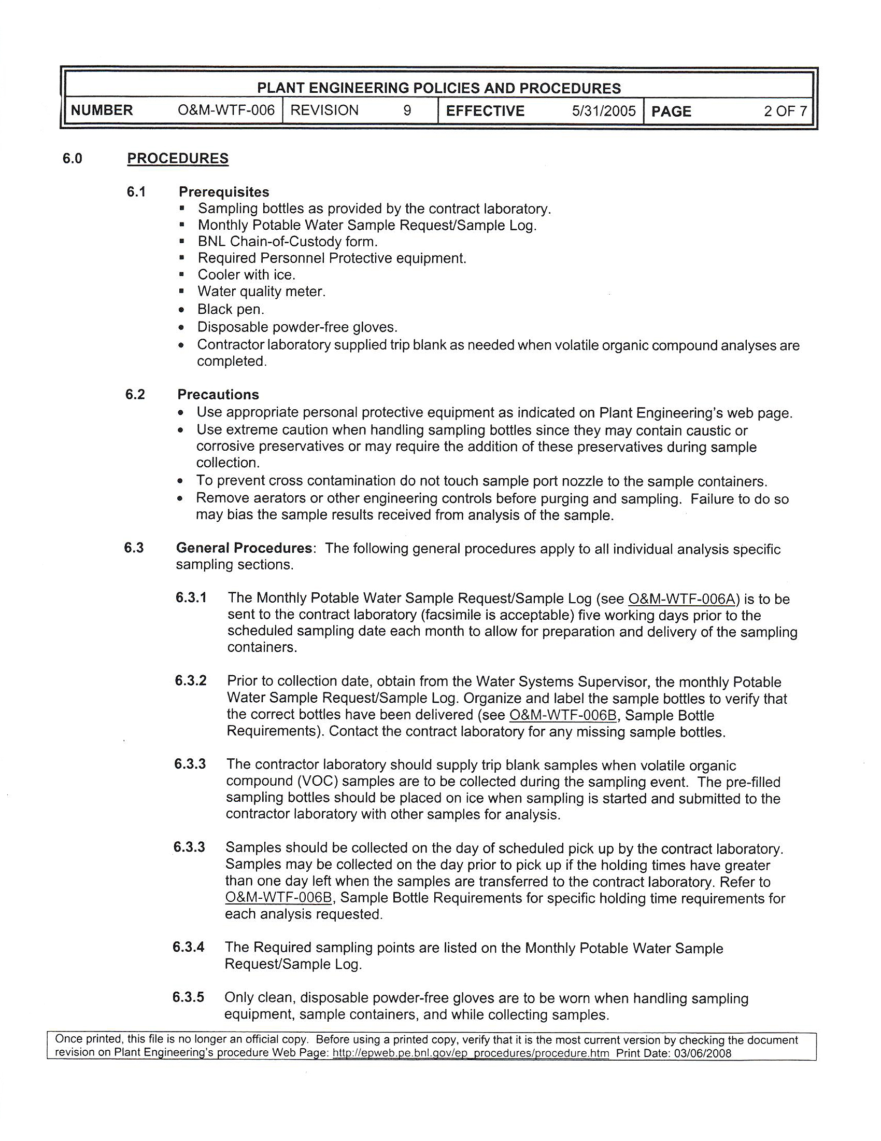

Attachment 2
IC-10/08
PE Policies and Procedures document O&M-WTF-006
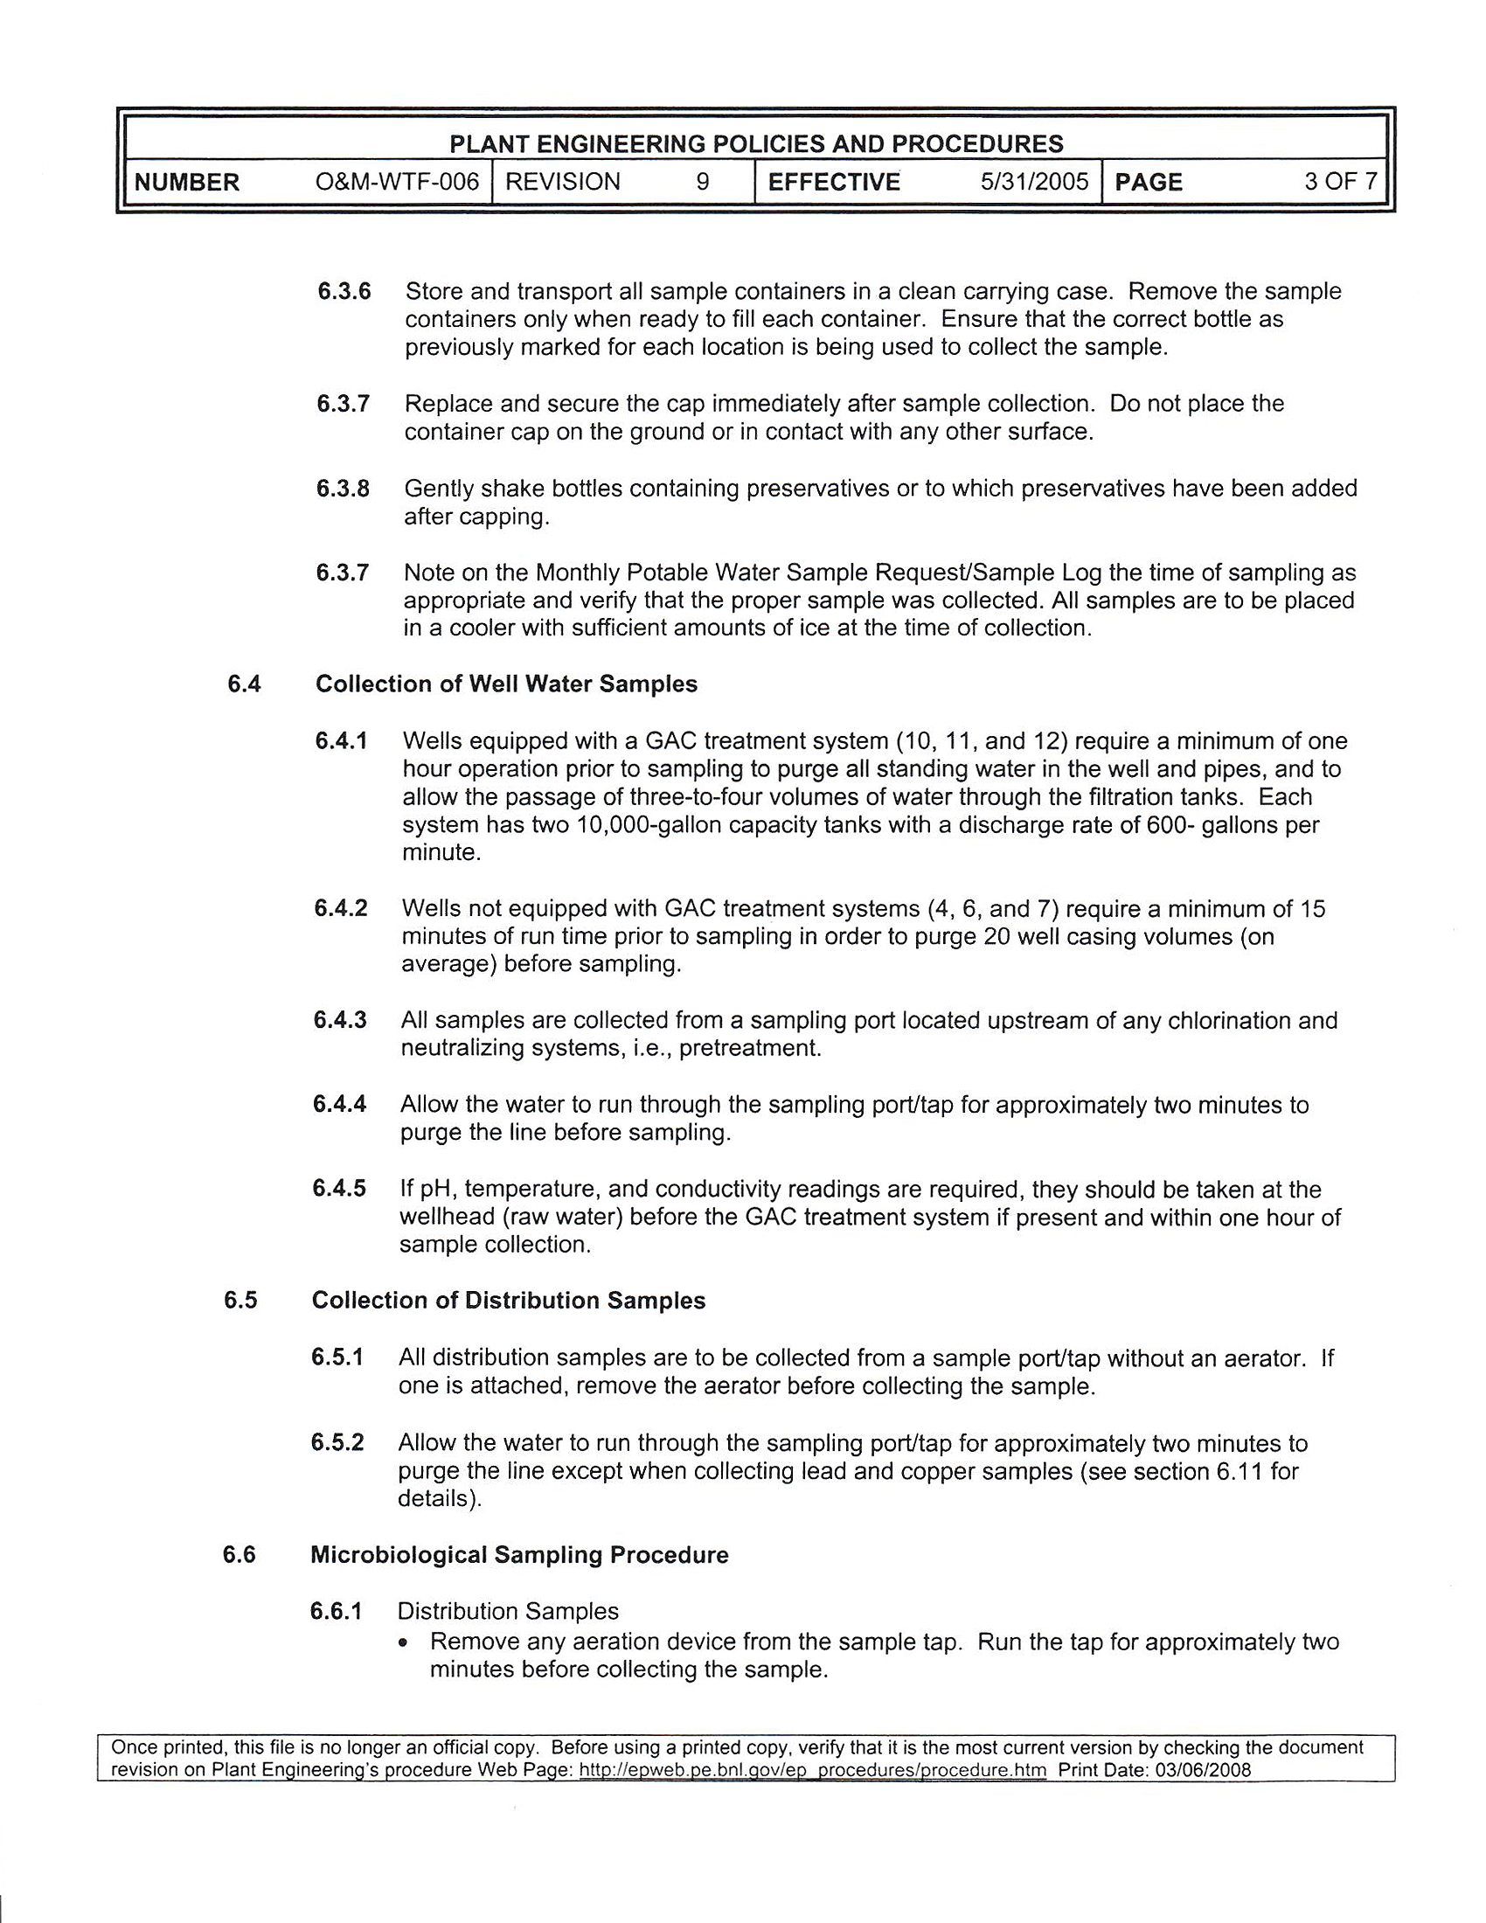

Attachment 2
IC-10/08
PE Policies and Procedures document O&M-WTF-006

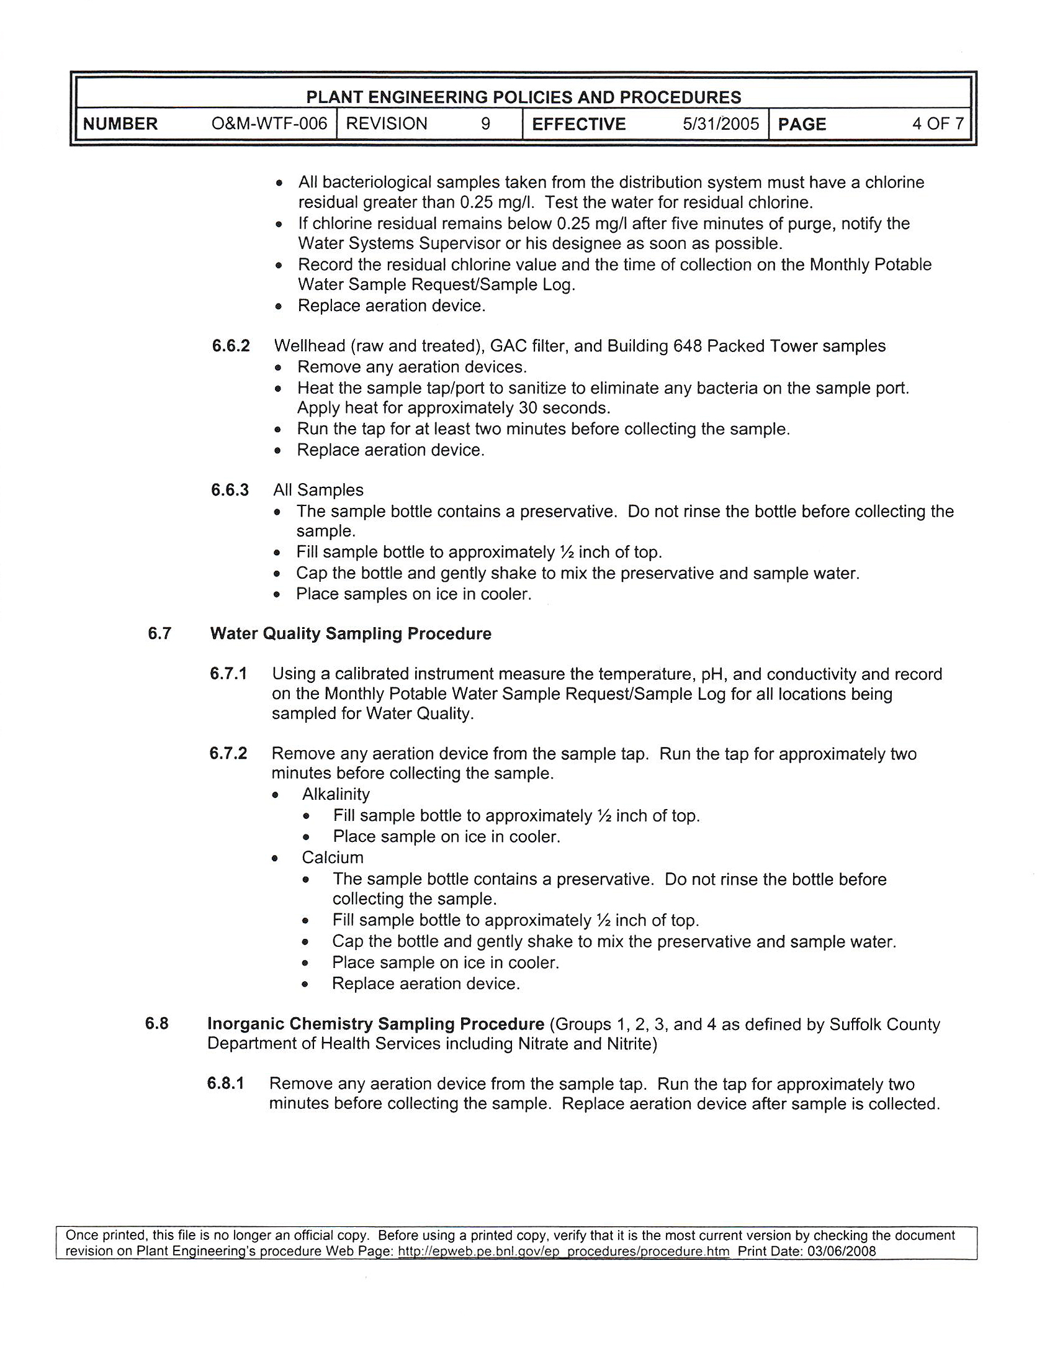

Attachment 2
IC-10/08
PE Policies and Procedures document O&M-WTF-006
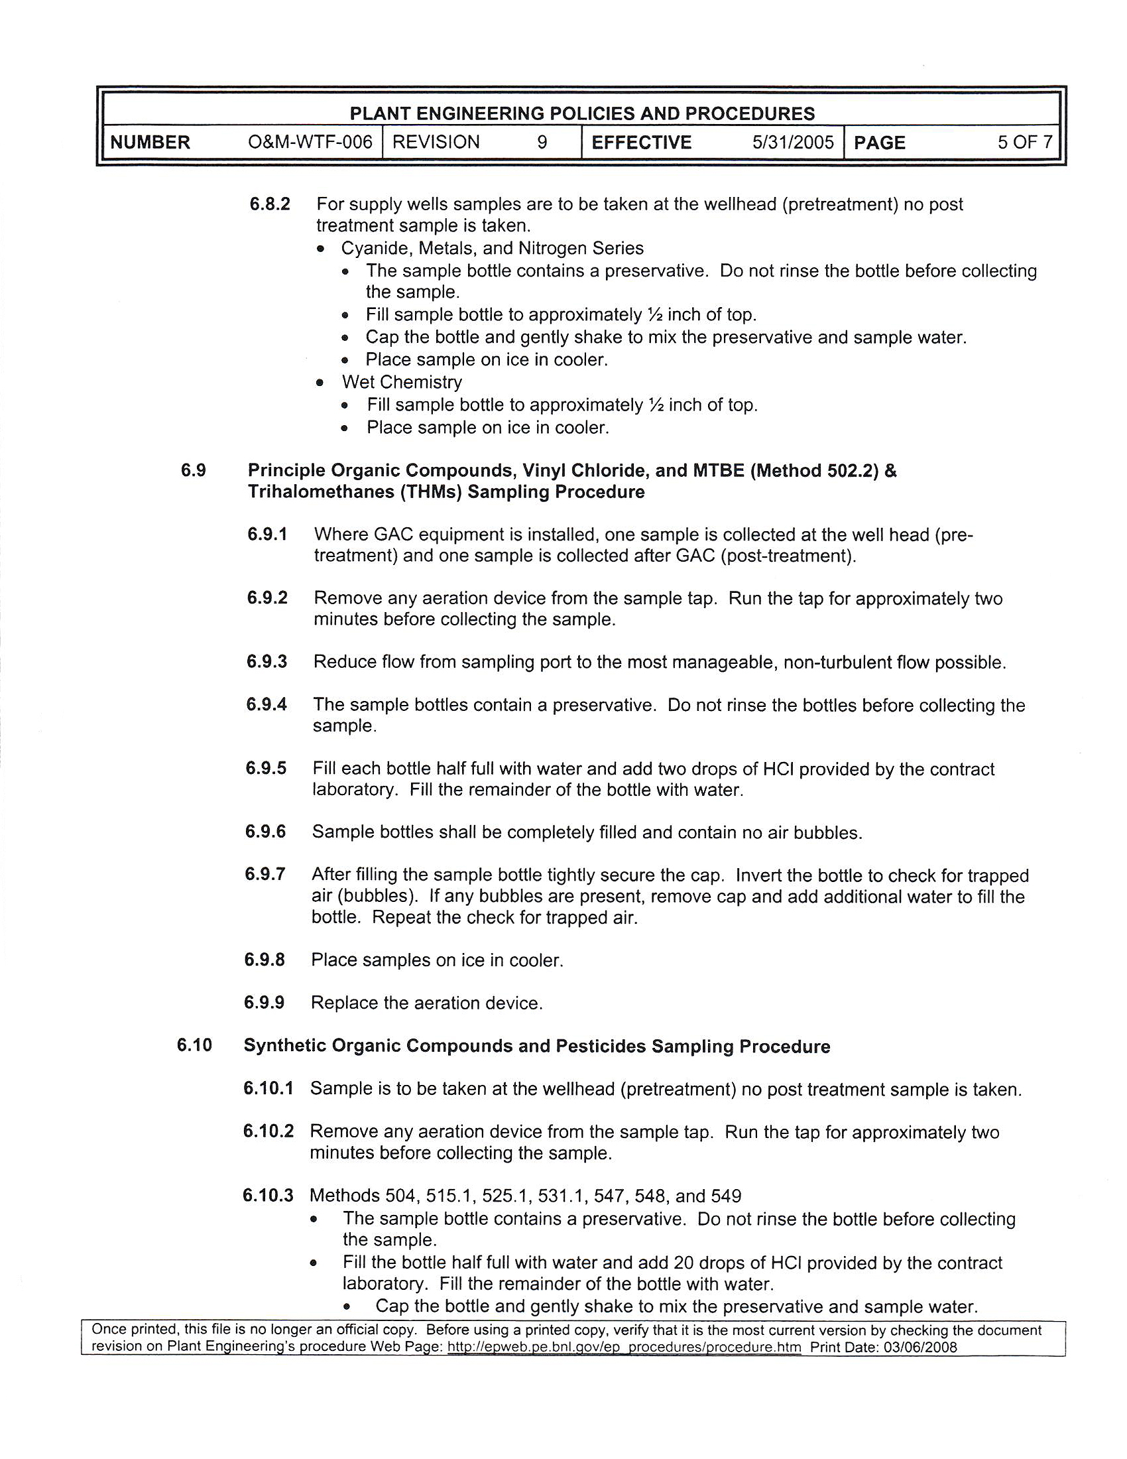

Attachment 2
IC-10/08
PE Policies and Procedures document O&M-WTF-006
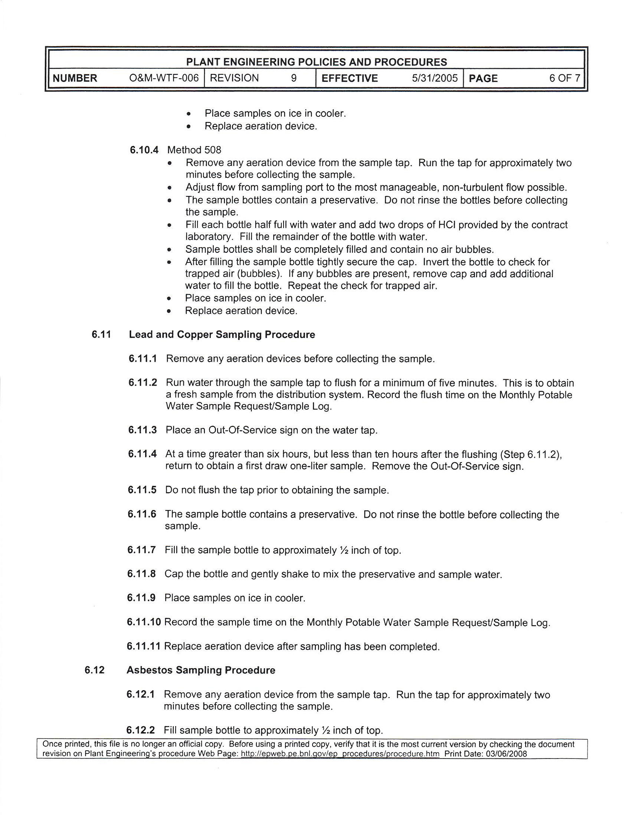

Attachment 2
IC-10/08
PE Policies and Procedures document O&M-WTF-006
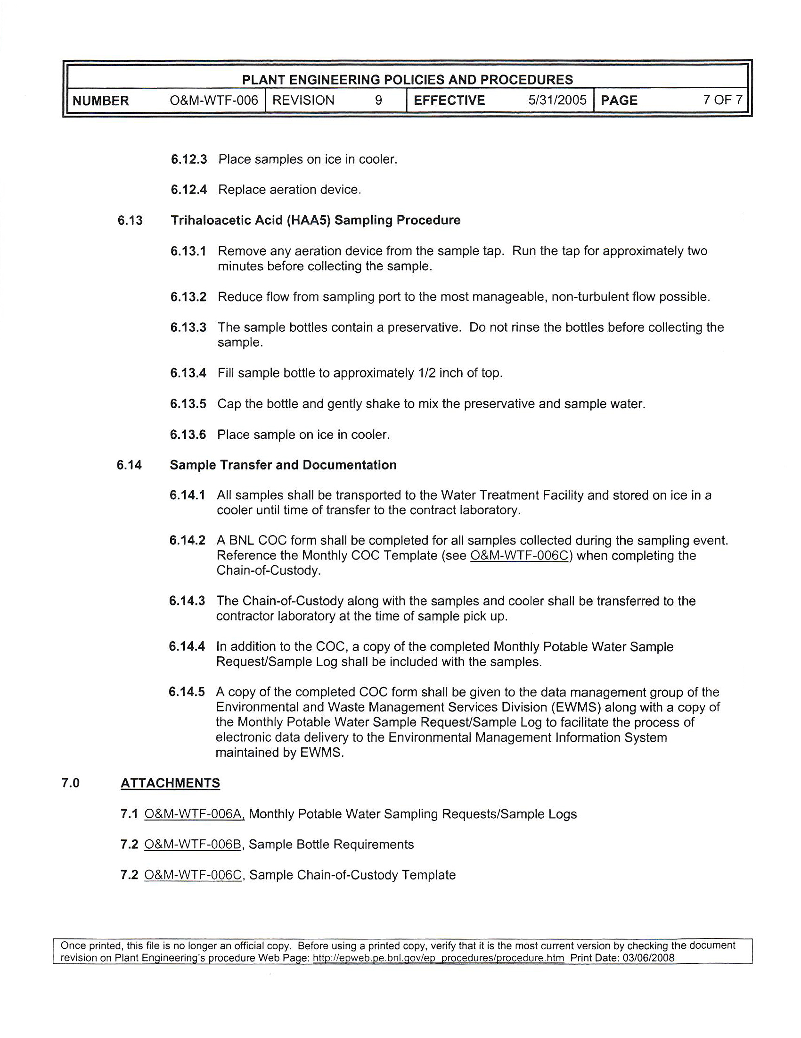

Attachment 2
IC-10/08
PE Policies and Procedures document O&M-WTF-006

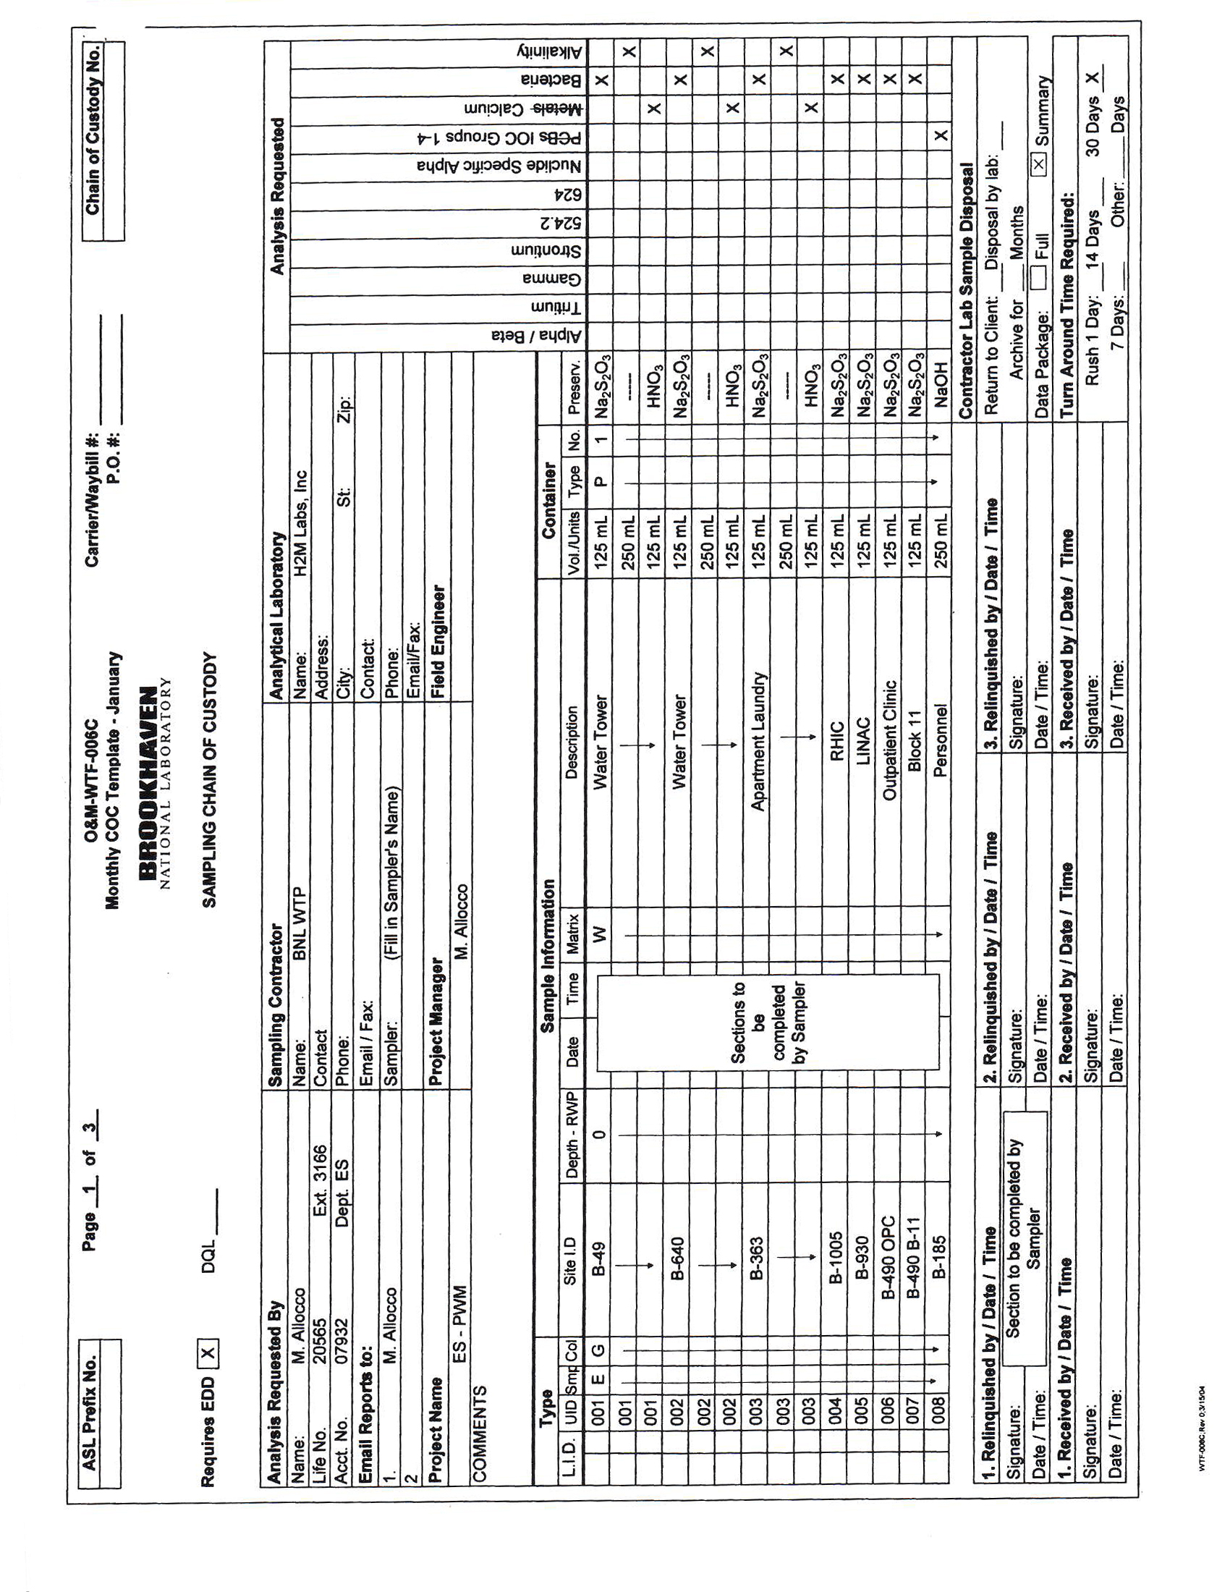

Attachment 2
IC-10/08
PE Policies and Procedures document O&M-WTF-006

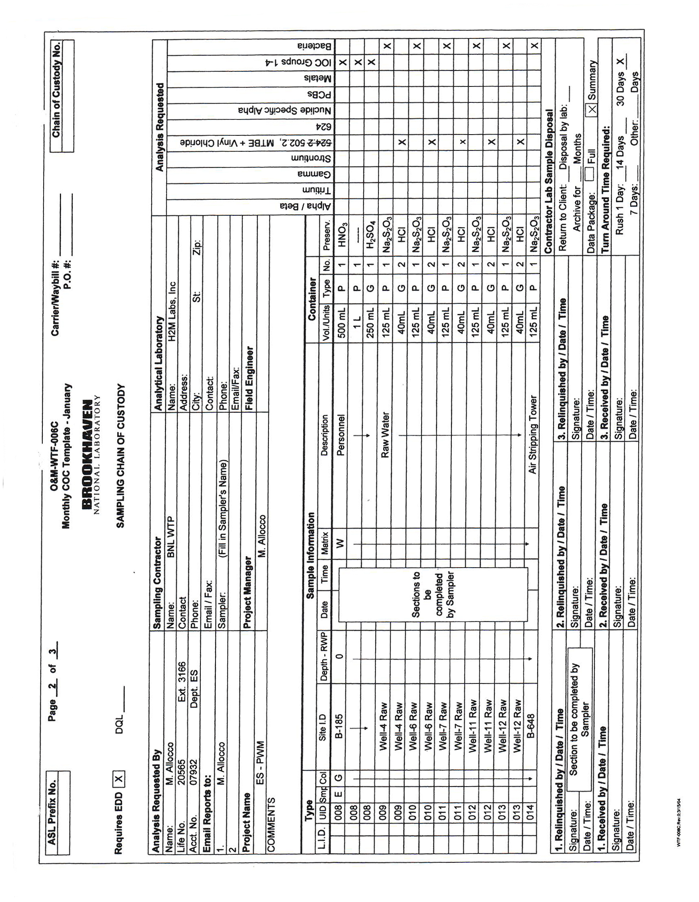

Attachment 2
IC-10/08
PE Policies and Procedures document O&M-WTF-006

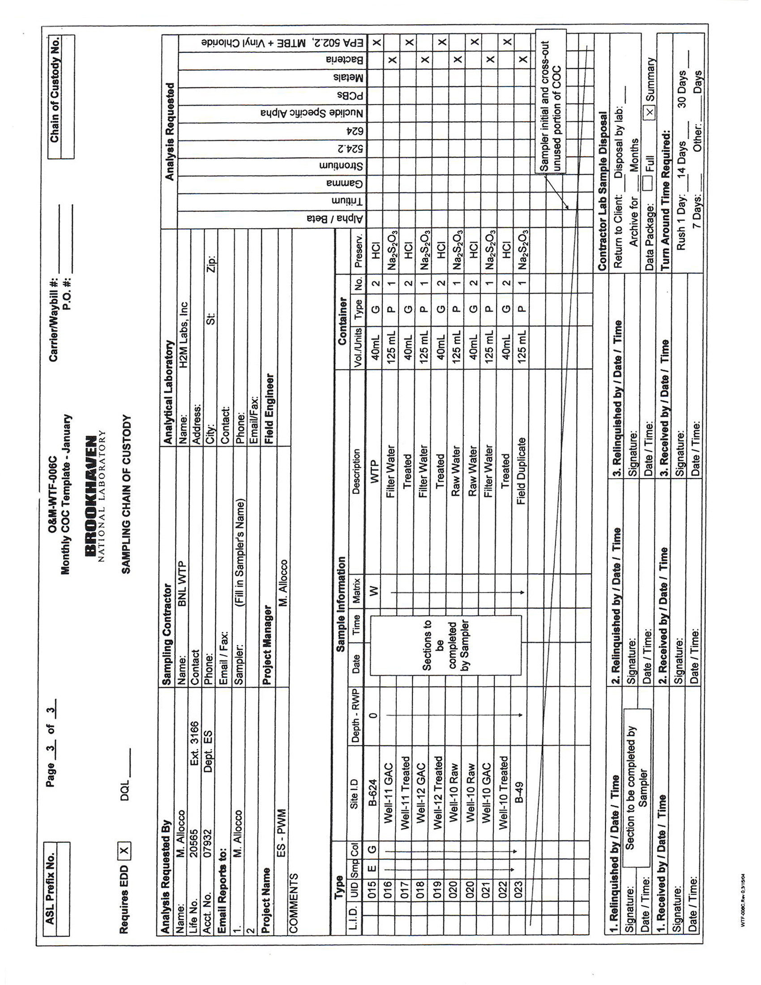
Attachment 3 IC-10/08

Individual | Phone |  | Bldg. | Room #
Apelskog, M | 2636 |  | 490 | 8-5
Bonti, K. | 3620 |  | 490 | Block 11
Tomasi, D. | 3640 |  | 490 | Pavilion 1
Folk,L (OMC) | 3675 |  | 490 | 7-22
Colichio, R. | 8440 |  | 490 | 9-93
Colochio, R. | 8440 |  | 490 | 8-11
Terry. J. | 3361 |  | 490 | 8-42
Harris, C. | 7151 |  | 490 | 8-116
Koebel, R. | 3671 |  | 490 | OMC Treatment Room
Harris,C. | 3177 |  | 490 | Outside-9-144
Guida, P. | 2913 |  | 490 | 9-729
Dispenser Location |  | Date |  |  | #

