

Uncertainty Analysis of Pandemic Influenza Impacts on National Infrastructure
Supplement to the National Population and Infrastructure Impacts of Pandemic Influenza Report

15 October 2007

Prepared by
National Infrastructure Simulation & Analysis Center
Infrastructure Analysis and Strategy Division
Office of Infrastructure Protection
Department of Homeland Security

This page intentionally left blank.
Table of Contents
1. Introduction 1
2. Model Overview 3
2.1 Infectious Disease Model 4
2.1.1 Disease Stages 4
2.1.2 Demographic Groupings 4
2.1.3 Vaccination, Antiviral Prophylaxis and Treatment, Quarantine, and Isolation 5
2.2 Regional Population Model 6
2.3 Public Health Model 7
2.3.1 Normal Care 7
2.3.2 Treatment of Pandemic Flu Patients 9
2.3.3 Worried Well 10
2.4 Economic Impacts Model 11
3. Sensitivity and Uncertainty Analysis 13
3.1 Approach 13
3.1.1 Experimental Design 13
3.2 Mitigation Scenarios 14
3.2.1 Contact Tracing 14
3.2.2 Social Distancing (Self-Quarantine) 15
3.2.3 Targeted Versus Mass Vaccination 16
3.2.4 Antiviral Treatment 17
3.3 Variable Ranges 17
3.3.1 Selection of Uncertain Parameters 17
3.4 Biological Uncertainty Factors 20
3.4.1 Reproductive Number 20
3.4.2 Nominal Fatality Rate 21
3.4.3 Asymptomatic Infection 22
3.5 Sociological Uncertainty Factors 23
3.5.1 Nonpharmaceutical Interventions 23
3.6 Public Health Uncertainty Factors 24
3.6.1 Base Fraction of Afflicted Seeking Healthcare 24
3.6.2 Maximum Mortality Enhancement Multiplier 25
3.6.3 Health Threat Reaction Time 25
3.7 Parameter Distributions 26
3.7.1 Pre-symptomatic and Asymptomatic Spread 27
3.7.2 Effective Reproductive Number 31
4. Results and Analysis 35
4.1 Initial Sensitivity Analysis 35
4.2 Final Analysis 39
4.2.1 Mitigation Strategies Compared 39
4.3 Economic Impact 46
4.3.2 Case Fatality Rate 52
4.4 Final Sensitivity Analysis 53
4.4.1 Pandemic Model Comparison 56
4.5 Decision Model 72
4.5.1 Methodology 72
4.5.2 Aid to Decision Making 74
4.5.3 Decision Model Results 75
4.5.4 Satisfaction and Regret Analysis 80
4.5.5 Highlights and Comparison to EpiSimS Results 86
5. Summary and Conclusions 89
Appendix A: Summary of Intervention Strategy Frequency Histograms A-1
Appendix B: Summary of Intervention Strategy Consequence Statistics B-1
Appendix C: Outlines for Nonpharmaceutical Mitigation Measures for Pandemic Influenza C-1
Appendix D: Summary of Cost Estimates D-1
List of Figures
Figure 2-1: Major elements of the Critical Infrastructure Protection Decision Support System (CIPDSS) models used in the pandemic influenza impacts analysis 3
Figure 2-2: Representation of the multi-stage susceptible-exposed-infected-recovered (SEIR)
general infectious disease model in the Critical Infrastructure Protection Decision Support System (CIPDSS) 4
Figure 2-3: Division of the U.S. into 10 Federal Emergency Management Agency (FEMA)
regions 6
Figure 2-4: Flow diagram for normal emergency care in the public health model 9
Figure 2-5: Flow diagram for pandemic flu patients in the public health model 10
Figure 2-6: Flow diagram for worried well patients in the public health model 11
Figure 3-1: The beta (5,20) distribution for the fraction of transmission that occurs prior to
clear symptoms 29
Figure 3-2: The beta (6,8) distribution for the relative contagiousness of asymptomatic
infected people 29
Figure 3-3: The beta (4,8) distribution for relative fraction of asymptomatic infections
compared to symptomatic infections 30
Figure 3-4: The relationship of fraction of contagious population isolated per day to the
reduction in overall transmission of the disease 31
Figure 3-5: Cumulative distributions of sampled R₀ and effective R (all 512 realizations) 32
Figure 3-6: Distributions of R₀ and effective R (243 realizations with R ≥ 1) 33
Figure 4-1: Cumulative number of illnesses for baseline scenario runs with no mitigations 35
Figure 4-2: Scenario averages for different R₀ groupings 38
Figure 4-3: Scenario Averages for total deaths due to the pandemic 41
Figure 4-4: Scenario averages for flu illnesses 41
Figure 4-5: Scenario ranges for flu illnesses 42
Figure 4-6: Scenario ranges for flu deaths 43
Figure 4-7: Patients treated in hospital versus effective reproductive number (baseline) 44
Figure 4-8: Scenario averages for patients hospitalized in temporary care facilities 45
Figure 4-9: Scenario ranges for patients hospitalized in temporary care facilities 45
Figure 4-10: Scenario averages for lost gross domestic product 46
Figure 4-11: Scenario averages for peak fraction of workers unavailable 47
Figure 4-12: Scenario ranges for lost gross domestic product 48
Figure 4-13: Scenario ranges for peak fraction of workers unavailable 48
Figure 4-14: Effect of social distancing on the no intervention scenario 50
Figure 4-15: Effect of social distancing on the targeted vaccination no antivirals scenario 51
Figure 4-16: Influenza deaths for the baseline scenarios by case fatality rate 53
Figure 4-17: Scatter plot of the overall attack rate against R₀ for the baseline (no interventions; noSDnoAV, vaccination strategy 1); feasibility assessment for
vaccines and antivirals 60
Figure 4-18: Relative preference of intervention strategies over the likelihood of a
pandemic (risk-neutral profile [excludes social distancing scenarios]) 77
Figure 4-19: Relative preference of intervention strategies including social distancing over
the likelihood of a pandemic, risk-neutral profile 79
Figure 4-20: Satisfaction/regret analyses for selected pairs of intervention strategies not
involving quarantine 81
Table 4-12: Satisfaction/regret statistics for selected pairs of intervention strategies not
involving quarantine 82
Figure 4-21: Satisfaction/regret analysis for selected pairs of pandemic influenza intervention strategies involving quarantine and targeted vaccination 83
Figure 4-22: Satisfaction/regret analysis for the choice of mass vaccination over targeted
vaccination strategies with partially-effective pre-pandemic vaccine 85
List of Tables
Table 2-1: Summary of medical care in 2003 8
Table 3-1: The 24 scenarios simulated in the sensitivity/uncertainty analysis 14
Table 3-2: Input variables with ranges considered in sensitivity analysis 18
Table 3-3: Output variables of interest 19
Table 3-4: Probability distributions for uncertainty analysis 26
Table 3-5: Input variables that affect transmission 28
Table 4-1: Comparison of scenario averages 40
Table 4-2: EpiSimS phase 2 and published simulation studies for pandemic influenza 57
Table 4-3: Conversion factors from trivalent seasonal flu vaccine to monovalent pandemic
flu vaccine capacity 62
Table 4-4: Conversion factors from seasonal to pandemic vaccine, assuming a 2-dose
regimen 63
Table 4-5: The Health and Human Services pandemic medical countermeasure goals for
vaccines 63
Table 4-6: Influenza vaccine prices 67
Table 4-7: Vaccination campaign costs 70
Table 4-8: Antiviral drug distribution campaign costs 72
Table 4-9: Value tradeoffs (indifference equivalencies) among decision metrics 73
Table 4-10: Relative preference and equivalent measures for pandemic influenza
intervention strategies 76
Table 4-11: Incremental additional equivalent facilities for vaccination strategies,
antiviral and no antiviral 80
Table 4-12: Satisfaction/regret statistics for selected pairs of intervention strategies
not involving quarantine 82
Table 4-13: Satisfaction/regret statistics for selected pairs of intervention strategies
involving quarantine and targeted vaccination 84
Table 4-14: Satisfaction/regret statistics for the choice of mass vaccination over targeted
vaccination strategies with partially-effective pre-pandemic vaccine 86

List of Acronyms and Abbreviations
ANL | Argonne National laboratory
ANOVA | analysis of variance
AV | antivirals
BEA | Bureau of Economic Analysis
CDC | Centers for Disease Control and Prevention
CIDRAP | Center for Infectious Disease Research and Policy
CIPDSS | Critical Infrastructure Protection Decision Support System
CT | contact tracing
DHS | Department of Homeland Security
EMS | emergency medical services
EpiSimS | Epidemiological Simulation System
ER | emergency room
EV | early vaccine
FEMA | Federal Emergency Management Association
GDP | gross domestic product
GID | General Infectious Disease model
GSP | gross state product
H | hemagglutinin
IASD | Infrastructure Analysis and Strategy Division
LANL | Los Alamos National Laboratory
LHS | Latin hypercube sampling
MV | mass vaccination
N | neuraminidase
NISAC | National Infrastructure Simulation and Analysis Center
NPI | nonpharmaceutical intervention
OA | orthogonal array
SNL | Sandia National Laboratories
SD | social distancing
SEIR | susceptible-exposed-infected-recovered
SNS | Strategic National Stockpile
TV | Targeted Vaccination
U.S. | United States
WHO | World Health Organization

This page intentionally left blank.

Introduction
The U.S. Department of Homeland Security (DHS) tasked the National Infrastructure Simulation and Analysis Center (NISAC) and the Critical Infrastructure Protection Decision Support System (CIPDSS) project to assess the potential impacts of pandemic influenza on our nation’s infrastructures and the potential effectiveness of a range of intervention strategies. This report describes sensitivity and uncertainty analyses conducted by the CIPDSS project in support of the analysis.
A simulation-based uncertainty analysis uses repeated evaluations of a model, using different combinations of key model parameters, to estimate not only the range of potential outcomes but the probability distribution of those outcomes. Key model parameters are identified through a sensitivity analysis, which determines how the outcomes vary with changes in the values of model parameters; parameters that cause the most variation in the outcome are used in the uncertainty analysis. Information about the distribution of likely outcomes, which needs to account for likely outcomes as well as exposure to low-probability, high-consequence events, is important in a risk-informed decision-making environment.
The objectives of the analysis described in this report are to
- Assess the potential range of consequences of pandemic influenza given the uncertainty about its disease characteristics (What if it isn’t like the 1918 pandemic?)
- Investigate multiple mitigation strategies
- Assess the importance of vaccines, antivirals, and social distancing measures
- Assess the feasibility of mitigation strategies where the implementation cost is difficult to quantify, such as school closures
- Assess the impacts of a pandemic on the healthcare infrastructure
- Identify high utility and robust strategies
There are many sources of uncertainty in studying the potential effects of an influenza pandemic. These can be grouped into 4 categories: biological, policy, sociological response, and infrastructure response.
- Biological Uncertainty: Rapidly changing infectious diseases such as influenza have strong elements of uncertainty due to evolution of the virus as well as individual, population, and regional differences in how the host and viral pathogen interact in a pandemic. During a pandemic, the influenza virus continues to evolve, altering its contagiousness and virulence as it adapts to new hosts. The diversity of human populations with regard to immune function, health status, and gene function for responses to infectious diseases represents another element of uncertainty. Even as targeted vaccines are developed for a specific instance of a viral disease, the rapidity of viral evolution and the length of time to develop and deploy a vaccine imply uncertainty in vaccine efficacy. These aspects combine to define biological variation that leads to uncertainty in an analysis of a pandemic.
- Policy Uncertainty: There are numerous intervention strategies for fighting infectious diseases. These include vaccinations, antivirals, social distancing, quarantining infectious and susceptible persons, and respiratory protection. Each of these strategies decreases either the transmission or the virulence of the diseases. The selection of particular combinations of interventions, timing of implementation, and resources available (such as vaccine and antiviral drug stockpiles) to implement the strategies are all elements of policy uncertainty. Because state health departments are autonomous of federal control, it is likely that their approaches to containing a pandemic will vary. Differences in state and local responses to a pandemic, such as school closures, are likely to exist.
- Sociological Uncertainty: It is rarely certain what fraction of the affected people will actually comply with policy guidance in an emergency situation. Within the context of an influenza pandemic, individual values, religious beliefs, perception of risk, confidence in authorized agencies, and a myriad of other characteristics influence an individual’s decision of whether to comply with recommended policy. Sociological responses to a pandemic today may be very different than those of almost a century ago, minimizing the benefit that historical examples may bring to analyzing the uncertainty of human behavioral responses to a pandemic. The uncertainties addressed in this analysis include the wide variation of nonpolicy actions undertaken by individuals intending to lower personal risk; for example, self-isolation, refusing vaccination, reliance on over-the-counter drugs, and so forth.
- Infrastructure Response Uncertainty: The resilience of infrastructure operations in a pandemic is related to the availability of the workforce, flexibility in labor management and usage (for example, overtime), and shifts in demand for infrastructure services. Labor availability is dependent on the disease severity (illnesses) and the sociological response. This analysis focuses on the response of the healthcare infrastructure, in particular as an infrastructure facing labor shortages and significantly increased demand.
The analysis described in this report identifies key uncertain variables in each of these 4 categories and assesses the variability in outcomes due to uncertainty in the inputs. Feasibility and costs for identified intervention strategies are also assessed. Outcomes and costs are combined in a decision model to assess the relative utility of selected mitigation strategies as a function of event likelihood.
Section 2 discusses the CIPDSS model and its component disease propagation and public health models. Section 3 describes the approach to sensitivity and uncertainty analysis. Section 4 presents the simulation results and analysis. Section 5 presents the summary and conclusions of the study. Appendix A contains intervention strategy frequency histograms. Appendix B contains intervention strategy consequence statistics. Appendix C is an outline of nonpharmaceutical mitigation measures for pandemic influenza. Appendix D contains a summary of cost estimates.

Model Overview
The model used to perform this analysis is a subset of the suite of CIPDSS models described elsewhere. The set of models used represents infectious disease spread and intervention, population, travel, labor, and infrastructure operations as shown in Figure 2-1. The model is on a national scale with the country partitioned into 10 multi-state regions. Important submodels include a general infectious disease (GID) model, a population model used to track inter-region travel and labor availability, the public health model, and an economic impact estimation model.
The population and infectious disease models interact to introduce the pandemic flu strain into the population and spread the disease across the nation. The population developing symptoms and needing treatment place a demand on the public health sector. The use of various intervention strategies, such as vaccination, affects the spread of the disease and alters the impacts on the public health system and on the overall population. The population model also tracks which members of the ill population are also members of the workforce and estimates absenteeism due to illness, care for ill family members, or other reasons. The economic impact model tracks the impact of absenteeism and mortality on the economy.
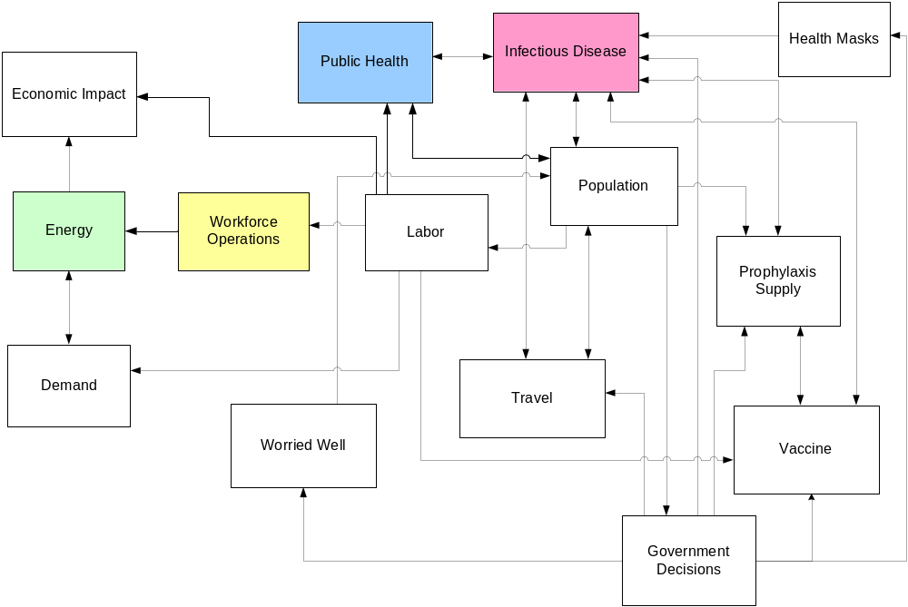

Note: The more critical models are highlighted and described in the following paragraphs.
Figure 2-1: Major elements of the Critical Infrastructure Protection Decision Support System (CIPDSS) models used in the pandemic influenza impacts analysis

Infectious Disease Model
The infectious disease model is a modified susceptible-exposed-infected-recovered (SEIR) model using an extended set of disease stages; demographic groupings; an integrated model for vaccination, antiviral prophylaxis and treatment, quarantine, and isolation; and demographic and stage-dependent behavior. As a variant on the SEIR model paradigm, this implementation represents the populations as homogeneous and well mixed, with exponentially distributed residence times in each stage. However, the use of additional stages and demographic groupings adds heterogeneity where it is useful in capturing key differences between subpopulations for disease spread and response.

Disease Stages
The disease stages are represented generically so that the model can be used for a number of infectious agents by adjusting the input parameters appropriately. This is illustrated in Figure 2-2.
Susceptible
Population
Incubating
Prodromal
infectious
Symptoms
infectious
Late Symptoms
Final
Infection Rate
Stage 1
Rate
Stage 3
Rate
Stage 4
Rate
Recovered
Fatalities
Fatality
Rate
Stage Residence Time

Figure 2-2: Representation of the multi-stage susceptible-exposed-infected-recovered (SEIR) general infectious disease model in the Critical Infrastructure Protection Decision Support System (CIPDSS)

Demographic Groupings
The demographic groups used in the model are as follows:
- Infants (ages 0–4)
- Youth (ages 5–18)
- Young adults (ages 19–44)
- Older adults (ages 45–64)
- Elderly (ages 65+)
- Responders
Responders are health and emergency-services workers, and they are assumed to be taken from the two adult groups (young adults and older adults). The populations of young adults and older adults are reduced by the number of responders in each group. Responders are treated separately in the model to allow modeling of different levels of disease exposure compared to the general population and to model alternate policies regarding access to vaccines, antivirals, and other prophylactic measures.
The basic reproductive number (R₀) is the average number of people infected by a typically infectious individual in an otherwise susceptible population. If R₀ is greater than 1, the disease has the potential to spread. If it is less than 1, the disease will die out after only a few generations. The parameters that affect R₀ include the ease of transmission of a disease and the contact rates among the populations. The CIPDSS infectious disease model can either use R₀ as an input into the model or it can calculate it as an output of the model based on input contact rates by demographic group. For this study, R₀ was used as an input to the model.

Vaccination, Antiviral Prophylaxis and Treatment, Quarantine, and Isolation
Government response in the model in the form of quarantine and vaccination programs is initiated after recognition of the first cases in the public health system or by direct detection if available. Once the disease is detected, appropriate mitigation measures are employed. The model represents the mitigation strategies under a variety of policy assumptions. Mitigation options include vaccines (delivered via targeted vaccination, mass vaccination, or a combination), antivirals (as prophylaxis prior to infection or treatment after infection), and isolation and quarantine. Vaccination can be biased toward particular subpopulations to model priority vaccinations of children or healthcare personnel. Allowances can be made for segments of the population who either refuse vaccination or cannot tolerate vaccination. The model can handle 2 separate vaccines during a simulation if desired: a pre-pandemic strain that is available early but is assumed less effective because it wasn’t designed for the particular strain being dealt with and a subsequent targeted (specifically designed for the disease strain), more effective, vaccine available after a delay for production and distribution. This is a particularly relevant feature for a potential pandemic influenza outbreak that, in order to be human transmissible, will be different from the infectious agent for which current vaccines are designed.
Schools are not included in the generic infectious disease model, but school closing can be modeled by including age-group dependence for R₀ or contact rates, thus allowing age-dependent control of the transmission and infection of school-age children. The model also responds to investments in better hospital care, isolation, and antiviral treatments, which can affect fatality and recovery rates in the population. The model keeps track of the state of the population in terms of immunity, health status, unavailability (sick and/or in quarantine), and fatalities. Unavailability and fatalities are passed to the population and infrastructure models, where their effects can then feed back into the infection model. Examples of this behavior include sickness and fatalities leading to reductions in healthcare staff, which in turn can raise fatality rates in the infection model due to poorer and less timely care.

Regional Population Model
The regional population model is arrayed to represent the spread of disease in each of 10 regions. For this analysis, the regions are chosen to be the 10 Federal Emergency Management Agency (FEMA) regions (Figure 2-3). The population model keeps track of the number of people in different health statuses for each region. It drives the visitation rates for the public health model in 3 categories: normal afflictions, pandemic influenza afflictions, and “worried well” afflictions. (Worried well people are those who think they might have the pandemic flu, but who do not.) The population model also outputs the fractional labor availability for each infrastructure category. In addition to normal, pandemic influenza, and worried well people, it also takes into account the number of quarantined and self-isolating people. Parents of infected children that stay home from work to care for them can be tracked by the model.
A submodel tracks emergency responders separately, so the labor availability for emergency services can be different than for other infrastructures. All other infrastructures have essentially the same level and time history for labor availability.
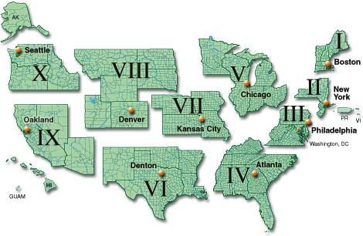

Note: Guam, Puerto Rico, and the Virgin Islands are not included in this analysis.
Figure 2-3: Division of the U.S. into 10 Federal
Emergency Management Agency (FEMA) regions
The regional population model tracks how many contagious people are currently visiting another region. The fraction of each region’s contagious people who are currently traveling in another region is input into the epidemiological submodel, which spreads the disease across regions. The pandemic influenza simulations did not have a single outbreak point, but the contagious travel submodel ensures that the pandemic continues to be spread across regions as a national outbreak, rather than having 10 separately modeled regional epidemics. Travel restrictions that lower travel rates can also be implemented with this model.

Public Health Model
The public health model represents treatment of patients by physicians’ offices and clinics, emergency medical services (EMS), emergency rooms (ERs), and hospitals. Regional variations are represented by dividing the U.S. into large regions. As with the population model, this model uses the 10 FEMA regions for the regional breakdown. Within each region, average values are used for patient-treatment capacities, number of hospital beds, and so forth. The 3 types of patients tracked in the model are “normal” patients (numbers based on historical data), patients who have pandemic flu (denoted “special” within the model), and worried well patients (people who think they might have the pandemic flu, but who do not). If the numbers of patients increase substantially over normal conditions, backlogs and long waits result, causing a reduction in the quality of care. Also, if significant numbers of healthcare workers are sick or in isolation, the capacity to treat patients is reduced, further exacerbating the overloading of the healthcare system. In a situation like this, it is possible that additional healthcare workers would be brought in (for example, healthcare workers from other locations and the armed services, retirees, and volunteers) to relieve the overloading, but the ability to add healthcare workers is not included in the model at present. It is worth noting, however, that the usual methods of bringing in additional healthcare workers might not work well in a pandemic because the entire country is affected.

Normal Care
The ongoing rates of medical treatment under normal conditions are based on data for year 2003 from the “National Hospital Ambulatory Medical Care Survey: 2003 Emergency Department Summary”; Health, United States, 2005; and the “National Hospital Discharge Survey: 2003 Annual Summary.” Key data are summarized in Table 2-1. Visit rates are given per year in the table, but the model uses units of hours. Weekdays and weekends are not differentiated in the model, so annual totals were divided by the number of hours in a year to get the hourly values used by the model. The numbers listed in the table are all national averages. The last 2 numbers (hospital beds and hospital occupancy rate) are available for each state in Health, United States, 2005, and were averaged over FEMA regions for input to the model. The hospital occupancy rate is not a model input parameter, being calculated within the model, but appropriate occupancy rates for the FEMA regions were obtained by specifying the number of staffed beds per person and the average length of stay for each FEMA region.
Table 2-1: Summary of medical care in 2003
Quantity | Value
Rate of visits to physicians’ offices and hospital outpatient departments | 3.5 visits per year per person
Rate of visits to hospital emergency departments | 0.40 visits per year per person
Rate of admissions to community hospitals | 0.12 visits per year per person
Fraction of emergency department patients arriving by ambulance | 14%
Fraction of emergency department patients requiring hospital admission | 14%
Fraction of emergency department visits dead on arrival or dying in the emergency department | 0.3%
Fraction of hospital inpatients dying | 2.3%
Average time spent in emergency department | 3.2 hours
Average hospital length of stay | 5.7 days (rounded to 135 hours)
Number of staffed community hospital beds | 0.0028 beds per person
Occupancy rate for community hospital beds | 66%

A flow diagram illustrating the major patient flows for “normal” emergency care in the model is shown in Figure 2-4. Several of the fractions are unknown, but they have been chosen to be consistent with the data in Table 2-1. For example, a 75-percent/25-percent split between emergency patients going directly to an ER versus being treated in the field by EMS, coupled with the assumption that half of the patients treated by EMS are then taken to ER by ambulance, results in approximately 14 percent of patients arriving at the ER by ambulance, as shown in Table 2-1. A total mortality rate of 0.3 percent is derived by combining the mortality rates of the EMS and ER patients.
Notes: EMS = emergency medical services; ER = emergency room
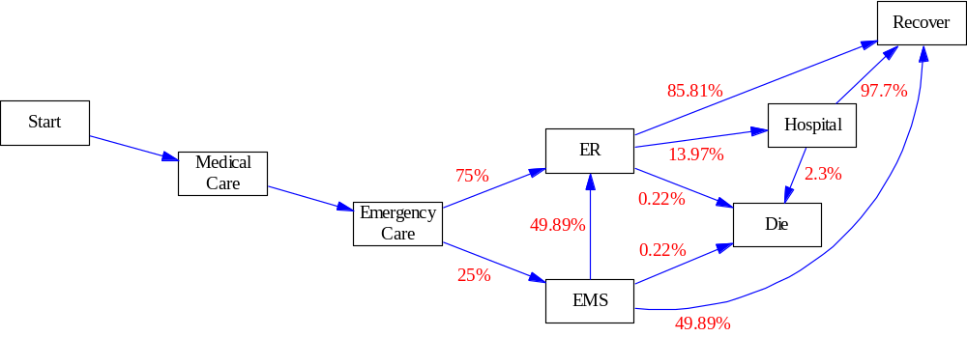
Figure 2-4: Flow diagram for normal emergency care in the public health model
The demand for “normal” care continues even during an influenza pandemic; therefore, the CIPDSS team made a number of adjustments in the model:
- When there is a long waiting time for visits, up to 20 percent of the patients who would have gone to a physician’s office are assumed to go instead to a hospital ER because of an urgent problem; up to 40 percent of the patients who would have gone to a physician’s office are assumed to cancel if there is a long waiting time for visits
- If the waiting time for EMS response gets too long, more people will go directly to the ER rather than wait
- When hospital beds are full, nonemergency patients are not admitted to hospitals, but the patients who would have been admitted wait and are admitted later when the hospital crowding subsides
- When demand exceeds normal capacity for treatment, the time it takes to treat a patient goes up and quality of care goes down, which can cause an increase in the mortality rates

Treatment of Pandemic Flu Patients
People becoming ill with the pandemic flu are added to the normal load on the healthcare system. The rates at which people get sick and recover or die from the pandemic flu are calculated by the epidemiological model, which was discussed above. Figure 2-5 illustrates the entry of pandemic flu patients into the healthcare system. The fractional splits in the model are variable, depending on the average case fatality rate and the degree of crowding in the healthcare system. A higher case fatality rate indicates a more severe variant of the disease and so the fractions of patients seeking healthcare, requiring emergency care, and requiring admission to hospital are higher.
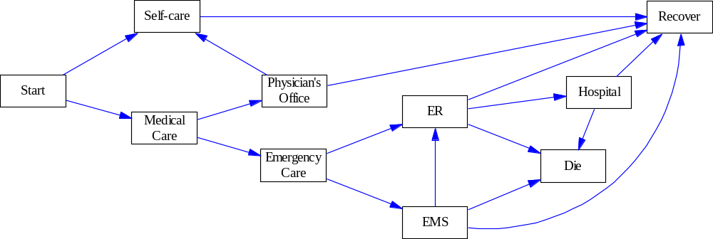
Overcrowding in the healthcare system can have several effects, including more people self-treating because waiting times are so long, more people going directly to an ER rather than waiting for EMS, and if wait time for hospital admission is long enough, people starting to recover before getting into the hospital. Further, as mentioned above, overcrowding can cause quality of care to decline and mortality rates to increase. In Figure 2-5, hospital includes temporary alternative-care facilities that are assumed to be set up when hospitals are full. The calculated healthcare cost includes a reduced cost per patient-day. For these simulations, CIPDSS assumed that there are sufficient alternative beds (for example, in gyms, convention centers, or elsewhere). CIPDSS also assumed that some patients are sent home for care because there is no room in hospitals or temporary facilities.

Notes: EMS = emergency medical services; ER = emergency room
Figure 2-5: Flow diagram for pandemic flu patients in the public health model
CIPDSS assumed the time spent in an ER would be the same for pandemic patients as for normal patients, but the time in hospital would be longer. CIPDSS also assumed the average hospital stay for pandemic flu patients would be the same as the flu recovery time (the amount of time spent in the last disease stage in Figure 2-2).

Worried Well
The number of worried well patients is highly uncertain, but it could be large enough to cause a significant additional load on physicians’ offices and ERs. For the analysis discussed here, CIPDSS assumed the number of worried well patients would be 20 percent larger than the number of people who have pandemic flu symptoms (that is, the number of worried well patients would be 1.2 times the number of pandemic flu patients). The worried well rate has been much higher for many past incidents; for example, there were 5 times as many worried well patients as actual patients afflicted after the Sarin attack in Tokyo. However, because a large fraction of the population is assumed to become ill in the influenza pandemic if there is no mitigation, the worried well multiplier could not be too much higher. If mitigation measures successfully reduce the fraction of population becoming ill, then there would be less reason for the fear response that leads to people becoming worried well. Furthermore, while worried well patients can have an important impact on crowding in parts of the healthcare system, the uncertainty in the number of worried well patients has less impact than many other uncertainties on the quantities of greatest concern (such as number of deaths and economic impact). Therefore, for this analysis, the worried well multiplier was fixed at 1.2.
The flow of worried well patients through the healthcare system is simpler than for normal or pandemic-flu patients because, by definition, worried well patients are not seriously ill, but are only afraid they might be. Therefore, CIPDSS assumed that not one person is treated by an EMS, admitted to the hospital, or dies. This simplified patient flow is illustrated in Figure 2-6.
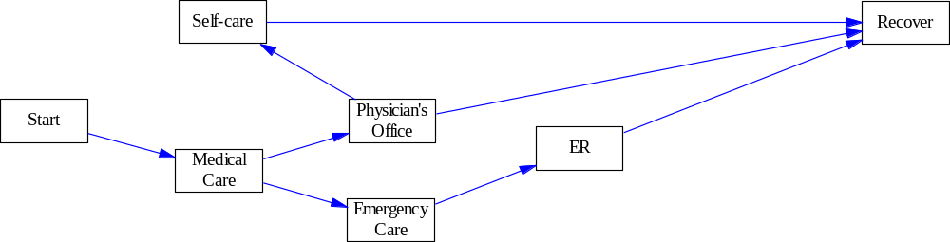
The split of patients seeking care at a physician’s office versus an ER is variable, depending on the average case fatality rate. CIPDSS assumed that if the disease is more severe (as indicated by a higher case fatality rate), then worried well patients would be more likely to seek emergency care instead of going to a physician’s office. Also, if the waiting time for an appointment at a physician’s office is too long, some patients may end up self-treating and bypassing the healthcare system as they start to recover from their flu-like symptoms.

Note: ER = emergency room
Figure 2-6: Flow diagram for worried well patients in the public health model

Economic Impacts Model
This model calculates a dollar value for economic impacts to estimate the magnitude of a possible pandemic influenza. The main number in this estimate is the lost gross domestic product (GDP). This number is an estimate of direct GDP losses. “The National Infrastructure Impacts of Pandemic Influenza: Phase 1 Summary Report” included a more extensive estimate of direct and indirect losses.
Lost GDP is a measure of lost output. The input values are directly derived from the 2002 GDP data for state and industry, which are available from the Bureau of Economic Analysis (BEA). Specifically, the model calculates the lost GDP by multiplying the total value of the GDP per day, by state and industry, by the fraction of workers in that state and industry not working on any given day. The model derives the fraction of unavailable workers from population estimates of sick, dead, and self-isolation workers. This unavailable-worker fraction directly determines the derived economic losses.
The summed GDP for all states is equal to the total GDP for the nation. For this reason, the lost-GDP calculation can be considered to be an estimate for the losses to the U.S. economy over the time studied, in this case, a year. However, the following caveats apply:
- Although the events may cause structural changes to the economy, those changes are not evaluated in the economics model or in the rest of the CIPDSS infrastructure models (most of these changes will take more than a year to emerge)
- The ability to change business processes and, for example, substitute inputs, is limited during the scenario and generally is not modeled; this ability may decrease the actual GDP losses
This model estimates the economic impacts from reductions in output due to reduced workforce participation attributable to the pandemic. One calculation not included in these results is the agricultural costs due to losses in stocks of poultry from an avian form of the influenza. This study did not calculate potential losses in this or other areas, although they are high, because the human costs of a pandemic influenza would far outweigh agricultural losses.

Sensitivity and Uncertainty Analysis
Uncertainty analysis is estimating the distributions of outcome metrics of interest so that probability estimates can be made on the consequences of the simulated pandemic. In this context, sensitivity analysis is identifying which input variables cause the most variation in the outputs. The relative sensitivity of an output to an input variable is often given as a ratio of variance measures, referred to as the R² metric later in this section.

Approach
The analysis team selected an initial set of uncertain input variables to study, including biological variation, policy options, and sociological response differences, based on the team’s experience. An initial sensitivity analysis identified key input variables that are important in determining the variation in the outcomes. The team then used the resultant variables as the basis for a subsequent uncertainty analysis to characterize the uncertainty in the outcomes.

Experimental Design
In the design and modeling of complex systems, designed experiments are frequently the only practical approach to obtaining a solution. Typically, a simulation model of system performance is constructed based on knowledge of how the system operates, and sampling via experiments may be employed to estimate the number of possible outcomes. If the simulation model is computationally expensive, then the optimization of the possible outcomes may instead rely on a sampling methodology to adequately cover all the possible ranges of inputs that contain uncertainty or variability.
This uncertainty analysis employed an experimental design approach to pandemic scenario simulations to obtain information for statistical estimates and correlation in the most efficient manner possible. The goal of the experiment design was to improve the understanding of the relationship between important factors that drive a pandemic and the response to a pandemic. The team based the design on a fractional factorial experiment, which allows an experiment to be conducted with only a fraction of all the possible experimental combinations of parameter values. The team uses orthogonal arrays to aid in the design of an experiment. The orthogonal array specifies the combinations of inputs for each run of the simulation experiment. This approach to designing and conducting an experiment to determine the effect of design factors (parameters) and noise factors give this statistical strength for both the uncertainty analysis and sensitivity analysis.
The statistical method of Latin hypercube sampling (LHS) was developed to generate a distribution of plausible collections of parameter values from a multidimensional distribution. The sampling method is often applied in uncertainty analysis. The LHS technique was first described by McKay and it was further elaborated by Ronald Iman and others. In the context of statistical sampling, a square grid containing sample positions is a “Latin square” only if there is only 1 sample in each row and each column. A Latin hypercube is the generalization of this concept to an arbitrary number of dimensions, whereby each sample is the only one in each axis-aligned hyperplane containing that sample.
The model experimental design applied an orthogonal array (OA)-based LHS plan (strength 5), using 512 runs and varying 20 input variables based on their input distributions, to 24 distinct scenarios (see Table 3-1) for a total of 12,288 simulation runs. Each scenario involved a unique combination of a vaccination strategy, social distancing, contact tracing, and antiviral prophylaxis.
Table 3-1: The 24 scenarios simulated in the sensitivity/uncertainty analysis
Vaccination Strategies:
- No vaccination or contact tracing
- Contact tracing without vaccination
- Mass vaccination only without early vaccine
- Mass vaccination and early vaccine
- Targeted vaccination followed by mass and early vaccination
- Targeted vaccination and early vaccination

Scenario Set for each Vaccination Strategy:
- No social distancing, no antivirals
- No social distancing, antivirals
- Social distancing, antivirals
- Social distancing, no antivirals

Mitigation Scenarios
CIPDSS developed mitigation responses based on potential interventions for pandemic influenza. The team developed 24 distinct mitigation scenarios to evaluate, based upon combinations of 6 vaccination strategies and 4 scenario sets of social distancing and antiviral usage (Table 3-1). These included 2 baseline scenarios with minimal mitigation measures. The vaccination strategies included mass and targeted vaccination, contact tracing, and the availability of a partially-effective and immediately available vaccine (early vaccine). The following sections include discussions on the characteristics of the vaccination scenarios and scenario sets.

Contact Tracing
Contact tracing is identifying and diagnosing persons who may have come into contact with an infected person. Public health workers identify symptomatics, interview them for their contacts, and quarantine them and their contacts for the time they are infectious so they can't infect others. The fraction of actual contacts identified and traced varied in the study, ranging from 0.025 to 0.5. These lower values are appropriate because the disease is assumed to be contagious prior to the appearance of symptoms. Reviewers of this work have advised the authors that the upper limit is far too high and suggested that an upper bound of 0.1 is more reasonable, with average effectiveness less than 0.05. The distribution governing contact tracing effectiveness was changed to have a range of 0.0 to 0.1 with a mean of 0.333 and the simulation output was updated. The number of contacts per afflicted case varied between 5 and 40 people.

Social Distancing (Self-Quarantine)
There are many ways to achieve social distancing including measures to limit person-to-person interactions such as canceling events involving large gatherings and closing buildings or schools. These restrictions are sometimes called “focused measures to increase social distance” and decrease the rate of contact between individuals, thereby slowing the spread of the disease. Closing office buildings, stores, schools, and public transportation systems is a feasible community containment measure that could be employed during a pandemic. Because CIPDSS does not have the resolution to closely model specific social distancing measures, CIPDSS approximated social distancing by varying the self-quarantine behavior in the models. People self-quarantine by voluntarily limiting their contacts with others, thus achieving social distancing. Self-quarantined individuals may remain home for a variety of reasons, including school closures, child or afflicted persons care, fear, telecommuting, or extended leave policy, but the reason for their self-quarantine is not explicitly represented in CIPDSS. This differs from analyses such as those from the epidemiological simulation system (EpiSimS) where some of these different methods for achieving social distance are explicitly represented.
The CIPDSS model for social distancing begins by estimating what is called the nominal rate of self-quarantine, which is the rate if this quarantine behavior was unaffected by competing model behaviors such as getting sick or being contact traced. This nominal rate is based on a multiplier of the rate that people are entering the prodromal stage. This multiplier can be varied by demographic group and is delayed from the prodromal rate by a user-defined reaction time delay. Thus, the self-quarantine behavior is linked to the observed progression of the disease; that is, as more people get sick, the tendency for self quarantine increases. Time reaction delay allows strengthening or weakening of coupling between the disease progression and social distancing.
This nominal rate of self-quarantine won’t be the actual rate, because the model has to account for the fact that people would be getting sick and not self-quarantining. CIPDSS also wants to allow for some user control to cap the self-quarantine behavior based on data or judgment. Therefore, the model calculates an “otherwise occupied rate” that accounts for vaccinations, contact tracing (with quarantine), and people entering prodromal. The model uses an “otherwise-occupied” rate to calculate a fraction of the population that is otherwise occupied. Only the population not otherwise occupied is available to be self-quarantined. Thus, the model estimates the actual self-quarantine rate as the nominal self-quarantine rate (based on prodromal rate) times a power law damping factor that accounts for the fraction of the population available for self-quarantine and the user-defined maximum fraction self-quarantined. CIPDSS incorporated this maximum relative tendency of the different demographic groups to self-isolate during a crisis to represent demographic differences in quarantine behavior. For example, infants and the elderly will be much more likely to self-isolate than working-age people who need to continue work-related tasks. In addition, school-age children may stay home at a higher rate due to school closures. So as the nominal rate approaches either the fraction available for self-quarantine or the desired maximum self-quarantine rate, it is damped down smoothly so that it never exceeds these values.
The infectious disease model applies this self-quarantine rate to the unexposed population. A user-defined multiplier determines the rate people leave self-quarantine on the characteristic time of the disease (the time from infection to recovery or death). The result is that early in the disease progression, the self-quarantine rate looks like a straight multiplier on the sick rate; however, as things progress, it becomes altered below this nominal rate. In many cases, the self-quarantine rate gets damped down much lower than this nominal rate as the population gets depleted and the maximum behavior is reached.
The reaction delay is an important parameter that regulates how closely tied the population’s self-quarantine behavior is to the progression of the disease. The smaller the delay, the closer it is tied to disease progression and the more oscillations it creates in the self-quarantine and disease progression behavior. People lower their self-quarantine behavior as soon as the disease starts to let up, allowing for the disease to grow again, and so on. The longer the delay, the more these behaviors are decoupled and the oscillations are damped out.
The model calculates a number of metrics that provide useful representations of the overall social distancing behavior in a scenario, including the cumulative number of persons self-quarantined, the cumulative number of person-days spent in self-quarantine, a population-weighted overall fraction self-quarantined (taking into account the differing behaviors of the demographic groups), the peak self-quarantine fraction, and the time during the scenario when the peak self-quarantine behavior is achieved.

Targeted Versus Mass Vaccination
A targeted vaccination campaign is limited to contacts of infected people while a mass vaccination program vaccinates all susceptible people until vaccine stockpiles are used or the program catches up to the vaccine production. A fraction of the population may not be able to receive vaccines due to allergies, immunodeficiency diseases, or other reasons. Targeted vaccination includes contact tracing and quarantine as described above.

Partially Effective Vaccine
CIPDSS considered the use of a partially effective pre-pandemic vaccine that is stockpiled and available early in the pandemic as one of the vaccination strategy options. Accordingly, this mitigation uses stockpiled vaccine that may be designed based on a close relative strain of the pandemic influenza strain. The relative efficacy of the partially effective vaccine varied in the study between 10 percent and 70 percent. The size of the stockpile varied between 20 million and 120 million doses.

Fully Effective Vaccine
Vaccine providers typically take several months to develop a strain-specific vaccine. In this analysis, time to production of the vaccine varied from 1.5 to 6 months. After initial introduction, the team assumed that providers would continue producing and distributing the vaccine, providing a stable production rate of approximately 13 million doses per day for mass vaccination.

Antiviral Treatment
CIPDSS assumed that antivirals would be available in the following 2 scenario sets: social distancing, antivirals; and no social distancing, antivirals. The stockpile of available courses varied between the current 21 million and the projected 80 million courses. An optional capability to produce additional antivirals with a ramp-up to a designated production rate is also available. One course for treatment is 5 days, or 10 days for prophylactic measures.

Variable Ranges

Selection of Uncertain Parameters
For this study, CIPDSS identified 20 input variables as likely influential variables on the estimated consequences. The team reviewed these selected variables and associated reasonable ranges with each input (Table 3-2) based on the literature and the ranges of similar values defined in mitigations used by EpiSimS. Each input varied within the specified ranges for every simulation run. Table 3-3 lists the output variables of interest. Input variables that are together in a box were varied together (that is, with 100-percent correlation). The team describes the significance of some of the inputs in a subsequent section of this report.
Table 3-2: Input variables with ranges considered in sensitivity analysis
Variable | Low Range | High Range | Units
Antivirals/Vaccines
Initial antiviral availability | 21M | 80M | Courses
Antiviral standard production rate | 0 | 120M | Courses/year
Fraction antivirals applied to prophylaxis | 0.10 | 0.90 | Fraction
Death rate reduction from antivirals | 0.20 | 0.70 | Fraction
Initial vaccine stockpile (partially effective) | 21M | 121M | Doses
Vaccine effectiveness (partially effective) | 0.1 | 0.7 | Fraction
Vaccine effectiveness (fully effective) | 0.4 | 0.8 | Fraction
Time before vaccine gives immunity (both types) | 168 | 1152 | Hours
Quarantine and Isolation
Self quarantine sick rate modifier | 2 | 10 | Dimensionless
Contact Tracing
Fraction contact effectiveness | 0.025 | 0.5 | Fraction
Transmission
Average contacts per case | 5 | 40 | People
Reproductive number (all ages) | 1.1 | 4.5 | Dimensionless
Fraction of transmission prior to clear symptoms | 0.1 | 0.5 | Fraction
Relative contagion of asymptomatic | 0.1 | 0.8 | Fraction
Additional fraction of asymptomatic | 0.05 | 0.8 | Fraction
Case Fatality Rates
Nominal fatality rate (all population groups) | 0.005 | 0.15 | Fraction
Disease Stage Time Periods
Time to incubate | 12 | 96 | Hours
Duration of prodromal (infectious/asymptomatic) | 12 | 96 | Hours
Duration of early symptoms | 24 | 120 | Hours
Time to recover | 120 | 552 | Hours
Public Health Factors
Maximum mortality enhancement multiplier | 1 | 2 | Factor
Base fraction of afflicted seeking healthcare | 0.4 | 0.9 | Fraction
Detection threshold | 1 | 512 | People
Note: M = million
Table 3-3: Output variables of interest
Output Response Variable | Description
Total cumulative deaths | Cumulative deaths caused by event
Total event healthcare cost | Total cost in the healthcare sector
Total fraction workers unavailable | This is the fraction (weighted average) of workers unavailable across all regions
Total scenario affliction rate | Total rate at which people are becoming afflicted by the scenario (persons per hour)
Maximum outbreak duration | The maximum over all regions of the outbreak duration; based on a threshold of 25 people remaining in the exposed stage that determines when the outbreak is considered over
Overall total cases | Number of pandemic cases, irrespective of treatment
Total attack rate | The total attack rate (ratio of cumulative cases to population) in percentage terms
Total cumulative deaths | Total fatalities
Total cumulative symptomatic | Total symptomatic cases
Total number hospitalized | Hospitalizations
Total patients leaving without being admitted | Number of patients who are supposed to be admitted to the hospital, but who end up leaving because waiting times are too long
Total patients treated in alternative beds | Number of flu patients who need to be hospitalized, but who are sent to temporary facilities because of insufficient room in hospitals
National lost gross domestic product (GDP) | The dollar amount of GDP activity lost during the study period
National baseline GDP | The dollar amount of GDP activity that would have occurred during the time period with no pandemic
Cumulative cases demographically | Cases by age groups
Cumulative deaths demographically | Deaths by age groups
Maximum peak fraction self-quarantined | The maximum over all regions of the peak fraction self-quarantined in each demographic group
All regions cumulative self-quarantine person-days | Total days for self-quarantined population
Overall peak fraction self-quarantined | The weighted average over population of the peak fraction self-quarantined
Total cumulative self-quarantine person-days | The cumulative number of person-days that people have been self-quarantined, summed over all regions and all demographic groups
Total vaccination cost | The total cost of administering vaccinations
Total antiviral cost | The total cost of treating afflicted with antivirals

Biological Uncertainty Factors

Reproductive Number
Generating reliable estimates of the reproductive number (R₀) for influenza is difficult from analyses of past outbreaks because of confounding influences of etiological properties of the infectious agent and population-level effects. An example of the former is the profound antigenic diversity of influenza and the consequent impact of population immunity on transmission. Population age structure, contacts, and density are factors that need to be incorporated. The doubling time for a pandemic curve is a function of the reproductive number. The magnitude of R₀ also determines the intensity of control measures needed to bring the pandemic to a halt.
Estimates of R₀ for pandemic influenza in the literature range from 1.68 to 20. The lower bounds typically correlate with longer serial intervals, or generation times. The study by Murray uses a simple pandemic model to fit an outbreak in a boarding school for boys. This study implied an R₀ value of 3.8, with an implied infectious period of approximately 2.3 days, which is low for influenza. Behavioral factors could be the origin here, as the boys were sent to the infirmary when they showed symptoms, corresponding to a large reduction of contact rate with susceptible people and leading to a low estimate of the infectious period. Spicer fitted a daily time-series model to weekly deaths from influenza and influenza pneumonia in England and Wales for the 1958–1973 pandemic seasons. Multiplying his result, which was estimated on a per-day basis, by the length of the infectious period leads to a large value for R₀ in the range of 11.5–22.7. Mills and others fitted the pneumonia and influenza death pandemic curves from 45 U.S. cities during the 1918 pandemic to a deterministic SEIR, where an R₀ between 2 and 3 was estimated. Mills and others estimated the median value for these data to be 2, with an interquartile range of 1.7–2.3 and an absolute maximum of 6.3. Over the interquartile range, Mills and others did not significantly correlate R₀ with latitude, longitude, population size, population density, age distribution, or sex distribution. The extreme value, R₀ = 6, correlated weakly with population density (p=0.001). If the Mills and others analysis is accurate, it indicates that the 1918 pandemic A/H1N1 strain did not have an inherently higher transmission rate than other influenza subtypes that cause yearly flu epidemics. By comparison, the range of R₀ used in this study, 1.1 to 4.5, is fairly conservative.

Nominal Fatality Rate
Nearly 50 percent of the influenza-related deaths during the 1918–1919 pandemic occurred among young (20 to 40 years old) and previously healthy adults, which is 10 times higher than the influenza pandemics of 1957 and 1968. This led to more than 500,000 excess deaths in the U.S. and 20 million excess deaths worldwide. During the 1957–1958 A/H2N2 pandemic, 36 percent of all excess influenza-related deaths occurred in people under 65 years old. During the 1968–1969 A/H3N2 pandemic, the excess mortality rate for people under 65 years old was 48 percent. By way of comparison, between 1972 and 1992, annual influenza epidemics caused a mortality of 21,000 excess deaths per year. In the most recent seasons, 80 to 90 percent of these deaths occurred in the people over 65 years old.
While the accepted case mortality rate for the U.S. in the 1918 pandemic is generally agreed to be
2–2.5 percent, the global rate ranged as high as 33 percent. The Board of Global Health reported that for the 1918 pandemic:
The case mortality rate varied widely. An overall figure is impossible to obtain, or even estimate reliably, because no solid information about total cases exists. In U.S. Army camps where reasonably reliable statistics were kept, case mortality often exceeded 5 percent, and in some circumstances exceeded 10 percent. In the British Army in India, case mortality for white troops was 9.6 percent, for Indian troops 21.9 percent. In isolated human populations, the virus killed at even higher rates. In the Fiji islands, it killed 14 percent of the entire population in 16 days. In Labrador and Alaska, it killed at least one-third of the entire native population (Jordan, 1927; Rice, 1988).
To include this wide range of possible case mortality rates, this study distributed the nominal fatality rate according to a beta (2,38) distribution, which has 99 percent of its values in the interval [0.00, 0.16] and has a mean value of 0.05, obviously higher than the 1918 pandemic. This distribution is meant to characterize severe pandemics. The Phase I study concluded that a 1918-like pandemic would not cause significant disruption of any infrastructure other than public health. CIPDSS used this distribution to explore cases that would be more severe than the 1918 pandemic and gauge the consequent effects on infrastructures
The model combined the nominal fatality rates for the other demographic groups with the same range, but independent of the value for infants and the elderly. This range allows for a very high influenza case mortality rate in comparison to the 1918 pandemic, but far lower than the observed H5N1 case mortality rate. The model mapped simulation results to the pandemic severity indices recommended by the U.S. Centers for Disease Control and Prevention’s (CDC’s) “Pre-Pandemic Planning Guidance.”

Asymptomatic Infection
There are 2 main aspects of asymptomatic infections in a population with circulating influenza: the total fraction of asymptomatic people and how transmissible the infection is to other persons from an asymptomatic person. Considerable variation exists in these two aspects of asymptomatic infections for both seasonal and pandemic influenza. Indeed, since 1997, the clinical spectrum of H5N1 infection ranges from asymptomatic infection to fatal, and authors are currently debating on the real numbers of cases of H5N1 in humans that have been asymptomatic. In a report to the World Bank, Zelicoff argues that data show that hundreds of millions of people have antibodies to H5, strongly implying infection with an H5-containing strain of influenza. Thus, the overwhelming majority of these infected humans did not develop disease or even mild symptoms. The implication of this argument would be a much reduced case fatality rate for H5N1. Nonetheless, studies such as Zelicoff’s point to the fact that even more commonly accepted assumptions regarding influenza can be major uncertainties in the scientific community.
In one study by Frank and others, at least 8 percent of illnesses in children in a seasonal outbreak were associated with pre-symptomatic shedding, which was noted up to 6 days before illness; 5 percent continued to shed at the end of the second week. Peak rates of shedding correlated with symptoms. In an influenza type A study of children by Hall and others, symptoms and the highest viral shedding occurred early in illness, and 30 percent of patients still shed at day 7. Several studies have also shown that asymptomatic shedding at a low concentration may be common during a seasonal outbreak. Monto and others documented that approximately 60 percent of seasonal infections were asymptomatic. However, this fraction included persons with partial immunity due to infection with the same subtype as in previous years. The prevailing idea for H5N1, with the majority of the world being immunologically naïve, is that the percentage of asymptomatic infections would be lower in a pandemic. Viral shedding in asymptomatic persons is likely to be quite low and viral shedding is correlated with symptoms. To stay within the bounds of what is known about asymptomatic infections of influenza and to capture the uncertainty inherent in asymptomatic infections, CIPDSS used lower transmission values for the fraction of transmission (10 to 50 percent) occurring prior to the onset of clear symptoms. The total fraction of asymptomatic infections could then be varied from 5 to 80 percent, and all parameters for asymptomatic infections were co-varied.

Sociological Uncertainty Factors

Nonpharmaceutical Interventions
Ultimately, the successful control and containment of a pandemic will depend on using a variety of mitigation measures that include both pharmaceutical and nonpharmaceutical interventions (NPIs). In February 2007, the CDC released a guidance document for the use of NPIs during an influenza pandemic. These guidelines document the objectives of NPIs during a pandemic to include
- Delaying the exponential growth in illnesses and shifting the pandemic curve to the right to “buy time” for production and distribution of a well-matched pandemic strain vaccine
- Decreasing the pandemic peak
- Reducing the total number of incident cases and reducing community morbidity and mortality
While NPIs have been shown to be effective in controlling a pandemic in other modeling simulation studies, they can also be the most costly in terms of lost wages and workers available.

Isolation and Quarantine
Isolation refers to separating persons who have a specific infectious illness from those who are healthy and restricting their movement to stop the spread of that illness. Quarantine refers to separating and restricting movement of persons who, while not yet ill, have been exposed to an infectious agent and therefore may become infectious. Both isolation and quarantine are public health strategies that have proven effective in stopping the spread of infectious diseases. Quarantine of a person exposed to pandemic influenza would last for 1 incubation period. For annual influenza, the incubation period usually is as long as 4 days. However, this period could be either potentially shorter or longer for a new type of influenza virus. To capture this uncertainty, this study used a uniform range of 12 to 96 hours.
The simulation scenarios for pandemic influenza used a general quarantine factor that varied by age class and by public health responders that correspond to the 4 types of social distancing suggested by the CDC guidelines. These included, but were not limited to,
- Voluntary isolation of the sick at home or in a hospital
- Voluntary home quarantine of potentially exposed family members of the sick
- Child social distancing, including dismissing students from schools, closing childcare programs, and reducing out-of-school social contacts and community mixing
- Adult social distancing, including canceling large public gatherings and altering work environments and schedules

Self Quarantine
The fraction of people who self-quarantine is dependent on age group, correlated to the rate that people become ill and restricted to those who are not already affected by the outbreak (such as the sick or vaccinated). Individuals may self-quarantine either as a result of their own preferences (for example, fear reaction to media coverage) or in response to guidance from government officials. There is a delay in the model between changes in the progress of the outbreak and changes in self-quarantining behavior. This delay decouples the disease progression and self-quarantine behavior to some degree, with delays of a week or more producing reasonable results.
Due to demographic differences in quarantine behavior, the study incorporated a maximum relative tendency of the different demographic groups to isolate themselves during a crisis. For example, infants and the elderly will be much more likely to self-isolate than working-age people who need to continue work-related tasks. In addition, school-age children may stay home at a higher rate due to school closures.
The self-quarantine sick-rate modifier is a multiplier of the rate that people are becoming ill, which is used as the initial estimate of the rate at which people self-quarantine. The team assumed that the people that self-quarantine will be a multiple of the infected people. They then modified the rate to reflect limitations imposed by the availability of people to self-quarantine and the maximum fraction of the population subset that engages in the self-quarantine activity (self-quarantine tendency is 0.95 for infants and elderly, 0.9 for school-age children, 0.4 for adults, and 0.25 for responders). A range of 2 to 10 was used for the sick-rate modifier, loosely based on survey results from the SARS outbreak in Hong Kong. The team believes that the resulting range of self-quarantine behavior in the simulations is reasonable.

Public Health Uncertainty Factors

Base Fraction of Afflicted Seeking Healthcare
This parameter is the fraction of people who would be symptomatic with the pandemic flu and who would seek healthcare of some kind (at a physician’s office, clinic, or ER or by calling for EMS) if the case fatality rate was 0.02 (the 1918 pandemic case mortality rate). CIPDSS used a case fatality rate of 0.02 for the point-case analyses earlier in this study and assumed the fraction of afflicted seeking healthcare to be 0.6, with the other 40 percent of people with pandemic flu self-treated. The team based this choice for the earlier part of this study on the planning assumptions in the HHS [U.S. Department of Health and Human Services] Pandemic Influenza Plan, which were that 50 percent of ill people would seek outpatient medical care and 11 percent would be hospitalized in a severe (1918-like) pandemic. This study took the fraction seeking medical care to be 60 percent rather than 50 percent, because the HHS plan is unclear about whether the fraction hospitalized is a subset of those patients seeking outpatient medical care or a separate fraction.
In setting an appropriate range of values for the uncertainty analysis, CIPDSS considered it unlikely that 100 percent of flu victims would seek medical care, so the analysts set the upper limit to 90 percent. The team set the lower limit to 40 percent because, in preliminary simulations, unrealistic results would sometimes occur if the fraction was lower. For example, if over 60 percent of flu cases were mild enough that the people would simply self-treat, there might not be enough severe cases to account for the assumed death rate. The model is currently structured so that anyone sick enough to be at risk of dying is assumed to seek healthcare. In reality, some people might die without having sought care, but the current model neglects that possibility.
CIPDSS incorporated a number of adjustments to this fraction in the model. Most notably, for case fatality rates higher than 0.02, CIPDSS assumed the fraction of afflicted seeking healthcare to be higher than the base fraction that is sampled. Thus, at the upper end of the case fatality rates considered (that is, near 0.15), the model assumes that almost all flu victims would seek care even if the sampled value of base fraction of afflicted seeking healthcare is well below 1. In addition, the model allows for the possibility that some people will seek healthcare and then cancel their request for care if the healthcare system is heavily overloaded and the waiting time is so long that their health starts to improve.

Maximum Mortality Enhancement Multiplier
This parameter takes into account a decline in the quality of treatment if the healthcare system is overloaded. If waiting times for emergency care or to gain admission to hospital are too long, the mortality rate in the model will increase, up to the maximum mortality enhancement multiplier. In the earlier analyses, this effect was not included, so the mortality enhancement multiplier was left at 1. For the uncertainty analyses, inclusion of this effect was desired, but the amount of increase in mortality that could occur is not really known. There have been a number of studies (usually relating to particular illnesses) that have found increases in mortality when care is delayed, but how the increase in mortality might average out over all patients in an emergency room or a hospital is not known. Thus, the range of 1 to 2 for the maximum effect is somewhat speculative although it does have some support in the literature.

Health Threat Reaction Time
This parameter determines how quickly an outbreak of pandemic influenza is recognized. It is the number of cases of flu that occur before the outbreak is recognized, and it is determined independently for each region. After the outbreak is recognized, various mitigation policies can be activated (such as targeted or mass vaccination and contact tracing with quarantine), depending on what policies are assumed for a given scenario. At the lower end, the outbreak is recognized with the very first case, which is not realistic but is included to see how much it would help if the pandemic could be recognized immediately. There is no specific rationale for the upper limit of 512 cases, but the team assumed in the model that the pandemic would be recognized by the time there are that many cases.

Parameter Distributions
The model initially assigned the uniform probability distribution over the expected range of the variable for the 20 parameters selected for uncertainty analysis in this study. The uniform distribution assumes that any value in the variable range is equally likely and is often used to represent a lack of knowledge about the relative frequency of values for a variable. While less useful for uncertainty analysis, it is appropriate for sensitivity analysis. Distributions other than the uniform are more appropriate for several of the parameters. For example, the input variable for time of incubation in days can be described by a beta distribution and R₀ by a lognormal distribution. By assigning appropriate probability distributions to the input variables, distributions on the output consequences can be represented and average outcomes can be determined with greater confidence.
CIPDSS completed the sensitivity analysis using the uniform distribution for all of the variables in order to obtain equal and appropriate samples of each possible scenario. Table 3-4 defines the distributions used in the uncertainty analysis.
Table 3-4: Probability distributions for uncertainty analysis
Variable Name | Distribu-tion | Mean | Std Dev | Param1 | Param2 | Scaling Factor | Shift Factor
Initial antiviral availability | uniform | 5.10E+07 | 1.73E+07 | 2.10E+07 | 8.10E+07 | 1 | 0
Fraction antivirals applied to prophylaxis | uniform | 0.50 | 0.2309 | 0.1 | 0.9 | 1 | 0
Death rate reduction from antivirals | uniform | 0.45 | 0.1443 | 0.2 | 0.7 | 1 | 0
Initial vaccine stockpile[partially effective] | uniform | 7.00E+07 | 2.89E+07 | 2.00E+07 | 1.20E+08 | 1 | 0
Vaccine effectiveness[partially effective] | uniform | 0.40 | 0.1732 | 0.1 | 0.7 | 1 | 0
Vaccine effectiveness[fully effective] | uniform | 0.60 | 0.1155 | 0.4 | 0.8 | 1 | 0
Time before vaccine gives immunity [partially effective] | gamma | 432.0000 | 83.1384 | 27 | 16 | 1 | 0
Time before vaccine gives immunity[fully effective] | gamma | 432.0000 | 83.1384 | 27 | 16 | 1 | 0
Fraction contact effectiveness | beta | 0.033 | 0.0163 | 4 | 116 | 1 | 0
Standard production rate | beta | 2.00E+07 | 1.13E+03 | 2 | 10 | 1.20E+08 | 0
Self quarantine sick rate modifier | uniform | 6.0 | 2.3094 | 2 | 10 | 1 | 0
Average contacts per case | normal | 20.0 | 5.0000 | 20 | 5 | 1 | 0
Reproductive number[infant] | lognormal | 2.33 | 1.1802 | 0 | 0.76 | 1 | 1
Reproductive number[youth] | lognormal | 2.33 | 1.1802 | 0 | 0.76 | 1 | 1
Reproductive number[young adult] | lognormal | 2.33 | 1.1802 | 0 | 0.76 | 1 | 1
Reproductive number[old adult] | lognormal | 2.33 | 1.1802 | 0 | 0.76 | 1 | 1
Reproductive number[elderly] | lognormal | 2.33 | 1.1802 | 0 | 0.76 | 1 | 1
Reproductive number[responders] | lognormal | 2.33 | 1.1802 | 0 | 0.76 | 1 | 1
Fraction of transmission prior to clear symptoms | beta | 0.20 | 0.0784 | 5 | 20 | 1 | 0
Relative contagion of asymptomatics | beta | 0.43 | 0.1278 | 6 | 8 | 1 | 0
Table 3-4: Probability distributions for uncertainty analysis (continued)
Variable Name | Distribu-tion | Mean | Std Dev | Param1 | Param2 | Scaling Factor | Shift Factor
Additional fraction asymptomatic | beta | 0.33 | 0.1307 | 4 | 8 | 1 | 0
Nominal fatality rate[infant] | beta | 0.05 | 0.0340 | 2 | 38 | 1 | 0
Nominal fatality rate[elderly] | beta | 0.05 | 0.0340 | 2 | 38 | 1 | 0
Nominal fatality rate[youth] | beta | 0.05 | 0.0340 | 2 | 38 | 1 | 0
Nominal fatality rate[young adult] | beta | 0.05 | 0.0340 | 2 | 38 | 1 | 0
Nominal fatality rate[old adult] | beta | 0.05 | 0.0340 | 2 | 38 | 1 | 0
Nominal fatality rate[responders] | beta | 0.05 | 0.0340 | 2 | 38 | 1 | 0
Time to incubate | gamma | 42.00 | 24.2487 | 3 | 14 | 1 | 0
Duration of prodromal | gamma | 42.00 | 24.2487 | 3 | 14 | 1 | 0
Duration of early symptoms | gamma | 63.48 | 29.5977 | 4.6 | 13.8 | 1 | 0
Time to recover | gamma | 288.00 | 83.1384 | 12 | 24 | 1 | 0
Maximum mortality enhancement multiplier | uniform | 1.50 | 0.2887 | 1 | 2 | 1 | 0
Base fraction of afflicted seeking healthcare | uniform | 0.65 | 0.1443 | 0.4 | 0.9 | 1 | 0
Normal health threat reaction time | gamma | 180.00 | 103.9230 | 3 | 60 | 1 | 0

Pre-symptomatic and Asymptomatic Spread
The evidence supporting the transmission of influenza prior to symptoms includes data from 2 sources. First, experimental and observational studies of viral excretion usually find that infected people start excreting influenza viruses at low levels from their respiratory tracts a short while before they develop symptoms. Second, serological studies of levels of population immunity to influenza often find people who show antibodies from prior infection but have no recollection of symptoms. Other surveys suggest that many more people have been infected during annual pandemics than can be explained by the number of cases observed. However, as there are few field reports of infections from asymptomatic or pre-symptomatic persons, the public health importance of such transmission remains unclear. One systematic review found very few convincing reports of transmission from a pre-symptomatic patient. Reports of asymptomatic or pre-symptomatic patients excreting high levels of virus are rare and it is possible that any infections resulting from such transmissions are mild or asymptomatic, although they could be important in maintaining chains of transmission.
Because the spread of influenza by infected but asymptomatic people is one of the largest biological uncertainties, it has been described as the top research priority. Knowledge gaps for influenza include the following questions:
- What is the length of the asymptomatic incubation period?
- Is there viremia excreted during the asymptomatic stage?
- What is the infectivity of blood during the asymptomatic stage?
- What are the contributions to influenza transmission and disease from pre-symptomatic and asymptomatic spread?
- Is there significant pre-symptomatic (transmission from people who will become sick with influenza before they develop symptoms) and/or asymptomatic spread (transmission from people who are infected but never develop symptoms)?
To capture the uncertainty of the role of transmission of influenza prior to symptoms or in asymptomatic individuals, the model uses 3 input variables that affect transmission, as listed in Table 3-5.
Table 3-5: Input variables that affect transmission
Variable | Low Value | High Value | Units
Fraction of Transmission Prior to Clear Symptoms | 0.1 | 0.5 | Fraction
Relative Contagion of Asymptomatic | 0.1 | 0.8 | Fraction
Additional Fraction of Asymptomatic | 0.05 | 0.8 | Fraction

The 3 variables in the model were varied while using a beta distribution for each.

Fraction of Transmission Prior to Clear Symptoms
This parameter (equal to theta in Fraser et al., 2004) is the average fraction of transmissions of an infected individual before symptoms appear. The larger the value, the harder it is to suppress a pandemic using a limited quarantine based on recognition of symptoms alone (that is, not doing aggressive contact tracing). Fraser et al. (2004) indicate that the range for this parameter is from 0 up to 0.20 (Figure 3-1). For this study, the team selected 6.6 percent in consultation with EpiSimS.
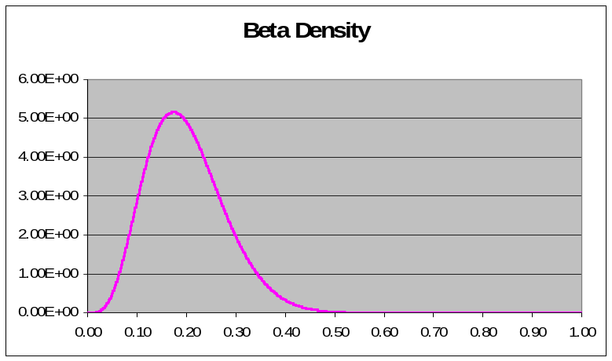

Figure 3-1: The beta (5,20) distribution for the fraction of
transmission that occurs prior to clear symptoms

Relative Contagion of Asymptomatics
The contagiousness of asymptomatics is expressed as a fraction of the contagiousness of the symptomatics (Figure 3-2).
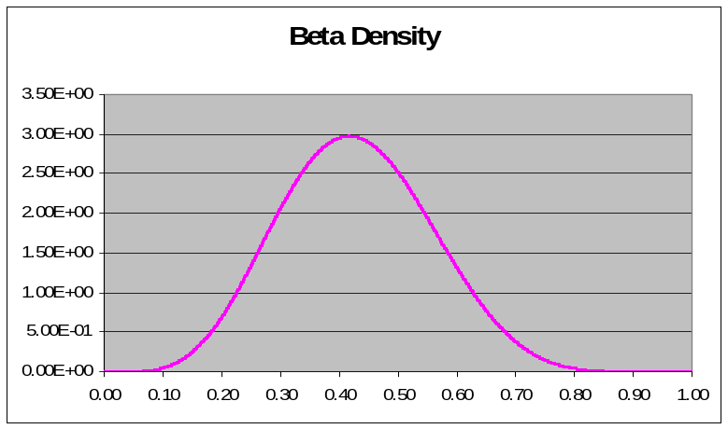

Figure 3-2: The beta (6,8) distribution for the relative contagiousness of asymptomatic infected people

Additional Fraction of Asymptomatics
The number of persons who are asymptomatic is expressed as a fraction of those showing symptoms (Figure 3-3).
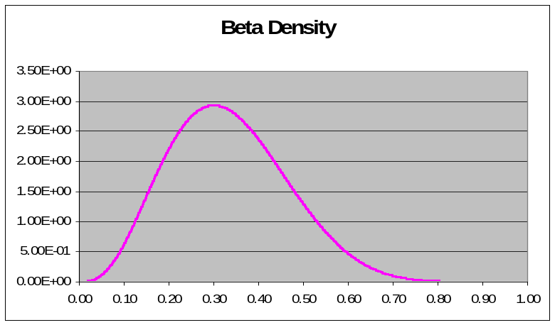

Figure 3-3: The beta (4,8) distribution for relative fraction of asymptomatic
infections compared to symptomatic infections

Reduction in Early Symptom Contagion Due to Limited Quarantine
This parameter captures the effect of the assumption that 50 percent of remaining cases are isolated per day after symptoms become apparent; for example, 15 percent of cases slip through due to delayed recognition. This study assumed this fraction of persons isolating themselves to be 0.82 based on the idea of isolating 50 percent of the remaining symptomatics each day for 3 days. The assumption would work as follows: If the duration of the early (contagious) stage is 5 days, 20 percent of the possible transmissions (without any isolation) would occur each day. If 50 percent of those people were isolated at the beginning of the first day (with the initial onset of symptoms), only 10 percent of the possible transmissions would occur. If 50 percent of the remaining people were isolated at the beginning of the second day, only 5 percent of the possible transmissions would occur that day. Again, isolating 50 percent of the remaining symptomatics at the beginning of the third day would result in 2.5 percent of the possible transmissions occurring. Assuming everyone else is isolated by the beginning of the fourth day, the total transmission would be 0.1+0.05+0.025=0.175 of the possible transmissions and the reduction multiplier would be 0.825. Figure 3-4 gives the relationship of transmission reduction to fraction of people being isolated. The model set this variable at 0.82 for all runs. This value may be optimistic for pandemic influenza.

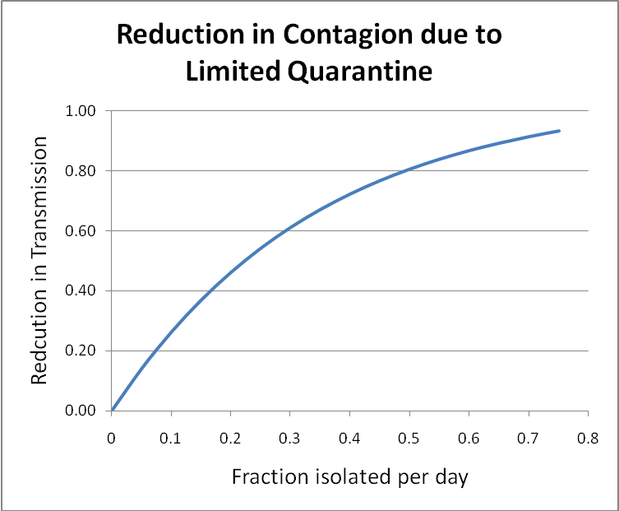

Figure 3-4: The relationship of fraction of contagious population isolated per day to the reduction in overall transmission of the disease

Effective Reproductive Number
The effective reproductive number, R, for disease transmission is defined as the average number of secondary infectious cases produced in a population where a fraction X is susceptible over the lifetime of one infectious individual. The effective reproductive number, R, is related to the basic reproductive number, R₀, by the equation
R = R₀X Equation 1
The basic and effective reproductive numbers are good indicators of the severity of a pandemic and the effectiveness of control. In general, estimation of these parameters from actual disease outbreak data is limited because the process of infection is not observed, data are often incomplete, and the rate of infection is non-linear. An effective reproductive number is calculated to integrate the impacts of asymptomatic transmission and effects of individuals who isolate themselves early in the disease progression due to being ill. Self-isolation of infected and symptomatic persons greatly affects the transmission of the disease to new individuals. In terms of the parameters used in the CIPDSS infectious disease model, the effective reproductive number is given by the following formula:
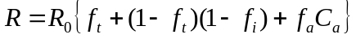 Equation 2

Where
R₀ is the basic reproductive number
f_{t} is the fraction of transmission prior to clear symptoms
f_{a} is the additional fraction asymptomatic
C_{a} is the relative contagion of asymptomatic
f_{i} is the reduction in early symptom contagion due to limited quarantine
The ranges and probability distributions of the above parameters were described previously. Figure 3-5 gives the resulting distribution of the effective reproductive number, R, and shows the cumulative distribution function (CDF) obtained from the 512 sampled values. Figure 3-5 also shows the CDF of the basic reproductive number, R_{o}, for comparison. Approximately half of the sampled realizations had an effective reproductive number less than 1, which means that a pandemic would not develop in those realizations. To retain the focus of this study on the potential for a severe pandemic, the realizations with R < 1 were dropped, and the 243 realizations with R ≥ 1 were the focus of discussion. Figure 3-6 shows the CDFs of R and R₀ over the subset of realizations with
R ≥ 1.
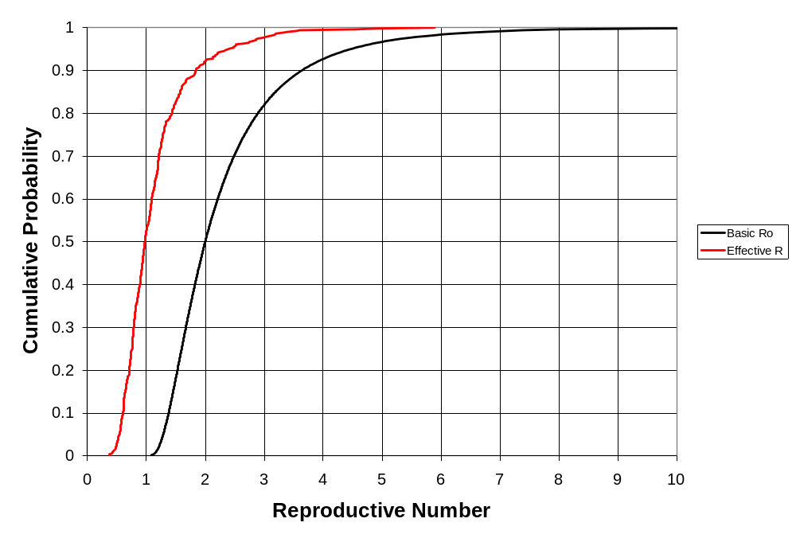

Figure 3-5: Cumulative distributions of sampled R₀ and effective R
(all 512 realizations)

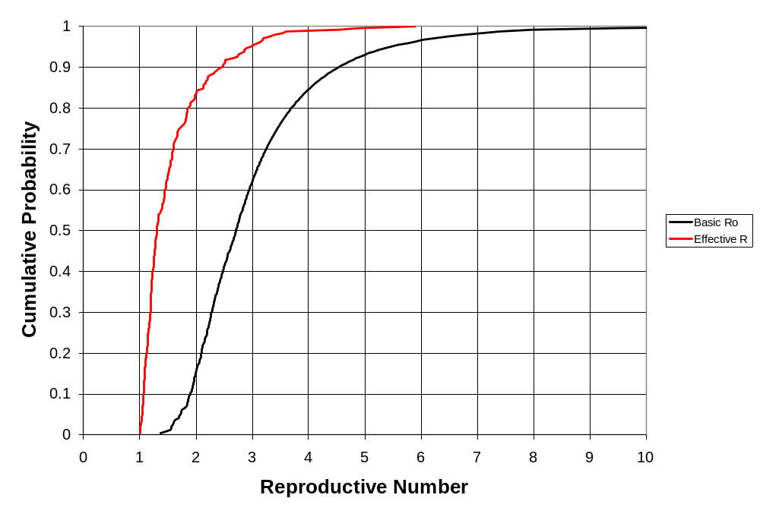

Figure 3-6: Distributions of R₀ and effective R (243 realizations with R ≥ 1)

This page intentionally left blank.

Results and Analysis

Initial Sensitivity Analysis
Acknowledging the high degree of uncertainty with the possible variable ranges and outcomes, the analysts conducted a preliminary sensitivity analysis to reduce the number of variables included, the acceptable ranges used, and the number of co-varied outcomes. Results show that the overall uncertainty in the parameters of the infectious disease model can be remarkably large. Figure 4-1 shows some of the variability that may be expected for multiple scenario runs that cover the range of biological, sociological, and mitigation options for affecting the cumulative number of illnesses.
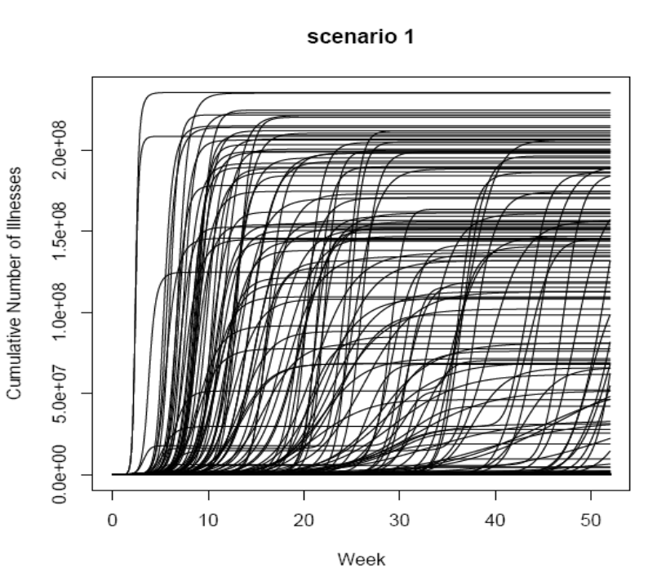

Figure 4-1: Cumulative number of illnesses for baseline scenario
runs with no mitigations
R² is a standard goodness of fit measure for evaluating fit of a model to a response. For the preliminary sensitivity, the model used R² as a tool to rank inputs with respect to relative importance. The R² was based on fitting a single input, x, to a response modeled as
y = mx + b Equation 3

If for a certain response, the R² for a model based on x₁ is larger than R² for a model based on x₂, then x₁ is judged more important or influential than x₂ for that response. The model applied an approximate test of significance for R²: if R² for a particular response (x_{i}) is below a statistically determined threshold, then x_{i} is judged unimportant. The model then computed the R² values for 20 inputs and 47 responses. The results served as a filter to eliminate unimportant variables for the subsequent uncertainty analysis.
The CIPDSS team completed a coarse sensitivity analysis on 14 mitigation scenarios (minus the baseline scenarios) for a total of 64 runs per case and a total number of 896 simulation runs.
Using the R² criterion in the preliminary sensitivity analysis for each of the outputs listed below, the highest ranking variables that affect that pandemic scenario outputs are given.
- Total attack rate and overall total illnesses
- Fraction transmission prior to clear symptoms (infectious asymptomatic)
- Reproductive number
- Total cumulative deaths
- Fraction transmission prior to clear symptoms (infectious asymptomatic)
- Nominal fatality rate (infant, elderly)
- Nominal fatality rate (youth, adults, responders)
- Reproductive number
- Total cumulative event deaths by cause (normal)
- Maximum mortality enhancement multiplier
- Self-quarantine tendency maximum (adults, responders)
- Disease stage duration (all stages)
- Maximum total scenario affliction rate
- Fraction transmission prior to clear symptoms (infectious asymptomatic)
- Reproductive number
- Disease stage duration (all stages)
- Maximum total workers unavailable
- Self-quarantine tendency maximum
- Total lost GDP
- Disease stage duration (all stages)
- Total event healthcare cost
- Fraction transmission prior to clear symptoms (infectious asymptomatic)
- Nominal fatality rate (infant, elderly)
- Nominal fatality rate (youth, adults, first responders)
- Reproductive number
- Base fraction of afflicted seeking healthcare
- Total number of hospitalized cases (normal)
- Average contacts per case
- Self quarantine tendency maximum
- Reproductive number
- Disease stage duration (all stages)
- Base fraction of special patients requiring admission
- Fraction of special patients treated in field by EMS
- Additional fraction asymptomatic
- Nominal fatality rate (infant, elderly)
- Total number of hospitalized cases (special)
- Fraction of transmission prior to clear symptoms (infectious asymptomatic)
- Reproductive number
- Disease stage duration (all stages)
The results showed several variables that were not significant according to the R² criterion. Therefore, these variables would not have a strong impact on the outcome of the pandemic in the number of people affected, deaths, or outbreak duration. The following variables also failed the R² criterion and were deemed unimportant for subsequent analysis in this study (in no particular order):
- Normal health threat reaction time
- Base fraction of patients seeking care at physicians offices and clinics (special)
- Base fraction of patients seeking care at physicians offices and clinics (worried well)
- Base fraction of special patients taken to hospital by EMS
- Delta nominal fatality rate
- Detection threshold
- Amount of time to create vaccine (fully effective)
- Initial vaccine stockpile (partially effective)
- Time before vaccine gives immunity (partially and fully effective)
- Vaccine effectiveness (partially and fully effective)
- Initial antiviral availability (given that the sample range was 20–80 million)
- Fraction of physicians office and clinic visits that are urgent
- Self quarantine tendency maximum (youth, infant, elderly)
- Fraction antivirals applied to prophylaxis
- Death rate reduction from antivirals
Figure 4-2 shows the averages for scenario deaths for the preliminary analysis using the uniform distributions for the input variables that are binned by reproductive number. Mitigations show an impact at all values of reproductive number.

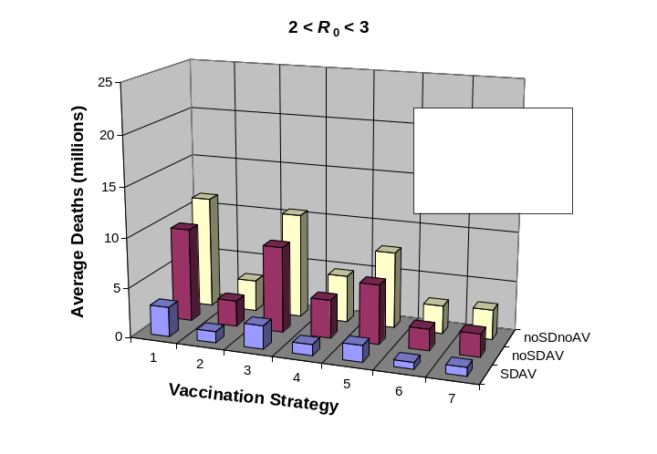
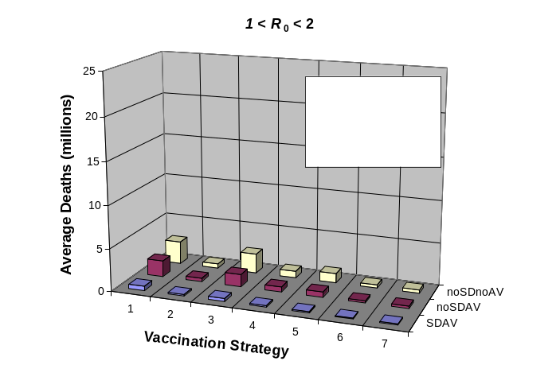

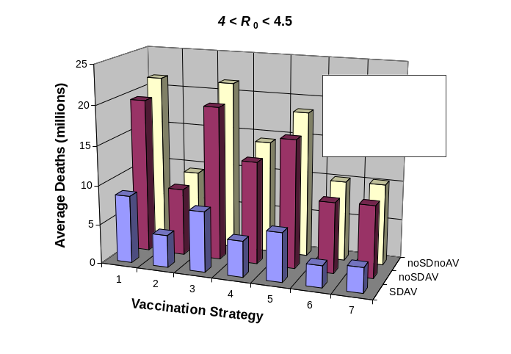
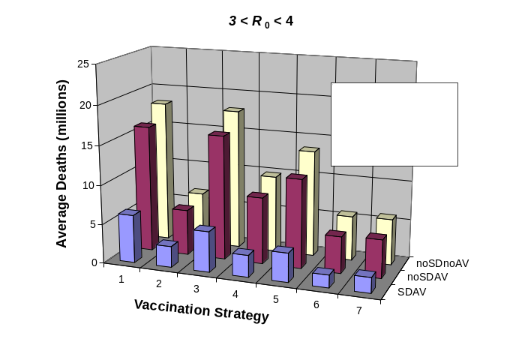

Notes: AV = antiviral; SD = social distancing
Vaccination Strategy:
1 No vaccination or contact tracing 5 Mass vaccination and early vaccination
2 Contact tracing without vaccination 6 Targeted followed by mass vaccination and early vaccination
3 Mass vaccination only with no early vaccine 7 Targeted vaccination and early vaccination
4 Targeted vaccination only with no early vaccine

Figure 4-2: Scenario averages for different R₀ groupings

Final Analysis

Mitigation Strategies Compared
Table 4-1 summarizes the scenarios analyzed in terms of the averages of some key measures of impact. Figures 4-3 and 4-4 present the averages for flu deaths and illnesses. The results show that all of the interventions considered provide some reduction in the number of illnesses and deaths caused by the pandemic, but social distancing (in all social distancing scenarios; labeled SD in the figures) shows the best results in this analysis. Mass vaccination provides little reduction in deaths if it only occurs after a fully effective vaccine is developed (vaccination strategy 3), because the pandemic has largely run its course by then. Even mass vaccination with a stockpile of partially effective vaccine (vaccination strategy 4) does not perform as well as social distancing because of the limited quantity of vaccine available in the initial stockpile. The results show only a small reduction in deaths from contact tracing and quarantine, with or without vaccination (vaccination strategies 2, 5, and 6). The scenarios that include antivirals (labeled AV in the figures) have lower deaths than the corresponding scenarios without antivirals, but the reduction in deaths is relatively modest. However, social distancing provides substantial reduction in deaths, even without any contact tracing or vaccination. On average, antivirals provide a reduction in deaths of about 8 percent, social distancing provides a reduction in deaths of about 62 percent, and the combination of social distancing plus antivirals provides a reduction in deaths of about 66 percent. (There is some variation in these numbers for the various vaccination strategies.)
The computed numbers of flu deaths shown in Table 4-1 and illustrated in Figure 4-3 include an increased death rate when the healthcare system is overloaded, as discussed in the model section. Under such conditions, the model also includes an increased death rate from normal (non-flu) afflictions. The number of non-flu deaths attributable to the pandemic averages about 35,000 in the simulations and is as high as about 400,000 in the most extreme realizations, but the computed number of non-flu deaths is insignificant compared to the number of direct influenza deaths. If the average number of deaths shown in Table 4-1 is divided by the average number of illnesses, the result is an average case fatality rate of approximately 6 percent. The average of the distribution used for the nominal fatality rate is about 5 percent. The increase from 5 percent to 6 percent indicates an average 20-percent increase in deaths because of healthcare overloading. However, there is great uncertainty about this effect so the average 20-percent increase in deaths should not be considered representative, but only indicative of the potential magnitude of the effect.

Table 4-1: Comparison of scenario averages
Scenario Set | Vaccina-tion Strategy | Flu Illnesses (millions) | Flu Hospitali-zations (millions) | Flu Deaths (millions) | 1-Year Lost GDP (%) | Peak Fraction Workers Unavail-able (%) | Health-care Cost ($billions)
No social distancing, no antivirals | 1 | 100 | 22.7 | 6.6 | 2.9 | 13 | 220
No social distancing, no antivirals | 2 | 72 | 16.2 | 4.6 | 2.7 | 14 | 170
No social distancing, no antivirals | 3 | 92 | 21.0 | 6.1 | 2.8 | 13 | 200
No social distancing, no antivirals | 4 | 59 | 13.2 | 3.8 | 1.8 | 8 | 130
No social distancing, no antivirals | 5 | 63 | 14.2 | 4.1 | 2.3 | 13 | 150
No social distancing, no antivirals | 6 | 68 | 15.4 | 4.4 | 2.5 | 14 | 160
No social distancing, antivirals | 1 | 93 | 21.1 | 6.1 | 2.7 | 12 | 210
No social distancing, antivirals | 2 | 68 | 15.3 | 4.4 | 2.6 | 13 | 170
No social distancing, antivirals | 3 | 85 | 19.3 | 5.6 | 2.5 | 12 | 190
No social distancing, antivirals | 4 | 53 | 11.9 | 3.4 | 1.6 | 7 | 120
No social distancing, antivirals | 5 | 58 | 13.0 | 3.7 | 2.1 | 12 | 140
No social distancing, antivirals | 6 | 63 | 14.3 | 4.1 | 2.3 | 13 | 160
Social distancing, no antivirals | 1 | 41 | 8.9 | 2.4 | 6.0 | 22 | 100
Social distancing, no antivirals | 2 | 35 | 7.6 | 2.0 | 6.0 | 21 | 90
Social distancing, no antivirals | 3 | 32 | 7.1 | 1.9 | 4.3 | 21 | 80
Social distancing, no antivirals | 4 | 22 | 4.9 | 1.3 | 2.8 | 14 | 50
Social distancing, no antivirals | 5 | 26 | 5.6 | 1.5 | 4.0 | 20 | 70
Social distancing, no antivirals | 6 | 32 | 7.0 | 1.9 | 5.5 | 20 | 80
Social distancing, antivirals | 1 | 37 | 8.1 | 2.1 | 5.6 | 20 | 90
Social distancing, antivirals | 2 | 33 | 7.1 | 1.9 | 5.6 | 19 | 90
Social distancing, antivirals | 3 | 29 | 6.3 | 1.7 | 4.0 | 20 | 70
Social distancing, antivirals | 4 | 19 | 4.2 | 1.1 | 2.6 | 13 | 50
Social distancing, antivirals | 5 | 23 | 5.0 | 1.4 | 3.7 | 19 | 70
Social distancing, antivirals | 6 | 29 | 6.4 | 1.7 | 5.1 | 19 | 80
Notes: GDP = gross domestic product
Vaccination Strategy
1 No vaccination or contact tracing 4 Mass vaccination with early vaccine
2 Contact tracing without vaccination 5 Targeted followed by mass vaccination with early vaccine
3 Mass vaccination only with no early vaccine 6 Targeted vaccination with early vaccine
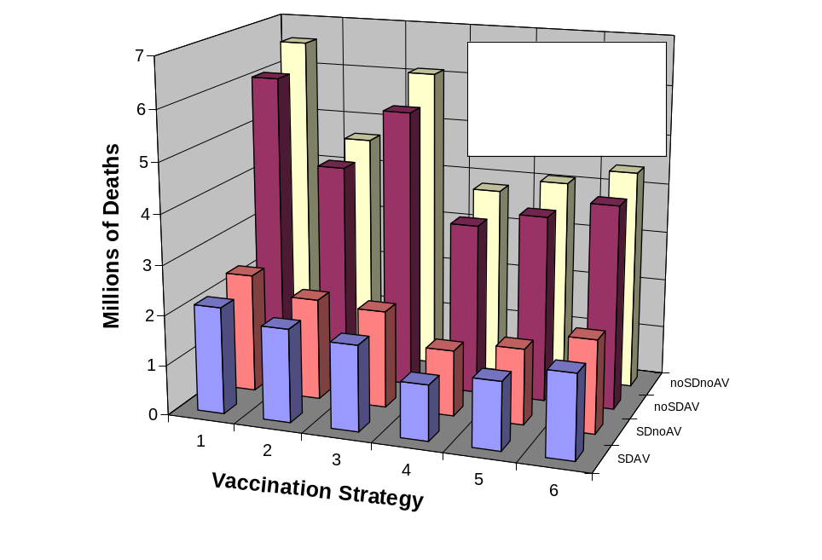

Notes: AV = antiviral; SD = social distancing
Figure 4-3: Scenario Averages for total deaths due to the pandemic
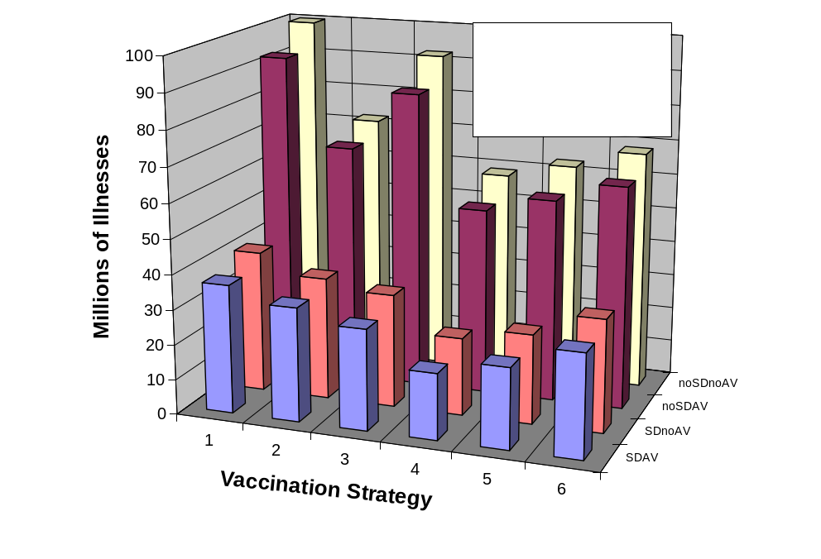

Notes: AV = antiviral; SD = social distancing
Figure 4-4: Scenario averages for flu illnesses
The amount of variation in the number of illnesses and deaths about the averages is presented in box plots in Figures 4-5 and 4-6. In each box plot, the range of values is shown for each of the 24 scenarios. For each scenario, the box has its bottom at the 25th percentile of the distribution and its top at the 75th percentile. A line within the box indicates the 50th percentile (median value) and a circled plus sign indicates the average value. (The averages are the values listed and plotted in Table 4-1, Figure 4-3, and Figure 4-4). A whisker extends above each box either to the highest value or to a length of 1.5 times the box length, whichever is less. Any additional values are considered outliers and are indicated individually above the whiskers.
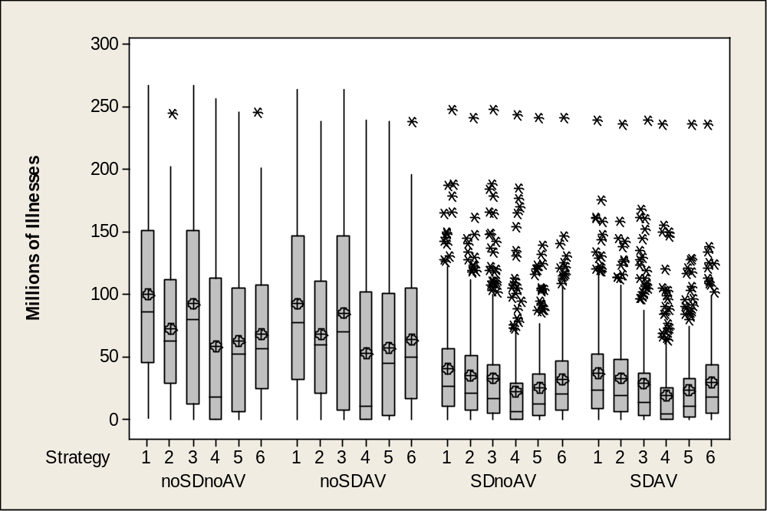
The ranges are quite large for each scenario, ranging from near zero to much higher than the average. The average is sometimes significantly higher than the median. The highest values in these figures would represent extremely severe consequences, far more severe than any pandemic in recent history. The wide ranges of the consequence measures result, of course, from the large amount of uncertainty in the sampled input parameters. The previous discussion based on the average values would still be generally valid if maximum values were used instead, but the differences among the maxima are not as strong as the differences among the averages.
Notes: AV = antiviral; SD = social distancing
Figure 4-5: Scenario ranges for flu illnesses

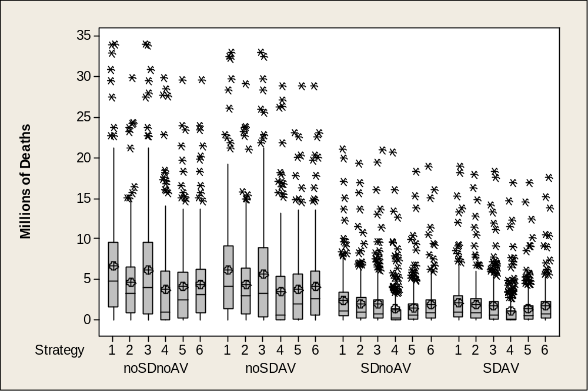

Notes: AV = antiviral; SD = social distancing
Figure 4-6: Scenario ranges for flu deaths

Public Health Infrastructure Impacts
Following are a few results relating to the public health infrastructure, which was the only infrastructure included in the model simulations. As with the consequence measures already discussed, there is a very large range of stresses on the healthcare system in the simulations. If the average number of hospitalizations is divided by the average number of illnesses, the result is that approximately 22 percent of the people becoming sick with the pandemic flu are sick enough to require hospitalization. This is much higher than the 11 percent assumed for a severe pandemic in the HHS Pandemic Influenza Plan, but that is because the range of severity considered in this analysis goes well beyond the HHS severe pandemic (for example, a case fatality rate of 2 percent is assumed for a severe pandemic in the HHS plan, as compared with the average of 5 percent for the assumptions of this analysis). The number of flu patients cared for in hospitals averages 2–5 million in the various scenarios, with a maximum on the order of 13 million. As with other variables, there is also a large range of pandemic durations represented in the results, and the number of patients treated in a hospital with a limited number of beds can be greater for a longer pandemic. This is illustrated in Figure 4-7, noting that the numbers treated in hospital are greatest for relatively low values of the effective R₀, for which the pandemic develops more slowly. Of greater importance is that in approximately 40 percent of the realizations there are not enough hospital beds available to admit all the patients who need treatment. In that case, the model assumed that temporary facilities would be set up to care for the excess flu patients. Figure 4-8 shows the average number of patients treated in temporary facilities for the various scenarios. Figure 4-9 shows that the scenario-to-scenario variation is similar to that for illnesses and deaths. Figure 4-9 also shows the amount of variation within each scenario. The high end of the range is extraordinary; that is, nearly half of the entire population. It seems unlikely that temporary facilities could be set up to care for that many people, and many of them would likely have to go home for self-care or care by family or friends. It would even be a challenge to set up enough temporary facilities for the average number in the higher scenarios (almost 20 million patients). This underscores the importance of providing interventions (vaccinations with an initial stockpile of partially effective vaccine, antiviral treatments, contact tracing with quarantine, and social distancing) that can reduce the numbers to a manageable level. It also highlights the need for hospitals to have viable plans to engage alternate treatment facilities, including home care, temporary facilities, and use of workforce plans for highly stressed situations.
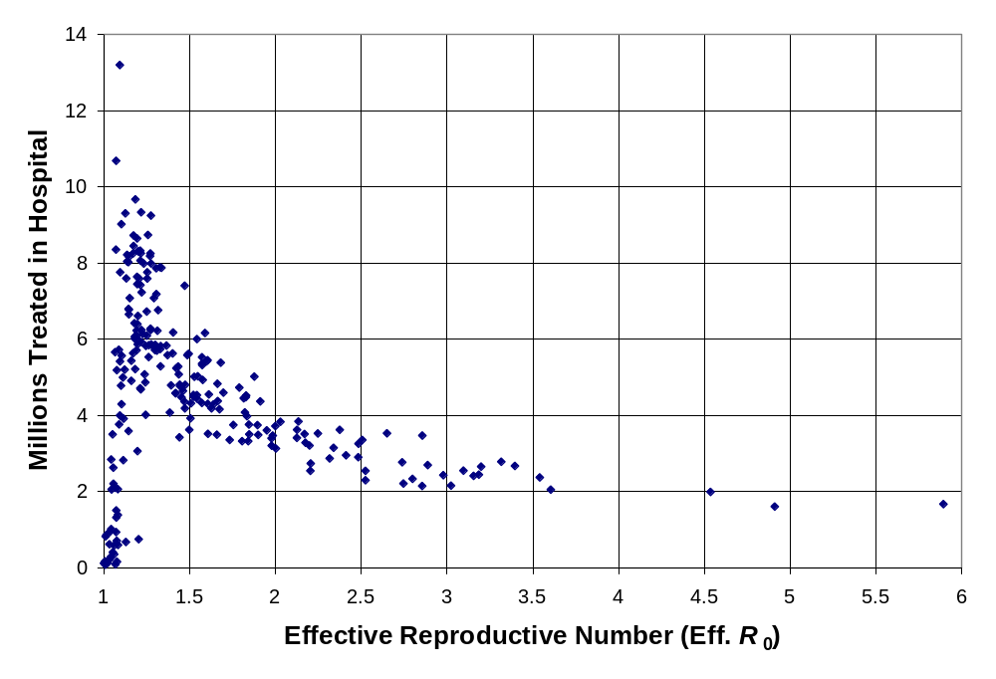
Figure 4-7: Patients treated in hospital versus effective
reproductive number (baseline)
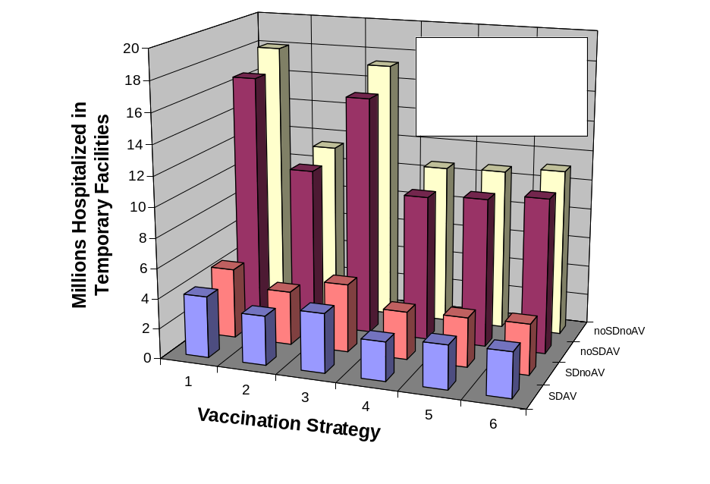

Notes: AV = antiviral; SD = social distancing
Figure 4-8: Scenario averages for patients hospitalized in temporary care facilities
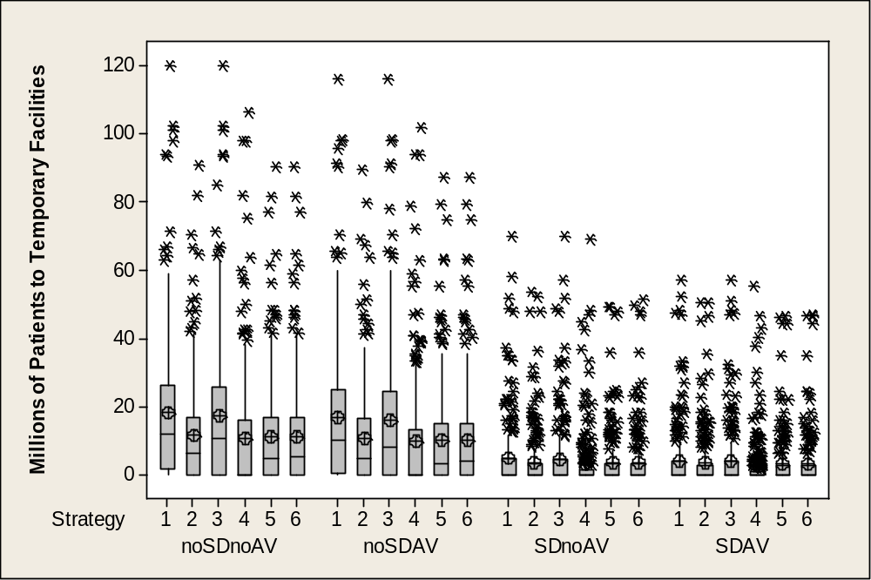

Notes: AV = antiviral; SD = social distancing
Figure 4-9: Scenario ranges for patients hospitalized in temporary care facilities

Economic Impact
The scenario averages for the calculated lost GDP are shown in Table 4-1 and Figure 4-10. The results show greater economic impact (lost GDP) in scenarios that include social distancing because the assumptions for social distancing include people staying away from work, and the calculation of lost GDP is based on the number of worker-days lost. Thus, while the scenarios with social distancing have the lowest number of deaths, they also have the highest economic impact. The lowest average economic impact is indicated to be in the scenarios with mass vaccination and a stockpile of partially effective vaccine (vaccination strategy 4, without social distancing). Another measure of economic impact is the peak fraction of workers who are unavailable either because of sickness or social distancing, shown in Table 4-1 and Figure 4-11. In comparing social distancing and no social distancing with no antivirals, the result is a reduction of 60 million illnesses and 4 million deaths and an increase of the peak worker unavailability from 13 percent to 22 percent. If large numbers of employees are out of work, it could be difficult for an infrastructure or industry to operate. Such effects were discussed in some detail in the earlier report and will not be discussed further here. The computed lost GDP is strongly correlated with the peak fraction of workers who are unavailable to work, but they are not completely correlated because there is variation in the amount of time workers are out in addition to the fraction of them who are out.
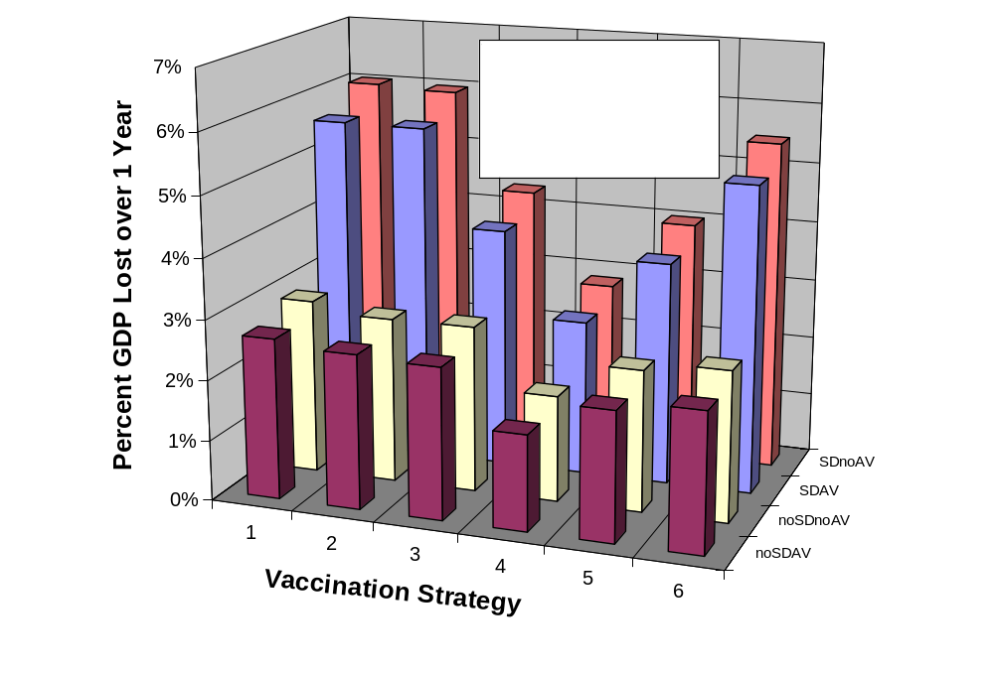

Notes: AV = antiviral; SD = social distancing
Figure 4-10: Scenario averages for lost gross domestic product
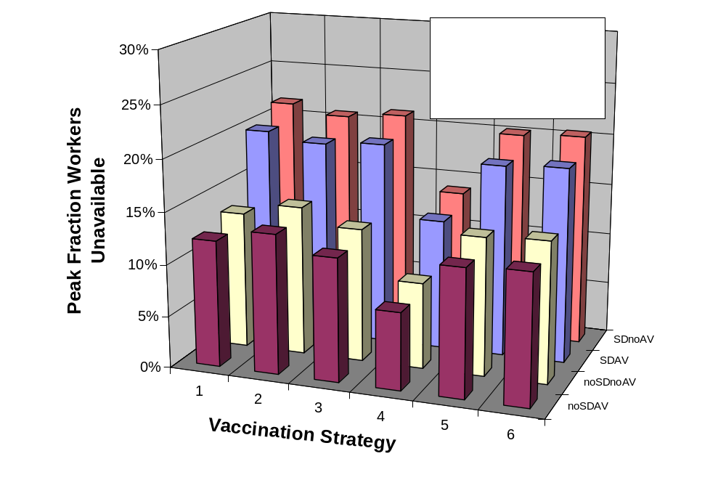

Notes: AV = antiviral; SD = social distancing
Figure 4-11: Scenario averages for peak fraction of workers unavailable
Box plots for lost GDP and peak fraction of workers unavailable because of sickness or social distancing are shown in Figures 4-12 and 4-13. Once again, the range for each scenario is very large, and the highest values represent extremely severe consequences (although at low probability). Few, if any, organizations could function with an absentee rate of 80 percent. The most-cited potential peak for worker absenteeism is 40 percent, which originated as a worst case planning assumption for the pandemic effect on the workforce. The average absentee rates in this study are much lower than that (Table 4-1 and Figure 4-8), but the full range of results in individual realizations includes absentee rates higher than 40 percent (Figure 4-13). Perhaps even more importantly, Ehrenstein and others found that a modest majority of healthcare professionals and only a minority of hospital administrators recognize the obligation to treat patients in a pandemic situation despite the potential risks. It will be a priority to maintain essential services during the pandemic’s peak and ensure continuity of businesses nationwide. No special vaccinations or prophylactic treatments were given to medical personnel in this study.
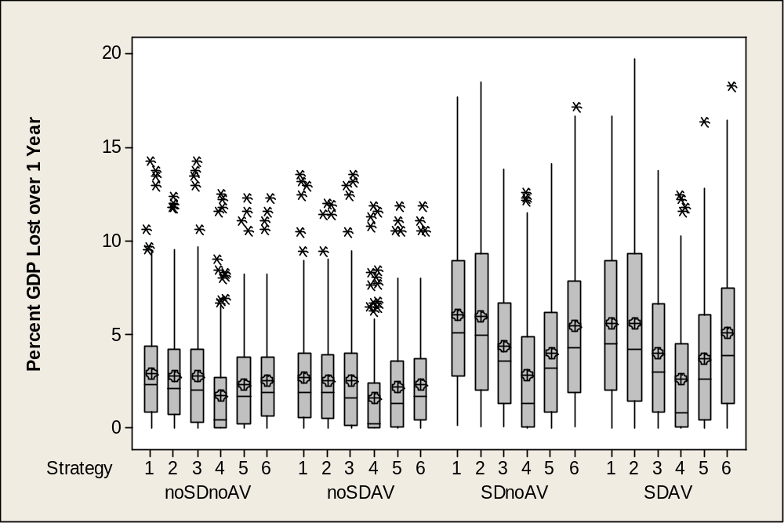

Notes: AV = antiviral; SD = social distancing
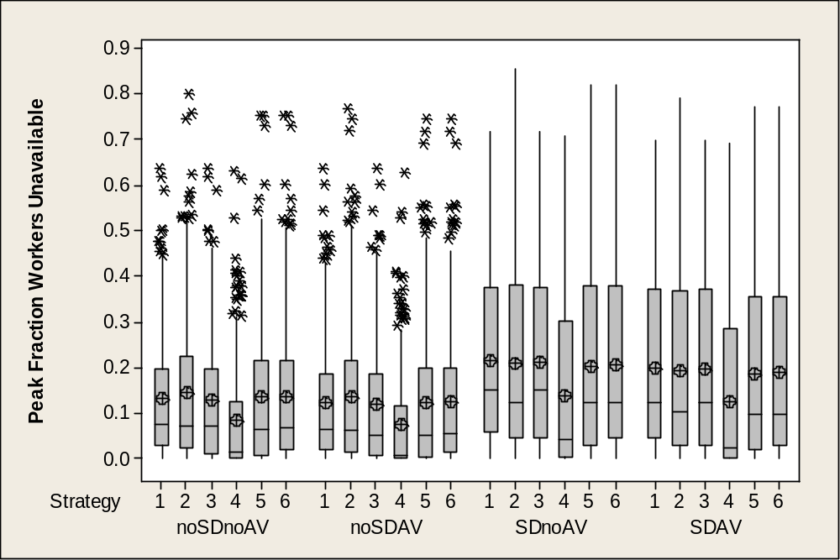
Figure 4-12: Scenario ranges for lost gross domestic product

Notes: AV = antiviral; SD = social distancing
Figure 4-13: Scenario ranges for peak fraction of workers unavailable

Antiviral Use
If the scenario averages with antivirals are compared to those without antivirals (no social distancing in both cases), the antivirals provide an average reduction in deaths of 6 percent to 10 percent. The benefit from antivirals will, of course, depend on the amount of antivirals available. With the assumptions used in this analysis, the reduction in deaths due to antivirals depends more on the antiviral production rate than on the size of the initial antiviral stockpile. The results show a large spread in the effectiveness of antivirals, with some increase in the effectiveness at greater production rates.
Because antiviral agents can be stored (Tamiflu and Relenza have shelf-lives of 3 and 5 years, respectively), developing a stockpile has advantages as part of a strategy for a flu pandemic. By the end of 2006, more than 20 million courses of antivirals were in the U.S. Strategic National Stockpile (SNS). By 2008 it is estimated that there will be 80 million courses. Because this amount would be enough to cover only about 5 percent of the population for an 8-week period, which is far short of WHO’s recommendation that governments have enough antiviral treatments on hand for at least 25 percent of their population, this study considered an antiviral stockpile of up to 120 million courses. The effectiveness of antivirals is dependent upon the infectiousness and virulence of the disease and the amount in the SNS.

Effectiveness of Social Distancing
A primary social response to a contagious disease is to voluntarily modify one’s behavior, by any number of means, to reduce the rate of contact with other potentially infectious individuals. While it is reasonable to assume that some degree of social distancing occurs in a pandemic, in this study social distancing is modeled as “on” or “off.” When social distancing is on, the degree of social withdrawal is assumed to be proportional to the rate of infection. The rate of social distancing is mildly decoupled from the rate of infection by introducing a delay to account for individual perception of the risk of infection and any preparation needed for entering a social distancing behavior.
The effect of social distancing is two-fold. First, it tends to reduce morbidity and mortality by an average of 30 million cases and 10 million deaths, respectively, over all vaccination strategies. Second, it tends to increase the fraction of workers unavailable and, hence, increases the fraction of lost GDP, by 0.05 (morbidity) and 0.01 (mortality), averaged over all vaccination strategies. These results rely on assumptions about gross social distancing behavior, as it is very difficult to get reliable data upon which to base the model. It points to a need for additional research in sociological response to pandemics.
The model calculates and reports the total number of self-isolation person-days during the course of the disease based on input assumptions about the strength of this behavioral response in the population. This information is converted to an average reduction in the nominal contact rate of the susceptible population by dividing the total self-isolation person-days by the product of the duration of the disease in the population and the average number of susceptible in the population:
Average Nominal Contact Rate Reduction of the Susceptible Population = Equation 4
Total Self-Isolation Person-Days/Disease Duration * (293.6 Million - Cases)/2)
Because the input variables are characterized with uncertainty distributions and these affect the level of self-isolation adopted in each model run, the value of the average nominal contact rate reduction also varies across the runs. Furthermore, because of nonlinear interdependencies in the model, there is not a simple relationship between the level of contact rate reduction and the reduced number or fraction of cases across the various vaccination strategies investigated. However, in general, relatively small reductions in contact rates (increases in social distancing), especially if implemented early in the disease progression, can significantly attenuate disease progression when compared to like scenarios without social distancing implemented.
Figure 4-14 shows the effect of social distancing on the baseline (no intervention) scenario by comparing the number on influenza cases with the social distancing switch turned off (noSDnoAV1) and with social distancing turned on (SDnoAV1). The comparison is presented in the form of a scatter diagram that plots the number of cases with social distancing (y-axis) against the number of cases without social distancing (x-axis) from each of the 243 corresponding runs of the SDnoAV1 and noSDnoAV1 scenarios. The vertical distance that each point lies below the diagonal line drawn on the chart is the reduction in number of influenza cases resulting from social distancing, with all other input assumptions being the same. The average of all 243 runs is noted by the vertical arrow extending down from the diagonal line and the horizontal arrow extending from the left y-axis. When social distancing assumptions are applied to the baseline (no intervention) scenario runs, the average number of influenza cases decreases to 38.6 million from 98.2 million.
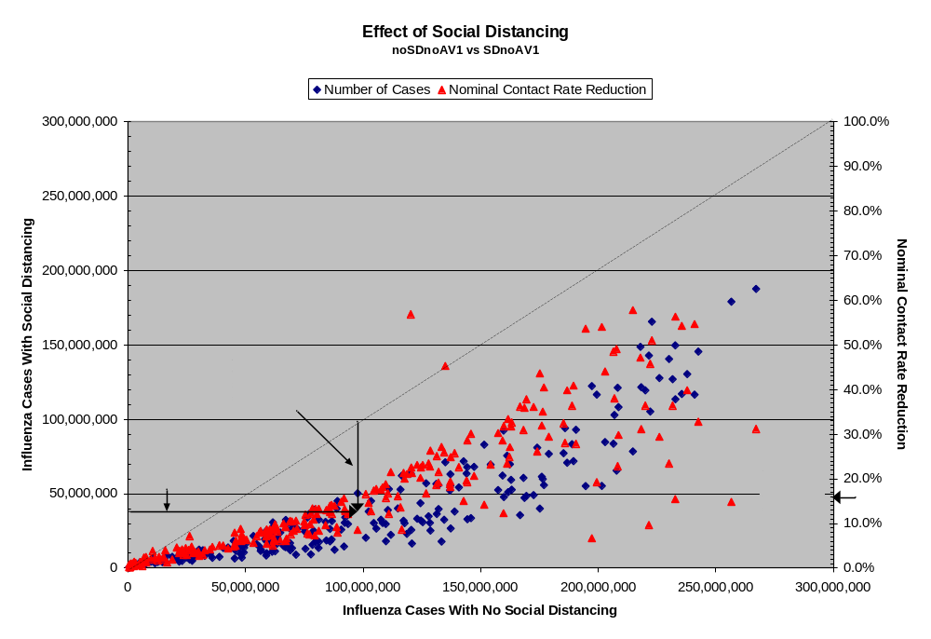

Figure 4-14: Effect of social distancing on the no intervention scenario
Figure 4-14 also shows the average reduction in nominal contact rate for each social distancing scenario (SDnoAV1) run from the corresponding no social distancing (noSDnoAV1) run for all 243 runs. The average contact rate reduction ranged from 0.2 percent to 57.8 percent, with an average value of 16 percent across all 243 runs. The largest reductions in cases are not necessarily associated with higher contact rate reductions, because many other factors in the runs influence the effect of contact rate reduction, such as the gross attack rate or the rate of disease progression through time.
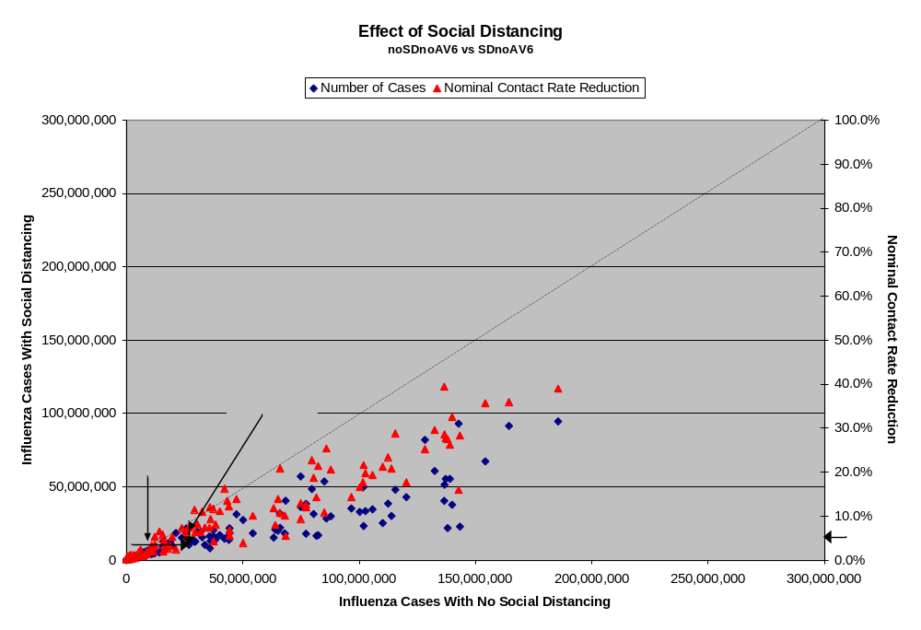
In comparison, the effect of social distancing on the no intervention scenario (Figure 4-15) shows a similar result based on the targeted vaccination scenarios (noSDnoAV6 and SDnoAV6). Although the general pattern of the results is similar, the reduction in contact rate is generally smaller, averaging only 5 percent (range of 0.02 percent to 39.4 percent), and the average number of cases is reduced to 10 million from 24.1 million. In both examples, the relative reduction in cases is around 60 percent; examination of all the no social distancing and social distancing scenarios results in average case reductions ranging from 50 percent to nearly 70 percent.
Figure 4-15: Effect of social distancing on the targeted
vaccination, no antivirals scenario

Vaccination
The primary defense against acquiring influenza is vaccination. Vaccination for seasonal influenza has been shown to prevent disease, reduce the rates of complications such as pneumonia, and reduce the rates of hospitalizations and deaths. In the event of pandemic influenza, vaccination will be important in controlling the pandemic. However, because of the time required under current vaccine production techniques, vaccines may not be available at the onset. Currently, the time between identification of the candidate vaccine strain and production of the vaccine for distribution to the population is estimated to be approximately 6 months. As a result, considerable effort is underway to develop better methods to produce vaccines, such as developing cell-based or generic vaccines. Manufacturing capacity for vaccine development is currently being improved to decrease the time to distribution and increase the quantity of vaccines.
In addition, candidate pre-pandemic vaccines, based on the H5N1 strain, are under development. The goal of pre-pandemic vaccines is to provide a sufficient immune response using the smallest amount of antigen in a single dose. Because the population is immunologically naïve, pandemic vaccines currently under development require 2 doses. Current vaccine protocols call for 2 doses (28 days apart) for experimental pandemic vaccines. Pre-pandemic vaccines, as they are based on strains other than the specific but unknown strain of the pandemic, are less effective in providing immunity. Often, the system for distributing vaccines, based mostly on private distributors, is unpredictable and may deliver vaccines at various times throughout a pandemic. In a press release dated 23 April 2007, the U.S. Food and Drug Administration (FDA) announced the first vaccine with U.S. approval to prevent people from becoming infected with the H5N1 influenza strain. For this approved vaccine, 2 shots must be given 28 days apart.
Model results show that a pre-pandemic vaccine may be effective in reducing the size and impact of an outbreak. However, there is much variability surrounding the pattern for death rate reduction for an early and partially effective vaccine. In the simulations, a single dose was assumed to be given rather than 2, so the effective stockpile might be considered to be half the size (if 2 doses are necessary). No pattern for a threshold vaccine stockpile can be discerned at this time for the range of pre-pandemic vaccine stockpile numbers considered. The next step in investigating the relationship between potential responses and the unknowns about the disease will be to differentiate the biological uncertainty values in relationship to the variability in vaccine stockpile and death-rate reduction. Using different transmission values, EpiSimS may be able to add more detailed analyses to estimate vaccine stockpile effectiveness.

Case Fatality Rate
Case fatality is related to the overall deaths in a pandemic. In early 2007, the CDC released “Interim Pre-pandemic Planning Guidance: Community Strategy for Pandemic Influenza Mitigation in the U.S. – early targeted layered use of non-pharmaceutical interventions,” which contained the pandemic severity index based on case fatality rate. Figure 4-16 shows the relationship between the case fatality rate and the total number of deaths, by the CDC severity index, in the baseline scenario. As the case fatality rate increases, variability due to the influence of the other disease characteristics increases.
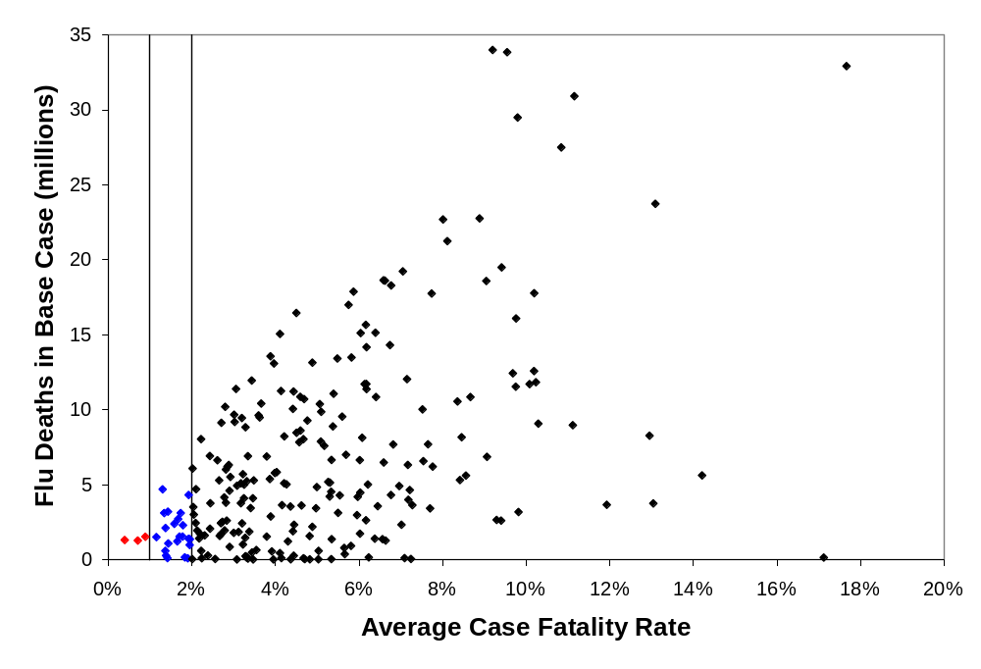
Notes:
CDC Category 3 (red) = 0.5 - <1.0 % case fatality rate
CDC Category 4 (blue) = 1.0 - < 2.0 % case fatality rate
CDC Category 5 (black) = ≥ 2.0% case fatality rate
CDC = Centers for Disease Control (CDC, 2007)

Figure 4-16: Influenza deaths for the baseline scenarios by case fatality rate

Final Sensitivity Analysis
Using the R² criterion in the final sensitivity analysis for each of the outputs listed below, the highest ranking variables that affect that pandemic scenario outputs are given.
There were 10 parameters that significantly contributed to the variance of the output variables of interest:
- Nominal fatality rate (infant, elderly)
- Nominal fatality rate (youth, adults, responders)
- Reproductive number
- Time to recover (all stages)
- Additional fraction asymptomatic
- Fraction transmission prior to clear symptoms (infectious asymptomatics)
- Maximum mortality enhancement multiplier
- Fraction contact effectiveness (contact tracing)
- Time to when vaccine gives immunity (both fully and partially effective)
- Antiviral production rate
The following parameters were found to significantly affect the response variables for all scenarios:
- Total attack rate and overall total illnesses
- Fraction transmission prior to clear symptoms (infectious asymptomatics)
- Reproductive number
- Time to recover (all stages)
- Relative contagious asymptomatic
- Additional fraction asymptomatic
- Fraction contact effectiveness (contact tracing)
- Total cumulative deaths
- Fraction transmission prior to clear symptoms (infectious asymptomatics)
- Nominal fatality rate (infant, elderly)
- Nominal fatality rate (youth, adults, responders)
- Reproductive number
- Relative contagious asymptomatic
- Additional fraction asymptomatic
- Fraction contact effectiveness
- Maximum total scenario affliction rate
- Fraction transmission prior to clear symptoms (infectious asymptomatics)
- Reproductive number
- Disease stage duration (all stages)
- Maximum total workers unavailable
- Reproductive number
- Relative contagious asymptomatic
- Additional fraction asymptomatic
- Fraction contact effectiveness (contact tracing)
- Fraction transmission prior to clear symptoms (infectious asymptomatics)
- Total lost GDP
- Nominal fatality rate (youth, adults, first responders)
- Reproductive number
- Time to recover (all stages)
- Relative contagious asymptomatic
- Additional fraction asymptomatic
- Fraction contact effectiveness (contact tracing)
- Fraction transmission prior to clear symptoms (infectious asymptomatics)
- Social distancing sick rate modifier
- Total event healthcare cost
- Fraction transmission prior to clear symptoms (infectious asymptomatics)
- Nominal fatality rate (infant, elderly)
- Nominal fatality rate (youth, adults, first responders)
- Reproductive number
- Base fraction of afflicted seeking healthcare
- Time to recover (all stages)
- Relative contagious asymptomatic
- Additional fraction asymptomatic
- Fraction transmission prior to clear symptoms (infectious asymptomatics)
- Fraction contact effectiveness (contact tracing)
- Total number of hospitalized cases (normal)
- Average contacts per case
- Self-quarantine tendency maximum
- Reproductive number
- Disease stage duration (all stages)
- Base fraction of special patients requiring admission
- Fraction of special patients treated in field by EMS
- Additional fraction asymptomatic
- Nominal fatality rate (infant, elderly)
- Relative contagion of asymptomatics
- Total number of hospitalized cases (special)
- Fraction of transmission prior to clear symptoms (infectious asymptomatics)
- Reproductive number
- Disease stage duration (all stages)
In addition to looking at R² within each scenario, the model can identify other inferences on the relative importance of each parameter by using the aggregate data for all 24 scenarios. IncR² is the increase in the R² for a model with a single input, modeled linearly for each scenario, above the R² for a model fitting the average for each of the 24 scenarios. The inference is similar to the primary sensitivity analysis, with the 20 inputs being screened for variability in the responses, which is explained by the scenarios being different sets of data.

Pandemic Model Comparison
A major limitation of models for pandemic influenza is the uncertainty inherent in many of their assumptions. This uncertainty and the differences in the assumptions used in each model make model comparison difficult. However, one way of making sense of these uncertainties, in addition to sensitivity analysis, is comparison of competing models. Table 4-2 highlights several recent models and the EpiSimS Phase 2 analysis for pandemic influenza and the uncertainties included in each study. Overall, the infectiousness of the influenza estimated by R₀ was the most investigated uncertain parameter (ranging from 0.5 to 21). Most models were in the range for R₀ of 2 to 3.5. In comparison, this study investigated R₀ up to 14.4 to examine where impacts begin to degrade the critical infrastructure and public health. For runs where R₀ is between 2 and 3.5, the average attack rate is 27.5 percent for our baseline scenario (Figure 4-17), which compares favorably with other published model attack rates for baseline scenarios. Three important biological parameters can be identified from the results of all previous pandemic influenza models: the R₀ that corresponds to the number of secondary infections generated by primary infections in a susceptible population, the disease generation or stage time that is the time interval between one person and the people they infect, and the proportion of transmission occurring prior to the onset of symptoms and the related fraction of persons that are asymptomatic.
The most investigated mitigation strategies included vaccination, antivirals, and social distancing (focusing on school closures). Overall, the models are in agreement when using similar infectiousness parameters. However, different mitigation results occur when the biological parameters differ significantly. For example, school closure was found to be effective by several studies, but was found to minimally affect the overall attack rate by Ferguson and others.
Table 4-2: EpiSimS phase 2 and published simulation studies for
pandemic influenza
Study | Mitigation Strategies | Uncertainties | Results
Carrat et al., 2006 | Vaccination; antiviral treatment/prophylaxis  quarantine; school closure | Infectivity; susceptibility | Antiviral stockpile crucial; accelerated mass vaccine development effective; school closures effective
Cooper et al., 2006 | Reducing transmission to simulate mitigation impacts; air travel restrictions | R₀ = 0.5 to 3.5;  susceptibility; seasonality; infectious time | Interventions to reduce local transmission of influenza than air travel restrictions
Stroud et al., 2007 | School closures; social distancing by age; quarantine; antivirals and early and fully-effective vaccination | Different mitigation strategies and combinations | Household quarantine effective; partially effective pre-pandemic vaccine had minimal impact at 20 million stockpile doses; antiviral stockpile crucial; high-risk vaccination not more effective; fear-based isolation has great impact on worker absenteeism
Ferguson et al., 2005 | Targeted/mass  antiviral prophylaxis; school closure; social distancing | R₀ = 1 to 2; AV stockpile | Socially targeted antiviral only effective for containment at low R₀; geographical prophylaxis required; combination of social distancing and antivirals required to contain outbreak
Ferguson et al., 2006 | Household quarantine; travel restrictions; school closure; antivirals; early vaccine | R₀ = 1.4 to 2.0; incubation period | Travel restrictions only delay pandemic; school closure reduces peak attack rates by 40%, but little impact overall; isolation and quarantine effective; mass antiviral effective; early and partially effective vaccine significantly reduces illnesses; multiple combinations required
Table 4-2: EpiSimS phase 2 and published simulation
studies for pandemic influenza (continued)
Study | Mitigation Strategies | Uncertainties | Results
Fraser et al., 2004 | Isolation of symptomatics; contact tracing and quarantine | R₀ up 21; fraction transmission prior to symptoms; isolation parameters | Fraction transmission prior to symptoms important; in four-disease comparison, influenza hardest to control using isolation and quarantine measures
Gani et al., 2005 | Antiviral treatment | Antiviral stockpile; R₀ = 1.28 to 2.0 | Antiviral stockpile for 20–25 percent of population sufficient to treat patients; for smaller antiviral stockpiles, targeting at-risk groups required
Germann et al., 2006 | Targeted antivirals; early vaccine; school closure; social  distancing | R₀ = 1.6 to 2.4 | Travel restrictions only delay pandemic; early and partially effective vaccine significantly reduces illnesses; antivirals effective at low R₀; multi-strategy combinations required at high R₀
Glass et al., 2007 | Targeted social distancing; school closure; | R₀ = 1.5 to 2.5 | Targeted social distancing can be effective without vaccination and antivirals. At low R₀, school closure and child quarantine effective
Haber et al., 2007 | School closing; isolation and targeted quarantine; long-term care facility quarantine | Contact rate;  Infectiousness;  withdrawal to home | School closing had little impact on illnesses and deaths; isolation of ill effective
Klinkenberg et al., 2006 | Contact tracing | Infectious period length; time to detection | Iterative contacting tracing could be better for influenza
Table 4-2: EpiSimS phase 2 and published simulation
studies for pandemic influenza (continued)
Study | Mitigation Strategies | Uncertainties | Results
Longini et al., 2004 | Targeted and m Table 4-2: EpiSimS phase 2 and published simulation  studies for pandemic influenza (continued)ass antiviral prophylaxis; vaccination | Time for detection | Vaccination of 80% of children effective; targeted antiviral use on a large scale effective (requiring 1.9 billion antiviral doses)
Menon et al., 2005 | Antiviral treatment; critical care services | Attack rate; outbreak duration | 25% attack rate exceeded United Kingdom present critical care capacity by 200 percent; antivirals reduced hospitalization and bacterial infections; mild pandemics scenarios overloaded critical care
Wu et al., 2006 | Quarantine; isolation; antivirals; contact tracing | Compliance household- interventions; R₀ 1.0 to 3.0; transmission variables | Combination of household quarantine, isolation of cases, and targeted antiviral prophylaxis most effective; moderate-level quarantine compliance can be effective.

Note: This figure is based on untransformed data.
Figure 4-17: Scatter plot of the overall attack rate against R₀ for the baseline (no interventions; noSDnoAV, vaccination strategy 1); feasibility
assessment for vaccines and antivirals
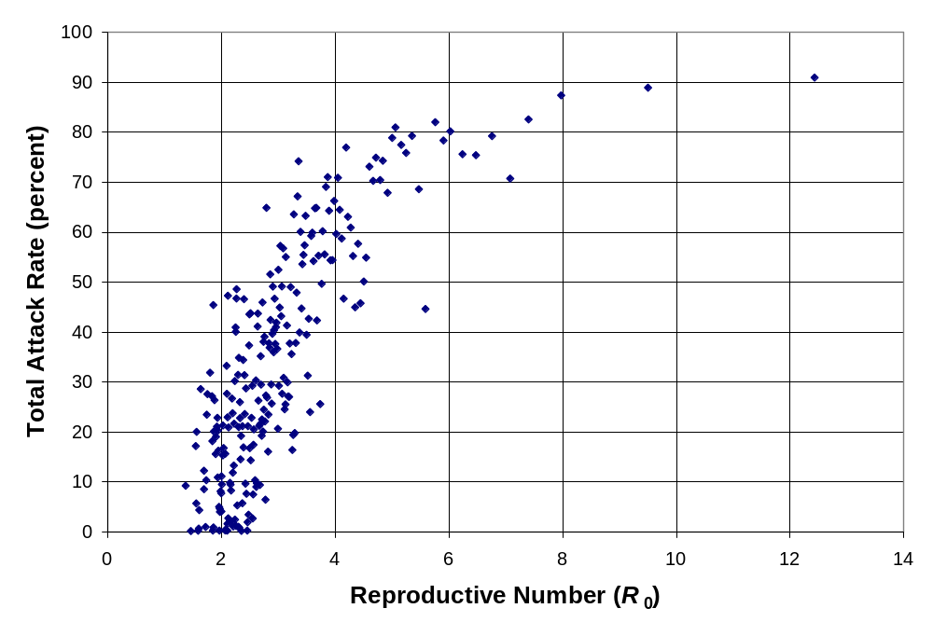
The sensitivity analysis covers a broad range of stockpile sizes and of doses distributed for vaccines and antivirals. In this section, the feasibility of attaining the assumed ranges for vaccines and antivirals is assessed by considering federal investments in pandemic readiness and recent developments in vaccine and antiviral medicines and production methods.
The full range of stockpile size and distribution for vaccines, assumed in the sensitivity analysis, is feasible, though near the feasible limit. This conclusion is subject to attaining the milestones in the federal program. The conclusion for antivirals is similar, though less dependent on dramatic developments and, again, subject to the timing of a pandemic occurrence.

Vaccines
Each scenario includes distribution of a specific number of vaccine doses. The cost can be calculated based on unit cost for production of the pharmaceutical plus distribution cost. While cost may be a factor in feasibility, this is primarily a budget issue. The focus of this study is the practical limits to production and production capacity expansion. Vaccine production is already a high-volume industry. The world’s largest manufacturer of vaccines, Sanofi Pasteur, has a worldwide annual production of nearly 1 billion doses of vaccines, covering 20 diseases. In 2006, global production capacity for seasonal influenza vaccine was about 350 million doses per year. Recognizing this, it seems feasible to develop a production capacity of up to 430 million doses for a pandemic virus strain. This is especially true because some seasonal flu vaccine production capacity might be reallocated to production of pandemic influenza vaccine. However, the reality is more complicated and introduces considerable risk; therefore, the capacity needed for the U.S. program may not be realized.
A key difficulty in expecting to rely on this international production capacity is that worldwide demand will exceed 6 billion courses. Countries with production capacity are likely to commit to their own needs first. Thus, the U.S. cannot rely on purchasing pandemic vaccines from foreign sources and sufficient domestic capacity must be built. Currently, only one vaccine production facility operates in the U.S., the Swiftwater, Pennsylvania, plant of Sanofi Pasteur. A planned doubling of capacity at that plant will result in a capacity of 60 million doses of trivalent seasonal influenza vaccine (treats 3 separate strains). This suggests a current capacity of 30 million doses of trivalent vaccine. The Center for Infectious Disease Research and Policy (CIDRAP) reported that the estimated U.S. capacity for influenza vaccine production was 50 million trivalent doses in 2004. As of this writing, a call to Sanofi Pasteur to resolve this discrepancy has not yet been returned. The Center for Biosecurity of the University of Pittsburgh also reports a U.S. domestic production capacity of 50 to 60 million doses.
Japsen has reported that if the expanded capacity of 60 million doses was used to produce a dedicated monovalent pandemic influenza strain, it could produce 180 million doses (90 million courses) of a monovalent pandemic flu vaccine. This estimate overlooks important health policy and technical issues. From a health policy perspective, the need for seasonal flu vaccine makes complete diversion of the production capacity to pandemic flu vaccine very unlikely. Technically, differences in production process, yield, and dosage make this simple calculation significantly in error. The same error has been made by others in the conversion of trivalent seasonal flu vaccine capacity to monovalent pandemic flu vaccine capacity. Dr. Margaret Chan, Director-General of the WHO, stated “For a trivalent pandemic vaccine, annual manufacturing capacity is about 500 million doses. For a monovalent vaccine, this figure increases to 1.5 billion doses.”
More specifically, the antigen yield in egg cultures for the H5N1 virus is very low and, at the same time, it appears that higher antigen content is required for the pandemic vaccine than for the typical seasonal flu vaccine. In addition, a 2-dose regimen is likely to be required for successful immunization. To date, yields in egg cultures have generally been about one-quarter to one-third of the yield obtained with seasonal influenza strains with the best result of about one-half. The correct multiplier for conversion of trivalent seasonal flu vaccine capacity to monovalent pandemic flu vaccine capacity is shown in Table 4-3. The relative yield is the ratio of antigen yield for the pandemic vaccine to the antigen yield for the seasonal vaccine. Trivalent seasonal vaccine doses currently contain 3 15-microgram (μg) doses of antigen, or 45 μg of antigen. Note that for a
2-dose regimen, these factors should be further divided by 2, as shown in the subsequent table.
Table 4-3 shows multipliers for conversion from seasonal to pandemic vaccine capacity assuming a single dose regimen.
Table 4-3: Conversion factors from trivalent seasonal flu vaccine to monovalent
pandemic flu vaccine capacity
Relative Yield | Antigen Dose (micrograms)
Relative Yield | 15 | 30 | 45 | 60 | 90
1.00 | 3.0000 | 1.5000 | 1.0000 | 0.7500 | 0.5000
0.75 | 2.2500 | 1.1250 | 0.7500 | 0.5625 | 0.3750
0.50 | 1.5000 | 0.7500 | 0.5000 | 0.3750 | 0.2500
0.33 | 1.0000 | 0.5000 | 0.3333 | 0.2500 | 0.1667
0.25 | 0.7500 | 0.3750 | 0.2500 | 0.1875 | 0.1250
Source: Argonne National Laboratory
Table 4-4 shows multipliers for conversion from seasonal to pandemic vaccine capacity assuming a 2-dose regimen.
Table 4-4: Conversion factors from seasonal to pandemic vaccine,
assuming a 2-dose regimen
Relative Yield | Antigen Dose, micrograms
Relative Yield | 15 | 30 | 45 | 60 | 90
1.00 | 1.5000 | 0.7500 | 0.5000 | 0.3750 | 0.2500
0.75 | 1.1250 | 0.5625 | 0.3750 | 0.2813 | 0.1875
0.50 | 0.7500 | 0.3750 | 0.2500 | 0.1875 | 0.1250
0.33 | 0.5000 | 0.2500 | 0.1667 | 0.1250 | 0.0833
0.25 | 0.3750 | 0.1875 | 0.1250 | 0.0938 | 0.0625
Source: Argonne National Laboratory
On 17 April 2007, the FDA approved a Sanofi Pasteur H5N1 vaccine, the first such vaccine to attain that approval. The manufacturer had already contracted with HHS to manufacture and stockpile this vaccine. To achieve the demonstrated effectiveness, it was necessary to provide 2 doses of 90-μg hemagglutinin (H) antigen. The doses were given 28 days apart. Given that Sanofi Pasteur has reported an H yield of about 50 percent of that achieved for seasonal vaccines, the correct multiplier for conversion from seasonal influenza vaccine capacity to pandemic vaccine capacity is 0.125. Thus, if the current U.S. capacity of 60 million trivalent doses was converted to production of monovalent pandemic vaccine, the capacity would be 7.5 million courses. If the same technology was used to provide a 300-million-course pandemic influenza vaccine in a 12-month production run, the required capacity would be 2.4 billion doses per year.
In response to the shortfall in domestic supply, the federal government is supporting a series of efforts to expand production capacity and improve vaccine performance. These include sponsoring the Swiftwater plant expansion, refurbishing former vaccine manufacturing capacity, enhancing egg production systems, and developing advanced manufacturing techniques for vaccines. This federal plan is the key to feasibly providing vaccine at the rates assumed in the mitigation scenarios. Without federal funding, the required expansion in production capacity would not take place and necessary technical improvements would be delayed or not achieved at all. The capacity goals for the federal program are listed in Table 4-5.
Table 4-5: The Health and Human Services pandemic
medical countermeasure goals for vaccines
Vaccine Goal #1 | To establish and maintain a dynamic pre-pandemic influenza vaccine stockpile for 20 million persons (at 2 doses per person) based on the H5N1 virus
Vaccine Goal #2 | To provide pandemic vaccine to all U.S. citizens within 6 months of a pandemic declaration (600 million doses of pandemic vaccine)
If Vaccine Goal #1 is achieved with the current vaccine technology, the equivalent seasonal vaccine capacity required would be 20 million/0.125 = 160 million doses per year based on the multiplier analysis. This is 3 times the current U.S. capacity and it must be available over and above the existing capacity for seasonal vaccine. The sensitivity studies include cases with stockpiles ranging up to 120 million doses, or 60 million courses; that is, 3 times the federal stockpile goal. The feasibility of a stockpile exceeding the federal goal is very low, at least in the near term. The federal goal is to stockpile 20 million courses (40 million doses) of pre-pandemic vaccine by 2009. This seems feasible because 14 million doses had been accumulated by January 2007. In summary, the feasible stockpile level currently is the existing 14 million doses, and the feasible stockpile level by 2009 is the federal goal of 40 million doses.
A higher level of pre-pandemic stockpile implies a change in the federal goals and will only be achieved at a later date using new technologies, some of which are currently under development. In the near term, antigen-sparing techniques could be employed to reduce the amount of antigen required per dose. There are both technical and strategic means of antigen sparing under investigation. The technical means involve the use of an adjuvant, which increases the level of immune response for a given amount of antigen. The strategic approach involves priming the population by giving doses of pre-pandemic vaccine as it becomes available. There is some evidence that a primed population has a stronger immune response to new, related influenza strains. Such a primed population may only need a single dose from the pre-pandemic vaccine stockpile when it is released at the onset of a pandemic. While this does not increase the size of the stockpile, it may double the size of the population that the stockpile can serve.
The use of an adjuvant can actually increase the number of doses in the stockpile because the adjuvant reduces the amount of antigen required to produce an immune response. Alum is used as an adjuvant in many vaccines. In a trial with 51 volunteers, the addition of alum to a Sanofi Pasteur H5N1 vaccine allowed a reduction of antigen from 90 μg to 30 μg with a somewhat improved immune response; 2 doses were still required. Because antigen production is the limiting step in vaccine production, this approach would triple the number of doses that could be stockpiled from a given production capacity. Because the federal plan is to provide a stockpile of 20 million courses (40 million doses), based on current technology, the use of an adjuvant could extend the stockpile to 120 million doses. Other trials have demonstrated a strong immune response with antigen levels as low as 3.8 μg. GlaxoSmithKline has achieved a 10-fold reduction in antigen requirements using a proprietary adjuvant. While these results are from clinical trials, there is consistency in results from several manufacturers. Using the adjuvant technology, it is feasible that the intended federal investment for a 40-million-dose stockpile could result in sufficient production capacity to produce a 120-million-dose or greater stockpile of pre-pandemic vaccine. Thus, the full range of stockpile sizes assumed in the sensitivity studies is deemed feasible. However, a change in the federal strategy that extends pre-pandemic vaccine production to a broader population will be required. Also, additional investment in the formulating, filling, and packaging of vaccines will be required to increase capacity even if the adjuvant extends the effective capacity of antigen production. Testing for optimal levels, type, and safety of adjuvant may add some time to the creation of this larger stockpile, perhaps moving the federal timetable from 2009 to 2010.
Because the creation of a pre-pandemic stockpile is a near-term goal, vaccine production for the stockpile has emphasized the current commercial egg-based antigen production technology. Antigen production in cell cultures has been used for other vaccine and pharmaceutical manufacturing, but has not been commercially established for flu vaccine. Cell culture production is faster and more flexible than egg-based production. Furthermore, it does not require the planned availability of millions of specially prepared eggs. However, historically, the yield of human influenza virus on tissue cultures has been far lower than that in chicken embryos. Solving this problem was already identified in 1994 as a key to pandemic readiness. At that time in a short article in the European Journal of Epidemiology, Youri Ghendon of the World Health Organization (WHO) called for the identification of an “egg-independent” production technology. Ghendon suggested that production on tissue culture could solve the problems associated with a large increase in vaccine production. Between fiscal years 1998 and 2005, the U.S. National Institute of Infectious Diseases provided $35 million in support of cell culture technology. In 2005, Sanofi Pasteur was awarded a $97-million,
5-year contract with HHS to develop cell-based technology for production of an influenza vaccine with the intention of obtaining FDA approval. By September 2006, Sanofi Pasteur had completed a clinical trial of such a vaccine and demonstrated production-scale potential in a 20,000-liter bioreactor. Chiron and Novartis have also completed successful clinical trials of cell-based flu vaccines.
On 26 April 2007, the European Union (EU) Committee for Medicinal Products for Human Use (CHMP) recommended that the cell-cultured Novartis vaccine, Optaflu, a seasonal flu vaccine, be authorized by the European commission. A decision normally follows within 3 months and usually honors the CHMP recommendation. The Influvac cell-based flu vaccine from Solvay Pharmaceuticals was approved for sale in The Netherlands by the EU in 2001. However, the company has not yet introduced it to the market. Novartis expects to apply for U.S. licensing of its technology in 2008. Depending on the timing of FDA approval, Novartis could have a cell-based production facility in full production by 2012. In part, this facility would rely on an HHS grant of $220 million, which was committed in May 2006. Considering this status, it seems that the long-held goal of producing a cell-cultured vaccine for seasonal influenza is within reach. These developments will not have an immediate impact on Vaccine Goal #1, the 20-million-course stockpile of pre-pandemic vaccine. However, in the years following 2012, they may be the technology of choice for maintaining that stockpile.
Vaccine Goal #2 is to provide pandemic vaccine to all U.S. citizens within 6 months of a pandemic declaration. Nominally, this federal goal is equivalent to 300 million courses (600 million doses). Because this is the pandemic vaccine, it will not be immediately available upon declaration of a pandemic. In fact, using current (egg-based) production methods, 5 to 8 months is required for full-scale production once a virus strain has been identified. This alone, seems to make the federal goal infeasible in the near term. The simulations performed for this analysis allow for such a delay, supplying vaccine on a more realistic timetable. The federal plan is to develop cell-based culture technology, which can produce commercial quantities of vaccine within 3 months of the virus identification. Specifically, the federal plan is to rely on egg-based production for 60 million courses and on cell-based production for 240 million courses. However, it is unknown whether the cell-based technology can be successfully scaled up and applied to a pandemic flu vaccine. Current projections are that it should be demonstrated on a commercial scale by 2009 and that the desired capacity will be on line between 2011 and 2013. If this technology does not work or if the pandemic occurs before adequate cell-based production capacity is in place, only the egg-based capacity can be used. As demonstrated above, an extraordinary base capacity of 240 million doses of seasonal vaccine must be on hand to produce 60 million courses of the current H5N1 vaccine. Without technological advances, meeting the federal goals for egg-based capacity is not feasible. However, the adjuvant technologies and the cell-based technologies are progressing rapidly.
The goal of delivering this vaccine within 6 months of identification of the pandemic is a significant challenge. In the low feasibility case, only egg-based technology is available and it will take 6 months to develop commercial quantities of the vaccine. In the high feasibility case, 20 percent of the vaccine is still egg-based, and 80 percent of the vaccine will not be available until at least the fourth month. This means that distribution of 240 million courses would have to occur in 3 months, which would require an annual capacity of 920 million doses. This is the case because there is no stockpile of pandemic vaccine. Any stockpiled vaccine is a pre-pandemic vaccine that, at best, will be only partially effective. There seems to be a divergence between the policy goal and implementation limits. The simulation scenario assumptions allow for a more realistic timetable for vaccine distribution.
The sensitivity runs include cases with a range of units dispensed (doses given) up to 420 million in an 8-month period. This corresponds to an annual capacity of 630 million units. The federal program goal is to establish a cell-based production capacity of 475 million doses by 2013. This, in conjunction with egg-based capacity and antigen-sparing technology, should make the 420-million-dose scenarios feasible. A study by a University of Michigan team has found that there is sufficient bioreactor capacity in the U.S. now to produce 600 million doses of pandemic flu vaccine in a 4-month period. They recommend a training program for existing bioreactor production teams to ready them for producing the vaccine. The authors believe this is the best strategy to respond to a pandemic within the next 5 years. This analysis suggests that both the federal Vaccine Goal #2 and the sensitivity run range of assumptions are feasible near term. However, the author gives the caveat that a government subsidy would be required to cover training and down-time costs for the existing bioreactor capacity. Furthermore, the profits from flu vaccine are likely to be low relative to those from other products produced by the bioreactor capacity. In addition, FDA approval has not yet been obtained for any cell-based H5N1 vaccine and some allowance must be made for the other pharmaceuticals normally produced in the reactor facilities. This strategy would require a substantial revision of the federal program, which seems unlikely to occur in advance of a pandemic.

Vaccine Costs
Until recent shortages in seasonal flu vaccines, the cost per dose was roughly $1.60. In October 2006, the WHO reported a cost range of $3 to $7 per dose. Current costs in the U.S. are provided in the following CDC table (Table 4-6). These prices include packaging, but none of them include the cost of distribution, which is discussed below.
Table 4-6: Influenza vaccine prices
Vaccine | Brand name/ Trade name | Packaging | CDC  Cost/Dose | Private Sector  Cost/Dose | Contract End Date | Manufacturer
Influenza ^{a,b}  (Age 6 months and older) | Fluzone® | 10-dose vials | $10.153 | $11.198 | 2/28/08 | Sanofi Pasteur
Influenza ^{b}  (Age 6–35 months) | Fluzone®  Pediatric dose Preservative-free | 10-pack -  1-dose syringes | $12.77 | $13.613 | 2/28/08 | Sanofi Pasteur
Influenza ^{b}  (Age 36 months and older) | Fluzone®  No-preservative | 10-pack -  1-dose syringes  10-pack–  1-dose vials | $13.751  $13.751 | $14.663  $14.663 | 2/28/08 | Sanofi Pasteur
Influenza ^{a,b}  (Age 4 years and older) | Fluvirin® | 10-dose vials | $10.16 | $12.48 | 2/28/08 | Chiron

Table 4-6: Influenza vaccine prices (continued)
Vaccine | Brand name/ Trade name | Packaging | CDC  Cost/Dose | Private Sector  Cost/Dose | Contract End Date | Manufacturer
Influenza ^{b}  (Age 18 years and older) | Fluarix™ | 5-pack–  1 dose syringes | $12.00 | $13.25 | 2/28/08 | GlaxoSmithKline
Influenza ^{b}  Live, Intranasal (Age 5–49 years) | FluMist® | 10-pack–  1-dose sprayers | $17.65 | $17.95 | 2/28/08 | MedImmune
Notes:
ªVaccines that contain Thimerosal as a preservative
^{b}Vaccine cost includes $0.75 per dose Federal Excise Tax
CDC = U.S. Centers for Disease Control and Prevention
These current and historical vaccine prices all apply to seasonal influenza. It is naïve to assume that they would apply directly to future costs of pre-pandemic and pandemic vaccines because of differences in production technologies, as described above, and because of the interplay of supply and demand along with government intervention in the market. The price of a vaccine reflects research and development, production, and regulatory compliance. Research and development costs are normally embedded in the intellectual property value, which is protected by patents and trade secrets. Patent protection and limited licensing can certainly result in higher prices. Some vaccine examples show a drop of more than 90 percent in prices following the defeat of a patent through litigation or through new technology. Also, the agreement on Trade-Related Aspects of Intellectual Property Rights (TRIPS) will extend minimum universal intellectual property rights to developing countries. This will strengthen the hand of property rights holders. However, developing countries have a strong interest in maintaining access and low prices. Also, exclusive licenses do not apply to many new vaccines, which rely on technology in the public domain. Furthermore, much of the research on pandemic vaccines is supported by the federal government in the U.S. and other governmental agencies in Europe and in Asia. As a condition of that support, public access to the technology should be assured.
Production, the next element of costs, is likely to decline relative to current vaccine production methods because of the large increase in scale associated with pandemic preparedness and because of the presumed shift to new, more efficient production technologies. The final element of costs, regulatory compliance, principally involves clinical trials as required for government licensing. These costs are likely to increase for pandemic and pre-pandemic vaccines because population characteristics worldwide will have to be taken into account through broader trials. In addition, regulatory authorities in the U.S. and in Europe are likely to require broader Phase III trials and may formalize Phase IV studies of safety after marketing has begun. Clinical trials were expected to account for 45 percent of drug development research and development budgets in 2003.
In conclusion, the broad government support for pandemic and pre-pandemic vaccines is likely to blunt the tendency of intellectual property rights to increase prices. The large scale of this production endeavor may also contribute to favorable economics, though demand will be high. Most of the cost of clinical trials (regulatory compliance) would be borne by the government. We, therefore, assume costs in the range of $3 to$7, as currently reported by the WHO, for seasonal flu vaccine.

Vaccine Distribution Costs
The cost of mass vaccination campaigns is not limited to the price of the medication. Distribution will be equally, if not more, expensive on a per-person-treated basis. Responsibility for mass vaccination preparedness spans the levels of government from the federal to local level. Most counties and large municipalities have begun the process of updating plans based on potential terrorist events and combining them with annual flu clinic plans, to be prepared for a pandemic disease. Required resources include large-scale logistical support in materiel and warehousing, general medical supplies, information technology, and most importantly highly skilled and trained manpower in the form of doctors, nurses, and emergency medical technicians.
The duration of a campaign is the variable that contributes most to mass vaccination campaign costs (Table 4-7). Because the largest cost of distribution is wages, the time employees will be on the books and how that time is managed to deal with overtime is the single greatest factor in calculating potential cost. The figures below are derived from internal planning documents from the Chicago Metropolitan Area. Key assumptions are
- The majority of paid personnel are hourly, and a portion of the hours worked at mass clinics will be overtime
- Mass clinics will be conducted in public school buildings with costs based on the most recent energy and maintenance cost (2005)
- Transport of vaccine from a central point to the state based on overnight shipping costs for palletized freight, intrastate transit based on mileage driven per vehicle used
- Well-run clinics are capable of completing a mass vaccination campaign in between 2 and 3 days (this represents 40 vaccinations per hour per vaccinator)
- If clinic throughput is significantly less than what is required to meet a 3-day goal, the per-dose costs would increase.
Table 4-7: Vaccination campaign costs
Cost Factor |  | Population Size | Cost per Vaccine | Total per Cost Factor
Campaign Cost
Personnel cost |  | 2,800,000 | $8.02 | $22,460,461.35
Building cost |  | 2,800,000 | $0.13 | $366,092.77
Transportation |  | 2,800,000 | $0.01 | $34,601.73
Total campaign cost |  | 2,800,000 | $8.16 | $22,861,155.84
Preparation Cost
Consumable supplies |  | 2,800,000 | $0.01 | $26,023.77
Capital supplies/investment |  | 2,800,000 | $0.07 | $187,443.18
Contractual |  | 2,800,000 | $0.04 | $110,910.00
Total preparation cost |  | 2,800,000 | $0.12 | $324,376.95
Total cost |  | 2,800,000 | $8.28 | $23,185,532.79
Note: Costs are based on a single dose vaccination. Should a booster be needed, the total cost of the campaign would double.

Antivirals
The sensitivity analysis evaluates cases with a very broad range of assumptions for the production and distribution of antivirals. For some cases, the annual production implied by the rate of distribution for an 8-month campaign exceeds 1.7 billion courses. These cases also incorporate a range of antiviral stockpile sizes, though that range is more narrowly prescribed and remains within the limits of current U.S. pandemic flu plans; that is, up to 81 million courses. As in the case of vaccines, the feasibility of attaining the stockpile sizes and production rates assumed in the simulation is closely tied to the federal program goals. The antiviral goals for that program are
- To provide influenza antiviral drug stockpiles for pandemic treatment of 25 percent of the U.S. population; that is, 75 million treatment courses
- To provide influenza antiviral drug stockpiles for strategic limited containment at the onset of a pandemic
By FY 2008 (October 2007), a 20-million-course stockpile should be in place for the protection of healthcare workers and first responders, and a 24-million-course stockpile should be in place for treatment of pandemic flu. Also in 2008, a 6-million-course stockpile will be established for containment of 1 or 2 local outbreaks. This is a total of 50 million courses. The federal plan provides for a 24-percent subsidy of state stockpiles, totaling 31 million courses. These stockpiles also are to be completed in 2008. As of January 2007, 43 states had committed to a total purchase of 30.6 million courses, with 11 million already on order. On the basis of these considerations, it certainly seems feasible to achieve the stockpile assumptions implicit in the sensitivity runs, though not before 2008.
The conclusion on stockpile feasibility is bolstered by the fact that Roche has increased its global production capacity to 400 million courses with the recent addition of an 80-million-course production capability in the U.S., which was expected to be fully operational by the end of 2006. The current 400-million-course capacity represents a 10-fold increase over the 2004 capacity. The federal plan for antivirals does not include a specific goal for domestic production capacity. The newly established capacity of 80 million courses is more than sufficient to maintain the 81-million-course stockpile, because the antivirals in the stockpile have a 5-year shelf-life. That is, only 20 percent or 16 million courses will expire per year.
The feasibility of a production capacity of over 1.7 billion courses seems extremely unlikely, given a current domestic capacity of only 80 million. Given that Roche has increased capacity 10-fold since 2004 to the current total of 400 million courses, it may be feasible to increase global capacity to 1.7 billion courses over perhaps a decade. However, in the absence of specific international government plans for a major capacity expansion, this is unlikely. An alternative is to provide a larger stockpile. The sensitivity runs examine the implications of courses given over about an 8-month campaign. The necessary courses can be obtained from a stockpile and from current production rather than just from current production. The relative contribution from current production declines as time permits the building of a larger stockpile. If accumulation of the larger stockpile begins after completion of the mandated 81-million-course stockpile and continues for 5 years, this larger stockpile will be created during the years from 2009 through 2013. The maximum distribution for an 8-month campaign is about 1.2 billion courses. For distribution in the fifth year of production, 80 percent would be derived from the stockpile and 20 percent from current production. This would require an average production capacity of about 240 million courses per year. This is less than the current global capacity, 90 percent of which was developed from 2004 through 2006. On this basis, it is surely feasible to develop domestic capacity sufficient to stockpile antivirals for even the broadest distribution anticipated in the sensitivity cases. However, this strategy would require federal support and a change in the pandemic planning goals.

Antiviral Costs
The HHS has secured contract prices through the end of 2007 of $19.32 for Tamiflu and $21.72 for Relenza. Future prices are a matter of speculation, because they will reflect both economies of scale associated with rapidly increasing production and increases in demand as developed and developing countries try to stockpile antivirals in anticipation of a pandemic. Competition may also challenge current prices if Peramivir, a new antiviral that is just entering clinical trials, is successful. Given these uncertainties, it is assumed that the current contract prices are representative of future antiviral prices.

Antiviral Distribution Costs
The process for distributing antivirals through mass dispensing centers is not dissimilar to mass vaccinations. Due to there being less labor involved in handing out orally consumed medication and the practice completed in terrorism response exercises, the goal for completion of an oral antiviral campaign is cut to 2 days (Table 4-8).
Table 4-8: Antiviral drug distribution campaign costs
Cost Factor | Population Size | Cost per Antiviral | Total per Cost Factor
Campaign Cost
Personnel cost | 2,800,000 | $3.95 | $11,047,538.28
Building cost | 2,800,000 | $0.06 | $179,444.40
Transportation | 2,800,000 | $0.01 | $34,601.73
Total campaign cost | 2,800,000 | $4.02 | $11,261,584.41
Preparation Cost
Consumable supplies | 2,800,000 | $0.01 | $26,023.77
Capital supplies/investment | 2,800,000 | $0.07 | $187,443.18
Contractual | 2,800,000 | $0.04 | $110,910.00
Total preparation cost | 2,800,000 | $0.12 | $324,376.95
Total cost | 2,800,000 | $4.14 | $11,585,961.36

Decision Model

Methodology
The decision problem involves choosing, under conditions of great uncertainty and risk, the preferred intervention strategy to protect human health and the economy against the possibility of an influenza pandemic with an optimum expenditure of public funds. In making choices between alternative intervention strategies, decision makers are concerned with minimizing the combined impact on human fatalities, illnesses, and costs to the economy, including the cost of the intervention strategy. An important benefit of the decision model is the understanding of which intervention strategy, including no intervention, is the preferred alternative to pursue, given information and judgment about the likelihood of an influenza pandemic and the values placed on statistical fatalities and illnesses relative to national economic impacts. Because there is large uncertainty in the possible conditions that may characterize an influenza pandemic and the mitigation of available intervention strategies, it is also important to understand that a lesser preferred alternative might actually result in lower impacts than a more preferred alternative if a pandemic occurs. This is a result of uncertainty in the possible outcomes of an event and, if the uncertainty is judged to be too great, might suggest that further research or analysis be undertaken to reduce that uncertainty.
Table 4-9 shows the value structure, or indifference equivalencies, between the decision metrics. It is common to express these tradeoffs in terms of an economic measure. That is, for this analysis, an increase in economic costs of $5 million has the same influence on the preference calculation as 1 additional influenza-related fatality. One additional case of illness due to pandemic influenza has the same influence as (is equivalent to) an increase of $10,000 in economic costs or an additional $10,000 to adopt and implement an intervention strategy. The indifference equivalency ascribed to influenza-related fatalities, $5 million, is consistent with the value of human life used in a majority of historical federal policy studies concerning safety measures, environmental health impacts, and medical interventions, which generally adopt values ranging from $5 to $6.5 million. Because value of fatalities tends to dominate the choice of intervention strategy in the decision model, choosing a value of life over a wide range around $5 million; that is, $2 to $10 million, has no effect on the order in which the strategies would be preferred.
Table 4-9: Value tradeoffs (indifference equivalencies) among decision metrics
Decision Metric | Standard Units | Equivalent Economic Cost
Cost of intervention | $1 M | $1 M
Economic costs (lost GDP) | $1 M | $1 M
Statistical fatalities | 1 influenza-related death | $5 M
Non-fatal illnesses | 1 influenza illness | $0.01 M
Notes: GDP = gross domestic product; M = million
The model derived the value ascribed to an influenza illness from the fatality value assuming the average fatality shortened life by 35 to 40 years and the average length of an influenza illness from infection to full recovery ranged from 25 to 30 days. The indifference equivalency reflects the ratio of days lost to illness to those lost as a result of influenza-related death.
In addition to the value tradeoffs between the metrics, attitude toward risk can be an important consideration that can influence the choice of a preferred intervention strategy. For situations that involve making choices between alternatives that present only undesirable outcomes under conditions of uncertainty, risk attitude describes the propensity to tolerate or avoid the chance of incurring outcomes that are worse than the expected value of all of the uncertain outcomes. A decision maker’s risk attitude is measured by having him or her consider propositions having uncertain outcomes and specifying a “certain equivalent” for a proposition that is as desirable as the uncertain proposition.
For example, consider a decision maker who is faced with a proposition that is equally likely to result in a $200 million cost or a $100 million cost. The expected cost of the proposition is $150 million, but the outcome is uncertain: it could be either $100 million or $200 million. A decision maker who is willing to accept a certain cost that is greater than the expected outcome to avoid the proposition is said to be “risk averse.” That is, a risk-averse decision maker would seek to avoid the chance of incurring the $200 million cost outcome by accepting for certain the expected value and a “premium” over the expected value of the outcomes. The maximum amount of “premium” the decision maker is willing to accept to avoid the uncertainty is a measure of the degree of risk aversion.
Alternatively, a decision maker who is willing to accept a maximum certain cost that is equal to the expected cost is said to be “risk neutral.” In this summary, the results relate only to the risk-neutral attitude. The influence of different risk attitudes, from highly risk tolerant to highly risk averse, was explored in this study and found not to change the order of preference for the alternative intervention strategies. Attitude toward risk does have an influence on the relative preference value over the range of likelihood of the pandemic occurring, but the nature of uncertainty in the scenarios and other characteristics of the scenarios are such that the order of preference remains unchanged.

Aid to Decision Making
The model used to compute the relative preference of alternative intervention strategies is based on multi-attribute decision theory and was developed specifically as an aid to making decisions under conditions of uncertainty and risk. CIPDSS applied this model to help decision makers integrate the large amount of quantitative information and insights generated by the consequence simulations into a single measure of relative merit that informs the decision maker’s comparison of available alternative intervention strategies. The relative preference model is combined with an analysis model that calculates the level of confidence in choosing any one intervention strategy over another and quantifies maximum and expected levels of satisfaction and regret, assuming the pandemic occurs.
The decision model features the following primary benefits:
- Adaptability to the value structure of the decision maker, or decision-making organization, through the value tradeoffs or indifference equivalencies ascribed to the decision metrics (Table 4-9 lists the value tradeoffs used in this study.)
- Explicit accounting for and addressing the decision maker’s or the decision-making organization’s attitude toward risk by scaling the contribution of each consequence drawn from uncertainty distributions resulting from OA-based LHS simulation results in accordance with the decision maker’s propensity for tolerating or avoiding risk
- The relative preference of the alternative intervention strategies is based on an expected value that accounts for the cost of the strategy in lieu of the occurrence of a pandemic, the cost and mitigation value of the intervention strategies in the event that the pandemic does occur, and the likelihood of a pandemic occurring sometime in a definable future. For this analysis, CIPDSS set the time horizon to 5 years. The model plots relative preferences for the alternative intervention strategies as a function of the likelihood of a pandemic occurring anytime during this period.
- Measures of confidence in selecting one intervention strategy over another and measures of expected satisfaction and regret can be computed for sets of alternative intervention strategies. These measures help to better understand and visualize the value of choosing one strategy over another and provide an additional dimension that is important to some decision makers, but that is not otherwise apparent in the utility theory model.
The choice of a 5-year horizon was somewhat arbitrary, but it only influences the costs of stockpiling vaccines and antiviral medications because of the limited shelf life of these items. The choice of a longer time horizon would affect the analysis by marginally increasing the cost of intervention strategies involving vaccine and/or antiviral stockpiles by the additional stock replacement costs associated with the longer time horizon. Because these costs are generally very small compared to the consequence of a pandemic, the conclusions of the analysis do not change if a longer time horizon is considered.

Decision Model Results

Relative Preference of Alternative Intervention Strategies
The team determined the relative preference of each intervention strategy from the uncertainty analysis runs, and the results of those calculations are displayed in Table 4-10 for 2 endpoints. The first endpoint assumes that all stockpiling of partially effective vaccines and/or antivirals is completed, but that a pandemic has not occurred. All intervention strategies have their highest relative preference value at this endpoint because only the costs of stockpiles and other preparatory costs are included. The relative preference values between the intervention strategies at this endpoint reflect only the difference in stockpile and other preparation costs, with the higher cost strategies producing lower preference values.
Table 4-10: Relative preference and equivalent measures for pandemic
influenza intervention strategies
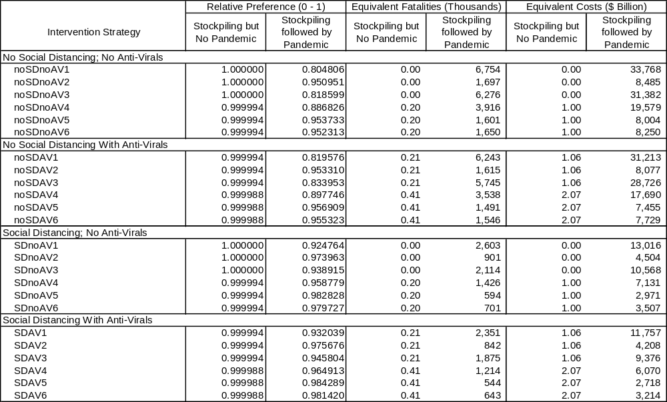
Notes: AV = antiviral; SD = social distancing
The second endpoint is under the condition that a pandemic has occurred following expenditure of all preparation and stockpiling costs. Intervention strategies will have their lowest relative preference values at this endpoint because the relative preference is based on the full set of consequences resulting from the pandemic: illnesses, fatalities, economic losses, and implementation costs associated with the intervention strategy, in addition to the preparation costs. The relative preference values between the intervention strategies at this endpoint reflect all the consequences associated with a pandemic. Again, higher overall consequence strategies produce lower preference values.
By using the indifference equivalencies from Table 4-9, analysts can convert the relative preference values in Table 4-10 to equivalent physical measures such as the equivalent costs and equivalent fatalities as are presented in Table 4-10. It is often easier for decision makers to think about the difference between alternative intervention strategies in terms of these more familiar units than a dimensionless relative preference value, which is arbitrarily set to a 0 to 1 scale. Therefore, CIPDSS uses equivalent fatalities in the remainder of this section to discuss the relative preference of the intervention strategies.
Figure 4-18 shows the relative preference of all intervention strategies without social distancing compared to the baseline, or no intervention, scenario. The solid lines represent those intervention scenarios that also exclude the use of antivirals, and the dashed lines represent the corresponding vaccination strategies with the use of antivirals. Two measures of preference are used on the y-axis. The left y-axis indicates relative preference in a dimensionless “utility” value over the range of 1 to 0, where the best value (1) corresponds to no impacts and the worst value (0) corresponds to a state that would have a total equivalent cost of $173 trillion, which is only slightly larger than the worst simulation run. The right y-axis shows the equivalent scale in millions of expected fatalities, where the best value (0) corresponds to no fatalities and the worst value corresponds to a state that would have a total of 34.6 million equivalent fatalities.
Relative Preference of Pandemic Influenza Intervention Strategies
No Social Distancing
0.80
0.81
0.83
0.84
0.85
0.86
0.87
0.88
0.89
0.90
0.91
0.92
0.93
0.94
0.95
0.96
0.97
0.98
0.99
1.00
0%
10%
20%
30%
40%
50%
60%
70%
80%
90%
100%
Likelihood of Influenza Pandemic within 5 Years
Relative Preference
0.00
0.35
0.69
1.04
1.38
1.73
2.08
2.42
2.77
3.11
3.46
3.81
4.15
4.50
4.84
5.19
5.54
5.88
6.23
6.57
6.92
Equivalent Expected
Fatalities (Millions)
noSDnoAV1
noSDnoAV2
noSDnoAV3
noSDnoAV4
noSDnoAV5
noSDnoAV6
noSDAV1
noSDAV2
noSDAV3
noSDAV4
noSDAV5
noSDAV6
Scenario Settings:
noSDnoAV No Social Distancing, No Antivirals
noSDAV No Social Distancing, Antivirals
SDnoAV Social Distancing, No Antivirals
SDAV Social Distancing and Antivirals
Vaccination Strategies:
1 No vaccination or contact tracing
2 Contact tracing without vaccination
3 Mass vaccination only with strain-specific vaccine
4 Mass vaccination with early vaccine
5 Targeted followed by mass vaccination with early vaccine
6 Targeted vaccination with early vaccine
Figure 4-18: Relative preference of intervention strategies over the likelihood of a pandemic (risk-neutral profile [excludes social distancing scenarios])
The relative preference for all of the intervention strategies is a function of the likelihood that a pandemic will occur within 5 years. If there were a zero probability of a pandemic occurring, then the only cost would be the preparation costs associated with stockpiling vaccines and antivirals (that would never be used). If a pandemic were to occur, then the costs would also include the value of illnesses and lost lives, pandemic-related medical costs, economic value lost due to worker absenteeism, and additional intervention measure implementation costs. This state is represented by the 100-percent likelihood on the x-axis. In the region between no pandemic (0 percent) and a pandemic (100 percent), the measure of relative preference includes an increasing fraction of costs associated with a pandemic (including the preparation and stockpiling costs) and a decreasing fraction of the costs associated with only preparation and stockpiling.
The 5-year period is defined by the period over which costs were calculated for stockpiling vaccines and antivirals. That is, the intervention strategy costs include 5 years worth of stockpile maintenance and replacement of expired doses. Because these costs are very small compared to economic losses and equivalent costs of illnesses and fatalities, the results shown in Figure 4-18 are also indicative of much longer time horizons.
Of the intervention strategies shown, the least preferred would be the no intervention case (noSDnoAV1) because it has the lowest relative preference (and highest equivalent fatality) measure over the likelihood range. All of the other strategies would be preferred over the no intervention strategy (noSDnoAV1) by the difference displayed between that strategy and the no intervention strategy at a given likelihood. Likewise, any strategy with a higher utility (or lower equivalent fatality) value would be preferred over another strategy with a lower utility (or higher equivalent fatality) value by the vertical difference between them, which represents the expected benefit of choosing the more preferred over the less preferred strategy.
For example, with no use of antivirals, if a pandemic strikes (100 percent on the x-axis), the expected benefit of choosing a mass vaccination strategy with a partially effective vaccine (noSDnoAV4) compared to a no intervention strategy (noSDnoAV1) is a reduction in total impacts (costs, illnesses, and deaths) that is equivalent to only about 2.8 million fatalities (6.7–3.9 million) out of an impact-equivalent 6.7 million fatalities. When antivirals are used in addition to mass vaccination with a partially effective vaccine [noSDAV4], the expected benefit is equivalent to nearly 3.2 million fatalities (6.7–3.5 million) or avoiding additional health and economic impacts that are equivalent to another 400,000 lives.
Figure 4-19 shows the relative preference for the intervention strategies that include social distancing both with and without the use of antivirals. These are displayed on the same axis scales as Figure 4-18 for ease of comparison. In general, the social distancing assumptions made in these runs show significant improvement in reducing the impacts associated with an influenza pandemic. Overall, as a group, these strategies show a 50- to 70-percent reduction in the impacts of a pandemic. Unfortunately, it was not possible to model individual social distancing policies as part of this uncertainty analysis, so little additional commentary can be made with respect to the effectiveness of specific social distancing policies. It is clear, however, that social distancing, particularly in the early stages of a pandemic, can have a significant impact on disease progression if it is practiced extensively and effectively.
Relative Preference of Pandemic Influenza Intervention Measures
Social Distancing Scenarios
0.80
0.81
0.82
0.83
0.84
0.85
0.86
0.87
0.88
0.89
0.90
0.91
0.92
0.93
0.94
0.95
0.96
0.97
0.98
0.99
1.00
0%
10%
20%
30%
40%
50%
60%
70%
80%
90%
100%
Likelihood of Influenza Pandemic within 5 Years
0.00
0.35
0.69
1.04
1.38
1.73
2.08
2.42
2.77
3.11
3.46
3.81
4.15
4.50
4.84
5.19
5.54
5.88
6.23
6.57
6.92
Equivalent Expected
Fatalities (Millions)
SDnoAV1
SDnoAV2
SDnoAV3
SDnoAV4
SDnoAV5
SDnoAV6
SDAV1
SDAV2
SDAV3
SDAV4
SDAV5
SDAV6
Scenario Settings:
noSDnoAV No Social Distancing, No Antivirals
noSDAV No Social Distancing, Antivirals
SDnoAV Social Distancing, No Antivirals
SDAV Social Distancing and Antivirals
Vaccination Strategies:
1 No vaccination or contact tracing
2 Contact tracing without vaccination
3 Mass vaccination only with strain-specific vaccine
4 Mass vaccination with early vaccine
5 Targeted followed by mass vaccination with early vaccine
6 Targeted vaccination with early vaccine
Relative Preference
Figure 4-19: Relative preference of intervention strategies including social distancing over the likelihood of a pandemic, risk-neutral profile
Figure 4-19 indicates a similar preference ordering of the alternative vaccination strategies, with and without the use of antivirals, when social distancing is included as when it was absent from the scenarios, except that strategies 3 and 6 reverse order depending on whether or not antivirals are used (Table 4-11). However, this reversal is not significant because the difference in benefits between these scenarios is very small, only 43,000 and 9,000 equivalent fatalities for no-antivirals and antivirals, respectively.
Table 4-11: Incremental additional equivalent facilities for vaccination
strategies, antiviral and no antiviral
Strategy | Vaccination Strategy Description | Incremental Additional Equivalent Fatalities (thousands)
Strategy | Vaccination Strategy Description | noAV | AV
4 | Mass vaccination with early vaccine | Best | Best
5 | Targeted followed by mass vaccination with early vaccine | 250 | 297
6  3 (AV) | Targeted vaccination with early vaccine  Mass vaccination only with no early vaccine | 394 | 364
3  6 (AV) | Mass vaccination only with no early vaccine  Targeted vaccination with early vaccine | 43 | 9
2 | Contact tracing without vaccination | 135 | 209
1 | No vaccination or contact tracing | 354 | 259
Note: AV = antiviral

Satisfaction and Regret Analysis
Knowledge and insights derived from the consequence simulations combined with the relative preference maps from the decision model are key tools supporting the goal to better understand and structure intervention strategy decisions that affect multiple criteria in different ways. These tools can help decision makers to recognize the uncertainty and risks and help to identify preferred choices in highly uncertain situations based on a defined value structure and attitude toward tolerating or avoiding the risks. However, because of uncertainty, any choice of intervention strategy, even the optimally preferred choice, can have some chance of resulting in greater losses than a less preferred intervention strategy if a pandemic does occur.
The satisfaction and regret analysis performed by the decision model calculates the confidence level with which any intervention strategy can be selected over another, based on the results of the uncertainty analysis simulations. The model also calculates several statistics related to “satisfaction” and “regret” in the event a pandemic occurs. Satisfaction is defined as the occurrence of a less undesirable consequence than what otherwise would have occurred due to the same incident because of the choice of one intervention strategy over another. Conversely, regret is defined as the occurrence of a more undesirable consequence than what otherwise would have occurred due the same incident because of the choice of one intervention strategy over another.
Figure 4-20 depicts satisfaction and regret for selected vaccination strategies, comparing the use of antivirals to the same strategies without antivirals. Table 4-12 lists some important data related to these curves. The standard CIPDSS convention is to describe undesirable consequences, such as costs and deaths, as positive values; thus, the regret region in Figure 4-20 is to the right of zero and the satisfaction region is to the left. That is, negative costs are benefits or gains.
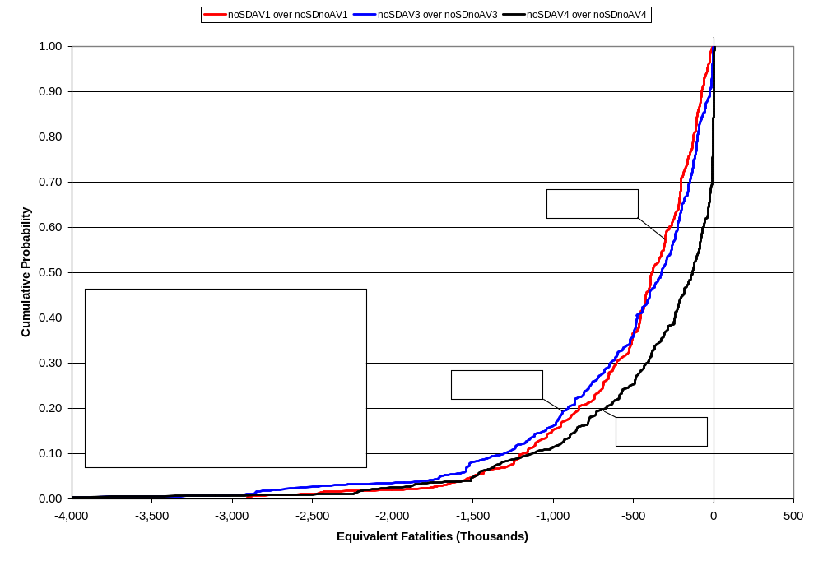

Figure 4-20: Satisfaction/regret analyses for selected pairs of intervention
strategies not involving quarantine
Satisfaction and regret curves are calculated under the assumption that an influenza pandemic does occur and they are useful in answering the following questions:
- If Intervention X is selected over Intervention Y, what level of confidence can the decision maker have that Intervention X will outperform Intervention Y in the event of a pandemic?
- If Intervention X does outperform Intervention Y in the event of a pandemic, how much better off will society be than if Intervention Y were selected? What are the maximum, conditional average, and expected levels of satisfaction?
- If Intervention X does not outperform Intervention Y in the event of a pandemic, how much worse off will society be than if Intervention Y were selected? What are the maximum, conditional average, and expected levels of regret?

Table 4-12: Satisfaction/regret statistics for selected pairs of intervention
strategies not involving quarantine
Satisfaction/Regret | noSDAV1 over  noSDnoAV1 | noSDAV3 over  noSDnoAV3 | noSDAV4 over  noSDnoAV4
Likelihood of satisfaction | 100% | 100% | 84%
Maximum possible satisfaction | 2,905 | 4,133 | 4,161
Average conditional satisfaction | 511 | 541 | 448
Expected satisfaction | 511 | 541 | 378
Likelihood of regret | 0% | 0% | 16%
Maximum possible regret | 0 | 0 | 6
Average conditional regret |  |  | 2
Expected regret |  |  | 0.3
Expected overall payoff | 511 | 541 | 377
Notes: Values expressed in thousands of equivalent fatalities unless otherwise stated
AV = antiviral; SD = social distancing
The analysis of using antivirals in the manner modeled over no intervention; that is, choosing strategy noSDAV1 over noSDnoAV1, indicates that all 243 uncertainty runs of the model resulted in a lower total consequence, measured in equivalent fatalities, or a 100-percent likelihood of being satisfied with this choice if a pandemic occurs. This was also the case when the strategy pairs included mass vaccination when a fully-effective vaccine becomes available; that is, choosing noSDAV3 over noSDnoAV3. This similarity should be expected because, in many model runs, the majority of pandemic impacts occur prior to the availability of a strain-specific vaccine. The same comparison based on a mass vaccination with partially-effective vaccine; that is, choosing noDSAV4 over noSDnoAV4, results in 16 percent of the model runs having worse outcomes if a pandemic occurs. Although, the 16-percent chance may seem great, the maximum possible level of regret is only 5,800 equivalent fatalities (barely detectable on the graph), compared to an 84-percent chance of satisfaction and a maximum satisfaction level of over 4 million lives not lost to influenza.
CIPDSS performed a similar analysis on non-social-distancing scenarios to compare contact tracing and quarantine alone (vaccination strategy 2), with targeted vaccination followed by mass vaccination with an early, pre-pandemic vaccine (vaccination strategy 5), and only targeted vaccination with an early, pre-pandemic vaccine (vaccination strategy 6). Both the targeted strategy and the targeted followed by mass vaccination strategy, strategies 5 and 6, are predicated on contact tracing and quarantine; that is, they are essentially extensions of the contact tracing and quarantine alone strategy (strategy 2). In the targeted scenario and the targeted followed by mass vaccination scenario, contact tracing and quarantine alone accounted for roughly 75 to 80 percent of the reduction in illnesses and fatalities.
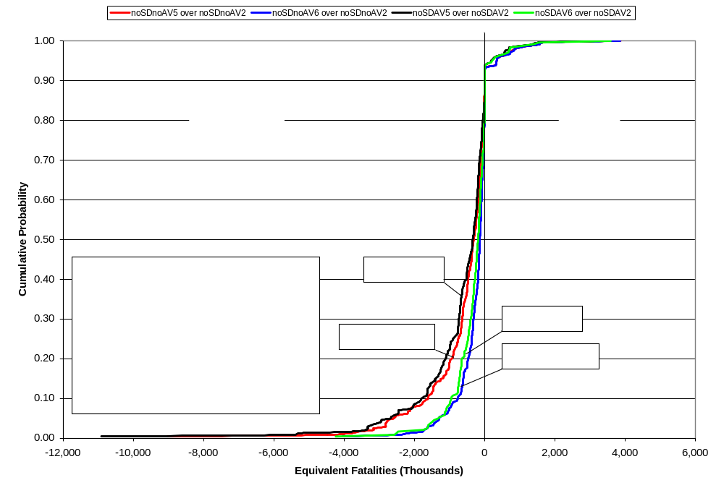
Figure 4-21 displays the results of this satisfaction/regret analysis and Table 4-13 lists the supporting statistics. The results indicate there is a high degree of assurance that combining targeted vaccination or targeted vaccination followed by mass vaccination with a partially effective, pre-pandemic vaccine and with contact tracing and quarantine will result in fewer illnesses and deaths. The results indicate that if these strategies are used over contact tracing and quarantine alone, there is an 85- to 90-percent chance that the combined economic and health impacts will be less by an expected value of 236,000 to 656,000 equivalent fatalities. There is a 10- to 15-percent chance that the result will be otherwise, and that the combined impacts will be greater that they otherwise would have been. If the combined impacts are greater, however, the expected level of regret is only 50,000 to 62,000 equivalent fatalities.
Figure 4-21: Satisfaction/regret analysis for selected pairs of pandemic influenza
intervention strategies involving quarantine and targeted vaccination
Table 4-13: Satisfaction/regret statistics for selected pairs of intervention strategies
involving quarantine and targeted vaccination
Satisfaction/Regret | noSDnoAV5 over  noSDnoAV2 | noSDnoAV6 over  noSDnoAV2 | noSDAV5 over  noSDAV2 | noSDAV6 over  noSDAV2
Likelihood of satisfaction | 88% | 86% | 85% | 90%
Maximum possible satisfaction | 9,026 | 4,039 | 10,909 | 4,237
Average conditional satisfaction | 703 | 348 | 836 | 397
Expected satisfaction | 622 | 298 | 708 | 358
Likelihood of regret | 12% | 14% | 15% | 10%
Maximum possible regret | 3,863 | 3,862 | 3,570 | 3,584
Average conditional regret | 537 | 433 | 327 | 517
Expected regret | 62 | 62 | 50 | 51
Expected overall payoff | 560 | 236 | 659 | 307
Notes: Values expressed in thousands of equivalent fatalities unless otherwise stated
AV = antiviral; SD = social distancing
The analysis has demonstrated that if a partially-effective pre-pandemic vaccine is available, the preferred strategy is mass vaccination over either of the two targeted vaccination strategies modeled, whether or not antivirals are also used. The mass vaccination strategies noSDnoAV4 and noSDAV4 are preferred because the expected, or average, level of illnesses, fatalities, and other consequences, combined, are less than if either of the corresponding targeted vaccination strategies were used. However, in some situations, the targeted vaccination strategies result in lower illnesses, fatalities, and other consequences. Figure 4-22 and Table 4-14 show the results of a satisfaction/regret analysis for the choice of the preferred mass vaccination strategy (vaccination strategy 4) over the less-preferred targeted vaccination strategies (vaccination strategies 5 and 6), with and without the use of antivirals, but with no social distancing.
Figure 4-22: Satisfaction/regret analysis for the choice of mass vaccination over targeted vaccination strategies with partially-effective pre-pandemic vaccine
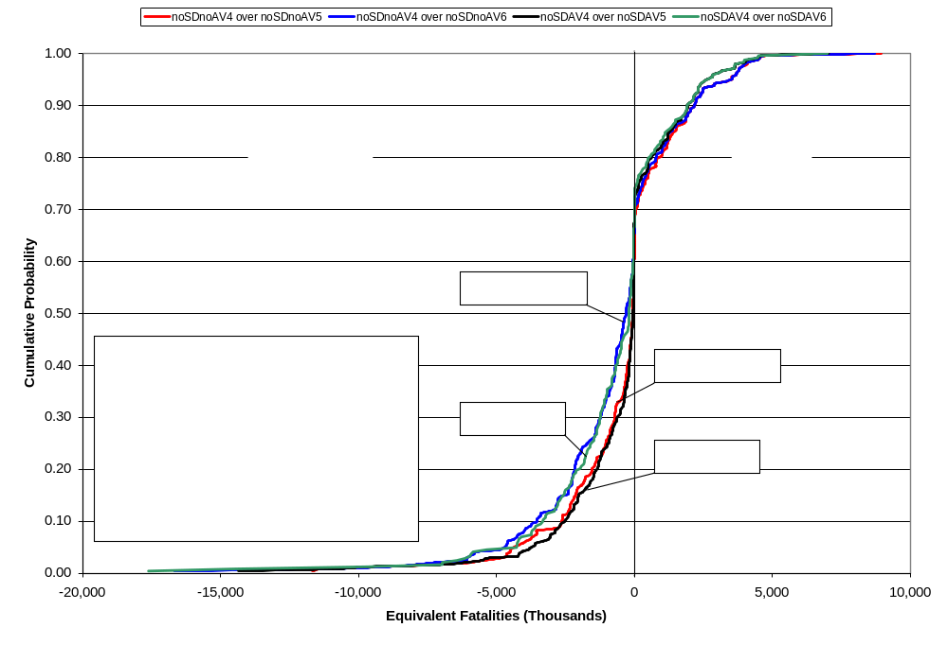

Table 4-14: Satisfaction/regret statistics for the choice of mass vaccination over targeted vaccination strategies with partially-effective pre-pandemic vaccine
Satisfaction/Regret | noSDnoAV5 over  noSDnoAV2 | noSDnoAV6 over  noSDnoAV2 | noSDAV5 over  noSDAV2 | noSDAV6 over  noSDAV2
Likelihood of satisfaction | 68% | 70% | 72% | 74%
Maximum possible satisfaction | 11,687 | 16,674 | 14,352 | 17,612
Average conditional satisfaction | 1,276 | 1,695 | 1,134 | 1,563
Expected satisfaction | 871 | 1,179 | 816 | 1,151
Likelihood of regret | 32% | 30% | 28% | 26%
Maximum possible regret | 8,933 | 8,694 | 7,023 | 6,984
Average conditional regret | 1,722 | 1,736 | 1,662 | 1,702
Expected regret | 546 | 529 | 465 | 448
Expected overall payoff | 326 | 650 | 351 | 703
Note: AV = antiviral; SD = social distancing
Because this analysis is based on the choice of mass vaccination strategy 4 instead of vaccination strategies 5 and 6, the cumulative probability traces to the left of zero in Figure 4-22 result from the model uncertainty runs in which the choice of mass vaccination resulted in lower consequences than if either of the targeted vaccination strategies had been chosen. These runs result in “satisfaction” because the chosen strategy produces the lowest level of consequences. However, the traces in the regret region result from model uncertainty runs in which the chosen mass vaccination strategy did not produce a lower level of consequences. In the situations represented by the points along the lines representing each choice of mass vaccination over targeted vaccination, the targeted vaccination strategy produced lower consequences, resulting in “regret” for having chosen the mass vaccination strategy. The statistics in Table 4-14 indicate that the likelihood of regret; that is, the likelihood that targeted vaccination will result in lower consequences as measured in equivalent fatalities, is between 26 and 32 percent, depending on which targeted vaccination strategy is compared and the use of antivirals. Thus, sometimes targeted vaccination is better than mass vaccination. A detailed multivariate analysis of the runs in both the satisfaction region and the regret region is needed to determine if there are any observable precursor conditions in the runs that uniquely or statistically differentiate “satisfaction” runs from “regret” runs. If so, decision makers could use observation of these variables during a pandemic, when these variables are known, as a further aide to choosing the best vaccination strategy, which might be targeted vaccination.

Highlights and Comparison to EpiSimS Results
CIPDSS model results in comparison with the EpiSimS sensitivity study results are summarized here.
- The impact of the next pandemic is highly sensitive to how infectious the virus will be. Both models predict that transmission or contagiousness of the influenza virus is critical for the propagation of the disease, the number infected, and the resulting impacts.
- Household-based interventions can significantly reduce pandemic spread. EpiSimS showed that much of the expected disease transmission will occur at home, especially when the stay-home behavior of affected individuals is considered. While CIPDSS did not model household transmission, CIPDSS results show social-distancing interventions that reduce the number of daily interactions can reduce the severity of the pandemic (although at significant economic cost).
- Partially effective pre-pandemic vaccine at the current stockpile level will have minimal impact. Both EpiSimS and CIPDSS examined the use of an influenza vaccine developed prior to the pandemic based on avian strains that may not be well matched to the pandemic strain. Such a partially effective vaccine with limited availability will have a minimal impact on reducing the number of cases. However, when using a higher availability of partially effective vaccines in the CIPDSS model, the potential impact on controlling the pandemic increased.
- Targeted vaccination can be more effective than mass vaccination. It is unclear whether the elderly and children will be at highest risk during the next pandemic. Therefore, the CDC seasonal recommendation on prioritization groups might not be appropriate for a pandemic. CIPDSS results documented that a targeted vaccination strategy reduced the pandemic outcome significantly more than a mass vaccination strategy.
- Antiviral stockpile. Antiviral usage may delay a pandemic. CIPDSS runs contained antivirals availability, which ranged from the current stockpile of 20 million to the projected 80 million and even up to 120 million courses. Antiviral effectiveness was also varied due to uncertainty in antiviral effectiveness per influenza strain and the potential for evolved resistance.
- Pharmaceutical interventions reduce worker absenteeism. In agreement with EpiSimS, CIPDSS found that pharmaceutical interventions, such as antiviral medication and vaccine, reduce worker absenteeism and can help ensure continuity of critical services.
- Behavioral modifications may generate waves. Individual and community-based behavioral modifications, such as school closures, fear-based home isolation, and social distancing, have a significant effect on slowing influenza spread and reducing morbidity and mortality. CIPDSS modeled a uniform self-quarantine (social-distancing) strategy that varied by age. Because CIPDSS does not model schools, it could not represent the infection waves caused by reopening. However, the social-distancing model can generate re-infection waves.
- Social distancing for any reason can have an impact on worker absenteeism. Staying home for any reason can be effective in reducing morbidity and mortality and slowing transmission. However, CIPDSS also documented that the economy can be greatly affected if large numbers of people withdraw from their daily activities, causing disruption in social life.
- Impact of workforce absenteeism on critical infrastructure. During a pandemic, significant absenteeism may occur. Absenteeism can be affected by variations in assumptions, and model parameters are affected in very different ways than illness and death. While using the entire range of possibilities, in extreme cases for both biological and sociological ranges and the mitigations such as self-quarantining, CIPDSS documented extreme values for unavailable workers. Minimizing the number of influenza-infected people and mortalities, while maximizing workers available, needs to be a focus for minimizing the overall impacts of the disease.

Summary and Conclusions
National influenza pandemic preparedness plans currently focus on reducing the impacts associated with a constant attack rate in addition to reducing transmission. CIPDSS model results build on previous modeling studies of pandemic influenza that have focused on the possibility of containment through mitigation strategies. The model results also complement the pandemic scenarios of EpiSimS by using similar mitigation options, but under the additional conditions of uncertainties in the influenza virus and the different ways people may respond to a pandemic.
Understanding and predicting the effectiveness of different mitigation strategies in controlling a pandemic will depend on the range of virulence, transmissibility, age-effects, public response, and response of the public health infrastructure. Mitigation strategies and combinations of responses may vary with the reality of the pandemic scenario presented, while maintaining a cost-effective and appropriate response that does not affect critical infrastructure and does maintain continuity of the nation’s business operations and economy.
The most important variables related to the total number of afflicted people in a pandemic are the fractions of the transmission that occur prior to symptoms presenting themselves in a person (infectious asymptomatics), the reproductive number, and the length of each disease stage. The most important aspect of influenza transmission is the limited window of time before symptoms appear when a person is able to transmit the virus to other people. The reproductive number (cases that an infected person subsequently infects) is directly related to the attack rate of a pandemic.
The maximum total number of hospitalized cases was dependent on a wider variety of both disease and response characteristics, including
- Average contacts per case
- Self-quarantine tendency maximum
- Reproductive number
- Disease stage duration (all stages)
- Base fraction of special patients requiring admission
- Fraction of special patients treated in field by EMS
- Additional fraction asymptomatic
- Nominal fatality rate (infant, elderly)
- Relative contagion of asymptomatics
Public health preparedness will be dependent on the virulence of the influenza virus, number of total cases, vaccine and antiviral mitigations that are available, management of the medical professional workforce, and sociology of the local population in the area.
The total impacts to the economy are predominately dependent on lost worker days during the pandemic through illnesses, deaths, fear, school closures, and other reasons for otherwise not being able to maintain duties. Total workers unavailable are predominantly affected by the fraction of workers that are self-quarantined or use social distancing and the spread of the days that the specified fraction of workers is self-quarantined.
The CIPDSS results are consistent with and supported by the published literature. Most results are in congruence with the NISAC EpiSimS model results. CIPDSS used a system dynamics model with the top mitigation strategies represented that include rapid vaccine production, antiviral usage, detection of the disease, fraction of social distancing by age groups, and ability to effectively contact exposed persons. With the ability to rapidly compute simulation runs, multiple mitigation strategies were modeled for the various disease characteristics that are possible.
The ability to effectively find and contact persons that may have been exposed to an infected person and then have them be quarantined greatly reduced the continued transmission of the influenza virus and thus, reduced the total numbers of illnesses and deaths. Contact tracing alone reduced the impact of the pandemic significantly. The best overall vaccination strategy was to have an early and partially effective vaccine that is available immediately, followed by a mass vaccination specific to the strain 4 to 6 months later. Similar to EpiSimS, it was found that a pre-pandemic vaccine greatly reduced the impacts of the pandemic.
Immediate administration of antivirals may or may not have an impact upon the pandemic, depending on the biological characteristics of the influenza virus such as infectivity or virulence. Overall, antivirals reduced the impacts of the pandemic, but there was also significant variation in the responses due to the characteristics of the virus. EpiSimS found that immediate administration of antivirals does not have a large impact upon the pandemic with the current stockpile. This study found that the current stockpile may or may not affect the pandemic, depending upon the infectivity and virulence of the virus. Variability of the responses for the availability of antivirals was considerable, even when using the more unrealistic number of antiviral courses of 120 million. Impact of antivirals will depend on the severity of the disease and stockpiled courses to be effective in curbing a pandemic.
The use of the NPI of social distancing reduced the pandemic outcomes for all of the vaccination strategies. Social distancing with antivirals reduced the pandemic on average by 63 percent. However, social distancing also greatly affected the percent loss to the GDP for all scenarios due to worker unavailability.
Similar to EpiSimS, when combining all mitigation strategies available, it was found that the overall pandemic impact can be dramatically reduced. The more infective, asymptomatic and infective, and virulent an influenza virus is, the more it will limit the effectiveness of any or even a combination of mitigation strategies. All scenarios within the 12,288 simulation runs contained a significant amount of variation. However, even for R₀ of greater than 3, using the combination strategy of a partially effective early vaccine followed by a mass vaccination when the specific strain was available and social distancing, can reduce the pandemic significantly. Containing a pandemic that is highly infective and has a case fatality rate is possible with a combination of strategies. However, the simulations here have shown that although uncertainty and variability is large, coordinated efforts for response and stockpiled pharmaceuticals can reduce the impacts felt by potentially millions of people.
Overall, large variability was observed in the outcomes using all of the possible biological, sociological, interventions, and policy uncertainties. The top parameters that significantly contributed to the variance of the output variables of interest, such as the number of illnesses/deaths or unavailable workers, follow:
- Fraction transmission prior to clear symptoms (infectious asymptomatics)
- Reproductive number (R₀)
- Time to recover (all stages)
- Relative contagious asymptomatic
- Additional fraction asymptomatic
- Fraction contact effectiveness (contact tracing)
- Case fatality rate
- Antiviral production
The impact of the next pandemic is highly sensitive to how infectious the virus will be as well as how infectious the disease is prior to an infected person showing symptoms. The majority of the variables listed above deal with biological variability, with the exception of the effectiveness of contact tracing and antiviral production rate. Mitigation strategies for pandemic influenza that reduce the top disease variables will be the most effective. The results show that all of the interventions considered provide some reduction in the number of deaths caused by the pandemic, but social distancing (in all social-distancing, antiviral scenarios) and contact tracing with quarantine (in vaccination strategies 2, 4, 6, and 7) show the best results in this analysis. Mass vaccination provides little reduction in deaths if it only occurs after a fully effective vaccine is developed (vaccination strategy 3), because the pandemic has largely run its course by then.
This page intentionally left blank.
Appendix A: Summary of Intervention Strategy Frequency Histograms
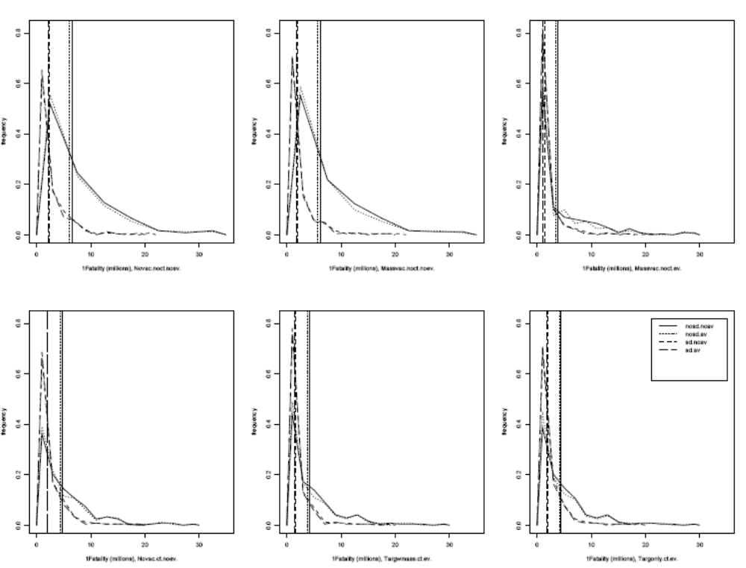
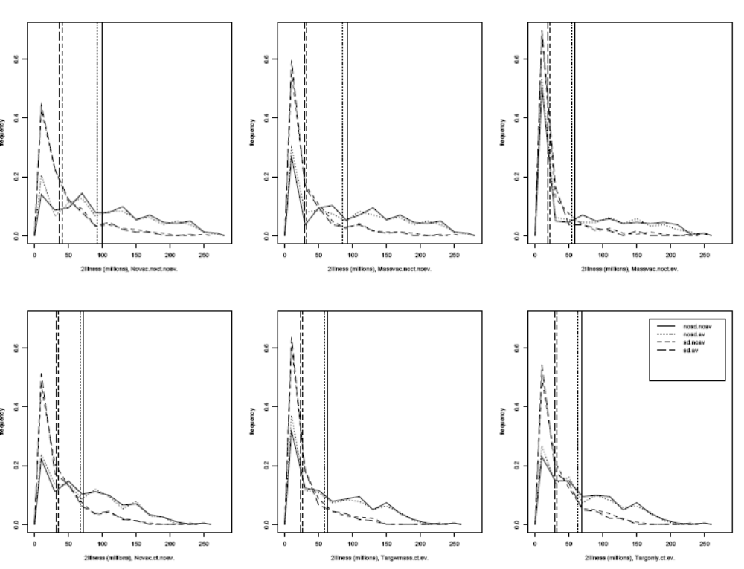
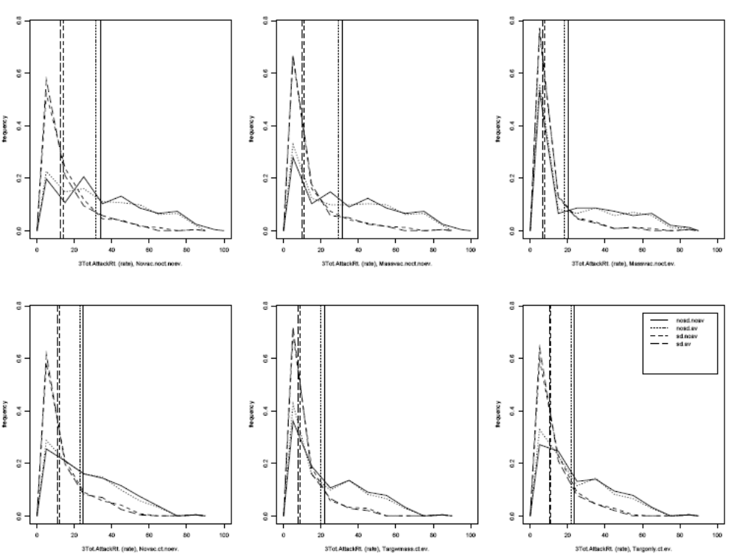
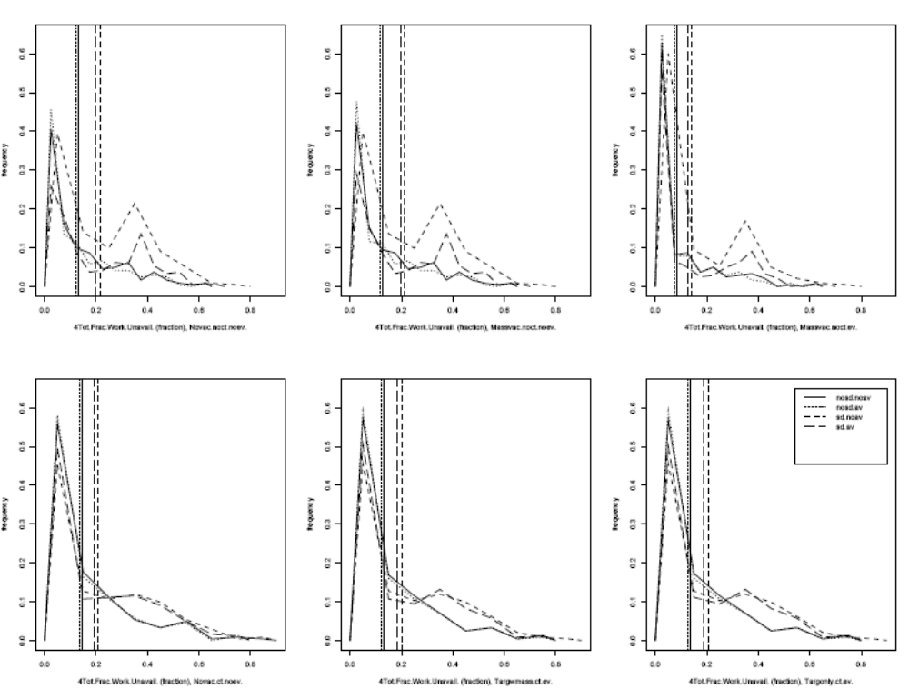
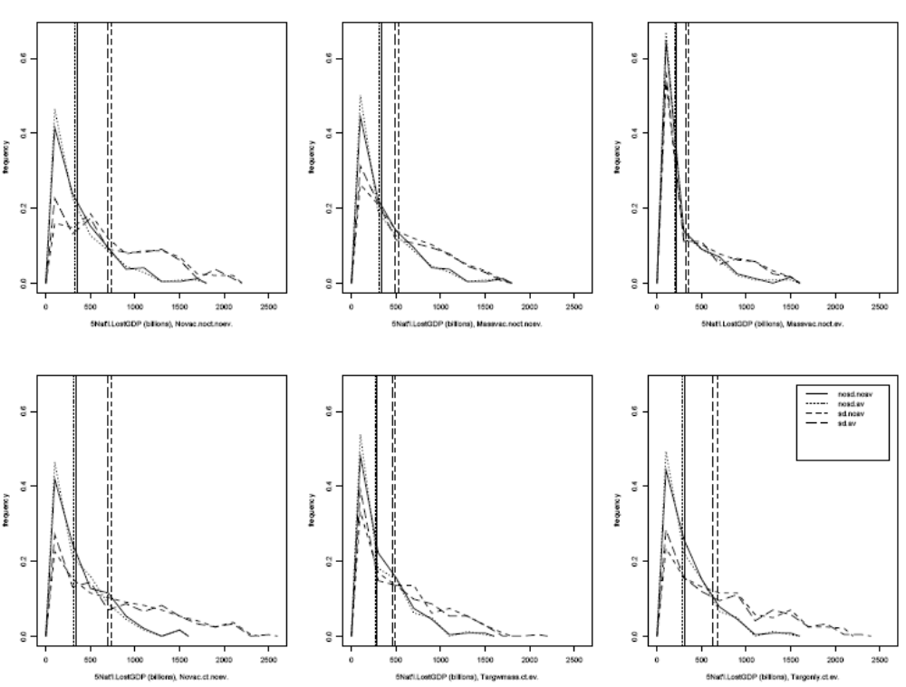
This page intentionally left blank.
Appendix B: Summary of Intervention Strategy Consequence Statistics
Mean and extreme decision metric values alternative
intervention strategy scenarios
No social distancing with no antivirals scenarios 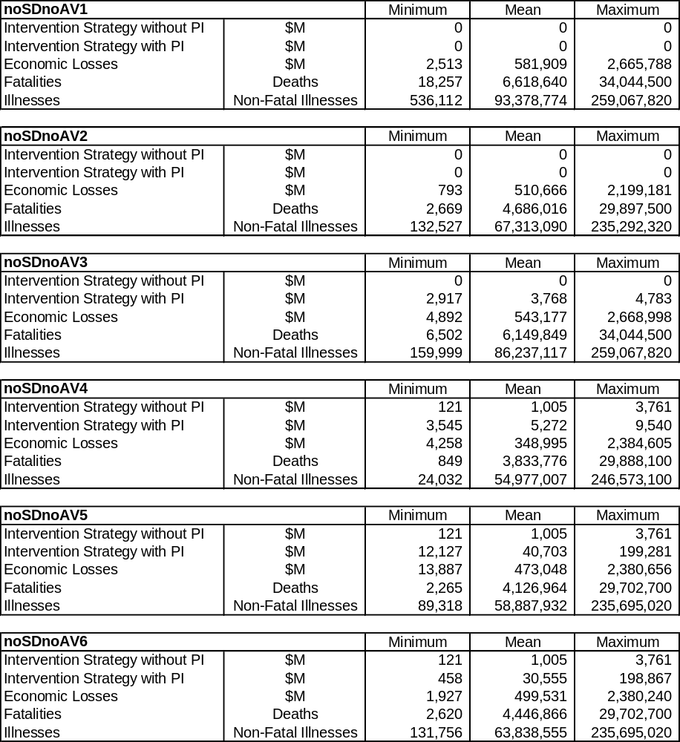

Mean and extreme decision metric values alternative
intervention strategy scenarios (continued)
No social distancing with antivirals scenarios
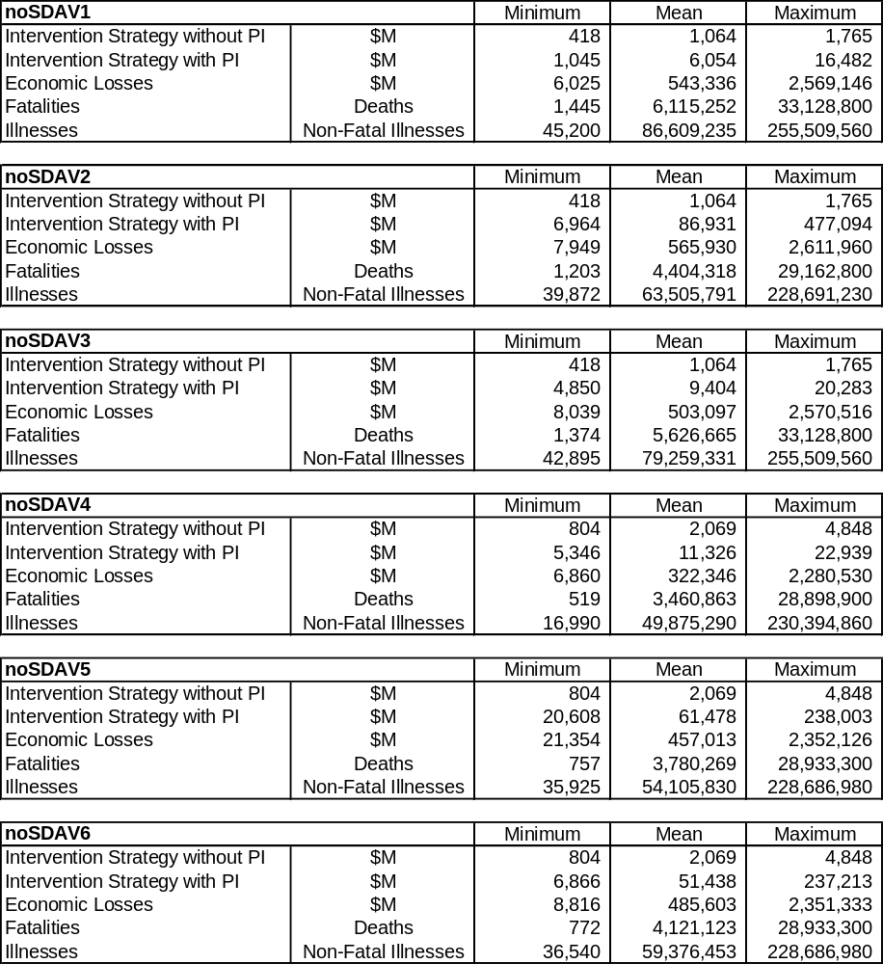

Mean and extreme decision metric values alternative
intervention strategy scenarios (continued)
Social distancing with no antivirals scenarios
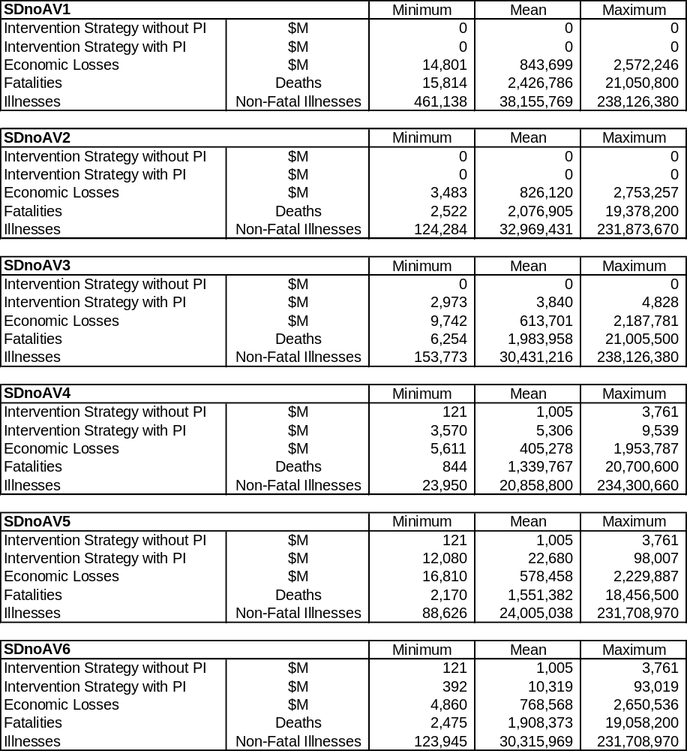
Mean and extreme decision metric values alternative
intervention strategy scenarios (continued)
Social distancing with antivirals scenarios
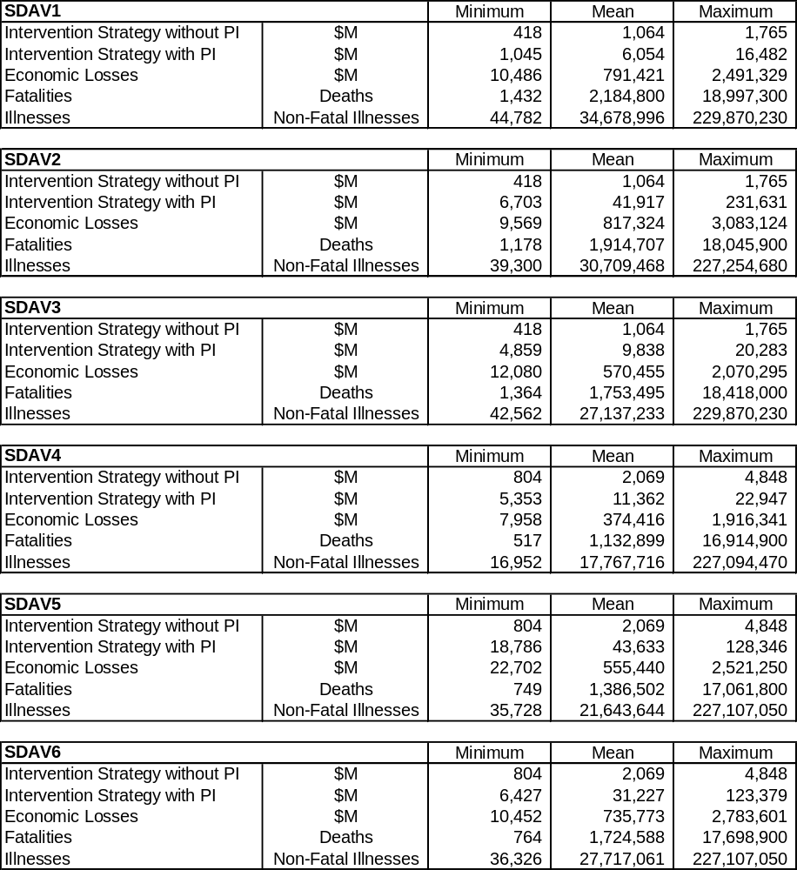
Appendix C: Outlines for Nonpharmaceutical Mitigation Measures for Pandemic Influenza
Table of Contents
Introduction C-3
Public Information and Education C-6
School Closure C-12
Home Isolation and Quarantine C-17
Social Distancing Policies—Voluntary Social Withdrawal C-23
Social Distancing Policies–Restrict Large Public Gatherings C-25
Social Distancing Policies—Restrict Public Transportation C-28
List of Acronyms and Abbreviations
ASTHO | Association of State and Territorial Health Officials
CDC | The Centers for Disease Control and Prevention
CIPDSS | Critical Infrastructure Protection Decision Support System
DEAS | Digital Emergency Alert System
DHS | Department of Homeland Security
HAN | Health Alert Network
HHS | U.S. Department of Health and Human Services
HOV | high occupancy vehicle
JIC | Joint Information Center
JIS | Joint Information System
MIDAS | Models of Infectious Disease Agent Study
NAACHO | National Association of County and City Health Officials
PSA | public service announcement
RSS | really simply syndication
SARS | Severe Acute Respiratory Syndrome

Introduction
The application of antiviral drugs and vaccines is expected to be the key strategy for blunting the impact of pandemic influenza. However, these pharmaceutical measures are subject to limited availability. This is particularly true of the pandemic vaccine, which may not be available for months after the start of a pandemic. Thus, nonpharmaceutical measures will also play a critical role in limiting disease spread. These measures reduce the spread of infection by reducing contact rates between infectious and susceptible persons and by reducing transmission of infectious agents through good hygiene. The intent of this appendix is to provide a descriptive outline of the principal nonpharmaceutical interventions and to broadly describe their feasibility, effectiveness, and cost. The measures described are public information and education, school closure, home isolation and quarantine, and social distancing policies. The later include voluntary social withdrawal, restricting large public gatherings, and restricting public transportation.
For each measure, the Critical Infrastructure Protection Decision Support System (CIPDSS) has applied the following outline, though the level of detail varies by mitigation measure according to the availability of information. This outline is simply a consistent way to organize descriptions of practical steps in implementing these measures and of issues likely to be encountered. For some of the measures, CIPDSS has identified cost benchmarks.
- Implementation of mitigation measure
  - Responsibility and authority
  - Major steps for implementation
  - Required resources
  - Problems and issues
- Effectiveness
  - Percent of population affected by mitigation measure
  - Compliance rate
- Duration
  - Feasible duration of intervention
  - Factors limiting duration
- Impacts and costs
  - Economic sectors affected
  - Type of impacts

The following table is a very brief summary of these outline elements for each of the interventions.
Summary of nonpharmaceutical options
Nonpharmaceutical Intervention Measure | Implementation | Effectiveness | Duration | Impacts and Costs
Public information and education | Distribution of literature, news announcement, training and awareness programs | Essential as preparation for the application of any other interventions, including pharmaceutical interventions | Ongoing in pre-pandemic period with accelerated program effort during pandemic | Prepare the public to avoid fear and overreaction; reduce spread through good hygiene and reduced contacts; clarify treatment options and service options  Costs: $17 million per year before pandemic, $160 million during pandemicª
School closure | Official closure of schools or severe restrictions on attendance to provide for at-risk children; must be implemented early in pandemic | Uncertain effectiveness because of the need to provide for at-risk children and the need for companion restrictions on other forms of social interaction among students | Feasible duration is 90 to 300 days because the pandemic may come in waves; distribution of vaccines and antivirals may be a factor | Loss of educational opportunity for students; lost teacher salaries; basically, the full school budget for the duration of the closure will be lost because continuity must be provided and no product (education) will result; $10,600 to $12,400 per student per year lost
Summary of nonpharmaceutical options (continued)
Nonpharmaceutical Intervention Measure | Implementation | Effectiveness | Duration | Impacts and Costs
Home isolation and quarantine | Isolation of symptomatic individuals in their home and quarantine of close contacts also at home; program would be triggered by policy when pandemic reaches predetermined threshold | Experience with Severe Acute Respiratory Syndrome (SARS) suggests that public cooperation can be expected; quarantine of contacts with symptomatic isolates is likely to spread the disease | Program would be triggered by policy when pandemic reaches predetermined threshold; individuals would be released after recovery; program would continue until pre-set threshold of population is symptomatic | Isolated and quarantined individuals will need medical support, food, salary replacement, and social support, with a 6-week average isolation and quarantine period for a household and 25% of households affected during the course of a pandemic; cost could exceed $2.5 billionª
Social distancing: voluntary social withdrawal | Self-isolation and quarantine of households; this may be in compliance with official requests to reduce public contacts | A compliance rate of 10% to 40% is expected, though economic needs will largely dictate compliance | Individual household participation likely to be from 10 to 30 days, depending on number of members in the household and economic circumstances | Though this is a voluntary program, the same levels of support as for isolation and quarantine may be required; however, for a household of well individuals, the costs would be lower because of reduced medical needs. Also, as a voluntary program, some participants will not require salary replacement

Summary of nonpharmaceutical options (continued)
Nonpharmaceutical Intervention Measure | Implementation | Effectiveness | Duration | Impacts and Costs
Social distancing: restrict large public gatherings | Public gatherings, including special events and periodic meetings such as church and government forums would be suspended for the duration of the pandemic. | Many public events involve close contact between individuals; therefore, restricting such events should reduce contact rates and disease transmission. | Duration of restrictions may be for the full period of the pandemic or for a shorter period determined by health officials; public resistance may be strong | Loss of revenue to sports, entertainment, and religious organizations; for a 12-week restriction period, these losses may exceed $50,000,000ª
ªFor a city population of 5 million
Public Information and Education

Intervention
Implement local public policies that reduce public anxiety and fear and reduce risks of influenza exposure through person-to-person contacts by educating the public about how influenza is transmitted and about social distancing techniques.

Implementation

Responsibility and Authority
State and local government, as represented by public health departments, schools, and other agencies, are generally responsible for developing and disseminating public information on pandemic influenza. The federal government, particularly the U.S. Department of Health and Human Services (HHS) and the Centers for Disease Control and Prevention (CDC) support this effort with technical assistance, prepared pamphlets, and educational resources. In addition, healthcare-related businesses, such as hospitals, clinics, pharmacies, and special care facilities, will be responsible for the distribution of information to patients. During a pandemic, all commercial news media will be relied upon to get out critical influenza care and avoidance messages. Finally, volunteer organizations, such as the Red Cross, may make important contributions in particular communities by distributing information.
Major Implementation Steps
- Develop key messages to educate the public about the risks associated with a pandemic influenza outbreak and about ways to minimize chances of exposure (including social distancing techniques and when and how to seek treatment)
- Identify intended recipients for specific messages to optimize media choice and distribution channels. This may involve, for example, addressing the requirements of special needs populations, specific age groups, and non-English-speaking populations.
- Coordinate messages between all levels of government and the private sector. The key to such coordination will be use of the Joint Information System (JIS), including creation and staffing of a national Joint Information Center (JIC) and creation and staffing of state and regional JICs.
- Identify and establish competent “spokespersons” for the duration of the crisis
Another key organizational structure for pandemic communications is being developed as the Health Alert Network (HAN). According to a CDC web-site:
The Health Alert Network (HAN) is a nationwide program to establish the communications, information, distance-learning, and organizational infrastructure for a new level of defense against health threats, including the possibility of bioterrorism. The HAN will link local health departments to one another and to other organizations critical for preparedness and response: community first-responders, hospital and private laboratories, state health departments, CDC, and other federal agencies. CDC is leading development of the HAN, in partnership with the National Association of County and City Health Officials (NACCHO), the Association of State and Territorial Health Officials (ASTHO), and other health organizations.
The HAN will participate in developing dissemination strategies for key messages and in the production and dissemination of public education materials. The types of materials that will be produced by the HAN and other organizations include:
- Written materials
- Brochures, pamphlets, flyers, and so forth
- Newspaper inserts
- Video/Audio
- Public service announcements (PSAs) (television)
- PSA (radio)
- Podcasts
- Web/Net-based
- A standard-format National information site and state/local sites
- Really Simple Syndication (RSS) feeds
- Social networking sites
- Mass text messaging (targeted by geographic region)
- U.S. Department of Homeland Security (DHS) PrepNet programming
- Digital Emergency Alert System (DEAS) messages (targeted by geographic region)
- News Media
- News releases
- Interviews
One final responsibility of coordinating agencies is to monitor key message dissemination for effectiveness or possible misinformation.

Required Resources
The resources needed to accomplish the intended communication goals are funded (public and/or private) to identify and create message materials, facilitate communication within the JIS, and house and equip JICs; and determine staffing required for identification, development, and dissemination of key messages, coordination of messages, and staffing of JICs. A typical JIC organization is represented in the following figure.

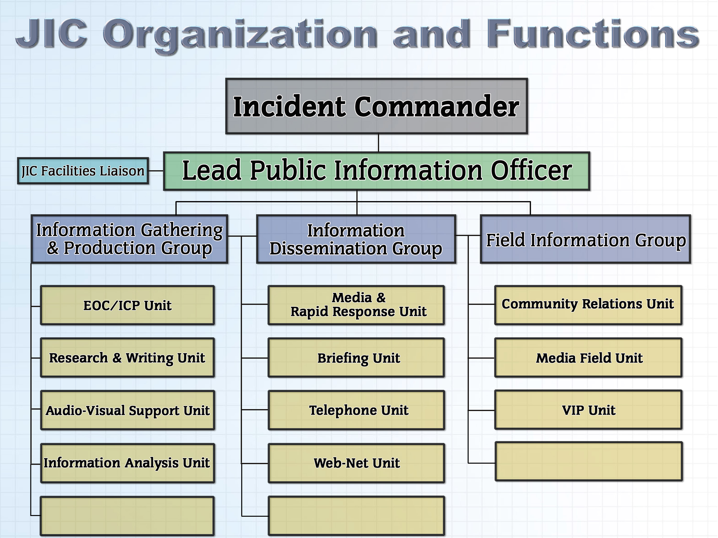

Problems and Issues
- Given the cross-jurisdictional and overlapping nature of the information programs, CIPDSS anticipates that problems of the following types will need to be overcome:
- Political infighting and turf squabbles
- Loss of public confidence in response due to mixed or confusing messages
- Increase in public fear/anxiety from lack of information or mixed/confusing messages

Duration
The pre-pandemic information campaigns are expected to be ongoing, at least while the threat posed by current avian influenza or other similar threats exist. Such ongoing programs are at risk of losing public support and interest if they are not renewed regularly with creative new approaches to getting out the messages. This implies continuous funding for staff, product development, and redistribution. During the pandemic, information distribution, particularly as coordinated by the JICs, will continue for the duration of the pandemic and during any subsequent recovery period, during which normal social and economic activities are restored.

Impacts
The main impacts of the public education and outreach program will be benefits to the private sector, particularly to households. Assistance to commercial enterprises and public schools will also be important. These benefits include
- Population not overreacting to events unfolding
- Media coverage becoming more reasonable
- Criticism of official actions lessening
- Rumors countered more effectively
- Fewer “worried well” to inundate medical facilities
- Fewer disease transmissions due to exposure mitigation
- Minimized financial impact if disease spread is lessened and safe behaviors are practiced

Pre-Outbreak Education and Awareness Program Costs
Costs are associated with development of new or adaptation of existing materials to educate the public about the risks associated with a pandemic influenza outbreak and how to minimize risk of exposure. All materials must be produced in multilingual formats. Elements of cost for a city of 5 million are provided in the following table.
Pre-outbreak education and awareness program costs
Newspaper inserts, brochures, pamphlets, and flyers
replacement cycle, years | 2
target audience fraction | 0.7
number of items | 10
 | unit cost | extended cost
layout and design | $2,000.00 | $10,000.00
printing | $0.48 | $8,400,000.00
distribution | $0.25 | $4,375,000.00
 | total | $12,785,000.00
Video and Audio Public Service Announcements
replacement cycle, years | 0.25
number of messages | 5
languages | 3
frequency, per year | 1000
 | unit cost | extended cost
Design and production | $35,000.00 | $2,100,000.00
broadcasting | $0.00 | $0.00
Joint Information System Pandemic flu capability
 | staff is in-place, no additional cost
Web-site | staff-years | extended cost
$/staff year, computer specialists | $150,000.00
Development and maintenance of a standard format central National information site and state/local sites | 10 | $1,500,000.00
RSS feeds | 5 | $750,000.00
Establishment and utilization of social networking sites | 0 | $0.00
Total Annual Cost, Pre-pandemic |  | $17,135,000.00

Outbreak Crisis Messaging
During an outbreak, the emphasis of messages will shift to the status of disease spread, avoidance through good hygiene and social distancing, and treatment. Information must be distributed on treatment centers, isolation units, school closures, and restrictions on public gatherings and transportation. Messages of all types will be updated and renewed more frequently. Cooperation from the commercial media is expected. All materials must be produced in multilingual formats. Staffing for the JIC will be increased. Also, a reverse 911 program may be implemented. Elements of cost for a city of 5 million are provided in the table on the following page.
Outbreak Crisis Messaging
Newspaper inserts, brochures, pamphlets, and flyers
replacement cycle, years | 0.25
target audience fraction | 1
number of items | 10
 | unit cost | extended cost
layout and design | $2,000.00 | $80,000.00
printing | $0.48 | $96,000,000.00
distribution | $0.25 | $50,000,000.00
 |  | $146,080,000.00
Video and Audio Public Service Announcements
replacement cycle, years | 0.02
number of messages | 5
languages | 3
frequency, per year | 1000
 | unit cost | extended cost
Design and production | $10,000.00 | $7,500,000.00
broadcasting | $0.00 | $0.00
Use of U.S. Department of Homeland Security PrepNet | In-place, no specific pan-flu costs
Reverse 911 | unit cost, $/call | extended cost
 | 0.2 | $500,000.00
fraction called | 0.5
Web-based information
servers to handle increased demand for information | 1 | per 5,000 population
 | Unit cost $/server | extended cost
 | 4000 | $4,000,000.00
maintenance | 500 | $500,000.00
Joint Information Center focused on Pan flu
staff per center | 16
Population per center | 3000000
cost per staff | 75000
total operating cost for one year |  | $2,000,000.00
Total annual cost during pandemic |  | $160,580,000.00

School Closure

Intervention
Temporarily close public and private schools to reduce the attack rate of the disease by avoiding contacts typical of those experienced in schools. Of the 3 Models of Infectious Disease Agent Study (MIDAS) researchers (Ferguson and Glass), 2 predict 30 percent of all infections will occur in schools, a plurality of the infections. Glass predicts that infants are twice as infectious as adults and teenagers are 1.5 times as infectious. School closure, especially in combination with other nonpharmaceutical interventions could significantly reduce and delay the attack rate of a pandemic influenza outbreak.

Implementation

Responsibility and Authority
Federal, state, and local public health departments have authority to close schools. The local school boards, in conjunction with or separate from private school leadership bodies, can close their own doors. The actual decision will almost definitely be made between all of these bodies and the elected leaders of those jurisdictions. These leaders will probably aim to make one decision for all the schools of a region. Because each college, junior college, and university has its own independent leadership and is often an afterthought in current discussion, it is less likely they will be included in an attempt at a singular decision. These schools also have a layered choice of canceling classes before closing the school, the latter being an extreme step they are unlikely to consider. Timing is critical. Longini concludes that school closures must occur before reaching the 3-percent attack rate in a community. By 10 percent, the school closures will have no effect.

Major Steps
- Conduct meetings among local public health departments and local public and private school authorities and decide to act alone or in concert with other jurisdictions; these local jurisdictions will look to the State Board of Education for information and guidelines
- Establish plans for resumption of classes, perhaps based on immunization records
- Negotiate with teachers unions on their pay, distance learning, and immunization during the closure
- Negotiate new state and federal funding formulas, not based on absenteeism, and develop national requirements for college admissions recognizing various local closure durations

Required resources
- Funding may be needed to support extended school year
- Specialized manpower may be needed to provide distance-learning systems
- Logistical support may be required including:
- Continuing free meals to at-risk kids
- Keeping the kids home and out of the malls
- Quarantined or social-distanced daycare may be needed for parents who are poor, first responders, public health providers, or critical infrastructure personnel

Problems and Issues
- Research by Steven Bankes of the CDC concludes that a series of smaller and less-costly interventions is superior to school closure
- Compliance levels; for example, if schools stay open, handling teacher and student absenteeism in an equitable manner will present challenges. If schools close, some parents may insist or unwittingly continue to send their kids to school and some teachers may insist on attending to serve those students.
- The decision on school closure, which is likely to be a product of a bureaucracy of bureaucracies, must be made quickly as a pandemic is just starting in a community or it is not effective
- Will higher education institutions be subject to the same closure policies?
- School closure must be in conjunction with a level of household quarantine or the overall attack rate could be only slightly reduced as children infect each other at other social events
- Would a jurisdiction’s Public Health Department close local schools without their consent?
- If schools close, will buildings remain open to serve meals or provide a safe haven in dangerous neighborhoods?
- A survey by the Harvard School of Public Health found that 25 percent of students do not have anyone to take care of them at home
- The Chicago Public Schools serve 400,000 meals per day, with at least 80 percent of those going to children who may not get any other meal

Effectiveness
The effectiveness of school closure is not widely debated. Only Bankes appears dubious and many have vocally disagreed with his research. As previously noted, school closure must be done in conjunction with a level of household quarantine or the overall attack rate could be only slightly reduced as children infect each other at other social events.
The compliance rate will probably not exceed 75 percent. A Harvard study shows school closure is the public health mandate during a pandemic with the lowest acceptance and, hence, the lowest likely compliance. Compliance by students may decrease with increasing age. Some honor-roll teenagers, near the end of high school, and college students, focused on a career, may be unwilling to have their career plans delayed by a year.
School closures are time-sensitive; schools need to close at the pandemic onset.

Duration
Correct closure duration is difficult to predict, because influenza can travel in multiple waves. Schools definitely would prefer to close only once and not have to engage the complex bureaucracy multiple times.
The feasible duration of school closure is 90 to 300 days. Some of the factors to be considered, in addition to the persistence of the pandemic, are
- Assuming that supplies will be limited, state and local government will be receiving vaccine and antiviral shipments over the course of months rather than days or weeks. Immunization is desirable before reopening schools.
- The slow arrival of prophylaxis will stretch the distribution process over nearly a year in highly populated states and large municipalities
- Typical summer closure is 2.5–3.5 months, and there will be some pressure to keep the duration of school closure less than that length so the closure can be made up over the summer
- Epidemiology—The speed of the spread of the disease through a group of communities that close their schools together will influence the duration of the closure
- Stockpiles of antivirals and vaccines—Speed of distribution and total stockpile size in a group of communities that closed their schools together will influence the duration of the closure
- As with other “childhood disease” immunizations, children may be kept out of school until they have a record of their vaccination

Impacts
School closures will affect all economic sectors because parents of students are employed in all sectors and will need to provide or arrange childcare. The types of impacts expected are
- Worker absenteeism
- Cost of continuing to make and deliver free lunches
- Cost of paying teachers and administrators for an extended school year
- Cost of distance learning during closure
- Funding shortfalls as current formulas are based on absenteeism
- Delay in flow of newly trained workers into the workforce
Following is text from an analysis of MIDAS and other disease/nonpharmaceutical intervention models currently available. This analysis identifies limitations of models generally, but highlights school closure assumptions as a major shortcoming:
Another limitation of current models is their focus on a narrow set of influenza- related outcome measures, which ignores the broader cost-benefit tradeoffs of alternative intervention strategies. For example, one might weigh the costs associated with a school closure against its benefits. Costs need not necessarily be measured in dollars; costs can also include other benefits forgone (e.g., health benefits). The potential benefits of school closing might take the form of reductions in influenza transmission to the adults living in households that include school-age children. However, the costs or risks associated with extended school closings are largely non-influenza-related and mostly affect the children themselves. For example, some might experience increased exposure to violence in communities or poor nutrition due to lack of free or subsidized school lunches. These costs would not be captured in a model that focuses only on influenza-related outcomes. It would be important to weigh benefits and costs for epidemics of different severity. Indeed, employing a broad range of social interventions may entail a cost greater than the pandemic itself.

School Closure Costs
For reasons cited above, including employee contracts, building maintenance and alternative uses, child care, and security, it is unlikely that temporary school closures will result in significant savings from operating budgets. Instead, CIPDSS has taken the perspective that operating costs will remain close to normal, but education will not be accomplished. Therefore, the operating budgets represent a loss, because the education will have to be made up after the closure at additional cost. A representative unit cost (per student) can be derived from the operating budget of the Chicago schools based on the assumption that closure will result in little change in budget but full loss of the product, education, during the closure.

Chicago Public Schools (CPS)
FY 2007 Operational Budget: $4.6 billion

CPS Budget Allocations
Federal 18% $828,000,000 (reimbursement)
State 38% $1,748,000,000 (grant programs)
Local 44% $2,024,000,000 (38% property tax; corporate taxes, lunchroom fees, miscellaneous tax)

Summary: If CPS had to close for 300 days, it would lose $3.7 billion ($12,602,739 per day). Of the $3.7 billion in losses, federal reimbursement losses would total $680,547,900.

CPS Operational Budget - Per Day Cost
$4.6 billion/365 = $12,602,739/day

Operational budget loss estimates:
1 day = $12,602,739
1 week/7 days = $88,219,173
6 weeks/42 days = $529,315,038
8 weeks/56 days = $705,753,384
12 weeks/84 days = $1,058,630,076
300 days = $3,780,821,700

Operational losses–federal allocation (student reimbursement)
CPS Federal Budget allocation at 18 percent or $828 Million

Federal reimbursement loss estimates:
$828 M/365 = $2,268,493/day
1 week = $15,879,451
6 weeks = $95,276,706
8 weeks = $127,035,608
12 weeks = $190,553,412
300 days = $680,547,900

Sources: Chicago Public Schools FY 2007 Budget; Federal Emergency Management Agency (FEMA) State and Local Mitigation Planning Guide: identifying hazards and estimating losses.
Based on a 2000 enrollment of 435,470, the loss would be about $10,600 per student per year for a full year closure.
Additional cost data from Montgomery County, Maryland, are available in similar detail. Unit cost is $12,422 per student per year.
Home Isolation and Quarantine

Intervention
This mitigation measure applies public health system-mandated or voluntary home isolation of confirmed or presumed influenza cases and home quarantine of their contacts (pre-symptomatic exposed persons), respectively. The goal of these interventions is to reduce community transmission from members of households in which there is a person ill with pandemic influenza. Members of households in which there is an ill person may be at increased risk of becoming infected with a pandemic influenza virus. As determined on the basis of known characteristics of influenza, a significant proportion of these persons may shed virus and present a risk of infecting others in the community despite being asymptomatic or only having a minimally symptomatic illness that is not recognized as pandemic influenza disease. Thus, members of households with ill individuals may be required to stay home for an incubation period following the end of the infectious period of the infected household member. If other family members become ill during this period, the recommendation is to extend the home quarantine for another incubation period, starting from the time that the last family member becomes ill. In addition, consideration may be given to combining this intervention with provision of influenza antiviral medication to persons in quarantine if such medications are effective and quantities are sufficient and a feasible means of distributing them is in place.

Implementation

Responsibility and Authority
Many of the actions that may be warranted during a pandemic influenza will require legal authority; most notably, enacting quarantine and/or isolation. Numerous federal and state statutes authorize public health actions to address pandemic influenza. The federal government has statutory authority to order a quarantine to prevent the transmission of communicable diseases across national or state boundaries. The HHS provides general guidance and delegates responsibility for preparedness to the state and municipal levels. The states, which enact quarantine statutes pursuant to their police powers, are primarily responsible for quarantine within their borders. Local health departments have responsibilities on the frontline for responding to public health emergencies, although the role and organization of local heath departments varies considerably across the U.S.

Major Steps
- Develop adequate statutory authority and administrative procedures for all movement restrictions and monitoring measures for confirmed and suspected pandemic influenza cases and their contacts
- Implement protocols for imposing, maintaining (including enforcing when applicable), monitoring, and terminating home isolation or quarantine
- Set up monitoring/contact systems to ascertain and record compliance and health status of quarantined persons
- Implement procedures for providing medical care, food needs, and other essential services for those isolated and quarantined
- Provide N95 masks, disposable thermometers, and other medical supplies to households where persons are providing home care to patients
- Provide public messages explaining the purpose and implementation methods for quarantine
- Provide individuals requested to self-isolate with information regarding infection control, symptom monitoring and identification, and the importance of health department notification of symptom development
- Address where those who refuse to submit to home isolation/quarantine shall be held and who will care for them
- Address income loss for families experiencing isolation/quarantine

Required Resources
- Quarantining contacts will require extensive public health resources. The success of quarantining as a containment and control strategy is contingent upon early implementation, the thoroughness of contact tracing, and ongoing monitoring. When combined with the demands of providing direct services, the data management of isolation/quarantine and communications between all affected parties can be overwhelming for health department staff.
- Delivery systems will be required for providing essentials such as food and medicine (both prescription and nonprescription drugs) to quarantined households. Needed medical supplies may include masks and other medical consumables, antivirals, thermometers, and other symptom monitoring supplies/equipment. Other supportive services will be needed, such as transportation to medical treatment. In addition, vital, life-sustaining supports will need to be continued for vulnerable populations, such as the frail elderly, disabled, homeless, and so forth). Mental health and psychological support services also may be required by those facing extended quarantine periods.
- State and local law enforcement agencies, with assistance from their state’s National Guard as needed, may be needed to enforce quarantines. Based on the Severe Acute Respiratory Syndrome (SARS) experience, which showed that most people will comply, it is anticipated that a majority of individuals will comply with quarantine or isolation orders.
- At least daily contact will be made by a representative of the health department to ascertain situation and needs. This could be by phone or in person for situations when the risk of exposure and subsequent development of the disease is high and the risk of delayed recognition of symptoms is moderate.
- Personal protective and communications equipment will be required for workers placed at risk because their job duties require them to impose, maintain, enforce, monitor, or terminate quarantine
- Phone lines and a hotline for notification of symptoms or personal needs will be required to monitor and respond to isolated and quarantined individuals and households.
- Protocols, plans, standards, and so forth, will need to be developed to manage cases and contacts (such as plans that address telecommunications, essential services, and financial support)
- For those isolated and quarantined, 1 set of instructional handouts per household, 1 disposable thermometer per person in the household, and 2 masks per person per day for 14 days will need to be supplied.

Problems and Issues
- The U.S. has not implemented a large-scale quarantine during the past 80 years and, consequently, there is little to no foundation from which to assess U.S. best practices or lessons learned. However, it was necessary to initiate 21 days of isolation (but not quarantine) for dozens of people in the monkey pox outbreak of 2003. Also, while the use of quarantine during the SARS epidemic provides some valuable insights, there are important differences between the epidemiologic parameters of the SARS and influenza viruses. In particular, influenza has a serial interval of 2–4 days and infectivity is maximal early in the illness, while for SARS the serial interval is 8–10 days and infectivity peaks during week 2 of the illness. These factors allow little time for instituting the quarantine and isolation interventions that were essential for controlling SARS.
- Requirements for success of this intervention include the prompt and accurate identification of an ill person in the household for isolation, identification of their contacts for quarantine, voluntary compliance with isolation and quarantine by household members, commitment of employers to support the recommendation that employees living in a household with an ill individual stay home, the ability to provide needed support to households that are under isolation or voluntary quarantine (such as food, supplies, and medications), guidance for infection control in the home, and actions to enforce involuntary isolation and quarantine when needed (such as guards, bracelets, and facilities).
- There may be difficulty in reaching a large proportion of the affected households. Acquisition of adequate mask and thermometer supplies may also be difficult without some stockpiling.
- Quarantine is not effective in controlling multiple influenza outbreaks in large, immunologically naive populations because the disease spreads too rapidly to identify and control chains of transmission. Even if quarantine was somewhat effective in controlling influenza in large populations, it would not be feasible to implement and enforce with available resources and would damage the economy by reducing the workforce. Isolation is only partially effective if there is an asymptomatic period of viral shedding because cases will be missed.
- First responders and other sick health workers should be isolated or they will spread disease to naive patients. Exposed workers who are not ill can be closely monitored (for example, daily temperatures) instead of quarantined, unless there is an asymptomatic shedding period early in the infection course. In that case, they may need at least a temporary quarantine from the shortest incubation period to the end of the asymptomatic infection period.
- The occurrence of large numbers of cases would prevent contact tracking and quarantine monitoring due to inadequate numbers of health department staff. Although there may be new technologies to assist, they have not been tested.
- Quarantine strategies are limited to the extent that they can be implemented only after cases are identified
- Adherence to ethical principals in use of quarantine during pandemics, along with proactive anti-stigma measures, would need to be assured
- The risk of noncompliance increases as the duration increases
- Effectiveness and compliance depend on public confidence in disease-control policies and information
- Quarantine or isolation may infringe on personal movement and cause a feeling of isolation from family and friends and may also lead to loss of income or employment
- Many view the community hospital as a "safe haven," a place to go for food, shelter, protection, and medical attention. However, in the event of transmissible infectious diseases such as pandemic flu, the traditional concept of safe haven may not be applicable. The public will need to be educated about the concept of the home as a safe haven.

Effectiveness

Percent of Population Affected by or Participating in the
Intervention by Age Group
The percentage of population affected by or participating in the intervention by age group would vary with the number of confirmed cases. Assuming an average household size of 3 persons, it would be reasonable to expect that 2 people would be quarantined for every reported case. The program would also need to consider potential quarantine of coworkers, schoolmates, and others.

Compliance Rate
The compliance rate is the proportion of the affected or potentially-affected population that is likely to comply with constraints for the prescribed duration of the intervention. The estimated range is 70 to 90 percent.
During the SARS outbreaks, public health departments were required to work closely with law enforcement personnel to ensure compliance with quarantine measures. Methods of enforcement varied widely, as did the success of the chosen tactics. For example, in Toronto, where the transmission of SARS was limited primarily to hospitals and households that had contact with patients, the public was cooperative with home quarantine orders. In other cases, however, quarantines caused public protest and even violence.

Duration

Feasible Duration of Intervention Measure
For the quarantine of individuals exposed to patients with pandemic influenza, the contact remains separated from others for a specific period (up to 10 days after exposure) during which time the contact is regularly assessed for signs and symptoms of disease.

Factors Limiting Duration
- Declining public compliance as the quarantine period increases
- Workforce to support both life needs and compliance
- Insufficient supplies of masks or thermometers

Impacts

Sectors Affected
All sectors of the economy will be affected.

Type of Impact
- Worker absenteeism
- High costs for system administration, household monitoring, household supply, and so forth in the public health sector
- Public health worker illness
Cost estimates for support of a home quarantine program are provided in the following table for a city of 5 million. For these estimates, CIPDSS assumed that 25 percent of households are expected to quarantine at some time during the pandemic.
Home Isolation and Quarantine
Fraction of households affected | 0.25 | total households
Duration, weeks | 6 | 480769
Food, $/week | $150 | $432,692,308
Medical Supplies, $/week | $50 | $144,230,769
Income replacement $/week | $446 | $1,929,807,692
Total |  | $2,506,730,769

Key Terms
Isolation: Isolation is the separation of a person or a group of persons infected or believed to be infected with a contagious disease to prevent the spread of infection. Ill persons are usually isolated in a hospital, but they may also be isolated at home or in a designated community-based facility, depending on their medical needs.
Quarantine: Quarantine is the separation and restriction of movement or activities of persons who are not ill, but who are believed to have been exposed to infection, for the purpose of preventing transmission of diseases. People are usually quarantined in their home, but may also be quarantined in community-based facilities.
Social Distancing Policies—Voluntary Social Withdrawal

Intervention
Individuals isolate themselves at home to reduce their risk of exposure to influenza.

Implementation

Responsibility and Authority
Individuals make self-determined decisions to not work outside the home, avoid public gatherings, and so forth.

Major Steps
- Develop policies, plans, and guidelines for advising the public about the practicalities, best practices, and benefits of voluntary social withdrawal
- Ensure information regarding social withdrawal is compatible with restricted transportation and public gathering guidelines
- Implement the decision to self-isolate

Required Resources
- Funding (public and/or private) to develop and disseminate information regarding voluntary social withdrawal

Problems/Issues
- Economic and productivity impacts of protective self-isolation include absenteeism and reduced participation in the economy.

Effectiveness
The percentage of population affected by or participating in the intervention by age group:
Child (0–4): 50–75 percent
Youth (5–18): 25–50 percent
Adult (19–65): 10–30 percent
Senior (66+): 20–50 percent
Compliance rate: 10–40 percent

Duration

Feasible Duration of Intervention
- 10–30 days

Factors Limiting Duration
- Ability of individuals/families to re-supply food and staples
- Loss of household income

Impacts

Sectors Affected
- All

Type of Impact
- Cost to develop and disseminate information regarding voluntary social withdrawal, which is included in the public information and education description above
- Lost value-added (including lost revenue to business and voluntary organizations); this cost is already included in CIPDSS calculations
- Costs incurred to support families in self-isolation, including delivery of food and medicine. Without such support, compliance levels are expected to be far lower.
Social Distancing Policies–Restrict Large Public Gatherings

Intervention
Government will implement protective measures that reduce risks of influenza exposure by restricting large public gatherings.

Implementation

Responsibility and Authority
- State and, in some cases, local authorities can issue orders restricting large public gatherings. State law (emergency management statutes and public health statutes) must be consulted to determine specifically what powers are held by which authorities.
- The endorsement of state and federal authorities may help validate local recommendations to restrict public gatherings through the moral and scientific support of a larger jurisdiction
- In the absence of coercive authority or as an alternative to it, voluntary compliance by businesses and organizations such as churches may be an important component of public protection

Major Steps
- Develop recommendations for limiting public gatherings based on current knowledge of disease threat and vectors for transmission
- Disseminate public education information prior to emergencies, including public-gathering guidelines
- Distribute protective orders and/or recommendations during an emergency
- Implement orders and/or recommendations in response to infection phases

Required Resources
- Legal authorization to restrict public gatherings
- Funding (public and/or private) to develop and disseminate public-gathering guidelines
- Commitment of business and organization personnel and resources to participate as stakeholders in the development of public-gathering guidelines
- Ability to deputize larger-than-usual public health workforce to report and enforce violations (such as a public health authority to direct police or other workers)

Problems and Issues
- Lack of political will to develop and disseminate public-gathering prohibitions and guidelines
- Resistance by the public, business community, or other organizations to restrictions on public gatherings
- Lost business revenue, employment, and community morale caused by absence of public gatherings

Effectiveness
Percentage of population affected by or participating in the intervention by age group:
Child (0–4): 40–60 percent (with child care included)
Youth (5–18): 40–60 percent (assuming schools are closed but youth gatherings are not enforced)
Adult (19–65): 40–60 percent
Senior (66+): 40–60 percent
Compliance rate: 40–80 percent

Duration

Feasible Duration of Intervention
- 30–90 days

Factors Limiting Duration
- Public resistance and lack of political will
- Loss of revenue to sports, entertainment, church, and other organizations; may be able to partly address with digital alternatives
- Loss of value-added to the economy

Impacts

Sectors Affected
- Services
- Manufacturing
- Government
- Voluntary services
- Entertainment
- Religion
- Education

Type of Impact
- Cost to develop public gathering reduction guidelines
- Cost to disseminate public gathering information and guidelines
- Lost value-added (including lost revenue to business and voluntary organizations)
Social Distancing Restriction of Public Gatherings
 |  | Unit Cost or Revenue | Extended Cost or Revenue
Duration, weeks | 12
Small events per week per 100,000 | 10 | 15
Average attendance | 500 |  | $900,000.00
Large events per week per 100000 | 10 | 40
Average attendance | 10,000 |  | $48,000,000.00
Theater showings per week per 100,000 | 500 | 7
Average attendance | 100 |  | $4,200,000.00
Churches services per week per 100,000 | 40 | 10
Average attendance | 500 |  | $2,400,000.00
 |  | Total | $55,500,000.00

Social Distancing Policies—Restrict Public Transportation

Intervention
Transportation authorities will implement local public policies that reduce the likelihood of influenza exposure contacts by restricting public transportation., Public transportation restrictions could also be implemented by altering schedules or service such that passenger density is reduced (for example, extending hours of rail service, modifying bus routes, and waiving high-occupancy vehicle [HOV] lane restrictions).

Implementation

Responsibility and Authority
- State or local government (commuter rail and municipal buses)
- Federal government and business (airlines and interstate rail)

Major Steps
- Develop scheduling and service reduction options (service providers)
- Disseminate schedule and service reduction information
- Implement transportation service reduction in response to infection phases
- Provide public information regarding the service changes

Required Resources
- Funding (public and/or private) to disseminate service reduction information
- Manpower required of transportation service providers to develop service revision policies, modify services, and revise schedules

Problems and Issues
- Public resistance and lack of political will to restrict freedom of movement
- Need for management and labor support to reduce public transportation service
- Loss of revenue to transportation businesses and agencies that typically have cash-flow problems
- Loss of income to idled transportation workers
- Disruption of businesses whose workers commute; absenteeism higher than normal
- Loss of revenue to retail businesses whose customers use public transportation to get to them
- Increased traffic congestion and delays

Effectiveness
Percentage of population affected by or participating in the intervention by age group
Child (0–4)
Youth (5–18): 5–25 percent
Adult (19–65): 20–50 percent
Senior (66+): 20–40 percent
Compliance rate: 80–90 percent

Duration

Feasible Duration of Intervention
- 30–90 days

Factors Limiting Duration
- Public resistance and lack of political will
- Loss of revenue by transportation businesses and agencies
- Loss of value-added to the economy

Impacts

Sectors Affected
- Services
- Government

Type of Impact
- Cost to develop scheduling and service reduction options
- Cost to disseminate schedule and service reduction information
- Lost value-added (including lost revenue to service providers); already included in CIPDSS calculations

This page intentionally left blank.
Appendix D: Summary of Cost Estimates
Cost Estimates for Non-Pharmaceutical Mitigation Measures
Pre-Outbreak Education and Awareness Program Costs
Newspaper inserts, brochures, pamphlets, and flyers
replacement cycle, years | 2
target audience fraction | 0.7
number of items | 10
 | unit cost | extended cost
layout and design | $2,000.00 | $10,000.00
printing | $0.48 | $1,680,000.00
distribution | $0.25 | $875,000.00
 | total | $2,565,000.00
Video and Audio Public Service Announcements
replacement cycle, years | 0.25
number of messages | 5
languages | 3
frequency, per year | 1000
 | unit cost | extended cost
Design and production | $35,000.00 | $2,100,000.00
broadcasting | $0.00 | $0.00
Joint Information System Pandemic flu capability
 | staff is in-place, no additional cost
Web-site | staff-years | extended cost
$/staff year, computer specialists | $150,000.00
Development and maintenance of a standard format central National information site and state/local sites. | 10 | $1,500,000.00
RSS feeds | 5 | $750,000.00
Establishment and utilization of social networking sites | 0 | $0.00
Total Annual Cost, Pre-pandemic |  | $6,915,000.00

Outbreak Crisis Messaging
Newspaper inserts, brochures, pamphlets, and flyers
replacement cycle, years | 0.25
target audience fraction | 1
number of items | 10
 | unit cost | extended cost
layout and design | $2,000.00 | $80,000.00
printing | $0.48 | $19,200,000.00
distribution | $0.25 | $10,000,000.00
 | Sub-total | $29,280,000.00
Video and Audio Public Service Announcements
replacement cycle, years | 0.02
number of messages | 5
languages | 3
frequency, per year | 1000
 | unit cost | extended cost
Design and production | $10,000.00 | $7,500,000.00
broadcasting | $0.00 | $0.00
 | Sub-total | $7,500,000.00
Utilization of DHS PrepNet | In-place, no specific pan-flu costs
Reverse 911 | unit cost, $/call | extended cost
 | 0.2 | $100,000.00
fraction called | 0.5
Web-based information
servers to handle increased demand for information | 1 | per 5,000 population
 | Unit cost $/server | extended cost
 | 4000 | $800,000.00
maintenance | 500 | $100,000.00
Joint Information Center focused on Pan flu
staff per center | 16
Population per center | 3000000
cost per staff | 75000
total operating cost for one year |  | $400,000.00
Total during pandemic |  | $38,180,000.00

Social Distancing Restriction of Public Gatherings
 |  | unit cost or revenue | extended cost or revenue
Duration, weeks | 12
small events per week per 100,000 | 10 | 15
average attendance | 500 |  | $900,000.00
large events per week per 100000 | 10 | 40
average attendance | 10000 |  | $48,000,000.00
theater showings per week per 100,000 | 500 | 7
average attendance | 100 |  | $4,200,000.00
churches services per week per 100,000 | 40 | 20
average attendance | 500 |  | $4,800,000.00
 |  | Total | $57,900,000.00

Home Isolation and Quarantine
Fraction of households affected | 0.5 | total households
Duration, weeks | 6 | 192307.6923
Food, $/week | 150.00 | $173,076,923.08
Medical Supplies, $/week | 50.00 | $57,692,307.69
 | Total
  $1,002,692,307.69

This page intentionally left blank.

NISAC is part of the U.S. Department of Homeland Security, Office of Infrastructure Protection, Infrastructure Analysis and Strategy Division.
CIPDSS is funded by the U.S. Department of Homeland Security, Science and Technology Directorate.
Powell, D., B. Bush, L. Dauelsberg, D. LeClaire, S. DeLand, and M. Samsa, 2007, “Critical Infrastructure Protection Decision Support System Overview,” Los Alamos National Laboratory report LAUR-07-1769
Holmberg, S. D., C. M. Layton, G. S. Ghneim, and D. K. Wagener, 2006, “State Plans for Containment of Pandemic Influenza,” Emerging Infectious Diseases, 12:1414–17
Bush, B., L. Dauelsberg, R. LeClaire, D. Powell, S. DeLand, and M. Samsa, 2005, “Critical Infrastructure Protection Decision Support System (CIP/DSS) Project Overview,” Submitted to the 3rd International Conference of the System Dynamics Society, Boston, Massachusetts, 17–21 July, Los Alamos National Laboratory report LAUR-05-1870
Murray, J. D., 1993, Mathematical Biology, Springer, New York; NCHS (National Center for Health Statistics), 2005, Health, United States, 2005 With Chartbook on Trends in the Health of Americans, U.S. Department of Health and Human Services, Centers for Disease Control and Prevention, National Center for Health Statistics (hereinafter referred to as Murray, 1993)
McCraig, L. F., and C. W. Burt, 2005, “National Hospital Ambulatory Medical Care Survey: 2003 Emergency Department Summary,” Advance Data from Vital Health and Statistics No. 358, National Center for Health Statistics
NCHS (National Center for Health Statistics), 2005, Health, United States, 2005, With Chartbook on Trends in the Health of Americans, U.S. Department of Health and Human Services, Centers for Disease Control and Prevention, National Center for Health Statistics (hereinafter referred to as NCHS, 2005)
Kozak, L. J., K. A. Lees, and C. J. DeFrances, 2006, “National Hospital Discharge Survey: 2003 Annual Summary with Detailed Diagnosis and Procedure Data,” Vital Health and Statistics 13:160, National Center for Health Statistics
Taneda, K., 2005, “The Sarin Nerve Gas Attack on the Tokyo Subway System: Hospital Response to Mass Casualties and Psychological Issues in Hospital Planning,” Traumatology, 11(2):75–85
NISAC/CIPDSS (National Infrastructure Simulation & Analysis Center/Critical Infrastructure Protection Decision Support System), 2006, “The National Infrastructure Impacts of Pandemic Influenza: Phase 1 Summary Report”
Ewers, M., and L. R. Dauelsberg, 2007, “Pandemic Influenza Mitigation Strategies and their Economic Impacts,” Los Alamos National Laboratory, LA-UR-07-1965
BEA (Bureau of Economic Analysis), 2006, “U.S. Economic Accounts,” U.S. Department of Commerce, http://www.bea.gov
McKay, M. D., W. J. Conover, and R. J. Beckman, 1979, "A Comparison of Three Methods for Selecting Values of Input Variables in the Analysis of Output from a Computer Code," Technometrics 21:239–245
Iman, R. L., J. C. Helton, and J. E. Campbell, 1981, "An approach to sensitivity analysis of computer models, Part 1. Introduction, input variable selection and preliminary variable assessment," Journal of Quality Technology 13(3):174–183
The reviewers were John Glasser of the Centers for Disease Control and Prevention and Captain Terry Adirim of the DHS Office of Health Affairs.
Mills, C. E., J. M. Robins, M. Lipsitch, 2004, “Transmissibility of 1918 Pandemic Influenza,” Nature 432:904–6, 16 December (hereinafter referred to as Mills et al., 2004)
Murray, 1993 (See Footnote 6)
Spicer, C. C., 1979, “The Mathematical Modelling [sp] of Influenza Epidemics,” British Medical Bulletin 35(1):23–8, July
Mills et al., 2004 (See Footnote 7)
The interquartile range is the range of the middle 50 percent of the data and is defined as the 75th percentile minus the 25th percentile.
Collins, S. D., 1931, “Age and Sex Incidence of Influenza and Pneumonia Morbidity and Mortality in the Pandemic of 1928-29 with Comparative Data for the Epidemic of 1918–19,” Public Health Rep. 33:1909–37
Noble, G. R., 1982, “Epidemiological and Clinical Aspects of Influenza,” Basic and Applied Influenza Research, A. S. Beare, ed, CRC Press, Boca Raton, Florida, pp. 11–50
Simonsen, L., M. J. Clark, L. B. Schonberger, N. H. Arden, N. J. Cox, and K. Fukuda, 1998, “Pandemic versus Epidemic Influenza Mortality: A Pattern of Changing Age Distribution,” Journal of Infectious Diseases 178:53–60
Board of Global Health, 2005, “The Threat of Pandemic Influenza: Are We Ready?” Workshop Summary, National Academy Press, p. 61
CDC (U. S. Centers for Disease Control and Prevention), 2007 “Interim Pre-Pandemic Planning Guidance: Community Strategy for Pandemic Influenza Mitigation in the United States—Early, Targeted, Layered Use of Nonpharmaceutical Interventions,” February, http://www.pandemicflu.gov/plan/community/community_mitigation.pdf (hereinafter referred to as CDC, 2007)
Chan, P. K. S., 2002, “Outbreak of Avian Influenza A (H5N1) Virus Infection in Hong Kong in 1997,” Clinical Infectious Diseases 34:S58-S64
Zelicoff, A., 2007, “Avian Flu: Risk of a Human Pandemic from H5N1?” World Bank Working Paper Avian Flu Task Force,” New Mexico
Frank A. L., L. H. Taber, C. R. Wells, J. M. Wells, W. P. Glezen, and A. Paredes, 1987, “Patterns of shedding of myxoviruses and paramyxoviruses in children,” Journal of Infectious Diseases 144:433–41
Hall C. B., R. Dolin, C. L. Gala, D. M. Markovitz, Y. Q. Zhang, P. H. Madore, F. A. Disney, W. B. Talpey, J. L. Green, A. B. Francis, and M. E. Pichichero, 1987, “Children with influenza A infection: treatment with rimantadine,” Pediatrics 80:275–82, August
Foy H. M., M. K. Cooney, I. D. Allan, and J. K. Albrecht, 1987, “Influenza B in households: virus shedding without symptoms or antibody response,” American Journal of Epidemiology 126:506–15; and Monto A. S., J. S. Koopman, I. M. Longini, Jr., 1985, “Tecumseh study of illness. XIII. Influenza infection and disease, 1976–1981,” American Journal of Epidemiology, 121:811–22 (hereinafter referred to as Monto et al., 1985)
Monto et al., 1985 (See Footnote 31)
Hayden F. G., R. Fritz, M. C. Lobo, W. Alvord, W. Strober, and S. E. Straus, 1998, “Local and systemic cytokine responses during experimental human influenza A virus infection. Relation to symptom formation and host defense,” The Journal of Clinical Investigation 101:643–9 (hereinafter referred to as Hayden et al., 1998)
CDC, 2007 (See Footnote 26)
Ibid.; Cooper, B. S., R. Pitman, W. J. Edmunds, and N. Gay, 2006, “Delaying the international spread of pandemic influenza,” PLoS Medicine 3:845-855; and Wu, J. T., S. Riley, C. Fraser, and G. M. Leung, 2007, “Reducing the impact of nest influenza pandemic using the household-based public health interventions,” PLoS Medicine 3: 1532–1540 (hereinafter referred to as Cooper et al., 2006)
CDC, 2007 (See Footnote 26)
HHS (U.S. Department of Health and Human Services), 2005, HHS Pandemic Influenza Plan, November, http://www.hhs.gov/pandemicflu/plan/pdf/HHSPandemicInfluenzaPlan.pdf (hereinafter referred to as HHS, 2005)
WHO (World Health Organization), 2005, “H5N1 avian influenza -- first steps towards development of a human vaccine,” World Health Organization, 12 August (hereinafter referred to as WHO, 2005)
Zelicoff, A., 2007, “Avian Flu: Risk of a Human Pandemic from H5N1?” World Bank Working Paper Avian Flu Task Force,” New Mexico
Elder A. G., B. O'Donnell, E. A. McCruden, I. S. Symington, and W. F. Carman, 1996, “Incidence and recall of influenza in a cohort of Glasgow healthcare workers during the 1993-4 epidemic: results of serum testing and questionnaire,” BMJ 313:1241–2; and Glezen W. P., W. A. Keitel, L. H. Taber, P. A. Piedra, R. D. Clover, and R. B. Couch, 1991, “Age distribution of patients with medically-attended illnesses caused by sequential variants of influenza A/H1N1: comparison to age-specific infection rates, 1978-1989,” American Journal of Epidemiology 133:296–304
WHO, 2005 (See Footnote 38)
Hayden et al., 1998 (See Footnote 33)
Stohr K., 2005, “Avian influenza and pandemics, research needs and opportunities,” New England Journal of Medicine 352:405–7; and WHO, 2005 (See Footnote 38)
Fraser, C., S. Riley, R. A. Anderson, and N. M. Ferguson, 2004, “Factors that make an infectious disease outbreak controllable,” National Academy of Sciences 101:6146–51 (hereinafter referred to as Fraser et al., 2004)
Ibid.
Anderson, R. M., and R. M. May, 1991, Infectious diseases of humans, Dynamics and control, Oxford University Press, Oxford, England ; and Salpeter, E. E., and S. R. Salpeter, 1998, “Mathematical Model for the Epidemiology of Tuberculosis, with Estimates of the Reproductive Number and Infection-Delay Function,” American Journal of Epidemiology, 147(4):398–406
Hethcote, H. W., and P. van den Driessche, 1995, “An SIS epidemic model with variable population size and delay,” Journal of Mathematical Biology 34:177–94
Zhang, Z., 2007, “The outbreak pattern of SARS cases in China as revealed by a mathematical model,” Ecological Modelling 204(3&4):420-6, 16 June
Due to lack of reliable information on the labor structure for other infrastructures, they were omitted from this analysis.
HHS, 2005 (See Footnote 37)
Ehrenstein, B. P., F. Hanses, and B. Salxberger, 2006, “Influenza Pandemic and Professional Duty: Family or Patients first? A Survey of Hospital Employees” BMC Public Health 6:311-313
Monto, A. S., 2006, “Vaccines and Antivirals in Pandemic Preparedness,” Emerging Infectious Diseases, 12:55–60 (hereinafter referred to as Monto, 2006); Schwartz, B., and B. Gellin, 2005, “Vaccination Strategies for an Influenza Pandemic,” Journal of Infectious Diseases 191:1207–9; and Bresson, J. L., C. Perrone, O. Launay, C. Gerdil, M. Saville, J. Wood, K. Hoschler, and M. C. Zambon, 2006, “Safety and Immunogenicity of an Inactivated Split-Virion Influenza A/Vietnam/1194/2004 (H5N1) Vaccine: Phase I Randomized Trial,” Lancet 367, 1657–1664, 6 June (hereinafter referred to as Bresson et al., 2006)
Monto, 2006 (See Footnote 52)
Stephenson, I., 2006, “H5N1 Vaccines: How Prepared Are We for a Pandemic?” Lancet 368:965–6
CDC, 2007 (See Footnote 26)
Fraser et al., 2004 (See Footnote 44)
Ferguson, N. M., D. A. T. Cummings, C. Fraser, J. C. Cajka, P. C. Cooley, and D. S. Burke, 2006, "Strategies for mitigating an influenza pandemic," Nature 442:448-452 (hereinafter referred to as Ferguson et al., 2006)
Carrat, F., J. Luong, H. Lao, A. V. Sallé, C. Lajaunie, and H. Wackernegel, 2006, “A ‘Small-World-Like’ Model for Comparing Interventions Aimed at Preventing and Controlling Pandemics,” BMC Medicine 4:26, October
Cooper et al., 2006 (See Footnote 35)
Stroud, P. D., S. Y. Del Valle, S. M. Mniszewski, J. M. Reise, and S. J. Sydoriak, 2007, “EpiSimS Pandemic Influenza Sensitivity Analysis (Part of the “National Infrastructure Impacts of Pandemic Influenza Phase 2 Report”), Los Alamos National Laboratory LA-UR-07-1989
Ferguson, N. M., D. A. T. Cummings, S. Cauchemez, C. Fraser, S. Riley, A. Meeyai, S. Iamsirithaworn, and D. S. Burke, 2005, "Strategies for containing an emerging influenza pandemic in Southeast Asia," Nature 437:209-214
Ferguson et al., 2006 (See Footnote 57)
Fraser et al., 2004 (See Footnote 44)
Gani R., H. Hughes H, D. Fleming, T. Griffin, J. Medlock, and S. Leach, 2005, “Potential impact of antiviral drug use during influenza pandemic,” Emerging Infectious Diseases 11:1355-1362
Germann, T. C., K. Kadau, I. M. Longini, and C. A. Macken, 2006, "Mitigation strategies for pandemic influenza in the United States," Proceedings of the National Academy of Sciences of the United States of America 103: 5935-5940
Glass R. J., L. M. Glass, W. E. Beyeler, and H. J. Min, “ Targeted social distancing design for pandemic influenza,” Emerging Infectious Diseases, 12:1671-1681
Haber, M. J., D. K. Shay, X. M. Davis, R. Patel, X. Jin, E. Weintraub, E. Orenstein, and W. W. Thompson, 2007, "Effectiveness of interventions to reduce contact rates during a simulated influenza pandemic," Emerging Infectious Diseases 13:581-589
Klinkenberg, D., C. Fraser, and J. A. P. Heesterbeek, 2006, "The effectiveness of contact tracing in emerging epidemics," European Journal of Epidemiology 21:64-65
Longini, I. M., M. E. Halloran, A. Nizam, and Y. Yang, 2004, "Containing pandemic influenza with antiviral agents," American Journal of Epidemiology 159:623-633
Menon, D. K., B. L. Taylor, and S. A. Ridley, 2005, "Modelling the impact of an influenza pandemic on critical care services in England," Intensive Care Society, United Kingdom, Anaesthesia 60:952-954
Wu, J. T., S. Riley, C. Fraser, and G.M. Leung, 2007, “Reducing the impact of nest influenza pandemic using the household-based public health interventions,” PLoS Medicine 3: 1532–1540
This capacity is expanding; WHO suggests an increase in capacity from 300 to 350 million doses. Sources: UN (United Nations), 2006, “Increased Flu Vaccine Production Needed,” influenza.un.org, 23 October (hereinafter referred to as UN, 2006); World Health Organization, http://influenza.un.org/index.asp?PageID=166; and WHO, 2005 (See Footnote 38)
430 million doses are sufficient to envelope the dose distribution in all sensitivity cases.
The simulation experiments run for this analysis assume that a single vaccine dose is dispensed to each recipient. However, it is likely that 2 doses separated by about 28 days will be required for maximum immunity. This 2-dose “course” suggests a global demand of 12 billion doses. This distinction between dose and course is recognized in the U.S. plans for pandemic influenza.
Pre-pandemic vaccine may be purchased on the international market.
Maloy, S., R. L. Berkelman, G. H. Cassell, M. T. Osterholm, M. A. Hamburg, K. I. Berns, R. M. Atlas, and J. M. Campos, 2005, “ASM Statement on Pandemic Influenza Plan,” American Society for Microbiology letter to The Honorable Michael O. Leavitt, Secretary of Health and Human Services, 5 December
Gellin, B., 2005, “Pandemic Influenza Preparedness,” testimony before the Subcommittee on Health, Committee on Energy and Commerce, U.S. House of Representatives, 26 May
Japsen, B., 2005, “U.S. Lags on Bird Flu Vaccine,” Chicago Tribune, Chicago, Illinois (hereinafter referred to as Japsen, 2005); and Lavenda, L., and P. Barollier, 1006, “Sanofi Pasteur Influenza Vaccine Production Tops 170 Million Doses in 2006,” Sanofi Pasteur, Lyon, France, and Swiftwater, Pennsylvania
CIDRAP (Center for Infectious Disease Research and Policy), 2007, “Pandemic Influenza” (hereinafter referred to as CIDRAP, 2007a)
Mair, M., R. W. Grow, J. S. Mair, and L. J. Radonovich, 2006, “Universal Influenza Vaccination: The Time to Act is Now,” Biosecurity and Bioterrorism: Biodefense Strategy, Practice, and Science 4(1):20–40 (hereinafter referred to as Mair et al., 2006)
Japsen, 2005 (See Footnote 78)
Here, Dr. Chan has made the additional error of referring to current trivalent seasonal flu vaccine capacity as trivalent pandemic flu vaccine capacity. Such capacity is virtually zero at this time. This error has propagated through news reports. The correct analysis, as provided by Dr. David Heymann, WHO representative for Avian and Pandemic Influenza, is that the maximum current capacity of the seasonal vaccine is between 400 and 500 million doses per year. Note that this shows substantial continued growth in capacity over 2006 estimates. Source: Chan, M., 2007, “Opening Remarks at the Meeting on Options for Increasing the Access of Developing Countries to H5N1 and Other Potential Pandemic Vaccines,” World Health Organization, Geneva, Switzerland, 25 April
Mair et al., 2006 (See Footnote 80); CIDRAP, 2007 (See Footnote 79)
CTV (Canadian Television), 2006, “Making bird flu vaccine proving problematic,” Canadian Press, http://www.ctv.ca/servlet/ArticleNews/story/CTVNews/20060510/bird_flu_vaccine_060510/20060510?hub=Health, 10 May
Greater than 50 percent of test subjects demonstrated a significant immune response. Source: Treanor, J. J., J. D. Campbell, K. M. Zangwill, T. Rowe, and M. Wolff, 2006, “Safety and Immunogenicity of an Inactivated Subvirion Influenza A (H5N1) Vaccine,” The New England Journal of Medicine 354:1343–51, 30 March
Parker, G. W., 2007, “Pandemic Influenza Preparedness: Update on the Development & Acquisition of Medical Countermeasures,” testimony before the Committee on Appropriations; Subcommittee on Labor, Health, and Human Services; Education and Related Agencies, U.S. Senate, 24 January (hereinafter referred to as Parker, 2007)
Fauci, A. S., 2005, “Pandemic Influenza: The Road to Preparedness,” testimony before the Committee on Foreign Relations, U.S. Senate, 9 November
Some of the stockpile is approaching the end of its shelf life, which is about 1 year. Source: Parker, 2007 (See Footnote 86)
CIDRAP, 2007a (See Footnote 79)
Bresson et al., 2005 (See Footnote 52)
Alternatively, the government could respond to the success of an adjuvant by reducing the capacity investment. However, contracts are already in place to create the capacity needed for 20 million courses without the use of an adjuvant.
CIDRAP, 2007a (See Footnote 79)
AP (Associated Press), 2007, “Vaccine may fight different bird flu strains,” The Associated Press. London, 6 March, http://www.msnbc.msn.com/id/17480849/; and Manning, A., 2007, “Experimental bird flu vaccine could be doubly promising.” USA Today
Ghendon, Y., 1994, "Influenza Vaccines: A Main Problem in Control of Pandemics." European Journal of Epidemiology 10:485–6
Heffner, S., 2007, “Biomarket Trends: Cell Culture Landscape Changes Rapidly,” GEN (Genetic Engineering & Biotechnology) News, 27:9, 1 May
Ibid.
CIDRAP (Center for Infectious Disease Research and Policy), 2007b, “Panel Supports EU Approval of Cell-Based Flu Vaccine,” CIDRAP News
This Federal goal does not recognize the potential growth rate in the United States population. On the high side, the U.S. Census Bureau has projected a 2015 population of 350 million. The vaccine production capacity goal will not be met until 2011–2013.
Parker, 2007 (See Footnote 86)
Henry Wang, professor of chemical and biomedical engineering, and doctoral student Lyle Lash.
UM (University of Michigan) News Service, 2006, “Existing Vaccine Facilities Can Handle Flu Pandemic, New Research Suggests” Ann Arbor, Michigan, 25 September, http://www.umich.edu/~urecord/0607/Sept25_06/05.shtml (hereinafter referred to as UM News Service, 2006)
News Service, 2006 (See Footnote 101)
UN, 2006 (See Footnote 72)
Milstien, J., and B. Candries, 2001, “Economics of Vaccine Development and Implementation: Changes over the Past 20 Years,” World Health Organization, Geneva, Switzerland
Ibid.
Parker, 2007 (See Footnote 86)
Ibid.
CIDRAP, 2007a (See Footnote 79)
Roumeliotis, G., 2006, “Roche hikes US Tamiflu production capacity,” http://www.in-pharmatechnologist.com/news/ng.asp?id=70624-roche-ampac-tamiflu-bird-flu-shikimic-acid
Indifference equivalencies can be expressed in terms of any of the metrics; for example, 1 illness is equivalent to 0.002 fatalities.
In this analysis, the quantitative information includes multiple decision criteria, including economic and human health impacts, for 24 different mitigation measure scenarios, with uncertainty characterized by 243 different runs for each scenario (a total of 5,832 different model runs).
Equivalent Cost = Cost of the Intervention Strategy + Economic Losses + Fatalities * $5,000,000 + Non-Fatal Illness * $10,000. In most of the simulation runs, more than 95 percent of the contribution to equivalent cost comes from the high number of fatalities.
34,600,000 fatalities = $173,000,000,000,000/$5,000,000 per fatality
Preference measure = (1–p) * Preparation Costs + p * (Preparation Costs + Pandemic Costs), where p = probability of a pandemic in the next 5 years.
CDC (Centers for Disease Control and Prevention), 2007b, “The Health Alert Network (HAN),” U.S. Department of Health and Human Services, Emergency Preparedness & Response, http://www.bt.cdc.gov/DocumentsApp/HAN/han.asp
Ferguson, N. M., D. A. T. Cummings, C. Fraser, J. C. Cajka, P. C. Cooley, and D. S. Burke, 2006, "Strategies for mitigating an influenza pandemic," Nature 442:448-452 (hereinafter referred to as Ferguson et al., 2006)
Longini, I. M., A. Nizam, S. F. Xu, K. Ungchusak, W. Hanshaoworakul, D. A. T. Cummings, and M. E. Halloran, 2005, "Containing pandemic influenza at the source," Science 309:1083–1078
Bankes, S., S. Popper, J. Aledort, and S. Bozzette, 2006, “The RAND Model on Non-Pharmaceutical Interventions for Pandemic Influenza,” PowerPoint presentation at the Institute of Medicine Workshop on Modeling Community Containment of an Influenza Pandemic, Washington, D.C., 25 October (hereinafter referred to as Bankes et al., 2006)
Blendon, R. J., J. M. Benson, K. J. Weldon, and M. J. Herrmann, 2006, “Pandemic Influenza and the Public: Survey Findings,” Harvard School of Public Health Project on the Public and Biological Study, Presented at the Institute of Medicine, 26 October (hereinafter referred to as Blendon et al., 2006)
Bankes et al., 2006 (See Footnote 118)
Blendon et al., 2006 (See Footnote 119)
Ferguson et al., 2006 (See Footnote 116)
Center for Disease Control and Prevention (CDC) recommends closing schools for 12 weeks during a Category 4 or 5 pandemic, per their “Interim Pre-pandemic Planning Guidance: Community Strategy for Pandemic Influenza Mitigation in the U.S.,” U.S. Department of Health and Human Services, Washington, D.C., 2007 http://www.pandemicflu.gov/plan/community/community_mitigation.pdf (hereinafter referred to as CDC, 2007)
Ibid.
CDC, 2007 (See Footnote 123)
NACCHO (National Association of County and City Health Officials), 2007, “The National Connection for Local Public Health” website, http://www.naccho.org/
HHS (U.S. Department of Health and Human Services), 2005, “HHS Pandemic Influenza Plan,” Washington, D.C., November
HSC (Homeland Security Council), 2006, “National Strategy for Pandemic Influenza Implementation Plan,” The White House, Washington, D.C., May (hereinafter referred to as HSC, 2006)
Juckett, G., 2006, “Avian Influenza: Preparing for a Pandemic,” American Family Physician 74(5):783-790
CRS (Congressional Research Service), 2005, “An Overview of the U.S. Public Health System in the Context of Emergency Preparedness,” Order Code RL31719, The Library of Congress, Washington, D.C., March
Public Health Agency of Canada, 2006, The Canadian Pandemic Influenza Plan for the Health Sector, Annex M: “Public Health Measures,” No. HP40-10/2006E-PDF), Immunization and Respiratory Infections Division, Centre for Infectious Diseases Prevention and Control (CIDPC) Ottawa, Ontario, http://www.phac-aspc.gc.ca/cpip-pclcpi/; and Knobler, S., 2004, Learning from SARS: Preparing for the Next Disease Outbreak, Workshop Summary, Forum on Microbial Threats, Board on Global Health, Institute of Medicine of the National Academies, Washington, D.C., 27 January
CDPHE (Colorado Department of Public Health and Environment), 2006, “CDPHE Internal Emergency Response Implementation Plan, Annex U: Disease Outbreak, Appendix 1: Pandemic Influenza, Attachment 7: Community Containment Measures, Including Non-Hospital Isolation and Quarantine,” Disease Control and Environmental Epidemiology Division, Denver, Colorado (hereinafter referred to as CDPHE, 2006)
HSC (Homeland Security Council), 2005, “National strategy for pandemic influenza,” The White House, Washington, D.C.
Santa Clara County Public Health Department, 2006, “Pandemic Influenza Preparedness and Response Plan, Critical Capacity Module IV, Limiting the Spread of Disease,” Pandemic Influenza Preparedness and Response Planning Team, Santa Clara, California
Richards, E. P., K. C. Rathbun, C. S. Brito, and A. Luna, 2006, “The role of Law Enforcement in Public Health Emergencies,” No. NCJ 214333), Office of Justice Programs, U.S. Department of Justice, Washington, D.C.; and CDPHE, 2006
State of Illinois, 2006, “Pandemic influenza preparedness and response plan,” (Final Draft Version 2.05), Rod R. Blagojevich, Governor, Springfield, Illinois; and HHS (U.S. Department of Health and Human Services), 2005, “HHS Pandemic Influenza Plan,” Washington, D.C., November (hereinafter referred to as State of Illinois, 2006)
Florida Department of Health, 2006, “Pandemic Influenza Annex, Emergency Operations Plan, Appendix 9: Monitoring, Isolation, And Quarantine Protocols, No. Version 10.4),” Office of Emergency Operations, Division of Emergency Medical Operations, Tallahassee, Florida
CSIS (Center for Strategic and International Studies), 2005, “Model Operational Guidelines for Disease Exposure Control” (pre-publication draft), Homeland Security Program, Washington, D.C.; and WHO (World Health Organization) Writing Group, 2006, “Nonpharmaceutical Interventions for Pandemic Influenza, International Measures,” Emerging Infectious Diseases 12(1): 81-87 (hereinafter referred to as CSIS, 2005)
CDC, 2007 (See Footnote 123)
State of Illinois, 2006 (See Footnote 135)
CDC (Centers for Disease Control and Prevention), 2007 (See Footnote 123)
CDC (Centers for Disease Control and Prevention), 2007 (See Footnote 123)
HHS, 2005 (See Footnote 126)
Ibid.
Health Systems Research, Inc., 2007, “Providing Mass Medical Care with Scarce Resources: A Community Planning Guide No. 07-0001,” Agency for Healthcare Research and Quality (AHRC), Rockville, Maryland
CSIS, 2005 (See Footnote 137); WHO (World Health Organization) Writing Group, 2006, “Nonpharmaceutical Interventions for Pandemic Influenza, International Measures,” Emerging Infectious Diseases 12(1): 81-87; and Svoboda, T., B. Henry, L. Shulman, E. Kennedy, E. Rea, W. Ng, T. Wallington, B. Yaffe, E. Gournis, E. Vicencio, S. Basrur, and R. Glazier, 2004, “Public Health Measures to Control the Spread of the Severe Acute Respiratory Syndrome During the Outbreak in Toronto,” New England Journal of Medicine 350(23): 2352-2361, 3 June
CDHS (California Department of Health Services), 2006, “Pandemic Influenza Preparedness and Response Plan,” September 8, http://www.dhs.ca.gov/ps/dcdc/izgroup/pdf/pandemic.pdf
State of Illinois, 2006 (See Footnote 135)
CDPHE, 2006 (See Footnote 131)
This would include gatherings at schools, restaurants, theatres, churches, and so forth, or sporadic gatherings such as parades. It does not include school closings, which are covered separately.
Emergency powers and authorities for dealing with any emergency, including disease outbreaks, reside with the Governor. Depending on state law, a public health emergency may also trigger special powers on the part of local government executives (such as the Mayor or County Board Chair) or on the part of state or local Health Directors. In addition to these mechanisms, most large venues (for example, stadiums and coliseums) are subject to permitting or licensing practices (building codes), public health law, and other legal handles, such as emergency suspension of permits due to a health hazard.
The establishment of uniform policies or recommendations helps avoid confusion when neighboring jurisdictions take different actions (which lowers public understanding of what actions they are to take and erodes public confidence in the authorities recommending them).
Fairly applied, uniform action recommendations combined with effective public education reduce public resistance.
Secondary effects of lost work days due to school closings are not included here as they are considered under school closure.
Public transportation is used here in the broadest sense to include commuter rail, busses, airlines, and all conveyances that require dense contact. This does NOT include school buses, because school closings are considered separately.
A range of strategies to alter public transportation services could be implemented to achieve this goal, ranging from shutting down services to reducing ridership (such as asking people not to ride except for absolute necessity) or maintaining ridership, but reducing density on particular conveyances (for example, reducing the number of cars on trains while increasing the frequency of service).
Certain interventions, such as mandatory travel restrictions or disease-controlling barriers around entire communities, may in some cases not be contemplated for implementation at the state or local level because they seem infeasible under any foreseeable circumstance (for example, see Florida Department of Health, Pandemic Influenza Annex, State of Florida Emergency Operations Plan, October 2006).
Based on a served population of one million
This is the average effective lifetime of a flyer or other printed item. After this time it needs to be revised and redistributed to keep it current or to maintain interest by the public.
This is the number of active messages at any given time for both radio and TV
Broadcast is assumed to be provided as a public service
Assuming 1 staff year for national, 0.1 for each state (5 total), and 4 distributed over local jurisdictions
Assuming part-time effort by existing staff
This network is assumed to rely on voluntary participation without paid professional support. The resulting information should be monitored for accuracy; hence, the staff time at a national level.
Assume this is ongoing for one full year. Estimates are based on a served population of 1 million
Assume capital equipment is already in place
This fraction assumes an average household size of about 2.6 and one call per household plus some additional calls for multiple lines
Attendance values are based on a population of 1 million
Quarantine services are for a fraction of the full population of one million for the indicated duration
Includes masks, antiseptic agents, over-the-counter medications, personal protective equipment; does not include antivirals or vaccines

