USDA Foreign Agricultural Service
GAIN Report

Template Version 2.09

Global Agriculture Information Network

Required Report - public distribution
Date: 2/1/2006
GAIN Report Number: EC6001
EC6001
Ecuador
Grain and Feed
Annual
2006

Approved by:
Melinda D. Sallyards
U.S. Embassy
Prepared by:
Rene A. Alarcon

Report Highlights:
Ecuador's production of wheat continues to decrease, and imports are expected to grow to 460,000 MT in MY 2006. Corn production is estimated to continue at current levels, roughly 365,000 MT for MY 2006. Although the U.S. continues to dominate Ecuador's corn market, Uruguay has increased its corn exports given its 50% tariff preference under Ecuador-Mercosur agreement. Rice production will be normal at 480,000 MT once rainfalls in production areas have normalized. Also, milled rice exports to Colombia resumed in 2005 and reached 21,000 MT.

Includes PSD Changes: Yes
Includes Trade Matrix: Yes
Annual Report
Quito [EC1]
[EC]
Table of Contents
EXECUTIVE SUMMARY 3
WHEAT 4
Production 5
Consumption 5
Trade 6
Policy 7
CORN 8
Production 9
Consumption 9
Trade 10
Policy 11
RICE 12
Production 13
Consumption 13
Trade 14
Policy 14

EXECUTIVE SUMMARY

Wheat production in Ecuador continues to decline to a point where it is almost negligible. Production in MY 2005 has been revised to 6,000 MT and a projection of 3,000 MT for MY 2006. Wheat imports for MY 2006 are forecasted at 460,000 MT, a slight growth over the past year given an increased consumption by the feed industry and the reduction in local production. Total imports in CY 2005 reached 456,000 MT, of which imports from the U.S. accounted for 139,000 MT (30 percent). Canada continues to be the main supplier of wheat to Ecuador with 287,000 MT/year (63 percent) in CY 2005.

Corn production is estimated to remain without major changes in MY 2006/2007 at 365,000 MT in 118,000 Ha. Overall annual corn consumption is estimated to grow to 760,000 MT due to the rapid growth of the feed meal compound industry and a greater production of poultry, eggs, pork and shrimp. Post forecasts corn imports of 430,000 MT in MY 2006. In CY 2004, corn imports reached a record value of 457,000 MT, the majority from the United States. Although Uruguay has made an inroad to the Ecuadorian market in CY 2005, it is expected that the U.S. will continue to have the largest share of Ecuador’s corn market.

Rice production is forecasted at 480,000 MT for MY 2006 on 215,000 Ha, a small decrease compared to MY 2005. The planting season started late this year due to dry conditions that caused losses and discouraged farmers. However, as rainfalls resumed in early January the planting season is expected to be normal. Exports to Colombia resumed in 2005 with 21,000 MT. Exports for MY 2006 are estimated at 25,000 MT.

WHEAT

PSD Table
Country | Ecuador
Commodity | Wheat |  |  |  | (1000 HA)(1000 MT)
 | 2004 | Revised | 2005 | Estimate | 2006 | Forecast | UOM
 | USDA Official [Old] | Post Estimate [New] | USDA Official [Old] | Post Estimate [New] | USDA Official [Old] | Post Estimate [New]
Market Year Begin |  | 07/2004 |  | 07/2005 |  | 07/2006 | MM/YYYY
Area Harvested | 18 | 16 | 15 | 10 | 0 | 5 | (1000 HA)
Beginning Stocks | 93 | 75 | 59 | 80 | 53 | 77 | (1000 MT)
Production | 12 | 10 | 9 | 6 | 0 | 3 | (1000 MT)
TOTAL Mkt. Yr. Imports | 416 | 455 | 450 | 456 | 0 | 460 | (1000 MT)
Jul-Jun Imports | 416 | 455 | 450 | 456 | 0 | 460 | (1000 MT)
Jul-Jun Import U.S. | 107 | 139 | 0 | 150 | 0 | 160 | (1000 MT)
TOTAL SUPPLY | 521 | 540 | 518 | 542 | 53 | 540 | (1000 MT)
TOTAL Mkt. Yr. Exports | 2 | 0 | 5 | 0 | 0 | 0 | (1000 MT)
Jul-Jun Exports | 2 | 0 | 5 | 0 | 0 | 0 | (1000 MT)
Feed Dom. Consumption | 40 | 35 | 40 | 40 | 0 | 45 | (1000 MT)
TOTAL Dom. Consumption | 460 | 460 | 460 | 465 | 0 | 470 | (1000 MT)
Ending Stocks | 59 | 80 | 53 | 77 | 0 | 70 | (1000 MT)
TOTAL DISTRIBUTION | 521 | 540 | 518 | 542 | 0 | 540 | (1000 MT)

Import Trade Matrix
Country | Ecuador
Commodity | Wheat
Time Period | Jan-Dec | Units: | MT
Imports for: | 2004 |  | 2005
U.S. | 145000 | U.S. | 139500
Others |  | Others
Canada | 271000 | Canada | 287000
Argentina | 292 | Argentina | 30380
Total for Others | 0 |  | 0
Others not Listed | 0 |  | 0
Grand Total | 416292 |  | 456880

Production

Ecuador’s production of wheat is insignificant and continues to decrease drastically. Production for MY 2005 has been revised to 6,000 MT, and production for MY 2006 is estimated at no more than 3,000 MT. Most farmers in the highland areas are replacing wheat with more profitable crops such as white corn, potatoes, and legumes. In addition, farmers are discouraged by repetitive droughts during the planting season, lack of irrigation systems and bad geographical conditions for wheat production.

Most wheat produced in Ecuador grows in the central and northern highlands under adverse geographic and weather conditions. Rudimentary production techniques and lack of improved seeds result in yields averaging 0.6 MT per hectare. The final product is high in price, low in quality and not suitable for milling. Most local wheat is consumed in rural areas as an ingredient of soups or purees. A small percentage is used by the feed meal compound industry and the remaining is stored as seeds or given to animals as feed.

Consumption

Ecuador’s total domestic consumption of wheat is forecasted to reach 470,000 MT in MY 2006, roughly 39,000 MT per month.

Ecuador mostly uses hard wheat suitable for flour (for white bread and pasta), thus the ratio of wheat imports is 85% hard to 15% other (basically soft). Wheat consumption is fairly stable and the demand by the milling industry depends highly on the sale price of flour. Currently, the price of flour is low ($17 per hundred-pound bag at wholesale as opposed to $22-24 last year), but that does not necessarily translate into cheaper bread or higher consumer demand. It rather means that millers would be processing the same or less wheat in order to push the price up given the constant demand. According to industry sources, this phenomenon occurs more noticeably during electoral years, when the price of flour is used politically. Flours (for bread, baking and other purposes) represent the majority of Ecuador’s human consumption of wheat (75%), followed by pasta (15%), and nutritional products and crackers (10%).

Consumption of wheat for feed has shown interesting growth in the past few years, and is expected to reach 45,000 MT in MY 2006. This constant increase is explained by the shrimp industry’s recovery from the white spot disease, and an important growth in production and exports. Despite higher import duties (1.97%-4.42%) imposed by the United States to Ecuador as part of an anti-dumping case in late 2004, Ecuador exported more shrimp to the U.S. and other markets in 2005. In fact, shrimp exports grew by 16% in 2005 compared to 2004. This may be explained by reduced supply of shrimp production areas of Asia that were affected by the Tsunami at the end of 2004. In addition, an important growth in Ecuador’s production of tilapia marks a trend for increased consumption of wheat for feed.

The milling industry estimates that their ideal revolving stocks would be six weeks worth of consumption, or approximately 59,000 MT when using MY 2006 forecast figures. However, they continue to have difficulties contracting vessels for their imports, and with the changing tariffs they have to pay under the Andean Price Band during a one-year period. For these reasons, the industry is obliged to maintain higher stocks of wheat. Final stocks in MY 2004 and 2005 were estimated at 80,000 and 77,000 MT respectively, and the forecast for MY 2006 is 70,000 MT.

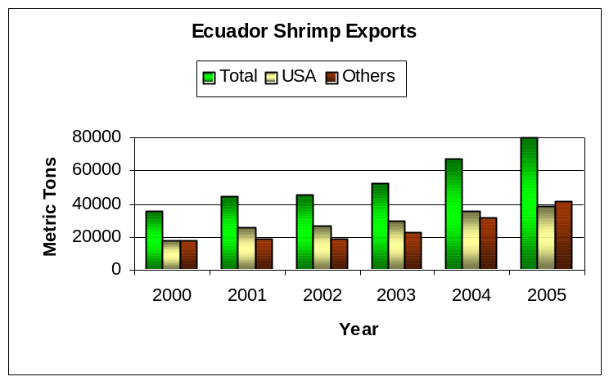

Trade

Ecuador’s wheat imports for MY 2006 are forecasted at 460,000 MT. Imports in CY 2005 reached 457,000 MT, and the MY 2004 figure was revised to 455,000 MT. The MY 2006 forecast is 7 percent over the average of the past ten years, but less that 1% higher than the estimation for MY 2005. The 1995-2005 average is 426,000 MT with a minimum of 303,000 MT in 1995 and maximum of 500,500 MT in 1998.

Imports from the U.S. in the period 1995-2005 were 184,000 MT on average. In CY 2005, imports from the U.S. reached 139,500 MT (30 percent of the market), and Canada continues to be the main supplier of wheat to Ecuador with 287,000 MT and 63 percent market share. Ecuadorian millers perceive high-protein Canadian wheat as more reliable in its milling quality than the American wheat and lower in price. According to the buyers, for the same price or lower price, Canada offers wheat with higher protein and gluten, as well as lower dockage. Aggressive marketing carried out by the Canadian Wheat Board, careful pre-shipment inspection, and economic support of the Canadian Commercial Corporation to Ecuadorian importers helps in maintaining Canada’s market share.

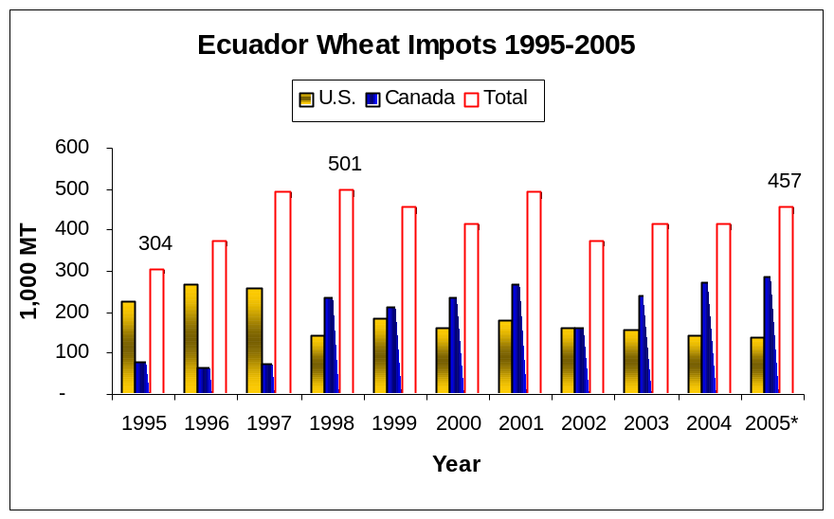

The US Wheat Associates are currently providing technical assistance to selected Ecuadorian millers on the use of U.S. wheat varieties to obtain quality products at lower costs. These activities aim at increasing the preference of U.S. wheat.

As expected, Argentina made an important inroad of 30,380 MT in the Ecuadorian wheat market during CY 2005. These exports took place during the period April-September when the price band registered a variable levy of zero and the final duty on wheat was 10%. As a result of the Ecuador-Mercosur agreement, Argentine wheat paid a reduced ad-valorem of 9% during that period, a fact that may have motivated imports. Also, Ecuadorian millers have in the past used low-protein Argentine wheat to blend with high-protein American or Canadian wheat. The animal feed industry also uses a large portion of the Argentine wheat.

Policy

Wheat is a marker product under the Andean Price Band System, with basic duty of 10 percent plus an additional variable levy, depending on the reference price. In July of 2001, the Government of Ecuador phased–out wheat from the price band system as part of its WTO commitments. However, Ecuador re-included wheat in the price band in August of 2003 arguing an obligation to do so by Andean Community commitments. For the period April 2005 -March 2006, floor and ceiling prices were set at $160 and $180 respectively. The variable levy has ranged between 0% and –10%, thus average tariffs on wheat were 3.6% for most of CY 2005.

Ecuadorian wheat millers support immediate tariff reduction of wheat to zero, and exclusion from the price band system under the current Free Trade Agreement. This, according to the industry, would boost imports of U.S. wheat by making it more competitive by price.

In addition, Ecuador has bilateral trade agreements with Peru and Chile, and multilateral trade agreements with ALADI (Latin American Association of Integration). In 2004, Ecuador reached a tariff liberalization agreement with Mercosur (Argentina, Brazil, Paraguay and Uruguay). Implementation of these agreements in Ecuador was scheduled to start by January 1, 2005, but actual implementation started on April 1, 2005. Wheat has special treatment under the agreements with Mercosur, thus tariff preferences are granted over the total duty, which is comprised of the ad-valorem (basic) duty plus the Andean Price Band variable levy. Currently, trade partners pay tariffs on wheat as follows:

HTS | Product | Paraguay/4 | Uruguay/2 | Argentina/3 | Brazil/3 | Mexico/1 | U.S. and Canada
10011090 | Wheat, durum | 7.5% | 0.3% | 9.0% | 9.0% | 9.2% | 10.0%
10019020 | Wheat, other | 7.5% | 0.3% | 9.0% | 9.0% | 9.2% | 10.0%
/1 Under ALADI.
/2 Uruguay will have reached zero tariffs on wheat by January 1, 2009
/3 Argentina and Brazil will have reached zero tariffs on wheat by January 1, 2018
/4 Paraguay will have reached zero tariffs on wheat by January 1, 2015.

CORN

PSD Table
Country | Ecuador
Commodity | Corn |  |  |  | (1000 HA)(1000 MT)
 | 2004 | Revised | 2005 | Estimate | 2006 | Forecast | UOM
 | USDA Official [Old] | Post Estimate [New] | USDA Official [Old] | Post Estimate [New] | USDA Official [Old] | Post Estimate [New]
Market Year Begin |  | 10/2004 |  | 10/2005 |  | 10/2006 | MM/YYYY
Area Harvested | 113 | 113 | 120 | 110 | 0 | 118 | (1000 HA)
Beginning Stocks | 121 | 75 | 121 | 60 | 181 | 62 | (1000 MT)
Production | 300 | 315 | 360 | 340 | 0 | 365 | (1000 MT)
TOTAL Mkt. Yr. Imports | 450 | 393 | 450 | 417 | 0 | 430 | (1000 MT)
Oct-Sep Imports | 450 | 393 | 450 | 417 | 0 | 430 | (1000 MT)
Oct-Sep Import U.S. | 322 | 311 | 0 | 300 | 0 | 310 | (1000 MT)
TOTAL SUPPLY | 871 | 783 | 931 | 817 | 181 | 857 | (1000 MT)
TOTAL Mkt. Yr. Exports | 50 | 33 | 50 | 35 | 0 | 45 | (1000 MT)
Oct-Sep Exports | 50 | 33 | 50 | 35 | 0 | 45 | (1000 MT)
Feed Dom. Consumption | 600 | 650 | 650 | 680 | 0 | 710 | (1000 MT)
TOTAL Dom. Consumption | 700 | 690 | 700 | 720 | 0 | 760 | (1000 MT)
Ending Stocks | 121 | 60 | 181 | 62 | 0 | 52 | (1000 MT)
TOTAL DISTRIBUTION | 871 | 783 | 931 | 817 | 0 | 857 | (1000 MT)

Import Trade Matrix |  |  |  |  | Export Trade Matrix
Country | Ecuador |  |  |  | Country | Ecuador
Commodity | Corn |  |  |  | Commodity | Corn
Time Period | Jan-Dec | Units: | MT |  | Time Period | Jan-Dec | Units: | MT
Imports for: | 2004 |  | 2005 |  | Exports for: | 2004 |  | 2005
U.S. | 426000 | U.S. | 269000 |  | U.S. | 0 | U.S. | 0
Others |  | Others |  |  | Others |  | Others
Argentina | 31000 | Argentina | 121500 |  | Colombia | 38291 | Colombia | 27446
 |  | Uruguay | 27300
Total for Others | 31000 |  | 148800 |  | Total for Others | 38291 |  | 27446
Others not Listed | 0 |  | 0 |  | Others not Listed
Grand Total | 457000 |  | 417800 |  | Grand Total | 38291 |  | 27446

Production

Corn production in Ecuador is estimated at 365,000 MT on 118,000 Ha for MY 2006/2007 (October/September). Initial production estimations for MY 2005/2006 have been revised to 340,000 MT. This is explained by an area reduction of approximately 10,000 Ha, which were not planted given a drought in production areas during the start of the winter planting season (November and December of 2005).

Given that the first planting occurred in January of 2006, the winter harvest season of MY 2005/2006 is expected to start two months late by May or June. This means that Ecuador will likely need to import corn during at least the first semester of CY 2006.

Production of corn in Ecuador is estimated to remain virtually stagnant in MY 2006/2007 given several factors. The first is a noticeable change in weather conditions, especially during the early stages of the winter planting season. The winter planting and harvest are the largest and represent 80 percent of the total annual production. It is, however, very dependent on rainfalls during the months of and November and December. Another factor is the lack of irrigation systems and very limited access to credit for agricultural inputs such as seeds and agrochemicals.

Production of corn in Ecuador remains inefficient with yields averaging 2.7 to 3.0 metric tons per hectare. However, several private initiatives (especially by the poultry industry) currently provide improved seeds, technical assistance and other inputs to some 10 percent of the planted area, which can reach production yields up to 5 metric tons per hectare.

Consumption

Ecuador’s total corn domestic consumption is estimated at 760,000 MT for Marketing Year 2006/2007, 93 percent of which is consumed by the feed industry. The increased demand is explained by the feed industry’s 6 percent annual growth rate, along with an important annual growth of the poultry and egg industry (8 percent) and a higher per capita consumption of poultry meat in Ecuador (18 to 20 Kg/year). The feed meal compound industry has had an important growth in production in the past 12 years, from 600,000 MT to 1.6 million MT in 2006.

Consumption figures have been revised for MY 2004/2005 and for MY 2005/2006 to reflect the reality of the feed meal compound industry, which currently uses the majority of corn. Some 40,000 MT/Year are being used in MY 2005 for human consumption in the form of snack foods and also as seeds. Another 35,000 MT/Year are exported to Colombia for human consumption.

The poultry industry, with total population of 125 million chickens per year, and annual sales growth rate ranging 5-10%, consumes 80% of the feed corn every year. This industry produces some 185,000 MT of poultry meat, and approximately 70,000 MT of eggs per year. Another sector showing interesting growth is pork, with a population of 1.7 million pigs per year, and which now consumes some 100,000 MT/year. Other industries demanding corn-based feed are shrimp (showing a considerable growth in the past few years), trout and tilapia.

Trade

Ecuador imported 417,800 MT of yellow corn in CY 2005. Approximately 269,000 MT were imported from the United States and the remaining from Argentina and Uruguay. The Ecuadorian feed industry prefers U.S. corn to Argentine corn because of its lower foreign material content, and a faster delivery to Ecuadorian ports. Although the U.S. maintained a 64% market share in 2005, Uruguay made an important inroad to the Ecuadorian market by exporting some 27,000 MT of corn in that year. This broke the homogeneity of Ecuador’s corn purchases between the United States and Argentina since 1999, and shows the first trade effects of the Ecuador-Mercosur tariff liberalization agreement in detriment of U.S. exporters. Further details will be provided under the Policy discussion.

On average, Ecuador has imported 40 percent of its corn demand since 1995, with a minimum of 16,800 MT registered in that year, and a maximum of 457,000 MT in CY 2004. Although the animal feed industry considers Ecuadorian corn as better quality than the American and Argentine product, they purchase the imported corn because of its lower price and availability given that Ecuador has not met the local demand of corn since 1997. In fact, it is not likely that Ecuador will meet its demand in the short term, thus major imports will continue with variations depending on the availability of local production and prices. Corn imports are forecasted at 430,000 MT for MY 2006-2007.

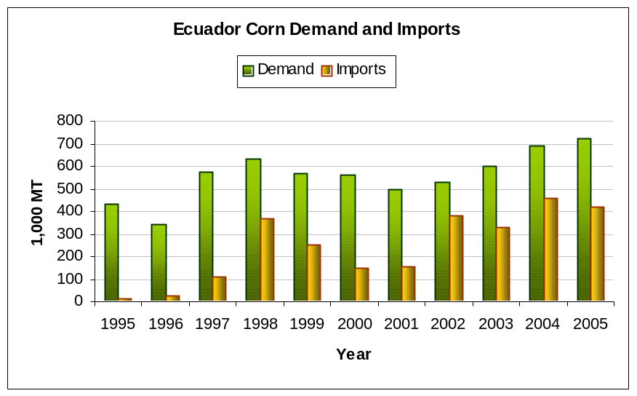

Due to a high demand and good prices paid to Ecuadorian corn in Colombia, Ecuador has exported an average of 60,000 MT/year of corn to that market in the past ten years. These exports usually take place during the peak of the harvest season (May), and are destined for human consumption in the form of “arepa” or tortilla due to the suitability of Ecuadorian corn for such purposes. Exports to Colombia in CY 2004 and 2005 were 38,000 MT and 27,000 MT respectively. Future exports during 2006 are estimated at 45,000 MT.

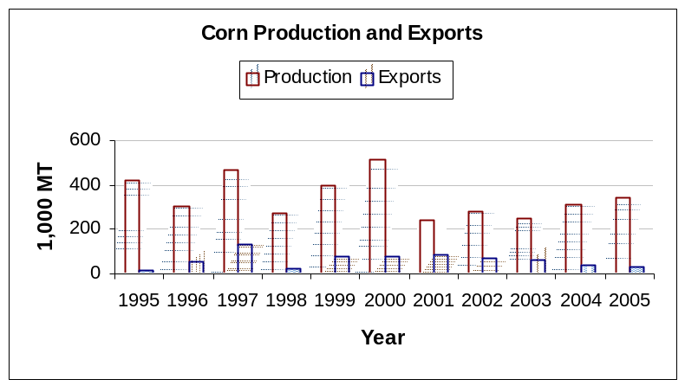

Policy

Corn imports are assessed 15% ad-valorem duty (over CIF), plus a variable levy applied under the Andean Price Band System (APBS). Under this system, the ad-valorem tariffs are adjusted (increased or reduced) depending on the correlation between international reference prices at the time of import, and set floor and ceiling prices. The Andean Community set floor and ceiling prices of corn for the period April 2005 to March 2006 at $126 and $138 per MT. Upon accession to the WTO, Ecuador bound its tariffs (including the additional APBS levy) for corn at 45%. In addition, Ecuador maintains a worldwide TRQ of 19,600 MT of corn at a set tariff of 25%. This TRQ is filled when international corn prices drop and the APBS increases corn duties beyond 25% (15% ad-valorem + a variable levy over 10%).

The Government of Ecuador does not provide any formal subsidy or economic assistance program to promote yellow corn production. However, the Ministry of Agriculture usually encourages corn production by implementing absorption programs, and import bans during the corn harvest season. These absorption programs guarantee the total purchase of the local production at high prices. In September of 2004, the Ministry of Agriculture implemented an absorption program by which the feed industry was obliged to purchase some 300,000 MT of local corn at $185 per MT. A “Consultative Committee” that has the participation of the feed industry, the official sector and a majority of producers makes these decisions. The consultative committee meeting to fix prices for the MY 2005/2006 harvest has not met yet, but it is expected that the last price of $185 per MT will be maintained or even increased.

Under the CAN-Mercosur trade talks, Ecuador has negotiated bilateral tariff reductions with Argentina, Brazil, Paraguay and Uruguay. These tariff reductions apply only to the ad-valorem duties as the Andean Price Band System is maintained for corn. The Ecuador–Mercosur agreement entered into effect in Ecuador on April 1, 2005 and has liberalization schedules of 14 years for most cereals, including corn as follows:

Country of Origin | First Liberalization | Full Liberalization
Argentina | 3 year grace period 2005-2008, 10% reduction starting in January 2008. | In 2018, 100% liberalization
Brazil | In 2005: 10% reduction until 2008. | In 2018: Yearly reduction for 8 years and 100% in 2018.
Paraguay | In 2005, 40% reduction until 2012. | In 2018, 100% liberalization
Uruguay | In 2005, 50% reduction until 2013. | In 2018: Yearly reduction for 8 years and 100% in 2018.

RICE

PSD Table
Country | Ecuador
Commodity | Rice, Milled |  |  |  | (1000 HA)(1000 MT)
 | 2004 | Revised | 2005 | Estimate | 2006 | Forecast |  | UOM
 | USDA Official [Old] | Post Estimate [New] | USDA Official [Old] | Post Estimate [New] | USDA Official [Old] | Post Estimate [New]
Market Year Begin |  | 01/2004 |  | 01/2005 |  | 01/2006 |  | MM/YYYY
Area Harvested | 215 | 205 | 230 | 230 | 0 | 215 |  | (1000 HA)
Beginning Stocks | 262 | 98 | 192 | 72 | 195 | 76 |  | (1000 MT)
Milled Production | 430 | 430 | 513 | 490 | 0 | 480 |  | (1000 MT)
Rough Production | 694 | 694 | 827 | 790 | 0 | 774 |  | (1000 MT)
MILLING RATE (.9999) | 6200 | 6200 | 6200 | 6200 | 0 | 6200 |  | (1000 MT)
TOTAL Imports | 5 | 0 | 5 | 0 | 0 | 0 |  | (1000 MT)
Jan-Dec Imports | 5 | 0 | 5 | 0 | 0 | 0 |  | (1000 MT)
Jan-Dec Import U.S. | 0 | 0 | 0 | 0 | 0 | 0 |  | (1000 MT)
TOTAL SUPPLY | 697 | 528 | 710 | 562 | 195 | 556 |  | (1000 MT)
TOTAL Exports | 85 | 1 | 85 | 21 | 0 | 25 |  | (1000 MT)
Jan-Dec Exports | 85 | 1 | 30 | 21 | 0 | 25 |  | (1000 MT)
TOTAL Dom. Consumption | 420 | 455 | 430 | 465 | 0 | 470 |  | (1000 MT)
Ending Stocks | 192 | 72 | 195 | 76 | 0 | 61 |  | (1000 MT)
TOTAL DISTRIBUTION | 697 | 528 | 710 | 562 | 0 | 556 |  | (1000 MT)

Export Trade Matrix
Country | Ecuador
Commodity | Rice, Milled
Time Period | Jan-Dec | Units: | MT
Exports for: | 2004 |  | 2005
U.S. | 0 | U.S. | 0
Others |  | Others
Colombia | 1476 | Colombia | 20636
Total for Others | 1476 |  | 20636
Others not Listed | 0 |  | 0
Grand Total | 1476 |  | 20636

Production

Ecuador’s milled rice production for MY 2006 (January-December) is estimated at 480,000 MT on 215,000 Ha with the first harvest starting late in May or June of 2006. The small decline in the planted area responds to the lack of rainfalls registered in production areas without irrigation (65% of the area), where some farmers lost their crops or refrained from planting until rainfalls began.

In late December, the Government of Ecuador declared the agricultural sector in emergency due to a drought that was affecting some areas specialized in cattle breeding and other smaller areas where rice is normally produced. However, as rains normalized during January in non-irrigation rice areas, some 50,000 Ha are currently being re-planted. Another factor that may be discouraging farmers from producing rice is the low price registered in 2005 along with the high production cost of approximately $620 per hectare.

Production figures for MY 2004 and MY 2005 have been revised to reflect the latest available information. Production for MY 2005 was 490,000 MT, and actual exports were less than estimated thus Ecuador did not need to import rice during MY 2005.

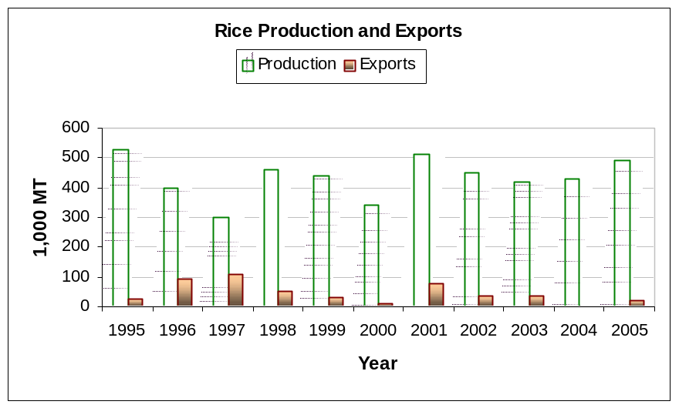

Consumption

Rice is a staple food of Ecuadorians for two meals a day and the majority of Ecuador’s production is consumed locally. Monthly consumption is estimated at 39,000 MT per month, roughly 470,000 MT in MY 2006. Current per capita consumption is calculated at 40 Kg. per month, and this is explained by higher prices of alternative staples, such as bread or pasta. Rice is also replacing other traditional staples in the highlands, such as quinoa and even potatoes.

Rice sales are traditionally marketed through wholesalers in one hundred pound sacks (45 Kg) or in small stores by pounds. Prices vary depending on the marketing channel. For example, the wholesale price of the 45 Kilogram sacks is $26, while sales by the pound can make the price grow to $32 per sack. Some 80 percent of rice sales are made in sacks or by the pound. In addition, as a result of supermarket expansion in the main cities of Ecuador, purchasing habits have shifted towards buying presentations of 2 or 5 kg, with a brand name. It is estimated that 15 percent of total rice sales are now made trough supermarkets under these presentations. The majority of rice produced and consumed in Ecuador is short according to U.S. standards.

Trade

Ecuador has imported minimal quantities of paddy rice in the last ten years since 1995, except in 1998 where weather-related losses made imports grow to 140,000 MT, mostly paddy. If Ecuador’s production capacity were to continue as now, it is unlikely that Ecuador will be in need to import rice in the future.

White, milled rice exports to Colombia were reestablished in 2005 after very low exports in 2004. Exports reached 21,000 MT in 2005, and are forecasted at 25,000 MT in MY 2006.

Policy

Rice imports are very sensitive issue in Ecuador. The Government of Ecuador is pushing a self-sufficiency program for rice by continuing to implement the Andean Price Band System (APBS) and by controlling imports. APBS floor and ceiling prices for the period April 2005-March 2006 have been set at $241 and $265 per MT. The final tariff during the most part of 2005 was 0%.

In addition, the Ministry of Agriculture’s Consultative Committee on rice, consisting of producers, millers and government officials decide on the timing and quantity of rice imports. The Ad-valorem duty for paddy rice is set at 15 percent, and 20 percent for all other types of rice. Andean Community Nations (CAN) are assessed zero tariffs and are not assessed the Andean Price Band. Other Latin American countries have been granted ad-valorem tariff preferences under ALADI, but they still are assessed the Andean Price Band:

HTS | Description | U.S. & World | CAN | Peru | Chile | ALADI *
 |  |  |  |  |  | Paraguay | Uruguay | Argentina | Brazil | Mexico
10061090 | Rice, Paddy | 15% | Zero | Zero | 15% | 15% | 7.5% | 15% | 15% | 15%
10062000 | Rice, Brown | 20% | Zero | Zero | 20% | 20% | 10% | 20% | 20% | 20%
10063000 | Rice, Milled | 20% | Zero | Zero | 20% | 12% | 10% | 20% | 20% | 20%
10064000 | Rice, Broken | 20% | Zero | Zero | 20% | 20% | 10% | 20% | 20% | 20%

* ALADI stands for Latin American Integration Association.

