MODULE 3:

Protecting
and
Safeguarding FPLS
and
other
Child Support Information
Training Notes
- While the primary emphasis of this module is on access to FPLS data, the module also deals with all child support data and covers topics such as customer service, penalties for misuse of child support data, dealing with special cases, and physical precautions that can be taken in child support offices to protect the data.
- Display: Module 3, PowerPoint slide 1

Protecting and Safeguarding FPLS and other Child Support Information

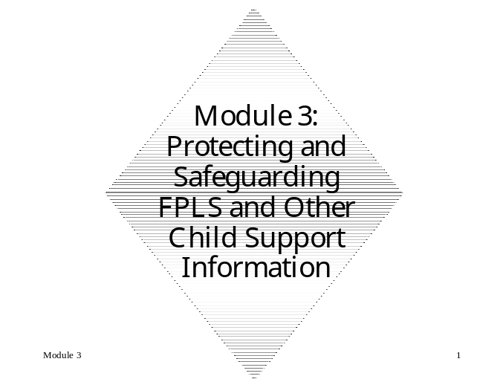
training notes
- This module emphasizes that access to FPLS data is governed by Sections 453 and 463 of the Social Security Act. These sections outline a two-prong test to determine who may have access to FPLS data, and for what purposes they may request access to the data. The data may be obtained only by authorized users, and then only for authorized purposes. Once you have identified an authorized user (the who) for an authorized purpose (the why), the how and what can be determined. The how is almost always that the request for FPLS data must be submitted through the State IV-D agency. The what is associated with the type of information that is returned to the requestor based on the who and the why.
- It is very important to note the intent of this module is to acquaint the participants with §453 and §463 and to emphasize the two-prong test. Our intent is to cover the most common requestors and reasons to which a child support worker will be exposed. The trainer must not fall into the trap of answering participants’ case-specific questions regarding who constitutes an authorized user or what constitutes a valid reason. These questions and the interpretation of §453 and §463 can only be addressed by the Policy and Planning Division of the Federal Office of Child Support.
- Display: Module 3, PowerPoint slide 2
- Discuss learning objectives.

Module Objectives

The learning objectives for this module are to enable participants to describe:

- For the FPLS data, describe:
- WHO: Identify who is authorized by statute to request information from the FPLS
- WHY: Identify the purposes for which an authorized person may request information from the FPLS
- HOW: Describe how an authorized person may request information from the FPLS
- 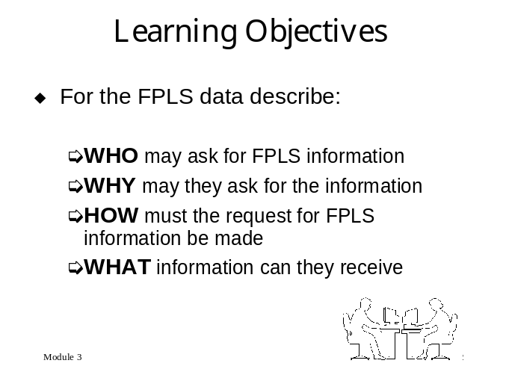WHAT: Identify what information is available from the FPLS in response to a request from an authorized person for an authorized purpose

training notes
- Display: Module 3, PowerPoint slides 3 and 4
- Explain the statutory State and federal requirements for safeguarding FPLS and other child support information
- Describe the penalties for unauthorized access to and use of FPLS and other child support information
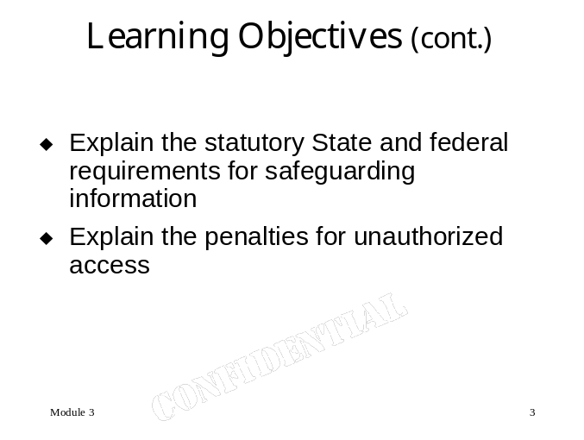
- Discuss some of the confidentiality issues that arise in the context of customer service
- Discuss and list ways to protect child support information

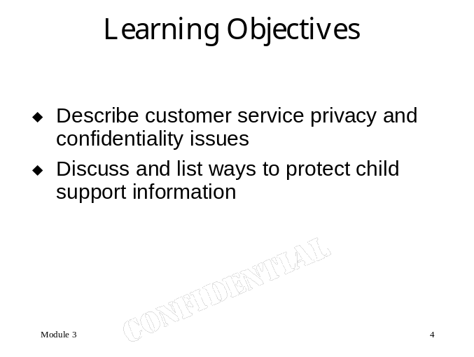

TRAINING NOTES

Introduction
First, let’s talk about security and what it means to the child support program. When we talk about security, traditionally, we talk about equipment—PC’s, printers, and the like. However, we live in an era in which the rapid increase in computerized business transactions has increased public concern about the security of the personal information available to businesses and government.

We have looked at the information that is available, how easy it is to access, and how it may affect you. Now, let’s explore the safeguards against the release of the data.
Training notes
- Review what the FPLS is:
- NDNH
- External locate sources
- Proactive matching
- Display: Module 3, PowerPoint slide 5

Requests for Information from the FPLS—the Who, Why, How, and What

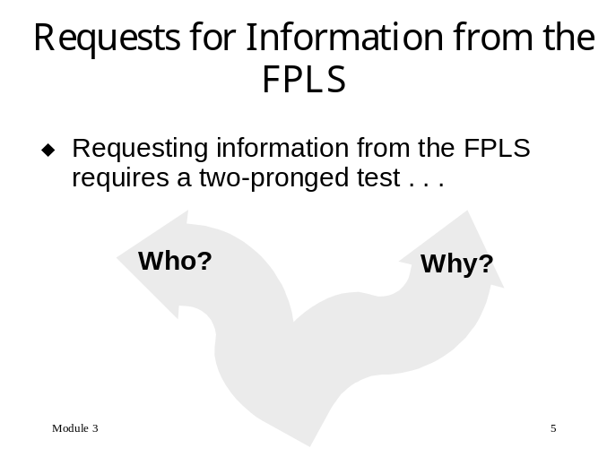

The federal government safeguards both the security and privacy of information contained in the records they access and maintain.

State and local child support agencies are required to understand and adhere to federal disclosure laws relative to the authorized disclosure of information.
training notes
- Display: Module 3, PowerPoint slides 6 and 7

FPLS Access
    - Access from the FPLS is a two prong test—Once you determine the Who and Why then you can move onto the How and What.
- Who: A request must be from an authorized person and
- 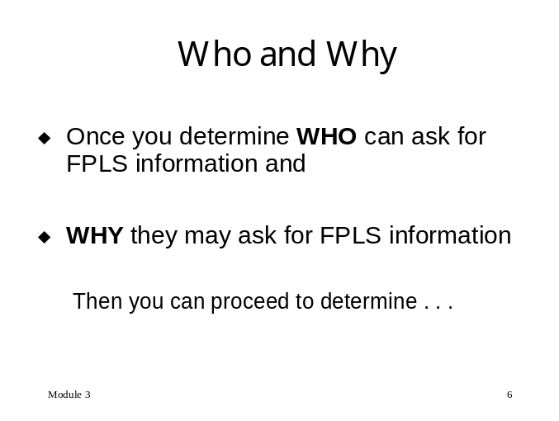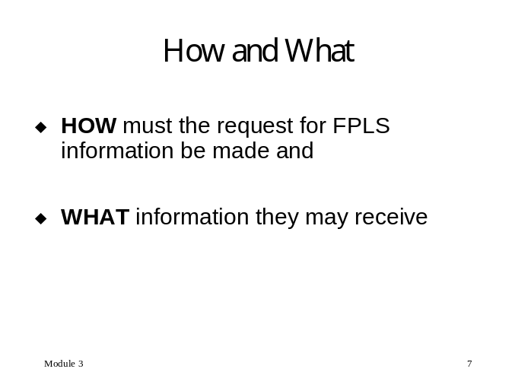Why: For an authorized purpose
- How: Requests are made through a State IV-D agency
- What: The information which is returned is determined by the Who and Why

training notes
- Sections 453 and 463 refer to Sections of the Social Security Act. These two pieces of legislation govern access to the FPLS data.
- You can refer participants to the Appendix, beginning at page 1 where they will find the text of both Acts.
- Display: Module 3, PowerPoint slide 8
- Tell participants that Action Transmittal AT-99-09 in the Appendix, page 3, deals with requests for information from the FPLS pursuant to Section 453 and 463 requests.

- 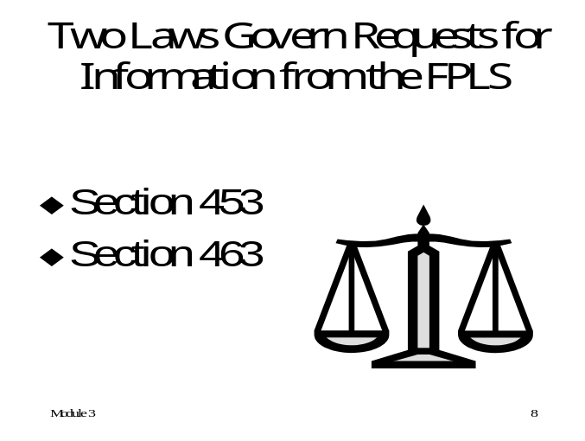Two laws govern requests for information from the FPLS:
- Social Security Act Section 453
- Social Security Act Section 463

training notes
- Display: Module 3, PowerPoint slides 9 and 10
- §453 of the Social Security Act governs requests for child support purposes
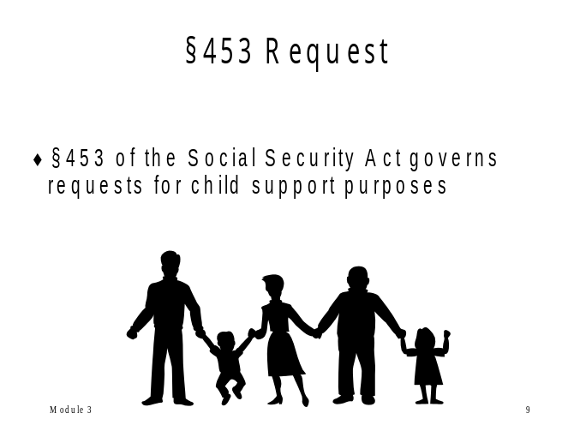
- §463 of the Social Security Acts governs requests for custody and visitation purposes, or in matters of a parental kidnapping

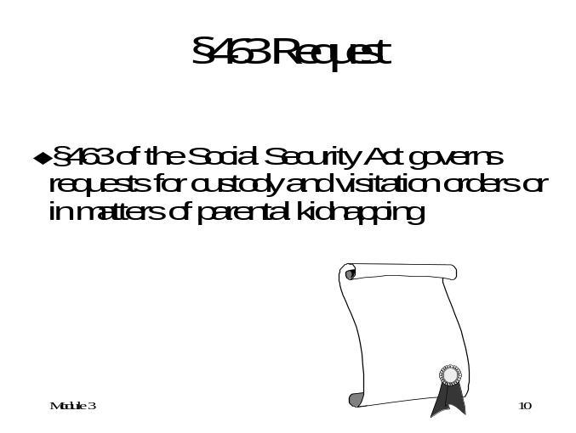
training notes
- We’re going to take a look at Section §453 first. It deals with access to FPLS information for child support purposes.
- 45 CFR §303.70 deals with requests by the State Parent Locator Service (SPLS) for information from the FPLS. Refer to the Appendix, page t view 45 CFR §303.70.
- Display: Module 3, PowerPoint slide 11

§453 Request—Requests for Child Support Purposes
§453 Request—§453 of the Social Security Act governs requests for child support purposes

Who may request FPLS information for a child support purpose?
    - IV-D agency
    - A court or an agent of a court with authority over child support matters
    - The “resident parent” (i.e., custodial parent), legal guardian, attorney, or agent of a child not receiving TANF
    - A State foster care or child welfare agency
    - IV-B and IV-E agencies have access to administer such programs through requests to the SPLS in accordance with 45 CFR §303.70.

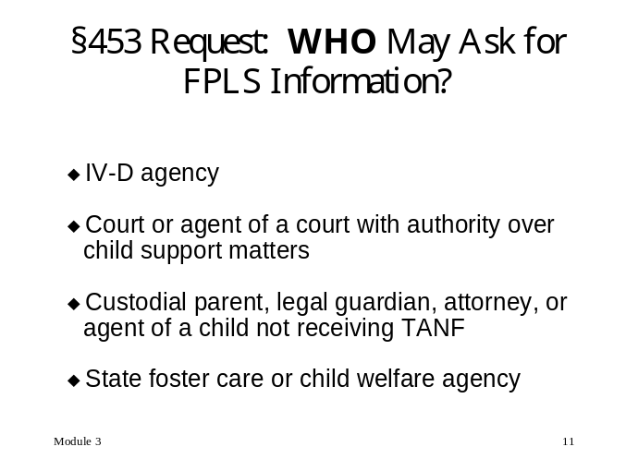

training notes
- Display: Module 3, PowerPoint slide 12
- Now that we’ve looked at the authorized users under Section §453, let’s look at the authorized purposes.

For what purposes may an authorized person request FPLS information under §453? For the purpose of:
    - Establishing parentage
    - Establishing, setting the amount of, modifying, or enforcing a child support obligation
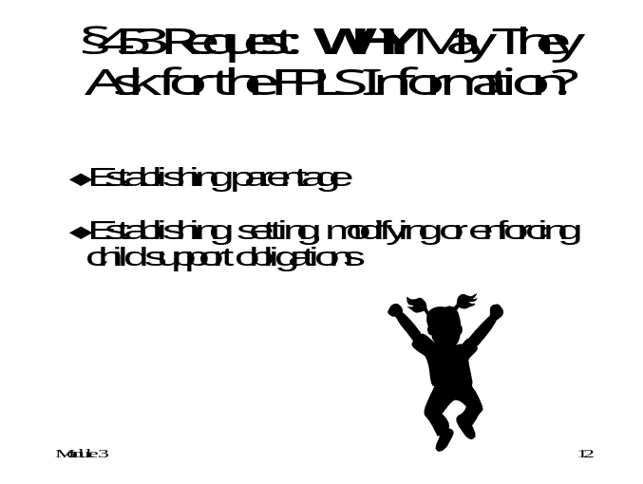

training notes
- Now let’s look at how the request must be made.
- Display: Module 3, PowerPoint slide 13. Emphasize the request must go through the IV-D agency. Explain that there is an annual certification that each State IV-D Director submits to the FPLS.

If an authorized person is requesting FPLS information for an authorized purpose under §453, how must the request be made?
    - All requests for information from the FPLS should be sent through the State Parent Locator Service (SPLS) at the State Child Support Agency pursuant to 45 CFR §303.70
    - Annually the State IV-D Directors submit a certification indicating that all the cases being submitted to FPLS are for a statutorily authorized purpose and will be safeguarded and treated confidentially

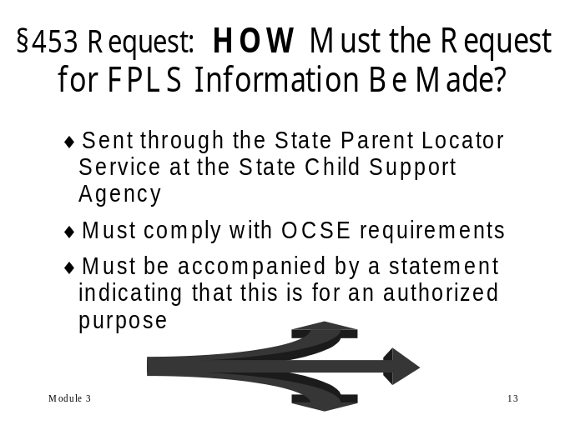
training notes
- Display: Module 3, PowerPoint slide 14
- Do not dwell on this. Basically the FPLS will return whatever information is available to the requestor.
- Asset information is currently available from the IRS and provisions of the Internal Revenue Code restrict this information to IV-D agencies.
- While the Act provides for debt information, this information is not currently being provided.
- Are there any questions on §453 requests?
- If there are no questions introduce §463 by saying that it governs requests for FPLS information for reasons other than child support.

What information is available from the FPLS in response to a request under §453?
    - Location information
    - SSN
    - Address
    - Employer’s name, address, and Federal Employer Identification Number (FEIN)
    - Wage and employment information
    - Asset information
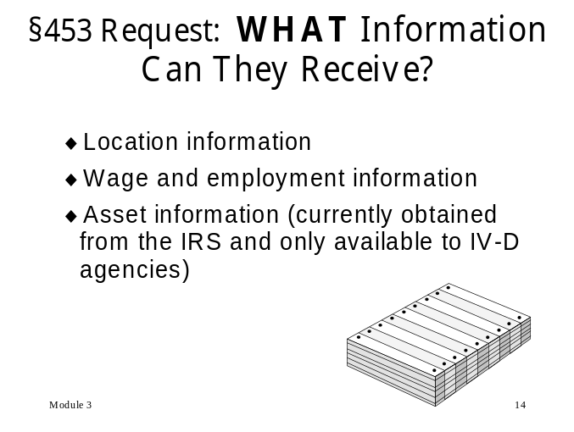
training notes
- Display: Module 3, PowerPoint slide 15 and explain bullet points.
- Now let’s take a look at who is an authorized user under §463.

§463 request—Request for Custody, Visitation, and Parental Kidnapping Purposes
§463 Request—For purposes of custody and visitation orders, or in a case of parental kidnapping

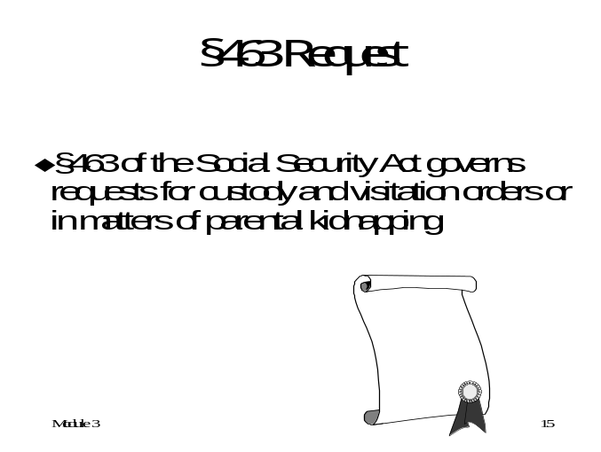
training notes
- Display: Module 3, PowerPoint slide 16 and explain bullet points.

Who may request FPLS information under §463?
    - An agent or attorney of a State who has the authority under the law of the State to enforce a child custody or visitation determination
    - A court with jurisdiction to make or enforce a child custody or visitation determination, or any agent of such court
    - Any agent or attorney of the United States, or of a State who has the duty or authority to investigate, enforce, or bring prosecution with respect to the unlawful taking or restraint of a child (referred to as parental kidnapping cases)

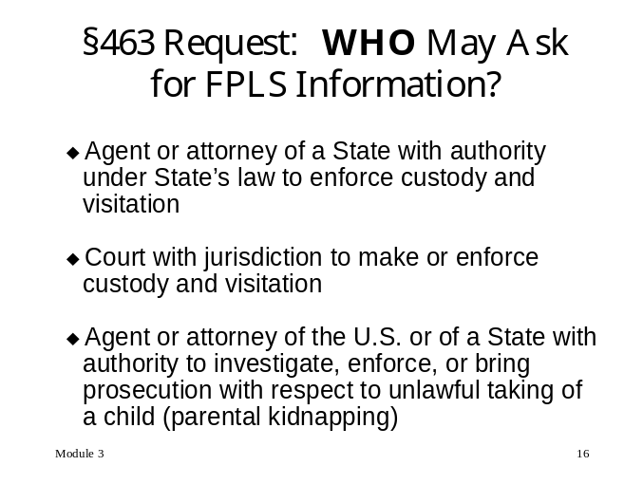
training notes
- Now let’s see what the authorized purposes are under §463.
- Display: Module 3, PowerPoint slide 17 and explain the bullet points.

Why may an authorized person request FPLS information under §463? For the purposes of:
    - Enforcing any State or federal law with respect to the unlawful taking or restraint of a child
    - Making or enforcing a child custody or visitation determination
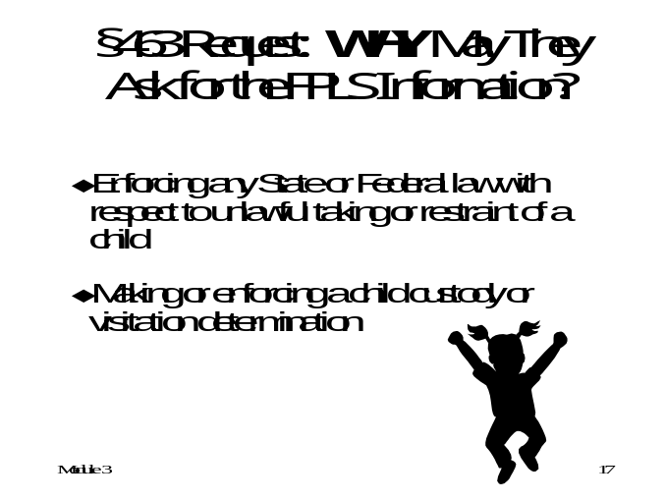

training notes
- Display: Module 3, PowerPoint slide 18.
- Notice that it is identical to how requests must be submitted under §453.

If an authorized person is requesting FPLS information under §463, how must the request be made?
    - All requests for information from FPLS should be sent through the State Parent Locator Service at the State Child Support Agency pursuant to 45 CFR §303.70
    - Annually the IV-D Directors submit an annual certification indicating that all the cases being submitted to FPLS are for a statutorily authorized purpose and will safeguarded and treated confidentially
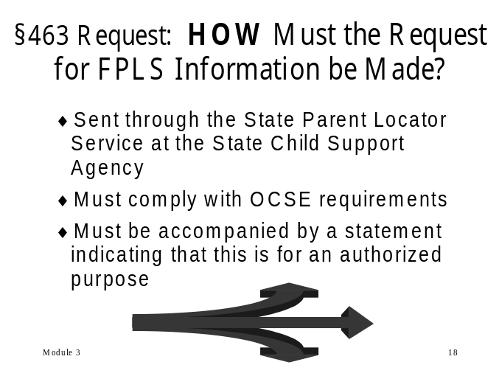

training notes
- Let’s look at what data is returned for §463 requests.
- Display: Module 2, PowerPoint slide 19

What information is available from the FPLS in response to a request under §463?
    - Most recent address
    - Place of employment

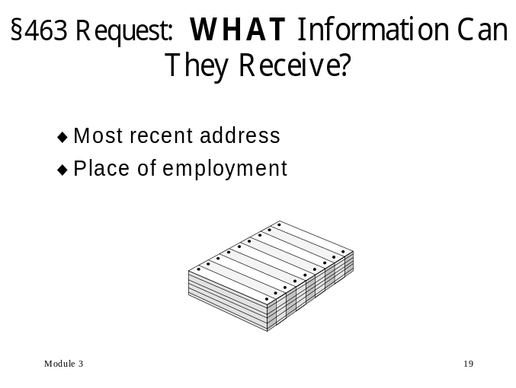

training notes
- Display: Module 2, PowerPoint slide 20. Review the two-prong test. Emphasize:
- The who’s and why’s cannot be mixed or matched from §453 and §463 to create a valid request. For example, a valid who from §453—a child support worker—could not request FPLS data for the purpose of enforcing a child custody order—a valid why under §463.
- §453 and §463 govern access to FPLS data only. However, the two-pronged approach is a good rule-of-thumb to keep in mind for requests for access to any child support information.
- It is important at this point to discuss the following point. As more and more States automate the integration of FPLS data returned from the NDNH and FCR through proactive matching, it will be more difficult for the average child support worker to discern the source of the data in their cases. For this reason, child support workers will need to apply the two-prong test to requests to the case data on an ever-increasing basis.
- Ask if there are any questions regarding access to FPLS data, §453, or §463. If not, turn off the overhead projector or projection system and set up for the review exercises.

Summary of Requesting Information from the FPLS
So the “Who, Why, How and What” are critical factors in the determining who may request FPLS information.

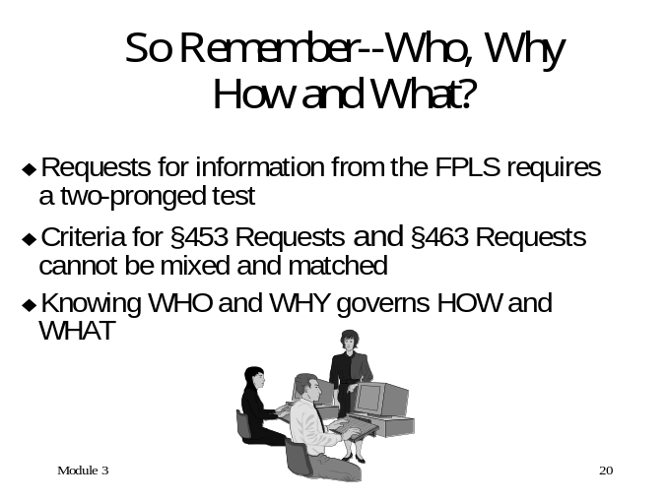
training notes
- Refer participants to the independent Case Scenario Activity in the Appendix, page .
- Allow about 15 minutes to complete this exercise. While the participants are completing this exercise, set up for the flannel board exercise. See directions on page o the Appendix.
- Solicit answers from the participants. The correct answers are:
- # 1 = No. A police officer is not an authorized person under the statute.
- # 2 =Yes. §453
- #3 = Yes. §453
- #4 = No. A Grandmother is not an authorized person under the statute.
- #5 = No. This is not an authorized purpose for which a social worker may request this information under either statute.
- #6 = No. A private attorney is not an authorized person under statute.

Case Studies
Your trainer will guide you through this exercise designed to test your knowledge of Sections 453 and 463.

Independent Activity
    - When instructed by your trainer, turn to page i the Appendix, for the Case Scenario Exercise. Read through each scenario and answer the questions appropriately. When finished, your trainer will review and discuss the answers.
    - Take about 15 minutes to complete this exercise independently.

training notes
- Directions for the flannel board exercise start on page o the Appendix.

Group Activity
    - Flannel board exercise
    - Interactive, instructor-led exercise
training notes
- While §453 and §463 govern access to child support information provided by the FPLS, there is a lot of information which is acquired through State and local sources.
- What legislation or rules apply to this information?
- It might be beneficial to review (ask participants to provide) the list of State agencies that provide locate information and what data they provide. Note that some agencies have their own laws, regulations, and disclosure statements, which govern access to their information. Ask participants for some examples.
- Briefly discuss with participants the laws that govern access to their child support information in their individual States. If training workers from a specific State, you should research this topic prior to the training and provide the necessary information to the participants.

Persons Authorized to Obtain Information for Authorized Purposes—State Requirements

Child support agencies are required to understand and adhere to federal and State disclosure laws relative to the authorized disclosure of information.

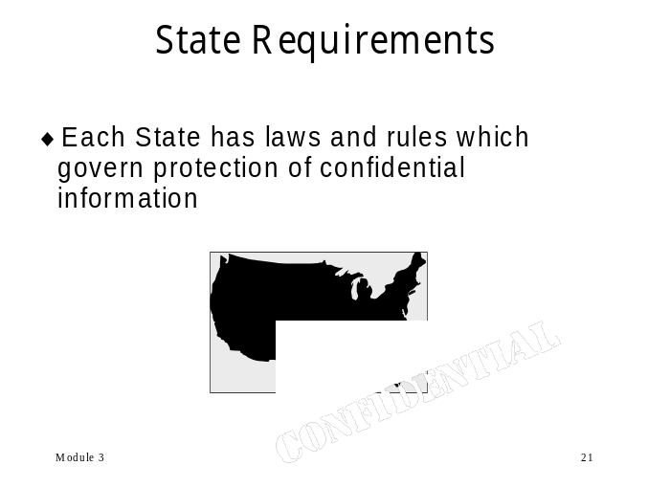Each State may have established laws and rules which govern the protection of confidential information, who can access it, and for what purposes.

training notes
- Display: Module 3, PowerPoint slide 22
- So, now we know who, why, how, and what. What happens when we violate this and provide information to an unauthorized person?
- Ask participants to indicate any other penalties for unauthorized disclosure.
- How does your State train employees on security, privacy, and confidentiality of data?

What are the penalties for wrongfully disclosing State-acquired information?

For most child support workers, violation of the rules governing security would be a civil or criminal offense, resulting in suspension or loss of employment, the imposition of fines or jail time, and the potential for personal financial liability.

- Do you know what penalties you and/or your State would suffer if you provided information to inappropriate personnel?

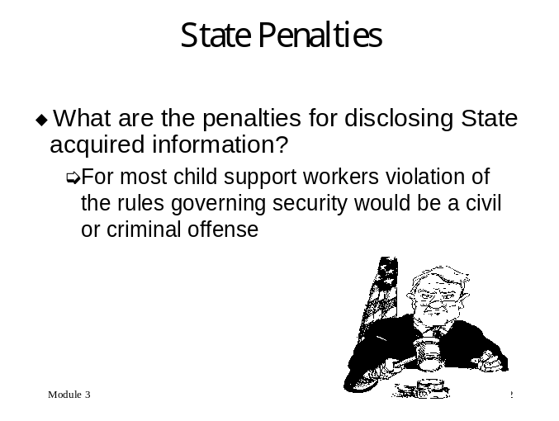
training notes
- On the next page are some examples of State penalties. Ask participants if they have other examples or stories they can share with the class.
- Display: Module 3, PowerPoint slide 23

Examples of State penalties
    - Any employee or other person who has access to records in an official capacity and violates the safeguarding provisions commits a misdemeanor. The offense is punishable by fine, imprisonment, or both.
    - Failure to comply with the guidelines on confidentiality, or any unauthorized accessing of tax or child support information, will result in the imposition of progressive discipline. However, should the particular facts and circumstances warrant it, discipline for a first-time violation may begin at a higher level, up to and including termination.
    - Any unauthorized disclosure of State or federal tax returns or return information may subject employees to criminal penalties.
    - Unauthorized disclosure of child support data is prohibited; any violation is punishable by a fine of $1,000 or by imprisonment or both and by disqualification from holding office in the Commonwealth for such a period as the court determines, not exceeding three years.
    - Prohibits disclosure of any information, which was obtained to identify or locate a NCP, or to evaluate his or her ability to pay support. Violation of this section is punishable by a fine of $100 and administrative disciplinary proceedings.

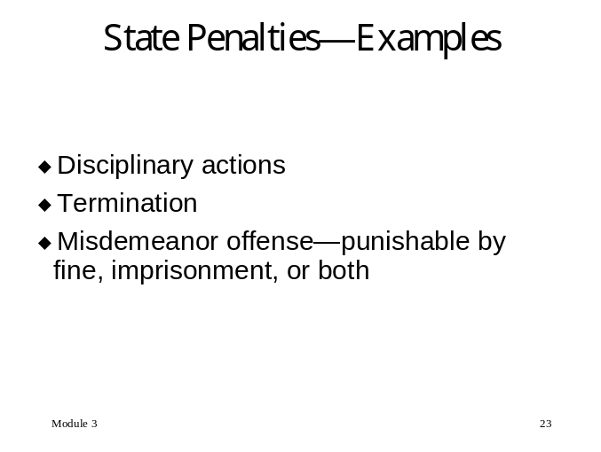
training notes
- We’ve looked at the Federal laws governing FPLS data. What other Federal laws or guidelines are States expected to obey with regard to all child support information?
- Display: Module 3, PowerPoint slide 24 and explain bullet points.

What the federal government requires of the States

Section 454(26) of the Social Security Act
    - States must have in effect safeguards, applicable to all confidential information, that are designed to protect the privacy rights of the parties and should include:
- Safeguards against unauthorized disclosure of information
- 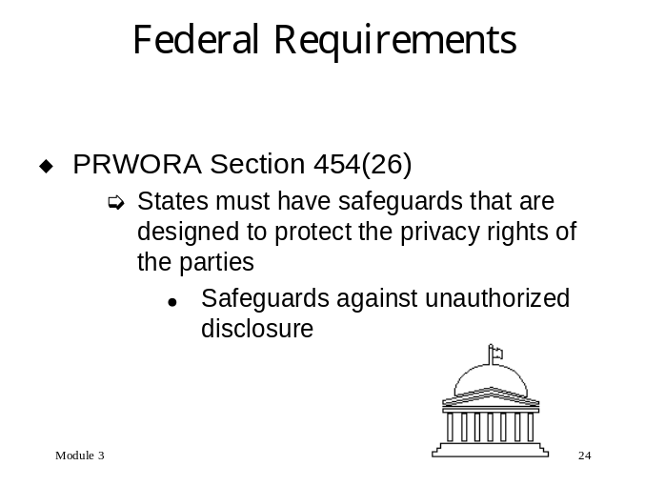Prohibitions against the release of information on the whereabouts of one party to another against whom a protective order has been entered

training notes
- Display: Module 3, PowerPoint slide 25 and explain bullet points.
- The Family Violence Indicator (FVI) is set by each State to prohibit information from the FPLS be released on cases in which there is evidence of family violence. Each State determines if the case should have an FVI. If the FVI is in place when the FPLS conducts proactive matching, OCSE will send no data back to the State(s). For a locate request, the answer from the FPLS will be “Disclosure Prohibited—DP Code”.

Family violence indicator
  - Prohibitions against the release of information on the whereabouts of one party to another if the State has reason to believe the release may result in physical or emotional harm to the other party.
- The Family Violence Indicator (FVI) is a data element that is set in the SCR and transmitted to the FCR
- Federal law forbids the FPLS from disclosing data to any person when a State has reasonable evidence of domestic violence or child abuse.
- State criteria for determining when to use the FVI:
- Protection Orders
- Good Cause (TANF)
- Self Reports
- Child Abuse Reports/Cases
- 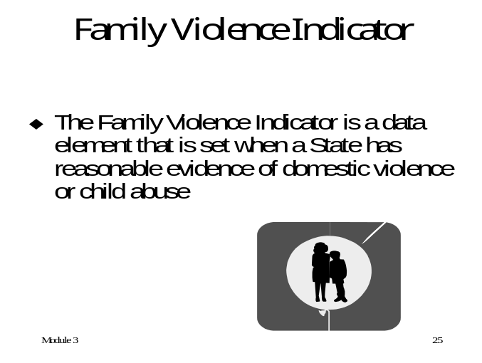Worker Knowledge

training notes
- Display: Module 3, PowerPoint slide 26 and explain the bullet points.

Subsection 454A(16) of the Social Security Act
  - Requires the State IV-D agency to have safeguards in the automated system ensuring the integrity and accuracy of the data. These safeguards shall include:
- Written policies concerning access to data by State agency personnel and sharing of data with other persons
- System controls (such as passwords or blocking of fields) to ensure direct adherence to the policies
- 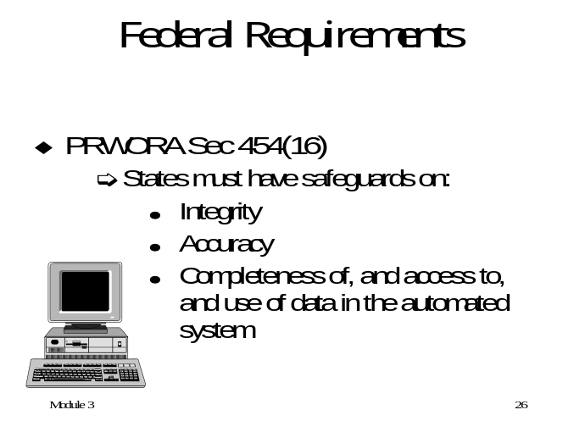Routine monitoring of access to and use of the automated system

Training notes
- Display: Module 3, PowerPoint slide 27 and explain the bullet points.

- Procedures to ensure that all personnel who may have access to or be required to use confidential program data are informed of applicable requirements and penalties and are adequately trained in security procedures
- Administrative penalties (up to and including dismissal from employment) for unauthorized access to, or disclosure of, confidential data

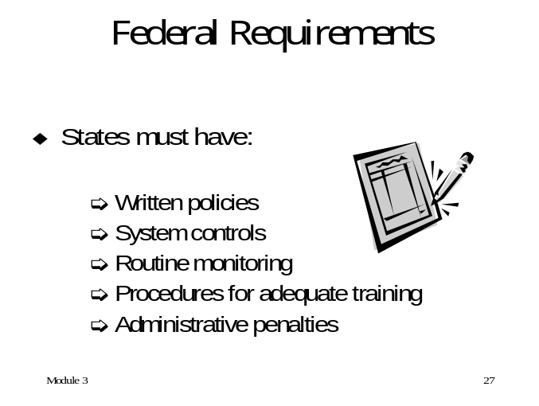
training notes
- Display: Module 3, PowerPoint slide 28

Disclosure Restrictions

Release of IRS information
    - Internal Revenue Code (IRC 6103(1)(6))


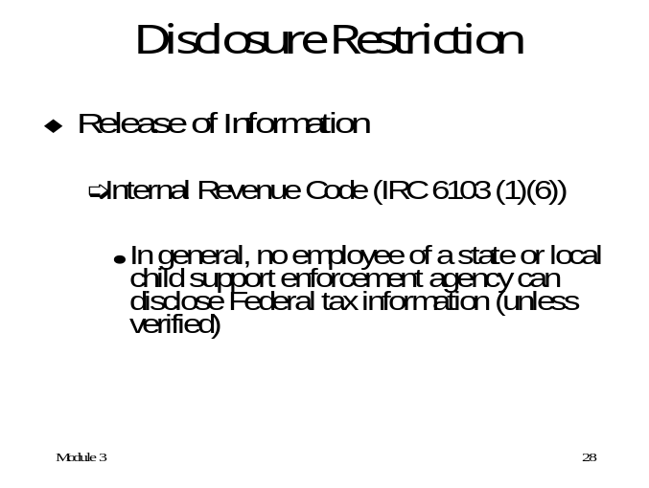
training notes
- Let’s talk about the misuse of data. First, let’s define misuse.
- Go over the definition of misuse as stated on the page.
- Display: Module 3, PowerPoint slide 29

misuse of data

What is misuse?
Knowingly and willfully requesting or obtaining any information under false pretenses for unauthorized purposes

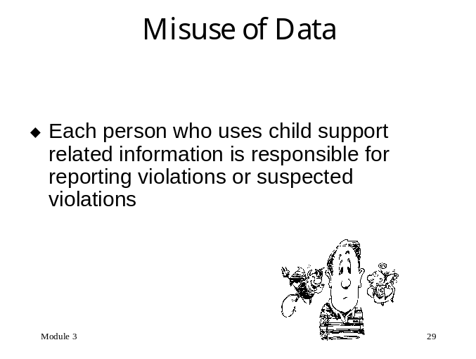
training notes
- How does your State or office handle incidences of misuse of data?
- Display: Module 3, PowerPoint slide 30
- Discuss why the activity—regardless of its seeming innocence—is not allowed and could result in harm. Is the activity, although not for criminal use, still a violation?
- Name some other seemingly “innocent” misuses of data.
- Remind participants that there is no innocent misuse of data.

Reporting Misuse
    - Does your State have clear regulations on what constitutes misuse of data? Reporting requirements?
    - Does your State have written policies and procedures to follow if someone is suspected of misusing data? For example, administrative leave with/without pay, suspension, etc.
    - State examples:
- Each person who uses child support related information is responsible for reporting violations or suspected violations.
- Any violations of the federal or State disclosure statutes should be referred to the Office of Internal Affairs. (Can be anonymous)

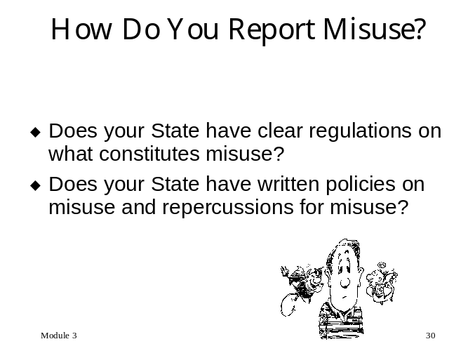

training notes
- In almost every child support office there are certain “special” cases. These include celebrity cases, politicians, IV-D employee cases, etc.
- Ask participants if they have any stories to share regarding “special cases.”
- OCSE has access to the Social Security Administration (SSA) database. At SSA there are restrictions against employees accessing celebrity files. An SSA worker cannot routinely access files on celebrities (for example The President, high profile politicians, movie stars, etc). An OCSE employee wondered if OCSE had the same restrictions about accessing these celebrity files. She remembered reading that day in the newspaper that it was former President Reagan’s seventieth birthday. So she did the calculations and figured out his birth date and tried to access his SSA file. The access was denied, so the worker just concluded that OCSE was also prohibited from accessing the celebrity files. The next day, several black cars pulled up to OCSE and the Secret Service came to OCSE demanding to see the worker. SSA not only had the celebrity files blocked but also knew exactly who had tried to access the file. Needless to say the OCSE worker was in a little bit of hot water.
- Display: Module 3, PowerPoint slide 31
- What kind of measures does your State take to secure “confidential” files?

What kinds of security measures are in place to prevent employees from reviewing “special” cases?

Consider keeping cases separate (physically and automatedly secure)
    - Employees’ cases
    - Domestic violence cases
    - Celebrity cases

Example from States:
    - Counties may establish processes in which specific case records are worked only by a supervisor or worked manually. Any employee with a personal interest in a case shall not engage in any child support enforcement work activity related to that case
    - Employees are given access only to certain counties and screens. Through software in the statewide automated system, employees can be prevented from seeing sensitive cases on the automated system. This is to prevent access to cases in which an employee has a personal interest

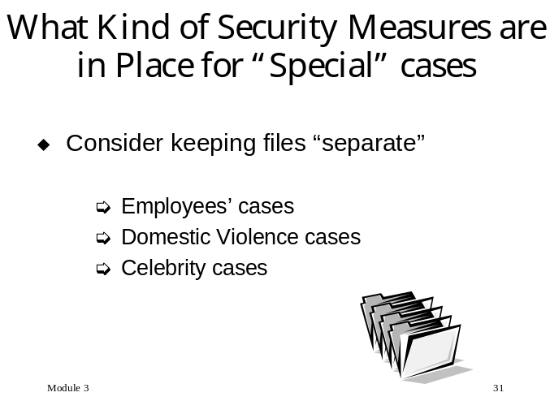
training notes
- Display: Module 3, PowerPoint slide 32
- One of the dilemmas that we, as child support workers, face is that of balancing customer service with the right to privacy. We want to be as helpful to our clients as possible, but we can’t disclose more than we are allowed. We saw this depicted in our video.
- The customer service area may not have clear-cut procedures, laws, or regulations in many of the newer ways of communication. Ask participants for their State procedures. Flip chart for “best practices” from each State.
- Ask participants: Has your office had discussion in this area? Write input on flipchart

Customer Service
How do we balance customer service (the right to know) with privacy and security?

Customer service is a critical function in the child support program. Each day, thousands of child support employees across the country access various data sources in order to serve the needs of the public. However, if an individual employee violates the privacy of the people served, he or she jeopardizes the reputation of the child support agency, as well as destroys the trust of the people we serve.

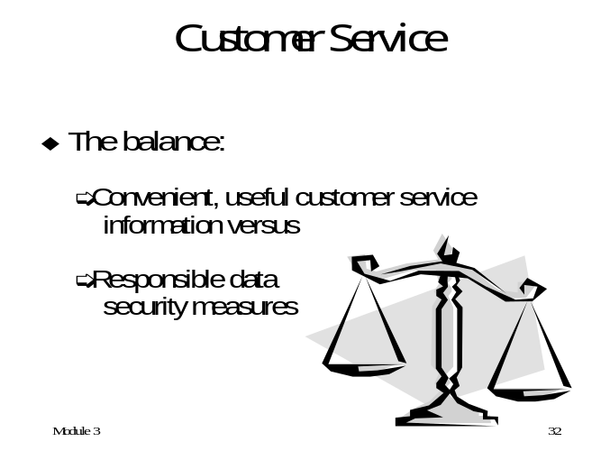
training notes
- Display: Module 3, PowerPoint slide 33 and discuss bullet points.

Phone Contacts
    - Do you know with whom you are talking? What measures do you take to make sure it is appropriate to disclose information to the caller?
- Suggestion: Verify requestor’s identity. Ask for unique identifying information such as SSN, court case number, IV-D case number and/or birth dates for children.
- Do you know what information is appropriate to disclose to the caller?
- 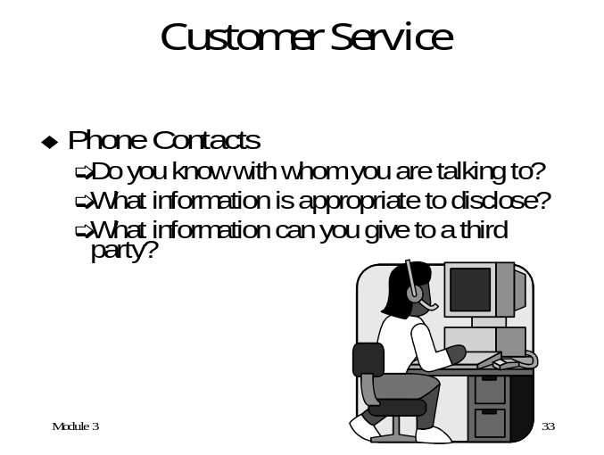Third party request. Do you know if it is appropriate to disclose information to a third party? For example, would you release information to the custodial parent’s current spouse? Mother?

training notes
- Display: Module 3, PowerPoint slide 34
- Is your email as a “public” employee archived and available as a public document to any requestor?
- Do you have procedures in place that address what is appropriate to send via e-mail? Think about the information you may put in an e-mail— name, social security number, address, and date of birth. Is there sufficient information if that email fell into the wrong hands that someone could become the victim of identity theft?

E-mail
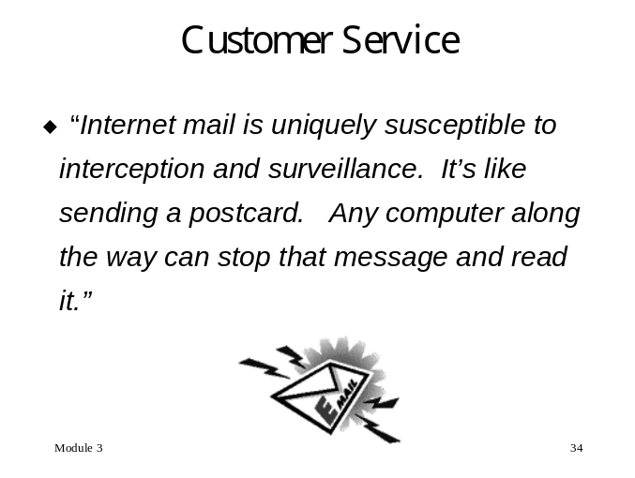
- What information is appropriate to send to a customer via e-mail? Who is the recipient or requestor? How do you verify?
- What kind of information is appropriate to send via “Quick Locate” requests from one State to another State? How do you know to whom you are talking? How do you know who is receiving the request?
- Suggestion: The requestor’s identity should be verified by a photo ID. In addition, the requestor should specify for what purpose the information is requested. Information should not be released until the requestor’s identity has been verified.

training notes
- Display: Module 3, PowerPoint slide 35
- Think about your fax procedures. How many people have access to the fax on the receiver’s end? Do you verify transmission and receipt?
- Refer to page i the Appendix: “Warming Up to a Security Blanket; If You Think Encryption Isn’t Important To You, Think Again”—Washington Post

FACSIMILES
  - 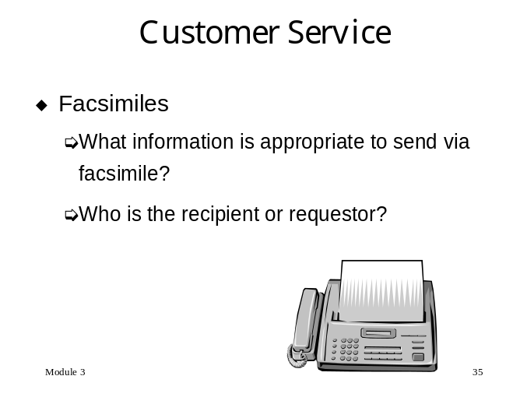What information is appropriate to send to a customer via facsimile? Do you verify that the facsimile has been received? How long before it is transmitted and who has access to the facsimile machine?

training notes
- Let’s talk about what kind of precautions you can take.
- Display: Module 3, PowerPoint slide 36 and discuss bullet points.

Precautions

What kind of precautions can you take to ensure you are disclosing information to the appropriate party?

- Written waivers
- Are the terminals open to client access?
- “PIN” numbers

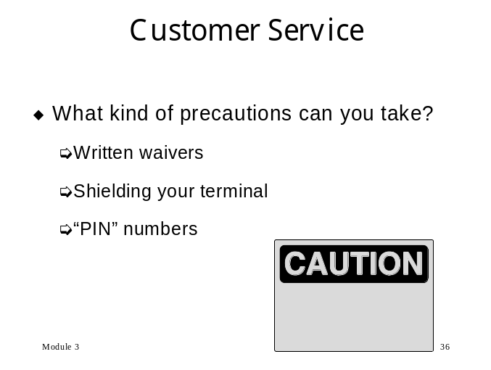
training notes
- Sometimes IV-A staff has access to the CSE system.
- Display: Module 3, PowerPoint slide 37 and discuss bullet points.

IV-A staff
    - What kind of training on security and confidentiality of the child support information have they had?
- Have they signed a Confidential/Privacy/Security non-disclosure document?
- 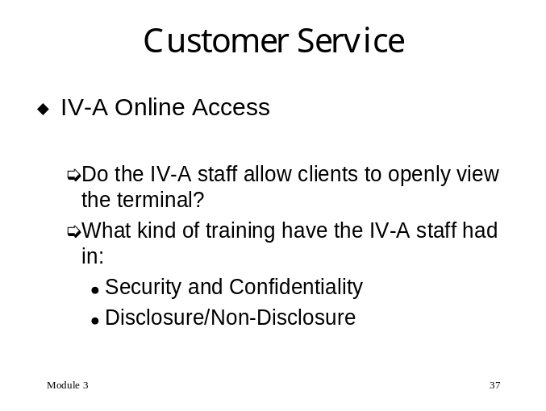What about the terminal the IV-A worker uses—is the CSE system open to customer scrutiny?
.
training notes
- Does your office have an Automated Voice Response (AVR) System?
- Display: Module 3, PowerPoint slide 38 and discuss bullet points.
- Solicit participants to discuss their local AVR systems noting what information is given out.

Automated Voice Response Systems (AVR)
    - What kind of information does your State’s AVR give out?
    - What security and confidentiality is built into the AVR to avoid disclosing information to an unauthorized person?

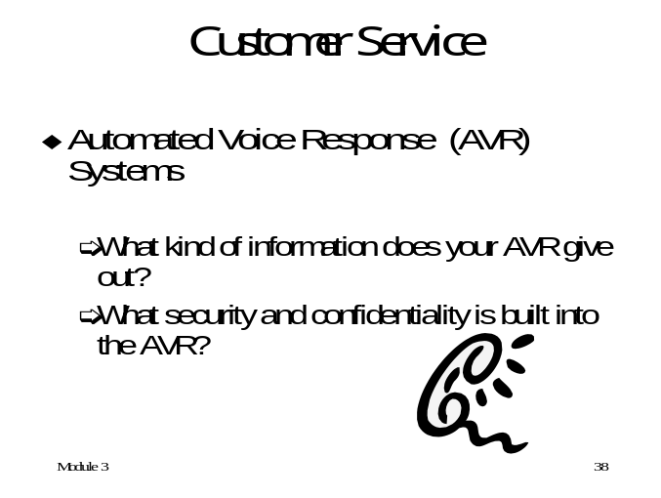
training notes
- How do you handle requests when the answer is “no way”?
- Display: Module 3, PowerPoint slide 39 and discuss bullet points.

Just Say ‘No” to Unauthorized Requests for Access to FPLS information
    - Do not be intimidated. Be firm in denying access to unauthorized requests for FPLS information
    - Be courteous and polite and firmly deny requests.
    - 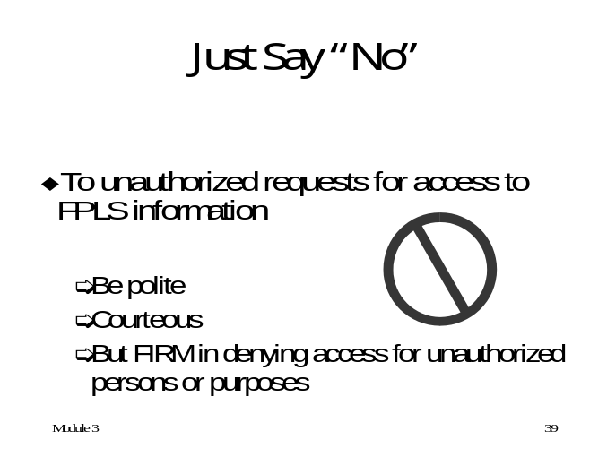If the requestor persists, you can forward to your supervisor.

training notes
- Advocacy groups are concerned with privacy issues and are watching the child support agencies’ broad access to personal data for clients and non-clients. We need to take every precaution available to ensure that our offices and the child support information contained within are not easy targets for misuse, theft, or unauthorized access.
- Display: Module 3, PowerPoint slides 40 and 41

Physical Precautions
  - Why is it important to protect child support data?
  - Think about your office. What might be out in the open and subject to unauthorized access?
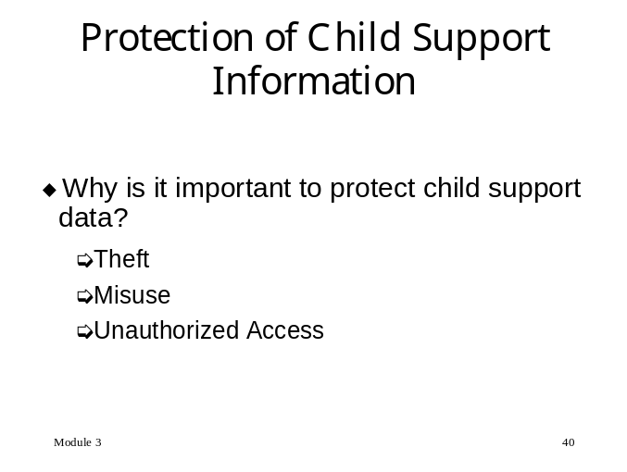

Data security
    - Screen savers. Do you have a screen saver on the computer? Is the data on your screen accessible to anyone in the office, walking by or through the window?
    - 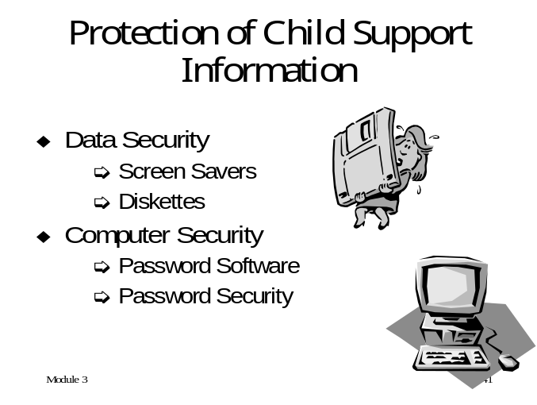Diskettes. Do you have case information on diskette? Are your diskettes in an easily accessible place?
training notes
- Display: Module 3, PowerPoint slide 42 and discuss the bullets.
- Refer to the Appendix, page , Password Checklist, which provides some important information on protection of and setting your password such as:
- Never let anyone use your password
- Create a password that contains a combination of numbers and letters
- Continue to change your password frequently
- Refer to the Appendix, page , Computer Security Checklist, which will provide participants with some helpful information to think about in keeping their office and data secure.
- Remind participants as we discuss protection of child support information: this could be your personal information we are talking about!
- If the janitor were to walk into your office right now while you are in training, what would he have access to? Do you have any files on your desk? Computer printouts? NCP or CP data in the trash can?

Computer Security
    - How to protect the data
- Passwords
- Password Security
- 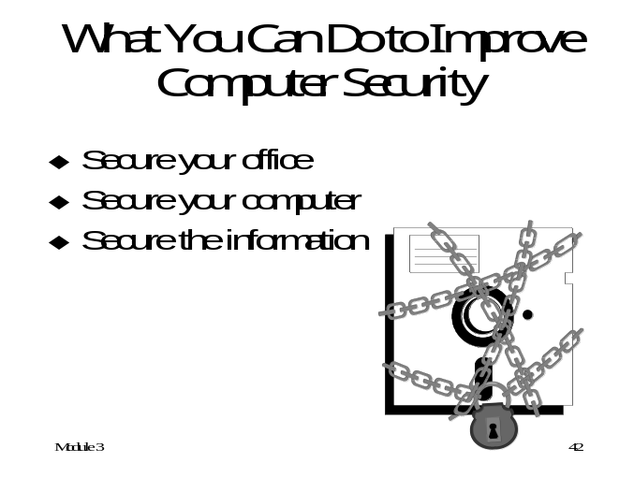Screen saver password

training notes
- Display: Module 3, PowerPoint slide 43 and discuss bullet points.

Summary
    - Protecting child support data in the “Information Age” brings about the need for tighter security and controls.
    - We have talked about how technology can have a positive and negative impact on us personally.
    - We have talked about the child support program and the enviable position we are in with our resources.
    - We have talked about who we can give access to and for what purpose.
    - How does this all fit together? We have access to valuable information that we are responsible for safeguarding. Data in the wrong hands leads to identity theft and fraud. Do we want to be responsible for being the cause of identity theft for an NCP or CP? How about ourselves? Do we want to lose access to our valuable resources for failing to safeguard them?
    - In the next module we will explore ways to safeguard our environment and protect you, the child support worker.



