
NOT MEASUREMENT SENSITIVE
DOE G 450.1-2
DRAFT XX-XX-04

Implementation Guide for Integrating Environmental Management Systems into Integrated Safety Management Systems
[This Guide describes suggested nonmandatory approaches for meeting requirements. Guides are not requirements documents and are not to be construed as requirements in any audit or appraisal for compliance with the parent Policy, Order, Notice, or Manual.]



U.S. Department of Energy
Washington, D.C. 20585
PREFACE
DOE G 450.1-2, Implementation Guide for Integrating Environmental Management Systems into Integrated Safety Management Systems is the second guidance document in a series of Guides issued to provide suggested approaches for meeting the requirements of DOE O 450.1. DOE O 450.1 requires DOE elements to establish an Environmental Management System (EMS) that is integrated into DOE’s Integrated Safety Management System (ISMS). Draft DOE G 450.1-1, which was issued for “review and use” in October 2003, provides an overview of the integration process. DOE G 450.1-2 provides detailed guidance relating to integrating EMSs into a site’s ISMS.
CONTENTS
Acronyms and Abbreviations ix
Introduction 1
Purpose 1
Applicability and Scope 1
Use of Guidance 1
Overview 1
CHAPTER I. Phase I—Planning and Aspects Identification
Step 1 Identifying Environmental Aspects I-1
1.1 TASK 1: Identify and List the Organization’s Activities, Products, and Services and Their Interactions With the Environment (Environmental Aspects) I-1
1.1.1 Starting Task 1 I-2
1.1.2 Environmental Aspects Identification I-2
1.1.3 Approaches for Identifying Activities, Products, and Services and their Interactions with the Environment I-3
1.2 TASK 2: Identify How Each Environmental Aspect Impacts the Environment I-6
1.2.1 Understanding the Aspect Impact Analysis I-6
1.2.2 Approach to Characterizing Environmental Impacts I-6
1.2.3 Documenting Positive Impacts I-7
Step 2 Determining Significant Aspects I-8
2.1 TASK 3: Identify All Environmental Aspects That Are Regulated, Have Regulatory Implications, or Are Required by DOE Directive I-8
2.1.1 Identifying Environmental Aspects with Regulatory Consequences I-10
2.1.2 Specific Environmental Interactions I-11
2.1.3 Pollution Prevention I-13
2.1.4 Clean Air Act General Conformity I-13
2.1.5 Watershed Approach for Surface-Water Protection I-14
2.1.6 Site-Wide Approach for Groundwater Protection I-14
2.1.7 Natural Resources—Biota I-16
2.1.8 Wildland Fire Management Program I-17
2.1.9 Cultural Resources Management I-17
2.1.10 Long-Term Stewardship Program I-17
2.1.11 Preoperational Characterization and Assessment; Effluent and Surveillance Monitoring I-18
2.1.12 Environmental Quality Systems I-20
CONTENTS (continued)
2.2 TASK 4: Determine Significance Based on Environmental and Organizational Consideration I-22
2.2.1 “Significance” in the NEPA and ISMS/EMS Context I-22
2.2.2 Criteria for Scoring Likelihood of Occurrence I-23
2.2.3 Criteria for Scoring Environmental Consequences of Impacts I-24
2.2.4 Criteria for Scoring Mission Consequences I-24
2.2.5 Determination of Overall Impact Score I-26
Step 3 Setting Objectives and Targets I-28
3.1 TASK 5: Develop Objectives and Targets To Address Significant Aspects I-28
3.1.1 Defining Objectives and Targets I-29
3.1.2 Approach to Setting Objectives and Targets I-30
3.2 TASK 6: Formalize Environmental Objectives and Targets And Develop The Environmental Management Plan I-31
CHAPTER II. Phase II—Implementation and Operation
Step 4 Integrated Safety Management System/Environmental Management System Documentation II-1
4.1 TASK 7: Updating the Integrated Safety Management System/Environmental Management System Description II-1
4.1.1 Background II-2
4.1.2 Documenting Environmental Management System Elements II-2
4.2 TASK 8: Developing an Environmental Management System Roadmap II-2
4.2.1 Background II-2
4.2.2 EMS Roadmap Template II-3
Step 5 Developing Environmental Management Programs II-3
5.1 TASK 9: Create environmental management programs II-3
5.1.1 Create Environmental Management Programs II-4
5.2 TASK 10: Document Environmental Management Programs II-5
5.3 TASK 11: Approve the Environmental Management Programs II-5
5.3.1 Review and Approval II-6
5.3.2 Placement of Completed Environmental Management Program Documents II-6

CONTENTS (continued)
Step 6 Developing Operational Controls II-6
6.1 TASK 12: Specify Operational controls II-6
6.1.1 Specifying Operational Controls II-7
6.2 TASK 13: Approve operational controls II-8
6.2.1 Review and Approval II-8
6.2.2 Placement of Completed Operational Controls II-8
Step 7 Develop Integrated Safety Management System/Environmental Management System Procedures II-9
7.1 TASK 14: Establish Integrated Safety Management System/ Environmental Management System Procedures II-9
7.1.1 Integrated Safety Management System/Environmental Management System Procedures II-11
7.1.2 The Role of Integrated Safety Management System/Environmental Management System Procedures II-11
7.1.3 Keeping Procedures Simple II-11
7.2 TASK 15: Documenting Integrated Safety Management System/Environmental Management System Procedures II-11
7.2.1 Integrated Safety Management System /Environmental Management System Procedures II-11
7.2.2 Implementing Integrated Safety Management System/Environmental Management System Procedures II-12
7.3 TASK 16: Approve Integrated Safety Management System/ Environmental Management System procedures II-12
7.3.1 Review and Approval II-13
7.4 TASK 17: Implement Integrated Safety Management System/ Environmental Management System procedures II-13
7.4.1 Background II-13
7.4.2 Training II-13
7.4.3 Responsibility for Maintaining Records II-14
7.4.4 Maintaining Procedures II-14
7.4.5 Accessibility II-14
CHAPTER III. Phase III—Checking and Corrective Action
Step 8 Establish the ISMS/EMS Assessment Program III-1
8.1 TASK 18: Establish the ISMS/EMS Assessment Program III-1
CONTENTS (continued)
8.1.1 Background and Purpose III-2
8.1.2 The Assessment Program III-2
8.1.3 Assessment Concepts III-3
8.2 TASK 19: Plan the Assessment III-5
8.2.1 Basic Principles III-6
8.2.2 Conducting the Assessment III-7
8.3 TASK 20: Conduct Onsite Assessment Activities III-7
CHAPTER IV. Phase IV—Management Review and System Maintenance
Step 9 Develop the management review process IV-1
9.1 TASK 21: Prepare for the Management Review IV-1
9.1.1 Background IV-2
9.1.2 Importance of Senior Management Involvement in the Management Review IV-3
9.1.3 Coordinating the Management Review IV-3
9.1.4 Management Review Participants IV-4
9.2 TASK 22: Conduct the Management Review IV-4
9.2.1 Background IV-4
9.2.2 Decisions Made in the Management Review IV-6
9.2.3 Documenting the Management Review IV-7
9.2.4 Followup to the Management Review IV-7
Step 10 Develop a Plan to Keep the ISMS/EMS Updated IV-8
10.1 TASK 23: Keeping the ISMS/EMS Updated IV-8
10.1.1 Background IV-8
10.1.2 Environmental Aspects IV-9
10.1.3 Legal and Other Requirements IV-9
10.1.4 Objectives and Targets IV-9
10.1.5 Environmental Management Programs IV-10
10.1.6 Training IV-10
10.1.7 Operational Controls IV-10
10.1.8 Resources for the Environmental Management System IV-11
10.1.9 Occurrence Identification and Corrective Actions IV-11
10.1.10 Developing a Formal Maintenance Schedule IV-11

Appendixes
A. Additional Guidance Documents
B. EMS Roadmap Templates
C. Assessments
D. Glossary
E. References

TABLES
1. Example of Listing Environmental Aspects and Activities/Products/Services I-5
2. Example of Listing Environmental Impacts I-7
3. Regulatory and Other Requirements Related to Environmental Aspects I-10
4. Assigning a Regulatory Score to aspects I-12
5. Sample criteria for scoring the likelihood of occurrence I-23
6. Sample Criteria for Scoring Environmental Consequences on DOE Sites I-25
7. Sample Criteria for Scoring Mission Consequences for DOE Sites I-25
8. Determination of Significance Based on Environmental and Organizational Considerations I-27
8a. Rank of Overall Significance Based on environmental and Organizational Considerations I-28
9. Overview of Objectives, Targets, Required Resources, and Management Approval Status I-32
10. Sample portion of the assessment questionnaire III-13
11. Sample ISMS/EMS Corrective Action Report Template III-15
12. Example. Suggested schedule for maintaining and Updating Required and Important Selected Elements of the ISMS/EMS. IV-13

FIGURES
1. Sample assessment program reflecting how concepts of the plan-do-check-act cycle are incorporated in it III-4
2. ISMS/EMS assessment process flow chart III-8
3. Identifying legal and other requirements and new activities, products, and services that are incorporated into the ISMS/EMS IV-14

Acronyms and Abbreviations
ANSI American National Standards Institute
ASER Annual Site Environmental Reports
ASQC American Society for Quality Control
CAR Corrective Action Report
CCE continuing core expectation
CERCLA Comprehensive Environmental Response, Compensation and Liability Act
CRD Contractor Requirements Document
CRMP Cultural Resources Management Plan
D & D Decontamination and Decommissioning
DOE U.S. Department of Energy
EIS Environmental Impact Statement
EMP environmental management program
EPA U.S. Environmental Protection Agency
EMS Environmental Management System
ES&H Environment, Safety and Health
ISMS Integrated Safety Management System
ISO International Standards Organization
LTS long-term stewardship
MSDS material safety data sheets
NAAQS national ambient air quality standards
NEPA National Environmental Policy Act
NNSA National Nuclear Security Administration
ODS ozone-depleting substance
QA quality assurance
QC quality control
QMP Quality Management Plan
QS Quality System
UFP-QAPP Uniform Federal Policy for Quality Assurance Project Plan
UFP-QS Uniform Federal Policy for Implementing Environmental Quality Systems
UST underground storage tank
Introduction
Purpose
This document provides discretionary guidance for implementing the requirements of Department of Energy (DOE) Order (O) 450.1, Environmental Protection Program. DOE O 450.1 requires implementation of sound stewardship practices that are protective of the air, water, land, cultural and ecological resources impacted by DOE operations, and by which DOE meets or exceeds compliance with applicable environmental, public health and resource protection laws, regulations and DOE requirements in a cost-effective way. This objective is to be accomplished by implementing Environmental Management Systems (EMSs) as part of existing Integrated Safety Management Systems (ISMSs) established pursuant to DOE P 450.4, Safety Management System Policy, at DOE facilities. This Guide provides suggested approaches for meeting the requirements of DOE O 450.1.
Applicability and Scope
This Guide is for use by all DOE elements, including the National Nuclear Security Administration (NNSA) and contractors required to implement DOE O 450.1.
Use of Guidance
DOE Guides are not requirements documents and may not be construed as requirements in any audit or assessment of compliance with the associated Policy, Order, Notice, or Manual. The information in this Guide will be useful for the implementation of DOE O 450.1, Environmental Protection Program. This Guide provides information on acceptable methods for meeting the requirements of DOE O 450.1. Alternatively, other methods that are equally effective in meeting desired levels of environmental protection and that satisfy the requirements of DOE O 450.1 may be used.
Overview
DOE O 450.1 requires DOE elements to establish an EMS that is integrated into a DOE site’s ISMS. The integration of an EMS into a ISMS (hereinafter referred to as ISMS/EMS) provides a unified strategy for the management of resources; the control and attenuation of risks; and the establishment and achievement of the organization’s environment, safety and health goals. The ISMS/EMS should be viewed as an enhancement of ISMS that adds those EMS elements not previously included in the ISMS. The guidance contained in this document recognizes that many DOE sites have already implemented ISMSs and should, therefore, have most if not all of the elements of an EMS already in place. This document focuses on providing guidance to assist DOE sites in identifying those missing EMS elements and integrating them into the site’s ISMS.
This Guide is organized around the following four phases of establishing an EMS:
- Phase I, Planning and Aspects Identification;
- Phase II, Implementation and Operation;
- Phase III, Checking and Corrective Action; and
- Phase IV, Management Review and System Maintenance.
Chapter I, Phase I—Planning and Aspects Identification, provides guidance on how to identify environmental aspects associated with site activities, products and services, and determine the significance of impacts associated with these aspects. Chapter II—Phase II, Implementation and Operation, provides guidance on how to document an EMS through the use of the site’s ISMS description. Chapter II also provides guidance on how to develop or modify existing environmental management programs and how to develop operational controls and procedures. Chapter III—Phase III, Checking and Corrective Action, provides guidance on conducting an internal assessment program. Chapter IV—Phase IV, Management Review and System Maintenance, provides guidance on conducting a management review and ensuring that the ISMS/EMS is current. The following matrix is a roadmap to the entire ISMS/EMS integration process.
PHASE | STEP | TASK
I. Planning and Aspects Identification | 1. Identifying Environmental Aspects | 1. Identify & List the Organization’s Activities, Products & Services and Their Interactions With the Environment (environmental aspects).
I. Planning and Aspects Identification | 2. Determining Significant Aspects | 2. Identify How Each Environmental Aspect Impacts the Environment
I. Planning and Aspects Identification | 2. Determining Significant Aspects | 3.Identify Environmental Aspects that are regulated, have regulatory implications, or are required by DOE directive
I. Planning and Aspects Identification | 2. Determining Significant Aspects | 4. Determination of Significance Based On Environmental and Organizational Considerations
I. Planning and Aspects Identification | 3. Setting objectives and targets | 5. Develop objectives and targets to address significant aspects
I. Planning and Aspects Identification | 3. Setting objectives and targets | 6. Formalize Environmental Objectives and Targets
II. Implementation and Operation | 4. Integrated Safety Management System/Environmental Management System Documentation | 7. Updating the Integrated Safety Management System/Environmental Management System Description
II. Implementation and Operation |  | 8. Developing an Environmental Management System Roadmap
II. Implementation and Operation | 5. Developing Environmental Management Programs | 9. Create Environmental Management Programs  10.Document Environmental Management Programs  11.Approve Environmental Management Programs
II. Implementation and Operation | 6. Developing Operational Controls | 12. Specify Operational Controls
II. Implementation and Operation | 7. Develop ISMS/EMS Procedures | 13. Approve Operational Controls  14. Establish ISMS/EMS Procedures  15. Document ISMS/EMS Procedures  16. Approve ISMS/EMS Procedures  17. Implement ISMS/EMS Procedures
III. Checking and Corrective Action | 8. Establish the ISMS/EMS Assessment Program  9. Develop the Management Review Process | 18. Establish the ISMS/EMS Assessment Program  19. Plan the Assessment  20. Conduct Onsite Assessment Activities  21. Prepare for the Management Review  22. Conduct the Management Review
IV. Management Review and System Maintenance | 10. Develop a Plan to Keep the ISMS/EMS Updated | 23. Keeping the ISMS/EMS Updated

- Phase I—Planning and
Aspects Identification
- Identifying Environmental Aspects
Task 1. Identify and list the organization’s activities, products, and services and their interactions with the environment (environmental aspects).
Task 2. Identify how each environmental aspect impacts the environment.
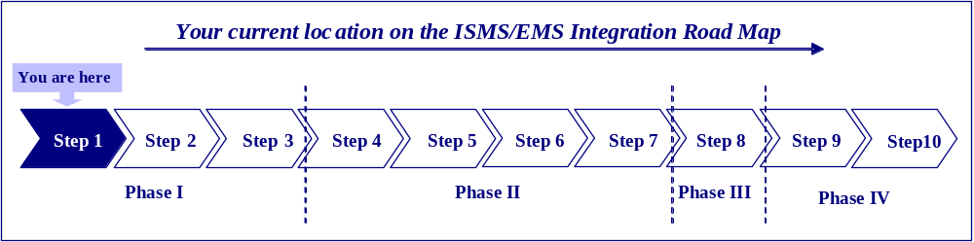
  - TASK 1: Identify and List the Organization’s Activities, Products, and Services and Their Interactions With the Environment (Environmental Aspects)
References
This task fulfills DOE Order requirements listed below.
- The ISMS/EMS includes policies [and] procedures to identify activities with significant environmental impacts [DOE O 450.1 §4.a.(2)].
- The ISMS/EMS provides for the systematic planning of programs for public health and environmental protection [DOE O 450.1 §4.a.(1)(a)].
- The ISMS/EMS provides for the systematic planning of programs for pollution prevention [DOE O 450.1 §4.a.(1)(b)].
The provisions in this task relate to established requirements of the following ISMS element.
- ISMS Core Function 2, “Analyze the Hazards: Hazards associated with the work are identified, analyzed and categorized.”
    - Starting Task 1
Task 1 in developing the ISMS/EMS is to identify how the organization might impact the environment. In EMS terms, this is known as identifying the environmental aspects of an organization’s existing, as well as new or proposed activities, products, and services. These cover all the possibilities for an organization to influence the environment, both positive and negative. Options to identify environmental aspects are described below. To understand these approaches, individuals must first have a working knowledge of the terms activities, products, and services and environmental aspects and know how they relate to a DOE site.
Activities
Activities offer the greatest possibilities for DOE sites to influence the environment. Activities may include those that generate waste (radioactive, hazardous, solid waste), such as construction of waste management units or equipment maintenance, or general administrative activities that use resources, including paper, water, or natural resources.
Products
DOE sites do not, on the whole, make products in the conventional manufacturing sense. The aspects identification methodology will, therefore, place greater emphasis on activities and services typically associated with DOE operations. However, policies and/or procedural documents may have tangible environmental implications when sites implement them. For example, the institutional control policy (DOE P 454.1, Use of Institutional Controls) provides a mechanism designed to appropriately limit access to or uses of land, facilities and other real and personal properties to protect cultural and natural resources, which can have tangible environmental implications when put into practice. These policies/procedures may therefore be considered products by organizations that are determining their impacts on the environment.
Services
DOE sites may include several organizations that provide services to other site operations. For example, services may include waste treatment, waste pickup, and technical support services. These services should be considered when determining how a site interacts with the environment.
    - Environmental Aspects Identification
Environmental aspects are the attributes of a site’s activities, products, and services that can interact with the environment. An environmental aspect signifies the possibility of an environmental impact, whether good or bad.
DOE sites that have implemented ISMS/EMSs have already identified their various activities, products, and services. The process of identifying activities, products, and services may be accomplished using a variety of techniques. In small organizations, individuals may be able to name all of the activities, products, and services at the site. This is unlikely to be the case at the larger DOE sites, given their size and complexity. Large DOE sites should conduct the analysis at the lowest work activity level and then aggregate the data into the site-wide analysis. Section 1.1.3 contains some commonly used approaches to identify activities, products, and services within an organizational unit.
Many parallels exist between safety management and environmental management. For example, using a ladder in the workplace could result in a worker injury. Therefore, a possible fall is the safety hazard of a ladder in the workplace in the same way that a possible spill is an environmental aspect of waste transportation. In other words, an environmental aspect is the equivalent of a safety hazard.
    - Approaches for Identifying Activities, Products, and Services and their Interactions with the Environment
This guidance describes three approaches that may be used to identify activities, products, and services and can also be used to identify the environmental aspects. In some cases, it may be possible to identify activities, products, and services and their associated environmental aspects at the same time to avoid duplication and increase efficiency. In other cases, it is necessary to first identify all of the activities, products, and services, and then determine what the environmental aspects of these are. The three approaches are—
- brainstorming,
- physical walk-through, and
- employee input.
Approach 1––Brainstorming
The site ISMS/EMS team (see Section 7 of draft DOE G 450.1-1 for a discussion of how to establish a site ISMS/EMS team) and other individuals with relevant knowledge participate in a brainstorming session. Brainstorming is extremely effective when participants have a detailed understanding of the site’s activities, products, and services and their environmental aspects. Typically an organization assembles an ISMS/EMS team at the site. This group meets and lists all the activities products and services that occur on the site. In many cases, brainstorming can be supplemented and structured by using site documents and records to direct the group. Common examples are regulatory documents, National Environmental Policy Act (NEPA) documents, compliance agreements, and the Annual Site Environmental Reports (ASERs). Brainstorming may be inadequate by itself, so sites can use additional approaches, such as the physical walk-through and employee input for further exploration.
Approach 2––Physical Walk-Through
This technique involves an actual walk-through of all areas and functions of the organization. Seeing these different areas and operations serves as a visual trigger to identify possible interactions with the environment. It is most effective to have the ISMS/EMS team conduct the walk-through of all areas and operations of the site to ensure that the analysis includes all possible sources. The team should have a detailed understanding of the activities and operations in a particular location. It should also be familiar with the potential environmental issues of various operations and activities. It may be useful to provide a checklist of potential environmental aspects that may prompt the ISMS/EMS team to recognize such aspects. The Team can develop these types of checklists in a brainstorming exercise, like that described above. The walk-through should ensure the inspection and consideration of all areas and operations. This effort requires sufficient time for the completion of a thorough survey of the entire site.
Approach 3––Employee Input
No other individuals are likely to be as familiar with a particular area of the site as the employees who work there. It can be particularly useful, therefore, to engage employees in the process of identifying activities, products, and services that involve an environmental aspect. An added benefit of soliciting employee input is that it begins the process of raising employee awareness, involvement, and eventually ownership of practices that avoid waste and environmental degradation.
To be useful, employee input needs to be structured, thus enabling its proper evaluation. A questionnaire or survey instrument can be an effective tool for capturing employee input. Following are examples of appropriate questions to ask on a questionnaire.
- Do activities in your work area—
- use chemicals, radiological sources, or other hazardous substances?
- use appreciable amounts of materials or natural resources?
- discharge to air, soil, water, and/or sewers?
- produce solid waste (e.g., scrap, refuse)?
- consume large amounts of electrical energy or fuels?
- consume large amounts of water?
  - Is the site prepared for any accident or emergency?
- Does the site have adequate training and/or experience to avoid, prevent, or mitigate potential environmental consequences?
- Are there activities that involve the use of material safety data sheets (MSDS)?
- Do any other conditions or attributes of the activity/product/service pose a risk to the environment or to health and safety?
Environmental aspects identified should be listed against the activity with which they are associated (see Table 1). Table 1 provides some examples of typical environmental aspects at DOE sites. These illustrate how the environmental aspects are paired with the activities, products, and services that cause them.

Table 1. Example of listing environmental aspects and activities/products/services
ENVIRONMENTAL ASPECT | Activities/products/services
Air Emissions | - Using and Storing Chemicals  - Constructing or Modifying Facilities, Processes, or Equipment  - Deactivating, Decommissioning, Dismantling or Closing Facilities, Equipment, and Processes  - Maintaining, Servicing, or Repairing Refrigeration and Air Conditioning Equipment  - Constructing Hazardous Waste Units  - Closing Waste Management Units  - Combusting fuel for heat, power or electricity
Disturbance of Cultural and Historic Resources | - Constructing or Modifying Facilities, Processes, or Equipment  - Conducting Open Burning  - Constructing or Modifying Aboveground and Underground Storage Tanks (USTs)
Releases to Wastewater System and Groundwater | - Deactivating, Decommissioning, Dismantling, or Closing Facilities, Equipment, and Processes  - Conducting Research and Development  - Leaks, Spills, and Releases from Waste Management Activities  - Closing Waste Management Units
Medical Waste Generation, Management, and Disposal | - Conducting Research and Development
Radioactive Waste Generation, Management, and Disposal | - Preparing Buildings or Facilities for Transfer to Surplus, Inactive Facility Status or D & D  - Leaks, Spills, and Releases from Waste Management Activities  - Closing Waste Management Units  - Conducting Research and Development  - Disposition of Excess Materials  - Treating, Storing, Disposing of Waste  - Cleanup of Legacy Waste Sites

  - TASK 2: Identify How Each Environmental Aspect Impacts the Environment
Reference
The provisions in this task relate to established requirements of the following ISMS element.
- ISMS Core Function 2, “Analyze the Hazards: Hazards associated with the work are identified, analyzed and categorized.”
Task 2 involves the identification of the potential environmental impacts of an environmental aspect. A potential environmental impact is defined by its likelihood of occurrence and the likely consequences if it does occur. When the potential environmental impacts have been identified, their descriptions should be recorded alongside the activity and aspect with which they are associated. To assist in the identification of potential impacts, Table 2 lists some sample environmental impacts. The environmental impact should include as much detail as possible including the identification of pollutants.
    - Understanding the Aspect Impact Analysis
Aspect impact analysis identifies the significant aspects (i.e., interactions with the environment) that site management should address to prevent or control activities thereby reducing the site’s risk to the environment. There is no single correct approach to aspect identification and impact analysis. Differences in structures and missions will lead organizations to adopt different approaches. Whenever possible, aspect impact analysis should rely on existing site information from documents such as Environmental Impact Statements (EISs), permit applications, ASERs, and ISMS documents.
    - Approach to Characterizing Environmental Impacts
As discussed previously, the potential environmental impact of an aspect is defined by the likelihood of that aspect occurring and the likely consequences to the environment, mission, and/or community when it does occur. Although it is possible to determine these characteristics in a technically rigorous manner, including the use of decision trees, modeling, and studies of toxicological parameters, this level of rigor is rarely necessary and is often impractical for purposes of identifying how an environmental aspect affects the environment. In most cases, individuals with experience at a DOE site should be able to assign a realistic likelihood and consequence to potential environmental impacts. In many cases, sites can use the experiences of other organizations or sites for similar activities under similar circumstances, and the environmental aspects and impacts are likely to be comparable. Quantification of potential environmental impacts, where possible, will facilitate the determination of significance. Entries in the “impacts” column of Table 2 should be as descriptive as possible; for example, instead of simply listing a potential spill impact as “soil contamination,” it would be more useful to describe the impact as “soil contamination––biohazards.” This fuller description, when available, will greatly facilitate the proper determination of the impact’s significance.
Table 2. Example of listing environmental impacts
ENVIRONMENTAL ASPECT | Activities/products/services | POTENTIAL IMPACTS
Air Emissions | - Using and Storing Chemicals  - Constructing or Modifying Facilities, Processes, or Equipment  - Deactivating, Decommissioning, Dismantling or Closing Facilities, Equipment, and Processes  - Maintaining, Servicing, or Repairing Refrigeration and Air Conditioning Equipment  - Constructing Hazardous Waste Units  - Closing Waste Management Units  - Combusting fuel for heat, power, or electricity | General reduction in air quality and potential human, ecological, and habitat effects in the locality affecting all media and biota.
Disturbance of Cultural and Historic Resources | - Constructing or Modifying Facilities, Processes, or Equipment  - Conducting Open Burning  - Constructing or Modifying Aboveground and Underground Storage Tanks | Ecological damage, damage of culturally and historically significant artifacts.
Releases to Wastewater System and Groundwater | - Deactivating, Decommissioning, Dismantling or Closing Facilities, Equipment, and Processes  - Conducting Research and Development  - Leaks, Spills, and Releases from Waste Management Activities  - Closing Waste Management Units | Runoff to local surface waters with species, habitat, biota, and fisheries impact. Leaching to groundwater aquifer of hazardous wastes.
Medical Waste Generation, Management, and Disposal | - Conducting Research and Development | Ecological damage, contamination of air, water, and soil with biohazards, impact to human health and biota, waste generation.
Radioactive Waste Generation, Management, and Disposal | - Preparing Buildings or Facilities for Transfer to Surplus, Inactive Facility Status or D & D  - Leaks, Spills, and Releases from Waste Management Activities  - Closing Waste Management Units  - Conducting Research and Development  - Disposing of Excess Materials  - Treating, Storing, Disposing of Waste  - Cleanup of Legacy Waste Sites | Ecological damage, contamination of air, water, and soil with radiological contaminants, impact to human health and biota, waste generation.
    - Documenting Positive Impacts
For purposes of this Guide, an environmental impact is “any change to the environment, whether adverse or beneficial, wholly or partially resulting from an organization’s activities, products, or services.” Although the aspect/impact analysis is inherently geared toward identifying risks and, essentially, the degree of negative impact, it can also identify those positive impacts on the environment that are a result of existing programs or activities. Examples of positive impacts include protecting wetlands with buffer strips and maintaining wooded areas to protect species and habitat diversity. Positive impacts should be identified in the aspect/impact analysis because the aspects that create them may be incorporated into environmental management programs (EMPs) and systematically managed.
As an example, a site may voluntarily decide to let a 50-foot buffer strip grow alongside a stream. This action can have positive impacts on the environment such as reduced storm-water flow, sediment loading, etc. A proactive program may need ongoing management to maintain the buffer strip.
When characterizing impacts as “positive,” it is important that the impact actually improve the quality of the environment and is not just the result of minimizing a negative impact. For example, cleaning up a site that has contaminated the soil is not a positive impact; it is simply mitigating a negative impact (contamination).

- Determining Significant Aspects
Task 3. Identify all environmental aspects that are regulated or have regulatory implications.
Task 4. Determine significance based on environmental and organizational considerations.
  - TASK 3: Identify All Environmental Aspects That Are Regulated, Have Regulatory Implications, or Are Required by DOE Directive
References
This task fulfills several DOE Order requirements listed below.
- The ISMS/EMS provides for the systematic planning of programs for compliance with applicable requirements [DOE O 450.1 §4.a.(1)(c)].
- The ISMS/EMS includes (if applicable) conformity of DOE proposed actions with State Implementation Plans to attain and maintain national ambient air quality standards [DOE O 450.1 §4.b.(1)(a)].
- The ISMS/EMS includes (if applicable) implementation of a watershed approach for surface-water protection [DOE O 450.1 §4.b.(1)(b)].
- The ISMS/EMS includes (if applicable) implementation of a sitewide approach for groundwater protection [DOE O 450.1 §4.b.(1)(c)].
- The ISMS/EMS includes (if applicable) protection of other natural resources, including biota [DOE O 450.1 §4.b.(1)(d)].
- The ISMS/EMS includes (if applicable) protection of site resources from wildland and operational fires [DOE O 450.1 §4.b.(1)(e)].
- The ISMS/EMS includes (if applicable) protection of cultural resources [DOE O 450.1 §4.b.(1)(f)].
- The ISMS/EMS promotes the long-term stewardship of a site’s natural and cultural resources throughout its operational, closure, and postclosure life cycle [DOE O 450.1 §4.b.(2)].
- The ISMS/EMS provides for reduction or elimination of the generation of waste, the release of pollutants to the environment, and the use of Class I ozone-depleting substances (ODS) through source reduction, reuse, segregation, and recycling and by procuring recycled-content materials and environmentally preferable products and services [DOE O 450.1 §4.b.(3)].
- The ISMS/EMS ensures the early identification of, and appropriate response to, potential adverse environmental impacts associated with DOE operations, including, as appropriate, preoperational characterization and assessment and effluent and surveillance monitoring [DOE O 450.1 §4.b.(4)].
- The ISMS/EMS includes environmental monitoring, as appropriate, to support the site’s ISMS, to detect, characterize, and respond to releases from DOE activities; assess impacts and estimate dispersal patterns in the environment; characterize the pathways of exposure to members of the public; characterize the exposures and doses to individuals and to the population; and to evaluate the potential impacts to the biota in the vicinity of the DOE activity [DOE O 450.1 § 5.d.(14)].
- The ISMS/EMS ensures the implementation of the analytical work supporting environmental monitoring, using a consistent system for collecting, assessing, and documenting environmental data of known and documented quality [DOE O 450.1 § 5.d. (15)(a)].
- The ISMS/EMS ensures the implementation of the analytical work supporting environmental monitoring, using a validated and consistent approach for sampling and analyzing radionuclide samples to ensure laboratory data meet program-specific needs and requirements within the framework of a performance-based approach for analytical laboratory work [DOE O 450.1§5.d.(15)(b)].
- The ISMS/EMS ensures the implementation of the analytical work supporting environmental monitoring, using an integrated sampling approach to avoid duplicative data collection [DOE O 450.1 §5.d.(15)(c)].
The provisions in this task relate to established requirements of the following ISMS elements.
- ISMS Core Function 3, “Develop and Implement Hazard Controls: Applicable standards and requirements are identified.”
- ISMS Principle 5, “Identification of [Environment, Safety and Health] Standards and Requirements. Before work is performed, the associated hazards shall be evaluated and an agreed-upon set of [environment, safety and health] standards and requirements shall be established . . . .”
    - Identifying Environmental Aspects with Regulatory Consequences
Task 3 includes identification of all activities, products, or services whose aspects have regulatory implications. Because of the ramifications that regulatory violations might have for a site, it is important that all aspects with regulatory implications be managed through the ISMS/EMS. Site environmental and legal personnel should help determine those legal requirements that apply to environmental aspects on DOE sites. The site ISMS/EMS team and other parties that the team believes can contribute (e.g., the site regulatory experts) should list all environmental aspects whose activities, products, or services are subject to regulation, as shown in Table 4. Table 3, below, includes a recommended approach for capturing the regulatory status of a particular environmental aspect. The appropriate value should be entered beside the corresponding impact in Table 4.
Table 3. Regulatory and Other Requirements Related to Environmental Aspects
Scale of Regulatory and Other Requirements
5 = Regulated––Mandated by Federal, host nation, State, or local government agency statutes, laws, or regulations or Executive orders and DOE regulations or required by DOE directives (Automatically Significant)
4 = Regulated in the Future––Not currently mandated by a government agency, but under proposal
3 = Site Best Management Practice (i.e., not DOE-wide but mandated by site management)
0= No applicable regulatory requirement

The ISMS/EMS team may use a variety of techniques to identify regulated aspects. In some cases, a brainstorming exercise similar to that conducted when identifying aspects may be effective. A search of existing documents such as environmental permits and compliance agreements may be helpful in identifying regulated activities. In this case, it is usually important to include a member of the legal staff to be confident of the regulatory implications of each possible aspect. In other cases, the responsible environmental expert for that issue may be able to review each aspect within his or her area of expertise and provide the ISMS/EMS team with the necessary regulatory information. Any of these or other methods is suitable as long as it provides a high degree of certainty regarding the regulatory implications of environmental aspects.
In Task 3, all aspects with regulatory and policy implications should be identified and assigned a value of “5” using the rating system shown in Table 3. In practical terms, those assigned a value of “5” should be considered significant environmental aspects. As a result, when an organization identifies its significant environmental aspects, those that are regulated or governed by external regulation; Executive Orders (i.e., E.O. 13148, Greening the Government Through Leadership in Environmental Management); or Departmental directives (e.g., DOE O 450.1 or DOE P 450.4) will be automatically designated as significant aspects.
Aspects that will be regulated in the future are assigned a value of “4,” and site best management practices assigned a value of “3.” Although these aspects may be considered minor, they should be documented when assigning a score. If there is no applicable requirement, a value of “0” should be assigned.
    - Specific Environmental Interactions
After listing all activities, products, and services (see example Table 1) and identifying their associated environmental aspects, sites should consider specific environmental interactions and impacts and develop measurable objectives and targets (see Section 3.1). Through this process, sites should consider pollution prevention opportunities.
DOE O 450.1 §4b (1), (2), (3), and (4) require consideration for inclusion, as applicable.
- Conformity of DOE proposed actions with State Implementation Plans to attain national ambient air quality standards;
- Implementation of watershed approach for surface-water protection;
- Implementation of site-wide approach for groundwater protection;
- Protection of other natural resources, including biota;
- Protection of site resources from wildland and operational fires;
- Protection of cultural resources;
- Promotion of long-term stewardship of a site’s natural and cultural resources;
- Reduction or elimination of the generation of waste, the release of pollutants to the environment, and the use of Class I ozone-depleting substances (ODS) through source reduction, reuse, segregation, and recycling and by procuring recycled-content materials and environmentally preferable products and services;
- Ensure the early identification of and appropriate response to, potential adverse environmental impacts associated with DOE operations, including, as appropriate, preoperational characterization and assessment, and effluent and surveillance monitoring.
Env. Aspect | Activities/Products/Services | Potential Impacts | Reg. Score
Air Emissions | Using and Storing Chem. Products and Chem. Hazardous Agents | General reduction in air quality, and potential human, ecological, and habitat effects in the locality, spreading over a large footprint affecting all media and biota. Noncompliance with applicable laws/regulations. | 5
Air Emissions | Constructing or Modifying Facilities, Processes, or Equipment |  | 5
Air Emissions | Deactivating, Decommissioning, Dismantling, or Closing Facilities, Equipment, and Processes |  | 5
Air Emissions | Maintaining, Servicing, or Repairing Refrigeration and Air Conditioning Equipment |  | 5
Air Emissions | Constructing Hazardous Waste Units |  | 5
Air Emissions | Combusting fuel for heat, power, or electricity |  | 5
Air Emissions | Closing Waste Management Units |  | 5
Disturbance of Cultural and Historical Resource | Constructing or Modifying Facilities, Processes, or Equipment | Ecological damage, damage of cultural and historically significant artifacts. Noncompliance with applicable laws/regulations. | 5
Disturbance of Cultural and Historical Resource | Conducting Open Burning |  | 5
Disturbance of Cultural and Historical Resource | Constructing or Modifying Aboveground and Underground Storage Tanks |  | 5
Releases to Wastewater System and Groundwater | Deactivating, Decommissioning, Dismantling, or Closing Facilities, Equipment, and Processes | Runoff to local rivers and streams with species, habitat, and fisheries impacts. Leaching to groundwater (aquifers) and biota of hazardous wastes. Noncompliance with applicable laws/regulations | 5
Releases to Wastewater System and Groundwater | Conducting Research and Development |  | 5
Releases to Wastewater System and Groundwater | Leaks, Spills, and Releases |  | 5
Releases to Wastewater System and Groundwater | Closing Waste Management Units |  | 5
Medical Waste Generation Management, and Disposal | Conducting Research and Development | Ecological damage, contamination of air, water, and soil with biohazards impact to human health and biota, and waste generation. Noncompliance with applicable laws/regulations. | 5
Radioactive waste generation | Preparing Buildings or Facilities for Transfer to Surplus, Inactive Facility Status or D & D | Ecological damage, contamination of air, water, and soil with radiological contaminants, impact to human health and biota, and waste generation. Noncompliance with applicable laws/regulations. | 5
Radioactive waste generation | Releases, leaks, spills or unusual operating conditions from USTs |  | 5
Radioactive waste generation | Closing Waste Management Units |  | 5
Radioactive waste generation | Conducting Research and Development |  | 5
Radioactive waste generation | Disposition of Excess Materials |  | 5
Radioactive waste generation | Clean up of Legacy Waste Sites |  | 5
Radioactive waste generation | Treating, Storing and Disposing of Waste |  | 5

2.1.3 Pollution Prevention
Pollution prevention is not a stand-alone program; rather it is incorporated into the day-to-day operations at DOE sites. DOE O 450.1 §4 a. (1) requires that all DOE elements ensure that site ISMSs include an EMS that provides for the systematic planning, integrated execution, and evaluation of programs for pollution prevention. DOE O 450.1 §4.b.(3) requires that as part of integrating EMSs into site ISMSs, DOE elements must reduce or eliminate the generation of waste, the release of pollutants to the environment, and the use of Class I ODSs through source reduction, reuse, segregation, and recycling and by procuring recycled-content materials and environmentally preferable products and services.
DOE O 450.1 §5.d.(6) requires sites to conduct pollution prevention opportunity assessments (PPOA) and implement cost effective pollution prevention solutions. A PPOA is an appraisal of a process, activity, or operation to identify and evaluate potential pollution prevention opportunities (see Appendix D, Glossary). Pollution prevention opportunities should be considered before setting your site’s objective and targets. For example, specific pollution prevention goals were set forth in a Secretary of Energy Memorandum issued in 1999. Site-specific goals that contribute to these existing pollution prevention goals can be a site’s environmental objective for reducing or eliminating a certain impact (i.e., waste generation or discharge). A target could be a schedule for conducting a PPOA to identify pollution prevention solutions for achieving the objective.
Subsequent guidance regarding incorporating pollution prevention elements into the site’s ISMS/EMS will provide additional details.
    - Clean Air Act General Conformity
Under Section 176(c)(1) of the Clean Air Act (and the Environmental Protection Agency’s implementing regulations at 40 CFR Part 93, or State or local agency implementing regulations), a Federal agency is prohibited from carrying out or providing financial assistance for any activity that does not conform to State efforts to attain or maintain compliance with the national ambient air quality standards (NAAQS) for the criteria pollutants (i.e., ozone, nitrogen dioxide, sulfur oxides, particulate matter, carbon monoxide, and lead). If there are air emissions of criteria pollutants of concern for a proposed DOE action in a nonattainment or maintenance area, the general conformity regulations require that an analysis of these emissions of pollutants of concern be carried out prior to the initiation of the proposed action, preferably in conjunction with the NEPA compliance process. This analysis is not required for proposed DOE actions that would cause air emissions to occur in attainment areas (i.e., areas complying with all NAAQS).
After the site has identified activities, products and services related to general conformity requirements and how they interact with the ambient air environment, the ISMS/EMS team may determine the impacts (and their significance) caused by emission of criteria air pollutants for the planned DOE action in nonattainment and maintenance areas.

Sites may evaluate environmental impacts by comprehensively estimating criteria pollutant emissions from proposed DOE actions. If estimated emissions are greater than either of two conformity de minimis emission levels, the emissions associated with the proposed DOE action are considered to be of significance, and a more detailed “conformity determination” is needed.
Examples of potential impacts include—
- deterioration of air quality,
- possible greater health hazards to the public due to the DOE action, and
- noncompliance with conformity regulations.
An example of an environmental objective for conformity is to go beyond compliance with all conformity regulatory requirements. Examples of targets are to ensure that all organizations on the site are responsible for proposed DOE actions in nonattainment and maintenance areas conduct PPOAs to identify pollution prevention solutions such as reductions in the use of chemicals that produce criteria pollutants.
Appendix A contains a list of additional guidance materials.
    - Watershed Approach for Surface-Water Protection
A watershed is defined as a geographic area of land, water, and biota within the confines of a drainage divide and the total area above a given point of a water body that contributes flow to that point. Aspects that impact surface water include, but are not limited to, waste generation and discharge to the watershed, spills from raw material storage, construction and maintenance, fresh water and energy consumption, solid waste generation and disposal, and radiation.
Examples of potential impacts include—
- reduction of fresh water supply,
- reduction in the number of flora and fauna, and
- degradation of water quality.
An example of an environmental objective for watershed management might be the use of a consistent, science-based, approach to watershed assessments. A target might be to ensure compliance with applicable regulatory requirements.
Appendix A contains a list of additional guidance materials.
    - Site-Wide Approach for Groundwater Protection
After the site has identified activities, products and services that could impact groundwater quality, the site may determine the impacts (and their significance) caused by such actions. Since groundwater can be affected by any operating facility or activity, the ISMS/EMS should provide a framework whereby all efforts to protect groundwater are integrated, including, but not limited to, the following:
- integration of active remediation of contaminated groundwater with prevention of future groundwater contamination,
- integration of compliance with external and internal regulatory requirements,
- integration of ongoing program activities and facilities with site-wide landlord responsibilities, and
- integration of all groundwater and vadose zone monitoring activities.
Using the systems approach to groundwater protection allows for flexibility in the long term and should address current needs, be able to adapt to changes over time, and serve as a repository for historic groundwater activities, documents, and data. The site-wide approach can also address the needs for long-term protection, including surveillance and maintenance (see Section 2.1.10). Current needs are determined by specific requirements included in applicable permits and compliance agreements. Long-term needs are determined by the sources of potential future releases that will remain at the site after DOE operations cease and the completion of active remediation.
The site-wide groundwater protection approach should be tailored to each DOE site’s unique physical setting, history, current mission, and local or regional cultural characteristics. There are, however, certain objectives that are common to all DOE sites, and that should be reflected in each site ISMS/EMS.
Examples of objectives for groundwater protection include the following.
- Develop a strategy for controlling existing contamination and pursuing site-wide pollution prevention goals for preventing future contamination.
- Establish and maintain a process for identifying possible future sources of contamination.
- Ensure that all external and internal regulatory requirements are met.
- Maintain documentation of all measures used for monitoring the groundwater and vadose zone.
- Maintain a consolidated system for documenting the quality of ambient groundwater and vadose zone conditions and reporting the results of groundwater and vadose zone monitoring.
- Maintain a process of program review and evaluation that includes regular evaluation of technical improvements and cost-effective technologies.
Targets may be set to—
- ensure compliance with applicable regulatory requirements,
- identify and document possible future sources of contamination,
- prevent contamination, and
- ensure dates for completing PPOAs are set.
Appendix A contains a list of additional guidance materials.
    - Natural Resources—Biota
Biota is defined as the plant and animal life in a particular region. After the site has identified activities, products, and services related to interactions with biota, the site may then determine the impacts (and their significance) caused by such actions.
When determining the environmental impacts to biota, sites should use evaluation methods that consider—
- site-related physical, chemical, and radiological hazards;
- routes of exposure to biota from these hazards or sources;
- potential for harm or reduction in biota populations;
- actual or potential habitat loss that could directly or indirectly impact biota populations;
- noncompliance with permits, limits and standards; and
- associated costs and schedule impacts to site operations, decontamination and decommissioning, and property and land transfer as a result of impacts to biota or noncompliance with biota protection requirements.
Guidance for evaluating potential radiological impacts to biota is provided in the DOE Technical Standard, A Graded Approach for Evaluating Radiological Doses to Aquatic and Terrestrial Biota (DOE-STD-1153-2002). Sites should consider other requirements, standards, and guidance for protection of biota as appropriate (see Appendix A).
Examples of objectives for biota may include the following.
- Demonstrate to DOE, local regulators, and stakeholders that radioactive discharges and residual radioactive contamination on site lands does not impact biota.
- Determine that there are no significant impacts to biota associated with site activities and their associated environmental aspects.
Examples of targets for biota may include the following.
- Conduct biota dose evaluations for 80 percent of site operable units, facilities, or other defined evaluation areas within a specific timeframe and document the results of these biota dose evaluations in the site’s ASER.
- Determine if additional monitoring is needed or if the existing sampling program (e.g., locations and frequencies) needs refinement or augmentation.
- Promote awareness of biota protection activities to local regulators and stakeholders.
- Provide evidence that potential impacts to biota have been evaluated through a systems approach considering all relevant site activities and associated environmental aspects, and that any significant impacts to biota are identified and being addressed in the site EMS.
- Develop procedures for evaluating radiation doses to biota and needed monitoring are in place.
- Develop procedures for addressing noncompliance with permits, standards, and limits for biota protection are in place.
- Provide evidence that biota evaluation and protection activities are going beyond reactive compliance, and are fostering continuous improvement.
Appendix A contains a list of additional guidance materials.
    - Wildland Fire Management Program
Existing wildland fire management programs should be adopted into the site’s ISMS/EMS where appropriate. Most sites’ wildland fire management programs are already institutionalized (for example, emergency preparedness and response, roles and responsibilities, and training). This should facilitate inclusion of environmental aspects related to wildland fires in a site’s ISMS/EMS. Guidance regarding incorporation of wildland fire considerations in the site’s management system is available in draft DOE G 450.1-9.
Appendix A contains a list of additional guidance materials.
    - Cultural Resources Management Program
Existing cultural resources management programs should be adopted into a site’s ISMS/EMS where appropriate. Guidance regarding incorporating cultural resources elements into the site’s ISMS/EMS, are available in draft DOE G 450.1-3, Environmental Guidelines for Development of Cultural Resource Management Plans-Update. This guidance document provides guidelines to organizations responsible for the development of a Cultural Resources Management Plan (CRMP). As with all guidance, each site should consider individual needs and tailor the elements of the CRMP for incorporation into the site’s ISMS/EMS.
Appendix A contains a list of additional guidance materials.
    - Long-Term Stewardship Program
DOE O 450.1 §4.b. (2) requires that, as part of integrating EMSs into site ISMSs, DOE elements must promote the long-term stewardship (LTS) of a site’s natural and cultural resources throughout its operational, closure, and postclosure life cycle. LTS is a Department-wide responsibility and a component of all aspects of Departmental decision making. One effective and efficient way to implement the sound stewardship practices sought by DOE is by weaving pollution prevention technologies, practices, and policies into the EMS continuous cycle of planning, implementing, evaluating, and improving the organizations environmental performance. The following should be considered when setting objectives and targets:
- approaches to avoid, delay, or reduce the frequency or impact of harmful exposures to hazardous substances remaining after DOE cleanup projects and other operations are completed;
- approaches to ensure sustainable design, construction, and operation of new facilities and avoid creating waste and contamination problems that will require long-term stewardship; and
- approaches to ensure the use of improved technologies and institutional structures to improve reliability and reduce the costs of long-term stewardship.
Setting objectives and targets for LTS may require the ISMS/EMS team to interact with stakeholders and State, local, and tribal governments. Each site should consider its individual needs and tailor the elements of the LTS program into the site ISMS/EMS. (A subsequent Guide devoted to implementation of LTS into the ISMS/EMS will provide additional details.)
    - Preoperational Characterization and Assessment; Effluent and Surveillance Monitoring
DOE O 450.1 § 4.b(4) requires that as part of integrating EMSs into site ISMSs, DOE elements must ensure the early identification of, and appropriate response to, potential adverse environmental impacts associated with DOE operations, including, as appropriate, preoperational characterization and assessment, and effluent and surveillance monitoring. The ISMS/EMS should include adequate monitoring of environmental media to detect releases from facilities and operations, and to evaluate the impact of these releases on the general public and environmental resources.
Specific monitoring elements include the following:
- monitoring effluents from discharge points and air emissions from existing sources to ensure regulatory compliance and to assess potential impacts on the public and on the environment,
- preoperational monitoring to provide an adequate baseline of environmental conditions for new facilities or operations,
- meteorological monitoring to provide accurate environmental transport parameters for assessing potential exposure and dose, and
- using environmental surveillance (air, ground, surface water, vadose zone) to detect potential releases at the earliest possible time to ensure appropriate response.
Sites should conduct all environmental monitoring in an integrated fashion to ensure that the environmental stewardship responsibilities are met in a cost-effective manner. To achieve a fully integrated environmental monitoring program, the design of monitoring networks should meet site-wide needs for environmental measurements and facility- and area-specific surveillance monitoring needs. The environmental monitoring networks should be—
- designed to provide specific data on environmental conditions to ensure that facilities and operations are managed to have minimal impact on the environment;
- reevaluated by periodic assessment of the potential impact on the environment of each facility and operating program at the site;
- optimized regularly to ensure the provision of adequate data, given changing conditions over time, and that data produced by the networks are not duplicative or unnecessary; and
- designed to serve as the basis for long-term environmental stewardship monitoring for the period of time following cessation of active DOE operations.
Each DOE site will address monitoring differently and may tailor the monitoring program in response to unique site conditions. The following elements should be included in each site’s environmental monitoring program:
- sampling and analysis plan;
- surveillance or detection monitoring network;
- contingency plan that includes specific actions to be taken by specific individuals or organizations to take in response to certain monitoring results;
- site-wide vulnerability assessment process to identify priority areas for surveillance monitoring;
- site-wide subsurface characterization process for groundwater and vadose zone monitoring;
- prioritization system, based on vulnerability assessments, to determine the focus of surveillance monitoring and for estimating the site-wide surveillance monitoring program budget;
- integrated site-wide monitoring data management and reporting system;
- monitoring system maintenance plan;
- well abandonment monitoring and closure procedures for groundwater monitoring;
- detailed Quality Assurance/Quality Control (QA/QC) procedures designed for the specific data needs of the users of the results of each monitoring network; and
- external peer review process for assisting in periodic program performance assessments.
To ensure that the adequacy and utility of the site-wide environmental monitoring networks are maintained over time, each site’s monitoring program should include a process for periodic review and evaluation. The following criteria should be used in any periodic review of environmental monitoring program performance.
- The network provides sufficient quantitative data of appropriate quality for environmental resources management.
- The network provides sufficient quantitative data of appropriate quality for regulatory compliance, to include assessments of potential doses to the public.
- The program includes descriptions of each facility-specific and area-specific network, linking anticipated monitoring results with the stated purpose of the network’s design and the needs of the users of the data.
- The program maintains documentation of current size, scope, and technical specifications of each network, as well as historical data on the network’s design and operations.
- The program includes processes that ensure periodic evaluation of the network’s efficiency and cost-effectiveness for continuous improvement.
- The program ensures that data provided by the network meet the site’s needs.
- The program provides processes for periodic review of alternative and innovative monitoring methods.
- The program includes regular analyses of long-term trends in environmental data quality.
- The program includes processes to ensure that environmental data quality is comparable across environmental media, and the consistent gathering and reporting of data over time.
    - Environmental Quality Systems
DOE O 450.1 §5(d)(15) requires DOE elements to ensure that the analytical work supporting environmental monitoring is implemented using—
- a consistent system for collecting, assessing, and documenting environmental data of known and documented quality;
- a validated and consistent approach for sampling and analysis of radionuclide samples to ensure laboratory data meet program-specific needs and requirements within the framework of a performance-based approach for analytical laboratory work; and
- an integrated sampling approach to avoid duplicative data collection.
The Uniform Federal Policy for Implementing Environmental Quality Systems (UFP-QS) offers an implementation tool for meeting this requirement. The UFP-QS is based on the American National Standards Institute/American Society for Quality Control E-4 (ANSI/ASQC E4, 1994). The Quality System (QS) is a structured and documented management system (to be integrated into the site ISMS/EMS) that provides recommendations to Federal agencies for documenting and implementing a quality system for the management of environmental data collection and use. It ensures that data used to support environmental decisions are of adequate quality and usability for the intended purpose. The overall goal of this consensus system is simple: sound decisions must be based on sound documented data.
The QS is documented, at the organizational level, in a Quality Management Plan (QMP). The QMP details information by which the organization will manage, plan, implement, assess, and continually improve the activities involved in environmental data collection and use. At the project level the QS is documented in a Uniform Federal Policy for Quality Assurance Project Plan (UFP-QAPP).
The objectives of the UFP-QS are to—
- provide essential elements of a quality system for management of environmental data collection and use;
- provide a framework to Federal agencies for documenting and implementing an acceptable intergovernmental quality system based on an approved standard, (ANSI/ASQC E-4 1994, Part A); and,
- provide guidance to document, assess, and improve existing quality systems.
The following are examples of targets.
- Consolidating site-wide data collection across projects, programs, and media; enhancing knowledge communication; and using a graded approach to optimize and conserve valuable resources.
- Establishing a process to maintain a link among systematic planning, implementation, and assessment stages of environmental data collection to ensure that the data produced meet their intended purposes and are documented and defensible.
- Establishing a validated and consistent approach for sampling and analysis of radionuclide samples to ensure laboratory data meet program-specific needs and requirements within the framework of a performance-based approach for analytical laboratory work.
Appendix A contains additional guidance materials.
  - TASK 4: Determine Significance Based on Environmental and Organizational Consideration
Reference
This task fulfills the DOE Order requirement listed below.
- All DOE elements must ensure that the site ISMS include an EMS that does the following: Includes policies, procedures, and training to identify activities with significant environmental impacts; to manage, control, and mitigate the impacts of these activities; and to assess performance and implement corrective actions where needed [DOE O 450.1 § 4.a.(2)].
The provisions in this task relate to established requirements of the following ISMS element.
- ISMS Core Function 2, “Analyze the Hazards: Hazards associated with the work are identified, analyzed and categorized.”
There is no scientific test for determining “significance”; as such, the term is used in a subjective and flexible manner. It is ultimately up to the site to determine what constitutes significance. However, this task attempts to provide criteria for that determination that are both applicable and relevant to DOE site operations.
Numerous factors influence whether an environmental aspect is a significant environmental aspect. To identify the organization’s significant environmental aspects, the site must consider these factors systematically and appropriately as described in the following sections to protect the environment and support the organization’s environmental policy and mission priorities.
    - “Significance” in the NEPA and ISMS/EMS Context
There are similarities and differences in the basis for determining significance in the context of the ISMS/EMS and NEPA. The criteria for “likelihood” and “environmental consequence” used to identify significant environmental aspects in an ISMS/EMS are consistent with the criteria for assessing potential significance in NEPA, even though their application may be different in the two processes. The criteria for “mission consequence” may not factor into a determination of significant impacts under NEPA, however, there are instances where the Department’s NEPA documents do consider potential mission impact.
When identifying significant environmental aspects in ISMS/EMS planning, staff members should be aware whether those aspects have been addressed through the NEPA process and whether they are identifying information that might trigger the need for a NEPA review or that should be part of an otherwise planned NEPA review. Conversely, the NEPA process may identify aspects that are significant for the site’s ISMS/EMS, or may resolve such significant aspects (e.g., through mitigation commitments).
Another situation in which the relationship is important is when evaluating new proposals. In the NEPA context, the significance of potential environmental impacts is most relevant when evaluating a proposed major Federal action. The ISMS/EMS should account for this by encouraging an awareness of NEPA requirements and existing NEPA documentation during the assessment of environmental aspects for new proposals. In many circumstances, some environmental aspects would be significant for both NEPA and EMS, while in others they might be significant for one but not the other.
    - Criteria for Scoring Likelihood of Occurrence
One of the factors in scoring the significance of an aspect is the likelihood that its impact will occur. In this Guide, we use likelihood to score both the environmental consequence and the mission consequence of environmental impacts. Both the environmental and mission consequences are multiplied by the likelihood that the impact will occur for a given aspect. For example, surface-water contamination is an impact of the aspect hazardous materials spills (i.e., spills are an interaction with the environment). To determine the significance of these spills, it is important to understand the probability that spills will occur and the probability that contamination (i.e., impact) will occur. If contamination will never occur because no work occurs outdoors, then hazardous materials spills will not be significant for surface-water contamination. However, if indoor spills occur often and are flushed into the storm sewer system, then that hazardous materials spill may be designated significant on the basis of the likelihood of surface-water contamination.
Providing an estimate of the likelihood of an impact occurring helps to select the aspects that are the most significant to the environment and to the organization’s mission. Table 5 provides a rating system for assigning the relative likelihood that an impact will occur for a given aspect (e.g., the chance of contamination occurring while managing waste). The assigned value should be entered into the Likelihood column of Table 8 in Section 2.2.5.
Table 5. Sample criteria for scoring the likelihood of occurrence
Estimated chance that the impact will occur (e.g., contamination of surface water) for a given aspect (e.g., a hazardous material spill) for a given time period | Likelihood Score
Very Frequently | 5
Frequently | 4
Occasionally | 3
Infrequently | 2
Rarely | 1
Likelihood indicates the chance that an impact will occur. Therefore, it is important to obtain information from facility personnel with experience in site activities, who provides an indication of the chance that the aspect will occur (e.g., a spill when filling tanks) and from individuals who can provide a rough estimate of the chance that the impact will occur (e.g., surface-water contamination) if the spill happens. These estimates are likely to be based on subjective experience. When available, the ISMS/EMS team should give preference in its estimates to records that show objective data of actual occurrences.
    - Criteria for Scoring Environmental Consequences of Impacts
Another important component of an aspect’s significance is the consequence of the potential impact. For example, if two hazardous materials spills, (A) and (B), occur during an organization’s operations with equal frequency, they may be equally significant on the basis of likelihood. However, if (A) is volatile and evaporates almost immediately (i.e., becoming inert) and (B) is soluble and highly persistent (i.e., will stay in the environment for many years), the two spills have difference consequences for the environment. In this case, the site may designate spill (B) as significant based on the consequence of its impact to the environment (i.e., it is soluble and highly persistent and therefore greater risk of contamination).
After the likelihood of an impact has been determined, the next step is to determine the relative environmental consequence of the impact. Table 6 provides an approach for scoring the consequence of the environmental impacts of each aspect. The second column of Table 6 provides a few common characteristics that the site should consider when making this determination. The two main factors are the proximity of that aspect to sensitive receptors and the severity of harm that the aspect’s impact can cause to the environment. The importance the site places on these various characteristics depends on site conditions and priorities. The resulting score that is generated for a particular aspect should be transferred to the environmental score column in Table 8.
    - Criteria for Scoring Mission Consequences
The second type of consequence that needs to be evaluated to determine overall significance is the consequence of a potential environmental impact for the continued accomplishment of the site’s mission. This consideration will help ensure that a site’s ISMS/EMS is mission focused and that it sets priorities not just on the basis of potential environmental impact, but also on the basis of impact on core DOE missions. DOE’s overarching mission is to advance the national economic and energy security of the United States to promote scientific and technological innovation in support of that mission; and to ensure the environmental cleanup of the national nuclear weapons complex. Further, one of the four strategic goals is to protect the environment by providing a responsible resolution to the environmental legacy of the Cold War and by providing for the permanent disposal of the Nation’s high-level radioactive waste.
Table 7 provides an approach that can be used to determine the level of mission impact that an adverse environmental impact could have. For example, if a cleanup activity for the removal of contaminated soils required by the Comprehensive Environmental Response, Compensation and Liability Act (CERCLA) uncovers cultural/historical artifacts, and work cannot proceed until after the removal of the artifacts in an appropriate manner, then the mission of removing contaminated soil is delayed past a scheduled milestone the activity should be considered a significant mission consequence (score of 5).

Table 6. Sample criteria for scoring environmental consequences on DOE sites
Environmental Consequence Scale | Environmental Consequence Considerations  These general characteristics should be taken into account when determining the environmental consequences of an aspect.
5 = Severe/ Catastrophic–Very harmful or potentially fatal; great effort to correct and recover  4 = Serious–Harmful but not potentially fatal, difficult to correct but recoverable  3 = Moderate–Somewhat harmful; correctable  2 = Mild–Little potential for harm; correctable  1 = Insignificant–Trivial harm/ consequence; easily correctable | Toxicity/Hazard: The relative toxicity of the consequence (including attributes such as exposure pathway in the environment, mobility of a compound in the environment, persistence or bioaccumulation).  Quantity: Generally the size of the consequence (quantity of site scrap generated, gallons of water consumed) produced/used per year.  Duration: The length of time that the consequence will be felt by affected entities (noise impacts are generally short term, whereas contamination of an aquifer with lead or radioactive material generally creates a long-term impact).  Geographic Boundaries: Reflects the size of the physical area in which the consequence occurs (a 10-gallon diesel fuel spill may affect a few cubic feet of soil, whereas contamination of a local river with sediment or pollutants may impact the ecosystem of an entire watershed).  Proximity of Consequence to People or Sensitive Environmental Receptors: The closeness of an impact to sensitive environmental receptors such as those listed below.  Cultural resources [threatens (mild or moderate), disturbs/damages (serious), or destroys (severe) historic properties, cultural landscapes, cultural items, archaeological resources, Indian sacred sites, cemeteries].  Biota [threatens ([mild or moderate), alters (moderate or serious), or destroys (severe) sensitive natural and ecological resources such as wetlands, threatened and endangered species, critical habitats, sole-source aquifers, etc.].  People [poses acute or chronic (serious or moderate) or temporary (mild or moderate) risks to human health because of the impact’s proximity to schools, public stakeholders, employees, hospitals, housing, recreational areas, drinking water].
Table 7. Sample criteria for scoring mission consequences for DOE sites
Mission Impact Scale
5 = Loss of ability to accomplish mission (Automatically Significant)
4 = Mission restrictions/impacts
3 = Moderate mission restrictions/impacts
2 = Minor mission restrictions/impacts
1 = Insignificant mission restrictions/impacts
0 = No mission restrictions/impacts
As discussed above, the likelihood that an impact will occur is also used when scoring the mission impact. The criteria in Table 7 are applied to a given potential environmental impact that is present in an activity, product or service. To apply the criteria in Table 7, ask the following question: If this potential environmental impact were to actually occur in this activity, what would be the probable mission consequences (from among those listed in Table 7)?
    - Determination of Overall Impact Score
Once each aspect has been evaluated for regulatory status, likelihood of impact, environmental consequence, and mission consequence, the ISMS/EMS team can then score it for overall significance through use of the following equation.
Significance Score = (Likelihood x Env. Consequence) + (Likelihood x Mission Consequence) + Regulatory Status .

The ISMS/EMS team then decides on the overall impact score threshold above which an aspect is to be considered a significant environmental aspect. For example, the selected numerical threshold indicating significance in Table 8 was a score above 30 (therefore, impacts scoring 30 and below are not significant on the basis of their overall impact scores). The team determines the establishment of this cutoff value based on site considerations that should include account resources, risks, mission impact and priorities.
This overall score also serves as a useful factor for allocating resources in the EMPs. In general, the higher the score, the more opportunity and incentive for improvement. In other words, a higher overall score generally represents a higher payback potential in terms of lowering risks.
The three tests below are the recommended criteria for determining significance on DOE sites. The highlighted fields in Table 8 indicate significance.
- Overall impact score above some site-selected threshold value (Overall Score column, Table 8)
- Mission impact score of “5” (Mission Score column, Table 8)
- Regulatory status score of “5” (Reg. Score column, Table 8)
Table 8a illustrates how the site could rank environmental aspects for overall significance based on environmental and organizational considerations. As discussed previously, our examples use a score greater than 30 as the threshold for determining significance. With an overall score of 45, radioactive waste generation has the highest score. When allocating resources in the EMP, this environmental aspect would receive the highest priority.
Table 8. Determination of significance based on environmental and organizational considerations
Env. Aspect | Activities/ Products/Services | Potential Impacts | Reg. Score | Environmental Score | Mission Score | Likelihood Score | Overall Score | Significance based on  1. overall score>30  2. reg. Score  3. mission score
Air Emissions | Using and Storing Chem. Products and Chem. Hazardous Agents | General reduction in air quality, and potential human, ecological, and habitat effects in the locality, spreading over a large footprint affecting all media and biota. Noncompliance with applicable laws/regulations. | 5 | 4 | 3 | 3 | 26 | Significant on:  Reg. Score
Air Emissions | Constructing or Modifying Facilities, Processes, or Equipment
Air Emissions | Deactivating, Decommissioning, Dismantling, or Closing Facilities, Equipment, and Processes
Air Emissions | Maintaining, Servicing or Repairing Refrigeration and Air Conditioning Equipment
Air Emissions | Constructing Hazardous Waste Units
Air Emissions | Combusting fuel for heat, power or electricity
Air Emissions | Closing Waste Management Units
Disturbance of Cultural Historical Resources | Constructing or Modifying Facilities, Processes, or Equipment | Ecological damage, damage of culturally and historically significant artifacts. Noncompliance with applicable laws/regulations. | 5 | 3 | 3 | 2 | 17 | Significant on:  Reg. Score
Disturbance of Cultural Historical Resources | Conducting Open Burning
Disturbance of Cultural Historical Resources | Constructing or Modifying Aboveground and Underground Storage Tanks
Releases to Wastewater System and Groundwater | Deactivating, Decommissioning, Dismantling, or Closing Facilities, Equipment, and Processes | Runoff to local rivers and streams with species, habitat, and fisheries impacts. Leaching to groundwater (aquifers) and biota. Noncompliance with applicable laws/regulations. | 5 | 4 | 3 | 4 | 33 | Significant on:  Reg. Score  Overall Score
Releases to Wastewater System and Groundwater | Conducting Research and Development
Releases to Wastewater System and Groundwater | Leaks, Spills, and Releases
Releases to Wastewater System and Groundwater | Closing Waste Management Units
Medical Waste Generation, Management and Disposal | Conducting Research and Development | Ecological damage, contamination of air, water and soil with biohazards, impacts to human health and biota, waste generation Noncompliance with applicable laws/regulations. | 5 | 4 | 4 | 1 | 13 | Significant on:  Reg. Score
Radioactive waste generation | Preparing Buildings or Facilities for Transfer to Surplus, Inactive Facility Status or D & D | Ecological damage, contamination of air, water and soil with radiological material, impacts to human health and biota, waste generation. Noncompliance with applicable laws/regulations. | 5 | 5 | 5 | 4 | 45 | Significant on:  Reg. Score  Mission Score  Overall Score
Radioactive waste generation | Releases, leaks, spills or unusual operating conditions from USTs
Radioactive waste generation | Closing Waste Management Units
Radioactive waste generation | Conducting Research and Development
Radioactive waste generation | Disposition of Excess Materials
Radioactive waste generation | Cleanup of Legacy Waste Sites
Radioactive waste generation | Treating, Storing and Disposing of Waste

Table 8a. Rank of overall significance based on environmental and organizational considerations .
Environmental Aspect | Significance based on  overall score | Overall Score | Rank as a significant environmental impact
Air Emissions | Significant on:  Regulatory Score | 26 | 3
Disturbance of Cultural/Historical Resources | Significant on:  Regulatory Score | 17 | 4
Releases to Wastewater System and Groundwater | Significant on:  Regulatory Score  Overall Score | 33 | 2
Medical Waste Generation, Management and Disposal | Significant on:  Regulatory Score | 13 | 5
Radioactive Waste Generation | Significant on:  Regulatory Score  Mission Score  Overall Score | 45 | 1

- Setting Objectives and Targets
Task 5. Develop objectives and targets to address significant aspects.
Task 6. Formalize environmental objectives and targets and develop the Environmental Management Plan .

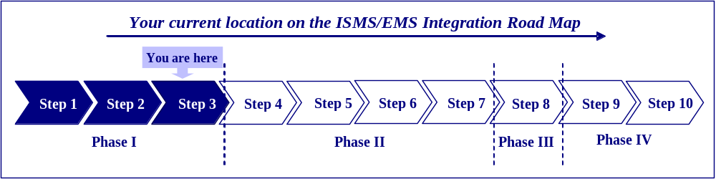

  - TASK 5: Develop Objectives and Targets To Address Significant Aspects
References
This task fulfills several DOE Order requirements listed below.

- The ISMS/EMS includes measurable environmental goals, objectives, and targets [DOE O 450.1 §4.a.(3)].
- The ISMS/EMS includes site-specific goals that contribute to the accomplishment of DOE pollution prevention and energy efficiency goals [DOE O 450.1 §5.c.(3)].
- Contractor ES&H performance objectives, performance measures, and commitments include appropriate environmental elements based on the environmental risks, impacts of activities at the site and established Departmental pollution prevention/energy efficiency goals [DOE O 450.1 §5.d.(17)].
The provisions in this task relate to established requirements of the following DOE Policies and Department of Energy Acquisition Regulations (DEAR).
- DOE P 450.5, “The Departments and contractors’ line organizations (a) Work together to develop ES&H performance objectives, measures, and expectations, . . . as well as performance goals and objectives of the [Environment, Safety and Health] Management System elements.”
- DOE P 450.5, “A robust, rigorous, and credible contractor self-assessment program linked to the DOE [Environment, Safety and Health] Management System is in place, which includes elements that address . . . performance measures and performance indicators . . . .”
- DEAR clause 970.5223-1(d), “The [ISM] System shall describe how the contractor will establish, document, and implement [environment, safety and health] performance objectives, performance measures, and commitments . . . . The System shall also describe how the contractor will measure system effectiveness.”
- DEAR clause 970.5223-1(e), “On an annual basis, the contractor shall review and update . . . its [environment, safety and health] performance objectives, performance measures, and commitments . . . .”
Task 5 sets forth the approach for setting objectives and targets for the significant environmental aspects. It is through the achievement of these objectives and targets that an organization addresses its significant aspects, including its compliance, mission, and environmental risks. To be confident that the objectives and targets will be effective in addressing the significant environmental aspects, it is important that they be systematically established and periodically reviewed and reconsidered within the management review process.
    - Defining Objectives and Targets
Setting objectives and targets requires a clear understanding of the exact meaning of these terms. The following paragraphs explain how the ISMS/EMS team might apply the terms in an EMS.
EMS Objectives
Objectives describe the organization’s goals for environmental performance. The organization should set measurable (and if possible quantified) objectives. Some objectives are quantifiable, while others that cannot be quantified may still be measured quantitatively. For example, the organization may set an objective to reduce pesticide usage by 4 percent in the first year. Such a quantified objective is possible because the organization is aware of its previous pesticide usage and thus has a baseline against which it can measure improvement.
An objective to develop a plan to reduce the use of hazardous chemicals by 20 percent through the use of less hazardous substitutes is measurable even if it is not quantifiable. Another common example of this relates to compliance. If the organization has achieved compliance with a regulatory requirement, it may set its objective to maintain compliance. The key when setting objectives is to ensure that they are measurable whether or not they are quantifiable.
EMS Targets
Targets are specific and measurable immediate steps that the organization can in terms of obtaining the objectives. When the organization has set objectives, it may break them down into more specific subordinate targets. For example, an objective may be to reduce pesticide use by 20 percent in 2 years. Targets for this objective may include reductions of pesticide usage by 10 percent in grounds maintenance and by 10 percent in facility pest control.
When the objective is not quantified, targets can be used to provide performance measures by setting dates for completion of specific tasks. For example, if the objective is to develop a plan to reduce the use of hazardous chemicals by 20 percent through the use of less hazardous substitutes, the targets may define the completion date for this plan, (i.e., within 1 year).
    - Approach to Setting Objectives and Targets
The ISMS/EMS team should consider a variety of factors when setting objectives and targets to ensure that the objectives and targets are feasible and achievable. The following paragraphs describe some well-recognized factors. However, there may be other factors specific to the organization that the team should consider. These include any items that the ISMS/EMS team believes may influence the effectiveness of the objectives and targets. The pollution prevention possibilities for a given aspect should be considered before setting objectives and targets.
Considerations for setting objectives and targets include the following.
- Applicability of regulatory requirements, Executive Orders, and DOE Orders.
- Applicability of pollution prevention opportunities.
- Views of interested parties, such as employees, neighbors, environmental groups, and customers.
- Financial, operational, and technological options available and feasible for the organization.
- Organizational mission and need for continued operations.
- Direction and commitments described in the organization’s environmental policy.
Setting Objectives and Targets
In addition, the ISMS/EMS team should consider measurability and timeframes when setting objectives and targets. Whenever possible, the ISMS/EMS team should set objectives and targets in quantitative terms, with specific timeframes for accomplishment, to facilitate performance monitoring and trends analysis. However, while measurability should normally be specified, quantification is not a requirement. In some cases, quantification may not be possible because there is no baseline against which to measure performance of the environmental aspect. In these cases, the first cycle of measurements will serve as a baseline against which to compare future performance.
Estimated resource requirements may be set for each objective and target. These resources include financial requirements, time needed, and manpower resources needed for achieving the objectives and targets.
The ISMS/EMS team should list all of the objectives with detailed descriptions, including all of the targets that make up each objective and a detailed resource estimate and justification. This information is necessary for assessing the ISMS/EMS. In addition, the ISMS/EMS team should maintain a summary table to track progress toward developing objectives and targets and to keep as a record after formalization of the objectives and targets are. Table 9 is an example of this type of summary table.
  - TASK 6: Formalize Environmental Objectives and Targets And Develop The Environmental Management Plan
The final task in Phase I is to formalize the organization’s objectives and targets. The primary decision makers (management) in the organization must agree on the objectives and targets before they can be formalized. Management must review the detailed descriptions of the objectives, the resource estimates, and any other related information necessary for it to authorize implementation of programs for achieving the objectives and targets (see Table 9).
Once management has authorized the use of resources and the development of programs to achieve objectives and targets, the organization can proceed to accomplish those aims through development of an Environmental Management Plan. The organization creates the EMP for achieving the objectives and targets set for significant environmental aspects. These new, modified, or existing EMPs should clearly describe any additional actions and tasks needed to achieve the objectives and targets for the EMS elements. For additional guidance on EMPs, see Section 5.1.1 of this Guide.
Env. Aspect | Activities/ Products/Services | Potential Impacts | Significance based  1 overall score>30  2 reg. score  3 mission score | Objective | Target | Resource  (FTE) | Approval
Air Emissions | Using and Storing Chem. Products and Chem. Hazardous Agents | General reduction in air quality, and potential human, ecological, and habitat effects in the locality, spreading over a large footprint affecting all media and biota. Noncompliance with applicable laws/regulations. | Significant on:  Reg. Score | Reduce air emissions  Reduce number of violations for non compliance | Conduct PPOA in a 1st quarter of FY. Report results in 3rd quarter of FY, set new target to implement P2 solution by 4th quarter of the second year | 0.75 | yes
Air Emissions | Constructing or Modifying Facilities, Processes, or Equipment
Air Emissions | Deactivating, Decommissioning, Dismantling, or Closing Facilities, Equipment, and Processes
Air Emissions | Maintaining, Servicing or Repairing Refrigeration and Air Conditioning Equipment
Air Emissions | Constructing Hazardous Waste Units
Air Emissions | Combusting fuel for heat, power or electricity
Air Emissions | Closing Waste Management Units
Disturbance of Cultural Historical Resources | Constructing or Modifying Facilities, Processes, or Equipment | Ecological damage, damage of culturally and historically significant artifacts. Noncompliance with applicable laws/regulations. | Significant on:  Reg. Score | Ensure that cultural and historical preservation training is available to waste management staff | Have training program in place within 9 months | 0.5 | yes
Disturbance of Cultural Historical Resources | Conducting Open Burning
Disturbance of Cultural Historical Resources | Constructing or Modifying Aboveground and Underground Storage Tanks
Releases to Wastewater System and Groundwater | Deactivating, Decommissioning, Dismantling, or Closing Facilities, Equipment, and Processes | Runoff to local rivers and streams with species, habitat, and fisheries impacts. Leaching to groundwater (aquifers) and biota. Noncompliance with applicable laws/regulations. | Significant on:  Reg. Score  Overall Score | Conduct PPOA of all activities and processes that produce discharges and identify opportunities to eliminate or reduce discharges. | Conduct PPOA in 1st quarter of FY. Report results in 3rd quarter of FY, set new target to implement P2 solutions by 4th quarter of second year. | 2.0 | yes
Releases to Wastewater System and Groundwater | Conducting Research and Development
Releases to Wastewater System and Groundwater | Leaks, Spills, and Releases
Medical Waste Generation, Management and Disposal | Conducting Research and Development | Ecological damage, contamination of air, water, and soil with biohazards, impact to human health and biota, waste generation. Noncompliance with applicable laws/regs. | Significant on:  Reg. Score | Analyze ways to reduce waste generation & maintain full reg. compliance | Reduce waste generation by 5% in 2 years. | 0.5 | yes
Radioactive waste generation | Closing Waste Management Units | Waste storage and disposal; harm to the environ. impact to human health and biota; solid waste generation. Noncompliance with applicable laws/regs. | Significant on:  Reg. Score  Mission Score  Overall Score | Analyze ways to reduce waste generation  Achieve full regulatory compliance | Reduce waste generation by 5% in 2 years.  Develop program to achieve full compliance within 2 years | 3.0 | yes
Radioactive waste generation | Treating, Storing, Disposal of Waste
Radioactive waste generation | Releases, Leaks, Spills, Releases from Waste Management Activities
Radioactive waste generation | Disposition of Excess Materials

- Phase II—Implementation
and
Operation

- Integrated Safety Management System/ Environmental Management System Documentation
Task 7. Updating the Integrated Safety Management System/ Environmental Management System Description
Task 8. Developing an Environmental Management System Roadmap
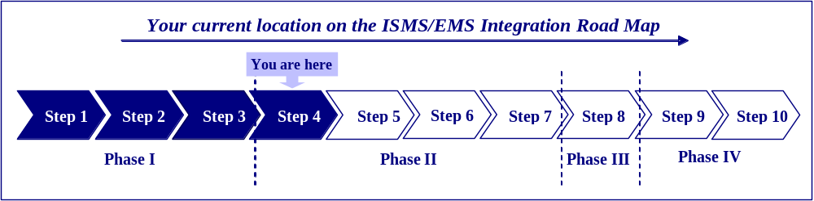
  - TASK 7: Updating The Integrated Safety Management System/Environmental Management System Description
References
This task provides guidance on how to meet the requirements listed below.
- The Contractor Requirements Document (CRD) attached to DOE O 450.1 specifies that one of the requirements of the Order is to “update approved ISMS descriptions as necessary to include EMS requirements of this CRD. The provisions in this task relate to established requirements of the following Integrated Safety Management System (ISMS) elements.
  - DEAR clause 970.5223-1(e), “The contractor shall submit to the contracting officer documentation of its [ISM] System for review and approval.”
  - ISM Guiding Principle 7, “Operations Authorization. The conditions and requirements to be satisfied for operations to be initiated and conducted shall be clearly established and agreed upon.”
    - Background
DEAR 970.5223-1 requires that the ISMS be documented, and many DOE sites have already met this requirement through the use of an ISMS description, which the contractor prepares and DOE approves. Generally, the ISMS description identifies existing policies, procedures, and manuals of practice used when performing work. In addition, many contractors have found it beneficial to provide details on the overall ISMS philosophy or vision, the implementation mechanisms, and the contractor’s approach to integrating Environment, Safety and Health requirements into the processes for planning and conducting work at the site to effectively protect the workers, the public, and the environment. Most contractors have organized their ISMS descriptions to reflect the core functions and guiding principles of ISMS.
ISMS Description
A tool that describes an organization’s approach to integrating ES&H requirements into conducting its work and helps to maintain and manage all information and documents relating to its ISMS/EMS.
Section 5.d. (2) of DOE O 450.1 requires the ISMS description to be updated, as necessary, to include the Environmental Management System (EMS) elements required by the Order. In many cases, sites with existing ISMSs are likely to have already addressed these EMS elements in their ISMS descriptions.
    - Documenting Environmental Management System Elements
Appendix B contains a list of the EMS elements required by DOE O 450.1 that the ISMS description should include. A gap analysis (see draft DOE G 450.1-1 for a discussion of conducting a gap analysis) can determine which EMS elements required by DOE O 450.1 are already included in the site’s existing ISMS description. The elements of an EMS and the ISMS core functions and guiding principles are very similar (see draft DOE G 450.1-1 for a discussion of the similarities between ISMS and EMS). Because of this compatibility between the two systems, updating the ISMS description should be straightforward. For example, if a site’s gap analysis uncovered the need to conduct an environmental aspects analysis, and the site conducted such an analysis, then the contractor should update the ISMS description to include a description of this analysis. Since analyzing environmental aspects is very similar to the “analyze the hazards” concept in ISMS, that part of the description should include a discussion of the environmental aspects analysis.
  - TASK 8: Developing An Environmental Management System Roadmap
    - Background
It may be useful for sites to develop a document that lists all the EMS elements required by DOE O 450.1 and describes their location in the ISMS description. This document can act as a checklist of EMS requirements, and allows an auditor or other interested party to quickly determine where all EMS elements are located or referenced in the ISMS description. For example, this checklist might be useful to the Office of Independent Oversight and Performance Assurance, which under the DOE O 450.1 has the responsibility to assess implementation of the requirements of the Order (DOE O 450.1 § 5.e.). This checklist is referred to as the “EMS Roadmap.”
    - EMS Roadmap Template
Appendix B contains a complete EMS Roadmap template and an example illustrating the use of this template. Although this template is not a requirement of the Order, when the site has fully integrated the EMS Elements into its ISMS, it should be able to provide references for all the DOE O 450.1 requirements.

- Developing Environmental Management Programs
Task 9. Create environmental management programs
Task 10. Document environmental management programs
Task 11. Approve the environmental management programs
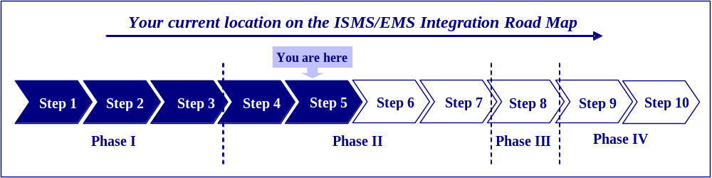
  - TASK 9: Create environmental management programs
References
This task provides guidance on how to meet the DOE O 450.1 requirements listed below.
- The ISMS/EMS includes policies [and] procedures to manage, control, and mitigate the potential impacts of site activities with significant environmental impacts [DOE O 450.1 §4.a. (2)].
- The ISMS/EMS includes (if applicable) conformity of DOE proposed actions with State Implementation Plans to attain and maintain national ambient air quality standards [DOE O 450.1 §4.b. (1)(a)].
- The ISMS/EMS includes (if applicable) implementation of a watershed approach for surface-water protection [DOE O 450.1 §4.b. (1)(b)].
- The ISMS/EMS includes (if applicable) implementation of a site-wide approach for groundwater protection [DOE O 450.1 §4.b. (1)(c)].
- The ISMS/EMS includes (if applicable) protection of other natural resources, including biota [DOE O 450.1 §4.b. (1)(d)].
- The ISMS/EMS includes development and implementation of cost-effective pollution prevention programs that use life-cycle assessment concepts and practices in determining program return-on-investment [DOE O 450.1 §5.c. (4)].
- The ISMS/EMS includes (if applicable) protection of cultural resources [DOE O 450.1 §4.b. (1)(f)].
- The ISMS/EMS includes (if applicable) protection of site resources from wildland and operational fires [DOE O 450.1 §4.b. (1)(e)].
- The ISMS/EMS provides for reduction or elimination of: the generation of waste, the release of pollutants to the environment, and the use of Class I ozone-depleting substances (ODS), through source reduction, reuse, segregation, and recycling and by procuring recycled-content materials and environmentally preferable products and services [DOE O 450.1 §4.b. (3)].
- The ISMS/EMS promotes the long-term stewardship of a site’s natural and cultural resources throughout its operational, closure, and postclosure life cycle [DOE O 450.1 §4.b. (2)].
The provisions in this task relate to established requirements of the following ISMS elements.
- ISM Guiding Principle 6, “Hazard Controls Tailored to Work Being Performed. Administrative and engineering controls to prevent and mitigate hazards shall be tailored to the work being performed and associated hazards.”
- Environmental management programs—environmental management programs [a subset of management programs (MP) in the ISMS/EMS] address the environmental goals, objectives, and targets set for significant environmental aspects.
    - Create Environmental Management Programs
At this point, the ISMS/EMS team should have identified the organization’s significant environmental aspects and established new or modified goals, objectives and targets based on the Chapter 1, Phase I guidance. The next task is to develop Environmental Management Programs (EMPs) to achieve these goals, objectives and targets. Sites may approach the creation of EMPs from different perspectives. They may develop one for each significant environmental aspect (identified in Chapter 1, Phase I); they may develop one for each objective and target; they may develop them for activities that contain significant environmental aspects; and they may even develop them for facilities with many significant environmental aspects. Wherever possible, sites should use existing ISMS programs to address the EMS goals, objectives and targets. If there is no suitable program under the ISMS, then the team should create new EMPs for that purpose. Whatever approach sites use should suit their operations and make best use of existing programs.
Environmental Management Program
An environmental management program is created for achieving goals, objectives, and targets set for significant environmental aspects.
EMPs should cover all EMS goals, objectives and targets set for significant environmental aspects and that they should include the allocation of organizational resources, the assignment of environmental management program responsibilities for tasks, and the specification of timelines for actions that are to be taken. It is also useful to document other EMS elements in the EMP such as employee training, operational controls, performance indicators, and relevant legal requirements.
  - TASK 10: Document Environmental Management Programs
The site should formally document its EMP. The EMP template, contained in Appendix B, is an optional approach for structuring the documentation of an EMP. A DOE site developed and used the template contained in Appendix B. Although many sites already have well-documented management programs, this template is useful for those sites that do not have written programs; those sites that have documented programs but would like to compare these programs against an alternative approach; and those sites that have formal documented programs for most of their goals, objectives, and targets but need to address some new ones related to the EMS elements.
  - TASK 11: Approve the Environmental Management Programs
Reference
This task provides guidance on how to meet the DOE Order requirements listed below.
- DOE Operations/Field/Site Office Managers must “ensure that contractors with approved ISMS descriptions update the ISMS description as necessary, to include the EMS requirements of this Order.” [DOE O 450.1 § 5.d. (2)]
The provisions in this task relate to established requirements of the following ISMS element.
- DOE P 450.4, “Responsibilities must be clearly defined in documents appropriate to the activity. For each management mechanism employed to satisfy [an environment, safety, and health] management principle or function, the associated approval authority needs to be established. The review and approval levels may vary commensurate with the type of work and the hazards involved.”
    - Review and Approval
Once completed, the EMPs should be presented to appropriate management for review and approval. The ISMS/EMS team should incorporate management’s comments before gaining final approval. Management’s approval should be obtained before individuals are trained, new activities designated, and resources expended.
    - Placement of Completed Environmental Management Program Documents
The ISMS/EMS description should reference the EMPs, after their approval.

- Developing Operational Controls
Task 12. Specify Operational controls
Task 13. Approve operational controls
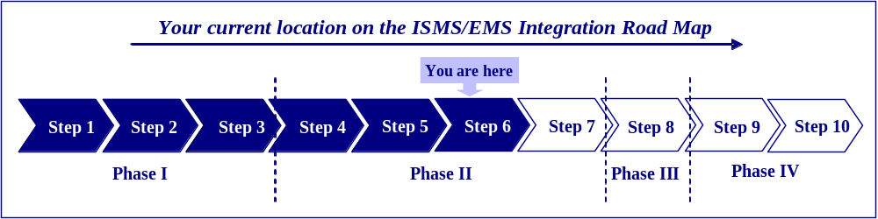
  - TASK 12: Specify operational controls
References
This task provides guidance on how to meet the DOE Order requirements listed below.
- The ISMS/EMS includes procedures to manage, control, and mitigate the potential impacts of site activities with significant environmental impacts [DOE O 450.1 §4.a.(2)].
- The ISMS/EMS includes training to identify activities with significant environmental impacts [DOE O 450.1 §4.a.(2)].
- The ISMS/EMS includes training to manage, control, and mitigate the potential impacts of site activities with significant environmental impacts [DOE O 450.1 §4.a.(2)].
- The ISMS/EMS includes training to assess performance and implement corrective actions where needed [DOE O 450.1 §4.a.(2)].
- The ISMS/EMS provides for obtaining, as appropriate, community advice relevant to aspects of “Greening the Government” Executive Orders, through new or existing outreach programs [DOE O 450.1 §5.d.(3)].
The provisions in this task relate to established requirements of the following ISMS elements.
- ISM Core Function 3, “Develop and Implement Hazard Controls: . . . controls to prevent/mitigate hazards are identified, the [environment, safety and health] envelope is established, and controls are implemented.”
- ISM Core Function 4, “Perform Work within Controls.”
    - Specifying Operational Controls
As mentioned in Step 5, operational controls are an important element for managing EMS goals, objectives, and targets. Operational controls are applied to specific activities or processes managed by the EMP and can fall into two categories: (1) engineering controls and (2) administrative controls.
Engineering controls intervene mechanically to avoid a potential incident. A simple example is using a funnel to reduce the chance of oil spills. Administrative controls include procedural approaches to activities, such as training employees on the procedure for filling fuel tanks. Frequently, sites use administrative and engineering controls in combination, in which case the procedure incorporates the funnel as one of the mechanical controls workers are to follow when filling fuel tanks. The system documentation should include these operational controls.
Sites should apply operational controls to the activities, products, and services that give rise to significant environmental aspects. For example, energy use may have been designated as a significant environmental aspect. One of the activities that could cause this aspect may be office work. While it may not be feasible to set operational controls for office work as a whole, individual operational controls can be set for each contributing source such as computers, the office kitchen, and office heating, all of which are component parts of office work. Sites implement operational controls as integral parts of the EMPs. Another example is an objective to reduce hazardous waste produced by a laboratory. In this case, the site could apply operational controls to specific tasks, processes, or analytical techniques.
Wherever possible, sites should use existing operational controls to control the occurrence of specific aspects identified in Phase I. However, it is possible that sites will need to develop new operational controls to address specific operations and activities that have significant environmental aspects as identified in Phase I. The ISMS/EMS description should reference these new operational controls. The operational control template, provided in Appendix B, is an approach that many organizations have used effectively to document their operational controls.
  - TASK 13: Approve operational controls
Reference
This task provides guidance on how to meet the DOE Order requirements listed below.
- DOE Operations/Field/Site Office Manager must “ensure that contractors with approved ISMS descriptions update the ISMS description as necessary, to include the EMS requirements of this Order.” [DOE O 450.1 §5.d.(2)]
The provisions in this task relate to established requirements of the following ISMS element.
- DOE P 450.4, “Responsibilities must be clearly defined in documents appropriate to the activity. For each management mechanism employed to satisfy [an environment, safety and health] management principle or function, the associated approval authority needs to be established. The review and approval levels may vary commensurate with the type of work and the hazards involved.”
    - Review and Approval
Once completed, an operational control should be sent to appropriate management for review and approval. The ISMS/EMS team should incorporate management’s comments before gaining its approval. The team should obtain management’s approval before individual training, designation of new activities, and resource expenditures occur.
    - Placement of Completed Operational Controls
The ISMS/EMS description should reference operational controls after their approval.
- Develop Integrated Safety Management System/Environmental Management System Procedures
Task 14. Establish Integrated Safety Management System/Environmental Management System procedures
Task 15. Document Integrated Safety Management System/Environmental Management System procedure templates
Task 16. Authorize Integrated Safety Management System/Environmental Management System procedures
Task 17. Implement Integrated Safety Management System/Environmental Management procedures
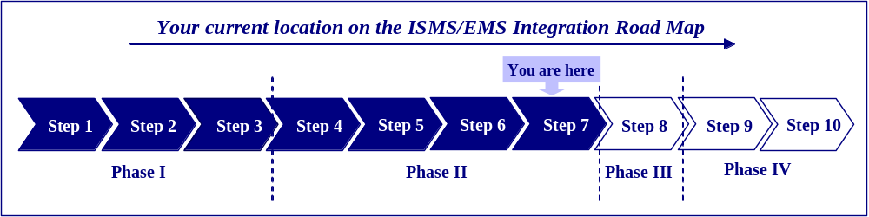
  - TASK 14: Establish Integrated Safety Management System/ Environmental Management System Procedures
References
This task provides guidance on how to meet the DOE Order requirements listed below.
- The ISMS/EMS includes policies, procedures to assess performance [DOE O 450.1 §4.a.(2)].
- Contractor ES&H self-assessment programs within the framework of DOE P 450.5 are established and continue to be effective [DOE O 450.1 §5.d.(16)].
- The ISMS/EMS ensures the early identification of, and appropriate response to, potential adverse environmental impacts associated with DOE operations, including, as appropriate, preoperational characterization and assessment and effluent and surveillance monitoring [DOE O 450.1 §4.b.(4)].
- The ISMS/EMS provides for the conduct of environmental monitoring, as appropriate, to support the site’s ISMS, to detect, characterize, and respond to releases from DOE activities [DOE O 450.1 §5.d.(14)].
- The ISMS/EMS provides for the conduct of environmental monitoring, as appropriate, to assess impacts, to estimate dispersal patterns in the environment, to characterize the pathways of exposure to members of the public, and to characterize the exposures and doses to individuals, and to the population [DOE O 450.1 §5.d.(14)].
- The ISMS/EMS provides for the conduct of environmental monitoring, as appropriate, to evaluate the potential impacts to the biota in the vicinity of the DOE activity [DOE O 450.1 §5.d.(14)].
- The ISMS/EMS provides for the implementation of the analytical work supporting environmental monitoring using a consistent system for collecting, assessing, and documenting environmental data of known and documented quality [DOE O 450.1 §5.d.(15)(a)].
- The ISMS/EMS provides for the implementation of the analytical work supporting environmental monitoring using a validated and consistent approach for sampling and analysis of radionuclide samples to ensure laboratory data meet program-specific needs and requirements within the framework of a performance-based approach for analytical laboratory work [DOE O 450.1 §5.d.(15)(b)].
- The ISMS/EMS provides for the implementation of the analytical work supporting environmental monitoring using an integrated sampling approach to avoid duplicative data collection [DOE O 450.1 §5.d.(15)(c)].
The provisions in this task relate to established requirements of the following ISMS elements.
- DOE P 450.4, “[Environment, Safety and Health] Mechanisms define how the core [environment, safety and health] management functions are performed. The mechanisms may vary from facility to facility and from activity to activity based on the hazards and the work being performed and may include: contractor policies, procedures and documents . . . established to implement [environment, safety and health] management . . . .”
- ISM Core Function 3, “Develop and Implement Hazard Controls: . . . controls to prevent/mitigate hazards are identified, the [environment, safety and health] envelope is established, and controls are implemented.”
- ISM Core Function 4, “Perform Work within Controls.”
    - Integrated Safety Management System/Environmental Management System Procedures
Standard operating procedures are an essential element of any management system. Sites should document these procedures, as well as other procedures that are repeatedly carried out in the ISMS/EMS. By documenting all procedures, sites improve the likelihood that they are carried out consistently and reliably. Table 10 of Appendix B lists all the procedures required by DOE O 450.1, as well as the procedures that are recommended. Sites should consider documenting all these procedures.
    - The Role of Integrated Safety Management System/Environmental Management System Procedures
Standard Operating Procedures include two types of procedures: (1) those that directly address environmental issues, such as the procedure for identifying environmental aspects, the procedure for identifying legal and other requirements and the procedure for setting goals, objectives, and targets, and (2) those that are administrative, such as record keeping and document control. Many DOE sites may already have most of these procedures. Standard operating procedures enable information to flow to individuals at the relevant functions and levels of the organization. This provides them with the knowledge and expertise to manage the day-to-day environmental impacts of their work activities and to support the organization’s ISMS/EMS goals, objectives and targets. ISMS/EMS procedures also promote reliable and appropriate information flows that allow the execution of emergency response plans, the checking of system status and progress, the correction of nonconformances, the upgrading of training levels and competence, the implementation of programs and operational controls to achieve goals, objectives and targets, and the proper involvement and intervention of the organization’s appropriate management. The EMS procedures discussed here can be used to help maintain the effectiveness of the EMS elements within an ISMS/EMS over the long-term.
    - Keeping Procedures Simple
ISMS/EMS procedures should be simple to implement and execute on an ongoing basis. The major goal of achieving reliability in the management of environmental, safety and health (ES&H) exposures can be jeopardized by complicated or unnecessarily prescriptive procedures. This is particularly important in using the ISMS/EMS to integrate ES&H programs into the organization’s total operations and not just those of the ES&H staff.
  - TASK 15: Documenting Integrated Safety Management System/Environmental Management System Procedures
    - Integrated Safety Management System /Environmental Management System Procedures
In many cases, DOE sites will already have the majority of these procedures in place, including records management, document control, emergency preparedness and response, and training as part of the ISMS or as part of the site general management system. Usually it is possible to incorporate the appropriate EMS requirements directly into these existing procedures. Therefore, ISMS/EMS teams should identify potentially applicable existing procedures wherever possible and then use them as the basis for satisfying any additional EMS requirements. If there is no existing procedure, the site should develop a new procedure to fulfill the requirement of the ISMS/EMS.
    - Implementing Integrated Safety Management System/Environmental Management System Procedures
The ISMS/EMS team should coordinates the preparation of the ISMS/EMS procedures. The task of writing or upgrading each procedure will fall either to the environmental staff or to functional staff members responsible for that particular activity in the organization. For example, the administrative staff at the site may modify or write records management and document control procedures to conform to the expanded ISMS/EMS requirements. Responsibility for modifying the emergency preparedness and response procedure may be a task for the emergency response and occupational health and safety staff with input from the environmental staff on the potential environmental consequences and the proper manner to respond to them. On the other hand, those assigned to environmental duties are more likely to write the environmental aspects identification procedure. Planning and coordinating the responsibilities for writing the ISMS/EMS procedures constitute a major effort. Sites should designate an individual to serve as the ISMS/EMS coordinator to coordinate the procedure drafting process. He or she should ensure that, to the greatest extent possible, such procedures do not duplicate existing site or ISMS procedures. The goal, rather, is to promote the total integration of EMS elements into the ISMS/EMS.
Although some specific functions play a greater role in the implementation of the ISMS/EMS, all employees have some role to play. This is because all job functions within the organization are likely to have the opportunity to interact with the ISMS/EMS at some point. Therefore, all employees should be able to implement those procedures that specifically apply to their job functions.
  - TASK 16: Approve Integrated Safety Management System/ Environmental Management System procedures
References
This task fulfills several DOE Order requirements listed below.
- The ISMS/EMS provides for the evaluation of programs for compliance with applicable requirements [DOE O 450.1 §4.a. (1)(c)].
- The ISMS/EMS provides for the evaluation of programs for public health and environmental protection [DOE O 450.1 §4.a. (1)(a)].
- The ISMS/EMS provides for the evaluation of programs for pollution prevention [DOE O 450.1 §4.a. (1)(b)].
- The assessment of ISMS/EMS implementation is a component of the implementation of DOE P 450.5 Line Environment, Safety and Health Oversight (DOE O 450.1 §5.b.).
- The ISMS/EMS includes policies and procedures to implement corrective actions where needed [DOE O 450.1 §4.a. (2)].
The provisions in this task relate to established requirements of the following ISMS element.
- DOE P 450.4, “Responsibilities must be clearly defined in documents appropriate to the activity. For each management mechanism employed to satisfy [an environment, safety and health] management principle or function, the associated approval authority needs to be established. The review and approval levels may vary commensurate with the type of work and the hazards involved.”
    - Review and Approval
It is essential that appropriate management review and approve new or adapted procedures. Once the ISMS/EMS procedures are complete, the ISMS/EMS team sends it to appropriate management for review, and incorporates management’s comments before obtaining final approval. The procedure must obtain management approval before its implementation at the site.
  - TASK 17: Implement Integrated Safety Management System /Environmental Management System procedures
References
The provisions in this task relate to established requirements of the following ISMS elements.
- ISM Core Function 4, “Perform Work within Controls.”
- ISM Guiding Principle 3, “Competence Commensurate with Responsibilities. Personnel shall possess the experience, knowledge, skills, and abilities that are necessary to discharge their responsibilities.”
    - Background
The site should implement ISMS/EMS procedures at all levels and functions and integrate the procedures into the existing site system, so all site employees can follow them. Procedures should reflect, therefore, actions occurring on the ground at the site. It is also essential that all employees in the organization be able to easily follow the procedures that apply to their job functions.
    - Training
Training is an important part of the implementation of the ISMS/EMS procedures. The site should make all employees aware of procedures through general awareness training, which should detail, in particular, any changes made to existing procedures.
    - Responsibility for Maintaining Records
The implementation of procedures creates records in the ISMS/EMS. These include training records, audit reports, minutes of meetings, records of equipment calibration, reports of compliance status, lists of aspects and legal requirements, communication memorandums, measurements of outcomes, and so on. Each procedure should specify the basis for producing such records. At the time of implementation, all applicable personnel must be aware of who is responsible for creating, managing, labeling, collecting, and storing these records.
    - Maintaining Procedures
Over time, it will be necessary to make changes to the procedures as employees identify elements for improvement or new record needs are identified as site operations evolve. In particular, it is likely that many changes will be necessary soon after the initial implementation of procedures. The first use of a procedure often reveals many areas for its improvement. Following this initial modification, the site should update procedures periodically as operations and systems evolve. This is part of the continual improvement process of the ISMS/EMS. As these updates occur, the ISMS/EMS coordinator should ensure—
- procedures are controlled in accordance with the site’s document control procedure and only the latest authorized version of each procedure is in circulation for use by employees,
- the revision date is displayed on each procedure, and
- employees are aware of any changes and have access to the latest authorized versions.
    - Accessibility
Because the purpose of procedures is to standardize common activities that occur in the ISMS/EMS to ensure their performance to the same high standard, employees should have easy access to the procedures. The accessibility of a procedure to employees is the result of several factors described below.
Physical Accessibility
The ISMS/EMS relies heavily on the participation and contributions of line functions. Physical accessibility ensures that employees can obtain the procedures they are supposed to be following. Physical accessibility is more than merely permitting the retrieval of a document from a file drawer; it requires that access to the document be convenient, immediate, and encouraged.
Employees need to know that documents exist and their locations, and that they have ready and easy access to them. This may necessitate posters at work sites that point to the location of applicable procedures and that encourage workers to retrieve them.

Conceptual Access
Employees must also have conceptual access to the specific requirements contained in procedures. This means that, in addition to being able to locate the procedures, they must be able to understand the concepts contained within them. Procedures should be simple and easy to follow for their primary users.
Operational Access
Operational access concerns whether employees can realistically apply the procedure in a real situation. The question to answer here is whether the procedural requirements consider the work area conditions and culture, and whether employees can apply them under those conditions. The internal ISMS/EMS assessment and employee feedback will eventually answer this question.
- Phase III—Checking and
Corrective Action

- Establishing the ISMS/EMS Assessment Program
Task 18. Establish the ISMS/EMS Assessment Program
Task 19. Plan the Assessment
Task 20. Conduct On-site Assessment Activities
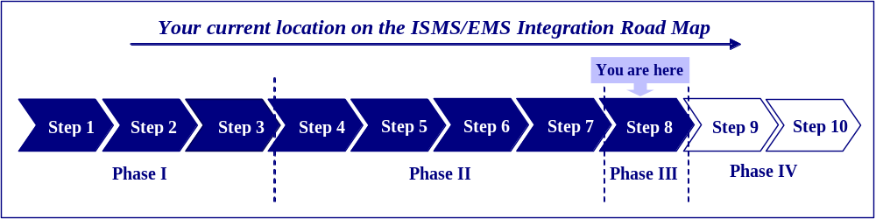
  - TASK 18: Establish the ISMS/EMS Assessment Program
References
This task fulfills requirements in several DOE Directives listed below.
- The Integrated Safety Management System/Environmental Management System (ISMS/EMS) provides for the evaluation of programs for public health and environmental protection, pollution prevention, and compliance with applicable requirements [DOE O 450.1 §4.a.(1)].
- Contractor ES&H self-assessment programs within the framework of U.S. Department of Energy (DOE) P 450.5 are established and continue to be effective [DOE O 450.1 §5.d.(16)(c)].
- The ISMS/EMS includes policies and procedures to assess performance and implement corrective actions where needed [DOE O 450.1 (4.a.(2)].
- Draft DOE Policy on Oversight, DOE P 226.1, and draft DOE Notice on Oversight Policy, DOE N 226.1, provide for the need for self-assessments, for internal independent assessments, and for independent oversight reviews.
The provisions in this task also relate to requirements in the following ISMS elements.
- ISM Core Function 5, “Provide Feedback and Continuous Improvement: . . . line and independent oversight is conducted . . . .”
- DOE P 450.5, “A robust, rigorous, and credible contractor self-assessment program linked to the DOE [Environment, Safety and Health] Management System is in place, which includes elements that address . . . line and independent evaluations.”
- DOE P 450.5, DOE field elements conduct “a periodic, value-added appraisal of sufficient frequency and duration to confirm the contractor’s [safe and environmentally sound] performance of work and the effectiveness of the [contractor’s] self-assessment program.”
- DOE G 450.4-1B, Chapter III, discusses assessing an ISMS, and Chapter IV discusses maintaining and sustaining an approved ISMS.
    - Background and Purpose
Self-assessment activities range from informal, to formal and structured. The purpose of this section of the Guide is to provide guidance on conducting formal self-assessments. Normally an organization with an appropriate degree of independence from the activity being reviewed conducts these assessments.
The assessment described here (referred to as assessment or ISMS/EMS assessment) is a structured, formal self-assessment used to evaluate a site’s ISMS/EMS. For example, some DOE sites have already established Internal Independent Review Boards that conduct these types of assessments of the site’s ISMS. These existing programs should be used to satisfy the DOE O 450.1 requirement that a site’s ISMS/EMS include policies and procedures to assess performance and implement corrective actions.
    - The Assessment Program
DOE P 450.5 and DOE O 414.1A require a rigorous and credible contractor self-assessment program linked to the organization’s ISMS that address the following.
- Performance measures and performance indicators.
- Line evaluations and independent evaluations.
- Compliance with applicable requirements.
- Data collection, analysis, and corrective actions.
- Feedback and performance improvement.
Conducting an assessment is not a one-time activity. To ensure assessment performance and management in an organized fashion with regularity, efficiency, and effectiveness, sites should have an “Assessment Program.” The ongoing activities associated with providing for, preparing for, and carrying out the assessments makes up the site’s “Assessment Program.” The Assessment Program should also include the establishment of assessment procedures, protocols, and criteria that verify the effectiveness of both the individual elements of the system and of the system in its entirety (see Figure 1). The Assessment Program should comprise the site’s provisions and arrangements for ongoing assessments as well as its systematic approach for preparing for and planning each ISMS/EMS assessment. Other elements of the Assessment Program should include—
- communicating the Assessment Program to relevant parties;
- coordinating and scheduling assessments and other assessment program activities;
- establishing and maintaining a process for the initial training of the assessment team and for the ongoing evaluation of its training needs;
- ensuring the selection of assessment teams;
- providing necessary resources to the assessment teams;
- ensuring the conduct of assessments in accordance with the Assessment Program;
- ensuring the control of records of the assessment activities;
- ensuring review and approval of assessment reports, and ensuring their distribution to the site being assessed and other specified parties; and
- ensuring assessment followup, when applicable.
    - Assessment Concepts
The ISMS/EMS assessments should be carried out in order to determine whether or not the ISMS/EMS conforms to requirements established by DOE O 450.1 and whether the site has properly implemented and maintained it. Based on this presentation of information during the management review, the organization should consider actions or changes to the ISMS/EMS system such as the following.
- Corrective actions for functional environment, safety, and health program integration issues.
- Corrective actions to improve ISMS/EMS implementation and effectiveness.
- Performance measures for the next year.
- Any changes required in the assessment focus or criteria.
- Any changes, if required, to an ISMS/EMS description document.
- Impacts of any changes to laws, regulations, and directives.
- Any changes to the level of resources applied to the ISMS/EMS.
Figure 1. Sample assessment program reflecting how concepts of the plan-do-check-act cycle are incorporated in it.
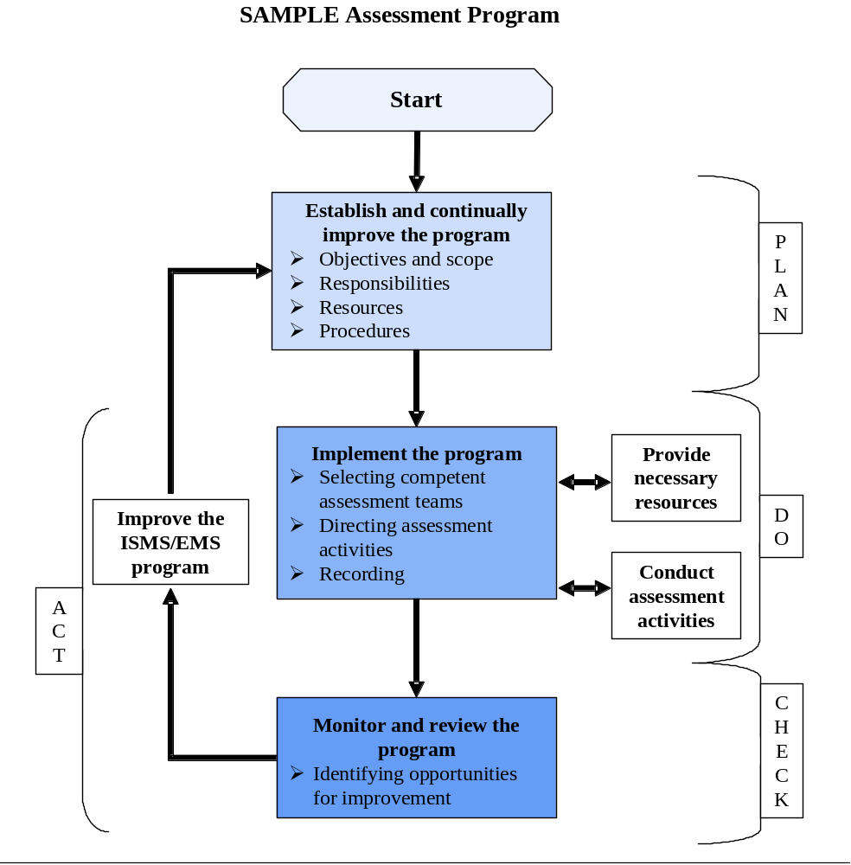

The organization should determine whether the ISMS/EMS system and performance objectives, performance measures, and commitments require modification, update, or revision in the scheduled review and approval process. (See DOE G 450.4.-1B.)
The ISMS/EMS assessment is a review of system implementation and system strength. It should provide senior management with information concerning the ISMS/EMS and enable managers to identify priority areas for improvement. Information gained from the ISMS/EMS assessment should be reviewed during the management review described in Phase IV. It may be helpful to clarify the meaning and intent of the ISMS/EMS assessment by stating what it is and what it is not.
- The ISMS/EMS assessment is a documented process that provides a snapshot view of the ISMS/EMS status at a point in time from which the organization can continue to improve.
ISMS/EMS Assessment is not—
- An ISO audit
- A self-declaration evaluation
- A regulatory compliance assessment
- A performance check
- The management review
- It is more than a walk-through (that may or may not be documented) by various individuals within an organization. It is a formal process that uses established criteria for conducting the assessment and individuals within the organization who are trained to conduct the assessments.
- It is not primarily a regulatory compliance assessment, so it need not verify the organization’s compliance with applicable laws and regulations. It can, however, make use of information on the compliance status of the organization to ascertain whether the management system is succeeding in addressing compliance and performance goals the organization has set.
- It is not, by itself, a performance check to ascertain whether the site is meeting performance goals or making progress toward meeting them (see below). As with compliance, the assessment team may use information on whether the site is meeting performance goals or progressing to evaluate whether the system needs further improvement in certain areas to ensure progress towards meeting certain performance goals. The assessment team should use information on both performance attainments and compliance as indicators of whether the elements of the ISMS/EMS require improvement.
- It is not a management review since that is a distinct and separate item of the ISMS/EMS that the organization’s management conducts (see Phase IV). The ISMS/EMS assessment should not duplicate or obviate management’s determination of the suitability, adequacy, and effectiveness of the ISMS/EMS. The ISMS/EMS assessment should, however, determine whether the process established for the management review is sufficiently rigorous to allow the organization’s management to make the determinations of suitability, adequacy, and effectiveness.
  - TASK 19: Plan the Assessment
References
This task fulfills requirements in several DOE directives listed below.
- The ISMS/EMS provides for the evaluation of programs for public health and environmental protection, pollution prevention, and compliance with applicable requirements [DOE O 450.1 §4.a.(1)].
- Contractor ES&H self-assessment programs within the framework of DOE P 450.5 are established and continue to be effective [DOE O 450.1 §5.d.(16)(c)].
- The ISMS/EMS includes policies and procedures to assess performance and implement corrective actions where needed [DOE O 450.1 (4.a.(2)].
- The draft DOE Policy on Oversight , DOE P 226.1, and the draft Notice on Oversight Policy, DOE N 226.1, provide for self-assessments, internal independent assessments, and independent oversight reviews.
The provisions in this task also relate to requirements in the following ISMS elements.
- ISMS Core Function 5, “Provide Feedback and Continuous Improvement: . . . line and independent oversight is conducted . . . .”
- DOE P 450.5, “A robust, rigorous, and credible contractor self-assessment program linked to the DOE [Environment, Safety and Health] Management System is in place, which includes elements that address . . . line and independent evaluations.”
- DOE P 450.5, DOE field elements conduct “a periodic, value-added appraisal of sufficient frequency and duration to confirm the contractor’s [safe and environmentally sound] performance of work and the effectiveness of the [contractor’s] self-assessment program.”
- DOE G 450.4-1B, Chapter III on assessing ISMSs and Chapter IV on maintaining and sustaining approved ISMSs.
Section 8.2.1 discusses audit principles that are relevant and appropriate for ISMS/EMS assessments (see Figure 2). Also included are best-practice descriptions of the implementation of these principles. While it is likely that sites already use many of these principles and practices in their assessments, the discussion below aims to provide additional insights and opportunities for sites to enhance or adapt their existing assessment programs.
    - Basic Principles
The same principles used in the auditing arena are applicable to conducting an assessment. A number of auditing principles ensure that assessments are effective and reliable so as to support management policies and to provide data that personnel can use to improve performance. Adherence to these principles also ensures that assessment team members working independently from one another can reach relevant and consistent assessment conclusions.
The following are two key principles of auditing.
- Impartiality—This is the basis for maintaining objectivity of the assessment conclusions. (Assessment team members should be independent of the activity being assessed and be free from bias and conflict of interest. Assessment team members should maintain an objective state of mind throughout the assessment process to ensure that the assessment findings and conclusions will be based only on the collected evidence.)
- Evidence-based approach—This is the method for reaching reliable and reproducible assessment conclusions in a systematic assessment process.
    - Conducting the Assessment
Planning
Typically, the assessment process should proceed in stages, including preparation, communication, coordination, execution, documentation, and closure. Figure 2, ISMS/EMS assessment process flow chart, illustrates this process. The assessment team may also use existing site assessment processes to accomplish this task.
- Initiating the assessment plan—The site should assemble an assessment team to develop a plan to conduct the assessment. Initially, the team should ensure that it has all the information necessary to write the plan. It can use a checklist to ensure the availability of the necessary information for the assessment plan. (See sample ISMS/EMS Internal Assessment Preparation Checklist, Appendix C). See other notes on page refs.
- Completing the assessment plan—Appendix C, provides a sample assessment plan, including instructions regarding how to use the plan. This or a similar form can help in the planning of an assessment.
  - TASK 20: Conduct Onsite Assessment Activities
References
This task fulfills requirements in several DOE Directives listed below.
- The ISMS/EMS provides for the evaluation of programs for public health and environmental protection, pollution prevention, and compliance with applicable requirements [DOE O 450.1 §4.a.(1)].
- Contractor ES&H self-assessment programs within the framework of DOE P 450.5 are established and continue to be effective [DOE O 450.1 §5.d.(16)(c)].
- The ISMS/EMS includes policies and procedures to assess performance and implement corrective actions where needed [DOE O 450.1 (4.a.(2)].
- The draft DOE Policy on oversight, DOE P 226.1, and draft Notice on oversight policy, DOE N 226.1, provide for self-assessments, internal independent assessments, and independent oversight reviews.
The provisions in this task also relate to requirements in the following ISMS elements.
- ISM Core Function 5, “Provide Feedback and Continuous Improvement: . . . line and independent oversight is conducted . . . .”
- DOE P 450.5, “A robust, rigorous, and credible contractor self-assessment program linked to the DOE [Environment, Safety and Health] Management System is in place, which includes elements that address . . . line and independent evaluations.”
- DOE P 450.5, “A robust, rigorous, and credible contractor self-assessment program linked to the DOE [Environment, Safety and Health] Management System is in place, which includes elements that address . . . compliance with applicable requirements . . . .”
- DOE P 450.5, DOE field elements conduct “a periodic, value-added appraisal of sufficient frequency and duration to confirm the contractor’s [safe and environmentally sound] performance of work and the effectiveness of the [contractor’s] self-assessment program.”
- DOE G 450.4-1B, Chapter III, on assessing ISMSs, and Chapter IV, on maintaining and sustaining approved ISMSs.
Figure 2. ISMS/EMS assessment process flow chart .
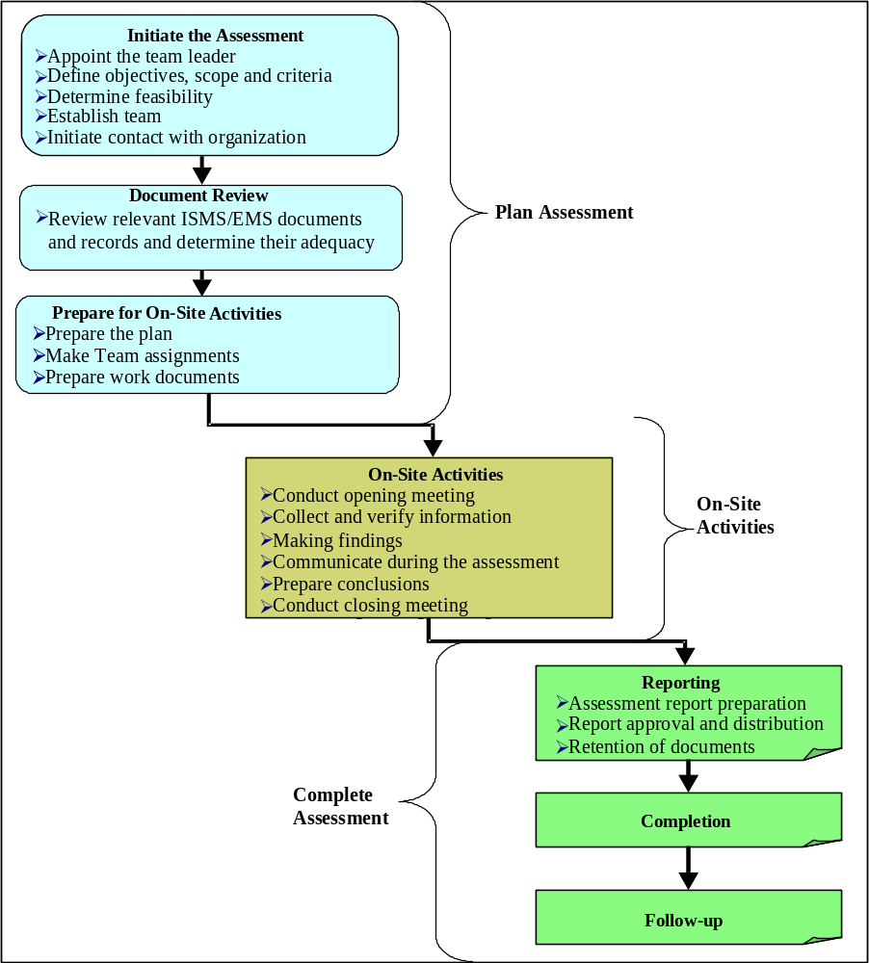

Having completed preparations for the assessment, the assessment team should be ready to conduct the assessment. The team does the assessment primarily through the analyses of documentation and by observing and interviewing employees. The planning phase of the assessment should have identified areas for priority, appropriate staff to be interviewed, and records to be analyzed. The assessment team should communicate these requirements to the organization being assessed prior to the initial meeting so that documents, records, employees to be interviewed, and any required safety items can be available in a timely and convenient manner. The tasks below describe an approach and key stages for conducting onsite assessments. The team can also use existing site assessment processes to accomplish this task.
- Conduct opening meeting. The assessment team should conduct an opening meeting with appropriate management of the organization it is assessing (e.g., the ISMS/EMS coordinator, facility manager, and other staff if necessary). The following should be included in the opening meeting.
- Proper introductions (initiate an attendance record).
- Review of the scope, objectives, and assessment plan and agreement on the timetable.
- Short summary of the methods and procedures that will be used.
- Establishment of the official communication link between the team and management of the organization to be assessed.
- Confirmation that the resources and facilities needed by the team are available.
- Confirmation of the time and date of the closing meeting (request that the organization’s senior management be present).
- Encouragement of the active participation of the organization’s personnel during the assessment.
- Review of relevant site safety and emergency procedures the team will follow during the assessment.
- Collect information. Assessment team members collect information in any of three ways: by reviewing documents and records, by interviewing employees, and by observing employees and systems in operation.
- Assess observations against criteria. Appendix C contains an example of the assessment criteria used by a DOE facility. Another example is provided in Table 10. The assessment team can use this questionnaire to determine—
- root causes of system failures (for example, inadequate training may be the root cause for repeated failure of an operational control),
- areas that conform and have best practices, and
- areas where further improvements can be made.
- Verify against the assessment criteria.
4.1 Findings—The assessment team must classify each of the findings either during the assessment or at its completion (see example in Table 10). The team can classify findings in any way that the assessed organization finds convenient. For example, findings may fall into four classifications.
- A = In Conformance
- B = Critical: Omission of an ISMS/EMS requirement or failure to implement an EMS Element of the ISMS/EMS.
- C = Serious: A significant number of minor nonconformances against any one ISMS/EMS requirement.
- D = Minor: A single nonconformance of a system requirement.
4.2 Recommendations—In addition to findings, the assessment team may identify areas where improvements could be made but that do not warrant a finding (see example in Table 10). Such improvements might include—
- alternative approaches that are recognized as best in class,
- approaches that enhance organizational mission, and
- approaches that reduce cost.
4.3 Comments—The assessment team may include comments in connection with findings, best practices, and opportunities to improve (see example in Table 10).
- Prepare Assessment Summary Report. In preparation for the assessment’s closing meeting, the assessment team should prepare a Findings and Summary Report that may include—
- A summary of the assessment (overall, areas of strength, areas of weakness) and recommendations and
- A list of all the findings, including—
    - the finding category,
    - finding description, and
    - finding location.
The sample Assessment Findings Summary Table and the sample ISMS/EMS Assessment Summary Report Template in Appendix C identify options for presenting the summary report and findings.
- Prepare Corrective Action Report. The assessment team may also prepare a Corrective Action Report (CAR) as shown in Table 11 for each finding. These CARs, if developed, should be delivered to the assessed organization during the closing meeting.
- Conduct closing meeting. A closing meeting should be conducted to complete the assessment to allow the assessment team members and the assessed organization to exchange information and lessons learned as well as to agree on followup actions to address findings. Closeout meetings may include the following—
- a discussion by the team leader of his/her overall impression of the assessment,
- a presentation that explains that the assessment team’s findings are based on a sampling of evidence,
- a presentation by each assessment team member of his/her individual findings and recommendations,
- distribution of copies of the CARs to the assessed organization’s management,
- an opportunity for the assessed organization’s representatives to ask questions regarding findings and recommendations,
- an explanation of the how the team will conduct the visit to check on corrective and preventive action progress,
- a discussion that explains to whom the team will forward draft assessment reports, and
- a discussion between the assessment team and the assessed organization regarding the findings. [Need to be sure there is a common understanding between the parties (may need to agree to disagree) on matters in contention.]
- Prepare final assessment report. The assessment report is the official record of the assessment that the team should provide to the assessed organization’s senior management. It is a key source of information on the general health of the ISMS/EMS and should be an important part of the subsequent management review.
Following a specified time period (e.g., a week), during which time corrective actions and associated CARs (see Table 11) can be generated, the assessment team should deliver the final assessment report. This report should identify all findings, including those that the organization has corrected, as well as best practices, opportunities to improve, and any recommendations or comments. In most cases, final assessment reports can be very similar to summary reports, except that they represent a formal record of the assessment outcomes.
The assessment team leader is usually responsible for the preparation and contents of the assessment report, which should provide a complete, accurate, concise, and clear record of the assessment and may include or refer to the following:
- assessment objectives;
- assessment scope, particularly the identification of the organizational and functional units or processes assessed and the time period covered;
- identification of the assessment team leader and members;
- dates and places where the onsite assessment activities were conducted;
- assessment criteria;
- assessment findings;
- assessment conclusions;
- assessment plan;
- summary of the assessment process, including uncertainty and/or obstacles encountered that can decrease the reliability of the assessment conclusions;
- confirmation that the assessment objectives have been accomplished within the assessment scope in accordance with the assessment plan;
- areas not covered, although within the assessment scope;
- unresolved, diverging opinions between the assessment team and the assessed organization;
- recommendations for improvement, if specified in the assessment objectives;
- agreed-to followup action plans, if any;
- statement of the confidential nature of the contents; and
- distribution list for the assessment report.
- Conduct corrective actions. Following the closeout meeting, the assessed unit should correct all findings and complete a corrective action report similar to that shown in Table 11. This corrective action report contains fields where the unit can describe actions it took to address the findings, including—
- root cause analysis,
- interim actions,
- corrective actions, and
- preventative actions.
Table 10. Sample Portion of the Assessment Questionnaire
[The following table contains a portion of the ISMS/EMS Assessment Questionnaire, which lists system requirements and root causes of nonconformances in the organization’s system (the full questionnaire is included in Appendix C).]
Questions to address implementation of system requirements and root causes of existing nonconformances | Finding | Best practice | Improvement opportunities | Comment/evidence
1. Questions to determine implementation and effectiveness of the ES&H Policy
System Requirements:
Does the organization have an ES&H Policy? | A
Does the policy reflect the organization’s values? | A
Does the policy provide a framework for setting and reviewing environmental objectives and targets at all levels within the organization? | A
Does the policy include a commitment to the prevention of pollution? | A
Does the policy include commitments to continual improvement and compliance with relevant laws and other requirements applicable to the organization? | C |  |  | Policy does not explicitly demand continual improvement but does describe the principle for it.
Is the policy appropriate to the nature, scale, and environmental impacts of the organization’s activities, products or services? | A
Is the policy communicated to all employees and made available to the public? | C |  | X | Policy not widely displayed. General employees were unfamiliar with it and did not apply it to daily activities.
Is it clear that the policy has senior management’s endorsement and commitment? | A
2. Questions to determine root causes for existing nonconformities
Was senior management involved in crafting the policy? |  | X |  | Meeting minutes show that management was principally involved in crafting the policy
Are there any obvious inconsistencies between the policy commitments and organizational practices?
Do employees believe that management is sincere in its commitment to the ISMS/EMS? |  |  | X | Employees did not believe that management understands that application of the policy is important
Does management believe that systematic environmental, safety and health management will improve the quality and success of this organization?
Is there evidence that sufficient resources have been allocated to the ISMS/EMS implementation over a sustained period?
Findings may fall into four classifications according to their seriousness. The classifications are as follows.
A = In Conformance.
B = Critical: Omission of an ISMS/EMS requirement or failure to implement an EMS Element of the ISMS/EMS.
C = Serious: A significant number of minor nonconformances against any one system requirement.
D = Minor: A single nonconformance of a system requirement.
X = Indicates where a best practices or improvement opportunity was found.
Table 11. Sample ISMS/EMS Corrective Action Report Template
(This is a sample of the CAR report template included in Appendix C.)
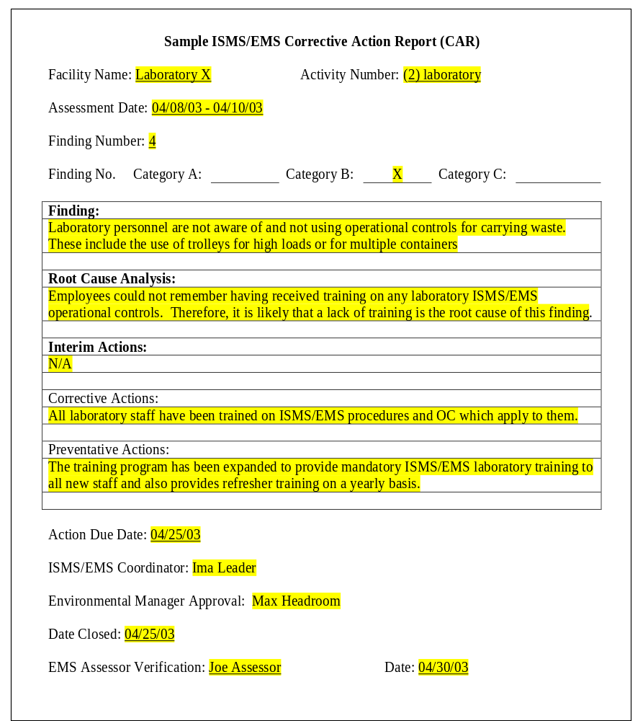
- Phase IV—Management Review and System Maintenance

- Develop the management review process
Task 21. Prepare for the management review
Task 22. Conduct the management review
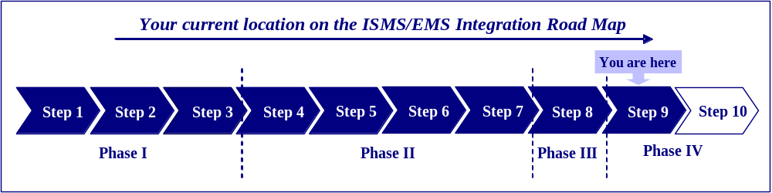
  - TASK 21: Prepare for the Management Review
References
This task fulfills several DOE Order requirements listed below.
- The Integrated Safety Management System/Environmental Management System (ISMS/EMS) provides for the evaluation of programs for public health and environmental protection, pollution prevention, and compliance with applicable requirements [DOE O 450.1 §4.a.(1)].
- The ISMS/EMS includes policies and procedures to assess performance and implement corrective actions where needed [DOE O 450.1 §4.a.(2)].
- The ISMS/EMS include annual reviews of and updates (when appropriate) the site’s measurable environmental goals, objectives, and targets [DOE O 450.1 §4.a.(3)].
- ISMS/EMS implementation is assessed as a component of the implementation of DOE P 450.5, Line Environment, Safety and Health Oversight (DOE O 450.1 §5.b.).
- Contractor ES&H performance objectives, performance measures, and commitments are reviewed through the annual ISM review process [established pursuant to DEAR 970.5223-1 (e)] [DOE O 450.1 §5.d.(17)].
The provisions in this task relate to established requirements of the following ISMS element.
- DOE G 450.4-1A states that the annual ISMS review “is the integration of numerous system-related activities in a manner that assists management in assuring that work is performed . . . in a manner that protects the public, workers, and environment from harm” (p. 92).
    - Background
When applied to a site’s ISMS/EMS, the term “Management Review” refers to the periodic evaluation of the ISMS/EMS by senior management (i.e., managers who have the authority to make decisions for the site or facility). This review completes the ISMS/EMS plan-do-check-act cycle and allows management to ascertain whether the ISMS/EMS continues to be suitable, adequate, and effective for its intended purposes. The management review is not the same as the assessment process discussed in Phase III. However, senior managers conducting the management review should consider the results of the site’s assessment.
Goals for the management review include—
Highlighting Management Commitment
- Promote management involvement in the ISMS/EMS.
- Provide management re-emphasis of ISMS/EMS objectives and allocation of resources.
Decision Making—on suitability, adequacy, and effectiveness. Decisions could include—
- Set new objectives and targets.
- Better align objectives and targets with environmental policy.
- Change the methods by which objectives and targets are achieved.
- Recommit human, fiscal, and/or technological resources.
- Promote continual improvement.
For DOE sites, the concepts and principles of the management review are already addressed by many areas of the ISMS developed under DOE P 450.4, particularly the requirement for an annual review of ISMS performance. For example, the management review aligns with ISMS core principle 5 for feedback and improvement; specifically, that sites “should have a process for management to consider and dispose of recommendations for improvement.” DEAR, 48 CFR 970.5223-1 (d) and (e) also contain provisions for a review which specify that, “dates for submittal, discussions and revisions to the system will be established by the contracting officer . . . . On an annual basis, the contractor shall review and update, for DOE approval, its safety performance objectives, performance measures, and commitments.” This task further reinforces the current requirement that “for the purpose of this clause, safety encompasses the environment . . . including pollution prevention and waste minimization.” The management review, therefore, should serve to identify any gaps or enhancement opportunities for the existing ISMS as well as for the integrated ISMS/EMS.
The primary goal of management review should be to ensure that the ISMS/EMS continues to be suitable, adequate, and effective for its intended purposes. The review accomplishes this by involving the members of the organization who have the authority to make needed changes to ensure the effectiveness of the system. The very first management review is usually conducted soon after the completion of corrective actions that follow the first assessment. Subsequent reviews are conducted on a scheduled basis or sooner if circumstances warrant management’s attention. Other important purposes of the management review are to—
- ensure that senior management stays involved in the ISMS/EMS;
- give the ISMS/EMS visibility within the organization; and
- allow senior management to set the environmental, safety, and health ethic for the organization and give guidance and direction for continual improvement of the system.
    - Importance of Senior Management Involvement in the Management Review
During the management review, senior managers should assess whether they are satisfied with the outcomes of the ISMS/EMS and whether they should make midcourse adjustments to bring the system back on track. In short, the management review process allows senior managers of the organization to—
- assess the existing ISMS/EMS,
- evaluate whether changes are necessary, and
- give direction and/or resources for any actions necessary to make the changes.
The importance of senior management involvement in the ISMS/EMS extends beyond the ability to authorize resources for continual improvement. The management review is an opportunity for the active and visible involvement of senior management in the ISMS/EMS and, thereby invigorates employee involvement and commitment through their leadership.
    - Coordinating the Management Review
The periodic ISMS/EMS management review should include the assessment of a appropriate of information relating to the performance of the ISMS/EMS. For example, management should review all continuing core expectations (CCEs) described by DOE G 450.1-1B for both safety and environment.
The ISMS/EMS coordinator should organize, schedule, and manage the management review. He or she should collect, analyze, and assemble pertinent information to present managers with the current status of ISMS/EMS. The ISMS/EMS coordinator should ensure that—
- the review meeting date is set,
- all the necessary managers are able to participate in the review,
- there is coordination among those presenting information during the review,
- the minutes of the review have management approval,
- management reaches decisions on whether to update the ISMS/EMS to maintain its effectiveness and compliance with DOE O 450.1 and DOE P 450.4,
- specific management decisions regarding actions, including allocation or reallocation of resources as a result of the review, begin, and
- there is proper execution of decisions, including specific actions and resource allocations authorized by management, following the review.
    - Management Review Participants
Participants in the management review should include the senior management (e.g., site managers, facility managers), the ISMS/EMS coordinator, appropriate members of the ISMS/EMS team, P2 managers, and other individuals with ISMS/EMS responsibilities (e.g., internal assessors, other ISMS/EMS representatives).
  - TASK 22: Conduct the Management Review
References
This task fulfills several DOE Order requirements listed below.
- The ISMS/EMS provides for the evaluation of programs for public health and environmental protection, pollution prevention, and compliance with applicable requirements [DOE O 450.1 §4.a.(1)].
- The ISMS/EMS includes policies and procedures to assess performance [DOE O 450.1 §4.a.(2)].
- The ISMS/EMS includes annual reviews and updates (when appropriate) the site’s measurable environmental goals, objectives, and targets [DOE O 450.1 §4.a.(3)].
- ISMS/EMS implementation is assessed as a component of the implementation of DOE P 450.5, Line Environment, Safety and Health Oversight (DOE O 450.1 §5.b.).
- Contractor ES&H performance objectives, performance measures, and commitments are reviewed through the annual ISM review process [established pursuant to DEAR 970.5223-1 (e)] [DOE O 450.1 §5.d.(17)].
The provisions in this task relate to established requirements of the following ISMS element.
- DOE G 450.4-1A states that the annual ISMS review “is the integration of numerous system-related activities in a manner that assists management in assuring that work is performed . . . in a manner that protects the public, workers, and environment from harm” (p. 92).
    - Background
In addition to fulfilling the requirements set forth in DEAR Clause 970.5223-1 that require contractors to update their environment, safety and health (ES&H) performance objectives, measures, and commitments on an annual basis, the management review is an opportunity for management to confirm that it is satisfied with the performance of the ISMS/EMS. This includes the achievement of goals set for the ISMS/EMS, and its alignment with the organization’s mission and commitments. In effect, management should ask whether the ISMS/EMS continues to be suitable, adequate, and effective for the DOE site in question.
Senior managers should be given all relevant information to enable them to make accurate and sound judgments regarding ISMS/EMS implementation. All information needed to assess the conformance of the ISMS/EMS with DOE P 450.4 and DOE O 450.1 as well as any other objectives set by the site should be collected, consolidated, analyzed, and communicated. As discussed above, this is typically one of the responsibilities of the ISMS/EMS coordinator (or individual who leads the ISMS/EMS team). Information for the management reviews may come from the following sources.
- Assessments
DOE P 450.5 and DOE O 414.1A require a rigorous and credible contractor assessment program with elements that address performance measures and indicators, line and independent evaluations, compliance with applicable requirements, data collection, analysis and corrective actions, and feedback and performance improvement. These assessments should cover ISMS and EMS elements alike and are a key source of information for the management review. Detailed discussion of the role of the assessments for maintaining the effectiveness and legitimacy of the ISMS/EMS was covered earlier in Phase III.
- Monitoring and measurement results
Data collected through ongoing system monitoring and measurement, including ISMS/EMS programs, processes, activities, and controls, are another key source of information for the management review. This information relates to the achievement of objectives and targets, the status of operational controls, the maintenance of regulatory compliance, and other parameters that are overseen to ensure that the ISMS/EMS remains effective.
- Occurrence reports
Information contained in occurrence reports, especially the root causes of an incident, are a good source of information for the management review.
- Corrective actions
Actions taken to correct deficiencies in the ISMS/EMS are a rich source of information on the day-to-day health of the ISMS/EMS. The data available from this source include—
- the status of training (both awareness training and competence training);
- the currency of regulatory and other requirements in the ISMS/EMS;
- the identification of new significant aspects;
- the implementation of new environmental management programs (EMPs);
- compliance with the schedule for internal ISMS/EMS assessments; and
- the assignment of responsibility and accountability for ISMS/EMS implementation, etc.
    - Decisions Made in the Management Review
Senior management should make specific decisions during the management review or immediately thereafter. They may wish to consider the following questions.
- Is the ISMS/EMS still suitable, adequate, and effective for the organization?
- Based on an assessment of these three characteristics, does the ISMS/EMS need changes?
- If it needs changes (see box below), what actions and what resources are needed for those changes?
- Who should be directed to oversee the implementation of those changes?
- When does management want an update on the status and effect of the changes?
Actions or changes that could result from the management review
- Develop corrective actions to improve system implementation and effectiveness
- Set performance measures and commitments for next year
- Make changes to criteria for conducting assessments
- Make changes, if required, to the ISMS description document
- Account for and integrate any changes to laws, regulations, and directives
Suitability: Refers to the nature of the ISMS/EMS and whether it continues to be appropriate to the organization. For example, if a site’s mission changes, as in the case of a site moving to closure status, then many of the programs and procedures established for ongoing operation may no longer be suitable to control risks under the site’s new mission. Other approaches to the ISMS/EMS relevant to this area would need to be considered.
Adequacy: Refers to the sufficiency of the arrangements for the ISMS/EMS. For example, if the resources allocated to management programs are not sufficient to achieve the objectives and targets set for them, then the ISMS/EMS may have inadequate support. If new employees do not receive timely awareness or competence training before they begin their assigned tasks, then the ISMS/EMS is inadequate with respect to the training element.
Effectiveness: Refers to the system’s progress in accomplishing the objectives and targets set for the ISMS/EMS. If progress is slower than expected or if operational controls fail more often than is expected or acceptable, then the system may be ineffective for its intended purposes. Because the organization sets its own objectives and targets, analyzing an ISMS/EMS’s effectiveness should help management evaluate success in achieving its own objectives and targets. In other words, effectiveness is a relative term depending on what the organization sets out for itself. The only exception to this is regulatory compliance. If the organization fails to maintain regulatory compliance, management may consider the ISMS/EMS ineffective regardless of whether other objectives and targets are being achieved.
    - Documenting the Management Review
The annual review and update of the ISMS/EMS should be documented. DOE G 450.4 describes this documentation in detail. The following are some of the documentation requirements, including those in DOE O 450.1.
- Contractor’s performance against the previous year’s safety and environmental commitments.
- Contractor’s commitments designed to achieve safety and environmental performance objectives and measures for the upcoming fiscal year.
- Commitment of resources necessary to meet environment, safety and health program minimum requirements.
In addition to documenting the above outcomes of the annual management review process, other details of the review, including the following, should be recorded.
- Names and functions of all participants.
- Copies of the presentations and other information.
- Decisions on the system’s suitability, adequacy, and effectiveness.
- Decisions on changes desired for the system.
- Management directions for actions to be taken and resources to be applied.
- Expected timeline for achieving changes and the date of any future review.
    - Followup to the Management Review
Implementation of the changes identified in the management review should occur as directed. Management should clearly assign responsibility for coordinating updates or implementation of new programs. Following the management review, management should ensure that there are sufficient resources to carry out revisions to the ISMS/EMS. Ensuring that there are sufficient resources aligns closely with ISMS guiding principle 4 “balanced priorities,” also provided for in sections (d) and (e) of DEAR Clause 970.5223-1. Identification of resources necessary for environment, safety and health programs should be a part of the DOE annual budget guidance and direction.
- Develop a Plan to Keep the ISMS/EMS Updated
Task 23. Keeping the ISMS/EMS properly updated
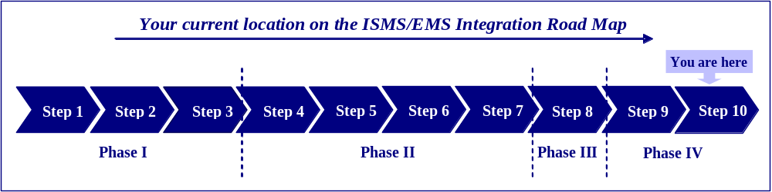
  - TASK 23: Keeping the ISMS/EMS Updated
References
The provisions in this task relate to established requirements of the following ISMS elements.
- DOE P 450.5, “A robust, rigorous, and credible contractor self-assessment program linked to the DOE [Environment, Safety and Health] Management System is in place, which includes elements that address . . . data collection, analysis, and corrective actions; [and] continuous feedback and performance improvement.”
- DOE P 450.5, “The Department’s and contractors’ line organizations … work together to develop a high level of performance assurance which results in improved environment, safety and health performance.”
- DOE G 450.4-1A, Chapter IV, on keeping approved ISMSs effective through continuous improvement actions.
    - Background
Changes in regulations, site mission, site operations, budget allocations, or customer needs will all cause changes in activities and operations, which in turn may have safety and environmental consequences. In some cases, it is sufficient to update the ISMS/EMS annually to remain current and relevant to the site. However, other changes such as regulatory amendments or new operations can occur at any time during the year and need continual updates to the ISMS/EMS. In particular DEAR, 48 CFR 970.5215-3, requires 1) compliance with applicable laws, regulations, and DOE Directives; 2) implementation of and adherence to the contractor’s Safety Management System; and 3) accomplishment of annual contractor environment, safety and health performance commitments. The suggestions below describe how the organization can update the ISMS/EMS to remain relevant to the organization. (Keeping the ISMS/EMS updated is also discussed in Step 9, above, under Management Review).
    - Environmental Aspects
DOE O 450.1 section 4.a(2) states that the ISMS includes policies and procedures to identify activities with significant environmental impacts. Most sites probably address this requirement under the ISMS Core Function 3, to identify and analyze hazards, which include environmental hazards also referred to as environmental aspects (see Phase I). The organization should periodically revise the procedure by which it identifies its environmental aspects and sets improvement objectives for those that are significant to reflect change in regulations, mission focus, and site operations. One approach to meet the need to maintain updated environmental aspects and safety hazards is to execute the procedure for Identifying Significant Environmental Aspects and Safety Hazards on a periodic basis. Another potential practice is to update the list of significant environmental aspects on an ongoing basis by subjecting each new activity, product, or service to an up-front evaluation to ascertain whether it includes an environmental aspect and whether that aspect meets a significance threshold that makes it a significant environmental aspect. This approach will keep the ISMS/EMS up-to-date and relevant, and will allow the organization to address significant environmental aspects as they appear.
    - Legal and Other Requirements
DOE O 450.1 §4.a.(1) requires that ISMS/EMS provides for the systematic planning of programs for compliance with applicable requirements. This recognizes that as State and Federal regulations change, it is critical that sites update their programs and procedures for compliance. Phase II of this Guide discusses the development of a formal procedure for identifying legal and other requirements based on the existing site procedure. This procedure should ensure that there is ongoing monitoring of new legal and other requirements, as well as assessment of new activities, products, and services to evaluate whether any legal requirements apply to them. This approach captures applicable information when a new requirement appears or the organization initiates a new activity, product, or service. In addition to addressing legal and other requirements on an ongoing basis, it is useful to conduct periodic reviews of the organization’s requirements to determine if any new requirements apply and if any of those being addressed are out of date. This periodic assessment can occur in conjunction with the management review.
    - Objectives and Targets
A fundamental element of the ISMS/EMS is the establishment of “measurable environmental goals, objectives, and targets” [DOE O 450.1 §4.a.(3)]. These objectives and targets will not remain static. The site may want to update its existing objectives and targets because it has been accomplished them and desires new ones, or because management directs changes based on the results of the management review, or because new regulations, operations, or changing site mission require revisions to these objectives and targets.
When the organization reaches an objective or target, it can set new ones at higher levels or it can decide to maintain the level that it has reached as long as that level satisfies regulatory requirements.
An organization normally resets or reconfirms objectives and targets in conjunction with its management review. Management has the responsibility to review the ISMS/EMS periodically and make determinations for reconfirming or setting new objectives and targets. Therefore, organizations find it convenient to reevaluate their objectives and targets during the management review. Another opportunity to establish or revise the site’s goals, objectives, and targets occurs with the identification of a new safety hazard or environmental aspect (possibly as a result of regulatory changes or new operations).
    - Environmental Management Programs
EMPs are implemented to achieve environmental objectives and targets. Any time an objective or target for the ISMS/EMS changes or a new one is set, the EMP that is associated with it should also reflect appropriate changes. A new objective and target for a newly introduced significant environmental aspect may require a new EMP.
In addition, sites should update EMPs so that the information within them reflects ISMS/EMS activities as they are implemented on the ground. Changes in management programs may occur on an ongoing basis due to reassigned program responsibilities, updated training, refined operational controls, or completed tasks.
If sites do not constantly review EMPs against the results of their actual implementation, within a very short time period the written program and the implemented program may become inconsistent.
    - Training
Training is an ongoing activity. All new employees should receive ISMS/EMS awareness training. Sites should require new employees who will work in areas that have significant environmental aspects to demonstrate appropriate competency based on their education, experience, or training. Existing employees should receive periodic refresher training for both awareness and competency in relevant areas of expertise. The ISMS/EMS training procedure should provide for both awareness and competency training and for refresher training.
    - Operational Controls
Sites should establish operational controls for those activities, products, or services that exhibit significant environmental aspects. They are synonymous with the ISMS Core Function 4, to develop and implement operational controls to prevent or mitigate hazards. If a new activity, product, or service exhibits a new environmental aspect or safety hazard, then the site should establish appropriate operational controls to ensure that the aspect is addressed.
If the management review finds any existing operational controls to be inappropriate or insufficient, then the site should develop and implement new ones. The management review may also mandate revisions to operational controls. Changes to operational controls may be necessary because new operations may require different controls. In some cases, the site might have automated controls that had been based on the use of human resources. In many instances, regulations mandate operational controls, so that a change in regulation may also trigger a change in the required operational controls. When a site revises operational controls, it is important that it also updates documentation related to the controls to reflect the operational controls as they are actually implemented by the organization.
    - Resources for the Environmental Management System
The ISMS/EMS cannot succeed without appropriate resources; this is recognized by ISMS Guiding Principles 4 “balanced priorities,” as well as sections (d) and (e) of DEAR Clause 970.5223-1 and by DOE O 450.1 §§ 5.c.(2), 5.d.(7). As mentioned earlier, this allocation of resources coincides with and is responsive to the DOE budget guidance and direction. In some cases, unforeseen expenses may require allocations of additional resources to continue progress toward the site’s ISMS/EMS objectives and targets.
    - Occurrence Identification and Corrective Actions
The site should devote the ISMS/EMS procedure for occurrence identification and corrective actions to making changes in the ISMS/EMS to fix problems found during the normal course of operation. These reflect ISMS Core Function 5, feedback and continuous improvements, as well as several areas in DOE O 450.1, including the implementation of corrective actions where needed [DOE O 450.1 §4.a.(2)]. Reporting and addressing identified nonconformances of the ISMS/EMS should be in accordance with this procedure. In addressing nonconformances, the site should take both corrective and preventive actions to mitigate the effects of the nonconformance and guard against the occurrence of similar nonconformances. In effect, this procedure provides a mechanism for the constant maintenance of the ISMS/EMS and is likely to generate a considerable number of changes on an ongoing basis. It is also prudent to periodically assess the effectiveness of the approach used to identify, correct, and document nonconformances.
    - Developing a Formal Maintenance Schedule
The site/facility personnel may find it valuable to develop a formal documented schedule of the various ISMS/EMS elements that require updates and maintenance. The sample schedule illustrated in Table 12 contains some suggestions for ensuring updates for certain EMS elements of the ISMS. Sites can use this example as a framework for developing a comprehensive ISMS/EMS schedule. A brief explanation of the schedule described in Table 12 follows.
- The schedule is divided into 12 columns, one for each month of the year; it is based on a 1-year cycle (12 months).
- The far left column contains the eight EMS elements the site should keep up-to-date (numbered 1 through 8).
- A checkmark in a column to the right of one of these eight elements signifies that the element should be assessed that month to determine if it is current with the organization’s operations. Please note that that the site should assess legal requirements and environmental aspects on an ongoing basis. For example, a regulatory revision should be incorporated into the ISMS/EMS as soon as possible. Similarly, a new activity, product, or service at the organization should be assessed to determine if it contains any significant aspects. The flow arrows for these elements (1 and 2) indicate what the ISMS/EMS team should do if there is a new regulation or new activity, product, or service. Figure 3 is a flow chart that illustrates the process of identifying any new legal requirements that may have an impact on an existing environmental aspect.
- The schedule sets objectives and targets (3) and resource allotment (4) for assessment as part of the management review (month 12).
- Following the management review, it may be necessary to update environmental management programs, operational controls, records, and training programs by integrating the findings of the review so that the ISMS/EMS continues to be suitable, adequate, and effective.
Table 12. Example. Suggested Schedule for Maintaining and Updating Required and Important Selected Elements of the ISMS/EMS. |  | January | February | March | April | May | June | July | August | September | October | November | December
 | MONTH | 1 | 2 | 3 | 4 | 5 | 6 | 7 | 8 | 9 | 10 | 11 | 12
1. Identify any new legal or other requirement that applies to an existing environmental aspect |  | √ | √ | √ | √ | √ | √ | √ | √ | √ | √ | √ | √
 | Integrate into environmental management programs
2. Identify any new activities, products or services occurring at the organization |  | √ | √ | √ | √ | √ | √ | √ | √ | √ | √ | √ | √
 | Identify significant aspects
 | Set objectives and targets
 | Develop environmental management programs
 | Assess in audit
3. Assess relevance of current objectives and targets |  |  |  |  |  |  |  |  |  |  |  |  | √
4. Assess the appropriateness of current resource allocation |  |  |  |  |  |  |  |  |  |  |  |  | √
5. Asses need to update current environmental management programs |  | √
6. Assess current operational controls for effectiveness at controlling specific operations |  | √
7. Update list of records to generate |  | √
8. Assess effectiveness of the current employee training program |  | √
Figure 3. Identifying legal and other requirements and new activities, products, and services that are
incorporated into the ISMS/EMS .
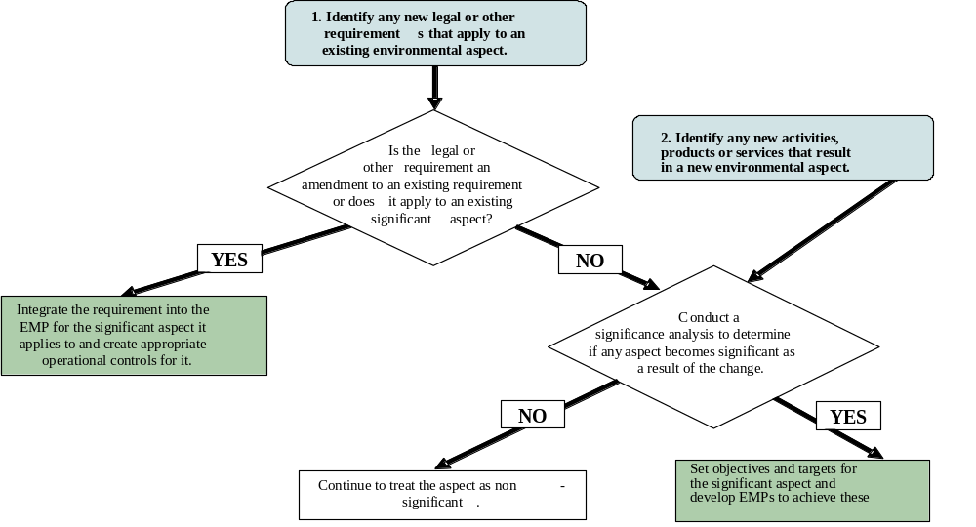
APPENDIX A
ADDITIONAL GUIDANCE DOCUMENTS

ADDITIONAL GUIDANCE DOCUMENTS

Clean Air Act General Conformity
- Clean Air Act General Conformity Requirements and National Environmental Policy Act (NEPA) Process, (April, 2000), http://www.eh.doe.gov/nepa/tools/guidance/caaguidance.pdf
- EH-41 Analysis of EPA’s Rule Requiring that Federal Actions Conform to State Implementation Plans, (November, 1999), http://homer.ornl.gov/oepa/guidance/caa/conform/pdf
- Attainment Status, http://homer.ornl.gov/oepa/data/naaqs.cfm
- “Determining Conformity of General Federal Actions to State or Federal Implementation Plans; Final Rule 58 FR 63214, November 30, 1993, http://www.epa.gov/ttn/oarpg/conform/genconf_00001.pdf.
- EPA General Conformity Guidance: Questions and Answers, (July 3, 1994), http://www.epa.gov/ttn/oarpg/conform/gogqa_71394.pdf.
- General Conformity Regulations, http://www.epa.gov/ttn/oarpg/genconformity.html.
- Compliance with the General Conformity Regulations, Information Brief, (March, 2003), http://www.eh.doe.gov/oepa.guidance/caa/conformbrf.pdf.

Watershed Approach for Surface-Water Protection
- Unified Federal Policy for a Watershed Approach to Federal Land and Resource Management, October 18, 2000, http://www.cleanwater.gov/ufp.

Groundwater Protection
  - Technical Impracticability Decisions for Ground Water at CERLCA Response Action and RCRA Corrective Action Sites (DOE/EH-413/9814), (August 1998), http://www.eh.doe.gov/oepa/guidance
  - RCRA Ground Water Assessment Plans and Annual Ground Water Quality Assessment Reports at Interim Status Facilities (DOE EH-413-069/0396), (March 1996), http://www.eh.doe.gov/oepa/guidance
  - Guide to Ground Water Remediation at CERCLA Response Action and RCRA Corrective Action Sites (DOE/EH-0505), (October 1995), http://www.eh.doe.gov/oepa/guidance
  - Department of Energy (DOE) Response to the Inspector General’s Recommendations on Groundwater Monitoring Programs at DOE Sites, (September 3, 2003), http://www.eh.doe.gov/oepa/guidance
  - Final Directive on the Use of Monitored Natural Attenuation at Superfund, RCRA Corrective Action, and Underground Storage Tank Sites, (June 9, 1999), http://www.eh.doe.gov/oepa/guidance
  - Monitored Natural Attenuation in Environmental Restoration, (February 17, 1999), http://www.eh.doe.gov/oepa/guidance
  - Ground Water Presumptive Response Strategy, (January 28, 1997), http://www.eh.doe.gov/oepa/guidance

Biota
- RESRAD-Biota Code, DOE Biota Dose Assessment Committee, (BDAC), http://homer.ornl.gov/oepa/public/bdac
- A Graded Approach for Evaluating Radiation Doses to Aquatic and Terrestrial Biota (DOE-STD-1153-2002), http://homer.ornl.gov/oepa/public/bdac
- RESRAD-Biota: A Tool for Implementing a Graded Approach to Biota Dose Evaluation, Users Guide, Version 1, Interagency Steering Committee on Radiation Standards (ISCORS) Technical Report 2004-02, DOE Report Number DOE/EH-0676 (January 2004).

Wildland Fire Management
  - Wildland Fire Management Program for Use with DOE O 450.1, Environmental Protection Program (DOE G 450.1-9) draft issued October 24, 2003, for review and use.
  - Secretarial Memorandum (Fire Management Program), 2001 Federal Wildland Fire Management Policy, (May 11, 2001).

Cultural Resources Management
- Department of Energy Management of Cultural Resources, DOE P 141.1
- Environmental Guidelines for the Development of Cultural Resource Management Plans (DOE/EH-051, August 1995), http://www.eh.doe.gov/oepa
- Draft Environmental Guidelines for Development of Cultural Resource Management Plans-Update, DOE G 450.1-3

Long-Term Stewardship
- Long-Term Stewardship Web Page, http://lts.apps.em.doe.gov/.

Pollution Prevention
- Secretarial Memorandum, “Pollution Prevention and Energy Efficiency Leadership Goals for Fiscal Year 2000 and Beyond,” November 12, 1999.
- Pollution Prevention Web Site, http://www.eh.doe.gov/p2. Environmental Quality Systems
Environmental Quality Systems
  - Uniform Federal Policy for Implementing Environmental Quality Systems: Evaluating, Assessing and Documenting Environmental Data Collection/Use and Technology Programs, (DOE/EH-0667, January, 2003) http://www.spa.gov/swerffrr/library/data.htm
  - Information Brief at http://www.eh.doe.gov/oepa
  - Multi-Agency Radiological Surveys and Site Investigation Manual (MARSSIM), Revision 1, August 2000, June 2001 Update, http://www.epa.gov/radiation/marssim/obtain.htm
  - Information Brief at http://www.eh.doe.gov/oepa
  - Multi-Agency Radiological Laboratory Analytical Protocols (MARLAP), August 2001, http://www.eml.doe.gov/marlap
APPENDIX B
EMS ROADMAP TEMPLATES

CONTENTS
B.1 ELEMENTS OF AN ISMS/EMS B-1
B.1.1 DEFINITION OF AN EMS B-1
B.1.2 Planning B-1
B.1.3 Implementation and Operation B-3
B.1.4 Checking and Corrective Action B-4
B.1.5 Management Review B-5
B.2 EMS Roadmap Templates B-6
B.2.1 Creating an EMS Roadmap B-6
B.2.2 EMS Roadmap Template B-6
B.3 Environmental Management Programs Template B-12
B.3.1 Documenting Environmental Management Programs B-12
B.4 Operational Controls Template B-20
B.4.1 Documenting Operational Controls B-20
B.4.2 Completing the Body of the Operational Controls Template (Table 7) B-20
B.5 Documenting Integrated Safety Management System/Environmental Management System Procedures B-26
B.5.1 Using the Procedure Templates B-28
TABLES

1. EMS Roadmap Example B-6
2. EMS Roadmap Template B-7
3. Example of Completed Environmental Management Program Template B-12
4. Example of Performance Indicators (Field 6) B-16
5. Example of Completed Field 10 (Structure, Authorities, Responsibilities) B-18
6. Competence B-20
7. Completed Operational Controls Template B-21
8. Examples of Operational Controls That Might Be Designated for a Variety of sources B-24
9. Examples of Maintenance Plans That Might Be Developed for a variety of Operational Controls B-24
10. EMS Element Procedures Required by DOE O 450.1 B-26
11 Example of ISMS/EMS Procedure for Determining Goals, Objectives,
and Targets B-29

B.1 ELEMENTS OF AN ISMS/EMS
The four principal elements of an ISMS/EMS, along with their corresponding subelements are described below. References to where these elements and subelements are addressed in DOE O 450.1 are also provided.
    - DEFINITION OF AN EMS
The environmental management system (EMS) is a continuing cycle of planning, implementing, evaluating, and improving processes and actions undertaken to achieve environmental goals (DOE O 450.1 §1.).
The EMS is part of the Integrated Safety Management System (ISMS) established pursuant to DOE P 450.4, Safety Management System Policy (DOE O 450.1 §1.).
    - Planning
The ISMS/EMS provides for the systematic planning of programs for public health and environmental protection [DOE O 450.1 §4.a.(1)(a)].
The ISMS/EMS provides for the systematic planning of programs for pollution prevention [DOE O 450.1 §4.a.(1)(b)].

Environmental Aspects
The ISMS/EMS includes policies [and] procedures to identify activities with significant environmental impacts [DOE O 450.1 §4.a.(2)].

Legal and Other Requirements
The ISMS/EMS provides for the systematic planning of programs for compliance with applicable requirements [DOE O 450.1 §4.a.(1)].
The ISMS/EMS includes (if applicable) conformity of DOE proposed actions with State Implementation Plans to attain and maintain national ambient air quality standards [DOE O 450.1 §4.b.(1)(a)].
The ISMS/EMS includes (if applicable) implementation of a watershed approach for surface water protection [DOE O 450.1 §4.b.(1)(b)].
The ISMS/EMS includes (if applicable) protection of other natural resources, including biota [DOE O 450.1 §4.b.(1)(d)].
The ISMS/EMS includes (if applicable) protection of cultural resources [DOE O 450.1 §4.b.(1)(f)].
The ISMS/EMS includes (if applicable) implementation of a site-wide approach for groundwater protection [DOE O 450.1 §4.b.(1)(c)].
The ISMS/EMS includes (if applicable) protection of site resources from wildland and operational fires [DOE O 450.1 §4.b.(1)(e)].
The ISMS/EMS provides for reduction or elimination of the generation of waste, the release of pollutants to the environment, and the use of Class I ozone-depleting substances (ODS) through source reduction, reuse, segregation, and recycling and by procuring recycled-content materials and environmentally preferable products and services [DOE O 450.1 §4.b.(3)].
The ISMS/EMS promotes the long-term stewardship of a site’s natural and cultural resources throughout its operational, closure, and postclosure life cycle [DOE O 450.1 §4.b.(2)].

Objectives and Targets
The ISMS/EMS includes measurable environmental goals, objectives, and targets [DOE O 450.1 §4.a.(3)].
The ISMS/EMS includes site-specific goals that contribute to the accomplishment of DOE pollution prevention and energy efficiency goals [DOE O 450.1 §5.c.(3)].
Contractor ES&H performance objectives, performance measures, and commitments include appropriate environmental elements based on the environmental risks, impacts of activities at the site and established Departmental pollution prevention/energy efficiency goals [DOE O 450.1 §5.d.(17)].

Environmental Management Programs
The ISMS/EMS includes policies [and] procedures to manage, control, and mitigate the potential impacts of site activities with significant environmental impacts [DOE O 450.1 §4.a.(2)].
The ISMS/EMS includes (if applicable) conformity of DOE proposed actions with State Implementation Plans to attain and maintain national ambient air quality standards [DOE O 450.1 §4.b.(1)(a)].
The ISMS/EMS includes (if applicable) implementation of a watershed approach for surface-water protection [DOE O 450.1 §4.b.(1)(b)].
The ISMS/EMS includes (if applicable) implementation of a site-wide approach for groundwater protection [DOE O 450.1 §4.b.(1)(c)].
The ISMS/EMS includes (if applicable) protection of other natural resources, including biota [DOE O 450.1 §4.b.(1)(d)].
The ISMS/EMS includes development and implementation of cost-effective pollution prevention programs that use life-cycle assessment concepts and practices in determining program return-on-investment [DOE O 450.1 §5.c.(4)].
The ISMS/EMS includes (if applicable) protection of cultural resources [DOE O 450.1 §4.b.(1)(f)].
The ISMS/EMS includes (if applicable) implementation of a site-wide approach for groundwater protection [DOE O 450.1 §4.b.(1)(c)].
The ISMS/EMS includes (if applicable) protection of site resources from wildland and operational fires [DOE O 450.1 §4.b.(1)(e)].
The ISMS/EMS provides for reduction or elimination of: the generation of waste, the release of pollutants to the environment, and the use of Class I ozone-depleting substances (ODS), through source reduction, reuse, segregation, and recycling and by procuring recycled-content materials and environmentally preferable products and services [DOE O 450.1 §4.b.(3)].
The ISMS/EMS promotes the long-term stewardship of a site’s natural and cultural resources throughout its operational, closure, and postclosure life cycle [DOE O 450.1 §4.b.(2)].
    - Implementation and Operation
The ISMS/EMS provides for the integrated execution of programs for public health and environmental protection, pollution prevention, and compliance with applicable requirements [DOE O 450.1 §4.a.(1)].

Structure and Responsibility
[Structure and responsibility is addressed in DOE P 450.4, Safety Management System Policy; DOE P 411.1, Safety Management Functions, Responsibilities, and Authorities Policy; DOE M 411.1-1C, Safety Management Functions, Responsibilities, and Authorities Manual; and other DOE policies, procedures, and requirements.]

Training, Awareness, and Competence
The ISMS/EMS includes training to identify activities with significant environmental impacts [DOE O 450.1 §4.a.(2)].
The ISMS/EMS includes training to manage, control, and mitigate the potential impacts of site activities with significant environmental impacts [DOE O 450.1 §4.a.(2)].
The ISMS/EMS includes training to assess performance and implement corrective actions where needed [DOE O 450.1 §4.a.(2)].

Communication
The ISMS/EMS provides for obtaining, as appropriate, community advice relevant to aspects of “Greening the Government” Executive Orders through new or existing outreach programs [DOE O 450.1 §5.d.(3)].

Environmental Management System Documentation
Approved ISMS descriptions have been updated, as necessary, to include EMS requirements [DOE O 450.1 §.5.d.(2)].

Document Control
Document control is addressed in other DOE policies, procedures, and requirements.

Operational Control
The ISMS/EMS includes procedures to manage, control, and mitigate the potential impacts of site activities with significant environmental impacts [DOE O 450.1 §4.a.(2)].

Emergency Preparedness and Response
Emergency preparedness and response is addressed in other DOE policies, procedures and requirements.
    - Checking and Corrective Action
The ISMS/EMS provides for the evaluation of programs for compliance with applicable requirements [DOE O 450.1 §4.a.(1)(c)].
The ISMS/EMS provides for the evaluation of programs for public health and environmental protection [DOE O 450.1 §4.a.(1)(a)].
The ISMS/EMS provides for the evaluation of programs for pollution prevention [DOE O 450.1 §4.a.(1)(b)].
ISMS/EMS implementation is assessed as a component of the implementation of DOE P 450.5, Line Environment, Safety and Health Oversight (DOE O 450.1 §5.b.).

Monitoring and Measurement
The ISMS/EMS includes policies and procedures to assess performance [DOE O 450.1 §4.a.(2)].
Contractor ES&H self-assessment programs within the framework of DOE P 450.5 are established and continue to be effective [DOE O 450.1 §5.d.(16)].
The ISMS/EMS ensures the early identification of, and appropriate response to, potential adverse environmental impacts associated with DOE operations, including, as appropriate, preoperational characterization and assessment and effluent and surveillance monitoring [DOE O 450.1 §4.b.(4)].
The ISMS/EMS provides for the conduct of environmental monitoring, as appropriate, to support the site’s ISMS to detect, characterize, and respond to releases from DOE activities [DOE O 450.1 §5.d.(14)].
The ISMS/EMS provides for the conduct of environmental monitoring, as appropriate, to assess impacts [DOE O 450.1 §5.d.(14)].
The ISMS/EMS provides for the conduct of environmental monitoring, as appropriate, to estimate dispersal patterns in the environment [DOE O 450.1 §5.d.(14)].
The ISMS/EMS provides for the conduct of environmental monitoring, as appropriate, to characterize the pathways of exposure to members of the public; and to characterize the exposures and doses to individuals, and to the population [DOE O 450.1 §5.d.(14)].
The ISMS/EMS provides for the conduct of environmental monitoring, as appropriate, to evaluate the potential impacts to the biota in the vicinity of the DOE activity [DOE O 450.1 §5.d.(14)].
The ISMS/EMS provides for the implementation of the analytical work supporting environmental monitoring using a consistent system for collecting, assessing, and documenting environmental data of known and documented quality [DOE O 450.1 §5.d.(15)(a)].
The ISMS/EMS provides for the implementation of the analytical work supporting environmental monitoring using a validated and consistent approach for sampling and analysis of radionuclide samples to ensure laboratory data meet program-specific needs and requirements within the framework of a performance-based approach for analytical laboratory work [DOE O 450.1 §5.d.(15)(b)].
The ISMS/EMS provides for the implementation of the analytical work supporting environmental monitoring using an integrated sampling approach to avoid duplicative data collection [DOE O 450.1 §5.d.(15)(c)].

Nonconformance and Corrective and Preventive Action
The ISMS/EMS includes policies [and] procedures to implement corrective actions where needed [DOE O 450.1 §4.a.(2)].

Records
Records are not specifically addressed in DOE O 450.1. Records management is addressed in other DOE policies, procedures, and requirements.

Environmental Management System Assessment
The ISMS/EMS provides for the evaluation of programs for public health and environmental protection, pollution prevention, and compliance with applicable requirements [DOE O 450.1 §4.a.(1)].
Contractor ES&H self-assessment programs within the framework of DOE P 450.5 are established and continue to be effective [DOE O 450.1 §5.d.(16)].
    - Management Review
The ISMS/EMS provides for the evaluation of programs for public health and environmental protection, pollution prevention, and compliance with applicable requirements [DOE O 450.1 §4.a.(1)].
The ISMS/EMS includes policies [and] procedures to assess performance [DOE O 450.1 §4.a.(2)].
The ISMS/EMS reviews annually, and updates (when appropriate) the site’s measurable environmental goals, objectives, and targets [DOE O 450.1 §4.a.(3)].
ISMS/EMS implementation is assessed as a component of the implementation of DOE P 450.5, Line Environment, Safety and Health Oversight (DOE O 450.1 §5.b.).
Contractor ES&H performance objectives, performance measures, and commitments are reviewed through the annual ISM review process [established pursuant to DEAR 970.5223-1 (e)] [DOE O 450.1 §5.d.(17)].
  - EMS Roadmap Templates
    - Creating an EMS Roadmap
It may be useful for sites to develop a document that lists all the EMS elements required by DOE O 450.1 and describes their location in the ISMS description. This document can act as a checklist of EMS requirements and would allow an assessment team or other interested party to quickly determine where all EMS elements are located or referenced in the ISMS description.
Table 1 is an example of an EMS roadmap. It depicts the EMS elements required by DOE O 450.1 in column A. In some cases, the DOE O 450.1 requirements are very specific and should therefore be addressed with appropriate detail in the ISMS description. The DOE site should place the ISMS description chapter or section in the column B field and then describe the location of EMS elements documentation in the column C field. A full roadmap template is provided in section B.2.2.
Table 1. EMS Roadmap Example
A. EMS Element | B. Location in ISMS Description | C. Document Location  (where a document exists)
1––PLANNING
DOE O 450.1 Element––The ISMS/EMS provides for the systematic planning of programs for pollution prevention [DOE O 450.1 §4.a.(1)(b)]. | Chapter 1, Section 1.3, 1.2 | www.EMS Program for Environment.DOEsite.gov
1.1–– ENVIRONMENTAL ASPECTS
DOE O 450.1 Element––The ISMS/EMS includes policies [and] procedures to identify activities with significant environmental impacts [DOE O 450.1 §4.a.(2)]. | Chapter 3, Section 1.1, 1.2, 1.3 | Room 2002, ISMS/EMS file Cabinet
1.2––LEGAL AND OTHER REQUIREMENTS

    - EMS Roadmap Template
The EMS Roadmap Template (Task 8) is not a requirement of DOE O 450.1; however, the site may opt to use this template (see Table 2) as a tool to document its full integration of the EMS elements set forth in DOE O 450.1 into its ISMS.
Table 2. EMS roadmap template
EMS Element | Location in ISMS Description | Document Location  (where a document exists)
1––PLANNING
DOE O 450.1 EMS Element––The ISMS/EMS provides for the systematic planning of programs for public health and environmental protection [DOE O 450.1 §4.a.(1)(a)].
DOE O 450.1 EMS Element––The ISMS/EMS provides for the systematic planning of programs for pollution prevention [DOE O 450.1 §4.a.(1)(b)].
1.1–– ENVIRONMENTAL ASPECTS
DOE O 450.1 EMS Element––The ISMS/EMS includes policies [and] procedures to identify activities with significant environmental impacts [DOE O 450.1 §4.a.(2)].
1.2––LEGAL AND OTHER REQUIREMENTS
DOE O 450.1 EMS Element––The ISMS/EMS provides for the systematic planning of programs for compliance with applicable requirements [DOE O 450.1 §4.a.(1)].
DOE O 450.1 EMS Element––The ISMS/EMS includes (if applicable) conformity of DOE proposed actions with State Implementation Plans to attain and maintain national ambient air quality standards [DOE O 450.1 §4.b.(1)(a)].
DOE O 450.1 EMS Element––The ISMS/EMS includes (if applicable) implementation of a watershed approach for surface water protection [DOE O 450.1 §4.b.(1)(b)].
DOE O 450.1 EMS Element––The ISMS/EMS includes (if applicable) protection of other natural resources, including biota [DOE O 450.1 §4.b.(1)(d)].
DOE O 450.1 EMS Element––The ISMS/EMS includes (if applicable) protection of cultural resources [DOE O 450.1 §4.b.(1)(f)].
DOE O 450.1 EMS Element––The ISMS/EMS includes (if applicable) implementation of a site-wide approach for groundwater protection [DOE O 450.1 §4.b.(1)(c)].
DOE O 450.1 EMS Element––The ISMS/EMS includes (if applicable) protection of site resources from wildland and operational fires[DOE O 450.1 §4.b.(1)(e)].
DOE O 450.1 EMS Element––The ISMS/EMS provides for reduction or elimination of: the generation of waste, the release of pollutants to the environment, and the use of Class I ozone-depleting substances (ODS), through source reduction, reuse, segregation, and recycling and by procuring recycled-content materials and environmentally preferable products and services [DOE O 450.1 §4.b.(3)].
DOE O 450.1 EMS Element––The ISMS/EMS promotes the long-term stewardship of a site’s natural and cultural resources throughout its operational, closure, and postclosure life cycle [DOE O 450.1 §4.b.(2)].
1.3––OBJECTIVES AND TARGETS
DOE O 450.1 EMS Element––The ISMS/EMS includes measurable environmental goals, objectives, and targets [DOE O 450.1 §4.a.(3)].
DOE O 450.1 EMS Element––The ISMS/EMS includes site-specific goals that contribute to the accomplishment of DOE pollution prevention and energy efficiency goals [DOE O 450.1 §5.c.(3)].
DOE O 450.1 EMS Element––Contractor ES&H performance objectives, performance measures, and commitments include appropriate environmental elements based on the environmental risks, impacts of activities at the site and established Departmental pollution prevention/energy efficiency goals [DOE O 450.1 §5.d.(17)].
1.4––ENVIRONMENTAL MANAGEMENT PROGRAMS (EMPS)
DOE O 450.1 EMS Element––The ISMS/EMS includes policies [and] procedures to manage, control, and mitigate the potential impacts of site activities with significant environmental impacts [DOE O 450.1 §4.a.(2)].
DOE O 450.1 EMS Element––The ISMS/EMS includes (if applicable) conformity of DOE proposed actions with State Implementation Plans to attain and maintain national ambient air quality standards [DOE O 450.1 §4.b.(1)(a)].
DOE O 450.1 EMS Element––The ISMS/EMS includes (if applicable) implementation of a watershed approach for surface water protection [DOE O 450.1 §4.b.(1)(b)].
DOE O 450.1 EMS Element––The ISMS/EMS includes (if applicable) implementation of a site-wide approach for groundwater protection [DOE O 450.1 §4.b.(1)(c)].
DOE O 450.1 EMS Element––The ISMS/EMS includes (if applicable) protection of other natural resources, including biota [DOE O 450.1 §4.b.(1)(d)].
DOE O 450.1 EMS Element––The ISMS/EMS includes development and implementation of cost-effective pollution prevention programs that use life-cycle assessment concepts and practices in determining program return-on-investment [DOE O 450.1 §5.c.(4)].
DOE O 450.1 EMS Element––The ISMS/EMS includes (if applicable) protection of cultural resources [DOE O 450.1 §4.b.(1)(f)].
DOE O 450.1 EMS Element––The ISMS/EMS includes (if applicable) protection of site resources from wildland and operational fires [DOE O 450.1 §4.b.(1)(e)].
DOE O 450.1 EMS Element––The ISMS/EMS provides for reduction or elimination of: the generation of waste, the release of pollutants to the environment, and the use of Class I ozone-depleting substances (ODS), through source reduction, reuse, segregation, and recycling and by procuring recycled-content materials and environmentally preferable products and services [DOE O 450.1 §4.b.(3)].
DOE O 450.1 EMS Element––The ISMS/EMS promotes the long-term stewardship of a site’s natural and cultural resources throughout its operational, closure, and postclosure life cycle [DOE O 450.1 §4.b.(2)].
2––IMPLEMENTATION AND OPERATION
DOE O 450.1 EMS Element––The ISMS/EMS provides for the integrated execution of programs for public health and environmental protection, pollution prevention, and compliance with applicable requirements [DOE O 450.1 §4.a.(1)].
2.1––ROLES, AUTHORITIES AND RESPONSIBILITIES
DOE O 450.1 EMS Element–– Structure and responsibility is addressed in DOE P 450.4, Safety Management System Policy; DOE P 411.1, Safety Management Functions Responsibilities and Authorities Policy; DOE M 411.1B, Safety Management Functions, Responsibilities and Authorities; and other DOE policies, procedures and requirements.
2.2–– TRAINING, AWARENESS, AND COMPETENCE
DOE O 450.1 EMS Element––The ISMS/EMS includes training to identify activities with significant environmental impacts [DOE O 450.1 §4.a.(2)].
DOE O 450.1 EMS Element––The ISMS/EMS includes training to manage, control, and mitigate the potential impacts of site activities with significant environmental impacts [DOE O 450.1 §4.a.(2)].
DOE O 450.1 EMS Element––The ISMS/EMS includes training to assess performance and implement corrective actions where needed (DOE O 450.1 §4.a.(2).
2.3––COMMUNICATION
DOE O 450.1 EMS Element––The ISMS/EMS provides for obtaining, as appropriate, community advice relevant to aspects of “Greening the Government” Executive orders, through new or existing outreach programs [DOE O 450.1 §5.d.(3)].
2.4––EMS DOCUMENTATION
DOE O 450.1 EMS Element––Approved ISMS descriptions have been updated, as necessary, to include EMS requirements [DOE O 450.1 §.5.d.(2)].
2.5–– DOCUMENT CONTROL
DOE O 450.1 EMS Element–– Document control is addressed in other DOE policies
2.6–– OPERATIONAL CONTROL
DOE O 450.1 EMS Element–– The ISMS/EMS includes procedures to manage, control, and mitigate the potential impacts of site activities with significant environmental impacts [DOE O 450.1 §4.a.(2)].
2.7–– EMERGENCY PREPAREDNESS AND RESPONSE
DOE O 450.1 EMS Element–– Emergency preparedness and response is addressed in other DOE policies, procedures and requirements.

2.8––CHECKING AND CORRECTIVE ACTION
DOE O 450.1 EMS Element–– The ISMS/EMS provides for the evaluation of programs for compliance with applicable requirements [DOE O 450.1 §4.a.(1)(c)].
DOE O 450.1 EMS Element–– The ISMS/EMS provides for the evaluation of programs for public health and environmental protection [DOE O 450.1 §4.a.(1)(a)].
DOE O 450.1 EMS Element–– The ISMS/EMS provides for the evaluation of programs for pollution prevention [DOE O 450.1 §4.a.(1)(b)].
DOE O 450.1 EMS Element–– ISMS/EMS implementation is assessed as a component of the implementation of DOE P 450.5, Line Environment, Safety and Health Oversight (DOE O 450.1 §5.b.)
2.9––MONITORING AND MEASUREMENT
DOE O 450.1 EMS Element–– The ISMS/EMS includes policies [and] procedures to assess performance [DOE O 450.1 §4.a.(2)].
DOE O 450.1 EMS Element–– Contractor ES&H self-assessment programs within the framework of DOE P 450.5 are established and continue to be effective [DOE O 450.1 §5.d.(16)].
DOE O 450.1 EMS Element–– The ISMS/EMS ensures the early identification of, and appropriate response to, potential adverse environmental impacts associated with DOE operations, including, as appropriate, preoperational characterization and assessment and effluent and surveillance monitoring [DOE O 450.1 §4.b.(4)].
DOE O 450.1 EMS Element–– The ISMS/EMS provides for the conduct of environmental monitoring, as appropriate, to support the site’s ISMS, to detect, characterize, and respond to releases from DOE activities [DOE O 450.1 §5.d.(14)].
DOE O 450.1 EMS Element–– The ISMS/EMS provides for the conduct of environmental monitoring, as appropriate, to assess impacts [DOE O 450.1 §5.d.(14)].
DOE O 450.1 EMS Element–– The ISMS/EMS provides for the conduct of environmental monitoring, as appropriate, to estimate dispersal patterns in the environment [DOE O 450.1 §5.d.(14)].
DOE O 450.1 EMS Element–– The ISMS/EMS provides for the conduct of environmental monitoring, as appropriate, to characterize the pathways of exposure to members of the public; and to characterize the exposures and doses to individuals, and to the population [DOE O 450.1 §5.d.(14)].
DOE O 450.1 EMS Element–– The ISMS/EMS provides for the conduct of environmental monitoring, as appropriate, to evaluate the potential impacts to the biota in the vicinity of the DOE activity [DOE O 450.1 §5.d.(14)].
DOE O 450.1 EMS Element–– The ISMS/EMS provides for the implementation of the analytical work supporting environmental monitoring using a consistent system for collecting, assessing, and documenting environmental data of known and documented quality [DOE O 450.1 §5.d.(15)(a)].
DOE O 450.1 EMS Element–– The ISMS/EMS provides for the implementation of the analytical work supporting environmental monitoring using a validated and consistent approach for sampling and analysis of radionuclide samples to ensure laboratory data meet program-specific needs and requirements within the framework of a performance-based approach for analytical laboratory work [DOE O 450.1 §5.d.(15)(b)].
DOE O 450.1 EMS Element–– The ISMS/EMS provides for the implementation of the analytical work supporting environmental monitoring using an integrated sampling approach to avoid duplicative data collection [DOE O 450.1 §5.d.(15)(c)].
2.10––NONCONFORMANCE AND CORRECTIVE AND PREVENTIVE ACTION
DOE O 450.1 EMS Element–– The ISMS/EMS includes policies, procedures to implement corrective actions where needed [DOE O 450.1 §4.a.(2)].
2.11––RECORDS
DOE O 450.1 EMS Element––This is addressed in other DOE policies, procedures and requirements.
3––INTERNAL ASSESSMENTS.
DOE O 450.1 EMS Element–– The ISMS/EMS provides for the evaluation of programs for public health and environmental protection, pollution prevention, and compliance with applicable requirements [DOE O 450.1 §4.a.(1)].
DOE O 450.1 EMS Element–– Contractor ES&H self-assessment programs within the framework of DOE P 450.5 are established and continue to be effective [DOE O 450.1 §5.d.(16)].
4––MANAGEMENT REVIEW.
DOE O 450.1 EMS Element–– The ISMS/EMS provides for the evaluation of programs for public health and environmental protection, pollution prevention, and compliance with applicable requirements [DOE O 450.1 §4.a.(1)].
DOE O 450.1 EMS Element–– The ISMS/EMS includes policies, procedures to assess performance [DOE O 450.1 §4.a.(2)].
DOE O 450.1 EMS Element–– The ISMS/EMS reviews annually, and updates (when appropriate) the site’s measurable environmental goals, objectives, and targets [DOE O 450.1 §4.a.(3)].
DOE O 450.1 EMS Element–– ISMS/EMS implementation is assessed as a component of the implementation of DOE P 450.5, Line Environment, Safety and Health Oversight (DOE O 450.1 §5.b.).
DOE O 450.1 EMS Element–– Contractor ES&H performance objectives, performance measures, and commitments are reviewed through the annual ISM review process [established pursuant to DEAR 970.5223-1 (e)] [DOE O 450.1 §5.d.(17).

  - Environmental Management Programs Template
    - Documenting Environmental Management Programs
The example below (Table 3) illustrates how the Environmental Management Program (EMP) template can be used. Table 3 shows an environmental management program template developed by a DOE site that has been a useful guide for dozens of organizations implementing EMSs. The template simply ties relevant EMS Elements together in a single place and can be used as a guide or checklist to ensure all necessary information is contained in existing or new programs. Instructions explaining how the template was completed follow the example in Table 3. Tables 4, 5, and 6 of this appendix contain additional examples that illustrate how fields 6, 10, and 13 can be completed.
Table 3. Example of completed Environmental Management Program Template
ENVIRONMENTAL MANAGEMENT PROGRAM - WASTE MANAGEMENT DIVISION
A. Significant Aspect:  Regulated Industrial Waste | B. Document  Control Code: |  | WMP Volume one
A. Significant Aspect:  Regulated Industrial Waste | C. Revision |  | 1
1. Objective Number 1:
Maintain compliance with all applicable operational and reporting requirements associated with waste pickup and storage, waste treatment, offsite transportation of waste, and maintenance activities.
2. Targets:
Target 1 – Maintain 100% on time regulatory required reporting for five key regulatory reports (see # 6 Performance indicators below).
Target 2 – Conduct maintenance operations in accordance with all applicable operational and reporting requirements.
Target 3 – Work with the Environmental Services Division to resolve EPA Phase II recommendations. (See EPA report No. XXXX, located at Records Storage Room 4002 of the Waste Management Division)
3. Reason for Significance:
Since Waste Management Division operates in a heavily regulated and structured operations envelope, it was determined that, due to compliance requirements, all Waste Management Division operational aspects would be considered significant.
4. Potential Environmental/Organizational Impacts:
Specific operational controls for standard Waste Management Division operations are listed in the governing Standard Operating Procedures (SOPs) these controls provide descriptions of Potential Environmental/Organizational Impacts.
Location: http://Waste Management Division-SOP-Potential-Impacts-at-FacilityX
5. Legal and Other Requirements (Specify):
Applicable DOE Orders, RCRA Permits limits, Facility Safety Limits, and state and county requirements. References to these requirements are found in applicable SOPs, Plans, Reports, and Administrative Procedures, located in Waste Management Divisions ISMS/EMS Description located at:
Location: (http://Waste-Management-Divisions-ISMS/EMS-description)
6. Performance Indicators: (for additional examples see Table 4)
A. Track on-time reporting for the 5 key regulatory reports identified.

(1) (State) Department of Environmental Conservation Hazardous Waste Reduction Plan
(2) (State) Department of Environmental Conservation Update to site’s FFCA Site Treatment Plan
(3) (State) Department of Environmental Conservation Annual Waste Generator Report
(4) (Agency) Department of Energy Annual and Quarterly Pollution Prevention and Waste Generator Reports
(5) (Site) DOE Quarterly Waste Forecasts

B. Track indicators in the Waste Management Division Database (Location: Computer in the Records Storage Room 4002 of the Waste Management Division)

C. Maintain evidence that demonstrates progress toward resolving EPA Phase II recommendations (See # 2 Target above).
7. Environmental Management Program Description:
Compliance with regulatory reporting is mandated by RCRA requirements as well as DOE, State, and local regulations. The compilation and distribution of annual reports are tracked by Waste Management Division personnel as departmental milestones.
Location: http://Waste Management Division-annual-reports

The Waste Management Division Maintenance Implementation Plan, WMP-222, sets requirements for all maintenance-related activities. These plans provide detailed descriptions of the activities, tasks, and requirements to maintain compliance with operational requirement of the ISMS/EMS program.
Location: http://Waste Management Division-Maintenance-Implementation-Plan
8. Operational Controls:
Specific operational controls for standard Waste Management Division operations are listed in their governing SOPs. For nonroutine activities, Technical Work Documents, Work Permits, radiation Work Permits, and/or Timely Orders list job-specific operational controls.

9. Budget (resources):
Describe the budget resources that enable this management program and/or provide a reference to the document that describes this allotment.

10. Structure, Authorities, Responsibilities: (for additional examples see Table 5)
Employee qualifications are in individual Roles, Responsibilities, Accountabilities and Authorities (R2A2’s) documents. Responsibilities for all personnel associated with this objective are delineated in the applicable procedures and are explicitly described in the ISMS/EMS description.
Location: (http://Waste-Management-Divisions-ISMS/EMS-description)
11. Records:
All Waste Management Division records are maintained in accordance with applicable site policies and procedures for records management, including Waste Management Division-ADM-333, Records Storage and Retrieval System.
Location: Hard copy of records can be found in the Records Storage Room 4002 of the Waste Management Division
12. Documents:
All Waste Management Division documents are controlled and distributed in accordance with the Waste Management Division Procedure on Control and Distribution of Controlled Documents Waste Management Division -ADM-330, and Records, Storage & Retrieval System Waste Management Division -ADM-333.
A complete list of documents including, the following.
The environmental management program description (also referenced in # 7, Environmental Management Program Description above).
The Waste Management Division material substitution plan.
Documents relating to operational and reporting requirements for waste pickup and storage, waste treatment, offsite transportation of disposal, or maintenance activities, can be found at: Location: (http://Waste-Management-Divisions-ISMS/EMS-description) [in most cases it is more convenient to provide a reference to documents rather than list all of them in this field]
13. Training: (for additional examples se Table 6)

Required training for all Waste Management Division staff members is delineated in documented Job Training Assessments (JTAs), which are kept on file by the site Central Training Office. The Waste Management Division Training Program, WMP-005, outlines the specific requirements of the internal training program.
Location: (On file by the site Central Training Office, Waste Management Division Training Program)
14. Emergency Response:
Waste Management Division personnel are not trained as emergency responders. In the event of an emergency, all Waste Management Division staff shall react to emergencies as outlined in the Waste Management Division Local Emergency Plan, WMP-009.
Location: (http://Waste Management Division Local Emergency Plan-WMP-009)
Authorization |  | Date
Appropriate management
Completing the title section of the environmental management program template (see Table 3)
- Sites may approach the creation of EMPs from different perspectives. They may develop one for each significant environmental aspect (identified in Phase I); they may develop one for each objective and target (also developed in Phase I); they may develop them for activities that contain significant environmental aspects; and, they may even develop them for facilities with many significant environmental aspects. Whatever approach sites use should suit their operations and make best use of existing programs. In the example depicted above, the EMP is developed for a specific objective, which is linked to the reduction of an aspect - Regulated Industrial Waste. Other EMPs may be developed to address aspects such as—
- spills,
- energy conservation,
- water effluents, and
- air emissions.
- In large facilities, or in instances where environmental aspects have many contributing sources, it is useful to break the aspect down into specific types with their own goals, objectives and targets. Where such a breakdown already exists for a facility, it should be used. For example, the items in the above list might be further subdivided as follows.
- Spills
  - Spills from “refuelings”
  - Spills from chemical storage
  - Spills from operational activities
  - Spills from waste disposal
  - Etc.
  - Energy conservation
  - Building 101
  - Offices
  - Etc.
  - Water Effluents
  - Laboratory sinks
  - Water treatment plant
  - Etc.
  - Air emissions
  - Greenhouse gas
  - Ozone-depleting (ODS) substances
  - Radon
  - Etc.
EMPs can be and may need to be created for each of these subcategories of environmental aspects.
    - A separate field in the title section of the template provides space for a document control code. The primary purpose of this code is to allow the completed EMP to be easily referenced in other documents. The team should follow the site’s existing document control procedure to specify this code.
    - The date field indicates when the EMP information was last updated. (Because references in the EMP may point to information contained in other documents, this date may reflect modifications to data located in those other documents.)
Completing the body of the EMPs template (see Table 3)
Field 1—Objectives
The objectives specified in this field are the same set of objectives developed in Phase I, for each of the significant environmental aspects. In this case, to “maintain compliance with all applicable operational and reporting requirements associated with waste pickup and storage, waste treatment, offsite transportation of waste, and maintenance activities.”
Field 2—Targets
The targets specified in this field are the same targets set in Phase I and associated with the objective listed in Field 1. Like the objectives, these targets can be simply transcribed into this field.
Field 3—Reasons for Significance
The information for this field comes from the analysis prepared in Phase I, which provide the reasons that the particular aspect has been designated a significant environmental aspect (e.g., on the basis of its regulatory score, mission score or overall score).
Field 4—Potential Environmental/Organizational Impacts
The relevant information for this entry was also prepared in Phase I. This entry describes or makes reference to a documents that describes the potential environmental/organizational impacts deemed important enough by the organization to make the aspect a significant environmental aspect.
Field 5—Legal and Other Requirements
This field contains data on the specific legal and other requirements that pertain to this significant aspect. The legal requirements are usually the regulatory requirements that were found to apply to a given environmental aspect during the significance analysis in Phase I. However, there may also be other legal requirements, such as contractual obligations and imposed restrictions (e.g., DOE directives or court orders and injunctions). Other requirements may originate from customers, neighbors, employee trade unions, commitments made by the organization, or policies followed by appropriate management. (In an EMS a legal requirements procedure should be implemented for collecting and maintaining legal and other requirements associated with existing aspects. This procedure is covered in Phase III of this Guide). There is no need to enter the complete, word-for-word requirements in this field; it is sufficient to provide a general reference to the legal requirement and make reference to the location of specific site requirements, such as an Internet link.
Performance Indicators
Are usually developed for ISMS/EMS goals, objectives, and targets and are indicators of completion or performance status toward achieving goals, objectives, or targets.
It is recommended that these performance indicators be quantitative, where possible. Performance indicators should provide a measure of the achievement of goals, objectives, and targets.
Field 6—Performance Indicators
The entries for this field are derived from the goals, objectives, and targets described in Table 9 of Phase I. Performance indicators are used to track progress toward achieving the goals, objectives, and targets. A procedure for monitoring and measurement is a recommended EMS Element. Performance indicators may be entered directly into the environmental management program or referenced as in Table 3 of this appendix. Table 4 of this appendix provides an example of the types of indicators that can be used. In all cases, performance indicators should be developed to provide valuable information on the achievement of goals, objectives and targets and on the success of the ISMS/EMS. Quantitative measures, such as tons of waste reduced or dollars saved, should be used over qualitative indicators whenever possible.
Table 4. Example of Performance Indicators (Field 6)
Objectives | Indicators
1. Maintain compliance | 1. Compliance status as determined in compliance audit
2. Reduce energy consumption 10% next fiscal year | 2. Kilowatt hours as measured on all meters and aggregated for the enterprise
3. Recycle 50% of solid waste generated | 3. Either the weight or volume of solid waste generated
Targets | Indicators
1.1 Achieve Ozone Depleting substance substitution 2 years ahead of requirement | 1.1 Meeting deadlines in the elimination timetable
2.1 Reduce energy consumption in operations by 8% in next fiscal year | 2.1 Kilowatt hours as measured on meter in operations area
2.2 Reduce energy consumption in vehicle maintenance shop by 15% in next fiscal year. | 2.2 Kilowatt hours as measured on meter in vehicle maintenance shop
3.1 Recycle 70% of office paper | 3.1 Weight of recycled paper compared to weight of paper used
3.2 Recycle 50 tons of glass | 3.2 Weight of glass packaged for pickup by recycling firm
Field 7—Environmental Management Program (EMP) Description
The EMP description provides a complete picture of the program that is implemented to achieve the goals, objectives and targets. This provides newly assigned program managers with useful background, so they can continue to manage the EMP effectively. For example, Table 3 of this appendix provides some basic background on the environmental management program for maintaining compliance with regulated waste requirements. In some cases, ISMS/EMS teams may find it advantageous to provide a much more detailed description, including the specific actions to achieve the goals, objectives, and targets. If a description of the EMP already exists, it is sufficient to place a reference to it in this field, as shown in Table 3 of this appendix.
Field 8—Operational Controls (OCs)
Operational controls are applied to activities, products, or services that have environmental aspects in order to prevent potential impacts from occurring. Operational controls can be engineering controls (e.g., valves, vessels, alarms) or administrative controls (e.g., protocols, standing procedures, inspections) and are among the most essential elements of an EMP. Without fully implemented operational controls, the organization is not likely to maintain compliance with regulations or to achieve its goals, objectives, and targets. Because of their importance, it is recommended that a separate template be used to specify operational controls (discussed in section B.4 below). The entry in the operational control field of an EMP should therefore reference the operational control templates associated with that EMP. It is more than likely that operational controls already exist for all major environmental releases at the site.
Field 9—Budget (Resources)
No program can be effectively executed without resources. The information in this field describes those resources. For most programs, the information here will consist of a reference to the organizational budget or overhead account that allocates funds to the program.
Field 10—Structure, Authorities, Responsibilities
This field identifies those individuals with specific EMP responsibilities. ISMS/EMS duties may be specified in individual job descriptions such as the roles, responsibilities, accountabilities, and authorities described in Table 5 of this appendix. ISMS/EMS duties should be specified in the job descriptions for all job types, not just the environmental positions. It is sufficient to reference these descriptions. Specific tasks may also be assigned to individuals to implement the EMP. Designated responsibilities relate to the programs, objectives, targets, performance indicators, or any other part of the environmental management program that requires some action or oversight. An example of how this might be accomplished for certain goals, objectives and targets is presented in the example for field 10 in Table 5 of this appendix.
The list of tasks in Table 5 of this appendix matches the commitments and expectations stated in the goals, objectives, and targets and in the performance indicators. This match-up can be used to test entries in this field; for example, do the entries detail the tasks needed to achieve the goals, objectives and targets, and to monitor performance indicators? The information included here about the person responsible for accomplishing each task can be either the name or the organizational title of the individual accountable for that particular task.
Field 11—Records
This field generally provides a reference to the fact that records are to be maintained in accordance with site policies and procedures. A reference to the location of the records should also be included.
Field 12—Documents
This field references a list of the documents needed to execute the environmental management program including documents that are referenced or implied in other fields (often provided in the ISMS/EMS description). These are documents that provide instructions and guidance to the employees of the organization on how to achieve the goals, objectives, and targets. The following are examples of the types of documents that might be listed or referenced in field 12 of the environmental management program template for a waste management division at a DOE site.
- The environmental management program description (if this is lengthy and is not already included in the template).
- Documents relating to operational and reporting requirements for waste pickup and storage, waste treatment, offsite transportation of disposal, or maintenance activities.
- Documents that specify any other operational controls (e.g., the operational control template associated with this environmental management program).
Table 5. Example of completed field 10 (Structure, Authorities, Responsibilities)
Tasks | Persons Responsible
Develop program to maintain compliance with ODS regulations | Regulatory expert
Implement program to maintain compliance with OD substance regulations | (a) Manufacturing engineer, for manufacturing area  (b) Facilities engineer, for all other applications (e.g., chillers, air conditioning)
Replace ODS in manufacturing | Manufacturing engineer
Replace ODS in chillers | Facilities engineer
Replace ODS in air-conditioning | Facilities engineer
Establish contractual relation with dealers to sell OD substances | Purchasing manager
Audit compliance with ODS regulations | Compliance audit manager
Ensure commitments to replace ODS are met and contract with ODS leader is established. | General manager of operations
The following list shows potential environmental management program objectives, targets, and performance indicators for ozone depleting substances (ODSs). Below that is the list of the tasks needed to address these objectives, targets, and performance indicators and the individuals responsible for each task.
Objectives
- Comply with regulations for ODSs.
- Replace 100 percent of ODSs within 3 years.
- Obtain market value for recycled ODSs from authorized dealers.
Targets
- Implement program to ensure compliance with regulatory requirements for ODSs.
- Replace ODSs in manufacturing within 1 year.
- Replace ODSs in chillers within 2 years.
- Replace ODSs in air conditioners within 3 years.
- Establish contractual agreement to sell unneeded ODSs by March 31.
Performance Indicators
- Periodic audit of ODSs compliance.
- Replace 100 percent of ODSs within 3 years.
- The date the contract for ODSs was established.
Field 13—Training
Field 13 of the environmental management program template contains information on the competence and training of individuals responsible for tasks and activities in the environmental management program. The term “competence” does not imply an evaluation of a person’s overall abilities or inabilities; it is narrowly applied to the experience or training of individuals assigned to accomplish specific tasks in the environmental management program.
Competence is assessed on the basis of training, education, and/or experience. The actual assessment of the competence of each “responsible person” is performed by his or her manager or some other suitable person. This official is asked to declare that the responsible person whom he or she supervises is competent to accomplish the task that is being assigned to him or her. Some examples of the types of information that might be given to show the competence of an individual are provided in Table 6 of this appendix.
Field 14—Emergency Response
This field contains a reference to the organization’s emergency response program. This program is usually well established in DOE facilities although it must be reviewed to ensure that it contains contingencies for incidents that have potential environmental impacts.
Other Fields
ISMS/EMS teams may wish to add other fields to the environmental management program documentation.
  - Operational Controls Template
    - Documenting Operational Controls
DOE sites have already implemented a vast array of technological and administrative controls for their various operational activities. Nevertheless, the operational control template is valuable for documenting the details of operational controls, particularly if a new operational control is being implemented for an existing or new activity. The template ties together all the interrelated elements needed to effectively implement the operational control. The operational controls are integral to specific environmental management programs (as described in Table 3 above), and the operational control template is used to record information that would otherwise be entered into fields of the environmental management program template. Therefore, an operational control template should be linked to the environmental management program template that it is associated with.
Table 6. Competence
Responsible Person | Basis of Competence
John Henry, regulatory expert | Completed training on Hazardous Waste Regulations (RCRA training) in January of this year
John Doe, manufacturing engineer | Attended course provided by vendor of new clean materials available for substitution in processes
Jane Doe, facilities engineer | Extensive experience with previous employers with P2 process reengineering
Sally Doe, purchasing manager | Extensive experience in buying and selling chemicals and in dealing with recyclers
Tom Doe, compliance audit manager | Extensive experience in compliance auditing. Has discussed Hazardous Waste requirements with John Henry and has included Hazardous Waste management and improvement elements in audit criteria
James Doe, general manager of operations | Experience in managing operations with tasks similar to those required for the successful execution of this program
    - Completing the Body of the Operational Controls Template (Table 7)
Table 7 of this appendix is an example of a completed operational control template for operational controls associated with activities that generate waste. This example comes from a facility at a DOE site. It provides an illustration of how the operational control template links relevant EMS elements that are specific to that operational control.
Table 7. Completed Operational Controls Template
Operational Controls Template
A. Significant Environmental Aspect: Waste Generation | B. Objectives:  - Operate in accordance with applicable regulatory requirements.  - Investigate P2 opportunity for maintenance operations.
C. Document Control Code: EP-329-CSS |  |  |  | D. Date: 05/15/2003  Revision Date: 05/15/2004
1. Source of Aspect (activities):
- Spray Painting
- Laboratory use of chemicals
- Maintenance operations
- Management of stored chemicals
2. Legal and Other Requirements (specific to activities):
The following requirements are listed for information purposes. Refer to XYZ Laboratory—Management Systems Description: Environmental Managements Systems (Site internet reference) for the most current list of environmental permits, regulations, DOE directives, and other requirements.
A. XYZ Laboratory (Site internet reference)
B. Plant Engineering Operations & Maintenance Operational Policies & Procedures
C. State Air Quality Permits #472002-943-4402 and #47022-943-42203
3. Operational Controls [such as technological, operational, procedural (and corresponding written controls, where applicable)]:
- Laboratory Subject Areas and Environmental, Safety and Heath standards provide Laboratory-level operational control requirements. The following subject areas are applicable to the significant environmental aspects associated with these activities:
> Hazardous Waste Management Subject Area
> Storage and Transfer of Hazardous Materials
> Radiation Work Permits
- The following Environmental, Safety and Health Standards provide additional operational controls in the area of inspections and planning nonroutine work:
> Standard 2.1.0. Departmental Environmental, Safety, and Health Inspections
> Standard 3.1.6. Work Planning and Control for Operations requires a work permit for operations like site preparation/tree clearing, and evaluates waste generation, sensitive/endangered species, sensitive habitat, and pine barrens issues (among others).
- Project Specific Health and Safety Plans evaluate safety and environmental concerns associated with project implementation and prescribe appropriate protective measures.
Batteries are managed in accordance with the guide listed on the “How do I manage this waste stream” web page (Site internet reference)
Control and Description |  |  |  | Legal and Other Requirements (see field 2)
1.0 XYZ Laboratory Requirements |  |  |  | A
1.1 Facility Use Agreements |  |  |  | A
1.2 Liquid effluents |  |  |  | A
1.3 Air Emissions |  |  |  | A, C
1.4 Waste Disposal |  |  |  | A.1
1.5 Training |  |  |  | A
2.0 Operational Procedures (Site internet reference) |  |  |  | B
4. Maintenance plans for the operational controls:
- Maintenance Management Center: Preventive Maintenance Program.
- Procedural Operational controls [subject areas, ES&H standards, Standard Operating Procedures (SOPs)] are maintained in accordance with the Laboratory-wide procedures and guidelines subject area.
- Since all operational controls identified are either procedural or operator aids, there is no need for a plan to maintain controls due to a shutdown.
5. Actions to be taken if controls fail:
- Implement the Local Emergency Plan.
- Comply with Spill Response subject area.
- Implement the contingency plan for the 90-day Accumulation Area if applicable
- Contact appropriate authority, Building Maintenance & Services General Supervisor, Cabinetry & Paint Supervisors, Multitrade Supervisor
6. Records:
- Control and Record Description:
- 1.1 90-Day Area Log & SAA Location List (FUA)
- 1.4 Process Knowledge form
- 1.5 Training Records
- 2.0 Tier 1 Documents, Tier 1 & Self-Assessment Inspection Records,
7. Responsibility:
- To ensure controls are in place
- To ensure controls keep working
- To take action when controls fail
- To create and keep records relative to operational controls
Control & Description |  |  |  | Responsible
Ensure laboratory-level controls (subject areas and standards) are in place |  |  |  | Office Manager
1.0 All staff are empowered to Stop Work and/or initiate emergency actions in the event controls fail |  |  |  | All staff
1.0 Maintain training records |  |  |  | Central Training Office
1.0 Storage & transfer of waste, hazardous material. See R2A2 profile (Site internet reference) |  |  |  | 90-day Accumulation Area Coordinator
1.0 Maintain Training & Qualifications as Waste Generator |  |  |  | Generator and/or Line Manager
1.0 Maintain Operational Control Templates |  |  |  | EMS Coordinator
1.1 Facility Use Agreements |  |  |  | Building Manager
1.4 Coordinate waste disposal. Provide technical assistance to manage waste in compliance with requirements. |  |  |  | Waste Management Representative (WMR)
1.5 Waste & materials storage, handling, generating, disposal, transport. See R2A2 profile (Site internet reference) |  |  |  | General Supervisor, Cabinetry & Paint Supervisor, Cabinetmakers, Model Makers Cabinetmaker Apprentice, Sign Painter, General Supervisor
2.0 Initiate pork planning and control for operation standard (1.3.6) and involve staff with appropriate environmental expertise (ECR). |  |  |  | Work Controls Coordinator, General Supervisor, Cabinetry & Paint Supervisor
2.0 Participate in work planning and health and safety plan preparation. Identify legal and other requirements applicable to planned work and lead effort to develop solutions. Participate in surveillance activities. |  |  |  | Environmental Compliance Representative (ECR), General Supervisor, Cabinetry & Paint Supervisor
2.0 Participate in work planning |  |  |  | Contractor Services, General Supervisor, Cabinetry & Paint Supervisor, Cabinetmakers, Model Makers, Cabinetmaker Apprentice, Sign Painter, General Supervisor
2.0 Tier 1 Documentation |  |  |  | Tier 1 Inspection Committee
2.0 Tier 1 Self-Assessment & Environmental Compliance Assessment Documents |  |  |  | Safety Committee
8. Competency (as evidenced by training, experience, or education.) (Note: Individuals implementing operational controls are to be trained to a level commensurate with their responsibility):
Title |  | Required person |  | 8.2 Competence
1.0 ABMS subject area |  | General Supervisor,  Cabinetmaker  Cabinetmaker Apprentice Model Maker Sign Painter |  | - Completion of required training for assigned craft code  - Plant engineering O7M procedure review for relevant craft code
1.1 Facility Use Agreements |  | Building Manager |  | - Building Manager Training
2.0 Operational Procedure |  | Supervisor, Cabinet Shop |  | - RCRA 90 day Area Manager (HP-90 DAY)  - Hazardous Waste Generator (HP-RCGEN#)  - Environmental Protection for General Employees (GE-ENV-GET)  - Emergency Planning Response (GE-EMERGPLAN)  - Hazard communication (IND 200R)
2.0 Operational Procedure |  | Cabinetmakers  Finishers  Sign Painter  Model Maker |  | Environmental Protection for General Employees (GE-ENV-GET)  Emergency Planning and Response (GE-EMERGPLAN)  Hazard Communication (IND200R)
Authorization |  |  | Date
Appropriate management
Operational Controls Title Section
Field A—Significant Environmental Aspect
Although operational controls are developed for specific activities, products or services, it is useful to link them back to the original significant environmental aspect that they will address.
Field B—Objectives
It is also useful to link the operational control to the objective to which it applies. The significant aspects and the goals, objectives and targets in the EMS provide the basis for both the environmental management programs and the operational controls.
Field C—Document Control Code
This code is simply one approach for managing the various documents that exist under the ISMS/EMS. Using a document control code facilitates cross-referencing and database searches.
Field D—Date
The date tells users when the operational control was developed; the revision date prescribes when it should be reviewed and revised. It may also be useful to insert the name of the person or persons who completed the operational control so that queries can be referred to them.
Field 1—Source of Aspect (activities)
Field 1 contains all of the activities to which the operational control applies. The desired result is to apply the appropriate control to the individual activity. For example, if laboratory use of chemicals is the activity and waste generation is the aspect, it is likely that a number of actual laboratory activities might result in waste generation, such as disposing of spent samples, collecting samples in the field, and analyzing samples. These individual activities generate waste and must be controlled to avoid the mismanagement and potential impacts of that waste. Different controls will be appropriate for these different activities.
Field 2—Legal and Other Requirements (specific activities)
It is not always necessary to identify the legal and other requirements related to the operational controls. Table 7 addresses regulatory compliance as these in particular are closely connected to the operational controls specified here.
Field 3—Operational Controls (technological, administrative, etc.)
For any significant aspect, operational controls can be developed for all of its processes, activities that comprise a process, and individual tasks that comprise an activity. The operational control reduces the probability of negative aspects, enhances positive aspects, and furthers ES&H objectives set by the organization. Table 7 shows that operational controls can be linked to individual legal and other requirements. Table 8, below, illustrates some alternative approaches for completing field 3.
Field 4—Maintenance plans for the operational controls
This field describes or points to plans to maintain the operational controls (i.e., keep them updated and relevant to operations and activities). Table 9 of this appendix shows that operational controls can be maintained by several functions in the organization that are referenced in field 4. Alternatively, the ISMS/EMS team can describe the actual approaches that will be taken to maintain operational controls as exemplified in Table 9 of this appendix.
Table 8. Examples of Operational Controls That Might Be Designated
for a Variety of Sources
Source for Aspect | Operational Controls
Analysis of samples | - Chemical Hygiene Plan (steps . . . ); annual internal inspection by Region III SHEM Managers  - Triennial external inspection by EPA Headquarters
Use of solvents | - Chemical Hygiene Plan (steps . . . .); storm drain system and catch basin designed to contain uncontrolled spill; annual Facility Inspection Checklist in SPCCP Appendix D
Change oil in pumps | - Inspection, use of SOPs, log book for inspection and oil change
- Storage tank | - Place the storage tank aboveground with secondary containment. Also, double-walled pipes to and from the tank. (Reference to storage tank engineering specs)
5. Overfilling or poor operation of equipment | - SOP for the filling of storage tanks including use of spill flange and log book to record filling operations
Table 9. Examples of Maintenance Plans That Might Be Developed
for a Variety of Operational Controls
Operational Controls | Maintenance Plan
- Chemical Hygiene Plan (steps . . . .); annual internal inspection by Region III SHEM Managers; triennial external inspection by EPA Headquarters | - Periodic review of internal and external inspection findings; lessons learned procedure followed, and suitable adjustments made.
- Chemical Hygiene Plan (steps . . . .); storm drain system and catch basin designed to contain uncontrolled spills; Annual Facility Inspection Checklist in SPCC | - Review of inspection findings, including effectiveness of storm drain system and adjustments made accordingly
- Inspection, use of SOPs, log book for inspection and oil change | - Periodic review of logbook and SOPs
- Place the storage tank above ground with secondary containment. Also, double-walled pipes to and from the tank (reference to storage tank engineering specs). | - Inspect storage tank and piping periodically and do scheduled maintenance (reference to inspection and maintenance procedure for fuel tanks and piping)
- SOP for filling storage tanks, including use of spill flange and log book to record filling operations. | - Periodic review of SOPs for filling tanks
Field 5—Actions to be taken if controls fail
Field 5 provides information on the countermeasures to take if a significant environmental aspect occurs despite implementation of operational controls. Although some of these measures may also be included in the organization’s emergency response and preparedness plan, the purpose here is to address the limited and less dramatic events that do not trigger an emergency response. For example, a plan could be developed to deal with small spills or waste discharges. As required by the Clean Water Act, this need could be met through the SPCC. If the organization is not subject to regulatory requirements for such plans, it may want to create them for inclusion in its ISMS/EMS. (A reference to the existing SPCC will suffice as an entry for this field.)
Field 6—Records
Field 6 captures information about the records to be generated regarding use of operational controls. As with the environmental management program, the operational control template can simply include references that indicate the record names and their location within the organization. Following are examples of operational control records typically generated:
- records of maintenance on operational controls,
- records of actions taken in cases of control failures,
- records of changes made to operational controls, and
- logs that record the functioning of operational controls
Field 7—Responsibility
An EMP specifies a list of tasks and persons accountable for achieving the program’s goals, objectives, and targets, and monitoring performance indicators. Field 7 of the operational control template similarly provides a list of names of those responsible for operational controls. Some of these individuals may be the same as those designated in the EMP. The types of responsibilities outlined in the operational control template are shown in Table 7 and may also include the following.
- Ensuring that controls are in place.
- Ensuring that controls keep working as intended.
- Taking action when controls fail.
- Creating and/or keeping records relative to operational controls.
Field 8—Competency
Field 8 of the operational control template provides information on the competencies expected of the persons listed in field 7. As with environmental management programs, competence is not a judgment regarding a person’s total ability or inability. The concept is applied only to the person’s ability to deal with the assigned operational controls. The value in making this determination is that it compels an evaluation by management that will more likely result in the right person being assigned to a task that is suitable to his or her current expertise (see also Table 6).
  - Documenting Integrated Safety Management System/Environmental Management System Procedures
Standard operating procedures are an essential element of any management system. It is highly recommended that sites document these procedures, as well as other procedures that are repeatedly carried out in the ISMS/EMS. By documenting common procedures, sites ensure that they are carried out consistently and reliably. Table 10 lists all the procedures required by DOE O 450.1, as well as the procedures that are recommended. Sites should consider documenting all these procedures.
Table 10 can also be used to identify any existing procedures used at the site that would apply to the ISMS/EMS. Once these EMS procedures have been identified, ensure that they address all EMS requirements by comparing them to the list of procedures in Table 10. If any of the EMS elements listed in Table 10 of this appendix are not addressed by an existing procedure, the ISMS/EMS team should develop a new procedure based on the templates provided in Table 11. An example of how these templates may be used by ISMS/EMS teams to develop a new procedure is provided below.
Table 10. EMS Element Procedures Required by DOE O 450.1
Management System Elements to Include in Standard Operating/ Administrative Procedures for ISMS/EMS | DOE O 450.1 Procedures | ISMS Links
Identifying Significant Environmental Aspects | Procedure Required [§4.a.(2)] “procedures . . . to identify activities with significant environmental impacts” | “hazards . . . are identified, analyzed, and categorized”—DOE P 450.4
Identifying Legal and Other Requirements | Procedure Recommended [§4.a.(1)(c)] “programs for … compliance with applicable environmental protection requirements” | “applicable . . . requirements are identified . . . .”—DOE P 450.4
Establishing Measurable Environmental Goals, Objectives and Targets | Procedure Recommended [§4.a.(2)] “includes measurable environmental goals, objectives and targets that are reviewed annually and updated when appropriate” | DEAR Clause “establish, document, and implement performance objectives, performance measures, and commitments”—DOE P 450.4  “develop ES&H performance objectives, measures, and expectations” —DOE P 450.5
Determining Operational Controls | Procedure Required [§4.a.(2)] “procedures to . . . manage, control and mitigate the impacts of . . . activities [with significant environmental impacts]” | “develop and implement hazard controls”—DOE P 450.4
Determining Environmental Management Programs | Procedure Required [§4.a.(2)] “procedures . . . to manage, control, and mitigate the impacts of . . . activities [with significant environmental impacts]” | “develop and implement hazard controls”—DOE P 450.4
Environmental Training of Employees | Procedure Required [§4.a.(2)] “training to identify activities with significant environmental impacts, to manage, control, and mitigate the impacts of these activities, and to assess performance and implement corrective actions where needed” | “controls are implemented;”  “personnel shall possess the experience, knowledge, skills, and abilities . . . necessary to discharge their responsibilities”—DOE P 450.4
Emergency Preparedness and Response | Procedure Required [§4.a.(2)] “procedures . . . to manage control, and mitigate the impacts of . . . activities [with significant environmental impacts]” | “develop and implement hazard controls”—DOE P 450.4  (also addressed in other DOE requirements)
Tracking Environmental Performance | Procedure Required [§4.a.(2)] “procedures . . . to assess performance . . . .” | “feedback on the adequacy of controls is gathered”—DOE P 450.4  “data collection, analysis”—DOE P 450.5
Calibrating Monitoring and Measuring Instruments | Procedure Recommended [§5.d.(15)]
Providing Internal Communications | Procedure Recommended, consistent with DOE P 450.1 and DOE P 141.2 | “open, honest, and responsive communication”—DOE P 450.1
Responding to External Interested Parties | Procedure Recommended, consistent with §5.d.(3), as well as DOE P 450.1 and DOE P 141.2 | “encourage participation by all interested parties in our activities”  “open, honest, and responsive communication”—DOE P 450.1  “actively seek, consider, and respond . . . to the views of . . . stakeholders” —DOE P 141.2
Providing External Communication of Significant Aspects | Procedure Recommended, consistent with DOE P 450.1 and DOE P 141.2 | “encourage and promote the sharing of ES&H information and resources” —DOE P 450.1
Communicating with Suppliers and Contractors | Procedure Recommended | “encourage participation by all interested parties in our activities;”  “encourage and promote the sharing of ES&H information and resources” —DOE P 450.1
Document Control | (covered in other DOE directives) | (implicit in ISMS—covered in other DOE directives)
Records Management | (covered in other DOE directives) | (implicit in ISMS—covered in other DOE directives)
Nonconformance, Corrective and Preventive Action | Procedure Required [§4.a.(2)] “procedures to … implement corrective actions where needed” | “provide feedback and continuous improvement”—DOE P 450.4
Internal EMS/ISMS and Compliance Status Auditing | Procedure Required [§4.a.(2)] “procedures . . . to assess performance and implement corrective actions where needed” | “line and independent oversight is conducted”—DOE P 450.4  “address . . . compliance with applicable requirements”—DOE P 450.5
Management Review | Procedure Required [§4.a.(2)] “includes procedures to assess performance”  also [§4.a.(1)] “EMS . . . provides for the systematic . . . evaluation of programs for public health and environmental protection, pollution prevention, and compliance with applicable requirements ” | DEAR clause; G 450.4, Ch IV
    - Using the Procedure Templates
The example in Table 11 below assumes that following an assessment of a site’s procedures against Table 10 the ISMS/EMS team determines that there is no suitable procedure for establishing goals, objectives, and targets consistent with the requirements for an effective ISMS/EMS.
In summary, this procedure should ensure that documented environmental goals, objectives, and targets, consistent with ES&H policy and P2, are established and maintained at each relevant function and level within the organization; that these goals, objectives and targets consider legal and other requirements and significant environmental aspects identified in Phase I; and that they consider the technological options, the views of interested parties, as well as the site’s financial, operational, and business requirements. The following steps summarize the information that should be reflected in the three sections of the procedure.
1––Purpose and Scope
The purpose, scope, and definitions in Table 11 require no alteration unless the ISMS/EMS team decides that changes are needed. For example, the team may believe that additional introduction on the role of procedures is necessary or that all the procedures should be listed so that users understand that this procedure is one of an interlinked set in the system.
2––Approach
The approach reflected in Table 11 corresponds to the approach described in Phase I. It may be useful to review the relevant contents of Phase I at this point. The ISMS/EMS procedure must be created to reflect the actual procedural tasks to be used onsite. Procedures should make sense to individuals working onsite (i.e., they should apply to real operations and activities). One method for ensuring that a procedure can be followed is to ask someone not involved with this procedure to review it and then describe how he or she would carry it out.
3––Records
The records section in an ISMS/EMS procedure must be customized to reflect the actual records that are generated by that procedure. The records generated must show that the procedure has been carried out and that the element of the ISMS/EMS in question is implemented effectively.
Table 11. Example of ISMS/EMS Procedure for Determining
Goals, Objectives, and Targets
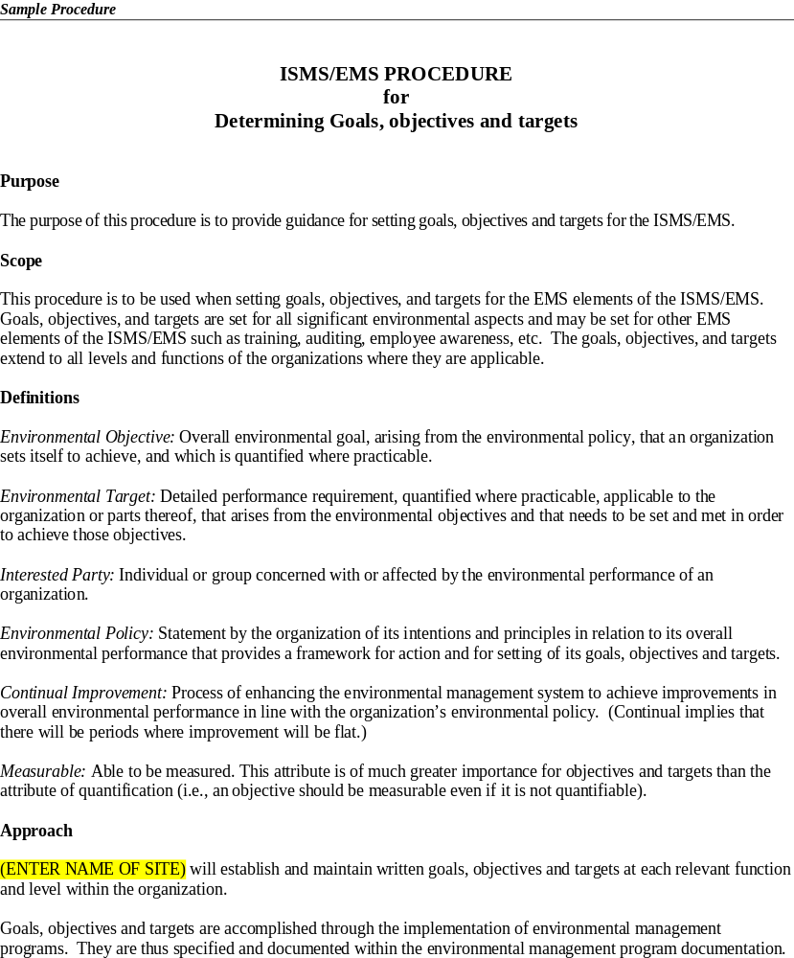
Table 11. Example of an ISMS/EMS Procedure (continued)
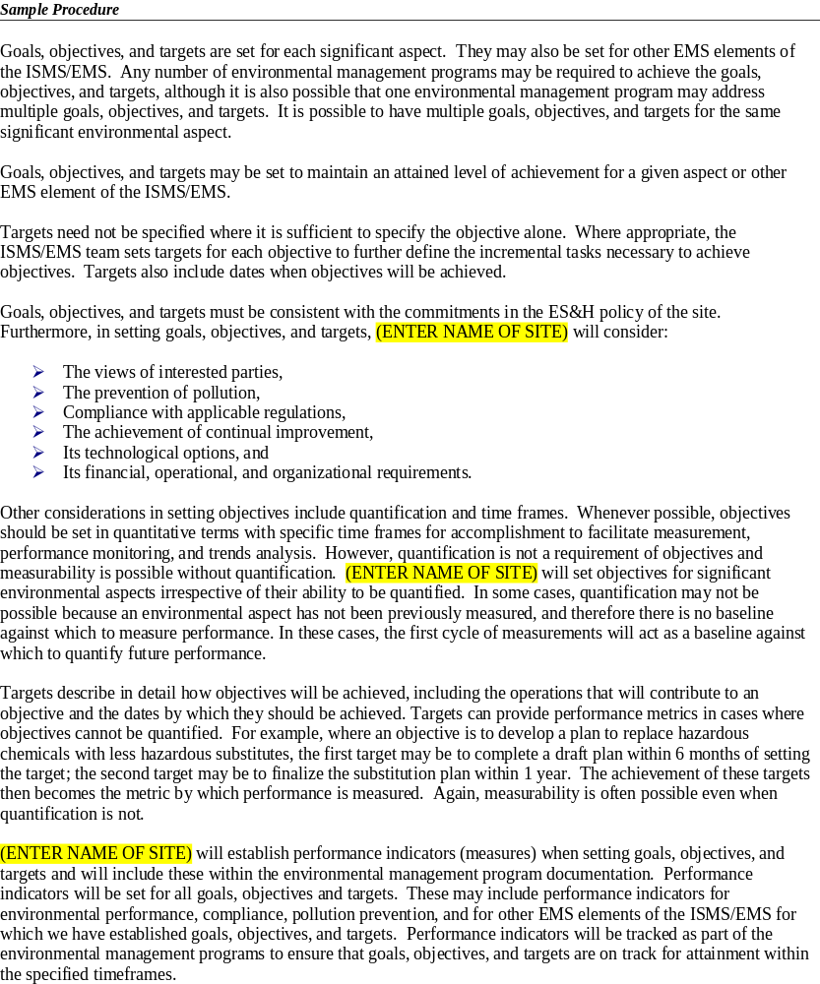
Table 11. Example of an ISMS/EMS Procedure (continued)
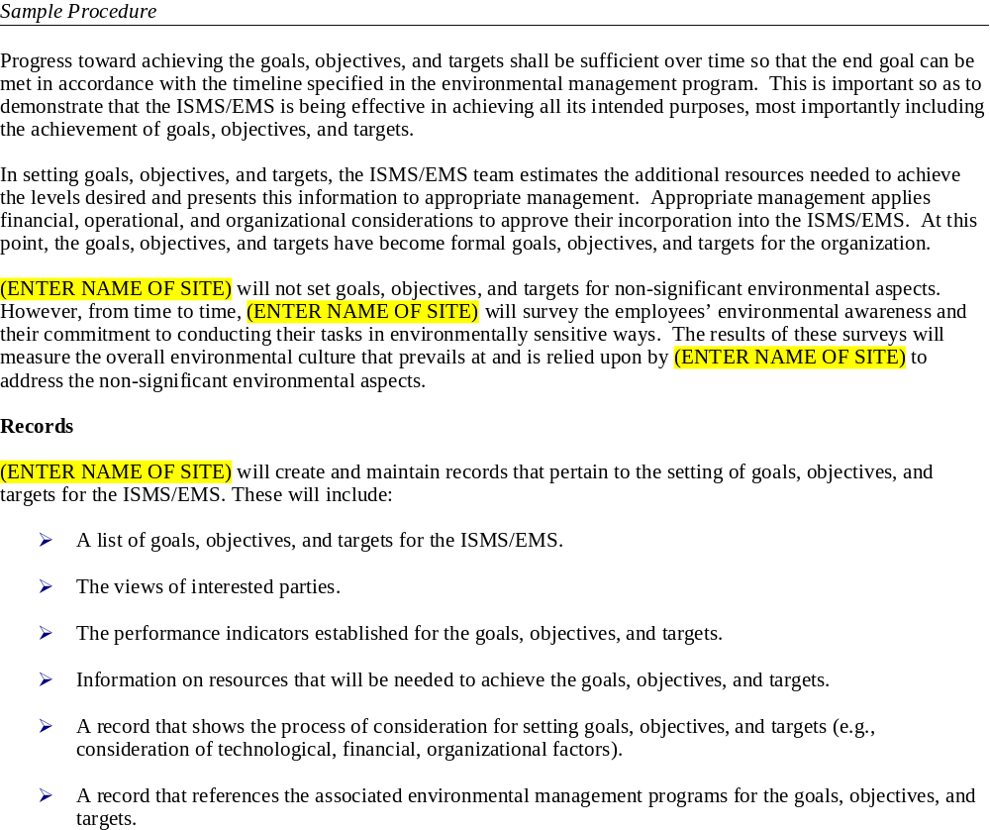
APPENDIX C
ASSESSMENTS

CONTENTS

C.1 Planning the Assessment C-1
C.1.1 Sample Assessment Plan C-2
C.1.2 Assessment Preparation Checklist C-6
C.1.3 Assessment Plan Checklist C-8
C.2 Conducting the Assessment C-9
C.2.1 Assessment Criteria (as a questionnaire) C-10
C.3 Completing the Assessment C-24
C.3.1 Assessment Findings Summary Table C-24
C.3.2 Assessment Summary Report Template C-25
C.3.3 Corrective Action Report Template C-26

  - Planning the Assessment
Typically, the assessment process should proceed in stages, including preparation, communication, coordination, execution, documentation, and closure. The assessment team should develop a plan to conduct the assessment. A sample assessment plan and an assessment plan checklist are set forth below.
    - Sample Assessment Plan
Sample Assessment Plan with various Fields completed. The following Template can be used to plan the ISMS/EMS assessment. Instructions for completing this template are set forth below.
Assessment Plan No.:  1 |  | Assessment Dates:  04/08/03 – 04/10/03 |  |  | Assessment team leader:  Joe Assessor
A. Assessment team
Jill Checking
Jennifer Intrusive
Etc.
B. Assessment objectives and scope
Objective and Scope – Assess whether an ISMS/EMS that is fully conforming to the DOE requirements has been implemented facility wide, and that this ISMS/EMS is operating in a systematic manner and achieving its desired goals.
C. Assessment Criteria
See ISMS/EMS assessment questionnaire contained in the ISMS/EMS procedure Section 4, page 10 of the XYZ Plant Manual.
D. Organization/functional units to be assessed
All organizational units.
E. Contact person | Department/Location |  | Responsibility
Jim Operator | Laboratories |  | Administration of laboratory operations including ISMS/EMS programs.
Nick Preventor | Room 202 |  | Hazardous waste manager, responsibility for compliance with RCRA, and P2 program.
Etc
F. Document review comments
Reviewed all ISMS/EMS procedures and familiarized assessment team with facility ISMS/EMS and operations.
G. High priority elements
- Hazardous waste satellite storage areas (previous ISMS/EMS assessment identified improvement opportunities for these storage areas including….
- Office waste recycling procedures
- Employee training procedures
H. Assessment Tasks |  |  | Team Member Responsible |  |  | Revision
- Assessment Questionnaire parts: 1–5  - Also focus on hazardous waste satellites storage areas |  |  | Jill Checking |  |  | None
- Assessment Questionnaire parts: 6–12  Also focus on office waste recycling procedures |  |  | John Verifier |  |  | None
- Assessment Questionnaire parts: 13–17  - Also focus on Employee training procedures |  |  | Jennifer Intrusive
I. Reference documents, ISMS/EMS procedures |  |  | Revision
XYZ Plant Internal Assessment Procedures |  |  | Second revision (03/04/03)
XYZ Plant ISMS/EMS Manual |  |  | N/A
J. Preassessment conference schedule  1 hour meeting on first morning to include agenda  - Introduction to process and assessment team  - Description of assessment schedule  - Description of areas and operations to be visited  - Confirmation of individuals interviewed  - Personal Protective Equipment required  - Etc |  |  | K. Daily briefings schedule  Short summary briefing at the end of each day to include agenda…
L. Postassessment conference schedule  1 hour meeting on first morning to include agenda  - Summary of assessment  - Presentation of assessment report  - Discussion of assessment report  - Discussion of corrective actions  - Discussion of assessment report schedule  - Etc |  |  | M. Assessment report schedule  Assessment summary report presented in postassessment conference  Presentation of final report following 1-week review period.
O. Communication of observations/ findings
Discussion of observations and findings will be provided in the daily briefings.
Summary findings will be provided on closeout meeting.

P. REpORTING AND dISTRIBUTION reQUIREMENTS
Summary and final reports will be distributed to senior management and the ISMS/EMS team.
Opportunities to make programs more effective and/or efficient will also be reported to line management for their consideration, DOE P 226.1.
N. Confidentiality requirements
All assessment findings, conclusions and documentation are confidential.
Prepared by: Jill Checking |  |  |  | Reviewed and approved by: Joe Assessor  Date: 03/22/03
Instructions for completing the assessment plan template
- At the top of the plan enter the plan number, the plan date, and the assessment team leader.
- Field A contains a list of the assessment team members. Team members should—
- be adequately qualified and experienced,
- be impartial and objective,
- be ethical,
- provide fair presentation of the facts, and
- show professionalism.
- Enter assessment objectives and scope in field B. Objectives may cover any areas that the team or organization wishes but should at minimum include—
- assessment of the ISMS/EMS capability to maintain compliance,
- assessment of the ISMS/EMS operational effectiveness and systemization, and
- assessment of the completeness of implementation.
The scope of the assessment should cover all locations and individuals covered by the ISMS/EMS. This includes all members of the organization, with special attention to employees with specific roles such as: Senior management, the ISMS/EMS coordinator, the ISMS/EMS team, and any employees with specific responsibilities under the ISMS/EMS.
- In field C, enter a reference to the ISMS/EMS assessment criteria against which the assessment will evaluate the organization.
For example, if your organization is basing part of its assessment criteria on the questionnaire discussed in section C.2.1 of this appendix, it might reference the location of this criteria.
- In field D, identify the organizational units to be assessed. This could include all the organizational units.
- In field E, enter the names of all the individuals with whom you will be speaking during the assessment as well as the department they are in and the responsibilities or roles they perform
- In field F, enter the results of a review of the organization’s documentation including—
- all documentation related to the ISMS/EMS,
- previous assessment reports and findings, and
- records relating to the ISMS/EMS.
- In field G, identify those areas of the ISMS/EMS that are priorities and on which the onsite portion of assessment should focus. These may include—
- previous assessment findings;
- areas not well covered in previous assessments;
- new organizational activities, products, and services; and
- areas of specific mission or environmental importance.
The team members will need to familiarize themselves with this information in preparation for the assessment.
- In field H, list the assessment team members responsible for certain portions of the ISMS/EMS assessment questionnaire (section C.2.1 of this appendix). In addition, use this field to designate priority areas to specific team members to ensure that the assessment covers all criteria questionnaire items.
- In field I, enter references to those documents that the assessment team will use for the assessment. In particular, note those elements of the organization’s assessment procedure to be used in the assessment.
- In fields J, K, L, and M, enter the schedule for the preassessment conference, daily briefings, the postassessment conference, and the assessment reports.
- In fields N, O, and P, list the methods the team will use to communicate observations and findings during the assessment, reporting and distributing requirements, and any confidentiality requirements.
- Finally, enter the name of the individual who completed the plan, the individual who reviewed and approved the plan, and the date.
- While working through the assessment plan, complete the assessment plan checklist (see below) to ensure all necessary planning tasks are completed prior to the assessment.

    - Assessment Preparation Checklist
This checklist can be used to make sure that the assessment team is prepared for conducting the assessment.
INTERNAL ASSESSMENT PREPARATION CHECKLIST
Department/Site to be assessed:
Assessment Date:
Assessment Objectives, Scope, and Criteria
Do assessment objectives test capability to maintain compliance: | Yes | No
Does the assessment scope assess boundaries, activities, units or time period: | Activities | Units | Time
Does the assessment criteria include programs, standards, contract requirements: | Program | Standards | Contract  Requirements
Assessment Feasibility
Have the team assured that necessary information is available: | Yes | No
Has the availability of assessment team members been sought and gained: | Yes | No
Makeup of Assessment Team
Has the objectivity of the assessment team been considered and ensured: | Considered | Ensured
Has the competence of the assessment team been considered and ensured: | Considered | Ensured
Has the appropriateness of assessment team been considered and ensured: | Considered | Ensured
Contact the Assessed Unit
Has the assessment team established a dialogue with the assessed unit: | Yes | No
Have all necessary documents been identified, requested to be made available and are available: | Identified | Requested | Are available
What dialogue/interaction has taken place:
Have the logistics been determined: | Yes | No

Document Review
Have ambiguities been clarified: |  | Yes |  | No
Have all necessary records and documents been identified, requested to be made available and are available: |  | Identified |  | Requested |  | Are available
Have previous assessments been requested to be made available and are available: |  | Identified |  | Requested |  | Are available
Have prior nonconformances requested to be made available and are available: |  | Identified |  | Requested |  | Are available
Have corrective/preventive actions been requested to be made available and are available: |  | Identified |  | Requested |  | Are available
Have organization charts and procedures been requested to be made available and are available: |  | Identified |  | Requested |  | Are available
Have monitoring and measurement records been requested to be made available and are available: |  | Identified |  | Requested |  | Are available
Have compliance status records been requested to be made available and are available: |  | Identified |  | Requested |  | Are available
Have permits been requested to be made available and are available: |  | Identified |  | Requested |  | Are available
Have management review reports been requested to be made available and are available: |  | Identified |  | Requested |  | Are available
Assessed Unit contacted: |  | Yes |  | Date:
Assessors notified: |  | Yes |  | Date:
Set opening meeting date:
Assessors Names: |  |  | Date:

    - Assessment Plan Checklist
Assessment Plan No. |  | Assessment Dates
A. Assessment objectives and scope

B. Assessment Criteria

C. Organizational/functional units to be assessed

D. Contact person | Department/Location |  |  | Responsibility
E. High priority elements

F. Assessment procedures Title |  |  |  |  | Revision
G. Communication of observations/ findings during the assessments
H. Reference documents |  |  | Revision
I. Time/duration of assessments
J. Date |  |  | Locations
L. Assessment Team Members
M. Preassessment conference schedule |  |  | N. Daily briefings schedule
O. Postassessment conference schedule |  |  | P. Assessment report schedule
Q. Confidentiality requirements
R. Reporting and distribution requirements
Prepared by: |  |  | Reviewed and approved by:
  - Conducting the Assessment
Once all the planning activities are completed, the assessment team should be ready to conduct the assessment. The team does the assessment primarily through the analyses of documentation, and by observing and interviewing employees. One of the stages in the assessment process includes assessing observations against criteria. The criteria below are an example of assessment criteria used by a DOE facility. Members of the assessment team can use this questionnaire to determine (1) root causes of system failures, (2) areas that conform and have best practices, and (3) areas where further improvements can be made.
    - Assessment Criteria (as a questionnaire)
Questions to address system requirements and root causes | Finding | Best practice | Opportunities to improve | Comment
1. Questions to determine implementation and effectiveness of the environmental policy
System Requirements:
Does the organization have an environmental policy?
- Does the policy reflect the organization’s values?
- Does the policy drive the setting of Environmental objectives and targets?
- Does the policy include a commitment to the prevention of pollution?
- Does the policy include commitments to continual improvement and compliance to relevant laws and other requirements to which the organization subscribes?
- Is the policy appropriate to the nature, scale and environmental impacts of the organization’s activities, products or services?
- Is the policy communicated to all employees and made available to the public?
- Is it clear that the policy has senior management’s endorsement and commitment?
- Does the policy provide a framework for setting and reviewing environmental objectives and targets at all levels within the organization?
Root Causes:
9. Was top management involved in crafting the policy?
10. Are there any obvious inconsistencies between the policy commitments and organizational practices?
11. Do employees believe that management is sincere?
12. Does management believe that environmental management will improve the quality and success of this organization?
13. Is there evidence that sufficient resources will be allocated to the ISMS/EMS implementation over a sustained period?
2. Questions to determine implementation and effectiveness of the Environmental Aspects
System Requirements:
- Has a procedure to identify the significant environmental aspects of operations, products, and services been established and implemented?
- Does this procedure include determining which aspects the organization can be expected to have influence over?
- Has the organization developed criteria for identifying those aspects which have or can have significant impacts?
- Have all aspects which can have significant impacts been designated as significant aspects?
- Have all aspects with regulatory requirements been designated as significant aspects?
- Is the procedure to identify significant environmental aspects exercised periodically to maintain currency?
- Is the procedure generally sufficient given the nature, scale and potential environmental impacts of this organization?
Root Causes:
- Does the procedure provide for the evaluation of all inputs, processes, operations, products and services? Has this been done?
- Are the persons doing the evaluation sufficiently versed in environmental matters to reliably identify environmental aspects?
- Is there commitment to execute the procedure frequently so as to capture any new aspects?
- Were the products or services from external suppliers sufficiently evaluated for environmental aspects?
- Does the significance criteria truly reflect the values and priorities of the organization? Has there been a thoughtful consideration of the consequences?
- Are business exposures adequately represented in the significance criteria?
3. Questions to determine implementation and effectiveness of the Legal and Other Requirements
System requirements:
- Has a procedure to identify and provide access to applicable laws and regulation, and other environmental requirements to which the organization subscribes been established and implemented?
- Does the procedure identify environmental legal requirements for activities, products and services?
- Does the procedure address applicable international, national, state, provincial, local, or contractual requirements?
- Is the flow of information on legal requirements reliable, competent, and unobstructed?
- Have the legal and other requirements been translated into nontechnical language and brought to the individuals that will have primary responsibility for compliance? (This is the meaning of “provide access” in the standard.)
- Does the procedure ensure that when new aspects arise they will be reviewed for any regulatory requirements?
Root Causes:
- Have all identified aspects been reviewed by a legally competent individual to ascertain the existence of any regulatory requirements?
- Are qualified individuals that can determine the applicability of regulations to specific configurations of environmental aspects accessible? Are they engaged in the process?
- Has the need for redundant sources of regulatory information been considered? If such a need is perceived, are there redundant sources?
- Do line personnel appreciate, in layman’s terms, the legal requirements that apply to their specific duties? Is this tested from time to time?
- Is there a general awareness among employees that legal duties attach to certain environmental responsibilities?
4. Questions to determine implementation and effectiveness of the Objectives and Targets
System Requirements:
- Are objectives and targets based on the environmental policy, take into account significant environmental aspects, legal and other requirements and the views of interested parties?
- Has the organization developed a method or criteria for determining who its “interested parties” are for the purposes of the ISMS/EMS?
- Does the organization keep the views of interested parties?
- Are there objectives and targets for all significant environmental aspects? (Even those that have already achieved their objective?)
- Is the objective for aspects with regulatory requirements to reach compliance?
- In setting objectives and targets, were technological options and its financial, operational and business requirements considered?
- Do objectives and targets contain a commitment to P2?
- Have the objectives and targets been distributed to each relevant function and level within the organization?
- Are the individuals that need to achieve objectives and targets aware of what is expected of them?
Root Causes:
- Do the objectives and targets reflect the vision and aspirations communicated by the policy statement?
- Has top management agreed with the scope and reach of the objectives and targets?
- Will achieving the objectives and targets result in the advantages and benefits envisioned when the ISMS/EMS was conceived?
- Does management keep track of progress towards achieving the objectives and targets?
- Have indicators of progress been chosen with care to allow monitoring and measurement with relative ease?
- Is responsibility for keeping track of objectives and targets, clearly designated, and is oversight sufficient to ensure this occurs?
- Is there a general awareness among the employees of the objectives and targets of the EMS?
5. Questions to determine implementation and effectiveness of the Environmental Management Programs
System Requirements:
- Are there Environmental Management Programs (EMPs) for achieving all objectives and targets?
- Do EMPs designate responsibilities for achieving the objectives and targets at each relevant function and level of the organization?
- Do EMPs include the means and timeframe for achievement?
- Have the relevant programs been revised to address new or modified activities, products or services?
- Do the management programs incorporate these elements of the ISMS/EMS:
- Objectives and targets
- Structure and responsibility
- Training, awareness and competence
- Records, identification and retention
- Operational control
- Monitoring and measurement
- Performance indicators
- Documents to be used
- Resources and timeframes
Root Causes:
- Are there programs to address all significant aspects in all activities, operations, products and services in which they exist?
- Is there sufficient detail in the program to cover all instances of each significant aspect?
- Is someone in the organization designated to be responsible to oversee each program? Are responsibilities for the various parts of each program clearly designated?
- Are persons with responsibilities for various parts of each program aware and committed to their roles?
- Are the resources allocated to each program sufficient to make the program successful?
- Do designated individuals have enough time left from their other duties to allocate to the programs?
6. Questions to determine implementation and effectiveness of the Operational Controls
System Requirements:
- Have documented operational controls for activities associated with significant environmental aspects been developed and implemented?
- Does the organization have procedures that stipulate the operating criteria and operational controls for identified operations and activities?
- Does the organization have procedures to cover control situations that deviate from the environmental policy and objectives and targets?
- Has the organization assigned responsibility for reviewing, maintaining, and updating operational controls and procedures?
- Have controls and procedures been communicated to suppliers and contractors relative to any significant environmental aspects of goods and services used by the organization?
- Does the organization have a procedure to identify the significant environmental aspects of externally provided goods and services?
- Have individuals responsible for operational controls been notified and qualified for those controls?
- Have operators been made aware where operational controls are necessary to achieve and maintain compliance to regulatory requirements?
Root Causes:
- Have operational controls been carefully considered and crafted for each activity, product or service that is associated with a significant aspect? (Has this really happened and did the analysis include specifying operating criteria, maintenance and backup controls?)
- Are the people on whom the organization relies for manning the operational controls aware, committed, competent and resourced to do their jobs?
- Is the monitoring of operational controls frequent enough to allow recovery in case of malfunction or error?
- Are operational controls assessed for their adequacy once they’ve been in place for a while?

7. Questions to determine implementation and effectiveness of the Structure and Responsibility
System Requirements:
- Have defined roles, responsibilities and authorities been established and communicated to the appropriate employees?
- Have sufficient financial, technical and personnel resources been made available to implement the ISMS/EMS?
- Has a management representative been appointed by senior management to oversee the ISMS/EMS and to report on its performance and progress?
- Are roles, responsibilities and authorities appropriately specified within the environmental management programs?
Root Causes:
- Have the employees shown that they understand their responsibilities and will actually fulfill them?
- Were the employees given the opportunity to structure the procedures they will follow to execute their responsibilities?
- When an employee leaves and another takes his/her place, is there a process for reassigning responsibilities and getting understanding, competence and commitment from the new employee?
- Is the understanding and commitment refreshed frequently enough so it is not forgotten or neglected?
- Are responsibilities fairly distributed so as not to overburden some individuals?
- Are the assigned responsibilities logical and a natural fit in the employee’s normal duties?
8. Questions to determine implementation and effectiveness of Training, Awareness and Competence
System Requirements:
- Has the organization identified and evaluated training needs for all personnel and contractors, where appropriate, whose functions may create a significant impact on the environment?
- Has the organization identified training needs for providing general awareness to all employees and managers at each relevant function and level?
- Does training emphasize the importance of compliance with all applicable laws and regulations, conformance with the organization’s environmental policy and with the requirements of the ISMS/EMS?
- Does training emphasize the significant environmental impacts, actual or potential, of work activities?
- Does training emphasize the environmental benefits of improved personal performance relative to environmental aspects?
- Does training emphasize the roles and responsibilities of employees and onsite contractors in achieving conformity with the environmental policy and procedures?
- Does training emphasize the potential consequences of departure from specified operating procedures?
- Are all employees whose work can cause significant environmental impacts competent by training, experience, or education?
- Has a determination of competence for such employees been made and recorded?
- Does the employee know that he is deemed to be so competent?
Root Causes:
- Are employees tested to ensure that training was effective?
- Are the skills or knowledge of employees deemed competent by virtue of experience or education ever tested?
- Is training done in a serious manner with sufficient time and skill so that employees do not take it as a joke?
- Do employees believe they will be held accountable for the transgression of reasonable and expected care?
- Does training convey concepts of responsibility and accountability?
9. Questions to determine implementation and effectiveness of the Emergency Preparedness and Response Procedure
System Requirements:
- Have emergency preparedness and response procedures been established, implemented and tested?
- Has the organization reviewed, and where necessary, revised its emergency preparedness and response procedures after occurrence of accidents or emergency situations?
- Does the scope of the emergency preparedness and response procedures address the prevention and mitigation of environmental impacts?
- Does the organization periodically test such procedures?
Root Causes:
- Do existing emergency procedures actually address “environmental emergencies” as well as other emergencies?
- When testing emergency procedures, do the tests exercise that portion dealing with environmental consequences?
- Are all employees aware of simple, immediate response actions that can mitigate consequences in an environmental emergency? Are they encouraged to take such actions?
- Are emergency drills done with sufficient seriousness and realism so that employees actually learn something from them?
- Has emergency planning considered all the possible emergencies that can occur?
- Do these plans address realistic scenarios?
- Are provisions sufficient to prevent or mitigate significant harm?
10. Questions to determine implementation and effectiveness of Monitoring and Measurement
System Requirements:
- Are key characteristics of significant environmental aspects, operational controls and progress toward objectives and targets being monitored and measured (e.g., record reviews, performance observations, trend analyses)?
- Does the organization maintain procedures to record information to track performance, relevant operational controls and progress towards the environmental objectives and targets?
- Have performance indicators been specified within the environmental management programs to facilitate tracking of progress towards objectives and targets?
- Is environmental monitoring equipment calibrated and maintained and are records of this process kept according to the organization’s procedures?
- Have procedures to determine the status of compliance (e.g., compliance audits or inspections) with the law been established, and are they being implemented?
- Is the information obtained from monitoring and measurement properly recorded and prepared for use during the management review?
Root Causes:
- Is there a strong commitment in the organization’s leadership to monitoring and measurement? Do they ask for periodic updates on measures?
- Have the proper monitoring and measurement tools been acquired and installed appropriately?
- Have operators been trained to read, record, calibrate and report on the readings from monitoring and measurement tools?
- Do operators exhibit a sense of discipline and desire to maintain the monitoring and measurement procedures?
- Are the results of monitoring and measurement used creatively to maintain the ISMS/EMS momentum and to invigorate the desire of operators to continue their efforts?
11. Questions to determine implementation and effectiveness of Communications
System Requirements:
- Have internal communications procedures regarding ISMS/EMS issues been established and implemented?
- Does the organization have procedures for receiving, documenting, and responding as necessary to relevant communication from external interested parties?
- Has the organization considered procedures for external communication of its significant environmental aspects?
- Has the organization recorded its decision on whether to have procedures for external communication of its significant environmental aspects?
- Does the organization have procedures to communicate with suppliers and contractors on the environmental aspects of supplies and on operational controls for onsite work?
Root Causes:
- On a periodic basis, does the organization test the effectiveness of its communications to employees? Are people getting the word?
- Does the organization test contractors at times, to ensure that they have knowledge and are following required operational controls for onsite work?
- Is it easy and un-intimidating for employees to communicate up the chain of command?
- Do communications flow down to all employees or are they prone to blockages along the way?
- Are line managers held accountable for communications reaching the employees under their charge?
- Are communications made simple and logical and do they avoid jargon? Are they translated when necessary?
12. Questions to determine implementation and effectiveness of the Nonconformance and Corrective and Preventive Actions
System Requirements:
- Are there procedures in place that are being implemented for handling ISMS/EMS nonconformances?
- Do these procedures define responsibility and authority for handling and investigating nonconformances?
- Do they define responsibility and authority for taking action to mitigate any impacts caused?
- Do they define responsibility and authority for initiating and completing corrective and preventive action?
- Have the corrective and preventive actions been appropriate to the magnitude of the problems and impacts?
- Following corrective and preventive actions, have any procedures that were affected by these actions been changed accordingly?
- Is the information on corrective and preventive actions being recorded and provided to senior management for management review?
Root Causes:
- Are employees aware that system failures need to be reported so that they can be addressed as quickly as possible?
- Do the corrective and preventive actions require an analysis of “root causes”?
- Is there followup on corrective and preventive actions to ensure they are effective?
- Does the organizational culture encourage employees to report system deficiencies or does it discourage it? (Are employees thanked for reporting such deficiencies?)
- Do the most competent individuals address nonconformances, so that corrective and preventive actions are the most effective available?
- Are nonconformances being closed out completely, effectively and timely?
13. Questions to determine implementation and effectiveness of the ISMS/EMS Assessment
System Requirements:
- Is there a program and procedure for ISMS/EMS assessments and is it being implemented?
- Can the procedure for ISMS/EMS assessments determine whether the ISMS/EMS responds appropriately to the organization’s environmental policy?
- Can it determine whether the ISMS/EMS conforms to the organization’s planned arrangements for environmental management?
- Can it determine whether the ISMS/EMS conforms to DOE O 450.1?
- Can it determine whether the ISMS/EMS had been properly implemented and maintained?
- Is the ISMS/EMS assessment schedule based on the importance of the activities and the results of previous assessments?
- Do the assessment procedures cover the assessment scope, frequency, and methodologies?
- Do the assessment procedures cover the responsibilities and requirements for conducting assessments and reporting results?
- Is the information from ISMS/EMS assessments being recorded and reported to senior management for management review?
Root Causes:
- Do the internal ISMS/EMS assessors have a solid understanding of the ISMS/EMS, its expectations, and the requirements?
- Have the internal ISMS/EMS assessors received appropriate training to conduct ISMS/EMS assessments?
- Is sufficient time allocated to allow the internal assessors to prepare for an assessment, to execute it and to prepare the reports and any followups?
- Are internal assessors given separate recognition (rewards) for conducting ISMS/EMS assessment when this is not their primary function?
- Is there a culture of respect for assessors among employees?
- Do assessors see themselves as internal consultants and stewards of the ISMS/EMS?
- Do internal assessors prepare the assessment criteria and are they doing this thoughtfully, completely and with real understanding?
14. Questions to determine implementation and cohesion of ISMS/EMS Documentation
System Requirements:
- Are the core elements of the ISMS/EMS documented, including all of the required procedures?
- Does the documentation of the core elements of the ISMS/EMS describe their interaction?
- Does documentation of the core elements of the ISMS/EMS provide direction to related documentation?
Root Causes:
- Is the description of the system, its components, its details on how things will be done and by whom complete?
- Are all references to other systems, subsystems, procedures, programs, etc. incorporated in the ISMS/EMS documentation?
- Was the documentation compiled with the intention that it would clearly describe the system, be complete and serve as a reference for those wishing to learn about the ISMS/EMS?
- Is the documentation kept current as the ISMS/EMS evolves?
- Is documentation seen as a necessary adjunct to a well-working system, or is it seen as useless red tape?
15. Questions to determine implementation and effectiveness of the Document Control system
System Requirements:
  - Is there a procedure for managing and controlling the documents that are being implemented in the ISMS/EMS to ensure that:
- They can be located;
- They are periodically reviewed, revised as necessary, and approved for adequacy by authorized personnel;
- Only the current versions are in use;
- They are located where they are needed;
- Obsolete documents are no longer in use;
- Documents that need to be retained are suitably identified for that purpose.
  - Are documents legible, dated (with dates of revision) and readily identifiable?
  - Are documents maintained in an orderly manner and retained (if required) for a specific period?
  - Are there procedures and designation of responsibilities for the creation and modification of the various types of documents?
Root Causes:
- The fewer the individuals that are involved in document control, the easier the task becomes. Does the procedure for document control minimize the number of people that need to be involved? (The most efficient document control is to do it online with only one individual responsible for making the changes to the authorized, official online copy.)
- If the procedure relies on a number of individuals, is there one authorized coordinator who scrupulously ensures that new copies are properly distributed and used while old copies are collected and disposed?
- When more than one individual is involved in document control, it is important to have a well-defined procedure and discipline to make the system work. Does this culture prevail in the organization?
16. Questions to determine implementation and effectiveness of the ISMS/EMS Records
System Requirements:
- Is there a procedure for the identification, maintenance and disposition of environmental records?
- Are ISMS/EMS records:
- Legible
- Identifiable and traceable to the activity, product, or service involved
- Stored and maintained so as to be readily retrievable and protected against damage, deterioration or loss
- Have the retention times for ISMS/EMS records been established and recorded?
- Are the ISMS/EMS records being retained for the periods established?
- Are the ISMS/EMS records kept to demonstrate conformance to DOE O 450.1?
Root Causes:
- Does the prevailing culture assign a high value to creating, storing and maintaining records in all parts of the enterprise? (It is unlikely that environmental records will be accorded a different importance than is given to other records produced by the organization.)
- Does the organization apply retention times to environmental records that comply with regulatory requirements? (Is there recognition that such regulatory requirements need to be researched at the time legal and other requirements are being established for the list of environmental aspects?)
- Is responsibility for maintaining and retrieving records clearly established? Is the system for doing this reliable?
- Is the record system tested periodically for its integrity and reliability? How do we know the system is working?
17. Questions to determine implementation and effectiveness of the ISMS/EMS Management Review
System Requirements:
- Is senior management, on a regular basis, reviewing the structure and performance of the ISMS/EMS to determine the effectiveness of the ISMS/EMS and identify potential opportunities for improvement?
- Do management reviews address the possible need for changes to policy, objectives and other elements of the organization’s ISMS/EMS, in light of performance information, audit results, changing circumstances and the commitment to continual improvement?
- Has sufficient information for this assessment been reviewed, including:
- Monitoring and measurement
- ISMS/EMS assessments
- Compliance status
- Corrective and preventive actions
- Progress towards objectives and targets
- Is the review (including the decisions taken) recorded and are the records kept for a suitable period of time?
- Are these management reviews planned and organized by the ISMS/EMS management representative?
Root Causes:
- Does top management accept that the top goal of an ISMS/EMS is to change environmental culture (That the environmental culture is as necessary and as valuable as the safety culture?)
- Does top management accept that their continued leadership and involvement are necessary to effect such a change in the organization’s environmental culture?
- Does top management readily agree to participate and contribute in the management reviews?
- Is top management aware of and does it believe in the potential benefits of having a well-established environmental culture?
- Are management reviews focused on the results of the system and do they consider sufficiently the evaluation and authorization of changes to promote progress and continual improvements?

  - Completing the Assessment
After the assessment is conducted, the assessment team should hold a closing meeting to complete the assessment by discussing the findings and agreeing to followup actions to address the findings. In preparation for this meeting, the assessment team should prepare a Findings and Summary Report. The Assessment Findings Summary Table template and the Assessment Summary report template in sections C.3.1 and C.3.2. below can be used to assist the assessment team in preparing a Findings and Summary Report.
The assessment team may also prepare a corrective action report (CAR). A template that can be used to develop a CAR is in section C.3.3 below.
    - Assessment Findings Summary Table
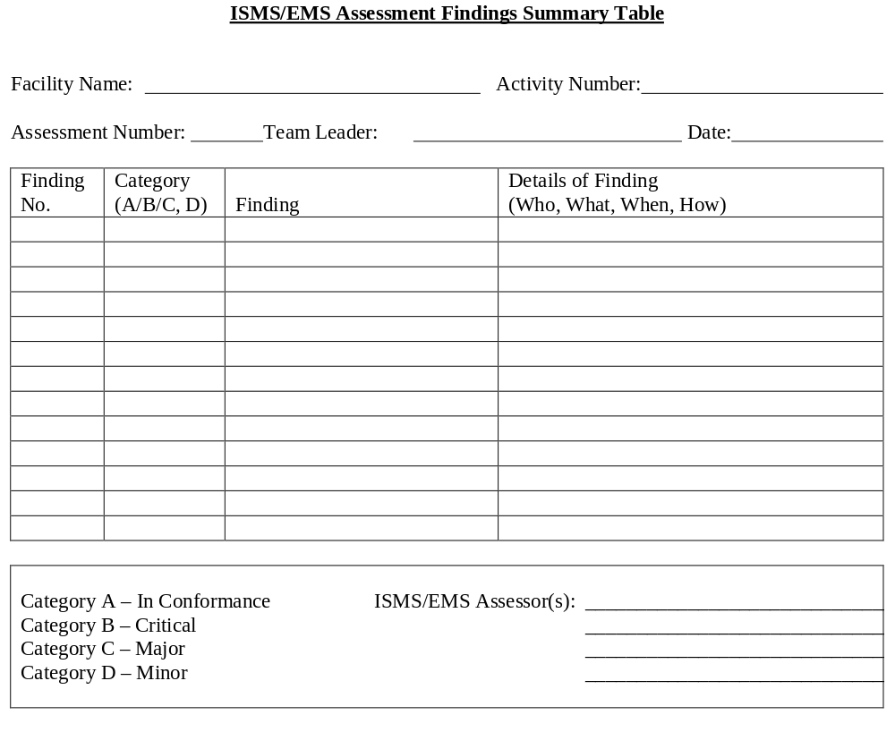

    - Assessment Summary Report Template
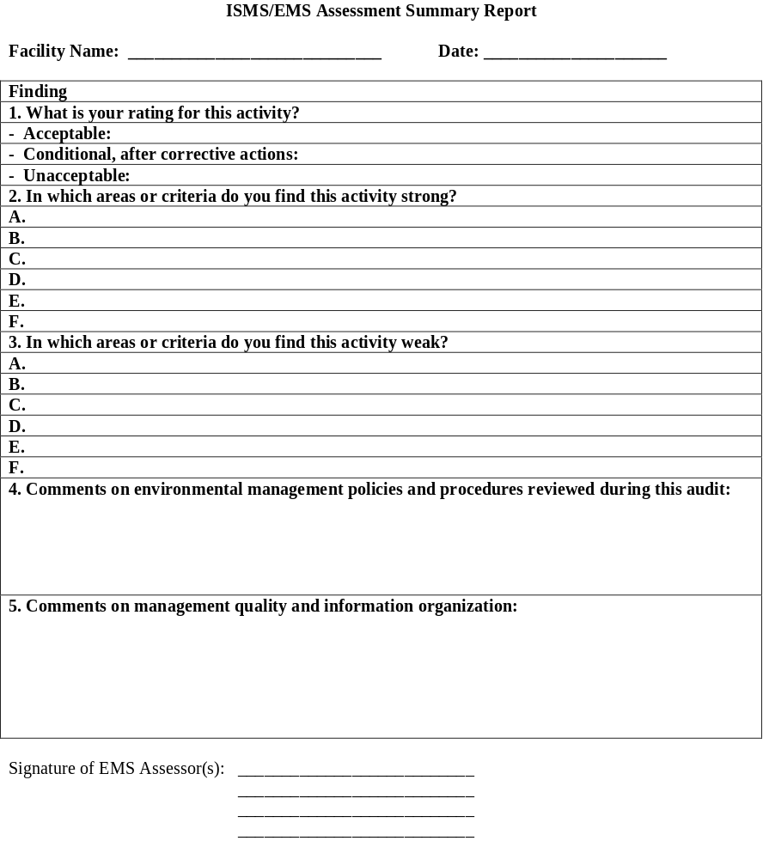
    - Corrective Action Report Template
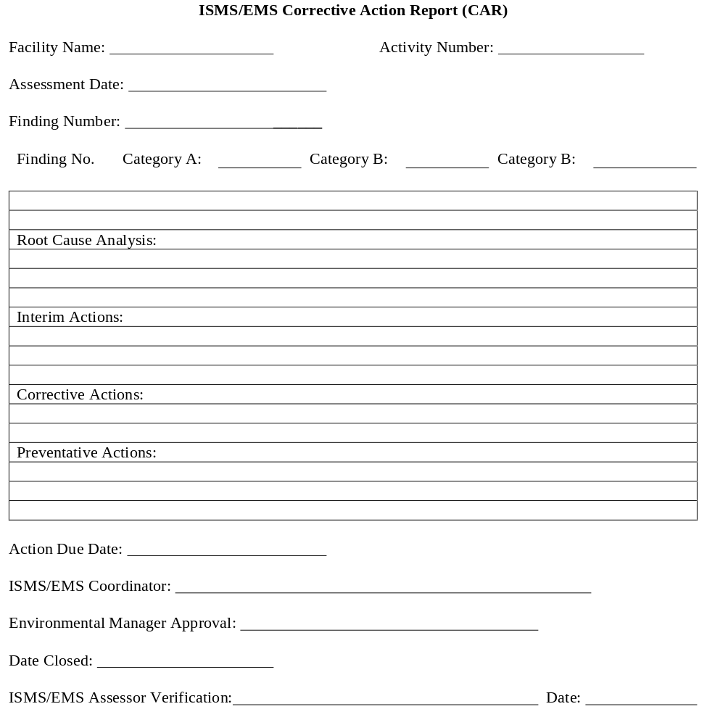

APPENDIX D
GLOSSARY

GLOSSARY

Activities, Products, and Services—A catchall phrase that was developed by Technical Committee 207 of ISO to capture all of the elements at a facility or organization that can interact with the environment.
Assessment—see ISMS/EMS Assessment.
Audit—A systematic and documented verification process of objectively obtaining and evaluating evidence to determine the adequacy of a program or system within an organization.
Compliance Audit—A systematic and documented verification process of objectively obtaining and evaluating evidence to determine the status of a DOE program regarding compliance with laws, regulations, and DOE Orders.
Continuous Improvement—The process of enhancing the environmental management system to achieve improvements in overall environmental performance in line with the organization’s environmental policy. This process need not take place in all areas of activity simultaneously.
Corrective Action—An action taken to eliminate the causes of an existing noncompliance, nonconformity, defect, or other undesirable situation in order to prevent recurrence.
Cultural Resources—Historic properties as defined in the National Historic Preservation Act, archaeological resources as defined in the Archaeological Resources Protection Act, and cultural items as defined in the Native American Graves Protection and Repatriation Act. Include artifacts and sites dating to the prehistoric, historic, and ethnohistoric periods that are currently located on the ground or buried beneath it; standing structures that are more than 50 years of age or are important because they represent a major historic theme or era; cultural and natural places, select natural resources, and sacred objects that have importance for Native Americans and other ethnic groups; and American folklife traditions and arts.
Environment—Surroundings in which an organization operates, including air, water, land, natural resources, flora, fauna, humans, and their interrelation (ISO-14001, 1996).
Environmental Aspect—Elements of an organization’s activities, products, or services that can interact with the environment (ISO-14001, 1996) (The environmental aspect of an activity is that part of it that creates a possibility for an environmental impact. As such, it is equivalent to the concept of “hazard” in safety, which is also defined as the mere possibility of a negative event.)
Environmental Impact—A change to the environment, whether adverse or beneficial, wholly or partially resulting from an organization’s activities, products, or services (ISO-14001, 1996).
Environmental Management System (EMS)—The part of the overall management system that includes organizational structure, planning activities, responsibilities, practices, procedures, processes, and resources for developing, integrating, achieving, reviewing, and maintaining environmental policy; a continuing cycle of planning, implementing, evaluating, and improving processes and actions undertaken to achieve environmental goals.
Environmental Objective—An overall environmental goal, arising from the environmental policy, that an organization sets itself to achieve, and which is quantified where practicable (ISO-14001, 1996).
Environmental Performance—Measurable results of the environmental management system, related to an organization’s control of its environmental aspects, based on its environmental policy, objectives, and targets (ISO-14001, 1996).
Environmental Policy—A statement by the organization of its intentions and principles in relation to its overall environmental performance, which provides a framework for action and for the setting of its environmental objectives and targets (ISO-14001, 1996).
Environmental Target—A detailed performance requirement, quantified where practicable, and applicable to the organization or parts thereof, which arises from the environmental objectives and needs to be set and met to achieve those objectives (ISO-14001, 1996).
Gap Analysis—An assessment of EMS requirements against existing management system descriptions, policies, and procedures.
Integrated Safety Management System (ISMS)—A DOE management system that provides a formal, organized process whereby people plan, perform, assess, and improve the safe conduct of work efficiently and in a manner that ensures protection of workers, the public, and the environment. This management system shall be used to systematically integrate safety into management and work practices at all levels so that missions are accomplished while protecting the public, the worker, and the environment.
ISMS/EMS Assessment (Assessment)—A formal self-assessment (see self-assessment) that is normally conducted by an organization with an appropriate degree of independence.
ISO Audit/ISO 14001 EMS Audit—an audit that is used as a vehicle through which the environmental aspects of an organization and how they are managed are systematically compared against the requirements of the ISO 14001 specification.
ISO-14001 Standard—Internationally recognized voluntary environmental management system standard that provides organizations with the elements of an effective environmental management system that can be integrated with other management requirements to help organizations to achieve environmental and economic goals.
Likelihood—A measure of how often an aspect can be expected to occur within an activity given the probability of its occurrence for each repetition of the activity and the frequency of the activity over time.
Operational Controls—Procedures that help a site in implementing its environmental policy, objectives, and targets.
Organization—A company, corporation, firm, enterprise, authority, or institution, or part or combination thereof, whether incorporated or not, public or private, that has its own functions and administration (ISO-14001, 1996).
Pollution Prevention—A source reduction as defined in the Pollution Prevention Act and other practices that reduce or eliminate the creation of pollutants through (1) increased efficiency in the use of raw materials, energy, water, or other natural resources or (2) protection of natural resources by conservation. The DOE has expanded this definition to include recycling.
Pollution Prevention Opportunity Assessment—an appraisal conducted to identify those processes, projects and operations that need to be improved or replaced to promote pollution prevention, including waste minimization and energy conservation. A pollution prevention opportunity assessment (PPOA) documents material and energy usage, project size, process by-products, equipment, and waste generation. The assessment consists of a systematic approach which includes the following: (1) organization of PPOA teams, (2) assessment of waste-producing activities, (3) development and evaluation of pollution prevention opportunities, and (4) recommendations for implementation of pollution prevention options.
Potential Environmental Impact—An aspect defined by its likelihood of occurrence and likely consequences. It is equivalent to the concept of “risk” in Safety, which assigns a probability and consequence to the possible negative event that may result from a “hazard.”
Recycling—(1) The use or reuse of a material as an effective substitute for a commercial product and as an ingredient or feedstock in an industrial or energy-producing process and (2) the reclamation of useful constituents within a waste, or removal of contaminants from a waste to allow it to be reused.
Root Cause—The origin of an environmental deficiency.
Self-Assessment—An analysis or evaluation, that can be informal or formal and structured, of a DOE program or contractor management system by that program or contractor to ensure conformance to regulatory and DOE internal requirements and to confirm the safe and environmentally protective performance of work.
Self-Declaration—An organization determines that it is in full conformance with the requirements of DOE O450.1 and publicly asserts that it conforms to these requirements.
Self-Declaration Evaluation—An evaluation conducted by an organization for the purpose of determining whether its Environmental Management System is in full conformance with the requirements of DOE O 450.1.
Significant Environmental Aspect—An environmental aspect that has or could have a significant impact on the environment, the organization, or to the organization’s mission (ISO-14001, 1996).
Senior Management—The level of management that has the authority to make decisions for the site or facility.
APPENDIX E
REFERENCES
The following references were used in compiling this document.
American National Standards Institute. 2001. ANSI Auditing Policy and Procedures. National Issues Committee, September 2000.
Block, M., and Marash, I. R. 2001. Integrating ISO-14001 in to a Quality Management System. Milwaukee: ASQ Quality Press.
Block, M. 1999. Identifying Environment Aspects and Impacts. Milwaukee: ASQ Quality Press.
Canadian Standards Association. 1995. Competing Leaner, Keener and Greener A Small Business Guide to ISO 14000.
Cascio, Joseph, et al. ISO 14000 Guide, McGraw-Hill, 1996.
Cascio, Joseph, Editor, The ISO 14000 Handbook. ASQ,,1996.
Deaver, T. 1998. Integrating facilities planning and ISO 14000. IIE Solutions, Sept v30 n9 p1(4).
Diamond, Craig P. 1995. “Voluntary Environmental Management System Standards: Case Studies in Implementation.” Total Quality Environmental Management. Winter 1995/1996, pp. 9–23.
Department of Energy and Environmental Protection Agency. 1998. Environmental Management Systems Primer for Federal Facilities. Department of Energy, Office of Environmental Policy and Assistance; and EPA, Federal Facilities Enforcement Office, DOE/EH-0573
( http://www.epa.gov/Compliance/resources/publications/incentives/ems/emsprimer.pdf ).
EMAS. 1993. Eco-management Audit Scheme. Brussels: European Council. Text of Council Regulation 1836/93-EMAS.
Fryxell, G. E. and Vryza, M. 1998. “Managing environmental issues across multiple function: and empirical study of corporate environmental departments and functional co-ordination.” Journal of Environmental Management, v. 55, p. 39(56).
GETF. 2000. The USEPA Environmental Management System Pilot Program for Local Government Entities. January 2000.
Hamilton, E. 1997. “The top eleven pitfalls of environmental audits and how to avoid them.” Journal of Environmental Law and Practice, Mar/Apr v4 n5 p. 29(6).
Hillary, Ruth. 1999. Evaluation of Study Reports on the Barriers, Opportunities and Drivers for Small and Medium Sized Enterprises in the Adoption of Environmental Management Systems. October 1999.
Institute of Quality Assurance. 1995. Quality Systems in the Small Firm: a Guide to the Use of the ISO 9000 Series. March 1995.
International Organization for Standardization. 1996. ISO 14004-Environmental Management System—General Guidelines on Principles, Systems, and Supporting Techniques.
International Standards Organization. 1996. ISO-14001.Environmental Management Systems Specification with Guidance for Use, ISO-14001; 1996(E).
McDonough, William and Michael Braungart. Cradle to Cradle, 2002.
Metcalf, K. R., Williams, P. L., Minter, R. J. and Hobson, C. M. 1995. “An assessment of corporate environmental programs and their performance measurement systems.” Journal of Environmental Health, Sept v58 n2 p. 9(9).
Michigan Department of Commerce and Natural Resources. 1996. Business Waste Reduction: Creating an Action Plan. Michigan Department of Commerce and Natural Resources, Environmental Services Division, November 1994.
Northern Environmental. 2000. ISO-14001 Guide for Small to Medium-Sized Companies. Northern Environmental.
NSF-ISR. 1998. Environmental Management Systems: A Guide for Metal Finishers. NSF-ISR.
NSF-ISR. 1998. Implementing Environmental Management Systems in Community-Based Organizations. NSF-ISR.
Raymond, Martin, Dr. 1998. ISO-14001 Guidance Manual. National Center of Environmental Decision-Making Research (NCEDR). Technical Report NCEDR/98-06.
Rikhardsson, P. M. 1998. Information systems for corporate environmental management accounting and performance measurement. Greener Management International, Spring, p. 51.
Sisk, Steven. 1997. Compliance-Focused Environmental Management System—Enforcement Agreement Guidance. EPA, Office of Criminal Enforcement, Forensics and Training, EPA330/9-97-002R. Revised December 2001 (http://www.epa.gov/compliance/resources/publications/incentives/ems/ems12elemr.pdf).
Stapleton, P., and Glover, M. 2001. Environmental Management Systems: An Implementation Guide for Small and Medium-Sized Organizations. NSF International
(http://www.epa.gov/OW-OWM.html/iso14001/wm046200.htm).
Tibor, T., and Feldman, I. 1996. ISO 14000 A Guide to the New Environmental Management Standards. Irwin Professional Publishing.
United Nations Environment Programme (UNEP). 1995. Environmental Management System Training Resource Kit. Version 1.0, UNEP, the International Chamber of Commerce (ICC), and the International Federation of Consulting Engineers (FIDIC). December 1995.
United States Department of Energy. Environmental Management System Implementer’s Guide (Draft), March 2003.
United States Department of Energy, Office of Defense Programs, Model Pollution Prevention Opportunity Assessment Guidance, Revised December 1995.
United States Environmental Protection Agency. 2001. Compliance-Focused Environmental Management System-Enforcement Agreement Guidance. EPA330/9-97-002R, Revised December 2001. (http://www.epa.gov/Compliance/resources/publications/incentives/ems/ems12elemr.pdf ).
United States Environmental Protection Agency. 2001. Draft College and University Environmental Management System Guide. EPA, New England. (http://www.epa.gov/ne/assistance/univ/emsguide.html).
United States Environmental Protection Agency. 2003. EMS Implementation Training Course. Office of Administration; Safety, Health and Environmental Management Division. (Produced by Booz Allen Hamilton, EMS Team, to be completed March 2003).
United States Environmental Protection Agency. 1998. Environmental Audit Program Design Guidelines for Federal Agencies. Office of Enforcement and Compliance Assurance, EPA300-B-96-011
United States Environmental Protection Agency. 1986. Environmental Auditing Policy Statement. EPA, Office of Administration. 51 FR 25004.
United States Environmental Protection Agency. 1996. Generic Protocol for Conducting Environmental Audits of Federal Facilities. Office of Enforcement and Compliance Assurance, EPA300-B-96-012B.
United States Environmental Protection Agency. 1997. Implementation Guide For The Code of Environmental Management Principles for Federal Agencies (CEMP). Federal Facilities Enforcement Office, EPA 315-B-97-001.
(http://www.epa.gov/compliance/resources/publications/incentives/ems/cempmaster.pdf).
United States Environmental Protection Agency. 2000. Incentives for Self-Policing: Discovery, Disclosure, Correction and Prevention of Violations. [FRL 6576-3].
United States Environmental Protection Agency. 2000. Integrated Environmental Management Systems Company Manual for Small Business. Office of Pollution Prevention and Toxics, EPA744-R-00-012.
(http://www.epa.gov/dfe/pubs/iems/iems_template/template.pdf).
United States Environmental Protection Agency. 2000. Integrated Environmental Management Systems (IEMS) Implementation Guide. Office of Pollution Prevention and Toxics, EPA744-R-00-011. (http://www.epa.gov/opptintr/dfe/tools/iemsguide.htm)
United States Environmental Protection Agency. 2002. Practical Guide to Environmental Management for Small Business. Small Business Division, EPA233-K-02-001. (http://www.smallbiz-enviroweb.org/html/pdf/EM_Guide0902.pdf).
United States Postal Service. 1995. Environmental Resources Handbook. United States Postal Service.
Internet sites
Environmental Management Systems Home Page. (http://www.p2pays.org/iso). Accessed January 2003.
EPA’s Action Plan for Promoting the Use of Environmental Management Systems (EMS). (http://www.epa.gov/ems/policy/goals.htm). Accessed January 2003.
EPA’s EMS Web site.
(http://www.epa.gov/ems/index.htm). Accessed January 2003.
EPA’s EMS Web site: EMS Publications.
(http://www.epa.gov/ems/assist/guide/general.htm). Accessed January 2003.
EPA’s National Compliance Assistance Clearinghouse: EMS Page. (http://cfpub.epa.gov/clearinghouse/index.cfm?Tab=Tools&TopicID=C:10:300:EMS). Accessed January 2003.
EPA’s National Compliance Assistance Clearinghouse. (http://cfpub.epa.gov/clearinghouse/). Accessed January 2003.
EPA’s National Environmental Performance Track. (http://www.epa.gov/performancetrack/). Accessed: August 2001.
Global Reporting Initiative (GRI). (http://www.globalreporting.org). Accessed: August 2001.
Iowa Waste Reduction Center: EMS Service Center. (http://www.iwrc.org/programs/ems.cfm). Accessed January 2003.
Northeast Business Environmental Network (NBEN) (2002). (http://www.nben.org). Accessed: January 2003.
P2 Regional Information Center: Environmental Management Systems. (http://p2ric.org/TopicHubs/toc.cfm?hub=9&subsec=7&nav=7). Accessed January 2003.

Secretary of Energy Memorandum, “Pollution Prevention and Energy Efficiency Leadership Goals for Fiscal Year 2000 and Beyond,” November 12, 1999.
Nonattainment areas are areas not meeting one or more NAAQS, and maintenance areas are former nonattainment areas now in attainment, with an approved maintenance plan to stay in attainment.
American National Standards Institute and American Society for Quality Control E-4 (ANSI/ASQC E4-1994) was selected as the basis for the intergovernmental quality system because it is a national standard that specifically addresses environmental data collection and use and environmental technology. Part A, Management Systems, describes the quality management elements needed for managing environmental programs effectively. These include: management and organization, quality system and description, personnel qualification and training, procurement of items and services, documents and records, computer hardware and software, planning, implementation of work processes, assessment and response, and quality improvement.
ANSI/ASQC E-4 Part B, “Collection and Evaluation of Environmental Data.” It addresses project-specific requirements needed to plan, implement, and assess environmental data operations, including the collection, handling, analysis, and evaluation of environmental-related data. Such data include: chemical, biological, toxicological, and radiological data.

