Effective April 3, 2007

EMI WELCOME PACKAGE

Below is information to help you plan your travel to the National Emergency Training Center (NETC). Even if you’ve taken classes at NETC previously, please read it carefully. The procedures may have changed since you were here last, and you will be responsible for complying with the current procedures. The last page of this package is entitled “CONTACT INFORMATION.” We suggest you print it and provide a copy to your family and office staff in case they need to contact you while you are here. Although friends or family may not stay in Housing, they are welcome to attend graduation. Please contact Security before their arrival for current security protocol required for their entry to NETC campus.

If you have any questions, you may call us at either (800) 238-3358 or (301) 447-1000. When you reach the operator, ask for the appropriate extension:
- Housing/Transportation: x1048/1113
- Admissions: x1035
- Food Service: x1551
- Security: x1111

You may send an email to:
- Housing/Transportation: NETC-Housing@dhs.gov
- Admissions: NETC-admissions@dhs.gov
- Food Service: NETC-cafeteria@dhs.gov

If you need to fax information to any of the following offices, please note the following fax numbers:
- Housing/Transportation: (301) 447-1324
- Admissions: (301) 447-1658
- Food Service: (301) 447-6944

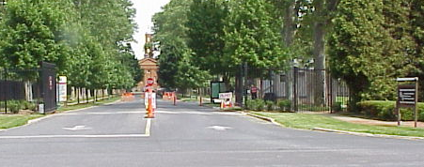 SECURITY 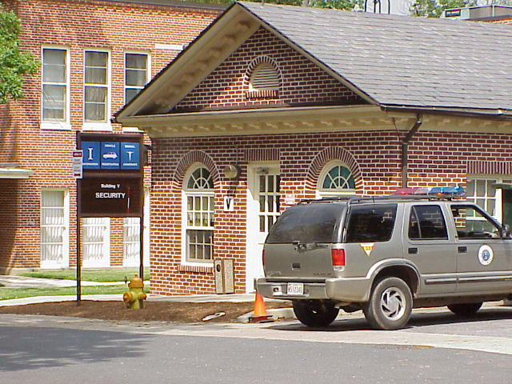

Due to increased security precautions, students should bring two photo ID’s to campus. PLEASE HAVE THEM WITH YOU, NOT IN YOUR BAGGAGE! If you do not have the photo ID’s, you will not be permitted on campus. Security checks will delay your registration at NETC.

If you are a student from a foreign country, please be prepared to show your passport or visa at registration.

Firearms: Prohibited on campus!
Due to heightened security requirements, please understand that security and law enforcement personnel may search you, your vehicle or your luggage. Maryland law is very narrow in its definition of law enforcement officers who may carry firearms. For your own protection, and to expedite your processing into the NETC, do not bring weapons of any kind to campus. Weapons include knives with blades longer than 3 inches, machete, bow & arrows, ammunition, rifles, shotguns, pistols, etc. Sworn/commissioned, and state POST certified officers, and federal officers, or local officers with concurrent jurisdiction who require a firearm for the performance of required official duties must obtain an exception from the Director of Support Services prior to arrival on campus. If you arrive at NETC with weapons of any kind without prior approval, your entry to campus will be significantly delayed.

Alcoholic Beverages: Consumption of alcoholic beverages is limited to the Pub & Log Cabin. Alcohol is not allowed in lodging rooms or vehicles, and will be confiscated. If you arrive at NETC with, or are attempting to bring alcohol on campus, your entry will be significantly delayed.

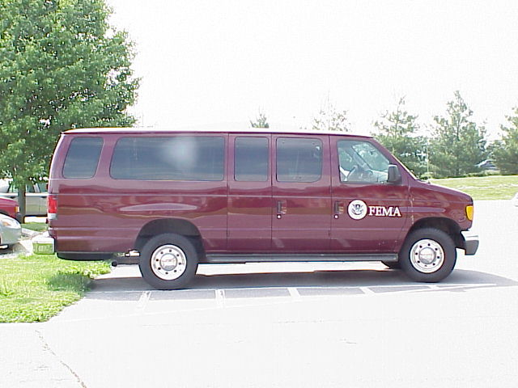 TRAVEL 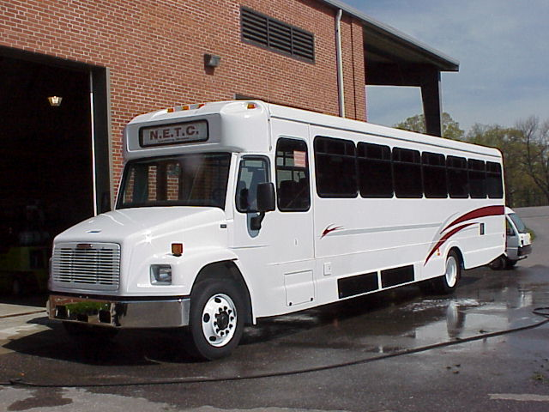

TRAVEL BY AIR:
- You must make your own travel arrangements.
- You must be sure your flights meet the shuttle pickup/departure times. Ticket purchase follows the parameters of travel as defined under “REIMBURSEMENT” in this package.

NETC SHUTTLE SERVICE:
- Shuttle service is available between NETC and the airport(s) listed on the “COURSE SPECIFIC INFORMATION” sheet – a pink page enclosed with the acceptance letter you received for this class. Read it carefully before making flight arrangements!
- If you need bus transportation to NETC from the airport, you should plan to arrive at least 1 hour before bus departure time. You must notify (email, phone or fax) the NETC Transportation Office at least 1 week prior to the course start-date to reserve a seat. IF YOU DO NOT CALL, SEATING MAY NOT BE AVAILABLE AND TRANSPORTATION TO EMMITSBURG WILL BE AT YOUR OWN EXPENSE.
- Our transportation will be either a motor coach/charter bus identified with NETC signage in the front window/door, or a maroon passenger van with the NETC signage in the front window. You may contact the NETC Transportation Office a day before your arrival to inquire as to which vehicle will be used. For airport security reasons, our drivers cannot leave their vehicles and must circle the airport pickup area, SO YOU WILL NEED TO LOOK FOR THE BUS OR VAN. If you do not see the vehicle 5 minutes prior to the pickup time, please call the NETC Transportation Office for guidance.

SHUTTLE PICKUP POINTS AT EACH AIRPORT: (check your pink “Course Specific Information” sheet as to which airport you may use. You can ONLY use an airport listed on that sheet! Ground transportation from other airports will be at your own expense. If your scheduled arrival time does not coincide with the shuttle schedule, ground transportation will be at your own expense as well.)

- Ronald Reagan National Airport (DCA): Pickup is near the Travelers’ Aid Desk in Terminal ‘B’ (Lower Level, between gates 5 & 6). Buses and vans depart from the outside lane. If you arrive in Terminal ‘A’ please take the Economy/Rental Car airport bus shuttle to Terminal ‘B’, lower level, or walk across the terminal connector and go downstairs to exit door number 5, on your left.
- Baltimore/Washington International Airport (BWI): Pickup is near the Lower Level Baggage Areas 13 & 14. There is not a Travelers’ Aid Desk in this location. Buses and vans depart from the outside lane. BWI Airport is currently undergoing construction. If you have any questions or concerns, please contact the NETC Transportation Office or visit the BWI website at:
http://www.bwiairport.com/customer_assistance/lower_level_terminal_map
- Dulles International Airport (IAD): There is a Traveler’s Aid Desk between Baggage Claim Areas 4 & 5 on the baggage level, located at the east end of the terminal. Go up the ramp and out exit-door number 6.

DELAYED FLIGHTS: If you are scheduled to use NETC transportation, but your flight is delayed for other than weather-related reasons, the airline is responsible for your transportation. If they will not transport you, please call the NETC Transportation Office when you arrive at the airport (it will be approximately 2 hours before we can pick you up). If you choose not to use NETC transportation and arrange for other transportation, it will be at your own expense.

IF DRIVING:
- You may arrive on campus any time after 12:30 p.m. the day before your course begins.
- You must depart campus after the end of your course, except for courses with a next-day departure date.
- Your vehicle must be registered at Housing/Security for stipend/security reasons, even if you do not stay on campus.
- There are no connections for mobile homes or recreational vehicles available at NETC.

DIRECTIONS TO NETC:
- From Baltimore: I-695 (Baltimore Beltway) to I-70 West (towards Frederick) to Route 15 North to Emmitsburg. Left turn off Route 15 to South Seton Avenue. 2nd Right onto campus (tree-lined drive).
- From Washington: I-495 (Washington Beltway) to I-270 North (towards Frederick) to Route 15 North to Emmitsburg. Left turn off Route 15 to South Seton Avenue. 2nd Right onto campus (tree-lined drive).
- From Philadelphia and East: Pennsylvania Turnpike West to Harrisburg, Exit 236 (Route 15). Go South on Route 15 to Emmitsburg. Right turn off Route 15 to South Seton Avenue. 2nd Right onto campus (tree-lined drive).
- From Pittsburgh and West: Pennsylvania Turnpike East to Harrisburg, Exit 236 (Route 15). Go South on Route 15 to Emmitsburg. Right turn off Route 15 to South Seton Avenue. 2nd Right onto campus (tree-lined drive).

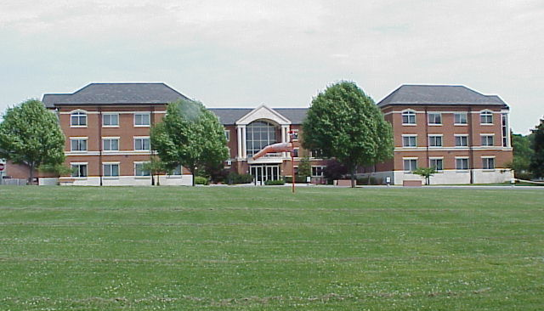 REGISTRATION 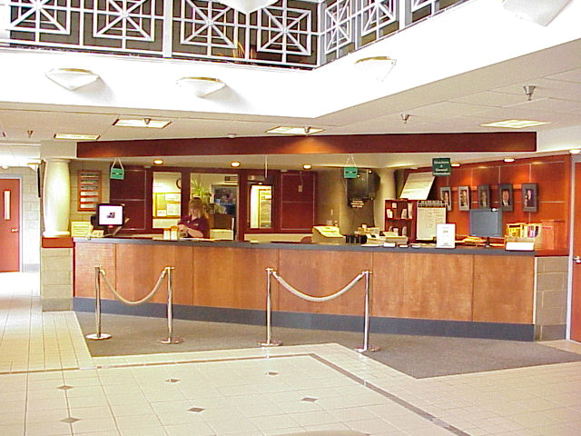

Where do I register?
- Class, dormitory, and vehicle registration take place in Building C Lobby.
- Since you may have to walk some distance to your room, we recommend you bring luggage with wheels.

If I am claiming reimbursement, what do I need to provide at registration?
- A copy of a check for an account that bears your name. Deposit slips or accounts for an organization or another individual are not acceptable; a copy of a check is the best source for the correct financial information.
- We’ve found it speeds up registration if you fax the information to the Admissions Office (301) 447-1441 prior to your course start date. Please include your name, Social Security Number, and course code/title/date on the fax along with your vehicle or flight information. Please be sure that the copy is legible.
- If your account is with a credit union, or if the account is payable through another bank, please have the bank provide you with the routing and account numbers for ACH deposit.
- If you incurred additional expenses for transportation/lodging/meal costs, you must receive prior written approval to be eligible for reimbursement of these expenses. If approved, original receipts must be presented at the time of your arrival.
- If traveling by air or train you will need:
  - A copy of your ticket that shows an itinerary of your trip indicates proof that the ticket was purchased at least 21-days in advance of the course travel date, and is non-refundable.
  - If you have an electronic ticket, you must submit the itinerary/receipt (with ticket number and actual ticket amount shown as having been paid).
• If driving, you will also need to provide:
- Automobile registration
- Odometer readings
- License tag number
- A signed statement from the owning agency on letterhead stationery acknowledging your eligibility for reimbursement, if you are driving a state, county or municipal vehicle
- If you drove to NETC, but you will not be keeping your car on campus, it must be registered on campus or you will not receive reimbursement.

What if I am here for back-to-back courses?
- You will be housed in the same room for the entire length of the stay. If you stay off-campus and do not purchase a meal ticket for the time between the courses, you must check out of housing after the first course ends (turn in the keycard and remove your belongings), and be assigned a new room upon your return.
- If you choose to leave campus between courses, any additional expenses that you may incur shall remain your responsibility.

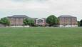 LODGING

Must I call to make a lodging reservation?
- Once you are accepted into a course, you will be assigned a room. Because of the random assignment, you may or may not be lodged in the same building as your classmates.
- A room on the NETC campus will be reserved for you. If you are a non-DHS Federal employee your Travel Authorization should state that “Housing will be provided to the traveler at NETC” (currently $20 to $30 per night), payable upon arrival to NETC. If Housing is not available at NETC a “Certificate of Non-Availability” will be issued by NETC. If you are a foreign student, private sector representative, or contractor to a State or local government entity, you are responsible for your own travel and per diem costs, and lodging (currently $20 to $30 per night), payable upon arrival to NETC. USFA accepts credit card payment (VISA, MasterCard, Discover, or American Express) for lodging. If you are a DHS employee (includes DAE/SAE’s), you must present a copy of your travel authorization at registration, and you should read the FEMA instructions, policies and comptroller grams dealing with travel to NETC. Your travel authorization should state that “Housing will be provided to the traveler at NETC at no cost”. If lodging on the NETC campus is not needed, you must notify the Housing Office in writing at NETC-Housing@dhs.gov. Failure to notify the Housing Office that lodging is not needed will result in you being charged for the room for the length of the course.
- If you are a Federal employee participating in a course at NETC, a dormitory room will be reserved for you. If you do not require lodging at NETC, you must notify the Housing Office in writing at NETC-Housing@dhs.gov. You must make this notification upon receipt of your acceptance letter. Failure to notify the Housing Office that lodging is not needed will result in your being charged for the room for the length of the course.
- We make every effort to ensure you have a single room. However, if the student count is high, you may be doubled with another student. Please do not call to request a single room.
- Disabilities/Special Accommodations: Students who mark “yes” in block 11 of the application form must submit in writing, from their physician or medical attendant on official stationery, what specific accommodation(s) is needed. This must be done no later than 2 weeks prior to your arrival. Security is responsible for providing emergency medical services. Any student, even those who marked “no” in block 11, who may have special needs in the event of an emergency, should consider notifying Security upon arrival to the campus.

Is there a charge for lodging?
• No, not if you are eligible for stipend reimbursement or if you are a DHS federal traveler (see “Reimbursement” section).
• If you DO have to pay for lodging, the current charge is $30/day.
- If you are a Federal employee participating in a course/training session at NETC and you did not notify the Housing Office that you did not need a dormitory room, you will be charged.
• NETC Housing accepts cash, personal check, travelers check, and credit card (American Express, VISA, MasterCard and Discover).

What if I want to stay off campus? If you choose to stay off campus, it will be at your own expense. You will still need to purchase a break ticket from the food service contractor for the length of your class.

What amenities are in each room?
- Private bathroom
- TV and clock radio
- Refrigerator
- Linens and towels, with daily housekeeping service.
- Telephone with voice mail
- A telephone jack is located in each room for dial-up Internet access. Check with your Internet Service Provider (ISP) for local calling area access. Out-of-area ISP accessibility will require credit card, third party or collect billing for access from NETC. You should consider bringing a longer cord (10 ft.) if you are bringing your laptop computer. Some courses require students to bring reports or projects to be shared with the class. It is convenient to bring that information in an electronic format. NETC can support CD-ROM, USB devices and 3-1/2” floppy storage. USB devices will be scanned before being allowed to connect to Government equipment.

Additional costs you could incur during your stay:
- Laundry and vending machines; dry cleaner costs
- Recreation Association pass ($1) allows use of all recreation facilities and Pub (see section on NETC Recreation Association)

Are there laundry facilities available?
- Yes, there are coin-operated washers and dryers in each lodging building (change available at the convenience store on campus).
- You may purchase laundry supplies at the convenience store on campus.

Are family, friends or pets allowed in the lodging rooms on campus?
- No, only NETC students are allowed in the room. Relatives or friends are not allowed in the rooms, and cannot be lodged on campus. Upon request, the NETC Housing Office will provide information regarding local off campus accommodations; however, you are responsible for arranging and paying for those accommodations.
- Animals are not allowed in campus housing, except for seeing-eye and other service dogs. Please notify the housing office at least 2 weeks in advance if you will be bringing a guide/service dog.

What time must I check out of my room? Check out time is 9:00 a.m. You may leave your luggage in your room until 9:30 a.m., but it must be packed and by the door. When you return for your luggage, please do not use the bathroom facilities if the room has already been cleaned for the next occupant. Please return your key card to the front desk by 9:30 a.m.--you will no longer have access to your room after that time.

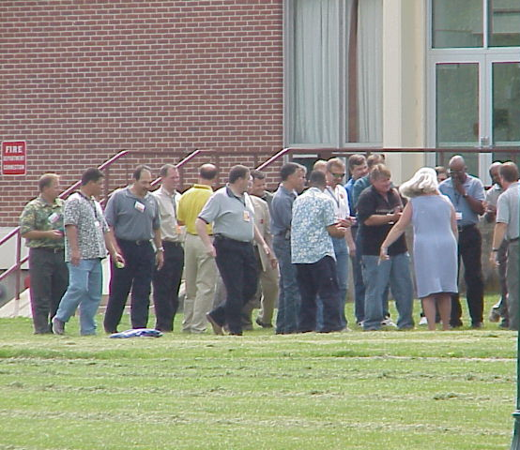 DRESS CODE 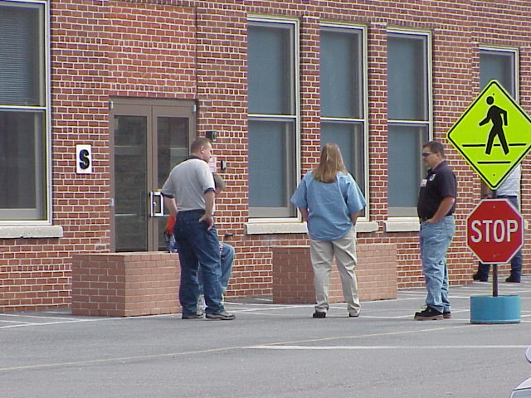

It is each student's responsibility to use good judgment in selecting attire which projects a professional image, and is appropriate for both local climate differences and classroom activities. We recommend you check the weather channel so you can plan your attire accordingly. If EMI staff determines that your attire is inappropriate, you will be required to change into more appropriate clothing before being allowed to continue class.

Exercise attire, ball caps, flip flops, etc. are NOT permitted in the dining hall, classrooms or auditorium. Bathing suits/trunks are not permitted outside of the pool area.

ADMISSIONS POLICIES
Attendance:
- You are required to attend all sessions of the course. If you do not, you will not receive a certificate and your stipend may be denied.
- EMI students are limited to three trips per fiscal year, and one offering of the same course (DHS employees and students who are employees of State, local and tribal offices of emergency services, or those enrolled in the Master Trainer Program or Master Exercise Practitioner Program are excluded from this policy).

Substitutions:
- Substitutions for EMI courses are made from waiting lists; slots do not belong to the organizations.
- All requests to consider an equally qualified person must be in writing and be accompanied by a completed General Admissions Application (FEMA Form 75-5) for the substitute. The application must be submitted for signature through the appropriate State or Regional Training Office.

Cancellations or No-Shows: EMI’s mission for delivery of courses is impaired significantly by cancellations and no-shows. It is very difficult and costly to recruit students at the last minute. Currently there is a 2-year ban on student attendance for students who are no-shows or cancel within 30 days of the course start date without a valid reason. If you receive such a restriction, your supervisor needs to send a letter to Admissions explaining the cancellation/no-show.

NETC POLICIES/INFORMATION

Conduct:
- Federal Regulations (available at the LRC).
- FEMA and NETC Instructions (available at C Lobby, dormitory rooms, and on NETC Intranet web site).

Smoking:
- All buildings on campus are NON-SMOKING, with the exception of the solarium portion of the Command Post Pub.
- If you smoke in your room, you will be asked to leave campus, relinquish your stipend reimbursement, and be charged to clean the room.

Medical services:
- All medical expenses are your responsibility.
- Local hospitals accept medical insurance identification, cash, check, or major credit card.
- If you do not have proof of insurance, expect that payment may be a prerequisite to possible treatment.
- International students should be prepared to pay for medical services in the event the hospital or doctor does not accept foreign insurance coverage.

Student Word Processing Center (located in D Basement):
- Provides IBM® compatible Microcomputers with Internet access and printing capabilities.
- Systems utilize Microsoft Windows XP with Microsoft’s Office Suite 2003.
- The center is open from 6:00 a.m. till 11:00 p.m. every day. There is a technician available Monday through Friday from 5:00 p.m. to 9:00 p.m., and on Saturday from 8:00 a.m. till noon.

Learning Resource Center: Located in Building N, the LRC provides current information and resources on fire and emergency management subjects. With its collection of more than 100,000 books, reports, periodicals, and audiovisual materials, the LRC facilitates and supports student and faculty research and supplements classroom lectures and course materials. While classes are in session, the Schedule of Hours for the LRC is as follows:
Monday-Thursday 8:30 a.m. – 9:00 p.m.
Friday 8:30 a.m. – 5:00 p.m.
Saturday 4:00 p.m. – 8:00 p.m.
Sunday 12:00 p.m.- 4:00 p.m.

Telephones:
- Outgoing calls can be placed from your lodging room via calling card, collect, or third-party billing.
- You are not allowed to accept collect calls on campus phones. Any and all expenses related to phone use shall remain your responsibility.

Faxes:
- Fax services are available at the convenience store for a fee.
- You may receive fax messages up to 4 pages in the Housing Office at (301) 447-1324.
- Anything over 4 pages will not be forwarded by Housing. Please use the fax service available at the convenience store, or have it sent by overnight mail.

Automatic Teller Machine: Located in D basement outside of O’Leary’s Emporium, and at various locations off campus. Inquire at the registration desk at Building C for additional directions.

Public Transportation: Limited service. Inquire at the registration desk at Building C.

Car Rentals: You may contact the campus convenience store at (301) 447-1493 to arrange car rentals at your expense.

NETC Recreation Association: On the NETC campus, the NETC Recreation Association operates a Pub providing beverage and limited food service each evening. The Pub is a private club under Maryland liquor laws and membership in the Recreation Association is required for service. The cost is $1.00 per campus stay and membership cards can be obtained from the Pub. Other items provided by the Recreation Association to its members and funded by the sale of membership cards and Pub items include:

- Athletic equipment such as softball equipment, volleyballs, basketballs, golf clubs, and fishing equipment
- Keg service for special occasions such as cookouts
- Propane and replacement parts for the gas grills
- Acquisition and maintenance of the Christmas lights at the entrance to the campus
- Karaoke entertainment
- Maintenance of special stage lighting in the Student Center
- Assistance with maintenance of the bicycles
- Bicycle helmets
- Maintenance of the billiard tables and equipment
- Large screen television in the Pub
- Games in the Student Center

NETC recreational activities include:
- Gym with running track
- Exercise room
- Swimming pool
- Tennis/basketball/volleyball (sand and inside) courts
- Bicycles are available in Building H for use by Recreation Association members

Nearby points of interest/recreational facilities (in season):
- National/State parks
- Historic Gettysburg (tours available)
- Golf
- Swimming
- Snow skiing
 STIPEND REIMBURSEMENT

Frequently asked questions/answers about reimbursement procedures are available at http://training.fema.gov/emiweb/welcomepkg.html
Please read them carefully. If you have any questions about your eligibility to receive a stipend please contact Admissions either by email at netc-admissions@dhs.gov or by phone at (301) 447-1035.

Any exceptions to travel must be requested in writing and faxed along with documentation to (301) 447-1658, AND approved in writing prior to making your travel arrangements. Otherwise, your stipend will be denied or limited to the state ceiling amount.

Who is eligible for stipend reimbursement?
- State, local or Tribal government representatives
- Recognized volunteer organization representatives
- Active emergency management organization representatives
- Representatives from State or local fire organizations
- If you do not apply for a stipend reimbursement within 60 days following the course start date your stipend reimbursement will be denied.

Who is NOT eligible for stipend reimbursement?
- Federal government (federal students are subject to federal travel regulations and travel under orders prepared by their office)
- Private industry employees
- Employees who are contracted to Federal, State or local government entities.
- Representatives of a foreign organization
- Students eligible for federally-funded grants

How will I be reimbursed?
- Reimbursement will be electronically deposited into the checking or savings account that you identify.
- Reimbursement will only be made to an account that bears your name. You are responsible for reimbursing your department, if applicable. This is a result of increased restrictions by the receiving financial institutions.
- If you do not have a personal account, please contact the Admissions office prior to your arrival for further instructions.

If I fail the course, will I be reimbursed?
- If eligible for a stipend, you will be reimbursed for the course you failed.
- If you reapply to either EMI or NFA and are accepted, no stipend will be paid for that course, and you will be required to pay for lodging. Once you successfully complete a course, you will once again be eligible to receive a stipend for future courses.

If I fly, what will I be reimbursed? You will be reimbursed the cost of a direct (no side-trips or extended stays), 21-day prior to the course travel date pre-purchase, non-refundable ticket for round/trip transportation by common carrier (economy coach class or less) for each course or back-to-back courses that you attend. Proof of non-refundable fare is required!
- If you take side trips or travel outside of the defined travel days, your reimbursement will be limited to no more than the state ceiling amount as noted on the enclosed Reimbursement Ceiling Chart.
- To eliminate the perception of misuse of government funds, FIRST CLASS, BUSINESS CLASS and REFUNDABLE AIRLINE TICKETS WILL NOT BE REIMBURSED AT FULL FARE, unless you request, in writing, an exception PRIOR to making your travel arrangements, and have received a written approval. Otherwise, your reimbursement will be limited up to the state ceiling amount.
- It is your responsibility to find the cheapest ticket available. Failure to do so may result in your reimbursement being limited, to the state ceiling amount.
- Use of frequent flier miles toward the purchase of a ticket is NOT reimbursable.
- Flight or ticket insurance is not reimbursable.
- If any portion of your airfare is subsidized by another source, that portion is NOT reimbursable under the Stipend program.

If I drive, what will I be reimbursed? You will be reimbursed the current Privately Owned Vehicle (POV) Federal mileage allowance, or the state ceiling, WHICHEVER IS LESS.
- POV mileage is subject to validation.
- If you do not register your vehicle with the Housing Office, reimbursement for POV mileage will be denied.
- If someone drops you off, you must have the vehicle verified by the Housing office prior to the vehicle departing campus, or your stipend will be denied.
- If you carpool with another student, only the driver will be reimbursed.
- If you drove a rental car instead of your POV, your reimbursement will be limited to the POV allowance.

If I take a train or bus, what will I be reimbursed?
- Your reimbursement is limited to the cost of the ticket, not to exceed the state ceiling amount.
- You must provide copies of the tickets actually used.
- Reimbursement shall not include costs for sleep accommodations or for transport of vehicles on the train.

If I save money on my airfare, will I be reimbursed for extra expenses? Yes, but ONLY if your class is 5 days or less in length with no Saturday stay over, and you save a minimum of $250 off the cost of a 21-day prior to the course travel date pre-purchase non-refundable round trip economy class common carrier ticket. To do this, submit written documentation of the savings -- this can consist of itinerary copies of both the original price and the cheaper fare, OR copies of both fares from the Internet. Comparisons should be of like travel. If you do not acquire written approval from Admissions prior to making your travel arrangements, the extra expenses will not be reimbursed. The following options apply if your request is approved:

a.) You may stay on campus 1 night prior to your regularly scheduled arrival date if lodging is available and you have received written approval to do so.

- Please contact the NETC Transportation Department to see if there will be shuttle service available on your travel date. If you carpool from the airport using a rental car, the rental agency must list (as drivers) all students claiming reimbursement on the rental agreement or only the driver will be reimbursed. Original receipts must be provided.

b.) You may stay in the Baltimore/DC metro areas before or after your course.
- If you save at least $250.00 in airfare as noted in the terms above, you may be reimbursed up to $90/day (2-day limit for savings over $500) for lodging or transportation expenses. Original receipts must be provided. If you carpool from the airport using a rental car, all students claiming reimbursement must be listed (as drivers), by the rental agency, on the rental agreement or only the driver will be reimbursed.
- If you stay after your course ends, ask for a Stipend Agreement Amendment (FEMA Form 75-3a) when you register. When you return home, mail it with original hotel or transportation receipts to Admissions, Room I-216, 16825 South Seton Avenue, Emmitsburg, MD 21727 within 60 days of the start date of the course, or reimbursement WILL BE DENIED.

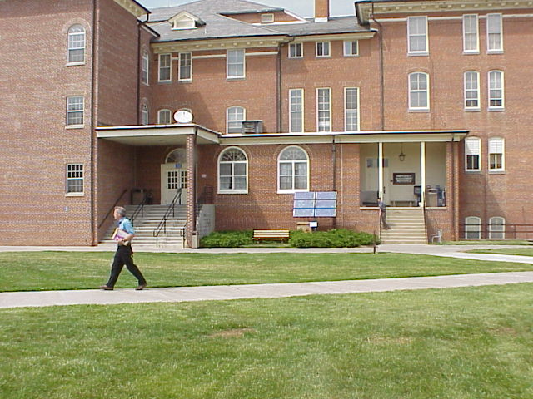 FOOD SERVICE 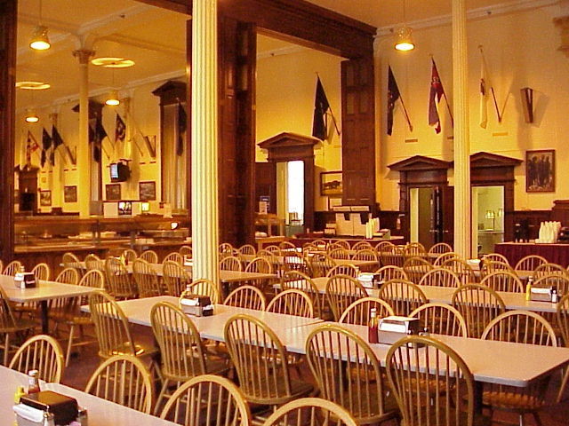

Must I purchase a meal ticket?
- If you stay on campus, you must purchase a meal ticket. If you do not, you will be asked to vacate your room on campus. You will then be responsible for your off-campus lodging costs, and we will deny your request for stipend reimbursement.
- If you stay off campus, you must purchase a break ticket, currently $3 per day.

What is the cost of my meal ticket?
- Your meal ticket cost is identified in your acceptance letter.
- Meals other than those included in your meal ticket are to be paid for by cash.

What if I’m here for back-to-back courses?
- Your meal ticket includes the time between the two courses.
- If you stay off campus between the two courses (vacating your room), you must notify the food service contractor before purchasing your meal ticket for the first course. If you do not, you will be charged the full amount. (Refer to information under “Registration”)

How do I pay for my meals?
- Cash
- Traveler's checks
- State or Local government checks payable to the food service contractor
- Advanced payment by department check. Please notify your department to include: your name, course code and course date on the check, and send it to the food service contractor at Building K, 16825 South Seton Avenue, Emmitsburg, MD 21727. Please call the food service if you need their Federal Tax ID#.
- Purchase order payable to the food service contractor.
- Credit card (MasterCard or VISA) (Minimum charge of $6)
- The food service contractor DOES NOT accept personal checks.

What if I will not be on campus for the first and last meal identified as part of my meal ticket? You must notify the food service contractor at least 1 week prior to your course start date. If you do not, you will be obligated to pay the full amount.

May I get a refund on my meal ticket? There are no refunds except for emergency departures!

What if I’m on a special diet? Please call the food service contractor at (301) 447-1551 or fax your request to (301) 447-6944 at least 2 weeks prior to arriving at NETC. They will make arrangements to meet your needs. If you don’t make arrangements prior to your arrival, you will be responsible for purchasing the normal meal ticket.

What happens if the bus arrives after the dining hall has closed?
- The food service contractor will provide you with a boxed dinner.
- Snack food is available at the Command Post Pub.

CONTACT INFORMATION

How do I get a telephone call? The caller may dial your direct extension (301) 447-xxxx. If requested, you will be provided with your extension at check-in. Numbers are NOT given to anyone else.
- For non-emergency situations, the caller may dial (301) 447-1048. The Student Coordinator will either transfer the call to your room or take a message and place it on the message board located in ‘C’ Lobby, which you should check daily.
- NETC will not accept personal telephone calls to students from the (800) number. Family members should dial (301) 447-1000 to contact a student.
- You may NOT accept collect calls. To do so may restrict you from attending future EMI or NFA courses.

What if the call is an emergency?
- The caller should state that the call is an emergency.
- The message will be delivered to you immediately unless you are not on campus.
- If you are leaving campus for a period of time, you should notify security where you can be reached.
- If you must return home due to an emergency, check out with the Housing Office in Building C before you depart the campus!

How do I get mail?
- Mail is delivered to C Lobby Monday through Friday, except Federal holidays.
- All packages are x-rayed and no delivery is provided on weekends or holidays.
- Letters or packages should not be mailed to reach NETC before you arrive, since mail-holding areas are not available. Mail received when you are not on campus will be automatically returned to the sender.
- Outgoing mail should be deposited in the mailbox located near Building K (Dining Hall). The NETC Mailroom cannot mail outgoing items for students.
- Address:

(Your name)--Student
National Emergency Training Center
Building C, Room (Room numbers are provided upon arrival)
16825 South Seton Avenue
Emmitsburg, MD 21727-8998

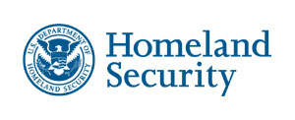

National Emergency Training Center
16825 South Seton Avenue
Emmitsburg, Maryland 21727

