USDA Foreign Agricultural Service
GAIN Report

Template Version 2.09

Global Agriculture Information Network

Voluntary Report - Public distribution
Date: 3/3/2009
GAIN Report Number: CH9404
CH9404
China, Peoples Republic of
Market Development Reports
Beijing Market Update
2009

Approved by:
Eric Trachtenberg
ATO Beijing
Prepared by:
Wang Tong & ATO Staff

Report Highlights:
Beijing is not only the political and cultural center of China, but also the economic hub of Northern and Western China. As one of China’s largest and wealthiest cities and home to the central government and many national organizations, Beijing is an important market for U.S. exporters. Despite a slowdown in local growth caused by the world economic crisis, the Beijing offers significant opportunities for U.S. exporters. This report updates conditions in the Beijing market since the end of the Olympic Games, held in August, 2008.

Includes PSD Changes: No
Includes Trade Matrix: No
Trade Report
Beijing ATO [CH4]
[CH]
Table of Contents
I. Introduction 3
II. Beijing City 3
III. Tianjin Port 4
IV. The Local Economy 4
V. The Customer 5
VI. The Food Market 6
VI. Cold Chain Logistics & Food Safety 6
VII. Retail Sector 7
VIII. Food Service Sector 9
IX. Hotel Sector 10
X. Institutional Food Service Sector 11
XI. A National Hub 11
XII: Post Contacts & Other Resources 12

I. Introduction
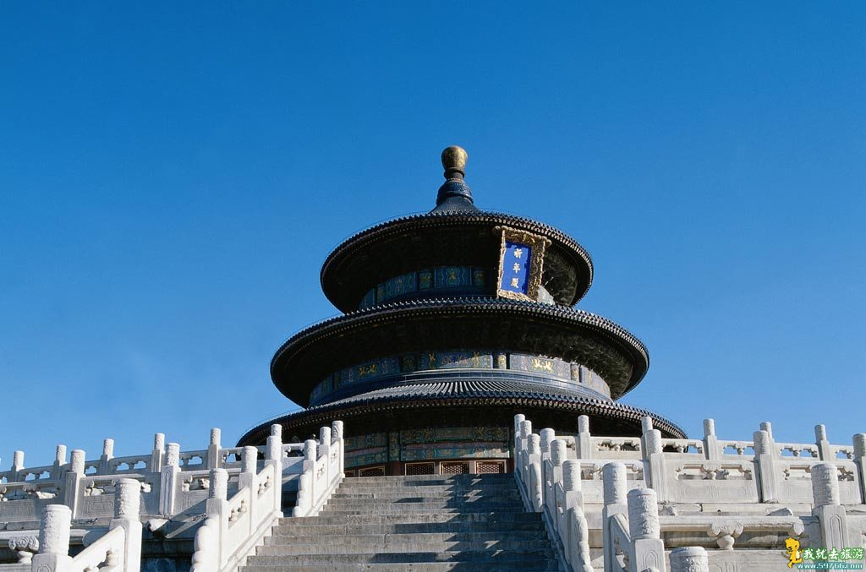
Beijing is the political and cultural center of modern China. With a history of more than 3,000 years, the city has served as the Middle Kingdom’s capital for more than 800 years over four dynasties. Today, the city is home to more than 9,000 diplomatic missions, multinational corporations and organizations – as well as numerous Chinese public and private entities. Beijing hosts hundreds of international meetings annually and is leading creative center of the knowledge economy. The city is home to countless historic landmarks, including several on UNESCO’s World Heritage List including the Temple of Heaven, the Forbidden City, Summer Palace, the Ming Tombs, and the Great Wall. With its large and wealthy population and significant influence over the rest of China, Beijing is one of China’s most important markets.

II. Beijing City

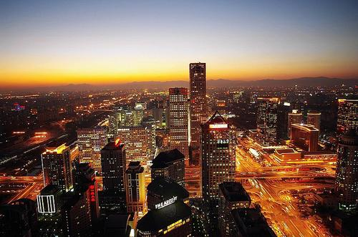
Beijing has been the on-and-off capital of China since 1153. It first became a capital during the Jin Dynasty and then later during the Yuan (1279-1368), Ming (1368-1644) and Qing Dynasties (1644-1911). The city was first put on the world map during the 13th Century when Marco Polo discovered the city’s splendor and riches.

As a result of 800 years’ construction and expansion, today’s Beijing has become one world’s most influential and important urban regions. Reflecting this and its status of a national capital, Beijing is a Special Municipality directly under the control of China’s central government. Consequently, Beijing enjoys the same status as a province and its mayor has cabinet-level rank.

The city covers an area of about 18,000 square kilometers currently divided into 18 districts: Dongcheng, Xicheng, Chongwen, Xuanwu, Chaoyang, Fengtai, Shijinshan, Haidian, Mentougou, Fangshan, Tongzhou, Shunyi, Changping, Daxing, Huairou, Pinggu, Miyun and Yanqing. Many major trading, banking and commercial businesses are located within the Central Business District (CBD) in Chaoyang District. Beijing has Tian’anmen Square at its center while the city’s main thoroughfare, Chang’an Boulevard, runs 38 kilometers East to West. The city has changed beyond recognition over the last few decades as old residential hutongs (alley-way houses) were replaced by skyscrapers and new apartment buildings. For most of its history, Beijing fit inside the old city walls until these were replaced by the Second Ring Road. After the mid-1980s, the city expanded dramatically. The Third Ring Road was completed in 1994, the Fourth Ring Road was finished in 2001, and the Fifth Ring Road was done in 2003. A Sixth Ring Road is under construction. The Olympics increased building to a fever pitch in the years up to 2008 -- before slowing abruptly after the Games. The economic slowdown has slowed development since then.

Beijing’s population reached 16.95 million in 2008, including a large pool of migrant workers that accounted of 25 percent of the total. According to a recent report by the Beijing Population Institute, the city’s population is likely to soar to more than 20 million by 2020, largely due to the continued influx of migrants from other parts of the country. Although the current economic slowdown caused a partial reversal of migration because of fewer job opportunities in Beijing, the inflow will likely resume as local growth rate recovers.

III. Tianjin Port

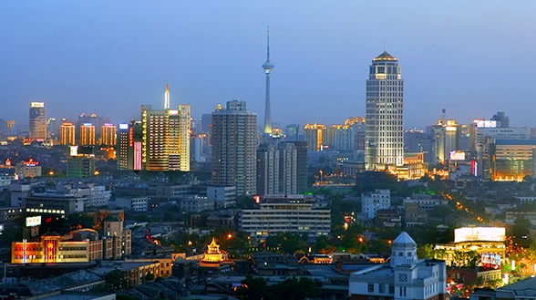
Located 1.5 hours by car due southwest of Beijing is Tianjin, North China’s largest costal city. Located on the Bohai Sea, Tianjin serves as the major industrial base and harbor to Beijing and nearby Hebei Province. The Port of Tianjin is the largest port in Northern China. In 2007, the throughput of the Port of Tianjin reached 309.46 million tons, the fourth largest total in China. In terms of containers, Tianjin ranked the sixth in China in 2007 with a total volume of 7.1 million TEU. In 2006, the total value of imports and export for the Tianjin Port reached $129 billion, an increase of 27 percent compared with the previous year.

Tianjin is also a Special Municipality like Beijing and there are a number of plans in place to integrate the two urban areas over the next decade. For example, a high speed train service between Beijing and Tianjin began service on August 1, 2008. Running at 350 kph, it has cut travel time between the two cities to 30 minutes.

IV. The Local Economy

Beijing serves as both the nation’s capital and as the economic center of Northern and Western China. In addition, the Beijing Olympics and Paralympics fueled Beijing’s growth in 2008 until the slowdown began to affect the economy. For example, investment in infrastructure related to the Beijing Olympics boosted Beijing GDP by 1.3 percent annually over the past five years.

Per capita GDP exceeded $8,000 and GDP surpassed $153 billion in 2008, making Beijing one of the wealthiest cities in China. These figures represent significant increases over previous years, although the economic crisis and falling national GDP growth will likely dent economic expansion in the near future. Although China’s official GDP growth estimate is 9.0 percent, the IMF puts it at 6.7 percent while the World Bank has it at 7.5 percent. Although the 4 trillion RMB ($585.7 billion) stimulus package will help Beijing, it is unlikely that the city will reach the 9 percent level official forecast growth rate. Given the slump in trade, construction and tourism, Beijing’s actual 2009 growth will likely be in the low single digits. However, Beijing’s mayor has declared that the city will maintain its rapid economic development and will build a “culturally-enriched, technology-empowered, and environmentally friendly city.”

The capital’s external trade continued to grow at more than 28 percent in 2008 with import and export values reaching $214.39 and $271.85 billion. In addition, the service sector accounted for 73.2 percent of Beijing’s GDP in 2008. The Games benefited Beijing’s economy by leaving a legacy of improved facilities, infrastructure, services, and an improved international profile. These changes will help support the service sector even during challenging economic times.

V. The Customer

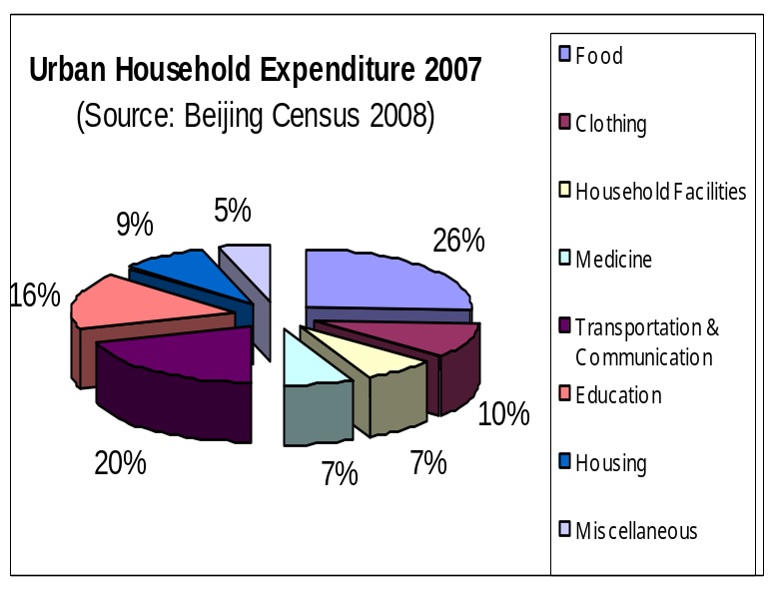
Beijing is one of the wealthiest cities in China, and per capita GDP continues to increase rapidly. At the end of 2008, Beijing’s population was 16.95 million, up 620,000 from a year earlier. Per capita disposable urban income continued to grow along with rising per capita GDP, which reached $3,609 in 2008. By the end of 2007, Beijing had over 3.5 million private cars on the road or 0.55 cars per household. In addition, about 1,466 new vehicles take to the roads everyday. However, large gaps in income, education, and access to credit continue to widen the income gap between the rich and poor. The difference between locals and migrants is especially significant.

The nation’s capital is also home to more than 400 research institutes and 162 institutions of higher education, including the most prestigious universities in China such as Beijing, Qinghua, and People’s Universities. There are more than 300,000 local scientists and engineers, and 70,000 international residents. By the end of 2007, more than 26 percent of Beijing’s residents had a higher education pushing up the number of middle class families. Primary consumers for U.S. food products are a large and growing population of well-educated, urban and affluent middle class residents. Compared to the United States where key consumers tend to be aged 40 to 55, the target demographic in Beijing is between 19 and 35. These increasingly well informed and educated consumers seek high-quality, safe, diverse, and fashionable products. Tourists from overseas are also an important market segment with nearly 4.5 million international visitors coming to the city – in addition to the millions of Chinese who visit Beijing for vacation and business each year.

VI. The Food Market
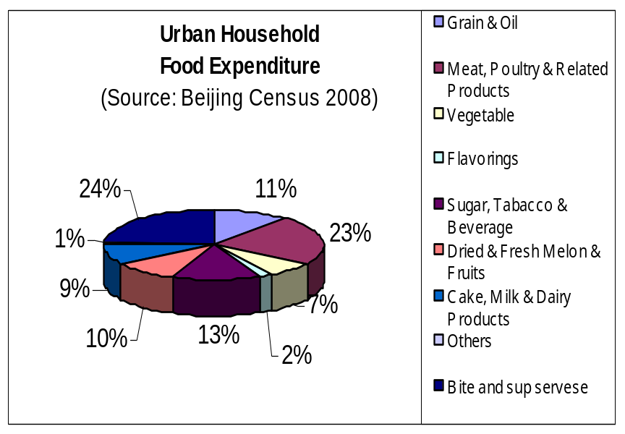
With recent surges in housing, automobile ownership, and travel expenditures, Beijingers are clearly interested in the quality of life. Beijing consumers, like most urban Chinese, are consuming more meat, dairy, fruit and fewer traditional cereals and grains than ever before. Natural and organic products have become a standard fixture in the market as affluent consumers seek a better quality of life and improved health. Retail food, beverage and tobacco sales reached $5.1 billion in 2008, a 21.4 percent increase from 2007.

VI. Cold Chain Logistics & Food Safety

As Beijing has developed, more people have become concerned about food safety. A food safety survey by China Chain Stores & Franchise Association (CCSFA) in 2007 of Chinese chain stores in five big cities including Beijing showed that in 2006 more than 96 percent of consumers were very concerned about food safety compared with 73 percent in 2005. About 75 percent of the interviewed consumers were willing to pay an extra amount of money for the purpose of food safety. The survey also showed that consumers chose supermarkets and hypermarkets to purchase 70 percent of all their chilled food and 92 percent of all their frozen food because of the better cold chain logistics of supermarkets and hypermarkets. This interest in safety has also given restaurants an incentive to secure the cold chain for their supplies. Fast food chains such as McDonalds and Kentucky Fried Chicken have been leaders in this process.

During the 2008 Beijing Olympic Games, China provided catering services for more than 360,000 athletes, support personnel and media with no significant problems. In order to guarantee food safety for 2008 Beijing Olympics, Beijing municipal government activated the Olympic Food Safety Source-tracing System and set-up new food inspection systems that can monitor all links in food production, transportation and manufacturing. A standardized system of cold chain logistics was adopted to guarantee the food quality. The Olympic experience greatly improved the Beijing food safety system through the upgrading of agricultural and food markets as well the food cold chain logistics infrastructure. These will positively impact further development of the food safety system and cold chain logistics in Beijing in the future.

VII. Retail Sector

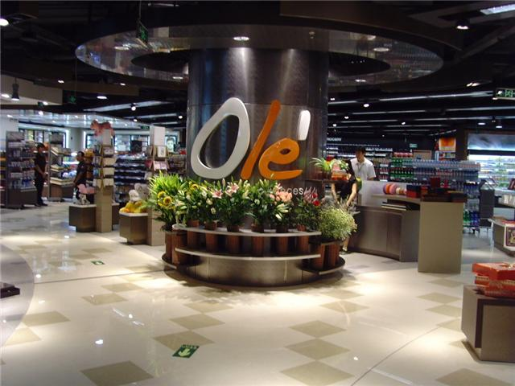
Beijing customers are changing where they shop for food. Demand has shifted from “wet” markets or open air market to supermarkets and convenience stores. Beginning with the opening of the first Carrefour in Beijing (first in China) in 1995, a large number of international retailers have set up operations in Beijing alongside local operators. In 2008, retail sales of consumer goods totaled $65.7 billion, a 20 percent increase over 2007.

Competition is extremely intense in Beijing as more stores with higher standards are built and local consumers demand diverse and higher quality food at competitive prices. International hypermarket operators include Carrefour, the largest with twelve hypermarket outlets, followed by Wal-Mart with four stores and Sam’s Club, Metro and Tesco -- with two hypermarkets each. In order to lure more customers, most hypermarkets provide free parking facilities and shuttle bus service as well as adjacent shopping and entertainment complexes. Special aisles dedicated to imported food products are often arranged by country of origin. A large variety of imported foods such as cheese, butter, and other dairy products, cereal, cookies, coffee, candy, beverages, wine and snack food are represented in such supermarkets, with products from the United States, Spain, Germany, Switzerland, France, Canada, Italy, Australia, and Korea among them. To compete under slowing economic conditions retailers such as Carrefour and Wal-Mart have lowered prices on selected products by as much as 20-30 percent in Beijing stores during the New Year and Spring Festival holiday to encourage sales. These sales have even continued after the end of the holidays.
Major Retailers in Beijing 2008
Retailers | Business Line | Store (No.)
Carrefour | Hypermarket | 12
Wal-Mart | Hypermarket | 4
Sam Club | Hypermarket | 1
Metro | Hypermarket | 2
Tesco | Hypermarket | 2
Jusco | Hypermarket | 1
Ole | Supermarket | 10
City Shop | Supermarket | 1
Jenny Lou | Supermarket/Convenience | 12
7-Eleven | Convenience | 69

Supermarkets operated by local companies include CRV, Wu Mart, Hua Pu, Jenny Lou’s, etc., with CRV the largest (ten upscale Ole Supermarkets) targeting upper-income and middle-class consumers and expatriates. More than 50 percent of the products in Ole are imported. Also, City Shop, a Shanghai based retailer, opened its first store in Beijing near the U.S. Embassy in 2008 targeting expatriate and upper income locals – especially those who have lived or studied overseas. Over 85 percent of their products are from the United States, Australia, Europe, and Korea.

Convenience stores continued to expand in Beijing in 2008 with 7-Eleven leading the pack with 69 stores at the end of 2008. Most stores are located near upscale communities and business centers targeting white-collar workers, upper-middle class, and younger consumers who increasingly demand convenience and ready-to-eat items.

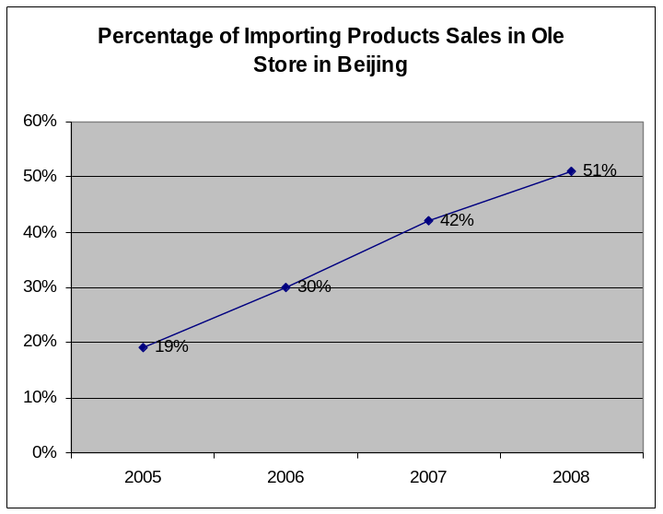
Jenny Lou’s, a major upscale food retailer in Beijing, operates twelve specialty stores in Beijing, targeting expatriates, upper to middle income Chinese consumers and others who have lived or studied overseas. Mostly located in high-income/upscale communities or near diplomatic compounds-missions more than 98 percent of their products are imported -- with more than half from the United States. In particular, breakfast cereals, seasonings, dairy products and wine are of the greatest interest. Jenny Lou reports the economic downtown has had little impact on sales which are down by a modest 5-10 percent. However, customers are trading down to less expensive brands and giving up luxury products. High priced foods have been hit the hardest as lower priced substitutes gain market share. For example, wine priced below RMB100 ($14.62) is popular but products priced above RMB100 ($14.62) have lost sales. Beyond this, sales patterns are stable since most people are reluctant to change dietary preferences and habits, even during lean times.

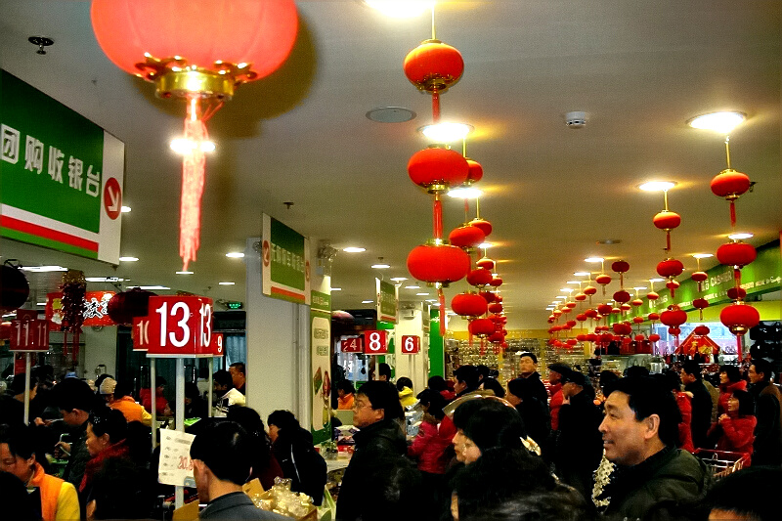
For expensive products, the effects of the slowdown have been real as customers tighten budgets. A major packaged food product importer and distributor based in Beijing reported his food imports from the U.S. plummeted from a minimum of three to one 40 foot containers each month this past December -- which is usually the strongest sales month. For example, the General Manager of Ole Supermarkets reported that sales dropped 10 percent in December, compared to 2007. Other stores were not so lucky. According to local media reports, high-end supermarket "C-Mart" located in one of Beijing's upscale shopping malls literally disappeared overnight this past December, leaving behind RMB 566,000 ($82,748) of unpaid bills to suppliers.

Despite the general slowdown, holiday sales remained strong over the Chinese New Year with staple products expected to increase by 15-16 percent. Several major shopping malls reported sales revenues up by as much 33-65 percent, even under the current economic environment. Given the importance of gift giving to relationship building, the gift and holiday markets are likely to be very resilient to economic downturns.

VIII. Food Service Sector
Beijing is home to some of China’s most sophisticated food culture. During the Ming Dynasty, the capital was moved to Beijing with a diverse variety of foods from all over China finding their way to Beijing. In addition to the delicate and subtle flavors of Imperial cuisine, world-famous Peking duck, lamb hot pot are said to all have originated in here. Now an international crossroads, Beijing diners savor the food and flavors of China’s regional cuisine as well as an expanding range of international options. Restaurants like trendy Element Fresh Restaurant, using modern American cuisine with Asian twists, to Legation Quarter, where five top notch Chinese, French, New York, Spanish and Japanese cuisines are offered, the palates of Beijingers continue to expand along with their pocketbooks.

2007 Beijing HRI Sector Reviews by Sub-Sector:
Sub-Sector | Registered Companies | Business Revenue ($Million)
Star Rated Hotels | 638 | 3,485
Restaurant* | 1,475 | 2,684
Snack Counter* | 115 | 730
Chain Catering Services | 73 | 1,350
Total | 2,301 | 8,249
* Yearly Revenue over $294,118 (2 Million RMB)

Beijing’s place as a center for top universities, central government agencies, international diplomatic missions and the global business community puts the city on the leading edge of global dining trends. Initially inspired by returned overseas Chinese and expatriates, affluent local Beijingers are now part of the driving force behind the trend for diversity in dining options. Interviews with food service managers reveal that today’s Beijing diners are becoming more health conscious when it comes to choose dining outlets and menu items, particularly those with high disposable incomes. This is different compared to just a few years before because now people are willing to try almost anything. According to the Beijing Western Food Association, the number of restaurants serving international cuisine is expected to more than double between 2004 and 2008, from over 1,000 to more than 3,000 restaurants. Price increasingly takes a backseat to perceptions of lifestyle; customers expect that the food will be excellent and have turned their attention to service, ambiance, and, creative restaurant themes. Modern Western restaurants often offer a wine bar, or wine club to create a platform for those gourmet customers. Wine tastings and dinners are a common occurrence and continue to attract the attention of the city’s affluent.

Beijing’s enormous size means that, like most metropolitan areas, location plays a large role in restaurants’ client base and success. The Central Business District (CBD), stretching across central and eastern Beijing, is home to many of Beijing’s best restaurants. Many fashionable new dining destinations serving a wide range of international cuisine are located in or near the CBD, including The Place, Shing Kong Place, Block 8 and Solana. Convenience for young and wealthy Chinese professionals and proximity to businesses and embassies likely to expense lunch or dinner make the CDB prime real estate for many high-end dining establishments.

Sichuan food is one of the most popular cuisines in Beijing, along with Hunan, Cantonese, Shanghainese and Dongbei styles. Many locals will tell you it is hard to find real Beijing food, and those places claim serving authentic Beijing specialties, such as Quanjude for Beijing Roast Duck, are mainly for tourists.

Beijing’s nightlife continues to be dominated by increasingly sophisticated bars and clubs in the Sanlitun, Workers Stadium, and Houhai areas, catering to wealthy affluent young professionals. Many of these nightlife neighborhoods are filled with high-end dining options, many have international cuisine or snacks on the menu with imported food stuff and beverages.

IX. Hotel Sector

Beijing continues to set new records for total rooms each year, and has the highest growth rate of new hotel buildings in Asia. The 2008 Beijing Olympic Games represented a unique opportunity for international lodging companies to establish their brands in Beijing, and throughout China. Shangri-La, Marriott, Hyatt, InterContinental, Accor, Starwood and Hilton are global market leaders in China, and continue to expand their presence in Beijing. The Hong Kong-based Shangri-La Hotel Group is a major player in Beijing with six hotels in town including four five-star hotels and two four-star hotels, of which two opened in 2008/2009. Another market leader Marriott Hotel group currently owns or operates 37 hotels/residential apartments in China, with ten located in Beijing. The Inter-Continental Hotel Group currently has 18 hotels in Beijing alone includes InterContinental, Crowne Plaza, Holiday Inn, and Holiday Inn Express.

ATO interviews with chefs, food & beverage (F & B) managers at a number of star-rated hotels in Beijing and other north China cities confirm that imported food products make up a very substantial portion of hotel food budgets. Some leading five-star hotels in Beijing stated that imported food, beverage and wine products account for more than 50 percent of overall food-purchasing budgets and estimated that comparable full-service hotels have similar purchasing patterns. Food ingredients and meat products make up the bulk of the imported food purchased by these hotels. The newly opened JW Marriott Hotel adjacent to the new Ritz Carlton Hotel, for example, has five different food and beverage outlets featuring American, Italian, French, International and Chinese cuisine as well as lounges and bars. In general, the Western style food service operations such as steakhouses, for example, purchase a larger proportion of food imports than Chinese outlets. In addition, banquet and conference food service use a large proportion of imports in upscale hotels.
Beijing’s star-rated hotels do not normally target price-sensitive consumers, but instead focus on business travelers, banquets and company events. In general, chefs and food & beverage directors believe that delicious, high quality food is their highest priority – and price is less important to their customers. Hotel food service operators also concentrate on creating trendy and attractive menus, incorporating high-quality food products emphasizing nutrition and health benefits. According to some chefs, “imported food, including American and European imports offer good food safety and quality control assurances prior to export, so we are very happy to purchase these products. We would also like to learn more about new American food service trends through media, promotion, and chef training to help us stay on the forefront of providing premium food service.”
Beijing’s high-end hotels are ideal venues for introducing new-to-market food and cuisine. Restaurants in international-branded hotels associated with stylish ambience, convenient location, highly trained chefs and wait staff tend to be open to using top-quality ingredients. Hotel dining has expanded beyond resident guests, with well above 50 percent of diners coming from outside the hotel.

X. Institutional Food Service Sector

Cost-conscious young professionals seeking convenient dining options, largely drive Beijing’s institutional food service at this point. As property values rise across Beijing’s Central Business District (CBD), 30-story office buildings have replaced many local mom-and-pop eateries. Professionals who don’t want to pack a lunch are left scrounging for options. Most office buildings over ten stories have outsourced cafeterias managed by Chinese companies located in the basement, but quality food products are not readily available - even at the best international office complexes. Cafeteria lunches range from around 10-20 RMB (US $1.3-2.6), and generally include a number of Chinese-style main and side dishes, rice, bread and soup. While bulk imported food products such as flour and oils may find a market here in coming years, the price point of cafeteria food service in Beijing, and in the rest of China, still does not accommodate the incorporation of high value imported food and beverage products.

Domestic catering services such as old-time Lihua Fast Food is one of the largest food delivery companies in China, and is still widely accepted and popular in Beijing. It delivers single lunchboxes to offices or home for a fee ranging from RMB10-30. Like many catering services, Lihua has no storefronts and orders are placed by phone. Lunchboxes are delivered by teams armed with maps on bicycles. Orders are guaranteed to arrive within 30-45 minutes after the order is placed, or your money is refunded. Newly emerged on-line catering services ‘Goodies’ and ‘Isender’ have developed amazingly successful business module to deliver food from several of the major restaurants around town to anywhere in the city. Customers place orders by phone, which are relayed to food production centers via Internet. For an increasingly overworked workforce, it is certainly a convenient, relatively inexpensive, and time-saving meal solution.

As catering services continue to develop in Beijing, current domestic players are not fully successful in satisfying the increasingly high nutritional, hygiene, price, and efficiency expectations of consumers, there is still room in this market segment and more market players are emerging to compete, forcing domestic old-style catering service to change or to be out of the game.

The rise of office and home delivery services has brought more players into the institutional and catering market in Beijing. Global brands such as Aramark, which was an official caterer for the Beijing Olympics, is taking the lead in high-end institutional food service. On the other hand, most of Beijing’s full-service restaurants and major fast food outlets also provide delivery services as well. International brands such as Pizza Hut, Papa Johns, and Domino’s continue to introduce higher-profile delivery to homes and offices. At the same time, many local restaurants such as the Italian-American Annie’s chain have also introduced home delivery.

XI. A National Hub

As the national capital, Beijing plays a central role in Chinese life. Not only is it the home of important government agencies but it is home to many industrial, technical, scientific and academic bodies. Beijing hosts the headquarters of numerous associations related from everything from cold chain to cuisine and tourism.

Beijing is also unarguably China’s media centre. As required by government policy, Beijing hosts all the influential national media including China Central Television, China Central Radio, and People’s Daily – with few exceptions. Since these media all cover the whole country, they are very influential. Beijing is also home to 256 newspapers and 2,810 magazines in 2008, the largest number in China. Beijing also hosts all major gateway websites and boasts the biggest number of internet websites (over 120,000 by 2006) in China. Finally, as required by the government, all foreign related publications are headquartered in the capital. These factors give the Beijing-based media an unusually long reach in China on every topic from hard news to the lifestyle issues.

XII: Post Contacts & Other Resources
For further information about the China market, as well as updates on our upcoming events and activities, please visit our website at www.usdachina.org or contact the Agricultural Trade Office in Beijing:

Agricultural Trade Office, Beijing
No. 55, An Jia Lou Lu
Chaoyang District, Beijing, China 100600
Phone: (8610) 8531-3950
Fax: (8610) 8531-3050
E-Mail: atobeijing@fas.usda.gov

