Before the
Federal Communications Commission
Washington, D.C. 20554

In the matter of  Revision of Parts 2 and 15 of the Commission’s Rules to Permit Unlicensed National Information Infrastructure (U-NII) devices in the 5 GHz band | )  )  )  )  ) | ET Docket No. 03-122

MEMORANDUM OPINION AND ORDER

Adopted: June 29, 2006 Released: June 30, 2006

By the Commission: Commissioners Copps, Adelstein and McDowell issuing separate statements.

Introduction
- By this Memorandum Opinion and Order (MO&O), we respond to requests for clarification or reconsideration of our rules for unlicensed National Information Infrastructure (U-NII) devices in the 5.25-5.35 GHz and 5.47-5.725 GHz bands, including Radio Local Area Networks (RLANs), which were adopted in the Report and Order in this proceeding. Specifically, we are granting a request by the Wi-Fi Alliance to clarify the Transmit Power Control (TPC) requirements in section 15.407(h)(1), dismissing a request by the Wi-Fi Alliance to clarify the channel availability check time requirement in section 15.407(h)(2)(ii), denying a request by Globespan Virata (Globespan) to revise the rules to state that U-NII devices are not required to detect and avoid frequency hopping radar signals, and dismissing a request by Extreme Networks Inc. (Extreme Networks) to modify the definition of a U-NII central controller that must include Dynamic Frequency Selection (DFS) capability. We also issue a revised measurement procedure for certifying U-NII devices for compliance with the DFS requirements in these bands. Our action here will ensure that all applications for equipment certification of U-NII devices filed on or after July 20, 2006 will comply with all U-NII requirements for these bands.

BACKGROUND
- U-NII devices are unlicensed intentional radiators that operate in the frequency bands 5.15-5.35 GHz and 5.47-5.825 GHz and use wideband digital modulation techniques to provide a wide array of high data rate mobile and fixed communications for individuals, businesses, and institutions. In the Report and Order, the Commission amended Part 15 of the rules to make 255 megahertz of spectrum available in the 5.47-5.725 GHz band for U-NII devices. This action aligned the frequency bands used by U-NII devices in the United States with the frequency bands used by U-NII devices in other parts of the world, thus decreasing development and manufacturing costs by allowing for the same products to be used in most parts of the world.
- Operation in the newly available U-NII spectrum is conditioned upon compliance with certain technical requirements. Specifically, the new rules require that U-NII devices operating in the 5.25-5.35 GHz and 5.47-5.725 GHz bands employ DFS in order to avoid causing interference to Federal Government radar systems. DFS is a feature that monitors the spectrum and selects for operation a frequency that is not already in use. Prior to the start of any transmission, a U-NII device equipped with DFS capability must continually monitor the radio environment for a radar’s presence. If the U-NII device determines that a radar is present, it must either select another channel or enter a “sleep mode” if no channels are available.
- Additionally, the new rules require U-NII devices to employ a TPC mechanism when operating in the 5.25-5.35 GHz and 5.47-5.725 GHz bands to further protect operations in the Earth Exploration-Satellite Service (active) (EESS) and the Space Research Service (active) (SRS). TPC is a feature that adjusts a transmitter’s output power based on the signal level present at the receiver. As the signal level at the receiver rises or falls, the transmit power will decrease or increase as needed. Therefore, TPC will cause the transmitter to operate at less than the maximum power when lower signal levels can provide acceptable service.
- In addition to the rules adopted in the Report and Order, the Commission provided an interim measurement procedure to be used by the Commission and others in determining whether U-NII devices comply with the rules. The Commission stated that the provisions of this test procedure would need to be modified as equipment was developed and as testing methodologies were refined. The Commission also stated that the OET Laboratory may issue updated measurement procedures in the future. Since the release of the Report and Order, the International Telecommunication Advisory Committee-Radiocommunication (ITAC-R) Government/Industry Project Team (Project Team) has worked to develop revised measurement procedures for performing DFS compliance measurement tests for U-NII equipment operating in the 5.25-5.35 GHz and 5.47-5.725 GHz bands. Recently, the Project Team reached consensus on revised compliance and measurement procedures for DFS, and the National Telecommunications and Information Administration (NTIA) presented these recommendations to the Commission. The revised DFS measurement procedure includes modified definitions, technical requirements (e.g., detection thresholds and new response requirements), radar test waveforms, test procedures, and test report guidelines.

- The Wi-Fi Alliance, Globespan, and Extreme Networks each filed petitions seeking clarification or reconsideration of various aspects of the requirements adopted in the Report and Order. After NTIA presented the recommendation of the Project Team on a revised compliance and measurement procedure, the Commission, in order to refresh the record in this proceeding, issued a Public
Notice seeking additional comments on the DFS issues raised in the pending reconsideration petitions and how the issues are addressed in the revised measurement procedures and Commission’s rules. Six comments and two reply comments were filed in response to the Public Notice.

DISCUSSION
- The Wi-Fi Alliance Motion for Clarification. In the Report and Order, the Commission required that U-NII devices operating in the 5.25-5.35 GHz band and the 5.47-5.725 GHz band employ a TPC mechanism and that they have the capability to operate at least 6 dB below the mean EIRP value of 30 dBm. However, the Commission also exempted systems with an EIRP of less than 500 mW from the requirement. As set forth in the rules, this requirement is currently stated as:

U-NII devices operating in the 5.25-5.35 GHz band and the 5.47-5.725 GHz band shall employ a TPC mechanism. The U-NII device is required to have the capability to operate at least 6 dB below the mean EIRP value of 30 dBm. A TPC mechanism is not required for systems with an e.i.r.p. of less than 500 mW.

- In its Motion for Clarification, the Wi-Fi Alliance seeks clarification of the TPC requirements for U-NII devices. Specifically, the Wi-Fi Alliance states that the definition of TPC in rule section 15.403(s), along with the TPC requirement in rule section 15.407(h)(1), might imply that dynamic TPC must always be employed for systems with an EIRP of less than 500 mW. It submits that the first part of the rule states that all U-NII devices must employ TPC, while the last sentence exempts systems with EIRP of less than 500 mW. The Wi-Fi Alliance states that the objective for TPC in the 5 GHz bands, as developed by the International Telecommunication Union-Radiocommunication (ITU-R), is to reduce interference into satellite based receivers by an average of 3 dB below the maximum level allowed. It further contends that this reduction can be done in one of two ways. One way of achieving this reduction is by using a dynamic mechanism that adjusts the transmitter power to meet needs for a transmission to a given receiver. The second way to achieve the same result is by limiting the maximum transmission power to 500 mW in the case where all transmissions are at the same power level. In addition, the Wi-Fi Alliance seeks clarification of the meaning of the word “system” in section 15.407(h)(1) when applying the 500 mW EIRP threshold. The Wi-Fi Alliance says that the word “system” could be read as “a transmitter with any of its certified antennas” or “a transmitter with a given antenna attached.”
- Also in its Motion for Clarification, the Wi-Fi Alliance addresses the text in section 15.407(h)(2)(ii) regarding the DFS requirement for channel availability check time. The Wi-Fi Alliance states that the text in 15.407(h)(2)(ii) (the rule requires a 60 second listening period before moving to a channel) can be interpreted to prevent fast channel changing in the event of detection of a radar signal on the operating channel and that this issue is of concern to the wireless LAN industry since it has performance implications. The Wi-Fi Alliance notes that this issue and their concerns with the interim measurement procedures were being discussed by the Project Team and therefore the text in 15.407(h)(2)(ii) may need clarification at a later date.
- Comments. In their comments in response to the Public Notice, the Wi-Fi Alliance and Motorola contend that the issue raised in the Wi-Fi Alliance petition regarding the definition of transmit power control has been addressed in the revised measurement procedure. With regard to the part of its petition seeking change to the channel availability check time in Section 15.407(h)(2)(ii), the Wi-Fi Alliance states that, since there is no consensus on whether or how to modify this rule section, the Commission can either take no action and leave this issue pending or dismiss without prejudice this issue as part of adopting the test procedures, which will allow for industry to continue discussions with government on this issue.

- Decision. The TPC requirement is intended to protect EESS and SRS operations by regulating a device’s transmit power in response to an input signal or a condition (e.g., a command signal issued by a controller when the received signal falls below a predetermined threshold). We recognize that the first sentence of section 15.407(h)(1) states that all U-NII devices must employ a TPC mechanism, while the last sentence modifies the first sentence by indicating that TPC is not required for systems with an EIRP of less than 500 mW. Because the wording of the TPC requirement in section 15.407(h)(1) may be confusing, we clarify, as the Commission stated in the Report and Order, that there is no need to require TPC for a low-power U-NII device and that TPC is only required for U-NII devices operating at power levels higher than 500 mW. A U-NII device with an EIRP less than 500 mW is exempt because the device will not interfere with other operations in the 5.25-5.35 GHz and 5.47-5.725 GHz bands. We also clarify that the TPC requirement applies to each U-NII device since a U-NII device’s transmission output power when combined with antenna gain produces an overall power referred to as “EIRP.”

- With regard to further clarification of section 15.407(h)(2)(ii) on DFS channel availability check time, the Project Team reached a consensus in the revised measurement procedure on a definition for channel availability check time that allows for fast channel changing. Since this issue is addressed in the revised measurement procedure that we are issuing with this MO&O, we dismiss this part of the Wi-Fi Alliance petition. Our action will allow industry to continue discussions with the Federal Government on this issue as needed, and the Commission’s Laboratory may issue updated measurement procedures in the future if further modifications are needed.
- The Globespan Petition for Clarification or Reconsideration. In the Report and Order, the Commission required that U-NII devices operating in the 5.25-5.35 GHz and 5.47-5.725 GHz bands use DFS to avoid causing interference to Federal Government radar operations. Section 15.407(h)(2) of the rules provides, in pertinent part, that “U-NII devices operating in the 5.25-5.35 GHz and 5.47-5.725 GHz bands shall employ a DFS radar detection mechanism to detect the presence of radar systems and to avoid co-channel operation with radar systems.” Section 15.407(h)(2)(iv) of the rules provides that “A channel that has been flagged as containing a radar system, either by a channel availability check or in-service monitoring, is subject to a non-occupancy period of at least 30 minutes. The non-occupancy period starts at the time when the radar system is detected.”
- In its petition, Globespan requests that we clarify our rules to state that DFS-equipped U-NII devices are not required to detect and avoid frequency hopping radars in the 5.25-5.35 GHz and 5.47-5.725 GHz bands. Globespan asserts that such a requirement is unnecessary because a U-NII device operating within the provisions of the rules would not be expected to cause harmful interference to frequency hopping radars. It notes that even if a U-NII device emits on one frequency used by a frequency hopping radar, the other frequencies used by that radar would be unaffected, so that the radar should continue to function successfully. Furthermore, Globespan states that the rule requiring a 30 minute non-occupancy period for a channel flagged as containing a radar system, if applied to each channel used by a frequency hopping radar system, would lock out most parts of the U-NII band for long periods of time, and in some cases shut down U-NII operation entirely. For these reasons, Globespan argues that a DFS requirement with respect to frequency hopping radar systems is both unnecessary to protect the radar and detrimental to the operation of the U-NII devices.
- Globespan argues that if we intended to include frequency hopping radars in the DFS requirement, we should reconsider the applicable radar test signal and the definition of testing success in the interim measurement procedure. Globespan also states that these issues should be delegated to the Project Team for resolution, and certification requirements should be limited to fixed-frequency radar systems until the Project Team reaches a decision.
- Comments. In its comments in response to the Public Notice, the Wi-Fi Alliance states that Globespan’s petition asking for clarification that DFS does not have to detect frequency hopping radars has been mooted by the revised measurement procedure and should be dismissed. Similarly, Motorola comments that the revised measurement procedure directly clarifies the questions surrounding frequency hopping radars raised by Globespan in its petition.

- Decision. Contrary to Globespan’s arguments, we did not intend to exclude frequency hopping radars from the DFS requirement. In the Report and Order, we adopted DFS requirements to protect all Federal Government radar systems from interference from U-NII devices operating in the 5.25-5.35 GHz and 5.47-5.725 GHz bands. We made no distinction in the protection requirements between frequency hopping and other types of radars and Globespan points to no language that would support its contention. In fact, the interim test procedure appended to the Report and Order in this proceeding, which was developed by the Project Team, addresses the unique sharing challenges of how DFS should perform in the presence of frequency hopping radars.

- The revised measurement procedure that we are endorsing with this MO&O addresses how DFS should perform in the presence of different types of radar systems, including frequency hopping radars. More specifically, section 6 of the revised measurement procedure provides the parameters for the required test waveforms, the minimum percentage of successful detections, and the minimum number of trials that must be used to determine DFS conformance. Accordingly, the DFS requirement is clearly intended to encompass frequency hopping radar systems.

- The Extreme Networks Request for Clarification. The interim test procedures adopted in the Report and Order include the DFS requirements that must be met for product certification. These procedures specify that an unlicensed device operating in master mode (a master device or central controller) must include DFS capability and be able to select a channel and establish a network by sending enabling signals to other client U-NII devices. On the other hand, an unlicensed device operating in client mode (a client device) must only operate under the control of the master device and not be able to initiate a network transmission.
- In its request, Extreme Networks seeks clarification of the definition of a central controller that must have DFS capability. Extreme states that this definition should include not only stand-alone devices, such as an RLAN access point (AP) with DFS capability, but also network switches that can offload DFS capabilities from radio devices. It states that these radio devices can be placed in different locations under the control of an expanded central controller or may be grouped together in a cluster and share the same frequency and DFS functionality under an expanded central controller. Extreme also contends that a central controller may control multiple radio device clusters operating at different frequencies as determined by the DFS. Under this architecture, Extreme states that an RLAN system could consist of several access points that are grouped into one single “AP cluster” controlled by a network switch with DFS controllability.
- Comments. In its comments in response to the Public Notice, Motorola states that Extreme Networks request for clarification on central control devices is discussed in the revised compliance procedure. Also, the Wi-Fi Alliance contends that Extreme Networks petition seeking clarification on the definition of “master” or “controller” does not seek a rule change or a change to the testing pass/fail criteria in the revised measurement procedure. Wi-Fi Alliance states that, since the scenario raised by Extreme Networks may raise questions about how to conduct certification tests, not the compliance criteria, the Commission should handle issues like those addressed in Extreme Networks petition on a case-by-case basis. Similarly, Motorola asserts that if Extreme has a unique implementation that is not adequately addressed in the revised measurement procedure, then the Commission should address those issues on a waiver basis.
- Decision. The intent of the DFS requirement in the rules is to ensure that all elements of a system (both master devices and client devices) are capable of avoiding causing harmful interference to government radars by dynamically switching frequencies. Although Section 5 of the revised measurement procedure addresses DFS capability for U-NII devices operating in master-client configurations, it does not address the specific configuration suggested by Extreme Networks. Nonetheless, Extreme Networks does not question the DFS requirement or the compliance criteria in the revised measurement procedure.
- All U-NII implementations will be tested individually as part of the equipment certification process. If a unique implementation of DFS in U-NII devices is not directly addressed by the revised measurement procedure, the application for U-NII device certification will be handled on a case-by-case basis. We thus decline to clarify at this time the definition of a central controller that must have DFS capability as Extreme Networks requests and dismiss its petition.

- Revised Measurement Procedure. As previously mentioned, the Project Team has worked to develop new measurement procedures for performing DFS compliance measurement tests for U-NII equipment operating in the 5.25-5.35 GHz and 5.47-5.725 GHz bands. Recently, the Project Team reached a consensus on revised DFS measurement procedures that were presented by the NTIA to the Commission on March 30, 2006 as part of this proceeding.

- Comments. In response to the Public Notice, four parties filed comments in support of the revised measurement procedure. Covad Communication Group (Covad), Motorola, Wi-Fi Alliance, and the 5 GHz Coalition state that the revised measurement procedure should be implemented promptly in order to expedite the certification and deployment of U-NII devices. On the other hand, Compliance Certification Services (CCS) filed comments noting editorial and technical errors in the revised measurement procedure that they state might have technical implications. Praveen Rao states that the revised measurement procedure could threaten Fujitsu’s notebook business because of industry’s non-readiness of DFS test capability and raises concerns with the timeliness of the certification process. In response to CCS’s comments, the 5 GHz Coalition filed reply comments stating that some of the proposed changes by CCS are unimportant editorial changes. But the 5 GHz Coalition contends that some of the other proposed changes by CCS are substantive modifications that would decrease device performance or unnecessarily increase compliance testing burdens and costs, while not providing additional protection to military radars.
- Decision. In order to allow for immediate implementation of U-NII devices in accordance with the rules adopted in the Report and Order of this proceeding, we are issuing the revised measurement procedures recommended by NTIA for certifying U-NII devices as an Appendix to this MO&O. Because these revised procedures represent a consensus agreement of industry and government participants, we are not making the substantive changes suggested by CCS since they may materially affect the implementation of the measurement procedures. We encourage industry and government entities to continue discussions on these procedures, as needed, and note that the Commission’s Laboratory may issue further updates to the measurement procedures in the future as equipment is developed and as testing methodologies are refined. The revised measurement procedure that we are issuing with this MO&O does include non-substantive editorial changes submitted by CCS. As for the other concern, with respect to the certification process, applications for certification of U-NII devices will be processed in the order in which they are received. Further, with respect to industry readiness to test DFS capabilities, we note that the criteria for DFS and TPC compliance in U-NII devices have been acknowledged and recognized since the adoption of the Report and Order in this proceeding. Therefore, manufacturers were aware of these new rules for U-NII devices well in advance of the July 20, 2006 implementation date.

- Finally, we note that definitions for some terms used in the revised measurement procedure differ in minor respects from those in the Commission’s rules and that the revised measurement procedure defines terms which are not part of the Commission’s rules. These differences do not change the underlying requirements for DFS capability. The definitions in the revised measurement procedure reflect and clarify the procedure and thus apply for compliance testing purposes.

PROCEDURAL MATTERS

Regulatory Flexibility Certification Analysis
- The Report and Order included a Final Regulatory Flexibility Certification pursuant to the Regulatory Flexibility Act (RFA). We received no petitions for reconsideration of that Final Regulatory Flexibility Certification.
- The Commission will send a copy of the Memorandum Opinion and Order, including a copy of this Regulatory Flexibility Certification Analysis, in a report to Congress pursuant to the Congressional Review Act. In addition, the Memorandum Opinion and Order and this final certification will be sent to the Chief Counsel for Advocacy of the SBA, and will be published in the Federal Register.

Paperwork Reduction Act of 1995 Analysis.

- This Memorandum Opinion and Order does not contain an information collection subject to the Paperwork Reduction Act of 1995 (PRA), Public Law 104-13.

Contact Person

- For further information concerning this Memorandum Opinion and Order, contact the Office of Engineering and Technology, Shameeka Hunt, (202)418-2062, email Shameeka.Hunt@fcc.gov.

ORDERING CLAUSES
- Accordingly, IT IS ORDERED that pursuant to the Section 1, 4, 301, 302(a), and 303, of the Communications Act of 1934, as amended, 47 U.S.C. §§ 151, 154, 301, 302(a), and 303, the Memorandum Opinion and Order IS ADOPTED.

- IT IS FURTHER ORDERED that the Motion for Clarification filed by The Wi-Fi Alliance IS GRANTED IN PART AND DISMISSED IN PART, consistent with the terms of this Memorandum Opinion and Order.

- IT IS FURTHER ORDERED that the Request for Clarification filed by Extreme Networks, Inc. and the Petition for Clarification or Reconsideration filed by Globespan Virata, Inc. ARE DENIED.

- IT IS FURTHER ORDERED that the Commission’s Consumer and Governmental Affairs Bureau, Reference Information Center, SHALL SEND a copy of this Memorandum Opinion and Order, including the Final Regulatory Flexibility Certification, to the Chief Counsel for Advocacy of the Small Business Administration.

FEDERAL COMMUNICATIONS COMMISSION

Marlene H. Dortch
Secretary
APPENDIX

COMPLIANCE MEASUREMENT PROCEDURES FOR UNLICENSED-NATIONAL INFORMATION INFRASTRUCTURE DEVICES OPERATING IN THE 5250-5350 MHz AND 5470-5725 MHz BANDS INCORPORATING DYNAMIC FREQUENCY SELECTION

1. INTRODUCTION
This document describes the compliance measurement procedures including acceptable instrument system configurations for performing Dynamic Frequency Selection (DFS) tests under FCC Part 15 Subpart E Rules required for Unlicensed –National Information Infrastructure (U-NII) equipment that operates in the frequency bands 5250 MHz to 5350 MHz and/or 5470 MHz to 5725 MHz.

2. SCOPE
The scope of this document includes applicable references, definitions, symbols and abbreviations with an overview of the DFS operational requirements, test signal generation and methods of measuring compliance. The methods include calibration and test procedures for conducted and radiated measurements. Either conducted or radiated testing may be performed. Equipment with an integral antenna may be equipped with a temporary antenna connector in order to facilitate conducted tests. When the antenna cannot be separated from the device and a radio frequency (RF) test port is not provided, radiated measurements will be performed.

General information about radio device compliance testing facilities and measurement techniques are assumed to be known and not covered here.

3. REFERENCES
[1] Recommendation ITU-R M.1652
[2] ITU Resolution 229 (WRC-03)

4. DEFINITIONS, SYMBOLS AND ABBREVIATIONS
For the purposes of the present document, the following terms and definitions apply.

4.1 Definitions

Association: An active relationship between two wireless devices in which one device (referred to as a Master Device in this document) exercises certain control functions over other devices (referred to as a Client Device in this document).

Available Channel: A Channel on which a Channel Availability Check has not identified the presence of a Radar Waveform.

Burst: A series of radio wave pulses defined by pulse width, pulse repetition interval, number of pulses, and modulation to simulate radar transmissions.

Channel: Amount of spectrum utilized by a Master Device and any associated Client Device(s).

Channel Availability Check: A DFS function that monitors a Channel to determine if a Radar Waveform above the DFS Detection Threshold is present.

Channel Availability Check Time: The period of time during which a Channel Availability Check is performed.

Channel Closing Transmission Time: The total duration of transmissions, consisting of data signals and the aggregate of control signals, by a U-NII device during the Channel Move Time.

Channel Move Time: The time to cease all transmissions on the current Channel upon detection of a Radar Waveform above the DFS Detection Threshold.

Client Device: A U-NII device operating in Client Mode.

Client Mode: Operating mode in which the transmissions of the U-NII device are under control of the Master Device. A U-NII device operating in Client Mode is not able to initiate a network.

Dynamic Frequency Selection: An interference mitigation technique for U-NII devices to avoid co-channel operations with radar systems.

In-Service Monitoring: A DFS function that monitors the Operating Channel for the presence of a Radar Waveform above the DFS Detection Threshold.

DFS Detection Threshold: The required detection level defined by a received signal strength (RSS) that is greater than a specified threshold, within the U-NII Detection Bandwidth.

Master Device: A U-NII device operating in Master Mode.

Master Mode: Operating mode in which the U-NII device has the capability to transmit without receiving an external control signal and can perform Network Initiation.

Network Initiation: The process by which the Master Device sends control signals to Client Device(s) that allow them to begin transmissions.

Non-Occupancy Period: The time during which a Channel will not be utilized after a Radar Waveform is detected on that Channel.

Operating Channel: Once a U-NII device starts to operate on an Available Channel then that Channel becomes the Operating Channel.

Radar Waveform: A Burst or series of Bursts designed to simulate a radar signal.

Uniform Channel Spreading: The spreading of U-NII device Operating Channels over the 5250-5350 MHz and/or 5470-5725 MHz bands to avoid dense clusters of devices operating on the same Channel.

U-NII Device: Intentional radiators operating in the frequency bands in the 5150-5350 MHz and 5470-5825 MHz that use wideband digital modulation techniques and provide a wide array of high data rate mobile and fixed communications for individuals, businesses, and institutions.

U-NII Detection Bandwidth: The contiguous frequency spectrum over which a U-NII device detects a Radar Waveform above the DFS Detection Threshold.

4.2 Symbols
For the purposes of this document, the following symbols apply:

ATT Attenuator
B Number of Bins
Burst_Count The number of Bursts within a single 12 second Long Pulse radar (waveform 5)
Ch_{r} Channel occupied by a radar
D Distance
Dwell Dwell time per bin
G Antenna gain (dBi)
N Number of spectrum analyzer bins showing a U-NII transmission
F_{H} Highest frequency at which detection occurs above the required value during the U-NII Detection Bandwidth test.
F_{L} Lowest frequency at which detection occurs above the required value during the U-NII Detection Bandwidth test.
P_{d}1 Percentage of Successful Detections for Waveform 1
P_{d}2 Percentage of Successful Detections for Waveform 2
P_{d}3 Percentage of Successful Detections for Waveform 3
P_{d}4 Percentage of Successful Detections for Waveform 4
P_{d}N Percentage of Successful Detections for Waveform N
S Sweep Time
T_{channel_avail_check} The 60 second time period required for the Channel Availability Check
T_{power_up} Amount of time it takes a U-NII device to turn on, initialize, and then begin Channel Availability Check
T₀ Time instant
T₁ Time instant
T₂ Time instant
T₃ Time instant

4.3 Abbreviations
For the purposes of this document, the following abbreviations apply:

ALC Automatic Level Control
AWG Arbitrary Waveform Generator
CW Continuous Wave
DFS Dynamic Frequency Selection
EIRP Equivalent Isotropic Radiated Power
FM Frequency Modulation
IF Intermediate Frequency
IL Insertion Loss
IP Internet Protocol
LO Local Oscillator
MHz Megahertz
MPEG Moving Picture Experts Group
msec Millisecond
PRI Pulse Repetition Interval
RDD Radar Detection Device
RF Radio Frequency
RMS Root Mean Square
UUT Unit Under Test
U-NII Unlicensed National Information Infrastructure
µsec Microsecond
VSA Vector Signal Analyzer
VSG Vector Signal Generator

5. TECHNICAL REQUIREMENTS FOR DFS IN THE 5250-5350 MHz AND 5470-5725 MHz BANDS

5.1 DFS Overview
A U-NII network will employ a DFS function to:
- detect signals from radar systems and to avoid co-channel operation with these systems.
- provide on aggregate a Uniform Spreading of the Operating Channels across the entire band. This applies to the 5250-5350 MHz and/or 5470-5725 MHz bands.
Within the context of the operation of the DFS function, a U-NII device will operate in either Master Mode or Client Mode. U-NII devices operating in Client Mode can only operate in a network controlled by a U-NII device operating in Master Mode.

Tables 1 and 2 shown below summarize the information contained in sections 5.1.1 and 5.1.2.
Table 1: Applicability of DFS Requirements Prior to Use of a Channel
Requirement | Operational Mode
Requirement | Master | Client  Without Radar Detection | Client With Radar Detection
Non-Occupancy Period | Yes | Not required | Yes
DFS Detection Threshold | Yes | Not required | Yes
Channel Availability Check Time | Yes | Not required | Not required
Uniform Spreading | Yes | Not required | Not required
U-NII Detection Bandwidth | Yes | Not required | Yes

Table 2: Applicability of DFS requirements during normal operation
Requirement | Operational Mode
Requirement | Master | Client  Without Radar Detection | Client  With Radar Detection
DFS Detection Threshold | Yes | Not required | Yes
Channel Closing Transmission Time | Yes | Yes | Yes
Channel Move Time | Yes | Yes | Yes
U-NII Detection Bandwidth | Yes | Not required | Yes

The operational behavior and individual DFS requirements that are associated with these modes are as follows:

5.1.1 Master Devices
- The Master Device will use DFS in order to detect Radar Waveforms with received signal strength above the DFS Detection Threshold in the 5250 − 5350 MHz and 5470 − 5725 MHz bands. DFS is not required in the 5150 − 5250 MHz or 5725 − 5825 MHz bands.
- Before initiating a network on a Channel, the Master Device will perform a Channel Availability Check for a specified time duration (Channel Availability Check Time) to ensure that there is no radar system operating on the Channel, using DFS described under subsection a) above.
- The Master Device initiates a U-NII network by transmitting control signals that will enable other U-NII devices to Associate with the Master Device.
- During normal operation, the Master Device will monitor the Channel (In-Service Monitoring) to ensure that there is no radar system operating on the Channel, using DFS described under a).
- If the Master Device has detected a Radar Waveform during In-Service Monitoring as described under d), the Operating Channel of the U-NII network is no longer an Available Channel. The Master Device will instruct all associated Client Device(s) to stop transmitting on this Channel within the Channel Move Time. The transmissions during the Channel Move Time will be limited to the Channel Closing Transmission Time.
- Once the Master Device has detected a Radar Waveform it will not utilize the Channel for the duration of the Non-Occupancy Period.
- If the Master Device delegates the In-Service Monitoring to a Client Device, then the combination will be tested to the requirements described under d) through f) above.

5.1.2 Client Devices
- A Client Device will not transmit before having received appropriate control signals from a Master Device.
- A Client Device will stop all its transmissions whenever instructed by a Master Device to which it is associated and will meet the Channel Move Time and Channel Closing Transmission Time requirements. The Client Device will not resume any transmissions until it has again received control signals from a Master Device.
- If a Client Device is performing In-Service Monitoring and detects a Radar Waveform above the DFS Detection Threshold, it will inform the Master Device. This is equivalent to the Master Device detecting the Radar Waveform and d) through f) of section 5.1.1 apply.
- Irrespective of Client Device or Master Device detection the Channel Move Time and Channel Closing Transmission Time requirements remain the same.

5.2 DFS Detection Thresholds
Table 3 below provides the DFS Detection Thresholds for Master Devices as well as Client Devices incorporating In-Service Monitoring.
Table 3: DFS Detection Thresholds for Master Devices and Client Devices With Radar Detection
Maximum Transmit Power | Value  (See Notes 1 and 2)
≥ 200 milliwatt | -64 dBm
< 200 milliwatt | -62 dBm
Note 1: This is the level at the input of the receiver assuming a 0 dBi receive antenna.
Note 2: Throughout these test procedures an additional 1 dB has been added to the amplitude of the test transmission waveforms to account for variations in measurement equipment. This will ensure that the test signal is at or above the detection threshold level to trigger a DFS response.

5.3 Response Requirements
Table 4 provides the response requirements for Master and Client Devices incorporating DFS.

Table 4: DFS Response Requirement Values
Parameter | Value
Non-occupancy period | Minimum 30 minutes
Channel Availability Check Time | 60 seconds
Channel Move Time | 10 seconds  See Note 1.
Channel Closing Transmission Time | 200 milliseconds + an aggregate of 60 milliseconds over remaining 10 second period.  See Notes 1 and 2.
U-NII Detection Bandwidth | Minimum 80% of the U-NII 99% transmission power bandwidth. See Note 3.
Note 1: The instant that the Channel Move Time and the Channel Closing Transmission Time begins is as follows:
- For the Short Pulse Radar Test Signals this instant is the end of the Burst.
- For the Frequency Hopping radar Test Signal, this instant is the end of the last radar Burst generated.
- For the Long Pulse Radar Test Signal this instant is the end of the 12 second period defining the Radar Waveform.
Note 2: The Channel Closing Transmission Time is comprised of 200 milliseconds starting at the beginning of the Channel Move Time plus any additional intermittent control signals required to facilitate a Channel move (an aggregate of 60 milliseconds) during the remainder of the 10 second period. The aggregate duration of control signals will not count quiet periods in between transmissions.
Note 3: During the U-NII Detection Bandwidth detection test, radar type 1 is used and for each frequency step the minimum percentage of detection is 90 percent. Measurements are performed with no data traffic.
6. RADAR TEST WAVEFORMS
This section provides the parameters for required test waveforms, minimum percentage of successful detections, and the minimum number of trials that must be used for determining DFS conformance. Step intervals of 0.1 microsecond for Pulse Width, 1 microsecond for PRI, 1 MHz for chirp width and 1 for the number of pulses will be utilized for the random determination of specific test waveforms.

6.1 Short Pulse Radar Test Waveforms
Table 5 – Short Pulse Radar Test Waveforms
Radar Type | Pulse Width  (µsec) | PRI  (µsec) | Number of Pulses | Minimum  Percentage of Successful Detection | Minimum Number of  Trials
1 | 1 | 1428 | 18 | 60% | 30
2 | 1-5 | 150-230 | 23-29 | 60% | 30
3 | 6-10 | 200-500 | 16-18 | 60% | 30
4 | 11-20 | 200-500 | 12-16 | 60% | 30
Aggregate (Radar Types 1-4) |  |  |  | 80% | 120

A minimum of 30 unique waveforms are required for each of the Short Pulse Radar Types 2 through 4. For Short Pulse Radar Type 1, the same waveform is used a minimum of 30 times. If more than 30 waveforms are used for Short Pulse Radar Types 2 through 4, then each additional waveform must also be unique and not repeated from the previous waveforms.

The aggregate is the average of the percentage of successful detections of Short Pulse Radar Types 1-4. For example, the following table indicates how to compute the aggregate of percentage of successful detections.

Radar Type | Number of Trials | Number of Successful Detections | Minimum Percentage of Successful Detection
1 | 35 | 29 | 82.9%
2 | 30 | 18 | 60%
3 | 30 | 27 | 90%
4 | 50 | 44 | 88%
Aggregate (82.9% + 60% + 90% + 88%)/4 = 80.2%

  - Long Pulse Radar Test Waveform

Table 6 – Long Pulse Radar Test Waveform
Radar Type | Pulse Width  (µsec) | Chirp Width  (MHz) | PRI  (µsec) | Number of Pulses per Burst | Number of Bursts | Minimum  Percentage of Successful Detection | Minimum Number of  Trials
5 | 50-100 | 5-20 | 1000-2000 | 1-3 | 8-20 | 80% | 30

The parameters for this waveform are randomly chosen. Thirty unique waveforms are required for the Long Pulse Radar Type waveforms. If more than 30 waveforms are used for the Long Pulse Radar Type waveforms, then each additional waveform must also be unique and not repeated from the previous waveforms.

Each waveform is defined as follows:

- The transmission period for the Long Pulse Radar test signal is 12 seconds.
- There are a total of 8 to 20 Bursts in the 12 second period, with the number of Bursts being randomly chosen. This number is Burst_Count.
- Each Burst consists of 1 to 3 pulses, with the number of pulses being randomly chosen. Each Burst within the 12 second sequence may have a different number of pulses.
- The pulse width is between 50 and 100 microseconds, with the pulse width being randomly chosen. Each pulse within a Burst will have the same pulse width. Pulses in different Bursts may have different pulse widths.
- Each pulse has a linear frequency modulated chirp between 5 and 20 MHz, with the chirp width being randomly chosen. Each pulse within a Burst will have the same chirp width. Pulses in different Bursts may have different chirp widths. The chirp is centered on the pulse. For example, with a radar frequency of 5300 MHz and a 20 MHz chirped signal, the chirp starts at 5290 MHz and ends at 5310 MHz.
- If more than one pulse is present in a Burst, the time between the pulses will be between 1000 and 2000 microseconds, with the time being randomly chosen. If three pulses are present in a Burst, the random time interval between the first and second pulses is chosen independently of the random time interval between the second and third pulses.
- The 12 second transmission period is divided into even intervals. The number of intervals is equal to Burst_Count. Each interval is of length (12,000,000 / Burst_Count) microseconds. Each interval contains one Burst. The start time for the Burst, relative to the beginning of the interval, is between 1 and [(12,000,000 / Burst_Count) – (Total Burst Length) + (One Random PRI Interval)] microseconds, with the start time being randomly chosen. The step interval for the start time is 1 microsecond. The start time for each Burst is chosen randomly.
A representative example of a Long Pulse Radar Type waveform:
- The total test waveform length is 12 seconds.
- Eight (8) Bursts are randomly generated for the Burst_Count.
- Burst 1 has 2 randomly generated pulses.
- The pulse width (for both pulses) is randomly selected to be 75 microseconds.
- The PRI is randomly selected to be at 1213 microseconds.
- Bursts 2 through 8 are generated using steps 3 – 5.
- Each Burst is contained in even intervals of 1,500,000 microseconds. The starting location for Pulse 1, Burst 1 is randomly generated (1 to 1,500,000 minus the total Burst 1 length + 1 random PRI interval) at the 325,001 microsecond step. Bursts 2 through 8 randomly fall in successive 1,500,000 microsecond intervals (i.e. Burst 2 falls in the 1,500,001 – 3,000,000 microsecond range).
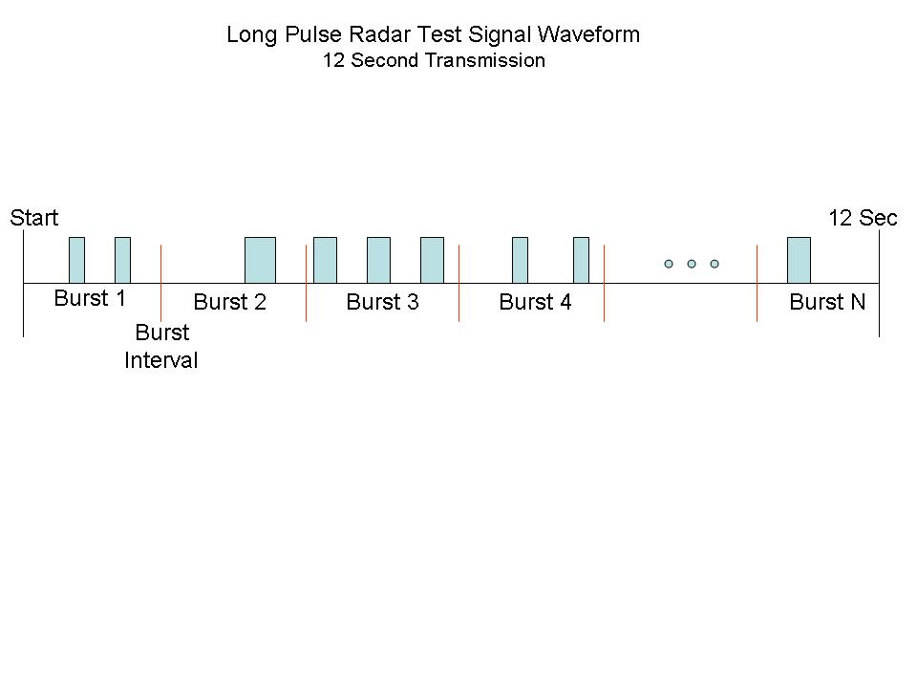
Figure 1 provides a graphical representation of the Long Pulse Radar Test Waveform.
Figure 1: Graphical Representation of a Long Pulse Radar Type Waveform

  - Frequency Hopping Radar Test Waveform

Table 7 – Frequency Hopping Radar Test Waveform
Radar Type | Pulse Width  (µsec) | PRI  (µsec) | Pulses per Hop | Hopping  Rate  (kHz) | Hopping Sequence  Length (msec) | Minimum Percentage of Successful Detection | Minimum Number of Trials
6 | 1 | 333 | 9 | 0.333 | 300 | 70% | 30

For the Frequency Hopping Radar Type, the same Burst parameters are used for each waveform. The hopping sequence is different for each waveform and a 100-length segment is selected from the hopping sequence defined by the following algorithm:

The first frequency in a hopping sequence is selected randomly from the group of 475 integer frequencies from 5250 – 5724 MHz. Next, the frequency that was just chosen is removed from the group and a frequency is randomly selected from the remaining 474 frequencies in the group. This process continues until all 475 frequencies are chosen for the set. For selection of a random frequency, the frequencies remaining within the group are always treated as equally likely.

7. TEST PROCEDURES

7.1 Test Protocol
For a Master Device, the DFS conformance requirements specified in Section 7.8 will be verified utilizing one Short Pulse Radar Type defined in Table 5. Additionally, the Channel Move Time and Channel Closing Transmission Time requirements specified in Section 7.8 will be verified utilizing the Long Pulse Radar Type defined in Table 6. The statistical performance check specified in Section 7.8 will be verified utilizing all Radar Types (1-6).

For a Client Device without DFS, the Channel Move Time and Channel Closing Transmission Time requirements specified in Section 7.8 will be verified with one Short Pulse Radar Type defined in Table 5.

For testing a Client Device with In-Service Monitoring, two configurations must be tested.
1) The Client Device detects the Radar Waveform. The Channel Move Time and Channel Closing Transmission Time requirements specified in Section 7.8 will be verified utilizing Short Pulse Radar Type defined in Table 5 and the Long Pulse Radar Type defined in Table 6. The statistical performance check specified in Section 7.8 will be verified utilizing all Radar Types (1-6). During this test, it must be ensured that the Client Device is responding independently based on the Client Device’s self-detection rather than responding to detection by the Master Device. The signal level of the Radar Waveform as received by the Client Device must be set in accordance with the DFS Detection Threshold specified by the DFS technical requirements (Table 3).
2) The Master Device detects the Radar Waveform. The Channel Move Time and Channel Closing Transmission Time requirements specified in Section 7.8 will be verified utilizing Short Pulse Radar Type defined in Table 5. During this test, it must be ensured that the Client Device is responding to detection by the Master Device rather than self-detection by the Client Device.

For all tests of Client Devices (with or without In-Service Monitoring), the Master Device to which the Client Device is associated must meet the DFS conformance requirements.

Some of the tests may be performed more readily if a test mode for a Master Device (or Client Device with In-Service Monitoring) is provided that overrides the Channel selection mechanism for the Uniform Spreading requirement to allow a specific Channel to be set for startup (Channel Availability Check). In this mode it is preferable that the Master Device will continue normal operation upon starting (i.e. perform Channel Availability Check on the chosen Channel and begin normal operation if no Radar Waveform is detected – or respond normally if a Radar Waveform is detected during the Channel Availability Check or In-Service Monitoring on the chosen Channel). However, this mode of operation is not required to successfully complete the testing.

Other tests may be performed more readily if a test mode for a Master Device (or a Client Device with In-Service Monitoring) is provided that overrides the Channel move mechanism and simply provides a display that a Radar Waveform was detected. In this mode it is preferable that the UUT will continue operation on the same Channel upon detecting a Radar Waveform. However, this mode of operation is not required to successfully complete the testing.

Once a UUT is powered on, it will not start its normal operating functions immediately, as it will have to finish its power-up cycle first (T_{power_up}). As such, the UUT, as well as any other device used in the setup, may be equipped with a feature that indicates its status during the testing, including, for example, power-up mode, normal operation mode, Channel Availability Check status and radar detection events.

The test transmission will always be from the Master Device to the Client Device.

7.2 Conducted Tests
The sections below contain block diagrams that focus on the Radar Waveform injection path for each of the different conducted setups to be used. Each setup consists of a signal generator, analyzer (spectrum analyzer or vector signal analyzer), Master Device, Client Device, plus power combiner/splitters and attenuators. The Client Device is set up to Associate with the Master Device. The designation of the UUT (Master Device or Client Device) and the device into which the Radar Waveform is injected varies among the setups.

Other topologies may be used provided that: (1) the radar and UUT signals can be discriminated from each other on the analyzer and (2) the radar DFS Detection Threshold level at the UUT is stable.

To address point (1), for typical UUT power levels and typical minimum antenna gains, the topologies shown will result in the following relative amplitudes of each signal as displayed on the analyzer: the Radar Waveform level is the highest, the signal from the UUT is the next highest, while the signal from the device that is associated with the UUT is the lowest. Attenuator values may need to be adjusted for particular configurations.

To address point (2), the isolation characteristic between ports 1 and 2 of a power combiner/splitter are extremely sensitive to the impedance presented to the common port, while the insertion loss characteristic between the common port and (port 1, for example) are relatively insensitive to the impedance presented to (port 2, in this example). Thus, the isolation between ports 1 and 2 should never be part of the path that establishes the radar DFS Detection Threshold. The 10 dB attenuator after the signal generator is specified as a precaution; since many of the radar test waveforms will require typical signal generators to operate with their ALC turned off, the source match will generally be degraded from the closed loop specifications.

7.2.1 Setup for Master with injection at the Master
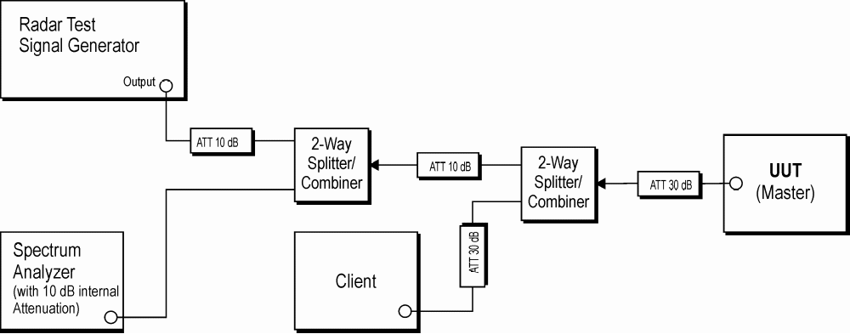
Figure 2: Example Conducted Setup where UUT is a Master and Radar Test Waveforms are injected into the Master

7.2.2 Setup for Client with injection at the Master
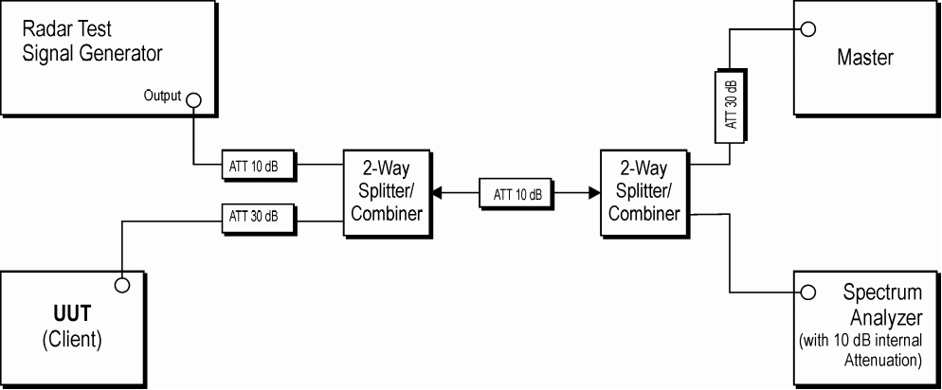
Figure 3: Example Conducted Setup where UUT is a Client and Radar Test Waveforms are injected into the Master
7.2.3 Setup for Client with injection at the Client
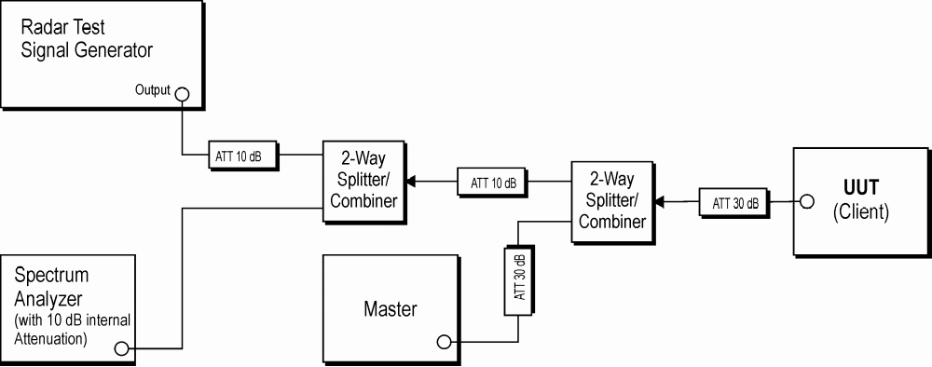
Figure 4: Example Conducted Setup where UUT is a Client and Radar Test Waveforms are injected into the Client

7.3 Radiated Tests
The subsections below contain simplified block diagrams that illustrate the Radar Waveform injection path for each of the different radiated setups to be used. The basic setup is identical for all cases.

7.3.1 Master with injection at the Master

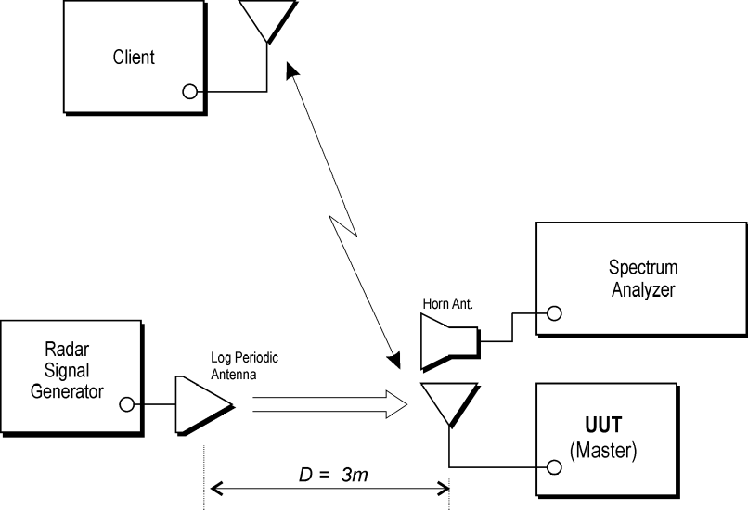
Figure 5: Example Radiated Setup where UUT is a Master and Radar Test Waveforms are injected into the Master

7.3.2 Client with injection at the Master
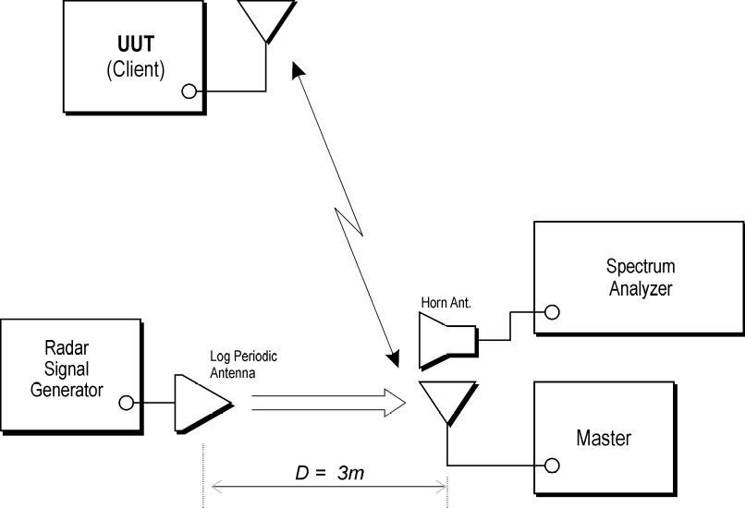
Figure 6: Example Radiated Setup where UUT is a Client and Radar Test Waveforms are injected into the Master

7.3.3 Client with injection at the Client
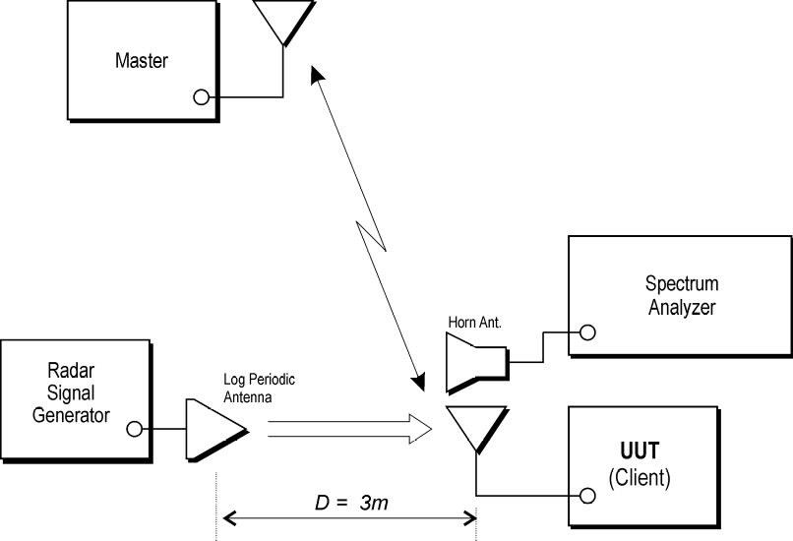
Figure 7: Example Radiated Setup where UUT is a Client and radar Test Waveforms are injected into the Client

7.4 Test Signal Generation
A complete test system consists of two subsystems: (1) the Radar Waveform generating subsystem and (2) the DFS monitoring subsystem. Method #1 and Method #2 subsystems are described for the Radar Waveform generating subsystem and the DFS monitoring subsystems. These two subsystems are independent such that the Method #1 subsystem for one function can be used with the Method #2 subsystem for the other function.

The Method #1 subsystems schematics and a parts list are available to those who are interested in replicating the custom hardware devices. The custom software and data files that control this subsystem will be made available to those who are interested.

The Method #2 subsystems used to generate simulated frequency hopping waveforms will be made available to those who are interested.

Other instrument configurations may also be used. However, any deviations from the subsystems described here must be submitted to the FCC for evaluation.

7.4.1 Radar Waveform Generating Subsystems
Computer control is not necessary to generate the Short Pulse Radar Waveforms. However, the Long Pulse Radar Waveform and Frequency Hopping Radar Waveforms by their nature require computer control. Both of the Frequency Hopping Radar Waveform generating subsystems can also generate the required Short Pulse Radar Waveforms.

A manually operated Short Pulse Radar Waveform generating subsystem is described, followed by descriptions of the computer controlled Frequency Hopping Radar Waveform generating subsystems.

7.4.1.1 Short Pulse Radar Waveform Generating Subsystem
Figure 8 shows the setup for the Short Pulse Radar Waveform generating subsystem.

The pulse generator is adjusted to the shortest rise and fall times. The pulse width, PRI, and number of pulses per Burst are set according to the Short Pulse Radar Waveforms (Table 5). The pulse generator is triggered manually. The trigger output from the pulse generator can also be connected to the DFS monitoring subsystem as required to synchronize the two subsystems.

The Signal Generator is set to the Channel center frequency and pulse modulation mode. The amplitude is adjusted to achieve the specified DFS Detection Threshold (Table 3).

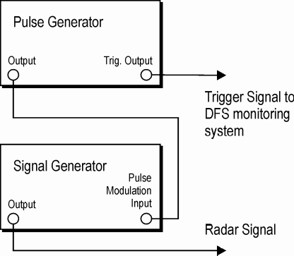
Figure 8: Short Pulse Radar Waveform Generating Subsystem

7.4.1.2 Method #1 Radar Waveform Generating Subsystems
With the exception of the Frequency Doubler and the DFS Test Box, the test and measurement system uses off-the-shelf components with vendor-supplied software and customized software. Figures 9a-9d shows the example setup for the Method #1 Radar Waveform Generating Subsystems.

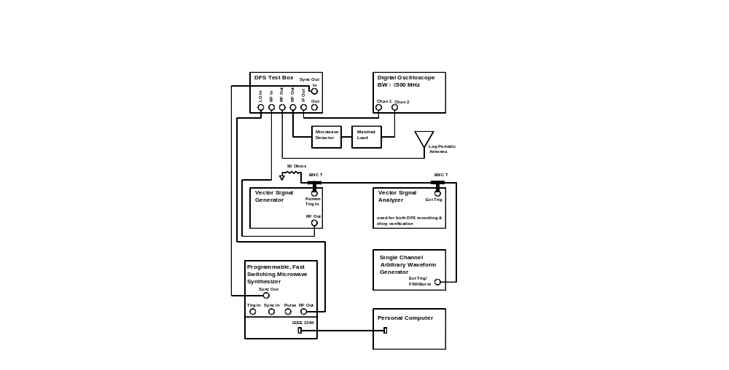
Figure 9a: Example Short and Long Pulse Radar Waveform Generator
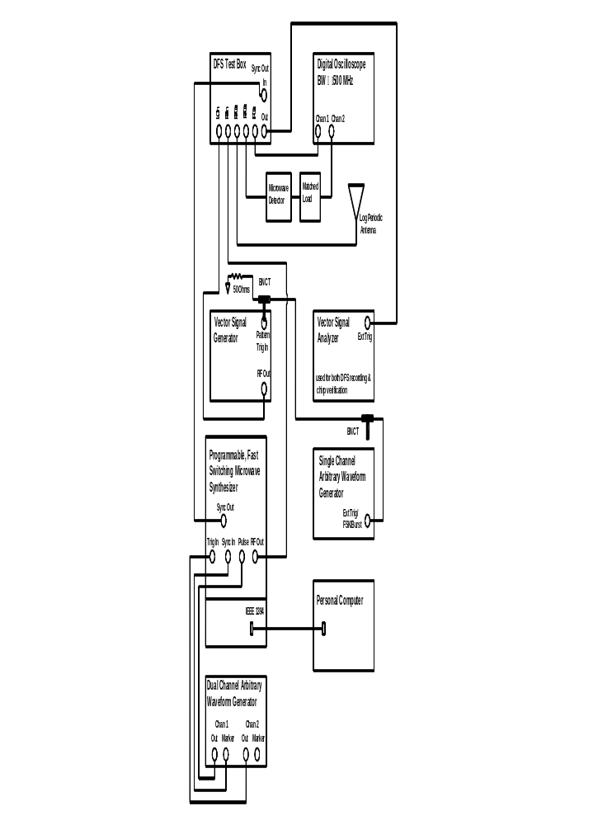
Figure 9b: Example Frequency Hopping Radar Waveform Generator
The first step in generating the Frequency Hopping Radar Waveform is accomplished by entering 274 sets of hopping sequences of the randomized 475 hop frequencies into a frequency list stored in memory in the fast-switching microwave synthesizer.

Generation of the Frequency Hopping Radar Waveform proceeds as follows: The center frequency of the microwave synthesizer is set according to the frequency list in the synthesizer’s memory. The microwave synthesizer is set up to run for 10 seconds at a time (one Burst period). During the ten-second-burst period, every 3 milliseconds the microwave synthesizer switches (hops) to the next frequency in the frequency list. The microwave synthesizer’s center frequency is pulse modulated by a pulse train that consists of a Burst of 900 pulses (each with a 1 microsecond pulse width) that occurs at the beginning of the ten-second-burst period. The PRI of the Burst is 333 microsecond. Therefore, the hopping sequence length is 300 milliseconds and there are 9 pulses per frequency hop.

Because the pulses occur within the first 300 millisecond of the ten-second-burst period, only the first 100 frequencies out of a given set of 475 randomized frequencies are actually transmitted. Therefore, it is possible for none of the transmitted frequencies during a ten-second-burst period to fall within the receiver bandwidth of the U-NII device being tested. Whenever this occurs the particular ten-second-burst period will not be included in the performance of the U-NII device.

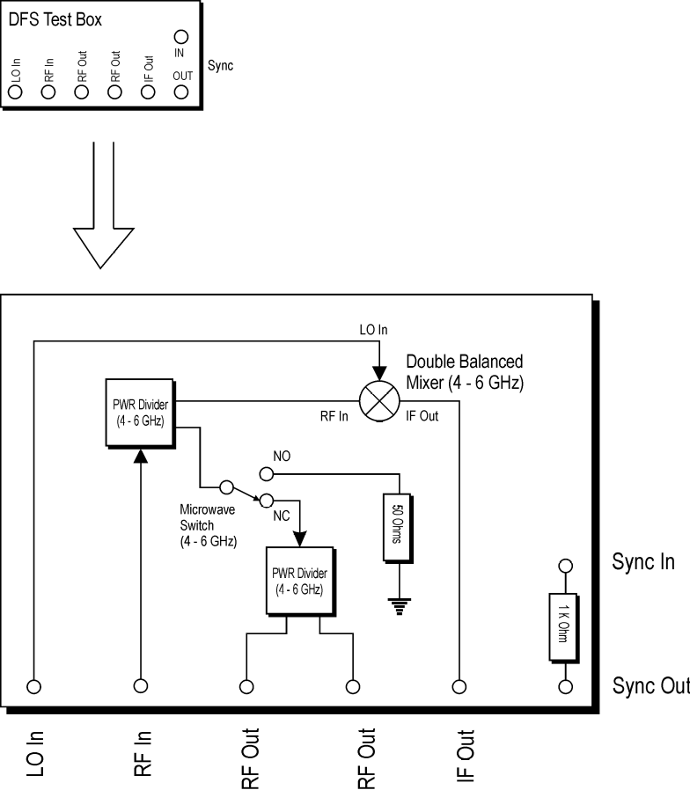

Figure 9c: Example DFS Test Box

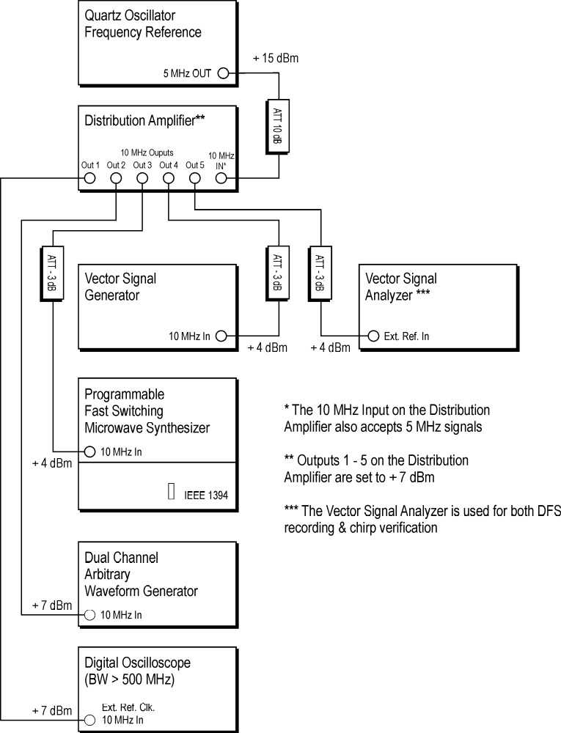

Figure 9d: Example Reference Oscillator Distribution

Quartz Oscillator Frequency Reference
The quartz oscillator provides a 5 MHz frequency reference signal that is distributed to the signal generators and measurement equipment via the distribution amplifier.

Distribution Amplifier
The distribution amplifier takes the 5 MHz frequency reference signal from the quartz oscillator, doubles it and distributes the resulting 10 MHz frequency reference signal to the critical signal generators and measurement equipment. This ensures synchronization of the signal generators and measurement equipment.

Digital Oscilloscope
The digital oscilloscope is used to examine the down-converted or detected radar transmissions in a full 500 MHz bandwidth. This is used to verify that the radar transmissions comply with the parameters as specified by the radar test waveforms.

Dual Channel Arbitrary Waveform Generator
The dual channel arbitrary waveform generator (AWG) is used when the system is configured to transmit frequency-hopping waveforms. The dual channel AWG produces two synchronized pulse trains that provide signals to control the fast-switching microwave synthesizer. One pulse train controls the microwave synthesizer switches (hops) to the next frequency in the frequency list. The other pulse train pulse modulates the RF output of the microwave synthesizer.

Microwave Detector and Matched Load
The microwave detector is used to monitor the envelope of the RF radar transmissions on the digital oscilloscope.

Radar Transmit Antenna
For radiated tests a log periodic antenna or equivalent directional antenna is used to transmit the Radar Waveforms to the DFS device during testing of the U-NII device.

Single Channel Arbitrary Waveform Generator
The single channel AWG is used when the Radar Waveform generator system is configured to transmit the Short Pulse Radar Type 1-5 waveforms. The single channel AWG is used to generate a trigger signal to begin transmission of the Radar Waveform and begin recording U-NII transmissions on the vector signal analyzer (VSA).

DFS Test Box
The DFS Test Box is constructed using off-the-shelf components. The DFS Test Box facilitates signal routing and monitoring for the radar transmissions. The radar transmissions are routed to the RF input of the DFS Test Box. The IF output provides a down-converted version of the RF radar transmissions. Two ports are available for RF output. One is connected to the log periodic antenna for radiated testing of the U-NII devices or directly to the UUT for conducted testing. The other RF output is connected to a microwave detector to display the envelope of the RF radar transmissions. Both the IF output and the detector output can be observed on the digital oscilloscope in a full 500 MHz bandwidth. This allows observation of the frequency-hopping signal that hops across 475 MHz. Both the IF output and the detector output can be used to verify Radar Waveform characteristics. The detector output can also be used to verify that an RF output signal is present.

Vector Signal Generator
When the Radar Waveform generator system is configured to transmit the frequency hopping signal, the vector signal generator (VSG) is used as a 5225 MHz continuous-wave (CW) signal source for the local oscillator (LO) input to the DFS Test Box. When the Radar Waveform generator system is configured to transmit radar type 1-5 waveforms, the VSG is used to transmit the Short Pulse Radar Type 1-5 waveforms. The Short Pulse Radar Type 1-5 waveforms are created using custom software. After the waveforms are created they are loaded into the VSG.

Personal Computer
The personal computer is used to generate and load the frequency-hopping list into and properly set up the fast-switching microwave synthesizer.

Fast-Switching Microwave Synthesizer
When the Radar Waveform generator system is configured to transmit the Short Pulse Radar Type 1-5 waveforms, the microwave synthesizer is used as a 5225 MHz CW signal source for the LO input to the DFS Test Box. When the Radar Waveform generator system is configured to transmit the frequency-hopping signal, the microwave synthesizer is used to transmit the frequency-hopping signal. Custom software is used to generate and load the hopping frequency list into and properly set up the fast-switching microwave synthesizer. A pulse train generated by the dual channel AWG controls when the microwave synthesizer switches (hops) to the next frequency in the frequency list. Another pulse train from the dual channel AWG pulse modulates the RF output of the microwave synthesizer to complete the generation of the frequency-hopping signal.

Vector Signal Analyzer
The VSA is used for two distinct purposes. One use is to verify the chirped radar transmissions of the Long Pulse Radar Type 5 waveforms. The FM demodulation capability is used to verify the chirp frequency range. The other use of the VSA is to provide 12 and 24 second recordings of the U-NII device transmissions, with fine-time resolution, during DFS testing. When Long Pulse Radar Type 5 waveforms are transmitted, the 24-second recordings (with a time between samples of approximately 675 nanoseconds) are taken; 12-second recordings (with a time between samples of approximately 390 nanoseconds) are taken when all other Radar Waveforms are transmitted.

The VSA receives a trigger signal from the Radar Waveform generator system to initiate a recording. When the Radar Waveform generator system is configured to transmit the Radar Type 1-5 waveforms, the single-channel AWG provides the trigger signal. When the Radar Waveform generator system is configured to transmit the frequency hopping signal, the microwave synthesizer generates the trigger signal when the frequency hopping radar transmission first falls within the U-NII Detection Bandwidth.

7.4.1.3 Method #2 Simulated Frequency Hopping Radar Waveform Generating Subsystem
The simulated frequency hopping signal generator system uses the hardware that is used to manually generate Short Pulse Radar Waveforms shown in Figure 8, with the addition of a control computer and a Burst generator to create the hopping trigger pulse pattern. The simulated signal generation approach produces both time-domain and frequency-domain simulations of an actual frequency hopping signal. The hardware configuration for an example Frequency Hopping Radar Waveform generator is shown in Figure 10.

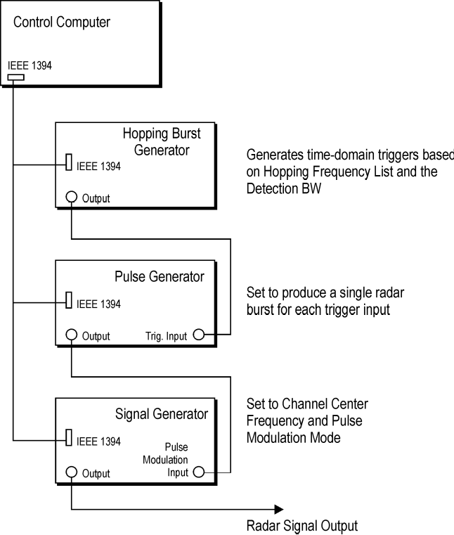

Figure 10: Example Simulated Frequency Hopping Radar Generator System

Conceptual Description of Simulated Frequency Hopping Generator
Time-domain simulation: The simulated hopping system generates the same number of hops, using identical pulse parameters, at the identical timing compared to the actual hopping waveform, using a fixed frequency within the U-NII Detection Bandwidth. Thus the detectable RF energy received by the UUT is identical in both instances.

Frequency-domain simulation: Multiple trials are made, each at a different fixed frequency. The frequencies selected for each trial lie within the U-NII Detection Bandwidth. Thus the UUT receives RF energy throughout the U-NII Detection Bandwidth.

Figure 11 and Figure 12 below show the comparison between an example frequency hopping waveform and the corresponding simulated hopping waveform. The horizontal axis is time and the vertical axis is frequency (although the figures depict 3 pulses per hop, the actual Frequency Hopping Radar Type 6 waveform contains 9 pulses per hop).

Referring to the actual hopping signal, the hops that are outside the U-NII Detection Bandwidth are shown as three dots in Figure 11 and Figure 12 and the hops that are within the U-NII Detection Bandwidth are shown as three lines. The center of the lines indicates the frequency of the hop. Note that three hops fall within the U-NII Detection Bandwidth.

Referring to the simulated hopping signal, the hops that are generated are shown as three lines. Note that three hops are generated, and each hop is at the same frequency.

Figure 11: Frequency Hopping Sequence
Total Hopping Span
Hopping Sequence Length
U-NII Detection Bandwidth

Total Hopping Span
U-NII Detection Bandwidth
Hopping Sequence Length

Figure 12: Time Domain Simulation of a Frequency Hopping Sequence

The frequency hopping Burst generator is a programmable pulse generator that is used to provide a trigger to generate the Burst pattern trigger pulses and the monitoring system.

The pulse generator is configured to generate a single Burst of pulses (refer to Table 7 for the frequency hopping waveform parameters) whenever triggered by the hopping Burst generator and is used as the modulation input for the RF signal generator, set to pulse modulation.

7.5 Setting the Test Signal Level
The radar test signal level is set at the Master Device, or the Client Device with In-Service Monitoring, as appropriate for the particular test. This device is known as the Radar Detection Device (RDD). The RDD consists of the applicable device and the device antenna assembly that has the lowest antenna assembly gain of all available antenna assemblies. Depending on the UUT, the following configurations exist:
- When the Master Device is the UUT, the Master Device is the RDD.
- When a Client Device without Radar Detection is the UUT, the Master Device is the RDD.
- When a Client Device with Radar Detection is the UUT, and is tested for response to the Master Device detections, the Master Device is the RDD.
- When a Client Device with Radar Detection is the UUT, and is tested for independent response to detections by the Client Device, the Client Device is the RDD.
A spectrum analyzer is used to establish the test signal level for each radar type. During this process, there are no transmissions by either the Master Device or Client Device. The spectrum analyzer is switched to the zero span (time domain) mode at the frequency of the Radar Waveform generator. The peak detector function of the spectrum analyzer is utilized. The spectrum analyzer resolution bandwidth (RBW) and video bandwidth (VBW) are set to at least 3 MHz.

The signal generator amplitude and/or step attenuators are set so that the power level measured at the spectrum analyzer is equal to the DFS Detection Threshold that is required for the tests. The signal generator and attenuator settings are recorded for use during the test.

Data demonstrating that the test signal level is correctly set for each radar type (1-6) will be recorded and reported.

7.6 DFS Monitoring
The DFS monitoring subsystem shown in Figure 13 is used to verify that the UUT has vacated the Channel in the specified time (Channel Closing Transmission Time and Channel Move Time) and does not transmit on a Channel for 30 minutes after the detection and Channel move (Non-Occupancy Period). It is also used to monitor UUT transmissions upon start-up (Channel Availability Check Time).

7.6.1 Method #1
The test setup of the Method #1 DFS monitoring subsystem is shown in Figure 13. This subsystem consists of two major functional blocks. One measures RF transmissions for a time period of 12 or 24 seconds and the other measures RF transmissions for a time period of 30 minutes.

The 12 and 24 -second measurement is made with a VSA controlled by a computer. A log-periodic antenna, or equivalent directional antenna, connected to the VSA is used to receive the UUT transmissions. Upon receiving a trigger signal from the signal generator system (AWG from the Method #1 system and Pulse Generator from the Method #2 system), the VSA will digitize the UUT transmissions for 12 or 24 seconds and stored. The stored data are time tagged and the UUT transmissions can be reviewed in voltage vs. time format using the software in the computer controlling the VSA or in a suitable computer program to verify that the UUT complies with the limits.

The 30 minute measuring time is made with a spectrum analyzer connected to an omni antenna. Since the power of the UUT transmissions are well above the noise floor of the analyzer, a preamplifier and tracking pre-selector are not required for this measurement. The analyzer is set to zero span, tuned to the center frequency of the UUT operating Channel, with a peak detector function, and a 32 minute sweep time. If any UUT transmissions occur within the observation time, they are detected and recorded.

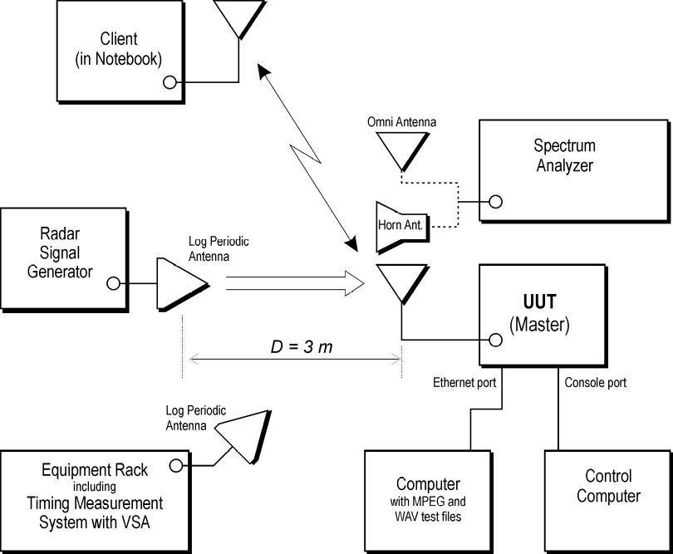

Figure 13: Example DFS Timing Monitoring Diagram for Method #1

7.6.2 Method #2
The test setup of the Method #2 DFS monitoring subsystem is shown in Figure 14. This provides coarser timing measurements than Method #1 and provides an upper bound measurement of the aggregate duration of the Channel Closing Transmission Time.

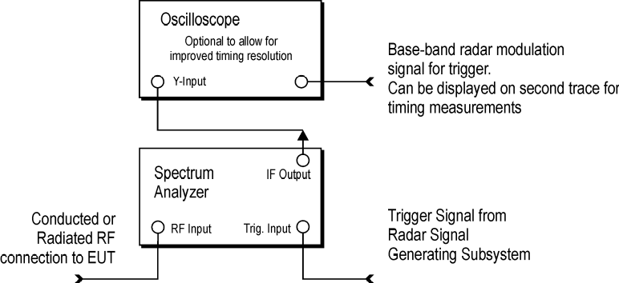

Figure 14: Example DFS Timing Monitoring Diagram for Method #2

With the spectrum analyzer set to zero span tuned to the center frequency of the UUT operating channel at the radar simulated frequency, peak detection, and max hold, the dwell time per bin is given by:

Dwell = S / B

where Dwell is the dwell time per spectrum analyzer sampling bin, S is the sweep time and B is the number of spectrum analyzer sampling bins.

An upper bound of the aggregate duration of the Channel Closing Transmission Time is calculated by:

C = N * Dwell

where C is the Closing Time, N is the number of spectrum analyzer sampling bins showing a U-NII transmission and Dwell is the dwell time per bin.

7.7 Channel Loading
System testing will be performed with the designated MPEG test file that streams full motion video at 30 frames per second for Channel loading. If the designated MPEG test file is not utilized then an equivalent test file will be used, subject to FCC approval.

7.7.1 IP Based Systems
The MPEG test file will be transferred from the Master Device to the Client Device for all test configurations.

7.7.2 Frame Based Systems
The MPEG test file will be transferred from the Master Device to the Client Device for all test configurations. For frame based systems with a fixed talk/listen ratio, the ratio will be set to 45%/55% during the entirety for all test performed for DFS functionality of a manufacturer’s device under test. For frame based systems that dynamically allocate the talk/listen ratio, the MPEG test file will be transferred from the Master Device to the Client Device for all test configurations.

7.7.3 Other Systems
Systems that do not employ IP or frame based architectures, or that represent a combination of the two, must submit their Uniform Channel Spreading methodology used in the compliance measurements to the FCC for evaluation.

7.8 DFS CONFORMANCE TEST PROCEDURES
The tests in this section are run sequentially and the UUT must pass all tests successfully. If the UUT fails any one of the tests it will count as a failure of compliance. To show compliance, all tests must be performed with waveforms randomly generated as specified with test results meeting the required percentage of successful detection criteria. All test results must be reported to the FCC. One frequency will be chosen from the operating Channels of the UUT within the 5250-5350 MHz or 5470-5725 MHz bands.

7.8.1 U-NII Detection Bandwidth
Set up the generating equipment as shown in Figure 8, or equivalent. Set up the DFS timing monitoring equipment as shown in Figure 13 or Figure 14. Set up the overall system for either radiated or conducted coupling to the UUT.

Adjust the equipment to produce a single Burst of the Short Pulse Radar Type 1 in Table 5 at the center frequency of the UUT Operating Channel at the specified DFS Detection Threshold level found in Table 3.

Set the UUT up as a standalone device (no associated Client or Master, as appropriate) and no traffic. Frame based systems will be set to a talk/listen ratio of 0%/100% during this test.

Generate a single radar Burst, and note the response of the UUT. Repeat for a minimum of 10 trials. The UUT must detect the Radar Waveform using the specified U-NII Detection Bandwidth criterion shown in Table 4.

Starting at the center frequency of the UUT operating Channel, increase the radar frequency in 1 MHz steps, repeating the above test sequence, until the detection rate falls below the U-NII Detection Bandwidth criterion specified in Table 4. Record the highest frequency (denote as F_{H}) at which detection is greater than or equal to the U-NII Detection Bandwidth criterion. Recording the detection rate at frequencies above F_{H} is not required to demonstrate compliance.

Starting at the center frequency of the UUT operating Channel, decrease the radar frequency in 1 MHz steps, repeating the above test sequence, until the detection rate falls below the U-NII Detection Bandwidth criterion specified in Table 4. Record the lowest frequency (denote as F_{L}) at which detection is greater than or equal to the U-NII Detection Bandwidth criterion. Recording the detection rate at frequencies below F_{L} is not required to demonstrate compliance.

The U-NII Detection Bandwidth is calculated as follows:

U-NII Detection Bandwidth = F_{H} – F_{L}

The U-NII Detection Bandwidth must meet the U-NII Detection Bandwidth criterion specified in Table 4. Otherwise, the UUT does not comply with DFS requirements. This is essential to ensure that the UUT is capable of detecting Radar Waveforms across the same frequency spectrum that contains the significant energy from the system. In the case that the U-NII Detection Bandwidth is greater than or equal to the 99 percent power bandwidth for the measured F_{H} and F_{L}, the test can be truncated and the U-NII Detection Bandwidth can be reported as the measured F_{H} and F_{L}.

7.8.2 Performance Requirements Check
The following tests must be performed for U-NII device certification: Initial Channel Startup Check with a radar Burst at start of Channel Availability Check and with a radar Burst at end of Channel Availability Check; In-Service Monitoring; and the 30 minute Non-Occupancy Period.

7.8.2.1 Initial Channel Availability Check Time
The Initial Channel Availability Check Time tests that the UUT does not emit beacon, control, or data signals on the test Channel until the power-up sequence has been completed and the U-NII device checks for Radar Waveforms for one minute on the test Channel. This test does not use any Radar Waveforms and only needs to be performed one time.

- The U-NII devices will be powered on and be instructed to operate on the appropriate U-NII Channel that must incorporate DFS functions. At the same time the UUT is powered on, the spectrum analyzer will be set to zero span mode with a 3 MHz RBW and 3 MHz VBW on the Channel occupied by the radar (Ch_{r}) with a 2.5 minute sweep time. The spectrum analyzer’s sweep will be started at the same time power is applied to the U-NII device.
- The UUT should not transmit any beacon or data transmissions until at least 1 minute after the completion of the power-on cycle.
This measurement can be used to determine the length of the power-on cycle if it is not supplied by the manufacturer. If the spectrum analyzer sweep is started at the same time the UUT is powered on and the UUT does not begin transmissions until it has completed the cycle, the power-on time can be determined by comparing the two times.

7.8.2.2 Radar Burst at the Beginning of the Channel Availability Check Time
The steps below define the procedure to verify successful radar detection on the test Channel during a period equal to the Channel Availability Check Time and avoidance of operation on that Channel when a radar Burst with a level equal to the DFS Detection Threshold + 1 dB occurs at the beginning of the Channel Availability Check Time. This is illustrated in Figure 15.
- The Radar Waveform generator and UUT are connected using the applicable test setup described in the sections on configuration for Conducted Tests (7.2) or Radiated Tests (7.3) and the power of the UUT is switched off.
- The UUT is powered on at T₀. T₁ denotes the instant when the UUT has completed its power-up sequence (T_{power_up}). The Channel Availability Check Time commences on Ch_{r} at instant T₁ and will end no sooner than T₁ + T_{ch_avail_check}.
- A single Burst of one of the Short Pulse Radar Types 1-4 will commence within a 6 second window starting at T₁. An additional 1 dB is added to the radar test signal to ensure it is at or above the DFS Detection Threshold, accounting for equipment variations/errors.
- Visual indication or measured results on the UUT of successful detection of the radar Burst will be recorded and reported. Observation of Ch_{r} for UUT emissions will continue for 2.5 minutes after the radar Burst has been generated.
- Verify that during the 2.5 minute measurement window no UUT transmissions occurred on Ch_{r}. The Channel Availability Check results will be recorded.

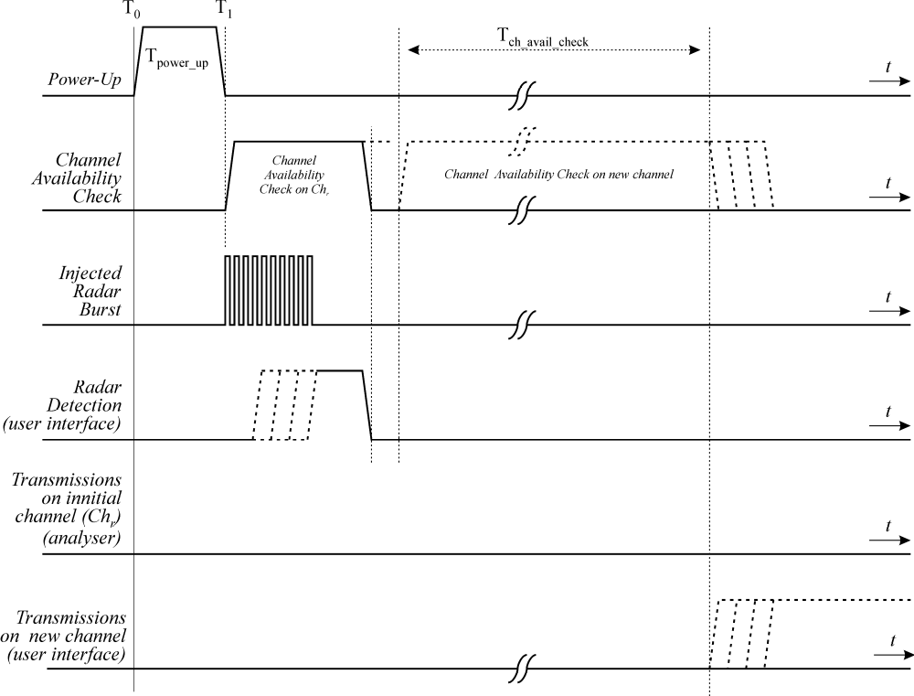
Figure 15: Example of timing for radar testing at the beginning of the Channel Availability Check Time

7.8.2.3 Radar Burst at the End of the Channel Availability Check Time
The steps below define the procedure to verify successful radar detection on the test Channel during a period equal to the Channel Availability Check Time and avoidance of operation on that Channel when a radar Burst with a level equal to the DFS Detection Threshold + 1dB occurs at the end of the Channel Availability Check Time. This is illustrated in Figure 16.

- The Radar Waveform generator and UUT are connected using the applicable test setup described in the sections for Conducted Tests (7.2) or Radiated Tests (7.3) and the power of the UUT is switched off.
- The UUT is powered on at T₀. T₁ denotes the instant when the UUT has completed its power-up sequence (T_{power_up}). The Channel Availability Check Time commences on Ch_{r} at instant T₁ and will end no sooner than T₁ + T_{ch_avail_check}.
- A single Burst of one of the Short Pulse Radar Types 1-4 will commence within a 6 second window starting at T₁ + 54 seconds. An additional 1 dB is added to the radar test signal to ensure it is at or above the DFS Detection Threshold, accounting for equipment variations/errors.
- Visual indication or measured results on the UUT of successful detection of the radar Burst will be recorded and reported. Observation of Ch_{r} for UUT emissions will continue for 2.5 minutes after the radar Burst has been generated.
- Verify that during the 2.5 minute measurement window no UUT transmissions occurred on Ch_{r}. The Channel Availability Check results will be recorded.

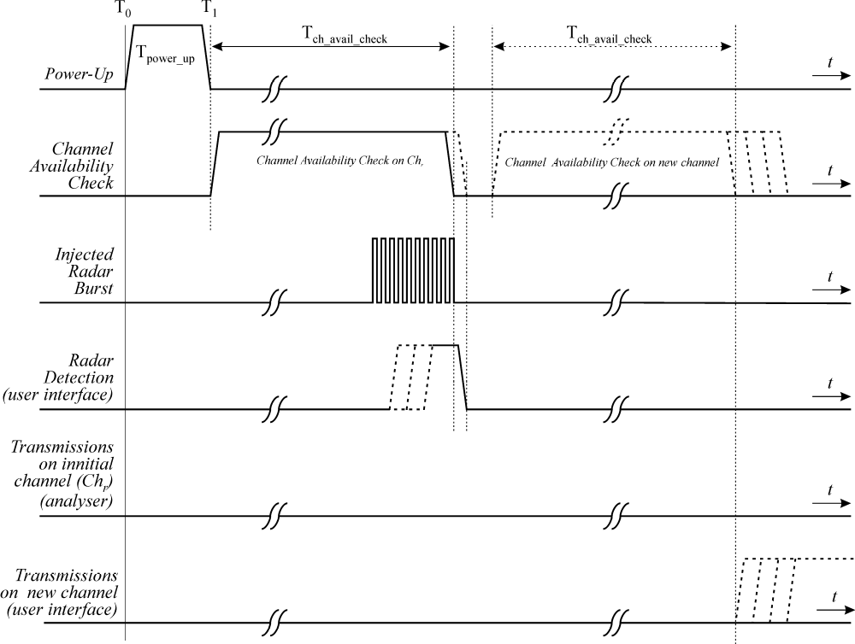
Figure 16: Example of timing for radar testing towards the end of the Channel Availability Check Time

7.8.3 In-Service Monitoring for Channel Move Time, Channel Closing Transmission Time and Non-Occupancy Period
These tests define how the following DFS parameters are verified during In-Service Monitoring;
- Channel Closing Transmission Time
- Channel Move Time
- Non-Occupancy Period
The steps below define the procedure to determine the above mentioned parameters when a radar Burst with a level equal to the DFS Detection Threshold + 1dB is generated on the Operating Channel of the U-NII device (In- Service Monitoring).

- One frequency will be chosen from the Operating Channels of the UUT within the 5250-5350 MHz or 5470-5725 MHz bands.
- In case the UUT is a U-NII device operating as a Client Device (with or without DFS), a U-NII device operating as a Master Device will be used to allow the UUT (Client device) to Associate with the Master Device. In case the UUT is a Master Device, a U-NII device operating as a Client Device will be used and it is assumed that the Client will Associate with the UUT (Master). In both cases for conducted tests, the Radar Waveform generator will be connected to the Master Device. For radiated tests, the emissions of the Radar Waveform generator will be directed towards the Master Device. If the Master Device has antenna gain, the main beam of the antenna will be directed toward the radar emitter. Vertical polarization is used for testing.
- Stream the MPEG test file from the Master Device to the Client Device on the test Channel for the entire period of the test.
- At time T₀ the Radar Waveform generator sends a Burst of pulses for one of the Short Pulse Radar Types 1-4 in Table 5 at levels defined in Table 3, on the Operating Channel. An additional 1 dB is added to the radar test signal to ensure it is at or above the DFS Detection Threshold, accounting for equipment variations/errors.
- Observe the transmissions of the UUT at the end of the radar Burst on the Operating Channel for duration greater than 10 seconds. Measure and record the transmissions from the UUT during the observation time (Channel Move Time). Measure and record the Channel Move Time and Channel Closing Transmission Time if radar detection occurs. Figure 17 illustrates Channel Closing Transmission Time.
- When operating as a Master Device, monitor the UUT for more than 30 minutes following instant T₂ to verify that the UUT does not resume any transmissions on this Channel. Perform this test once and record the measurement result.
- In case the UUT is a U-NII device operating as a Client Device with In-Service Monitoring, perform steps a) to f).

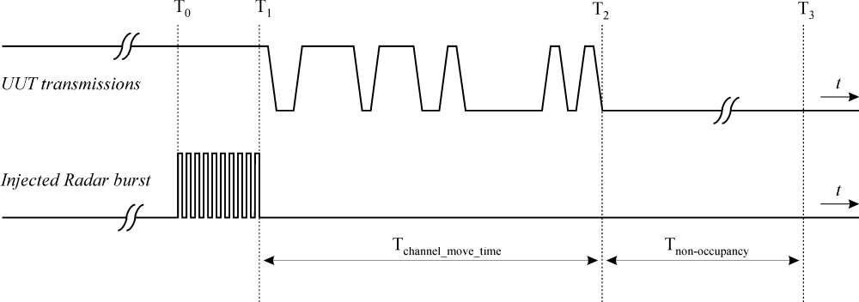
Figure 17: Example of Channel Closing Transmission Time & Channel Closing Time

7.8.4 Statistical Performance Check
The steps below define the procedure to determine the minimum percentage of successful detection requirements found in Tables 5-7 when a radar burst with a level equal to the DFS Detection Threshold + 1dB is generated on the Operating Channel of the U-NII device (In- Service Monitoring).

- One frequency will be chosen from the Operating Channels of the UUT within the 5250-5350 MHz or 5470-5725 MHz bands.
- In case the UUT is a U-NII device operating as a Client Device (with or without Radar Detection), a U-NII device operating as a Master Device will be used to allow the UUT (Client device) to Associate with the Master Device. In case the UUT is a Master Device, a U-NII device operating as a Client Device will be used and it is assumed that the Client will Associate with the UUT (Master). In both cases for conducted tests, the Radar Waveform generator will be connected to the Master Device. For radiated tests, the emissions of the Radar Waveform generator will be directed towards the Master Device. If the Master Device has antenna gain, the main beam of the antenna will be directed toward the radar emitter. Vertical polarization is used for testing.
- Stream the MPEG test file from the Master Device to the Client Device on the test Channel for the entire period of the test.
- At time T₀ the Radar Waveform generator sends the individual waveform for each of the Radar Types 1-6 in Tables 5-7, at levels defined in Table 3, on the Operating Channel. An additional 1 dB is added to the radar test signal to ensure it is at or above the DFS Detection Threshold, accounting for equipment variations/errors.
- Observe the transmissions of the UUT at the end of the Burst on the Operating Channel for duration greater than 10 seconds for Short Pulse Radar Types 1-4 and 6 to ensure detection occurs.
- Observe the transmissions of the UUT at the end of the Burst on the Operating Channel for duration greater than 22 seconds for Long Pulse Radar Type 5 to ensure detection occurs.
g) In case the UUT is a U-NII device operating as a Client Device with In-Service
Monitoring, perform steps a) to f).

7.8.4.1 Short Pulse Radar Test
Once the performance requirements check is complete, statistical data will be gathered, to determine the ability of the device to detect the radar test waveforms (Short Pulse Radar Types 1-4) found in Table 5. The device can utilize a test mode to demonstrate when detection occurs to prevent the need to reset the device between trials. The percentage of successful detection is calculated by:

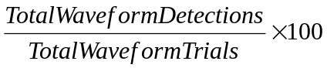 = Percentage of Successful Detection Radar Waveform N = P_{d}N

In addition an aggregate minimum percentage of successful detection across all Short Pulse Radar Types 1-4 is required and is calculated as follows:

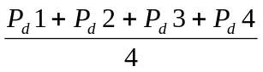
The minimum number of trails, minimum percentage of successful detection and the aggregate minimum percentage of successful detection are found in Table 5.

7.8.4.2 Long Pulse Radar Test
Statistical data will be gathered to determine the ability of the device to detect the Long Pulse Radar Type 5 found in Table 6. The device can utilize a test mode to demonstrate when detection occurs to prevent the need to reset the device between trials. The percentage of successful detection is calculated by:

7.8.4.3 Frequency Hopping Radar Test
Statistical data will be gathered to determine the ability of the device to detect the Frequency Hopping radar test signal (radar type 6) found in Table 7. The device can utilize a test mode to demonstrate when detection occurs to prevent the need to reset the device between trial runs. The probability of successful detection is calculated by:

8. DFS TEST REPORT GUIDELINES
The following items will be included in test reports for DFS testing of U-NII devices as indicated in the sections below. This section covers the minimum requirements that will be submitted on the DFS test results.

8.1 Complete description of the U-NII device
- The operating frequency range(s) of the equipment.
- The operating modes (Master and/or Client) of the U-NII device.
- For Client devices, indicate whether or not it has radar detection capability and indicate the FCC identifier for the Master U-NII Device that is used with it for DFS testing.
- List the highest and the lowest possible power level (equivalent isotropic radiated power (EIRP)) of the equipment.
- List all antenna assemblies and their corresponding gains.
  - If radiated tests are to be performed, the U-NII Device should be tested with the lowest gain antenna assembly (regardless of antenna type). The report should indicate which antenna assembly was used for the tests. For devices with adjustable output power, list the output power range and the maximum EIRP for each antenna assembly.
  - If conducted tests are to be performed, indicate which antenna port/connection was used for the tests and the antenna assembly gain that was used to set the DFS Detection Threshold level during calibration of the test setup.
    - Indicate the calibrated conducted DFS Detection Threshold level.
    - For devices with adjustable output power, list the output power range and the maximum EIRP for each antenna assembly.
    - Indicate the antenna connector impedance. Ensure that the measurement instruments match (usually 50 Ohms) or use a minimum loss pad and take into account the conversion loss.

  - Antenna gain measurement verification for tested antenna.
    - Describe procedure
    - Describe the antenna configuration and how it is mounted
    - If an antenna cable is supplied with the device, cable loss needs to be taken into account. Indicate the maximum cable length and either measure the gain with this cable or adjust the measured gain accordingly. State the cable loss.

- Test sequences or messages that should be used for communication between Master and Client Devices, which are used for loading the Channel.
  - Stream the test file from the Master Device to the Client Device for IP based systems or frame based systems which dynamically allocate the talk/listen ratio.
  - For frame based systems with fixed talk/listen ratio, set the ratio to 45%/55% and stream the test file from the Master to the Client.
  - For other system architectures, supply appropriate Channel loading methodology.
- Transmit Power Control description
Provide a description.
- System architectures, data rates, U-NII Channel bandwidths.
  - Indicate the type(s) of system architecture (e.g. IP based or Frame based) that the U-NII device employs. Each type of unique architecture must be tested.
- The time required for the Master Device and/or Client Device to complete its power-on cycle.
- Manufacturer statement confirming that information regarding the parameters of the detected Radar Waveforms is not available to the end user.
- Uniform Channel Spreading requirement for Master Devices. For Master Devices, indicate how the master provides, on aggregate, uniform Channel loading of the spectrum across all Channels.

8.2 Complete description of the Radar Waveform calibration
- Description of calibration setup
  - Block diagram of equipment setup, clearly identifying if a radiated or conducted method was used.
- Description of calibration procedure
  - Verify DFS Detection Threshold levels
    - Indicate DFS Detection Threshold levels used.
    - Consider output power range and antenna gain.
  - For the Short Pulse Radar Types, spectrum analyzer plots of the burst of pulses on the Channel frequency should be provided.
  - For the Long Pulse Radar Type, spectrum analyzer plot of a single burst (1-3 pulses) on the Channel frequency should be provided.
  - Describe method used to generate frequency hopping signal.
  - The U-NII Detection Bandwidth
  - For the Frequency Hopping waveform, a spectrum analyzer plot showing 9 pulses on one frequency within the U-NII Detection Bandwidth should be provided.
  - Verify use of vertical polarization for testing when using a radiated test method.
- When testing a Client Device with radar detection capability, verify that the Client Device is responding independently based on the Client Device’s self-detection rather than responding to the Master Device. If required, provide a description of the method used to isolate the client from the transmissions from the Master Device to ensure Client Device self detection of the Radar Waveform.

8.3 Complete description of test procedure
- Description of deviations to the procedures or equipment described in this document.

- Description of DFS test procedure and test setup used to monitor the U-NII device and Radar Waveform transmissions. Provide a block diagram of the signal monitoring equipment setup.
  - List of equipment
  - Test setup photos

- Description of DFS test procedure and test setup used to generate the Radar Waveforms.
  - Block diagram of equipment setup
  - List of equipment
  - Test setup photos
  - For each of the waveforms that were used for each signal type, supply the characteristics (pulse width, pulse repetition interval, number of pulses per burst, modulation).
  - For selecting the waveform parameters from within the bounds of the signal type, describe how they were selected (i.e., random selection using uniform distribution).

- The DFS tests are to be performed on U-NII Channel(s) at the smallest U-NII Channel bandwidth (worst case).
    - List each Channel frequency that was used for the tests.
    - Data Sheet showing the U-NII Detection Bandwidth for the Channel(s) used during the test.
    - Plot of RF measurement system showing its nominal noise floor in the same bandwidth which is used to perform the Channel Availability Check, initial radar bursts, In-Service Monitoring, and 30 minute Non-Occupancy Period tests.

- Timing plot(s) showing compliance with the Channel Availability Check Time requirement of 60 seconds at start up.
  - The plot should show the Initial T_{power-up} time.
  - The plot should include the Initial T_{power-up} period in addition to 60 second period.
- Timing plot(s) showing compliance with the Initial DFS radar detection requirements during the 60 second initial Channel Availability Check at start up.
  - Plot for DFS radar detection for Radar Waveforms applied 6 seconds after the Initial T_{power-up} time period. The minimum length of the plot should be 1.5 minutes after the T_{power-up} time period. The plot should show the radar burst at the appropriate time. This test is only required once and the Short Pulse radar Type 1 should be used for the test.
  - Plot for DFS radar detection for Radar Waveforms applied 6 seconds before end of the 60 second Channel Availability Check Time. The minimum length of the plot should be 1.5 minutes T_{power-up} time period. The plot should show the radar burst at the appropriate time. This test is only required once the Short Pulse Radar Type 1 should be used for the test.
  - The minimum time resolution of the plots should be sufficient to show the Radar Waveform bursts (overall, not individual pulses within the burst).

- Verification that when the device is “off” that the RF energy emitted is below the FCC rules for unintentional radiators:
For the plots of U-NII RF activity versus time, the device is considered to be “off” or not transmitting when intentional U-NII signals (beacons, data packets or transmissions, or control signals) are below the FCC rules for unintentional radiation due to device leakage, oscillator noise, clocks, and other unintentional RF generators.

- Spectrum Analyzer, VSA, or some other data gathering Instrument plots showing compliance with the Channel Move Time requirements during in the In-Service Monitoring testing for the Short and Long Pulse Radar Types. The plots need to show U-NII device transmissions on the Channel in the form of RF activity on the vertical axis versus time on the horizontal axis. Only one 10 second plot needs to be reported for the Short Pulse Radar Types 1-4 and one for the Long Pulse Radar Type in a 22 second plot. The plot for the Short Pulse Radar Types should start at the end of the radar burst. The Long Pulse Radar Type plot only needs to show the device ceased transmissions within the 10 second window after detection has occurred. The plot for the Long Pulse Radar Type should start at the beginning of the 12 second waveform. However, the Channel Move Time will be calculated based on the plot of the Short Pulse Radar type.
The plots need to show U-NII device transmissions on the Channel in the form of RF activity on the vertical axis versus time on the horizontal axis. Sufficient resolution should be used.
Only one 10 second plot needs to be reported for the Short Pulse Radar Types 1-4 and one for the Long Pulse Radar Type test in a 22 second plot. The plot for the Short Pulse Radar Types should start at the end of the radar burst. The Channel Move Time will be calculated based on the plot of the Short Pulse Radar Type.
The Long Pulse Radar Type plot only needs to show the device ceased transmissions within the 10 second window after detection has occurred. The plot for the Long Pulse Radar Type should start at the beginning of the 12 second waveform.
  - The plots and/or data must show the U-NII Device’s compliance with the 200 milliseconds limit on data transmission and compliance with the 60 millisecond aggregate limit found in Table 4.
  - Indicate the total number of times the test was performed.
  - Indicate a detect/not detect for each waveform within a signal type and the number of failures and the number of successful radar detection times within the time limit. Sample data sheets are shown in Tables 8-10.
  - Verify compliance with the minimum percentage of successful detection requirements found in Tables 5-7.

- Spectrum Analyzer plot(s) showing compliance with the 30 minute Non-Occupancy Period requirement.
Only one plot is required. This is a separate test that is performed in addition to the other In-Service Monitoring tests. However, any type of Radar Waveform can be used for this test.

Table 8: Sample Detection Data Sheet for Radar Types 1, 5, and 6
(Use a Separate Data Sheet for Each Radar Type)

Radar Type | Trial # | Detection | Trial # | Detection
Radar Type | Trial # | Yes / No | Trial # | Yes / No
1, 5 or 6 | 1 |  | 16
1, 5 or 6 | 2 |  | 17
1, 5 or 6 | 3 |  | 18
1, 5 or 6 | 4 |  | 19
1, 5 or 6 | 5 |  | 20
1, 5 or 6 | 6 |  | 21
1, 5 or 6 | 7 |  | 22
1, 5 or 6 | 8 |  | 23
1, 5 or 6 | 9 |  | 24
1, 5 or 6 | 10 |  | 25
1, 5 or 6 | 11 |  | 26
1, 5 or 6 | 12 |  | 27
1, 5 or 6 | 13 |  | 28
1, 5 or 6 | 14 |  | 29
1, 5 or 6 | 15 |  | 30

Table 9: Sample Data Sheet for Radar Types 2, 3, or 4
(Use a Separate Data Sheet for Each Radar Type)

Radar Type | Trial # | Number Pulses  per Burst | Pulse Width  (µs) | PRI  (µs) | Detection
 |  |  |  |  | Yes / No
2, 3, or 4 | 1
2, 3, or 4 | 2
2, 3, or 4 | 3
2, 3, or 4 | 4
2, 3, or 4 | 5
2, 3, or 4 | 6
2, 3, or 4 | 7
2, 3, or 4 | 8
2, 3, or 4 | 9
2, 3, or 4 | 10
2, 3, or 4 | 11
2, 3, or 4 | 12
2, 3, or 4 | 13
2, 3, or 4 | 14
2, 3, or 4 | 15
2, 3, or 4 | 16
2, 3, or 4 | 17
2, 3, or 4 | 18
2, 3, or 4 | 19
2, 3, or 4 | 20
2, 3, or 4 | 21
2, 3, or 4 | 22
2, 3, or 4 | 23
2, 3, or 4 | 24
2, 3, or 4 | 25
2, 3, or 4 | 26
2, 3, or 4 | 27
2, 3, or 4 | 28
2, 3, or 4 | 29
2, 3, or 4 | 30

Table 10: Sample Parameter Data Sheet for Radar Type 5
(Use a separate data sheet for each trial)

Radar Type 5
Trial Number:
Number of Bursts in Trial:
Burst | Number  of  Pulses | Pulse  Width  (µsec) | Chirp  Width  (MHz) | Pulse 1-to-2  Spacing  (µsec) | Pulse 2-to-3  Spacing  (µsec) | Starting Location  Within Interval  (µsec)
1
2
3
4
5
6
7
8
9
10
11
12
13
14
15
16
17
18
19
20

STATEMENT OF
COMMISSIONER MICHAEL J. COPPS

Re: Revision of Parts 2 and 15 of the Commission’s Rules to Permit Unlicensed National Information Infrastructure (U-NII) Devices in the 5 GHz Band, Memorandum Opinion and Order, ET Docket No. 03-122

I am very pleased that we announce a revised measurement procedure today for certifying U-NII devices in the 5GHz band. I look forward to seeing a new wave of devices that make use of this unlicensed band to bring valuable services to American businesses and consumers.

I am particularly pleased about the cooperative effort between government and industry that has given rise to the rules we adopt today. I am very thankful to our excellent Office of Engineering and Technology (OET), the ITAC-R Government/Industry Project Team, and the National Telecommunications and Information Administration (NTIA) for their hard work. The Commission reaches its best results in highly complex areas like this one when it can draw on the widest body of technical expertise, and I hope that this proceeding can be a model for future spectrum rulemakings.
STATEMENT OF
COMMISSIONER JONATHAN S. ADELSTEIN

Re: Revision of Parts 2 and 15 of the Commission’s Rules to Permit Unlicensed National Information Infrastructure (U-NII) Devices; Memorandum Opinion and Order; ET Docket No. 03-122

I am pleased to support this item because it marks the beginning of a significant new phase in the development and deployment of wireless broadband services. The growth of unlicensed devices over the past several years, in particular, has been an unmitigated success, and our decision today paves the way for the authorization of devices to use an additional 255 MHz of spectrum in the 5 GHz band, a significant increase in spectrum capacity for unlicensed uses.

Much credit for our decision goes to the joint efforts of industry and Government representatives through our ITAC-R Government/Industry Project Team. They have worked tirelessly to develop revised equipment authorization requirements for proposed devices in the band using dynamic frequency selection (DFS). I am hopeful that their ground breaking work on DFS and measurement procedures will allow us to develop innovative and creative spectrum policies in the future.
STATEMENT OF
COMMISSIONER ROBERT M. McDOWELL

Re: Revision of Parts 2 and 15 of the Commission’s Rules to Permit Unlicensed National Information and Infrastructure (U-NII) Devices in the 5 GHz Band, Memorandum Opinion and Order, ET Docket No. 03-122

I am pleased to support this item, which adopts a revised compliance measurement procedure for certifying devices operating in the 5 GHz band. I especially acknowledge the Commission’s Office of Engineering and Technology (OET), as well as the members of the International Telecommunication Advisory Committee – Radiocommunication (ITAC-R), for completing this challenging and technically difficult project. This government-industry partnership is a wonderful example of the myriad benefits that can result from cooperative collaboration, such as: protection to government users, certainty to manufacturers seeking to design and market new equipment, more robust use of the spectrum band, and delivery of new wireless broadband services to American consumers. I thank everyone involved.

Revision of Parts 2 and 15 of the Commission’s Rules to Permit Unlicensed National Information Infrastructure (U-NII) devices in the 5 GHz band, ET Docket No. 03-122, Report and Order, 18 FCC Rcd. 24484 (2004) (“Report and Order”).
Revision of Parts 2 and 15 of the Commission’s Rules to Permit Unlicensed National Information Infrastructure (U-NII) devices in the 5 GHz band, ET Docket No. 03-122, Order, 21 FCC Rcd 1816 (2006). Applications for equipment certification of U-NII devices filed on or after July 20, 2006 must comply with the U-NII rules for TPC and DFS. All U-NII devices operating in these bands that are imported or marketed on or after July 20, 2007 also must comply with the TPC and DFS requirements.
See 47 C.F.R. § 15.403(s).
See Appendix C of the Report and Order: Interim Measurement Procedures for DFS-Equipped U-NII Devices.
See Letter from Fredrick R. Wentland, Associate Administrator, NTIA to Julius Knapp, Deputy Chief, OET, filed March 30, 2006, and the enclosure Compliance Measurement Procedures for Unlicensed National Information Infrastructure Devices Operating in the 5250-5350 MHz and 5470-5725 MHz bands Incorporating Dynamic Frequency Selection (Compliance Measurement Procedures).
These petitions were placed on Public Notice, Report No. 2653, on April 1, 2004, but no comments were filed.
See Public Notice, ET Docket No. 03-122, DA 06-927, released on April 26, 2006.
Commenters include Compliance Certification Services, Covad Communication Group, Motorola, Praveen Rao, and Wi-Fi Alliance. Reply commenters include Compliance Certification Services and the 5 GHz Coalition (consisting of Cisco Systems, Dell, Intel Corporation, Motorola, and Nortel)
See Appendix B: Final Rules of the Report and Order.
See 47 C.F.R. § 15.407(h)(1).
See Wi-Fi Alliance Motion for Clarification filed February 19, 2004.
Rule section 15.403(s) is currently 15.403(r).
Section 15.403(s) defines TPC as a feature that enables a U-NII device to dynamically switch between several transmission power levels in the data transmission process, 47 C.F.R. § 15.403(s).
Section 15.407(h)(2)(ii) states: “Channel Availability Check Time: A U-NII device shall check if there is a radar system already operating on the channel before it can initiate a transmission on a channel and when it has to move to a new channel. The U-NII device may start using the channel if no radar signal with a power level greater than the interference threshold values listed in paragraph (h)(2) of this part is detected within 60 seconds.” 47 C.F.R. § 15.407(h)(2)(ii).
See Wi-Fi Alliance comments filed on May 15, 2006. See also Motorola comments filed May 15, 2006. We note, though, that the revised measurement procedure addresses DFS, not TPC, issues.
See Wi-Fi Alliance comments at 2.
See Report and Order at paragraph 35.
See Compliance Measurement Procedures at sections 4.1 and 5.
See 47 C.F.R. § 15.407(h)(2).
See 47 C.F.R. § 15.407(h)(2)(iv).
See Globespan Petition for Clarification or Reconsideration filed February 19, 2004.
See Globespan Petition at 2. See also 47 CFR § 15.407(h)(2)(iv).
See Appendix C: Interim Measurement Procedures for DFS-Equipped U-NII Devices of the Report and Order for the radar test signal and definition of testing success that Globespan refers to.
See Globespan Petition at 5-6.
See Wi-Fi Alliance comments at 2.
See Motorola comments at 3.
See Report and Order at paragraph 29.
See Appendix C: Interim Measurement Procedures for DFS-Equipped U-NII Devices of the Report and Order.
See Compliance Measurement Procedures at section 6.3.
See Extreme Petition filed February 17, 2004.
See Extreme Petition at 1.
See Motorola comments at 3.
See Wi-Fi Alliance comments at 2.
Id.
See Motorola comments at 3.
See Compliance Measurement Procedures at section 5.
See infra note 4.
See Covad comments at 4, Motorola comments at 1-2, Wi-Fi Alliance comments at 1. See also, 5 GHz Coalition reply comments filed on May 18, 2006 at 1.
See CCS comments filed on May 11, 2006 and May 15, 2006. See also, CCS reply comments filed on May 18, 2006.
See Praveen Rao comments filed on May 8, 2006.
See 5 GHz Coalition reply comments at 3.
See 5 GHz Coalition reply comments at 3-6. Some of the substantive changes include making the channel availability check a minimum value rather than an absolute value, expanding testing to include every channel bandwidth the device is capable of, and adding additional text to provide for alternate test procedures.
See Compliance Measurement Procedures in the Appendix. See also 47 C.F.R. § 2.947 (describing the different standards or measurement procedures that the Commission will accept).
In the Report and Order, the Commission codified some of the terms and definitions from the interim measurement procedure (47 C.F.R. § 15.403), primarily those were used in the U-NII general technical requirements rule (47 C.F.R. § 15.407).
See Appendix A: Final Regulatory Flexibility Analysis of the Report and Order.
See 5 U.S.C. § 601-612, as amended by the Small Business Regulatory Enforcement Fairness Act of 1996, Pub. L. No. 104-121, Title II, 110 Stat. 857 (1996).
See 5 U.S.C. § 801(a)(1)(A).
See 5 U.S.C. § 605(b).
MPEG is the name of a family of standards used for coding audio-visual information (e.g., movies, video, music) in a digital compressed format.
Applies to detection during the Channel Availability Check or In-Service Monitoring.
If a segment does not contain at least 1 frequency within the U-NII Detection Bandwidth of the UUT, then that segment is not used.
http://ntiacsd.ntia.doc.gov/dfs/
http://www.elliottlabs.com/wireless/dfs_alternate_hopper.htm
A complete description of the setup described in this document is available at http://ntiacsd.ntia.doc.gov/dfs/.
Up to 40 ten-second-burst periods may be run with unique random frequency hop sets. These 40 ten-second-burst periods may be transmitted one at a time or any number of them may be transmitted contiguously. After all 40 ten-second-burst periods have been transmitted, the test needs to be restarted at the beginning of either the current frequency list or a newly loaded, different frequency list.
A complete description of the example DFS Test Box is available at http://ntiacsd.ntia.doc.gov/dfs/.
A complete description of the software is available at http://ntiacsd.ntia.doc.gov/dfs/.
An example computer program is available at http://ntiacsd.ntia.doc.gov/dfs/.
The designated MPEG test file and instructions are located at: http://ntiacsd.ntia.doc.gov/dfs/.

