Briefing Document

Cardiovascular and Renal Drug Products

Advisory Committee

May 29, 2003

NDA 21-287 [alfuzosin HCl extended release (ER)]
Indication: Treatment of the signs and symptoms of benign prostatic hyperplasia
Applicant: Sanofi-Synthelabo, Inc.

NDA 21-400 (vardenafil HCl)
Indication: Treatment of erectile dysfunction
Applicant: Bayer Corporation

Prepared by the Division of Reproductive and Urologic Drug Products
April 29, 2003

Introduction:

The agenda for the May 29, 2003, Cardiovascular and Renal Drug Products Advisory Committee is a discussion of QT prolongation issues associated with two new drug applications (NDAs): 1) NDA 21-287, alfuzosin HCl, Sanofi-Synthelabo Inc., for the proposed indication of treatment of the signs and symptoms of benign prostatic hyperplasia and 2) NDA 21-400, Levitra (vardenafil HCl), Bayer Corporation, proposed for the indication treatment of erectile dysfunction. The proposed dose for alfuzosin (extended release) is 10 mg daily and the proposed doses for vardenafil are 5, 10, and 20 mg.

Alfuzosin is an alpha-adrenergic blocking agent and vardenafil is a phosphodiesterase (type 5) inhibitor. Both drugs received an “approvable” action following the initial NDA review. Although both sponsors had submitted data in those applications relating to their respective drug’s effect on the QT interval, the information was considered inadequate to ensure that there was no QT prolonging effect. Both sponsors were asked to conduct additional QT studies, including an evaluation of QTc prolongation at plasma drug concentrations that result from interaction with drugs that maximally inhibit their respective drug’s metabolism.

Both sponsors have submitted randomized, crossover, double-blind, placebo-controlled studies to evaluate the effect of their drug on the corrected QT interval (both drugs increase the heart rate). Both studies included doses up to 4 times the maximum dose for approval and both included a positive control (moxifloxacin). The results of both trials were analyzed by 1) standard QT correction formulae for heart rate (Bazett and Fridericia) obtained from 12-lead ECGs and 2) subject-specific analysis based on QT/RR data relationships (designated QTcNi for alfuzosin and QTci for vardenafil). For alfuzosin, the 12-lead ECG data were also analyzed by a population-specific analysis (QTcN) and QT changes were also analyzed by a Holter-monitoring method.

The alfuzosin results showed an increase in QTc (Fridericia) of 4.9 msec (95% CI: 0.9-8.8) and 7.7 msec (95% CI: 1.9-13.5) at 10 and 40 mg doses compared to placebo and an increase in QTcNi of 1.8 msec (95% CI: -1.3-5.0) and 4.3 msec (95% CI: -0.5-9.2) at 10 and 40 mg doses compared to placebo.

The vardenafil results showed an increase in QTc (Fridericia) of 8 msec (90% CI: 6-9) and 10 msec (90% CI: 8-11) at 10 and 80 mg doses compared to placebo and an increase in QTci of 6 msec (90% CI: 3-6) and 8 msec (90% CI: 4-7) at 10 and 80 mg doses compared to placebo.

The Advisory Committee meeting will focus on the following issues:
- clinical trial designs for assessment of QT prolongation
- approaches to the correction of QT interval for drugs that increase heart rate
- risks of cardiac arrythmias associated with different degrees of QT prolongation

I. Regulatory history:

A. Alfuzosin: NDA 21-287 was received on December 11, 2000, and an “approvable” action taken October 5, 2001. The Division concluded that “this application lacks adequate information, including clinical pharmacology data, to determine whether the product is safe for use because alfuzosin may increase the QTc interval. The QTc interval must be measured using an FDA agreed upon validated methodology. Additional pharmacokinetic and pharmacodynamic studies are necessary to determine the effect of maximum doses of inhibitor of the cytochrome P450 3A4 isozyme (e.g. ketoconazole) on QTc interval.” A complete response to the approvable action was received on December 12, 2002.

B. Vardenafil: NDA 21-400 was received on September 24, 2001, and an “approvable” action taken on July 23, 2002. The Division concluded that “although your application contains results from studies that evaluated the effect of Levitra on the QT interval, this information is insufficient to conclude that Levitra has no significant effect on the QT interval at the approvable doses for marketing and at systemic vardenafil exposures that result from expected drug interactions.” The sponsor was asked to “conduct clinical studies that characterize the vardenafil plasma concentration-response relationship for QTc interval prolongation and that also evaluate the degree of QTc prolongation at plasma concentrations following maximal potential interaction between LevitraTM and CYP 3A4 inhibitors.”

II. Drug class:

A. Alfuzosin is an alpha₁-adrenergic receptor antagonist. Three Phase 3 trials using the 10 mg dose of alfuzosin extended release (ER) demonstrated efficacy (decreased International Prostate Symptom Scores and increase in the maximum urinary flow rate). Other drugs in this class approved for the treatment of BPH are doxazosin (CarduraTM), terazosin (HytrinTM), and tamsulosin (FlomaxTM).

B. Vardenafil is a phosphodiesterase (type 5) inhibitor. Four Phase 3 trials using doses up to 20 mg (5 mg, 10 mg, and 20 mg) vardenafil demonstrated efficacy (measured by Erectile Function Domain of the International Index of Erectile Function and Sexual Encounter Profile Questions 2 and 3). The other drug in this class approved for the treatment of erectile dysfunction is sildenafil (ViagraTM).

III. Summary of pre-clinical QT findings:

A. Alfuzosin: HERG channel study: The IC₅₀ for inhibiting the I_{kr} was 83.3 micromolar (35,500 ng/mL) or approximately 2000 times the expected clinical blood level. (Table 1)

Table 1. HERG Channel IC₅₀ Results (from a study conducted by Sanofi-Synthelabo Inc.)
Drug | IC₅₀
Alfuzosin | 83.3 umol/L
Tamsulosin | 104.8 umol/L
Prazosin | 3.4 umol/L
Terazosin | 21.4 umol/L
Doxazosin | 2.5 umol/L

Purkinje fiber study: The no-effect level was 0.1 micromolar (42.6 ng/mL) or approximately 2.6 times the expected clinical blood level. The lowest dose at which an effect was seen was 1 micromolar or about 26 times the clinical blood level.

B. Vardenafil: HERG channel study: The IC₅₀ for inhibiting the I_{kr} was 32 micromolar at +40 mV. The threshold concentration (1 micromolar at 40 mV) is approximately 29 fold higher than the peak plasma level in man (34 nM). In this study conducted by Bayer Corporation, the IC₅₀ for sildenafil was 56 uM at +40 mV.

IV. Summary of drug-drug interaction studies with CYP 3A4 inhibitors:

A: Alfuzosin: Alfuzosin is metabolized primarily by CYP 3A4 and to a lesser extent by CYP 1A2. The proposed to-be-marketed dose is 10 mg daily. Ketoconazole 200 mg per day in healthy men (Trial INT4285) increased the C_{max} 2-fold and the AUC 2.5 fold of a single 10 mg dose of alfuzosin. The results of Trial INT5056 showed that ketoconazole 400 mg per day in healthy men increased the C_{max} and AUC of a single 10 mg dose of alfuzosin by 2.3 and 3.2- fold, respectively.

B Vardenafil: Vardenafil is metabolized primarily by CYP 3A4. The proposed to-be-marketed doses are 5, 10, and 20 mg. In Trial 100336 indinavir 800 mg tid increased the C_{max} and AUC of a 10 mg dose of vardenafil by 7 and 16-fold, respectively. In Trial 100512, when a lower dose, vardenafil 5 mg, was given following administration of a more potent CYP 3A4 inhibitor, ritonavir 600 mg bid, increases in vardenafil least square mean C_{max} and AUC ₀₋₂₄ of 12.7 and 49.1-fold were observed.

V. Summary of sponsors’ QT study results:

A. Alfuzosin: In response to the approvable letter, the sponsor submitted the results of Trial PDY 5105. The primary objective of this study was to assess the effect on the QT interval using Holter-monitoring following alfuzosin 10 mg, 40 mg, placebo, and moxifloxacin 400mg. The proposed to-be-marketed dose of alfuzosin is 10 mg. The secondary objectives were 1) to evaluate the change from baseline of QTc, corrected by Bazett (QTcB), Fridericia (QTcF), a population-specific formula (QTcN), and a subject-specific formula (QTcNi) following administration of single doses of alfuzosin 10 mg, 40 mg, and moxifloxacin 400mg at C_{max} using the 12-lead ECG; 2) to document systemic exposure after single doses of alfuzosin 10 mg, 40 mg, and moxifloxacin 400mg; and 3) to assess safety.

The protocol was a single-center, single-dose, 4 way-crossover, randomized, double-blinded, double-dummy, placebo-controlled study that enrolled 48 healthy Caucasian men between the ages of 18 and 50 years. Therapeutic (10mg) and supratherapeutic (40mg) doses of alfuzosin were evaluated and the QT interval was measured with both 12-lead ECGs and Holter monitors. Moxifloxacin was used as a “positive control.” Subjects were randomized to one of four sequences of drug administration in chronological order of entry into the study. Each period consisted of a 2-day run-in placebo period (Day 1 and Day 2) followed by a single-dose day (Day 3) with a washout of 5 to 9 days between successive periods. The duration of the study was 8 weeks.

The Agency concurred with the single-dose trial design. The half life of alfuzosin extended release is approximately 9 hours. Steady state levels, achieved after two days of dosing, are 60-70% higher than levels achieved with a single dose. The inclusion of a dose 4 times higher than that planned for marketing in the clinical trial was intended to cover plasma levels that might be achieved by either CYP 3A4 inhibition or continuous daily dosing. It is possible, however, that this element of the study design would not capture steady state effects in the compartment of interest, the heart, and there is a possibility that clinically relevant QT prolongation could be missed with a single-dose study design.

Subjects were hospitalized during the dosing periods and discharged during the washout periods. Subjects were required to remain supine or semi-recumbent for 12 hours on day 2 after placebo administration and in the supine position for 24 hours on day 3 after drug/placebo. Subjects were not allowed to sleep during hours 0-12 after drug administration on days 2 and 3 and were to be awake during the recording of all 12-lead ECGs. Standard 12-lead ECG’s were performed on Day 1 at hours T0, T4, and T12, Day 2 at T0 (3 successive ECG at 5 minute intervals) and at hours T2, T4, T6, T7, T8, T9, T10, T11, and T12 and on Day 3 at hours T0, T2, T4, T6, T7, T8, T9, T10, T11, and T12 (the T_{max} of alfuzosin ER is 7 to 11 hours).

Endpoints: The primary endpoints were the Holter assessments of 1000 msec RR bin, the largest sample-size RR bin, and the average of all RR bins. Secondary endpoints were the corrected QT interval variables using the following formulae: QTcB= QT/RR^{1/2} (Bazett), QTcF= QT/RR^{1/3} (Fridericia), QTcN = QT/RR^{B} (population-specific), and QTcN_{i} = QT/RR^{Bi} (subject-specific).

1. Holter methods: The Holter device used was a 3-lead Holter digital device (Syneflash digital recorder, ELA Medical, France). Data were processed by a single expert cardiologist in a blinded manner through the use of validated software, WinAtrec® and occurred in the following 3 steps. (96-98% of the recorded complexes were readable.)

Step 1. RR interval measurement
Each RR interval was measured using automatic reading with validation of QRS complex recognition. For each treatment period of each subject, the median RR was obtained.

Step 2. Classification of ECG complexes into 10msec RR groups (“bins”)
Each complex was stored automatically into groups of 10 msec width according to the preceding RR interval duration.

Step 3. Averaging of complexes and measurements of QT intervals
Within each bin, complexes (n≥50) were electronically averaged to obtain 1 averaged complex. QT length was measured from the start of the QRS complex to the return to baseline of the deflection produced by ventricular repolarization (T-wave).

2. 12-lead ECG methods
The ECG device used was the MAC 5000 (GE/Marquette Electronics, Inc., USA).

Electrode placements on the skin were marked with ink for reproducibility. Each ECG consisted of a 10-second recording. A standardized methodology was used on the digitized ECG waveforms with computerized-assisted, manual on-screen measurements. The tangent method or the overlapped averaged template were the two methods used for determination of HR and QT interval. The standard approach was the tangent method.

Heart rate correction formulae used for QT were the Bazett’s correction (QTcB=QT/RR^{1/2}), the Fridericia correction (QTcF=QT/RR^{1/3}), a population-specific correction formula (QTcN=QT/RR^{B} ), and a subject-specific correction formula (QTcNi=QT/RR^{Bi}).

3. Holter-monitoring results, Sponsor analyses:

The results of the QT changes using the Holter-monitoring method are shown in Table 2.

Table 2. Holter-monitoring method: QT change comparing alfuzosin 10mg, 40mg and moxifloxacin
[Taken from sponsor tables (11.4.1.1) 1 and (15.2.1)1]
Holter-Monitoring  Endpoints | Treatment | P-Value | Mean  Difference  vs Placebo  (msec) | Mean change  (msec) | Placebo  (msec) | 95% CI
 |  |  |  |  |  | Lower  Bound | Upper  Bound
1000 msec RR Bin | Alfuzosin 10 mg (n = 36) | 0.9694 | 0.1 | -2.3 | -2.2 | -2.5 | 2.6
 | Alfuzosin 40 mg (n = 35) | 0.0278 | 2.9 | 0.8 | -2.2 | 0.3 | 5.5
 | Moxifloxacin 400 mg (n = 37) | 0.0001 | 7.0 | 4.8 | -2.2 | 4.4 | 9.6
Largest Sample-Size
RR Bin
Largest Sample-Size  RR Bin | Alfuzosin 10 mg (n = 41) | 0.7017 | 0.4 | -2.0 | -2.4 | -1.8 | 2.6
Largest Sample-Size  RR Bin | Alfuzosin 40 mg (n = 45) | 0.0197 | 2.5 | 0.2 | -2.4 | 0.4 | 4.7
Largest Sample-Size  RR Bin | Moxifloxacin 400 mg (n = 43) | 0.0001 | 6.9 | 4.5 | -2.4 | 4.8 | 9.1
Average of All RR Bins
Average of All RR Bins | Alfuzosin 10 mg (n = 42) | 0.9547 | 0.1 | -2.2 | -2.2 | -1.9 | 2.0
Average of All RR Bins | Alfuzosin 40 mg (n = 45) | 0.0484 | 2.0 | -0.1 | -2.2 | 0.0 | 3.9
Average of All RR Bins | Moxifloxacin 400 mg (n = 43) | 0.0001 | 6.6 | 4.4 | -2.2 | 4.6 | 8.6

4. 12-lead ECG results, Sponsor analyses:

12-lead ECG results for alfuzosin and moxifloxacin with various correction formulae are shown in Tables 3 and 4 below. (Heart rate increased by 5.2 and 5.8 bpm over placebo at the 10 mg and 40 mg doses of alfuzosin at C_{max}.)

Table 3. 12-lead ECG: Change from baseline to Cmax: Alfuzosin 10mg and 40mg versus placebo
[Taken from sponsor tables (11.4.1.2)2 and (15.2.2)1]
 |  |  |  |  |  | 95% CI
 |  |  | Mean
 |  |  | Difference | Mean | Matched | Lower | Upper
ECG Parameters | Treatment | P-Value | vs Placebo | change | placebo | Bound | Bound
 | Alfuzosin 10 mg | 0.0013 | 5.2 | 5.7 | 0.6 | 2.2 | 8.3
HR (bpm) | Alfuzosin 40 mg | 0.0001 | 5.8 | 6.9 | 1.0 | 3.2 | 8.4
 | Alfuzosin 10 mg | 0.0115 | -5.8 | -13.9 | -8.4 | -10.2 | -1.4
QT interval (msec) | Alfuzosin 40 mg | 0.0590 | -4.2 | -10.7 | -6.5 | -8.5 | 0.2
 | Alfuzosin 10 mg | 0.0023 | 10.2 | 4.7 | -5.3 | 3.9 | 16.6
Bazett QTc (msec) | Alfuzosin 40 mg | 0.0012 | 13.9 | 11.9 | -2.0 | 5.8 | 22.0
 | Alfuzosin 10 mg | 0.0171 | 4.9 | -1.5 | -6.3 | 0.9 | 8.8
Fridericia QTc (msec) | Alfuzosin 40 mg | 0.0102 | 7.7 | 4.3 | -3.4 | 1.9 | 13.5
 | Alfuzosin 10 mg | 0.2709 | 1.8 | -5.0 | -6.8 | -1.4 | 5.0  9.0
QTcN (msec) | Alfuzosin 40 mg | 0.0819 | 4.2 | -0.1 | -4.3 | -0.6 | 5.0  9.0
 | Alfuzosin 10 mg | 0.2456 | 1.8 | -4.7 | -6.6 | -1.3 | 5.0
QTcNi (msec) | Alfuzosin 40 mg | 0.0804 | 4.3 | 0.1 | -4.2 | -0.5 | 9.2

Table 4 - Change from baseline to Cmax: Moxifloxacin 400mg
[Taken from sponsor tables (11.4.1.2)1 and (15.2.2)1]
ECG Parameter | p-Value | Mean  difference  vs placebo | Mean change | Matched  placebo | 95% CI
 |  |  |  |  | Lower  Bound | Upper  Bound
HR (bpm) | 0.0005 | 2.8 | 2.3 | -0.5 | 1.3 | 4.2
QT interval (msec)
QT interval (msec) | 0.0045 | 6.9 | 5.5 | -1.3 | 2.3 | 11.5
Bazett QTc (msec) | 0.0001 | 15.7 | 13.4 | -2.3 | 10.8 | 20.6
Fridericia QTc (msec) | 0.0001 | 12.7 | 10.8 | -1.9 | 8.6 | 16.8
QTcN (msec) | 0.0001 | 11.0 | 9.4 | -1.6 | 7.0 | 15.0
QTcNi (msec) | 0.0001 | 11.1 | 9.4 | -1.7 | 7.2 | 15.0

3. Outlier analysis, Sponsor analyses:

The outlier analysis based on ECG “potential clinical significant abnormality” is shown in Table 5. The sponsor defines “potentially clinically significant abnormalities” as: 1) for QTC absolute values: “prolonged” is > 450 msec in men and > 470 msec in women and “borderline” is 431-450 msec in men and 451-470 msec in women and 2) for increase in QTc versus baseline for both men and women: “prolonged” is > 60 msec and “borderline” is 30-60 msec.

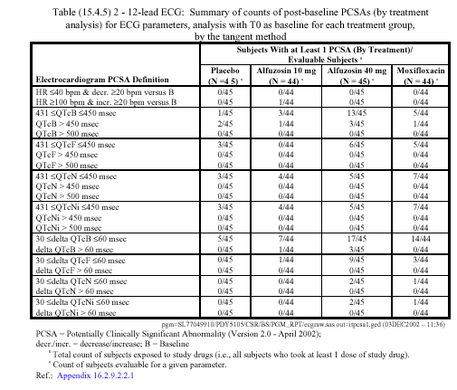
Table 5.

Ten subjects in the placebo, alfuzosin 10 mg, and alfuzosin 40 mg groups had potential clinical significant abnormality (PCSAs) of QTcB or delta QTcB. These abnormalities were not found when using other formulae (QTcF, QTcN, and QTcNi) to calculate the QT in case of HR >60 bpm.

Three subjects had QTcB over 450 msec after 40 mg alfuzosin administration.
Three subjects had delta QTcB over 60 msec after 40 mg alfuzosin administration.
One subject had QTcB over 450 msec and delta QTcB over 60 msec after 10 mg alfuzosin administration.

Three subjects not treated with alfuzosin had QTcB over 450 msec (1 after moxifloxacin 400 mg administration and 2 after placebo administration).

With regard to QTcF, no patient had a value >450 msec in any treatment group. No patient had a delta QTcF of > 60 msec and 13 patients had a delta QTcF of between 30 and 60 msec (1 with alfuzosin 10 mg, 9 with alfuzosin 40 mg, and 3 with moxifloxacin).

With regard to QTcN, no patient on either dose of alfuzosin had a QTcN >450 msec or a delta QTcN > 60 msec. No patient on either dose of alfuzosin had a QTcNi > 450 msec or a delta QTcNi > 60 msec.

B. Vardenafil: In response to the approvable letter, the sponsor submitted the results of Trial 10929. The primary objective of this study was to rule out a greater than 10 msec effect (i.e. to demonstrate lack of effect) of a single 80 mg oral dose of vardenafil on QTc interval compared to placebo, as measured by the change from baseline at the 1 hour post-dose time point. The 80 mg dose was chosen because the sponsor believed that maximum plasma concentrations achieved with this dose were above the maximum plasma levels achieved with 5 mg vardenafil (the lowest proposed to-be-marketed dose) and potent CYP 3A4 inhibition (with ritonavir, which increases Cmax by nearly 13 fold). (The to-be-marketed doses of vardenafil are 5, 10, and 20 mg). The one hour time point was chosen because this approximates T_{max}. Secondary objectives were to: 1) characterize the effect of a single 80 mg oral dose of vardenafil on QTc interval compared to placebo, as measured by the change from baseline at the time of maximum concentration (T_{max}), 2) to characterize the effect of a single oral dose of 400 mg of moxifloxacin on QTc interval relative to placebo, 3) characterize the effect on QTc relative to placebo of single oral doses of 10 mg of vardenafil and of 50 and 400 mg of sildenafil, 4) characterize the effect on QT and HR relative to placebo of single oral doses of 400 mg of moxifloxacin, 10 and 80 mg of vardenafil and of 50 and 400 mg of sildenafil, 5) characterize the pharmacokinetics of vardenafil, sildenafil and moxifloxacin, and 6) explore the relationship between vardenafil, sildenafil and moxifloxacin exposure versus ECG parameters (QTc, QT intervals and HR).

The trial was a double-blind, randomized, single-dose, 6-way crossover, period-balanced study in healthy adult males. Each subject participated in 6 study sessions separated by a minimum washout period of at least 3 days. Each subject received the following six regimens in a randomized crossover fashion (AFBECD, BACFDE, CBDAEF, DCEBFA, EDFCAB, or FEADBC). (Table 6)

Table 6. Regimen description
Regimen | Regimen Description
A | Vardenafil 10 mg
B | Vardenafil 80 mg
C | Sildenafil 50 mg
D | Sildenafil 400 mg
E | Moxifloxacin 400 mg
F | Placebo
Source: Study report 10929, page 11.

The study population consisted of healthy adult men between 45 and 60 years of age. Sixty men were enrolled and one man withdrew prior to dosing. Data from 59 subjects are included in the statistical analysis.

Six 12-lead ECGs taken approximately 1 minute apart were obtained at specified times (-0.5, -0.25, predose, 1, 1.5, 2.5, and 4 hours). Conduction intervals from the 12-lead ECGs were manually read and confirmed by an external cardiologist. All ECGs were read blinded. The final conduction intervals entered into the database were those generated by the over-reading cardiologist. Patients were not dosed if the pre-dose ECG showed either PR interval > 240 msec or ≤ 110 msec; or QTc > 440 msec. Blood samples for pharmacokinetic analysis of vardenafil, sildenafil and moxifloxacin were collected from each subject at times 0, 0.5, 1, 1.5, 2.5, and 4 hours following single oral administration on Day 1 of each period.

The primary endpoint was the change in Fridericia's correction formula (QTcF=QT/RR^{1/3}) from baseline at 1 hour post-dose. QTc at 1 hour post-dose was determined from the average of the 6 replicate measurements taken at 1 hour post-dose and baseline QTc was determined from the average of all 18 pre-dose measurements. Secondary endpoints included change from baseline at the time of maximum concentration (T_{max}), raw QT intervals and heart rate, and individually corrected QT intervals (QTci). QTci is calculated using the formula QTci = QT + [b*(1-RR)]. The variable “b” was obtained from fitting each subject’s data into the linear regression model QT= a + b * RR, where RR=60/HR. Based on median values, T_{max} occurred at approximately 1.2 hour postdose following oral 10 and 80 mg vardenafil. Exploratory endpoints included maximum change from baseline and time averaged change from baseline.

The change in heart rate at one hour post-dose is shown in Table 7.

Table 7. Change from Baseline in HR (bpm) at 1 hour post-dose
Regimen | Means¹ (s.e.) | Comparison | Point Estimate² |  | 90% CI
Placebo | -3 (0.5)
Primary Comparison:
80 mg vardenafil | 3 (0.5) | 80 mg vardenafil Placebo | 6 |  | (5, 7)
Secondary Comparison:
10 mg vardenafil | 2 (0.5) | 10 mg vardenafil Placebo | 5 |  | (4, 6)
50 mg sildenafil | 1 (0.5) | 50 mg sildenafil Placebo | 4 |  | (3, 5)
400 mg Sildenafil | 2 (0.5) | 400 mg sildenafil Placebo | 5 |  | (4, 6)
400 mg moxifloxacin | -1 (0.5) | 400 mg moxifloxacin Placebo | 2 |  | (1, 3)
1 represents adjusted arithmetic mean 2 represents difference between arithmetic means
Note: above results are rounded to the nearest integer (accounts for apparent discrepancies between means and point
estimates and asymmetry of CI). |  | Source: Study report 10929. Table 15, page 62.

1. Change in QTcF and QTci at one hour, Sponsor analyses:

Change in QTcF:

Point estimates and 90% confidence intervals for change from baseline at 1 hour
post-dose for QTc corrected using Fridericia’s formula and QTCi are provided in Tables 8 and 9.

Table 8: Change from baseline in QTcF (msec) at 1 hour post-dose
Regimen | Means¹ (s.e.) | Comparison | Point Estimate² | 90%CI
Placebo | 0 (0.7)
Primary Comparison:
80 mg vardenafil | 10 (0.7) | 80 mg vardenafil Placebo | 10 | (8, 11)
Secondary Comparison:
10 mg vardenafil | 8 (0.7) | 10 mg vardenafil Placebo | 8 | (6, 9)
50 mg sildenafil | 7 (0.7) | 50 mg sildenafil Placebo | 6 | (5, 8)
400 mg Sildenafil | 9 (0.7) | 400 mg sildenafil Placebo | 9 | (8, 11)
400 mg moxifloxacin | 8 (0.7) | 400 mg moxifloxacin Placebo | 8 | (6, 9)
1 represents adjusted arithmetic mean 2 represents difference between arithmetic means Note: above results are rounded to the nearest integer. Source: Study report 10929. Table 12, page 60.

Table 9: Change from Baseline in QTci (msec) at 1 hour post-dose
Regimen | Means¹ (s.e.) | Comparison |  | Point Estimate² | 90% CI
Placebo | 2 (0.7)
Primary Comparison:
80 mg vardenafil | 8 (0.7) | 80 mg vardenafil Placebo |  | 6 | (4, 7)
Secondary Comparison:
10 mg vardenafil | 6 (0.7) | 10 mg vardenafil Placebo |  | 4 | (3, 6)
50 mg sildenafil | 6 (0.7) | 50 mg sildenafil Placebo |  | 4 | (2, 5)
400 mg Sildenafil | 7 (0.7) | 400 mg sildenafil Placebo |  | 5 | (4, 7)
400 mg moxifloxacin | 9 (0.7) | 400 mg moxifloxacin Placebo |  | 7 | (5, 8)
1 represents adjusted arithmetic mean 2 represents difference between arithmetic means
Note: above results are rounded to the nearest integer (accounts for apparent discrepancies between means and point
estimates and asymmetry of CI). |  | Source: Study report 10929. Table 13, page 61.

QTcF and QTci were also determined at Tmax and the difference for each drug and dose in comparison to placebo and are shown in Tables 10 and 11.

Table 10. Change from baseline in QTcF (msec) at Tmax post-dose
Regimen | Comparison | Point Estimate¹ | 90% CI
Primary Comparison:
80 mg vardenafil | 80 mg vardenafil Placebo | 9 | ( 8, 11)
Secondary Comparison:
10 mg vardenafil | 10 mg vardenafil Placebo | 7 | ( 5, 9)
50 mg sildenafil | 50 mg sildenafil Placebo | 6 | (5, 8)
400 mg Sildenafil | 400 mg sildenafil Placebo | 6 | ( 4, 7)
400 mg moxifloxacin | 400 mg moxifloxacin Placebo | 8 | ( 7, 10)
1 represents difference between arithmetic means Source: Study report 10929. Table 16, page 63.

Table 11. Change from baseline in QTci (msec) at Tmax post-dose
Regimen | Comparison | Point Estimate¹ | 90% CI
Primary Comparison:
80 mg vardenafil | 80 mg vardenafil Placebo | 6 | (5, 8)
Secondary Comparison:
10 mg vardenafil | 10 mg vardenafil Placebo | 3 | (2, 5)
50 mg sildenafil | 50 mg sildenafil Placebo | 3 | (2, 5)
400 mg Sildenafil | 400 mg sildenafil Placebo | 5 | (3, 6)
400 mg moxifloxacin | 400 mg moxifloxacin Placebo | 7 | (6, 9)
1 represents difference between arithmetic means Source: Study report 10929. Table 17, page 63.

3. Outlier analysis for vardenafil, Sponsor analyses:

There were no uncorrected QT values > 500 msec.

- QTcF

QTcF > 450 msec:
There were no QTcF values > 450 msec in any of the drug groups, including moxifloxacin.

QTcF increase > 60 msec:
There were no mean differences (average of 6 recordings) greater than 60 msec for any subject or drug.

QTcF increase > 30 msec:
There was 1 subject with a mean difference (average of 6 recordings) of QTcF > 30 msec in the change from baseline following sildenafil 400mg at 1 hr post-dose.

There were 62 occurrences out of 10440 recordings of change from baseline > 30 msec. For each drug and drug dose there were 1740 total values and these 62 occurrences were seen in 20 of the 60 subjects. Out of these 62 data points, 10 were in 10 mg vardenafil group, 16 were in 80 mg vardenafil group, 10 were in 50 mg sildenafil group, 8 in 400 mg sildenafil group, 16 were in 400 mg moxifloxacin group and 2 in placebo group. Results are shown in Table 12 and Table 13 (Top number in each column cell is number of recordings and bottom number is percentage of events.).

Table 12. Occurrences of Changes from Baseline Greater than 30msec in QTcF
Frequency  Percent |  |  | Regimen
Frequency  Percent | A | B | C | D | E | F | Total
QTcF < 30  msec | 1730 | 1724 | 1730 | 1732 | 1724 | 1738 | 10378
QTcF < 30  msec | 99.43 | 99.08 | 99.43 | 99.54 | 99.08 | 99.89 | 99.41
^{QTcF} ≥ 30 msec  and < 60 msec | 10 | 16 | 10 | 8 | 16 | 2 | 62
^{QTcF} ≥ 30 msec  and < 60 msec | 0.57 | 0.92 | 0.57 | 0.46 | 0.92 | 0.11 | 0.59
Total | 1740 | 1740 | 1740 | 1740 | 1740 | 1740 | 10440
Regimen A = Vardenafil 10 mg; Regimen B = Vardenafil 80 mg; Regimen C = Sildenafil 50
mg; Regimen D = Sildenafil 400 mg; Regimen E = Moxifloxacin 400 mg; Regimen F = Placebo
Source: Study 10929, table 30, page 70.

Table 13. Number of subject-sessions with changes from baseline greater than 30 msec in QTcF (individual recordings)
Frequency  Percent |  |  | Regimen
Frequency  Percent | A | B | C | D | E | F | Total
QTcF < 30  msec | 51 | 49 | 53 | 53 | 49 | 56 | 311
QTcF < 30  msec | 14.53 | 13.96 | 15.10 | 15.10 | 13.96 | 15.95 | 89.37
QTcF ≥ 30 msec  and < 60 msec | 7 | 9 | 5 | 5 | 9 | 2 | 37
QTcF ≥ 30 msec  and < 60 msec | 1.99 | 2.56 | 1.42 | 1.42 | 2.56 | 0.57 | 10.63
Total | 58 | 58 | 58 | 58 | 58 | 58 | 348
Regimen A = Vardenafil 10 mg; Regimen B = Vardenafil 80 mg; Regimen C = Sildenafil 50
mg; Regimen D = Sildenafil 400 mg; Regimen E = Moxifloxacin 400 mg; Regimen F = Placebo
Source: Study 10929, table 31, page 70.

- QTci

QTci > 480 msec:
There were no occurrences of QTci > 480 msec.

QTci >450 msec:
There were 24 out of 16749 (0.14%) occurrences of QTci greater than 450 msec (but less than or equal to 480 msec). These 24 occurrences were seen in 3 out of 58 subjects. Out of these 24 data points, 3 were in 80 mg vardenafil group (range 450-461 msec), 19 were in 50 mg sildenafil group (range 450-461 msec) and 2 were in 400 mg moxifloxacin group (range 451-458 msec).

QTci > 60 msec:
There were no mean differences (average of 6 recordings) greater than 60 msec at 1 hr post-dose.

QTci > 30 msec:
Although there were no mean differences (average of 6 recordings) greater than 30 msec at 1 hr post-dose, of 10440 recordings, there were 30 occurrences (0.29%) of individual changes from baseline greater than 30 msec. For each drug and drug dose there were 1740 total values and these 30 occurrences were seen in 20 of the 58 subjects (see Table 14 and Table 15). Out of these 30 data points, 2 were in the 10 mg vardenafil group, 4 were in the 80 mg vardenafil group, 1 was in the 50 mg sildenafil group, 4 in the 400 mg sildenafil group, 18 were in the 400 mg moxifloxacin group and 1 in the placebo group. The number of subjects in each group with these changes is summarized below in Table 15.

Table 14. Occurrences of changes from baseline greater than 30 msec in QTCi (Top number in each column is number of recordings and bottom number is percentage of events.).
Frequency  Percent | Regimen
Frequency  Percent | A | B | C | D | E | F | Total
QTci < 30  msec | 1738 | 1736 | 1739 | 1736 | 1722 | 1739 | 10410
QTci < 30  msec | 99.89 | 99.77 | 99.94 | 99.77 | 98.97 | 99.94 | 99.71
^{QTci} ≥ 30 msec  and < 60 msec | 2 | 4 | 1 | 4 | 18 | 1 | 30
^{QTci} ≥ 30 msec  and < 60 msec | 0.11 | 0.23 | 0.06 | 0.23 | 1.03 | 0.06 | 0.29
Total | 1740 | 1740 | 1740 | 1740 | 1740 | 1740 | 10440
Regimen A = Vardenafil 10 mg; Regimen B = Vardenafil 80 mg; Regimen C = Sildenafil 50
mg; Regimen D = Sildenafil 400 mg; Regimen E = Moxifloxacin 400 mg; Regimen F =
Placebo Source: Study 10929, table 32, page 71.

Table 15. Number of subject-sessions with changes from baseline greater than 30 msec in QTci (individual recordings)
Frequency  Percent |  |  |  | Regimen
Frequency  Percent | A | B | C | D | E | F | Total
QTci < 30  msec | 56 | 54 | 57 | 56 | 48 | 57 | 328
QTci < 30  msec | 96.55 | 93.10 | 98.28 | 96.55 | 82.76 | 98.28 | 94.25
^{QTci} ≥ 30msec  and < 60 msec | 2 | 4 | 1 | 2 | 10 | 1 | 20
^{QTci} ≥ 30msec  and < 60 msec | 3.45 | 6.90 | 1.72 | 3.45 | 17.24 | 1.72 | 5.75
Total | 58 | 58 | 58 | 58 | 58 | 58 | 348
Regimen A = Vardenafil 10 mg; Regimen B = Vardenafil 80 mg; Regimen C = Sildenafil 50
mg; Regimen D = Sildenafil 400 mg; Regimen E = Moxifloxacin 400 mg; Regimen F =
Placebo source: Study 10929, table 33, page 71.

VI. FDA review of the QT data:

A. Effect of alfuzosin on QT interval: FDA data analysis

The QT interval is inversely related to heart rate. To determine the effect of drug on intrinsic duration of QT interval independent of associated heart rate changes, various methods of QT interval corrections are generally used. The sponsor has used the following methods to correct the measured QT interval from 12-Lead ECG recordings:

- Bazett’s correction (QTcB = QT/RR^{1/2})
- Fridericia’s correction (QTcF = QT/RR^{1/3})
- Population-specific correction (QTcN = QT/RR^{B})
- Subject-specific correction (QTcNi = QT/RR^{Bi})

Bazett and Fridericia methods of correction are commonly used methods.
For the population-specific correction method, the relationship between QT and RR-interval was assessed by fitting the Day 3 placebo on-treatment period data (12 recordings per subject) to the log-transformed power model: Log QT = Log A + B Log RR + error.

For the subject-specific correction method, the relationship between QT and RR-interval was assessed by fitting the Day 3 placebo on-treatment period data and Day 2 run-in placebo data of each period (55 recordings per subject) to the log-transformed power model: Log QT = Log Ai + B Log RR + error.

The resulting mean estimated B value (the exponent in the correction formula) for the population- specific method was 0.23767 and the mean estimated Bi value for individual-specific method was 0.24060 (range: 0.19939 – 0.28717) as opposed to a value of 0.33 for the Fridericia correction method.

The purpose of the QT correction methods is to make the measured QT intervals independent of heart rate (RR intervals). Ideally after applying the correction method, the slope of QTc versus RR interval should be horizontal (zero slope).
The relationship between uncorrected QT and RR intervals and corrected QT and RR intervals using the various correction methodologies for all subjects on placebo is shown in Figure’s 1 and 2, respectively.

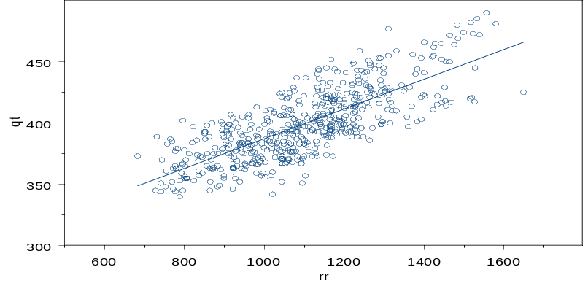
Figure 1. Uncorrected QT for all subjects on placebo versus RR interval

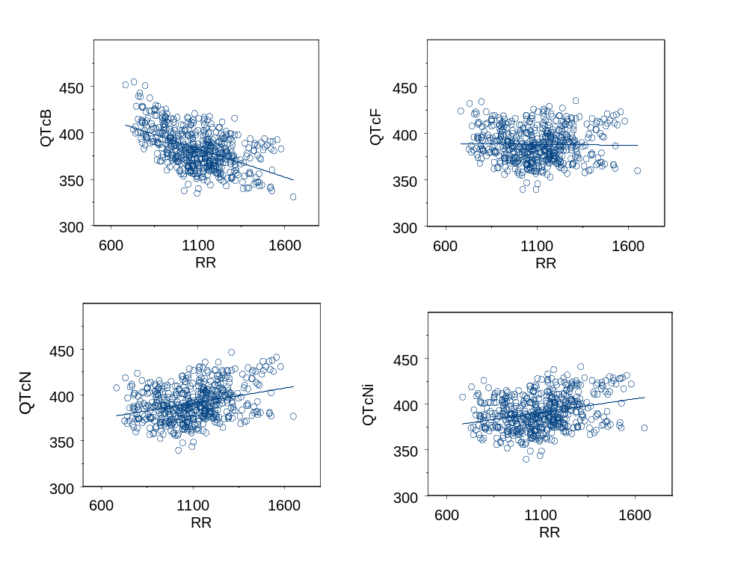Figure 2. Relationship between corrected QT and RR intervals for various methods of correction for all subjects on placebo (Bazett: QTcB, Fridericia: QTcF, population: QTcN and subject-specific: QTcNi)

As expected, the uncorrected QT is positively correlated with RR interval. After applying the Bazett correction, there is a significant negative slope. With Fridericia correction the slope appears to be close to zero when compared to population and subject specific methods of correction for which positive slopes are noted. In order to further explore these methods of correction, the linear regression slopes of QTc versus RR relationship for each subject, with each method was estimated and shown in Figure 3.

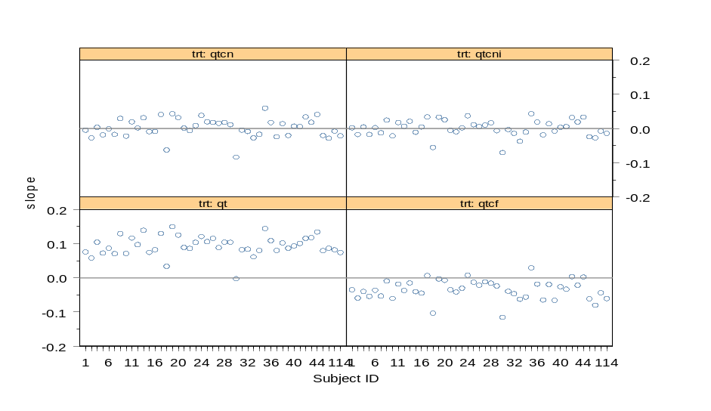
Figure 3: Slopes of QT versus RR relationship for each individual subject before correction (trt:qt) and after Fridericia (trt:qtcf), population specific (trt:qtcn) and subject-specific (trt:qtcni) correction methods.

The slopes for uncorrected QT vs. RR are greater than zero, as expected. For the population and individual correction methods the slopes are closer to zero when compared to the Fridericia correction method, where the slopes are mostly below zero. This analysis suggests, in this data set, contrary to the graphs in Figure 2, that population and individual methods may more accurately correct the QT interval for heart rate. The reason why a positive slope is noted for population and individual correction methods in Figure 2 when all QTc data are plotted against RR interval may be related to inter- individual differences in the range and distribution of RR intervals.

QT measurements obtained from three recordings from each subject at –1 hr (1 hour before each treatment) on Day 3 of the study constituted the “baseline” QT measurement. To compute QT/QTc change from baseline, the average of the three QT/QTc measurements at –1 hr was subtracted from all the measurements obtained following each treatment. The mean change in QTc (based on Fridericia and subject-specific corrections) from baseline following each treatment are shown in Figure 4 below.

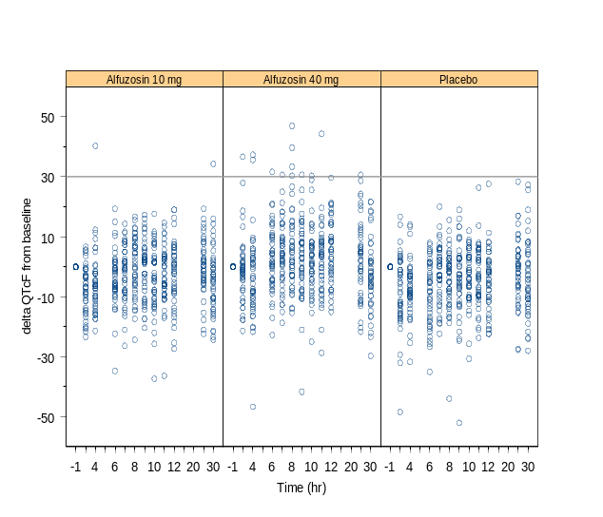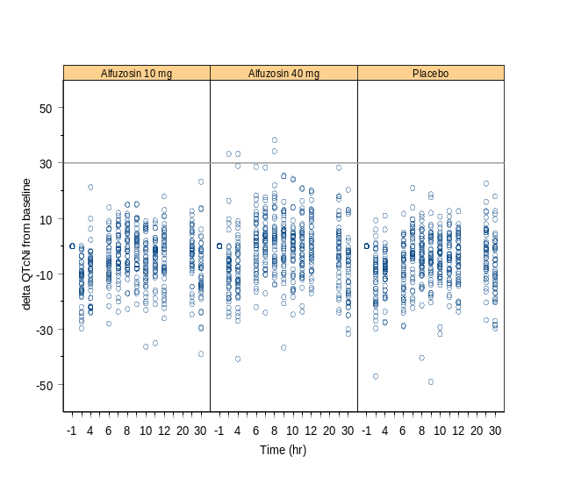

Figure 4. Individual changes in QTc (QTcF and QTcNi) from baseline all observations for all subjects following alfuzosin 10 and 40 mg compared to placebo [Baseline is defined as average of three measurements at 1 hr before administering each treatment. Note that data points above the reference line at 30 on Y –axis are observations of delta QTc values ≥30 msec. The number of outlier subjects may be different in Table 18 because it tabulates number of subjects

Mean changes in various ECG parameters from baseline are summarized in Table 16.

Table 16. 12-Lead ECG: Change from baseline at Tmax
ECG Parameter | Treatment | Mean change Vs Placebo | Mean change | Matched Placebo | 95% CI
 |  |  |  |  | Lower  Bound | Upper  bound
HR (Bpm) | Alfuzosin 10 mg  Alfuzosin 40 mg  Moxifloxacin 400 mg | 5.2  5.8  2.8 | 5.7  6.9  2.3 | 0.6  1.0  -0.5 | 2.2  3.2  1.3 | 8.3  8.4  4.2
QT interval (msec) | Alfuzosin 10 mg  Alfuzosin 40 mg  Moxifloxacin 400 mg | -5.8  -4.2  6.9 | -13.9  -10.7  5.5 | -8.4  -6.5  -1.3 | -10.2  -8.5  2.3 | -1.4  0.2  11.5
Bazett QTc (msec) | Alfuzosin 10 mg  Alfuzosin 40 mg  Moxifloxacin 400 mg | 10.2  13.9  15.7 | 4.7  11.9  13.4 | -5.3  -2.0  -2.3 | 3.9  5.8  10.8 | 16.6  22.0  20.6
Fridericia QTc (msec) | Alfuzosin 10 mg  Alfuzosin 40 mg  Moxifloxacin 400 mg | 4.9  7.7  12.7 | -1.5  4.3  10.8 | -6.3  -3.4  -1.9 | 0.9  1.9  8.6 | 8.8  13.5  16.8
QTcN (msec | Alfuzosin 10 mg  Alfuzosin 40 mg  Moxifloxacin 400 mg | 1.8  4.2  11.0 | -5.0  -0.1  9.4 | -6.8  -4.3  -1.6 | -1.4  -0.6  7.0 | 5.0  9.0  15.0
QTcNi (msec) | Alfuzosin 10 mg  Alfuzosin 40 mg  Moxifloxacin 400 mg | 1.8  4.3  11.1 | -4.7  0.1  9.4 | -6.6  -4.2  -1.7 | -1.3  -0.5  7.2 | 5.0  9.2  15.0

Mean changes in corrected QT from baseline at the time of maximum alfuzosin or moxifloxacin plasma concentrations for different methods of correction are presented in Table 17. This table includes the sponsor’s correction using QT interval measurements from continuous 3-lead holter monitor during the window of 7 to 11 hours (corresponding to T_{max} of alfuzosin ER tablets) by a selective beat average method, which were data the FDA did not reanalyze.

Table 17. Mean QTc change from baseline at Tmax (corrected for placebo)
Treatment | Fridericia (QTcF) | Population  (QTcN) | Individual  (QTcNi) | Holter Monitor  (Largest sample RR bins)
Alfuzosin 10 mg | 4.9 | 1.8 | 1.8 | 0.4
Alfuzosin 40 mg | 7.7 | 4.2 | 4.3 | 2.5
Moxifloxacin 400 mg | 12.7 | 11.0 | 11.1 | 6.9

As noted in Table 17, the mean changes in placebo corrected QTc for alfuzosin 10 mg (4.9 msec) and 40 mg (7.7 msec) doses based on Fridericia method were almost double those seen with population (1.8, 4.2 msec) and subject-specific (1.8, 4.3 msec) methods. However, for moxifloxacin, the differences in mean change in placebo corrected QTc for these different correction methods are small. This may be because moxifloxacin was associated with smaller increases in heart rate compared to alfuzosin (see Table 16) and consequently different correction methods may have yielded smaller differences in corrected QTc for moxifloxacin.

The mean changes in placebo corrected QTc from baseline with all methods of correction are dose dependent for alfuzosin, with higher change at the 40 mg dose compared to 10 mg. The mean QT interval changes from baseline for the Holter monitor method (as analyzed by the sponsor) were smaller than the 12-lead ECG measurements with various calculated correction methods.

The outliers for the different methods of correction (not including the sponsor’s Holter monitor methodology results) are presented below in Table 18.

Table 18. Outliers for corrected QTc interval and change in QTc from baseline
Outlier definition | Number of subjects with at least one outlier value
Outlier definition | Placebo  (N=45) | Alfuzosin 10 mg  (N=44) | Alfuzosin 40 mg  (N=45) | Moxifloxacin  (N=44)
431≤QTcB≥450 msec  QTcB≥450 msec  QTcB≥500 msec | 1  2  0 | 3  1  0 | 13  3  0 | 5  1  0
431≤QTcF≥450 msec  QTcF≥450 msec  QTcF≥500 msec | 3  0  0 | 0  0  0 | 6  0  0 | 5  0  0
431≤QTcN≥450 msec  QTcN≥450 msec  QTcN≥500 msec | 3  0  0 | 4  0  0 | 5  0  0 | 7  0  0
431≤QTcNi≥450 msec  QTcNi≥450 msec  QTcNi≥500 msec | 3  0  0 | 4  0  0 | 5  0  0 | 7  0  0
30≤deltaQTcB≥60 msec  deltaQTcB≥60 msec | 5  0 | 7  1 | 17  3 | 14  0
30≤deltaQTcF≥60 msec  deltaQTcF≥60 msec | 0  0 | 1  0 | 9  0 | 3  0
30≤deltaQTcN≥60 msec  deltaQTcN≥60 msec | 0  0 | 0  0 | 2  0 | 1  0
30≤deltaQTcNi≥60 msec  deltaQTcNi≥60 msec | 0  0 | 0  0 | 2  0 | 1  0

There were one subject at 10 mg and 9 subjects at 40 mg doses of alfuzosin with the Fridericia method who are outliers at 30≤deltaQTc≥60 msec and there were two subjects at the 40 mg dose of alfuzosin with population and subject-specific methods of correction who were outliers. There were no outliers with placebo.

There were no outliers using a cut-off of delta QTc ≥ 60 msec or QTc≥450 msec with any correction method (except for the Bazett method) or with any treatment.

Effect of vardenafil on QT interval: data analysis

The sponsor used two methods to correct measured QT intervals:

1. Fridericia’s correction QTcF = QT/RR^{1/3}
Baseline and placebo measures of QT, RR used.
2. Individual correction QTcI = QT+[b*(1-RR)]
Baseline and placebo measures of QT, RR used.

In addition to verifying these two sponsor analyses, FDA conducted an exploratory third correction method that is mathematically the same as the sponsor’s individual correction method, except that the placebo data were excluded from the analysis, i.e. the data used for the correction was limited to baseline data points. This exploratory analysis was performed to examine the impact of the sponsor’s inclusion of the placebo data points in their correction.

3. Individual correction #2 (FDA’s analysis, QTcI.2)
QTcI.2 = QT+[b*(1-RR)]
Only baseline measures of QT, RR used.

Both an analysis of central tendency and an outlier analysis are presented with respect to the sponsor’s corrections (QTcF and QTcI) and the FDA’s individual correction performed with respect to baseline data (not placebo) only (QTcI.2).

To perform the individual correction, a unique “b” is obtained for each individual by estimating the slope relating each individual’s QT and RR data in the linear model: QT=a+b*RR. This model has been discussed in the literature¹ where only pre-dose baseline data were used to estimate “b.” The sponsor used data obtained both at baseline and while on placebo to estimate “b”.

The sponsor used a total of 138 measurements of QT and RR taken in each individual to obtain that individual’s “b”. Of the 138 measurements, 108 come from pre-dose (“baseline”) data—6 measurements each of QT and RR were taken in each individual at 3 time points before dosing for each of the six regimens (vardenafil 10 mg, vardenafil 80 mg, sildenafil 50 mg, sildenafil 400 mg, moxifloxacin, and placebo). The remaining 30 of the 138 measurements come from placebo data—6 measurements each of QT and RR were taken in each individual at 5 time points after dosing placebo (hours 0.5, 1.0, 1.5, 2.5 and 4.0). Likewise, the slope “b” for the FDA’s individual correction method #2 is obtained by linear regression of QT on RR for the 108 pre-dose (“baseline”) data points.

The goal of QT correction is to make measured QT intervals independent of heart rate (or RR intervals, where RR=60/heart rate). Figures 5 and 6 show the trend between QT and RR for all subjects and demonstrate that correction is necessary regardless of whether baseline and placebo QT data (Figure 5) or baseline only QT data (Figure 6) are used.

Figure 5. Uncorrected QT vs. RR for all subjects; baseline and placebo data.
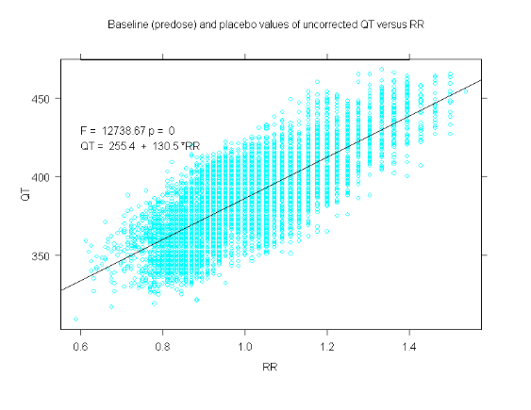

Figure 6. Uncorrected QT vs. RR for all subjects; baseline data.
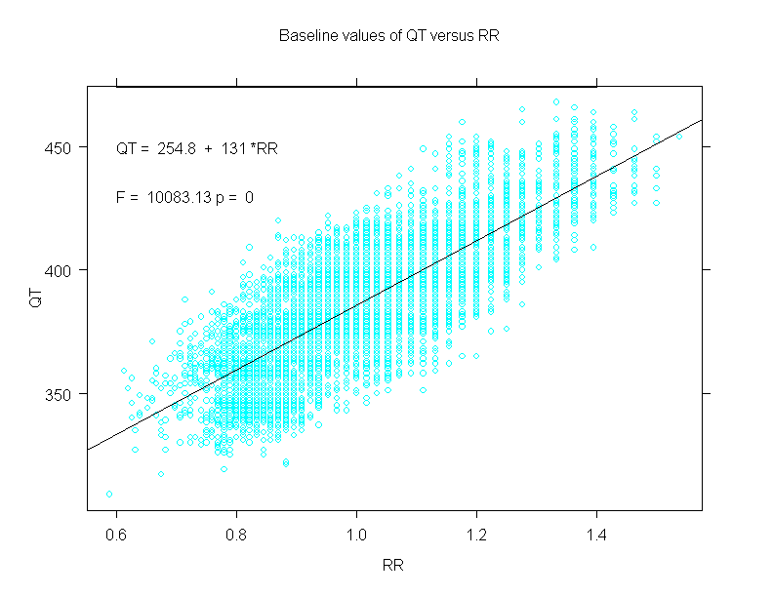
To evaluate a particular QT correction method’s ability to make corrected QTc intervals independent of heart rate, the linear regression slope of the relationship between the corrected QT interval (QTc; here QTcF, QTcI, and QTcI.2) and RR is estimated. The slopes of the QTc versus RR relationship for each method when all subjects’ QT and RR data are pooled are shown in Figures 7 (QTcF) and 8 (QTcI and QTcI.2). Figure 7 shows that the slope of QTcF vs. RR is 3.8. In Figure 8(A), the plot of QTcI vs. RR, and Figure 8(B), the plot of QTcI.2 vs. RR, have slopes of 51.6 and 57.5, respectively. From this perspective (pooling then fitting all individuals’ QTc,RR data), the Fridericia correction method appears to be the most appropriate correction method since it yields a slope closer to zero than the individual correction methods.

Figure 7. All subjects’ Fridericia corrected QT (QTcF) and RR data; Placebo and baseline data used.
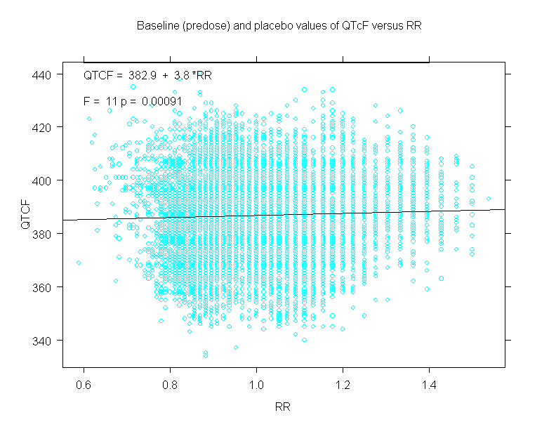
Figure 8. All subjects’ Individual corrected QT and RR data; (A) QTcI: Placebo and baseline data used, (B) QTcI.2: Baseline data used.

(A) QTcI (B) QTcI.2
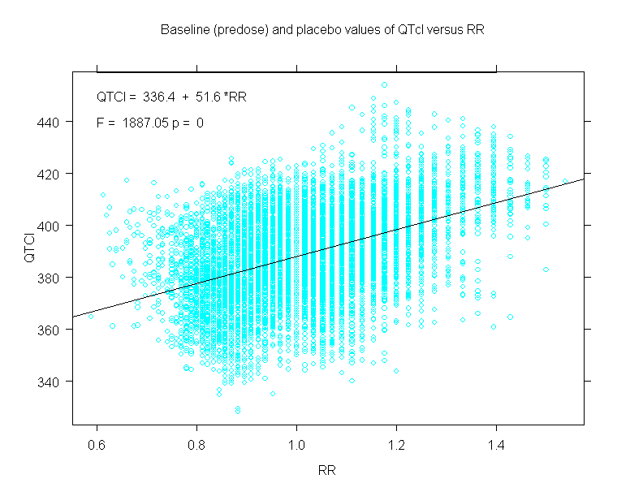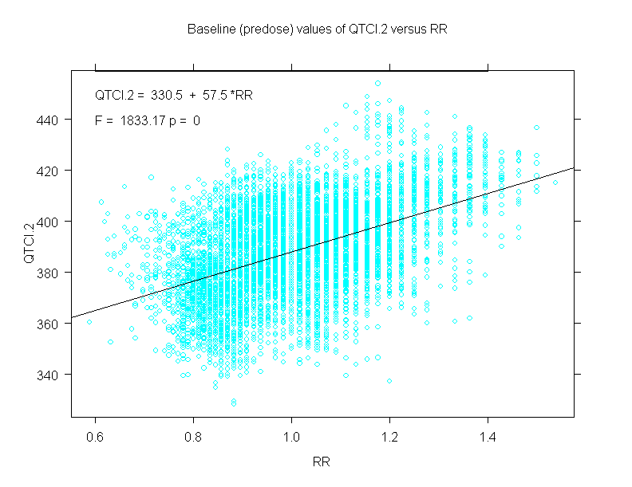

A different result is obtained if separate linear regressions are performed on each individual’s set of QTc, RR data. In Figures 9 (A) and (B) below, plots of the slope of the linear regression of each individual’s (A) QTcI and (B) QTcI.2 versus RR data show that both individual correction methods yield approximately a zero slope when each individual’s QTcI or QTcI.2 and RR data are fit to a linear model. The QTcI vs. RR slopes range from -3.4x10⁻¹⁰ to 3.4x10⁻¹⁰, while the QTcI.2 vs. RR slopes range from -6.9x10⁻¹³ to 9.9x10⁻¹³. In Figure 10, a plot of the slope of the linear regression of each individual’s QTcF versus RR data shows that Fridericia’s correction yields slopes ranging from –115.9 to 40.6. These slopes are larger than when all QTcF, RR data were pooled and modeled (compare the range of these slopes to the slope of 3.8 reported in Figure 7). From this perspective (examining the slope of each individual’s QTc,RR data), the individual correction methods appear more appropriate than the Fridericia correction method in correcting QT for HR.

Figure 9. Evaluation of the Individual correction methods. (A) Slope of QTcI vs. RR for each individual (placebo and baseline data used). (B) Slope of QTcI.2 vs. RR for each individual (only baseline data used).
(A) QTcI (B) QTcI.2

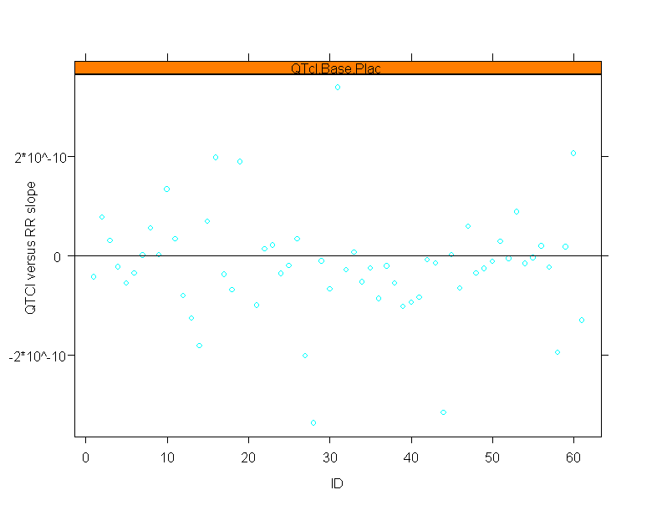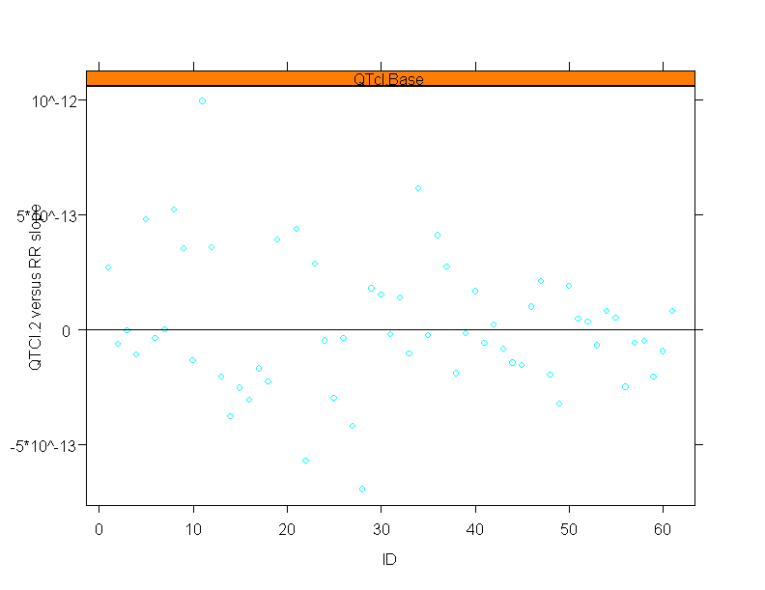

Figure 10. Evaluation of the Fridericia correction method. Slope of QTcF intervals vs. RR for each individual.

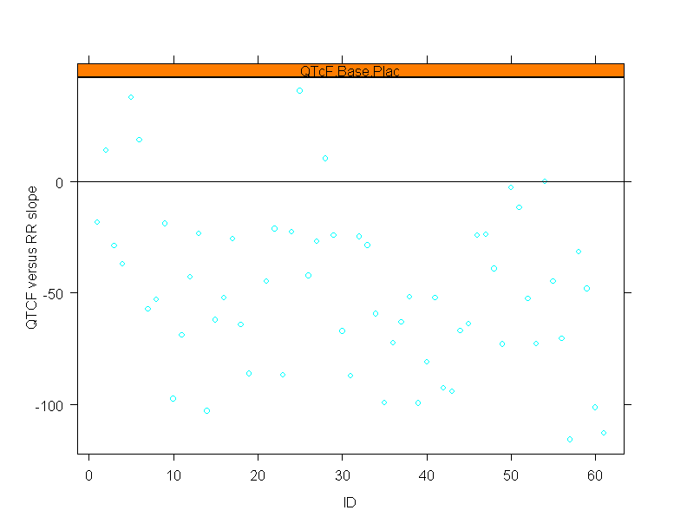

Depending on the manner in which the correlation between QTc and RR is evaluated (by estimating the slope of pooled QTc,RR data versus by estimating the slopes of each individual’s QTc,RR data), either the Fridericia or the individual correction method can be deemed more appropriate. In the circumstance where the individual method appears to perform better than the Fridericia method, both individual correction methods yield QTc values having nearly zero correlation with RR (Figure 9; note that the axes are in units 10⁻¹⁰ , i.e. slopes are <1.0). Although the Fridericia method yields less of a correlation between QTc and RR than the individual method when all data are pooled, in that case, the slope of QTcF versus RR (Figure 7) is 3.8, not zero.

Analysis of Central Tendency

Baseline QT/QTc (and HR) for each individual for each regimen was obtained by averaging each individual’s eighteen pre-dose recordings for a given regimen. The mean QT/QTc (and HR) at 1 hour post-dose for each individual for each regimen was obtained by averaging each individual’s 6 measures of QT/QTc (and HR) at 1 hour post-dose for a given regimen. Change in QT/QTc (and HR) from baseline at 1 hour post dose was computed by subtracting each individual’s baseline QT/QTc (and HR) from the their mean QT/QTc (and HR) at 1 hour post-dose.

The mean changes in heart rate and QT interval from baseline at 1 hour post-dose for each regimen is shown in Table 19.

Table 19. Mean change (95% CI) in Heart Rate and Uncorrected QT interval from baseline for each study arm at 1 hour.
 | Mean HR (bpm) | Mean QT (msec)
Vardenafil 10 mg | 2.07  (1.21,2.93) | 3.75  (1.94,5.56)
Vardenafil 80 mg | 2.87  (1.73,4.02) | 3.85  (1.78,5.92)
Sildenafil 50 mg | 1.22  (0.019,2.41) | 3.92  (1.45,6.39)
Sildenafil 400 mg | 2.00  (0.66,3.33) | 5.30  (3.42,7.18)
Moxifloxacin | -.79  (-1.74,0.16) | 9.61  (7.79,11.42)
Placebo | -2.64  (-3.35,-1.93) | 6.07  (4.38,7.75)

The mean change in corrected QT interval from baseline with placebo response subtracted out for each regimen is shown in Table 20. There is a dose-response relationship between the low and high doses of vardenafil regardless of the correction method used. By QTcF, the high dose of vardenafil causes more QT prolongation (9.76 and msec) than moxifloxacin (7.65 msec). This is not observed in either the QTcI or QTcI.2.

Note that the analysis of central tendency based on the QTcI correction are similar to the results of the QTcI.2 correction.

Table 20. Mean change (90% CI) in Fridericia and Individually corrected QT intervals from baseline for each treatment at 1 hour; relative to placebo.
 | QTcF | QTcI | QTcI.2
Vardenafil 10 mg | 7.71  (6.30,9.14) | 4.13  (2.69,5.57) | 4.07  (2.51,5.64)
Vardenafil 80 mg | 9.76  (8.37,11.14) | 5.79  (4.37,7.21) | 5.72  (4.13,7.31)
Sildenafil 50 mg | 6.26  (4.82,7.70) | 3.84  (2.27,5.40) | 3.83  (2.22,5.44)
Sildenafil 400 mg | 9.03  (7.56,10.50) | 5.45  (4.31,6.60) | 5.50  (4.29,6.72)
Moxifloxacin | 7.65  (6.33,8.98) | 6.62  (5.30,7.93) | 6.71  (5.36,8.05)

Outlier Analysis
The change from baseline of all QTc measures for all regimens was assessed for outliers. The number (and percent) of observations that increased greater than or equal to 30 msec QTc for each regimen and the number (and percent) of subjects for each regimen with at least one observation of QTc increase equal to or greater than 30 msec for each correction methodology are listed in Tables 21-23. (Note that due to study withdrawals, although 60 subjects were enrolled in the study, only 58 contributed data to the outlier analyses for each regimen.)

Table 21 shows the results of an outlier analysis for the Fridericia corrected QT. There is a dose-related change in the number of observations ≥30msec for vardenafil (10 mg vardenafil: 10 observations versus 80 mg vardenafil: 15 observations). The number of subjects with observations ≥30msec for the 80 mg dose of vardenafil was the same as observed for moxifloxacin (9 subjects). These are all greater than that observed for placebo (2 observations in 2 subjects). During the conduct of the study, when each patient’s exposure to all regimens was considered, it was 20 of 58 patients who experienced at least one observed outlier measurement.

Table 21. Outlier analysis: change in QTcF from baseline.
 | Vardenafil |  | Moxifloxacin | Placebo | Sildenafil
 | 10 mg | 80 mg |  |  | 50 mg | 400 mg
Total  Observations | 1740 | 1740 | 1740 | 1740 | 1740 | 1740
# < 30 msec | 1730 | 1725 | 1728 | 1738 | 1730 | 1733
(% < 30 msec) | (99.43) | (99.14) | (99.31) | (99.89) | (99.43) | (99.6)
# ≥ 30 msec | 10 | 15 | 12 | 2 | 10 | 7
(% ≥ 30 msec) | (0.57) | (0.86) | (0.69) | (0.11) | (0.57) | (0.4)
Total Subjects | 58 | 58 | 58 | 58 | 58 | 58
# ≥ 30 msec | 7 | 9 | 9 | 2 | 5 | 4
(% ≥ 30 msec) | (12.07) | (15.52) | (15.52) | (3.45) | (8.62) | (6.9)

Table 22 shows the results of the outlier analysis based on the sponsor’s individual corrected QT. There is a dose-response relationship in terms of the number of subjects with observations ≥ 30 msec for the low (2 subjects) versus the high doses of vardenafil (4 subjects) and in the number of observations ≥ 30 msec. The number of observations with a ≥ 30 msec change in QTcI for the low dose of vardenafil (2 observations) is less than that observed for moxifloxacin (17 observations) and is similar to placebo. In terms of the number of subjects with observations ≥ 30 msec, the low dose of vardenafil is comparable to placebo (2 subjects). This number is lower than that observed for moxifloxacin (10 subjects). The number of subjects (n=4) and observations (n=4) ≥ 30 msec associated with high dose vardenifil is less than that observed with moxifloxacin. During the conduct of the study, when each patient’s exposure to all regimens was considered, it was 17 of 58 patients who experienced at least one observed outlier measurement.

Table 22. Outlier analysis: change in QTcI from baseline.
 | Vardenafil |  | Moxifloxacin | Placebo | Sildenafil
 | 10 mg | 80 mg |  |  | 50 mg | 400 mg
Total  Observations | 1740 | 1740 | 1740 | 1740 | 1740 | 1740
# < 30 msec | 1738 | 1736 | 1723 | 1739 | 1738 | 1737
(% < 30 msec) | (99.89) | (99.77) | (99.02) | (99.94) | (99.89) | (99.83)
# ≥ 30 msec | 2 | 4 | 17 | 1 | 2 | 3
(% ≥ 30 msec) | (0.11) | (0.23) | (0.98) | (0.06) | (0.11) | (0.17)
Total Subjects | 58 | 58 | 58 | 58 | 58 | 58
# ≥ 30 msec | 2 | 4 | 10 | 1 | 2 | 2
(% ≥ 30 msec) | (3.45) | (6.9) | (17.24) | (1.72) | (3.45) | (3.45)

Table 23 shows the results of an outlier analysis with respect to the FDA individual correction of QT (QTcI.2; using baseline only QT and RR data). There are 2 subjects and 2 observations of ≥ 30 msec change in QTcI.2 for the low dose of vardenafil, which is similar to the number of subjects and observations ≥ 30 msec for placebo. Note that there is dose-related change in the number of observations ≥ 30 msec for vardenafil (13 observations for 80 mg dose versus 2 observations for 10 mg dose). The numbers are less than that observed for moxifloxacin (18 observations). A dose-related change in the number of subjects with observations ≥ 30 msec is also observed – 2 subjects with vardenifil 10mg vs. 8 subjects with vardenafil 80 mg. These numbers are lower than observed for moxifloxacin (12 subjects). During the conduct of the study, when each patient’s exposure to all regimens was considered, it was 20 of 58 patients who experienced at least one observed outlier measurement.

Table 23. Outlier analysis: change in QTcI.2 from baseline.
 | Vardenafil |  | Moxifloxacin | Placebo | Sildenafil
 | 10 mg | 80 mg |  |  | 50 mg | 400 mg
Total  Observations | 1740 | 1740 | 1740 | 1740 | 1740 | 1740
# < 30 msec | 1738 | 1727 | 1722 | 1738 | 1737 | 1735
(% < 30 msec) | (99.89) | (99.25) | (98.97) | (99.89) | (99.83) | (99.71)
# ≥ 30 msec | 2 | 13 | 18 | 2 | 3 | 5
(% ≥ 30 msec) | (0.11) | (0.75) | (1.03) | (0.11) | (0.17) | (0.29)
Total Subjects | 58 | 58 | 58 | 58 | 58 | 58
# ≥ 30 msec | 2 | 8 | 12 | 2 | 2 | 4
(% ≥ 30 msec) | (3.45) | (13.79) | (20.69) | (3.45) | (3.45) | (6.9)

Note that no subject on any regimen was observed to have a change in QTc >60 msec.

Table 24 shows the number of post-dose observations of QT and corrected QT interval greater than 450 msec for each regimen and correction methodology. Note that there were no observations of QT or corrected QT intervals greater than 480 msec for any regimen.

Table 24. Number of post-dose observations of QT/QTc greater than 450 msec.

 | Vardenafil |  | Moxifloxacin | Placebo | Sildenafil
 | 10 mg | 80 mg |  |  | 50 mg | 400 mg
Total  Observations | 1740 | 1740 | 1740 | 1740 | 1740 | 1740
QT > 450 msec | 2 | 43 | 51 | 39 | 38 | 8
QTcF > 450 msec | 0 | 0 | 0 | 0 | 0 | 0
QTcI >450 msec | 0 | 2 | 2 | 0 | 19 | 0
QTcI.2 > 450 msec | 0 | 2 | 3 | 0 | 19 | 0

Note that in Table 24 above a single patient, Patient #206, accounts for the two outlier observations at vardenifil 80 mg in the QTcI and QTcI.2 corrections, and the 19 outlier observations in the sildenafil 50 mg QTcI and QTcI.2 corrections. This patient was only exposed to these two drugs and at only these two dose levels in this study.

The results of an outlier analysis based on the sponsor’s individual correction method agree qualitatively with the results of the FDA’s correction method for both doses of vardenafil. However, the results differ quantitatively for the high dose of vardenafil. The number of observations of change in QTc from baseline ≥30msec appears identical (2 observations) for the 10 mg dose of vardenafil with respect to both individual correction methods, QTcI and QTcI.2. The number of subjects with a change in QTcI and QTcI.2 from baseline ≥30msec appears identical (2 observations) for the 10 mg dose of vardenafil, as well. The 80 mg dose of vardenafil appears to be associated with a greater number of observed changes in QTc≥30msec relative to the 10 mg dose by both individual correction methods. However, at the vardenifil 80 mg dose level, the FDA’s individual correction method yields an absolute higher number of both observations and subjects with QTcI.2≥30msec. There were 13 observations of QTcI.2≥30msec with the FDA methodology, while the sponsor’s individual correction method yields 4 observations of QTcI≥30msec. The FDA’s individual correction method resulted in 8 subjects with QTcI.2≥30msec compared to 4subjects when the sponsor’s individual correction method is applied.

1. Sagie A, Larson MG, Goldberg RJ, Bengtson JR, Levy D. An improved method for adjusting the QT interval for heart rate (the Framingham Heart Study) Am J Cardiol 1992 Sep 15;70(7):797-801.

VII. Relevant safety data from the NDA controlled clinical studies:

A. Alfuzosin:

Deaths: There were four deaths in the four major studies submitted to establish the efficacy of alfuzosin and their extension phases. One patient died of an infection following head trauma, two died of cancer (one colon and one stomach), and one died of pneumonia. (One thousand six hundred ninety patients completed one of the three month efficacy studies [1012 took alfuzosin; 678 placebo] and 645 patients had taken a dose of 10 mg alfuzosin or higher dose for one year).

Heart rhythm disorders (see Table 25 below):

Table 25. Number of Patients with Heart Rate and Rhythm Disorders in the Double-Blind Phase of the Major Efficacy Trials
 | Placebo  (N=678) | Alfuzosin 7.5 mg  (N=204) | Alfuzosin 10 mg  (N=473) | Alfuzosin 15 mg  (N=335)
Patients with at least 1 rhythm disorder | 4 (0.6%) | 1 (0.5%) | 2 (0.4%) | 4 (1.2%)
Palpitation | 2 (0.3%) | 1 (0.5%) | 1 (0.2%) | 1 (0.3%)
Supraventricular tachycardia | 0 | 0 | 1 (0.2%) | 0
Atrial fibrillation | 0 | 0 | 0 | 2 (0.6%)
Tachycardia | 0 | 0 | 0 | 1 (0.3%)
Extrasystoles | 2 (0.3%) | 0 | 0 | 0

In the double-blind and extension phases of the Phase 3 trials combined, there were 130 serious adverse events in 1690 patients (1012 on alfuzosin and 678 on placebo). The majority of these serious adverse events were not thought by the investigator to be related to study medication. There were 10 reports of angina pectoris (0.6%), 3 (0.2%) cerebrovascular disorder, 1 (0.1%) substernal chest pain, 3 (0.2%) coronary artery disorder, 2 (0.1%) fall, 1 (0.1%) hepatocellular damage, 4 (0.2%) myocardial infarction, and 13 (0.8%) syncope. Of these 13 cases of syncope, 1 (0.3%) occurred at the 7.5 mg dose (n=366), 3 (0.4%) at the 10 mg dose (n=690), and 9 (1.3%) at the 15 mg dose (n=707).

B Vardenafil:

Deaths: There were seven deaths in trials submitted with the original NDA (3750 patients treated with vardenafil; 730 patients were treated for at least one year). In placebo controlled trials, one death occurred in the placebo group, one in a drug comparator (sildenafil) group, and one patient taking 2.5 mg vardenafil died of a myocardial infarction 6 days after taking his last dose of study drug. Three deaths occurred in uncontrolled and ongoing studies. One man died 1 month after entering an extension study and 21 days after his last dose of vardenafil. One patient committed suicide and one died of lung cancer prior to taking any study drug. The seventh death was a 69-year-old man who died in his sleep and was found unresponsive at home. An autopsy determined the cause of death to be “cardiovascular disease secondary to diabetes and hypertension.” A temporal relationship to vardenafil use could not be determined.

Syncope: In the placebo controlled studies, the incidence of syncope in the placebo groups (n=793) was 0.1% (one patient) and in the vardenafil groups (n=1812) was 0.1% (two patients).

VIII. Relevant post-marketing data for the specific drugs:

- Alfuzosin:

The sponsor has developed three alfuzosin-containing oral dosage regimens that are marketed for use in benign prostatic hyperplasia (BPH). The immediate-release (IR) formulation is a 2.5 mg tablet for tid dosing. The sustained-release (SR) formulation is a 5 mg tablet for bid dosing. The IR and the SR formulations of alfuzosin were first approved for use in BPH in the European market in 1987 and 1993, respectively. Alfuzosin extended release (ER) was first approved in Europe in 1999 and is the intended formulation to-be-marketed in the United States. Since the first launch of alfuzosin 2.5 mg IR formulation in 1988 until September 30, 2002, the estimated number of therapy-days of alfuzosin (all formulations) is 1273.8 million.

Adverse event data for alfuzosin from the W.H.O. database is shown in Table 26.

Table 26. Alfuzosin: W.H.O. DATA

A search on 4/2/03 of the World Health Organization’s Adverse Event database provided the following data for alfuzosin

Adverse Event | # | Adverse Event | # | Adverse Event | #
Angina pectoris | 17 | Death | 2 | Myocardial infarction | 16
Angina pectoris aggravated | 5 | ECG abnormal specific | 1 | Myocardial ischaemia | 1
Arrhythmia | 7 | Extrasystoles | 2 | Palpitation | 30
Arrhythmia atrial | 1 | Fibrillation atrial | 13 | QT prolonged | 0
Blood pressure fluctuation | 1 | Fibrillation ventricular | 3 | Sudden death | 3
Bradycardia | 9 | Heart murmur | 1 | Syncope | 57
Cardiac arrest | 1 | Hypertension | 5 | Tachycardia | 14
Cardiac failure | 2 | Hypertension aggravated | 1 | Tachycardia supraventricular | 1
Cardiac failure left | 2 | Hypertension intracranial | 1 | Torsade de Pointes | 0
Cardiac failure right | 1 | Hypotension | 61 | Vasodilation | 1
Convulsions | 1 | Hypotension postural | 43

Vardenafil:

Vardenafil was recently approved for marketing in Europe. No post-marketing safety analysis was performed for this review.

- Relevant drug class safety data from post-marketing reports:

To determine whether clinically relevant adverse events could be identified in post-marketing data for other drugs in the two drug classes, the Office of Drug Safety searched the Adverse Event Reporting System (AERS) for clinically relevant adverse events for alpha-adrenergic blocking agents and phosphodiesterase (type 5) inhibitors.

LIMITATIONS OF THE ADVERSE EVENT REPORTING SYSTEM (AERS)

The main utility of a spontaneous reporting system, such as AERS, is to provide signals of potential drug safety issues. Clinical information (such as medical history, validation of diagnosis, time from drug use to onset of illness, dose, and use of concomitant drugs) may be missing or incomplete. Adverse drug reactions (ADRs) present in a particular report may be due to the drug in question, another concomitant drug, drug interactions, or any present disease states.

Adverse event reporting by the public is completely voluntary in the United States. (Manufacturers are required to report adverse events they receive.) The magnitude of underreporting is unknown, but it is thought that the rate of actual reporting is as low as a range of 1-15%, based on published studies. Some of the factors that may influence whether an event is reported include: awareness by health professionals and consumers of adverse drug event reporting, seriousness of the reaction, market share of the drug, length of time since marketing, publicity about a drug or an adverse event, litigation, and regulatory actions. Because of the multiple factors that influence reporting and uncertainty concerning the number of persons exposed to a drug, incidence rates of a particular event and reliable comparisons among drugs cannot be made from these data.

Alpha-adrenergic antagonists:

Alpha-adrenergic blocking agents approved for the treatment of BPH are tamsulosin (Flomax), terazosin (Hytrin), and doxazosin (Cardura). There are no generic tamsulosin products, 8 generic terazosin HCl products, and 11 generic doxazosin mesylate products.

The Division of Reproductive and Urologic Drug Products (DRUDP) requested updated information on postmarketing adverse event data from the Division of Drug Risk Evaluation in the Office of Drug Safety for adverse events that were potentially related to QT prolongation and Torsade de Pointes for tamsulosin, terazosin, and doxazosin. The search terms are listed in the table below.

Individual searches were conducted for the drugs, tamsulosin, terazosin, and doxazosin, on April 8, 2003, using the Adverse Event Reporting System (AERS). Generic drug adverse events were captured because “terazosin HCl” and “doxazosin mesylate” were used as search terms. AERS was searched using the following 22 MedDRA preferred terms:

Arrhythmia NOS | Electrocardiogram QT prolonged
Cardiac arrest | Sudden cardiac death
Cardiac death | Sudden death unexplained
Cardiac fibrillation NOS | Torsade de Pointes
Cardio-respiratory arrest | Ventricular arrhythmia NOS
Convulsions NOS | Ventricular fibrillation
Death NOS | Ventricular flutter
Death sudden | Ventricular tachycardia
Death unexplained | Ventricular trigeminy
Electrocardiogram ambulatory abnormal | LOC – death outcomes only
Electrocardiogram QT corrected interval prolonged | Syncope – death outcomes only

The search for “Electrocardiogram QT corrected interval prolonged”, “Electrocardiogram QT prolonged” and “Torsade de Pointes” identified 1 case of Torsade de Pointes for tamsulosin, 1 case of prolonged “Q” interval for terazosin, and three cases for doxazosin (1 case of Torsade de Pointes and 2 cases of prolonged QT interval).

By reviewing all reports by hand, three additional cases (terazosin case #5142043, terazosin case #5563529, and doxazosin case #5349460) were discovered that mentioned either polymorphic ventricular tachycardia or Torsade de Pointes, but were not coded under Torsade de Pointes.

All searches (all search terms) identified forty-four (44) tamsulosin cases, ninety-one (91) terazosin cases, and one hundred seventy-nine (179) doxazosin cases, totaling 314 unduplicated cases.

A single reviewer then excluded cases from those identified based on:
- Duplicate reports (8%)
- Suspected unrelated medical finding (50%)
- Documented myocardial infarction, chest pain or stroke.
- Arrhythmia if the patient had palpitations, sensation of “skipped” heartbeats, premature ventricular contractions (PVCs), or limited information as to the type of arrhythmia that occurred.
- Atrial arrhythmia cases
- Patient was off of the alpha-blocker at least a day prior to the adverse event (4%)
- 4 tamsulosin cases were excluded on this basis (1 stopped drug at least 2 days prior to event, 1 stopped at least 3 days, and 2 stopped at least 5 weeks prior)
- 2 terazosin cases were excluded (1 stopped drug at least 3 days prior to event and 1 at least 3 years prior to event)
- 8 doxazosin cases were excluded (2 stopped drug at least 1 day prior to event, 1 at least 3 days prior, 1 at least 1 month prior, and 4 several months prior)

All cases were also further assessed for the following risk factors for Torsade de Pointes:
- abnormal electrolytes
- concomitant use of 3A4 and 2C9 hepatic enzyme inhibitors
- other concomitant drugs: diuretics that could lead to electrolyte abnormalities, nitrates, alpha- blockers
- history of congestive heart failure/cardiomyopathy or other potential medical conditions that are reported to increase the risk of Torsade de Pointes - LBBB, valvular heart disease, and alcoholism

The remaining 147 cases were submitted to the Division of Reproductive and Urologic Drug Products (DRUDP) for clinical review and included:
Tamsulosin: 23 cases
Terazosin: 51 cases (includes 2 duplicates)
Doxazosin: 73 cases

Reports were further excluded by the DRUDP medical review team if they simply described a seizure without an associated arrhythmia, cardiac arrest or death. Some exclusions included 1) A case of prolonged “Q” interval for terazosin, which was excluded due to the patient’s discontinuation of terazosin three days prior to the event (case # 3036522). 2) One case for doxazosin of prolonged QT interval that was excluded due to the patient’s underlying disease of “tachybrady syndrome” (case #3514979).

After exclusions, the DRUDP medical review team grouped the remaining 86 cases based on the likelihood of causality using the following categories:

1) Torsades/polymorphic ventricular tachycardia/QT prolongation
Tamsulosin 1 case
Terazosin 2 cases
Doxazosin 3 cases

2) Patient took an alpha-blocker and died (cause of death not documented)
Tamsulosin 8 cases
Terazosin 13 cases
Doxazosin 32 cases

3) Patient took an alpha-blocker and had a documented ventricular arrhythmia
Tamsulosin 3 cases
Terazosin 5 cases
Doxazosin 5 cases

4) Patient had a seizure with a temporal relationship to the alpha-blocker
Tamsulosin 2 cases
Terazosin 5 cases
Doxazosin 7 cases

Therefore, the total number of reports included in this analysis that specifically mention Torsade de Pointes, prolonged QT interval, or polymorphic ventricular tachycardia are as follows and are summarized as narratives below:

Tamsulosin: 1 case (case #3413523)
Terazosin: 2 cases (case #5142043, #5563529)
Doxazosin: 3 cases (case #3038302, #3589319, #5349460)

Summary of Cases of Torsades/polymorphic ventricular tachycardia/ QT prolongation (portions of narratives taken directly from adverse event report forms):

Tamsulosin (n=1):

Tamsulosin Case #3413523, MFR Rpt #1999-003159
“A 76-year-old male with a history of coronary artery disease was admitted to the hospital with “Torsade de Pointes associated with angina”. The patient was taking tamsulosin along with nifedipine, amitriptyline, Sinemet, isosorbide mononitrate, and acetylsalicylic acid.”

Terazosin (n= 2):

Terazosin Case #5142043, MFR Rpt #JAUSA-13087
“A 58-year-old male with a history of pulmonary emboli secondary to stage D prostate cancer experienced cardiac arrest while asleep in his bed which presented as agonal type respirations. His wife administered CPR until the rescue squad arrived. He was found to be in ventricular fibrillation and was defibrillated three times. He developed asystole, epinephrine was administered and he converted to sinus tachycardia. Upon transfer to the hospital he was noted to be in sinus bradycardia (presumably from being on Inderal LA). His potassium and ionized serum calcium were both normal. Serum magnesium was 1.7 but according to the cardiologist it was not an accurate reflection of tissue magnesium (since the patient was on Lasix). At the hospital the patient experienced several episodes of polymorphic ventricular tachycardia which were treated with intravenous magnesium. His corrected QT interval was prolonged (0.58 seconds). He had no prior cardiovascular history. The patient had been taking terazosin along with Coumadin, Inderal LA, Keflex, furosemide, Pepcid, cisapride, Lupron, and high dose ketoconazole. The patient awoke without any neurological sequelae. Cisapride, Pepcid, Keflex and terazosin were discontinued. High dose ketoconazole and Lupron were continued. The patient’s corrected QT interval did normalize prior to hospital discharge.”

Terazosin Case #5563529, MFR Rpt #7391352
“A 63 year old male started terazosin in 2/95. In approximately 10/96 the patient experienced leg pains and shortness of breath with exercise. On 10/17/96 the patient experienced polymorphic ventricular tachycardia with a stress ECG. Atenolol 100mg daily was started. Terazosin therapy continued. Atenolol was “decreased to 25mg every day”. Second ECG showed singular premature ventricular contractions and some couplets, but no polymorphic beats. The patient experienced drowsiness, lightheadedness and depression with exercise. In 1/97 the patient reported worsening of drowsiness, lightheadedness, and depression. He then decided to discontinue terazosin on his own. Within one day, the events abated. A third stress ECG was normal. He did not report any concomitant medications but had a history of hypertension and benign prostatic hyperplasia. His father died a sudden death at 66 years of age.”

Doxazosin (n=3):

Doxazosin Case #3038302, MFR Rpt #89722
A 57 year old male was hospitalized for junctional rhythm with bradycardia, ventricular fibrillation, Torsade de Pointes, syncope and prolonged QT. The patient had a history of rheumatic heart disease, chronic atrial fibrillation, aortic valve and mitral valve replacement, and tricuspid valve annuloplasty. He had good left ventricular function. His concomitant medications included digoxin, Lasix, mebefradil, carvedilol, doxazosin, lisinopril, finasteride, and coumadin. On October 23rd, three weeks after starting mebefradil and one week after starting carvedilol the patient experienced a flushing sensation after a walk, he noticed his pulse was very slow. While on a tour bus the patient experienced bradycardia and lost consciousness for 3-4 minutes. The patient was taken to a hospital where he suffered a wide complex tachycardia with cardiac arrest that responded to cardioversion. He was transferred to another hospital on October 24th and mebefradil was discontinued. He continued to be in unstable rhythm. He would alternate between a slow questionable atrial fibrillation and 2-3 second runs of ventricular tachycardia. A temporary pacer was inserted for his bradycardia. He had a prolonged pacing period because the ventricular tachycardia would recur after each effort to decrease the pace. Finally the patient’s rhythm increased to 40-50 beats per minute and the ventricular tachycardia did not recur. Over the next week Lasix, doxazosin, coumadin and carvedilol were discontinued. On October 29th the patient had a QT interval of 460 msec. On November 1st the patient had a QT interval of 420 msec. The patient remained on lisinopril and was discharged.

Doxazosin Case #5349460, MFR Rpt #9514901
A 63 year old female patient with a history of a breast tumor was put on bacampicillin and acetaminophen for a fever and flu-like symptoms. Her fever continued so bacampicillin was discontinued and azithromycin and ambroxol (expectorant) were started. A few hours after their first intake she developed cardiac arrest. An ECG identified disturbances of cardiac ventricular rhythm. She underwent defibrillation and converted to sinus rhythm. Her cardiac ventricular rhythm disturbances were diagnosed as Torsade de Pointes. Blood ionogram identified hypokalemia. The patient developed encephalopathy post-anoxia (“coma”). Her concomitant medications included atenolol, Zestoretic, doxazosin, ambroxol, and azithromycin.

Doxazosin Case #3589319, MFR Rpt #AO39989
A 79 year old female outpatient who was taking doxazosin, cisapride, and indapamide developed nausea and dizziness on Sept 29th. On Sept 30th an ECG revealed a prolonged QT interval (718 msec). She was admitted to the hospital for prolonged QT and hypokalemia (K+=3.3). She developed ventricular extrasystole and multiple ventricular tachycardia, which abated by injection of magnesium. Cisapride was discontinued and oral potassium was administered. Her prolonged QT interval gradually improved by day 17 to 402msec. The patient was discharged from the hospital with independent gait on October 20th.

Drug Rechallenge – There was one doxazosin case of ventricular arrhythmia documented that was associated with a positive rechallenge. The narrative for that case (#3140509) follows:

Doxazosin Case #3140509, MFR Rpt #9826885
A male patient (unknown age) who was taking Cardura developed a “ventricular arrhythmia”. The Cardura was stopped temporarily and the event resolved. The event recurred when the Cardura was restarted.

- Phosphodiesterase (type 5) (PDE5) inhibitors:

Sildenafil (Viagra) is the only PDE5 inhibitor approved for the treatment of erectile dysfunction.

Individual follow-up searches were conducted for sildenafil on April 1, 2003, using the Adverse Event Reporting System (AERS) which included all reports for Viagra since marketing. AERS was searched using the following 22 MedDRA preferred terms:
Arrhythmia NOS LOC | Electrocardiogram QT prolonged
Cardiac arrest | LOC
Cardiac death | Sudden cardiac death
Cardiac fibrillation NOS | Sudden death unexplained
Cardio-respiratory arrest | Syncope
Convulsions NOS | Torsade de Pointes
Death NOS | Ventricular arrhythmia NOS
Death sudden | Ventricular fibrillation
Death unexplained | Ventricular flutter
Electrocardiogram ambulatory abnormal Ventricular tachycardia | Ventricular tachycardia
Electrocardiogram QT corrected interval prolonged | Ventricular trigeminy

The Office of Drug Safety search identified one thousand and four (1004) reports; some of these reports were duplicates. These reports were divided by search term amongst six team members who reviewed each report. Cases were excluded for duplication (5%) or if the following exclusion criteria were met (37%): documented myocardial infarction, chest pain or stroke, arrhythmia if associated with palpitations, reported sensation of “skipped” heartbeats, premature ventricular contractions (PVC) or limited information as to the type of arrhythmia that occurred. Atrial arrhythmia cases were also excluded. If a report only stated that the patient died while on the medication but there was no documented intake, then it was excluded for lack of information. However, if the patient died a sudden death, or had cardiac arrest without documented myocardial infarction, chest pain, or stroke, the report was not excluded. For events of syncope of loss of consciousness, cases that documented or suggested orthostatic hypotension (i.e. after rising from supine position) were excluded. Syncope or loss of consciousness cases that had a documented normal ECG were also excluded.

The remaining 581 cases that were not excluded were also assessed for the following risk factors for Torsade de Pointes:
- abnormal electrolytes
- concomitant use of 3A4 and 2C9 hepatic enzyme inhibitors
- concomitant other drugs: diuretics which could lead to electrolyte abnormalities, nitrates, alpha- blockers
- history of congestive heart failure/cardiomyopathy
- other potential conditions that are reported to increase the risk of Torsade de Pointes - LBBB, valvular heart disease, and alcoholism

These 581 cases were reviewed by the DRUDP medical review team and grouped based on likelihood of causality using the following categories:

“Temporal relationship” was defined as an event occurring within 4 hrs of taking sildenafil. “Supporting information” was defined as a witnessed event, detailed clinical information, and/or the presence of an ECG report. A total of 192 cases fit the criteria. All other cases were excluded based on clinical judgement.

Category 1. Torsades: 0 cases

Category 2. QT prolongation: 2 cases

Category 3:Took Viagra and died with temporal relationship and supporting
information= 16 cases
Took Viagra and had an event with temporal relationship and
supporting information= 9 cases

Category 4: Took Viagra and died with temporal relationship = 28 cases

Category 5: Took Viagra and died without temporal relationship and no
supporting information = 49 cases

Category 6: Other non-fatal events that were temporally related (includes seizure,
syncope) = 88 cases

SUMMARY OF CASES- portions of narratives taken directly from adverse event report forms (all patients were male):

Category 1. There were no cases of Torsade de Pointes.

Category 2. There were 2 cases of QT prolongation. (Narratives taken directly from adverse event reporting forms.)

Case 1: Case report 357646 MFR# A038117
Male patient (unknown age) with diabetes who started Viagra for erectile dysfunction. Patient also was taking cisapride. Since starting cisapride his QT interval increased from an adjusted value of 204 in April, 2000, to an adjusted value of 235 on November 16, 2002.

Case 2: Case report MFR# 3856974
77 year old male who last took Viagra on September 14, 2002, developed purpura, fever, chills, nausea and vomiting. Pt was hospitalized and had documented atrial fibrillation with rapid ventricular response. He was converted to sinus rhythm with cardizem and verapamil but subsequently had prolonged ventricular asystole. An ECG (unknown date) showed "somewhat prolongation of the QT interval" and his sotalol (unknown start date) dose was reduced. The original sotalol dose was restarted due to further rhythm disturbances.

Category 3: Took Viagra and died or had event with temporal relationship and supporting information (n=25)

Demographics:
Age: Mean 64.3 years (range: 43-78 years)
Date of Event: 1998=9, 1999=6, 2000=6, 2002=1, Unknown=3
Report Location: Domestic= 14 Foreign= 11 Unknown = 0
Time to onset of symptoms: few minutes – several hours
Number with nitrate mentioned as a concomitant medication = 2

Selected case narratives for Category 3:

Case #3380837, MFR Rpt #9943248
A 66 year-old male with a history of hypertension, diabetes, and colon cancer status-post colectomy is reported to have taken one-half tablet of Viagra 5 to 10 minutes before engaging in sexual activity. During intercourse, he became short of breath and “arrested”. His wife attempted CPR and he presented to the hospital in asystole. He was defibrillated with minimal response. The patient expired and an autopsy was not performed.

Case #3040669, MFR Rpt #9815928
A 59-year-old physician with a history of cardiomyopathy and bypass surgery (16 years prior to event) reported that he took Viagra 50mg as needed for impotence in May 1998. One hour later at orgasm, he had cardiac arrest and then “went out”. He reported he “literally died”. He had no chest pain or prodromal symptoms. His wife, who is also a physician gave him five precordial “thumps”, called 911 and two-three minutes later he “came out of it”. He believes he probably had an arrhythmia. He works out with weights and had no problems. Since the event he has not been able to exercise the same way as before the event. He cannot walk hills as before or carry things into the house without shortness of breath. Concomitant medications include lanoxin and Vasotec for cardiomyopathy (controlled for 16 years). He also has a history of premature ventricular contractions and “no ischemia”.

Case #3526218, MFR Rpt #A028953
71-year-old patient with a history of three myocardial infarctions, coronary artery disease, diabetes, atrial fibrillation, and cardiac insufficiency had a pacemaker put in for bradycardia in May of 1999. He took 100mg of Viagra for the first time on 2/8/00. After coitus the patient experienced anxiety and lost consciousness. He was taken to the hospital for resuscitation. He was in ventricular fibrillation, and cardioversion/resuscitation was performed. Ultrasound of the heart showed lowered function Patient was anxious in the hospital and after discharge. He did not do well at home and is known to be in permanent care. His concomitant medications included amiodarone, insulin, coumadin, Zocor, isosorbide mononitrate, digoxin, furosemide, thyroxin, losartan, citalopram, hyrdoxocobalamin shots, oxazepam, temazepam, and tramadol.

Category 4: Took Viagra and died (with a temporal relationship) (n=28)

Demographics:
Age: Mean 60.7 years, (range: 22-80 years)
Date of Event: 1998=17, 1999=1, 2000=2, 2001=2, 2002=2, Unknown=4
Report Location: Domestic= 16 Foreign= 12
Number with nitrate mentioned as a concomitant medication =3

Selected case narratives for Category 4 – (portrays limited information in some AERS reports):

Case #3153878, MFR Rpt #9833181
A urologist reports that a male patient began taking Viagra in September 1998 for erectile dysfunction. He presented to the emergency department about 2 hours after his first dose. He subsequently died. He had no prior cardiac history. It is unknown if the patient was on other concomitant medications. No other information was provided.

Category 5: Took Viagra and died (without a temporal relationship and no additional information given) (n=49)

Demographics:
Age: Mean 58.6 years, (range: 37-80 years)
Date of Event: 1998=18, 1999=9, 2000=4, 2001=3, 2002= 3, Unknown=12
Report Location: Domestic= 22 Foreign= 25 Unknown = 2
Number with nitrate mentioned as a concomitant medication = 5

Selected Case Narrative:

Case #3169472, Mfr # 983859
A male patient (unknown age) with history of “arrhythmia” and a pacemaker had taken a Viagra tablet the night before his sudden death. The patient died 4 hours post sexual intercourse.

Category 6: Other non-fatal events that were temporally related (includes seizure,
syncope) (n=88)

Demographics:
Age: Mean 58.9 years, (range: 18-82 years)
Date of Event: 1998=28, 1999=15, 2000=12, 2001=6, 2002=3, unknown=24
Report Location: Domestic= 50 Foreign= 36 Unknown=2
Number with nitrate mentioned as a concomitant medication = 0

Selected Case narratives:

Case #3321350, Mfr #9902058
A 58 year-old male with history of diabetes and hypertension, took a Viagra tablet at approximately 8 PM and experienced seizure-like activity at approximately 10 PM. The patient was seen at the emergency room after have a general seizure, lasting approximately 30 seconds. A CT of the head and neurologic exam were normal according to the ER physician.

Case # 3589106
A 76 year-old male patient with history of atrial fibrillation, hypertension and possible diabetes took ¼ to 1/3 tablet of Viagra after 2100 hours. Patient had sexual intercourse with orgasm at 2200 hours. Patient passed out immediately after orgasm and remained unconscious for 30 minutes until EMS arrived. The patient was amnestic to the event, was hospitalized and discharged 2 days later. Concomitant medications were digoxin and quinidine.

Case # 3402108, Mfr#9950036 (Rechallenge)
63 year old male with history of goiter treated with radioisotope. After taking his first dose of Viagra on an unknown date in November 1999, he experienced a seizure. After taking the second Viagra dose, he was found by a family member with a flaccid upper extremity and a rigid lower body. He was taken to the emergency room due to the events. An EEG was negative. An MRI was pending at the time of this report.

- Overall Briefing Document Summary

Two sponsors have submitted randomized, single-dose, crossover, double-blind, placebo-controlled studies to evaluate the effect of their respective drug on the corrected QT interval. Both sponsors included an active control arm in the study design. One of the sponsors included an additional comparator arm that was a member of the drug class to which its drug belongs.

Both studies included doses higher than the maximum dose proposed for approval as comparator arms in an attempt to assess the impact of the higher drug levels achieved if the drugs were co-administered with CYP 3A4 inhibitors in clinical practice. The highest dose of alfuzosin evaluated, 40 mg, produces blood levels that should exceed the Cmax anticipated with concomitant administration of ketoconazole with the proposed to-be-marketed dose. The highest dose of vardenifil evaluated, 80 mg, produces blood levels that should exceed the Cmax anticipated with concomitant administration of ritonavir with the lowest proposed to-be-marketed dose of vardenafil, 5 mg. The blood levels achieved with vardenifil 80mg, however, would not exceed the Cmax anticipated with concomitant administration of ritonavir with the two higher proposed to-be-marketed vardenifil doses, 10 mg and 20 mg.

An additional pharmacokinetic feature that should be considered in evaluating these studies is whether the impact of steady state levels of the drug in the compartment of interest, the heart, can be adequately assessed in single-dose trials. Given that the half-life of the alfuzosin extended release formulation is approximately 9 hours, steady state plasma levels would not have been reached in the single-dose trial. Although the higher dose (40mg) evaluated in the study was incorporated to compensate for this, it is possible that critical steady state levels had not been achieved in the compartment of interest in this single-dose study. The latter issue is also theoretically relevant to a single-dose study of a shorter half-life drug like vardenifil.

The results of both trials were analyzed using standard QT correction formulae and subject-specific corrections. The sponsors and FDA utilized varying individualized correction methodologies and utilized different data points (baseline vs. placebo) to calculate the individualized corrections. Varying degrees of QT prolongation and numbers of outliers were observed, depending on the correction methodology applied to the data.

Review of the postmarketing safety databases for drugs in the classes evaluated in these applications identified few clinical cases of documented Torsade de Pointes or QT prolongation, but a number of events that could have reflected an underlying Torsade de Pointes event (such as sudden death and ventricular arrythmia) were found. These latter cases range in persuasiveness from less to more concerning. “Confounding” medications (i.e. concomitant use of medications known to prolong QT) and medical illnesses may not have been mere confounders, but could have elevated what was indeed actual risk for developing QT associated with the classes of interest.

The clinical trial designs, QT correction methodologies employed, and the potential risks of cardiac arrythmias associated with different degrees of QT prolongation observed in these applications will be discussed in the Cardiovascular and Renal Drug Products Advisory Committee meeting. The relevance of the findings in these studies to other members of the respective drug classes will also be considered.

