PUBLIC NOTICE
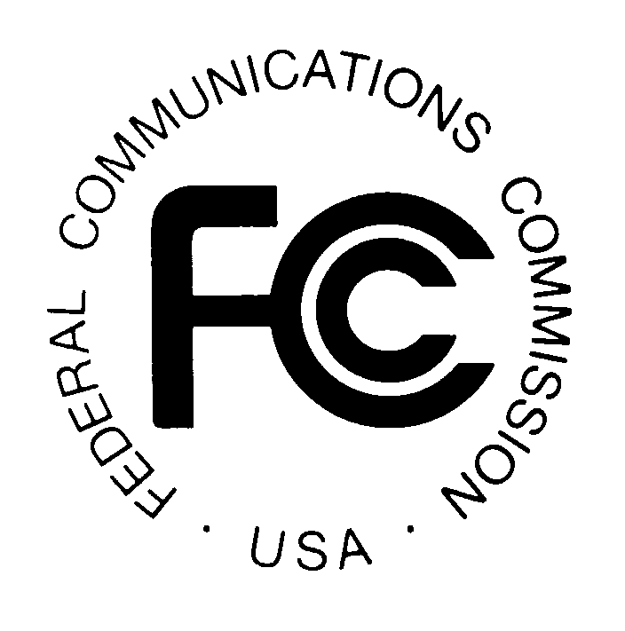
News media information 202 / 418-0500
Fax-On-Demand 202 / 418-2830
TTY 202 / 418-2555
Internet: http://www.fcc.gov
ftp.fcc.gov

Federal Communications Commission
445 12th St., S.W.
Washington, D.C. 20554

MASS MEDIA BUREAU
IMPLEMENTS
CONSOLIDATED DATABASE SYSTEM (CDBS) ELECTRONIC FILING OF
THE BROADCAST STATEMENT OF COMPLIANCE, THE BROADCAST
EQUAL EMPLOYMENT OPPORTUNITY MODEL PROGRAM REPORT,
AND THE BROADCAST EQUAL EMPLOYMENT OPPORTUNITY
PROGRAM REPORT FORMS

Released: November 29, 2000

The Broadcast Statement of Compliance (Form 397), the Broadcast Equal Employment Opportunity Model Program Report (Form 396-A), and the Broadcast Equal Employment Opportunity Program Report (Form 396) now are available on the Radio and Television Broadcast Station Consolidated Database System (CDBS) online electronic forms filing system. This enables broadcasters to file these forms electronically with the Commission. Effective November 27, 2000, users can access this system via the Internet from the Mass Media Bureau’s Web Site at: http://www.fcc.gov/mmb. Form 396-A became available for electronic filing on August 7, 2000. Paper filing of Form 397 and Form 396 also will be permitted until May 26, 2001. Paper filing of Form 396-A will be permitted until February 4, 2001.

Instructions for use of the electronic filing system are available in the CDBS User’s Guide which can be accessed from the electronic filing web page at: http://www.fcc.gov/mmb. Special attention should be given to the details of the applicant account registration function and the form filing function.

Internet access to the CDBS public access system at the Commission’s Web Site requires that the user have, at a minimum, a browser such as Netscape version 3.04 or Internet Explorer version 3.51.

For technical assistance in running the system or to report technical problems with the system, please contact the CDBS Help Desk at (202) 418-2MMB.

For further information, please contact the EEO Staff at (202) 418-1450

F C C -

