FOREST STAND IMPROVEMENT

PRACTICE INTRODUCTION

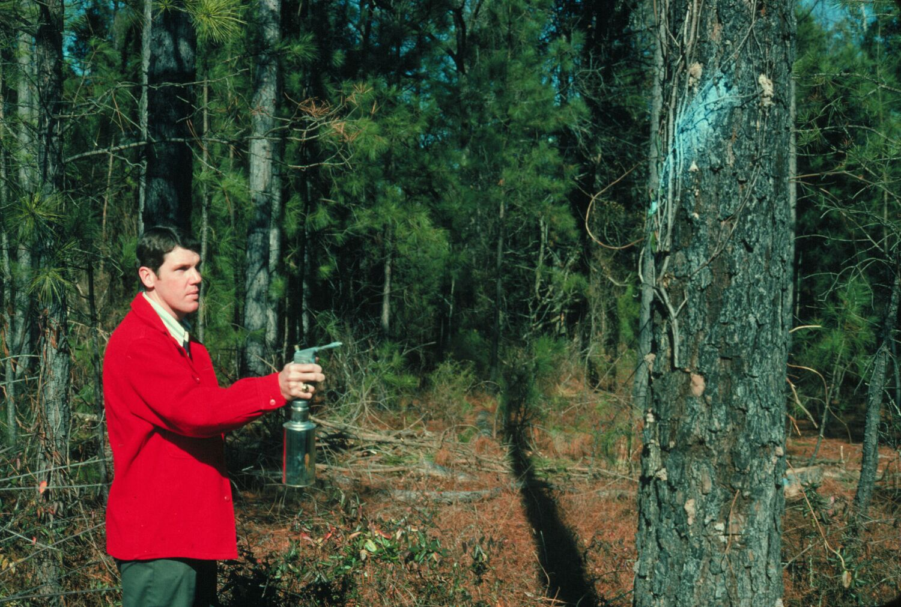
USDA, Natural Resources Conservation Service―Practice Code 666

FOREST STAND IMPROVEMENT
Forest stand improvement is manipulating species composition, stand structure, and stocking of trees by cutting or killing selected trees and understory vegetation.

PRACTICE INFORMATION
This practice applies to forestland where competing vegetation hinders development and stocking of preferred tree and understory species. The preferred species are identified and retained to achieve the intended purpose of improving the stand. Spacing, density, and amounts of preferred plants are carefully planned. Consideration is given to the total ecosystem. Timing of treatment and retaining dead or dying trees will help minimize impacts on nesting birds and other wildlife. Food and cover for wildlife are further retained by minimal modifications of composition and spacing necessary to improve the vegetative cover considering the total natural resource base.
Purposes of this practice include the following:
- Improve or sustain timber production
- Improve understory forage production, aesthetics, wildlife habitat, recreation, and hydrologic condition
- Harvest forest products
- Initiate forest stand regeneration.
- Achieve a combination of purposes

COMMON ASSOCIATED PRACTICES
Forest Stand Improvement is commonly applied as part of a Conservation Management System with practices such as Firebreak (394), Prescribed Burning (338), Tree/Shrub Pruning (660), Forest Trails and Landings (655), Critical Area Planting (342), and erosion control practices.
For more information, refer to the practice standard in the local Field Office Technical Guide and associated practice specifications and job sheets.

Start
LEGEND
#. Created by practice
D. Direct effect
I. Indirect effect
C. Cumulative effect
Pathway
(+) increase; (-) decrease
Mitigating practice
Associated practice
Critical Area Planting (342)
Access Control (472)
Sediment Basin (350)
Structure for Water Control (587)
Firebreak (394)
Prescribed Burning (338)
Fuel Break (383) (394)
Forest Slash Treatment (384)
4. Competing vegetation eliminated in whole or part
Forest Stand Improvement –
thinning (666)
D.3 (+) Residual stand wood fiber growth rate
1. Exposed roads, cuts, fills, landings, trails
D.1 (+) Surface erosion, runoff, sediment and airborne particulate matter
D.4 (-) Shade
5. Harvested wood fiber, renewable biomass/ fuel, etc.
Forest Stand Improvement – regeneration harvest (666)
C.1 (+) Wood-forest business and support infrastructure
C.5 (+) Income stability (individuals and community)
D.2 (+) Fire hazard
I.3 (+) Forest habitat and fauna
I.2 (+) Understory vegetation biomass
I.4 (+) Forage/browse biomass
I.5 (+) Livestock grazing
C.2 (+) Recreation business and support infrastructure
C.3 (+) Livestock business and support infrastructure
I.5 (+) Quality of receiving waters and airshed
C.4 (+) Related health of humans and animals; (-) associated costs
Initial setting: 1) Desired tree species competing with undesired species; 2) overstocked desired tree species. Sites can be grazed by wildlife or livestock.
D.5 (+) Landowner net income; contractor income
2. Slash and debris
3. Canopy cover reduced
Forest Stand Improvement
1/2009
I.1 (-) Older residual stand wood fiber growth rate
Prescribed Grazing (528)
Note: Effects are qualified with a plus (+) or minus (-). These symbols indicate only an increase (+) or a decrease (-) in the effect upon the resource, not whether the effect is beneficial or adverse.

Access Road (560)
Forest Trails and Landings (654)

