

FEDERAL ELECTION COMMISSION

CONGRESSIONAL JUSTIFICATION
BUDGET REQUEST FOR FY 2006

PRESENTED TO THE
UNITED STATES CONGRESS

PURSUANT TO GPRA AND OMB A-11

April 11, 2005

Submitted to Congress/OMB

EXECUTIVE SUMMARY

The Federal Election Commission (FEC) submits a budget request of $54,600,000 and 391 FTE for FY 2006, an increase of $2,858,272 (5.52%) over our enacted FY 2005 appropriation of $51,741,728 ($52,159,000 less the FY 2005 across-the-board rescission for domestic discretionary programs) and 391 authorized FTE. The FEC FY 2006 request conforms to the President’s budget request for FY 2006 and was the result of an agreement reached with OMB during the FY 2006 budget preparation process.

In FY 2004, the FEC Office of Election Administration (OEA) was transferred, with all remaining funds and other assets, to the Election Assistance Commission (EAC). The transfer took place April 1, 2004. Therefore, FEC funding for the OEA is not included in the FEC FY 2005 appropriation, or the FEC FY 2006 budget request.

The FY 2006 request represents a continuation of FY 2005 funding levels, adjusted for inflation and salary and benefits increases. As such, it represents essentially a Current Services request for FY 2006, with no additional funds or staff for new FEC programs or initiatives and represents an overall increase of only 2.28% for non-personnel costs. Many of the non-personnel object classes actually decrease from FY 2005 levels, with the exception of the funding of the FEC IT enhancement initiatives that are spread over several fiscal years for several projects. This is partially a reflection of the fact that the FEC reduced its original current services estimate of $55,108,000 to reach agreement with OMB for FY 2006, with the reductions coming from non-personnel to conserve full funding of 391 FTE. In addition, the FEC was able to accelerate some of the multi-year IT enhancements in FY 2004 due to personnel lapse; that in turn enabled the FEC to reduce some IT costs in FY 2005 to enable the conservation of staff, despite the across-the-board rescission in FY 2005.

The FEC FY 2006 request represents a 6.77% increase for personnel costs attributable to normal step increases (within grade or WIG increases), the annualized FY 2005 COLA (3.72% effective in January 2005) and the FY 2006 COLA (2.3% in January of 2006) and full staffing at 391 FTE; actual staff in FY 2005 is projected to reach about 388 FTE.

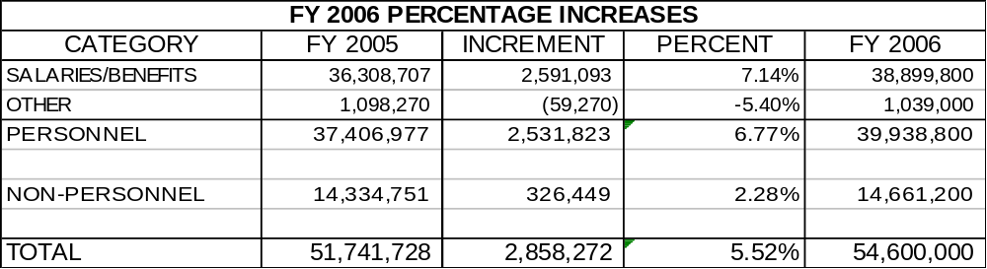

Federal Election Commission Mission

The mission of the FEC is to assure that the campaign finance process is fully disclosed and that the rules are effectively and fairly enforced, fostering the electorate's faith in the integrity of the nation's political process.

Desired outcomes from the successful achievement of this mission include: enabling the electorate to make informed decisions in the political process with regard to where candidates for federal office derive their financial support; and providing reasonable assurance that those who disregard the Federal Election Campaign Act of 1971, (FECA) as amended, restrictions on campaign financing and/or its requirements for public disclosure will suffer real and evenhanded consequences for non-compliance.

In attaining these outcomes, the FEC strives to foster and maintain an attitude of voluntary compliance with the rules of the campaign finance process. The FEC realizes that voluntary compliance and public confidence are necessary because limited budgetary resources preclude massive efforts to enforce the FECA.

The FY 2006 budget request will enable the FEC to perform its statutory mission and meet its program goals and objectives. The FEC budget justification is structured to reflect its mission to administer and enforce the three main components of the Federal Election Campaign Act of 1971, as amended (FECA):

- the disclosure of campaign finance information;
- the contribution limitations and prohibitions; and
- the public financing of Presidential elections.

Formerly, the FEC had the mandated responsibility to compile information and review procedures related to the administration of federal elections. That responsibility has been transferred to the EAC, which is funded in the President’s FY 2006 Budget. The OEA was formally transferred, with all existing assets, to the EAC on April 1, 2004.

Programs, Objectives and Goals

To accomplish its mission, the FEC has established three core programs. For each core program, the Commission has defined objectives and goals that are achieved through several Commission line programs. The core programs are listed below, followed by the dollar amount and FTE needed to achieve the objectives and goals under the FY 2006 Budget:

- Promoting Disclosure - $15,664,121 and 146.6 FTE

- Obtaining Compliance with FECA - $29,081,292 and 181.1 FTE

- Administering Public Financing of Presidential Elections - $9,854,586 and 63.3 FTE

Building on Past Successes

In FY 2003-2004, the FEC achieved major successes, including meeting statutory and court deadlines for the BCRA implementation and legal challenges to the BCRA and expansion of the compliance program. These successes are the result of FEC efforts and support from our Congressional oversight committees. In addition, two programs have received accolades from the regulated community—the Administrative Fine and Alternative Dispute Resolution (ADR) Programs.

BCRA Implementation

Operating under strict statutory deadlines for promulgation of new regulations to implement the BCRA amendments, the Commission met the required deadlines and issued new regulations to implement the changes to the FECA enacted in the BCRA. In addition, FEC staff reviewed all programs and processes for disclosure and compliance programs to ensure that all forms and procedures comply with the BCRA changes. Delayed funding and the lack of space for additional staff made it impossible to hire the requested staff for the BCRA implementation in FY 2003, and the Commission relied on overtime, contract temporary staff assistance, and pulling staff from other programs. Commission staff also was required to comply with strict court imposed deadlines in the legal cases challenging the BCRA and the constitutionality of several aspects of the new law. As in the case of the review of Commission processes and the regulations, lack of additional staff required the use of overtime, contract assistance, and “borrowed” staff from other programs.

The FEC anticipated that the result of the Supreme Court review of the BCRA legislation would require some range of revisions and changes to regulations; the number of changes depended upon the nature of the Court’s ruling. Due to the Court’s ruling substantially upholding the BCRA amendments and FEC regulations implementing them, the workload faced by the FEC is not as great as it might have been. However, there are still issues that can and are being raised and the FEC anticipates on going regulatory and policy work related to the BCRA amendments. The FY 2006 request assumes that the FEC will continue to conduct educational and informational programs on the FECA and BCRA; some of these efforts were held in abeyance in FY 2004 in order to wait for the final Supreme Court ruling before changing publications and guidance. Challenges to FEC regulations and the BCRA implementation continue and are expected to continue into FY 2006. The FEC also continues to issue new and revised regulations to deal with issues arising from the BCRA amendments and subsequent court decisions.

FEC Compliance Program

The first major overhaul of the FEC’s enforcement program occurred in May 1993. Faced with a large number of complex cases, the Commission developed the Enforcement Priority System (EPS) to classify and prioritize cases in tiers of complexity and importance. The EPS was designed to enable the FEC to focus limited enforcement resources on the more important enforcement actions and close low-rated and stale cases. The increased level of civil penalties assessed by the Commission subsequent to implementation of the EPS has demonstrated the benefits of pursuing more substantive cases. In 1991, there were 262 cases closed with civil penalties totaling $534,000; in 1995, there were 229 cases closed with $1,967,000 in civil penalties. By FY 2004, there were 250 cases closed with civil penalties and fines totaling $3,463,050. A more detailed discussion is included in the FY 2004 FEC Enforcement Profile included in this submission.

As the FEC’s caseload and the complexity of the issues continued to grow, Congress, in 1995, called for a comprehensive review of the Commission by Pricewaterhouse Coopers (PwC). As a result of that review, legislation enacted in 1999 established the Administrative Fine Program within the Commission. This program enables the Commission to streamline the enforcement of late and non-filer violations in an expedited system with a published schedule of penalties. The Commission also instituted an Alternative Dispute Resolution (ADR) program to process, in a more expeditious manner, matters that are “less serious breaches of the law,” but that are not “simple” late and non-filer issues.

Before 2000, the FEC’s enforcement program was administered entirely by the Office of General Counsel (OGC). The two new components of the Commission’s enforcement efforts – the Administrative Fine Program and the ADR Program – are administered by the Staff Director and are not part of the OGC. The goal of the ADR Program is to resolve matters quickly and effectively through bi-lateral negotiations. Both the ADR and Administrative Fine Programs are designed to expand the FEC enforcement presence and resolve certain types of cases without resorting to the more lengthy traditional enforcement process.

Another tool that has improved the efficiency of the enforcement process is the Case Management System, which enables the Commission to measure performance with regard to the substantive resolution of cases by issue and to measure timeliness of enforcement actions. This system has provided the Commission with a mechanism to more efficiently manage its caseload and has enabled the Commission to electronically track and store data related to cases and respondents. This program enables users to readily locate information related to pending cases and cases closed since FY 1995.

The Commission’s goal in implementing the measures discussed above was to increase the effectiveness of the enforcement program by activating more cases, closing more cases with substantive action, and resolving some cases that would otherwise have been dismissed. Another goal was to speed up the closure of enforcement cases. The Commission has met its compliance goals. Today, the Commission focuses its legal resources on the more complex enforcement matters, while using administrative processes to handle less complex matters, as the following analysis illustrates.

For example, from FY 1995 through FY 2000, the FEC closed an average of 197 cases each fiscal year. In FY 2001, with the addition of the Administrative Fine and ADR Programs, the FEC closed 518 cases, a 163% increase over the FY 1995-2000 annual average of 197 cases. In FY 2002, the FEC closed 226 cases, including enforcement, ADR and administrative fine cases. The total in FY 2003 was 529 closed cases and in FY 2004 it was 250 cases (cases increase markedly in odd fiscal years due largely to the timing of late and non-filer cases).

The ADR program affords both the FEC and the respondent parties the opportunity to resolve cases more rapidly. This is also an opportunity for the Commission to resolve cases substantively, as well as to process them more rapidly. Since the inception of the program on October 1, 2000 through September 30, 2004, the ADR office concluded agreements with respondents and formally closed 135 cases, 102 with substantive action (76%). For the four years the ADR program has imposed $154,743 in civil penalties. These 102 cases were generally closed within six months of referral to the ADR program; by FY 2004 the time required to close an ADR case with substantive action took an average of 254 days from the time matters were first sent to OGC and then referred to the ADR office. By FY 2004, substantive cases were closed by ADR within a median of 208 days; dismissed cases were closed within a median of 155 days.

The Administrative Fine Program has closed 1,009 cases since FY 2000 and assessed $563,810, $289,891, $668,392, and $369,055 in penalties in fiscal years 2001-2004, respectively. For the four years, the program closed cases in an average of 242 days from when the reports were due to be filed at the FEC.

For the OGC Enforcement program itself, from FY 1995 to 2000, 287 of a total of 1,180 cases were closed with civil penalties: 24% of the cases closed had civil penalties assessed. From FY 2001 to 2004, OGC closed 119 out of 377 cases with civil penalties (32%). In addition, while the average from FY 2001 to 2004 is 30 cases per fiscal year with civil penalties, compared to an average of 48 cases with civil penalties per fiscal year from FY 1995 to 2000, the average amount of civil penalties assessed per case in each of the last four years increased over the previous six fiscal years. This is all evidence that the overall compliance program is allowing OGC to focus limited enforcement resources on more substantial, significant cases.

Furthermore, from FY 1995 to 2000, 54% of OGC cases were dismissed without substantive action; that decreased to 29% from FY 2001 to 2004. Even more encouraging is the fact that 78% and 85% of OGC enforcement cases were closed with substantive action in the last two years. In addition, the average days required to close a case with substantive action improved from an average of 610 days for the period of FY 1995-2000 to an average of 446 days during FY 2004. On a median days required to close a case basis, the improvement was down to 240 days during FY 2004 for substantive cases. This analysis is strong evidence that the FEC has successfully increased the overall FEC enforcement presence, has increased the number of cases closed with substantive action, has collected more civil penalties and fines on a per case basis, has expedited the closing of cases within OGC, and, by use of the ADR and Administrative Fine Programs, has achieved these successes without large increases in enforcement staff. Clearly, from FY 2001 through 2004, the FEC has made significant improvements in the compliance program.

FEC Disclosure and Informational Outreach Programs

The FEC recognizes that with limited resources it must rely on voluntary compliance. In addition to fostering a belief that the campaign finance disclosure laws will be enforced when significant violations occur, the Commission has relied on effective outreach and informational programs to reduce violations due to lack of understanding of the law. Generally, FEC efforts, such as the 800 informational line, the campaign finance workshops and seminars, and the campaign guides and brochures, have all received high marks from the elections community, the media, and the public.

A 2004 hearing on the FEC enforcement process held by our House Oversight Committee was noteworthy for the consistently high marks given by Members to the FEC staff and informational programs. The FEC received high praise for its efforts to educate and inform the election community, and the responsiveness and professionalism of the FEC staff was remarked upon numerous times.

In addition, the FEC disclosure programs are generally praised, and often FEC data and reports provide the foundation for analysis and further study by the media and elections interest groups. The FEC continues to operate a storefront disclosure office in Public Records, but also increasingly serves the media and the public through the FEC web site and other electronically provided data and publications. While the Commission will continue to print and make available copies of brochures and publications, increasingly the needs of the election community, the public and the press are served by electronically available data and reports. In FY 2004, the FEC electronic disclosure database and website received over 4 million visits and 100 million hits by users seeking campaign finance data and FEC documents. The FEC continues to upgrade and enhance its website, the electronic filing system and other electronic systems, and to adapt to changes required by BCRA or any other changes to the FECA.

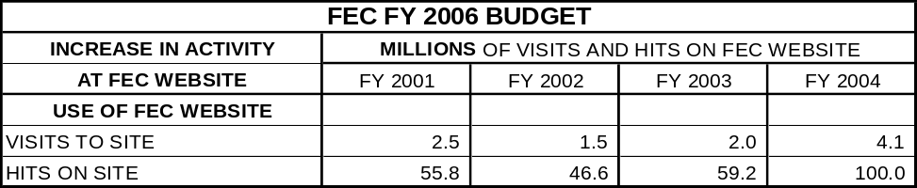

However, the FEC also continues to respond to many telephonic and written requests for information, data and assistance in filing reports, with an increase in the last two years partly due to the BCRA amendments to the FECA. The Information Division 800 line and the RAD analysts assigned to specific committees will continue to be an integral part of the FEC’s effort to inform and educate the public and to foster voluntary compliance with the filing requirements of the FECA. The FEC also utilizes the Internet and a monthly newsletter, The Record, to provide prior notice to filers and general assistance in the correct filing of reports.

There is recent evidence that the informational and educational outreach efforts, as well as the standardized and regularized Administrative Fine Program, have improved the timeliness of filing. The percentage of committees filing required reports and filing them on time has improved the last two election cycles. The FEC sees this as evidence that the disclosure and compliance programs are working to foster voluntary compliance with the FECA.

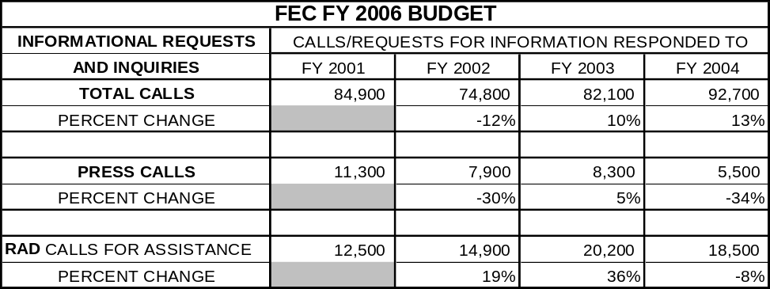

Financial Audit—Accountability of Tax Dollars Act of 2002

In FY 2004, the FEC was required to undergo a full financial audit. The Commission was successful in achieving a non-qualified opinion (a “clean” opinion) in our first year of the required annual financial audits. Although the audit report noted some material weaknesses and reportable conditions, the FEC successfully achieved an overall unqualified opinion. The FEC will endeavor to remove the material weaknesses and reportable conditions and continue to improve our financial management systems in FY 2005 and 2006.

Impact of Continuing the OMB Level for FY 2006

As noted, the FY 2006 budget represents minimal increases from the final enacted funding for the Commission in FY 2005. This funding is required to provide the Commission with the space and resources to house and support a full complement of staff in the successful administration of the 2004 and 2006 election cycles, as represented by activities during FY 2006.

The funding level contained in this budget request will enable the Commission to:

- continue to meet all requirements to implement and enforce the BCRA amendments;

- complete all Presidential audits within two years of the 2004 election;

- conduct 40-45 Title 2 “for cause” audits per election cycle as opposed to 20-25 in the previous election cycles;

- maintain a timely and enhanced campaign finance disclosure program;

- ensure that significant and timely efforts are made to enforce the FECA;

- maintain and enhance existing Commission educational and informational outreach programs designed to foster knowledge of the FECA and voluntary compliance with the disclosure and limitations provisions of the statute;

- continue disclosure programs that disseminate data and analytical reports to the media and private organizations for use in further analysis and more widespread disclosure of campaign finance information to the general public and the election community;

- continue the Administrative Fine and Alternative Dispute Resolution Programs;

- continue and enhance the automation of the reports review process; and

- maintain an unqualified opinion from the annual financial audit.

To continue reaping the benefits of automation in our disclosure and compliance programs, without adding additional staff, it is imperative that the Commission receive the requested resources in FY 2006 to implement the automated review of financial disclosure reports, to continue to enhance the analysis and accessibility of campaign finance disclosure information, to improve the timeliness and saliency of enforcement cases and to continue the alternative compliance programs.

DIFFERENCE FY 2005 TO FY 2006

FY 2006 Budget Request for FEC

FY 2005 Appropriation (post-rescission) $51,741,728

+ Increase in pay, benefits (COLAs, WIG increases) $ 2,531,823
WIG step increases
FY 2005 COLA of 3.72% annualized in 2006
FY 2006 COLA of 2.3%
Full 391 FTE and benefits costs (health, etc.)

+ Increase in IT enhancements/IT costs $ 1,106,500
+ Decrease in rent (acquisition of 5th floor completed in FY 2005) $ (151,000)
+ Net decrease in other non-personnel costs $ (629,051)
Increase in FY 2006 Request $ 2,858,272

= Budget for FY 2006 $54,600,000
FEDERAL ELECTION COMMISSION
FY 2006 BUDGET REQUEST

The Federal Election Commission (FEC) submits a budget request of $54,600,000 and 391 FTE for FY 2006, an increase of $2,858,272 (5.52%) over our enacted FY 2005 appropriation of $51,741,728 ($52,159,000 less the FY 2005 across-the-board rescission for domestic discretionary programs) and 391 authorized FTE. The FEC FY 2006 request conforms to the President’s budget request for FY 2006 and was the result of an agreement reached with OMB during the FY 2006 budget preparation process. This request represents a continuation of the FY 2005 funding level, as adjusted for inflation and salary and benefits increases, full staffing of the 391 FTE requested, and with no programmatic increases. This request level was reached through negotiations with OMB staff during the preparation of the FY 2006 President’s Budget Request. The FEC agreed to reduce its original current services estimate of $55,108,000 by $508,000 and to include the expected FY 2006 COLA at 2.3%, per OMB guidance.

In FY 2004, the FEC Office of Election Administration (OEA) was transferred, with all remaining funds and other assets, to the Election Assistance Commission (EAC). The transfer took place April 1, 2004. Therefore, FEC funding for the OEA is not included in the FEC FY 2005 appropriation, or in the FEC FY 2006 budget request.

The funding level contained in this budget request will enable the FEC to continue to meet all requirements for the full BCRA implementation, and:

- complete all Presidential audits within two years of the election;

- conduct 40-45 Title 2 “for cause” audits per election cycle, as opposed to 20-25 in the previous election cycles;

- maintain a timely and enhanced campaign finance disclosure program;

- ensure that significant efforts are made to enforce the disclosure provisions of the FECA;

- maintain existing Commission educational and informational outreach programs, designed to foster knowledge of the FECA and voluntary compliance with the disclosure and limitations provisions of the statute;

- continue disclosure programs that disseminate data and analytical reports to the media and private organizations for use in further analysis and more widespread disclosure of campaign finance information to the general public and the election community;

- continue the Administrative Fine and Alternative Dispute Resolution Programs;

- continue and enhance the automation of the reports review process;

- maintain a clean or unqualified financial audit opinion; and

- develop and maintain the following IT capabilities:

- support and enhance the mandatory electronic filing program;
- continue the conversion of legacy systems to a client server environment;
- complete the conversion to a Commission-wide document management system;
- complete the changes necessary to implement the BCRA amendments to the FEC;
* maintain and enhance the FEC website;
* maintain a new MIS and Budget system integrated with the FEC financial system; and
* support the Case Management System.

Information Technology (IT) Enhancements

The budget request funds IT initiatives, as outlined in the FEC IT Strategic Plan, including the following areas:

- client/server environment development and conversion;
- document management system development and implementation;
- telecommunications infrastructure enhancement;
- enhancement of automated review of disclosure reports;
- computer security;
- Case Management, Enforcement Query System (EQS) and related tracking systems;
- financial management and integrated MIS and budget preparation systems;
- website enhancement; and
- development of web-based access to FEC data.

Summary of Request and Differences from FY 2005

The following tables summarize the FY 2006 request and the differences from FY 2005. As noted in the Executive Summary, the net increase in FY 2006 is 5.52% over FY 2005, for a $2,858,272 increase. The increase in personnel costs results from full funding of the 391 FTE requested and the FY 2005 and 2006 COLAs. Although authorized 391 FTE in FY 2005, the FEC will reach approximately 388 FTE, with the reduction resulting from forced absorption of the full costs of the annualized FY 2004 COLA and the full FY 2005 COLA. Also a factor was the across-the-board rescission in domestic discretionary programs in FY 2005. In addition, delays in staffing increases were caused by the delay in acquiring additional space to house additional staff. The FY 2006 request assumes that the FEC will fully occupy the newly acquired additional space at 999 E Street during FY 2005 and will staff up accordingly.

TABLE 1: FY 2006 PERCENTAGE INCREASES

TABLE 2: FEC STAFFING

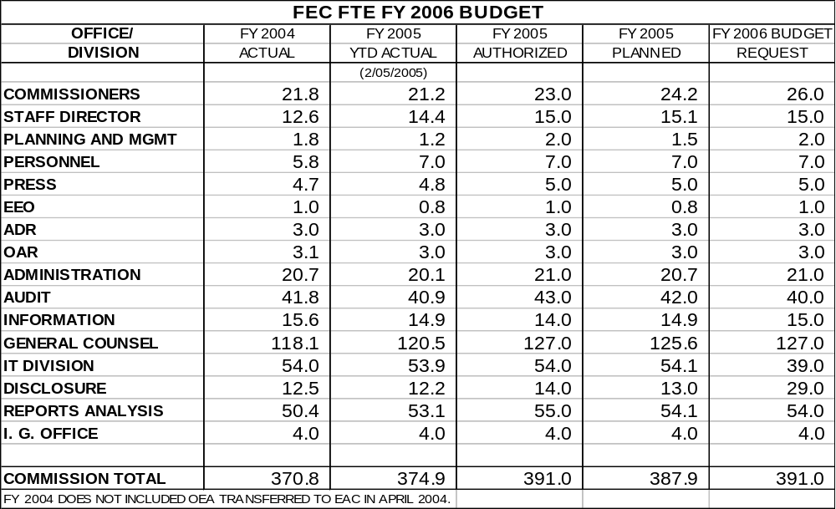

TABLE 3: SUMMARY CHANGES FY 2005-2006

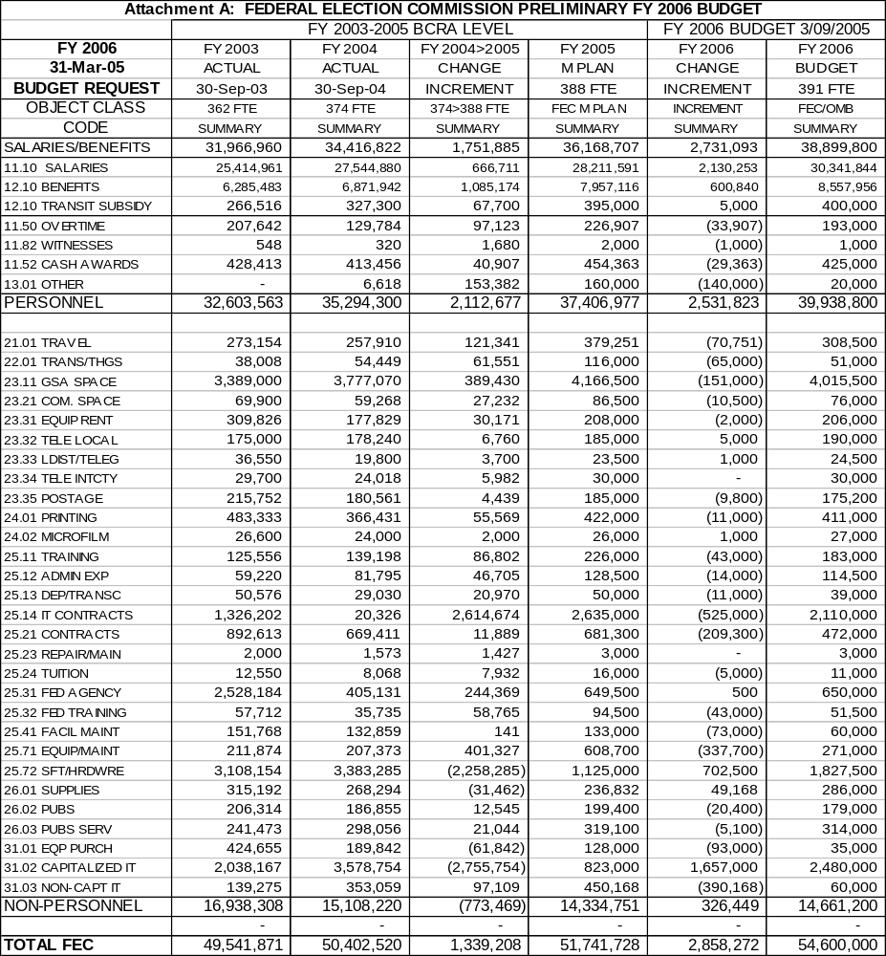

TABLE 4: BUDGET BY DIVISION/OFFICE

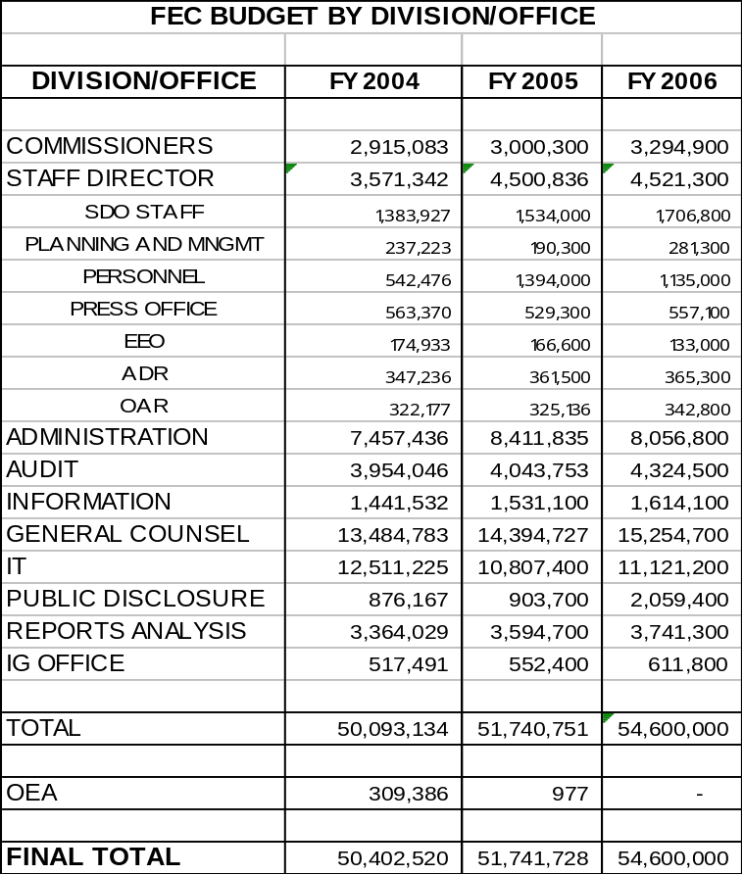

FEC Staffing and Workloads

FY 2006 covers the conclusion of the 2004 presidential election cycle and the beginning of the 2006 congressional election cycle. The 2004 election broke records for total financial activity in federal elections, with the total disbursements for all candidates and committees expected to exceed $5 billion. The 2002 cycle set a record for a congressional election cycle, and this record level of financial activity is expected to continue in the 2006 election.

Despite large increases in Commission workloads, because of increasing federal election-related campaign finance activity, the FEC has relied on management initiatives and information technology advancements to improve productivity to meet the increasing workloads. Total disbursements in federal elections increased by over 1,500% since 1976: from $310 million to a projected $5 billion in the 2004 cycle. This has translated into workload increases, such as a 27% increase in documents filed per cycle, from 1984 to 2000, and an increase of 400% in the number of transactions entered into the database since the 1984 election cycle. The final increases for the 2004 cycle will be even higher. The FEC has processed these record level workloads with modest staff increases.

As a result of the dramatic increase in activity, our available resources dictate that we audit and investigate a relatively small number of committees. With approximately 8,000 committees filing reports each election cycle, the FEC audits about 45 committees per cycle, or about .6% of the filing universe. With an average active caseload of between 100 to 150 enforcement cases in any given month, approximately 50% of the complaints received by the FEC are activated.

The Commission has attempted to maximize the effectiveness of the compliance and enforcement programs through the increased use of technology and with management initiatives to better focus the resources available. Because of the modest size of many of our compliance and enforcement programs, any reduction in staffing below our Current Services base will jeopardize our basic mission and objectives.

Total campaign finance activity for the 2004 cycle could finally reach $5 billion in total disbursements, from 8,000 committees filing over 95,000 reports and generating 3.5 million itemized transactions. Some resources in FY 2006 will be dedicated to resolving outstanding issues and the final workload of the 2004 cycle. The 2006 cycle, a congressional cycle, should be slightly lower in volume than the 2004 presidential cycle. Nevertheless, total disbursements could exceed $3.5 billion in 2006, with 8,000 committees filing 85,000 to 90,000 reports and from 2.5 to 3 million itemized transactions.

Despite the prospect of continuing increases in campaign finance activity in federal elections, the FEC has requested no additional resources for the disclosure, compliance and enforcement programs. Given the expected total volume of money involved in the 2004 and 2006 election cycles, we believe that the FEC request for FY 2006 is fully supported and is a modest one.

FEC Mission

The FEC budget is based on the agency’s mission to administer and to enforce the three main components of the Federal Election Campaign Act of 1971, as amended (FECA):

- the disclosure of campaign finance information;
- contribution limits and prohibitions; and
- the public financing of Presidential elections.

Programs

To accomplish this mission, the FEC has established three core programs:

- Promoting disclosure;
- Obtaining compliance with FECA; and
- Administering the public financing of Presidential elections.

Within each of the core programs, the Commission has defined specific objectives. To achieve these objectives, the Commission must accomplish certain goals. To the extent that the agency succeeds in reaching these goals and objectives, it will fulfill its fundamental mission.

Overview of FEC Programs

Tables 5A and 5B provide an overview of the FEC budget by program. Table 5A shows the total dollars budgeted for each program, and Table 5B shows the personnel (FTE) for each program. The FEC management and administrative overhead costs, including information technology costs and FTE, are allocated pro rata to the three core programs and are included in Tables 5A and 5B.

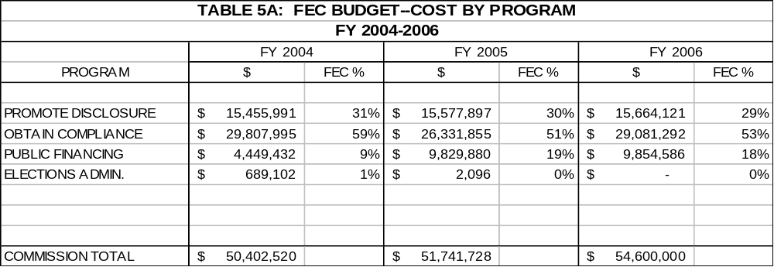

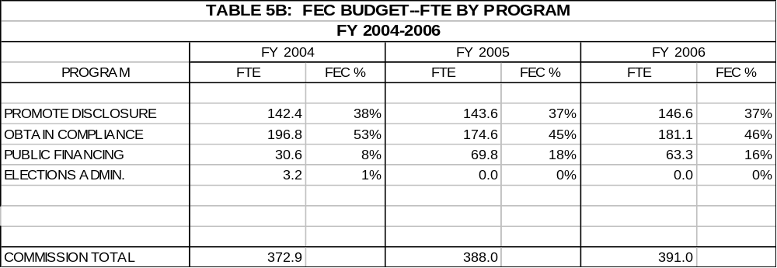

Personnel Allocations

Within the total authorized 391 FTE (unchanged from FY 2005) we have made some internal adjustments for 2006 because of changes in workload and mission. The preliminary staffing levels are essentially the same as FY 2005 with a few minor adjustments for the 2006 election cycle, and some changes in mission. The proposed FY 2006 staffing follows below.

Staffing in the Public Disclosure Division would be reduced by one FTE from the base of 14 FTE in recognition of a change in mission due to reduced demands for direct service in Public Records. This is offset somewhat with increased responsibility by the Division for the content of documents and information on the FEC website. ITD would continue as the technical provider of the website, but Disclosure would be responsible for updating and maintaining the content for all documents, other than the main disclosure database.

This proposed budget would also transfer the data coding and entry section of the IT Division to the Public Disclosure Division. As proposed, the coding and entry staff of 16 FTE would be transferred, as well as all equipment and furniture and related supplies. This proposal would consolidate the document imaging and processing staff with the document coding and entry staff in the same Division, placing all document processing functions in the same office.

The management of the Electronic Filing system will remain an ITD responsibility. Disclosure will continue to scan paper reports and documents into the system and perform all in-house coding and entry of documents. In addition, it will be responsible for maintaining all content on the website, with digital versions of FEC publications provided by the Information Division. As a result, the combined FTE for the newly constituted Disclosure Division will be 29 FTE.

Staffing will increase by one FTE in Information, in recognition of a change in mission as well: despite reduced direct demands for service in Information, the Division will move increasingly to digitizing and automating the FEC publications with on-demand printing of documents and publications possible, but more reliance on making information available on the web and electronically. Outreach and educational efforts will also be increased to further improve voluntary compliance with the FECA, as amended by the BCRA. This change results in a full authorized staff of 15 FTE in Information in FY 2006.

The budget request provides funding for 40 FTE in Audit, down from the 43 required for three FTE of document clerks in FY 2004-2005 to process matching fund requests. The FY 2006 request includes 38 permanent FTE and up to two FTE of part-time or summer audit interns to meet the goal of 40-45 Title 2 audits per election cycle.

The FY 2006 request reflects increased demands in ITD for programming and analysis staff, with the data coding and entry staff transferred to the Disclosure Division. The original total of 55 FTE in ITD, less the data coding and entry, leaves a remaining programming and systems analysis staff of 39 FTE in FY 2006. See discussion of OGC staffing below.

While maintaining most of the BCRA supplemented staffing in Reports Analysis (RAD), at 54 FTE, and OGC (127 FTE), the request includes a reduction of one position in RAD and one position in OGC. The latter reflects the transfer of one position and the related function back to ITD (OGC IT technical position) but the end of the detail of one position to the Chairman’s Office. Of the original 27 FTE increase in staffing due to BCRA, 11 positions were allocated to RAD and 10 to OGC.

While the additional staff in RAD (and significant overtime) has helped to improve the timeliness of review for the 2004 cycle, compared to the 2000 and 2002 cycles, the benefits derived from the development of the Automated Review Process should begin to be realized in FY 2006. Despite increasing total disbursements in federal elections and more reports being filed, RAD should be able to maintain reports review timeliness with the 54 FTE authorized.

OGC's ability to fulfill its responsibilities will not be impacted negatively by the loss of one FTE. The position that is being transferred out of OGC is an IT function that will reside in the IT division. Moreover, the IT division is in the process of recruiting a new employee who will be dedicated to serving OGC's IT support needs. Therefore, at the end of the day, OGC will not experience any loss in functionality due to the transfer of this FTE. The FY 2006 budget would still provide for nine additional FTE above the original base OGC staffing level of 118 FTE.

This proposal provides for full-year staffing of six FTE of Commissioner interns at the GS-9 level, one for each office (in addition to the three positions in each office and one additional EA for the Chairman and Vice Chairman). These are interns at the GS-9 level, but they are for the entire fiscal year and include full benefits. As in the FY 2005 Management Plan, each office will have three positions with an intern added, and the Chairman and Vice Chairman will have four plus the intern.

The remaining offices are funded at levels equivalent with the 391 FTE authorized for FY 2003 and 2004, and contained in the FY 2005 Management Plan.

Non-Personnel Cost Estimates

Key assumptions for non-personnel include the following:

- Rent includes the full cost of the newly acquired 5th floor and inflation of roughly 5% for all rent costs in FY 2006, with the storage space at 800 North Capitol Street eliminated, but does not include the 3rd floor, that was used for swing space during the construction on the 5th floor.

- IT funding includes the FY 2006 level provided for in the IT Strategic Plan for FY 2006, contained in the FY 2005 Budget Request and as modified by any reallocations in FY 2004—minor reductions were made in travel, printing, training, non-IT equipment, and similar object classes and should have no significant impact on the IT initiatives.

- Funds are included for the full financial audit required by the Accountability of Tax Dollars Act and support assistance to prepare for the Audit in FY 2006.

- Sufficient funds are included to continue to process all document retention plans and NARA document storage and retrieval requirements for the agency.

- Funds are included to continue educational and informational programs for the 2006 election cycle, and to provide for Current Services for all compliance activity, including audits and enforcement.

The preliminary estimate assumes continuation of the ADR and Administrative Fine Programs through at least the 2006 election cycle. It also provides a limited amount of funding for mediators, assuming that the mediation portion of the ADR program is activated in FY 2005 and 2006.

The request does include an additional $65,000 for IG contract audit funds to supplement the FEC OIG audit capability. This was funded within the agreement with OMB at $54,600,000 by reducing non-personnel costs across the agency by $65,000 to conserve the 391 authorized FTE—73% of the FEC budget request is for personnel costs.

Continuation of Operations Estimate

OMB directed agencies to submit estimates for the cost of continuing operations after a catastrophic attack on Washington, D.C. as serious as, or worse than, the 911 attacks. This Justification includes, but separates out the cost, of continuity of operations funding (it is not included in our request for $54.6 million and 391 authorized FTE). We are not requesting the funding, but have responded to Congressional and OMB requests for estimates of the full cost of continuity of operations funding in case of a large-scale catastrophic event in the Washington, D.C. area. Our estimate is over $15.6 million to cover preparing for continuity of operations in such an event. Annual costs for succeeding years would rise from about $4.5 million to over $5 million per fiscal year. This estimate is included as a separate part of our justification and we are not actively seeking the funding.

A rough estimate from ITD was that it would require from $10 to $15 million for replicating all IT systems and providing for some sort of infrastructure for users at an off-site location. This is a relatively costly item for the FEC, due to the personnel intensive nature of the Commission as a regulatory agency and the large percentage of IT use in our disclosure systems and the other FEC programs and systems.

A preliminary breakdown of costs for FY 2006 would be as follows, with about five percent inflation provided for each fiscal year thereafter:

cost of ITD to duplicate systems infrastructure--$8,000,000 for all hardware, software and direct IT support-related supplies and equipment;

cost of space, equipment and related support furniture and supplies for staff--$2,000,000 ($1,500,000 for 150 FTE at $10,000 each for furniture and equipment, $500,000 for larger items);

cost of supplies and materials of $500,000 to initially stock and supply the facility, with smaller amounts each succeeding year to replenish and update stocks;

cost of rent for 60,000 square feet of space (computer room, support facilities and 150 FTE of staff for Commissioners, management, and key staffing positions, not the full 391 FTE)--$2,700,000 for each year’s rent and $1,500,000 to acquire and make the space usable by the FEC;

cost of $300,000 for FEC support costs (phones, copiers, faxes, pagers, etc.);

cost of space management by a contractor to manage and maintain the facility, estimated at $250,000 per year;

cost of four FTE: $188,500 for one onsite manager, plus two technical staff positions and one administrative staff position on-site ($377,000 for 4 FTE--for one half of FY 2006 and full year each FY thereafter); and

cost of travel for FEC staff to visit and test the facility and the continuity of operations procedures, on set-up and, thereafter, periodically--$200,000.

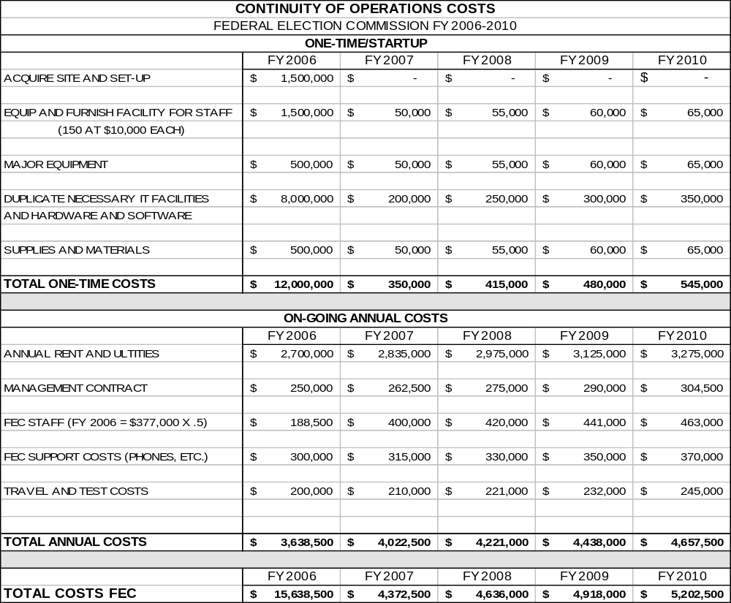
A Brief History of the Federal Election Commission
As early as 1905, President Theodore Roosevelt recognized the need for campaign finance reform and called for legislation to ban corporate contributions for political purposes. In 1907, he proposed public funding of federal elections. Congress enacted several statutes between 1907 and 1966 to:

• limit the disproportionate influence of wealthy individuals and special interest groups on the outcome of federal elections;
• regulate spending in federal campaigns; and
• deter abuses by mandating public disclosure of campaign finances.
In 1971, Congress consolidated its earlier reform efforts in the Federal Election Campaign Act (FECA), instituting more stringent disclosure requirements for federal candidates, political parties and political action committees (PACs). It also set up the income tax check-off to provide for the financing of Presidential general election campaigns and national party conventions. Still, without a central administrative authority, the campaign finance laws were difficult to enforce. Authority was split between the Government Accountability Office and the Clerk of the House and the Secretary of the Senate, with criminal enforcement in the Department of Justice. However, there was no real significant enforcement of campaign finance legislation for the most part until the post-Watergate period, after the 1972 elections.

Following reports of serious financial abuses in the 1972 Presidential campaign, Congress amended the FECA in 1974 to set limits on contributions by individuals, political parties, and PACs. It established the FEC as an independent agency to enforce the law, facilitate disclosure and administer the Presidential Public Funding Program. Amendments to the Internal Revenue Code that same year established the matching fund program for Presidential primary campaigns. Subsequent amendments in the late 1970’s streamlined the disclosure process and expanded the role of political parties.

The Bipartisan Campaign Reform Act of 2002 (BCRA) amended the FECA further. It banned national parties from raising or spending non-federal funds (often called “soft money”), restricted funding of so-called issue ads, increased the contribution limits, and indexed certain limits for inflation.
What the FEC Does
The sanctity of the political process is key to public faith in the policy decisions made by the elected and executive branches of government. The FEC strives to provide the electorate with the capability to make educated, informed decisions in the political process based, in part, on where candidates for federal office derive their financial support, and with the confidence that those who disregard the laws regarding campaign financing and/or its requirements for public disclosure will suffer real and even-handed consequences for noncompliance.

The Commission’s disclosure database, which contains millions of transactions, is available through the FEC’s website. Last year, the FEC redesigned its website to make it more user-friendly. Interested citizens can select a profile of a committee’s financial activity for each election cycle. Citizens also can access information on contributions by using a variety of search elements (e.g., donor’s name, recipient’s name, date, amount, or geographic location).

The sheer volume of data available to the public is staggering. The Commission defines its work in the context of election cycles, which include the preceding and actual election years—i.e., calendar years 2003 and 2004 constitute the 2004 election cycle. In any election cycle, nearly 8,000 committees file from between 85,000 to 90,000 reports, which contain information concerning between 2.5 to 3.0 million itemized contributions, as well as millions of other itemized disbursements, receipts, and other payments previously not entered into Commission databases. These reports now are filed electronically, except for Senate reports and other committees with less than $50,000 in activity. At the same time, the FEC has the resources to audit less than one percent of the committees filing reports in any given cycle, and only has the capacity to actively pursue approximately two percent of total committees through its compliance (enforcement) process at any given time.

Campaign financing has skyrocketed since 1976, when the FEC regulated the disbursement by federal candidates and committees of $310 million in the first publicly-funded elections. For the 2004 Presidential and Congressional elections, it is estimated that the FEC regulated the disbursement (spending) of approximately $5.1 billion—an increase of more than 1,500 percent in just eight Presidential election cycles.

Total disbursements (spending) by federal committees and candidates in federal elections is the most significant measure of the total workload faced by the Commission. The figures below depict total spending in recent federal Presidential and Congressional election cycles. Spending in Presidential cycles has more than tripled and in Congressional cycles it has nearly tripled. As of the 2004 year-end reports processed by the FEC, over $4.7 billion has already been disclosed for the 2004 cycle.

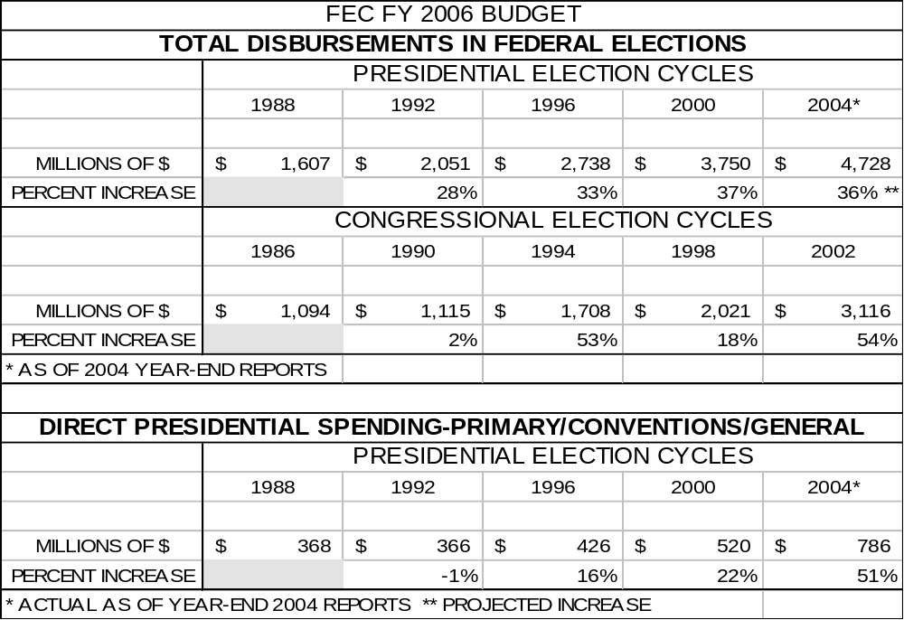
The FEC strives to foster and maintain an attitude of voluntary compliance with the rules of the campaign finance process through:

• facilitating public disclosure of campaign finance activity; providing information and policy guidance to the public, press, political committees, and elections officials on the law and Commission regulations;
• enforcing the FECA through audits, investigations, and civil litigation; and
• implementing the public funding programs for Presidential campaigns and conventions, including certification and audits of participating candidates and committees, and enforcement of public funding legislation.

How the FEC Accomplishes Its Mission
The FEC is structured to foster bipartisan decision-making. Its work is directed by six members, who are appointed by the President and confirmed by the Senate. Each member serves a 6-year term, and two seats are subject to appointment every two years. By law, no more than three Commissioners can be members of the same political party, and at least four votes are required for any official Commission action. Chairmanship of the Commission rotates among the members each year, with no member serving as Chairman more than once during his or her term.

The FEC’s mission is to assure that the campaign finance process is fully disclosed and that the rules are effectively and fairly enforced. The FEC’s overarching goal is to provide the electorate with the capability to make informed decisions as to where candidates for federal office derive their financial support, and with assurance that those who disregard the federal election campaign laws will suffer real and evenhanded consequences for noncompliance. To attain this desired outcome, the FEC strives to foster and maintain an attitude of voluntary compliance with the rules of the campaign finance process. Voluntary compliance and public confidence are necessary because limited budgetary resources preclude extensive efforts to enforce federal campaign laws.

The FEC’s performance targets include a number of measures and indicators that provide insight into how well the Commission is achieving its mission. These measures provide a basis for comparing actual program results with established program performance goals, as required by the Government Performance and Results Act.

During FY 2004, the Commission continued to implement the Bipartisan Campaign Reform Act of 2002 and respond to Constitutional challenges to the new Act. In December 2003, the Supreme Court upheld the two principal features of BCRA: the regulation of soft money and of electioneering communications. The Court found unconstitutional the BCRA’s ban on contributions from minors and the “choice provision,” which provides that a party committee cannot make both coordinated and independent expenditures on behalf of a candidate after that candidate’s general election nomination.

The FEC issued new regulations, rules, and advisory opinions, including candidate travel regulations that established uniform payment rates for all federal election travel on either government or private aircraft and other conveyances. As an interim measure, the Commission approved a Statement of Policy Regarding Disclosure of Closed Enforcement and Related Files that identified the categories or records that will be released to the public once enforcement cases are closed. The Commission presented 12 legislative recommendations to the President and the Congress for improving campaign finance laws.

In December 2003, the Commission unveiled its Enforcement Query System (EQS), a web-based search tool that allows users to find and examine public documents regarding closed Matters Under Review (MUR). Previously, these documents were available only on paper or microfilm at FEC headquarters in Washington, DC. The FEC also redesigned its website to better meet the needs of the regulated community, researchers, and the general public. In FY 2004, it recorded almost 100 million “hits” and 4.1 million visits from the public, an increase over previous years. In FY 2003, there had been 59 million “hits” and 2 million visits.

The electronic filing system and FEC management improvements have allowed the FEC to process the ever increasing amount of financial activity reported and disclosed in federal elections, and to improve the timeliness of processing and review of reports. For the 2004 election cycle, the median days required to process reports, and the days elapsed from filing of reports to 95% complete processing of those reports, both improved markedly from the 2002 cycle. In addition, the FEC completed review of 95% of reports filed three months more rapidly in the 2004 cycle, and a full six months more rapidly than the 2000 cycle. As timely disclosure of campaign finance information is one of the key measures of the FEC’s success, these achievements are key indicators of the Commission’s improved performance in the Disclosure program.

In FY 2004, the Audit Division completed a major effort to increase the number of non-Presidential committees audited in each election cycle. The goal was to complete 45-50 audits of committees or double the roughly 20-25 committees audited each election cycle in past years. In FY 2004, the division completed the last of 50 audits of these committees from the 2002 election cycle.

The Commission also continued to expand its enforcement presence and improve the timeliness of enforcement actions through the Alternative Dispute Resolution (ADR) and Administrative Fine Programs. These programs streamline the process for late and non-filers and for cases that would otherwise be dismissed due to lack of enforcement resources. In addition, the programs allow the General Counsel to focus resources on the more significant compliance issues and cases, and to improve the timeliness of the resolution of those cases. This has allowed the FEC to close a higher percentage of cases with substantive action, rather than dismissing them for staleness or lack of resources.

How the FEC Achieves Its Goals

Improvements in productivity, aided by IT enhancements, generally have enabled the FEC to keep pace with the large increases in federal campaign finance activity during recent election cycles. This activity has nearly doubled in the last 12 years. Total candidate and committee disbursements (spending) for a non-Presidential election cycle have increased from $1.1 billion in 1986, to $3.1 billion for the 2002 congressional cycle, a more than 184 percent increase. In Presidential election cycles, spending will exceed an estimated $5 billion for the 2004 Presidential election cycle, compared to $1.6 billion in the 1988 cycle.

The FEC receives information from approximately 8,000 committees filing over 90,000 reports and generating 2-3 million itemized transactions each cycle. Every election cycle since 1992 has seen a new record in total spending in federal elections for Congressional and Presidential elections. The FEC’s electronic filing system offers the capability of instantly updating the database and expanding the types of information collected. The average annual cost is about $1.5 million to maintain the electronic filing system. With the passage of mandatory electronic filing, FEC is beginning to see the benefits of timeliness and work process improvements, such a sophisticated system affords. For example, since the institution of mandatory electronic filing, the median time to process all documents has improved from 11 days (2000 cycle) to six days (2002 cycle) to two days for the 2004 cycle, as of September 30, 2004.

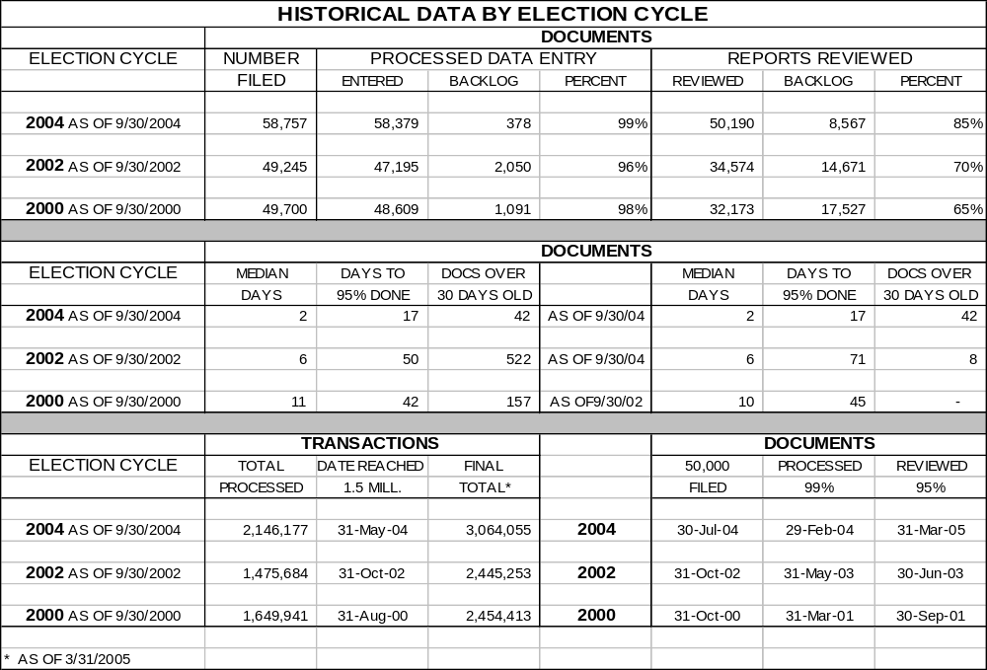

Program: Disclosure

Objectives

With regard to the Disclosure Program, the FEC seeks to:

- review and process the financial reports filed by political committees accurately and timely;

- make the reports and data readily accessible to the public, the media and the regulated community; and

- educate the public, the media and the regulated community about the legal requirements pertaining to disclosure, contributions limits and prohibitions, and the public financing of Presidential elections—the core elements of federal election campaign finance law.

Goals

To achieve the above objectives, the FEC will strive to accomplish the goals listed below.

Review and Processing of Reports

To achieve the accurate and timely review and processing of all reports, the FEC will:

- facilitate the electronic filing of reports by all political committees reaching a certain threshold, excluding Senate committees and the national parties’ Senate campaign committees;

- continue to meet the 48-hour deadline for placing reports filed by political committees on the public record;

- review all reports filed for accuracy and complete disclosure;

- encourage filers to voluntarily correct the public record by requesting additional information; and

- code and enter into the FEC database the information contained in 95 percent of reports within 45 days of receipt at the FEC.

Public Disclosure and Dissemination of Campaign Finance Data

To ensure that campaign finance data are widely distributed, the FEC will:

- provide the public with Internet access to its disclosure database and digital images of the reports (except those of Senate candidates);

- operate a Public Records Office where reports and data are available in paper, microfilm and digital images (scanned from original reports) and where the public can access the disclosure database;

- operate a Press Office to assist the media in the wide disclosure and dissemination of campaign finance data; and

- compile and release comprehensive statistical information based on the reports filed by political committees (e.g., using the Internet and news releases).

Education About the Law

To ensure that the public, the media and the campaign community fully understand the federal election law, and that information about the law is readily available, the FEC will:

- operate a toll-free line and maintain a well-informed staff to answer phone inquiries about the FEC and federal election law;

- produce educational and information brochures and booklets to supplement the FEC Annual Reports;

- make FEC publications available to the public through the FEC Website, an automated fax service, and the U.S. mail;

- conduct technical workshops on the law throughout the country;

- provide policy guidance through the timely release of Advisory Opinions; and

- review and revise FEC regulations to clarify federal election law.

The resources needed to meet the objectives and goals of the Disclosure Program in FY 2006 are summarized in Table 6 (shown before allocation of management and administrative overhead).

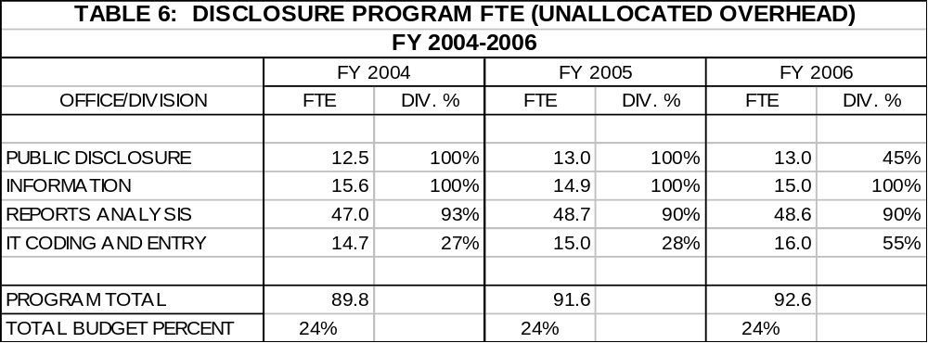

Program: Compliance

Objectives

The compliance program is based on the premise that the FEC’s first responsibility is to foster a willingness on the part of the regulated community to voluntarily comply with the law’s reporting requirements, fundraising restrictions and public funding statutes. The FEC encourages voluntary compliance through education. To buttress its educational efforts, the Commission carries out a Compliance Program with the following objectives:

- audit those committees whose reports fail to meet threshold requirements for substantial compliance with the FECA; and

- enforce the law, in a timely and fair manner, against persons who violate the law.

Goals

For each of these objectives, the Commission defines the following goals:

Audits

In those cases where committees have failed to meet the threshold requirements for substantial compliance with the FECA and have failed to voluntarily correct errors or omissions on their reports, the Commission will conduct 40-45 audits “for cause” for the 2004 election cycle, pursuant to 2 U.S.C. §438(b).

The Commission’s budget contains the resources added in FY 2001 to establish a “stand alone” Title 2 Audit “For Cause” Program. This enables the FEC to conduct approximately 40-45 Title 2 audits per cycle, as opposed to the previous 20-25 per cycle. This program, along with other procedural changes, allows the Commission to maintain the Title 2 audit program, even during presidential election cycles.

This budget also will allow the Commission to meet its goal of processing federal matching funds and completing the Title 26 Presidential audits, within two years after the presidential elections (see Public Financing objective below).

Enforcement

Because the majority (65% since 1995) of the Commission’s caseload arises from complaints filed by parties outside the agency, the total caseload figure is not singularly affected by the number of FTE in enforcement. The number of FTE affects the proportion of the total enforcement caseload that can be handled substantively, as well as the proportion of the caseload that is active vs. inactive. (A substantive finding is a finding based on the merits of the matter [other than dismissal], including findings of no “reason-to-believe” the FECA has been violated.”)

To reach the objective of enforcing the law in a timely and fair way, the Commission plans to:

- maintain a monthly average active caseload of at least 50 percent of the total caseload;

- close an estimated 75-100 cases. The Commission will close at least 60 percent of those cases through substantive Commission action;

- initiate several civil actions in federal court under 2 U.S.C. 437g(a)(6) to enforce the FECA/BCRA, and defend against several actions in federal court challenging the Commission's determinations under the Administrative Fines Program pursuant to 2 U.S.C.437g(a)(4)(C)(iii). (It is impossible to predict the number of such actions in either category. In recent years, the Commission has initiated a maximum of six actions under 2 U.S.C. 437g(a)(6) in any given year, and defended a maximum of eight administrative fine determinations in any given year.); and

- maintain the Enforcement Priority System (EPS), a system through which the Commission identifies and assigns the more significant enforcement cases to staff, disposes of the less significant cases rapidly, and manages limited staff resources.

Administrative Fine Program and ADR

Based on a legislative mandate, the FEC implemented an Administrative Fine Program in July 2000 to reduce the OGC staff resources required to enforce timely filing of disclosure reports. The Administrative Fine Program frees Commission resources for more complex, substantive enforcement actions.

The Commission also implemented an Alternative Dispute Resolution (ADR) Program in FY 2001. The ADR Program is designed to promote compliance with the federal election law by encouraging settlements outside the traditional enforcement or litigation processes. The program aims to expedite resolution of enforcement matters and to reduce the cost of processing complaints, and, therefore, enhance overall FEC enforcement. This program also frees Commission resources for other, more significant, enforcement matters.

The FEC anticipates that the ADR and Administrative Fine Programs will continue to enable the Commission to assign OGC enforcement resources to more complex, substantive matters. These programs expanded the number of compliance actions that the Commission enforcement program could process and resolve.

These two programs have allowed the Commission to expand the scope and reach of the enforcement process, and to streamline the case resolution process for late and non-filer cases, as well as to expedite the resolution of cases under ADR that might not have been activated under the EPS process (and might never have reached substantive resolution under the formal enforcement process). The two new programs help to ensure that limited enforcement resources are focused on more substantive and significant cases, yet allow the Commission to pursue the successful resolution of a major increase in the total number of cases processed. This is in response to recommendations stemming from a formal review of the Federal Election Commission, and a desire by the Commission to improve the timeliness of FEC compliance actions. The Administrative Fine Program was also Congressionally-mandated in language in the Commission’s appropriations legislation.
The Commission has set goals of activating more enforcement cases and dismissing fewer cases without substantive action. The ultimate goals of the ADR and Administrative Fine Programs, the Case Management System, and other information technology enhancements to the enforcement program are to speed up the resolution of cases and to increase the number of cases closed with substantive Commission action. the resources needed to meet the objectives and goals of the Compliance Program in FY 2006 are summarized in Table 7.

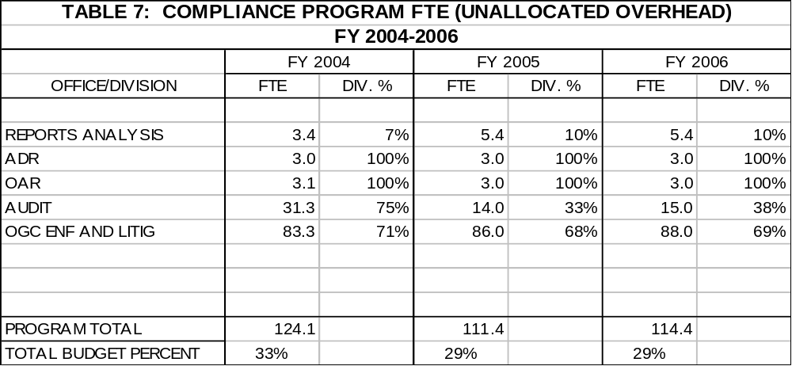

Program: Public Financing

Objectives

Under the Public Financing Program, the Commission seeks to:

- certify, on a timely basis, the eligibility of Presidential candidates and committees for payments;

- ensure timely U.S. Treasury payments to certified committees; and

- promote public trust by ensuring that all public monies are accounted for and expended in compliance with the FECA.

Goals

To reach the objectives described above, the Commission will:

- complete all public funding audits within two years of the 2004 Presidential general elections;

- successfully resolve all enforcement cases within the statutory time limits; and

- process the certifications quickly and accurately.

For FY 2006, the resources needed to complete any matters from the 2004 cycle and implement the Public Financing Program in the 2008 election cycle are summarized in Table 8.

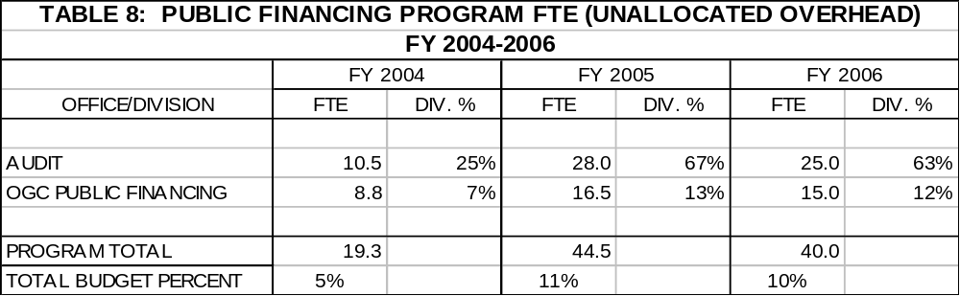

Tables 9 and 10 depict the ITD staff and FEC policy and administrative staff prior to allocation to the three major programs.

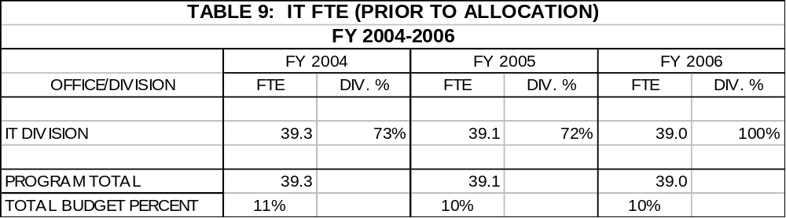

Table 9 reflects the transfer of entry and coding staff to Public Disclosure in FY 2006.

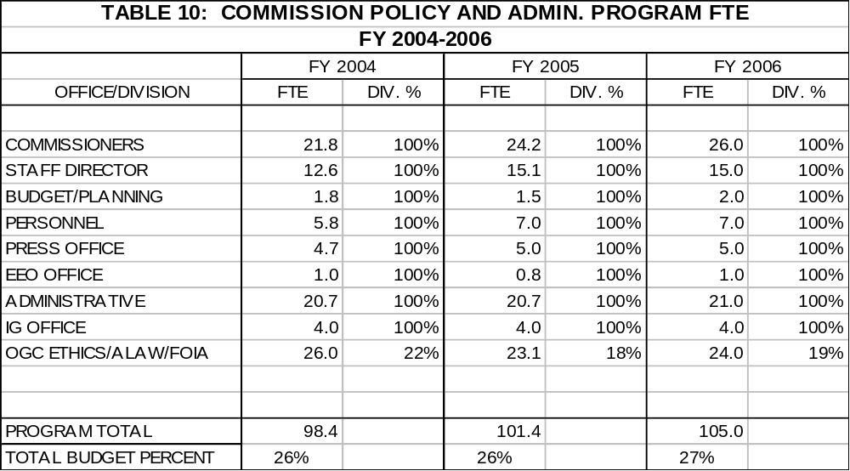

Public funding of Presidential elections has three components: matching funds for qualified Presidential primary candidates; public grants for the Presidential nominees of major and minor parties; and public grants to major parties to run their national Presidential nominating conventions.
There is a significant difference between mere “dismissal” and a finding of no “reason-to-believe” the law has been violated. A finding of no “reason-to-believe” reflects affirmative Commission action based on its consideration of the merits of the particular matter. A dismissal, on the other hand, usually reflects action by the Commission based on an application of the Enforcement Priority System criteria to a particular case to determine whether the case merits the use of the Commission’s limited resources.
Under EPS, OGC evaluates enforcement cases based on carefully crafted, Commission-approved criteria to determine the relative significance of the allegations. EPS is a tool to match the seriousness of a particular case to the resources available to undertake an investigation of the matter.

