The BLM Equipment Development Unit has been informed of three separate instances of wheel chock retaining device failures causing the chock to fall out during operation of the vehicle. The spring loaded lever that retains the chock has too much play and is allowed to open the retainer (as pictured below) and release the wheel chock.

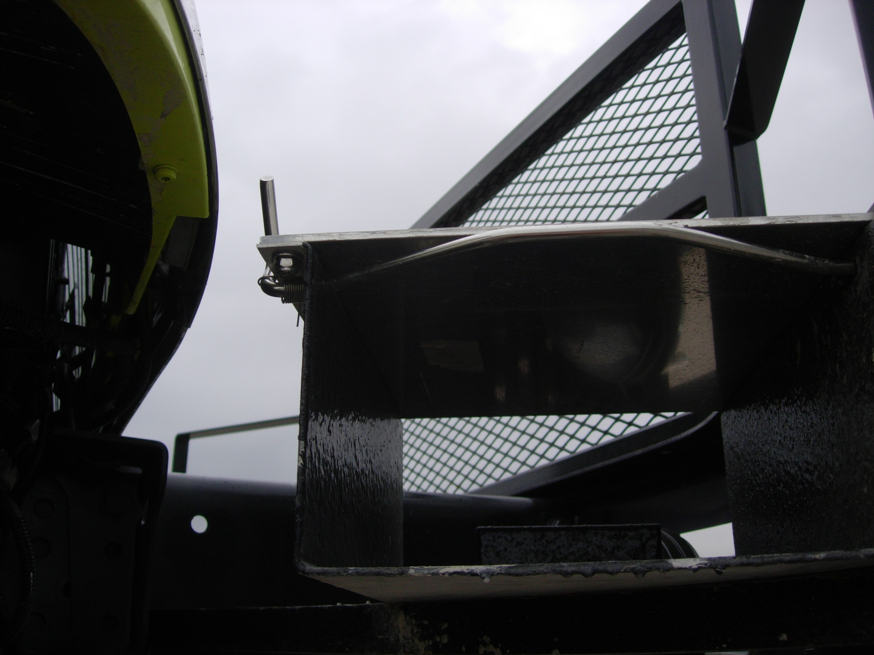
LEVER
LEVER SHOULD STOP HERE

Zico, the manufacturer of the chock and holder has been notified and is working on a correction. It is recommended that all vehicles equipped with Zico chocks be inspected immediately. If the chock retainer is found faulty, the chock shall be removed prior to operating the vehicle, and until repair parts are installed. Possible BLM vehicles affected include Type 4 engines, Type 3 engines, Water Tenders, and Fuel Trucks. The fix that Engineers at S&S Fire implemented is pictured below. Repair kits can be obtained from the Equipment Development Unit after May 22, 2006. Contact Mike Utecht (208)387-5424, Dan Y (208)387-5445, John Fitchner (208)3875425, or Carl Dorsey (208)387-5423



