

Physical Oceanography Division Phone: 305/361-4345
4301 Rickenbacker Cswy Fax: 305/361-4412
Miami, Florida 33149-1097

September 2008

Cruise Plan – AX7

Ship Name: M/V Hapag Lloyd Rome Express

Project Title: Atlantic Climate Change Program
Volunteer Observing Ship High Resolution XBT Line AX7

Beginning date: On or about 25 September 2008 from Barcelona, Spain

Ending date: Arriving Fort Lauderdale, Florida on or about 7 October 2008

Loading date: 2 September 2008, Port Everglades, Florida, USA

Scientific Ship Rider: Jim Farrington, NOAA/AOML

Description of the Scientific Program

The volunteer ship, M/V ROME EXPRESS, will be involved in a study of the upper ocean thermal structure of the subtropical North Atlantic Ocean within the context of the Atlantic Volunteer Observing Ship Program. Repeat crossings of the center of the subtropical gyre, every 3 months, will be conducted with the intent of determining and monitoring the seasonal-to-interannual variability of the upper ocean. This particular line along nominally 30⁰ N, designated as AX7, is ideal for monitoring heat flux variability in the Atlantic because it lies near the center of the subtropical gyre which has been shown to be the latitude of the maximum heat flux in the ocean. The upper ocean thermal structure obtained by the voluntary observing ship (VOS) using the expendable temperature probes (XBTs) will be used to correlate the subtropical gyre intensity with atmospheric forcing as well as determining the heat transport. XBT data along this latitude will be compared and combined with several ongoing and historical studies including estimates of the Florida Current and Deep Western Boundary Current Transports and several full water column historical surveys completed near the same latitude. The new higher resolution for this line should help determine the correct sampling strategies for lower resolution XBT lines as well as providing resolution of the eddy structure so necessary to incorporate into the atmospheric-ocean forecast models now being implemented at the National Meteorological Center.

Implementation

The first crossing of this VOS line (designated AX7) began on September 30, 1994 (Figure 1). We have more or less proceeded on the same route since that time (Figure 2). This VOS line will meet WOCE criterion for high-resolution deployment providing temperature profiles every 50 km in the open ocean and between 10-30 km near boundary currents down to a depth of about 800 m. This section emphasizes consistent horizontal spacing of XBT probes: clusters in space or time are of little value.


Figure 1: Table of times of all section occupations since the program began in 1994.
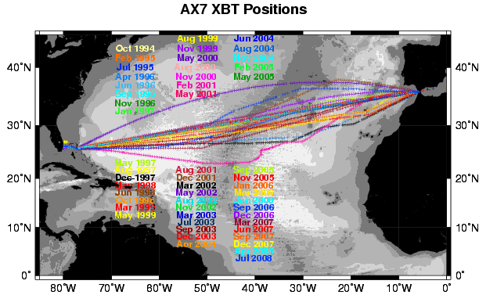

Figure 2: Map of station locations of all XBT sections taken along AX7 since the program began in 1994.

The overall plan for the ship track is as follows:

- From Barcelona, Spain to 5⁰20’W, 36⁰ N: Set up and test XBT launcher as desired. No planned sampling.
- From near 5⁰20’W, 36⁰ N to near 7⁰ W, 36⁰ N: High resolution sampling every 10 km: i.e., 15 probes over 150 km deployed every 22 minutes.
- From near 7⁰ W, 36⁰ N to near 70⁰ W, 26⁰30’N: Standard sampling every 50 km: i.e., 120 probes over 5990 km deployed every 1 hour and 48 minutes.
- From near 70⁰ W, 26⁰30’N to near 76⁰20’ W, 26⁰ N: Medium resolution every 30 km: i.e., 21 probes over 635 km deployed every 1 hour and 5 minutes.
- From (76⁰20’ W, 26⁰ N) to Hole in the Wall, Abaco (near 77⁰20’ W, 25⁰40’ N) : High resolution sampling every 10 km: i.e., probes over 107 km deployed every 22 minutes.
- Northwest Providence Channel: From Hole in the Wall, Abaco (near 77⁰07’ W, 25⁰48’ N) to the Western end of the Providence Channel (near 79⁰05’W, 26⁰10’ N): Medium resolution sampling every 30 km: i.e., 6 probes over 176 km deployed every 1 hour and 5 minutes.
- Florida Straits: From the end of the Providence Channel (near Great Isaccs, Bahamas, 79⁰12’W, 26⁰10’ N) to 80⁰00’W, High resolution sampling every 12 nautical miles (8 probes), then 1 final drop between 80⁰02’W and 80⁰01’W.

The above sampling time-interval time interval estimates are based on a ship traveling at 15 knots. If the ship is traveling at a different speed it will be necessary to adjust the launch times (see table 1 as a quick guide).

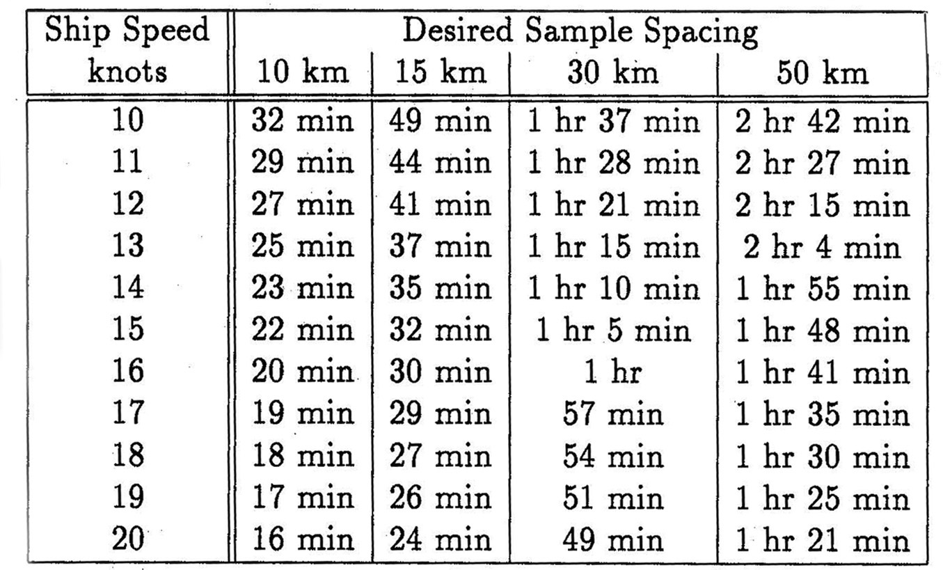

Table 1. Time interval between XBT launches based on ship speed and desired sampling spacing.

If the planned cruise track deviates significantly from the outline above please notify Molly Baringer at (305)361-4345 or (305)710-9240.

If the planned sampling is interrupted for any reason (such as an autolauncher failure) the procedure will be to drop another probe as close as possible to the planned drop and continue with the desired spacing of the XBTs for that section of the cruise track (according to the above guide). If a serious malfunction of the autolauncher occurs then manually deploy the XBTs from the stern of the ship using the hand launcher.

The ship-rider will work as needed around the clock to:

1) Check and load the auto-launcher;
2) Check that the system is logging data correctly; and
3) Deploy ARGO profiling floats and surface drifting buoys as necessary.

In addition to the above, four (4) surface drifting buoys were loaded aboard the ship. Deployment positions for the floats will be determined at a later date.

Summary

This high resolution XBT line will require 240 probes plus an anticipated 10% failure rate of 24 probes for each Atlantic crossing. This requires a total of 264 probes per crossing. Drifting buoys will also be deployed during the cruise. ARGO floats will not be deployed during this cruise.

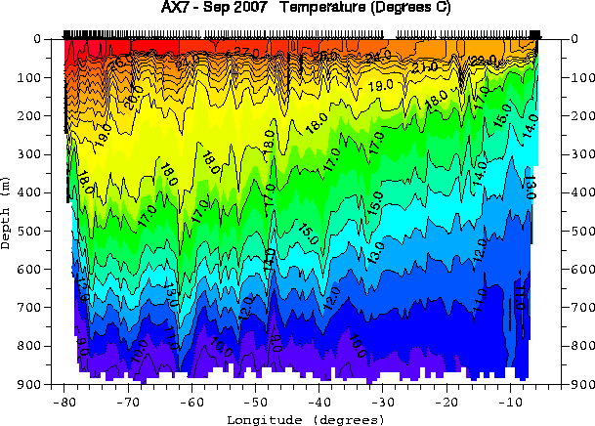

Figure 3. This figure shows a temperature section of a typical crossing along the AX7 route.
Temperature contours shown on the figure are in ⁰C. This section was taken aboard the
BARCELONA EXPRESS in September of 2007.

Figure 3 shows a typical temperature section across the subtropical Atlantic. Some features in these sections include:

- Increase depth of isotherms (constant temperature surfaces) towards the west (e.g., 15⁰C isotherm starts near 100m in the east and deepens to over 650m in the west).
- A rapid decrease in the depth of isotherms near the western boundary (where the Florida Current and Azores current bring warm water northward).
- Warmest surface water is found in the west (near the Gulf Stream/Florida Current and the subtropical gyre recirculation).
- Large fluctuations in the depth of temperature surfaces between 20-30⁰ W where the Azores current crosses the section.

Typical currents expected in the region are shown in Figure 4. The XBTs deployed will identify the vertical structure of the mesoscale features present in the region.

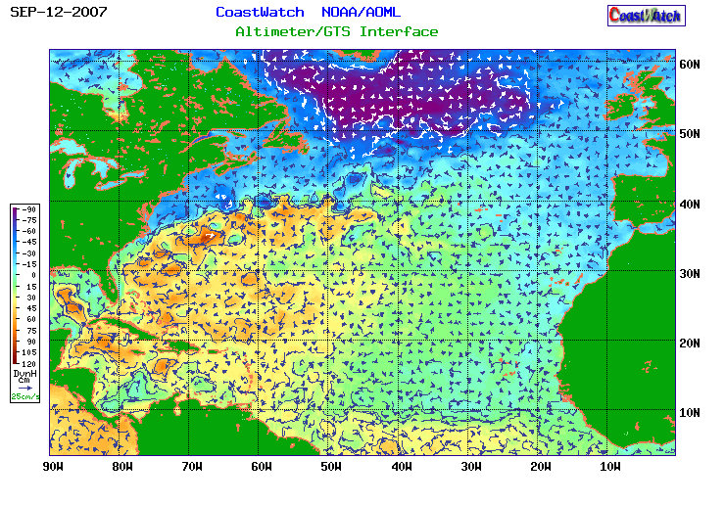

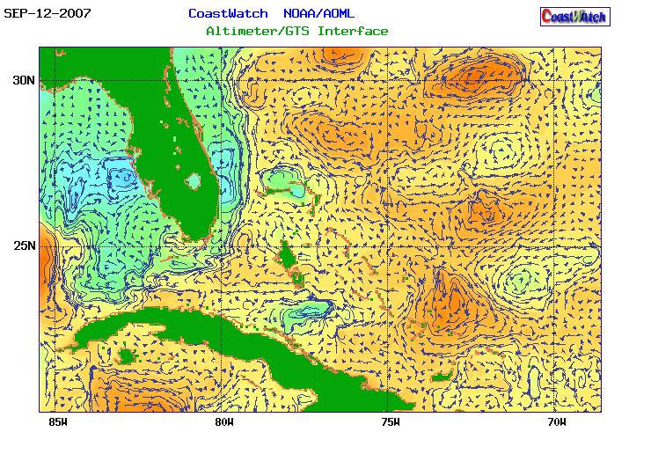
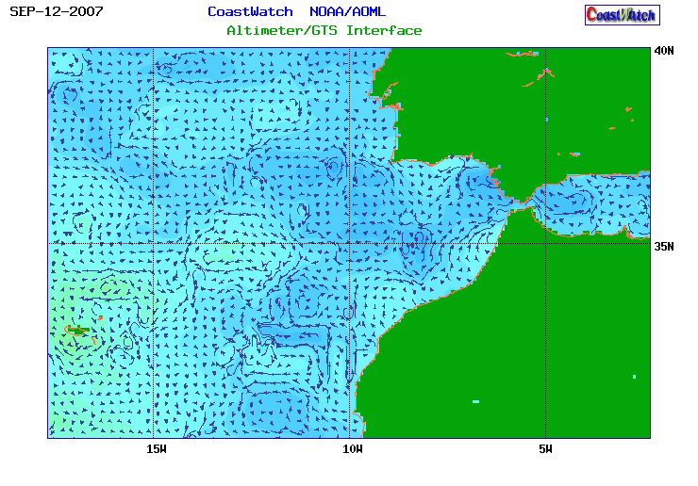

Figure 3. Satellite altimetry-derived surface currents and dynamic height in the North Atlantic for 12 September 2007.

Available Data Products

Temperature sections and information on XBT deployments can be found on the following web page: http://www.aoml.noaa.gov/phod/hdenxbt/high_density_home.html

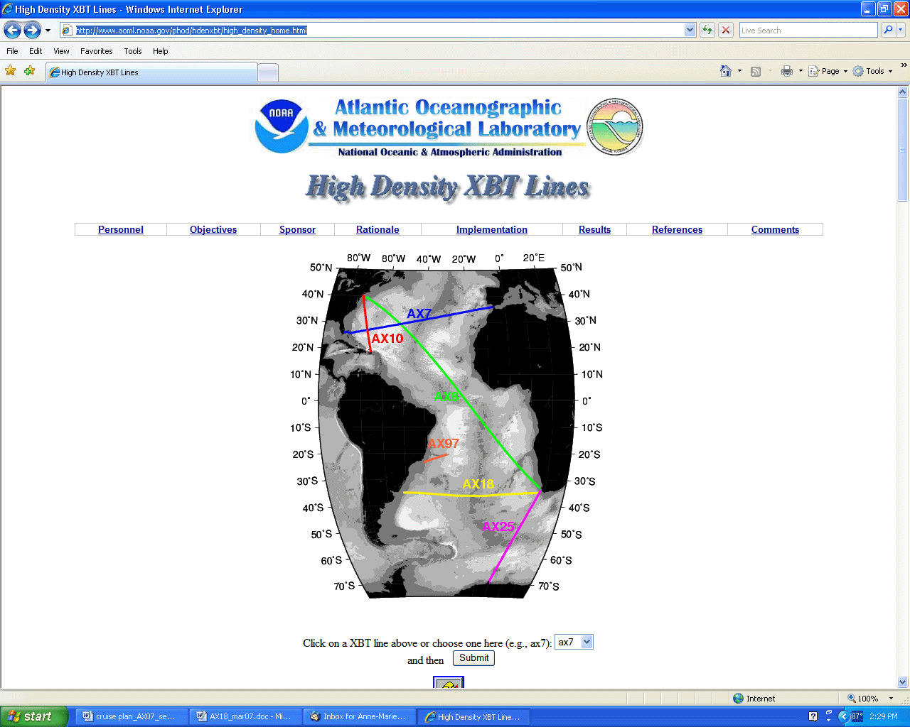

Real-time surface winds and ocean surface currents can be found at:
http://www.aoml.noaa.gov/phod/dataphod/work/trinanes/INTERFACE/index.html

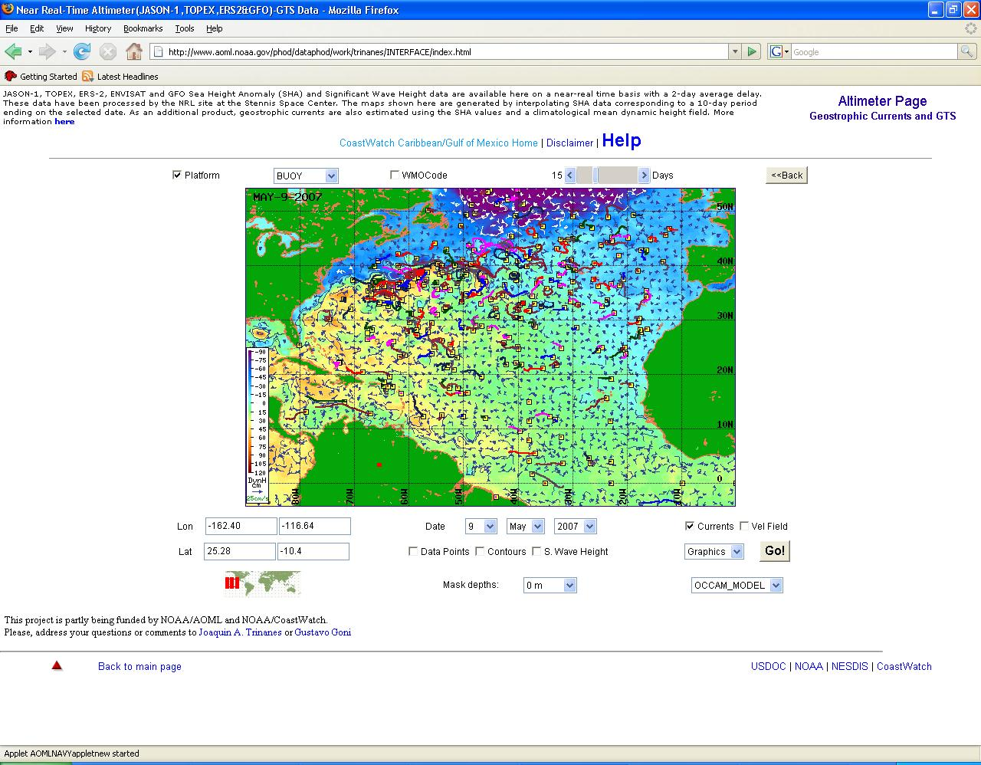
High Density Check-out list for the Ship Rider Date Completed

Data to be copied to CD or other means of transportable memory __________________
1. All XBT data in .BIN, .NDC and electronic XBT drop log sheet.
2. HistoryAllAttempts.txt – found at c:\ProgramFiles\AMVERSEAS\XBT\ARCHIVE
3. Cruise webpage summary, cruise report, drifting buoy log sheet and ARGO float log sheet

XBT data and HistoryAllAttempts.txt CD to each of the following:
Molly Baringer __________________
Robert Roddy __________________
Qi Yao __________________
Juan Delgado __________________

Argo deployment information while underway:
e-mailed to: aoml.argo@noaa.gov and robert.j.roddy@noaa.gov _____________________

Drifting buoy deployment information while underway:
shaun.dolk@noaa.gov __________________

Cruise webpage summary. This information goes on the webpage including number XBTs dropped, drifters/floats deployed, any data affecting issues. Send an email to each of the following:
Gustavo Goni gustavo.goni@noaa.gov __________________
Molly Baringer molly.baringer@noaa.gov __________________
Qi Yao (XBTs) qi.yao@noaa.gov __________________
Silvia Garzoli silvia.garzoli@noaa.gov __________________
Shaun Dolk shaun.dolk@noaa.gov __________________
Juan Delgado (GTS) juan.delgado@noaa.gov __________________

Please email a Cruise Report to Molly Baringer, Silvia Garzoli and Gustavo Goni stating the following:
  - XBTs deployed
  - Drifters deployed (ID, date, time, latitude, longitude)
  - Profiling floats deployed (start time, deployment time, latitude, longitude)
  - GTS transmission (Real-time, twice a day, problems)
  - Additional equipment, tools, supplies needed
  - Problems
  - Recommendations
  - Other narrative

At the end of the cruise please send an e-mail to Sommyr Pochan sommyr.pochan@noaa.gov notifying her that cruise is over so that a thank you note can be forwarded to the captain and crew. List any special thanks or comments that you would like included in the note.

