    United States Environmental Protection Agency  Office of Ground Water and Drinking Water  CONTRACT NO. EPA BPA OARMSC-SYS-04  SDWIS Project  Product Control No.  Systalex-SDWIS-01-5-d1f  July 31, 2007 |   SDWIS/eDV 1.0  User Guide

SDWIS/eDV 1.0 USER GUIDE

CONTRACT NO. EPA BPA OARMSC-SYS-04
SDWIS PROJECT

Prepared for:

United States Environmental Protection Agency
Office of Ground Water and Drinking Water
Drinking Water Protection Division
1200 Pennsylvania Ave., NW
Washington, DC 20460

Contracting Officer Representative

Edward Cottrill

Prepared by:

SAIC Solutions Delivery Center
Science Applications International Corporation
6565 Arlington Boulevard
Falls Church, VA 22042

CONTENTS

1.0 Introduction 1
1.1 Document Overview 1
1.2 Concept of Operations 1
1.3 SDWIS/eDV Compliance Determination For Federal Drinking Water Rules 2
1.4 Usage Assumptions 2
1.5 Software and Hardware Test Environment 2
1.6 User Support 3
2.0 SDWIS/eDV User Instructions 4
2.1 Initiating SDWIS/eDV Home Page 4
2.2 Managing Data Sources 5
2.2.1 Extracting a SDWIS/STATE Web Release 1.0 Database 5
2.2.2 Downloading the Extract 9
2.2.3 Importing a SDWIS/STATE Database 10
2.2.4 Importing a SDWIS/ODS Quality Assurance Extract 12
2.3 Performing SDWIS/eDV 14
2.3.1 Initiating SDWIS/eDV Processing 14
2.3.2 Monitoring SDWIS/eDV Progress 16
2.3.3 Restart Capability 19
2.3.4 Review SDWIS/eDV Discrepancies 20
2.4 Closing SDWIS/eDV 30

Appendix A - Violation Types Not Supported by SDWIS/STATE Web Rel 1.0 Compliance Determination/Assistance Processes

EXHIBITS

Exhibit 1. SDWIS/eDV Hardware and Software Test Environment 3
Exhibit 2. SDWIS/eDV Home page 5
Exhibit 3. Configure eDV 6
Exhibit 4. Specify Verification Periods 7
Exhibit 5. Perform eDV – SDWIS/STATE Extract 8
Exhibit 6. Dashboard – Extraction In Progress 9
Exhibit 7. Dashboard – Extraction Complete 10
Exhibit 8. Perform eDV – Import Current SDWIS/STATE Extract 11
Exhibit 9. Perform eDV – Import Previous SDWIS/STATE Extract 12
Exhibit 10. Perform eDV – Import SDWIS/ODS QA Extract 13
Exhibit 11. Specify Verification Periods 15
Exhibit 12. Perform eDV 16
Exhibit 13. Dashboard 18
Exhibit 14. JasperServer Login 20
Exhibit 15. eDV Discrepancy Report – Initial Presentation 21
Exhibit 16. eDV Discrepancy Report – Expanded 23
Exhibit 17. eDV Discrepancy Report – Drill-Through details 24
Exhibit 18. eDV Discrepancy Report – Filtering 25
Exhibit 19. Print Properties 27
Exhibit 20. View eDV Reports in PDF 28
Exhibit 21. Saving eDV Reports in PDF 29
Exhibit 22. Saved eDV Reports 30

Introduction
The SDWIS/eDV 1.0 User Guide contains instructions for using SDWIS/eDV 1.0. SDWIS/eDV 1.0 supports the EPA Data Verification process by automating the identification of violations and comparing those violations to the primacy agency’s SDWIS/STATE database and the SDWIS/ODS Quality Assurance (QA) Extract to identify discrepancies where the mismatches occur. SDWIS/eDV 1.0 targets a SDWIS/STATE Web Release 1.0 database architecture.

Document Overview
This document contains instructions for using SDWIS/eDV 1.0. It comprises the following two sections:

- Section 1.0, Introduction, describes the content of the document, the software and hardware test environment, and user-support procedures.

- Section 2.0, SDWIS/eDV User Instructions, describes the SDWIS/eDV user interfaces.

- Appendix A - Violation Types Not Supported by SDWIS/STATE Web Rel 1.0 Compliance Determination/Assistance Processes, describes the rules and violation types as implemented in SDWIS/STATE Web Rel 1.0.

Concept of Operations
SDWIS/eDV may be used by either EPA DV staff or by Primacy Agency personnel who wish to prepare for a DV. It automates the following processes:

- Setup of Data Sources
- Compliance Determination with federal drinking water rules
- Identification of discrepancies
- Reporting and presentation of the results

SDWIS/eDV Release 1.0 uses a suite of open-source tools to extract data from SDWIS/STATE and SDWIS/ODS databases, loads the data into an eDV database, and provides you an interactive report of the results.

SDWIS/eDV Compliance Determination For Federal Drinking Water Rules
The SDWIS/eDV Compliance Determination component reuses existing SDWIS compliance determination software. Specifically, it supports the following EPA rules in accordance with SDWIS/STATE Web Release 1.0 business rule implementation.

- Arsenic Rule
- Chemical Phase Rules (Acutes and Chronics)
- Consumer Confidence Rule
- Disinfectant and Disinfection By Product (Stage 1)
- Lead and Copper Rule
- Public Notification Rule
- Radionuclide
- Surface Water Treatment Rule (Long-Term 1, Filter Backwash, Turbidity, Interim Enhanced)
- Total Coliform Rule

SDWIS/STATE Web Release 1.0 handles the vast majority of compliance determination scenarios for these rules. However, as compliance determination was implemented for each rule in SDWIS/STATE, implementation of a few aspects of some rules was assessed to have a relatively low cost-benefit ratio. While these design decisions are recorded in SDWIS/STATE design documentation produced over the last several years, they have been re-summarized in Appendix A of this document for the convenience of those not familiar with SDWIS/STATE documentation.

Usage Assumptions
SDWIS/eDV 1.0 has been designed for usage according to the following assumptions:

- SDWIS/STATE Web Release 1.0 is the primacy agency’s database of record.
- Primacy Agency maintains sample schedules and sample results in SDWIS/STATE.
- Sample Schedules in SDWIS/STATE are established at the appropriate monitoring frequency.
- Existing SDWIS/STATE compliance assistance processes are used and extended to
generate anticipated violations.

Software and Hardware Test Environment
SDWIS/eDV 1.0 was tested using the hardware and supporting software versions listed in Exhibit 1.

Machine Type | Hardware | System Software | Application Software
Client Workstation | - Dell OptiPlex GX260  - Intel Pentium 4 CPU 3.06 GHz  - 1 GB RAM | MicrosoftWindows XP Professional Version 2002 Service Pack 2 | Internet Explorer 6  Apache Derby 10.2.2.0  Kettle ETL 2.4  JasperIntelligence 1.2.1  Adobe 7.0 and/or 8.1 (Optional for reading/printing report pdf)  MS Excel 2003 SP2 (Optional for use with SDWIS/eDV Report)

Exhibit 1. SDWIS/eDV Hardware and Software Test Environment

It is assumed that SDWIS/eDV will be run on a client workstation with at least 1GB RAM.

User Support
As a representative of a primacy agency or the Environment Protection Agency (EPA), you may call the SDWIS User Support Hotline at (703) 292-6298 or email SDWIS User Support at sdwis@saic.com. The hotline/email account is intended as a technical support tool for the operation and functionality of SDWIS products such as SDWIS/eDV. A SDWIS team member answers calls to the hotline between 8 a.m. and 5 p.m., Eastern Standard Time (EST), on weekdays (except federal holidays) and offers immediate user support when possible. During evenings, weekends, or those times when the support personnel are temporarily not available, callers may leave a detailed message. Questions requiring the expertise of other team members, such as developers or subject matter experts, are documented in the Events Tracking System, forwarded to those individuals, and answered as soon as possible.

SDWIS/eDV User Instructions
SDWIS/eDV is part of the SDWIS product suite and has been built to assist EPA in expediting and improving the data verification task and to assist states in identifying and addressing potential discrepancies.

Initiating SDWIS/eDV Home Page
This section applies to all SDWIS/eDV installations, both EPA DV auditors and the primacy agency. SDWIS/eDV is a web-based application accessed through web browsers. It installs as a stand-alone web application which requires that you start the web server.

To start the eDV web server:
- Click Windows Start Button
- Click All Programs
- Click SDWIS_eDV
- Click Start eDV

The result will be the initiation of a Tomcat session. It is ready when the Tomcat window says INFO: Server Startup in xxxxx ms. A Derby Console session will also open. It is ready when the Derby window says ready to accept connections.

To Access the SDWIS/eDV Home page (Exhibit 2):

- Click Windows Start Button
- Click All Programs
- Click SDWIS_eDV
- Click Open eDV

The result will be the presentation of the SDWIS/eDV Home page.

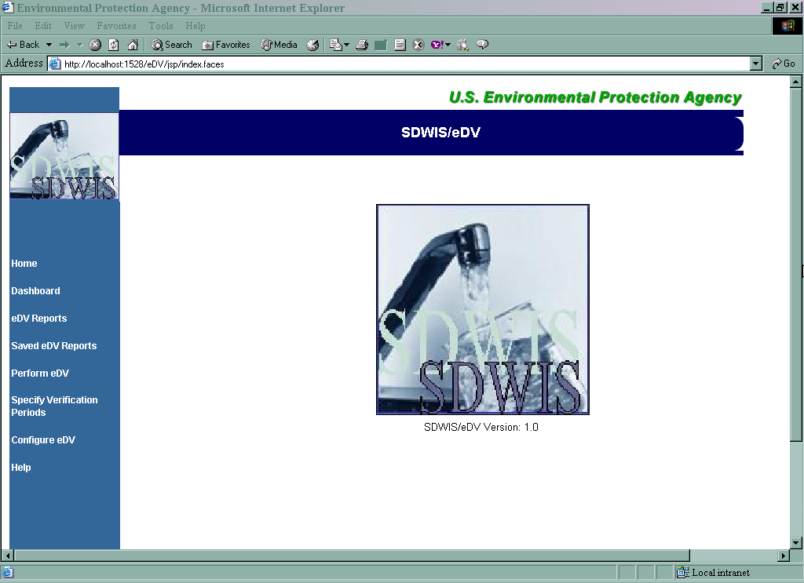

Exhibit 2. SDWIS/eDV Home page

Managing Data Sources
Executing SDWIS/eDV requires the import of two data sources: a SDWIS/STATE Web Release 1.0 database Extract and a SDWIS/ODS QA Extract.

Extracting a SDWIS/STATE Web Release 1.0 Database
The instructions in this section are performed by the primacy agency. To extract a SDWIS/STATE Primacy Agency database, you must perform three processes:

- Configure the database access parameters
- Establish the verification periods
- Submit the extraction

The following steps will start the extract of a database:

- Select Configure eDV from the SDWIS/State Home page. You will be presented the Configure eDV page (Exhibit 3).
- Select the Database Type appropriate for the target SDWIS/STATE database. Choices are Oracle, DB2, or SQL Server.
- Enter the Database Server name, the Database Port, the Service Name (for Oracle and DB2) or Database Name (for SQL Server), the Database Schema Name, and the Database Schema Password.
- Click Apply to save the configuration parameters.
- Click Test Database Connection to ensure all of your parameters are valid and that SDWIS/eDV can find your SDWIS/State database. When successful, you will receive a confirmation message, Test Completed Successfully. If the test fails, check all of the parameters for correctness.

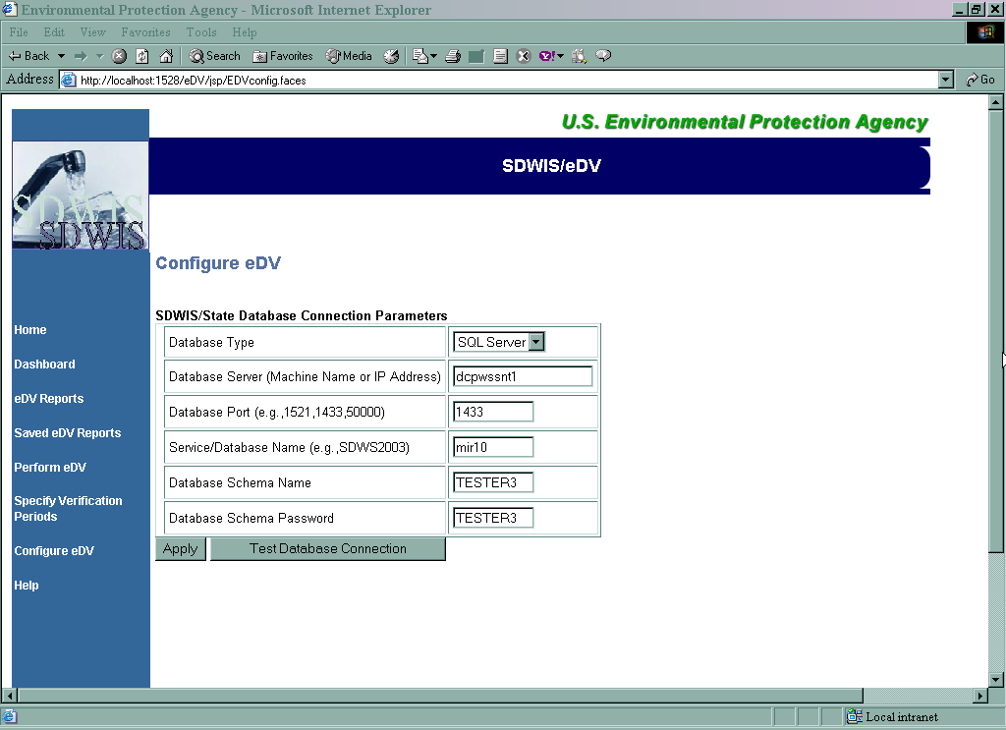

Exhibit 3. Configure eDV

- Click Specify Verification Periods (Exhibit 4) on the SDWIS/eDV Home page.

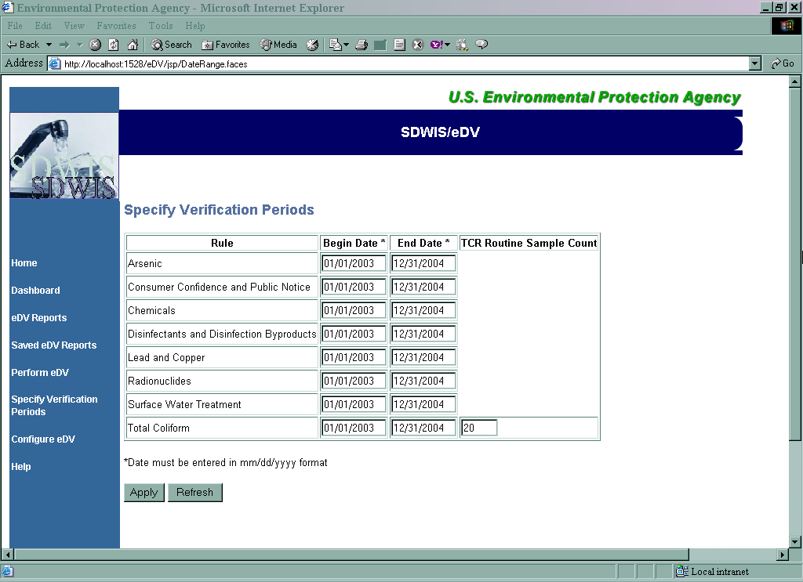

Exhibit 4. Specify Verification Periods

- Enter Begin and End dates for each Rule that you wish SDWIS/eDV to assess. These dates should be provided by the Data Verification auditor when a SDWIS/STATE Extract is requested from the Primacy Agency. These dates constrain the domain of the data extraction and therefore must match the intended Data Verification (DV) Periods to be used to perform the eDV process. (Reference the SDWIS/eDV Design Document for the details on this data extraction domain.)
- Click Apply to save the dates.
- Click Perform eDV (Exhibit 5) on the SDWIS/eDV Home page.
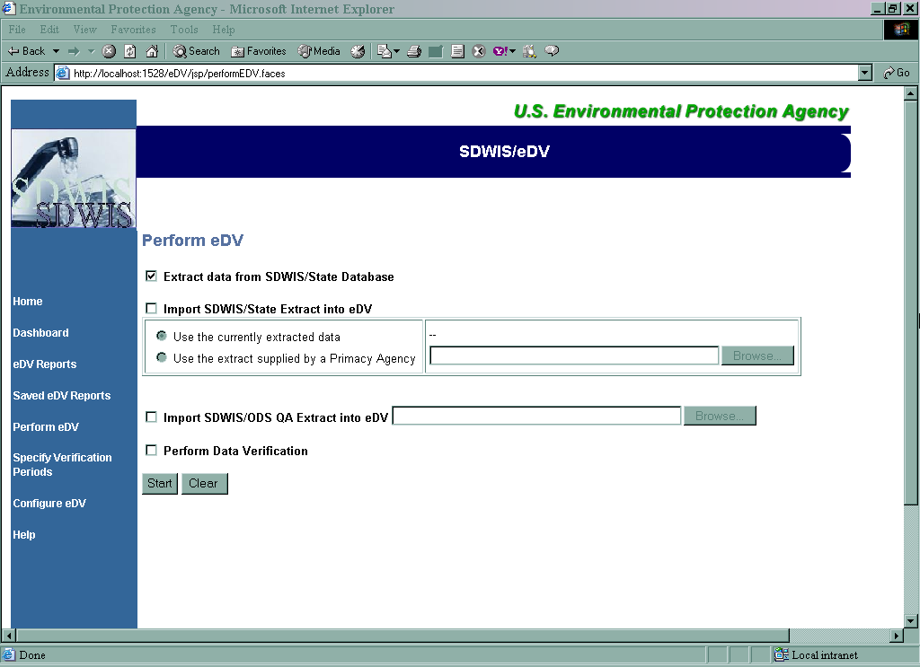

Exhibit 5. Perform eDV – SDWIS/STATE Extract

- Click the checkbox indicating Extract data from SDWIS/State Database.
- Click Start. You are automatically presented the Dashboard page (Exhibit 6) indicating that the extraction is In Progress. Click Refresh to see updates of the status. The extraction runs independently of the web page, so you may close your browser; however, you should not stop the Tomcat web application server. (That is, do not close the Tomcat window or choose to Shutdown eDV from the program window.)
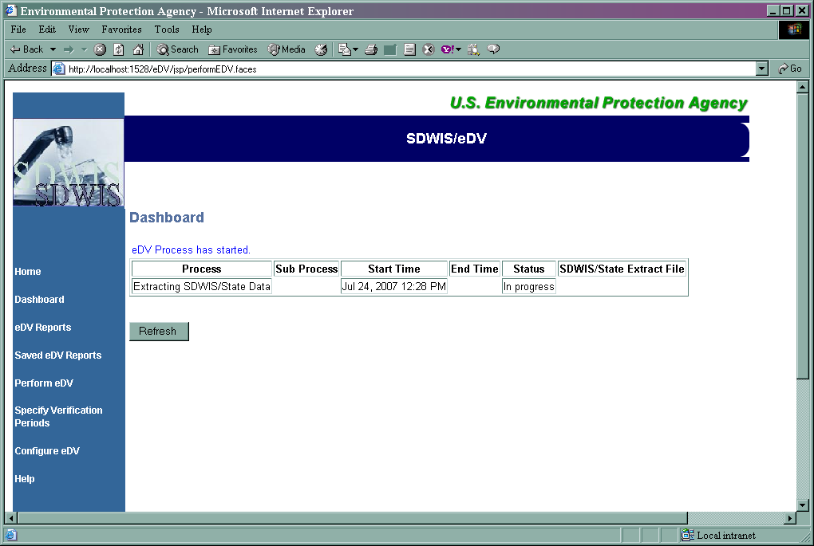
Exhibit 6. Dashboard – Extraction In Progress

Downloading the Extract
The instructions in this section are performed by the primacy agency. When your SDWIS/STATE primacy agency extraction is complete, the zip file containing all of the comma separated files will be available via a link on the Dashboard page in the SDWIS/State Extract File column (Exhibit 7).

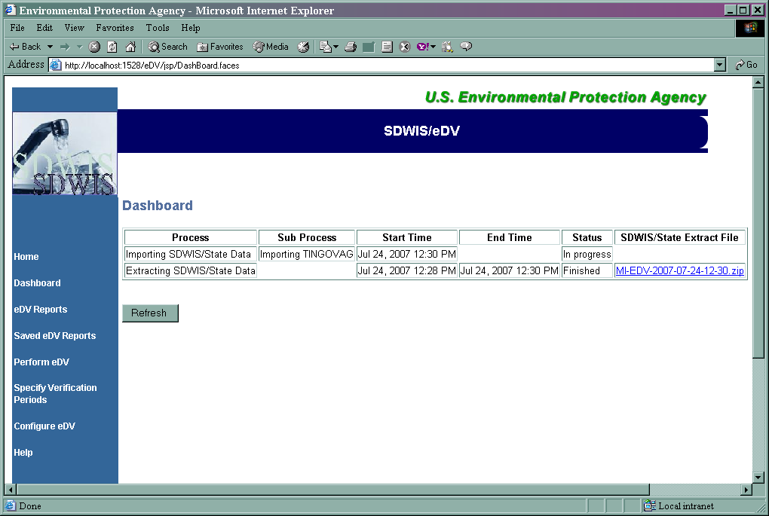

Exhibit 7. Dashboard – Extraction Complete

Click on the link to access the file and save it to the folder of your choice.

Importing a SDWIS/STATE Database
This section applies to all installations of SDWIS/eDV, both EPA HQ and primacy agency. If you want to import a SDWIS/STATE database that you are extracting in this same process flow, you can do this by:

- Performing the Extraction steps listed in section 2.2.1 above.
- On the Perform eDV page (Exhibit 8), prior to clicking the Start button, click the check box next to the Import SDWIS/STATE Extraction into eDV.
- This enables the radio buttons associated with this option. Click the Use the currently extracted data option.
- Click Start to initiate the extraction to be followed by an immediate import. You are automatically presented the Dashboard page (Exhibit 6) indicating that the extraction is In Progress. Click Refresh to see updates of the status. The extraction runs independently of the web page, so you may close your browser; however, you should not stop the Tomcat web application server. (That is, do not close the Tomcat window or choose to Shutdown eDV from the program window.)

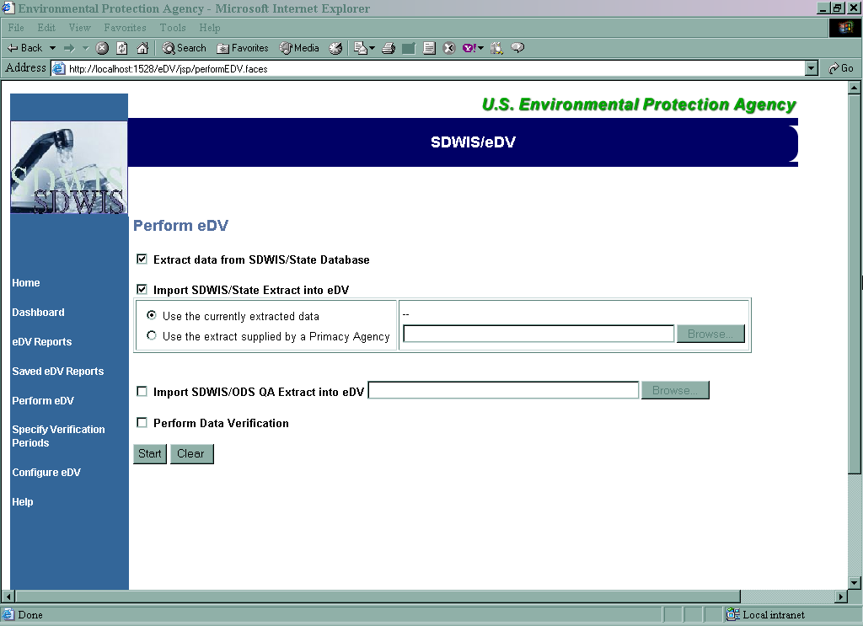

Exhibit 8. Perform eDV – Import Current SDWIS/STATE Extract

To import a SDWIS/STATE database that was sent to you by a Primacy Agency, or that you had previously extracted:

- Click Perform eDV page (Exhibit 9).
- Click the check box next to the Import SDWIS/STATE Extraction into eDV. This enables the radio buttons associated with this option.
- Click the Use the extract supplied by a Primacy Agency option.
- Enter the extraction path and file name in the entry field or use the Browse button to make a selection from the windows directory structure. The extraction file should be a .zip file.
- Click Start to initiate the import. You are automatically presented the Dashboard page indicating that the Import is In Progress. Click Refresh to see updates of the status. The import runs independently of the web page, so you may close your browser; however, you should not stop the Tomcat web application server. (That is, do not close the Tomcat window or choose to Shutdown eDV from the program window.)

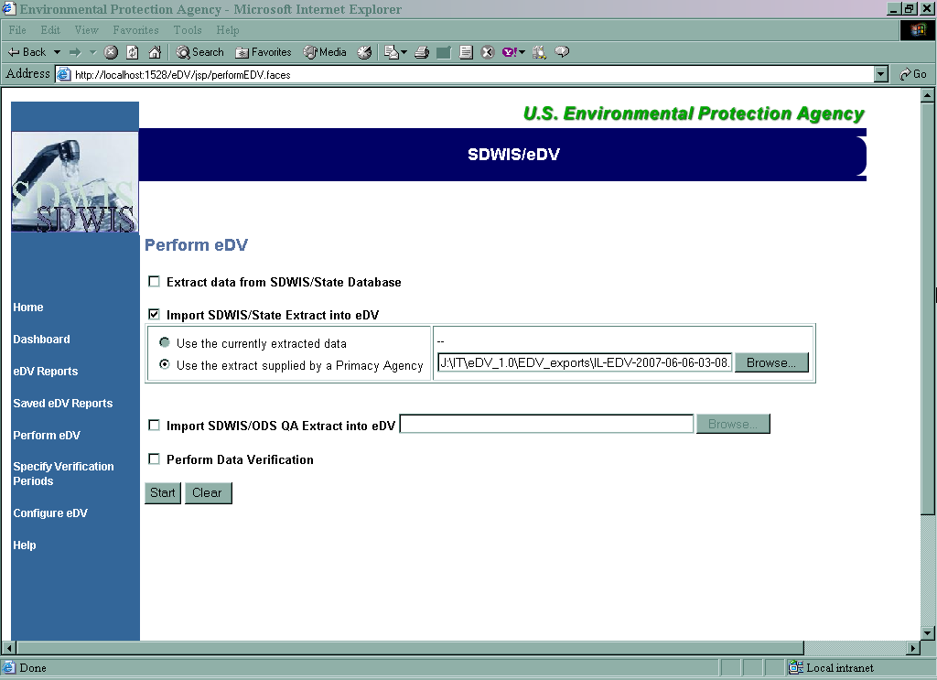

Exhibit 9. Perform eDV – Import Previous SDWIS/STATE Extract

You can remove the values from the check boxes and input fields by clicking the Clear button.

Importing a SDWIS/ODS Quality Assurance Extract
This section applies to both EPA DV auditors (with SDWIS/eDV installed at EPA HQ) as well as to those using the tool at the primacy agency. You may request a QA Extract from the SDWIS/ODS through EPA’s Central Data Exchange (CDX). (For further information on how to do this, see section 2.0 of the SDWIS/ODS QUALITY ASSURANCE UTILITY 2.0 Installation and User’s Guide.) Once you receive the QA Extract, you will need to import it into SDWIS/eDV.

To import a SDWIS/ODS QA Extract:

- Click Perform eDV page (Exhibit 10) from the SDWIS/eDV Home page.
- Click the check box next to the Import SDWIS/ODS QA Extract into eDV.
- Enter the extraction path and file name in the entry field or use the Browse button to make a selection from the windows directory structure. The extraction file should be a .zip file.
- Click Start to initiate the import. You are automatically presented the Dashboard page indicating that the import is In Progress. The import runs independently of the web page, so you may close your browser; however, you should not stop the Tomcat web application server. (That is, do not close the Tomcat window or choose to Shutdown eDV from the program window.)

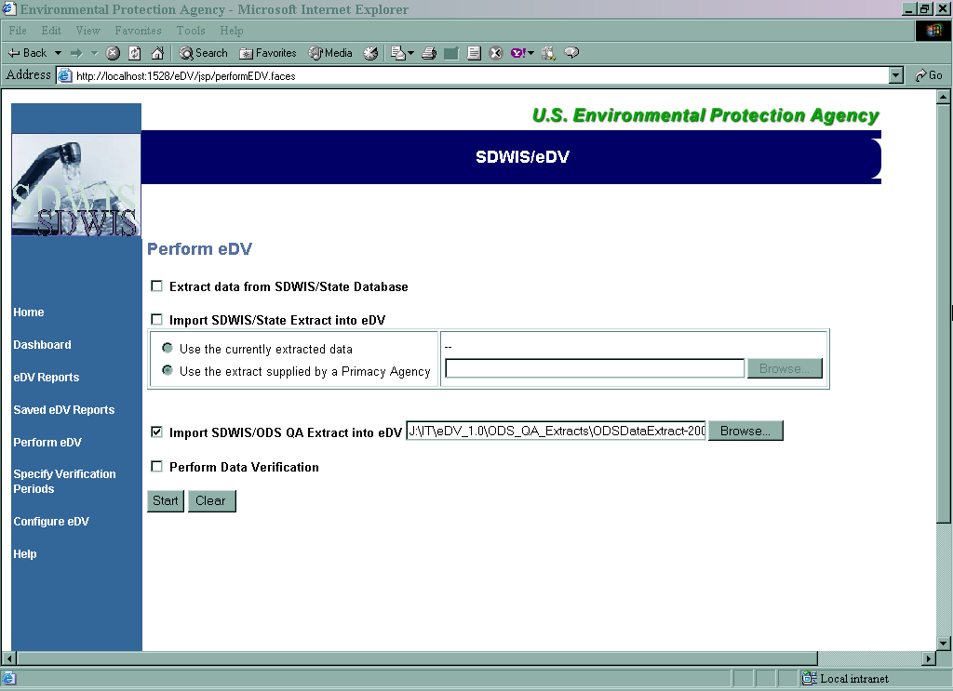

Exhibit 10. Perform eDV – Import SDWIS/ODS QA Extract

You can remove the values from the check boxes and input fields by clicking the Clear button or by checking the boxes again.

Performing SDWIS/eDV
This section applies to both EPA DV auditors (with SDWIS/eDV installed at EPA HQ) as well as to those using the tool at the primacy agency. Once the two data sources of SDWIS/STATE data and SDWIS/ODS data have been imported, you may perform the SDWIS/eDV process.

Initiating SDWIS/eDV Processing
The Perform eDV function requires you to enter a Verification Period for each Rule that you wish SDWIS/eDV to assess. If you performed the SDWIS/STATE Extract, these are the same dates you used in the Extraction process. If you are using a SDWIS/STATE Extract that was provided by a Primacy Agency, the Verification Period dates you enter for each Rule must match those that were used during the extraction process. The Verification Period dates used with the extraction determine the domain of data (samples and results in particular) extracted for each rule. A mismatch in Verification Period dates between the extraction process and the eDV process produces inaccurate results. For example, if the extraction domain is more constrained than that used for the eDV process, the result is an inaccurately large number of discrepancies. For this reason, the Data Verification auditor should provide the verification periods for each rule to the Primacy Agency when requesting a SDWIS/STATE Extract.

Before starting the Perform eDV function, please note the following key requirements:

- At least one rule must have a begin and end date for the Perform eDV function to execute.
- For each Rule you wish SDWIS/eDV to assess, you must supply both begin and end date, and the begin date must be before the end date.

SDWIS/eDV only evaluates rules for which Verification Period dates are provided.

To Specify Verification Periods:

- Click Specify Verification Periods (Exhibit 11) from the SDWIS/eDV Home page.
- Enter Begin and End Date in MM/DD/YYYY format for each Rule to be processed by the eDV process.
- For the Total Coliform Rule, you may enter a number of Routine Samples is required before a repeat schedule is created after a repeat positive sample is validated. The default value of 20 will be present when the Total Coliform rule verification periods are provided.
- Click Apply to save your input.

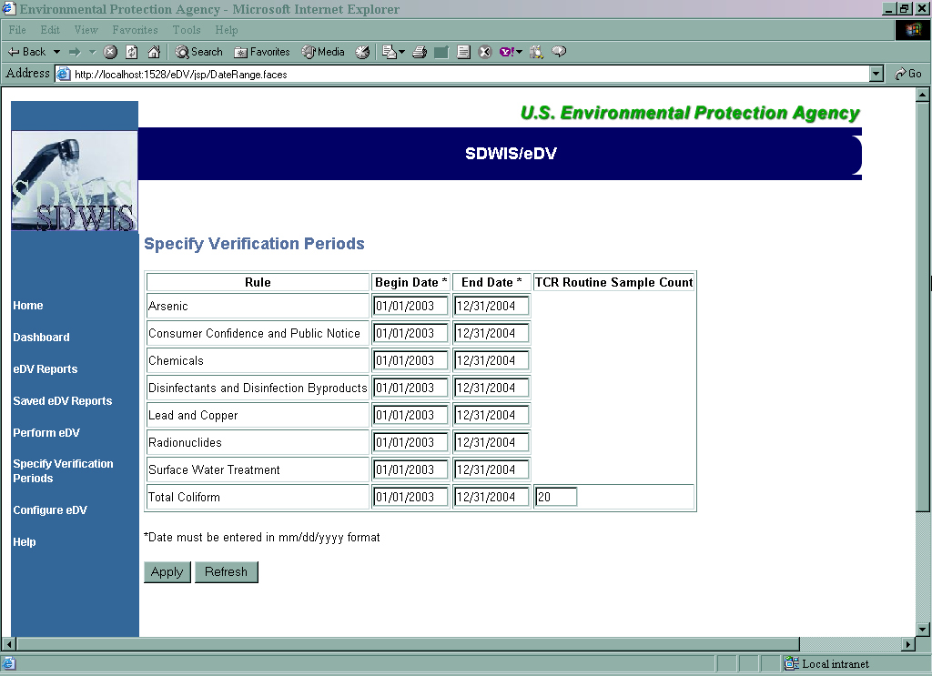

Exhibit 11. Specify Verification Periods

You can cancel page changes and redisplay the current database values for this page by clicking the Refresh button. Page changes (including removing data) are only saved, when the Apply button is clicked.

- Click Perform eDV (Exhibit 12) from the SDWIS/eDV Home page.
- Click the checkbox next to the Perform Data Verification option.
- Click Start to initiate the eDV process. You are automatically presented the Dashboard page indicating that the eDV Process is In Progress. The eDV Process runs independently of the web page, so you may close your browser; however, you should not stop the Tomcat web application server. (That is, do not close the Tomcat window or choose to Shutdown eDV from the program window.)

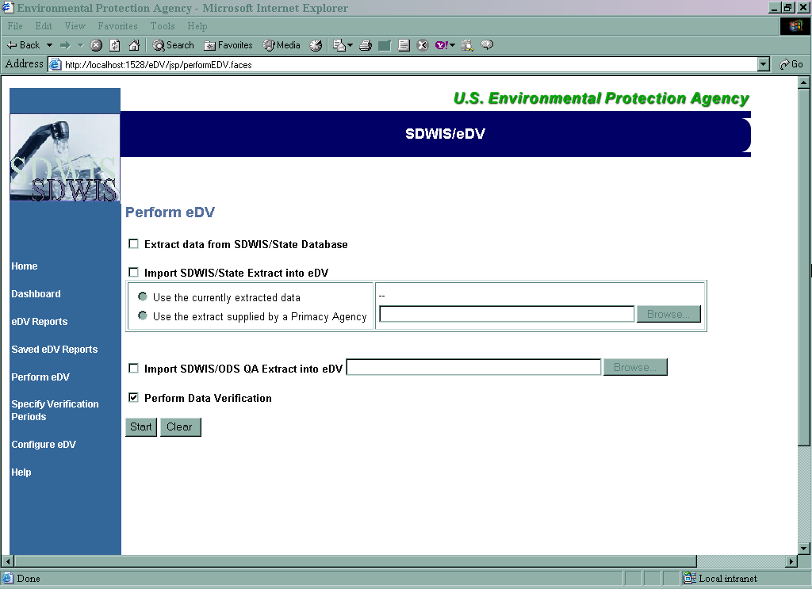

Exhibit 12. Perform eDV

If SDWIS/eDV is aborted before processing is completed, the Dashboard page will indicate a Failure in the status column of the process. To restart data verification, start SDWIS/eDV and go to the Perform eDV page. Select the Perform Data Verification checkbox and click Start to continue processing.
To restart SDWIS/eDV completely with a new data set or to continue an aborted extract or import process, start SDWIS/eDV and either extract or import a new database.

Monitoring SDWIS/eDV Progress

The SDWIS/eDV processes can be quite lengthy in execution time depending on many factors such as:

- Size of SDWIS/STATE database, particularly samples and sample results
- Number of Rules being processed
- Span of time specified for each Rule in the Verification Periods
- Capacity of machine on which SDWIS/eDV is deployed

Exhibit 13 shows the eDV Dashboard page that is available from the Home Page. It lets you monitor the status of the various processes executed by Perform eDV function.

The processes are listed in descending Start Time order so that the most recent process is first. The Status column displays various messages depending on the current status of the process (e.g. in progress, finished, or failed). The Dashboard information is retrieved from process log tables (TDVPRCLG and TDVLOG) maintained by the SDWIS/eDV software.

Click the Refresh button to get the most current processing information.

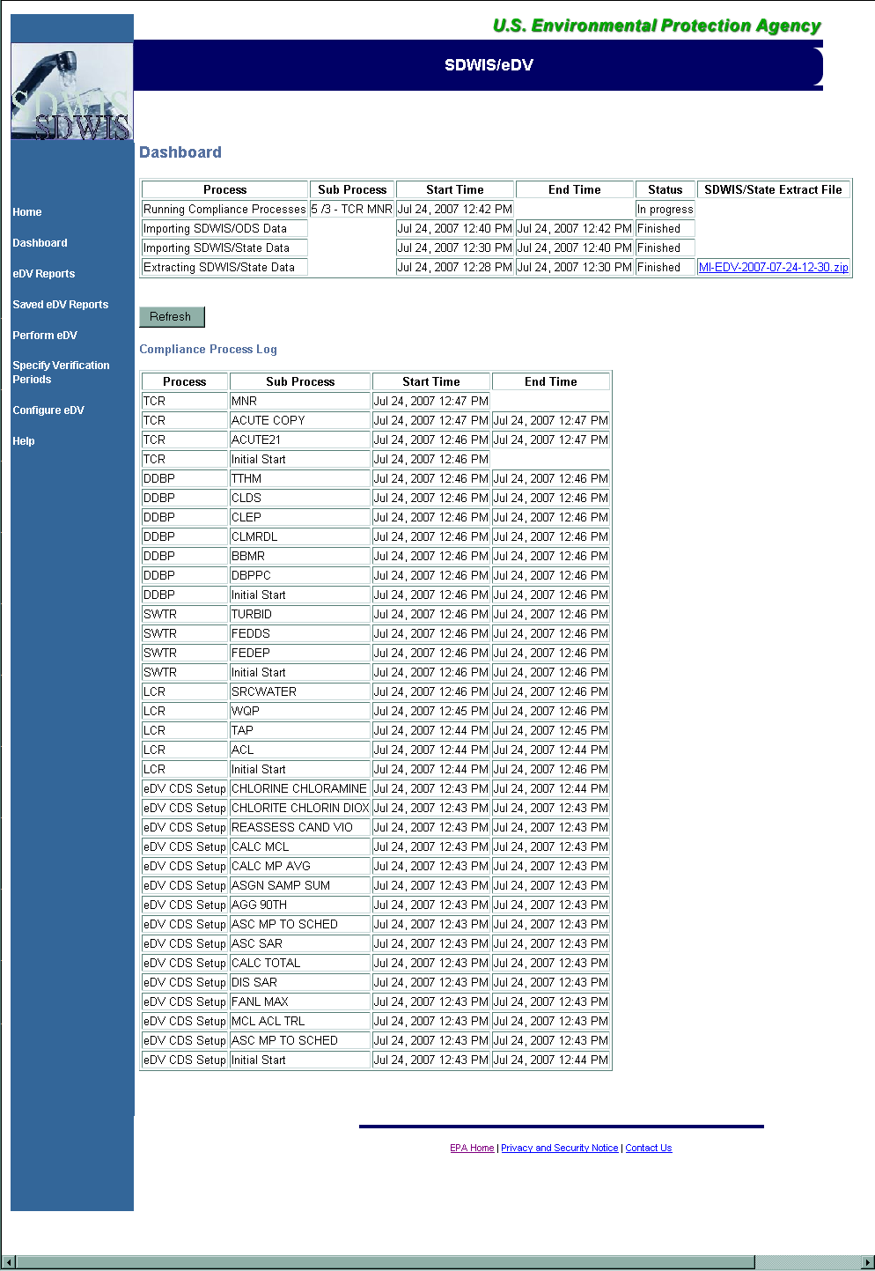

Exhibit 13. Dashboard

Restart Capability
In the event of a power outage or other accidental termination of SDWIS/eDV prior to completion of processing, some SDWIS/eDV processes can be restarted. The Dashboard page will indicate “Failed” in the status column of the process. If a process status column says “Failed”, further investigation is required. Check for text under the Message column to determine the reason for the failure. In addition, check the Tomcat Console, which is viewable in the open Tomcat window, to see what error may have occurred. Depending on the process that failed, examples could be:

- Server was stopped
- Database space was inadequate
- Folder space was inadequate
- Connection was lost to the primacy agency data source

To restart data verification, start SDWIS/eDV and go to the Perform eDV page. Select the Perform Data Verification checkbox and click Start to continue processing. The following SDWIS/eDV processes are restartable and will resume from the last completed activity when you start (which is actually a resume) the Perform Data Verification function.

- eDV CDS Setup
- LCR
- SWTR
- DDBP
- TCR
- RAD
- CHEM
- PN
- CompSched
- ARSENIC
The following SDWIS/eDV processes are not restartable from the point of failure. These processes always start at the beginning of the process when you click the check box and Start button.

- Extracting SDWIS/State Database
- Importing SDWIS/State Database
- Importing SDWIS/ODS QA Extract

To restart SDWIS/eDV completely with a new data set or to continue an aborted extract or import process, start SDWIS/eDV and either extract or import a new database. When a new SDWIS/STATE database or SDWIS/ODS QA Extract is loaded, the process log table reinitializes and prior run statistics in the process log table are deleted.

If you need assistance determining the problem, contact SDWIS User Support.

Review SDWIS/eDV Discrepancies
When the SDWIS/eDV Data Verification process is complete, the Dashboard page shows the final process of eDV Process Complete. This indicates that the comparison processes have completed discrepancies, if any, are ready for your review.

To view the discrepancy report, select eDV Reports from the SDWIS/eDV Home Page. This option launches the Online Analytical Processing (OLAP) Tool, JasperIntelligence.

Login using the username “edv” and password “edv” (Exhibit 14).

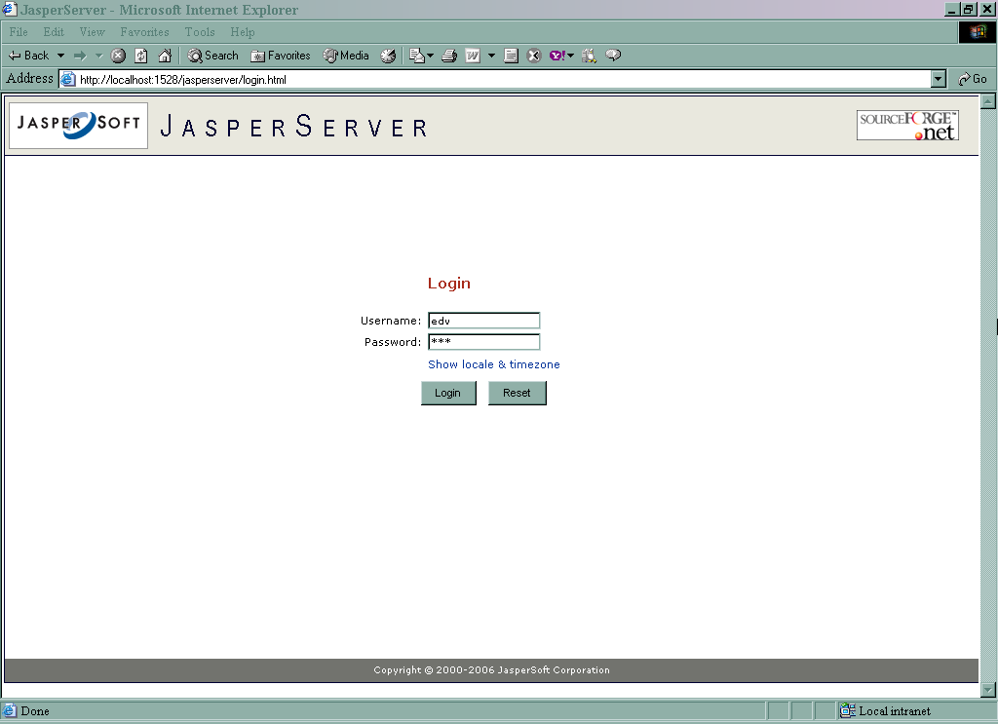

Exhibit 14. JasperServer Login

You are presented the SDWIS/eDV Discrepancy Report (Exhibit 15).

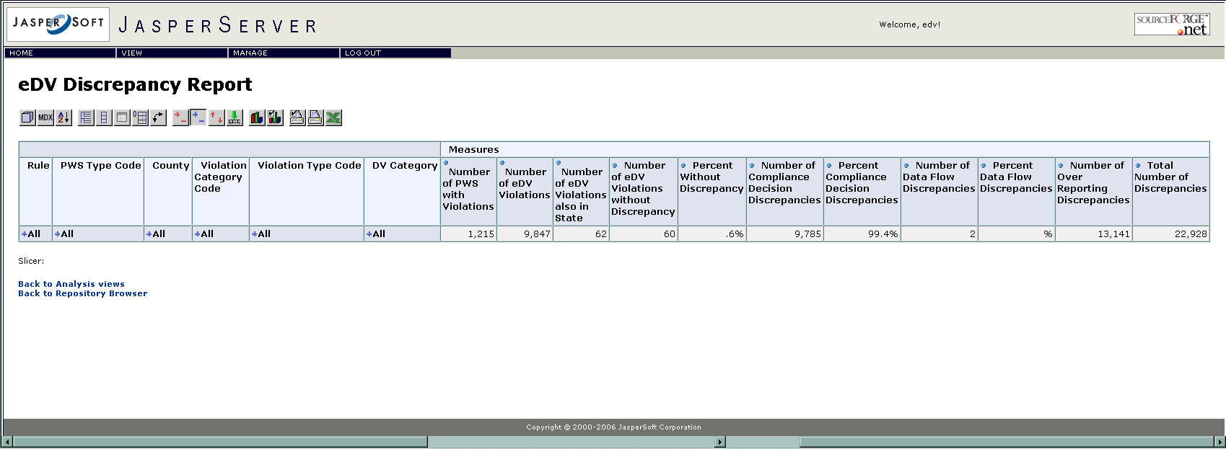

Exhibit 15. eDV Discrepancy Report – Initial Presentation

The SDWIS/eDV Discrepancy Report is an interactive report that allows you to drill down through increasing levels of detail. When you first open the report, you see what appears to be a row of data, as shown in Exhibit 15. This row is composed of two kinds of data: Totals (Dimensions) and Measures.

Dimensions
Each of the five left-most columns is a “Total” or “Dimension” column. The dimension columns allow you to drill down into more discrete levels of underlying data by clicking on the plus sign to the left of the label.

Measures
The Measures it presents are the count of:

- Number of PWS with Violations – this is the total count of PWS(s) for which SDWIS/eDV compliance determination identifies a candidate violation.
- Number of eDV Violations – this is the total count of all candidate violations identified by SDWIS/eDVcompliance determination.
- Number of eDV Violations also in State - This is the count of the candidate violations identified by SDWIS/eDV compliance determination for which a matching violation was found in the imported SDWIS/STATE Primacy Agency database.
- Number of eDV Violations without Discrepancy – This is the count of the candidate violations identified by SDWIS/eDV compliance determination for which a matching violation was found in both the SDWIS/STATE Primacy Agency database and in the SDWIS/ODS QA Extract.
- Percent without Discrepancy – Number of eDV Violations Without Discrepancy as a percentage of total Number of eDV Violations.
- Number of Compliance Decision Discrepancies – This is the count of the candidate violations identified by SDWIS/eDV compliance determination for which no matching violation was found in the SDWIS/STATE Primacy Agency database.
- Percent Compliance Decision Discrepancies - Number of Compliance Decision Discrepancies as a percentage of total Number of eDVViolations.
- Number of Data Flow Discrepancies - This is the count of the candidate violations identified by SDWIS/eDV compliance determination for which a match was found in the SDWIS/STATE Primacy Agency database but for which NO match was found in the SDWIS/ODS QA Extract.
- Percent Data Flow Discrepancies - Number of Data Flow Discrepancies as a percentage of total Number of eDV Violations.
- Number of Over Reporting Discrepancies – This is the count of the SDWIS/ODS QA Extract violations for which no match was identified by SDWIS/eDV compliance determination.
- Total Number of Discrepancies – This is the sum of Number of Compliance Decision Discrepancies, Number of Data Flow Discrepancies, and Number of Data Flow Discrepancies.

You do not have to drill down in any order (left to right) but each click will result in the presentation of a different count of Measures representing that aggregation. You can drill down by clicking the plus sign and back up by clicking the minus sign at any time. There is no restrictive order to this function. Exhibit 16 shows a fully expanded report.

Drill Through Functions
Once you get to the lowest level of granularity, which is when all five dimension columns are fully expanded, you may be interested in “drilling-through” to see the details of those violations. The root data you are accessing when you “drill-through” is stored in the TDVRESLT table. This drill-through function is most understandable when all dimension columns are expanded and the drill-through is selected on a cell for a particular DV Category.

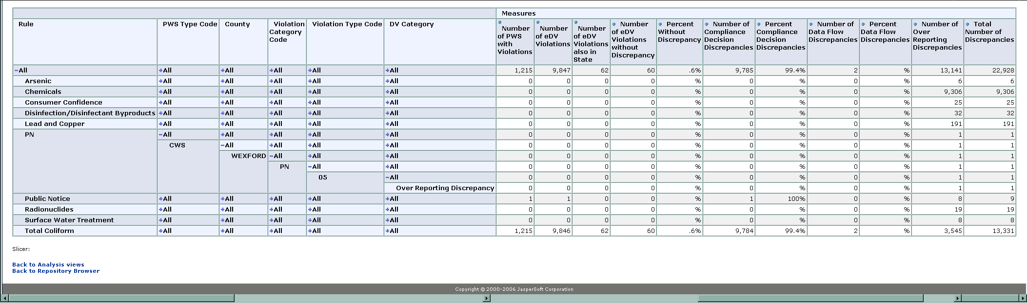

Exhibit 16. eDV Discrepancy Report – Expanded

You can drill back up by clicking on the blue minus sign at any time. Again, there is no restrictive order to this function.

Once you get to the lowest level of granularity, which is when all dimensions are fully expanded, you may be interested in seeing the details of those violations. This is called a drill-through and will access the root data stored in the TDVRESLT table. This drill-through function is most understandable when all of the dimensions are expanded and the drill-through is selected on a cell for a particular DV Category.

To enable drill-through:

- Click the icon to toggle the green drill-through arrows within the Measure counts. Click on a green arrow within the table. This drill-through function is most understandable when all dimension columns are expanded and the drill-through is selected on a cell for a particular DV Category.
- The drill-through box (Exhibit 17) is presented beneath the table listing the details of the violations.

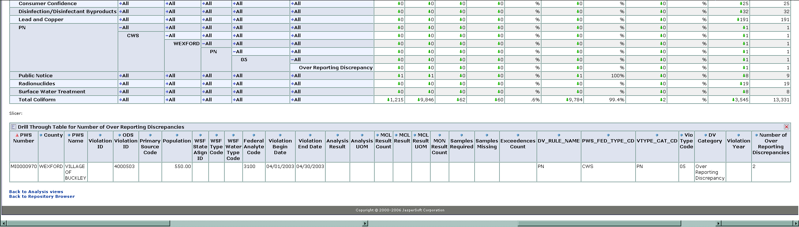

Exhibit 17. eDV Discrepancy Report – Drill-Through details

Filter Report Results
When large amounts of data are available for display, you may find it helpful to filter the results to display a smaller data set. For example, you may wish to filter the results for a specific analyte code. Using filtering by analyte code as an example, follow these steps to filter the results:

- Click the icon to display the filter ability for the eDV Discrepancy Report (Exhibit 18).
- Select a filter option, such as Analyte Code.
- Click the + sign to list the analyte codes from the source that generated the report.
- You can select a specific analyte code by clicking the radio button next to it.
- Click OK to close this filter option. In the same manner, you may optionally select other filter options.
- Once all your filters are selected, Click OK again. The Measure counts in your eDV Discrepancy Report are recalculated using only the Filters you selected.
- You can hide the filter options box by clicking the red X in the upper right corner, or by clicking the icon again.
- Remove the filters by clicking the icon to display the Filter options, if you have previously hidden it.
- Click the radio button next to All [filter option selected] and click OK to close that filter option.
- Click OK on the Filter Option box to recalculate the eDV Discrepancy report.

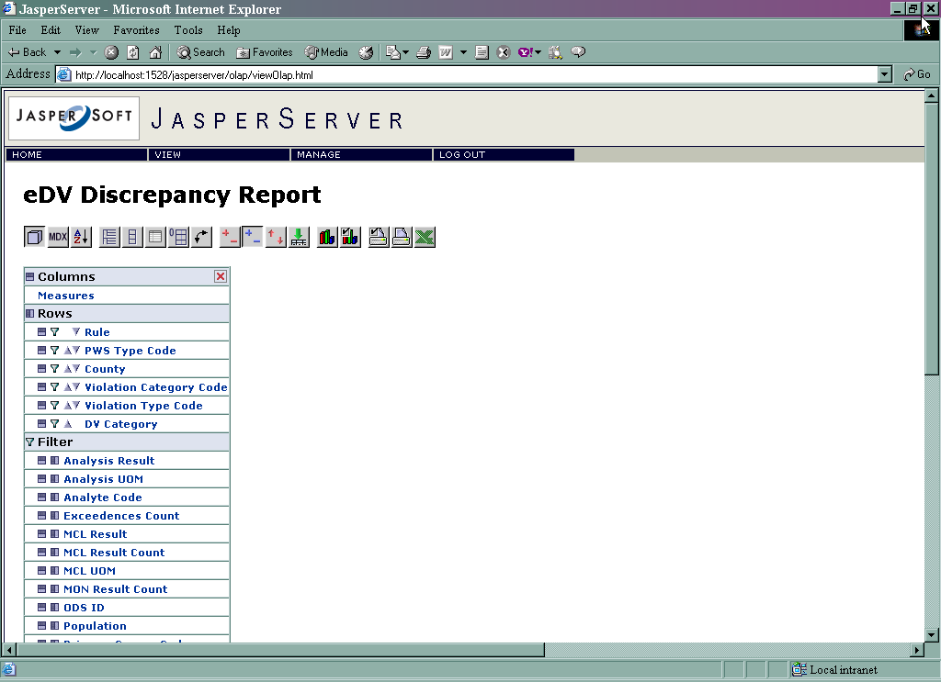

Exhibit 18. eDV Discrepancy Report – Filtering

Other JasperIntelligence OLAP Tool Data Display Options
You may also find the following options supplied by the JasperIntelligence OLAP tool helpful when using eDV Discrepancy Report.
(Show Parent Members)
When you view data in a dimension with multiple levels of hierarchy, this button toggles between displaying dimension members with or without their parent members. This is useful when you are using the "Drill Replace" feature (described below).
(Hide Spans)
This also applies to table view only when displaying dimension with multiple hierarchy levels. It toggles between parent member repeated in every row, versus parent members only displayed for the span.
(Suppress Empty Rows/Columns)
This allows you to suppress the column/rows that have all empty (zero) values.
(Swap Axes)
Moves dimensions from X axis to Y, and Y from X.
(Drill Position)
Turning this button on enables drilling from a high level member to members in lower levels, while still showing the parent level members. For example, if you drill down from Rule to PWS Type Code level while Drill Position button is on, you will see the PWS Type Code level information as well as the Rule level information. When this mode is on, you will see a blue + sign next to the parent level dimension member which expands when you click on it, displaying the child members.
(Drill Replace)
Turning this button on also enables drilling from a high level member to members in lower levels. This feature only shows the children member and not the parent members. For example, if you drill down from Rule to PWS Type Code level while Drill Replace button is on, you will only see the PWS Type Code level information, and the Rule level information will be hidden. When this mode is on, you will see a red arrow sign next to the dimension members. The direction of the arrow indicates whether you are going "down" from parent level to children level, or if you are going "up" from children to parent level.
(Drill-through)
- This feature enables you to drill-through a measure value and get the detailed data underneath it. For example, with this feature enabled, you can click on a count of Compliance Decision discrepancies, and get a list of the underlying violations looking at details underneath any summarized data.

- Clicking on this button shows a green arrow next to the measures. When you click the green arrow, it queries the underlying database, retrieving a list of the underlying violations. Remove the list by closing it or clicking the red X in the upper right corner.
(Configure Print Settings)
Brings up print properties settings (Exhibit 19).

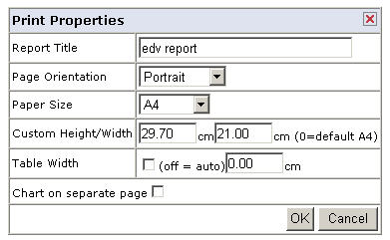
Exhibit 19. Print Properties

(Print this Page via PDF)
Presents the current page presentation as a PDF document which can then be printed or saved.
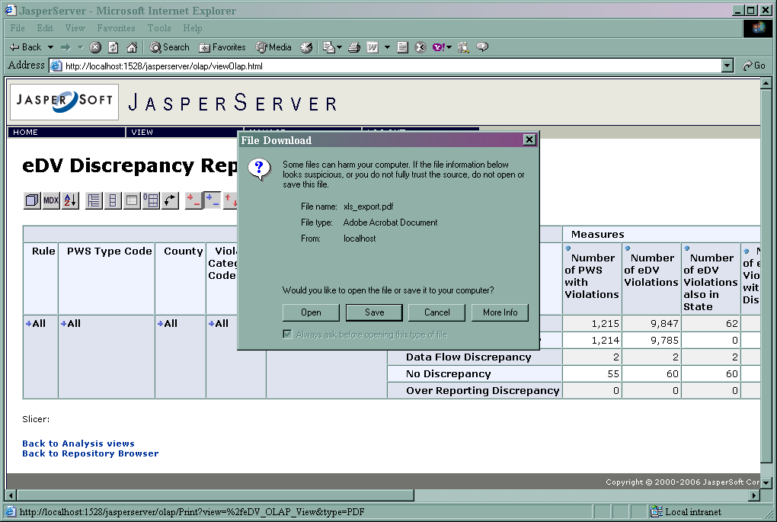
Exhibit 20. View eDV Reports in PDF
You can click Open and review the report in Adobe Acrobat where it can then be printed.
When you click Save, you are presented the Save As dialog, Exhibit 21. You can specify any location for the save, but to enable the report to be listed in the Saved eDV Reports menu item you should use the path:
C:\Program Files\eDV\apache-tomcat\webapps\eDV.
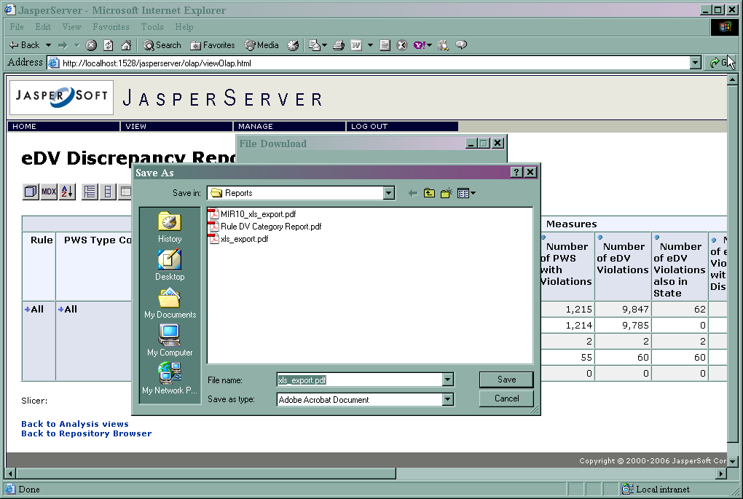
Exhibit 21. Saving eDV Reports in PDF

You can access reports that have been saved to path C:\Program Files\eDV\apache-tomcat\webapps\eDV by choosing the Saved eDV Reports from the SDWIS/eDV Home Page. The file can then be viewed in Adobe Acrobat and printed.
The links below display sample PDF reports.
Sample_PA_eDV_Mgt_Report_2.pdf
Sample_PA_eDV_Mgt_Report_3.pdf

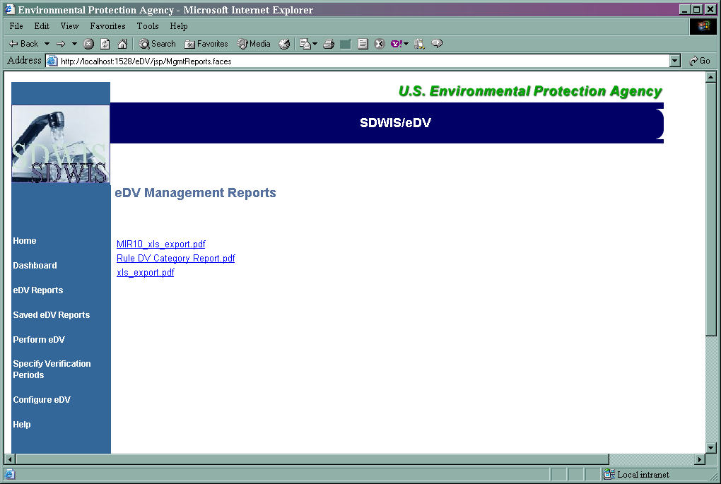
Exhibit 22. Saved eDV Reports

(Start Excel)
Exports the current analysis as an MS Excel file. The table is brought over as-is preserving the numerical cells, so you can apply additional calculation formula in MS Excel. The access to the database source via an ODBC connection is not available via the MS Excel interface. All data is now contained wholly within MS Excel.

Closing SDWIS/eDV
When you are done using the SDWIS/eDV application, you may close your browser session(s) in traditional ways, such as clicking the close ‘X’ on the top right of the browser. You should also stop any SDWIS/eDV services running.

To stop the SDWIS/eDV services:
- Click Windows Start Button
- Click All Programs
- Click SDWIS_eDV
- Click Shutdown eDV

Appendix A

Violation Types Not Supported by SDWIS/STATE Web Rel 1.0 Compliance Determination/Assistance Processes

The page is intentionally left blank

SDWIS/STATE Compliance Determination/Assistance adheres to the following methodology:

- For Violation Determination
    - SDWIS/STATE processes identify candidate violations.
    - Compliance officer reviews candidate violations and determines whether to issue candidate violation.
- For Monitoring Schedules
    - TCR: SDWIS/State suggests actual change in the monitoring schedule.
    - All other rules: SDWIS/STATE evaluates monitoring schedules and provides report of potential opportunities to increase/decrease monitoring.
    - In both cases, compliance officer makes schedule change decision.
- For Inventory Changes
    - SDWIS/STATE advises users when inventory changes may require schedule changes (e.g., population crosses a Rule-Population threshold, new Water System Facility entered, PWS Type changes, etc.).

SDWIS/STATE Rule Implementation adheres to the following methodology:

- In general, determines violations at detailed level desired by primacy agencies
    - Tools in SDWIS/STATE combined with SDWIS/FedRep translate to EPA reporting requirements.
- Total Coliform Rule
    - Implements identification of Acutes via real-time validation of positive sample results.
    - Enables creation of temporary routine, return to normal routine, and repeat schedules via real-time validation of positive sample results.
    - Identifies non-acute and monitoring violations via user-launched compliance checks.
    - Offers suggested monitoring schedule changes following inventory modification.
- All other Rules
    - Identifies MCL violations during batch processing of new data (typically nightly at most primacy agencies).
    - Identifies monitoring and other treatment technique violations via user-launched compliance checks.

SDWIS/STATE handles the vast majority of compliance determination scenarios for the federal drinking water rules listed in Section 1.0 of this document. However, as compliance determination was implemented for each rule in SDWIS/STATE, implementation of a few aspects of some rules was determined to have a relatively low cost-benefit ratio. While these design decisions are recorded in SDWIS/STATE design documentation produced over the last several years, they are re-summarized here. Exhibit A-1 lists rule-violation type combinations where SDWIS/STATE does not support automated candidate violation creation. Although some compliance assistance is available, these violations must be determined manually.

Rule  Code | Violation  Type | Contaminant | Violation Description | SDWIS/STATE Assistance
DBP | 02 | Chlorite | MCL Violation | The complexity and infrequency of these violations led to decision to not determine these violations via SDWIS/STATE Compliance Assistance. However, SDWIS/STATE does report results that are greater than the MCL, to help ensure these are not missed.
DBP | 11 | Chlorine dioxide | Chlorine Dioxide Non-Acute MRDL due to results (versus due to lack of results) | The complexity and infrequency of these violations led to decision to not determine these violations via SDWIS/STATE Compliance Assistance. However, SDWIS/STATE does report results that are greater than the MRDL to help ensure these are not missed.
DBP | 12 | 0400 | Qualified operator | SDWIS/STATE Compliance Schedule function may be used to determine candidate violations but, in most cases, these violations are determined during Site Visits or some other way.
DBP | 13 | Chlorine dioxide | Chlorine Dioxide Acute MRDL due to results (versus due to lack of results) | The complexity and infrequency of these violations led to decision to not determine these violations via SDWIS/STATE Compliance Assistance. However, SDWIS/STATE does report results that are greater than the MRDL to help ensure these are not missed.
DBP | 37 | 0400 | Failure to submit/obtain state approval for significant treatment modifications | SDWIS/STATE Compliance Schedule function may be used to determine candidate violations but, in most cases, these violations are determined during Site Visits or some other way.
FBR | 39 | 0500 | Failure To Submit Plant Schematic | No assistance – although users may build a query to identify those that were required but have not submitted a schematic; this information can be recorded in SDWIS/STATE.
FBR | 40 | 0500 | Failure To Properly Recycle | No assistance
SWT | 12 | 0300 | Qualified operator | SDWIS/STATE Compliance Schedule function may be used to determine candidate violations but, in most cases, these violations are determined during Site Visits or some other way.
SWT | 29 | 0300 | Failure to submit report required after failure of Individual filter performance | The SWTR Compliance Report alerts compliance officer of potential need for report.
SWT | 37 | 0300 | Failure to File Plan or Consult | SDWIS/STATE Compliance Schedule function may be used to determine candidate violations.
SWT | 47 | 0300 | Construction of an uncovered finished storage facility | SDWIS/STATE Compliance Schedule function may be used to track/determine candidate violations if an existing storage facility needs to be addressed.
Old PN | 05 |  | Notification State | No longer used.
Old PN | 06 |  | Failure to notify public after a violation. | No longer used.
Various | 07 |  | Treatment Technique (Non-SWTR) | No assistance provided.
Various | 09 |  | Record Keeping | SDWIS/STATE Compliance Schedule function may be used to determine candidate violations.
Various | 10 |  | Operations Report | SDWIS/STATE Compliance Schedule function may be used to determine candidate violations.
Exhibit A-1. Rule Violation Type Combinations For Which SDWIS/STATE Does Not Determine Violations

Exhibit A-2 lists EPA Rule Requirements not supported in SDWIS/STATE

Rule | EPA Rule Requirement | SDWIS/STATE
All | Samples must be collected according to a written sample site plan | Not supported
TCR | Samples must be collected at regular time intervals throughout the month. | Not supported
TCR | Two special requirements for Subpart H systems to collected near the first service connection given in 141.21 (a) (5) | Not supported
All | - Analytical Method Requirements  - Lab Certification Requirements | Not supported in SDWIS/STATE Web Rel 1.0 (scheduled for implementation in SDWIS/STATE 2.0)
All | Two quarterly samples in one year during each repeat compliance period [141.24 (h) (4) (ii)] | Not supported
Phase II/V | If the concentration in the composite sample is GT/EQ one-fifth the MCL, a follow-up must be taken within 14 days at each sampling point included in the composite. | Not supported
Phase II/V | If the population served is > 3,300, compositing may only be permitted by the State at sampling points within a single system. | Not supported
Exhibit A-2. Rule Requirements Not Supported in SDWIS/STATE

