6.2.2 VLHC-2 Cryogenic System Concept

6.2.2.1 Introduction.
This study of possible high field VLHC cryogenic systems relies heavily on previous reports about VLHC cryogenics, especially “Cryogenic Systems for the High Field RLHC Study Cases,” by M. McAshan and P. O. Mazur, and “Cryogenic Systems for the Low Field RLHC Study Cases,” by the same authors [1,2]. Comparisons are frequently made with LHC parameters not only because it is the most recent large accelerator cryogenic system design, but because the thorough analyses done in support of the LHC cryogenic system provide an excellent baseline for comparison. One of the most extensively used LHC documents was “LHC sector heat loads and their conversion to LHC refrigerator capacities,” by L. Tavian and U. Wagner [3].

6.2.2.2 System layout.
Like for the low field VLHC, the high field VLHC design effort will use six cryogenic plant locations as the working assumption for the cryogenic system layout. Such an arrangement creates 12 cryogenic strings of approximately 20 km length each, as shown in Figure 1, below.
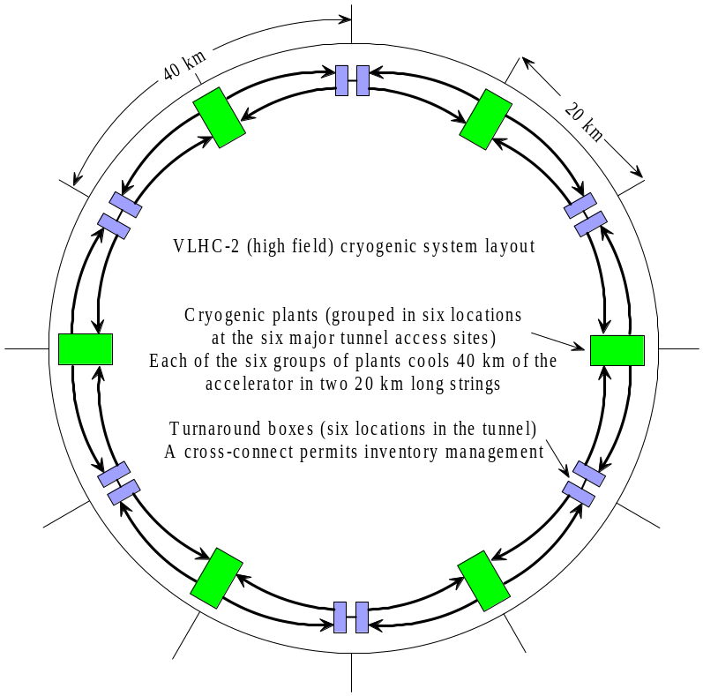

Figure 1. VLHC high field cryogenic system layout

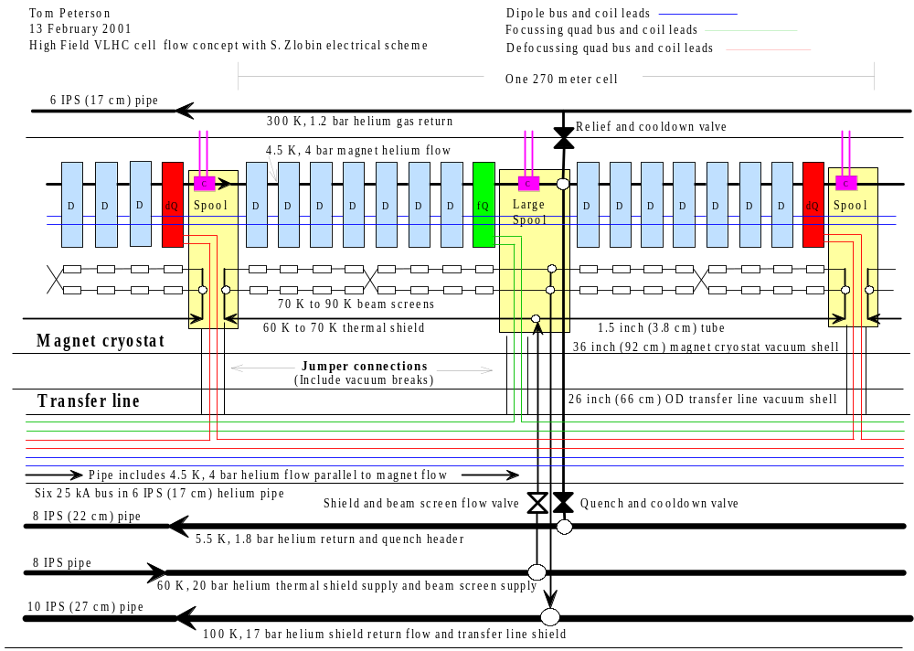

Figure 2. VLHC high field cryogenic schematic for one cell

Shown above in Figure 2 is a concept for a flow and electrical bus schematic for one cell of the high field VLHC. We avoid the use of recoolers or two-phase helium by allowing a 1 K rise in the helium flow through the magnet cold mass. Magnets are cooled by a large flow rate of supercritical, 4.5 K helium. Like for the low field VLHC cryogenic scheme, the combination of pressure drop and temperature rise permits an effectively very large specific heat for the helium coolant.
Thermal shields and beam screen are cooled by a nominally 60 K to 90 K helium stream. The starting temperature of 60 K for the thermal shield and beam screen circuit was chosen based on previous analyses (LHC and SSC) of optimal thermal shield temperatures. (We comment more about temperature optima later.) High pressure (20 bar) helium is selected for the shield and beam screen since the higher pressure and density permit more mass flow in a given pipe size. Nevertheless, pressure drops for the 60 K to 90 K flow should be small so that most of the pressure remains available for expander work upon returning to the cold box.
This flow scheme provides four parallel beam screen cooling flow paths in each cell, two in each 135 meter long half-cell. If the beam screen for one beam is hotter than the other, most of the flow will go though the colder screen, leaving little flow in the other flow paths. Such a situation is unstable, with the hotter beam screen getting even hotter due to lower flow. For that reason, a crossover is shown in each half-cell. The alternative to the crossover is balancing valves controlled by temperature sensors in the spool piece. Depending on how the beam screen passes through the interconnect, valves might be less costly than the crossover, but for now we will show the crossover.
This scheme puts all the large cold pipes and most of the electrical bus in a separate transfer line, so one does not have to deal with them at each magnet interconnect. It requires one jumper from the transfer line to the magnet string every 270 m for helium pipe connections, and one jumper every half-cell, or every 135 m, for electrical bus connections. Jumper connections containing electrical bus will require flow plugs to prevent helium flow short-circuits. The helium pipe containing six 25 kA bus may be cooled with a fraction of the 5.5 K, 1.8 bar return flow or with a parallel supply flow of 4.5 K, 4 bar helium. A 300 K helium gas return pipe is shown for lead flows and relief valve flow collection. A 300 K, 20 bar, helium gas line (not shown in Figure 2) might be required for inventory management.
The quench valve spacing of one every 270 meters appears to be adequate based on an analysis of quenching in 25 kA NbSn magnets [4]. Large quench valves would be required, with a port size of at least 60 cm, but quench pressures would remain under 20 bar.
All of the lines utilize helium as the coolant. Our initial decision is not to use nitrogen in the tunnel, but one might make good use of it above ground. Nitrogen in the beam screen would be risky. “The risk of its freezing is too high, and to prevent this possibility, the control system would have to be extensive. Handling nitrogen in beam screens would add significant complexity to operations.” (Mike McAshan, personal communication.) Also, nitrogen presents more severe oxygen deficiency hazards than helium for low areas, since cool nitrogen is denser than air.
However, nitrogen can be useful above ground for cool-down and load leveling. “If one has strongly varying loads it is advisable to work with a liquid nitrogen storage buffer.” (Has Quack, personal communication) After describing why we do not want LN2 in the beam screens, Mike McAshan wrote, “On the other hand, LN will be required for cool-down of the high-field machine, so in this case nitrogen will be around in any case. It is probably best to try to keep it above ground.”
Finally, one might reconsider the use of nitrogen in the tunnel, for example in the thermal shields and/or for recooling helium from the beam screens, in order to reduce the huge helium inventory of this system.

6.2.2.3 Estimated heat loads.
The heat load numbers in Table 1 (below) come from the following considerations. LHC heat loads are based on reference [3].
Consider first the arc components at 60 K other than the beam screen. The LHC total to the arc magnets at nominally 60 K is 12.1 kW over 3300 meters, or 3.7 W/m. The heat load depends on the magnet mass, the materials used and the cryostat surface area, which are taken to be approximately the same for VLHC as LHC. The contribution of the conduction and radiation on the LHC dipole cryostat were measured on a cryostat thermal model [5,6]. The heat loads for the VLHC are scaled from these measurements and permit us to determine the heat transfer relationships. Details of the calculation are presented in reference [7]. We take 4.2 W/m as the predicted static heat load to the thermal shield.

Table 1. Predicted heat loads
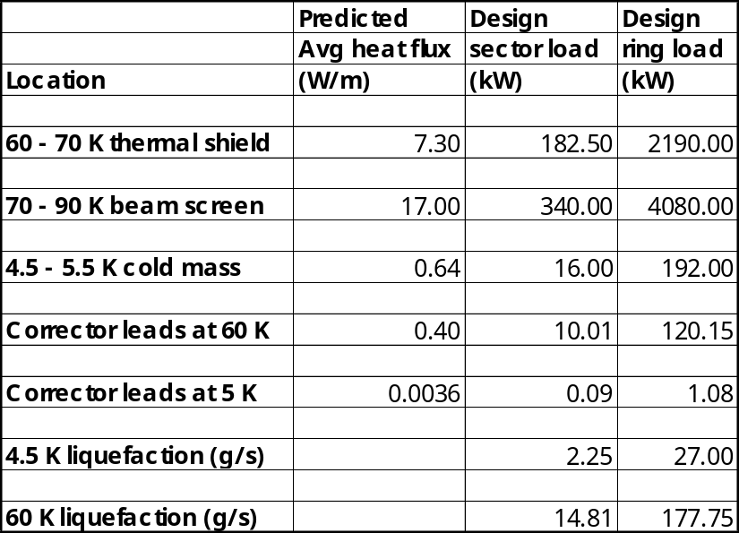

To the transfer line at 60 K, the LHC total is 9.0 kW over 3300 meters, or 2.7 W/m, for a line with a 61 cm inner diameter vacuum jacket. A sketch of a 6-inch pipe, two 8-inch pipes and a 10-inch pipe in a vacuum jacketed pipe indicates approximately a 26-inch OD vacuum jacket or about 63.5 cm ID. This is very close to the LHC diameter but probably will be slightly larger than CERN’s when we look at support details, etc., so we use 3.0 W/m. Add this to the 4.2 W/m for the arc magnets, plus 0.1 W/m for other piping, and we have the 7.3 W/m in the above table. An uncertainty factor of 1.25 is applied to the predicted 7.3 W/m to find the total design heat load.
For the magnet cold mass, we use the CERN 1.9 K heat load totals of 530 W static, 615 W dynamic (mostly resistive heating and beam gas scattering). The 0.16 W/m static plus 0.19 W/m dynamic = 0.35 W/m for LHC. Resistive heating is 389 W over 3300 meters or 0.12 W/m. Beam gas scattering is 168 W or 0.05 W/m. We would expect these to scale up with our higher current and higher luminosity in VLHC, so add 0.15 W/m to the 0.35 W/m for 0.50 W/m. We also have a warmer beam screen than LHC, which adds about another 0.14 W/m (total for two beams), for a total of 0.64 W/m. Like for the thermal shield, an uncertainty factor of 1.25 is applied to the 0.64 W/m to find the total design heat load.
To the beam screen we estimate 17 W/m total for both beams due primarily to synchrotron radiation. This figure was calculated through division of the total synchrotron radiation heat load by the total length magnets in the ring. In a less conservative approach, this heat load would be divided by the total arc length (thus including the short straight-sections between magnets, the arc quadrupoles, etc.) Therefore, although no uncertainty factor is applied to the beam screen heat load, some margin is included. Synchrotron radiation heat load dominates the thermal budget of the beam-screen. Image current heating and multipacting are negligible compared to the 8.5 W/m/beam synchrotron radiation.
As indicated in Figure 2 and in Table 1, the beam screen operational temperature in this flow scheme is between 70-90 K. This is less than the predicted optimal beam screen temperature [7,8] of about 105 K, but the cooling power is a relatively flat function of beam-screen temperature near the minimum. The optimum temperature results in a minimum refrigeration power cost. It balances the heat load absorbed by the beam screen refrigeration system with the heat load absorbed by the cold mass. At low beam screen temperature the heat load is absorbed mainly by the beam screen, but at low thermodynamic efficiency and thus at high cost. At high beam screen temperature the cost of beam screen refrigeration is reduced, but a significant part of the heat load is transferred from the beam screen by conduction and radiation to the cold mass where it is again extracted with low thermodynamic efficiency. (Conduction and radiation calculations were based on LHC beam screen experimental data.)
Studies [7] have shown the optimal magnet thermal shield temperature (in terms of minimizing overall refrigeration power) to be about 65 K, consistent with the LHC selection of thermal shield temperature. In order to reduce the number of pipes through the system, the thermal shield and beam screen are placed in series with the thermal shield first. The high heat load on the beam screen results in its optimum temperature dominating that for the screen and thermal shield combined. The optimum thermal shield inlet temperature when in series with the beam screen is 102 K (figure 3). In the effort to simplify the system by reducing the total number of pipes and in order to keep pipes smaller, we have selected a beam screen temperature significantly lower than optimum for 8.5 W/m per beam. Our thermal shield inlet temperature of 60 K results in a system power penalty of about 15% relative to optimum. An optimized system for these heat loads would include separate temperature levels for the thermal shield and beam screen, 65 K and 105 K respectively. However, if a significant amount of synchrotron radiation can be intercepted at room temperature, reducing the beam screen heat load, the optimum temperature comes down, making this series arrangement of thermal shield and beam screen flow more attractive.

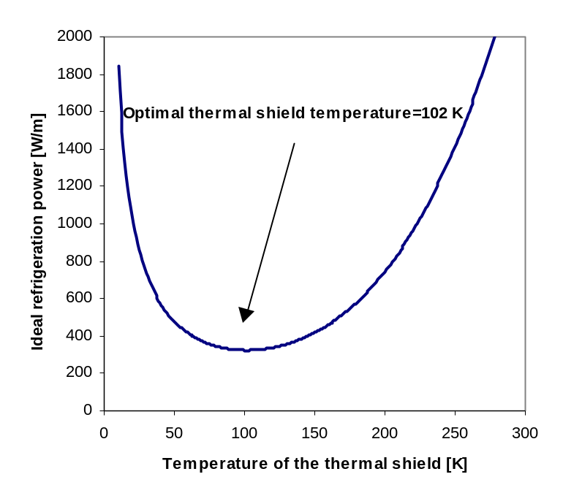

Figure 3. Ideal total refrigeration power versus thermal shield temperature with beam screen flow taken from thermal shield exit.

6.2.2.4 Line sizes and inventory.
The large heat loads, particularly for the beam screen, over a distance of 20 km result in large mass flow rates and large pipe sizes in order to keep pressure drops acceptably small. The inventory for the entire machine is estimated to be 1.3 million kg or 10 million liquid liters equivalent. This is about 170 times the Tevatron inventory, 13 times the LHC inventory, and about one tenth of the annual U.S. production of helium, costing about $25 million.

6.2.2.5 Current leads.
The following table (Table 2) summarizes current leads for one of the 12 sectors and provides input to the cooling power summary (Table 3).
The count of power leads assumes two 25 kA dipole circuits per 20 km sector and two 25 kA quadrupole circuits per 20 km sector. Each 25 kA dipole circuit requires current leads at each end of the 20 km sector, so four leads per dipole circuit. Two dipole circuits with four leads per circuit plus two quad circuits with two leads per circuit result in the 12 current leads per sector listed above. We assume six 100 amp corrector leads per beam per spool piece, with about 150 spools in one 20 km sector, so 1800 corrector leads per sector. One can see by comparing the bottom line in Table 3 with the total installed 4.5 K equivalent power predicted in Table 4, that the relatively low number of current leads and the use of HTS leads make the total cooling power for the current leads only about 2% of the cryogenic system power.
The power lead cooling analysis for the 25 kA leads assumes gas cooling of HTS leads with 2 atm helium at 60 K, but the present flow scheme does not provide low pressure, 60 K gas in the magnet strings, only high pressure gas at 60 K. For 25 kA leads at the refrigerator locations, low pressure gas may be obtained from the refrigeration plant. At the far end, perhaps 5.5 K gas will have to be used for the 25 kA leads. Since the cooling power for leads is relatively small, none of these considerations should have a significant effect on total cryogenic system power requirements. Gas cooling requirements are scaled from Fermilab HTS lead tests [9].
We assume conduction cooling of the 100 amp leads at each spool piece, a desirable simplification although somewhat less efficient than gas cooling. Heat conduction for the top (copper) part of the lead is scaled from LHC lead test data [9]. The HTS parts of the LHC leads in reference [9] were pure HTS rods with a steel shunt, different from the HTS tapes now in common use, so conduction for the HTS portion of the leads was scaled from Fermilab HTS lead tests [10].

Table 2. VLHC arc power leads
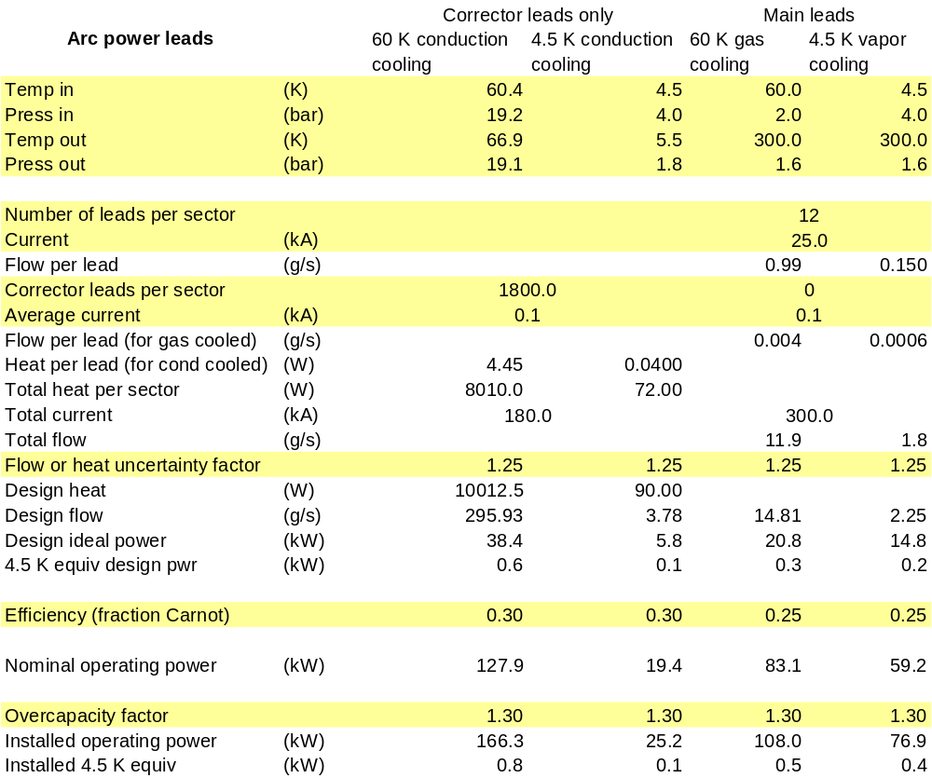

6.2.2.6 Cooling power requirements and plant sizing.
Table 3, below, shows that the heat load estimates in Table 1 and the 240 km circumference of the VLHC give rise to a system requiring about 150 MW of installed cooling power, equivalent to about five large cryoplants at each of the six locations. Such a system would total about five times the cooling capacity of the LHC cryogenic system. Note the applied factors: the uncertainty factor of 1.25 on heat loads other than the beam screen, the Carnot efficiency of 0.30 which is high but achievable with today’s technology (LHC reports 0.3 for their helium systems), and the overcapacity factor of 1.3. Overcapacity is the cooling capacity reserve required for maintenance, control, and non-optimal operation. LHC uses a factor of 1.5. We have reduced that to 1.3 in light of the large proportion of heat load due to synchrotron radiation, over which we have control.
As we mentioned above in the beam screen temperature discussion, analysis indicates that a fully optimized system for these heat loads would require about 15% less power, or about 125 MW installed power and 100 MW operating power.

Table 3. VLHC heat loads and powers.
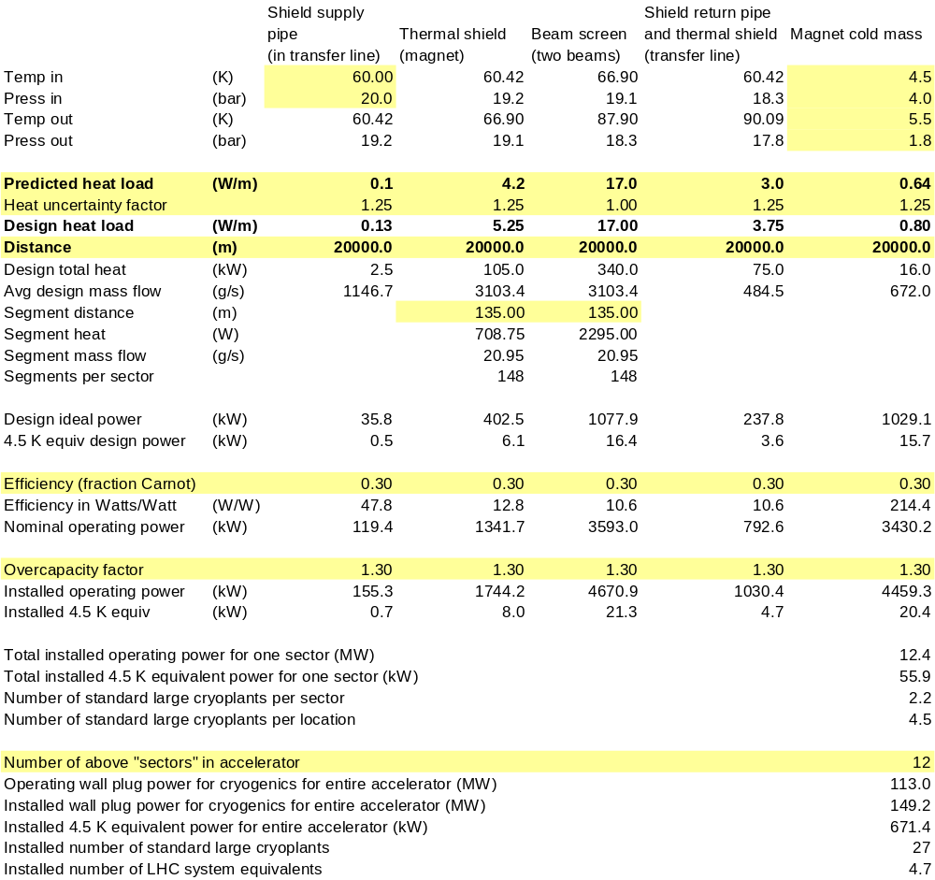

6.2.2.7 Comparison with other systems.
Table 4, below, compares the heat loads for LHC and the latest TESLA design with various VLHC systems. VLHC is still underestimated relative to LHC, since LHC total installed power includes cooling for IR regions, while VLHC does not. The VLHC variations listed in Table 4 just consider removal of a fraction of the synchrotron radiation at room temperature.
At $0.114/kWh, power would cost $1.00 per Watt-year, so the “installed power” shown in MW could be approximately the annual power bill in M$. Thus, one can see that it would be very desirable to at least reduce the installed power to less than 100 MW. The last two rows in Table 4, showing total power with about 75% of synchrotron heat removed at room temperature, do total less than 100 MW of installed power. Thus, a design allowing room-temperature absorption of most of the synchrotron power could help to bring the VLHC cryogenic power requirements down to reasonable levels.

Table 4. Comparison of large cryogenic systems.
 | Predicted cryogenic system total heat loads by temperature range (kW) |  |  | Installed Power (MW) | Number of large plants
 | 40 – 100 K | 4 K – 20 K | 2 K
LHC¹ | 256.7 | 63.0 | 18.3 | 32 (est) | 8  x 18 kW
TESLA | 325.8 | 29.6 | 17.5 | 36 | 7
VLHC  (17 W/m screen) | 6210 | 201.6 | __ | 149 | 27
VLHC (4 W/m beam screen) | 3090 | 201.6 | __ | 95 | 17
VLHC (4 W/m and 25% less static heat) | 2565 | 190 | __ | 86 | 16
1. LHC includes IR cryogenic totals, while VLHC does not.

6.2.2.8 Suggestions for R&D.
Large cryogenic systems are known technology. But scaling up the standard methods and systems to the size of a VLHC results in extremely large power requirements. How would one reduce required operating power in a VLHC? The following is a list of some possible areas for R&D toward reducing the power consumption for a VLHC.

- Dynamic heat load reduction would be a major improvement. Intercept as much synchrotron radiation as possible at room temperature! This probably must be done at discrete locations in order to avoid adding too much heat to the 4.5 K level, since a continuous room temperature beam screen radiates too much heat to the cold magnet bore tube.
- Static heat load (thermal radiation and conduction) reduction might be possible. Utilize techniques developed for MRI or by NASA (so trace cooling of supports and/or trace cooling of an inner shield). Perhaps also fund a development effort toward better MLI and MLI installation. How much can be gained? I am pessimistic, since I think our problems are different from NASA or MRI, but there could be some gain.
- Improve cryogenic plant efficiency. Hans Quack and Mike McAshan both state that there is no thermodynamic advantage in nitrogen as a working fluid in a cycle, in fact helium is somewhat better. The primary source of inefficiency in cryogenic plants is the compressors, and there might be some advantage of a higher molecular weight refrigerant (nitrogen or neon) in permitting the use of very large-scale air separation compressors and expanders. Hans Quack wrote: “At a paper, which I am going to present at the CEC in Madison I am going to propose a new system with a mixture of helium and neon as refrigerant. Such a refrigerant is nearly as efficient as helium, it allows power recovery of the turbines and a turbo compressor as main compressor and one can go down to 27 K.” In “A Study of Refrigeration for LN2 Cooled Power Transmission Cables,” by R.C. Longsworth and K.F. Schoch, in Advances in Cryogenic Engineering, Vol. 23, 1978 (pre-HTS, looking at cold resistive lines), the authors look at cooling loads of 40 kW/mile to 110 kW/mile over about 15 miles, so about 1500 kW at 65 K to 90 K. An efficiency of 30% relative to Carnot is assumed. Since they want LN2 subcooled to 65 K, they chose a refrigerator with neon as the working fluid since, “The compressor cost premium for helium and hydrogen is many time the cost of the neon.” The advantage seems not to have been in operating costs, but in initial capital costs. The 30% efficiency is typical for helium or nitrogen working at that temperature range.
- Improve helium screw compressor efficiency. This R&D item was listed at the Bloomington workshop in 1994 and the Jefferson Lab workshop in 1999. Quoting from the 1999 report: “Screw compressor efficiency (FY94 recommendation): This one component accounts for more than half of total inefficiency of a refrigeration system. We use screw compressors rather than the more efficient reciprocating compressors because of their very high reliability. The root problem is that the He market is so small compared to Freon that it is difficult to get the vendor’s R&D attention.”

6.2.2.9 Conclusions and recommendations.
- Installed power for the arc cryogenics should be well under 100 MW. A combination of optimizing the system temperature levels and removing a significant fraction (at least half) of the synchrotron radiation at room temperature could accomplish such a power reduction. Developing methods for removing synchrotron radiation at room temperature is vital for a high field VLHC.
- Reducing heat loads will have a secondary effect of reducing required pipe sizes, required inventory, and capital costs.
- R&D on methods to further reduce static heat loads utilizing methods developed for MRI and NASA may also prove beneficial.
- Industrial R&D on methods to improve helium compressor efficiency, while difficult to fund due to potentially high costs, could prove very beneficial to these large-scale systems.
- In light of the extremely large helium inventory, one might want consider how nitrogen could be used to replace some of the helium in this cryogenic system.

References.

[1] M. McAshan and P. O. Mazur, “Cryogenic Systems for the High Field RLHC Study Cases,” 1996 Snowmass Study.
[2] M. McAshan and P. O. Mazur, “Cryogenic Systems for the Low Field RLHC Study Cases,” 1996 Snowmass Study.
[3] L. Tavian and U. Wagner, “LHC sector heat loads and their conversion to LHC refrigerator capacities,” LHC Project Note 140 (1998).
[4] Roger Rabehl, VLHC quench study, personal communication.
[5] C. Darve, A. Poncet, D. Willems, “Technical Note 98-19, CTM3, the latest evolution of the cryostat thermal model: thermal performance measurements of the first run from March to May 1998,” 03/1999.
[6] C. Darve, G. Ferlin, M. Gautier, L.R, Williams, LHC-Project-Note-112, “Thermal performance measurements for a 10 meter LHC dipole prototype (Cryostat Thermal Model 2),” 11/1997.
[7] Christine Darve, et. al., “VLHC Thermal Shield Cooling,” to be published at a TD note or VLHC note.
[8] Pierre Bauer, et. al., “VLHC Beam Screen Cooling,” to be published at a TD note or VLHC note.
[9] Amalia Ballarino and Albert Ijspeert, “Design and Tests on the 30 to 600 A HTS Current Leads for the Large Hadron Collider”, CERN-LHC-Project-Report-78, 24 Oct 1996.
[10] G. Citver, et. al., “Thermal tests of 6-kA HTS current leads for the Tevatron,” Advances in Cryogenic Engineering, Vol. 45B, (2000), pp. 1549 – 1556. (Also FERMILAB-Conf-99-284)

original file: \\tdserver1\project\VLHC\TDDoc\DesignStudyReport\06_Stage2_components\Draft1\originals\6.2.2_VLHC2cryoDraft15Feb01.doc

