  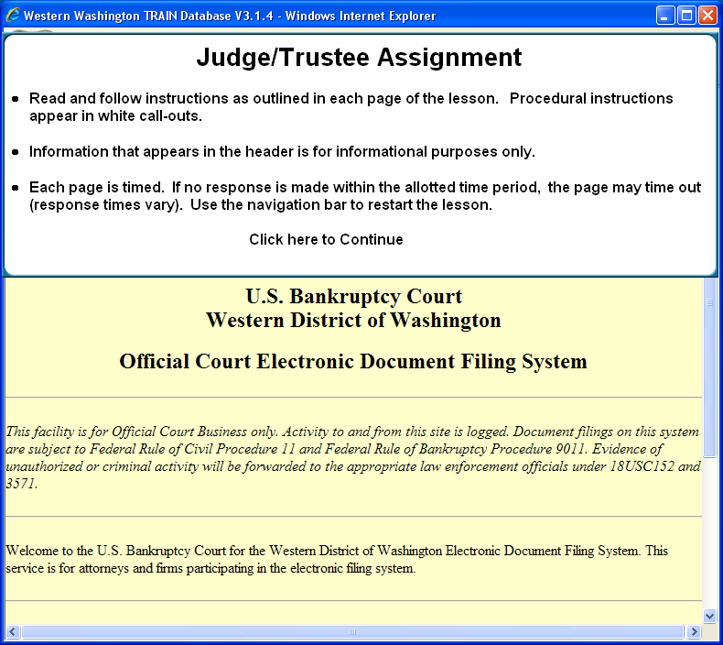
  Slide 1
  Read and follow instructions as outlined in each page of the lesson. Procedural instructions appear in white call-outs. Information that appears in the header is for informational purposes only. Each page is timed. If no response is made within the allotted time period, the page may time out (response times vary). Use the navigation bar to restart the lesson.
  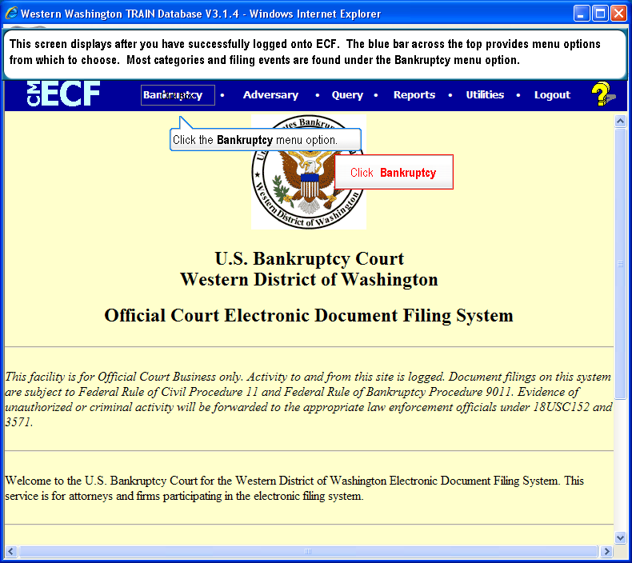
  Slide 2
  Text Captions: Click Bankruptcy
  This screen displays after you have successfully logged onto ECF. The blue bar across the top provides menu options from which to choose. Most categories and filing events are found under the Bankruptcy menu option.
  Click the Bankruptcy menu option.
  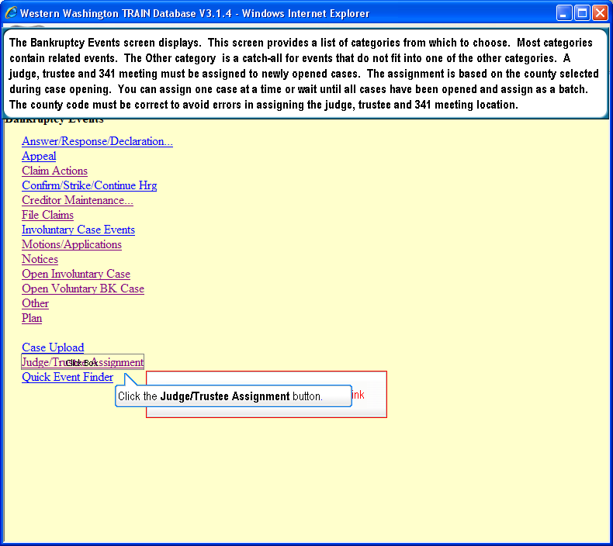
  Slide 3
  Text Captions: Select the Judge/Trustee Assignment link. This screen provides a list of categories from which to choose. The Other category is a catch-all for events that do not fit into one of the other categories. A judge, trustee and 341 meeting must be assigned to newly opened cases. The assignment is based on the county selected during case opening. You can assign one case at a time or wait until all cases have been opened and assign as a batch. The county code must be correct to avoid errors in assigning the judge, trustee and 341 meeting location. Click the Judge/Trustee Assignment button.
  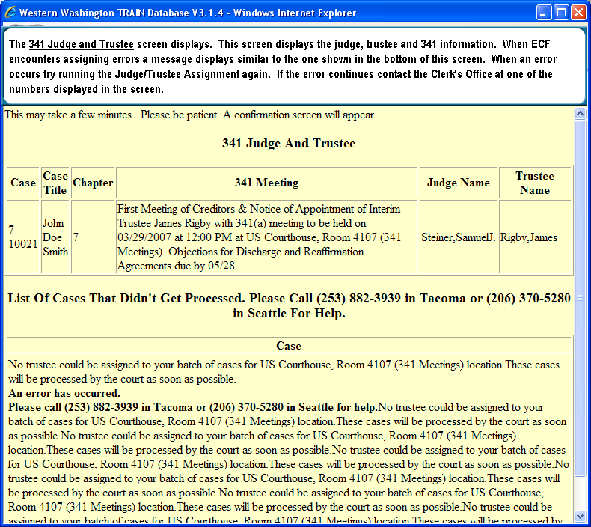
  Slide 4
  Text Captions: The 341 Judge and Trustee screen displays. This screen displays the judge, trustee and 341 information. When ECF encounters assigning errors a message displays similar to the one shown in the bottom of this screen. When an error occurs try running the Judge/Trustee Assignment again. If the error continues contact the Clerk's Office at one of the numbers displayed in the screen.

