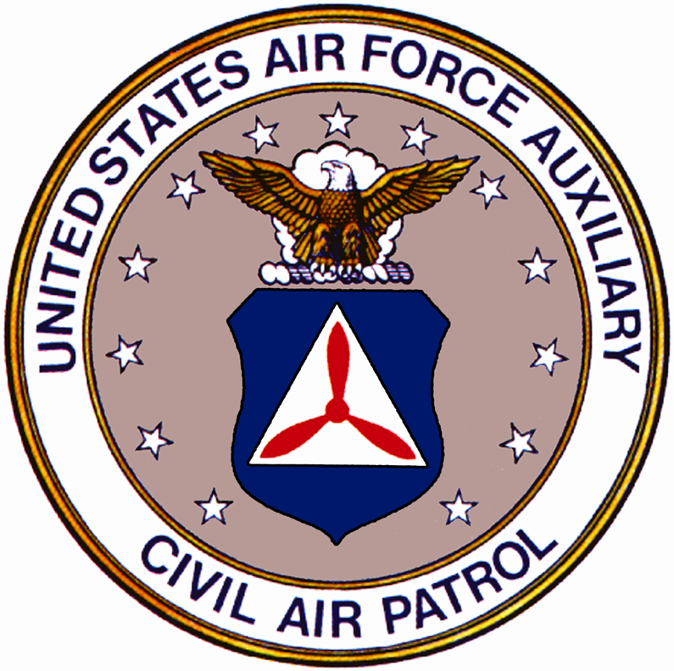

CIVIL AIR PATROL

MOODY AFB COMPOSITE SQD
Building 8265, Robins Rd,
Second Floor, Moody AFB
Meetings held Thursday 1800-2100
Phone 257-3268/3231//3238
Deputy Commander For Seniors
Professional Development Officer

Squadron Commander
Communications Officer
1st Lt Ferguson, William
W9unh4@peoplepc.com
Deputy Commander for Cadets
Capt Saad, Yusef
Yusef.saady@moody.af.mil

Operations Officer

Moral Leadership Officer
Lt Col Genseal, Patrick
Patrick.genseal@moody.af.mil

Logistics/Supply/Finance Officer
SFO O’Rourke, Eugene

Egorourk@valdosta.edu

Transportation Officer
2nd Lt Hauck, Manny
Mannyhauck@hotmail.com

Leadership Officer
1st Lt Moshell, Robert
Robert.moshell@moody.af.mil

Personnel/Testing/Cadet
1st LtVan Doren, Kay
Drmajmav@bellsouth.net

Aerospace Education Officer
Lt Col Van Doren, Mike
drmajmav@bellsouth.net

Communications Officer
2nd Lt Grana. Rafael
Rafael1942@yahoo.com

Administration/Testing Officer
Johnson, Loretta
Skep300@earthlink.net

SM Yarborough, Jason
Jason.yarborough@moody.af.mil

Safety Officer
TFO Arzayus, Juan
Arzayus_juan@yahoo.com

Historian
FO Miller, Amanda
Amanda.miller@moody.af.mil

SM Battermann-Dickinson, Denise
Denise_candles69@yahoo.com

Physical Fitness Officer
2nd Lt Hauck
FO Miller
Recruiting Officer
2nd Lt Hauck
Emergency Services
Capt Saad
Public Affairs
Lt Col Genseal

Mailing Address
Moody AFB Composite Squadron 5293 Schrader Street PCS Box p-1081
Moody AFB GA 31699

THIS ROSTER CONTAINS PRIVACY ACT INFORMATION AND IS TO BE USED FOR OFFICIAL BUSINESS ONLY

THIS ROSTER CONTAINS PRIVACY ACT INFORMATION AND IS TO BE USED FOR OFFICIAL BUSINESS ONLY
Civil Air Patrol National Commander

Maj Gen Richard L. Bowling
Group IV Commander
Lt Col McCracken
gacap411@worldnet.att.net

Aerospace Education 334-953-5095
Cadet Programs 334-953-4238
Emergency Service 334-953-4225
Counter drug 334-953-4225
DDR 334-953-4225
Homeland Security 334-953-4225
Membership Services 877-227-9142
Southeastern Regional Commander
Col Tony Pineda
1101 NW 114 Avenue
Plantation, FL 33323
Moody AFB Liaison Officer
Maj Chris Foltz
Christopher.foltz@moody.af.mil

Georgia Wing Liaison Officer
Maj Jeff Trest
jtrest@alltel.net

Georgia Wing Commander
Col Don Greene
Georgia Wing HQ
Phone 770-428-9031
P.O. Box 9279
Marietta, GA 30065-2279

CAP members are building the nation’s finest volunteer force for
Emergency Services, Counterdrug Operations, Cadet Programs and Aerospace Education
National HQ Civil Air Patrol
Phone 877-227-9142
http://cap.gov
105 South Hansell Street
Maxwell AFB AL 36112-6332
CAPMART
Phone 1-800-633-8768
www.capmart.org
30 S. Arnold St. Bldg 848
Maxwell AFB AL 36112-6332
Member Services 877-227-9142
National Ops Center 888-211-1812
Cadet Special Activities 334-953-5315
CAP News 334-953-5700
Strategic Communications 334-953-5463
Aerospace Education 334-953-5095

Civil Air Patrol Core Values

Integrity
Volunteer Service
Excellence
Respect

We embrace these values and embody them through strength of leadership, undisputed professionalism, and our love of aviation.

