COMPOSTING FACILITY

PRACTICE INTRODUCTION

USDA, Natural Resources Conservation Service―Practice Code 317

COMPOSTING FACILITY
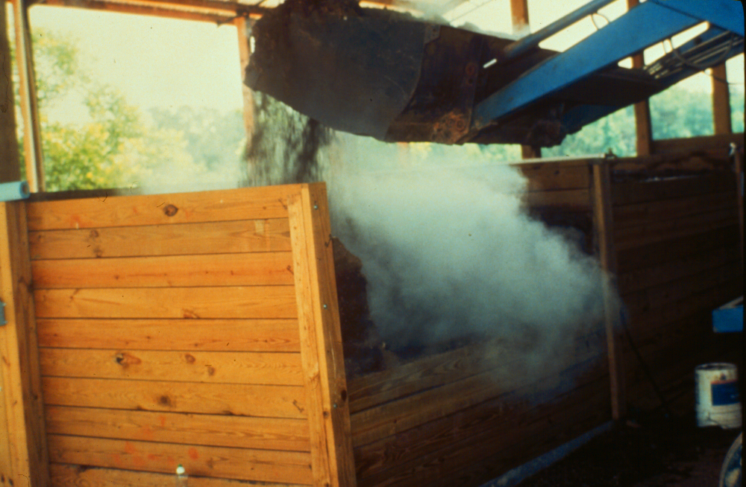
A composting facility is installed for biological stabilization of waste organic material.

PRACTICE INFORMATION
The purpose of this practice is to biologically treat waste organic material and produce humus-like material that can be recycled as a soil amendment or organic fertilizer. The material may also be used by other acceptable methods of recycling that comply with laws, rules and regulations.
Composting is accomplished by mixing an energy source (carbonaceous) with a nutrient source (nitrogenous) in a prescribed manner to meet aerobic bacteria requirements. Correct proportions of ingredients are essential to minimize odors and avoid pest problems.
Waste material for composting may include livestock and poultry manure, dead animal carcasses, and food processing material when it is considered part of a normal farm operation.
This practice applies where: (1) waste organic material is generated by agriculture production or processing, (2) composting is needed to manage the waste organic material properly, and (3) an
overall waste management system has been planned that accounts for the end use of the composted material. The three types of composting facilities covered in the Composting Facility standard are:
- Aerated windrows—Suited for large volumes of organic material managed by power equipment used to periodically turn the composting material.
- Static piles—Material is initially mixed into a homogeneous mixture that has the proper moisture content and bulk density to facilitate air movement throughout the pile without periodically turning the material. Forced air might be necessary to facilitate the composting process.
- In-vessel—An enclosed structure is used to contain a blended mixture of organic waste that is strictly controlled for optimum air and temperature. In-vessel composting also includes naturally aerated systems where organic materials are layered in a container and turned once during the composting process.

COMMON ASSOCIATED PRACTICES
Composting Facility is commonly used in a Conservation Management System with practices such as Waste Storage Facility (313), Nutrient Management (590), and Waste Utilization (633).
For further information, refer to the practice standard in the local Field Office Technical Guide and associated specifications and job sheets.

2. Compost-handling equipment purchased/dedicated
I.7 (-) Pathogens to ground & surface water
Composting Facility (313)
C.3 (+) Aquatic health for humans, domestic and wild animals
I.9 (+) On-farm usage
I.5 (-) Noxious algal growth
I.8 (+) Meeting water quality standards
I.2 (+) Agribusiness
C.4 (+/-) Income stability (individuals and community)
D.1 (+) Infrastructure and operational costs
I.3 (-) Manure-associated odors
C.1 (+) Community acceptance of AFOs
C.2 (+) Stream fauna, e.g., fish, invertebrates
Waste Storage Facility (313)
1. Structure/site dedicated to composting process
(loss of land or plant growth)
Initial setting: AFO is
established and wants a facility
for composting wastes
D.2 (+) Compost
Composting Facility
5/2002
Waste Utilization (633)
Nutrient Management (590)
LEGEND
#. Created by practice
D. Direct effect
I. Indirect effect
C. Cumulative effect
Pathway
(+) increase; (-) decrease
Associated practice
Start
Note: Effects are qualified with a plus (+) or minus (-). These symbols indicate only an increase (+) or a decrease (-) in the effect upon the resource, not whether the effect is beneficial or adverse.

I.1 (+) Product marketed
I.4 (-) Nutrients and organics to ground and surface water
I.6 (+) Dissolved oxygen in surface waters

