Offsets in Defense Trade
Eighth Report to Congress

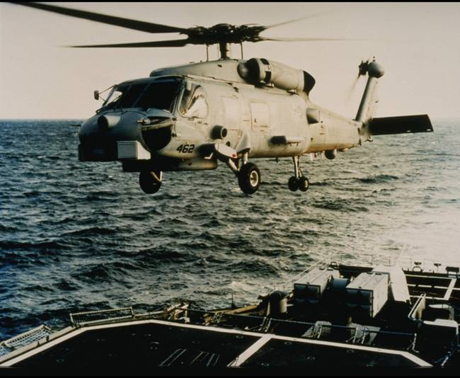


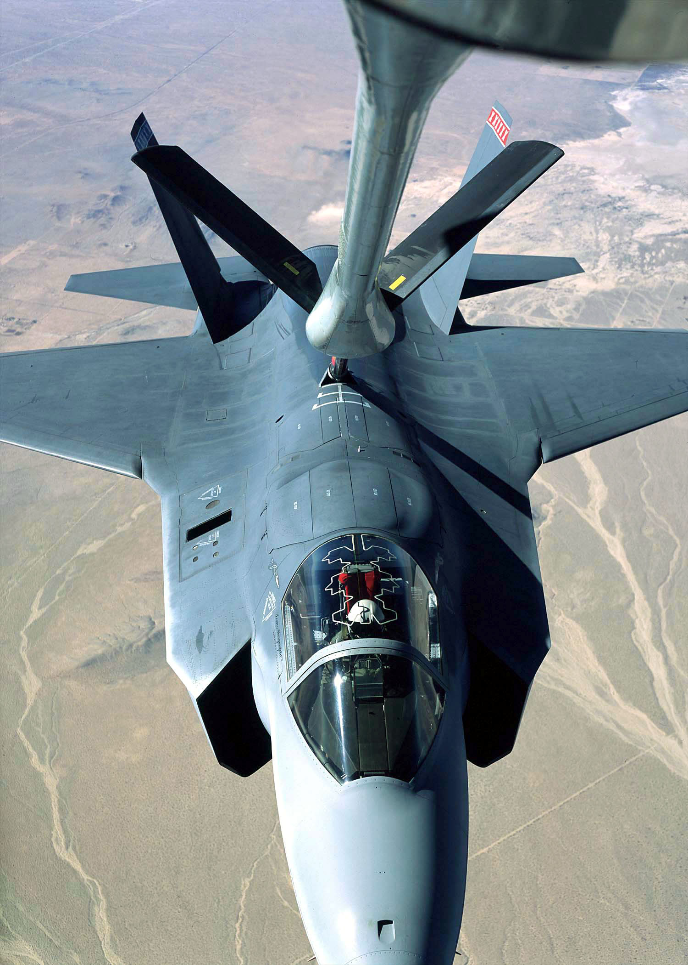
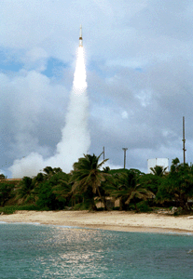
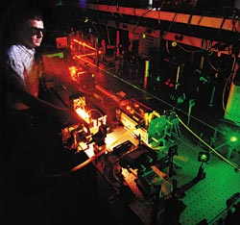

July 2004


U.S. Department of Commerce
Bureau of Industry and Security

Offsets in Defense Trade

Eighth Study
Conducted Under Section 309 of the Defense Production Act of 1950, as Amended

Prepared by
U.S. Department of Commerce
Bureau of Industry and Security

July 2004

For additional copies of this report, please contact the Office of
Strategic Industries and Economic Security at (202) 482-4506 or visit
www.bis.doc.gov/defenseindustrialbaseprograms

Table of Contents

Executive Summary v
1. Background 1
1.1 Legislation and Regulations 1
1.2 U.S. Government Policy 2
1.3 Offsets Terminology 3
1.4 Countries and Regions 4
1.5 Scope of Report 5
2. Statistical Overview 1
2.1 General Overview 1
2.2 Offset Transaction Types 2
2.3 Offset Transaction Categories 4
2.4 Industry Classification – SIC Codes 6
2.5 Countries and Regions 9
3. Impact of Offsets on the U.S. Defense Industrial Base 11
3.1 Defense Preparedness 11
3.2 Employment 11
3.3 Domestic Defense Productive Capability 12
4. Offset Agreements Activity, 1993-2002 15
4.1 Overview 15
4.2 Offsets Concentration 15
4.3 Regional Distributions 17
4.4 Europe vs. All Other Countries 17
4.5 Are Offset Demands Increasing? 20
5. Offset Transaction Activity, 1993-2002 25
5.1 Overview 25
5.2 Regional Distributions 27
5.3 Offset Transactions by Type 29
5.4 Offset Transactions by Category 31
5.5 Offset Transactions by Category and Type 33
5.6 Offset Transactions by Industrial Sector 35
6. Aerospace Offset Issues 39
6.1 Trends in the Import and Export Markets 39
6.2 Trends in Aerospace 42
6.3 Defense Trade Offsets in Aerospace 45
7. Other Government Offset Activities 49
8. Conclusions 51

Appendix A: Section 309 of the Defense Production Act
Appendix B: Department of Commerce Rules Regarding Reporting of Offset Activity
Appendix C: Defense Offsets Disclosure Act of 1999
Appendix D: Offset Transactions by Economic Sector
Appendix E: Country Offset Policies
Appendix F: Glossary and Offset Example
Appendix G: Publication List
Tables

Table 1-1: Purchasing Countries and Groups with Offset Agreements 5
Table 2-1: General Summary of Offset Activity, 1993-2002 2
Table 2-2: Offset Transactions by Type, 1993-2002 3
Table 2-3: Offset Transactions by Category and Type, 1993-2002 7
Table 2-4: Offset Transactions by Major Industrial Sector and Offset Type, 1993-2002 8
Table 2-5: Countries with Offset Agreements and Transactions By Region, 1993-2002 10
Table 5-1: Offset Transactions Analysis 26
Table 5-2: Offset Transactions by Leading Countries 27
Table 5-3: Regional Offset Transactions and Agreements 29
Table 5-4: Offset Transactions by Major Industrial Sectors 35
Table 6-1: U.S. Imports of Aerospace Products by Major Countries of Origin (in $ millions) 40
Table 6-2: Aerospace and Non-Aerospace Defense Exports and Offsets, 1993-2002 46

Charts

Chart 4-1: Reported Export Contracts and Offset Agreements Annually,
1993-2002 (in $ billions) 16
Chart 4-2: Regional Totals of Export Contracts and Offset Agreements,
1993-2002 (in $ billions) 18
Chart 4-3: Percentage Offsets for Europe vs. Rest of World (Weighted Moving Average, 1993-2002) 22
Chart 5-1: Regional Totals of Offset Transactions, 1993-2002 (in $ billions) 28
Chart 5-2: Direct, Indirect, and Unspecified Offset Transactions, 1993-2002
(in $ millions) 30
Chart 5-3: Offset Transactions by Category, 1993-2002 (in $ millions) 31
Chart 5-4: Percentage of Total Annual Offset Transactions Accounted
for by Top Three Transaction Categories, 1993-2002 32
Chart 5-5: Direct Offset Transactions by Category, 1993-2002 34
Chart 5-6: Indirect Offset Transactions by Category, 1993-2002 34
Chart 5-7: Offset Transactions by Industry and Type for Top 12 Sectors,
1993-2002 (in $ billions) 37

Chart 6-1: International Trade in Aircraft, Aircraft Engines, and
Parts, 1993-2000 (in $ millions) 46
Chart 6-2: U.S. Civil and Military Aircraft Sales ($ Millions) and
Civil Aircraft Sales as percent of total Aerospace Sales 51
Executive Summary

This is the eighth annual report on the impact of offsets in defense trade prepared pursuant to Section 309 of the Defense Production Act of 1950, as amended (DPA). The Department of Commerce’s Bureau of Industry and Security (BIS) has been delegated responsibility for preparing the reports required under Section 309. The report analyzes the impact of offsets on the defense preparedness, industrial competitiveness, employment, and trade of the United States. To assess the impact of offsets in defense trade, the Department of Commerce obtained data from U.S. defense firms involved in defense exports and related offsets and supplemented this information with statistics from the Bureau of the Census and the National Science Foundation.

This report covers offset agreements and offset transactions entered into from 1993 through 2002. This report (i) discusses the changes in the industrial base during the reporting period; (ii) provides summaries of offset agreements and transactions for the reporting period; and (iii) analyzes the impact of defense-related offsets specifically on the aerospace industry.

Offset Activity

Agreements
Total offset activity can be measured by the number and value of new offset agreements entered into between U.S. defense contractors and foreign governments.

Offset Agreements, 2001-2002: U.S. defense contractors reported entering into 35 new offset agreements with 14 countries in 2001 and 41 new offset agreements with 17 countries in 2002. For 2001, new U.S. offset-related defense export contract values totaled $7.0 billion. New offset agreements attached to these exports had a total value of $5.5 billion, equaling a 78.1 percent offset requirement. For 2002, new U.S. offset-related defense export contract values climbed to $7.4 billion, with new offset agreements attached to these exports having a total value of $6.1 billion, or an 82.3 percent offset requirement.

European nations received offsets equal to 95.8 percent of the total export values in 2001 and 94.3 percent in 2002, down from 111.1 percent in 2000. For non-European nations, though, the average offset requirement was 55.1 percent in 2001 and 77.3 percent in 2002, up significantly from 50.0 percent in 2000.

Offset Agreements, 1993-2002: U.S. companies reported entering into 434 offset agreements with 36 countries during the time period from 1993 to 2002. U.S. companies reported export sales of 181 different defense systems or subsystems with a total value of $63.6 billion. Offset agreements related to those export contracts were valued at $41.8 billion, or 65.7 percent of the export contract value. Sales of aerospace defense systems (i.e., aircraft, engines, and missiles) were valued at $53.6 billion and accounted for nearly 82 percent of the total export contracts.

Over the ten-year period, European countries alone accounted for nearly two-thirds (65 percent) of the value of offset agreements but less than half (46 percent) of the value of related export contracts. European offset demands continued to increase over the ten year period, although more slowly than the demands from other countries. Between 1993 and 2002, European offset demands as a percentage of exports increased by 16 percentage points, going from 78.3 percent to 94.3 percent; for the rest of the world, the increase was almost 55 percentage points, rising from 22.5 percent to 77.3 percent.

Asian countries are capturing an increasing share of offset agreements and export contracts as well as demanding higher offsets. In 2000, Asia accounted for only 2.8 percent of the value of offset agreements; in 2002, Asian countries accounted for 64.8 percent of the total. In contrast, European agreements secured 78 percent of the total value of offset agreements in 2000, but only 34 percent of agreements in 2002. Furthermore, Asian offset requirements reached 52.3 percent in 2001, and grew to 78.4 percent in 2002. The region’s 1993-2000 average offset requirement was only 26.2 percent.

The data indicate that the level of the demands from non-European nations as a group is rising as well. For 1993-2000, the average offset requirement for non-European countries totaled only 33.9 percent; for 1993-2002, the average requirement rose to 42.4 percent.

In a country-by-country analysis, Austria led Europe and the rest of the world in terms of its offset requirement percentage. On average, sales of U.S. weapons systems to Austria were associated with offset agreements worth 174.2 percent of the value of the weapon systems. Other countries with offset percentages greater than the value of the weapon systems exported were the Netherlands (120.5 percent), South Africa (116.7 percent), Greece (110.5 percent), and Sweden (103.9 percent).

Transactions
Offset activity can also be measured by the number and value of individual offset transactions carried out in fulfillment of offset agreements during the reporting period.

Offset Transactions, 2001-2002: U.S. companies reported offset transactions with a total actual value of $2.6 billion in both 2001 and 2002. The 2001 figure represents a 53 percent increase from the 2000 total of $1.7 billion, but is only slightly higher than the average annual value of offset transactions ($2.3 billion) during the ten-year period from 1993 to 2002. The percentage of the value of offset transactions classified as indirect rose during 2001 and 2002, reaching 63.8 percent in 2002, compared with 35.9 percent of the value in direct transactions that year. The remaining 0.3 percent of the value was unspecified.

Offset Transactions, 1993-2002: For 1993-2002, U.S. companies reported 5,903 offset transactions executed in 35 countries. These offset transactions were related to 230 defense systems under existing offset agreements. The actual value of the offset transactions from 1993 to 2002 was $23.5 billion. Indirect offsets accounted for 58.2 percent of the total value of transactions and direct offsets made up 39.1 percent. The remaining 2.7 percent of the value was unspecified.

The multiplier for all transactions during 2001-2002 was 1.265; this means that purchasing countries granted, on average, $1.265 of offset credit for each $1 in actual offset transaction value for those two years. For 1993-2002, the total multiplier was 1.224.

Findings

The Asian share of total export contracts and the region’s level of offset demands have experienced dramatic growth in recent years. Individual countries in other non-European regions of the world are also demanding and receiving increased levels of offsets; non-European reached 77 percent of the value of the sales. At the same time, increases in Western European offset demands are moderating, with requirements in 2001 and 2002 remaining around 95 percent of the value of the agreement, but still well above other regions of the world.

By combining BIS offsets data with aerospace industry data from the Census Bureau’s 2001 Annual Survey of Manufactures (ASM) (the most recent data published), the impact on defense productive capacity can be estimated. According to comparable BIS data for 2001, U.S. defense exports with offset agreements attached totaled $7.0 billion. Using ASM information on value added per aerospace worker, BIS estimates that (assuming 100 percent export content) these exports sustained 42,440 work-years in 2001.

In 2001, subcontracting, purchasing, co-production, and licensing transactions (those most likely to shift sales from U.S. suppliers to overseas firms) were valued at $1.9 billion. Dividing $1.9 billion by $165,858 (the value added by each worker in the aerospace industry in 2001) results in the loss of approximately 11,460 work-years in 2001.

Based on these calculations, it appears that defense export sales had a net positive effect on employment in the defense sector during the period from 1993 to 2001, although the net positive effect was diminished by the offset agreements. This calculation assumes that industry would not have received these defense export contracts if it had not entered into the related offset agreements. It should also be noted that the above analysis does not include an additional
$9 billion of offsets in technology transfer, training, overseas investment, and marketing transactions, because the impact of these transactions on the U.S. defense industrial base is difficult to calculate. Nor does this calculation include consideration of the long-term effect of creating new or enhanced competitors.

Purpose of Report

The DPA Section 309(b)(1) requires BIS to identify the cumulative effects of offset agreements on “the full range of domestic defense productive capability with special attention paid to the firms serving as lower-tier subcontractors or suppliers” and “the domestic defense technology base as a consequence of the technology transfers associated with such offset agreements.” To address the effects of offsets on defense productive capability, this analysis compares 2001 offset transactions dealing with transportation equipment and electronic equipment to 2001 value added from these two industries, as reported in the Census Bureau’s most recent Annual Survey of Manufactures. Over time, the lost future opportunity of offset transactions can negatively affect capacity utilization and ultimately, domestic productive capability. Value added, in turn, is a measurement of the productive capability of an entire industry, encompassing productivity of labor, efficient capital use, and full production capacity. In sum, 2001 offset transactions related to transportation equipment and electronic equipment totaled 1.4 percent of the 2001 value added for both industries. This value does not indicate that the domestic defense productive capability declined by 1.4 percent, but it is instead a measure of lost potential opportunity, with corresponding impacts on capacity utilization and in the end, domestic productive capability.

To identify the effects on the domestic defense technology base, this analysis compares total 2001 technology transfer transactions for aerospace manufacturing and electronic component industries to total 2001 research and development (R&D) spending for aerospace manufacturing industries. These two industries were chosen for their involvement in the most frequent and the highest levels of offset transactions for 2001. Offset transactions that involved technology transfer for these two industries in 2001 totaled $421 million. This value is equivalent to 1.9 percent of total R&D spending for those two industries in 2001. For aerospace manufacturing alone, the value of technology transfer offsets as a percentage of total R&D spending for the sector totaled 4.8 percent.

While there are no indications from other U.S. Government agencies that domestic defense productive capability has decreased cumulatively because of offsets, there is also no indication that offsets enhance defense productive capability, especially for lower tier subcontractors. The recent growth in new defense industrial subcontractors described and foreseen by officials with the Department of Defense (DoD) illustrate that the supplier base is improving. However, DoD officials attribute much of that growth to new, high-tech defense subcontractors that supply weapons systems almost exclusively marketed to the U.S. government. These new suppliers do not contribute to those systems sold abroad – those systems with related offset agreements.

Contents of Report

Sec. 309(d)(1) of the DPA, as amended, requires this report to include five specific analyses (Subparts A-E). The net assessment of the elements of the industrial base and technology base covered by the report, required in Subpart (A), is featured in Chapter 5. The six sectors of the industrial base most commonly involved in offset transactions are: Transportation equipment, electronic/electrical equipment, industrial machinery, business services, technical services and consultants, and measuring and analyzing instrumentation. These industrial sectors comprise 85 percent of all offsets transactions. A full listing of industrial sectors – based on SIC (Standard Industrial Classification) codes – affected by offsets appears in Chapter 2 along with a full discussion by SIC code in Chapter 5. Appendix D provides a more specific breakout by SIC code.

As required by Subpart (D), a detailed summary of offset arrangements – in the form of agreements and transactions – concluded during 1993-2002 is provided in Chapter 2. Chapter 4 provides a more detailed analysis of aggregated offset agreements for 1993-2002 as well as in 2001 and 2002 specifically. Included in this analysis are data that indicate a small number of U.S. companies and weapon systems dominated offset agreements during the reporting period. The top five companies (of 39 reporting offset agreements) accounted for 79.5 percent of the value of defense export contracts and 79.0 percent of the value of offset agreements reported for 1993-2002.

Chapter 5 provides a similar more detailed analysis of offset transactions aggregated from 1993 to 2002 as well as in 2001 and 2002, specifically. For example, more than half (51.6 percent) of the total value of offset transactions for the ten-year period fell into the transportation equipment group (SIC 37) that includes aircraft, guided missiles, ships, and motor vehicles.

Although the Department of Commerce is authorized in Subpart (B) to make recommendations for appropriate remedial action, at this time, no recommendations are provided. In addition, as described in Chapter 7, no other government agencies or interagency groups have conducted offset studies since the previous Annual Report on Offsets in Defense Trade. In the past, the Department of Commerce, through the Bureau of Industry and Security has participated in a Department of Defense-led Interagency Offsets Steering Committee (the Committee), which includes representatives from the Departments of Defense, State, Treasury, and Labor, and the Office of the U.S. Trade Representative. However, the Committee conducted no activities this year, and accordingly, there are no findings or recommendations of any interagency studies to be summarized, as required by Subpart (C). Furthermore, no bilateral or multilateral negotiations relating to the use of offsets were conducted during the past year. As such, the following report does not feature a summary of those negotiations, as required by Subpart (E).

Background

Legislation and Regulations

In 1984, the Congress enacted amendments to the DPA, which included the addition of Section 309 addressing offsets in defense trade. Section 309 required the President to submit an annual report on the impact of offsets on the U.S. defense industrial base to the then-Committee on Banking, Finance, and Urban Affairs of the House of Representatives and the Committee on Banking, Housing, and Urban Affairs of the Senate.

Initially, the Office of Management and Budget coordinated the interagency process of preparing the report for the Congress. Other agencies involved in the process included the Departments of Commerce, Defense, Labor, State, and Treasury, and the Office of the U.S. Trade Representative. In 1992, Section 309 of the DPA was amended, and the Secretary of Commerce was given the responsibility of preparing the report for the Congress, on the President’s behalf, and was directed to function as the President’s Executive Agent for carrying out responsibilities under Section 309 of the DPA. See Appendix A for the text of Section 309.

Under Section 309, the Secretary of Commerce is authorized to develop and administer the regulations necessary to collect offset data from U.S. defense exporters. The Secretary of Commerce delegated this authority to the Bureau of Industry and Security, which published its first offset regulations in the Federal Register in 1994. See Appendix B for a copy of the regulations.

The 1992 amendments to Section 309 of the DPA made other changes to the offset data collection process. The amendments lowered the offset agreement reporting threshold from $50 million to $5 million for U.S. firms entering into foreign defense sales contracts subject to offset agreements. Under the regulations, firms report all offset transactions for which they receive offset credits of $250,000 or more. Every year, U.S. companies report offset agreement and transaction data for the previous calendar year to BIS. The data elements collected each year from industry are listed in Section 701.4 of the Department’s offset regulations and are attached in Appendix B.

U.S. Government Policy

The U.S. Government policy on offsets in defense trade was developed by an interagency offset team. On April 16, 1990, the President announced a policy on offsets in military exports. In 1992, Congress passed the following provision that reflected the substance of the policy announced by the President:

(a) In General. Recognizing that certain offsets for military exports are economically inefficient and market distorting, and mindful of the need to minimize the adverse effects of offsets in military exports while ensuring that the ability of United States firms to compete for military export sales is not undermined, it is the policy of the Congress that--
(1) no agency of the United States Government shall encourage, enter directly into, or commit United States firms to any offset arrangement in connection with the sale of defense goods or services to foreign governments;
(2) United States Government funds shall not be used to finance offsets in security assistance transactions, except in accordance with policies and procedures that were in existence on March 1, 1992;
(3) nothing in this section shall prevent agencies of the United States Government from fulfilling obligations incurred through international agreements entered into before March 1, 1992; and
(4) the decision whether to engage in offsets, and the responsibility for negotiating and implementing offset arrangements, reside with the companies involved.
(b) Presidential Approval of Exceptions. It is the policy of the Congress that the President may approve an exception to the policy stated in subsection (a) after receiving the recommendation of the National Security Council.
(c) Consultation. It is the policy of the Congress that the President shall designate the Secretary of Defense to lead, in coordination with the Secretary of State, an interagency team to consult with foreign nations on limiting the adverse effects of offsets in defense procurement. The President shall transmit an annual report on the results of these consultations to the Congress as part of the report required under section 309(a) of the DPA.

In 1999, the offset policy was supplemented by provisions contained in the Defense Offsets Disclosure Act of 1999. Specifically, Congress made the following findings:

- A fair business environment is necessary to advance international trade, economic stability, and development worldwide, is beneficial for American workers and businesses, and is in the United States national interest.
- In some cases, mandated offset requirements can cause economic distortions in international defense trade and undermine fairness and competitiveness, and may cause particular harm to small- and medium-sized businesses.
- The use of offsets may lead to increasing dependence on foreign suppliers for the production of United States weapons systems.
- The offset demands required by some purchasing countries, including some close allies of the United States, equal or exceed the value of the base contract they are intended to offset, mitigating much of the potential economic benefit of the exports.
- Offset demands often unduly distort the prices of defense contracts.
- In some cases, United States contractors are required to provide indirect offsets which can negatively impact nondefense industrial sectors.
- Unilateral efforts by the United States to prohibit offsets may be impractical in the current era of globalization and would severely hinder the competitiveness of the United States defense industry in the global market.

The Defense Offsets Disclosure Act of 1999 continues with the following declaration of policy:

It is the policy of the United States to monitor the use of offsets in international defense trade, to promote fairness in such trade, and to ensure that foreign participation in the production of United States weapons systems does not harm the economy of the United States.

Offsets Terminology

There are several basic terms used in discussions of offsets in defense trade. For more definitions and an illustrative example of an offset arrangement, please see the Glossary in Appendix F.

Offsets: Compensation practices required as a condition of purchase in either government-to-government or commercial sales of “defense articles” and/or “defense services” as defined by the Arms Export Control Act (22 U.S.C. § 2751, et seq.) and the International Traffic in Arms Regulations (22 C.F.R. §§ 120-130).

Direct Offsets: Contractual arrangements that involve defense articles and services referenced in the sales agreement for military exports. These transactions are directly related to the defense items or services exported by the defense firm and are usually in the form of co-production, subcontracting, technology transfer, training, production, licensed production, or financing activities.

Indirect Offsets: Contractual arrangements that involve defense goods and services unrelated to the exports referenced in the sales agreement. These transactions are not directly related to the defense items or services exported by the defense firm. The kinds of offsets that are considered “indirect” include purchases, investment, training, financing activities, marketing/exporting assistance, and technology transfer.

Co-production: Overseas production based upon a government-to-government agreement that permits a foreign government or producer(s) to acquire the technical information to manufacture all or part of a U.S.-origin defense article. Co-production includes government-to-government licensed production, but excludes licensed production based upon direct commercial arrangements by U.S. manufacturers.

Licensed Production: Overseas production of a U.S.-origin defense article based upon transfer of technical information under direct commercial arrangements between a U.S. manufacturer and a foreign government or producer.

Subcontractor Production: Overseas production of a part or component of a U.S.-origin defense article. The subcontract does not necessarily involve license of technical information and is usually a direct commercial arrangement between the defense prime contractor and a foreign producer.

Overseas Investment: Investment arising from an offset agreement, often taking the form of capital dedicated to establishing or expanding a subsidiary or joint venture in the foreign country.

Technology Transfer: Transfer of technology that occurs as a result of an offset agreement and that may take the form of research and development conducted abroad, technical assistance provided to the overseas subsidiary or joint venture, or other activities under direct commercial arrangement between the defense prime contractor and a foreign entity.

Countries and Regions

For ease of analysis, and in some cases to protect company confidentiality, countries and country groups actively requiring offsets in connection with purchases of U.S. defense systems during the 1993-2002 period (as reported by industry) were divided into four geographic regions: Europe, the Middle East and Africa, North and South America, and Asia. The countries found in each region are listed in Table 1-1.

Scope of Report

This is the eighth report on the impact of Offsets in Defense Trade prepared by the Department of Commerce’s Bureau of Industry and Security. This report is prepared after analyzing offset data reported to the Department of Commerce by U.S. defense firms, in compliance with regulations established under Section 309 of the DPA.

The eighth report reviews offsets data for the ten-year period from 1993 to 2002. This report was prepared in consultation with the Departments of Defense, State, Treasury, and Labor; the Office of the U.S. Trade Representative; and the Central Intelligence Agency. The initial offsets report, issued in 1996, covered the time period from 1993 to 1994. The six subsequent offset reports added an additional year to the reporting period; this report adds two more years. The data for 2000 have been revised to reflect corrected data provided by industry for that year.

Table 1-1: Purchasing Countries and Groups with Offset Agreements
(by Region, 1993-2002)
Europe | Middle East and Africa
Austria | Israel
Belgium | Kuwait
Czech Republic | Saudi Arabia
Denmark | South Africa
EPG – The European Participating Group (Belgium, The Netherlands, Norway)  FINLAND | Turkey
 | United Arab Emirates
Finland | North and South America
France | Brazil
Germany | Canada
Greece | Chile
Italy | Asia
NATO | Australia
Netherlands | Malaysia
Norway | New Zealand
Portugal | Singapore
Slovenia | South Korea
Spain | Taiwan
Sweden | Thailand
Sweden/Norway
Switzerland
United Kingdom
Source: U.S. Department of Commerce/BIS Offsets Database

This report begins with an overview of the data collected from U.S. industry for 1993-2002, followed by an analysis of the effects of offsets on the U.S. defense industrial base. Next, the report presents a statistical analysis of offset agreements entered into from 1993 through 2002, including consideration of the high concentration of offsets among a relatively few firms, countries, and weapon systems. The regional distribution of offset agreements is also reviewed, and a detailed comparison made of offset activity in European countries with the countries in the rest of the world. This chapter is followed by a similar analysis of offset transactions, by type of offset and by the nine categories, and in terms of the offset recipients. Next, the report presents a review of aerospace issues – specifically, the recent offset trends in the U.S. aerospace industry.

Statistical Overview

In this part of the report, we provide a general overview of offset statistics collected by BIS for the years 1993 through 2002, along with a review of some of the terms used by BIS to organize the data for analysis. More detailed sections on agreements and transactions will follow in Chapters 4 and 5.

The following data points are used to organize and analyze the information collected:

1. Offset Agreement – Year – Country – Weapon System – Export Contract Value – Agreement Value – % Agreement Value to Export Value; and

2. Offset Transaction – Year – Country – Referenced Weapon System – Recipient – Actual Value – Credit Value – Multiplier (credit value ÷ actual value) – Type – Category – Description – Industry Identification.

General Overview

A summary of offset activity for 1993 through 2002 is provided in Table 2-1. Data for 2000 have been revised to reflect corrected information provided by reporting firms.

Table 2-2: General Summary of Offset Activity, 1993-2002
(all $ in millions)
Offset Agreements
Year | Export Value | Offset Value | % Offset | Companies | Agreements | Countries
1993 | $13,957.0 | $4,806.7 | 34.4% | 18 | 30 | 17
1994 | $4,792.4 | $2,048.7 | 42.8% | 18 | 49 | 20
1995 | $7,402.0 | $6,034.1 | 81.5% | 19 | 45 | 18
1996 | $2,987.8 | $2,270.7 | 76.0% | 15 | 50 | 19
1997 | $5,822.8 | $3,831.8 | 65.8% | 13 | 57 | 19
1998 | $3,257.8 | $1,846.6 | 56.7% | 11 | 44 | 17
1999 | $4,681.2 | $3,851.4 | 82.3% | 10 | 45 | 11
2000 | $6,278.3 | $5,498.1 | 87.6% | 8 | 38 | 14
2001 | $7,039.2 | $5,497.3 | 78.1% | 11 | 35 | 14
2002 | $7,406.2 | $6,094.8 | 82.3% | 12 | 41 | 17
10 Years | $63,624.9 | $41,780.3 | 65.7% | 39 | 434 | 36
Offset Transactions
Year | Actual Value | Credit Value | Multiplier | Companies | Transactions | Countries
1993 | $1,815.1 | $2,162.1 | 1.191 | 24 | 440 | 27
1994 | $1,891.1 | $2,161.5 | 1.143 | 21 | 550 | 26
1995 | $2,713.7 | $3,390.8 | 1.250 | 20 | 670 | 27
1996 | $2,731.5 | $3,098.9 | 1.135 | 21 | 623 | 26
1997 | $2,725.5 | $3,276.2 | 1.202 | 18 | 577 | 26
1998 | $2,364.8 | $2,684.6 | 1.135 | 19 | 582 | 30
1999 | $2,080.4 | $2,824.1 | 1.358 | 13 | 512 | 25
2000 | $1,998.5 | $2,613.0 | 1.307 | 14 | 601 | 23
2001 | $2,588.1 | $3,295.7 | 1.273 | 15 | 620 | 25
2002 | $2,613.0 | $3,281.5 | 1.256 | 17 | 728 | 27
10 Years | $23,521.5 | $28,788.4 | 1.224 | 42 | 5903 | 39
Source: BIS Offsets Database
Note: Due to rounding, totals may not add up precisely. Also, data for 2000 have been revised to reflect corrected information provided by reporting firms.

Offset Transaction Types

Table 2-2 presents offset transaction data by type (direct, indirect, or unspecified) and the percent distribution for each year from 1993 to 2002. As discussed in Chapter 1, direct offset transactions are those that are directly related to the weapon system that is exported. Indirect transactions are not related to the exported system. A transaction is classified as unspecified when there is not enough information available to determine whether it is direct or indirect. The table also shows the total actual and credit values of the transactions for each year. The credit value is normally more than the actual value assigned to transactions; some foreign governments

Table 2-3: Offset Transactions by Type, 1993-2002
($ amounts in millions)
Year |  | Total |  |  | Direct |  | Indirect |  | Unsp. |  |  | Dir. |  | Ind. |  | Unsp.
 |  |  | Actual Value |  |  |  |  |  |  |  | % Distribution
1993 |  | $1,815.1 |  |  | $583.0 |  | $1,106.0 |  | $126.1 |  |  | 32.1% |  | 60.9% |  | 7.0%
1994 |  | $1,891.1 |  |  | $600.7 |  | $1,129.5 |  | $160.9 |  |  | 31.8% |  | 59.7% |  | 8.5%
1995 |  | $2,713.7 |  |  | $1,064.1 |  | $1,649.6 |  | NR |  |  | 39.2% |  | 60.8% |  | NR
1996 |  | $2,731.5 |  |  | $1,097.5 |  | $1,553.8 |  | $80.1 |  |  | 40.2% |  | 56.9% |  | 2.9%
1997 |  | $2,725.5 |  |  | $1,030.3 |  | $1,570.7 |  | $124.4 |  |  | 37.8% |  | 57.6% |  | 4.6%
1998 |  | $2,364.8 |  |  | $1,464.2 |  | $895.3 |  | $5.4 |  |  | 61.9% |  | 37.9% |  | 0.2%
1999 |  | $2,080.4 |  |  | $690.2 |  | $1,351.0 |  | $39.1 |  |  | 33.2% |  | 64.9% |  | 1.9%
2000 |  | $1,998.5 |  |  | $779.9 |  | $1,122.5 |  | $96.1 |  |  | 39.0% |  | 56.2% |  | 4.8%
2001 |  | $2,588.1 |  |  | $949.1 |  | $1,638.2 |  | $0.8 |  |  | 36.7% |  | 63.3% |  | 0.0%
2002 |  | $2,613.0 |  |  | $938.7 |  | $1,667.7 |  | $6.6 |  |  | 35.9% |  | 63.8% |  | 0.3%
Total |  | $23,521.5 |  |  | $9,197.8 |  | $13,684.2 |  | $639.5 |  |  | 39.1% |  | 58.2% |  | 2.72%
Year |  |  | Credit Value |  |  |  |  |  |  |  | % Distribution
1993 |  | $2,162.1 |  |  | $708.2 |  | $1,323.0 |  | $130.9 |  |  | 32.8% |  | 61.2% |  | 6.2%
1994 |  | $2,161.5 |  |  | $774.1 |  | $1,221.9 |  | $165.4 |  |  | 35.8% |  | 56.5% |  | 7.7%
1995 |  | $3,390.8 |  |  | $1,257.9 |  | $2,132.9 |  | NR |  |  | 37.1% |  | 62.9% |  | NR
1996 |  | $3,098.9 |  |  | $1,188.7 |  | $1,795.6 |  | $114.7 |  |  | 38.4% |  | 57.9% |  | 3.7%
1997 |  | $3,276.2 |  |  | $1,171.1 |  | $1,952.3 |  | $152.8 |  |  | 35.8% |  | 59.6% |  | 4.7%
1998 |  | $2,684.6 |  |  | $1,621.8 |  | $1,055.1 |  | $7.8 |  |  | 60.4% |  | 39.3% |  | 0.3%
1999 |  | $2,824.1 |  |  | $1,121.8 |  | $1,599.5 |  | $102.8 |  |  | 39.7% |  | 56.6% |  | 3.6%
2000 |  | $2,613.0 |  |  | $1,135.8 |  | $1,377.7 |  | $99.4 |  |  | 43.5% |  | 52.7% |  | 3.8%
2001 |  | $3,295.7 |  |  | $1,282.3 |  | $2,010.2 |  | $3.2 |  |  | 38.9% |  | 61.0% |  | 0.1%
2002 |  | $3,281.5 |  |  | $1,108.2 |  | $2,165.8 |  | $7.5 |  |  | 33.8% |  | 66.0% |  | 0.2%
Total |  | $28,788.4 |  |  | $11,369.9 |  | $16,634.1 |  | $784.4 |  |  | 39.5% |  | 57.8% |  | 2.7%
 | Multiplier |  |  |  |  |  |  |  |  | # of Transactions
Year | Total |  |  | Direct |  | Indirect |  | Unsp. |  | Total |  |  | Direct |  | Indirect |  | Unsp.
1993 | 1.191 |  |  | 1.215 |  | 1.196 |  | 1.038 |  | 440 |  |  | 132 |  | 300 |  | 8
1994 | 1.143 |  |  | 1.289 |  | 1.082 |  | 1.028 |  | 550 |  |  | 157 |  | 383 |  | 10
1995 | 1.250 |  |  | 1.182 |  | 1.293 |  | NR |  | 670 |  |  | 203 |  | 467 |  | NR
1996 | 1.135 |  |  | 1.083 |  | 1.156 |  | 1.432 |  | 623 |  |  | 220 |  | 397 |  | 6
1997 | 1.202 |  |  | 1.137 |  | 1.243 |  | 1.228 |  | 577 |  |  | 200 |  | 371 |  | 6
1998 | 1.135 |  |  | 1.108 |  | 1.179 |  | 1.450 |  | 582 |  |  | 237 |  | 342 |  | 3
1999 | 1.358 |  |  | 1.625 |  | 1.184 |  | 2.629 |  | 512 |  |  | 200 |  | 295 |  | 17
2000 | 1.307 |  |  | 1.456 |  | 1.227 |  | 1.035 |  | 601 |  |  | 208 |  | 383 |  | 10
2001 | 1.273 |  |  | 1.351 |  | 1.227 |  | 4.000 |  | 620 |  |  | 222 |  | 397 |  | 1
2002 | 1.256 |  |  | 1.181 |  | 1.299 |  | 1.124 |  | 728 |  |  | 193 |  | 531 |  | 4
Total | 1.224 |  |  | 1.236 |  | 1.216 |  | 1.385 |  | 5903 |  |  | 1972 |  | 3866 |  | 65
Source: BIS Offsets Database
NR=None Reported
Note: Data for 2000 have been revised to reflect corrected information provided by reporting firms.

give greater credit as an incentive for certain kinds of offset transactions. This value varies by country and by the kind of transaction (i.e., purchase, technology transfer, investment). The multiplier, also shown in table 2-2, is the percentage difference between the actual value and the credit value. For the 1993-2002 period, the multiplier is 1.224. This multiplier means that, for the database as a whole, the total credit value of the transactions is 22.4 percent more than the actual value. Offset transaction data are more fully discussed in Chapter 5.

Offset Transaction Categories

In addition to classifying offset transactions by type (direct or indirect), offset transactions are identified by various categories, which more particularly describe the nature of the arrangement or exchange. These categories include Purchases, Subcontracts, Technology Transfers, Credit Assistance, Training, Overseas Investment, Co-production, Licensed Production, and Miscellaneous.

Table 2-3 presents a summary of offset transactions by category and type for the ten-year reporting period (1993-2002). Appendix F contains a listing of relevant offset definitions. A brief description of each category follows:

Purchases result in overseas production of goods or services usually for export to the United States. Purchases are always classified as indirect offsets to distinguish them from subcontracts, because purchases are of items unrelated to the exported defense system. The U.S. exporter may make the purchase, or it can be accomplished by brokering and marketing assistance that result in purchases by a third party. For 1993-2002, purchases represented 38 percent of the actual value of all offset transactions, the largest share of all categories. Purchases had a multiplier of 1.110, which is lower than the multiplier associated with any other category for the period.

Subcontracts result in overseas production of goods or services for use in the production or operation of a U.S.-exported defense system subject to an offset agreement. Subcontracts are always classified as direct offsets. During 1993-2002, subcontracts represented 28.5 percent of the actual value of all offset transactions, and 72.9 percent of the value of all direct offsets. At 1.124, subcontracts had the second lowest multiplier of all transaction categories.

Technology Transfer includes research and development conducted abroad, exchange programs for personnel, data exchanges, integration of machinery and equipment into a recipient’s production facility, technical assistance, education and training, manufacturing know-how, and licensing and patent sharing. Technology transfer, as that term is used here, is normally accomplished under a commercial arrangement between the U.S. prime contractor and a foreign company. A major subcontractor may also accomplish the technology transfer on behalf of the U.S. prime contractor. During 1993-2002, about 36 percent of the value of technology transfers was classified as direct offsets and 61 percent was indirect offsets; for the balance, the type was unspecified. Technology transfers accounted for 13 percent of the actual value of all offset transactions, and the multiplier for technology transfers was 1.368.

Credit Assistance includes direct loans, brokered loans, loan guarantees, assistance in achieving favorable payment terms, credit extensions, and lower interest rates. Credit assistance transactions accounted for 4.9 percent of the actual value of all transactions for 1993-2002. Credit assistance is nearly always classified as an indirect offset transaction, with indirect transactions making up more than 99 percent of the actual value of all credit assistance for the period. The multiplier for credit assistance was 1.137.

Training transactions relate to the production, maintenance, or actual use of the exported defense system or a component thereof. Training may be required in areas such as computers, foreign language skills, engineering capabilities, or management. This category can be classified as either direct or indirect offset transactions; more than
62 percent of the value of training transactions was direct. Training accounted for only
3 percent of the total value of offset transactions between 1993 and 2002. The multiplier for training was 1.609, the second highest for all categories.

Overseas Investments include capital invested to establish or expand a subsidiary or joint venture in the foreign country as well as investments in third-party facilities; the latter received the highest multipliers. Overseas investments accounted for just 2.3 percent of the actual value of all offset transactions, and usually were classified as indirect offsets; 75 percent of overseas investment transactions was classified as indirect. These transactions have the highest aggregate multiplier (2.762) of any category of offset transactions.

Co-production is overseas production based upon a government-to-government agreement that permits a foreign government or producer to acquire the technical information to manufacture all or part of a U.S.-origin defense system. Co-production is always classified as a direct offset. It includes government-to-government licensed production, but excludes licensed production based upon direct commercial arrangements by U.S. manufacturers. Virtually all of the co-production reported during the 1993-2002 period was aerospace-related. Co-production accounted for 1.9 percent of the value of offset transactions and had a multiplier of only 1.149, ranking just above the multipliers for purchases and subcontracts.

Past co-production transactions have involved constructing major production facilities in foreign countries (primarily at the expense of the foreign government) for the assembly of entire defense systems, such as aircraft, missiles, or ground systems. Co-production arrangements of this kind generally impose a high cost on the foreign government, including upfront construction and tooling costs and increased unit costs for limited production runs. Some countries negotiate with prime contractors for production or assembly contracts related to future sales to third countries of the weapon system or system components.

Licensed Production is overseas production of a U.S.-origin defense article. Licensed production differs from co-production in that it is based on commercial arrangements between a U.S. manufacturer and a foreign entity as opposed to a government-to-government agreement. In addition, licensed production virtually always involves a part or component for a defense system, rather than a complete defense system. Licensed production is the smallest among the offset categories, accounting for only 0.7 percent of the total value of offset transactions; 75 percent of the licensed production transactions (by actual value) was directly related to the weapon systems sold. The multiplier for licensed production was 1.314.

Miscellaneous transactions include activities such as feasibility studies, marketing assistance, export assistance, administrative support, business plan development, and trade conferences, among others. These varied transactions comprise 7.7 percent of the total, and the average multiplier during 1993-2002 was 1.361.

Industry Classification – SIC Codes

Table 2-4 shows the monetary impact of foreign military offsets on the U.S. defense industrial base. Each offset transaction is classified by industry type utilizing the Standard Industrial Classification (SIC) system, which is managed by the Office of Management and Budget in consultation with a number of other U.S. Government agencies. In total, forty SICs are listed, representing a wide cross section of the defense industrial base.

Table 2-4: Offset Transactions by Category and Type, 1993-2002
Transaction  Category | Actual Values in $ millions |  |  |  | Percent by Column Total
Transaction  Category | Total | Dir. | Ind. | Unsp. | Total | Dir. | Ind. | Unsp.
Purchases | $8,937.4 |  | $8,503.8 | $433.6 | 38.00% |  | 62.14% | 67.81%
Subcontracts | $6,701.3 | $6,701.3 |  |  | 28.49% | 72.86%
Technology Transfers | $3,059.1 | $1,093.2 | $1,874.3 | $91.6 | 13.01% | 11.89% | 13.70% | 14.32%
Miscellaneous | $1,815.5 | $309.1 | $1,496.6 | $9.8 | 7.72% | 3.36% | 10.94% | 1.53%
Credit Assistance | $1,142.8 | $5.1 | $1,137.7 |  | 4.86% | 0.06% | 8.31%
Training | $705.8 | $439.4 | $264.5 | $1.9 | 3.00% | 4.78% | 1.93% | 0.29%
Overseas Investment | $550.5 | $79.4 | $393.6 | $77.5 | 2.34% | 0.86% | 2.88% | 12.11%
Co-production | $455.7 | $454.6 |  | $1.1 | 1.94% | 4.94% |  | 0.17%
Licensed Production | $153.3 | $115.7 | $13.6 | $24.0 | 0.65% | 1.26% | 0.10% | 3.76%
Total | $23,521.5 | $9,197.8 | $13,684.2 | $639.5 | 100.00% | 100.00% | 100.00% | 100.00%
Transaction  Category | Credit Values in $ millions |  |  |  | Percent by Column Total
Transaction  Category | Total | Dir. | Ind. | Unsp. | Total | Dir. | Ind. | Unsp.
Purchases | $9,921.1 |  | $9,476.1 | $445.0 | 34.46% |  | 56.97% | 56.73%
Subcontracts | $7,531.6 | $7,531.6 |  |  | 26.16% | 66.24%
Technology Transfers | $4,183.9 | $1,545.3 | $2,545.5 | $93.1 | 14.53% | 13.59% | 15.30% | 11.87%
Miscellaneous | $2,470.6 | $544.7 | $1,853.4 | $72.4 | 8.58% | 4.79% | 11.14% | 9.24%
Credit Assistance | $1,299.9 | $70.6 | $1,229.3 |  | 4.52% | 0.62% | 7.39%
Training | $1,135.4 | $681.2 | $440.9 | $13.4 | 3.94% | 5.99% | 2.65% | 1.70%
Overseas Investment | $1,520.7 | $339.8 | $1,052.8 | $128.2 | 5.28% | 2.99% | 6.33% | 16.34%
Co-production | $523.7 | $522.6 |  | $1.1 | 1.82% | 4.60% |  | 0.14%
Licensed Production | $201.5 | $134.1 | $36.1 | $31.2 | 0.70% | 1.18% | 0.22% | 3.98%
Total | $28,788.4 | $11,369.9 | $16,634.1 | $784.4 | 100.00% | 100.00% | 100.00% | 100.00%
Transaction  Category | Multiplier |  |  |  | # of Transactions
Transaction  Category | Total | Dir. | Ind. | Unsp. | Total | Dir. | Ind. | Unsp.
Purchases | 1.110 |  | 1.114 | 1.026 | 3002 |  | 2960 | 42
Subcontracts | 1.124 | 1.124 |  |  | 1365 | 1365
Technology Transfers | 1.368 | 1.414 | 1.358 | 1.017 | 608 | 273 | 330 | 5
Miscellaneous | 1.361 | 1.762 | 1.238 | 7.385 | 404 | 83 | 316 | 5
Credit Assistance | 1.137 | 13.830 | 1.081 |  | 82 | 7 | 75
Training | 1.609 | 1.550 | 1.666 | 7.178 | 212 | 98 | 109 | 5
Overseas Investment | 2.762 | 4.277 | 2.675 | 1.655 | 85 | 9 | 71 | 5
Co-production | 1.149 | 1.150 |  | 1.000 | 114 | 113 |  | 1
Licensed Production | 1.314 | 1.160 | 2.660 | 1.300 | 31 | 24 | 5 | 2
Total | 1.224 | 1.236 | 1.216 | 1.227 | 5903 | 1972 | 3866 | 65
Source: BIS Offsets Database

Table 2-5: Offset Transactions by Major Industrial Sector and Offset Type, 1993-2002
(in $ millions)
2-Digit SIC Code and Description |  | Total | Direct | Indirect | Unsp. | Total | Direct | Indirect | Unsp.
07 | Agriculture | $42.0 |  | $42.0 |  | 0.18% |  | 0.31%
13 | Crude Petroleum & Natl. Gas | $16.3 |  | $16.3 |  | 0.07% |  | 0.12%
15 | Building Construction | $26.6 | $11.6 | $15.1 |  | 0.11% | 0.13% | 0.11%
16 | Heavy Construction | $1.5 | $1.2 | $0.3 |  | 0.01% | 0.01% | 0.00%
17 | Construction - Spec. Trades | $20.2 |  | $20.2 |  | 0.09% |  | 0.15%
20 | Food And Kindred Products | $15.5 |  | $15.5 |  | 0.07% |  | 0.11%
22 | Textile Mill Products | $6.4 |  | $6.4 |  | 0.03% |  | 0.05%
23 | Apparel & Other Fin Prods | $3.8 |  | $3.8 |  | 0.02% |  | 0.03%
24 | Lumber & Wood Products | $0.3 |  | $0.3 |  | 0.00% |  | 0.00%
25 | Furniture And Fixtures | $0.3 |  | $0.3 |  | 0.00% |  | 0.00%
26 | Paper Mills & Allied Products | $21.1 |  | $21.1 |  | 0.09% |  | 0.15%
27 | Printing & Publishing | $33.9 | $23.9 | $5.2 | $4.8 | 0.14% | 0.26% | 0.04% | 0.75%
28 | Chemicals & Allied Products | $188.1 | $14.7 | $173.4 |  | 0.80% | 0.16% | 1.27%
29 | Petroleum Refining | $3.2 |  | $3.2 |  | 0.01% |  | 0.02%
30 | Rubber & Misc Plastics Prod | $5.9 |  | $5.9 |  | 0.03% |  | 0.04%
32 | Cut Stone & Stone Products | $12.9 |  | $12.9 |  | 0.05% |  | 0.09%
33 | Primary Metal Industries | $196.1 | $9.1 | $187.0 |  | 0.83% | 0.01% | 1.36%
34 | Fabricated Metal Products | $589.2 | $146.1 | $339.2 | $103.9 | 2.50% | 1.59% | 2.48% | 16.24%
35 | Indl Machinery, Exc Elec | $1,455.8 | $139.7 | $1,316.1 |  | 6.19% | 1.52% | 9.62% | 0.00%
36 | Electronic/Electrical Equip | $3,574.6 | $1,312.6 | $2,249.3 | $12.7 | 15.20% | 14.27% | 16.44% | 1.99%
37 | Transportation Equipment | $12,129.9 | $5,851.3 | $5,796.1 | $482.5 | 51.57% | 63.62% | 42.36% | 75.45%
38 | Measuring & Analyzing Inst | $1,060.5 | $713.1 | $347.4 |  | 4.51% | 7.75% | 2.54%
39 | Misc Manuf Industries | $5.1 |  | $5.1 |  | 0.02% | 0.00% | 0.04%
42 | Motor Frt & Warehousing | $1.5 |  | $1.5 |  | 0.01% |  | 0.01%
44 | Water Transportation | $40.2 |  | $40.2 |  | 0.17% |  | 0.29%
45 | Transportation By Air | $70.1 | $55.1 | $15.0 |  | 0.30% | 0.60% | 0.11%
47 | Transportation Services | $3.5 | $0.1 | $3.4 |  | 0.01% | 0.00% | 0.03%
48 | Communications | $61.8 | $7.1 | $54.7 |  | 0.26% | 0.08% | 0.40%
49 | Electric, Gas, & San Serv | $2.5 |  | $2.5 |  | 0.01% |  | 0.02%
61 | Non-Depos Credit Inst | $610.4 | $10.2 | $600.2 |  | 2.59% | 0.11% | 4.39%
62 | Security & Comm Brokers | $46.5 |  | $46.5 |  | 0.20% |  | 0.34%
67 | Holding & Other Invest Off | $422.3 | $32.5 | $366.3 | $23.6 | 1.80% | 0.35% | 2.68% | 3.68%
73 | Business Services | $1,191.7 | $295.5 | $885.4 | $10.7 | 5.07% | 3.21% | 6.47% | 1.68%
76 | Misc Repair Shops | $8.5 | $2.4 | $6.1 |  | 0.04% | 0.03% | 0.04%
80 | Health Services | $0.0 |  | $0.0 |  | 0.00% |  | 0.00%
81 | Legal Services | $0.1 |  | $0.1 |  | 0.00% |  | 0.00%
82 | Educational Services | $412.3 | $193.1 | $219.2 |  | 1.75% | 2.10% | 1.60%
87 | Technical Servs & Cons | $1,081.0 | $303.3 | $776.4 | $1.3 | 4.60% | 3.30% | 5.67% | 0.21%
89 | Misc. Services | $60.5 | $37.4 | $23.1 |  | 0.26% | 0.41% | 0.17%
99 | Undetermined | $99.9 | $38.0 | $62.0 |  | 0.42% | 0.41% | 0.45%
 | Total | $23,521.5 | $9,197.8 | $13,684.2 | $639.5 | 100.00% | 100.00% | 100.00% | 100.00%
Source: BIS Offsets Database

More than half (51.6 percent) of the actual value of all transactions fell into the Transportation Equipment (SIC 37) industry group, which includes aircraft, guided missiles, ships, and motor vehicles. SIC 37 accounted for nearly 64 percent of the value of direct offset transactions and was also the largest industry group by value for indirect and unspecified offset transactions. Other major industry groups include Electronic/Electrical Equipment (SIC 36) with 15.20 percent, Industrial Machinery (SIC 35) with 6.19 percent, Business Services (SIC 73) with 5.07 percent, and Technical Services and Consultants (SIC 87) with 4.60 percent. These industry groups together comprised almost 83 percent of the total value of all transactions reported to date.

Countries and Regions

Table 2.5 lists the countries, by region, with which U.S. firms reported entering offset agreements. Also shown are the average percentage of offset requirements of new agreements and the average multiplier applied to offset transactions in each country. In some cases, the average offset requirement or multiplier was not reported or could not be calculated; these instances are marked “NR.” In other cases, the offset requirement or multiplier is withheld to protect company confidentiality; these cases are marked “W.”

Austria led Europe and the rest of the world in terms of its offset percentage; on average, U.S. weapon system exports to Austria were associated with offset agreements worth 174.2 percent of the value of the weapon system. At the same time, Austria offered the lowest reported multiplier for offset transactions carried out in fulfillment of the agreements.

Other European countries required offset percentages equal to or greater than the value of the weapon systems exported to them. These countries included the Netherlands (120.5 percent), Greece (110.5 percent), Sweden (103.9 percent), Denmark (100 percent), and Finland (100 percent). In the rest of the world, only one country, South Africa, required offsets greater than the price of the weapon systems it purchased; its average offset percentage was 116.7 percent. These six countries offered multipliers of 1 or more for offset transactions.

Portugal required an average offset percentage of 27.9 percent, the lowest of all countries. Its multiplier was also among the most generous, at 2.24 times the actual value of transactions.

It should be noted that the average regional offset percentages required by countries in Europe and Asia increased since the previous report on offsets in defense trade. In the previous report, which covered 1993-2000, Europe’s average offset percentage was 92.3 percent; with the addition of 2001 and 2002, the average rose slightly to 92.6 percent. In Asia, the average grew from 26.2 percent to 40 percent.

Table 2-6: Countries with Offset Agreements and Transactions
By Region, 1993-2002
EUROPE |  |  | MIDDLE EAST AND AFRICA
Country | % Offsets | Multiplier | Country | % Offsets | Multiplier
Austria | 174.2% | 0.84 | Egypt | NR | 1.00
Belgium | W | 1.09 | Israel | 49.2% | 1.05
Czech Republic | W | W | Kuwait | 30.2% | 2.53
Denmark | 100.0% | 1.27 | Saudi Arabia | 34.9% | NR
EPG | 27.8% | 1.23 | South Africa | W | W
Finland | 100.0% | 1.07 | Turkey | 61.5% | 1.07
France | 84.6% | 1.74 | United Arab Emirates | 55.3% | 2.33
Germany | W | 1.00 | Region Total | 44.0% | 1.11
Greece | 110.5% | 2.60 | ASIA
Italy | 93.8% | 1.05 | Country | % Offsets | Multiplier
Luxembourg | NR | W | Australia | 45.6% | 1.03
Netherlands | 120.5% | 1.21 | Indonesia | NR | 1.21
Norway | 99.5% | 1.41 | Malaysia | 37.3% | 1.12
Portugal | 27.9% | 2.24 | New Zealand | W | W
Slovenia | W | NR | Singapore | 58.3% | 2.27
Spain | 88.8% | 1.26 | South Korea | 64.7% | 1.45
Sweden | 103.9% | 1.15 | Taiwan | 21.2% | 2.21
Switzerland | 78.1% | 1.01 | Thailand | 26.6% | 1.79
United Kingdom | 92.1% | 1.01 | Region Total | 40.0% | 1.49
Region Total | 92.6% | 1.21
N. AND S. AMERICA
Multiplier
Country | % Offsets | Multiplier
Brazil | W | W
Canada | 83.1% | .997
Chile | W | NR
Region Total | 90.8% | 1.013

Source: BIS Offsets Database
Notes: NR=None Reported; W=Withheld to protect company proprietary information

Impact of Offsets on the U.S. Defense Industrial Base

The DPA requires that Commerce determine the impact of offsets on defense preparedness, industrial competitiveness, employment, and trade of the United States. This chapter discusses the impact of offsets on defense preparedness and employment; the impacts on industrial competitiveness and trade of the United States will be discussed in Chapter 6.

Defense Preparedness

Offsets enhance the defense preparedness of the United States in several ways. Exports and the revenue generated by export sales are crucial to producers of U.S. defense systems and, by extension, to U.S. foreign policy and economic interests; almost all purchasers of U.S. defense systems require offset agreements as a condition of the sale. Exports of major defense systems help defray high overhead costs for the U.S. producer and help maintain production facilities and expertise, in case they are needed to respond to a national emergency. Exports also provide additional business to many U.S. subcontractors and lower-tier suppliers, promote interoperability of weapon systems between the United States and allied countries, and add positively to U.S. international account balances.

An offset package – particularly one with a high proportion of subcontracting or purchases – can negate some of these benefits. U.S. subcontractors and suppliers are displaced by exports that include subcontract or licensed production offsets. Previous examples indicate that U.S. contractors sometimes develop long-term supplier relationships with overseas subcontractors based on short-term offset requirements. These new relationships can reduce future business opportunities for U.S. subcontractors, with possible consequences for the industrial base. Offsets can also increase spending and capital investment in foreign countries for defense or non-defense industries.

Employment

While it is difficult to determine precisely the impact of offset agreements and transactions on employment in the U.S. defense sector, BIS has developed an estimate by using employment data collected by the Bureau of the Census. Given that sales of aerospace weapon systems account for nearly 85 percent of the value of defense exports connected with offset agreements, this method appears to provide a reliable estimate.

For 2001, industry reported approximately $7.0 billion in defense export contracts with an offset agreement attached. According to the Annual Survey of Manufactures, the value added per employee for the aerospace product and parts manufacturing industry in 2001 was $165,858. Dividing this figure into the defense export sales total results in a total of 42,440 work-years that were supported in that year by defense exports associated with offset agreements.

However, by their very nature, subcontracting, purchasing, co-production, and licensing offset transactions are most likely to shift sales from U.S. suppliers to overseas firms. Other categories of offset transactions, in the short or long run, can shift sales from U.S. suppliers as well. BIS bases its estimate of employment impacts only on the specified types of transactions. For 2001, these transactions were valued at $1.9 billion. Dividing $1.9 billion by $165,858 (the value added by each worker in the aerospace industry in 2001) results in the loss of approximately 11,460 work-years for 2001, assuming the foreign contract could have been won without an offset agreement.

Based on these calculations, it appears that defense export sales had a net positive effect on employment in the defense sector in 2001, although the net positive effect was diminished by the offset agreements. It should be noted that the above analysis does not include an additional $687 million of offsets in technology transfer, training, overseas investment, and marketing transactions, because the impact of these transactions on the U.S. defense industrial base is difficult to calculate. Further, this calculation assumes that industry would not have received these defense export contracts if it had not entered into the related offset agreements.

Domestic Defense Productive Capability

The DPA Section 309(b)(1) requires identification of the cumulative effects of offset agreements on “the full range of domestic defense productive capability with special attention paid to the firms serving as lower tier subcontractors or suppliers” and “the domestic defense technology base as a consequence of the technology transfers associated with such offset agreements.” To address the effects of offsets on defense productive capability, this analysis compares 2001 offset transactions dealing with transportation equipment and electronics/electronic equipment to 2001 value added from these two industries, as reported in the Census Bureau’s Annual Survey of Manufactures. The comparison between transactions and value added stems from the lost future opportunity to U.S. companies caused by an offset transaction. Over time, the lost future opportunity can yield unused production capacity, affecting capacity utilization and ultimately, domestic productive capability. Value added, in turn, is a measurement of the productive capability of an entire industry, encompassing productivity of labor, efficient capital use, and full production capacity.

Table 3-7: Domestic Defense Productive Capability: Offset Transactions and Value Added, 2001
(in thousands)
 | Transactions & % of total | Value Added for Industry | Transactions as a % of Industry Value Added
Transportation Equipment | $1,690,082 (65.3%) | $72,656,606 | 2.33%
Electronic Components | $316,213 (12.2%) | $71,289,076 | 0.44%
Total | $2,006,294 (77.5%) | $143,945,682 | 1.4%
Source: Transaction data from DOC/BIS Offsets Database.
Value Added data from Bureau of the Census, Annual Survey of Manufactures 2001

As seen in Table 3-1, 2001 offset transactions related to these two industries averaged 1.4 percent of the 2001 total value added for both industries. This percentage does not indicate that the domestic defense productive capability is 1.4 percent less because of offsets. However, the 1.4 percent, not a negligible amount, is the value added that was gained abroad instead of domestically because of an offset agreement. This loss of future opportunity can affect capacity utilization and in the end, domestic productive capability.

There are no indicators from other agencies that suggest that domestic defense productive capability has decreased cumulatively because of offsets. At the same time, there is also no indication that offsets have enhanced defense productive capability, particularly for lower tier subcontractors. The recent growth in new defense industrial subcontractors described and foreseen by officials with the Department of Defense illustrate that the supplier base is improving. However, Defense officials attribute much of that growth to new, high-tech defense subcontractors that supply weapons systems almost exclusively marketed to the U.S. government. These new suppliers do not contribute to those systems sold abroad – those systems with related offset agreements. These offset-related weapon systems are often supplied by more established companies that are not necessarily experiencing the same kind of growth.

To identify the effects on the domestic defense technology base, this analysis compares total 2001 technology transfer transactions for aerospace manufacturing and electronics/electronic component industries to total 2001 R&D spending for aerospace manufacturing industries, collected by the Aerospace Industry Association from U.S. Bureau of the Census data, and electronics/electronic components R&D spending, collected by the National Science Foundation.

Table 3-8: Domestic Defense Technology Base: Technology Transfer Offsets and R&D Spending, 2001
(In thousands)
 | Technology Transfer Transactions & % of total tech transfer transactions | Total R&D spending | Technology Transfer Offsets as % of Total Industry R&D spending
Aerospace Manufacturing | $374,931 (68.2%) | $7,868,000 | 4.8%
Electronic Components | $46,981 (8.5%) | $14,200,000 | 0.33%
Total | $421,912 (76.7%) | $22,068,000 | 1.9%
Source: Transaction data from DOC/BIS Offsets Database.
Value Added data from Bureau of the Census, Annual Survey of Manufactures 2001.

As seen in Table 3-2, 2001 offset transactions that involved technology transfer for these two industries totaled $421 million. This value is equivalent to 1.9 percent of total R&D spending for those two industries in 2001. As with the value added comparison, this figure does not mean that domestic firms in these two industries lost 1.9 percent of their R&D spending in 2001. However, it does indicate that offset activities provided to foreign companies technology equivalent in value to 1.9 percent, again, not a negligible amount, of 2001 domestic R&D spending. Indeed, at some point in the past, U.S. R&D funding was used to develop that transferred technology.

Offset Agreements Activity, 1993-2002

Overview

According to offset data collected from industry covering 1993 to 2002, 39 U.S. firms reported entering into 434 offset agreements with a total value of $41.8 billion. These offset agreements were made with foreign purchasers in 36 different countries and were associated with defense export contracts valued at $63.6 billion. The exports involved 181 U.S. weapon systems. The value of the offset agreements represented 65.7 percent of the total value of the related export contracts during the entire reporting period. The average term for completing the offset agreements was 100 months, or slightly more than eight years. The percentage of offset agreements to export contracts (by value) declined slightly from previous years to 78.1 percent in 2001 and then rebounded in 2002 to 82.3 percent. The lowest percentage was recorded in 1993 at 34.4 percent, the highest in 2000 at 87.6 percent.

The annual values of defense export contracts and offset agreements (including offset percentages) are presented in Chart 4-1. In a sharp upward trend, the value of the offset agreements as a percentage of the value of defense export contracts increased an average of approximately 4.75 percentage points per year over the ten-year reporting period.

Offsets Concentration

The data reported by U.S. companies show that a small number of companies, countries, and weapon systems dominated offset agreements between 1993 and 2002. The top five U.S. exporters (of 39 companies reporting data on offsets) accounted for 79.5 percent of the defense export contracts and 79.0 percent of the offset agreements during this timeframe. This high level of market concentration reflects the high costs of modern defense systems and the small number of firms that produce them. Due to the complexity and expense involved, only a large, multi-disciplined company could produce and deliver modern defense systems. In addition, each exporter company coordinated the activities of hundreds, if not thousands, of subcontractors and suppliers that contributed to the systems production, as well as the work of thousands of employees.
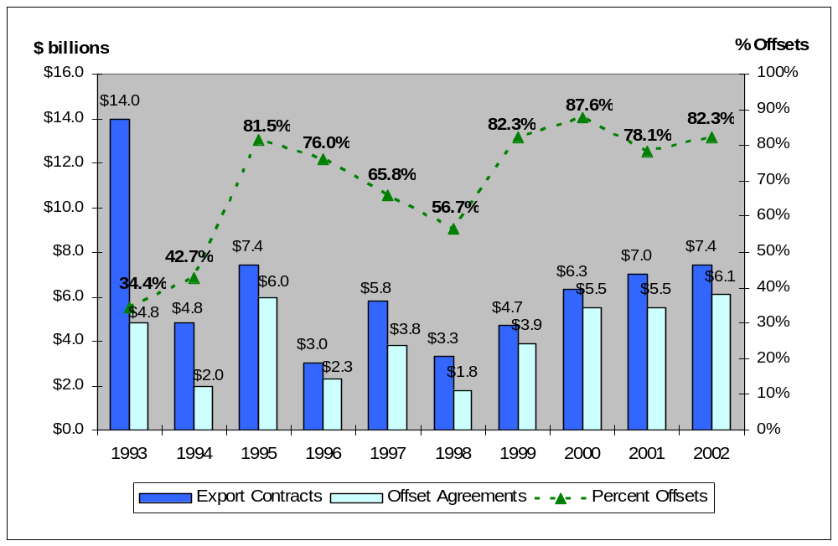
Source: BIS Offsets Database
Chart 4-1: Reported Export Contracts and Offset Agreements Annually, 1993-2002 (in $ billions)

Offsets also appear to be concentrated in a few purchaser countries. The top five countries (of a total of 36 involved in the reported offset activity) accounted for 58.6 percent of the total defense system purchases and 57.8 percent of the total offset agreements. The top 10 countries (of 36 total) represented 73.1 percent of defense system purchases and 74.7 percent of the offset agreements. The fact that relatively few countries accounted for the bulk of offset activity indicates that relatively few countries were in the market for big-ticket defense equipment. By dominating offset activity, these few countries also dominated the impact offsets have on the U.S. defense industrial base. In addition, these countries set a visible standard for offset demands for other countries to imitate.

The data reported by U.S. companies also show that specific defense systems were in high demand overseas. The top five weapon systems (of the 181 weapon systems sold) were aircraft systems. These top five exports accounted for 44.4 percent of the value of all export contracts and 37.3 percent of the offset agreements during the reporting period. The top 10 defense systems accounted for 59.3 percent of the export contracts and 56.9 percent of the offset agreements during the reporting period.

Regional Distributions

European countries dominated offset activity during the reporting period. Europe alone accounted for 65 percent of the value of offset agreements during the reporting period, while at the same time accounting for 46 percent of the value of U.S. defense export contracts. Asian countries ranked a distant second in both categories, accounting for over 22 percent of the value of offset agreements and 37 percent of related U.S. export contract values. However, Asia’s share of offset agreements is growing. In 2000, Asia accounted for only 2.8 percent of the value of offset agreements. The same year, European agreements comprised 78 percent of total offset agreements. By 2002, those numbers changed significantly: Europe was the source of
33.6 percent of the value of offset agreements (compared to 78 percent in 2000), while Asian offsets had climbed sharply to 64.8 percent (compared to 2.8 percent) of the total.

For the ten-year reporting period, Middle Eastern and African countries also had significant shares, accounting for nearly 10.5 percent of the value of offset agreements and 15.6 percent of the value of U.S. export contract business. Offsets with countries in North and South America (Canada, Brazil, and Chile) were less significant, accounting for approximately two percent of the value of offset agreements and 1.5 percent of the total value of related U.S. defense export contracts. Chart 4-2 illustrates regional totals of U.S. defense export contracts and offset agreements for 1993 to 2002.

Europe vs. All Other Countries

As noted above, Europe alone accounted for nearly two-thirds (65 percent) of total offset agreements (by value), but less than half (46 percent) of the value of U.S. defense export contracts. These figures show the impact of the high offset percentages typically demanded by European nations in connection with U.S. defense export sales. The average offset percentage demanded by the 17 European countries involved in offset activity during the ten-year reporting period was 92.6 percent of the export contract values – a percentage that was higher than any other region. U.S. firms reported entering into 230 offset agreements with European countries during the ten-year period for a total value of $27.3 billion. These offset agreements ranged from less than $2 million to $2.5 billion in offset demands, and averaged over $118 million per agreement. The average offset agreement had a term of 88 months, with a few agreements extending 180 months.

Chart 4-2: Regional Totals of Export Contracts and Offset Agreements, 1993-2002 (in $ billions)
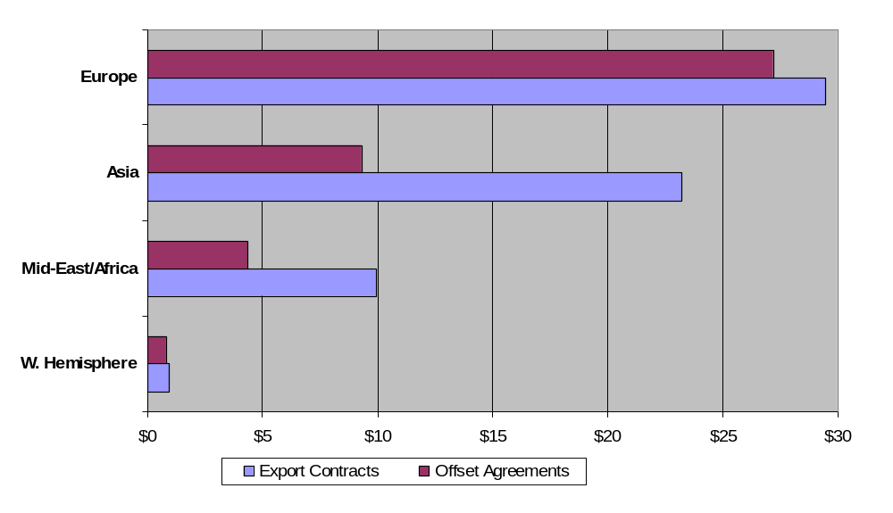
Many European governments require a minimum of 100 percent offsets on purchases of foreign defense systems. Of the 230 offset agreements with Europe, 148 (64 percent) had offset percentages of 100 percent. At the same time, 19 agreements (8 percent) demanded offset percentages of greater than 100 percent, including one for which the offset percentage was 200 percent. As shown in Table 4-1, the average offset percentages for Europe have exceeded 90 percent in each year since 1999, reaching a peak of 111.1 percent in 2000.

Source: BIS Offsets Database

Table 4-9: Offset Agreements: Europe vs. Rest of World
Yearly Totals | Area | # of Agreements | Export Contracts  (in $ millions) | Offset Agreements  (in $ millions) | Percent  Offsets | Duration  (in months)
1993 | Europe | 14 | $2,985,017,012 | $2,338,052,745 | 78.3% | 132
1993 | Non-Europe | 16 | $10,972,022,686 | $2,468,671,450 | 22.5% | 117
1993 | World | 30 | $13,957,039,698 | $4,806,724,195 | 34.4% | 124
1994 | Europe | 20 | $1,508,233,660 | $764,829,660 | 50.7% | 99
1994 | Non-Europe | 29 | $3,284,186,291 | $1,283,885,998 | 39.1% | 102
1994 | World | 49 | $4,792,419,951 | $2,048,715,658 | 42.7% | 101
1995 | Europe | 26 | $4,944,349,000 | $5,159,249,000 | 104.3% | 132
1995 | Non-Europe | 19 | $2,457,697,200 | $874,868,816 | 35.6% | 98
1995 | World | 45 | $7,402,046,200 | $6,034,117,816 | 81.5% | 127
1996 | Europe | 34 | $1,924,154,000 | $1,919,144,000 | 99.7% | 110
1996 | Non-Europe | 16 | $1,063,668,414 | $351,532,595 | 33.0% | 73
1996 | World | 50 | $2,987,822,414 | $2,270,676,595 | 76.0% | 104
1997 | Europe | 28 | $3,732,590,000 | $3,043,800,000 | 81.5% | 115
1997 | Non-Europe | 29 | $2,090,229,255 | $788,036,633 | 37.7% | 91
1997 | World | 57 | $5,822,819,255 | $3,831,836,633 | 65.8% | 110
1998 | Europe | 21 | $1,390,307,668 | $1,200,271,496 | 86.3% | 115
1998 | Non-Europe | 23 | $1,867,517,244 | $646,374,000 | 34.6% | 111
1998 | World | 44 | $3,257,824,912 | $1,846,645,496 | 56.7% | 113
1999 | Europe | 22 | $2,968,749,184 | $2,707,962,710 | 91.2% | 69
1999 | Non-Europe | 23 | $1,712,460,302 | $1,143,426,500 | 66.8% | 94
1999 | World | 45 | $4,681,209,486 | $3,851,389,210 | 82.3% | 75
2000 | Europe | 24 | $3,892,796,045 | $4,324,000,090 | 111.1% | 113
2000 | Non-Europe | 14 | $2,385,535,153 | $1,174,104,050 | 49.2% | 64
2000 | World | 38 | $6,278,331,198 | $5,498,104,140 | 87.6% | 79
2001 | Europe | 18 | $3,972,372,462 | $3,808,280,100 | 95.9% | 83
2001 | Non-Europe | 17 | $3,066,806,355 | $1,688,974,355 | 55.1% | 80
2001 | World | 35 | $7,039,178,817 | $5,497,254,455 | 78.1% | 82
2002 | Europe | 23 | $2,168,281,468 | $2,045,362,683 | 94.3% | 79
2002 | Non-Europe | 18 | $5,237,949,615 | $4,049,449,367 | 77.3% | 93
2002 | World | 41 | $7,406,231,083 | $6,094,812,050 | 82.3% | 85
Totals | Europe | 230 | $29,486,850,499 | $27,310,952,484 | 92.6% | 105
Totals | Non-Europe | 204 | $34,138,072,515 | $14,469,323,764 | 42.4% | 92
Totals | World | 434 | $63,624,923,014 | $41,780,276,248 | 65.7% | 100
Source: BIS Offsets Database

As shown in Table 4-1, the 16 countries representing all other regions (i.e., non-European countries) accounted for slightly over one-third (34.6 percent) of offset agreements (by value) but more than half (53.7 percent) the value of reported U.S. defense export contracts. The resulting average offset requirement for the reporting period was 42.4 percent. Although Europe still accounts for the preponderance of offset agreements by value, non-European countries’ offset requirement percentages are increasing significantly. For 1993-2000, the average offset requirement for non-European countries totaled only 33.9 percent. The past two reporting years alone boosted that percentage nearly 10 percent. Non-European countries accounted for 204 offset agreements that totaled $14.5 billion from 1993 to 2002, half of the European total. The average offset agreement for non-European countries was valued at $72 million and had a term of 78 months.

Two large defense export contracts in 1993 – one to Taiwan and another to Saudi Arabia – both featured extremely low offset requirements. These low requirements significantly lowered the average offset requirement in non-European nations. Excluding these sales, the average offset percentage for the ten-year period for non-European countries would have been 53 percent, or almost 10 points higher.

Overall, Middle Eastern countries and certain countries in the Pacific area generally demand lower offset levels than European countries. Of the 204 offset agreements with non-European countries, 136 (two-thirds) had offset percentages of 50 percent or less. Only 35 (one-sixth) of the offset agreements had percentages of 100 percent or more, and 11 of these had offset requirements in excess of 100 percent. Indeed, one offset agreement had an offset requirement of 333 percent, although this was associated with a relatively small defense export contract.

In general, the data show that countries with developed, technically advanced economies have demanded higher levels of offsets than other countries. As more economies and their military programs advance technically (e.g., Chile, South Africa, South Korea, and Turkey), higher levels of offset requirements are likely to continue. More advanced economies are able to absorb more offsets, both direct and indirect. Typically, their infrastructures are more advanced, and they are more likely than other countries already to have in place a diverse pool of industries among which to distribute offset transactions.

Are Offset Demands Increasing?

The data show not only that offset demands are increasing, but also that more countries outside Europe are demanding these higher offsets. Although historically low, offset requirements outside Europe are rising. Two-thirds of the non-European offset agreements valued at 100 percent or more of the export contract value have occurred since 1998. Of the 35 agreements with offset requirements of 100 percent or more, 13 were with Canada and another six were with Turkey.

Moreover, in the last three years, countries entering into offset agreements with U.S. firms for the first time have demanded 100 percent or more. Overall, evidence of these increases outside Western Europe began in 1999 when the offset percentage demanded by non-European countries reached an average of 66.8 percent. After a decline in negotiated offset requirements in 2000 and 2001, 2002 offset requirements by non-European countries rose to nearly 80 percent. This level reflects a substantial turnaround from 2001.

Agreements entered into by South Korea and Turkey illustrate the growing trend in non-European offset demands. From 1993 to 1998, the average offset requirement (by value) demanded of U.S. firms by South Korea was 36.5 percent. In contrast, from 1999 to 2002, that average nearly doubled to 71.0 percent. From 1993 to 1998, offset percentages (by value) demanded by Turkey of U.S. firms averaged 52.3 percent. However, Turkey’s offset requirements jumped in 1999-2002 to 95.7 percent.

European offset demands also continued to increase over the ten-year period, although more slowly than offset demands in the rest of the world. The trend in offset requirements for European countries increased at an annual rate of 1.6 percentage points. For the rest of the world, the average increase in offset percentages was 5.5 percentage points per year. Based on the three-year weighted averages in Chart 4-3, European offset requirements increased an average of 2.26 percentage points each year in the period, while non-European demands increased 2.81 percentage points. These values are in comparison to the rest-of-world unweighted average of 4.8 percent each year and the weighted average of 2.95 percent.

Offset requirement trends are more representative when viewed as a moving, weighted average. The weighted world trend in offset percentages still trended upward at an average annual rate of 4.79 percent, but the average was exaggerated by differences between Europe and all other countries (See Chart 4-3). Indeed, weighted averages of offset percentages for Europe show an average annual rise of 2.26 percent. The offset percentage for the final three-year period (2000-2002) topped 100 percent. However, in the same ten-year period that Europe has seen only a 22.64 percentage point increase, from 77.79 percent to 100.43, the rest of the world nearly doubled its offset requirements from 32.40 percent to 60.53 percent. Europe’s already high offset requirements may be rising, but at a slower rate, indicating that limits for higher and higher offset demands may exist.

Chart 4-3: Percentage Offsets for Europe vs. Rest of World (Weighted Moving Average, 1993-2002)
Source: BIS Offsets Database
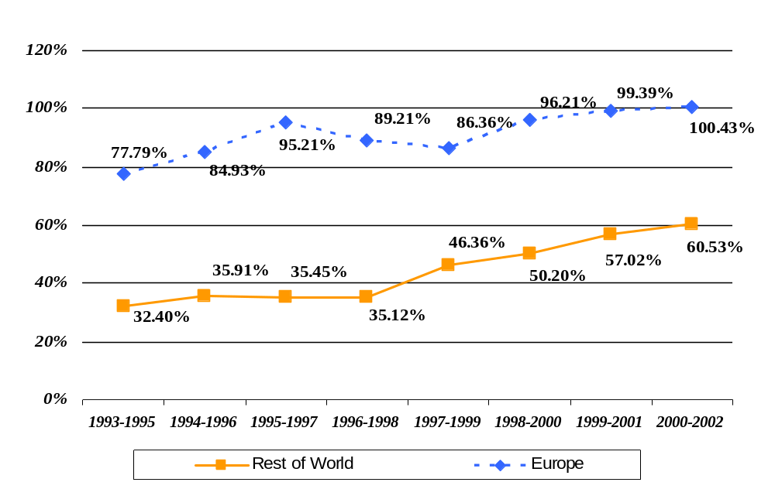
A reason for the upward trend in defense offset requirements is that the supply of defense systems greatly exceeds the demand for such items. In the last decade, shrinking worldwide defense expenditures and the overcrowding in the defense supplier sector have forced defense industries in many nations to consolidate. As sales opportunities narrowed, competition for such sales became more intense. Higher-than-normal overhead related to low levels of capacity utilization in defense industries coupled with competitive pressures on prices also have squeezed corporate profits. On the other hand, foreign purchasing governments are under pressure to sustain their indigenous defense companies or to create new ones and, accordingly, are demanding more offsets. Coupled with the recent world economic slowdown, significant public outlays for foreign-made weapon systems become even more controversial, which leads to higher offset demands to deflect political pressure.

In conclusion, the Asian share of total export contracts and the region’s level of offset demands have experienced dramatic growth in recent years. Individual countries in other non-European regions of the world are also demanding and receiving increased levels of offsets. At the same time, increases in Western European offset demands are moderating, with requirements in 2001 and 2002 remaining around 95 percent.

Offset Transaction Activity, 1993-2002

An offset agreement typically comprises multiple transactions entered into by the selling party to satisfy the requirements of the agreement. Analyzing transactions provides the basis upon which the impacts of offsets on the U.S. defense industrial base are estimated. For the purpose of analysis, offset transactions are grouped by type (i.e., direct, indirect, and unspecified), and then grouped again into the nine categories described in Chapter 2 (Purchases, Subcontracts, Technology Transfer, Credit Assistance, Training, Overseas Investment, Co-production, Licensed Production, and Miscellaneous).

Overview

During the time period 1993 to 2002, 42 U.S. defense companies reported 5,903 offset transactions with a total value of $23.5 billion. The reported offset transactions were completed with 39 different countries. The offset transactions were conducted in fulfillment of 230 U.S. weapon system exports, some dating from the 1980s. U.S. firms received a total of $28.8 billion in credit toward open offset obligations during the reporting period, yielding a composite multiplier of 1.224 (i.e., credit value divided by offset value). Almost 14 percent of offset transactions (812) earned extra credit (i.e., had a multiplier greater than 1). The yearly value of offset transactions averaged $2.35 billion.

Almost 40 percent of the value of reported offset transactions during 1993-2002 is related to offset agreements signed before 1993 (preceding BIS’s offsets data collection process). These older offset agreements (approximately 250) included requirements for practically all offset transactions for Finland, the second largest recipient country; 60 percent of offset transactions for South Korea; more than 80 percent of offset transactions for Italy; and smaller amounts for many other countries.

The values of offset transactions by type are reflected in Table 5-1.

Table 5-10: Offset Transactions Analysis
Offset Transaction Comparisons |  | Transactions Addressing Offset Agreements Entered into….
Data Element | All Transactions | Pre-1993 | 1993 and After
Total Value | $23,521,538,193 | $9,118,144,951 | $14,403,393,242
Direct Offsets | $9,197,835,488 | $3,375,693,397 | $5,822,142,091
Indirect Offsets | $13,684,248,145 | $5,522,641,373 | $8,161,606,772
Unspecified Offsets | $639,454,531 | $219,810,182 | $419,644,349
% Element | Percent Distributions
% Direct Offsets | 39.10% | 37.02% | 40.42%
% Indirect Offsets | 58.18% | 60.57% | 56.66%
% Unspecified Offsets | 2.72% | 2.41% | 2.91%
Source: BIS Offsets Database

The data in Table 5-2 show that seven countries were the recipients of approximately 63.2 percent of the actual value of all offset transactions. These seven countries had a composite multiplier of 1.099, and each country, with the exception of Spain, had more than $1 billion in offset transactions during the reporting period. The multipliers for the top seven countries ranged from 1.007 for the United Kingdom to 2.602 for Greece.

The United Kingdom and Finland were the two largest recipients of offset transactions, with totals of $4.4 billion and $3.2 billion, respectively, during the reporting period. Together, the two countries accounted for 32.3 percent of total offset transactions during the reporting period. Because of smaller than average multipliers, however, the United Kingdom and Finland represented only 27.3 percent of the total credit value of all transactions. Finland’s share of total transactions declined during 2001-2002, because it did not have any new transaction activity during the two-year period.

After the United Kingdom, Finland, and Israel, individual country offset transaction totals diminish significantly. For example, the Netherlands was a distant fourth in total value with only 6.4 percent of the offset transactions, followed by Switzerland with 5.1 percent. All other countries each accounted for shares of less than five percent of the total value of offset transactions. Of these countries, 18 had shares of less than one percent. The top seven countries receiving offset transactions with their multipliers are shown in Table 5-2.

Table 5-11: Offset Transactions by Leading Countries
(Total, 1993-2002)
Country | Actual  Value | Credit  Value | Multipliers
1. United Kingdom | $4,379,418,474 | $4,408,472,682 | 1.007
2. Finland | $3,216,337,843 | $3,446,007,399 | 1.071
3. Israel | $2,470,037,632 | $2,588,738,935 | 1.048
4. Netherlands | $1,503,777,165 | $1,822,252,935 | 1.212
5. Switzerland | $1,191,633,656 | $1,200,286,037 | 1.007
6. South Korea | $1,146,489,676 | $1,663,977,863 | 1.451
7. Greece | $1,036,652,820 | $2,698,232,819 | 2.602
Total | $14,944,347,266 | $17,827,971,670 | 1.193
Percent of All | 63.53% | 61.92%
All Countries (39) | $23,521,538,193 | $28,788,386,498 | 1.224
Source: BIS Offsets Database

Regional Distributions

As expected, the regional distribution of offset transactions mirrors the pattern of offset agreements (see Chart 5-1). As with offset agreements, European countries dominated the regional distribution of offset transactions. Europe accounted for 67.7 percent of the value of offset transactions during 1993-2002. However, with a smaller than average multiplier (1.156), European countries accounted for only 66.8 percent of the total credit value applied toward open offset agreements.

Asian countries ranked a distant second in both categories. Asia accounted for 13.6 percent of the total value of the offset transactions. However Asia, with a larger than average multiplier (1.48), accounted for 16.5 percent of the total credited value of such transactions.

Middle Eastern and African countries accounted for 14.7 percent of the total offset transactions and 13.4 percent of the credit value. The multiplier for Middle Eastern and African countries was 1.115, slightly lower than Europe’s.

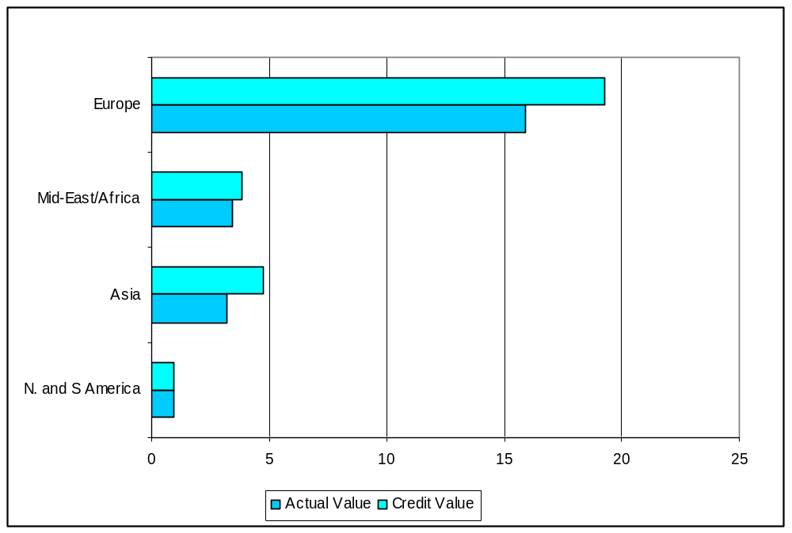
Chart 5-4: Regional Totals of Offset Transactions, 1993-2002 (in $ billions)
Source: BIS Offsets Database

North and South American countries were a distant fourth with only about 4.0 percent of the actual value of transactions and 3.3 percent of the credit. The multiplier for North and South America was the lowest of the four regions at only 1.002.

The multipliers for each region directly affect the impact offset agreements have on the U.S. defense industrial base. For the world at large, the offset percentage was 65.7 percent (i.e., the value of offset agreements was 65.7 percent of the total value of the related defense contracts). The multiplier for the world at large was 1.224. Therefore, when the 65.7 percent offset percentage is discounted by the multiplier, the resulting adjusted offset percentage is 53.8 percent. In this way, the multiplier reduces the requirement for fulfilling offset agreements.
Source: BIS Offsets Database
For the four main regions described above, the multiplier discount reduced Europe’s offset percentage from 92.6 percent to 76.6 percent. The offset percentage for Asia, with its high multiplier, dropped from 40.0 percent to 26.9 percent. The Middle East and Africa fell from 44.0 to 39.4 percent, while North and South America showed little change, dropping from 84.2 to 84.1 percent. Lesser-developed economies usually provide larger multipliers as an incentive to the prime contractor in an effort to obtain needed technology or production capacity. The calculations and results of this analysis are shown in Table 5-3 below.

Table 5-12: Regional Offset Transactions and Agreements
(Dollar values in $ millions)
 | Offset Transactions |  |  | Offset Agreements
Region | Actual  Value | Credit  Value | Multiplier | % Offset Agreements | Multiplier with Discount
Europe | $15,922 | $19,241 | 1.208 | 92.6% | 76.6%
Asia | $3,206 | 4,757 | 1.484 | 40.0% | 26.9%
Mid-East/Africa | $3,454 | $3,850 | 1.115 | 44.0% | 39.4%
N./S. America | $939 | $941 | 1.002 | 84.2% | 84.1%
Total | $23,522 | $28,788 | 1.224 | 65.7% | 53.8%
Source: BIS Offsets Database

Offset Transactions by Type

For 1993-2002, direct offsets accounted for 39.1 percent ($9.2 billion) of the total value of offset transactions. Indirect offsets accounted for 58.2 percent ($13.7 billion) of the value of offset transactions. The remaining 2.7 percent ($639.5 million) consisted of transactions that were not specified as direct or indirect. The level of direct offset transactions varied greatly from year to year, based mostly on which countries dominated the offset activity. The same variation held for indirect offsets.

Finland was the largest recipient of indirect offsets through most of the timeframe, receiving nearly 20.1 percent of the total value of indirect offset transactions. Only 15 percent of Finland’s offset transactions were classified as direct offsets. Removing the data on Finland causes the percentage of direct offset transactions to increase dramatically.

The United Kingdom led all countries in direct offset transactions received during 1993-2002, capturing almost 20 percent of the direct offset total, and these were almost exclusively related to aerospace contracts. A comparison between the United Kingdom and Finland leads to a conclusion that Finland lacks the indigenous aerospace infrastructure to take full advantage of direct offsets, while the United Kingdom is well positioned to do so.

Calculated on an annual basis, the value of direct offsets ranged from $583 million (in 1993) to $1.46 billion (in 1998). Direct offset transactions averaged $920 million yearly for the ten-year reporting period. The value of indirect offset transactions ranged from $895 million (1998) to $1.67 billion (2002), averaging $1.37 billion per year during the reporting period. Direct offset transactions were at their lowest levels in 1993 and 1994 relative to indirect offset transactions, accounting for about 32 percent of total offset transactions in those years. The share of direct offsets to total offsets increased in 1995 largely because of the United Kingdom’s substantial increase in direct offsets in that year, which increased to almost $650 million by 1997, before tapering off. A large value of direct offset transactions ($280 million) also was reported for Israel in 1995, contributing to the increase in the overall percentage of direct offsets to
39.2 percent that year.

Chart 5-5: Direct, Indirect, and Unspecified Offset Transactions, 1993-2002 (in $ millions)
32.1%
31.8%
39.2%
40.2%
37.8%
61.9%
33.2%
34.6%
38.9%
33.8%
$0.0
$500.0
$1,000.0
$1,500.0
$2,000.0
$2,500.0
$3,000.0
1993
1994
1995
1996
1997
1998
1999
2000
2001
2002
0%
10%
20%
30%
40%
50%
60%
70%
Direct
Indirect
Unspecified
% Direct
Percent Direct
(right scale)
$ Million
Source: BIS Offsets Database

In 1998, the percentage distribution of direct offsets peaked at an unusually high 61.9 percent. Exceptionally high direct offset transactions were reported with Italy, Israel, and the Netherlands in 1998, while transactions with the United Kingdom subsided from the prior year with direct offsets of $350 million. During 1999-2002, the ratio of direct offsets to total offsets remained in a narrow range, from a low of 33.2 percent to a high of 38.9 percent. These year-to-year variations in the distribution of direct and indirect offset transactions are presented in Chart 5-2.

Offset Transactions by Category

Three categories of offset transactions dominated offset activity during 1993-2002: purchases, subcontracts, and technology transfers. These three categories accounted for 79.5 percent of the value of all offset transactions during the timeframe. Purchases (38.0 percent) and subcontracts (28.5 percent) together accounted for almost two-thirds of the value of total offset transactions. Technology transfers made up an additional 13.0 percent. Most of the remaining 25 percent of the value of offset transactions was categorized as miscellaneous (7.7 percent) and credit transfer (4.9 percent). The remaining 7.9 percent of the value of offset transactions was distributed among the other four categories: training, overseas investment, co-production, and licensed production. Chart 5-3 shows the distribution of offset transactions by category.

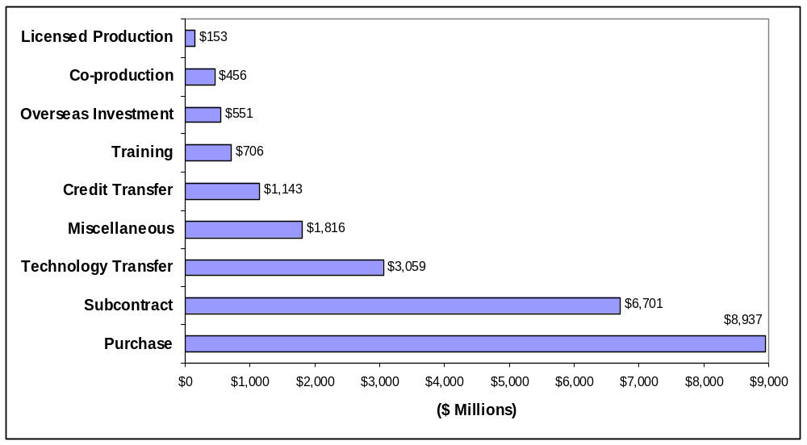
Chart 5-6: Offset Transactions by Category, 1993-2002 (in $ millions)
All 39 countries involved in offset transaction activity were recipients of offset transactions categorized as purchases, which were classified as either indirect or unspecified offsets. These purchases were comprised mostly of manufactured goods and services, including metal castings and forgings, aircraft parts, night vision components, machined parts, electronic components, software, and educational and consulting services. The countries with the most purchases were the United Kingdom (accounting for 25 percent of the value of all purchases), Finland (9.7 percent), and Switzerland (8.2 percent). Almost 49 percent of all offset transactions categorized as purchases were aerospace-related.
Source: BIS Offsets Database

Twenty-seven countries were recipients of offset transactions classified as subcontracts. Subcontracts are considered direct offset transactions, and the overwhelming majority of subcontracts involved aerospace-related manufactured parts, components, and services. Aerospace-related transactions accounted for 87.4 percent of the total value of all offset transactions categorized as subcontracts. The United Kingdom alone accounted for 26.3 percent of all subcontracts, while Israel accounted for 21.3 percent. Italy accounted for 7.7 percent of all subcontracts, and the Netherlands accounted for 7.3 percent. Combined, these four countries accounted for 62.6 percent of the value of all offset transactions categorized as subcontracts. Despite its large share of total offset transactions, Finland accounted for only 1.8 percent (or $118.1 million) of the value of subcontract transactions.

Chart 5-7: Percentage of Total Annual Offset Transactions Accounted for by Top Three Transaction Categories, 1993-2002
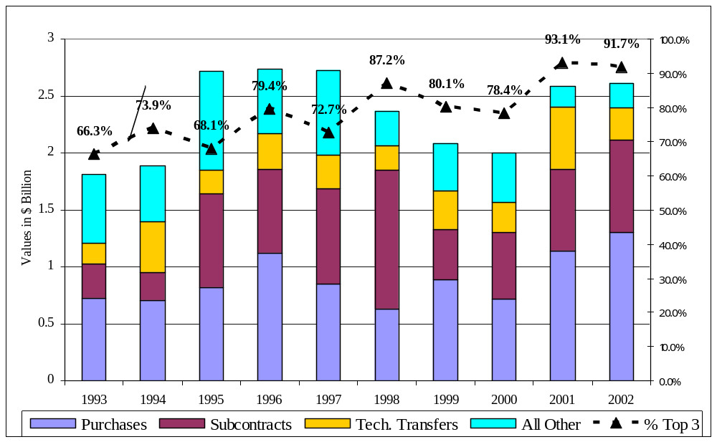
Source: BIS Offsets Database
Data showing the percentage of total offset transactions accounted for by purchases, subcontracts, and technology transfers are shown in Chart 5-4. The dominance of these three categories ranged from 66.3 percent of all offset transactions (by value) in 1993 to 93.1 percent in 2001.

Some 24 countries accounted for all technology transfers. Finland accounted for nearly
13 percent of the number and almost 21 percent of the value of technology transfers, while South Korea (15 percent and 12 percent) and Spain (16 percent and 11 percent) rounded out the top three. Others with significant shares included Taiwan (16 percent and 10 percent), Australia
(7.3 percent and 7.0 percent), and Norway (4.4 percent and 4.4 percent).

Offset Transactions by Category and Type

Analyzing the distribution of offset transactions by category and by type provides further insight into the effects of offsets on the U.S. defense industrial base. For example, subcontracts, co-production, and licensed production accounted for 79.1 percent of the value of all direct offset transactions, and each of these categories resulted in foreign production of goods or services. As a result of such offsets, U.S. suppliers can be dislodged from participation in the manufacture and/or assembly of a U.S. defense system as well as its future maintenance requirements. Offset transactions in these three categories totaled $7.3 billion during the 10-year reporting period, with subcontracts by far the largest portion ($6.7 billion).

Indirect offsets that involved foreign production of goods and services included purchases and a small amount of licensed production. Together, the value of these two categories totaled more than $8.5 billion during the period and accounted for 62.2 percent of the value of all offsets classified as indirect. In total, during the reporting period, $15.8 billion in overseas production – or an average $1.58 billion per year – was the result of either direct or indirect offset transactions.

Technology transfers, training, credit assistance, and overseas investment offsets also can enhance the capabilities of foreign producers and make them more competitive in the global market. These categories of offset transactions can be either direct or indirect. Aside from the monetary value, the effects of such transactions can be long-term and overflow into other defense systems in the United States and other countries to the extent that they make foreign manufacturers more competitive. The value of direct offset transactions in these four categories was $1.62 billion during 1993-2002, 67.6 percent of which was accounted for by technology transfer. The four categories accounted for approximately 17.6 percent of the value of all direct
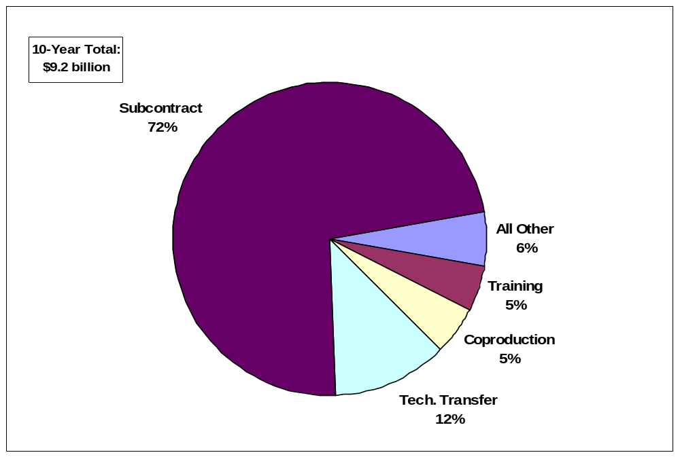

Chart 5-8: Direct Offset Transactions by Category, 1993-2002
Source: BIS Offsets Database
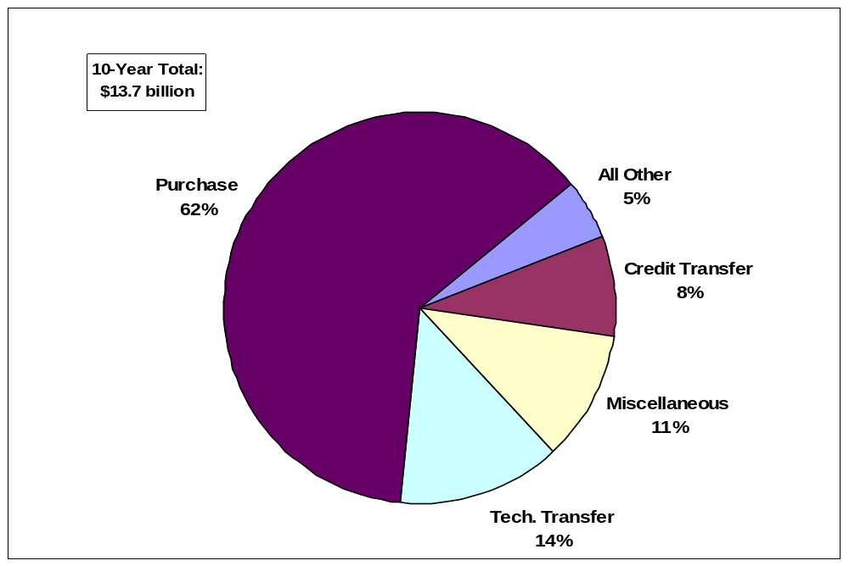
Chart 5-9: Indirect Offset Transactions by Category, 1993-2002
Source: BIS Offsets Database
Source: BIS Offsets Database
offset transactions. The value of indirect offset transactions in these four categories during the ten-year period was $3.67 billion, most of which was accounted for by technology transfer
(51.0 percent) and credit assistance (31.0 percent). In total, during 1993-2002, $5.29 billion in offset transactions was accounted for by direct and indirect transactions in these four categories. The annual average was $529 million. Charts 5-5 and 5-6 show the distribution of offset transactions by category.

Offset Transactions by Industrial Sector

Identifying offset transactions by industry sector allows for an even more detailed analysis of the effect of offsets on the U.S. defense industrial base. Offset transactions generally are clustered around a small number of major industries associated with defense production, as shown by the data in Table 5-4. The detailed data by SIC appear in Appendix D.

Table 5-13: Offset Transactions by Major Industrial Sectors, 1993-2002
SIC | Sector Description | Number of Transactions | Value in  $ millions |  | Percent of Total
37 | Transportation Equipment | 2,672 |  | $12,129.9 |  | 51.57%
36 | Electronic/Electrical Equipment | 983 |  | $3,574.6 |  | 15.20%
35 | Industrial Machinery | 604 |  | $1,455.8 |  | 6.19%
73 | Business Services | 318 |  | $1,191.7 |  | 5.07%
87 | Technical Services & Consultants | 306 |  | $1,081.0 |  | 4.60%
38 | Measuring & Analyzing Instrumentation | 267 |  | $1,060.5 |  | 4.51%
 | Sub-Total | 5,150 |  | $20,493.5 |  | 85.30%
 | Total | 5,903 |  | $23,521.5
Source: BIS Offsets Database

Offset transactions related to transportation equipment alone accounted for 51.6 percent of the value of all offset transactions and were composed mostly of aerospace products, including aircraft parts, engines, hydraulic subsystems, and guided missiles. During the reporting period, over $12 billion in offset transactions related to transportation equipment accounted for
63.62 percent (or $5.85 billion) of the total value of direct offsets and more than 42.4 percent (or $5.80 billion) of the total value of indirect offsets. In addition, more than 75 percent of the value of transactions not specified by type was in the transportation equipment sector.

The electronic and electrical equipment sector was a distant second to the transportation equipment sector, accounting for only 15.2 percent of the total value of all offset transactions. This sector includes products such as radar, communications equipment, and electronic components, as well as completed avionics equipment and material inputs for avionics such as circuit boards.

Transactions in the industrial machinery sector accounted for more than six percent of the value of all offset transactions during the reporting period. Industrial machinery includes capital equipment used in the production of both defense and non-defense items. This includes metal-working machine tools, conveyors, air and gas compressors, textile machinery, mining equipment, off-road vehicles, and welding equipment. There were significant offset transactions (by value) in two additional sectors – Business Services (SIC 73) and Technical Services and Consultants (SIC 87). Business services (5.1 percent of total offset transactions) were mostly related to computer software, databases, and other information technology. Technical services (4.6 percent of total offset transactions) included mostly engineering services and consulting, training, and related technical data packages.

Offset transactions were categorized into a total of 40 industrial sectors, including one labeled undetermined (SIC 99). The 34 sectors not specifically listed in Table 5-4 accounted for less than 15 percent of the total value of all offset transactions. Only four of these sectors accounted for more than one percent of the total value of offset transactions, while a majority of the rest had insignificant transaction values. The four were Non-Depository Credit Institutions (SIC 61) with 2.6 percent, Fabricated Metal Products (SIC 34) with 2.5 percent, Holding and Investment Offices (SIC 67) with 1.8 percent, and Educational Services (SIC 82) with 1.8 percent. These four sectors accounted for an additional 8.7 percent of the total value of offset transactions. Transactions in just 10 industrial sectors accounted for 95.8 percent of the value of all offset transactions.

Among the remaining 30 sectors, only Primary Metal Industries (SIC 33) and Chemicals and Allied Products (SIC 28) had significant offset activity. The total value for Primary Metal Industries was $179.8 million and for Chemicals and Allied Products was $188.1 million. Offset transactions in both sectors were composed almost exclusively of indirect offsets. No other sector had more than $70.1 million in total offset transactions during 1993-2002. The total value for the remaining 30 sectors was $994 million, and Primary Metal Industries (SIC 33) and Chemicals and Allied Products (SIC 28) represented over one-third of this total.

Manufacturing sectors ($17.2 billion) were by far the dominant offset choice, representing 73.0 percent of all offset transactions. Services ($3.3 billion) accounted for most of the remainder at 18.4 percent. One percent was composed of a combination of agricultural products ($42 million), mining ($15 million), and construction activities ($48 million); the sector(s) for another $99.9 million in activity were undetermined.

In terms of dollar value, the top 12 industrial sectors accounted for more than 97 percent of the total value of all offset transactions during the reporting period. Based on offset type distribution, these 12 sectors accounted for 98.1 percent of all direct offsets, 96.8 percent of indirect offsets, and virtually all of the unspecified offsets. The transportation equipment sector, with over half the total, was the leading sector for each type. Direct offsets were 48.3 percent of the sector’s total. Indirect offsets accounted for another 47.8 percent.

Two additional sectors that comprised significant quantities of direct offsets were the Electrical Equipment sector and the Measuring and Analyzing Instrumentation sector. Along with the Transportation Equipment sector, these sectors accounted for 85.2 percent of all direct offsets. The same three sectors accounted for 61.3 percent of indirect offsets, which shows a noticeable correlation. Expanding this analysis to eight sectors captures 97.1 percent of all direct offsets, 85.9 percent of all indirect offsets, and 94.2 percent of unspecified offsets. Chart 5-7 shows the relative shares of offsets by type for the 12 leading industrial sectors.

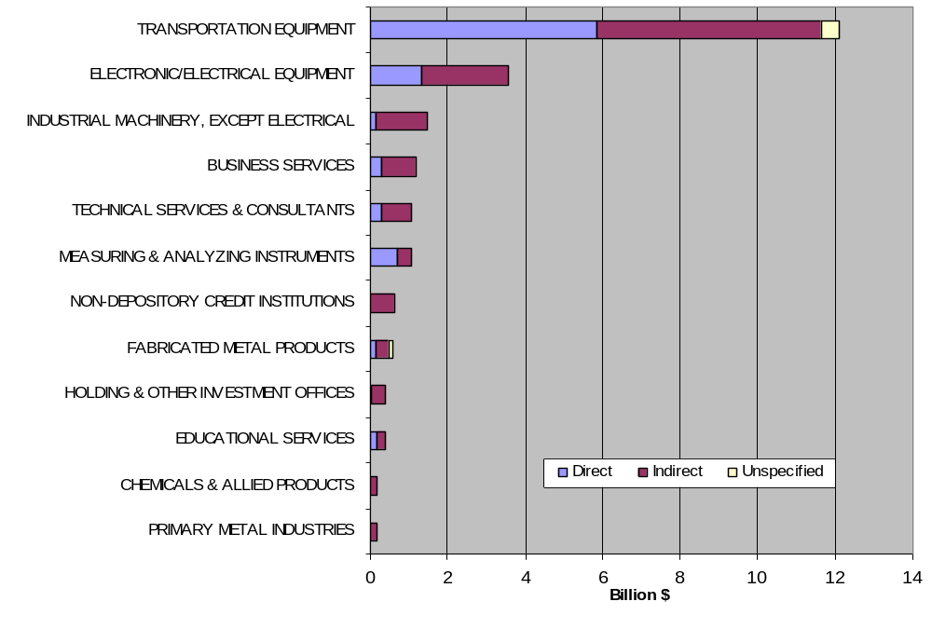
Chart 5-10: Offset Transactions by Industry and Type for Top 12 Sectors, 1993-2002 (in $ billions)

Aerospace Offset Issues

Given its large percentage of the total value of U.S. military exports, the U.S. aerospace industry is affected by offsets more than any other major economic sector. Indeed, from 1993 through 2002, aerospace-related military exports exceeded $53.5 billion. By comparison, non-aerospace military exports for the period only reached nearly $10 billion. Because aerospace-related exports make up the majority (85 percent) of export sales associated with offset agreements, the impact of offsets on the aerospace industry is a good indicator of the effect of offsets on the competitiveness and trade of the U.S. defense industrial base as a whole.

During 1998-2000, however, the rate of growth of aerospace exports declined. The growth rate for offset-related exports during the ten-year period shows a trend toward more non-aerospace exports, including maritime, ground transport, and high-tech navigation and radar systems. Indeed, 60 percent of all offsets-related aerospace exports occurred during 1993-1997 and only 40 percent occurred in the last five reporting years. Conversely, more than 70 percent of non-aerospace offsets-related exports were generated in 1998-2002.

Trends in the Import and Export Markets

The following analysis looks at trends in the import and export markets of all aerospace trade, both civil and military (unless otherwise noted). The U.S. maintained a trade surplus in aerospace products during 1993-2002, ranging from a low of $21.6 billion (1995) to a high of $41.0 billion in 1998 (see Chart 6-1). A large growth in imports during 1998-2001, coupled with flat or declining exports, drove down the surplus to $26.0 billion in 2001. The U.S. trade surplus rebounded slightly in 2002 as imports declined sharply, overshadowing a slight decline in exports.

Military-related aerospace exports have remained flat since 2000 at a level marginally higher than $9 billion and lower than in 1998 ($12 billion) and 1999 ($11.8 billion).

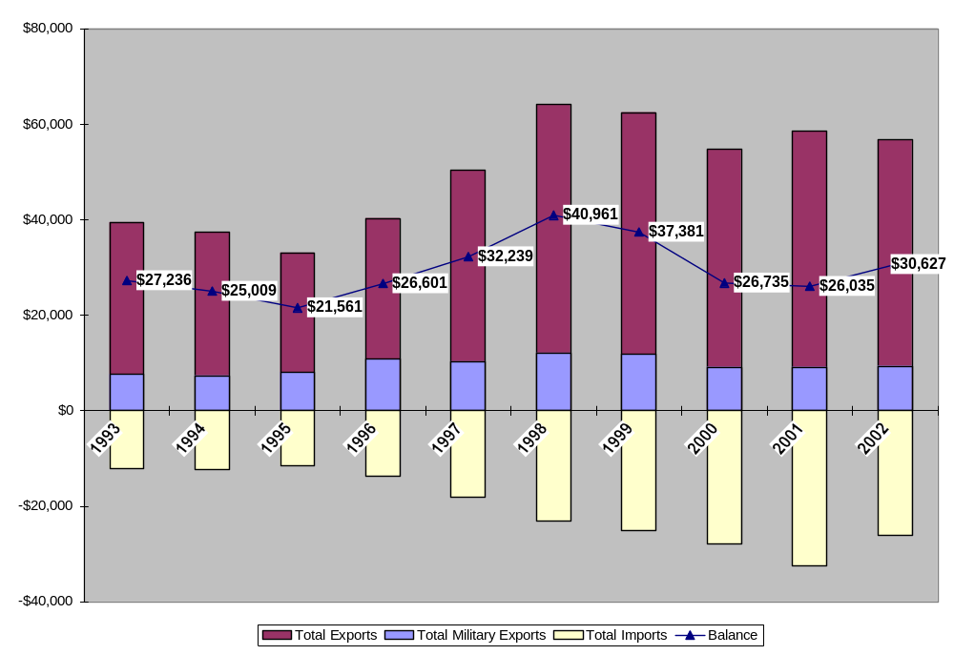

Chart 6-11:
International Trade in Aircraft, Aircraft Engines, and Parts, 1993-2000 (in $ millions)
Source: Aerospace Industries Association, Aerospace Facts and Figures, various issues
Table 6-14: U.S. Imports of Aerospace Products by Major Countries of Origin (in $ millions)
 | 1993 | 1994 | 1995 | 1996 | 1997 | 1998 | 1999 | 2000 | 2001 | 2002
Brazil | 119 | 73 | 110 | 154 | 371 | 917 | 1,285 | 1,494 | 1,973 | 1,868
Canada | 2,072 | 2,443 | 2,461 | 3,233 | 3,800 | 4,867 | 5,087 | 6,253 | 7,985 | 7,003
France | 4,249 | 4,087 | 3,072 | 3,043 | 4,087 | 5,814 | 6,313 | 8,071 | 8,721 | 7,591
Germany | 478 | 699 | 826 | 1,039 | 1,187 | 2,044 | 2,707 | 3,364 | 3,775 | 2,488
Japan | 538 | 583 | 671 | 1,081 | 1,728 | 2,148 | 1,710 | 1,614 | 1,986 | 1,507
United Kingdom | 2,523 | 2,546 | 2,236 | 2,634 | 4,034 | 5,173 | 4,968 | 4,197 | 4,818 | 3,600
Source: Aerospace Industries Association, Aerospace Facts and Figures, various issues
Includes civil and military products, c.i.f. (Cost, Insurance, and Freight) basis.

Primary countries of origin for U.S. aerospace imports over the past decade have included Canada, France, Germany, and the United Kingdom. The import rate of growth varied significantly among the top six sources for U.S. aerospace imports. During the 1993-2001 period (in 2002, imports from each of the six countries declined), annual imports from Germany increased nearly eight-fold, those from Canada almost quadrupled, and import levels from British and French sources doubled. Other countries also posted significant gains during the period, including a nearly four-fold increase in imports from Japan and a 16-fold increase in imports from Brazil. Table 6-1 shows the value of imports of civil and military aerospace products from a list of the major source countries.

The rapid increases in aerospace product imports from key sources, specifically Brazil, Germany, and Japan, indicate several trends for the U.S. aerospace industry. First, U.S. aerospace markets, primarily the commercial sector, are increasingly using foreign-made, imported systems and components. Second, the sources of these improving and more competitive products are becoming more varied internationally. Brazilian, German, and Japanese manufacturers, specifically, are relative newcomers to the sizeable U.S. aerospace market in the last ten years.

The defense trade also feels the effects of these two trends – increasing competitiveness and growing foreign firms. With more high-quality aerospace firms producing goods, there is more competition and a likelihood of fewer sales for existing firms. The resulting more crowded global aerospace market increases the reliance on offsets as a negotiation factor.

Industry-to-Industry Trade

Industry-to-industry sales provide a picture of both the integrated nature of the industry and increasing strength of European aerospace firms. E.U. aerospace industry data indicate that exports of all aerospace goods from the E.U. aerospace industries to the U.S. aerospace industries rose 87 percent from 1996 to 2000. In the same time period, exports from the U.S. aerospace industry to the E.U. industrial market grew more slowly, rising only 54 percent. In 1996, E.U. aerospace companies imported 50 percent more from the U.S. industry than vice versa, but by 2000, this ratio declined to only 20 percent. To illustrate the importance of intra-industry transactions, intra-industry E.U.-U.S. trade alone accounted for over 30 percent of total U.S. aerospace imports. However, these high levels of cross-Atlantic trade links between industries declined precipitously in 2002 with the overall industry decline. E.U. industry exports to U.S. industry declined 34 percent from 2001 to 2002.

This fluid trade balance between companies is in line with a significant increase in the value of offset agreements over the same 1996-2000 period. The value of offset agreements with E.U. entities more than doubled between 1996 and 2000 (from $1.9 billion to $4.3 billion). Over the same period, the average offset requirement rose from 99.7 percent to 111.0 percent.

Trends in Aerospace

The aerospace infrastructure is becoming more global, more integrated, and at the same time, more competitive. Globalization is exhibited by the wide reach of key firms. For example, European manufacturer Airbus maintains 1,500 suppliers from 30 countries; 250 of these suppliers are located in the United States. By mid-2002, the Airbus A380 team had signed contracts to source landing gear from U.S.-based Goodrich, navigation electronics from Honeywell, and in some versions, jointly developed GE-Pratt & Whitney engines. American competitor Boeing has more than 11,300 suppliers in 66 countries and maintains offices in 18 countries. In June 2003, the company announced that five key supply contracts would go to foreign firms, including three from Japan. Honeywell alone has operations in 100 countries and derives 45 percent of its sales from outside the United States.

As globalization increases, U.S. aerospace manufacturers broaden their global supplier chains seeking both subcontractors and strategic partnerships. At the same time, European counterparts are taking advantage of longer historical relationships in non-U.S. defense markets, thus increasing the competitive environment worldwide. Although the United States continues to maintain its position in first-tier integrator companies, with around half of the global aerospace market, European companies are growing and now command more than one-third of all global aerospace sales.

The recent merger-and-acquisition-led formation of large European defense companies is comparable to American aerospace corporate consolidation earlier in the 1990s. Today, the United States boasts five large defense companies. In 1990, there were 33 separate businesses. European consolidation occurred later in the 1990s and early 2000s, creating three large, closely linked “mega-firms.” This consolidation – both in U.S. and European industry – has created a small number of conglomerate first-tier firms. Indeed, this trend of industry consolidation is likely to continue.

The market power of these “mega-firms” can require lower tier suppliers to compete at cost and quality levels on a par with foreign suppliers. Moreover, a global competitive situation arises where EU firms generate sales and technology levels on a par with the large U.S. companies. Of the top seven aerospace companies by defense sales in 1999, three were these European mega-firms, and one – BAe Systems – had higher defense sales than any U.S. manufacturer. This increase in viable competition to a once formidable U.S. industry creates much greater competition in third-country markets. Increased offsets are a likely consequence of increased global competition.

Integration: F-35 Joint Strike Fighter

Falling defense spending in both Europe and the United States after the Cold War led to the purchase of fewer weapon systems. Defense companies in both Europe and the United States increasingly targeted each other’s markets for defense sales. To achieve these sales against a backdrop of political resistance to imports of defense products in both the United States and Europe, aerospace companies on both sides began forming transatlantic alliances. Cross-border integration within the industry continues to grow, with firms which regularly compete for sales in some sectors forming partnerships in others. U.S defense suppliers prefer these partnerships or alliances to mergers, because they “allow companies to choose new partners in each market in which they compete, increase capabilities without forming permanent relationships, and enable access to unique technology needed to meet military requirements.” These forms of cross-border collaboration include joint ventures, strategic alliances, co-development programs, and strategic teaming agreements and are almost entirely U.S.-E.U., U.S.-U.S., or E.U.-E.U. aerospace company agreements.

As an example of a co-development program, the F-35 Joint Strike Fighter (JSF) program combines a number of U.S. and European firms, at both prime (Lockheed Martin, Northrop Grumman, and BAe Systems) and subsystem levels (GE, Pratt & Whitney, and Rolls Royce), as well as the governments of the United States, the United Kingdom, Italy, the Netherlands, Canada, Turkey, Denmark, Norway, and Australia. Each partnering country has firms contributing to the project at the development level, and each provides public sector annual funding to the program. For example, the Italian government is contributing around $1 billion, while a number of Italian aerospace companies, including Alenia Aeronautica, recently sent engineers and technicians to the main development site in Texas. The British government is contributing $2 billion to the program, and BAe Systems is one of the key industry partners while Rolls Royce and Pratt & Whitney have teamed up to develop the engine propulsion system. Danish and Italian firms recently partnered with a U.S. firm to develop the JSF’s gun-related components.

Given the continued need for transatlantic sales and the growing requirement for armed forces interoperability among the United States and its allies, industry experts and defense policymakers on both continents expect this innovative multi-national system of development, testing, and production to continue in future large-scale system procurements. Indeed, these individuals largely see it as a necessity. Such partnerships may also lead to reduced offset demands, as more countries become involved at early stages of development.

Economic Downturn

Despite increasing partnership, this globalizing, collaborative, and complex industry is experiencing a significant downturn, especially in commercial sales. In the mid-1990s, sizeable increases in U.S. aerospace sales of civil aircraft were spurred by a growing air travel market (fueled by expanding economies) worldwide. However, since 2001, the sales of civilian aircraft have tumbled (See Chart 6-2) reflecting a declining air travel market. Civilian aircraft sales declined 16 percent between 2001 and 2002 and were projected to decline a further 27 percent between 2002 and 2003.

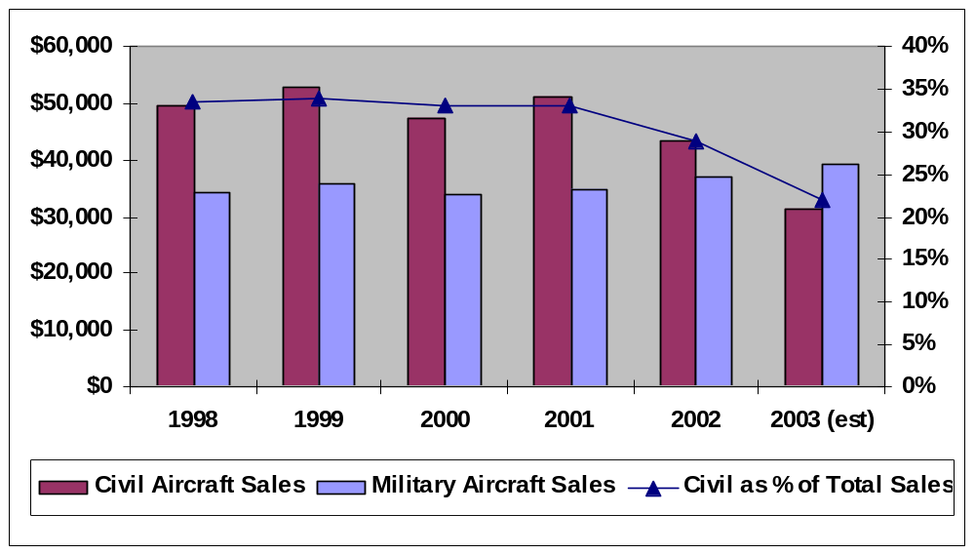
As declines continue in the civilian aircraft sector – the mainstay of the industry’s sales and investment growth during the late 1990s – companies become more reliant on military sales. Because aerospace subcontractors typically supply both military and commercial sectors, the shift toward highly-competitive military sales increases the competitive pressure on the supplier base. To the degree that American subcontractors are undercut by offset agreements elsewhere, this affects their capacity to service the commercial markets as well. The reliance on offsets as a condition of sales creates new global competitors in both sectors.
Source: Aerospace Industries Association, Aerospace Facts and Figures, various issues
Chart 6-12: U.S. Civil and Military Aircraft Sales ($ millions) and Civil Aircraft Sales as percent of total Aerospace Sales

Defense Trade Offsets in Aerospace

The reliance on offsets as a condition of awarding aerospace defense contracts has increased in recent years. Overall, the average weighted offset requirements for aerospace export agreements totaled 63.96 percent for 1993-2002; non-aerospace export offset requirements averaged 74.88 percent for the period. However, since 1998, aerospace offset requirements have increased significantly to 80.50 percent of the export value, while non-aerospace offset requirements have remained relatively stable, increasing only to 76.48 percent.

Table 6-15: Aerospace and Non-Aerospace Defense Exports and Offsets, 1993-2002
 | Export Value (in millions) |  | Offset Requirement Percentage
 | 1993-2002 | 1998-2002 | 1993-2002 | 1998-2002
Aerospace | $53,685.97 | $21,549.98 | 63.96% | 80.50%
Non-Aerospace | $9,938.96 | $7,442.29 | 74.88% | 76.48%
Source: BIS Offsets Database

The U.S. aerospace industry represents the major target of offset activity. New aerospace export contracts totaled 84 percent of all exports related to offsets ($53.6 billion) and accounted for
82 percent of the offset agreements ($34.3 billion). Transactions involving aerospace products and services totaled $20.9 billion or 88.9 percent of the value of all transactions for 1993-2002. The percentage of transactions involving aerospace products has declined slightly in the last five years, but still maintains a sizeable portion. From 1993 to 1997, aerospace-related offset transactions accounted for 90.7 percent of all transactions. From 1998 to 2002, the portion had declined to 86.9 percent.

The majority (by value) of aerospace-related offset transactions were not directly related to the sale of an aerospace system. While approximately 38 percent ($8.05 billion) of aerospace transactions was classified as Direct offset transactions; 59 percent ($12.24 billion) was Indirect; and three percent ($599 million) was Unspecified. Thirty-two percent ($6.67 billion) of the offset transactions was categorized as subcontracts; 35 percent ($7.27 billion) as purchases; and 12 percent ($2.49 billion) as technology transfers. These three categories accounted for
79 percent of the total value of aerospace-related offset transactions.

Changing Nature of Offsets

The globalization of the industry affects the trade picture that is closely linked to offset transactions and agreements. American aerospace companies conducted five times more trade between their offshore wholly-owned facilities and their European partners in 2000 than they did in 1996.

Moreover the industry recently has begun changing its approach to developing military systems, which may have an impact on the growth of offsets in the future. The multi-national and multi-corporate JSF program has created a situation where governments contribute in the form of development funding and implied future orders in order to receive domestic industrial benefits, such as production of one or more pieces of the F-35 system by a domestic firm. In turn, the U.S. project participants gain technological know-how through this cooperative effort, and the U.S. government is relieved of some of the funding burden. Offsets are not required in this type of arrangement. Such cross-border joint contract, development, and production projects are expected to become much more prevalent in the future as governments look at cost factors and interoperability requirements grow.

Other Government Offset Activities

In the past, the Department of Commerce, through the Bureau of Industry and Security, has participated in a Department of Defense-led Interagency Offsets Steering Committee (the Committee), which includes representatives from the Departments of Defense, State, Treasury, and Labor, and the Office of the U.S. Trade Representative. Since the publication of the seventh report on Offsets in Defense Trade in July 2003, the Committee has been inactive.

Conclusions

The data show that offset demands are on the rise globally. Although offsets with European countries accounted for more than two-thirds the value of total agreements during 1993-2002, offset agreements with non-European countries, especially in Asia, have risen sharply in the past two reporting years, capturing a majority of all new contracts. In a weighted, moving average comparison, European offset demands have increased only 30 percent points from 1993 to 2002, while the rest of the world has nearly doubled its average offset requirements in the same period.

Asian countries are capturing an increasing share of offset agreements and export contracts as well as demanding higher offsets. In fact, Asian countries accounted for about 65 percent of the value of new offset agreements in 2002, up from only 2.8 percent in 2000. In contrast, European agreements represented 78 percent of the total value of offset agreements in 2000, but only
34 percent in 2002. Further, new offset requirements from Asian countries climbed to
52.3 percent in 2001 and jumped to 78.4 percent in 2002.

The aerospace sector continued to attract the majority of offset agreements, accounting for almost 85 percent of the value of defense exports associated with offsets during 1993-2002. Despite the large majority of offset exports involving aerospace-related products over the ten-year period, the rate of growth of these exports declined during the 1998-2002 period, indicating a trend toward more non-aerospace offset-related exports, including maritime, ground transport, and high-tech navigation and radar systems.

BIS estimates that U.S. defense exports with offset agreements required supported 42,440 work-years in 2001. However, the kinds of offset transactions (co-production, subcontracting, purchasing, and licensing) most likely to result in the transfer of work from the U.S. to foreign firms reduce the number of hours supported by 11,460 work-years. Based on these calculations, it appears that defense export sales had a net positive effect on employment in the defense sector, although the net positive effect was diminished by the offset agreements. This calculation assumes that industry would not have received these defense export contracts if it had not entered into the related offset agreements. It should also be noted that the above analysis does not include other kinds of offset transactions, valued at about $687 million, including technology transfer, training, overseas investment, and marketing transactions, or the long-term implications of creating or enhancing competitors; the impact of these transactions on the U.S. defense industrial base is difficult to calculate.

The Department of Commerce neither encourages nor regulates the use of offsets in defense trade and recognizes that offsets can be market distorting. However, it should be recognized that offsets are a part of the current international defense trade environment. In this report, Commerce has not identified any specific recommendations for remedial action concerning offsets in defense trade. No other government agency has offered alternative findings and recommendations. However, in the coming year, under authorities granted under the DPA, Commerce is committed to work with U.S. industry, the Department of Defense, other U.S. Government agencies, and foreign governments to analyze the impact of offsets on all parties and seek ways to mitigate their effect on defense preparedness, industrial competitiveness, employment, and trade. The Department’s goal is to support the U.S. defense industry and to ensure a robust and vibrant industrial base.

Codified at 50 U.S.C. app. § 2099 (2000).
Remarks from Suzanne Patrick, Deputy Under Secretary of Defense (Industrial Policy), Defense Manufacturers Conference, Washington, DC, 2 December 2003.
See Pub. L. 98-265, April 17, 1984, 98 Stat. 149.
Section 309 of the DPA was amended in 2001 to reflect the change in the name of the House committee to the “Committee on Financial Services of the House of Representatives.” See 50 U.S.C. app. § 2099(a)(1).
See Pub. L. 102-558, Oct. 28, 1992, 106 Stat. 4198; see also Part IV of Exec. Order No. 12919, 59 Fed. Reg. 29525 (June 3, 1994).
See 59 Fed. Reg. 61796, Dec. 2, 1994, codified at 15 C.F.R. § 701.
See April 16, 1990 statement by Press Secretary Fitzwater on offsets in military exports.
Congress incorporated this policy statement into law with the Defense Production Act Amendments of 1992 (Pub. L. 102-558, Title I, Part C, § 123, 106 Stat. 4198).
See Pub. L. No. 106-113, Div. B, § 1000(a)(7) 113 Stat. 1536, 1510A-500 to 1501A-505 (1999) (enacting into law Subtitle D of Title XII of Division B of H.R. 3427 (113 Stat. 1501A-500) as introduced on Nov. 17, 1999) (found at 50 U.S.C. App. 2099, Note).
Primary examples include an Egyptian co-production facility which – since its 1988 inception – has only contracted enough orders to build half of what the government originally planned and a Japanese co-production program that cost the government nearly 2 times more per unit than an off-the-shelf purchase. See Military Aid to Egypt: Tank Coproduction Raised Costs and May Not Meet Many Program Goals, U.S. General Accounting Office, GAO/NSIAD-93-2003, and U.S. Military Aircraft Coproduction with Japan, U.S. General Accounting Office, GAO/T-NSIAD-89-6.
See GAO report on offset activities, “Defense Trade: U.S. Contractors Employ Diverse Activities to Meet Offset Obligations,” December 1998 (GAO/NSIAD-99-35), Pp. 4-5.
The year 2001 was used because 2002 Census data on value added was not available during the preparation of this report. See the U.S. Census Bureau website at http://www.census.gov/prod/www/abs/industry.html
The following calculation is based on the assumption that this value represents 100 percent U.S. content in all exports, not necessarily an accurate assumption.
“Electronic Components and accessories” is the title for SIC code 367. The comparable NAICS classification is 3344 and is titled “semiconductor and other electronic component manufacturing.” These two industries were chosen to reflect the two industries involved in the most frequent and the highest levels of offset transactions for 2001. The year 2001 was chosen as a sample because it was the most recent available data for value added from the Annual Survey of Manufactures during the preparation of this report.
Remarks from Suzanne Patrick, Deputy Under Secretary of Defense (Industrial Policy), Defense Manufacturers Conference, Washington, DC, 2 December 2003.
This value includes federal and company R&D funding. Aerospace company R&D alone accounted for $4.083 billion in 2001.
The figure of 65.7 percent is weighted to the annual values of export contracts and agreements. An unweighted average can be calculated by averaging the annual percentages of offsets. The unweighted result was 68.7 percent.
A weighted average was calculated based on the value and term of each offset agreement.
The percentage increase was calculated using a linear least-squares function of only the annual percent values.
Here, the value of export contracts and offset agreements is totaled for each successive three-year period, beginning with 1993-1995, followed by 1994-1996, and so forth; then the offset percentage is determined. This leads to eight three-year observations over the ten-year reporting period (1993-2002).
Most of these transactions were related to a major offset agreement signed before 1993.
The completed avionics arguably could be part of sector SIC 38 – Measuring and Analyzing Instrumentation, but the appropriate sector could not be determined based on the data provided.
See Aerospace Industries Association (AIA), Aerospace Facts & Figures, 2003/2004 (and prior editions). Data also available through AIA’s website, at www.aia-aerospace.org.
From European Aerospace Industry (EAI), Facts and Figures 2000, 2002.
From Airbus company overview information (www.airbus.com) and Sally B. Donnelly, “America Helps Build the ‘Bus,” Time, Vol. 160, Issue 5 (29 July 2002), B14.
From Boeing company overview information (www.boeing.com) and company press releases.
Remarks from Bob Johnson, president and CEO of Honeywell Aerospace. Reported in “World Aerospace Industry Is one Big Happy Family, Says Honeywell Executive,” Manufacturing and Technology News (17 October 2003).
Jerry Grossman, “Thinking Global: A Choice or a Mandate?” Washington Technology (27 August 2001).
In 2002, the export share of the U.S. aerospace industry accounted for 49 percent of global industry turnover. The E.U. aerospace industry accounted for 35 percent of worldwide turnover. Data from AECMA 2002 Facts and Figures. Available at: http://www.aecma.org/Publications/AECMA_FactsnFigures_2002.pdf.
For example, Lockheed Martin was created in 1995 from a merger of Lockheed Corporation and Martin Marietta Corporation. In 1994, Northrop Aircraft bought Grumman Corporation to create Northrop Grumman. In addition, North American Rockwell, McDonnell Douglas and Boeing merged in 1996-1997 to create a massive Boeing Corporation. From Company Reports and “Defense Trade: Contractors Engage in Varied International Alliances,” GAO Report, September 2000 (GAO/NSIAD-00-213).
BAe Systems was formed in 1999 from a merger of British Aerospace PLC and General Electric’s Marconi Electronic Systems. EADS, European Aeronautic Defense and Space Company, was created in 2000 from a merger of Daimler Chrysler’s aerospace division, France’s Airbus, and Spain’s CASA. Thales Group was created in June 2000 combining France-based Thomson-CSF and Britain’s Racal, plc as well as other Thomson-CSF acquisitions in South Africa and Australia, among others. From Company reports, Going Global? U.S. Government Policy and the Defense Aerospace Industry, RAND’s Project Air Force (2002) and Dov S. Zakheim, Toward a Fortress Europe?, Center for Strategic and International Studies, Washington DC (November 2000).
From a recent study by A.T. Kearney comparing the aerospace supplier base to the automotive supplier base. The study noted that, reminiscent of the automakers in the mid-1990s, aerospace suppliers are under increasing pressure to compete with rivals in other countries—sometimes required to move sub-tier businesses to non-traditional regions in return for large deals from prime contractors. “Restructuring the Global Aerospace Industry: The Shifting Roles of Suppliers,” A.T. Kearney (2003).
Going Global?, pg. 5-6.
Going Global?, pg. 8.
“Defense Trade: Contractors Engage in Varied International Alliances,” GAO Report, September 2000 (GAO/NSIAD-00-213).
Additional cross-border joint corporate efforts, other than the JSF described here, include a Northrup Grumman/EADS strategic alliance to develop surveillance systems and radar technology, an SAIC/Boeing/EADS (France)/British-German-Dutch defense research organizations team developed to bid for a NATO Theater Missile Defense project, and a Thales-Raytheon 50-50 joint venture focusing on air defense and command-and-control centers and air surveillance systems. See Going Global? U.S. Government Policy and the Defense Aerospace Industry, RAND’s Project Air Force (2002); Chapter Five.
F-35 Joint Strike Fighter Team Newsletter, Issue no. 5 (Summer 2003), published quarterly by JSF Operations.
See the Final Report of the Commission on Transatlantic Security and Industrial Cooperation in the 21st Century, The Future of the Transatlantic Defense Community, Center for Strategic and International Studies, Washington, DC (January 2003). John Hamre, former Deputy Secretary of Defense, was the Project Chair. Report available at: http://www.csis.org/pubs/2003_future.pdf.
See Aerospace Industry Sales by Product Group from AIA’s Year-End Review and Forecast, compiled from company reports and U.S. Department of Defense and Department of Commerce data.
European Association of Aerospace Industries (AECMA) Statistical Data Report 2000.

