MINOS Far Detector

Clear Fiber Installation and Routing

J. Musser

Overview 3
MINOS Clear Fiber Cable Plant 3
Clear Fiber Cable Description and Labeling 5
General Description 5
Cable Labeling Schema 5
Estimated Cable Lengths 5
Routing/Fixtures 12
Routing Diagram 12
On-Detector Routing Fixtures 14
Installation 15
Initial Mounting of the Cables to a Module Plane 15
Completion of the Installation – Mounting Cables to the MUX Box 15
Post Installation Tests of Light Integrity and Transmittance 15
Estimated Time/Manpower Requirements for Clear Cable Installation 16
Clear Fiber Cable Development Status 16
Milestones 16
Areas of Concern 16

Overview
In this memo, we describe the clear fiber cable routing and installation for the MINOS far detector. We begin with a general description of the routing problem, the properties of the cable as they relate to routing, and a proposed scheme for cable labeling. The implementation of the cable routes are described next, including a description of the cable mounting fixtures needed both on and off the detector. The installation process is described next, including the post-installation test procedure. Finally, an estimate of the time and manpower requirements of the clear fiber installation is made, based on our experience with the 4 PPT.

MINOS Clear Fiber Cable Plant

The MINOS scintillator strips are grouped in modules of either 20 or 28. A scintillator plane consists of 8 such modules (four of which are 28 wide and four 20 wide), oriented at an angle of +/- 45 degrees with respect to the horizontal. Associated with each module are two clear fiber cables, running from either end of the module to MUX boxes located in racks running along the length of the detector. The on-detector wire routing paths for the clear fiber are shown in Figure 1. The MUX boxes are contained in the top-most and bottom-most set of racks shown in this figure. A schematic representation of the position of the MUX box racks along the detector is shown in Figure 2. Each MUX box terminates the cables from one quadrant of two planes of detectors. There are 8 MUX boxes in each rack, for a total of 16 plane quadrants per rack. The nominal longitudinal distance between racks is 2 m. The cable runs along the detector axis needed to reach the rack is, through common usage, referred to as the ‘z run’ of the cable route.
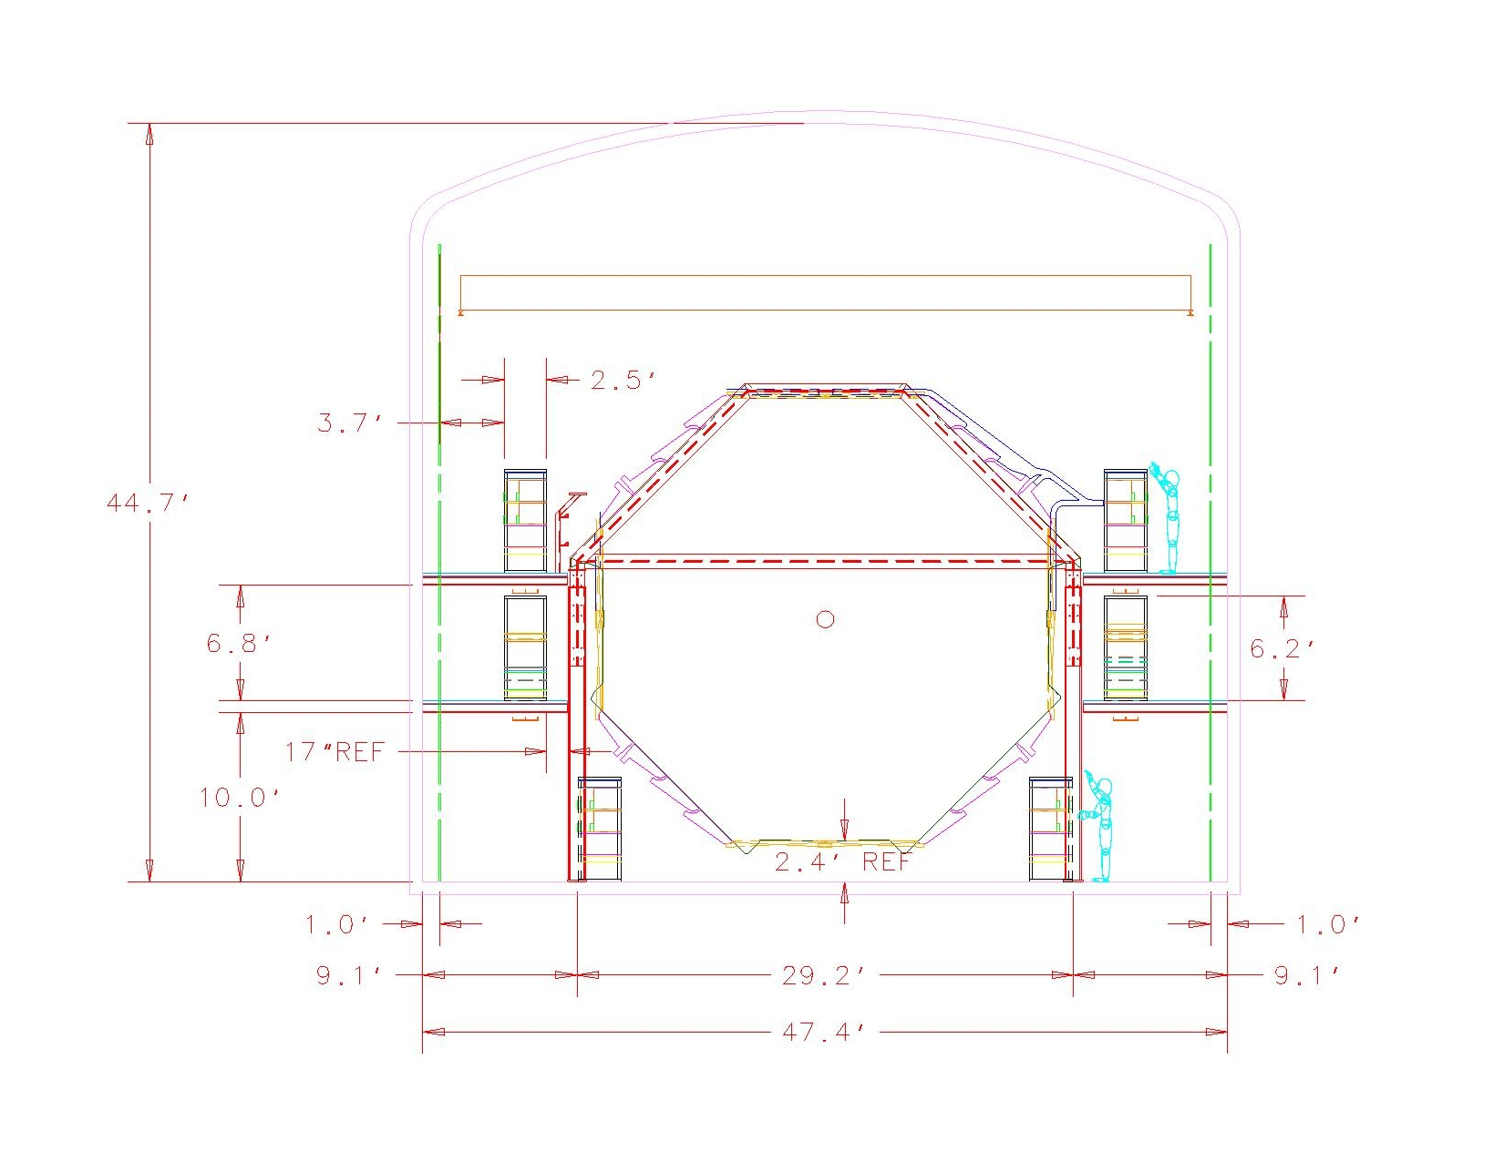
Figure 1: Face View of Far Detector Cable Routes

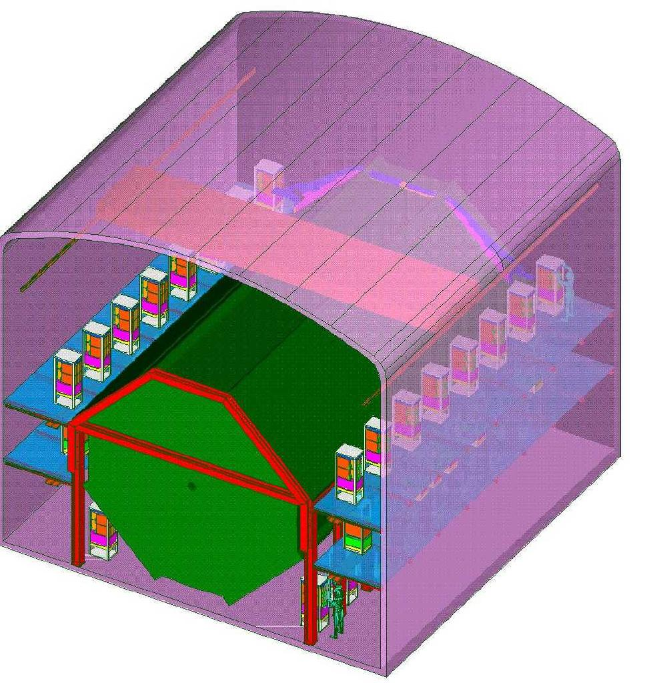

Figure 2: Longitudinal MUX Box Rack Location

Clear Fiber Cable Description and Labeling

General Description
The clear fiber cables constituting the optical connections between the MINOS scintillator modules and MUX boxes are made up of either 20 or 28 individual 1.2 mm fibers, jacketed with an opaque, fire resistant coating to a total diameter of 2 mm. The jacketed fibers in the cables associated with 20-wide modules are bonded into two planar ribbons of 10 fibers each, while the cables associated with 28-wide modules are grouped in two sets of 10-wide and one set of 8-wide ribbons. The fibers are separated into individual strands for a distance of 35 cm from each connector to allow insertion into the connector. For the remainder of the cable length, the two (or three) ribbons are stacked one on top of the other and tied together at roughly 0.5 meter intervals to form a bundle of 2.2 cm in width, and approximately 5 mm in thickness. A minimum bend radius of 12 cm must be observed at all times during the handling, installation, and final routing of the cables. The cables have two labels at each end – one indicating the cable length in meters, and the other a containing a unique cable identifier. The cables will have been fully tested for light integrity and attenuation length prior to shipment to the far detector site. The cables will be re-tested as part of the module testing procedure, conducted before the plane is raised to the vertical position.

Cable Labeling Schema
Since no two cables going to a given MUX box rack have the same length, and, in addition, the two ends of a given cable are not interchangable, it is necessary to provide each cable end with a unique designator. These designators will be in the form

SM # .plane # .mod. #.end # Mod/MUX

e.g. 1.10.5.0MUX and 1.10.5.0MOD are the two ends of the cable associated with the lower end of the 5th module on plane 10 in supermodule 1. The planes are numbered from 1 to 242, starting from the front (FNAL side) of the detector. The modules are numbered from 1 to 8, with the module with the lowest vertical position being module 1. The side of the module nearest the floor is designated side 0, with the opposite side designated side 1.

Estimated Cable Lengths

The present estimate of the cable lengths are based on the cable run lengths used on the 4 PPT, with adjustments for the ‘Z’ run lengths of each cable for the full detector configuration. Table 1 lists the nominal cable run lengths for each cable, not including the Z routing length appropriate for a given plane. This table also indicates the fiber ‘pin out’ on both the MUX and detector module side of each cable. The pin numbers listed are with respect to pin 1 as labeled on the connectors. Table 2 lists the additional Z routing lengths associated with each plane. The cable lengths obtained from these tables should be regarded as provisional - the final cable routing lengths will be based on incorporating the full cable routes into the 3D model of the far detector. This is TDB as of Jan 99.

Cable | Route | Cable | # fibers | Cable | Fiber 1 | Fiber n | Fiber 1 | Fiber n
 | Length (m) | Length (m) |  | Type | MUX side | MUX side | Module side | Module Side
 |  |  |  |  | Pin | Pin | Pin | Pin
s.p.1.1 | 3.43 | 3.73 | 28 | InvL | 1 | 28 | 28 | 1
s.p.2.1 | 1.63 | 1.93 | 28 | InvL | 1 | 28 | 28 | 1
s.p.3.1 | 1.88 | 2.18 | 20 | InvL | 1 | 20 | 20 | 1
s.p.4.1 | 1.80 | 2.10 | 20 | InvH | 1 | 20 | 30 | 11
s.p.5.1 | 2.41 | 2.71 | 20 | InvH | 1 | 20 | 30 | 11
s.p.6.1 | 3.18 | 3.48 | 20 | InvH | 1 | 20 | 30 | 11
s.p.7.1 | 3.96 | 4.26 | 28 | InvH | 1 | 28 | 30 | 3
s.p.8.1 | 5.77 | 6.07 | 28 | InvH | 1 | 28 | 30 | 3
s.p.1.0 | 6.45 | 6.75 | 28 | NorH | 1 | 28 | 3 | 30
s.p.2.0 | 4.65 | 4.95 | 28 | NorH | 1 | 28 | 3 | 30
s.p.3.0 | 3.86 | 4.16 | 20 | NorH | 1 | 20 | 11 | 30
s.p.4.0 | 3.07 | 3.37 | 20 | NorH | 1 | 20 | 11 | 30
s.p.5.0 | 2.41 | 2.71 | 20 | NorH | 1 | 20 | 11 | 30
s.p.6.0 | 2.36 | 2.66 | 20 | NorL | 1 | 20 | 1 | 20
s.p.7.0 | 2.57 | 2.87 | 28 | NorL | 1 | 28 | 1 | 28
s.p.8.0 | 4.37 | 4.67 | 28 | NorL | 1 | 28 | 1 | 28

Table 1
Clear Fiber Cable On-Detector Run Lengths and Pinnout

Plane | View | Rack | Rack Z (cm) | Z-Run (cm)
1 | U | 1u | 106.7 | 100.8
2 | V | 1v | 106.7 | 94.9
3 | u | 1u | 106.7 | 88.9
4 | v | 1v | 106.7 | 83.0
5 | u | 1u | 106.7 | 77.0
6 | v | 1v | 106.7 | 71.1
7 | u | 1u | 106.7 | 65.2
8 | v | 1v | 106.7 | 59.2
9 | u | 1u | 106.7 | 53.3
10 | v | 1v | 106.7 | 47.3
11 | u | 1u | 106.7 | 41.4
12 | v | 1v | 106.7 | 35.5
13 | u | 1u | 106.7 | 29.5
14 | v | 1v | 106.7 | 23.6
15 | u | 1u | 106.7 | 17.6
16 | v | 1v | 106.7 | 11.7
17 | u | 1u | 106.7 | 5.8
18 | v | 1v | 106.7 | -0.2
19 | u | 1u | 106.7 | -6.1
20 | v | 1v | 106.7 | -12.1
21 | u | 1u | 106.7 | -18.0
22 | v | 1v | 106.7 | -23.9
23 | u | 1u | 106.7 | -29.9
24 | v | 1v | 106.7 | -35.8
25 | u | 1u | 106.7 | -41.8
26 | v | 1v | 106.7 | -47.7
27 | u | 1u | 106.7 | -53.6
28 | v | 1v | 106.7 | -59.6
29 | u | 1u | 106.7 | -65.5
30 | v | 1v | 106.7 | -71.5
31 | u | 1u | 106.7 | -77.4
32 | v | 1v | 106.7 | -83.3
33 | u | 2u | 289.6 | 93.6
34 | v | 2v | 289.6 | 87.7
35 | u | 2u | 289.6 | 81.7
36 | v | 2v | 289.6 | 75.8
37 | u | 2u | 289.6 | 69.9
38 | v | 2v | 289.6 | 63.9
39 | u | 2u | 289.6 | 58.0
40 | v | 2v | 289.6 | 52.0
41 | u | 2u | 289.6 | 46.1
42 | v | 2v | 289.6 | 40.2
43 | u | 2u | 289.6 | 34.2
44 | v | 2v | 289.6 | 28.3
45 | u | 2u | 289.6 | 22.3
46 | v | 2v | 289.6 | 16.4
47 | u | 2u | 289.6 | 10.5
48 | v | 2v | 289.6 | 4.5
49 | u | 2u | 289.6 | -1.4
50 | v | 2v | 289.6 | -7.4
51 | u | 2u | 289.6 | -13.3
52 | v | 2v | 289.6 | -19.2
53 | u | 2u | 289.6 | -25.2
54 | v | 2v | 289.6 | -31.1
55 | u | 2u | 289.6 | -37.1
56 | v | 2v | 289.6 | -43.0
57 | u | 2u | 289.6 | -48.9
58 | v | 2v | 289.6 | -54.9
59 | u | 2u | 289.6 | -60.8
60 | v | 2v | 289.6 | -66.8
61 | u | 2u | 289.6 | -72.7
62 | v | 2v | 289.6 | -78.6
63 | u | 2u | 289.6 | -84.6
64 | v | 2v | 289.6 | -90.5
65 | u | 3u | 472.4 | 86.3
66 | v | 3v | 472.4 | 80.4
67 | u | 3u | 472.4 | 74.5
68 | v | 3v | 472.4 | 68.5
69 | u | 3u | 472.4 | 62.6
70 | v | 3v | 472.4 | 56.6
71 | u | 3u | 472.4 | 50.7
72 | v | 3v | 472.4 | 44.8
73 | u | 3u | 472.4 | 38.8
74 | v | 3v | 472.4 | 32.9
75 | u | 3u | 472.4 | 26.9
76 | v | 3v | 472.4 | 21.0
77 | u | 3u | 472.4 | 15.1
78 | v | 3v | 472.4 | 9.1
79 | u | 3u | 472.4 | 3.2
80 | v | 3v | 472.4 | -2.8
81 | u | 3u | 472.4 | -8.7
82 | v | 3v | 472.4 | -14.6
83 | u | 3u | 472.4 | -20.6
84 | v | 3v | 472.4 | -26.5
85 | u | 3u | 472.4 | -32.5
86 | v | 3v | 472.4 | -38.4
87 | u | 3u | 472.4 | -44.3
88 | v | 3v | 472.4 | -50.3
89 | u | 3u | 472.4 | -56.2
90 | v | 3v | 472.4 | -62.2
91 | u | 3u | 472.4 | -68.1
92 | v | 3v | 472.4 | -74.0
93 | u | 3u | 472.4 | -80.0
94 | v | 3v | 472.4 | -85.9
95 | u | 3u | 472.4 | -91.9
96 | v | 3v | 472.4 | -97.8
97 | u | 4u | 655.3 | 79.2
98 | v | 4v | 655.3 | 73.2
99 | u | 4u | 655.3 | 67.3
100 | v | 4v | 655.3 | 61.3
101 | u | 4u | 655.3 | 55.4
102 | v | 4v | 655.3 | 49.5
103 | u | 4u | 655.3 | 43.5
104 | v | 4v | 655.3 | 37.6
105 | u | 4u | 655.3 | 31.6
106 | v | 4v | 655.3 | 25.7
107 | u | 4u | 655.3 | 19.8
108 | v | 4v | 655.3 | 13.8
109 | u | 4u | 655.3 | 7.9
110 | v | 4v | 655.3 | 1.9
111 | u | 4u | 655.3 | -4.0
112 | v | 4v | 655.3 | -9.9
113 | u | 4u | 655.3 | -15.9
114 | v | 4v | 655.3 | -21.8
115 | u | 4u | 655.3 | -27.8
116 | v | 4v | 655.3 | -33.7
117 | u | 4u | 655.3 | -39.6
118 | v | 4v | 655.3 | -45.6
119 | u | 4u | 655.3 | -51.5
120 | v | 4v | 655.3 | -57.5
121 | u | 4u | 655.3 | -63.4
122 | v | 4v | 655.3 | -69.3
123 | u | 4u | 655.3 | -75.3
124 | v | 4v | 655.3 | -81.2
125 | u | 4u | 655.3 | -87.2
126 | v | 4v | 655.3 | -93.1
127 | u | 4u | 655.3 | -99.0
128 | v | 4v | 655.3 | -105.0
129 | u | 5u | 838.2 | 72.0
130 | v | 5v | 838.2 | 66.0
131 | u | 5u | 838.2 | 60.1
132 | v | 5v | 838.2 | 54.2
133 | u | 5u | 838.2 | 48.2
134 | v | 5v | 838.2 | 42.3
135 | u | 5u | 838.2 | 36.3
136 | v | 5v | 838.2 | 30.4
137 | u | 5u | 838.2 | 24.5
138 | v | 5v | 838.2 | 18.5
139 | u | 5u | 838.2 | 12.6
140 | v | 5v | 838.2 | 6.6
141 | u | 5u | 838.2 | 0.7
142 | v | 5v | 838.2 | -5.2
143 | u | 5u | 838.2 | -11.2
144 | v | 5v | 838.2 | -17.1
145 | u | 5u | 838.2 | -23.1
146 | v | 5v | 838.2 | -29.0
147 | u | 5u | 838.2 | -34.9
148 | v | 5v | 838.2 | -40.9
149 | u | 5u | 838.2 | -46.8
150 | v | 5v | 838.2 | -52.8
151 | u | 5u | 838.2 | -58.7
152 | v | 5v | 838.2 | -64.6
153 | u | 5u | 838.2 | -70.6
154 | v | 5v | 838.2 | -76.5
155 | u | 5u | 838.2 | -82.5
156 | v | 5v | 838.2 | -88.4
157 | u | 5u | 838.2 | -94.3
158 | v | 5v | 838.2 | -100.3
159 | u | 5u | 838.2 | -106.2
160 | v | 5v | 838.2 | -112.2
161 | u | 6u | 1021.1 | 64.8
162 | v | 6v | 1021.1 | 58.9
163 | u | 6u | 1021.1 | 52.9
164 | v | 6v | 1021.1 | 47.0
165 | u | 6u | 1021.1 | 41.0
166 | v | 6v | 1021.1 | 35.1
167 | u | 6u | 1021.1 | 29.2
168 | v | 6v | 1021.1 | 23.2
169 | u | 6u | 1021.1 | 17.3
170 | v | 6v | 1021.1 | 11.3
171 | u | 6u | 1021.1 | 5.4
172 | v | 6v | 1021.1 | -0.5
173 | u | 6u | 1021.1 | -6.5
174 | v | 6v | 1021.1 | -12.4
175 | u | 6u | 1021.1 | -18.4
176 | v | 6v | 1021.1 | -24.3
177 | u | 6u | 1021.1 | -30.2
178 | v | 6v | 1021.1 | -36.2
179 | u | 6u | 1021.1 | -42.1
180 | v | 6v | 1021.1 | -48.1
181 | u | 6u | 1021.1 | -54.0
182 | v | 6v | 1021.1 | -59.9
183 | u | 6u | 1021.1 | -65.9
184 | v | 6v | 1021.1 | -71.8
185 | u | 6u | 1021.1 | -77.8
186 | v | 6v | 1021.1 | -83.7
187 | u | 6u | 1021.1 | -89.6
188 | v | 6v | 1021.1 | -95.6
189 | u | 6u | 1021.1 | -101.5
190 | v | 6v | 1021.1 | -107.5
191 | u | 6u | 1021.1 | -113.4
192 | v | 6v | 1021.1 | -119.3
193 | u | 7u | 1204 | 57.6
194 | v | 7v | 1204 | 51.7
195 | u | 7u | 1204 | 45.7
196 | v | 7v | 1204 | 39.8
197 | u | 7u | 1204 | 33.9
198 | v | 7v | 1204 | 27.9
199 | u | 7u | 1204 | 22.0
200 | v | 7v | 1204 | 16.0
201 | u | 7u | 1204 | 10.1
202 | v | 7v | 1204 | 4.2
203 | u | 7u | 1204 | -1.8
204 | v | 7v | 1204 | -7.7
205 | u | 7u | 1204 | -13.7
206 | v | 7v | 1204 | -19.6
207 | u | 7u | 1204 | -25.5
208 | v | 7v | 1204 | -31.5
209 | u | 7u | 1204 | -37.4
210 | v | 7v | 1204 | -43.4
211 | u | 7u | 1204 | -49.3
212 | v | 7v | 1204 | -55.2
213 | u | 7u | 1204 | -61.2
214 | v | 7v | 1204 | -67.1
215 | u | 7u | 1204 | -73.1
216 | v | 7v | 1204 | -79.0
217 | u | 7u | 1204 | -84.9
218 | v | 7v | 1204 | -90.9
219 | u | 7u | 1204 | -96.8
220 | v | 7v | 1204 | -102.8
221 | u | 7u | 1204 | -108.7
222 | v | 7v | 1204 | -114.6
223 | u | 7u | 1204 | -120.6
224 | v | 7v | 1204 | -126.5
225 | u | 8u | 1386.8 | 50.3
226 | v | 8v | 1386.8 | 44.4
227 | u | 8u | 1386.8 | 38.5
228 | v | 8v | 1386.8 | 32.5
229 | u | 8u | 1386.8 | 26.6
230 | v | 8v | 1386.8 | 20.6
231 | u | 8u | 1386.8 | 14.7
232 | v | 8v | 1386.8 | 8.8
233 | u | 8u | 1386.8 | 2.8
234 | v | 8v | 1386.8 | -3.1
235 | u | 8u | 1386.8 | -9.1
236 | v | 8v | 1386.8 | -15.0
237 | u | 8u | 1386.8 | -20.9
238 | v | 8v | 1386.8 | -26.9
239 | u | 8u | 1386.8 | -32.8
240 | v | 8v | 1386.8 | -38.8
241 | u | 8u | 1386.8 | -44.7
242 | v | 8v | 1386.8 | -50.6

Table 2
Z Run Distances

Routing/Fixtures

Routing Diagram
The cables servicing a single detector plane are tied to that plane using a set of aluminum rods bolted to the edge of the steel. The locations of these tie points are shown in Figure 3. A detail showing the tie point rod lengths as implemented on the 4 PPT is shown in Figure 4.

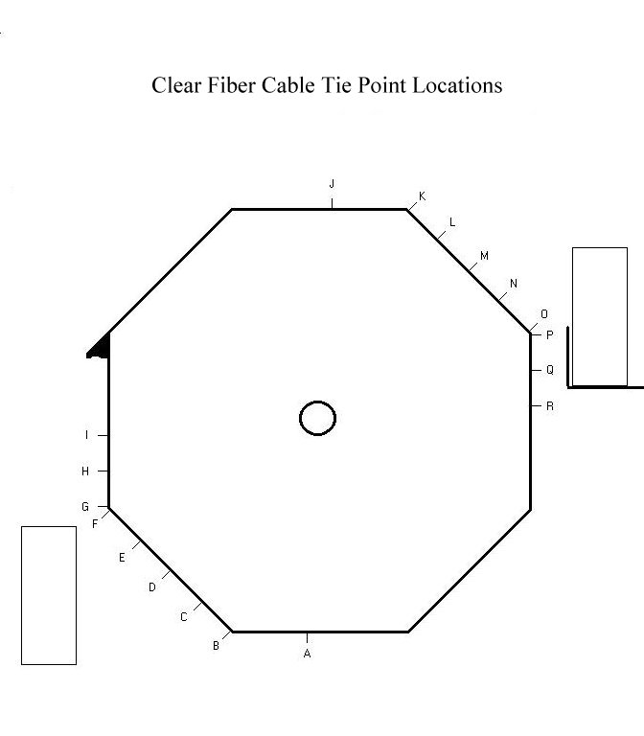
Figure 3
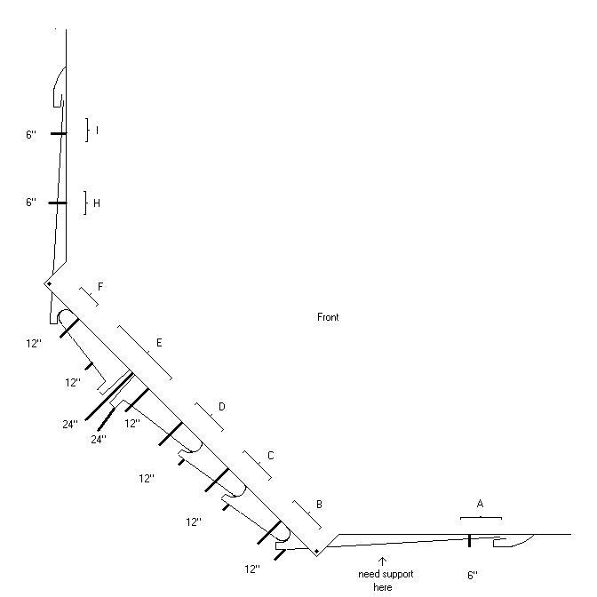

Figure 4: Cable Tie Point Detail

On-Detector Routing Fixtures

Examples of tie point fixtures on the 4 PPT are shown in Figures 5-7.

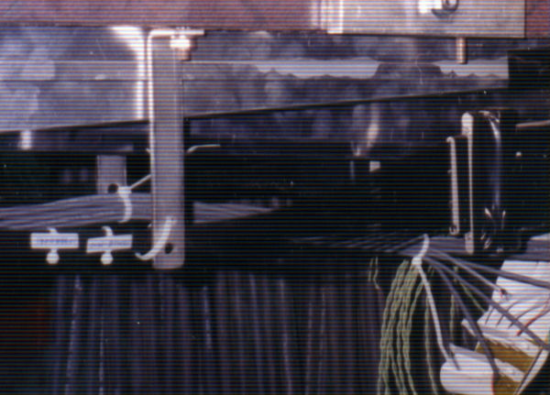

Figure 5 – Tie Point at Location ‘A’ in Figure 1

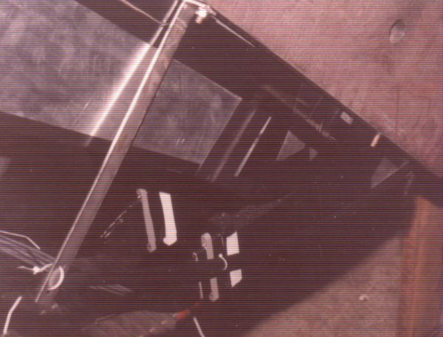

Figure 6– Tie Point at Location B in Figure 1

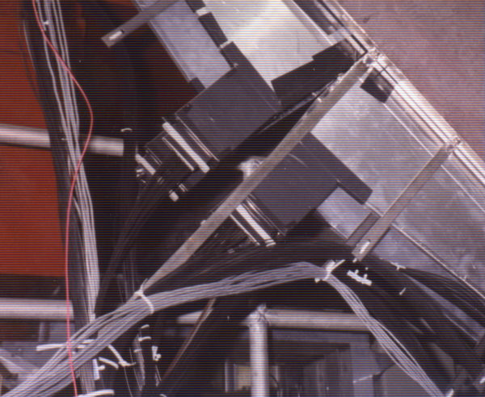

Figure 7 – Tie Point at Location ‘E’

Installation

Initial Mounting of the Cables to a Module Plane
The initial installation of the clear fiber cables takes place while the plane is in the horizontal position, after the scintillator modules have been mounted on the steel plane. Prior to the placement of the scintillator modules on the steel plane, the cable tie point fixtures will have been bolted to the steel at the locations shown in Figure 3. The cable mounting proceeds through the following steps

1: The crate containing the cables for the plane under assembly is opened.
2: The face of the module-side connector is coated with the optical couplant.
3: The light seal gasket is slid onto the module connector.
4: The cable connector is bolted to the module connector
5: The cable is unrolled, and tied to the appropriate tie points with loose cable ties.
6: Light seal and transmittance tests are conducted on the module/cable combination.
7: The remaining cable is safed at locations E or N, in preparation for lifting.

Completion of the Installation – Mounting Cables to the MUX Box

After the plane has been lifted into place, the cable routes can be completed to the MUX box. This is done by running the cables in the ‘Z’ direction in cable trays mounted at the height of the lowest MUX box, and located between the MUX box racks and the detector. The cable ends are then brought to the MUX box connectors, and coupled using the same procedure outlined above for the module connections.

Post Installation Tests of Light Integrity and Transmittance
After final connections have been made to a MUX box, an end to end system test of the module/cable/MUX box/PMT chain will be conducted using a radioactive source to excite the scintillator.

Estimated Time/Manpower Requirements for Clear Cable Installation

The initial installation manpower estimates contained in the MINOS TDR have been validated by time-motion studies conducted during assembly of the 4 PPT. The time required to perform the initial cable installation (the work conducted with the plane in the horizontal position) is 1 hour per plane, with four assembly technicians assigned to this task. In addition, 2 hours are required for checking performance and light integrity. This work is done by two assembly technicians. Final installation and inspection is accomplished by three technicians in one hour.

Clear Fiber Cable Development Status

Development of the cable connectors is essentially complete. In terms of the fiber itself, to date fiber cables have been constructed only from simplex (single stranded) fibers – cables of this type were used to instrument the 4 PPT. Fabrication of the first large lot (3 km) of ribbon cable is presently underway, with delivery expected in mid to late March. At that time, pre-production cables can be fabricated, and any routing issues specific to the ribbon cable can be addressed through tests on the 4 PPT. For example, the design of the cable tie points will need to be modified to accommodate a ribbon cable. The details of the cable routing along the detector axis have also not been finalized, and therefore, the cable lengths called out in this memo will be refined prior to fabrication. The final cable lengths will be determined from a combination of a more complete 3D model of the cable plant, and measurements on the 4 PPT.

Milestones

Final Production Specifications – RFP released March 1,2000
Receipt of Fiber Ribbon March 15,2000
Fabrication of prototype ribbon cable April 1,2000
Final Fire Safety Review April 15,2000
Fiber/Cable Order Placed June 1,2000
10% SM1 Cable Shipped Dec 30,2000
100% SM1 Cable Shipped Sept 2001
100% SM2 Cable Shipped Oct 2002

Areas of Concern

The nominal performance of the fiber cable, including the connector transmittance, attenuation length, light seal, and other mechanical properties, such as minimum bend radius, has been determined to meet the MINOS requirements in this area. The primary areas of concern at this point involve optimizing the yield of good cable in the production process. Specifically, the fiber produced by Kuraray has isolated regions occurring at a frequency of roughly 5/km in which the fiber diameter dramatically exceeds the nominal dimensional tolerances of the fiber. This has a substantial impact on the jacket fabrication process, which must be able to tolerate these excursions. We are presently working with both the fiber and jacket manufacturers to find a specification which optimizes the product of the fiber and jacket yields.
During installation, the primary area of concern is that the necessary level of attention to obeying the bend radius restrictions, and the general need to treat these cables with respect, be maintained throughout the installation period. This will require attention and sensitivity to this issue on the part of the on-site installation supervisors.

