
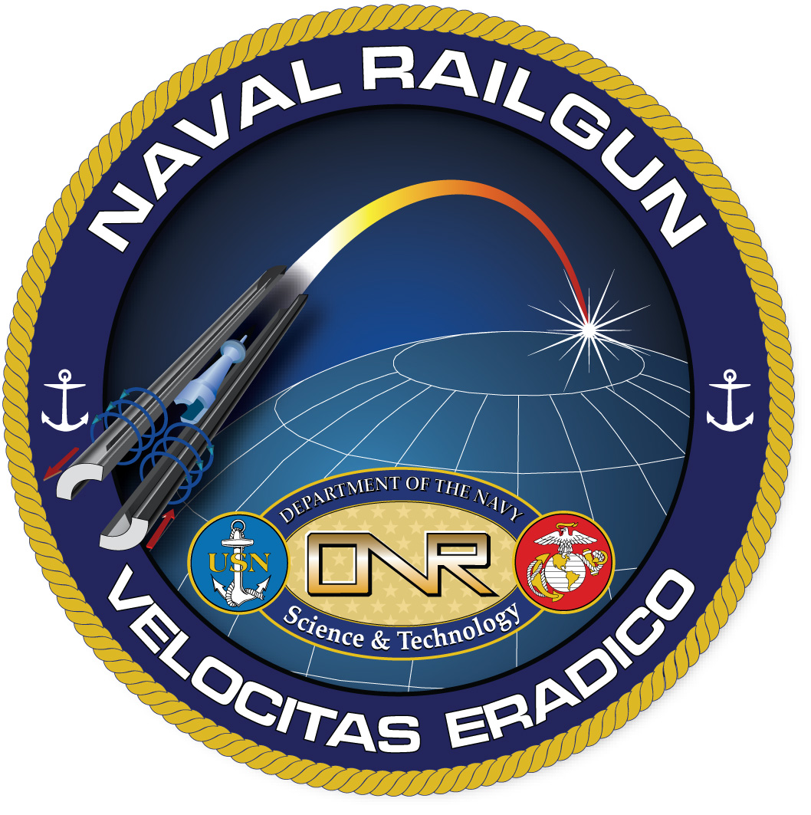
REGISTRATION FORM I
(Access to SECRET classified and all unclassified sessions)

DoD Innovative Science & Technology EM Railgun Workshop
September 23-25, 2008
Sandia National Laboratories, Albuquerque, NM
MUST BE A U.S. CITIZEN TO REGISTER AND ATTEND

Full Name:
Last |  |  |  |  | First |  |  |  | M.I.
Name for workshop badge:
Rank, Title, or Position:
MUST hold SECRET or higher clearance  Type of clearance:  DOE Q L  Other |  | Non-DOE clearances must be faxed by your Facility Security Officer (FSO) to Sandia Badge Office and to the Workshop Clearance Coordinator (WCC).  1st fax: Sandia Badge Office, Incoming Classified Visits, Fax: (505) 284-8812, Phone: (505) 845-8140  2nd fax: Jeanette Laslo, WCC, Fax: (505) 845-3651, Phone: (505)284-5668, email: jlaslo@sandia.gov  CLEARANCE SUBMITTAL DUE DATE: 9/8/08  (see page 2 for detailed clearance instructions)
Please provide the following information (*required for clearance processing):
*Social Security Number :
*Birth Date: |  |  |  | *Place of Birth:
Business/Organization: |  |  |  |  |  | Telephone: ( )
Mailing/street address: |  |  | City/State: |  |  |  | Zip Code:
Mobile Phone : ( ) |  |  | Fax: ( ) |  |  |  | email:
Administrative Contact: Telephone: ( ) email:
Workshop Fee |  | Day 1, 9/23/08: Continental Breakfast, Lunch and refreshments |  |  |  |  |  |  |  | $30.00
Workshop Fee |  | Day 2, 9/24/08: Continental Breakfast, Lunch and refreshments |  |  |  |  |  |  |  | $30.00
Workshop Fee |  | Day 3, 9/25/08: Continental Breakfast, Lunch and refreshments |  |  |  |  |  |  |  | $30.00
Social Mixer |  | 9/22/08, 6pm, @ MCM Elegante Hotel: Opportunity to network and receive workshop materials prior to meeting; mixer includes heavy hor’deurves and no-host bar |  |  |  |  |  | $16.50 / person # attendees |  | $
Workshop Dinner |  | 9/23/08, 7pm @ MCM Elegante Hotel; no-host bar; and indicate:  Petite Filet w/béarnaise and Tiger Shrimp #  Salmon w/orange brandy sauce and Tiger Shrimp # |  |  |  |  |  | $40.00 / person  # attendees |  | $
 |  | TOTAL paid on Webpay via Website: |  |  |  |  |  | $
Please indicate any special dietary requests:

- NO checks, wire transfers, or invoices will be accepted. To pay, please go to the Registration page of this website, then follow the Link to Web Pay at the bottom of the page. On the Web Pay page, select “EM Railgun Workshop” in the drop down menu that lists events.
- Refunds are made only in response to written requests to event coordinator at the address below, postmarked, faxed, or emailed by September 1, 2008. A 6% service charge will be imposed for processing.
- Completed registration form must be mailed, faxed, or emailed to Jeanette Laslo, Workshop Clearance Coordinator, Sandia National Laboratories, P. O. Box 5800, MS 1153, Albuquerque, NM 87185-1153, Fax: (505) 845-3651, Phone: (505) 284-5668, email: jlaslo@sandia.gov - REGISTRATION DUE DATE: 8/25/08

INSTRUCTIONS FOR SENDING CLEARANCES

CLEARANCE SUBMITTAL DUE DATE: 9/8/08

Visitors with DoD/non-DOE Clearances:

Ensure that the visit request includes the following 10 items:

- Name
- Social Security Number
- Citizenship
- Date of Birth
- Type of clearance and Date of clearance
- Dates of visit: 9/22/08 - 9/26/08
- Purpose of the visit: To attend DoD Innovative Science & Technology Electromagnetic (EM) Railgun Workshop
- Person to be visited: Ronald J. Kaye, Ph: (505) 845-7658, email: rjkaye@sandia.gov
- Place to be visited: Sandia National Laboratories, Albuquerque, NM
- Security officer signature and Security title (the word security MUST be in the title)

Have visitor’s facility security officer (FSO) fax clearances directly to Sandia’s Badge Office Incoming Visits, Fax: (505) 284-8812, confirmation phone: (505) 845-8140.

Fax copy of visit request to Workshop Clearance Coordinator (WCC): Jeanette Laslo, Fax: (505) 845-3651, Phone: (505) 284-5668, email: jlaslo@sandia.gov .

NOTE: Sandia Labs does not use JPAS

Visitors with a DOE Clearance:

DOE visitors with Q and L clearances must register for Workshop and be U.S. citizens. They do not need to submit a clearance form to the Sandia Badge Office. These visitors must register their DOE-issued badge at Sandia's Badge Office prior to Workshop Registration on September 23, 2008.

