13_041129_CLN_01.doc
TO: DISTRIBUTION
FROM: C NEUMEYER
SUBJECT: LOADS ON FLAG BOX/HUB FRICTION INTERFACE

Reference:

[1] “Update of NSTX Influence Matricies and EM Loads”, 13_041123_CLN_01
[2] NSTX-CALC-13-020, “PF Coil Axial and Radial Force Calculation”, R2
[3] NSTX-CALC-13-025, “TF Flag Box/Hub Connection”, R1

This memo presents results from analyses performed to estimate loads on the friction interface between the hub disks and flag boxes. In addition to the FEA another analysis method is presented based on a simplification which reduces the analysis to a statics problem. It is assumed that the flag/box assembly is a simple rigid body, and that the friction response of the interface can be modeled as point responses at the radii of the box bolts. The latter assumption is based on the idea that the pressure at the hub/box interface is concentrated in concentric regions around the box bolts. Figure 1 shows a FEMLAB simulation of the pressure distribution under a ½” stainless steel plate resulting from the application of 5500lbf over the annular region of a 1” OD washer on the other side of the plate. While this is a simplification of the actual condition, it supports the idea that the box bolt reaction can be modeled by a point response at the bolt radius.

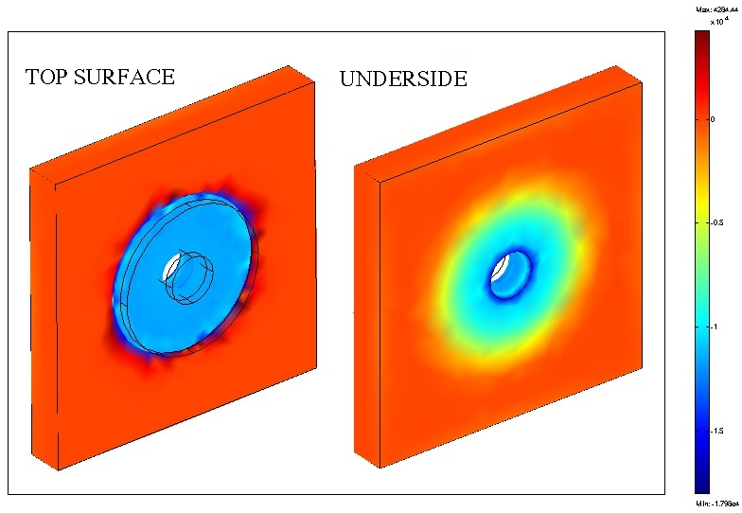

Figure 1 – FEMLAB Model of Box Bolts at 5500lbf applied on 1” OD Washer

The static model is shown in figure 2. Moment on bundle is replaced by F_bundle acting at bundle radius. F1, F2, F3 represent the box bolt reactions, and F_lateral is the equivalent point force due to the out-of-plane EM load. Reactions out through the flex links are ignored, since that load path is relatively soft.

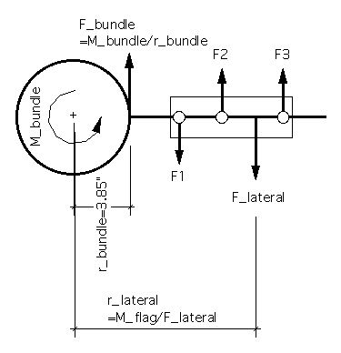
Figure 2 – Simplified Model of Load and Reactions on Flag Boxes

With the applied EM loads at bundle and on flag given, along with their radius, and the radii of the three box bolts know, one can solve for F1, F2, and F3 based on ∑F=0 and ∑M=0, assuming that F2 is linearly related to F1 and F3 based on the spacing of the bolts.
$$F_{3}=\frac{\left[\frac{(F_{b}∗r_{b}+F_{l}∗r_{l})(r_{3}−r_{1})}{(r_{1}(r_{3}−r_{1})+r_{2}(r_{3}−r_{2}))}−\frac{(F_{b}+F_{l})(r_{3}−r_{1})}{(2r_{3}−r_{1}−r_{2})}\right]}{\left[\frac{(r_{3}−2∗r_{1}+r_{2})}{(2r_{3}−r_{1}−r_{2})}−\frac{(r_{3}∗(r_{3}−r_{1})+r_{2}∗(r_{2}−r_{1}))}{(r_{1}(r_{3}−r_{1})+r_{2}(r_{3}−r_{2}))}\right]}$$

$$F_{1}=\frac{\left[F_{3}(r_{3}−2r_{1}+r_{2})−(F_{b}+F_{l})(r_{3}−r_{1})\right]}{(2r_{3}−r_{1}−r_{2})}$$

$$F_{2}=F_{1}−\frac{(F_{1}−F_{3})(r_{2}−r_{1})}{(r_{3}−r_{1})}$$

Table 1 gives values of the forces calculated using the procedure given herein, and FEA results provided by I. Zatz, along with the friction safety factors (out-of-plane loads only), for various operating states: SOFT is the start of flat top, EOFT is the end of flat top, MAXMAX is the case where all currents are simultaneously at their maximum values in the same current direction, and OTHER is a solved for combination of currents found to give the minimum friction safety factor while respecting the constraint that the current ranges and polarities must be consistent with realistic plasma operation. EM loads are calculated using the influence matrices given in [1]. Bundle torque is assumed taken 80% by the outer layer flags and 20% by the inners. Loads are assumed to be equally shared between the friction interfaces at each surface of the box.

TABLE 1 – Loads and Friction Safety Factors
 | SOFT | FEA  SOFT | EOFT | FEA  EOFT | MAXMAX | OTHER
M_bundle | 26317 |  | -26330 |  | -30025 | -27873 | ft-lbf
 | 315809 |  | -315955 |  | -360299 | -334481 | in-lbf
R_bundle | 3.85 |  | 3.85 |  | 3.85 | 3.85 | in
F_bundle | 82071 |  | -82109 |  | -93633 | -86923 | lbf
#Inner Turns | 12 |  | 12 |  | 12 | 12
#Outer Turns | 24 |  | 24 |  | 24 | 24
f_Inner | 0.20 |  | 0.20 |  | 0.20 | 0.20
f_Outer | 0.80 |  | 0.80 |  | 0.80 | 0.80
F_Bundle_Outer_Flag | 2736 |  | -2737 |  | -3121 | -2897 | lbf
M_Lateral_Outer_Flag | -2621 |  | 13775 |  | 65160 | 35549 | in-lbf
F_Lateral_Outer_Flag | -367 |  | 1141 |  | 5077 | 2765 | lbf
F_net_Outer_Flag | 2368 |  | -1596 |  | 1956 | -132 | lbf
R_Lateral | 7.14 |  | 12.07 |  | 12.83 | 12.86 | in
R_bolt1 | 6.51 |  | 6.51 |  | 6.51 | 6.51 | in
R_bolt2 | 9.14 |  | 9.14 |  | 9.14 | 9.14 | in
R_bolt3 | 12.89 |  | 12.89 |  | 12.89 | 12.89 | in
F1 | -2927 | -1424 | 3225 | 1318 | 4395 | 3793
F2 | -1057 | -154 | 869 | 218 | -21 | 513
F3 | 1615 | 552 | -2497 | -428 | -6330 | -4174
COF | 0.60 | 0.60 | 0.60 | 0.60 | 0.60 | 0.60
Bolt Force | 5500 | 5500 | 5500 | 5500 | 5500 | 5500 | lbf
Number of Surfaces | 2 | 2 | 2 | 2 | 2 | 2
Resisting Force/bolt | 6600 | 6600 | 6600 | 6600 | 6600 | 6600 | lbf
SF1 | 2.3 | 4.6 | 2.0 | 5.0 | 1.5 | 1.7
SF2 | 6.2 | 42.9 | 7.6 | 30.3 | 311.3 | 12.9
SF3 | 4.1 | 12.0 | 2.6 | 15.4 | 1.0 | 1.6
SF_MIN | 2.3 | 4.6 | 2.0 | 5.0 | 1.0 | 1.6

Load currents corresponding to the OTHER (practical worst case) condition are given in Table 2.

TABLE 2 – Current Combination for
Worst Case Box/Hub Friction Loading
Ioh | 24.0
Ipf1a | 5.0
Ipf1b | 0.0
Ipf2 | 0.0
Ipf3 | 20.0
Ipf4 | 0.0
Ipf5 | 20.0
Itf | 71.2

Comparison between the FEA for the SOFT and EOFT cases is given in Table 3.

TABLE 3 – Comparison Between Bolt Load Calculations

 | SOFT | EOFT
F_1 | -1463 | 1612
F_1_FEA | -712 | 659
Ratio_1 | 49% | 41%
F_2 | -528 | 434
F_2_FEA | -77 | 109
Ratio_2 | 15% | 25%
F_3 | 807 | -1248
F3_3_FEA | 276 | -214
Ratio_3 | 34% | 17%

The above suggests that the actual load may be as much as 49% of that calculated using the simplified analysis. Taking credit for the FEA result, and applying the realistic maximum condition, the friction safety factors including the vector sum of in-plane and out-of-plane loads are given in Table 4 (following the calculation technique used in [2]).

TABLE 4 – Box Bolt Safety Factor Calculations

COF for Coated Plates | 0.600 | 0.600 | 0.600
At 6 kG | 6 | 6 | 6 | kG
In Plane EM Moment | 70653 | 70653 | 70653 | in-lbf
% In Plane Load to Hub/Box Shear | 42% | 42% | 42%
Moment Arm to Interface | 3.25 | 3.25 | 3.25 | in
In Plane Shear Load per Interface | 4569 | 4569 | 4569 | lbf
In Plane Shear Load per Bolt | 1523 | 1523 | 1523
Max Out of Plane EM Load per Bolt | 2087 | 2087 | 2087
% Out Of Plane Shear Load per Bolt | 49% | 49% | 49%
Out of Plane Shear Load per Bolt | 1023 | 1023 | 1023
Field Strength kG | 6.00 | 5.00 | 4.00 | kG
In Plane Load | 1523 | 1058 | 677 | lbf
Out Of Plane Load | 1023 | 852 | 682 | lbf
Resultant Load | 1834 | 1358 | 961 | lbf
Min Bolt Tension | 3900 | 3900 | 3900 | lbf
Avg. Bolt Tension | 5500 | 5500 | 5500 | lbf
Max. Bolt Tension | 6500 | 6500 | 6500 | lbf
Min Resistance to Load | 2340 | 2340 | 2340 | lbf
Avg Resistance to Load | 3300 | 3300 | 3300 | lbf
Max Resistance to Load | 3900 | 3900 | 3900 | lbf
Min. FS Friction Resultant | 1.3 | 1.7 | 2.4
Avg. FS Friction Resultant | 1.8 | 2.4 | 3.4
Max. FS Friction Resultant | 2.1 | 2.9 | 4.1

Summary

The analysis predicts a safety factor of at least 1.3 at 6kG. However, the considering the complexity of the structural system, and the simplifications inherent not only in the statics analysis but also in the FEA, we need to proceed cautiously. A technique to inspect for relative displacement between box and hub needs to be developed.

L Dudek M Kalish M Ono J Schmidt A Von Halle M Williams
R Woolley IZatz

