Final Report
Social, Economic, and Cultural Factors That Influence
Community Support for Coastal Conservation

A Look at Carrabelle Florida and Similar
Coastal Communities

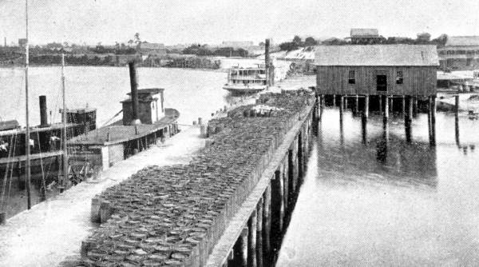

Final Project for Order FC133C07SE3784 for the Florida Panhandle Project - Cultural Resource Inventory & Human Dimension Roundtable

(Requisition Reference Number - NCNP0000-7-18361)

1000 Friends of Florida
August 2008

Final Report

Social, Economic, and Cultural Factors That Influence
Community Support for Coastal Conservation

A Look at Carrabelle Florida and Similar Coastal Communities

Contents

- Final Project Summary Report 1

- Research Report: Carrabelle – Cultural Assessment and Characterization
–An Enduring Relationship between a Florida Waterfront Community and Surrounding Area Natural Resources 2

- Waterfront Florida Community Survey
  - Survey 3
  - Survey Responses 4
  - Survey Analysis 5
- Roundtable Materials and Notes
  - Agenda 6
  - Sign-in Sheet 7
  - PowerPoint 1 – 1000 Friends of Florida: Social, Economic and Cultural Factors that Influence Community Support for Coastal Conservation 8
  - PowerPoint 2 - Linda Lanple, Lample Herbert Consultants: Humans and Resources – Relationships in Coastal Communities 9
  - Notes on the Carrabelle Community and Roundtable Meeting – By Herb Hiller, Writer and Community Tourism Expert 10

Final Report
Social, Economic, and Cultural Factors That Influence
Community Support for Coastal Conservation

A Look at Carrabelle Florida and Similar Coastal Communities

This project was an effort to assist coastal management professionals and allied constituencies gain a better understanding of the social, economic, and cultural factors that influence community support for coastal conservation. As a representative community we examined Carrabelle, Florida and the surrounding area, looking for long-term relationships that exist between coastal communities, their natural resources and varying social culture(s). The information gleaned from this project highlights a strong but evolving linkage between the cultural and social factors in Florida’s coastal communities and the inherent natural coastal and forest land resources.

This project performed the following actions (the results are included:
- Researched the historical relationships that exist between a particular Florida coastal community (Carrabelle) and social, economic, and cultural linkages to the surrounding natural resources. (Report attached)
- Performed a brief survey of various coastal communities in Florida to gain a better understanding of the social, economic, and cultural factors that influence community support for coastal conservation and explore the relationships between a community and area natural resources. (Survey and survey results attached. Survey results summarized below)
- Held a roundtable meeting in Carrabelle in April of 2008 that included natural resource management professionals, applied social scientists, and allied stakeholders to identify data gaps and approaches necessary to support and further ecosystem-based management decision-making for waterfront communities. (Agenda and various PowerPoint presentations attached and results and roundtable insights summarized below along with interview notes from Herb Hiller – roundtable notes as well as various Carrabelle cultural observations and notes.)

I. Commonly Expressed Points and Observations from the Survey and Round Table

1.) Basic limitation of land-to-water frontage has created a social competition of sorts between traditional resources harvesters (seafood storage and processing, boat dockage, unloading, repair and outfitting) and newer residents that live (build their homes, apartments and condos) on the waterfront land. A culture of “have’s and have nots” may be in the making relative to easy access to the developed waterfront areas.

Marine Resource Harvesters suffer when they lose tie-up processing and trucking space. These commercial fisherman and their boats either go out of business or go elsewhere (e.g., Apalachicola or Port St. Joe) where the facilities are better and dockage, places to buy fuel and ice, marine supplies still exist. Part of the solution may be to have frontage owned by city/county government to counter real estate pressure on private owners (the new Franklin County Seafood Landing Park in Apalachicola, a primary access point for oyster and recreational fishermen to western Apalachicola Bay is a recent example of such a cooperative public/private partnership).

2.) Similarly, the public’s access to the waterfront appears to be an issue of concern. Again the competition for waterfront has driven up land values there and parcelized development pattern (homes, condos, etc) have been edging out traditional “public” access points. A number of the communities share a common thread of concern about maintaining adequate public access to the waterfront. When citizens, someone passing through or potential tourist lose easy access to the waterfront (both physical and visual) there is an economic lose suffered by the community. Carrabelle report’s that hasn’t happened yet to the extreme, but recent real estate boom was challenging. The temptation to cash-in on potential profit on local waterfront frontage was tremendous.

3.) In several communities the “old families and residents (or long time semi-permanent residents) dominate community hierarchical order and political clout. Nevertheless, some responses indicated that this dominance is weakening as more new residents make these areas home and numerous older families have their young either leaving for other areas or selling and “cashing in” family land and waterfront resources.

4.) Seasonal residents are playing a growing role in the social strata in these communities. The newer residents strongly support the fishing way of life in the community since it, and the associated the coastal natural resources, attracted them there in the first place. They are often well educated and quite interested in Coastal and natural resources protection issues.

In addition, new permanent residents come from a far distance to “hunker down” and become rooted in Carrabelle (or similar coastal places) because it remains “real Florida” with a tangible energy and very direct linkages between the water, harvestable seafood and upland forests coastal resources. People like Tamara Allen, Mel Kelly and Skip Frank (at the Carrabelle workshop) fit into this group and are quintessential representatives of people from a broad educational and work backgrounds that have come to live in Carrabelle and are devoted to betterment of the community.

5.) Economies and social activities are often more-and-more ecotourism-based with festivals, celebrations, and community events based around the natural and historic resources these communities have.

6.) For many of these coastal communities, the challenge is to use the presence of “outsiders”, temporarily in the vicinity at leisure, to achieve local priorities and economic activity (some temporarily in the vicinity at leisure and others semi-permanent seasonal residents). Respondents express that the community priorities include protecting the resources and fostering sustainable economic situations that engenders respect for the resources.

Today the economic and commercial focus is to attract people who have money to spend. Condos, vacation homes and hotel rooms need to be filled. These outsiders go to local restaurants, to the hardware stores and support local businesses. They want fresh local seafood such as the oysters, fish or shrimp and they eat a lot either out on the town or at their “home”. So the view is, “we need tourists – or visitors”.

Both the Old timers and the “new” permanent residents are worried about how their communities are going to be developed. They are each interested in protecting the waterfront and the heritage there. Almost universally there were expressions that they do not want the place to look like Destin or Panama City (i.e., over-developed with the loss of significant local coastal natural and identifiable cultural heritage.

7.) The communities, their economies and their social networks seem to be moving away from the “natural resource factory” model - that is a model dependent upon direct harvesting of sea life or forest resources (varies from community to community). Instead, growing economic income to the communities is linked to tourism, retirees and second home constituencies. These constituencies tend to develop and support local natural resource social activism and recognition of the direct ecosystem-to-economic base linkage. And the balance between the ecosystem-to-economic base use, loss, conservation and restorations possibilities.

Recognized priorities often include protecting the coastal resources, but also doing what is necessary to sustain and grow the local economy. Communities seem to recognize the need to pursue economic growth, but in a way that engenders respect and sustainability for the resources. A vision seems to be - help preserve the natural integrity of the various coastal resources by creating/developing less consumptive recreational and leisure uses.
Carrabelle, Panacea, St. Marks and St. Andrews are good examples of such Florida communities.

8.) Restoration of historic waterfront and community buildings and their integration into the community fabric was repeated seen as a cultural and economic bonus to the communities surveyed and present at the round table. There was a general consensus in support of the preservation/restoration of both the natural system and the historical resources. In fact it is a rallying point and described as:
- The essence of the place that creates its authenticity.
- Rededication” to the historical linkages.

9.) Florida’s seafood harvesting communities have been economically stressed in recent years and hover back-and-forth between marginally profitable and unprofitable due to the rise of worldwide competition (cheaper to harvest and ship from afar then locally); some over fishing locally; and, escalating land values along the coast (causing many older fishing families to sellout). These conditions have driven a variety of adaptations. For example as discussed at the Carrabelle workshop, the fishing family of Vance Millender’s were ready to ease out of wholesaling seafood to larger markets and instead focus on retailing seafood locally to pass-through customers on Highway 98.

Today the Industry in transformation due to higher and higher energy costs. Nevertheless, overseas seafood producers that have damaged the local markets for the last decade may be likewise affected by increased costs due to energy price increases. This may be a benefit to local seafood harvesters since they may be able to more efficiently service local and regional markets. Local harvesters and distributers may find renewed local and regional marketing opportunities. Commercial fishing may not come back “big-time”, but likely it can continue to provide a sustainable economic and social base for Carrabelle and other Florida coastal communities.

10.) Carrabelle (and similar communities) needs to grow from the inside out relying on the prudent use and cultivation of its natural and cultural resources. Often they need to find and develop niche markets for the local seafood resources or seascape/waterfront experiences and then “brand them” which helps foster a consumer willingness to pay higher prices.

Carrabelle
Cultural Assessment and Characterization
An Enduring Relationship Between a Florida Waterfront Community and Surrounding Area Natural Resources

Background Information

Prepared by 1000 Friends of Florida for The Florida Panhandle Project

Cultural Resource Inventory & Human Dimension Roundtable
2008

Project FC133C07SE3784
(Reference Number - NCNP0000-7-18361)

Table of Contents

Background and Purpose of this Report ----------------------------------------- 3

Carrabelle Cultural Assessment and Characterization ---------------------- 4

Carrabelle Florida, Background Material – Population Characteristics - 5

Carrabelle – Its History ------------------------------------------------------------- 7
Early History and Settlement ------------------------------------------------ 7
Timber, Lumberyards and Saw Mills -------------------------------------- 9
Railroad and Port Development Cause Carrabelle to Grow ------------ 11
At the Turn of the Century – 1900 ----------------------------------------- 15
The World War II Era -------------------------------------------------------- 18
Post World War II to the Present ------------------------------------------- 21
The Development Boom of the 1990s and Early 2000s ----------------- 22
St. James Bay DRI ------------------------------------------------------------ 23
SummerCamp & Planned Development of the St. James Island Area - 23

2008 and Beyond -A Community with Inseparable Ties to Its Natural Resources - 23

Today’s Natural and Cultural Resources – Carrabelle ------------------------ 24
Carrabelle Beach --------------------------------------------------------------- 24
The Crooked River Lighthouse ---------------------------------------------- 24
Dog Island ---------------------------------------------------------------------- 24
St. George Island & St. George Island State Park ------------------------ 24
Apalachicola National Forest ----------------------------------------------- 25
Tate’s Hell State Forest ------------------------------------------------------ 25
Bald Point State Park --------------------------------------------------------- 26
Apalachicola National Estuarine Research Reserve ----------------------- 27
Diving ----------------------------------------------------------------------------- 29
Riverfront Festival -------------------------------------------------------------- 29

Comparing the Franklin County, the State of Florida and the United States Economies ------------------------------------------------------------------------------- 30-35

References -------------------------------------------------------------------------------- 35

Background and Purpose of this Report

This report has been prepared as an effort to assist coastal management professionals and allied constituencies gain a better understanding of the social, economic, and cultural factors that influence community support for coastal conservation. This report examines Carrabelle, Florida and the surrounding area as an example coastal community and the long-term relationship that exists between the community its natural resources and culture(s). The information highlights the strong linkage between the people, cultures and the natural resources.

The report has been prepared to support a regional roundtable workshop planned to identify human dimensions data gaps and applied social science approaches necessary to support ecosystem-based management decision-making for the region and to support the work of natural resource management professionals, applied social scientists, and allied stakeholders.

This report is not original work, but instead represents a compilation of existing sources (see reference and cite sources).

Carrabelle Cultural Assessment and Characterization

Carrabelle, and surrounding Franklin and Wakulla Counties are by location and culture linked to the water and associated coastal resources. The connection between the cultural and the natural environment has always influenced the lives and prosperity of the people who live in this area. Carrabelle is still very much tied to its natural resource base, though the social and culture base is changing. Changing realities such as the net ban, the rise and collapse of the real estate values along with pollution the have altered the social and economic foundations from being wholly dependent natural-resource-based economies (harvest and sale of natural products) to coastal locational-based leisure economies (coastal living and vacation products) with some harvesting of coastal resources. Nevertheless, underlying harvestable natural resources continue to be present as an underpinning to the local economic, social and cultural scene.

The newer constituencies, cultures and economies rely in their own way on the underlying natural resources linkages. Thus, today there are several fully equipped marinas, which cater to boaters and fishermen that live or visit the area. Recreational fishing possibilities abound and charter boats are available for offshore or bay fishing. Further, there are significant freshwater fishing opportunities up the Crooked and New rivers and surf and bay fishing yields catches for tourist and locals alike.

Carrabelle is located in Franklin County Florida in the Panhandle southwest of Tallahassee (approximately 50 miles southwest). For many years harvesting seafood and inland timber have been the economic mainstays for the community exhibiting a strong reciprocal relationship between the community and the area’s natural resources.

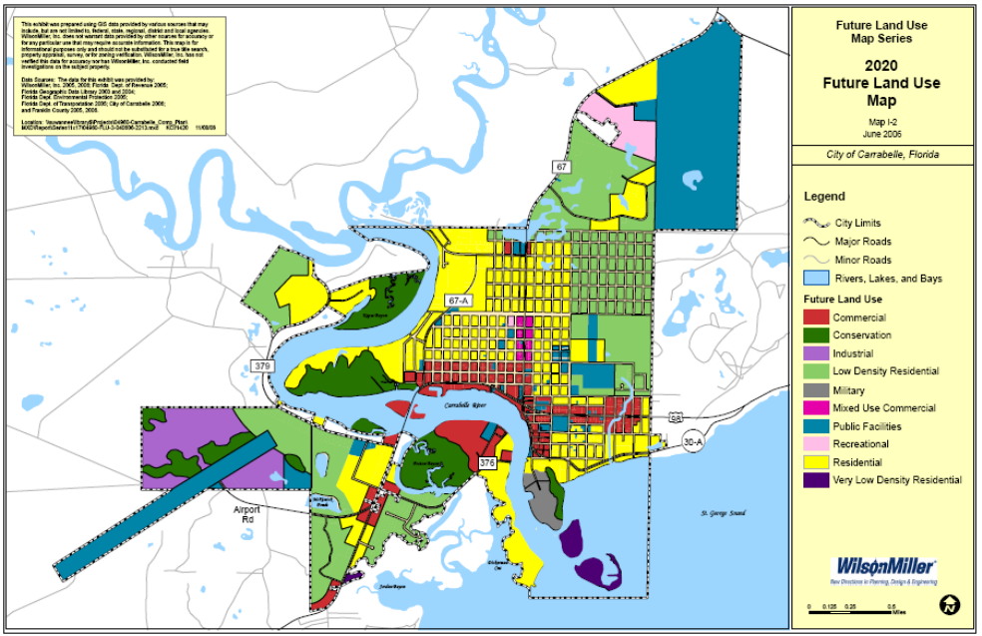

The town sits at the mouth of the Carrabelle River, a small coastal river made up of the convergence of the New and Crooked rivers. These rivers are small and provide linkage and drainage to lands within the Tates Hell Swamp and Ochlockonee river basin areas. Much of the town of Carrabelle is located on St. James Island. The so called “Isle of St. James” is essentially a part of the mainland but technically separated by the Crooked and Ochlockonee rivers and faces St George Sound and the Gulf. Along the gulf face are the eastern neighboring communities of Lanark Beach, St. Teresa and Alligator Point and off St. James Island to the west are Eastpoint and Apalachicola. These areas represent the “developed” portions of Franklin County, the remaining bulk of lands being under public ownership.

This coastal area features more than 200 miles of relatively undeveloped shoreline and includes the four barrier islands of St. George, Dog Island, Cape St. George and St. Vincent Island. Carrabelle is accessible via US Highway 98 or County Road 67. By air, Carrabelle can be reached through commercial airports in Tallahassee and Panama City and by private an airport in Carrabelle.

In the larger landscape, Carrabelle stands rather isolated midway along the Franklin County coastal shore and is surrounded by a vast area of publicly held state and national forests. The surrounding swamp and forest landscape has long been a vital part of the community’s economic base, providing many years of jobs and income from harvesting and transport of timber products. Equally important and culturally and historically a strong part of the local economic base have been activities associated with harvesting and marketing of seafood or sea-based products.

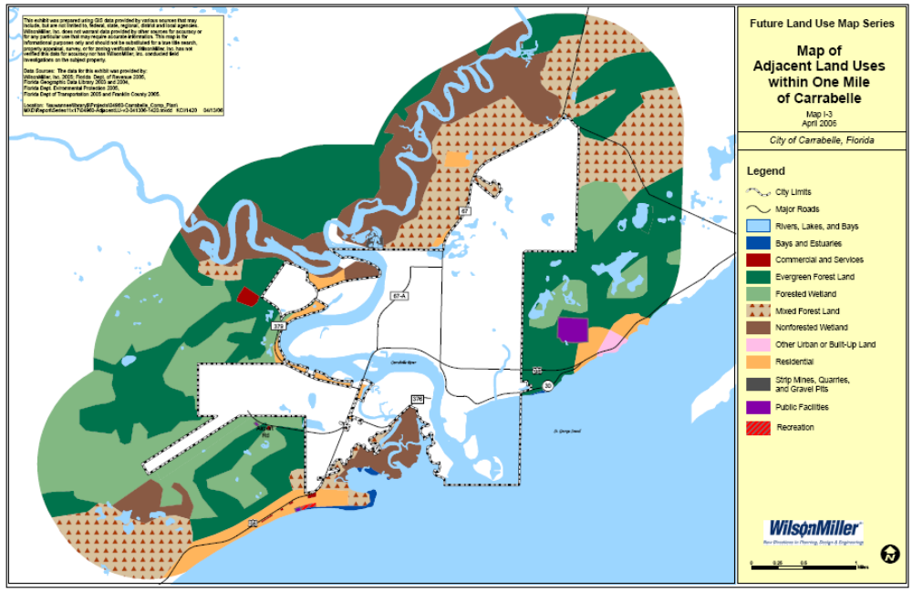

Carrabelle Florida, Background Material – Population Characteristics
As of the year 2000 census, there were 1,303 people, 562 households, and 370 families residing in the city. The population density was 134.9/km² (349.2/mi²). There were 790 housing units at an average density of 81.8/km² (211.7/mi²).

The racial makeup of the city was 91.48% White, 5.68% African American, 0.31% Native American, 0.08% Asian, 0.08% Pacific Islander, 0.84% from other races, and 1.53% from two or more races. Hispanic was 1.61% of the population.

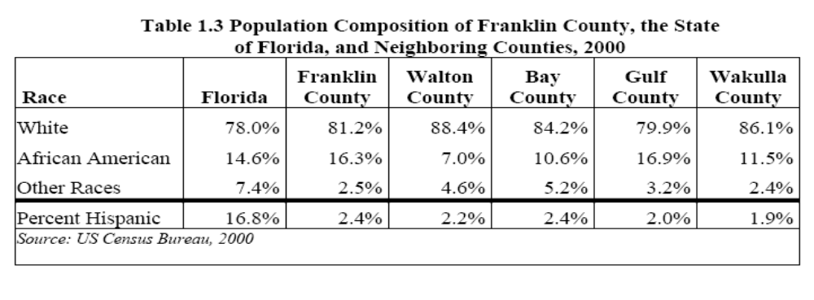
As noted above, there were 562 households out of which 26.9% had children under the age of 18 living with them, 48.0% were married couples living together, 12.1% had a female householder with no husband present, and 34.0% were non-families. 30.6% of all households were made up of individuals and 12.3% had someone living alone who was 65 years of age or older. The average household size was 2.30 and the average family size was 2.83.
In the city, the population was spread out with 23.3% under the age of 18, 7.8% from 18 to 24, 24.1% from 25 to 44, 27.5% from 45 to 64, and 17.3% who were 65 years of age or older. In 2000 the median age was 41 years. For every 100 females there were 93.3 males. For every 100 females age 18 and over, there were 92.3 males.
The median income for a household in the city was $23,749, and the median income for a family was $27,955. Males had a median income of $26,719 versus $19,018 for females. The per capita income for the city was low at $14,677, for the County it was $16,140 and for the State it was $21,557 (2000). About 14.8% of families and 19.4% of the population were below the poverty line, including 18.9% of those under age 18 and 24.2% age 65 or over.
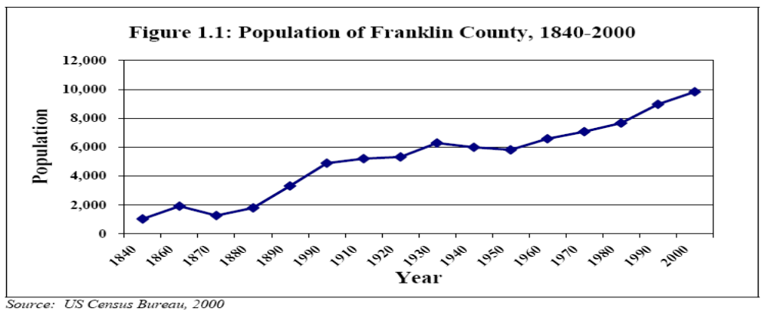
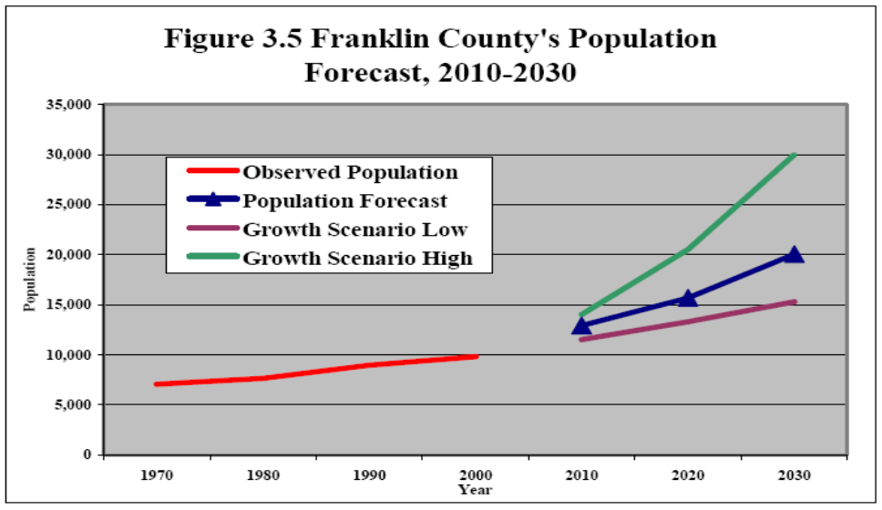

Carrabelle – Its History

Early History and Settlement
Native Americans, Spanish, English, and later Americans helped to shape and reshape this region throughout time. The history of Carrabelle and Dog Island, Florida includes a wonderful mix of Indians, shipping, bootlegging, logging and war. Native Indians sought this spot for a settlement where the river met the Gulf. The high hills kept them safe from attacks by enemy and predator alike while the waters of St. George Sound were calm enough for plentiful fishing from dugout canoes. Recently a 1200 year old canoe was unearthed on Dog Island indicating early use of the area by Indians.

In 1528 the first recorded Spanish expedition, the ill fated expedition of Panfilo de Narvaez, passes through the area. They recorded stopping at an Indian Village that may have been Tahiti Beach on St. Vincent's Island. The expedition had started from the Tampa Bay area and moved overland to an Indian village near present day St. Marks enroute to the Rio Grande in Texas. Here they decided to build boats in an effort to reach Mexico. Their situation was desperate; swords and armor were forged into saws and nails for the construction of their small boats. The details are sketchy as only four survived, one of them; de Vaca wrote the account of their eight year struggle to reach Mexico. Another survivor, a Moorish servant, started the fable of the "Seven Cities of Gold".

In 1683 on a map attributed to Alonso Solana, two Indian villages are located on the east bank of what appears to be the Carrabelle River. On his map he calls it Rio Chachave. The villages assumed to be Tocobagas, who relocated here after a war with the Calosas in the Tampa Bay area. In 1686 Juan Jordon de Reina mentions passing the mouths of three rivers before reaching the Apalachicola River. He was traveling from St. Marks to Pensacola.

In 1701 Father Antonio de Jesus of Pensacola landed on one of the islands off Carrabelle to take shelter from a storm. He was an investigator for the Inquisition. During this period of time, mariners and travelers avoided the area. Spanish Slavers raided the coast for Indian slaves to replace those in Cuba who had died from disease and overwork. It is believed that pirates and smugglers were well aware of the area and the protection offered in St. Georges Sound.

Dog Island and St. George Island were excellent staging areas for raids on the local ports. Pirates successfully raided San Marcos in 1677 and 1682, burning the fort, taking ships, and ransoming prisoners. The number of ships lost in this area will probably never be known. Pieces of old vessels continue to be found. Little is recorded of the Carrabelle River and the exploits of visitors to the area..

In 1776 the brigantine Tiger (Le Tigre) shipwrecked off of Dog Island during a winter storm on February 16th. Survivors eventually reached the swamp on the mainland near present day Carrabelle and began their trek slowly eastward toward Fort St. Marks. A best-selling narrative by survivor Pierre Viaud-Naufrage et Aventures de M. Pierre Viaud-shocked European audiences with its tales of disaster at sea, betrayal, death, murder, native savages, wild animals, cannibalism, and eventually, being rescued by the British soldiers garrisoned at St. Marks.

To tell the story of nineteenth century Carrabelle you must talk about boats, not just the large ocean going vessels that called on these two towns, but the local boats that facilitated commerce for these communities. These vessels worked among the mud flats, sandbars, oyster beds, shallow creeks, and short, choppy seas of the surrounding sounds. Local watercraft transported goods, people, and information throughout the region and ultimately facilitated the movement of commodities to more distant ports across the globe.

In the early 1800's there were roving bands of Indians and sea captains avoided the uninhabited coasts, landing only when they had no other choice. Most people of the time had heard stories of the North Florida Wilderness that was full of bears, wolves, wildcats, deer and alligators. This became an area to be avoided.

“Florida’s territorial and early statehood setting is a land where pioneers still fear the Indians and subjugate the blacks. Cracker cattle, wild boars, civets, and snakes saunter, run, sneak, and slither in your backyard. Cotton and lumber ply the rivers, turpentine camps flourish, and rural Florida thrives even as it hugs the waterways necessary for survival.” (Thesis paper, FSU)

Early settlers in the area, both Indians and early Europeans, hunted the bountiful game for food and furs, which were then shipped out of St. Marks. Sportsmen began coming from St. Marks to fish in the nearby New River and to hunt big game in the area that became known as Tates Hell Swamp. There was an old road that ran along the coast from St. Marks to the Apalachicola River. In 1837 the last Indians are removed from the Carrabelle area and Dog Island to be "moved" to Oklahoma.

By 1855 settlers near Carrabelle were beginning to create small homesteads out of the virgin forests and swamps. Among the first was a family headed by McCagor Pickett. By the beginning of the Civil War a small community existed. This was a time when Yellow Fever and hurricanes could easily obliterate communities.

During the Civil War the Crooked River area was defended by C. S. A. Captain H. T. Blocker of the Beauregard Rangers. Their Headquarters was located several miles away at Camp Gladden. The U.S. Gunboat Sagamore made several references to the location. The Gunboat was on Blockade Duty. There were two plantations two miles up the Crooked River. On May 20th a Union Cutter brought troops to the area. Captain Blocker had seen the Union Cutter and waited in ambush on Carr's Hill (now Coombs Hill). When they attacked, the Yankees jumped into the river, fled into the swamp or swam along side the cutter for protection. The Confederates killed or wounded 17 of the 21 men. Although the Yankees returned fire from their vessel, no one on the Confederate side was injured. The Confederates burned the stairway and damaged the lens in the Dog Island lighthouse to prevent its use as a lighthouse or lookout tower. Dog Island and St. Vincent Island were of strategic importance to the Union Navy during the Civil War, and they were used as staging points for the blockade of the Port of Apalachicola.

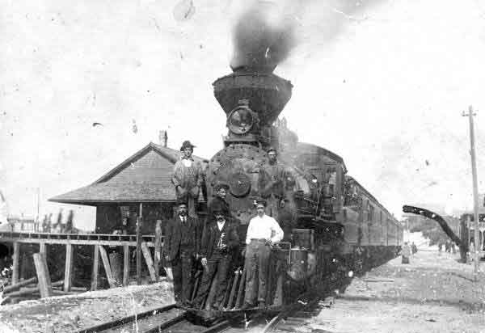
During the War Between the States blackout conditions were maintained since many Union ships sailed these waters. Union sailors rowed ashore from their ships into Postum Bayou in search of food and provisions. Carrabelle's boom time came after the Civil War when lumber and naval stores were the most important commodities.

Timber, Lumberyards and Saw Mills

In the 1870s the beginning of the area's timber industry starts with several small lumber mills. The supply of timber seemed endless and the industry began to grow. The timber industry would be the mainstay of the area's economy for many decades.

In 1875 the first lumber mill was established - cutting pine and cypress from up river and in swamps, and shipping it to the North. Ships, mainly schooners, would come through and pass and drop anchor behind Dog Island in Ballast Cove, so named because the ships would drop their ship’s ballast before sailing into Carrabelle to pick up their cargo. The ballast piles located in Ballast Cove are also important because they represent the remains of anchorage activities. That is, vessels dropped ballast overboard in order to take on the cargoes. As ballast was tossed overboard so was their onboard refuse providing some indication of the length of time the area was utilized as a ballast dump. To this day, you can find ballast rock in the cove. (From FSU Study – Student Thesis which also noted: The submerged archaeological resources throughout the region reflect the diverse nature of the resources as well as the different cultures that they represent. Furthermore, these submerged archaeological resources are also a reflection of the economic institutions within the region.)
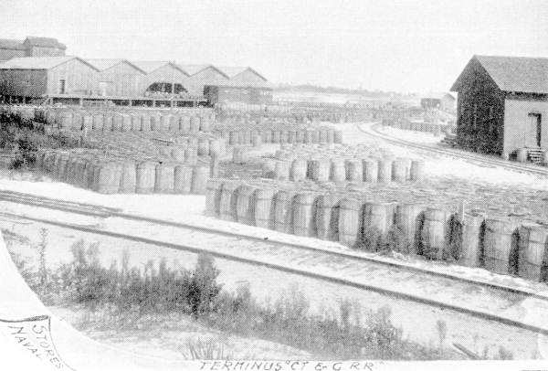
Though there were some local settlers at this time the area was still rather sparsely inhabited and in 1876 a geographic explorer named Nathaniel H. Bishop navigated the Crooked River through a low pine savanna country to the Ochlockonee River. To him the entire region appeared destitute of the habitation.

In 1877 a Mr. Oliver Hudson Kelly, from Massachusetts, came ashore with a few others and founded the town and named it "Rio Carrabelle". Rio Carrabella appears to mean "beautiful-faced river.” Though there are other stories and legends about the exact source of the name Carrabelle. Mr. Kelly had purchased 920 acres from Benjamin Curtis who also owned Dog Island. In the following year 1878 the first U.S. Post office was established and its address was Rio Carrabelle. By 1890 the United States Census reports that Carrabelle has 482 residents.

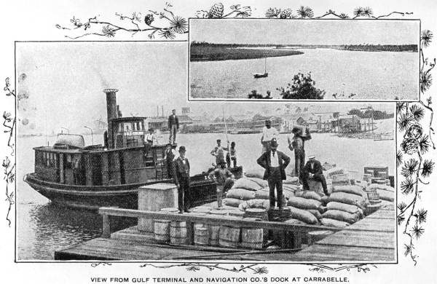
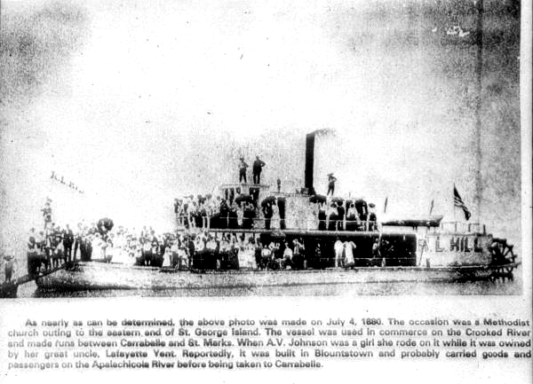
By 1893 there were many lumber and saw mills along the Carrabelle River and the downtown area was established around Coombs Mill, close to the mouth of the river. Lumberyards were prevalent in Carrabelle from the 1880s to the early 1920s. Sometimes the demand for specific wood products was strong enough that harvesters and local saw mills essentially decimated certain forest types within a geographical area. Sawmill owners would seek to buy non-contiguous land or lease other nearby lands to meet the increasing need for production.

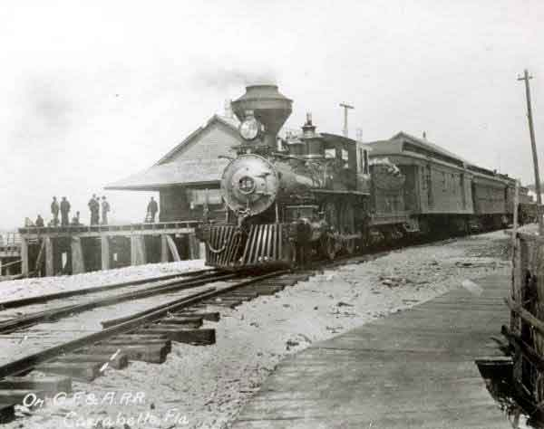
The former CT&G # 15 made its station stop at the Carrabelle wharf and depot after the 1906 merger.

Railroad and Port Development Cause Carrabelle to Grow
On the 11th of May, 1893, Carrabelle became a city within the State of Florida
The town of Carrabelle continued to exist and grow and was incorporated in May 1893. During this time, the area flourished - docks were stacked high with lumber (rich yellow pine forest in southwest Georgia and northern Florida), forest products such as rosin and turpentine, cotton and dried seafood products. Railroads began to extend into the region. Early Gulf Coast railroads tended to follow the path of high-yield lumber mills and modified natural products. For the Carrabelle area the story begins as two short lines began, one pushing north from Carrabelle, the other heading south from Bainbridge, Georgia.
The railroad from Carrabelle began in 1883. The railroad was run north from Carrabelle to Thomasville, Georgia, via Tallahassee. At first the railroad was only able to build 11-1/2 miles from Carrabelle when it met its first obstacle, the Sopchoppy River and a lack of funding for a bridge. At this point the railroad owned one locomotive, which was used for construction, but no regular trains were operated. In 1889 they reformed as the Augusta, Tallahassee & Gulf railroad. Helping to catalyze the operation, William Clark of the Clark Thread Company purchased 175,000 acres of pine lands near the railroad and needed a railroad to transport the pine. He purchased the Augusta Tallahassee & Gulf in 1891 and reorganized it as the Carrabelle, Tallahassee & Georgia (CT&G) Railroad.
Clark began construction of the bridge across the Sopchoppy River and the pushed north to Tallahassee, reaching the city by October of 1893. For a reward the soon received a state land grant of 206,370 acres. In Tallahassee the CT&G connected with the Florida Central & Peninsular, which ran east and west, connecting the railroad with Jacksonville and Chattahoochee. The FC&P would soon be absorbed by the Seaboard Air Line. Meanwhile in 1895, a Savannah lumberman by the name of John P. Williams needed a railroad to be built through his pine lands south of Bainbridge, Georgia. He quickly incorporated the Georgia Pine Railway on September 13, 1895. The railroad slowly built south from Bainbridge, reaching 40 miles to Arlington, Georgia in 1897.
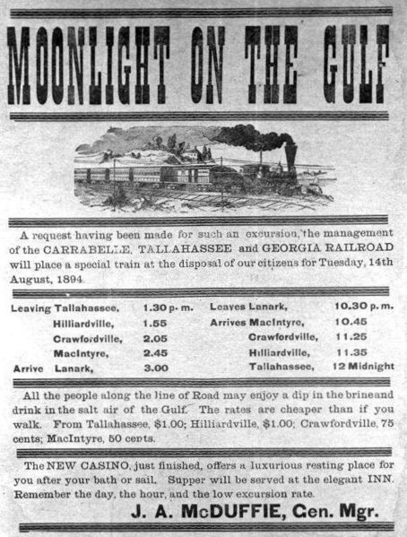
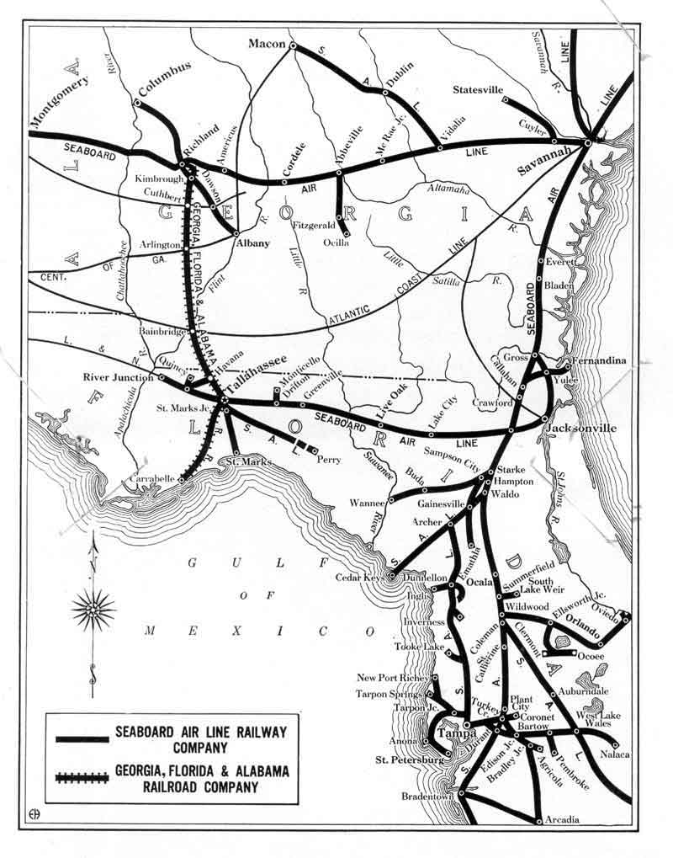
Seeing an opportunity to reach Tallahassee and its Jacksonville connection he proceeded to build 41 miles further south, reaching the Florida capital city in 1902.
In 1901 Williams reincorporated the railroad as the Georgia Florida and Alabama (GF&A). In 1904 he leased the struggling CT&G, buying it outright in 1906. The new GF&A stretched 192 miles from Carrabelle to Richland, Georgia forming an important bridge route. The Georgia, Florida & Alabama Railroad was the main artery into Carrabelle. The station along the waterfront was a center of activity. Trains carried locally harvested salted mullet and other seafood products, timber and other forest goods north, as well as serving as a transfer point for cargo being loaded onto ships leaving the port. The trains also brought in mail and needed supplies for the Carrabelle and regional residents. Interestingly, the railroad owned the side-wheeler "Crescent City" and the tug "Iola", which was used for freight barges.
In support of the early tourism industry, the railroad also brought tourists from Tallahassee and elsewhere to stay at the Lanark Springs Hotel, a luxurious resort hotel just to the east of Carrabelle. Steamship service was offered by the old CT&G and the new GF&A from Carrabelle to Apalachicola. However due to competition from the newly built Apalachicola Northern, the service of these boats was diminished by the 1910's. Eventually this steamship service was abandoned in 1923. Further, by 1927 the railroad was up for sale, due to the death of Mrs. Williams, who had inherited the railroad from her husband a few years before. The Carrabelle to Tallahassee line was abandoned in 1948, after serving a prominent role during World War Two as an important military line, serving an amphibious base near Carrabelle.
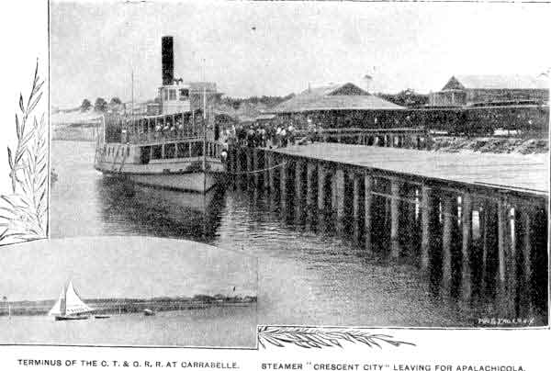
The Crescent City in Carrabelle
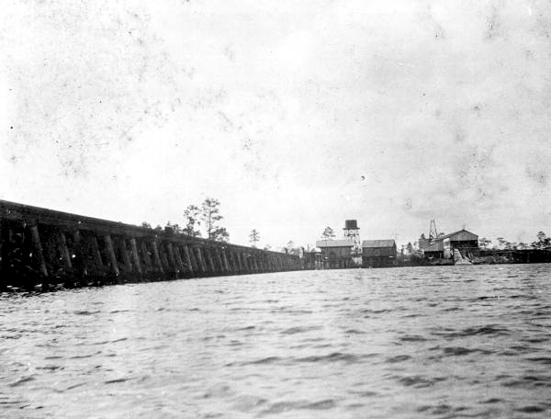
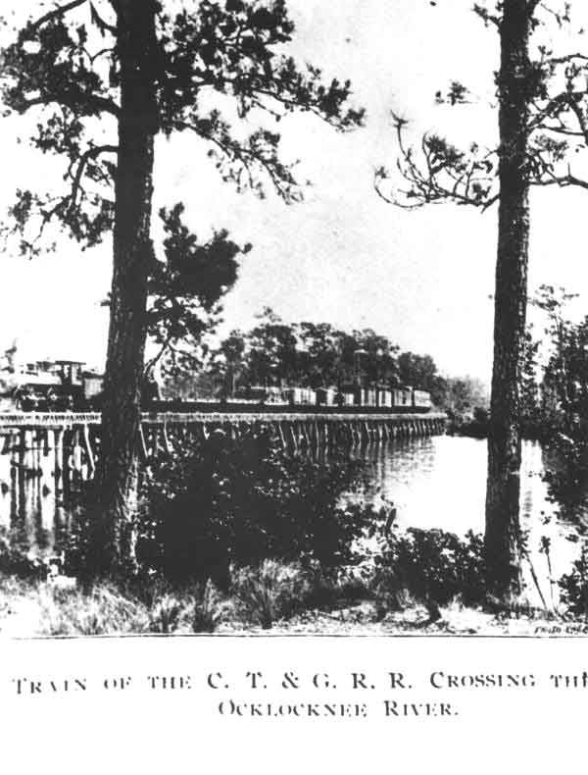

Two views of the Railroad bridge across the Ochlockonee River. The picture on the left is looking from Wakulla County to Franklin County (adjacent to where Highway 319 crosses). The logging and rail transfer point settlement of McIntyre is seen on the shore.

At the Turn of the Century – 1900
A disastrous hurricane hit the town at the turn of the century. The docks and wharves in Carrabelle containing about 400,000 feet of lumber and 50,000 barrels of rosin were all swept away. 15 vessels were tossed high and dry on St. George and Dog Islands. Masts from the wrecked vessels washed ashore all along the coast for years. A total of 40 cargo ships and sailing vessels in the area were destroyed by the hurricane. With telegraph lines down, a man was dispatched by horseback to Tallahassee with the news of the devastation of Carrabelle.

As a result of this hurricane the center of town was moved to the present location and the town was rebuilt, and many of today's larger buildings were built during the early part of the 1900's. The hurricane was detailed in an article published by the New York Times dated August 5, 1899.

DESTRUCTION IN FLORIDA, Three Towns Completely Annihilated by the Cyclone Wednesday, MANY VESSELS TOTAL WRECKS - Unidentified Dead Bodies Are Found in the Debris—Losses Over a Million Dollars
River Junction, Fla. Aug. 4 — the most disastrous cyclone that ever visited this section of Florida completely annihilated Carrabelle, McIntyre, and Lanark Inn, south of here Wednesday. At Carrabelle only nine houses remain of a once beautiful and prosperous town. Communications from the Mayor state that 200 families are without homes or shelter, and many are completely destitute.

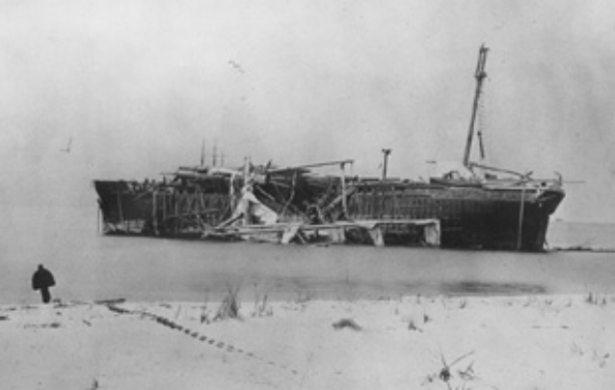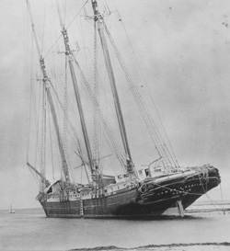
Ship wrecks on Dog Island 1899

Of McIntyre only two mill boilers mark the site of the town. Lanark Inn, the famous summer resort, was blown into the Gulf. The Carrabelle, Tallahassee & Georgia Railroad is washed away for a distance of thirty miles. A passenger train was blown from the track more than 100 yards. Many passengers were injured, but their names are unobtainable. Mary Williams, colored, was killed at Carrabelle. Numerous other people had legs and arms broken. Daniel Neel of Apalachicola had his back broken, and is not expected to recover. No fatalities are reported from McIntyre and Lanark.

Fifteen ships lying at anchor in Dog Island Cove and Upper Anchorage are complete wrecks, high and dry on St. George’s and Dog Islands. Twelve were loaded with lumber and ready for sea. When the Italian bark Corteria [sic] struck she split half in two from stem to stern. The names of the ships blown on the islands and which are total wrecks are as follows: Norwegian barks Ranavola, Edwardson, master; Vale, Andersen, master; Jafnar, Tygensen, master; Hindoo, Madsen, master; Elsbeth [sic], Pedersen, master; Russian bark Latara, Krantman, master; American schooners Benjamin C. Cromwell, McClean, master; Mary E. Morse, Densmore, master; Grace Andrews, Brown, master; Warren Adams, Gibbons, master; James A. Garfield, Cottingham, master; bark Vidette, Waldren, master; Italian bark Cortesia, fishing smack Albert Haley.
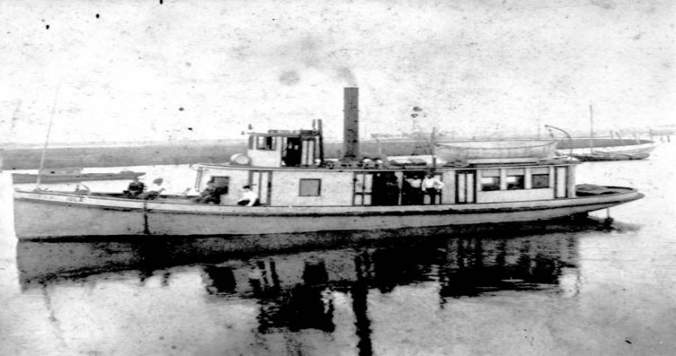
Small Steamer Iola

Three pilot boats and the steamers Iola and Capitola, and forty boats under twenty tons, were lost. Six lumber lighters, loaded, are gone. Not one of the entire fleet can be saved. Five unidentified bodies were recovered to-day, supposed to be sailors. Tugboats have gone from here to the scene of the wreckage. Fifty destitute sailors were brought here to-day and are being cared for. A mass meeting of citizens is being held here to-night, and all possible aid will be given the destitute at Carrabelle. One million dollars will not cover the loss. The insurance is small (New York Times, Aug. 5, 1899).
During Prohibition much business was done by barter and there was a brief period in which smugglers from the Caribbean unloaded their contraband near Alligator Point and hid in the nearby woods. Smugglers frequented the quiet port town of Carrabelle.

The depression of the 1930's brought even leaner years for the city of Carrabelle. During this period Mrs. Cliff Miller, also known as Miss Tilly, moved to Carrabelle from Louisiana. She brought with her much-needed medical skills and a generosity to match. The Bridge over the Carrabelle River was named the Tilly Miller Bridge in her honor.

Between this period of World War I and World War II, Carrabelle went into a severe economic slump. Money was in short supply and most accounts speak of a time a hard work with little pay. Fishing became the principal industry and along with the entire country and Carrabelle slipped into the depression and hunting in the forests and swamps served to supplement Carrabelle citizens’ daily living rations.

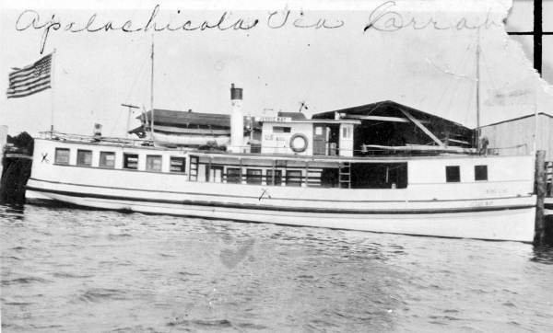

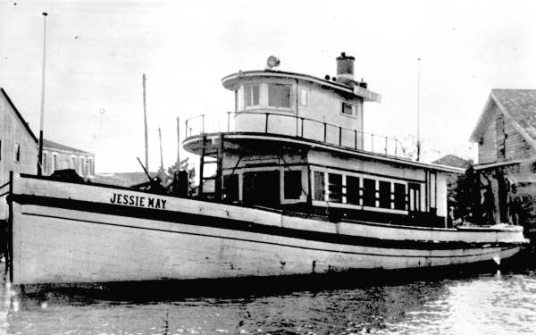
Jessie Mae – 1935 and an earlier shot

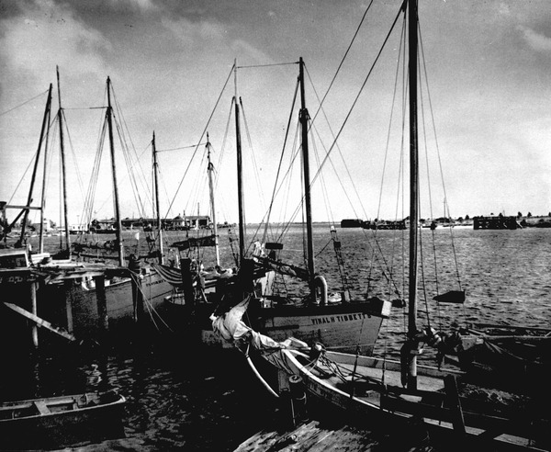
During a short period, Greek sailors came and began a flourishing sponge industry.

Greek Sponge Boats in Carrabelle

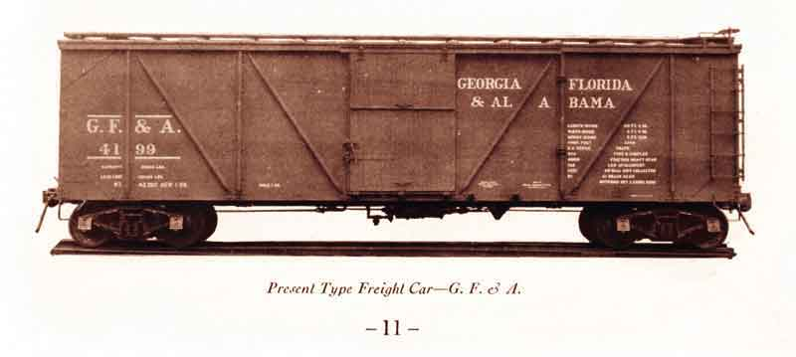

The World War II Era
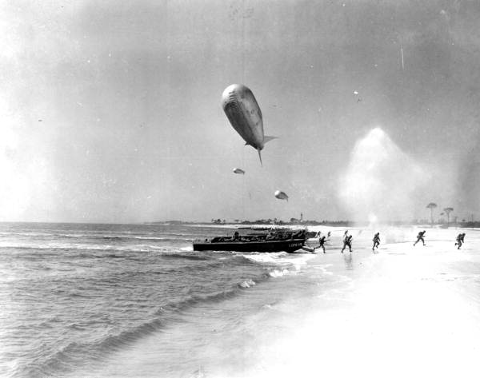
With the start of World War I, there was a great demand for lumber and turpentine. Business in the Carrabelle region picked up and ended the long-term slump of the Depression years. In 1942, with the entry of the United States into WW II, Camp Gordon Johnston was built and over 250,000 men trained at the camp for amphibious assault before its closing in June of 1946. For many soldiers it was the last stopover before going to the Pacific or European theaters.

“One of the larger bases was Camp Gordon Johnston. In June 1942 the U.S. War Department selected a 155,000 acre section of coastal Franklin County to be used as an amphibious warfare training center. Originally called Camp Carrabelle, the base was renamed in January 1943 to honor the memory of Colonel Gordon Johnston, who had died in 1934. The3rd Engineer Amphibian Brigade arrived for training on September 10, 1942. One of the largest army facilities in Florida during World War II, the base was known by troops stationed there as "Hell-by-the-Sea" because of its crude living conditions and dangerous training programs.

The 4th, 28th and 38th Infantry Divisions also received training at the base. Its mission was changed September, 1943 to train personnel to operate small harbor craft and amphibious vehicles. In 1944, German and Italian prisoners of war were interned at the camp. The end of World War II in August 1945 made Camp Gordon Johnston obsolete, and it was decommissioned in 1946.

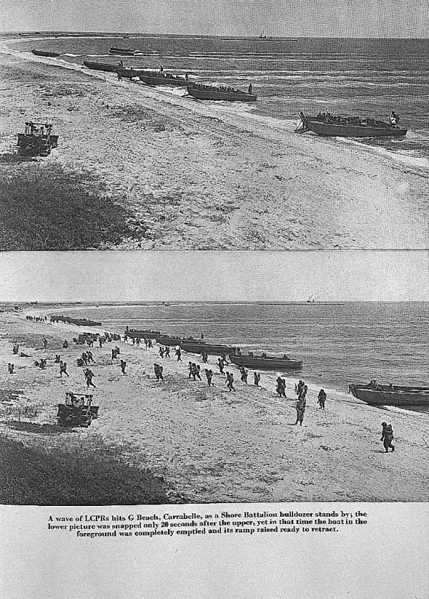
In late 1943, Carrabelle Beach and Dog Island, while they were a part of Camp Gordon Johnston, were used by the U.S. Army 4th Infantry Division to train for the Normandy Invasion on D-Day, June 6th, 1944. The Amphibious Training Center had been officially closed, but it was reopened and staffed for the purpose of training for this important mission. Although the troops had trained for over three years, the amphibious training conducted on this site was the last step
before shipping out to England for the invasion. On D-Day, the first amphibian infantry assault teams to arrive on French soil were from the 4th Infantry Division at Utah Beach.

On June 6, 2000, the Camp Gordon Johnston Association extracted a small amount of soil from this site and delivered it to the National 4th Infantry Division Association to be placed in the Association’s monument in Arlington, VA. The U.S. Department of Defense’s World War II Commemoration Committee in 1995 named the Camp Gordon Johnston Association an official “Commemorative Community.” [Adapted from the Florida Area Natural Inventory, Apalachicola Regional Resources on the Web (ARROW) – History of the Region]

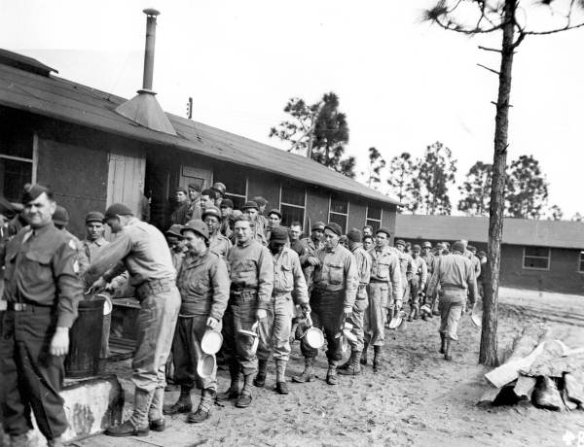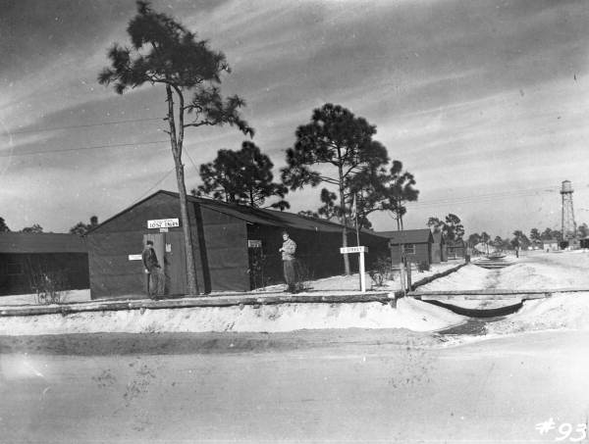
From the web page, 5th Armor Division, web page showing scenes from Camp Gordon Johnston. www.5ad.org/units/GordonJohnston.html

In Carrabelle there is the Camp Gordon Johnston Museum. The museum has compiled an extensive visual history of the area and camp life. The museum’s role is to preserve the heritage of the men who trained at the camp during World War II. The Camp Gordon Johnston Museum is located in downtown Carrabelle.

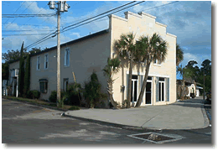

Carrabelle was also an important port for trans-shipment of oil during this time period. The oil was shipped by barge from Texas, through the Intracoastal Waterway to Carrabelle and then on to Jacksonville through a pipeline, where it was loaded on ships for delivery to Europe. The pipeline began at what is now known as Three Rivers.

Post World War II to the Present
After the war the town’s economy centered around shrimping with shrimp boats rafted three or more abreast during the harvest season. In addition, the tree farms of Buckeye Cellulose Company and the St. Joseph Paper Company made work for many residents, planting and harvesting trees.
The mid1950s and 1960s brought another boom to Carrabelle with the party boat era. Eight large boats shipped out of local marinas taking groups of visitors out to fish or just “party.”

This is the time when Carrabelle’s chief of police in 1963, Albin Westberg, needed a better vantage point for to monitor the traffic at the main intersection of US 98 and CR 65. The St. Joseph Telephone and Telegraph, Co installed a special telephone booth under a chinaberry tree at that corner and the world’s smallest police station became nationally famous when news of it appeared on the Johnny Carson Show and the Today Show.

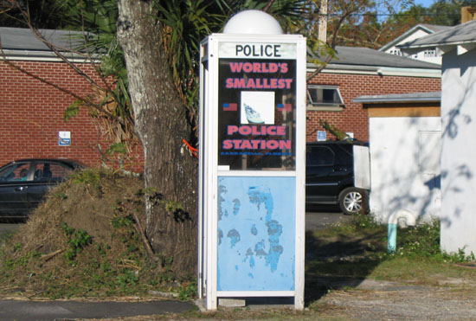

In the 1970s and 1980s Carrabelle continued to have a thriving seafood industry. Seafood processing houses dotted the waterfront employing local residents. The local waters were teeming with shrimp, mullet, scallops, and pompano that fed the local economy.

In the 1980s Franklin County was listed by the State of Florida as an Area of Critical State Concern (ACSC). This designation was applied to various portion of the state that had extremely important and environmentally sensitive natural resources. The designation brings state oversight of proposed development activities and requires state staff to review all local development projects. This designation was originally granted due to the importance of the Apalachicola Bay to the state’s environmental and economic health. Much of the area was de-designated as an ACSC in 1993 after the local governments had developed local development review processes and incorporated policies and land development regulations protective of the resources.

In the 1990s, Florida’s net ban and the rising price of gas seriously affected many small commercial fishermen and shrimpers and reduced their profits. Many independent commercial fishermen abandoned or had to restructure their means of livelihood. Further, due to the natural environmental resource sensitivities of the land and waters around Carrabelle and Franklin County in general, state and federal land and water conservation programs expanded the state and national forests and various hunting lands closed or became more regulated. These changes affected many local Carrabelle citizens that had grown up hunting and fishing on an unregulated landscape and supplemented their pantries with these game animal hunting resources.

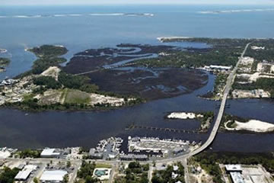

An added source of income that grew in local importance during the 1980 and 90s was drug smuggling. This was relatively common in the Carrabelle area and served to bolster the shrinking fishing based economy. The proverbial “square grouper”, large bales or packages of marijuana and other drugs were occasionally found along the area beaches resulting from being tossed or washed overboard.

The Development Boom of the 1990s and Early 2000s
In the late 1990’s, the “Pearl of the Panhandle” was discovered like the rest of this portion of Florida’s Forgotten Coast. Real estate developers and speculators began buying up, holding for a short while and then flipping all the available property - “for sale” signs sprung up everywhere. Waterfront buildings previously dedicated to the seafood harvesting and processing industry were being abandoned, torn down and land uses for residential and waterfront commercial were taking their place.

The shrimp boats, fish houses and commercial boating access points were being displaced by speculative residential and commercial developments. In addition, just outside the City limits larger new development were approved that catered to a new constituency or residents – retirees, second home owners and vacation rentals.

St. James Bay DRI
St. James Bay is located several miles east of Carrabelle on Highway 98. This is an approved Development of Regional Impact with a mixture of residential, commercial and golf course uses approved. Development is slowly proceeding especially since the real estate crash after 2006. St. James Bay has an 18-hole championship resort-style golf course was designed by Robert Walker, blends into the natural setting of the wooded environment. The developers worked closely with the Audubon International (not the Audubon Society) to create a course that blends with acres of wetland preserve and forests.
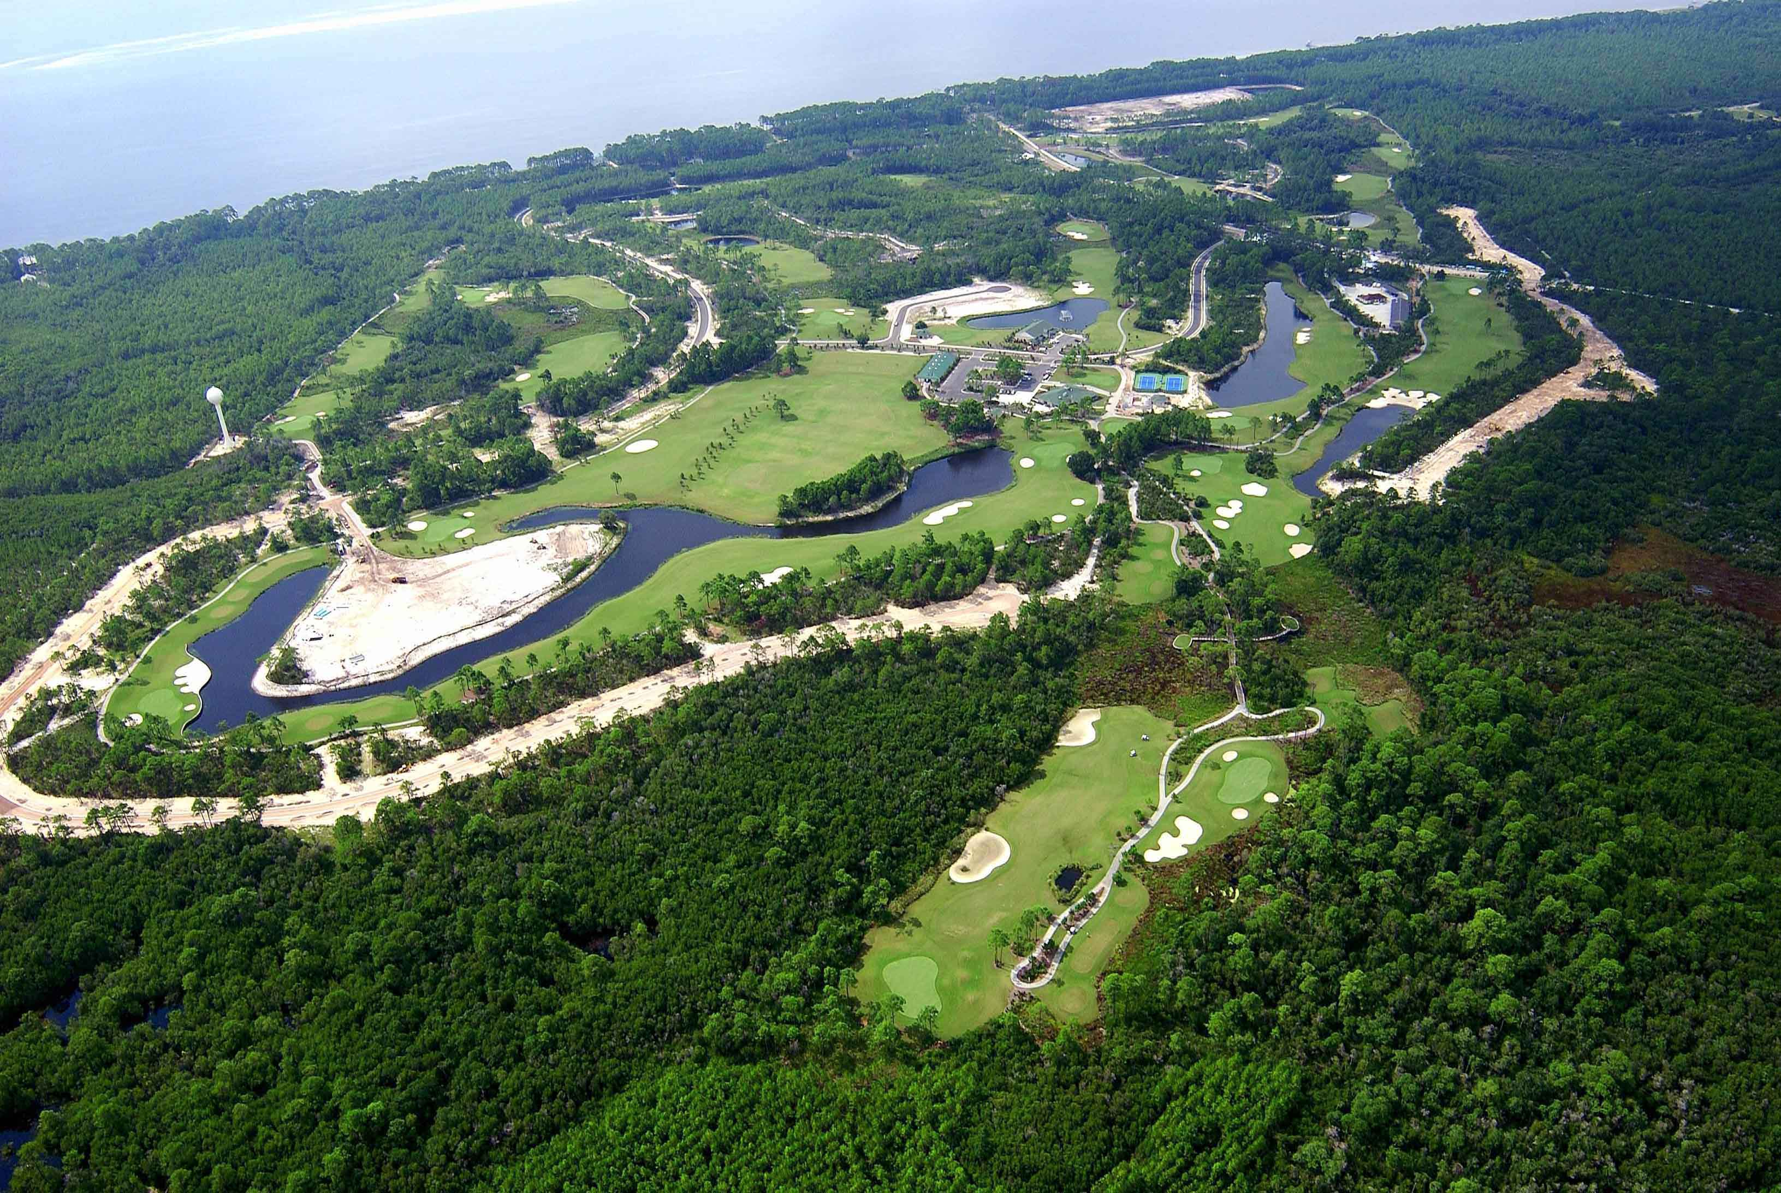

SummerCamp and Planned Development of the St. James Island Area
In the 1990s to the present, the largest private land owner in Franklin County, the St. Joe Company, initiated a development program under the new economic model of marketing to retirees, potential second home owners and vacation rentals. This new development program represented a major shift in focus for the area from directly linked natural-resource-based economies (harvest and sale of natural products) to coastal locational based leisure economies (coastal living and vacation products). St Joe lands within Carrabelle, such as Timber Island, and lands to the east all the way to Bald Point were being re-fashioned and entitlements sought and granted to foster this new economic model.

2008 and Beyond – A Community with Inseparable ties to Its Natural Resources
Carrabelle is still very much tied to its natural resource base though the social and culture is changing rapidly. Even with the collapse of the real estate bubble, the current economic base is moving from directly linked natural-resource-based economies (harvest and sale of natural products) to coastal locational based leisure economies (coastal living and vacation products). Nevertheless, the underlying harvestable natural resources continue to be present and provide an underpinning to the local economy and social and cultural scene.

The newer constituencies, cultures and economies rely in their own way on the underlying natural resources linkages. Thus today there are several fully equipped marinas, which cater to boaters and fishermen that live or visit the area. Recreational fishing possibilities abound and charter boats are available for offshore or bay fishing. Further, there are significant freshwater fishing opportunities up the Crooked and New rivers. Surf and bay fishing yields catches of flounder, redfish, pompano and at times Spanish mackerel.
Today’s Natural and Cultural Resources – Carrabelle
Carrabelle Beach - is just 1.5 miles west of Carrabelle and offers sunbathing, swimming and surf fishing. Public bathrooms and covered picnic areas are available.
The Crooked River Lighthouse was built in 1895 to replace the previous Dog Island Light House. In 1838, the Dog Island lighthouse was built near the western end of Dog Island to mark the middle entrance to St. George's Sound (present day East Pass). This was extremely important at this time due to the increased traffic of the cotton trade. The Dog Island Light that was destroyed in a hurricane in 1873.
The Crooked River Lighthouse saw many mariners safely home for the 100 years after it was lit. Authorities decided it would be better to have a lighthouse on the secure mainland rather than the exposed Dog Island. Electricity came to the lighthouse in 1933 and it became automated in 1952. The lens was built in 1894 by Henri LaPaute in Paris, France. The lens was removed in 1976 and is now located in the U.S. Coast Guard 8th District Offices in New Orleans. The lighthouse was decommissioned in 1995 and is no longer an active light.

The lighthouse sat forlorn and isolated for a few years. In 1999 a group of local residents decided that Carrabelle’s hidden jewel should be restored and open to the public. Thus, the Carrabelle Lighthouse Association (CLA) was born. The Association receives encouragement and assistance from the Florida Lighthouse Association as well as from many individuals. The goal of the CLA is to preserve, restore and open the lighthouse to the public. The deed was transferred to the City of Carrabelle in August of 2001. In February 2002 CLA reached an agreement with the city to manage the lighthouse.

Dog Island - Dog Island is a beautiful and fragile barrier island ecosystem in the Gulf of Mexico off of Carrabelle. As with many barrier islands, the land is constantly shifting and eroding because of winds, waves and tides. This sliver of land is approximately 6 and 1/2 miles long and up to 3/4 mile wide, encompassing approximately 1842 acres. Solitude is one word that is often used in describing Dog Island, as are peaceful and secluded. The only access is by boat or plane, and there are no phones, restaurants or stores. Visitors regularly come to the island and seek solitude, beachcombing, fishing, bird watching and hiking.

St. George Island & St George Island State Park is twenty minutes west of Carrabelle. Here you will find sugar white sands and rolling dunes. Biking & Hiking are available here are 9 miles of beautiful white sand beaches and high dunes, along with pine flatwoods and oak hammocks. Park visitors may also take advantage of the many trails and boardwalks throughout the park, or the 2 mile marked trail along the bay side of the park. Sandy coves and salt marshes along the bayside of the park make this place popular with canoeists. Kayaking enthusiasts may prefer the Gulf side, which also provides a scenic paddle.

Apalachicola National Forest
The Apalachicola National Forest, St. Vincent’s Wildlife Refuge and Apalachicola Wildlife Area provide approximately 650,000 acres in Franklin and adjoining counties. Hunt is and traditionally has been an important part of the local culture and economy. Game animals in these areas include deer, bear, turkey, wild hogs and a variety of small game.

Tate’s Hell State Forest - Tate's Hell State Forest is one continuous tract of land comprising over 185,000 acres. It essentially wraps around Carrabelle except coastal lands on St. James Island to the east. The Forest is home to several threatened and endangered species including; the red-cockaded woodpecker, bald eagle, black bear, gopher tortoise and white-topped pitcher plant.

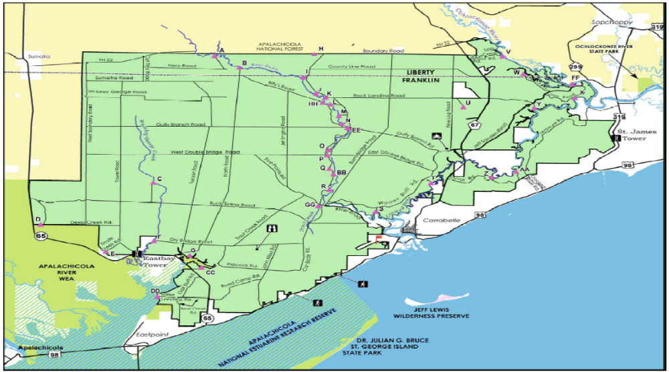
Thirty-five miles of rivers, streams and creeks throughout the forest provide excellent fishing opportunities. Catfish, trout, bass, bream, shellcracker and crappie are likely to be among the days catch. Tannin stained canoe trails wind through a variety of lowland habitats including marshes, tidal swamps, hardwood bottomlands and wet savannahs. Several launch sites are available throughout the forest with many conveniently located near primitive camp areas.

“The basic legend of Tate’s Hell is … that Cebe Tate, a 45 year old farmer living in Sumatra, went into the swamp one morning in 1875 looking for either lost cattle or for a panther that had been killing his stock. With him were three dogs. He became hopelessly lost trying to keep up with the distant baying of the hounds. One by one, the voices of the hounds diminished into silence. Tate is supposed to have fallen into a bog and lost his gun trying to free himself. Then, he was bitten by a moccasin. Instead of dying, he stumbled around the swamp delirious with a fever for 10 days. When he was found on the south side of the swamp near the coast, his hair had turned white. Asked his name and where he was from, Tate replied, my name is Tate, and I’ve just come through hell.”

The natural resources found on Tate's Hell State Forest are very diverse due to the unique and various natural community types. At one time Tate's Hell State Forest supported at least 12 major community types which included: wet flatwoods, wet prairie, seepage slope, baygall, floodplain forest, floodplain swamp, basin swamp, upland hardwood forest, sandhill, pine ridges, dense titi thickets and scrub. Currently, the forest contains approximately 107,300 acres of hydric communities such as wet prairie (contains a vast diversity of plant species), wet flatwoods, strand swamp, bottomland forest, baygall, and floodplain swamp. Past management practices have disrupted the function of the natural ecosystems on Tate's Hell State Forest. The restoration of these ecosystems is a primary objective of the Division of Forestry.
Many species of wildlife make their home on the forest. Those with confirmed sightings on Tate's Hell State Forest that are currently listed as threatened endangered or species of special concern are: bald eagle, Florida black bear, gopher tortoise, and red-cockaded woodpecker. Rare plant species living on the forest include: Thick-leaved Water-willow (Justicia crassifolia), White Birds-in-a-nest (Macbridea alba), Florida Bear grass (Nolina atopocarpa), Chapman's Butterwort (Pinguicula planifolia), and Small-flowered Meadow beauty (Rhexia parviflora).
The predominant hydrologic feature within the state forest is Tate's Hell Swamp, which drains toward Apalachicola River and Bay. The River and Bay are designated as Outstanding Florida Waters (OFWS), and are the highest priority water bodies under the Northwest Florida Water Management District's SWIM Program. The Apalachicola River is designated for recreation and propagation and maintenance of a healthy, well balanced population of fish and wildlife.
In Tate’s Hell canoe trails wind through a variety of lowland habitats which include marshes, tidal swamps, hardwood bottomlands and wet savannahs. Several canoe launch sites are available throughout the forest with many conveniently located near primitive camp areas.

Bald Point State Park - East of Carrabelle on the other end of St. James Island is Bald Point State Park. This relatively new park has over 4,800 acres of pristine coastal wilderness dotted with freshwater ponds and tidal marshes. Bald Point State Park’s coastal marshes, maritime hammocks, mesic flatwoods, and oak thickets host a wide variety of plant and animal life. The park supports more than 360 species of plants. Seasonal wildflowers, including the endangered Godfrey’s Blazing Star, may be seen blooming throughout the park.

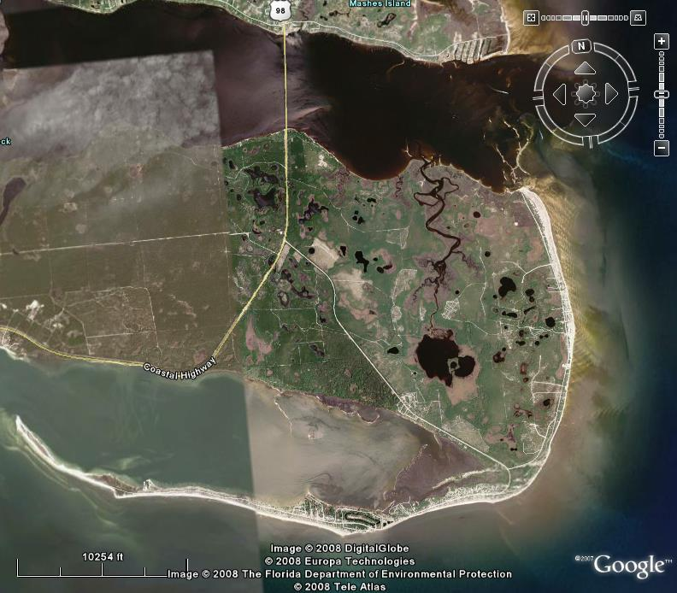

Wildlife at Bald Point is abundant with over 230 species of mammals, reptiles, birds and amphibians. Bald eagles, osprey, and migrating falcons are common sights in season. Deer, bear, raccoon, opossums, bobcats, foxes, birds, reptiles, and amphibians inhabit the woods, while monarch butterflies pause here on their autumn flight to Mexico. Tidal marshes, flat terrain of needle rush and sawgrass along the northwestern part of Bald Point provide breeding grounds for horseshoe crabs. The marshes are a valuable nursery for marine life and rich feeding ground for land and sea birds. Alligators also find the marsh a rich source of food.

To the west of Bald Point Road, mesic flatwoods are dotted with dark-water ponds, lakes, and marshes. Vegetation is predominantly a variety of pines, abundant hardwoods, saw palmetto and scrubby shrubs. Marsh grasses and other native swamp plants fill the wetlands. A thin strip of land along the northeastern shoreline, mostly old growth oak thickets and maritime hammocks, provides essential habitat for migrating and resident birds. Understory vegetation here is sparse – largely saw palmetto and yaupon holly.

Apalachicola National Estuarine Research Reserve was established September 1979 encompasses over 246,000 acres in Apalachicola Bay. It is the 2nd largest Estuarine Research Reserve System in the nation.
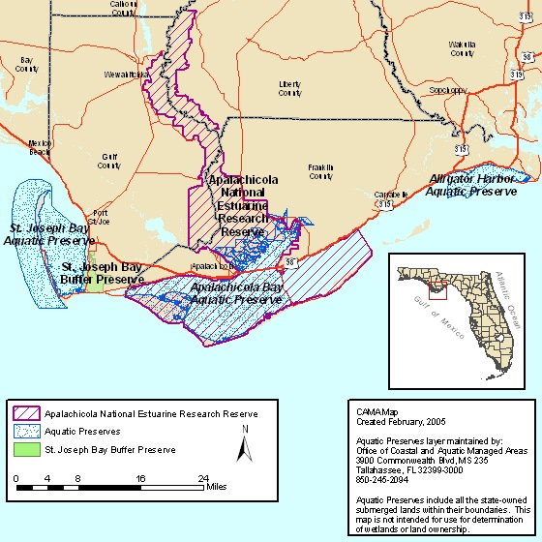
The Apalachicola National Estuarine Research Reserve (ANERR) is one of 25 sites designated by the National Oceanic and Atmospheric Administration as a Research Reserve. The program is a federal/state partnership with the Florida Department of Environmental Protection as the state program administrator. The ANERR is a consortium of management entities with various state and federal agencies assigned lead role management within the Reserve. National Estuarine Research Reserves have been established to provide opportunities for long-term estuarine research and monitoring, estuarine education and interpretations, resource management and to provide a basis for more informed coastal management decisions. All facets of Resource Management by the Reserve are guided by the primary goal of providing protection, conservation, restoration and enhancement of habitats within the Reserve, as well as those outside Reserve boundaries which may impact Reserve communities.

The reserve includes Apalachicola Bay. Apalachicola Bay is an exceptionally important nursery area for the Gulf of Mexico. Over 95% of all species harvested commercially and 85% of all species harvested recreationally in the open Gulf have to spend a portion of their life in estuarine waters. Blue crabs, for example, migrate as much as 300 miles to spawn in Apalachicola Bay. The Bay is a major forage area for such offshore fish species as gag grouper and gray snapper. The area is a major forage area for migratory birds in particular for trans-gulf migrants in the spring. Finally, Apalachicola Bay is a major point for migratory birds.

The area within the Reserve has state designations as; Aquatic Preserve, Outstanding Florida Waters, Class II Shellfish Harvesting Waters and a portion of the area is still designated as an Area of Critical State Concern, an EPA Gulf of Mexico Ecological Management Site and is a Biosphere Reserve by the United Nations UNESCO.

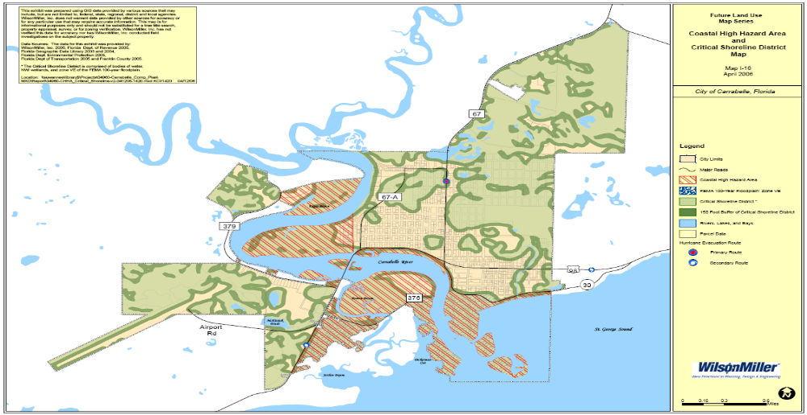

Diving
There are a number of good diving locations off our coast, most within 20 miles, making them readily accessible. Artificial reefs, ship wrecks, and five Air Force signal towers are just a few of the dive sites you will want to visit. Diving charters and instructors are available locally.

Riverfront Festival
The last weekend in April is a must-visit time in Carrabelle: Marine Street along the harbor is closed to traffic and lined end to end with art, crafts, food and music for 2 days.

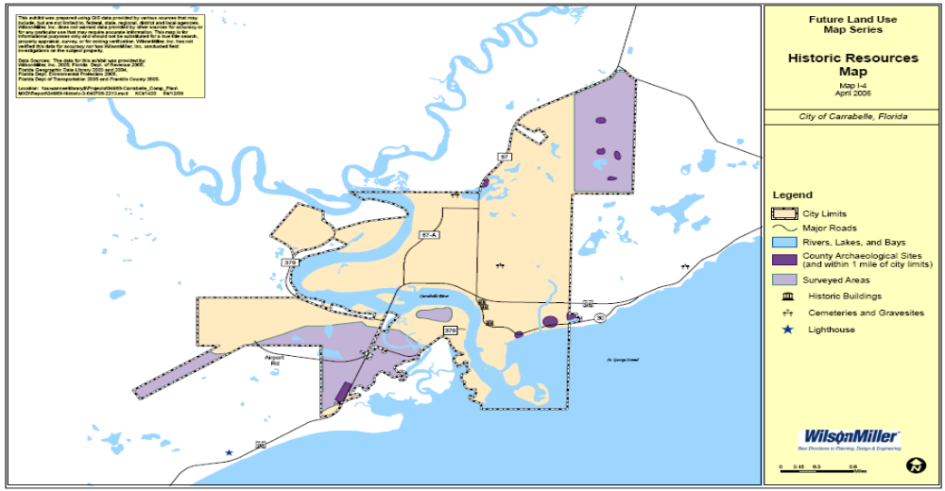

Comparing the Franklin County, the State of Florida and the United States Economies

“To understand Franklin County’s economy, it is useful to compare it to the state’s economy and that of the entire United States. This comparison is provided in Tables 4.1 and 4.2. Table 4.1 shows the number of employees by North American Industrial Classification System (NAICS) category and Table 4.2 provides a percentage of employment by industry.

These tables clearly illustrate how Florida’s economy differs markedly from the economy of the entire United States. The lack of manufacturing employment in the state and the county stand out (NAICS 31-33). In the US economy as a whole, roughly one in eight jobs is a manufacturing job, while Florida’s ratio is one in sixteen. The state’s tourist and retiree economy is evident in the high percentage of jobs tied up in accommodation (NAICS 72), support services (NAICS 56), and retail trade (NAICS 44-45).

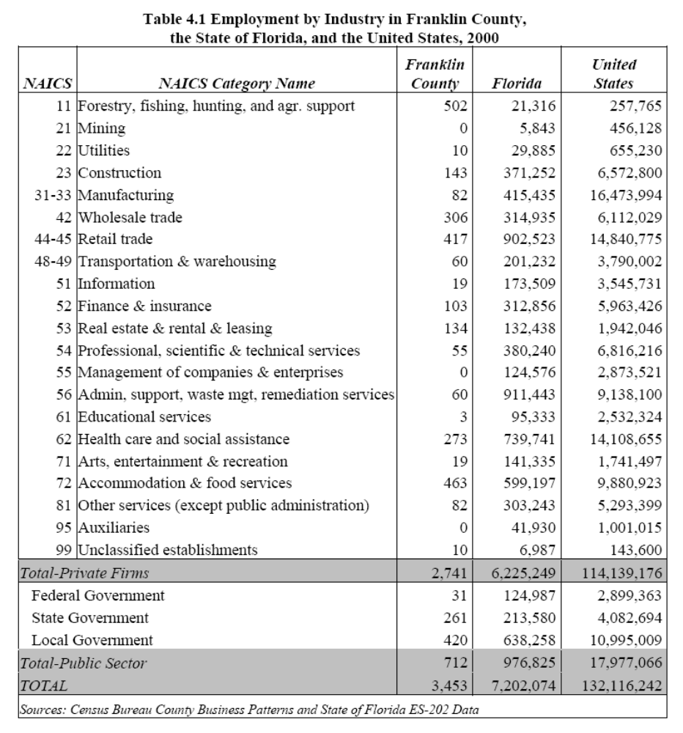
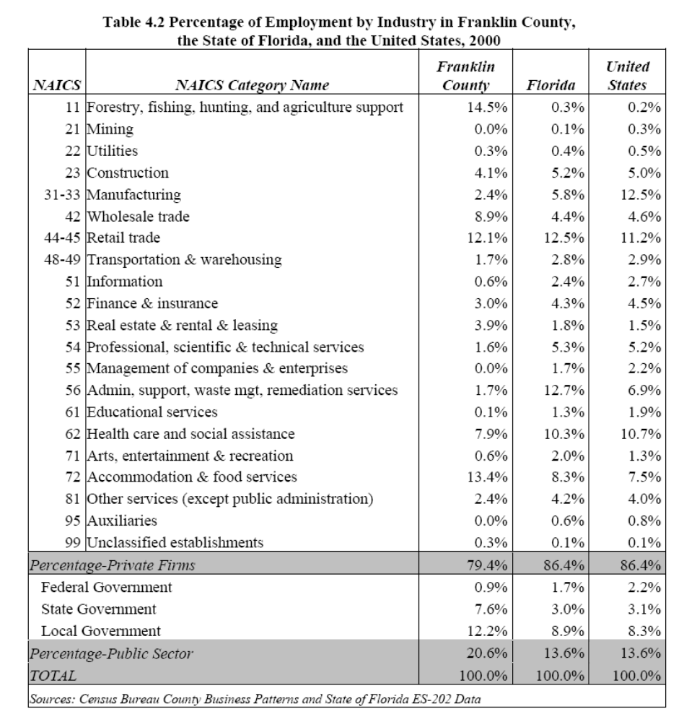

What these tables also illustrate is that Franklin County’s economy has already experienced a substantial transition from a resource-based economy to a tourism/recreation based economy. Franklin County has a large percentage of its private sector employment in retail trade and accommodation. In addition, almost four percent of the local workforce works in real estate development, well above the percentages in Florida and the United States, reflecting the importance of this sector to the local economy.

While tourism appears to be thriving in Franklin County, resource-based employment still plays a major role in the local economy. Franklin County has a substantial percentage of its workforce in the fishing economy, evidenced by the high values for Fishing (NAICS 11) and Wholesale Trade (NAICS 42). As most of the jobs in these two sectors are related to the fishing industry, Table 4.2 indicates that roughly one in five jobs in Franklin County are directly linked to this resource-based economy.

On the public sector employment side, surprisingly Franklin County has a higher percentage of its employment in state and local government jobs than might be expected for a small, rural county, at roughly twenty percent of its total employment. However, the state’s vast land holdings in the county and their commitment to protect and study Apalachicola Bay help to explain the large number of state jobs. As for the seemingly large number of local government jobs, it is important to recall that the administration of a county requires a substantial number of employees to cover the full range of duties of a local government. The county provides administrative services, fire and police services, waste management, as well as numerous other services that require personnel. In addition, many of the local government jobs in Franklin County are related to the school district.

What this initial analysis suggests is that Franklin County has an economy that reflects the emergent tourism/vacation/retiree economy of other developed counties in Florida’s Great Northwest rather than the still small, struggling economies of rural counties in the region. The county has already begun the transition to this services-based economy, although resource-based employment still has a strong foothold in the local economy. The data presented in Table 4.5 support this conclusion. This table presents population and employment data for all of the counties in Florida’s Great Northwest. …

A review of the percentage of jobs that are private sector in each county finds that Franklin County again fares well, placing fifth in the region. This suggests that Franklin County has more in common with developed, but non-government centered counties like Walton, Okaloosa, and Escambia, rather than smaller, rural counties like Gulf and Wakulla.

A New State Prison in Franklin County
Franklin County is the home of a new state prison. While this facility will bring inmates to the county, it is expected to have a sizable employment impact as well. The prison is assumed to be of similar size to that in Gulf County (approximately 1,200 inmates). The direct employment impact of the prison is projected to be 300 jobs (Franklin County Roundtable, 2003).

Central Finding: Taken together, this data paints a picture of a small, rural county that has a solid economic foundation. Despite its small population, the county has a well-developed and relatively diverse local economy reflective of more developed counties in the region. Franklin County’s economy has taken on attributes of larger, more developed counties, including: 1) the private sector share of the local economy is large, 2) the population to jobs ratio is relatively low, and 3) the economy has employment concentrated in more than one or two local sectors. The above findings suggest that Franklin County can be expected to weather any coming population growth relatively well. The economy has already begun the transition from a solely resource-based economy to a more diversified economy with employment concentrations across several industrial sectors.

Continued Decline of the Resource-Based Industries
Resource-based employment, one of Franklin County’s long-time economic bases, is expected to continue to experience hard economic times in the coming decades. While the fulltime equivalent employment in the fishing industry has been estimated for this report at roughly 500, the total employment impact has been estimated as upwards of 1,000 jobs, although many of these positions are only part-time (Franklin County Roundtable, 2003).

In addition to this direct employment, there is also a substantial spinoff effect in the local economy, as a number of seafood processing jobs are to be found in the county (under the heading of wholesale trade) and a number of local restaurants attract substantial business from the region due to the availability of fresh seafood. However, a number of factors have contributed to declining employment in these industries in recent years. These factors include an influx of cheap seafood and shellfish from overseas, fishing net bans, active state oversight over Apalachicola Bay, and environmental conditions that irregularly close the Bay and surrounding waters to oyster harvesting (Franklin County Roundtable, 2003).

While the seafood and shellfish industries have for decades been a major employer in the county and have generated billions in economic impact, it is generally agreed that the industry will at best, decline only slightly in the coming years. Most local experts, though, indicated that employment in the seafood and shellfish industries would experience substantial declines in the coming years (Franklin County Roundtable, 2003). This decline would likely also be felt in other industries, but most particularly wholesale trade.

An Employment Growth Scenario for the County, 2000-2020
Given the above major factors driving employment growth changes in the coming years, a growth scenario was developed for the county. The following assumptions were made in the preparation of a forecast of Franklin County’s employment:
1) No wars, sustained and long-term economic recessions, or natural disasters will come to the region and devastate the county.
2) The service economy will continue to prosper in response to the growing population of the county.
3) The economy of Franklin County will continue its shift from a partly resources-based economy to a service-based economy.
4) The state of Florida will build and operate a state prison in the county.
5) Employment in the seafood and shellfish industries will continue to decline as international, national, and state forces continue to limit this economic activity in the county.

Table 5.2 provides a summary the growth scenario by industry. The major industries are listed in the table and the expectations for the direction and pace of growth are detailed as well. As expected, certain industries are expected to experience moderate to fast employment growth in the coming decade, including real estate-based industries such as construction and accommodation. Employment in other industries is expected to remain relatively steady, including manufacturing and federal government. Finally, some industries are forecast to experience employment declines in the coming years, specifically forestry and fishing.

Some individual industries require some further explanation. Wholesale trade, which in Section 5.2.2 was suggested as likely to experience a decline in employment, is listed as ‘Level’. This designation reflects employment projections for the state and region that indicate an increase in employment in this sector. While seafood related wholesale employment is expected to decline, the general expectation for growth in this sector balances this decline out, resulting in the determination that growth in this industry would be neither substantially negative or positive.

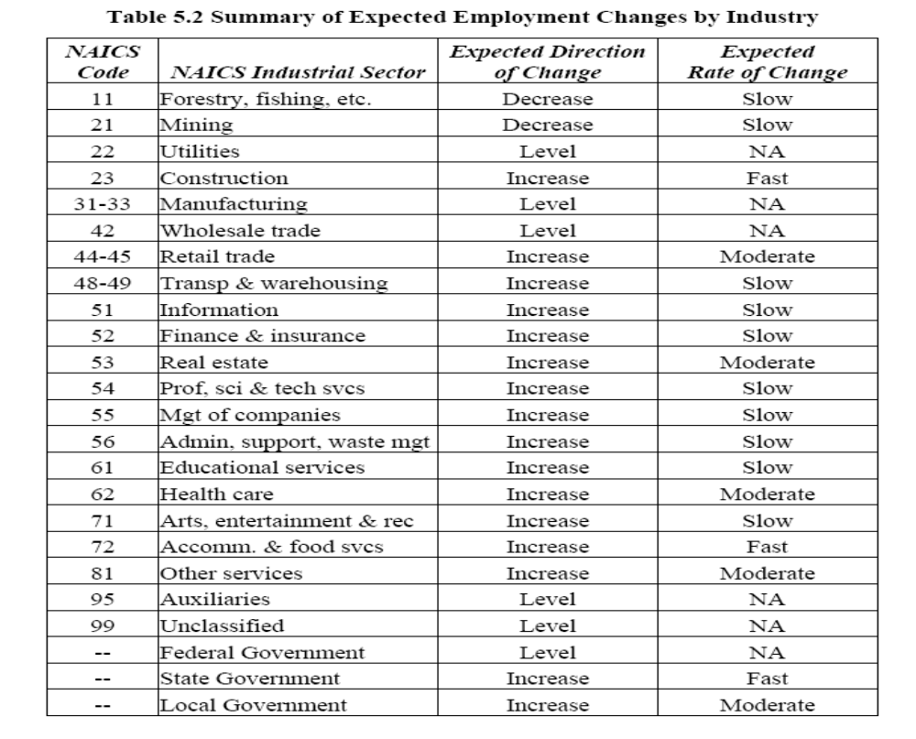
State government employment is another area that may initially seem counterintuitive. At a time when the state is cutting jobs, the designation of state government employment as not only increasing, but increasing quickly seems erroneous. However, the expectation that the state will build and operate a new prison in Franklin County, bringing 300 state jobs to the county, generates the expectation that employment in this industry will indeed experience substantial growth by 2010. Three hundred state jobs would more than double the current number of state employees in the county, a substantial expected increase that yields the designation shown in Table 5.2.”

References

- City of Carrabelle, Comprehensive Plan, Data and Analysis
- Bureau of Economic and Business Research. (2002). Florida Statistical Abstract. University of Florida: Gainesville, FL.
- History of Carrabelle and Frankiln County Florida at: www.gulfpirate.com/history.htm
- Gulf Pirate.Com an Internet site - devoted to information on St. George Island, Carrabelle, Cape San Blas, Apalachicola, Mexico Beach, St. Marks, Dog Island, and St. Vincent's Island & St. Joe State Park.
- The Florida Memory Project - www.floridamemory.com/PhotographicCollection/
- The History of Dog Island 8,000 Years of Maritime Cultures
www.adp.fsu.edu/fs99/dogisland/narrative/narrative.html and, www.anthro.fsu.edu/research/uw/research/ships/dog_island/canoe/canoe.html
- “Plying The Waters Of Time: Maritime Archaeology And History On The Florida Gulf Coast”, A Dissertation by Christopher Horrell. FSU, 2005
- Bald Point State Park Brochure, Florida Department of Environmental Protection, Florida Park Service.
- Florida Photographic Collection, Florida State Archives. http://fpc.dos.state.fl.us
- A Population and Employment Forecast for Franklin County, A Report Prepared by the Department of Urban and Regional Planning at Florida State University. Report Prepared By Dr. Tim Chapin, The Department Of Urban And Regional Planning Florida State University, June 2003.
- “From Boom To Bust: Ghost Towns Of Selected Florida Gulf Coast Communities”, By Rebecca Roberts. Thesis The Florida State University College Of Arts And Sciences 2005.
- Carrabelle Visitor’s Guide 2006-7, Carrabelle Area Chamber of Commerce (850) 697-2585. www.carrabellechamber.org.
- “The History of Carrabelle”, Short briefing paper provided by the Carrabelle Waterfronts Florida effort.
- Forgotten Florida web site. This site is business identification and promotional site, and sources for information on the area. www.forgotten-florida.com/mycarrabelle/mailhandler.htm.

Field and Round Table Notes & Observations by Herb Hiller – Writer and Community Tourism Development Expert

22 June
Carrabelle and vicinity

Highway 98 to the west across Ochlocknee Bay: a couple cyclists on bike lane heading east, no helmets. A Scenic Byway. Houses off the road to the water in the woods. SummerCamp here. The St. Joe is either side of where the two roads come back in at their western junction. A row of ghastly condos one after the other, all identically rowed up, slammed up against each other. High-pillared houses post-hurricane new code.

Camp Gordon Johnston: you don’t notice it. . . Lanark Village.

Quite a few houses were going up. Island View Inn shuttered on east side by the water.

Cut-off along the water. Is this Marine Street?

All shell next door to Old Carrabelle Hotel, lot of surface shell. Marvelous, Southern seafood. Menu on a blackboard. Gumbo, oysters, steamed shrimp, boudan, gator. Big open porch all wood and screen. Was Oyster Cottage for hotel. Open beam, miscellany: a paddle, surfboard, Mardi Gras paraphernalia. One of a kind. Sheriff poster for someplace. Big room, but open bar. Informal. Mix-&-match chairs with a raised area of sofa cushions. Every nail head differently painted.

Skip and Kathy know they need “affordable housing.” More places like this. Assisted living home opening. “Katrina cottages” factory-build on Timber Island. Bud Chiles involved. Comes down on motorcycle.

Studied medicine, psych, advertising design al at UF. Likes hotel: our own business, very hands on. We’re remodelers and can change anything whenever.

We love our retired people. Community needs a work force.

Plains Mayor in shorts and tee shirt.

Lot of trailer parks. They’re gone if there’s a storm. Not really invested. This is me talking. Need permanent affordable housing.

Randy and Tracy. Our little 2-block C1 commercial. Up through Tate’s Hell.

About 5 churches in the C1. Tough for business. City shut down the oyster place for two weeks. We hear that churches don’t want to see their parishioners there.

Old Carrabelle Hotel

Inn cat stays outside, Zorro, black and white.

Couple from Utah: he grown up in Jackson County. Old Florida hasn’t changed all that much here.

Name from a picture in 1940, had Carrabelle Hotel sign on it.

Kathy Frink. From Birmingham. Relative had been football coach, John Upchurch, Carrabelle High, late ‘50s, early ‘60s. Another bought a place on the beach. Came down summers. Back then took six and a half hours. Came through Sopchoppy or Hosford. Swaffords were the relatives on the beach. Destroyed during ‘80s. She had been coming since ’64. Brought Skip in 1993. In 2001 in St. George Island for the chili cookoff, down from Atlanta for end-February. Read real estate book on the way home. Next weekend returned and bought. $125,000; place in shambles. Partners were in with them. Renovated over a year. Skip was the fulltime person. Rest came weekends. Lots of before and after photos.

Weldon Vowell owned it. Ran antique shop out of here. He had bought early ‘90s. For 40 years, Capt. Leon Langston owned, ran big charter fishing boat. Died in the house. May have been in the dining room, “as legend has it.” Went to his son David. Was a fire. Really good response of the VFD saved the damage. Partly destroyed when changed hands to Weldon. “Repair work of sorts.”

Tried to take as far back as could. Two layers of drop-down ceilings. Was only 6½ in here. Maybe 11 feet down.

Were home remodelers and interior designers in Atlanta. I wasn’t a mall person. Doesn’t go into Tallahassee more than two or three times a year, though goes back to Atlanta from time to time.

A neighbor walks in, Betty Godwin; cousin of Rosalyn Carter. He’s mayor of Plains, Bose, and they have a place down here. They’re eating next door at Funky Oyster Shack, which serves Cajun and burgers, shrimp. Asked Kathy to look at a property for her. Kathy about a year after she moved went into a real estate business right close by, a block away, so she could run back and forth and tend to the inn. “I love the area. Like to see new people come into the area. The Godwins would stay at the inn, renovating a sailboat. So loved the place and bought”. They first came as guests.

Lot of Atlanta people here.

Watercolor and drawing of the house.

Six hours from Atlanta.

Was a lot of rotten wood.

Knew had to do something with it if we were going to renovate it. Since it had been a hotel, we were going to turn it back into one. Skip runs the hotel and does renovations. Sometimes we buy properties, renovate and re-sell. Five rooms here.

Carrabelle Inn: Mrs. Susie Cato Prop. Charming location on high bluff overlooking the bay and facing the harbor where ships of all nations anchor. Free from insects and malaria, cool and refreshing breezes day and night. Here sleep is sound and dreams are true. Far the best the market affords. Rates.. Reasonable. Historian believes this from 1913.

A photo circa 1940 that said Carrabelle Hotel.

One year tons of English. This is the year of the German, German couple after German couple after German couple this year. Also from Africa, Czech Republic, Ireland, Spain – a lot of international travelers.

1961 browned framed rates: $2 for one person, 2 in a bed = $3.

Busiest time of year spring and summer. Typical of the Forgotten Coast. We get hot when it gets hot.

Have had people from Miami and Key West, Destin, Tampa Bay, Jacksonville. Business typical one or two nights; Europeans stay longer. They go to see everything there is. They structure their days: from 8-to-10 to Wakulla Springs. About a mile to the beach, over the bridge. Miles of hiking trails in Tate’s Hell.

Bought the cash register counter from Burda-Rexall Drug Store (old Carrabelle family). All the monkey paraphernalia in the Monkey Bar from guests. Started with the monkey mosaic that forms the counter.

All tiles in the hotel made of scrap (broken) tiles.

The next door lately opened. We lease the restaurant to them. They’re from Destin. They have stories about escaping the crowds and the high rises. He used to build Home Depots. Had a restaurant over there. Cajun is different from Carrabelle. Everybody has fried seafood. Most of them will broil some seafood. We had an Italian restaurant for about three years and went out of business. Otherwise, it’s Southern seafood and now Cajun. Next door had also been an oyster processing plant. “We had called it the Oyster Cabin,” was a commercial oyster place.

Pirates utterly lacks atmosphere. High ceiling central apse. No sense of décor, texture. Airplane hangar. Near harbor mouth and open gulf.

Carrabelle deepest harbor between Tampa and Panama City; might be 12 feet. 23-foot Westerly Brit sailboat, easily find safe harbor. Bridge 38 feet high.

Plasticene down, A C on, but all can be opened. Four miles to Dog Island. Dan Tonsmeire Riverkeeper now. Baptist minister born and raised Cedar Key. Had been in law enforcement.

You recognize almost everybody, and everybody you. Hardware store owner, school superintendent. Skip grew up military bases. Air Force Greenland, Newfoundland, Turkey. Everybody agrees harbor centers life, our calling card. Historical, cultural, economic ways of looking. Deciding what we want to be.

Ben Lovell: launch canoe or kayak at the restaurant. Suits Ben if you pull up on the lawn and leave it whether you’re going to eat here or not.

Evening: town with its lights on along the docks. Not over-lit. Helpful lights, not crime prevention lights.

Avenue A to the east climbs a short hill. “Not a bad hill for Florida,” says Skip.

23 June
Carrabelle

Almost 0900, the town quiet. Only the real estate collapse that kept the Forgotten Coast from being ruined. Signs of ruin show up unmistakably. New condos conspicuous. You have to love the way of the little river slicing through this town. Condos rise on scarified land, and stand as assaults. As if nothing anybody can think of doing here, and so, we will just build housing for people who come here to do nothing, i.e., to retire. So the place becomes a tableau, an available platform for transfiguring. It’s a place because it has no options for wink & nod development.

Julia Mae’s closed some time ago; either somebody died or just decided to quit.

Arthur L. Perry, Jr. A L makes Al, the two Al’s. Everybody thinks it’s 2 Owls because in the south they sound the same. Last year a great horned owl set up a nest in a big pine. Picture of two young owls in the next. Wall with caricature of the 2 Owls and another of the 2 Al’s. Story on wall about the 2 owls. Gateway to the Western Panhandle, says Al. Also true because of the bridge that slants across the river. Emphatic break with its curve. All the beach to the west.

Old black-and-whites of Camp Gordon Johnston. Soft drink bottles Cokes with distinctive labels from various promos they used to do. All from the ‘80s, small organizations could o. Vidalia Onion Festival, Macon Cherry Blossom Festival.

Huge breakfast platters. Before Dennis, the place was out of sight with real estate. All came to screeching halt. Wonder we can still hang out.

Really small trailer outside with picture very tropical, toucan and radiant palms. 2 Al’s World Headqtrs. (didn’t have enough room to spell it out) Rising atop a surreal sculpture of red beckoning lips and black shades with lot of frizzly wire hair. Quite the come-on. Actually holds Al’s computer. After the hurricane stopped comin’, customers stopped, people working construction stopped. People stopped comin’ to the beach. Been here a bout four years.

These are not yet the beaches of sugar sand, though unusual broad cove beaches with islets off shore. No hotels or anything to block views. Morning glories studding the low dunes. Remember how high on Dog Island! Remote and Caribbean. Houses back of the shore along the road.

Little roar of the waves completely blows away sounds of traffic on 98. You hear nothing though pick-ups and tractor-trailers pass. Sound neutered.

All around empty lots you see pipe scattered unused. Rain puddles on dirt streets full of potholes.

No appreciable aesthetic, though accumulation over decades, which is troubled by the new standardized housing.

2 Al’s on the big shed with obligatory newspaper boxes out front, couple benches for Oyster Country WOYS 100.5 FM and 106.5 FM Oyster Country; fish nets, what look like fish, cheap streamy banners, big one of a kind sign: 2 Als at the Beach Cafe [cq]. Beautiful vista to town from the bridge. Condos shaded by sailboat masts that interrupt the visual.

Expeditions in Hell
Robin Hilton

Not a make-up person. It smears and you look like hell.

Partner is Rama Ben-Baruch.

Opened last week. This is a fabulous area for boating, kayaking, canoeing – all that stuff. Husband and she sailors. In Europe met Rama and husband. In 2005 researched where back in States. Wanted avoid plastic, Wal-Marts, K-Marts and all that. The state forest, beautiful rivers, bayous and bay, the gulf and all of those places. Eco-friendly. Doesn’t use fuel. Fish out of it. People rent for a week. Surrounded by dolphins out in the bay. That’s what we want, people to have fun, explore, not prohibitively costly, using up their bucks stuck into a fuel tank.

She doesn’t see the place coming back in “those type of proportions.” A waterfront community group, relatively new. Presentation to come to city commission. Waterfront development that we’re concerned about. Want activities eco-friendly. Continue promoting shrimping industry. Places for them to pull up, waterfront open for public use. Lot of that thinking going on in this community, real big-time.

People are worried about how it’s going to be developed. Want protect the waterfront for their use. An economic group and also historical group, all part of playing on this thing. Want to protect the heritage here. Don’t want the place to look like Destin. County limit of 35 ft. – which is from top of the pylons. Property next to hers was sold in 2005. Developers started pulling out after a new mayor came in. The old came back. Strife between those who have been a long time and the outsiders. The locals want to make some money. The new are into the eco-system, don’t want to destroy the marshes, where the fish spawn. Others want to put in landfill.

Putting in public landings for boat launching and kayaks. Kayaks and canoes will be right downtown. The waterfront is basically the whole downtown. The other side is Timber Island, owned by Port St. Joe and other developers.

Want public restrooms and showers, places where boaters can protect their landing rights, whether commercial or free.

Some want moorings. She doesn’t. A lot involved and might be setting up for liability. “I’m into freedom. Put your own hook down and leave when you want. Leave the water without balls atop that may or may not be used.” She had a major incident with un-maintained mooring in Townsville, Australia. Drop your hook where you want.

Hoping for grants. Sites, buildings, cemeteries being surveyed. Want people involved in this. We hear that Camp Gordon Johnston Museum being relocated to Carrabelle Beach. Use what we already have – our river systems, bay, gulf for water sports, and stay away from motorized types of vessels. Noisy and they pollute. The museum is moving about two miles for more space.

Elsewhere? Have seen overdevelopment in Herzelya (sp), huge big mall, beautifully designed but a lot of concrete. No natural harbors there, all man-made, so everything is developed. The whole country is purposefully set up. The old stuff that they do have there, in old Jerusalem, in Haifa, actual cities that have been working. They’ve put in a new part of Jerusalem but of course I didn’t pay attention to that, just the old stuff. And in Europe, in Indonesia. Major resorts come in, ready to develop, just sit here empty. Indonesia: plastic in the water, terrible mis-use of resources. We had saved all of our plastic. A guide they asked threw it right into the sea! In another harbor, drop your anchor into plastic bags all around.

It’s the Waterfronts Partnership.

Not here that she wants: better educated people and that they would want that. Deteriorating. Losing students to Wakulla and to Gulf counties. You’re losing young people takes away for the education system to ever get any better. Consolidated school opening over toward Eastpointe. There’s contention between Apalach and Carrabelle, racism, drugs. Educators, from what she understands everything into the FCAT, but really educated? Isn’t enough to keep young people here. Consider that this is a fishing, oystering community. When it was oyster season, pulled ‘em out of school. Lot of kids illiterate. Problems wit h health system. Still awaiting an urgent care system. Sales tax a cent for this. We’re 7 cents.

Wants people more together, less on opposite sides of the fence. Environmentalists nitpick everything that goes down the line and the developers who just want to do whatever they want.

Her husband works construction – everything – prefers carpentry and historic homes. Foreman of a company based in Apalach.

Some retired here. Concerted effort to get more and develop communities for these people. Yet a real mish mosh of people, all different kinds, including intelligence levels.

Hexaport just opened, factory developing hurricane-safe affordable housing. From NH, partnered with Bud Chiles. “One of the main industries in Franklin County is incarceration.” Way too much policing for such a small community. Between Fish & Wildlife, police, sheriffs, forest rangers – “a lot of policing.”

The plan is to stay here awhile. Had been living on the boat for 27 years. First time. This is a change.

Martin Ben-Baruch, Rama’s husband, is working boats. “He’s the substitute for Rama, in Chicago. Getting his own business situation together. Robin: people who know what they’re doing needed.

Everything in this town is walkable.

The space had been empty; previously a kind of tattoo parlor.

You want aesthetically pleasant, not over the top. Don’t want Carrabelle to be mediocre

Waterfront the deepest harbor. Precious to keep the character.

She thinks of opening an international cruising academy.

She had run clothing store with husband in Apalach after Dennis.

Rates: $65 day tandem, $45 single; more-than-day discounts. Sit-inside or atop.

That’s where good leadership comes in (how to keep the character while developing). Just elected leadership on the right track. Let the commercial seafood industry, development and the pleasure fishermen all coincide in one area. IN the past, we’ve had leadership that was against development, just shutting it all down. In a perfect world just shut the gates and live here forever in peace. Commercial seafood industry is the flavor of Carrabelle. Not as strong as used to he but still viable. City in the short term must accommodate that or it’ll move somewhere else. People from Tallahassee area, Thomasville, they like to see the working boats, the outriggers – that’s attractive and unusual for them. We don’t need to lose that. A lot of intangible effects on our community.

Carrabelle Riverwalk

Went in in April 1998. Wharf may be more recent. How far does it run? Office for the Waterfront Partnership (Tamara Allen). Beautiful new fish cleaning tables with granite (?) tops. FRDAP, FCT others making this happen. Stabilizing shoreline by replanting with native plants.

Millender’s

Have to attract people who have money to spend. The condos along the river not overdone to this point. They need to be bought and filled. They go to local restaurants, to the hardware stores, support local businesses. They’re gonna want fresh local seafood. Lot of your hometown people know people who oyster, fish or shrimp and they eat a lot of that home; so we need tourists – or visitors – and the restaurants order from me and I can buy more from the local boats.

People with money are going to want to buy on the river the bay or the gulf. Over-development? When you lose your commercial seafood industry fading out, you’re in trouble. Carrabelle still has enough water front on Timber Island and here to preserve so many feet for commercial activity. Also in trouble when the everyday citizen or someone passing through loses easy Access to the waterfront. That hasn’t happened yet.

We are in trouble losing tie-up space for the commercial fishermen. These boats either going to Apalach or St. Joe that used to unload here. There’s facilities there, better dockage, places to buy fuel and ice, marine supplies. We should have that in Carrabelle. Needs to be owned by city government because too much pressure on private owners. He had these facilities, marine supplies, ice and oil and he sold a lot of his waterfront property.

He had thought about it. He likes to buy raw land and re-sell it but not get involved ion the construction business.

Grandfather started the business in thought about it. He likes to buy raw lane and re-sell it out not get involved ion the construction business.

Grandfather started the business in 1942. His daddy originated from Virginia. His great-grandfather moved here and established himself along the river and we believe relied on the bountiful fisheries. Grandfather then started the seafood business. Vance took over from his father and I’m actually working for my two sons now. Four or five generations involved. Just in our blood. You can make more money doing other things but we just enjoy doing this. Hoping and praying that my sons can do the same. Has given Vance opportunities to buy and sell real estate – “which supports my seafood habit. . . I’ve done really well with that.”

The new city administration recognizes importance of keeping the industry viable, keeping the boats. I go to meetings about keeping seafood in Carrabelle. Only three full-time commercial shrimping boats in Carrabelle and maybe only three in fishing. A great many pleasure fishermen, but maybe six or 10 left now. Going back to peak years in shrimping in the ‘70s and ‘80s, from February through May might be 50 to 60 any given time. Commercial grouper fishermen maybe 12 or 15 of those. Maybe had 10-15 commercial gill netters. Kept Carrabelle thriving. Whatever they made, they spent. Commercial deckhand made $.The new city administration recognizes importance of keeping the industry viable, keeping the boats. I go to meetings about keeping seafood in Carrabelle. Only three full-time commercial shrimping boats in Carrabelle and maybe only three in fishing. A great many pleasure fishermen, but maybe six or 10 left now. Going back to peak years in shrimping in the ‘70s and ‘80s, from February through May might be 50 to 60 any given time. Commercial grouper fishermen maybe 12 or 15 of those. Maybe had 10-15 commercial gill netters. Kept Carrabelle thriving. Whatever they made, they spent. Commercial deckhand made $400-$500? Local businesses would get that money. The community is missing all that money. They’d spend a night in the motels. They’d spend maybe three or four days. Called their families who’d come down to spend time with ‘em. Didn’t appreciate the grocery bill for these boats staying out a week to three weeks; could be $1,000 to $3,000! These boats were biggest supporters of our grocery stores. Fuel, ice all supported.

We need to do what we can as a community to help this as long as we can. These are die-hard guys and let them decide if they can’t make it anymore, but not because the city didn’t give ‘em a way to tie up, get supplies, fuel and ice.

These remaining guys could form a co-op to run these facilities or hire Vance and his sons to run it. I would definitely help. We buy all the product we can get but I have to rely on trucked-in shrimp and imports. Most of his product ends up in restaurants. A few small retail markets we supply and a few wholesalers.

We have no Millender & Sons Seafood Company, Carrabelle, Florida. We got rid of the trucks and now just trailers you can hook to a truck. We don’t want the hassle of the tricks, but truck on the road and it’s got the word seafood on it, go through check stations, tie you up a long time. You get less of a hassle if you’re not advertising to law enforcement that you’re carrying seafood. H: surmises might want a pint of oysters or whatever, some steaks.

Moving east along 98 still in the city limits. Our biggest competitors now multi-million-dollar food service companies that weren’t in seafood, but when imports became so available a generation ago, they took it on along with beef patties, grease, salt and pepper. Just added seafood to their inventory. US Foods, Cisco. Hard to compete with ‘em. Better product and competitive on price as we can. Personal service. Run out of food on a weekend? We’ll put it in a truck and take it to them. Helps that we have domestic product. 75-80 percent of our business is going to be retail: we’re going to sell to someone driving buy. Right now, just here. Not sure how it’s gonna work. Team re-thinking.

Neither son married. Wasn’t sure what they would do. If they weren’t interested he was going to fade out, just buy and sell real estate. But both wanted to stay in seafood. So we’re re-focusing what we need to do for them to stay. Local residents become really important.

Lot of traffic through town but nothing to make them stop. Come from south Georgia or Tallahassee, they’ve got one thing on their mind: that’s St. George Island. A real nice retail market, good product at a fair price, stop and buy their seafood in Carrabelle on their way to St. George Island, and when they go back home. We have thought about being open on Sundays. We have a conflict about this. Faith is really important in our lives. We’re struggling with that. We know we’re going to have to put in more hours.

He knows they’re putting themselves ahead of the curve. We’ve already made the commitment to the retailing. That gives me a little more authority to speak to the city. More activity on ’98, dress up the town, make it look like a sea town, nautical type frontages on buildings. I can’t do it alone. I think eventually other business owners along 98 are going to realize what I’ve realized.

We have so much to offer: pristine waters, the rivers, great fishing, lot of forest area, great hunting, camping, minutes from the bay and Gulf of Mexico. So much natural beauty that hasn’t been tapped into. Right now in a downturn. Our economy has been centered around construction and around buying and selling real estate. We’ll have investors come back into the market. I don’t want it to be feeding frenzy like it was four years ago.

You could borrow money so cheap, prices were dirt cheap in this whole county, buy a lot here for $2,000. People came in with money. They didn’t come here to build. They came here to buy and flip. [Miami in the ‘20s.] Everybody jumped in buying and flipping, buying and flipping. Got so high that people couldn’t buy and build, and some got caught with the property with big interest payments. Reached its peak and collapsed. “That’s not really a good thing to happen in a local community, not for the people living here.” The stock market wasn’t doing anything. People’d take money out of the market. Then the market doing better, interest rates went up and collapse. What had been $2,500 not long ago went up to $80,000! Acre from $5M to $50M in two-three-year period.

Hurricane could shut down Highway 98. Not going to worry about that. Will build to withstand 160 mph winds. Had up to 20 people. Three now, the dad and sons who also do the office work. Owned boats. Eliminated those; not enough profit to maintain. First time they’ve never owned a commercial boat. Might have been 8-10 commercial seafood houses along the river. He’s it.

Pallets out back, boxes, water running to clean everything, price list: bay scallops, jumbo shrimp, grouper $10.75 lb.

850/697-3989 Dog Island Water Taxi.

Along Marine Street, empty storefronts. Gift place. Print shop, florist empty. Couple restaurants. Empty brick building. Camp Gordon Johnston WWII Museum moving. Furniture store closed middle of the day.

Carrabelle Junction
James “Buz” Putnal

Bulletin board, cash; sell diamonds, but most of the cards for Wakulla County, music store in Apalach. Taxidermist in Sopchoppy. Body piercing in Tallahassee. The Gypsies, Lola & Freddie D., music from ’40s to ‘70s.

Worked away from here for Proctor & Gamble. P&G had a forest industry-supplied towel and diapers facility. Closed in about 1991. He left in 1989. He managed a mill, road construction supervisor, reforestation. 27 years. Born in Carrabelle. That house is gone. His niece bought it, sold, and it was torn down. Between 8th and 7th Street on Avenue C. Best town in the world you could have grown up in as a teenager. Movie theater, ballfields, we had a teen center, churches supplied lots of activities. Beautiful big school right where Gulf State Bank now. Was the big lot across from OCH. “That’s progress. You tear something like that down and build some little tin building.” Went down – beautiful old brick building – probably late ‘60s or early ‘70s. Was just they were going to build a new school. One of those metal buildings. They’ve just shut it down and built a consolidated school.

Movie theater charged – over 12, 40 cents, under, paid 9 cents. You’d have a penny left to buy you a piece of bubble gum.

All but four years lived here. Then was briefly Perry.

Mayor from probably 1995 to 1997, “after I retired.” People asked me to. Didn’t take long to get tired of it, either. Some projects was, there’s a state prison out there, stayed after the state to get it built. Preserved the riverfront land so wouldn’t lose it to some sort of real estate. “Lot of jobs at the prison; good for the economy.” Biggest disappointment – had a big gymnasium left over from the school. He had got funding to re-build the old gymnasium. Could have made a civic center. I couldn’t get it passed. Nobody seemed to interested. We have a library but if you wanted to have a community center type thing; we don’t have anything like that. Some money would have been tax money after the net ban; enterprise zone money, paid off with funding from that extra tax money. Hate to say that I was the only person interested in it.

He actually resigned. That started me to thinking about getting out. He had been a city commissioner. Mayor sick and resigned. Was mayor pro tem, then was to finish it out but didn’t quite finish it out and chose not to run anymore. From 1993 thinks was a commissioner.

If I was a teenager tonight, would have absolutely no idea what to do with a date. You’d have to go out of town someplace I guess. All the buildings you see plus a lot of others were thriving businesses. The town was full of tourists. Carried people out fishing. Commercial fish houses lined the whole river. Really, a lot of the good stuff is gone. The people who commercial fished spent all their money here. Dry goods store.

Just played out. People now go to Wal-Mart and these small businesses just don’t make it anymore.

Could come back from a ballgame at midnight, a service station open, a restaurant open. Better buy it early now or you won’t get it.

Deep harbor, high elevation, not reaching its true potential I don’t think.

Meeting tonight might lead to something.

If a house burned down, clothing, household needs. A good place to live.

Town today lends itself to more retired people than anything else.

Sport fisherman buy their food in Tallahassee, fuel their boat there; they’ll go out fishing and they won’t spend a dime.

He used to say would like Carrabelle be something like Mayberry, just a family-type town. And I guess in a lot of ways it is.

Real estate speculation and part-0timers? People speculated to make a big pile of money. Market went down, they got stuck. Taxes up. They’re wanting to sell but can’t. Didn’t help taxes at all.

Have to free commercial fishermen up from regulation. Limits on numbers allowed to fish (though he’s not sure of this).

He looks for oystering to be the next thing to go. That will really punch a whole in things. All these things are being regulated out of business.

He has four children, one Sarasota, two daughters in Port St. Joe, another daughter in Pennsylvania. Has 10 grandchildren and he’d like to see them every day. I been here too long to leave.

He knows Helen, Georgia; now it’s a goldmine. I think here you could go wituh some theme, maybe some Scandinavian theme and make a town sort of like that to attract all kinds of people to come in. To pull it out of the doldrums, you’d have to have some money. Chamber of Commerce might come up wit ha plan. Business owners would have to fix up their storefronts. He tells of the plans for the riverfront. That will help. Hope it materializes.

We have the natural resources, just need to come up with some dream and go with it.

He points to a n old green building that used to be a barber shop, next to that was a grocery store, this right here was a grocery store with a little hotel upstairs, just up was a building supply, was a Chevron Station, Gulf Station, another grocery store, dry good store and fishing supply store, f fishing store, a theater, a bar room, another grocery store. He wrote a book on the history of Carrabelle. Back ages told you what was on every street. Gonna amaze you the number of businesses that were open then but not now. Mechanical garage. Across from the bank was a Gulf bulk plant that supplied gasoline for two counties, big fuel and dock there. Seabreeze Hotel, a TV repair shop, a mechanical shop. If you went this way, was a Western Auto, a drug store across the way a service station, down by the ballfield another grocery store, large black communities with a few stores.

Ron subscribes to New Yorker.

He is 71.

Gander Hardware: 1952. Drug store and hardware divided down the middle before. “If he ain’t got it, he’ll get it for you within a week.”

Bookstore closed this day. Sign: Daybreak Massage. Carrabelle. Call.

The world’s smallest police station, of course.

Who was Tillie Miller (of the bridge?).

Carrabelle Beach a separate district. Road along the water. Crooked River Lighthouse done with FCT monies and other. Between 1893 and 1895 to replace a light on Dog Island downed by ‘cane in 1875. Became rear range for section of the 20-ft. channel just west of the island. Electrified 1933, automated an dun-manned in 1952. Dwellings sold and removed (keeper). Lens removed 1976. Re-commissioned [/] 1995. Again to open to public. White and red atop narrow cylinder within spider framework, cupola and walk atop black. False galleon in a kids’ park. Sea creature rocking “horses.”

Most beautiful portion of shore road that continues west; most of a long stretch directly on the water, no condos, nothing commercial. Islets on view.

Maybe half everything toward the water for sale.

Public beach with lots of picnic stations, Carrabelle Beach, also cove beach.

1943 sites for training Normandy invasion.

Franklin correctional Institution. “We are hiring.” Resemble poultry farms.

Lot of big-porched houses.

Commercial fishermen in an open shed beside the river at Pirates. Going to gulf, evening sun sparks off the condos on the east side. Yellows exuberantly yellow, the soft greens exuberantly soft green. A high digital tower. Everything beautiful beyond pretense. Big bowl of onion rings, platters of hush puppies. Two vats of iced tea. Some 30 out here, lotta wives. Fellow says all the NOAA ships tied up because fuel. No research. Redfish back but a menace to crabbing. Can’t protect one species because will overcome everything else. Study predator-prey relationships. Carrying capacity, ecosystem management not sufficiently studies.

24 June
Old Carrabelle Hotel

Ceiling fan, good lights, clapboard, nautical bric-a-brac. Ceramic tern, crab trap buoy float. Paintings, prints of lighthouses. Ship model. Recessed sculpture of sailing ship and lighthouse in burlap frame. Framed mounting of knots. Sea chest. Carpet; comfortable firm bed. Small room, no chair; adequate for sleeping, reading.

Formal dining room, cherry table, four regal chairs; tchotchkes from the sea, oak fireplace (closed off), Venetian blinds. Living room set for watching TV, not for conversation. Rattan and wicker pieces. Fire stove (propane).

Area rugs over carpet, tropical designs on rugs and elsewhere on walls. Also monkey themes. One for Isle del Sol, Tropical Paradise. Prop. I. P. Santos.

Long narrow hotel.

Breakfront. Other rooms more spacious, less themed maybe. Everything carpeted and with area rugs.

Monkey Bar with shuttered oak fireplace.

“Street girls bringing in sailors must pay for room in advance.”

Sign for Millenders Seafood gives rates.

Hotel sits behind large oleanders and palms. Lattice surrounds upstairs porch. Downstairs behind a turquoise slab around two sides, some 6” up. Five pillars out front, about the same around side to the sitting porch with slatback rockers and wicker chairs. Persimmon slat shutters surround windows. Faux primitive palms to either side of door in pots.

Almost a shame to get to know Carrabelle because it’s so quirky and quaint. The mystery may be more appealing than the experience. Up the road to the forest, still some old houses with sleeping porches. The old two-story Gander’s Hardware shed with steeply sloped roof. Street a-gaggle with wires on high, looping through the air. These are such signs of yesteryear that we hardly notice them. Main storefront with flat awning suspended by cables. Post: sign in form of cross: Who read the bible is Jesus? Gina’s cleaning service, top to bottom. Carrabelle United Methodist Church, one for J&J’s Place in the old Burda Drug Store, which is a consignment shop now. Reward for a Ford Tractor 1969. Another for Funky Oyster Shack.

Ron grew up in West Palm when it looked like this; it’s true, he avers. Family in Woodville brought him back. Daily Scoop Potrero Hill. Food, culture, diversity, art – what he misses. Likes nothing here. Easy living, nice pace. People don’t come here for rules and regulations. Some come to make money and change the place. Doesn’t happen though almost did. Might have been 250 people in 15 real estate offices from here to the bridge. 1,250 or so, 15,000 the county.

Slants to the streets: side street up a hill to the east, 98. Marine to the harbor, Franklin 67 to the forest, and the road heading west. Storefronts not continuous. Sloped rooves, one and two stories, old-style Western storefronts with flat awnings. Mostly board, masonry, a brick or two. One lane either direction, parking in their own lanes. No light in main downtown. Carrabelle Junction: espresso, coffee, ice cream, sandwiches – starts in between. Steaming cuppa joe. Ice cream cone on the window. Old 7-Up sign. Clunky Franklin Chronicle vending unit out front. Gander’s with wheelbarrows out front. Ron: every 30 years, a boy’s gotta make a move. Charles Curran: personal injury, admiralty, wills & estates, insurance, construction, real estate.

People talk more about the real estate whirlwind; outside telling ‘em how to live in a luxury house worth more than four times what worth.

Front of OCH, parrot atop. Especially sloped roof. c. 1900.

Cakes by Amy. Plain storefront with lot of local art. Party supplies. Last week August, had been five years in the area. Started from house for friends and families. Surviving. From here (when 1). Tampa awhile. Biggest seller is chocolate fudge. Shell art. Frames, plant pots (fishin’ pots). Tables and chairs in and out. $2 hot dogs, $2.50 chili dog.

People don’t lock cars. Real estate offices selling tee shirts.

Laurel Newman write fro the Franklin Chronicle. About 3,000 books. Eclecticism the emphasis. Name a topic; it’s here somewhere. A third edition Twain. Tama Janowitz, Joan Collins, James Clavell, Elmore Leonard (lots of Florida fiction). Fort Lauderdale, Port Antonio (knew Cher and Woody) eight and a half years. Driven out by PJ’s JDF forces. Three or four miles out of town, mechanic; she a boat detailer. Guy Lauderdale told about it. Came up, fell in love, and that’s it.

NOAA/1000 Friends program
Methodist Church, Carrabelle

Round Table Social, Economic, and Cultural Factors
that Influence Community Support for Coastal Conservation.

Round Table Agenda
Social, Economic, and Cultural Factors that Influence
Community Support for Coastal Conservation
June 24, 2008 – Carrabelle
United Methodist Church, 102 NE B Avenue

9:00 a.m. Get Acquainted - Coffee, Juices and Continental Breakfast Treats

9:30 a.m. Welcome and Introductions – Tamara Allen, Carrabelle CARES organization and Carrabelle Waterfronts Florida Partnership and
Charles Pattison, FAICP, President 1000 Friends of Florida

10:00 a.m. Project Background and Overview of Survey and Results and Report
- Dan Pennington, 1000 Friends of Florida

10:30 a.m. Better Linking the Coastal Conservation Message, Data and Actions to Waterfront and Coastal Communities and their Social Networks - Developing a Portable Model to Communicate WITH Communities (Not “to”) - Linda Lample, Lampl Herbert Consultants

11:15 a.m. Discussion – Cultural Communication Divides between Local Culture and Social Networks and Agencies tasked with Ecosystem Management and Coastal Conservation – Discussion leader Herb Hiller

12:00 noon Lunch on Your Own, But Please Join us at: Nearby Local Spot - Menus for Carrabelle Junction Provided

1:30 p.m. Commonalities, Differences and Resource Needs for Waterfront Communities Relative to Coastal Conservation and Management Actions - Short Presentation and then Discussion

Working as a Team Member with Local “Networks” to Achieve Useful Results to Further Coastal Conservation and Management Efforts. Short Presentation and then Discussion

2:30 p.m. Round Table Discussion - Data and project gaps and the approaches necessary to advance waterfront community economies while furthering Coastal Conservation and Ecosystem management

3:30 p.m. Value of such round table efforts to identify future needs assessment and actions. Suggestions for future additional work?

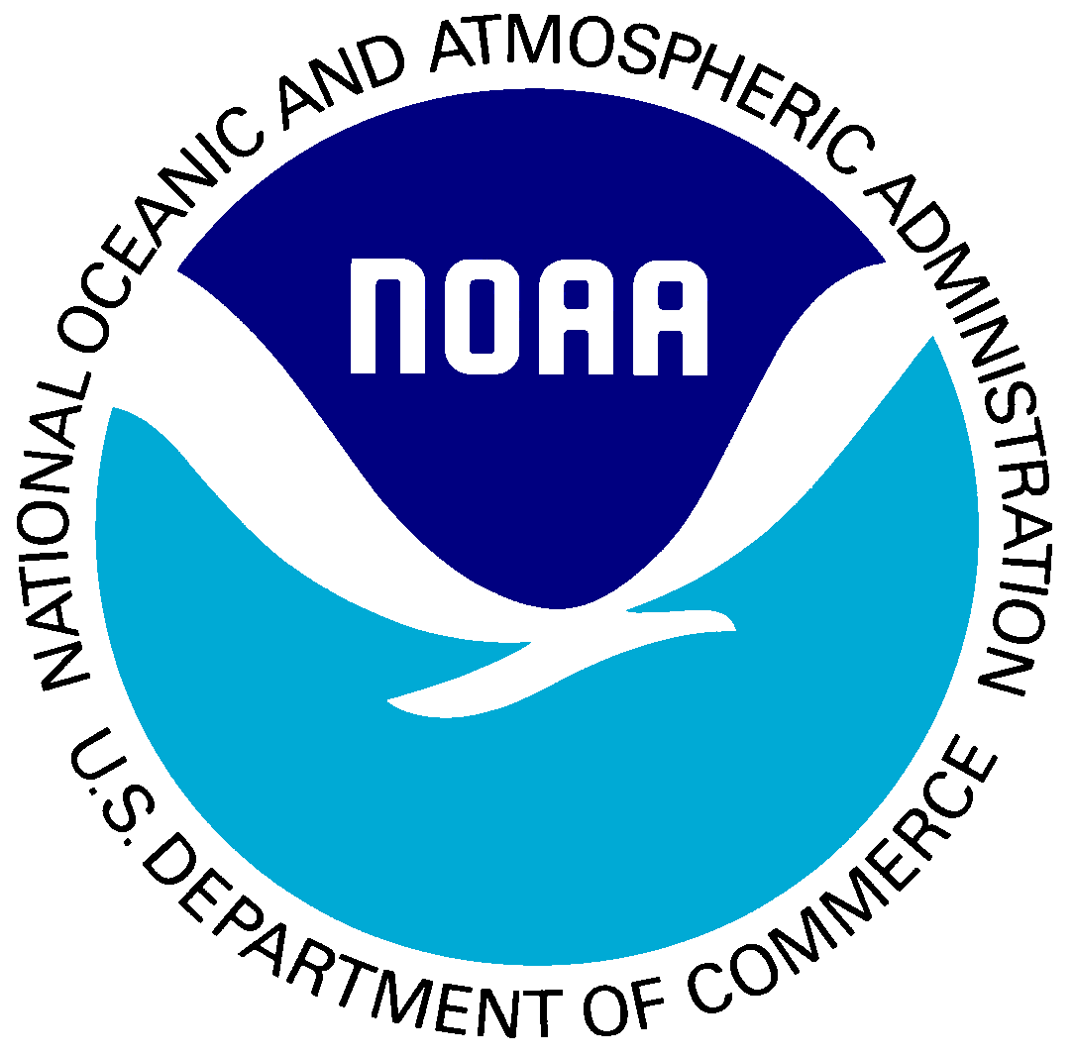
4:00 p.m. Summary and Adjourn
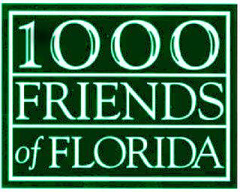

Notes on the Carrabelle Community and Roundtable Meeting – By Herb Hiller, Writer and Community Tourism Expert

We are 17 to start at 0940. Up to 19, 20.

18 projects underway and city-funded (CRA, FRDAP, tourism development dollars, etc.), water park, the historic lighthouse, historical building re-use, a conservation park for displaced gopher tortoises. Large 2-lane boat ramp, shoreline stabilization. $150,000 grants in the first year.

The factory is building hurricane-resistant houses. Several high school grads who were going to join the Army instead at the factory.

Beach re-nourishment to red tide to ecosystem management, weather – NOAA.

What do communities need to support coastal conservation? The NOAA lady refers to its social science role, which others might not associate with the agency. This is the first project of its kind, though in a series of social assessments.

Carrabelle 1500+ Spain. Timber early, lumberyards and saw mills. Rail and water dependent. More forest based. (Site GF&A.) 1920-1980 seafood based on oysters, shrimp. Since 1990s development: St. James Bay DR!, SummerCamp, land speculation.

Dan: the natural resource can always significantly support the economy.

Was a timber and railroad town.

First 12 feet of digging up along the waterfront was boards preserved in saltwater, lumber that floated down the river.

Before the bridge, people used to get to work in Eastpoint and Apalach by coastal boat.

People would take the train down from Tallahassee for “Midnight on the Gulf.”

Town is an island, isolated; learn to do things on their own. Don’t look to Government. Mel: proud, independent ethic, pile their own sandbags. Ironically, 81 percent of Franklin County owned by governments. Development along the coast. Only Highway 98 connects the place.

Oyster catch lately at its highest level. More people than ever taking out oyster licenses.

The boom occurred when the community was most susceptible still in the aftermath of the net ban. All of a sudden everyone’s property was going to end the struggle.

Yet shrimp has crashed, also blue crab. Shrimp down by 90 percent! Could be lack of freshwater.

Red tide could put hundreds of people out of work. 60 lb bag for $15 or so; about the same as scrap fish sell for. New marketing plans sought.

Lisa Marie green. Natural resource social activism, Dan mentions, about which she nods in vigorous affirmation. Social marketing, a mantra of hers.

Combination fuel and regulation defeating re-emergence of the fixed-up marina in St. Andrews.

The essence of place creates its authenticity (Dan).

Funnel cakes, tee shirt shops, waterslides – watch out for all.

Story telling. . . Paddling (minimal fuel cost). . . Processing for retail (Millender). . . Marketing the highway. How do we get everyone to stop along Highway 98? Consecutive cross-highway banners? “Statuary”? . . . Artistic signage? . . . Screen door town. . . Do the Highway 98 marketing and you will also get national publicity that will help fill rooms. . .

A sense among locals that when they get suburban development they have arrived. Yet visitors want the place because of this absence.

Linda Lample presentation. See PowerPoint Presentation

  - percent Florida population.

The place is utterly natural. Must have lodgings that fit authenticity. No more Moorings.

I hear a lot about “betrayal” and “stabbing(s) in the back,” with resultant loss of faith.

Fishing communities: fishermen like the isolation, even maybe a genetic disposition. They love to take risks. They don’t want to take part. They want to go fishing. You have to have the right connection to the group.

Lisa Marie: strengthen the authentic resource.

Local shrimper: bronzed statue of a sea captain? A living museum, maybe? All the rusty pipes and debris from rebuilding and patching through history. Stuff is historic, built of necessities of the time. Our greatest asset is the work ethic. Instead of tourism based on museum, people expose the working relationship.

St. Andrews: people buy tickets and go out on a shrimp boat and do the work.

Another: preserving space. Fishermen use the yards, the streets, not just the docks. That space is disappearing through zoning laws. Working waterfronts are disappearing. Traps, boats in the front yard. Soon as you gentrify, this stuff gets “disappeared.” Nor do people want an overlay. Dan: do an LDR for this.

Laurel” strengthen the sustainable resource: overlooking the resource (as Steve mentioned), the work ethic, the fierce independence. The work ethic still here.

St. Andrews: tourism moving from being entertained to being a part.

Linda: through Eastpoint, remembers to 1988, people lived on the north side but worked on the south side.

’95 tourists walked along the docks, buy seafood off the boat. Folksy pictures, salty stories. Course they went fishing and went to the beach.

Dan makes point that the industry has died. Greed (about property), says Laurel.

Fishermen harvesting and selling retail. Value added product.

Find niche markets. Looking into grouper and pink shrimp, brand ‘em for a higher price. Industry in transformation: fuel costs, imports.

Tamara: a commercial dock that hangs on to only that is part its time. A commercial wharf only that is past its time. She talks of a new tourism to look at our nature-based, including birding. On the flyovers, also butterflies. This stuff came out of the community visioning. No more condos and no high-rises. Nix PCB, nix Destin.

Steve: many grant programs not moldable for communities of this size. What H talking about, Vance and others just want to be out catching their fish. They run the business reluctantly, out of necessity.

We hear Mayport, Singleton’s; Cortez, also a seafood restaurant, retail. People know it’s fresh Florida seafood. Julia Mae’s. Reputation for fresh Florida seafood. Go out each day to catch, place to land.

We’re actually 17, then 16 afternoon.

Diverse economy, St. Andrews comments. “A smart thing.” Yet a barrier that we hit: preserve buildings, promote coastal clean-up, restore waterfront. But we hit a private enterprise wall. Can we cross the line to help them without looking like a handout.

Seafoods man says a program now to promote local Florida seafood.

Lisa Marie: celebrating these authentic resources. Social aspect of bringing people in, exposing local values. So, festivals that bring heads into beds. In Cortez: Institute for Saltwater Heritage (FISH). Whole village so much a part of this now. Has done something (good) for the community.

Tamara: promote birding stop on the Scenic Byway. Specialty market. We hear to tie in all the waterfront communities along here, Panacea to St. Andrews.

Lisa Marie: birding tour by water, which would use the boats. Bradenton Beach history is hospitality, though constantly changing.

Tamara: Bears in the backyard, gopher tortoises. “Just shoot the damned bears and be done with it.” But Charles says, What if somebody (from Audubon) showed up and spent $5,000 to go watch birds from a boat.

Fisher guy: We’ve heard of fishermen’s wives in Cortez who do ecotours. Tamara tells about how for $300 a fellow will tour his boat for up to 6 to Dog Island.

Lisa Marie: film site.

Josh: in Milton, resisted rail-trail. Such a fight! Now farmers market, Mardi Gras on the trail Brings so much money into the city!

FTHP: tells about grants. Carrabelle grant July 1st for cultural resources survey. Important to preserve heritage resource. Can be objects, not just building. Also: multi-use grants for structures rehabilitated. More.

NOAA reprise: Authentic? The work ethic is an interesting aspect. Not just the work ethic of the fishing industry. Carrabelle has been resilient, authentic over time. This place fascinating with all its history. Now a green steel factory. She doesn’t know how you market it but it’s more than structures.

Start by marketing it locally, says the one next to Lisa Marie. (Wakulla person: Kelli?) Educating the young.

The taller NOAA person (not Heidi): anything we can help other folks learn from. Do an authentic resources inventory. Get al ideas on the table and do the strategies. Marketing strategies, conservation strategies, whatever. Carrabelle has been very observant of what’s happening and not letting it get away from you. How can we start to adapt. Those conversations lead you to what to do next. Be systematic so you cover all your bases. What cool could we develop? How address these social, cultural, historical factors. “You guys are just right there.”

Heidi: legislation to fund commercial fishing (as per a farm subsidy).

The seafood man: Waterfronts Florida should hold a statewide conference. Others comment about budget sharing that could result.

Charles tells about Dade County Commission apparently now trying to shut down the working river.

Bradenton Beach and Key West gaining greater riparian jurisdiction to avoid private interference wit h their waterways.

Heidi: Dan’s research and the discussion: useful? More of this?

Follow through and help us, says Panacea. Very useful for us, says Heidi.

Steve indicates that next steps should include tourism per H.

