Direct-Pickup Interference Tests of Three Consumer Digital Cable Television Receivers
Available in 2005

July 31, 2007

Technical Research Branch
Laboratory Division
Office of Engineering and Technology
Federal Communications Commission

OET Report Prepared by:
FCC/OET 07-TR-1005 Stephen R. Martin

TABLE OF CONTENTS

EXECUTIVE SUMMARY iii
CHAPTER 1 INTRODUCTION 1
Background and Objective 1
Overview 2
CHAPTER 2 TEST DESCRIPTION 2-1
TV Samples 2-1
Test Sites 2-1
Test Setup 2-10
Test Methodology 2-14
CHAPTER 3 TEST RESULTS 3-1
Overview of Measurements Under Common Conditions Across the Test Sites 3-1
Detailed Results for All Measurement Conditions 3-2
Variability of Direct Pickup Vulnerability 3-6

ILLUSTRATIONS

Figure 2-1. Test Site 0—No Wall 2-4
Figure 2-2. Test Site 1—Inside View of Exterior Wall 2-5
Figure 2-3. Test Site 1—Outside View of Exterior Wall 2-5
Figure 2-4. Test Site 2—View of Inter-Unit Townhouse Wall from Townhouse A During Tests at 2 Meters Separation Distance 2-6
Figure 2-5. Test Site 2—Antenna Positioned for 2 Meters Separation Distance 2-7
Figure 2-6. Test Site 2—Townhouse A with Antenna Positioned for 10 Meters Separation Distance (Inter-Unit Wall Is Behind and to the Left of Camera) 2-7
Figure 2-7. Test Site 2—TV Positioned in Front of Common Wall in Townhouse B for Tests at 2 Meters Separation Distance 2-8
Figure 2-8. Test Site 2—TV Positioned in Townhouse B for Tests at 10 Meters Separation Distance 2-8
Figure 2-9. Inter-Unit Wall of a Townhouse Under Construction 2-9
Figure 2-10. Close-Up View of Inter-Unit Wall of a Townhouse Under Construction 2-9
Figure 2-11. Block Diagram of Test Setup 2-10
Figure 2-12. Test Equipment as Set Up at Site 1 2-11
Figure 2-13. Close-Up of Test Equipment 2-12
Figure 2-14. Spectrum of Cable TV Signal Measured at Site 1 2-13
Figure 2-15. Spectrum of OFDM Signal Used as Interferer 2-14

TABLES

Table 2-1. Wall Construction 2-2
Table 2-2. Test Configurations at Each Site 2-3
Table 2-3. Equipment List 2-11
Table 3-1. Minimum EIRP at TOV Across Two Antenna Heights and Two Polarizations for Interference to TVs from the Rear 3-2
Table 3-2. Measurements at Site 0 With 2 Meters Separation 3-3
Table 3-3. Measurements at Site 1 With 2 Meters Separation 3-3
Table 3-4. Measurements at Site 1 With 10 Meters Separation 3-4
Table 3-5. Measurements at Site 2 With 2 Meters Separation 3-4
Table 3-6. Measurements at Site 2 With 10 Meters Separation 3-5

EXECUTIVE SUMMARY
This report presents the results of in situ measurements of the interference susceptibility of three digital television (DTV) receivers to direct-pickup of emissions within the channel width of a digital cable TV signal to which the receivers were tuned. The tests were intended to identify the susceptibility of cable TV reception by a digital cable TV receiver connected directly to the cable TV system (without the use of a set-top box) to interference from devices that might operate within the TV broadcast spectrum on locally unused broadcast channels (TV white spaces) that overlap the frequencies of channels used by the cable TV system. The Commission is currently considering rules that would permit the use of such white-space devices.

The three DTV receivers were Digital Cable-Ready (DCR) models that were on the market in 2005. The digital cable TV signal used in these tests was a 256-quadrature amplitude modulation (256-QAM) signal adjusted to a signal level near the minimum level specified by the “Digital Cable Network Interface Standard” for the “input terminals of the first device located on the subscriber’s premises.” Tests were performed on EIA cable TV channel 70, which overlaps the spectrum of broadcast UHF TV channel 19.

The interfering signal was a 4.8-MHz wide orthogonal frequency-division multiplexing (OFDM) signal operating in the spectrum occupied by the selected cable TV channel. This signal was radiated from an antenna having near 0 dBi gain.

The tests were performed with the interfering signal source separated from the DTV receiver by distances of 2 meters or 10 meters and, in most cases, by one of two residential walls: an exterior wall of a single-family house or a wall separating two townhouse units. The interfering source was operated at two different heights at most locations and at two different polarizations. Most measurements were performed with the interferer located behind the TV receiver, but some measurements were also performed with interference from the front of the TV and a few measurements were performed at other aspect angles. A total of 108 measurements were made.

The tests show that an OFDM source operating at an effective isotropic radiated power (EIRP) as low as 6.3 dBm can cause interference to cable DTV reception at a distance of 2 meters and that an EIRP as low as 15.3 dBm can cause interference at a distance of 10 meters. The TVs exhibited less susceptibility to interference from the front than to interference from the rear. For interference from the rear, the median interference threshold EIRPs across the three tested receivers and all antenna heights, polarizations, and lateral-offset positions were 16.9 dBm and 24.2 dBm for 2 and 10 meter distances, respectively. Median thresholds for interference from the front were 21.2 dBm and >25.1 dBm at 2 and 10 meters, respectively. (We note that interference from a device in a neighboring residential unit is unlikely to occur with the front aspect at a distance of only 2 meters.)

Due to the limited scope of these tests (three TV sets, one cable-TV channel, and two primary test sites), the results are not intended to constitute a complete basis for defining criteria necessary to protect cable TV viewers from interference by devices operating in the TV white spaces. Nevertheless, the tests provide an empirical demonstration of the potential for such interference at relatively low power levels, and, as such, a useful input to the decision process.

INTRODUCTION
This report presents the results of in situ tests of the direct-pickup co-channel interference susceptibility of Digital Cable-Ready (DCR) TV receivers connected to a digital cable system delivering 256-quatdrature amplitude modulation (256-QAM) signals. The interferer for these tests was an orthogonal frequency-division multiplexing (OFDM) signal radiated in the frequency band occupied by the digital cable signal to which the “victim” TV receiver was tuned. The tests were intended to identify the susceptibility of cable TV reception by a digital cable TV receiver connected directly to the cable TV system (without the use of a set-top box) to interference from devices that might operate within the TV broadcast spectrum on locally unused broadcast channels (TV white spaces) that overlap the frequencies of channels used by the cable TV system. The Commission is currently considering rules that would permit the use of such white-space devices.

The tests were limited to three TV sets, one cable-TV channel, and two primary test sites—with limited comparative tests performed at an additional outdoor site. Given the observed variability of interference thresholds among the receivers and among the test sites and the expected variability with frequency (i.e., tuned channel), we recognize that the limited testing reported herein is not sufficient to serve as the sole basis for establishing emission limits to protect cable TV viewers from interference by devices operating in the TV white spaces. Nevertheless, the tests provide an empirical demonstration of the potential for such interference at relatively low power levels, and, as such, a useful input to the decision process.

Background and Objective
Digital TV signals carried over consumer cable television networks in United States use QAM modulation, which requires a different type of demodulator than the ATSC 8-VSB signal format used for broadcast digital TV in the U.S. Many digital TV receivers include QAM demodulators, in addition to the required ATSC 8-VSB demodulators, in order to allow reception of digital cable TV signals without the use of a set-top box from the cable company. This provides a convenience to the consumer by eliminating one device and one or more cables that must be connected and by allowing the TV’s remote control to be used for channel selection.

Digital TVs having QAM tuners can receive unencrypted digital cable TV programming. TVs that are identified as “Digital Cable Ready” (DCR) have the additional capability of tuning encrypted digital cable TV programming to which the consumer subscribes. Decryption is provided by means of a “Point of Deployment module” (POD) that can be rented from the cable service provider and inserted into a slot in a DCR TV. The POD is more commonly known by the term as CableCARDTM, a trademark of Cable Television Laboratories Inc.

The FCC is considering rules that would allow unlicensed radio devices to operate on locally-unused broadcast TV channels. This concept is commonly known as use of the TV “white spaces.” The cable TV industry has expressed concern that such devices could cause interference to television receivers connected directly to a digital cable TV service without the use of a set-top box. The concern exists because the portion of TV spectrum that is not used for TV broadcast in a given local area is still likely to be used within the cable-TV transmission system; i.e., there may be few, if any, white spaces within the cable system, even though there are white spaces in the local broadcast spectrum. Depending on the effectiveness of shielding of a TV receiver’s tuner, emissions within a broadcast white space (i.e., within an unused broadcast channel) could potentially cause co-channel interference to a TV receiver tuned to a digital cable channel that overlaps the spectrum of the white-space device emission. (It is also plausible that adjacent-channel interference could occur; however, based on conducted measurements of TV interference rejection performance for ATSC 8-VSB signals, adjacent-channel interference susceptibility is much less than co-channel susceptibility. For first adjacent channels, this difference is typically on the order of 54 dB.) This issue is less of a concern for consumers that use cable-company-provided set-top boxes because those are expected to be better shielded than typical DTV receivers.

The purpose of this study is to provide an initial set of empirical data regarding the potential for such interference.

Overview
Tests were performed to determine the susceptibility of three DCR DTV receivers to interference on one digital cable TV channel. In each test, the power of an OFDM signal applied to an antenna was adjusted to determine the minimum level that caused interference to operation of a TV connected to a digital cable system. In the tests, the interferer was separated from the TV by a distance of 2 or 10 meters and, in most tests, by a wall at one of two residential locations. Limited testing was also performed outdoors with no wall separating the interferer from the TV.

TEST DESCRIPTION
This chapter describes the selection of sample TVs, the test sites, the test equipment configuration, and the methodology used for the tests.

TV Samples
The tested TV samples were selected from among DTV receivers that were used in a 2005 study by the Commission’s laboratory of DTV reception performance. Eight of the televisions in that study included QAM tuners for digital cable reception—a requirement for this direct-pickup study. The three of those that were most easily transportable were selected for the field tests described herein. The three are 2005-model flat-panel LCD digital TVs of different brand names. All have the DCR logo, indicating that they are “Digital Cable Ready.” As such, all can accept a CableCARDTM to allow premium digital cable channels to be decrypted; however, no CableCARDTM was used in these tests, so testing was limited to unencrypted “clear QAM” channels.

In order to avoid revealing the performance of specific brands or models of the samples, the TV sets are identified in this report by a letter and number code assigned to each product. The receivers tested for this report are designated D3, F3, and I1.

Test Sites
In all tests, an interfering signal was radiated from a biconical antenna placed at a distance of either 2 meters or 10 meters from the TV receiver under test. One test site was outdoors, with no objects between the antenna and the TV. Two test sites included a wall between the antenna and the TV: in one case, an exterior wall of a single-family home, and in the other, the wall separating two adjacent townhouses. Table 2-1 describes the walls. Table 2-2 describes the test configuration used at each site.

Site 0: No Wall
Tests of one TV were performed with both the TV and the interfering source located outdoors above an asphalt driveway. Figure 2-1 shows a photo of the test setup. Note that in this and other photographs, the TV receiver is obscured to prevent identification of brand and model. This test was performed for comparison to the tests at site 1. The metal garage door was in the open position during the tests, as shown in Figure 2-1.

Table 2-1. Wall Construction
 | Site 1: Exterior House | Site 2: Townhouse
Description | Exterior garage wall of single-family home | Wall between adjacent townhouse units
Construction | Drywall inside  2x4 wood framing on 16-inch centers  Energy-Brace sheathing + vinyl siding outside  (Same as exterior of 3 sides of house, except for absence of insulation, electrical wiring, and windows.) | Probable construction based on nearby townhouses under construction:  2-inch thick gypsum firewall framed and joined with steel channels  2x4 wood framing on 12-inch centers on each side of firewall  Drywall for interior walls
Insulation | None, but fiberglass used in rest of house | Fiberglass
Vapor barrier | None, but clear plastic sheeting used in rest of house | Unknown
Metallic objects in wall | Only nails and screws | Electrical outlets adjacent to test area  Probable steel channels to join and frame gypsum sheets for firewall:  --Horizontal piece at bottom and approximately 10-foot intervals vertically  --Vertical pieces at 24-inch horizontal intervals  Single diagonal metal T-channel in each wall
Note: Townhouse wall construction was assumed to be the same as nearby townhouses that were under construction (by a different builder) at the time of the tests.
Table 2-2. Test Configurations at Each Site
 | Site 0: No Wall | Site 1: Exterior House Wall | Site 2: Inter-Unit Townhouse Wall
Transmit Antenna:
-- Location | Outdoors | Garage | Townhouse A, ground floor
-- Mount | Wood/fiberglass mast | Wood/fiberglass mast | Wood tripod
-- Floor | Asphalt driveway | Concrete slab | Carpeted concrete slab
-- Height (center of antenna) | 0.97 m and 1.47 m | 0.97 m and 1.47 m for 2-m distance  0.97 m and 2.39 m for 10-m distance | 0.88 m and 1.26 m at 2-m distance  0.88 m and 1.45 m at 10-m distance
TV:
-- Location | Outdoors | Outdoors | Townhouse B, ground floor
-- Mount | 0.85-m tall plastic cart | 0.85-m tall plastic cart | 0.85-m tall plastic cart
-- Floor | Asphalt driveway | Asphalt driveway extension at 2-m distance  Grass at 10-m distance | Carpeted concrete slab
-- Aspect Angle | Front, rear, right side, right-rear (~45 deg.) | Front and rear | Rear
# of TVs Tested | One | Three | Three
Separation Distance | 2 m | 2 m and 10 m | 2 m and 10 m
-- Wall thickness |  | 5.25 inches (0.13 m) | 12 inches (0.30 m)
-- From transmit antenna to wall |  | 20 inches (0.51 m) for 2-m distance  162 inches (4.11 m) for 10-m distance | 33 inches (0.85 m) for 2-m distance  191 inches (4.85 m) for 10-m distance
-- From TV to wall |  | 53 inches (1.36 m) for 2-m distance  226 inches (5.75 m) for 10-m distance | 33 inches (0.85 m) for 2-m distance  191 inches (4.85 m) for 10-m distance
Cable Connection | 8-way splitter near cable entrance --> 6-foot RG-6 --> step attenuator --> 100-foot “quad shielded” RG-6 --> TV | 8-way splitter near cable entrance --> 6-foot RG-6 --> step attenuator --> 100-foot “quad shielded” RG-6 --> TV | Cable wall outlet on far side of test room --> 6-foot RG-6 --> step attenuator --> 50-foot RG-6 --> TV
Note: Aspect angle refers to the location of the interferer with respect to the TV receiver. For example, “rear” indicates that the transmit antenna was located behind the receiver.

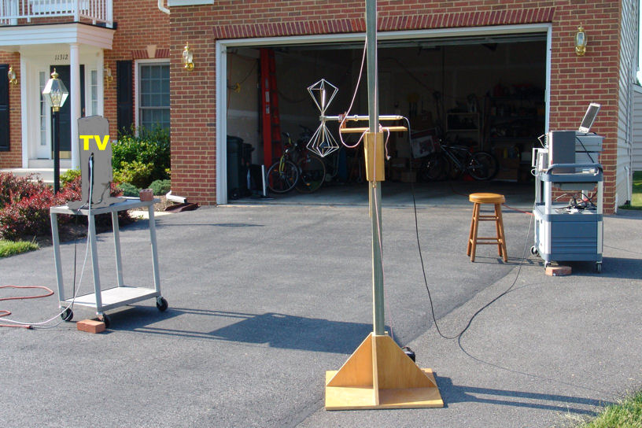
Figure 2-1. Test Site 0—No Wall

Site 1: Exterior House Wall
Three TVs were tested at a single-family house. The initial intent had been to place the TV inside the residence and the transmitter outside. The plan was to avoid windows in order to ensure that the interfering emission propagated through a wall rather than through a window; however, all potential test areas included either closely-spaced windows or large metallic objects (air-conditioning units, metal gas fireplace, or washer and dryer). Consequently, an exterior garage wall was selected as the barrier between the transmitter and the TV receiver. It was more convenient at this site to run the cable for TV operation outdoors than into the garage; consequently, the TV was place outdoors for the tests and the interfering source was placed inside the garage. Figures 2-2 and 2-3 show the test setup.

As was shown in Table 2-1 and the illustrations, the exterior garage wall had the same type of construction as the back and side walls of the house (wood frame with drywall inside and vinyl siding over sheathing on the outside). The only elements missing from the garage wall relative to the exterior residence walls were insulation and electrical wiring. Because the insulation in the residence walls was fiberglass with a clear plastic vapor barrier, it is not expected to contribute significantly to wall attenuation; consequently, the absence of insulation is not expected to influence the test results. While the presence or absence of electrical wiring in a wall can affect propagation, we note that, except where wall switches, overhead lights, or feeds to the second floor exist, the first floor wiring on the exterior walls extends above the floor level only to the height of the outlets (16 inches), which are spaced at 12-foot intervals; consequently, in at least some cases, its effect on propagation is likely to be small.

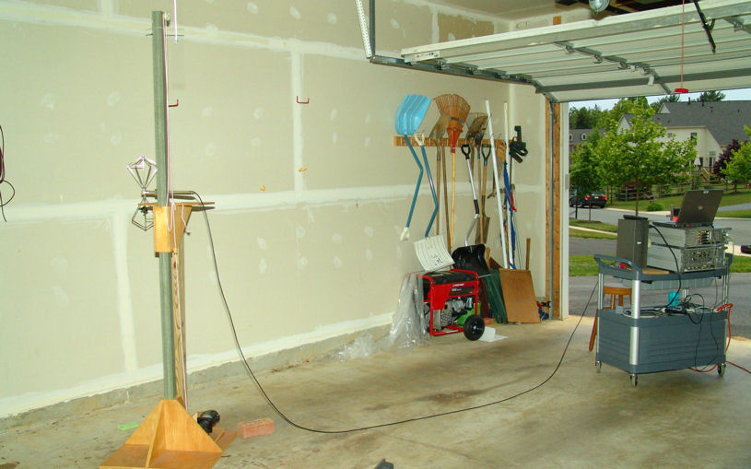
Figure 2-2. Test Site 1—Inside View of Exterior Wall

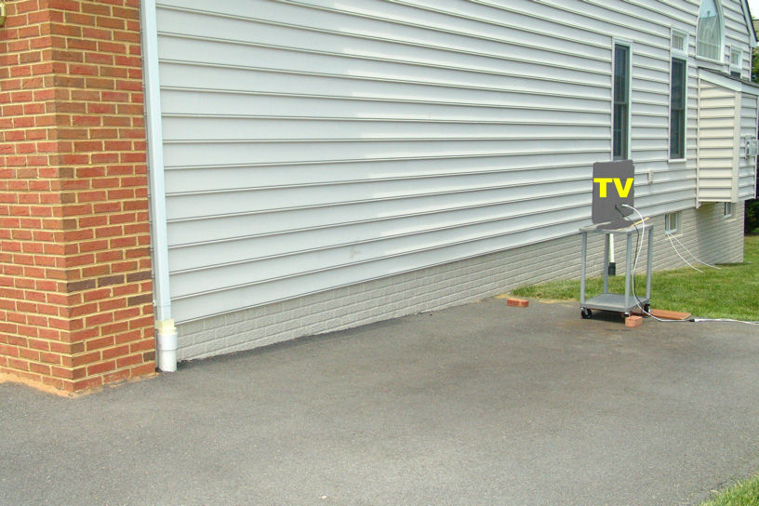
Figure 2-3. Test Site 1—Outside View of Exterior Wall

Site 2: Inter-Unit Townhouse Wall
At site 2, the TV and the interfering source were placed in adjacent townhouses, separated by a firewall. The tests were performed on the ground floor of each townhouse in finished, carpeted rooms.

Figures 2-4 and 2-5 show the interferer test setup in the Townhouse A for 2 meters separation distance. Figure 2-6 shows the configuration with the antenna on the other side of the room for tests at 10 meters distance. Figures 2-7 and 2-8 show the setup of a TV sample in Townhouse B for 2 meters and 10 meters separation distances, respectively.

The townhouse site was expected to create more complex multipath propagation between the interferer and the TV than that at the other two sites. A wrought iron bookcase can be seen in the Figures 2-7 and 2-8, 37” to left of centerline between antenna and starting position of the TV (to the right of the TV when viewed from the front of the TV). In addition, the townhouse fire wall is believed to include metallic components, based on observations of similar townhouses under construction near site 2. Figures 2-9 and 2-10 show photographs of the firewall in one of those townhouses. The gypsum firewall panels (two-inches thick) are joined by vertical steel channels on 24-inch centers, as described in Table 2-1; the firewall also includes horizontal channels at about 10-foot intervals vertically and each wall includes a diagonal metal strip.

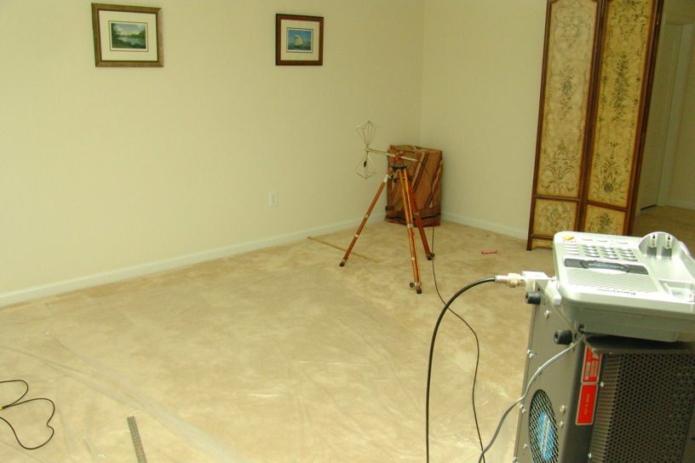
Figure 2-4. Test Site 2—View of Inter-Unit Townhouse Wall from Townhouse A During Tests at 2 Meters Separation Distance
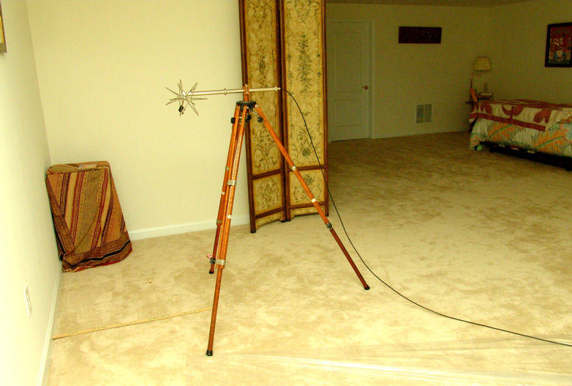
Figure 2-5. Test Site 2—Antenna Positioned for 2 Meters Separation Distance
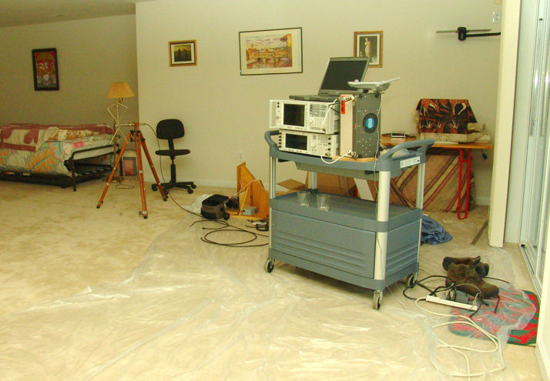
Figure 2-6. Test Site 2—Townhouse A with Antenna Positioned for 10 Meters Separation Distance (Inter-Unit Wall Is Behind and to the Left of Camera)
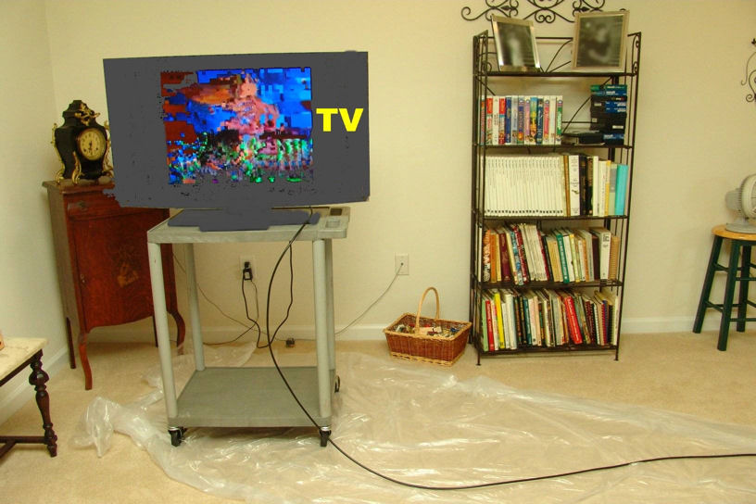
Figure 2-7. Test Site 2—TV Positioned in Front of Common Wall in Townhouse B for Tests at 2 Meters Separation Distance

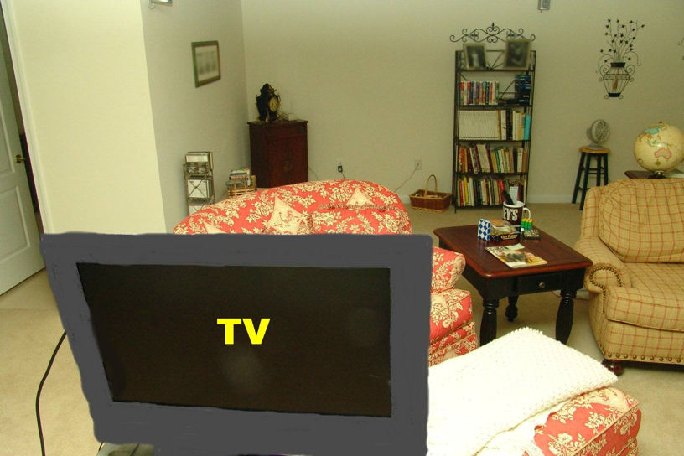
Figure 2-8. Test Site 2—TV Positioned in Townhouse B for Tests at 10 Meters Separation Distance
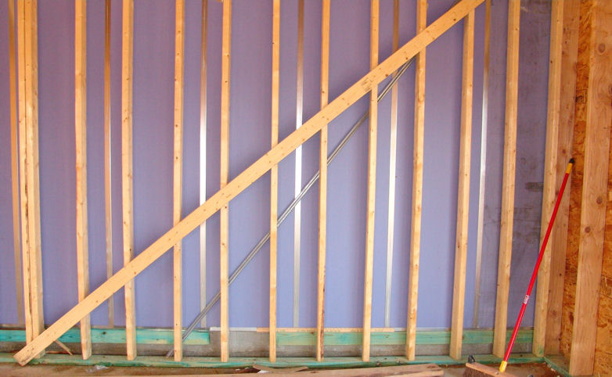
Figure 2-9. Inter-Unit Wall of a Townhouse Under Construction

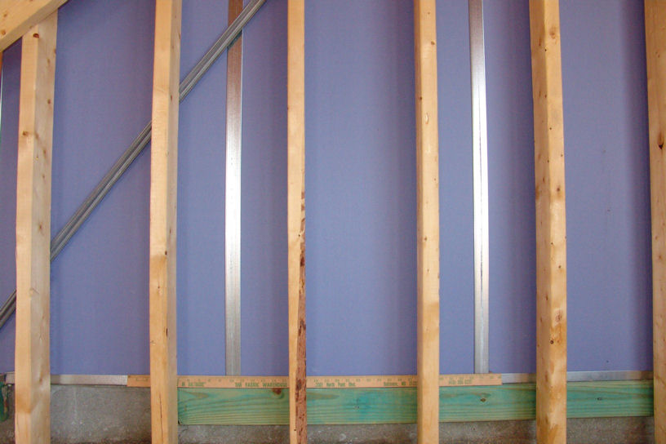
Figure 2-10. Close-Up View of Inter-Unit Wall of a Townhouse Under Construction

Test Setup
Figure 2-11 shows a block diagram of the test setup for all tests. Table 2-3 identifies the equipment that was used. Figures 2-12 and 2-13 show photographs of the signal generation and measurement equipment taken at test site 1.

A vector signal generator was configured to generate a 4.8-MHz wide DVB-H OFDM signal. That signal was amplified by an RF power amplifier that drove a signal splitter, allowing the signal to be delivered to both a spectrum analyzer and a calibrated UHF biconical antenna having -1.1 dBi gain at 501 MHz. On-site measurements were performed to calibrate the relative gains of the two signal paths, including the effects of splitter imbalance and cable losses so that signal power measurements on the spectrum analyzer could be converted into equivalent power delivered to the antenna.

A cable TV source was connected through a step attenuator with 0.1 dB steps at a location on the opposite side of the room (site 2) or at the other end of the house (site 1) from the interfering source. The step attenuator output was fed through a 50- or 100-foot long 75-ohm coaxial cable to the RF input of the TV under test. The step attenuator was used to adjust the signal level delivered to the TV by the cable TV system.

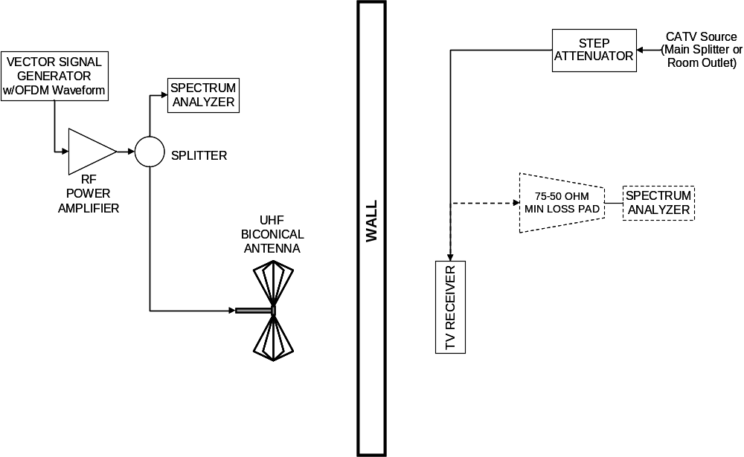
Figure 2-11. Block Diagram of Test Setup

Table 2-3. Equipment List
Equipment | Brand and Model
Vector signal generator | Agilent E4438C
RF power amplifier | Amplifier Research 5W1000
Splitter | Mini-Circuits ZFSC-2-4-N
Spectrum Analyzer | Agilent E4440A
UHF Biconical Antenna | Schwarzbeck Mess model VUBA 9117
50-ohm cables in interferer test setup | Various double-shielded coaxial cables
75-ohm cables in CATV setup | Identified in Table 2-2
Step Attenuator | Trilithic ZMT-57 75-to-50 ohm matching transformer  +  Weinschel AF119A-99-33 50-ohm 1-dB step attenuator  +  JFW Industries 50R-249 50-ohm 0.1-dB step attenuator  +  Trilithic ZMT-57 50-to-75 ohm matching transformer
75 to 50-ohm minimum-loss pad | Trilithic ZM-57

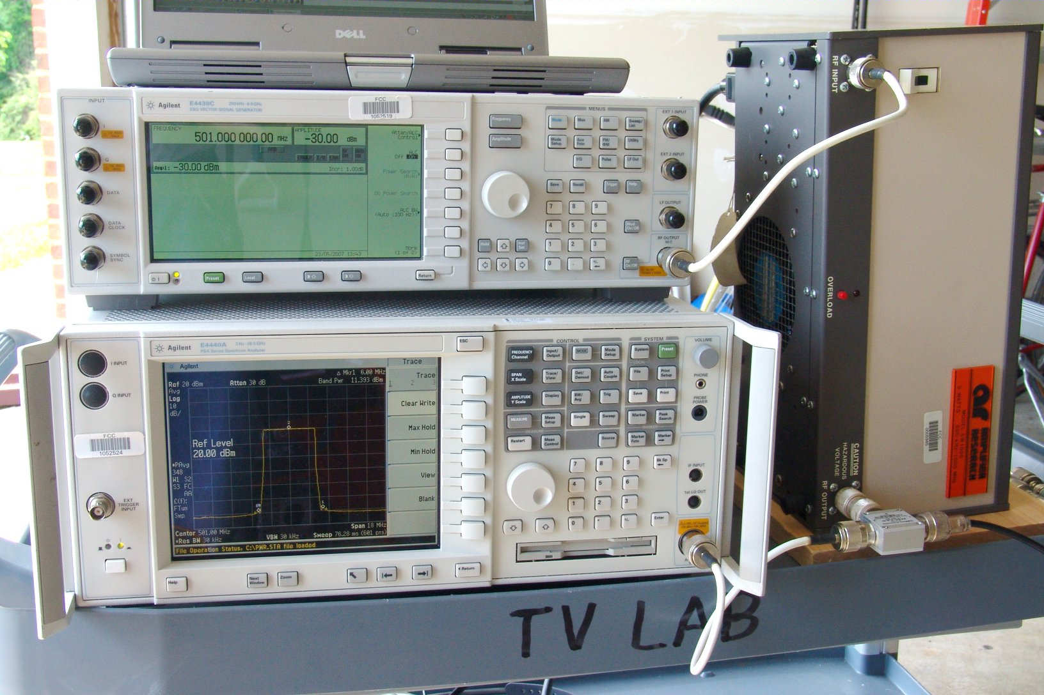
Figure 2-12. Test Equipment as Set Up at Site 1
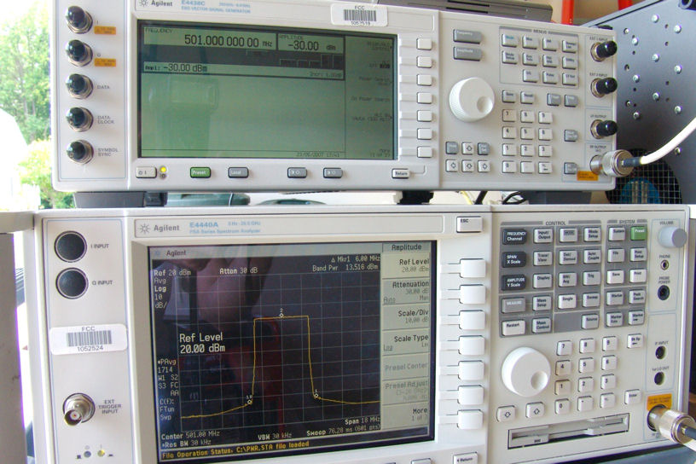
Figure 2-13. Close-Up of Test Equipment

Cable TV Channel Selection and Signal Level
The cable TV signals for these tests came from Verizon FIOS installations at the two residences. Verizon identifies the digital cable signals as being 256-QAM.

The intent was to test at one or more cable TV channels that overlap broadcast TV bands. Verizon provided a list of clear-QAM channels on their FIOS system in terms of virtual channel numbers, but did not provide a mapping to EIA RF cable channel numbers; consequently, the availability of clear-QAM signals in terms of EIA channel numbers was determined by “channel surfing”.

Only two cable RF channels within the TV broadcast bands were found to include clear-QAM programming—EIA channels 70 and 73; however, channel 73 was not successfully tuned on two of the receivers. Consequently, EIA cable channel 70 was selected for testing. This RF channel is centered at 501 MHz and overlaps broadcast channel 19, which is centered at 503 MHz. (Cable TV channels, like broadcast TV channels, have 6 MHz bandwidth.) The cable channel included multiple standard-definition program streams, but no high-definition programming.

In each residence, a step attenuator with 0.1-dB steps was inserted into the cable TV signal path at the source end of the cable driving the TV to allow signal level to be set. The “Digital Cable Network Interface Standard” specifies that the carrier level at the “input terminals of the first device located on the subscriber’s premises” should be -12 to +15 dBmV (-60.8 to -33.8 dBm) for 256-QAM signals. The step attenuator was adjusted so that the power delivered on EIA channel 70 to the television’s RF input terminal was -11 dBmV (-59.8 dBm), i.e., 1 dB above the minimum specified level.

Figure 2-14 shows the measured spectrum of the signal delivered to the TV for an 18-MHz span centered at EIA channel 70 at site 1. The spectrum levels have been adjusted for loss of the impedance-matching pad used in the measurement.

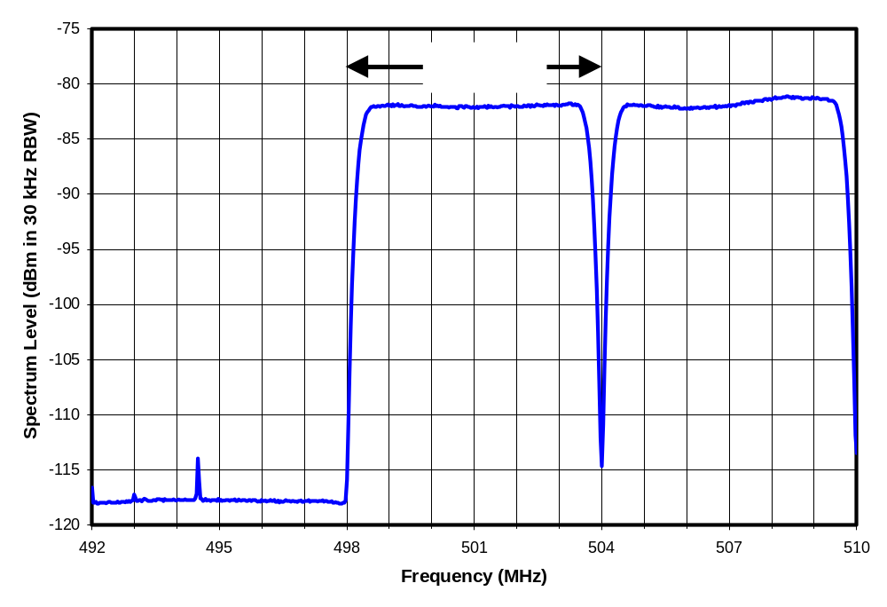
Figure 2-14. Spectrum of Cable TV Signal Measured at Site 1

Interference Source
The interfering signal for these tests was an OFDM DVB-H signal generated using a commercial software package for a vector signal generator with parameters set for a 2k OFDM signal with 5-MHz channel width and 64-QAM modulation. Measured bandwidths were 4.76 MHz at the -3-dB points and 4.8 MHz at the -20-dB points.

Figure 2-15 shows the spectrum of the interfering signal, which was centered on the cable channel. The cable channel center is 2-MHz below the center of the nearest broadcast channel. Such an offset exists for all cable channels that overlap UHF TV broadcast channels under the standard and IRC cable channel plans; the offset is larger under the HRC channel plan. In VHF, there is no offset between broadcast and cable channel frequencies under the standard cable channel plan and, for most channels, under the IRC plan.
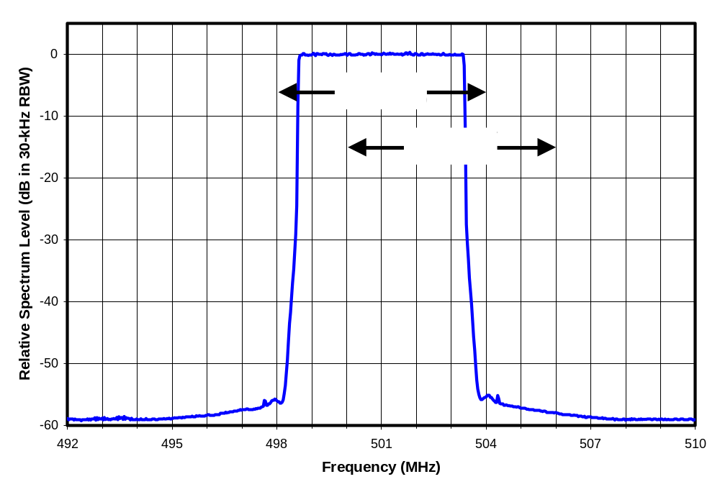
Figure 2-15. Spectrum of OFDM Signal Used as Interferer

In an application involving white-space use of broadcast TV spectrum, the transmit spectrum of the white-space device is likely to be centered on a broadcast channel rather than on the cable channel, as was done here. In such a case, we anticipate that the interference effect would depend on the amount of power that overlaps the cable channel. If, for example, a device transmitted with a bandwidth of 2-MHz or less, centered on broadcast channel 19, then all of the power would fall within EIA cable channel 70 and the interference thresholds would likely match those measured in this report. For greater bandwidths, a portion of the transmit power would fall into another cable channel. For example, a transmission with a rectangular signal spectrum having 4-MHz bandwidth centered on broadcast channel 19 would extend from 501 to 505 MHz; since only 75% of the spectrum overlaps cable channel 70, the interference effect on that channel would be reduced by about 1.25 dB.

Test Methodology

Determining the Interference Threshold
Sound from the TV receiver under test was monitored as a basis for identifying interference. This enabled the tests to be performed by a single engineer without moving from the interfering signal generation location to the TV location multiple times per measurement. At sites 0 and 1, the sound was monitored directly by the test engineer. At site 2, the sound was monitored through a 2.4 GHz wireless phone operating in intercom mode. To confirm that the phone itself did not cause interference, the cable TV signal level was reduced 5 dB below the level used in the interference tests. The phone handset was then moved to various locations in contact (plastic-to-plastic) with the case TV receiver housing, with particular emphasis in regions near the location of the RF input to the TV, while monitoring the TV picture and sound for signs of interference. No interference effect was observed.

With the cable signal level returned to the level used for interference testing, the OFDM transmit signal level was increased in one-dB steps while monitoring the sound from the TV for about 4 seconds at each step. If an audio dropout was observed, the sound was monitored for an additional period of about 20 seconds. If dropouts were found to last less than about 50 percent of the observation period, the interference level was increased another 1 dB until a sound dropout exceeding 50 percent was observed. At that point, the transmit level was measured. In most cases sound was present continuously during the 4 seconds of monitoring for one amplitude step, but it dropped out completed (based on about 20 seconds of monitoring) on the next step. In a few cases sound dropped out and back in during the 20-second monitoring, but was absent well over 50% of the time.

The interference amplitude at which greater than 50 percent loss of sound occurred was then known to be between the measured level and the previous step, 1 dB lower; consequently, 0.5 dB was subtracted from the measured power to obtain the nominal threshold at which sound loss exceeds 50 percent.

Interference threshold measurements based on loss of sound were performed as a matter of convenience, though the actual parameter of interest is the undesired signal level at the threshold of visibility (TOV) of picture degradation. Because of the cliff effect that is observed with DTV systems, the difference between the TOV level and the level that causes complete loss of picture and sound was expected to be relatively small. For ATSC 8-VSB systems, this difference is about 1 dB. Since the 256-QAM system used for the digital cable TV tests could have exhibited a different slope to its cliff from that of the 8-VSB system, measurements were performed to determine the difference in interference level at TOV versus that at loss of sound. The measurements were performed using receiver I1 with the desired signal level specified earlier in this chapter and with the interfering signal summed with the desired signal by means of a signal combiner (i.e., the test was conducted rather than radiated). The undesired signal level was adjusted in 0.1-dB steps to determine thresholds. Results were as follows:
Interference level at 50 percent loss of sound is 0.9 dB above that at TOV;
Interference level at complete loss of sound is 1.1 dB above that at TOV. The picture is also completely lost at this point.

Based on these results an additional 1 dB was subtracted from the interference power levels to provide an estimate of the interference level at the threshold of visibility (TOV) of picture degradation.

The level was then calibrated for splitter and cable attenuation imbalance and for antenna gain (-1.1 dBi) to obtain an estimate of effective isotropic radiated power (EIRP) at TOV.

Test Conditions
At each site and separation distance, several measurements of interference thresholds were performed while varying the parameters described below.

Transmit Polarization
All tests were performed for two different polarizations of the transmit antenna—vertical and horizontal.

Transmit Antenna Height
The reflection of the interfering signal from the ground can combine with the direct-path signal in a way that either enhances or partially cancels the direct signal depending on the phase shift occurring on reflection from the ground and on the difference in path length between the bounce path and the direct path, in wavelengths. Given sufficient time, tests could be performed over a range of transmit antenna heights to determine the minimum interference threshold that occurs as a function of height; however, in order to reduce the number of measurements to a manageable level while still attempting to ensure that the measurements were not exclusively performed under conditions that caused signal cancellation by the ground reflection, measurements were performed at two antenna heights. The heights were selected so that the path length difference between the direct and the ground-reflected paths was approximately half-wavelength greater for the higher antenna height as compared to the lower antenna height; however, for tests at site 2 (the townhouses) at a 10-meter separation distance, the tripod on which the antenna was mounted was not tall enough to achieve this condition. In that case, the higher antenna height resulted in only a 0.2-wavelength increase in path length difference relative to the lower antenna height.

TV Orientation
For tests at site 2, the TV under test was oriented so that rear of the TV faced the interfering source antenna. At site 1, two orientations were used: rear facing the source and front facing the source. At site 0, two additional orientations were tested.

Lateral Offset
At site 2, the wall separating the interferer from the TV is believed to have contained vertical metal channels and a diagonal metallic strip, as described in Table 2-1. These conductive components can be expected to affect propagation through the wall in ways that may vary with horizontal positioning of the interfering source antenna and the TV. In addition, the site included a wrought iron bookcase near the propagation path.

To provide an indication of these effects, tests at that site with one of the TVs were performed for several lateral offset positions (parallel to the wall separating the interferer from the TV) of the antenna and of the TV.

TEST RESULTS
A total of 108 measurements of interference thresholds were made. Each was converted to an EIRP corresponding to the threshold of visibility (TOV) of picture degradation, as described in the previous chapter. In addition to other measurement tolerances, the reported values are subject to a tolerance of
+/-0.5 dB due to the 1-dB step size used in identifying thresholds.

Overview of Measurements Under Common Conditions Across the Test Sites
At all three test sites, measurements were performed using two heights and two polarizations of the transmit antenna, with the test TV oriented so that the interfering emission was directed at the back of the receiver. We will refer to the configurations for those measurements—four at each separation distance tested at each site for each TV—as the common conditions of the tests, though we note that the pair of antenna heights tested differed among the sites, as was shown in Table 2-2.

In addition to these common test conditions, tests were performed at some sites using other conditions including other aspect angles for the TV and lateral offsets of the TV and of the transmit antenna. In this section we discuss only the measurements made under the “common” conditions.

Table 3-1 summarizes the measurements corresponding to maximum susceptibility (minimum threshold EIRP) across two antenna heights and two polarizations with the interfering emission coming from the rear of the TV receiver (i.e., the common conditions).

Interference thresholds occurred at EIRPs as low as 6.3 dBm for the two-meter separation distance and as low as 15.3 dBm for the ten-meter separation distance.

Table 3-4. Minimum EIRP at TOV Across Two Antenna Heights and Two Polarizations for Interference to TVs from the Rear
 |  | Minimum EIRP at TOV (dBm) with Specified Wall Between the Interferer and the TV Receiver^{A}
Separation Distance (m) | TV | Site 0 —  No Wall | Site 1 — Exterior Single-Family House Wall | Site 2 —  Inter-Unit  Townhouse Wall
2 | D3 |  | 13.4 | 8.5
2 | F3 |  | 9.4 | 14.4
2 | I1 | 6.3 | 6.3 | 16.4^{B}
2 | Minimum |  | 6.3 | 8.5
10 | D3 |  | 21.2 | 24.2
10 | F3 |  | 15.3 | 15.4
10 | I1 |  | 17.4 | >24.2
10 | Minimum |  | 15.3 | 15.4
Notes
^{A} In addition to other measurement tolerances, the EIRP values are subject to +/- 0.5 dB error due to 1-dB step size used in identifying thresholds.
^{B} The values in the table correspond to minimum threshold EIRP across two polarizations and two heights of the interferer for interference arriving directly from the rear of the TV receiver. In addition, measurements were performed on TV I1 at site 2 for 2 meters separation with two lateral offset positions for the transmit antenna and one lateral offset position of the TV receiver in order to observe the effects of metallic components of the wall construction and of the wrought-iron bookcase. Those measurements resulted in a 3-dB lower minimum threshold EIRP for receiver I1 than that shown in the table (i.e. greater susceptibility to interference).

Detailed Results for All Measurement Conditions
Each of the measurements presented in the previous table corresponded to the lowest of four measurements across two antenna heights and two polarizations for interference from the rear of the TV receiver. The tables that follow contain all of the EIRP measurements underlying those results, as well as additional EIRP measurements corresponding to other conditions that were not included in the previous table.

Site 0: No Wall
Table 3-2 shows the results of all measurements performed at site 0. The site-0 tests involved only one TV receiver and one separation distance. The tests were performed after the site-1 measurements, outside of the site-1 residence, as a basis for comparison. The measurements were performed for four aspect angles of the TV: interference from the front of the TV; interference from the back of the TV; TV rotated 45 degrees counter-clockwise from the rearward aspect (i.e., interference from the right rear of the TV as viewed from the front); TV rotated 90 degrees counter-clockwise from the rearward aspect (i.e., interference from the right side of the TV). The tested TV had its RF input on the right side, which suggests that the tuner was also on that side. The rear aspect exhibited the greatest susceptibility to interference among the aspects that were tested.

Table 3-5. Measurements at Site 0 With 2 Meters Separation
 |  | EIRP at TOV (dBm)
Tx Antenna Height (m) ➔ |  | 0.97 | 0.97 | 1.47 | 1.47
Tx Polarization ➔ |  | H | V | H | V | Min
TV | Aspect
I1 | Front | 21.2 | >25.1 | 16.2 | 20.2 | 16.2
I1 | Rear | 20.3 | 10.3 | 12.4 | 6.3 | 6.3
I1 | 45deg CCW | 11.3 | 10.3 | 7.4 | 8.4 | 7.4
I1 | 90deg CCW | 11.3 | 14.3 | 15.3 | 14.3 | 11.3
Overall Min |  |  |  |  |  | 6.3

Site 1: Single-Family Home Wall
Table 3-3 shows the results of all measurements at site 1 for two meters separation between the transmit antenna and the TV receiver. The measurements were performed on three TV receivers for front and rear aspects of the TV. The individual threshold EIRP measurements at site 1 averaged 2.1 dB lower than those at site 0 for the seven measurements at corresponding conditions. This result is unexpected, given that the wall attenuation at site 1 was expected to result in higher threshold EIRP values at site 1. We note, however, that differences in the multipath environment, such as a possible difference in effective depth of the ground planes could cause measurement differences at fixed antenna heights. Though the individual measurements differed from most of the corresponding measurements at site 0, the overall minimum threshold EIRP (i.e., maximum susceptibility to interference) at site 1 matched that measured at site 0.

Table 3-6. Measurements at Site 1 With 2 Meters Separation
 |  | EIRP at TOV (dBm)
Tx Antenna Height (m) ➔ |  | 0.97 | 0.97 | 1.47 | 1.47
Tx Polarization ➔ |  | H | V | H | V | Min
TV | Aspect
D3 | Front | >25.1 | >25.1 | >25.1 | >25.1 | >25.1
D3 | Rear | >25.1 | 13.4 | 19.3 | 13.4 | 13.4
F3 | Front | 14.4 | 19.3 | 10.3 | 21.3 | 10.3
F3 | Rear | 11.3 | 15.3 | 19.3 | 9.4 | 9.4
I1 | Front | 16.3 | >25.1 | 15.3 | 25.1 | 15.3
I1 | Rear | 14.3 | 7.4 | 7.4 | 6.3 | 6.3
Overall Min |  |  |  |  |  | 6.3

Table 3-4 shows the results of all measurements at site 1 for ten meters separation distance. The minimum threshold EIRP at this distance was 9-dB higher than that at two meters separation.

Table 3-7. Measurements at Site 1 With 10 Meters Separation
 |  | EIRP at TOV (dBm)
Tx Antenna Height (m) ➔ |  | 0.97 | 0.97 | 2.39 | 2.39
Tx Polarization ➔ |  | H | V | H | V | Min
TV | Aspect
D3 | Front | >25.1 | >25.1 | >25.1 | >25.1 | >25.1
D3 | Rear | >25.1 | 25.1 | 21.2 | 22.2 | 21.2
F3 | Front | 16.3 | >25.1 | 15.3 | 25.1 | 15.3
F3 | Rear | >25.1 | 18.4 | 15.3 | 18.3 | 15.3
I1 | Front | >25.1 | >25.1 | >25.1 | 25.1 | 25.1
I1 | Rear | 17.4 | 25.1 | 20.3 | 24.2 | 17.4
Overall Min |  |  |  |  |  | 15.3

Site 2: Inter-Unit Townhouse Wall
Table 3-5 shows the results of all measurements at site 2 for two meters separation between the transmit antenna and the TV receiver. The measurements were performed on three TV receivers, but with only one aspect angle—interference from the rear.

Table 3-8. Measurements at Site 2 With 2 Meters Separation
 |  | EIRP at TOV (dBm)
Tx Antenna Height (m) ➔ |  | 0.88 | 0.88 | 1.26 | 1.26 |  | Lateral Offset (inches)
Tx Polarization ➔ |  | H | V | H | V | Min
TV | Aspect |  |  |  |  |  | Antenna | TV
D3 | Rear | 10.4 | 12.5 | 9.4 | 8.5 | 8.5 | 0 | 0
F3 | Rear | 20.3 | 17.4 | 14.4 | 15.4 | 14.4 | 0 | 0
I1 | Rear | >24.2 | 24.2 | 17.4 | 16.4 | 16.4 | 0 | 0
I1 | Rear | >24.2 | 22.3 | 13.4 | 18.4 | 13.4 | 32 | 0
I1 | Rear | >24.2 | 16.4 | 19.4 | >24.2 | 16.4 | -32 | 0
I1 | Rear | >24.2 | 20.3 | 17.4 | 15.4 | 15.4 | 0 | 16
I1 | Rear | 19.4 | 21.3 | 18.4 | 20.3 | 18.4 | 32 | 16
Overall Min |  |  |  |  |  | 8.5

Because of the vertical metal channels that are believed to be a part of the construction of the firewall between the two townhouses and because of the wrought iron bookcase near the television receiver, one receiver was tested for combinations of lateral offsets of the antenna and of the TV from the centerline used in the primary tests. The lateral offsets shown in the table are specified in inches to the right of the centerline from the antenna to the TV receiver in their initial positions, as viewed from behind the antenna. Thus, the +16-inch offset shown for the TV corresponds to a 16-inch offset to the right as viewed from the antenna, but to the left as viewed from the front of the TV; this corresponds to a position farther from the bookcase. Two of the four new offset combinations that were tested yielded lower minimum interference thresholds than the zero-offset results by amounts of 1 dB and 3 dB (i.e., 15.4 and 13.4 dBm relative to 16.4 dBm); one yielded a higher minimum offset by 2 dB.

The minimum threshold EIRP (corresponding to maximum susceptibility to interference) measured at site 2 was about 2 dB higher than that measured at site 1. This may suggest that the inter-unit townhouse wall exhibited higher attenuation than the exterior house wall, although the caveats presented in the next section should be observed. The townhouse wall is believed to include 1.5 inches more gypsum drywall thickness than the exterior house wall, as well as more closely-spaced studs (12 inches versus 16 inches), in addition to having metal channels that were not present in the exterior house wall. The exterior house wall included sheathing and vinyl siding not present in the townhouse wall.

Table 3-6 shows the results of all measurements at site 2 for ten meters separation distance. At 10 meters distance, the higher of the two transmit antenna heights was limited by the tripod height, which, in turn, limited the change in direct-path versus ground-reflected path between the two heights to only 0.2 wavelength instead of the half-wavelength change that was desired and was achieved for the other tests. This creates the possibility that, for a given TV, the measurements at both heights could have been in a region of partial cancellation of the direct path by the bounce path signal.

Table 3-9. Measurements at Site 2 With 10 Meters Separation
 |  | EIRP at TOV (dBm)
Tx Antenna Height (m) ➔ |  | 0.88 | 0.88 | 1.26 | 1.26
Tx Polarization ➔ |  | H | V | H | V | Min
TV | Aspect
D3 | Rear | >24.2 | 24.2 | >24.2 | >24.2 | 24.2
F3 | Rear | 20.3 | 15.4 | >24.2 | 21.3 | 15.4
I1 | Rear | >24.2 | >24.2 | >24.2 | >24.2 | >24.2
F3 Repeat | Rear | 20.3 | 21.3 | >24.2 | 22.3 | 20.3
Overall Min |  |  |  |  |  | 15.4

Based on the minimum measurements across the two antenna heights and two polarizations, the interference threshold of receiver F3 was found to be only 1 dB greater at 10 meters than at 2 meters. This difference was unexpectedly small. After all other tests had been completed, the 10-meter tests of F3 were repeated. The second set of tests, shown in Table 3-6 as “F3 Repeat”, produced higher interference thresholds for two of the test conditions than the corresponding thresholds in the first set of measurements. It is assumed that the change is due to slightly different positioning of the transmit antenna and of the TV, because both the tripod and the TV cart had been moved to the 2-meter separation distance between the two sets of 10-meter measurements on receiver F3.

Across the three TVs, the minimum threshold EIRP at 10 meters was 7-dB higher than that at two meters separation. The 10-meter minimum EIRP thresholds at site 2 closely matched those at site 1.

Median Results
Though median results are not generally of direct interest where interference probabilities must be reduced to low levels, the median measurement results are summarized here for completeness.

Measurements with interference arriving from the rear of the TV comprised 72 of the 108 measurements performed in this study. Of the rear aspect measurements, 44 were at 2 meters distance and 28 were at 10 meters distance. The rear aspect measurements were performed on only one TV at site 0 and on all three TVs at sites 1 and 2. The median interference threshold EIRP was 16.9 dBm at 2 meters and 24.2 dBm at 10 meters.

Front aspect measurements were performed on one TV at site 0, three TVs at site 1, and none at site 2, for a total of 16 measurements at 2 meters distance and 12 measurements at 10 meters distance. Median thresholds for interference from the front were 21.2 dBm and >25.1 dBm at 2 and 10 meters, respectively, though we note that interference at a distance of 2 meters from a device in a neighboring residential unit is unlikely to occur with the front aspect of the TV.

Variability of Direct Pickup Vulnerability
The propagation loss between the antenna and the TV receiver point of vulnerability (presumably the tuner module) is expected to be a function of—among other things—the phase of the arriving ground-reflected wave relative to the direct-path wave. This phase difference depends on the horizontal separation distance as well as on the heights of the transmit antenna and of the TV receiver point of vulnerability above the effective ground plane.

In measuring emission levels of a device—as opposed to susceptibility to interference—typical procedures call for varying the height of the receive antenna to find the maximum response. In the interference susceptibility tests presented here, the transmit antenna height was varied, but only among two heights for each propagation distance. As a result of testing at only two heights, we cannot know how closely we achieved a propagation condition that maximized the interference potential. Furthermore, the difference between the observed interference levels and those corresponding to a true maximum interference susceptibility across antenna heights can be expected to vary: (1) among the TV receivers, since the height of the point of interference vulnerability probably varies among the tested TVs; (2) among the test sites, since antenna heights differed among some of the sites and the depths of the effective ground plane may differ among the sites; and, (3) among the separation distances, since the bounce-versus-direct-path propagation path length difference varies with separation distance. Additionally, each test site had its own other sources of multipath reflections (such as the bookcase at the townhouse location.). These variations should be recognized when comparing test results to estimate differences in wall attenuation, differences in TV susceptibilities, and differences in propagation loss for 10 meters versus 2 meters separation distances.

We note, for example, that receiver D3 appears to be the least susceptible to interference among the three TVs by a margin of about 4 dB based on tests at site 1 at both separation distances (Table 3-1); however, in the two-meter separation tests at site 2, receiver D3 exhibited the greatest susceptibility to interference among the three receivers—by a 5-dB margin if all measurements are included, or by a 6-dB margin based on only the comparable measurements (i.e., measurements with zero lateral offset). This apparent relative increase in susceptibility of receiver D3 may be a result of variations caused by the effects discussed in the preceding paragraph. Alternatively, we note that the wrought iron bookcase located to the right of the TV during the two-meter tests at site 2 could have altered the effective arrival direction of the interference to a direction from which that TV is more susceptible to interference.

Society of Cable Telecommunications Engineers, “Digital Cable Network Interface Standard”, ANSI/SCTE 40-2004, p.1, 17.
The Commission’s First Report and Order and Further Notice of Proposed Rule Making (FCC 06-156), adopted October 12, 2006, proposed permitting fixed white space devices to operate at EIRP levels up to 36 dBm (1 watt power with up to 6 dBi antenna gain). The earlier Notice of Proposed Rule Making (FCC 04-113), adopted May 13, 2004, proposed a peak EIRP limit of 26 dBm (100 mW peak power with up to 6 dBi antenna gain) for portable devices. Final power limits have not yet been determined.
For 8-VSB signals, D/U rejection ratio for co-channel interference is about 15 dB. Median D/U rejection ratio for first-adjacent channel interference of 8 DTV receivers measured by the FCC Laboratory was about -39 dB—a difference of 54 dB. First-adjacent channel D/U ratio is from Appendix A of: Stephen R. Martin, “Interference Rejection Thresholds of Consumer Digital Television Receivers Available in 2005 and 2006”, Report FCC/OET 07-TR-1003, March 30, 2007.
Stephen R. Martin, “Tests of ATSC 8-VSB Reception Performance of Consumer Digital Television Receivers Available in 2005”, Report FCC/OET TR 05-1017, <SHVERA Study>, November 2, 2005.
In the 2005 study, laboratory tests were performed to characterize the over-the-air DTV reception performance of 28 consumer receivers that were selected as representative of the products that were on the market in 2005. Since the tests involved 8-VSB signals (the DTV signal format used for broadcast in the United States) rather than QAM signals and did not include direct pickup interference, the results of that testing are not directly related to the work performed for the current report. Nevertheless, the relative performance in those earlier tests of the three receivers selected for the current study may be of interest as an indication of overall quality or level of technological advancement. In terms of multipath-handling capability the 28 receivers were found to fall primarily into two performance tiers; receivers D3 and I1 were among the ten receivers fell into the upper performance tier, while receiver F3 was among the majority that fell into the lower tier. In terms of ability to receive weak over-the-air DTV signals in UHF, receivers I1, F3, and D3 ranked 2nd, 5th, 22nd, respectively, among the 28 tested receivers, where first would represent the best performing receiver. The difference in sensitivity between the 2nd and 22nd ranked receivers was 1.7 dB. Thus, the selected receivers represent a reasonable range of performance levels among the receivers tested in 2005.
The metal garage door was in the open position during the tests, as shown in Figure 2-2.
This device was an Agilent 4438C vector signal generator equipped with Signal Studio for DVB software.
Calibration was performed by setting the vector signal generator to produce a CW signal at the center frequency to be used for the OFDM transmission; the signal level at the output of each cable from the splitter was measured while the other cable was terminated in 50 ohms.
Since no CableCARD was used in these tests, reception was limited to unencrypted (clear QAM) channels.
Society of Cable Telecommunications Engineers, “Digital Cable Network Interface Standard”, ANSI/SCTE 40-2004, p.1, 17.
Power levels were measured by disconnecting the 75-ohm cable at the TV RF input and connecting it through a 75-ohm to 50-ohm impedance matching pad connected directly to a spectrum analyzer. Band power in the 6-MHz TV channel was measured after power averaging by the spectrum analyzer; the measurement was then corrected for loss of the impedance matching pad.
Agilent Signal Studio for DVB software was used to create the waveform for an Agilent 4438C vector signal generator.
Cable channel frequencies can be found in “Cable Television Channel Identification Plan”, CEA Standard CEA-542-B, July 2003
<SHVERA Study>, p.1-2 to 1-3.
Ideally, the path-length difference would be computed based on heights of the center of the transmit antenna and the center of the point of interfering signal ingress into the TV receiver, and heights would be measured relative to the effective ground plane. In practice, the calculation was based on height of the center of the transmit antenna and the average height of the RF inputs of the three TVs (presumed to be near the average height of the tuners) above the floor surface (e.g., top of the carpet at site 2).
Ceiling height was too low to accommodate the antenna mast that was used at sites 0 and 1.
The Commission’s First Report and Order and Further Notice of Proposed Rule Making (FCC 06-156), adopted October 12, 2006, proposed permitting fixed white space devices to operate at EIRP levels up to 36 dBm (1 watt power with up to 6 dBi antenna gain). The earlier Notice of Proposed Rule Making (FCC 04-113), adopted May 13, 2004, proposed a peak EIRP limit of 26 dBm (100 mW peak power with up to 6 dBi antenna gain) for portable devices. Final power limits have not yet been determined.
This discussion is presented from the perspective that leakage into the TV receiver’s tuner can be approximated as occurring at a single discrete location. In reality, the leakage may be more complex than that.

