State Research Center of the Russian Federation – the Arctic and Antarctic Research Institute of the Russian Federal Service for Hydrometeorology and Environmental Monitoring

International Arctic Research Center, University of Alaska, Fairbanks

HYDROCHEMICAL ATLAS OF THE ARCTIC OCEAN

St. Petersburg

Fairbanks
2001

Contents

- Introduction……………………………………………………………………………………3
  - Electronic climatic hydrochemical Atlas of the Arctic Ocean……………………………… 3
  - How to use the Atlas………………………………………………………………………… 4
  - List of participants…………………………………………………………………………… 5
  - References to Section 1……………………………………………………………………….5
- Hydrochemical investigations in the Arctic Ocean……………………………………………6
  - History of investigations……………………………………………………………………...6
  - Methods of measurement and determination accuracy……………………………………….9
  - References to Section 2………………………………………………………………………13
- Data processing……………………………………………………………………………….15
  - Hydrochemical information………………………………………………………………….15
    - Data sources………………………………………………………………………………15
    - Spatial and temporal distribution of observations………………………………………...16
  - Control of hydrochemical data……………………………………………………………….23
    - Data input………………………………………………………………………………....23
    - Formal data control in the database of hydrochemical elements………………………...24
      - Control of station passports………………………………………………………………24
      - Control of maximum station observation depths…………………………………………24
    - Regional control…………………………………………………………………………...24
    - Control of variability limits……………………………………………………………….26
    - Expert control………………………………………………………………………..…...26
  - Statistical characteristics……………………………………………………………………..27
  - Objective analysis…………………………………………………………………………….38
  - References to Section 3………………………………………………………………………..40
- Presentation of hydrochemical information……………………………………………………42
  - Data set of initial measurements………………………………………………………………42
4.2. Gridded climatic fields of the objective analysis……………………………………………...43
4.3. Profiles, transects and fields…………………………………………………………………...43
- Climatic distribution of hydrochemical characteristics in the Arctic Ocean…………………..48
  - Vertical profiles………………………………………………………………………………..48
  - Transects……………………………………………………………………………………….48
5.3. Mean values and dispersions at the standard depths…………………………………………..49
  - Maps of climatic distribution of the hydrochemical characteristics at the standard depths……49
Appendixes
Appendix 1. Tables of determination methods
Appendix 2. Metadata

- Introduction

  - Electronic Climatic Hydrochemical Atlas of the Arctic Ocean

Chemical composition of water determines its physical properties and character of processes proceeding in it: freezing temperature, volume of evaporation, density, color, transparency, filtration capacity, etc. Presence of chemical elements in water solution confers waters special physical properties exerting significant influence on their circulation, creates necessary conditions for development and inhabitance of flora and fauna, and imparts to the ocean waters some chemical features that radically differ them from the land waters (Alekin & Liakhin, 1984).
Hydrochemical information helps to determine elements of water circulation, convection depth, makes it easier to distinguish water masses and gives additional knowledge of climatic variability of ocean conditions. Hydrochemical information is a necessary part of biological research. Water chemical composition can be the governing characteristics determining possibility and limits of use of marine objects, both stationary and moving in sea water.
Subject of investigation of hydrochemistry is study of dynamics of chemical composition, i.e. processes of its formation and hydrochemical conditions of water bodies (Alekin & Liakhin 1984). The hydrochemical processes in the Arctic Ocean are the least known. Some information on these processes can be obtained in odd publications. A generalizing study of hydrochemical conditions in the Arctic Ocean based on expeditions conducted in the years 1948-1975 has been carried out by Rusanov et al. (1979).
The “Atlas of the World Ocean: the Arctic Ocean” contains a special section “Hydrochemistry” (Gorshkov, 1980). Typical vertical profiles, transects and maps for different depths – 0, 100, 300, 500, 1000, 2000, 3000 m are given in this section for the following parameters: dissolved oxygen, phosphate, silicate, pH and alkaline-chlorine coefficient. The maps were constructed using the data of expeditions conducted in the years 1948-1975. The illustrations reflect main features of distribution of the hydrochemical elements for multi-year period and represent a static image of hydrochemical conditions. Distribution of the hydrochemical elements on the ocean surface is given for two seasons – winter and summer, for the other depths are given mean annual fields.
Aim of the present Atlas is description of hydrochemical conditions in the Arctic Ocean on the basis of a greater body of hydrochemical information for the years 1948-2000 and using the up-to-date methods of analysis and electronic forms of presentation of hydrochemical information. The most wide-spread characteristics determined in water samples were used as hydrochemical indices. They are: dissolved oxygen, phosphate, silicate, pH, total alkalinity, nitrite and nitrate. An important characteristics of water salt composition – “salinity” has been considered in the Oceanographic Atlas of the Arctic Ocean (1997, 1998).
Presentation of the hydrochemical characteristics in this Hydrochemical Atlas is wider if compared with that of the former Atlas (Gorshkov, 1980). Maps of climatic distribution of the hydrochemical elements were constructed for all the standard depths, and seasonal variability of the hydrochemical parameters is given not only for the surface, but also for the underlying standard depths up to 400 m and including. Statistical characteristics of the hydrochemical elements are given for the first time. Detailed accuracy estimates of initial data and map construction are also given in the Atlas. Calculated values of mean-root deviations, maximum and minimum values of the parameters demonstrate limits of their variability for the analyzed period of observations. Therefore, not only investigations of chemical statics are summarized in the Atlas, but also some elements of chemical dynamics are demonstrated.
Digital arrays of the hydrochemical elements obtained in nodes of a regular grid are the new form of characteristics presentation in the Atlas. It should be mentioned that the same grid and the same boxes were used in the Atlas, as those that had been used by creation of the US-Russian climatic Oceanographic Atlas. It allows to combine hydrochemical and oceanographic information of these Atlases.
The first block of the digital arrays contains climatic characteristics calculated using direct observational data. These climatic characteristics were not calculated in the regions without observations, and the information arrays for these regions have gaps. The other block of climatic information in a gridded form was obtained with the help of objective analysis of observational data. Procedure of the objective analysis allowed us to obtain climatic estimates of the hydrochemical characteristics for the whole water area of the Arctic Ocean including the regions not covered by observations. Data of the objective analysis can be widely used, in particular, in hydrobiological investigations and in modeling of hydrochemical conditions of the Arctic Ocean.
Array of initial measurements is a separate block. It includes all the available materials of hydrochemical observations in the form, as they were presented in different sources. While keeping in mind that this array contains some amount of perverted information, the authors of the Atlas assumed it necessary to store this information in its primary form. Methods of data quality control can be developed in future in the process of hydrochemical information accumulation. It can be supposed that attitude can vary in future to the data that were rejected according to the procedure accepted in the Atlas.
The hydrochemical Atlas of the Arctic Ocean is the first specialized and electronic generalization of hydrochemical observations in the Arctic Ocean and finishes the program of joint efforts of Russian and US specialists in preparation of a number of atlases for the Arctic. The published Oceanographic Atlas (1997, 1998), Atlas of Arctic Meteorology and Climate (2000), Ice Atlas of the Arctic Ocean prepared for publication and Hydrochemical Atlas of the Arctic Ocean represent a united series of fundamental generalizations of empirical knowledge of Arctic Ocean nature at climatic level.
The Hydrochemical Atlas of the Arctic Ocean was elaborated in the result of joint efforts of the SRC of the RF AARI and IARC. Dr. Ye. Nikiforov was scientific supervisor of the Atlas, Dr. R. Colony was manager on behalf of the USA and Dr. L. Timokhov – on behalf of Russia.

1.2. How to Use the Atlas.

The software Ocean Data View (Schlitzer, 2001) should be used for visualization of hydrochemical information. This software allows one to construct schemes of station location, profiles, transects, distribution maps of hydrochemical characteristics. All the possibilities and methods of their use are given in HELP – files of these software.

1.3. List of Participants.

- Leading research associate, Dr. Nikiforov Ye.G. (Sections 1, 3, 5)
- Principal research associate, Dr. Timokhov L.A. (Sections 1, 3, 4)
- Department head, Dr. Priamikov S.M. (Sections 1, 5).
- Dr. R. Colony (Section 1)
- Laboratory head Sokolov V.T. (Sections 2, 3).
- Senior Research Associate Karpiy V.Yu. (Sections 1-5).
- Senior Research Associate Lebedev N.V. (Sections 1-5).
- Senior Research Associate, Dr. Pivovarov S.V. (Sections 2, 3, 5).
- Principal research associate, Dr. Pokrovsky O.M. (Section 3).
- Research Associate Nitishinsky M.A. (Sections 3, 5)
- Research Associate Garmanov A.L. (Sections 2, 4).
- Junior Research Associate Novikhin A.Ye. (Sections 3, 5)
- Junior Research Associate Kirillova Ye.P. (Sections 3, 5).
- Technician Karpiy S.V. (Web Design).

1.4. References to Section 1.

Alekin O.A., Liakhin Yu. I.: Chemistry of the Ocean. – L., Gydrometeoizdat, 1984, 343 p.
Atlas of the oceans. The Arctic ocean. – Published by GUNIO, Ministry of Defense of the USSR, 1980, 184 p.
Joint US-Russian Atlas of the Arctic Ocean, Oceanography Atlas for the Winter Period. Ed. by F. Tanis, L. Timokhov. Environmental Working Group, University of Colorado, Boulder, CD-ROM, 1997.
Joint US-Russian Atlas of the Arctic Ocean, Oceanography Atlas for the Summer Period. Ed. by F. Tanis, L. Timokhov. Environmental Working Group, University of Colorado, Boulder, CD-ROM, 1998.
Rusanov V.P., Yakovlev N.I., Buynevich A.G.: Hydrochemical conditions of the Arctic Ocean. – Proc. of the AARI, 1979, v. 355, 144 p.
Schlitzer R. Ocean Data View software, 2001 – www. AWI-Bremerhaven. de

2. Hydrochemical Investigations in the Arctic Ocean

2.1. History of Investigations

Arctic seas of the Siberian shelf and the Arctic Basin were absolutely unexplored in hydrochemical aspect till the 20-s of the XX-th century. Some amount of determinations were made by expeditions of A. Nordenskiold on board of “Vega” (1878-1879), F. Nansen on board of “Fram” (1893-1896), H. Sverdrup and F. Malmgren on board of ”Maud” (1918-1921).
Hydrochemical observations for parameters of sea water related with biochemical processes (nutrients, elements of the carbonate system) began in the 20-s because of fishery intensification. Amount of information significantly increased during the Second International Polar Year (1932-1933), and principle of international coordination was introduced in practice of investigations of the Arctic seas. Annual observations were carried out in the Chukchi Sea in the years 1932-1938 by Soviet and US expeditions.
Systematical hydrochemical study of the Kara and Laptev Seas began in the 30-s after establishment of the Main Administration of the Northern Sea Route. Study of the East Siberian and Chukchi Seas began somewhat later.
Materials collected up to the year 1941 by the marine expeditions of the Arctic Institute allowed to obtain the first comparative hydrochemical characteristics of the Arctic seas (for example, by then there were 10.000 determinations of dissolved oxygen and more than 12.000 determinations of alkalinity in the Kara Sea, and several thousand determinations in the Laptev and Chukchi Seas).
Cycles of limited in number, but, nevertheless, special observations were done in this period in some expeditions. These observations have been carried out in order to reveal influence exerted by ice melting and freezing on hydrochemical conditions of these seas, including chemical properties of sea ice, study of a possibility to use hydrochemical characteristics as reagents of water mass origin and propagation, study of river runoff influence on hydrochemical conditions of the seas. With this in mind, spatial distribution have been studied of alkaline and sulfate coefficients, pH, concentration of dissolved oxygen, as well as of complete set of nutrients and electric conductivity of sea water. These observations have given some material for estimation of daily and seasonal oscillations of hydrochemical element concentrations.
In particular, alkalinity increase of sea water were revealed both in melting zones, as well as in water areas with strong influence of river runoff. However, concentration of dissolved oxygen in the melting zones was increased in the surface layer because of intensive development of phytoplankton, production of oxygen, and often over-saturation of seawater by oxygen (Wiese, 1938). The author revealed that ice edge in the polar seas is a frontal zone according to hydrochemical and biological indications.
Selective rejection of salt out of brine captured by ice takes place by freezing and successive ice thickness growth, it causes a relative concentration decrease of carbonates and sulfates in surface waters. This fact is also approved by study of chemical composition of sea ice (Laktionov, 1930). Deterioration of normal relationships between salt components of seawater is a consequence of this fact.
By ice melting, these processes are reversal in those water areas, where the ice has drifted during polar winter (i.e. for 7-9 months).
Deficit of dissolved oxygen is observed in the water areas influenced by river runoff, because of inflow of a large amount of organic matters and intensive oxidation. As this takes place, active reaction of environment strongly shifts to the acid side (pH values decrease up to 7.5 and lower) (Laktionov, 1936).
Therefore, results of hydrochemical investigations of this period revealed wide possibilities for their implementation in diagnostics of water mass origin and dynamics in the Arctic seas and Arctic Basin.
A large amount of complete analysis of sea and salty water composition has also been performed. Using this material P. Lobza (1947) has studied a relationship between water salinity and chlorine concentration. She revealed significant deviations of the chlorine coefficient in the Arctic seas from the White Sea to the Chukchi Sea from that accepted in the formula of Knudsen-Sorensen for the ocean water (Fig. 2.1):

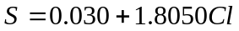.

According to her determinations, there is a growth of the chlorine coefficient in the salty waters (S< 25 psu) from 1.807 by S=25 psu (it is for 0.002 higher than the value for the ocean) to 1.845 by S=10 psu. Therefore, salinity (and density) of the waters freshened by river runoff can be up to 2% higher, than it follows from the formula for the ocean. However, at a later time, interest to this problem has significantly weakened because of insufficient accuracy and labor-intensity of the used analytical methods.
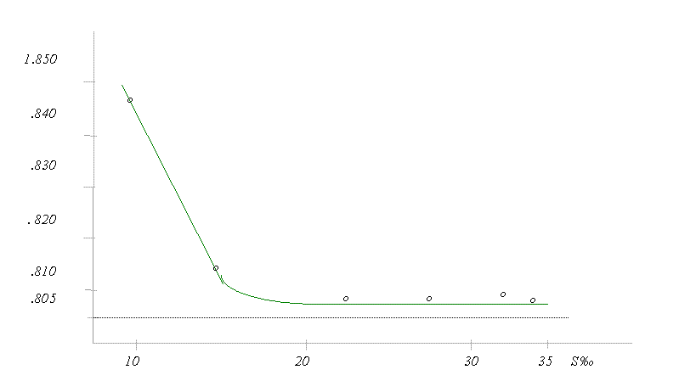
Fig. 2.1 Dependence of the chlorine coefficient K_{Cl} of water salinity in the Arctic seas influenced by river runoff.
according to P. Lobza (1940)
the formula of Knudsen-Sorensen
data of analytical determinations

Investigations were continued in the 80-s using high precision methods of determination of chloride activity in sea water (in particular, with the help of chloride electrodes (Melnikov, 1984; 1989). It has been found that noticeable oscillations of inter-element relationship appeared by low water temperatures (- 1.8 4⁰ C) exerting influence on accuracy of water salinity determination using two methods – electrometric and argentometric.
Both these methods give underestimated values for the surface waters (upper layer of 10 m) in all four Arctic seas in summer. Difference between actual and measured values can be rather significant: dispersion of the deviations is 0.03-0.12 psu for the first method, and 0.05-0.18 psu for the second one.
Chemical processes exert significant influence on relative composition of the surface waters in winter. These processes develop by ice formation and changes of ice cover state, for example, it is brine rejection in the under-ice water layer. That is why, both indirect methods of salinity determination give overestimated results. As this takes place, 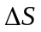 values exceeding 0.02 psu were observed in 30-40% of cases, they were equal practically to zero in 20-30% of cases.
Overestimated results are common in the waters of the Arctic seas underlying the upper layer of 10 m. However, errors do not exceed 0.02 psu in 80% of cases.
The hydrochemical observations were substantially reduced during the Second World War, they were continued only after the war in marine expeditions of the Arctic and Antarctic Research Institute (AARI).
Since 1946, the annual summer hydrochemical observations were performed in marine oceanographic expeditions “Ice Patrol” in the Arctic seas, at first in the Chukchi Sea and later on in the Kara, Laptev and East Siberian Seas. The observations were carried out at standard transects. Aspiration to unification of methods of chemical analysis of sea water, all-embracing character of investigations and their higher level were typical for the post-war period. Materials of these expeditions were used in many research works and became a basis for drawing of maps of mean distribution of hydrochemical parameters in the Arctic seas (Atlas of the Arctic Ocean, 1980; Atlas of the Arctic, 1985).
The most large-scale and systematic hydrochemical observations using a fixed grid were performed in the 70-s and in the beginning of 80-s according to the plan of the Natural Experiment in Study of Interaction of the Ocean and Atmosphere (Trioshnikov et al., 1968). In this period, hydrological and accompanying hydrochemical observations were organized as plan hydrological surveys of sea water areas. This work was carried out using vessels in summer and aircraft in winter, covering the entire sea water area and the Arctic Basin. Observations at “North Pole” drifting stations were continued simultaneously. Number of hydrochemical determinations increased in this period to several tens of thousand for previously poor covered areas. It allowed to study hydrochemical conditions in the seas, Arctic and North European Basin using a serious statistical basis.
The “Ice Patrol” marine expeditions were stopped in the 80-s. Summer observations in the Kara Sea were carried out by the research vessels “Academician Shuleikin” and “Professor Multanovsky”. Summer surveys of ice free parts of the sea were completed by observations in sea ice made by the research icebreaker “Otto Shmidt”. The vessels of the “Shuleikin” type were equipped by modern sounding complexes, plastic bottles were used for sampling, nutrient concentration in sea water was determined with the help of AutoAnalyzer AKEA. Use of modern analytical and sampling equipment allowed to improve significantly quality of hydrochemical information.
Vast amount of information on hydrochemical conditions in coastal and river mouth zones of the Arctic seas was collected by sledge-tractor expeditions of Arctic departments of the USSR Hydrometeorological Service and in coastal observatories (Zubakina, 1974, Miskevich, 1979, Sidorov, 1992).
It should be mentioned that chemical analysis of water samples were performed using unified instructions. It guaranteed comparability of data obtained in different expeditions.
International cooperation in study of the Arctic seas received wide impetus in the 90-s. Several Russian-Norwegian and Russian-German expeditions were carried out in the Kara Sea. Russian-French expeditions SPASIBA (Letolle et al., 1997) worked in the Laptev Sea in September 1989 and in August-September 1991. A series of multidisciplinary Russian-German expeditions was performed in the Laptev Sea in 1992-1999 in accordance with the program “Laptev Sea System”, some of these expeditions were unique (Kassens & Karpiy, 1994; Kassens & Dmitrenko, 1995). This expedition for the first time was carried out in autumn in 1995 in the period of intensive ice formation (Kassens, 1997). In 1996 propagation of river water in seashore near estuary during flood on Lena was studied for the first time (Dmitrrenko et al., 1999). Joint US-Russian expeditions with participation of Japanese specialists were performed in this period of time in the Chukchi Sea and in the eastern part of the East Siberian Sea. The main specific feature of the expeditions in this period of research is simultaneous collection of information in different branches of science and study of the Arctic seas as unit systems.
Of course, data of expeditions performed in different years are not of the same quality. Information obtained since the 60-s is more reliable, because of presence of a definite experience of hydrochemical observations in the Arctic, and implementation of optical devices instead of the visual methods of analysis. The most accurate data have been obtained in the expeditions on the vessels of the “Shuleikin” type and in international expeditions in the 90-s.
There were no foreign publications in hydrochemistry of the Russian Arctic seas till the middle of the 90-s. Foreign research vessels have worked usually in the Chukchi and Beaufort Seas. However, a US icebreaker made an oceanographic survey in the East Siberian and Laptev Seas in the summer of 1963, and in the Kara Sea in 1965. Results of these observations have been later published (Codispoti & Richards, 1968). Nevertheless, many scientists were interesting in processes on the wide Siberian shelf (Anderson, 1995; References to this Section). Problems of biological productivity of the Arctic seas have attracted a maximum attention, as well as influence of river runoff (Anderson et all., 1983; Schlosser et all., 1994; Dai & Martin 1995 and others), interaction of the shelf and the Arctic Basin (Legendre et all., 1996; Schauer et all., 1997).
International cooperation in study of the Kara and Laptev Seas has given results. New data have been obtained on water mass distribution in the northern troughs of the Kara Sea (Augstein, 1997; Pivovarov et al., 1999). The hydrochemical observations performed in the Russian-French expeditions SPASIBA were used in a number of articles devoted to influence of the Lena river on the south-eastern part of the Laptev Sea.
The most complete review of investigation results of hydrochemical water structure of the marginal Arctic seas of the Siberian shelf and of the Arctic Basin were made by V. Rusanov et al. (1979), geochemical processes in the Eurasian shelf seas were studied by Ye. Romankevich et al. (1982) and V. Smagin (1995). Hydrochemical division into districts for these water areas has been carried out, and variability limits of the main hydrochemical elements and their structure have been determined.

2.2. Methods of Measurement and Determination Accuracy.
Hydrochemical Atlas of the Arctic Ocean unites data collected in expeditions of different scientific and industrial organizations of different countries for a long period of time. Naturally, methods of chemical analysis of seawater were constantly refined during such a long period of time. Chemical analysis of sea water was performed in the USSR using unified instructions and standard methods which had been elaborated in the following methodical centers: the State Oceanographic Institute (SOI), the Hydrochemical Institute (HCI), the Arctic and Antarctic Research Institute (AARI), and others. It ensured the possibility to compare data obtained in different expeditions by different organizations.
These instructions for performance of chemical analysis of sea water were periodically changed, because of perfection of analytical equipment and in order to meet more strict requirements to determination accuracy and to ensure consistency of the Russian methods with the international standards. These changes can be traced analyzing successive editions of the “Guidance for Chemical Analysis of Sea Waters” published in 1950, 1959, 1977, 1993, however, the principle remains invariable that all the observations regardless of expedition or region of field work should be carried out using the last accepted “Guidance” or “Guiding Document”.
As a rule, concentrations of only main biohydrochemical indices were determined in the Arctic expeditions from all the variety of chemical elements and their compositions dissolved and suspended in seawater. They are as follows: nutrients (dissolved mineral forms of nitrogen, phosphorus, silicon), dissolved oxygen and some parameters of the carbonate system (pH and alkalinity). Choice of these chemical elements and parameters was determined by the fact that they were used for estimation of biological productivity of marine environment, and that many of them were indicators of water mass origin.
The Winkler method (Guidance 1993), which had shown itself to advantage, was used for determination of oxygen. Measurement error within the range of concentrations typical for the Arctic seas does not exceed 0.05 ml/l, the total error equals 3.4%. Tables of oxygen solubility in sea water have varied repeatedly in the course of long period of observations. It made difficult to perform joint analysis of the data obtained in different time. Calculations of sea water saturation by oxygen in the Hydrochemical Atlas of the Arctic Ocean were carried out using the formulas recommended by the Oceanographic Commission according to the UNESCO formula (Tables 1976).
Mineral nutrients are a nourishment base for life of phytoplankton. Dissolved inorganic forms of nitrogen (nitrites, nitrates, ammonium nitrogen), phosphorus (phosphates) and silicon (silicates) are the most important for algae.
Nitrite concentration was determined in seawater using the colorimetric method. Nitrite concentration is not high, therefore analysis error can be 20% and above. For determination of nitrate concentration, the method was used of their reduction to nitrite in a column of coppered fine-crystalline cadmium with subsequent determination of nitrite concentration using the colorimetric method. The total error within the range of concentrations observed in the Arctic seas varies from 3.1 to 7.4% (Guidance, 1993). The method error does not exceed 4.4% while using Autoanalyzers.
Ammonium nitrogen was determined using the colorimetric method with the total error varying from 2.8 to 11.4% within the range of concentrations from 15 to 500 g/l.
Concentration of dissolved inorganic silicon was determined using the colorimetric method and scale of colors with errors up to 20% and above (Guidance, 1954) and device methods with errors 4.6-5.8% depending on concentration (Guidance, 1993). Use of Autoanalyzers allowed to obtain a higher accuracy and presentation of results (Koroleff, 1983).
Concentration of dissolved inorganic phosphorus (orthophosphate) and total phosphorus was determined in seawater (Guidance, 1993). Error of the colorimetric analysis equals 4-5% depending on concentration and used devices. The term “phosphate” is often used in scientific literature on chemical oceanography instead of the term orthophosphate as a synonym.
The carbonate system of sea water is a buffer system, it supports a weak alkaline medium and plays a significant role in hydrobiological and physiological processes.
A pH scale with a set of indicators was usually used for pH determination in sea water (The Buch method). Accuracy of pH determination was significantly improved with implementation of potentiometers in practice of hydrochemical observations. The total error equals 0.04 conventional units (Guidance, 1993).
The volumetric-analytical and potentiometric methods were used for determination of total alkalinity of sea water. Error of these methods is about 0.5% (Guidance, 1993). The alkaline-saline coefficient and relative alkalinity are ratios of the total alkalinity to salinity and chlorinity of sea water, respectively. These indices were taken up in chemical oceanography, because using their values one can differ sea freshening caused by river runoff and that caused by precipitation and ice melting.
Detailed information about instructions and Guiding Documents used by investigators for performance of chemical analysis in specific expeditions or research vessel cruises are given below in Table 2.1.
It should be mentioned that there were some specific conditions of performance of hydrochemical observations in the Arctic. These conditions might cause violation of methodical requirements and appearance of systematic and accidental errors. They are as follows: severe climatic conditions, insufficiently well equipped ship laboratory, especially at small ships; overtime of analysts, and others. In the airborne “Sever” expeditions, water samples were analyzed in base laboratories 6-12 hours after sampling, and often transportation of the samples took much more time. Therefore, information about laboratory was certainly recorded in books for registration of primary hydrochemical observations. All the hydrochemical observations were subjected to a strict control and estimation by a methodical commission of the AARI hydrochemical laboratory.
List of instructions and methods used for hydrochemical determinations are given in Tables 2.1 and 2.2.. The table “Information on methods of hydrochemical analysis used in expeditions of the AARI and other organizations in the Arctic Ocean” is given in Appendix 1. Name of these expeditions, period of their performance, name of research vessel or other platform and number of stations carried out in each expedition are given in this table. Numbers divided by oblique stroke are given in the columns related with hydrochemical parameters. The left side gives a number of used guidance, instruction or other methodical document (Table 2.1), the right side gives a method number for determination of this specific element (Table 2.2) mentioned in the guidance.

Table 2.1

List of guiding documents and instructions used by hydrochemical investigations.

No. | Guidances, instructions
1 | Instruction for performance of hydrochemical investigations of sea water. The Main Administration of the Northern Sea Route, M. 1944
2 | Guidance for chemical analysis of sea waters (edited by P. Voronkov). Hydrometeoizdat, L. 1950
3 | Guidance for chemical analysis of sea waters. Published by the Main Administration of the Northern Sea Route, 1954
4 | Guidance for marine hydrochemical investigations. Hydrometeoizdat, L. 1959
5 | Guidance for methods of chemical analysis of sea waters. Hydrometeoizdat, L. 1977
6 | Methodical instructions No. 30 SOI, M. 1966
7 | Provisional instruction for determination of nutrients. AARI, 1968
8 | Instruction for determination of silicon in sea water. AARI
9 | Provisional methodical instructions for quantitative determination of mineral phosphorus in sea water. SOI, M. 1971
10 | Provisional methodical instructions for quantitative determination of silicon (with chlorine tin) in marine environment. SOI, M. 1971
11 | Provisional instruction for quantitative determination of dissolved oxygen in sea water. SOI, M. 1972
12 | Provisional methodical instructions for determination of oxygen in the Arctic waters. AARI
13 | Instruction of the All-Union Arctic Institute. Kondyrev, Bruevich
14 | Instruction for hydrochemical determinations in the sea. S. Bruevich, 1938
15 | Guidance for chemical analysis of sea waters. St. Petersburg, Hydrometeoizdat, 1993, GD 52.10.243-92

Table 2.2.

Methods of chemical analysis

Hydrochemical parameters and methods of their analysis
Oxygen
1 | Iodinemetric (the Winkler method)
pH
1 | Colorimetric
1 /a | Subjective (standard scale)
2 | Electrometric (рН-meter)
Total alkalinity
1 | Automatic titration with HCl (Acidometric, Volumetric-analytical method)
2 | Back titration method
3 | Electrometric (рН-meter)
Phosphate
1 | Colorimetric (color equalization according to the Denige-Atkins with chlorine tin)
1 /a | Subjective (Gener’s cylinder)
1 /b | Objective (photoelectrocolorimeter (PEC), spectrophotometer)
2 | Colorimetric (according to the Morphy-Riley with ascorbic acid)
2 /a | Objective (photoelectrocolorimeter, spectrophotometer)
Silicate
1 | Colorimetric (according to the Dienert-Wandenbulke method with Moor salt)
1 /a | Subjective (Gener cylinder)
1 /b | Objective (photoelectrocolorimeter, spectrophotometer)
2 | Colorimetric (All-Union Institute of Fishery and Oceanography) - PEC
3 | Colorimetric (Mullin-Riley for small concentrations) - PEC
4 | Autoanalizer АКЕА (DATEX manual)
Nitrite
1 | Colorimetric (color equalization according to the Griss-Ilosway method)
1 /a | Subjective (Gener cylinder)
1 /b | Objective (photoelectrocolorimeter, spectrophotometer)
2 | Autoanalizer АКЕА (DATEX manual)
Table 2.2 (to be continued)
Hydrochemical parameters and methods of their analysis
Nitrate
1 | Colorimetric (dephenilamin oxidation method)
1 /a | Subjective (standard scale)
2 | Colorimetric (reduction using the methods of Wood, Armstrong, et al.)
2 /b | Objective (photoelectrocolorimeter, spectrophotometer)
3 | Autoanalizer АКЕА (DATEX manual)

For example, numbers “4/1b” in the column of silicon determination (Si) means the following. The chemical analysis has been carried out in accordance with the Guidance for marine hydrochemical investigations (Hydrometeoizdat, L. 1959) given in Table 2.2.1 as number 4, the measurements have been made using the colorimetric method (color equalization according to the Dienert-Wandenbulke with Moor salt), in doing so, the measurement of optical density has been performed using photoelectrocolorimeter or spectrophotometer (see Table 2.2.2, column “silicate”, item 1b).

2.3. References to Section 2

Anokhin V.N., Melnikov S.A.: Physical-chemical properties of sea water and variation of its salt composition in the under-ice layer. – In: Vertical structure and dynamics of the under-ice layer. Hydrometeoizdat, L., 1989, pp. 25-35.
Wiese W.Yu.: Hydrochemical conditions in the marginal ice zone of the Arctic seas. – Problems of the Arctic, 1943, No. 2, pp. 13-31
Zubakina A.N.: Some hydrochemical specific features of estuary zones of Anabar, Lena, Yana, Indigirka. – Proc. of the SOI, 1974, v. 118, pp. 44-55
Lobza P.G.: Chemistry of the Kara Sea. Skeleton of the salt composition. - Proc. of the AARI, 1947, v. 197, 180 p.
Laktionov A.F.: Hydrochemical conditions in the Laptev Sea. 1936
Laktionov A.F.: On properties of sea ice. – Proc. of the Institute of North Investigations, 1930, v. 49
Melnikov S.A.: Study of concentrations of some elements of salt composition in the waters of the shelf zone of the East Siberian Sea using ion-selective potentiometry. – Pro. Of the AARI, 1984, v. 368, pp. 87-98
Miskevich I.V.: Extremely low levels of oxygen concentration in the waters of estuary sea-shore of the Lena delt. – Deposited in the All-Union Institute of Scientific and Technical Information – International Data Center, 1979, 10p.
Trioshnikov A.F., Borisenkov Ye.P., Nikiforov Ye.G., Mustafin F.M., Chaplygin Ye.I., Spaikher A.O.: Natural experiment in study of interaction of the ocean and atmosphere. – Problems of the Arctic and Antarctic, 1968, v. 28, pp. 5-20.
Romankevich Ye.A., Daniushevskaya A.I., Beliaeva A.N., Rusanov V.P.: Biochemistry of organic matters in Arctic seas. – “Nauka”, M., 1982, 240p.
Rusanov V.P., Yakovlev N.I., Buynevich A.G.: Hydrochemical conditions of the Arctic Ocean. – Proc. of the AARI, 1979, v. 365, 144 p.
Sidorov I.S., Gudkov A.Yu.: Influence of oxygen regime on living conditions of zoobenthos in coastal regions of the Laptev Sea. – Oceanography, 1992, v.32, No.5, pp. 902-904.
Smagin V.M.: Hydrochemical investigations of polar regions. - Problems of the Arctic and Antarctic, 1995, v. 70, pp. 183-192.
Anderson L.G., Dyrssen D., Jones E.P., Lowings M.G. Inputs and outputs of salt, freshwater, alkalinity, and silica in the Arctic Ocean // Deep-Sea Res. – 1983. – No. 1. – P. 87–94.
Anderson L.G. Chemical oceanography of the Arctic Ocean and its shelf seas // In: Arctic Oceanography: Marginal ice zones and continental shelves coastal and estuarine Studies. – 1995. – Vol. 49. – P. 183–202.
Augstein E. (Ed.) The expedition ARCTIC ’96 of RV “Polarstern” (ARK XII) with the Arctic Climate System Study (ACSYC) // Reports on Polar Research. – 1997. – No. 234. – 54 p.
Codispoti L.A., Richards F.A. Micro-nutrient distributions in the East Siberian and Laptev seas during summer 1963 // Arctic. – 1968. – No. 21. – P. 67–83.
Kassens H., Karpiy V.Y. Russian-German cooperation: The Transdrift I expedition to the Laptev Sea // Reports on Polar Research. – 1994. – No. 151. – 168 p.
Kassens H., Dmitrenko I. The TRANSDRIFT II Expedition to the Laptev Sea // Reports on Polar Research. – 1995. – No. 182. – P. 1–180.
Kassens H. (Ed.) Laptev Sea System: Expeditions in 1995 // Reports on Polar Research. – 1997. – No. 248. – 210 p.
Legendre L., Rivkin R.B., Michel C. Food web structure and biogenic carbon export on the continental shelves of the Arctic Ocean // Mem. Nat. Inst. Pol. Res. – 1996. – No. 51. – P. 41–65.
Letolle R., Martin J.M., Thomas A.J., Gordeev V.V., Gusarova S., Sidorov I.S. ¹³O abundance and dissolved silicate in the Lena delta and Laptev Sea (Russia) // Marine Chemistry. – 1993. – No. 43. – P. 47–64.
Pivovarov S.V., Hölemann J.A., Kassens H., Antonow M., Dmitrenko I. Dissolved oxygen, silicon, phosphorous and suspended matter concentration during the spring breakup of the Lena River. – In.: H. Kassens et al., (Eds.) Land-ocean system in the Siberian Arctic: dynamics and history. Springer. – 1999. – P. 251–264.
Schauer U., Muench R.D., Rudels B., Timokhov L. Impact of Arctic shelf waters on the Nansen Basin intermediate layers // Journal of Geophysical Research. – 1997. – Vol. 102. – No. C2. – P. 3371–3382.
Schlosser P., Bauch D., Fairbanks R., Bonisch G. Arctic river-runoff: Mean residence time in the shelves and in the halocline // Deep-Sea Res. – 1994. – Vol. 41. – No. 7. – P. 1053–1068.
Wiese,W. Zur Kenntnis der Salze der Meeresises - Annal. der Hydrol. und marit. Meteorolog., 1930.

3. Data Processing

3.1. Hydrochemical Information

3.1.1. Data Sources

Observations carried out by expeditions on drift ice, icebreakers in ice and research vessels on open water in the water area of the Arctic Ocean (Fig. 3.1) formed a data set of initial hydrochemical measurements. Period of observations was chosen since 1948 till 2000.
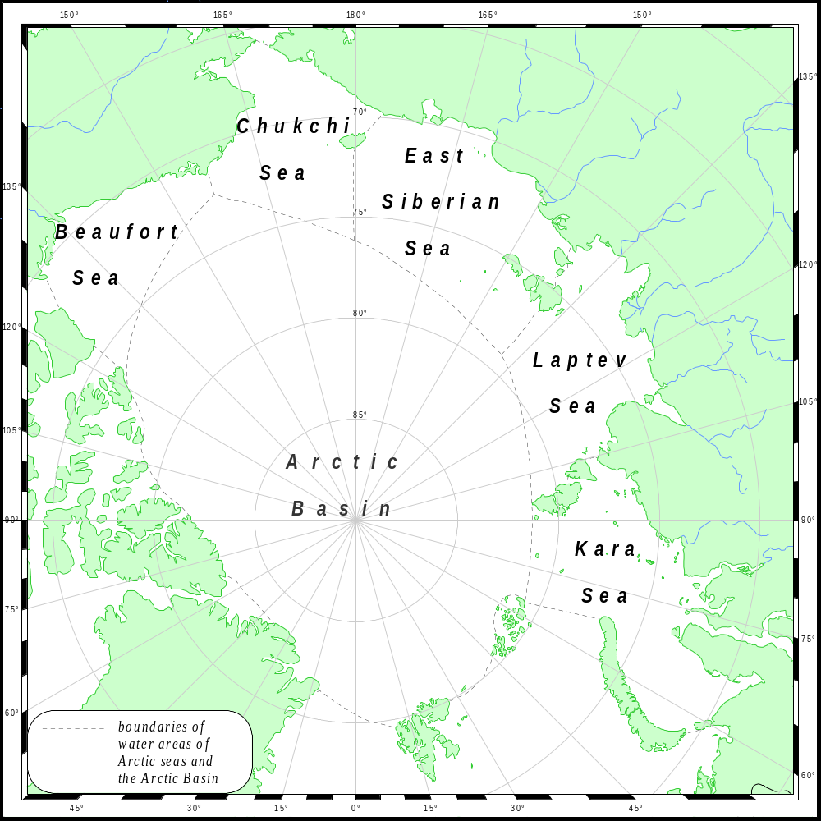

Fig. 3.1. Water areas for which data of hydrochemical measurements were collected for the years 1948-2000.

Data of the AARI and of the National Oceanographic Data Center– World Data Center - A(NODC) were used for creation of the complete historical data set of Russian and western observations. The NODC data set was collected from different sources including the Russian ones (See Appendix 2).
Significant part of the AARI hydrochemical information was stored on paper. Therefore, the data typing was organized first of all.
The collected data were united in a data set of initial measurements (See Section 4.1.). The data set included 21.264 stations with 163.127 observation depths. Structure of hydrochemical information was non-uniform. Observation data were presented in different formats, different measurement units of hydrochemical characteristics were used, indices of expeditions and vessels were often changed, there was duplication of data.
The data set of initial measurements was subjected to analysis for the data duplication. Presence of duplicated data is a serious problem of oceanographic databases, collected from different sources, because the present-day system of information collection and exchange allows repeated data input in data sets.
Check and exclusion of duplicated stations from the database was realized in two ways: using automatic check of data coincidence, during the expert control of hydrochemical information.
The automatic control provides data scan for coincidence of coordinates (with accuracy of 0.5/ of latitude and longitude), date and time of station performance, and information at the first standard depths. If coordinates and time of stations coincide, or, in the absence of time, information at the first standard depth coincides, then station with more useful information (time of observation, station depth, greater number of parameters at greater number of observation depths, presence of temperature and salinity measurements at the first observation depth, etc.) is selected for further processing and analysis. This method rather quickly allows to get rid of duplicating oceanographic stations (BarKode, 1999), however, there is a danger of a loss of some useful information.
Additional check for duplicates was made by the expert method. Data samplings were made for that purpose, these data were obtained by different expeditions at different time in specific regions of the Arctic Ocean. In presence of duplicated data, they were compared using the expert method. The most reliable and complete data sets were left in the database, and the questionable and incomplete duplicated data sets were eliminated.
The data set of initial measurements has reduced for 18.52% after preliminary analysis and duplicated data elimination. The obtained data set was used for description of specific features of spatial and temporal distribution of hydrochemical observations.
Metadata are given in Appendix 2.

3.1.2. Spatial and Temporal Distribution of Observations

Information on amount of stations for the years 1948-1993 in the joint database is given in Section 3. Location of oceanographic stations, where measurements of hydrochemical characteristics were carried out, is shown in Fig. 3.2-3.8. Fig. 3.9 and 3.10 demonstrate distribution of stations with element determination for different years.
Scale of temporal averaging for the Arctic Basin was chosen as follows. Seasonal variations of oceanographic characteristics in the Arctic Basin manifest themselves in the upper 200 m layer. Winter season lasts for 9 months, beginning in September and finishing in the end of May. Ice thickness growth and salinity increase in the upper layer are observed in the central part of the ocean till June. Therefore, May can be considered as the last month of the winter period.
In the southern parts of Arctic seas duration of the winter season is somewhat shorter. Transition to spring processes happens in river mouths and separate fiords in the second half of May.

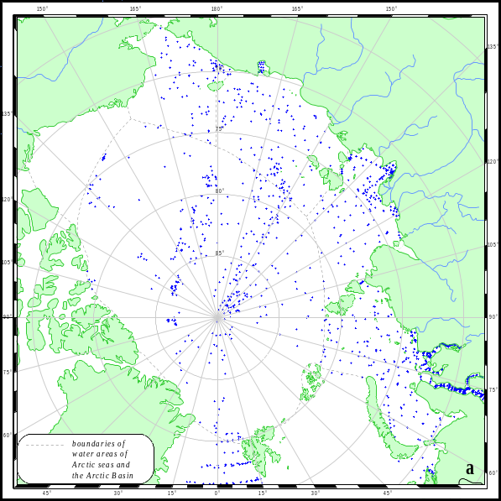
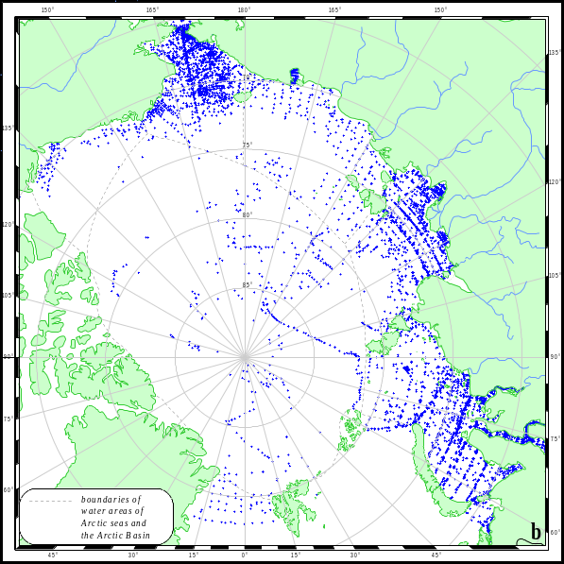

Fig. 3.2. Location of stations with oxygen observations in the Arctic Basin and Arctic seas for the years 1948-2000: a) winter (November- May) – 3017 stations; b) summer (July-September) – 8748 stations.

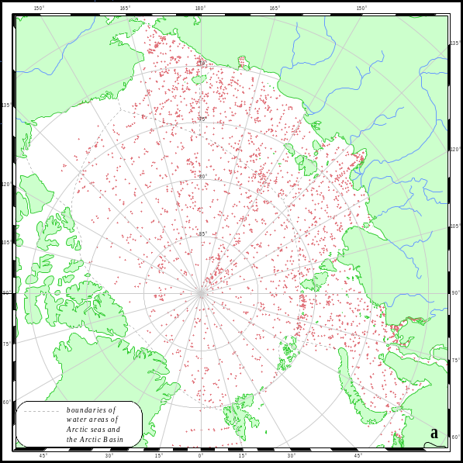
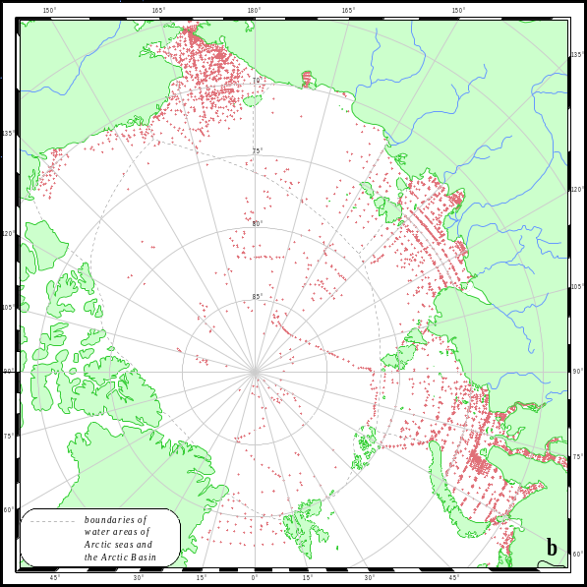

Fig. 3.3. Location of stations with silicate observations in the Arctic Basin and Arctic seas for the years 1948-2000: a) winter (November- May) – 4430 stations; b) summer (July-September) – 6966 stations.

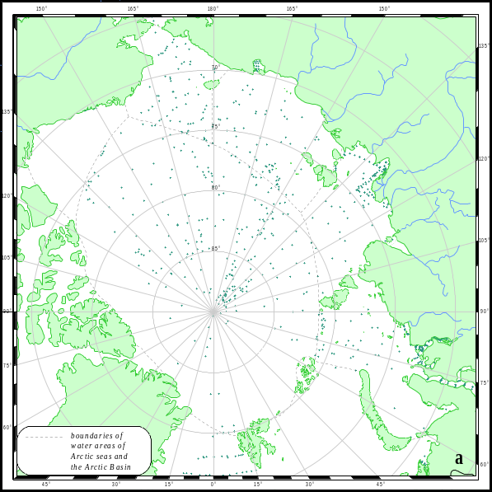
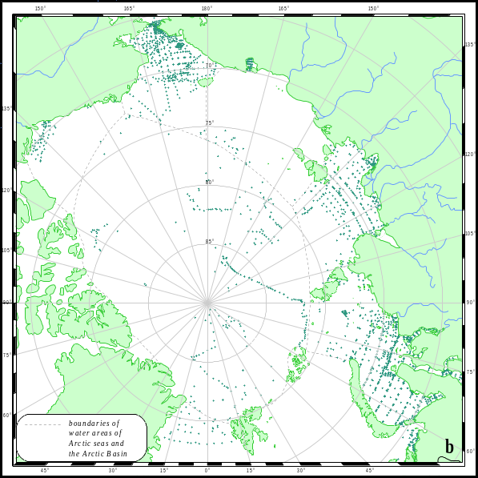

Fig. 3.4. Location of stations with phosphate observations in the Arctic Basin and Arctic seas for the years 1948-2000: a) winter (November- May) – 1626 stations; b) summer (July-September) – 3284 stations.

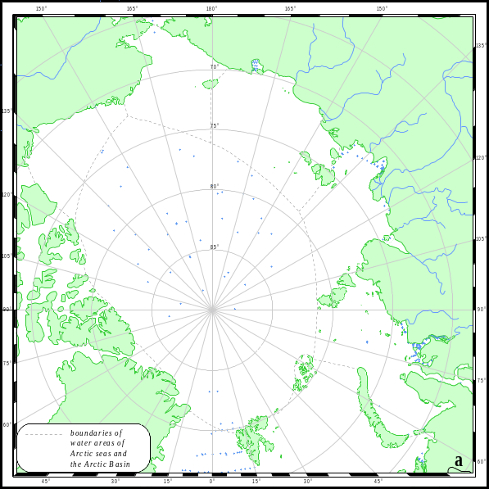
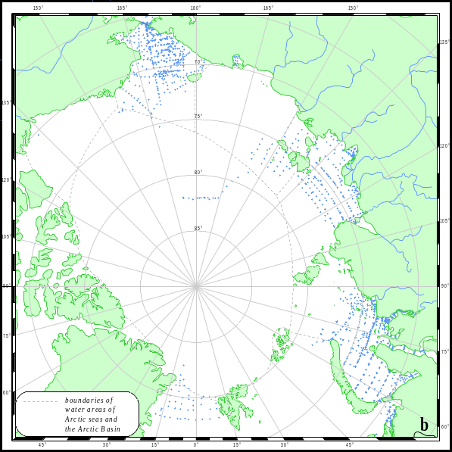

Fig. 3.5. Location of stations with nitrite observations in the Arctic Basin and Arctic seas for the years 1948-2000: a) winter (November- May) – 1423 stations; b) summer (July-September) – 2553 stations.

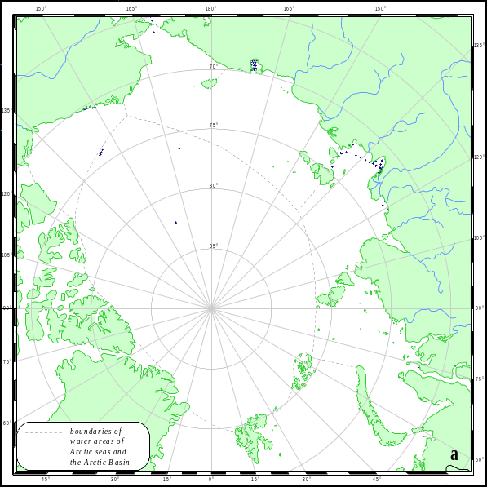
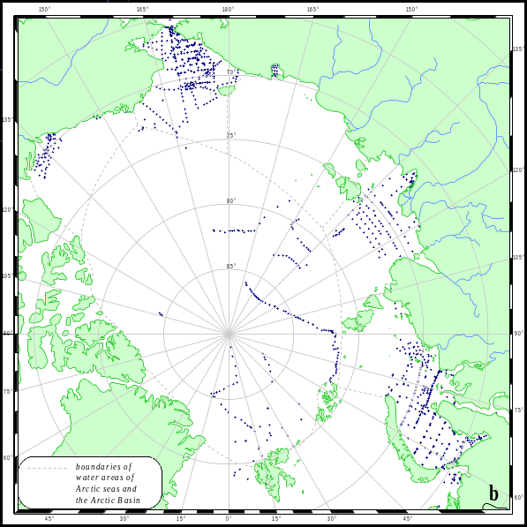

Fig. 3.6. Location of stations with nitrate observations in the Arctic Basin and Arctic seas for the years 1948-2000: a) winter (November- May) – 256 stations; b) summer (July-September) – 1461 stations.

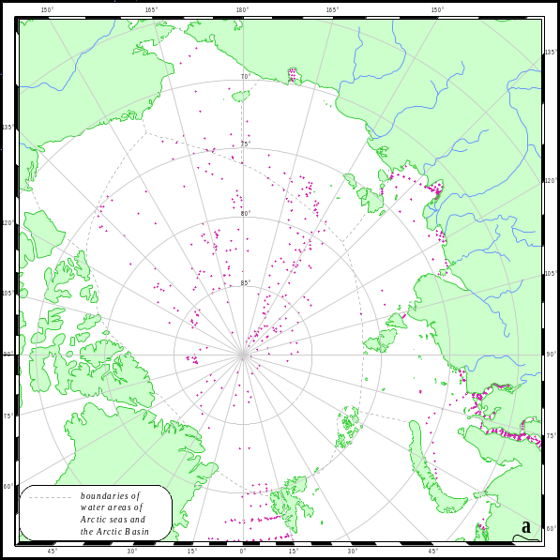
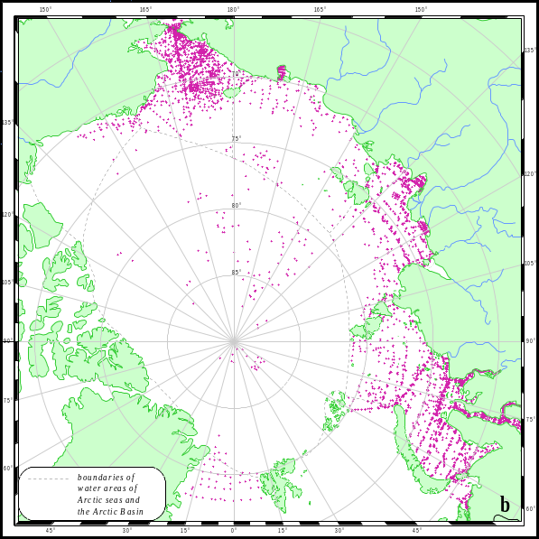

Fig. 3.7. Location of stations with pH_{B} observations in the Arctic Basin and Arctic seas for the years 1948-2000: a) winter (November- May) – 2247 stations; b) summer (July-September) – 6848 stations.

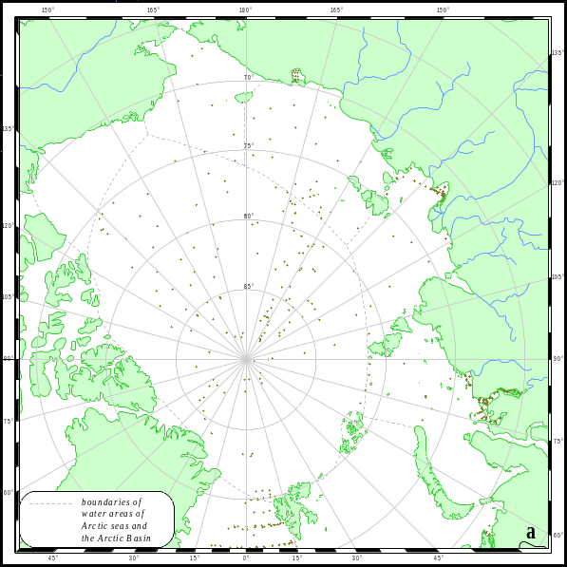
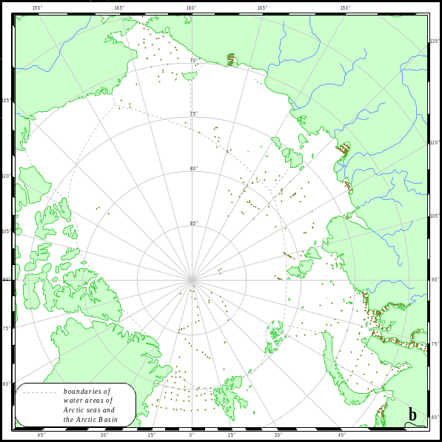

Fig. 3.8. Location of stations with alkalinity observations in the Arctic Basin and Arctic seas for the years 1948-2000: a) winter (November- May) – 1420 stations; b) summer (July-September) – 1567 stations.

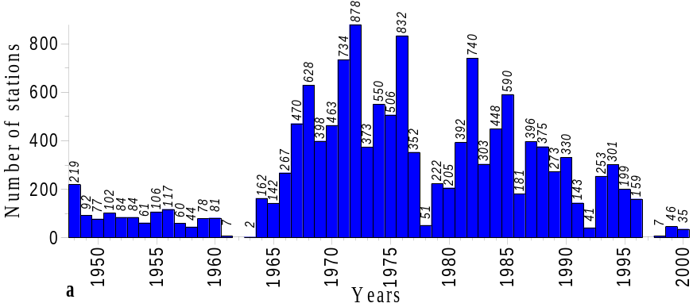
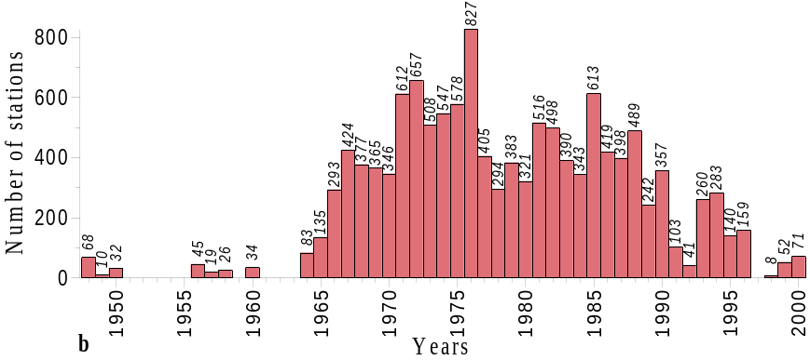
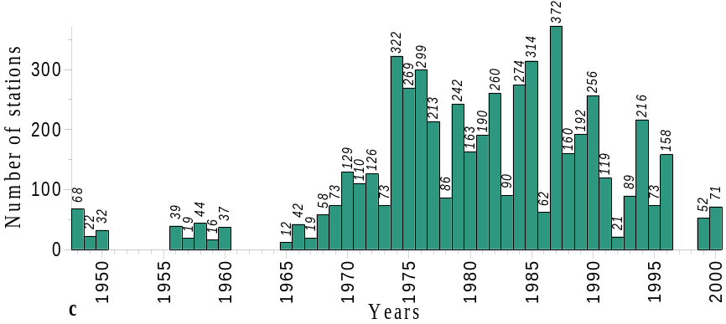
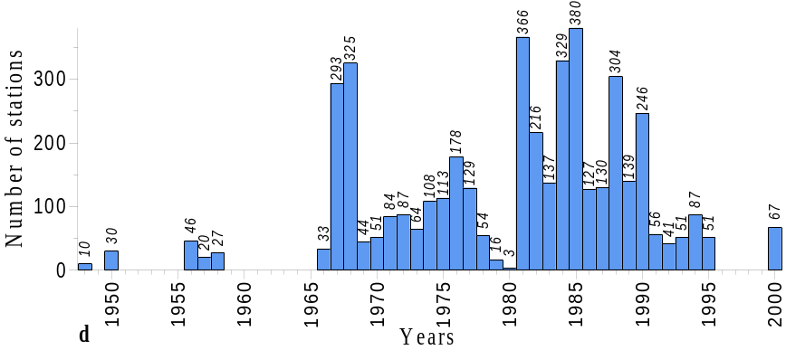
Fig. 3.9. Number of stations in the working base of hydrochemical determinations in the Arctic Ocean for different years (1948-2000) of concentration: a) dissolved oxygen, b) silicate, c) phosphate, d) nitrite

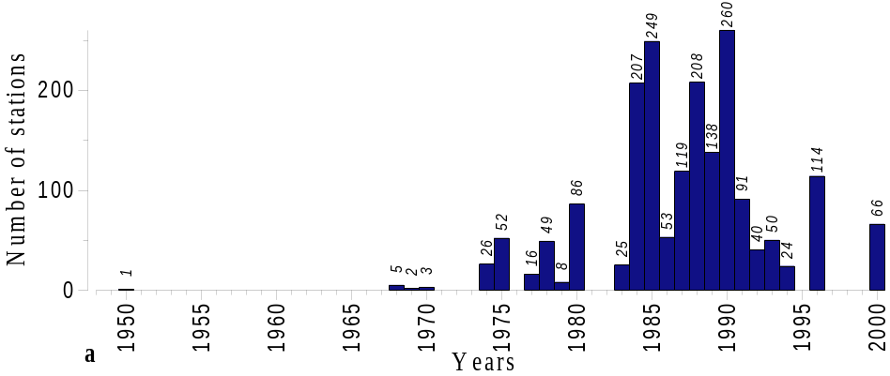
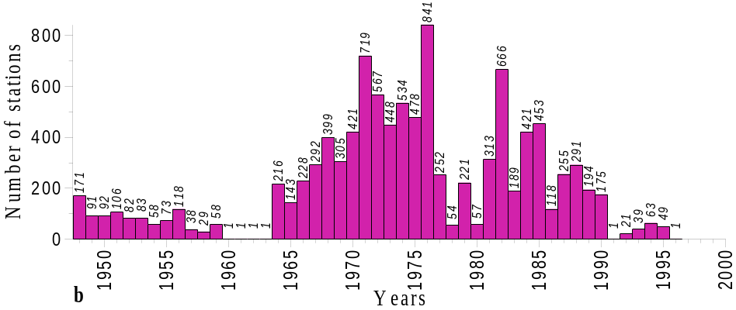
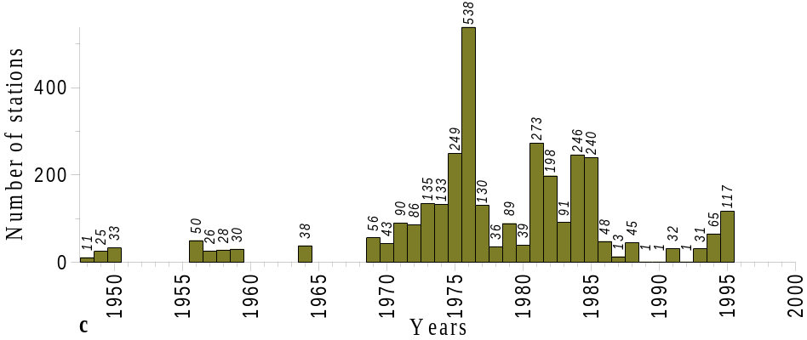

Fig. 3.10. Number of stations in the working base of hydrochemical determinations in the Arctic Ocean for different years (1948-2000) of concentration: a) nitrate, b) pH_{B}, c) alkalinity

3.2. Control of Hydrochemical Data

3.2.1. Data Input

Data from the primary paper sources were placed in computer and added the files already containing station passport, meteorological and ice information, water temperature and salinity at observation depths.
The following permissible ranges of parameter variations were accepted by the first computer-aided control:
- station passport
- station number should be positive,
- coordinates should change within the limits from 0 to 90⁰ and from 0 to 59/ for latitude, from 0 to 360⁰ and from 0 to 59/ for longitude; symbols S or N are given to latitude, and symbols E and W are given to longitude (longitude greater, than 180⁰, was later converted to the western one),
- use of a field of the “data” type realizes full control of date appropriateness up to the control of a leap-year in case typing “29 February”, time: hours – from 0 to 23, minutes – from 0 to 59;
- sea depth should exceed zero;
- air temperature should vary from –55 to +50⁰ C;
- wind speed should vary from 0 to 40 m/sec, wind direction – from 0 to 360⁰;
- atmospheric pressure should vary from 800 to 1200 mb;
- ice concentration should be within the limits from 0 to 10 conventional units, direction to the ice edge – from 0 to 360⁰, and distance to it should not be negative.
- oceanographic data:
- observation depth should be less or equal sea depth in the station passport,
- water temperature – from –2.20 to + 30⁰ C,
- salinity – from 0 to 36 psu,
- oxygen – from 0 to 20 ml/l,
- pH_{B} – from 7 to 9 conventional units,
- alkalinity – from 0 to 9.999 mg-eq/l,
- phosphates – from 0 to 99.9 g/l,
- silicate – from 0 to 7000 g/l,
- nitrite – from 0 to 30 g/l,
- nitrate – from 0 to 700 g/l.

Collation of the typed data with the primary paper sources was carried out after their input. One specialist typed the data, and the other one collated the input data with the primary paper sources.
After load, all the oceanographic information was subjected to a more strict computer-aided control. In the process of control system elaboration, notions were used outlined in different publications (Belkin, 1991; Boyer & Levitus, 1994; BarKode, 1999) and some other additional provisions. Control was carried out using 14 criteria: station coordinates, date and time of observations, correspondence of depths, correspondence of input data to general distribution regularities of temperature, salinity and hydrochemical parameters in the World Ocean and in the Arctic Ocean, in particular.
Questionable records were not eliminated from the database, but marked with special symbols. A system of quality flags was used for this procedure.

3.2.2. Formal Data Control in the Hydrochemical Database.

3.2.2.1. Control of Station Passports.

Station coordinates. According to this control, the stations with latitude exceeding 90⁰ and longitude beyond the limits of the range –180⁰ 180⁰ , or with coordinate minutes equal or greater 60 are marked with flag 23, and they are not used for further work. Such stations were not revealed in the result of this control.

3.2.2.2. Control of Maximum Station Observation Depths.

Control of observation depths. According to this control, the stations with observation depths exceeding sea depth taken from reference array of the Arctic Ocean depths are marked with flag 25, and they are not used for further work. The nearest to this station point from the depth array was chosen, but not far than 14.1 km. If the observation depth significantly exceeds sea depth in this point (for 120% for depth range 0-100 m, for 40% for depths greater than 100 m), location of the station is questionable. Formally, 1085 stations should have been marked according to this control. Location of the stations that did not pass the control was studied before station marking with flag 25 (Fig. 3.11). This location analysis showed that these stations were located in deepwater regions mainly over the continental slope or in places with strongly broken relief; in shallow regions, they were located mainly near shore. Taking into account, that depth interval in places with strongly broken relief at the distance of 14.1 km is significant, and grid spacing of the depth array in shallow waters (coastal water areas, estuaries, bays) did not guarantee necessary representativity, the stations in these regions were not marked with flag 25 and were used in further calculations. Group of the stations located over relatively flat region in the northern part of the Chukchi Sea was performed in the “Sever” expeditions. Depths at these stations in these expeditions could have been determined with insufficient accuracy. Taking into account results of this analysis and, first and foremost, significance of each station with hydrochemical observations in the Arctic Ocean, poorly covered by observations, these stations were not marked by flag 25 and were used for further calculations.

3.2.3. Regional control

Regional control included check of correctness of station coordinates. It was done at different stages of joint data set preparation. Because the main part of the data was placed in computer as separate files, each of these files contained data of a specific cruise of research vessel, airborne expedition or coastal observations at observatories, regional control was carried out before file input in the joint database. The Ocean Data View software (Schlitzer, 2001) gives an opportunity to scan operatively data of separate expeditions to make sure that vessel route coincides with schemes of its movement given in expedition reports. False station coordinates were corrected, and after this correction data input in the database was performed.
Some problem arose by data check for the data obtained from other sources and not from the AARI archives. Cruise or expedition reports were inaccessible. Check technique in these cases consisted of comparison of research vessel route with time of station performance. Succession of station performance in time was checked in condition that vessel speed did not exceed 15 knots. Oceanographic stations falling out of reasonable schedule of vessel movement at transects were marked as questionable.

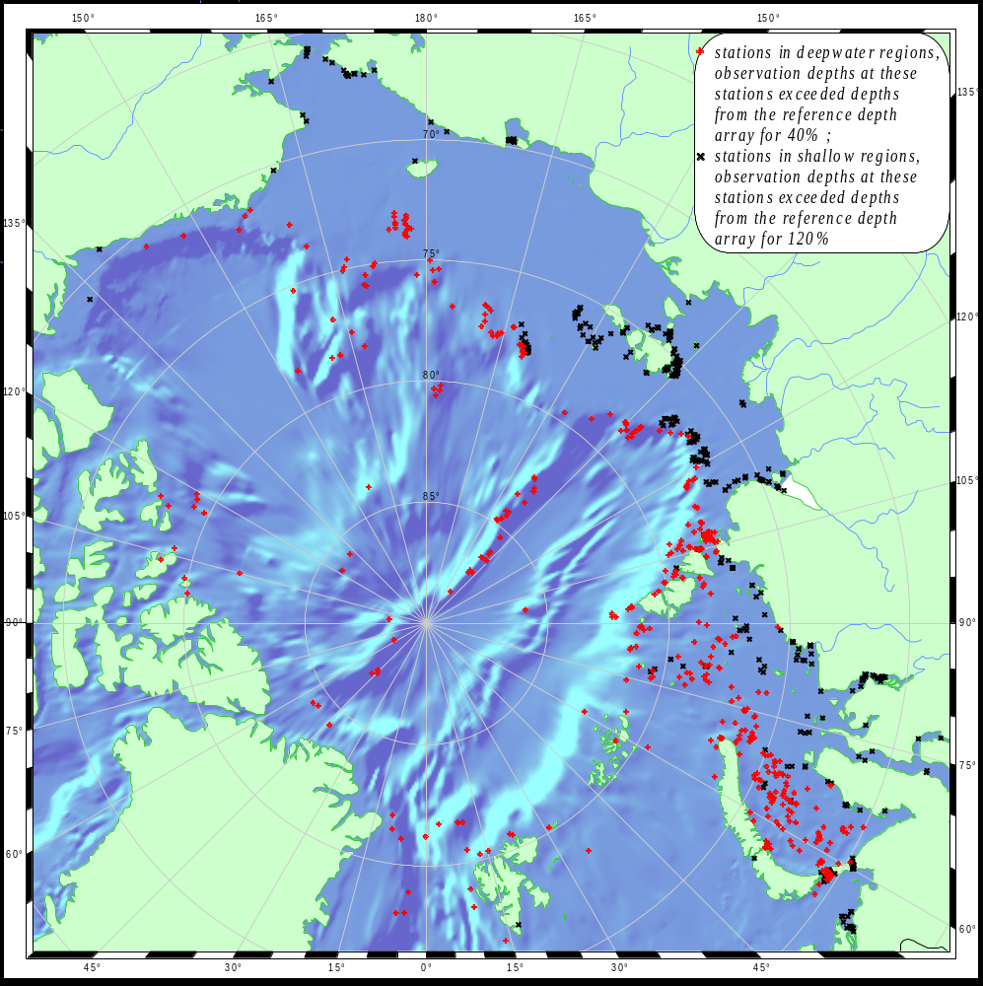

Fig. 3.11. Location of stations that did not pass formally control of maximum station observation depths (flag 25).

3.2.4. Control of Variability Limits.

Primary computer-aided control of the station passports and variability limits of the parameters was carried out both by data input and by loading of data obtained from different sources. Permissible ranges of different attributes of the station passports and values of the hydrochemical elements were described above in Section 3.2.1. Values beyond the limits of these permissible ranges were not eliminated by loading of data from files with hydrochemical information, but marked with the according flags of quality and reliability as questionable or rejected. The hydrochemical parameters vary over a wide range in the Arctic Ocean, therefore, criteria of control and data estimate for ranges of their variability in deepwater regions differs from that in shallow regions. Use of automatic methods of control recommended in other papers (Belkin, 1991; BarKode, 1999) does not give good results. That is why, only those data were rejected that were beyond the reasonable limits of variability of the hydrochemical parameters typical for the entire World Ocean. Expert data control was carried out afterwards.

3.2.5. Expert Control.

Expert control is initial and final phase of the procedure of quality estimate of hydrochemical measurements. Its importance in assessment of accuracy and representativity of observations in different parts of water area is specially great by insufficient number of observations and /or their non-uniform distribution in time and space. It is typical for this Atlas. The expert control was the most labor-consuming and minute part of the data set check. In the process of control, the base was divided into several parts according to regional indications: the Arctic Basin, the Kara Sea, the Laptev Sea and the region uniting the East Siberian Sea, the Chukchi Sea and the Beaufort Sea. These samples include all the available data for the region.
Four different experts did the control. Each of them controlled the data for his region. Cruise scan of the data was carried out using the Ocean Data View software (Schlitzer, 2001). In this process, station coordinates, dates and time of their conduction, correspondence of depths given in the station passports to bottom relief were checked. Distribution of the hydrochemical parameters at each station was analyzed, and it was compared with mean distributions of the same parameters in same region of seas or the Arctic Basin in the same period of the year. Correspondence of the loaded hydrochemical information with general regularities of distribution of the hydrochemical parameters in the Arctic Ocean and in the Arctic seas, in particular (Rusanov et al., 1979).
Results beyond the limits of tolerance were rejected, i.e. they were marked as bad data. Abnormal values of the hydrochemical parameters within the reasonable limits of hydrochemical element variability, but not appropriate to our notion of hydrochemical structure of a specific region, were marked as the questionable data. Number of rejected and questionable data revealed in the result of the expert control is given in Table 3.1.
Some problems, that arose by the data expert control, should be mentioned. First, it is complicated to check the data in such poorly studied regions as, for example, the East Siberian Sea or the north-eastern part of the Kara Sea. Second, the Arctic seas are characterized by complex vertical structure and inlaid distribution of the hydrochemical parameters, both on the surface, at the standard depths and, especially, at the near-bottom depths. Reference literature on structure of water column and variability of the hydrochemical parameters in shallow regions of the Arctic seas (shelf zone) is limited and contradictory. All this makes impossible to use unit criteria of data quality estimates not only for all the Arctic seas, but for separate regions of each of these seas.

Table 3.1.
Number of data marked as questionable and rejected at the first stage in the joint data set.

Parameter | Total | Questionable | Quest., % | Rejected | Rejected,% | Quest..+Rej., %
Oxygen | 111127 | 1116 | 1,00 | 737 | 0,66 | 1,67
Phosphate | 43132 | 976 | 2,26 | 1593 | 3,69 | 5,96
Silicate | 102750 | 1305 | 1,27 | 2334 | 2,27 | 3,54
Nitrite | 26465 | 184 | 0,70 | 1507 | 5,69 | 6,39
Nitrate | 16201 | 239 | 1,48 | 1240 | 7,65 | 9,13
pН | 74730 | 562 | 0,75 | 321 | 0,43 | 1,18
Alkalinity | 19442 | 124 | 0,64 | 203 | 1,04 | 1,68

The expert control was carried out using C-code specially elaborated for this project by AARI specialists, accounting for knowledge of hydrological and hydrochemical conditions of the Arctic Ocean.
Program of the expert control provided performance of the following procedures:
- Control of correspondence of extreme values of the hydrochemical elements determined at all the stations with actual hydrological and hydrochemical conditions.
- Construction of display plots of vertical distribution (profiles) of the elements and determination of those values that form extremes that cannot be caused by real processes.
- Drawing of experimental maps of gridded distribution of the hydrochemical elements of different scale using statistical characteristics.
- Check of extreme mean values of the elements on the gridded maps constructed with the help of objective analysis of observations for their correspondence to temporal series in the adjacent grid cells.
- Interpolation of separate values of the elements in grid nodes not covered by observations.
- Output of final data for map drawing of hydrochemical element distribution.
In the process of the expert control, the experts decide, what “quality flag” should be given to distributions. This information is placed and stored in the archive of distributions.
Therefore, the expert control was carried out after the statistical control and after gridding of the results of hydrochemical distributions by the objective analysis. Results of the control were put on maps, and plots of vertical distribution were constructed only after repeated performance of the expert control.

3.3. Statistical Characteristics.

Linear interpolation of values of the hydrochemical elements to the standard depths was carried out before calculation of statistical characteristics and after the formal and expert control: 0, 5, 10, 15, 25, 50, 75, 100, 150, 200, 250, 300, 400, 500, 750, 1000, 1500, 2000, 2500, 3000, 3500, 4000, 4500 meters (Fig. 3.12).
Number of oceanographic stations with the hydrochemical observations was analyzed. This analysis revealed that the standard depths were the best covered by observations. If observations at some station were conducted at other depths, linear interpolation of the hydrochemical elements to the standard depths was carried out. This interpolation was conducted only in the case, when
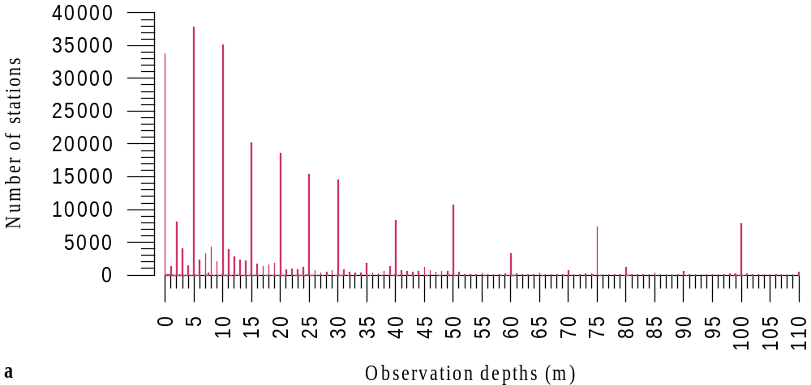
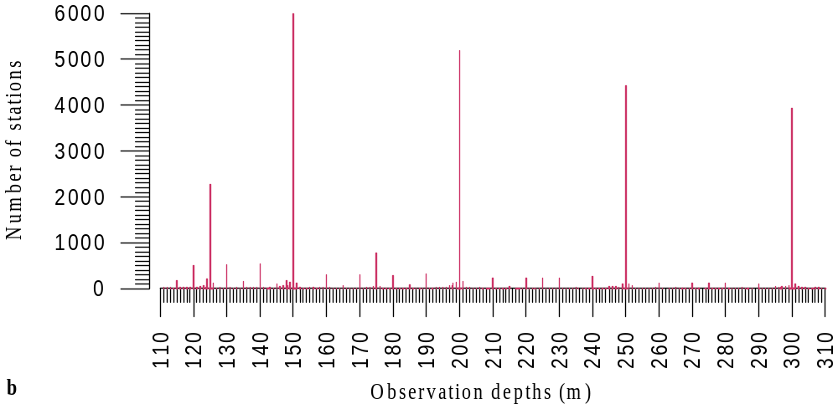
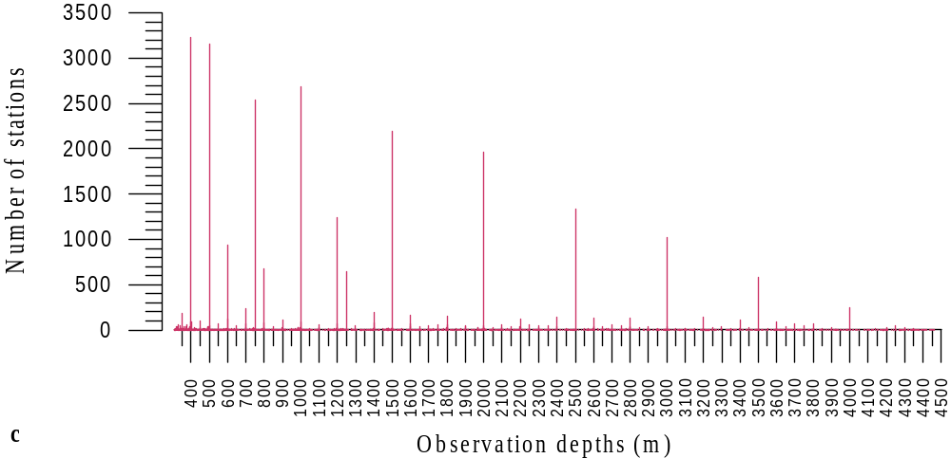
Fig. 3.12. Distribution of number of oceanographic stations with the hydrochemical observations for the years 1948-2000 (a – in the layer 0-110 m, b- in the layer 110-310 m, c – in the layer 310-4500 m) in the working base after the formal and expert control.

number of the standard depths between the observations did not exceed one. If the interpolation was prohibited according to this criterion, and difference between the observation depth and the nearest standard depth did not exceed 5% of the layer thickness between the neighboring standard depths and the observation, then values of the hydrochemical elements were transferred (“dragged”) to the nearest standard depth. For example, if the upper observation depth was 210 m, and the next one was 305 m, then the interpolation was not conducted for the “mixed” standard depths 250 and 300 m, because their number (two) exceeded the chosen criterion (one). However, value from 305 m was “dragged” (transferred) to the standard depth 300 m in this case. This procedure was not carried out for the observation depth 210 m. Values of the standard depths and upper and lower limits for the procedure of transfer are given in Table 3.2

Table. 3.2.
Standard depths and upper and lower limits for the procedure of transfer of observational depth to the standard depth

Standard depth (m) | Upper limit for the procedure of transfer of observational depth to the standard depth (m) | Lower limit for the procedure of transfer of observational depth to the standard depth (m)
5 | 4.75 | 5.25
10 | 9.75 | 10.75
25 | 24.25 | 26.25
50 | 48.75 | 51.25
75 | 73.75 | 76.25
100 | 98.75 | 102.5
150 | 147.5 | 152.5
200 | 197.5 | 202.5
250 | 247.5 | 252.5
300 | 297.5 | 305
400 | 395 | 405
500 | 495 | 512.5
750 | 737.5 | 762.5
1000 | 987.5 | 1025
1500 | 1475 | 1525
2000 | 1975 | 2025
2500 | 2475 | 2525
3000 | 2975 | 3025
3500 | 3475 | 3525
4000 | 3975 | 4025
4500 | 4475 | 4525

Statistical characteristics of the hydrochemical elements were calculated after the interpolation and transfer of values to the standard depths for all the standard depths from 0 up to 400 m separately for two seasons: winter (November-May) and summer (July-September). Winter and summer values of the hydrochemical elements were used together for calculations of statistical characteristics at the standard depths from 400 to 4500 m.
Final calculation of statistical characteristics of the hydrochemical elements after all the types of control was carried out at the standard depths in the winter season in squares 200x200 km, in the summer season - in squares 200x200 km for the Arctic Basin and 100x100 km for the Arctic seas (Fig. 3.13). Grid of the squares coincides with the location of the squares for which statistical characteristics of temperature and salinity were calculated in the Hydrographic Atlas of the Arctic Ocean (1997, 1998).
Coordinates of the squares are given as the Cartesian coordinates of the Lambert equigraphic azimuth projection calculated using the formulas:

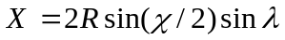
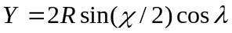,

here 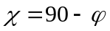is supplement of latitude, is longitude, R=6371.116 radius of the sphere having the same surface as the Earth ellipsoid, X, Y are grid coordinates.
X-axis is oriented along meridian 0-180 ⁰ , Y-axis is oriented along meridian 270-90⁰ . Center of the coordinate system is located in the Pole.
All the maps given in the Atlas are constructed in this coordinate system. X and Y axes are subscribed in tens of kilometers.
Calculation of the following statistical characteristics was conducted using the formulas:

Mean value of a parameter 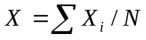;
Dispersion of a parameter 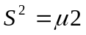;
Root-mean deviation 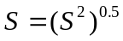;
Coefficient of skewness 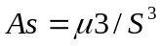
Coefficient of excess 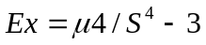
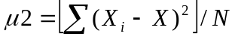;
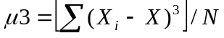;
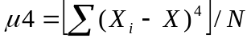;

here X is the parameter mean value, X_{i} is the parameter observed value, N is the number of observations in a square, S² is the parameter dispersion, S is the root-mean deviation, As is the asymmetry (skewness), Ex is the excess, 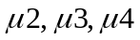 are the central moments of the second, third and fourth order, respectively.
Of course, calculation of the first three statistical characteristics has a sense only in the case, when number of measurements exceeds three (then appropriate estimates can be carried out using the Student criterion). However, these appropriate statistical characteristics can be reliably obtained in some points of coastal observations (located in estuaries and estuary seashores of Ob, Yenisei, Lena, Khatanga).
The parameter mean value in a square was calculated taking into account preliminary averaging for each year. Extreme values were chosen, and the other statistical characteristics were calculated using the whole series of observations in this square.
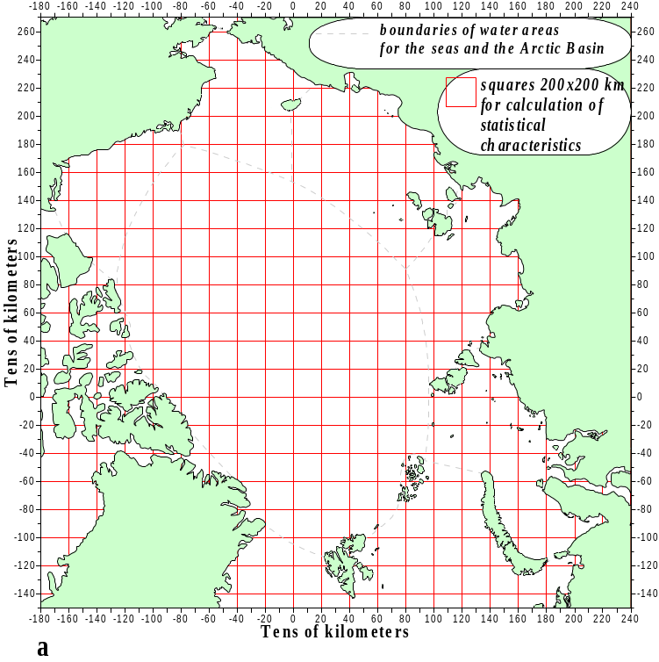
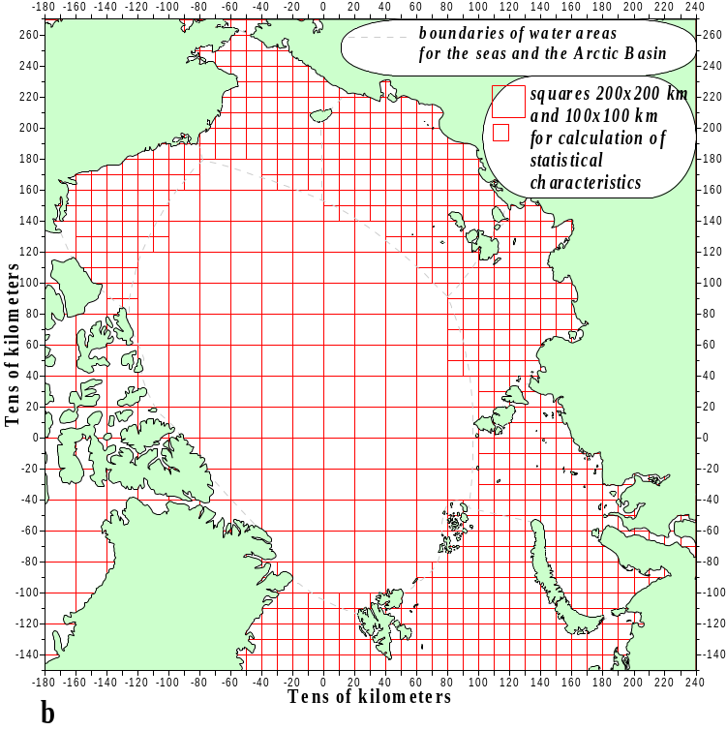

Fig.3.13. Grid used for calculation of statistical characteristics of the hydrochemical elements: a- grid 200x200 km for the winter season (November-May); b – 200x200 km (in the Arctic Basin) and 100x100 km (in the Arctic seas) for the summer season (July-September).
Besides, the equation of mean square regression plane was calculated using the least square method, scatter of observation points near this surface is the minimum one, if compared with other surfaces. Equation of this surface is as follows:

Z = Ax + By + C,

here Z is the parameter value (in corresponding units of measurement for this hydrochemical element), x and y are coordinates (in tens of kilometers).
The Cartesian coordinates of the square angles (in tens of kilometers) and values of the statistical characteristics of the hydrochemical elements are given in the ASCII-files (“Statistics\Txt” subdirectory) on CD-ROM. Mask of names of the ASCII- files looks as follows:

SSN_ELE_1948-2000_HHHH.TXT,

here:
SSN is the season (WIN – winter, SUM – summer);
ELE is the hydrochemical element (OXY – dissolved oxygen,
SIL – silicate,
PO4 – phosphate,
NO2 – nitrite,
NO3 – nitrate,
PHB – pH_{B},
ALK – alkalinity);
1948-2000 – period of observations;
HHHH is the standard depth (m);
TXT is the file name extension.

The characteristics demonstrated in Table 3.3. are given in columns of the files (in order from left to right).

Table 3.3.

Information given in the ASCII-files (“Statistics” Directory) with calculated statistical characteristics of the hydrochemical elements (in order from left to right).

Name of the column | Characteristics | Column format in notation SDF (“System Data Format”)
Name of the column | Characteristics | Initial and final position in line | Length
XMIN | Minimum value of X-coordinate (tens of km) for this square | 1-10 | 10
XMAX | Maximum value of X-coordinate (tens of km) for this square | 11-19 | 9
YMIN | Minimum value of Y-coordinate (tens of km) for this square | 20-28 | 9
Table 3.3 (to be continued)
Name of the column | Characteristics | Column format in notation SDF (“System Data Format”)
Name of the column | Characteristics | Initial and final position in line | Length
YMAX | Maximum value of Y-coordinate (tens of km) for this square | 29-37 | 9
NUM_VALUES | Number of actual, interpolated and “dragged” values of observations for this hydrochemical element in the corresponding* season in this square at this depth | 38-48 | 11
NUM_YEARS | Number of years with observations for this hydrochemical element in the corresponding* season in this square at this depth | 49-58 | 10
MIN_VALUE | Minimum value for this hydrochemical element in the corresponding* season in this square at this depth | 59-68 | 10
MEAN_VALUE | Mean value for this hydrochemical element in the corresponding* season in this square at this depth (taking into account preliminary averaging for each year) | 69-79 | 11
MAX_VALUE | Maximum value for this hydrochemical element in the corresponding* season in this square at this depth | 80-89 | 10
STAND_DEV | Mean-root (standard) deviation | 90-99 | 10
VARIANCE | Dispersion (variance) | 100-108 | 9
SKEWNESS | Coefficient of skewness (asymmetry) ** | 109-117 | 9
EXCESS | Coefficient of excess ** | 118-125 | 8
COEF_A | Coefficient A of the equation of mean square regression plane ** | 126-139 | 14
COEF_B | Coefficient B of the equation of mean square regression plane ** | 140-153 | 14
COEF_C | Coefficient C of the equation of mean square regression plane ** | 154-167 | 14

Note: * statistical characteristics were calculated at the standard depths from 0 to 400 m for each season and for the standard depths from 500 to 4500 m both winter and summer values of the hydrochemical elements were used together;
** value .NULL. in the data columns of the ASCII-files mean absence of the calculated statistical characteristics for this square.

Examples of fields of the statistical characteristics (mean values and mean-root deviations) at 5 m depth are shown in Fig. 3.14-3.17 for two elements: dissolved oxygen with the best coverage by observations and nitrite with the worst coverage.

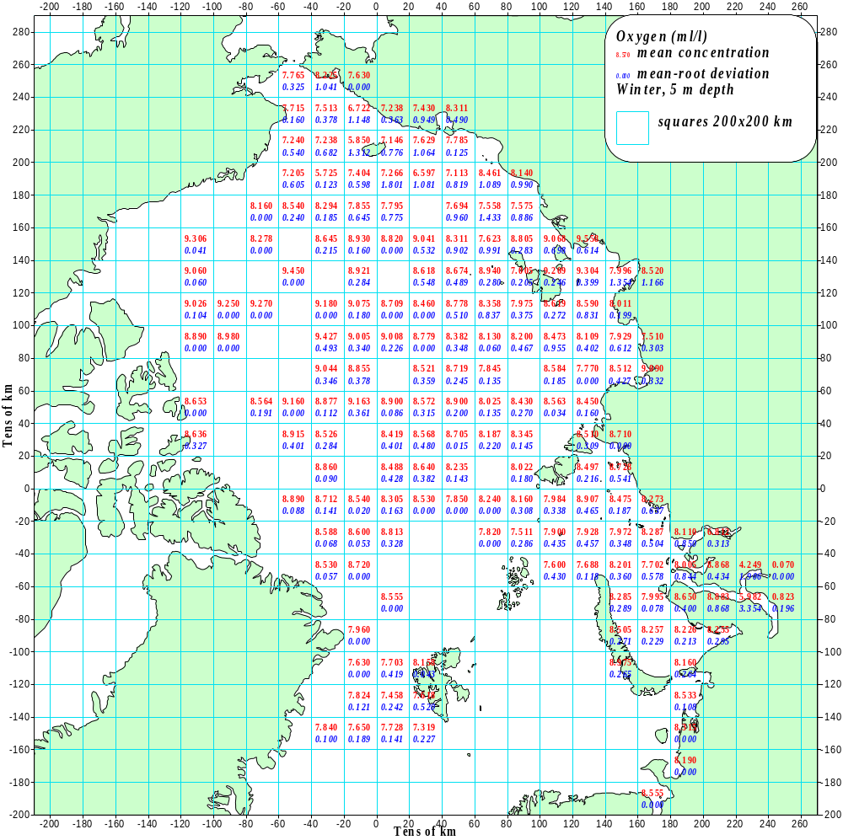

Fig. 3.14. Mean concentration of dissolved oxygen (ml/l) and its mean-root deviation in the Arctic Basin and the Arctic seas (according to data in the squares 200x200 km) in winter (November-May) for the years 1948-2000 at 5 m depth.

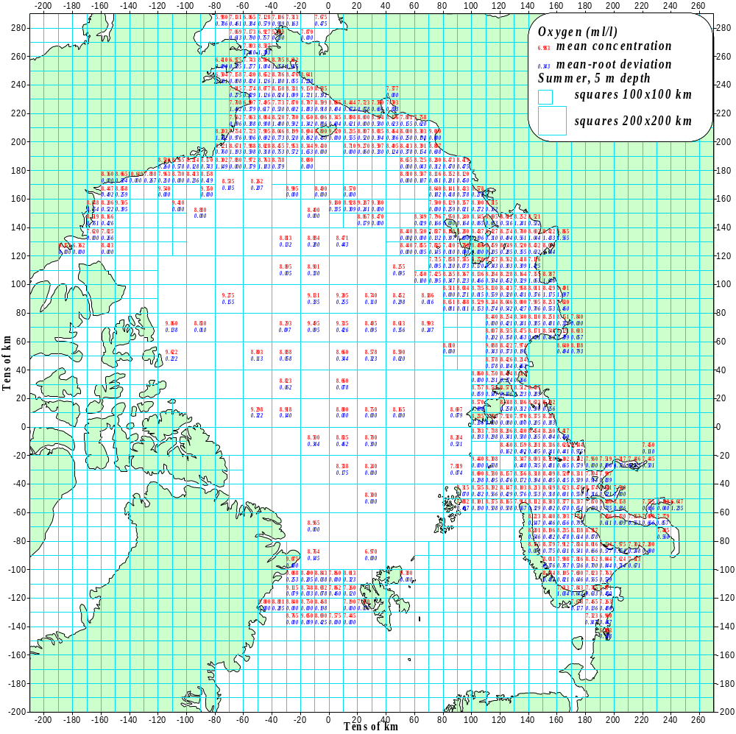

Fig. 3.15. Mean concentration of dissolved oxygen (ml/l) and its mean-root deviation in the Arctic Basin (squares 200x200 km) and the Arctic seas (squares 100x100 km) in summer (July-September) for the years 1948-2000 at 5 m depth.

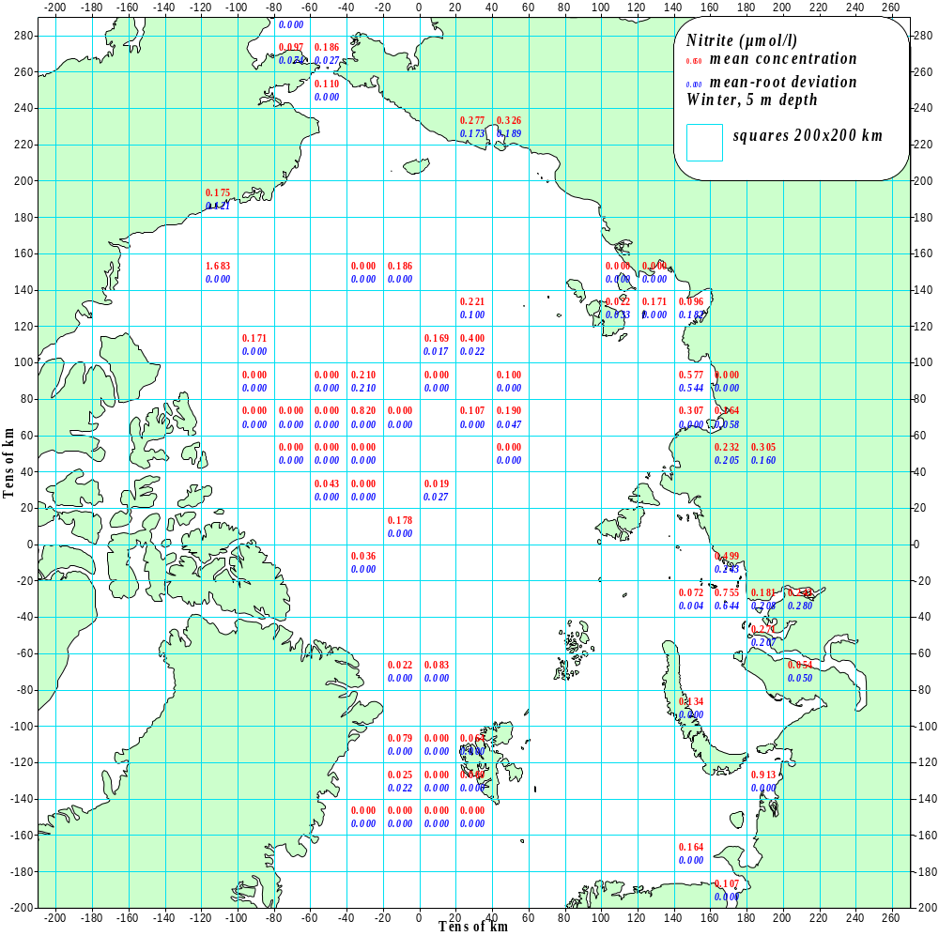

Fig. 3.16. Mean nitrite concentration (mol/l) and its mean-root deviation in the Arctic Basin and the Arctic seas (according to data in the squares 200x200 km) in winter (November-May) for the years 1948-2000 at 5 m depth.

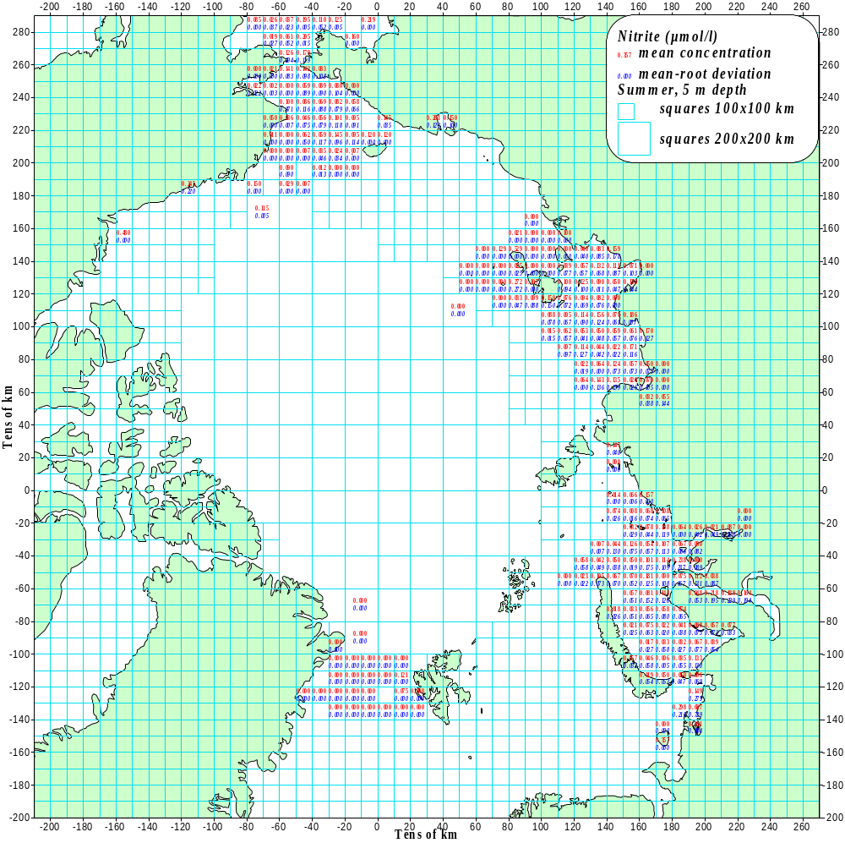

Fig. 3.17. Mean nitrite concentration (mol/l) and its mean-root deviation in the Arctic Basin (squares 200x200 km) and the Arctic seas (squares 100x100 km) in summer (July-September) for the years 1948-2000 at 5 m depth.

3.4. Objective Analysis

The spectral method of objective analysis, developed by Pokrovsky (1984), was used as the basic method for construction of decadal climatic fields of temperature and salinity by realizing of the US-Russian Oceanographic Atlas of the Arctic Ocean (1997, 1998). The spectral method of objective analysis has shown the best results in terms of reconstruction of temperature and salinity characteristics if compared with the other methods used in the Oceanographic Atlas of the Arctic Ocean. Moreover, only this method has been capable to reconstruct oceanographic fields using observations in the summer period in the absence of data on significant part of the central Arctic Basin. This method has also given the opportunity to obtain fields of reconstruction errors. The mentioned advantages of this method were determined by the fact that it was based on simultaneous spatial and temporal analysis of observational data by decomposition of these fields with the help of a combination of empirical spatial and temporal components. This method combines analytical approach and statistical interpretation of estimation results.
The essence of the method is as follows: measured values of hydrochemical characteristics z(t, x) are considered as a random function of temporal (t) and spatial (x) coordinates. The observed values z(t, x) are presented as a sum of a true value
Z^{(r)}(t, x) of a hydrochemical parameter and an observation error e(t,x). We postulate presence of spatial correlation for characteristics of z^{(r )}_{i} , absence of a systematic error and correlation between the observation errors e_{i} and hydrochemical characteristics
z^{(r )}_{i} , spatial and temporal independence of the observation error and presence of standard deviation 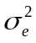. This totality of postulates is reduced to the following model of statistical structure of the analyzed characteristics.

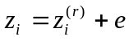,
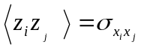,
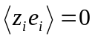, (1)
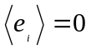,
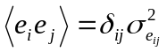.

The problem of estimation is formulated for anomalies of the hydrochemical characteristics z/ , i.e. deviations z of the corresponding mean values 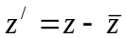. The mean values were obtained by temporal averaging and spatial smoothing. Taking into account, we shall further consider only the above-mentioned deviations, and they will be marked as z.
In order to take into account spatial and temporal connections of observational data, Pokrovsky (1984) proposed to use a biorthogonal decomposition of a hydrochemical parameter z as follows:

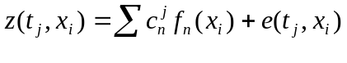, (2)
here f_{n}(x_{i}) is the spatial EOF, c_{n}^{j} is the estimated coefficient that is usually called the n-th principal component. x_{i} can be an irregular grid, and values of measured hydrochemical parameters are given in its nodes.
There are two versions of the spectral analysis (SA). The first variant of the method supposes interpolation of the spatial EOF in nodes of a regular grid x_{i} , where values of characteristics under consideration will be estimated. The second variant is based on EOF approximation with the help of a linear combination:

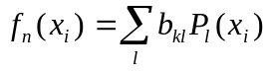 (3)
of appropriate analytical functions (polynomials, splines, trigonometric functions, etc.) P_{l}(x_{i}). In this case, we obtain the following modification of the biorthogonal decomposition (2):
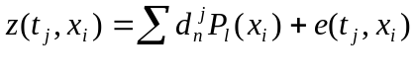, (4)
here 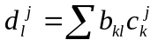.
There are no differences of principle between these mentioned approaches based on the formulas (2) and (4). In both cases, our problem is in estimation of a totality of coefficients of the spectral decomposition 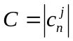 or 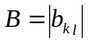. Therefore, we shall further consider only the version based on notion (2) without loss of generality. We shall rewrite formula (2) in the following matrix form:
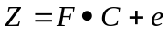. (5)

Let us introduce designations for the following covariance matrices:

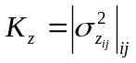 ,
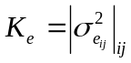,
(i,j = 1,…..,N).

The system of linear equations (5) in respect to unknown coefficients c_{k}^{j} can be solved on the basis of a priori statistical information (1) using methods of statistical estimation. A formula for the estimation of the matrix of unknown coefficients C was
obtained in () on the basis of ():

, (6)

here A⁻¹ and A^{T} are the back and transposed matrices in respect to A, and is the sign of matrix multiplication. The matrix of covariance errors of the decomposition coefficients K_{c} is a diagonal matrix composed of the eigenvalues of the covariance matrix K_{z} :

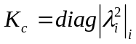, i=1,………..,N.

The matrix F is formed by the EOF values, and the matrix Z is composed of a totality of measurement data in the network of observations x_{i}.
In order to obtain an estimate of a hydrochemical characteristics in the nodes of a regular grid x_{i}, it is necessary to interpolate the EOF in appropriate nodes of the grid and to obtain a new matrix F of the EOF. Using the obtained matrix F and the estimates of coefficients C, formula (6) and matrix correlation

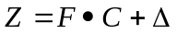 , (7)

we shall obtain the estimate of our parameters in the nodes of the regular grid.
Covariance matrices of estimate errors can be obtained simultaneously with hydrochemical fields using the following formulas:

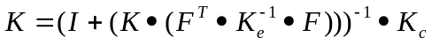 ,
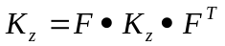, (8)

here K_{e} is the covariance matrix of observation error extended on the regular grid.
The described procedure of hydrochemical field restoration is a combination of the well-known method of singular decompositions (SVD – singular value decomposition in the original) and statistical regularization (Pokrovsky, 1984).
Practical realization of the SA method includes several main stages. The first stage is an optimal choice of a grid cell (grid spacing and distribution). Aim of this choice is to cover general spatial regions (for the time period under consideration), where observations were carried out. This stage is the basis for EOF calculation of a maximum dimensionality.
The next stage is a reconstruction of fields in the cells without observations. Dual character of the coefficients 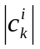 in formula (2) (in respect to spatial and temporal dependencies) is the basis for estimate of unknown geophysical parameters in the “empty cells” without observational data. The described approach was realized not only in spatial regions with low spatial data density, but also by restoration of the whole temporal series of observational data for each cell with observations for at least in one year. In order to realize this idea more effectively, we have proposed to perform a preliminary division into districts of the region under consideration. For that purpose, the analyzed region was divided into information-uniform zones (IUZ) on the basis of the previously elaborated method (Pokrovsky & Piatigorsky, 1995). Time interval of the analysis was divided into uniform sub-intervals. Values of hydrochemical parameters were statistically interconnected in each of these sub-intervals. For example, several first EOF’s did not change their signs with the aim that the time correlation function also did not change its sign within these IUZ’s. In the same time, sign could be changed at the boundaries of the IUZ’s and corresponding uniform intervals at time axis.
The principal temporal modes (the first terms of decomposition (2)) were used for calculation of mean values in the “empty” grid cells. Mean values of a hydrochemical parameter can be estimated in each grid cell with at least one observation for the time period under consideration, having these temporal modes.
The next stage of the calculation procedure is interpolation of the fields for one or several years in the given spatial grid. It is necessary now to interpolate the EOF in the given spatial grid and then to calculate the coefficients in decomposition (2). The described procedure should be applied to each year for the time period under consideration.
The next stage is calculation of mean climatic fields for several years. Such mean values were calculated in each grid cell on the basis of the described reconstruction method or by interpolation. In particular, it is possible to calculate decomposition coefficients using the EOF even in the case, when there is only one observation in each IUZ, while having spatial structure of the uniform zones.

3.5. References to Section 3.

Alekin O.A., Liakhin Yu. I.: Chemistry of the Ocean. – L., Gydrometeoizdat, 1984, 343 p.
Rusanov V.P., Yakovlev N.I., Buynevich A.G.: Hydrochemical conditions of the Arctic Ocean. – Proc. of the AARI, 1979, v. 355, 144 p.
BarKode (Barents and Kara seas oceanographic database). - IACPO Informal Report No. 5, Murmansk/Tromso, 1999.
Schlitzer R. Ocean Data View software. – AWI-Bremerhaven, 2001.
Artemyev A.O., Blinov N.I.: On the possibility of restoration of water temperature field restoration in the Arctic Basin using the method of optimal interpolation. – Proc. of the AARI, 1986, v. 408, pp. 117-122.
Gandin L.S.: Objective analysis of meteorological fields. - L., Gydrometeoizdat, 1963, 236 p.
Koltyshev A.Ye., Timokhov L.A.: Restoration of oceanographic fields of the Arctic Ocean. – Meteorology and Hydrology, 1998, No. 2, pp. 65-72.
Pokrovsky O.M.: Optimization of meteorological satellite sounding of the atmosphere. - L., Gydrometeoizdat, 1984, 264 p.
Pokrovsky O.M., Piatigorsky A.G.: Use of empirical orthogonal functions for division into districts of meteorological fields. – Meteorology and Hydrology, 1995, No. 6, pp. 12-22.
Rao S.: Linear statistical methods and their applications, M., “Nauka”, 1967, 568 p.
Joint US-Russian Atlas of the Arctic Ocean, Oceanography Atlas for the Winter Period. Ed. by F. Tanis, L. Timokhov. Environmental Working Group, University of Colorado, Boulder, CD-ROM, 1997.
Joint US-Russian Atlas of the Arctic Ocean, Oceanography Atlas for the Summer Period. Ed. by F. Tanis, L. Timokhov. Environmental Working Group, University of Colorado, Boulder, CD-ROM, 1998.
Smith T., Reynolds R., Livezey R., Stokes D.: Reconstruction of historical sea surface temperatures using empirical orthogonal functions. – J. of Climate, 1996, v. 9, pp. 1403-1420.

4.Presentation of Hydrochemical Information

4.1. Data Set of Initial Measurements

All the materials of hydrochemical observations, available to the authors, were accumulated in digital data set of initial measurements in the same format, as they had been stored in different sources. We had no opportunity to collect hydrochemical information only from primary sources. For example, some information was used that had been collected by NODC from different sources and placed in the Atlas of the World Ocean 2000. Therefore, the collected data set of initial data is rather heterogeneous by quality.
The data set of initial measurements was not subjected to quality control of observations. Therefore, it contains errors of different type: wrong coordinates, time, measurement errors, wrong measurement units, errors of operators by data input in tables, etc. According to our assessment, total percentage of rejects for different characteristics varies from 5% to 15% (See Table 3.1., Section 3).
Nevertheless, it has been assumed appropriate to place all the initial information in the Atlas, according to the following arguments. Methods of measurement quality control can be altered in the process of hydrochemical information accumulation. It may be supposed that attitude will vary in future to those data that were rejected according to the procedure accepted in this Atlas. Therefore, it is important to keep the information in its primary form for future investigators.
The data set of initial measurements is placed in the directory “Data” on CD-ROM (ASCII-file AO_CHEM.TXT). This format allow us to use the data in the mode of the software Ocean Data View (Schlitzer 2001). The Ocean Data View is attached.
For convenience of possible calculations and data manipulation, the data set of initial measurements was loaded in the database of hydrochemical data (DBHD) by management of DBMS VisualFoxPro 3.0. The database is of a relation character and consists of the following two tables mutually interconnected by the attribute “unique station number in the DBHD”.
The table of hydrochemical station general attributes (Headers) contains the following:
- Unique station number in the DBHD (un);
- Name of vessel or research platform (cruise);
- Number of the station in the cruise (expedition);
- Date of station performance (dat);
- Geographical coordinates of the station (lat, lon);
- Station depth (depth);
- Quality flag of the general attributes of this station (fq_st).

The table of hydrochemical data at these stations (Data_chem) contains the following attributes:
- Unique station number in the DBHD (un);
- Observation depth (level) [m];
- Reliability flag of the observation depth (fq_level);
- Concentration of dissolved oxygen at the observation depth (oxy);
- Reliability flag of the concentration of dissolved oxygen (fq_oxy);
- pH_{B} [Buch units] at the observation depth (phb);
- Reliability flag of the pH_{B} (fq_phb);
- Alkalinity (Alk) [mg-equivalent/l] at the observation depth (alk);
- Reliability flag of the alkalinity (fq_alk);
- Silicate [mol/l] at the observation depth (sil);
- Reliability flag of the silicate (fq_sil);
- Phosphate [mol/l] at the observation depth (po4);
- Reliability flag of the phosphate (fq_po4);
- Nitrite [mol/l] at the observation depth (no2);
- Reliability flag of the nitrite (fq_no2);
- Nitrate [mol/l] at the observation depth (no3);
- Reliability flag of the nitrate (fq_no3).

4.2. Gridded Climatic Fields of the Objective Analysis.

The database of the hydrochemical data, that had passed the quality control, was used for the objective analysis (See Section 3). Working array contained concentrations of dissolved oxygen, phosphate, silicate, pH, total alkalinity, nitrite and nitrate for each year at the standard depths. Geographical coordinates of each station were converted to coordinates of the Lambert projection which had been also used for construction of fields of the hydrochemical characteristics in nodes of the regular grid. Synoptic and meso-scale variations of the hydrochemical characteristics were not taken into account, they were considered as a statistical noise. Appropriate filtration was carried out on the basis of the EOF decompositions described in Section 3.4.
The array of values at the standard depths was subjected to spectral analysis with a use of procedures described in Section 3.4. Eigenvalues and values of the principal components were obtained in the result of this analysis, and gridded climatic fields of the hydrochemical elements were calculated on their basis. The grid with grid spacing 200 km is demonstrated in Fig. 4.1.
Distribution fields of phosphate and silicate at 5 m depth are shown as examples in Fig. 4.2. Maps constructed on the basis of data of the statistical analysis for boxes with centers located in the grid nodes are shown for comparison in the same figures. As one can see in these figures, results of the objective analysis correspond closely to results of the statistical analysis.
Numerical values of the gridded climatic fields (dissolved oxygen, phosphate, silicon, pH_{B}, total alkalinity, nitrite and nitrate) are placed in the subdirectory “Gridded_Data\Txt” as the ASCII-files.
Distribution maps of the hydrochemical elements at depths, constructed on the basis of objective analysis, are given in WEB-version.

4.3. Profiles, Transects and Fields.

Results of the statistical and objective analysis were used for construction of vertical and horizontal distributions of the hydrochemical elements in the Arctic Ocean.
Data of the statistical analysis and data interpolated at the standard depths were used for construction of vertical profiles.
Climatic values of the elements at the standard depths, obtained using the objective analysis, were used for construction of the transects (Fig. 4.3.). Examples of the mean profiles of silicate in Square No. 5 and vertical climatic silicate distribution at Transect No. 12 (See Fig. 4.3) are shown in Fig. 4.4 and 4.5. The vertical profiles of the elements and their distribution at the transects are given in WEB-version.
Element values at the standard depths, obtained in the result of the statistical and objective analysis, were used for construction of climatic maps.

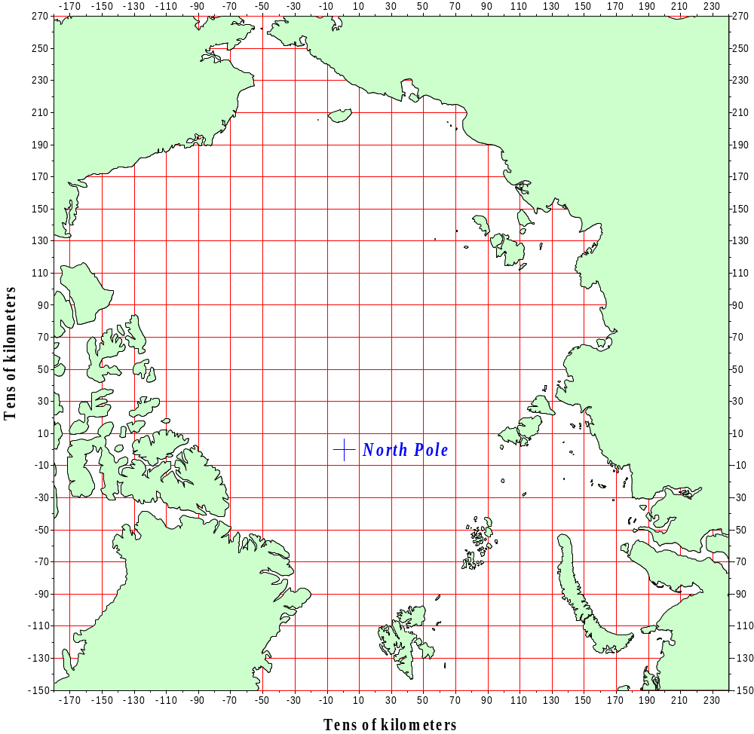

Fig. 4.1. Square grid (a – 200x200 km) used for calculation of climatic characteristics of the hydrochemical elements. Characteristics were calculated for centers of the squares.
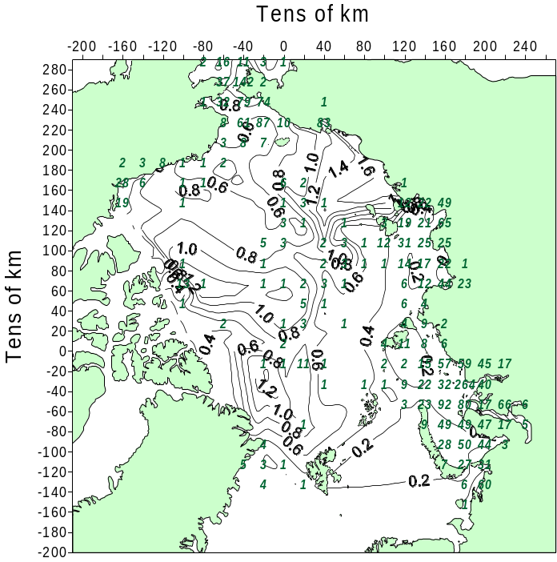
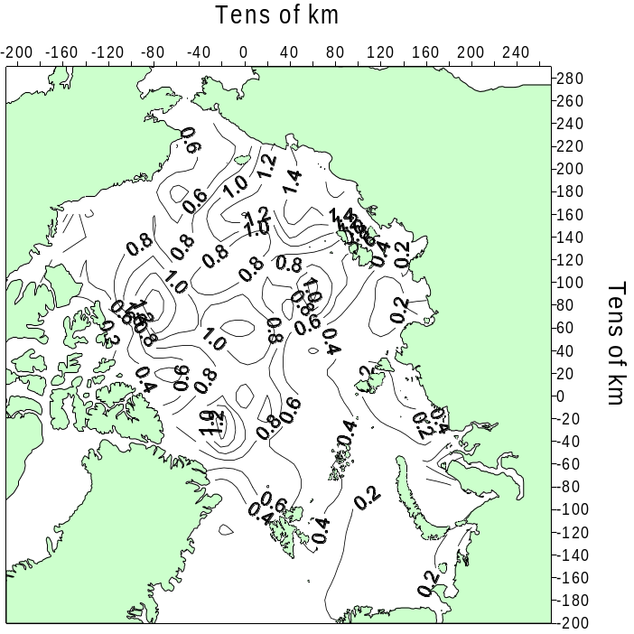
a b

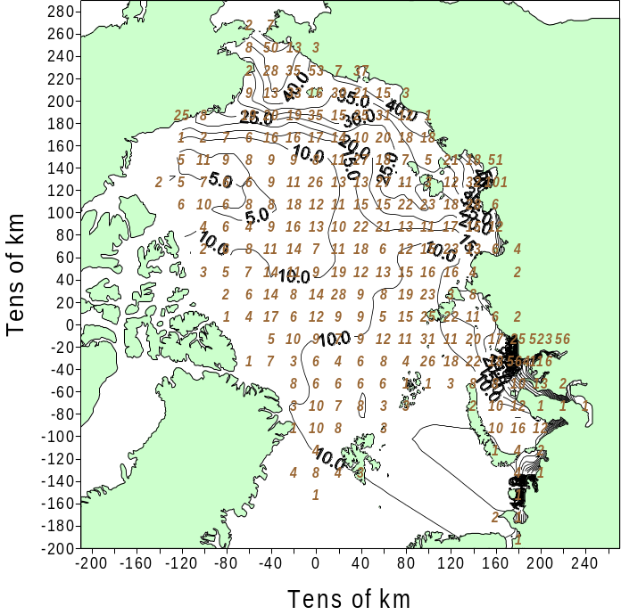
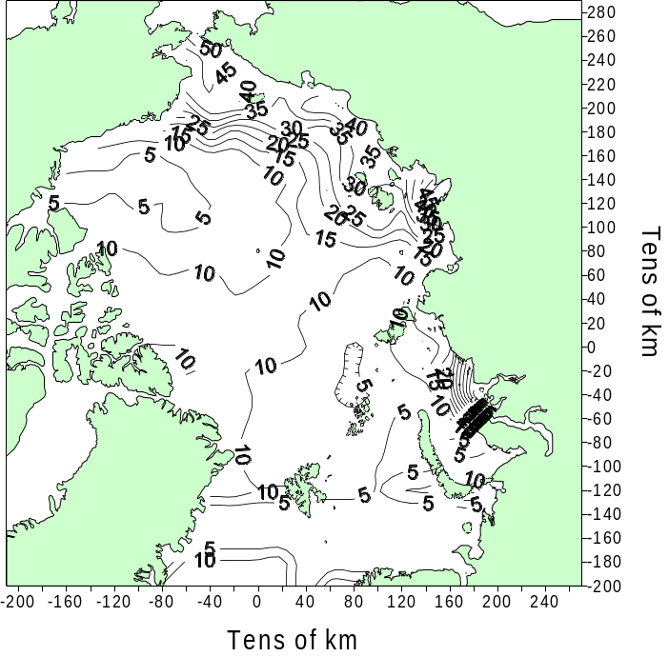
c d

Fig. 4.2. Phosphate [mol/l] , summer, 5 m depth: a – mean value in squares 200x200 km (17 – number of stations); b – gridded field.
Silicate [mol/l], winter, 5 m depth: c – mean value in squares 200x200 km (17 – number of stations); d – gridded field.

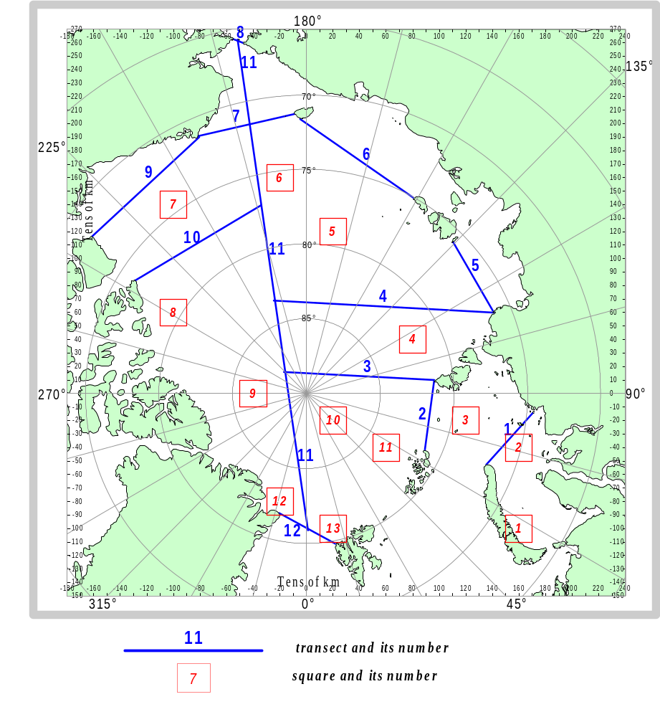

Fig. 4.3. Scheme of transects and squares, for which vertical profiles were calculated

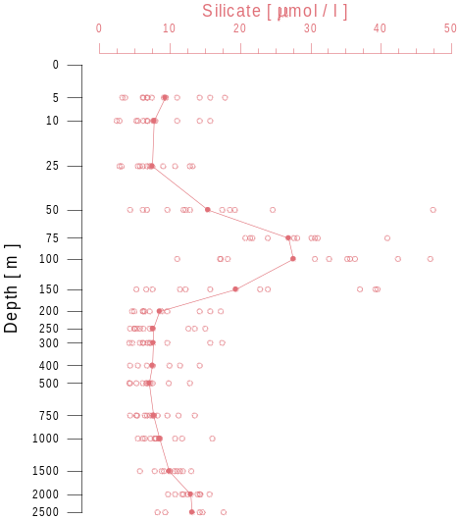
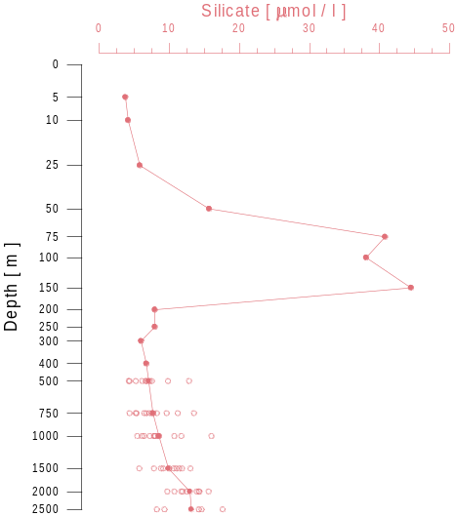
a b

Fig. 4.4. Mean profiles and values (data at the standard depths) of silicate concentration [mol/l] (a – winter, b – summer) for square No. 5 200x200 km (See Fig. 4.3).

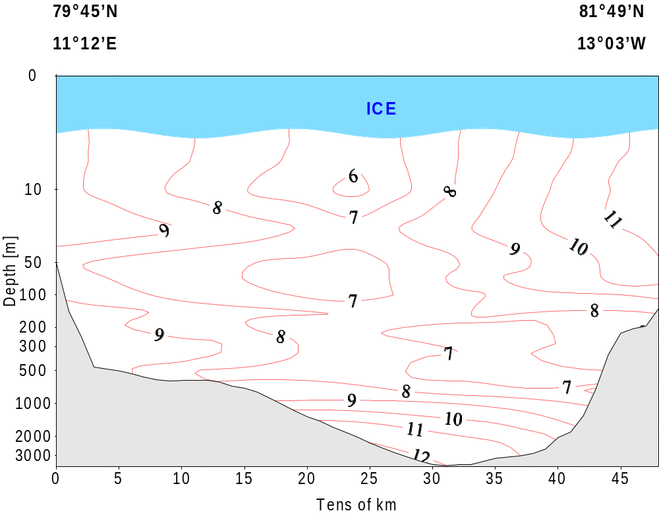

Fig. 4.5. Silicate distribution [mol/l], Transect No. 12 (See Fig. 4.3), winter.
5. Climatic Distribution of the Hydrochemical Characteristics in the Arctic Ocean.

5.1. Vertical Profiles.

Vertical distribution of hydrochemical parameters reflects a complicated, multi-layer water structure in the Arctic Basin and the Arctic seas.
Water column structure in the Arctic Basin is formed under the influence of a complex of external and internal factors. The external factors are: water exchange with the North European Basin through the Fram Strait and the straits between Svalbard and the Franz-Josef Land, with the Pacific Ocean through the Bering Strait, with the Baffin Bay through the straits of the Canadian Archipelago and with the Arctic seas.
The internal factors are: exchange of substance and energy with the atmosphere and ocean bottom, ice melting and freezing, interaction and dynamics of water masses within the basin, physical-chemical and biological processes in water masses.
Extreme values of concentrations of the hydrochemical elements at the vertical profiles demonstrate different origin of the water masses that form the water column in the Arctic Basin.
Unfortunately, investigators have not formulated to the present day a unit approach for description of the Arctic Basin structure and a unit terminology for water mass marking, though the water masses are the main element of the structure. It complicates our understanding of obtained results.
Attention should be paid to the most striking differences in vertical distributions of the hydrochemical parameters in the Eurasian and Canadian parts of the Arctic Basin. Minimum oxygen and pH concentrations and clearly pronounced maxima of nutrients at the intermediate depths characterize the layer of waters of the Pacific origin mainly circulating in the Canadian part of the basin.
Vertical distribution of the hydrochemical parameters in the Arctic seas is characterized as even more complicated and variable. The most general peculiarities typical for many regions of the Arctic seas are presence of maximum concentration of oxygen and minimum concentration of silicon at the intermediate depths in the zones of river runoff influence. Both these extrema characterize different origin and dynamics complexity of the small in volume and span of life water masses of the Arctic seas.

5.2. Transects.

Distribution of the hydrochemical parameters at vertical transects illustrates mean locations of the main elements of the water column structure in the Arctic Basin.
Extrema of the hydrochemical parameters in the Eurasian part of the basin are poorly pronounced. The upper quasi-homogeneous layer is saturated with oxygen up to 100% and is characterized with low concentrations of nutrients. Oxygen concentration decreases with depth, however, it is relatively high in deep layers, if compared with the other oceans, and it testifies for a good ventilation of the near-bottom layer. Concentration of nutrients increases with depth, and accumulation of mineral nutrients takes place in the near-bottom waters.
Kernels of low oxygen concentration are clearly seen at the vertical transects in the Canadian part of the basin, kernels of high nutrient concentration corresponding to them can be seen approximately at the same depths. These kernels indicate mean location of the Pacific waters of winter origin.

5.3. Mean Values and Dispersions at the Standard Depths.

Maps of mean values and dispersions of the hydrochemical parameters at the standard depths are given in the Atlas. This information allows us to estimate operatively general variability of the hydrochemical parameters in a given region and at a given depth. Naturally, the regions, located in frontal zones separating the water masses, are characterized by maximum variability. High variability of the hydrochemical parameters is typical also for the Arctic seas and the regions of continental slope.
Spatial and temporal irregularity of oceanographic stations with hydrochemical observations should be taken into account while working with the maps of mean values and dispersions. Moreover, we should mention insufficient accuracy and sensibility of methods of hydrochemical analysis carried out in the Arctic expeditions.

5.4. Maps of Climatic Distribution of the Hydrochemical Characteristics at the Standard Depths.

Maps of climatic distribution of the hydrochemical parameters at the standard depths were constructed using all available data, with the exception of questionable and rejected values. These maps illustrate general regularities of spatial distribution of the hydrochemical characteristics in the Arctic Ocean. The most serious problems by map construction were as follows: spatial and temporal irregularity of oceanographic stations and significant variability of the hydrochemical parameters in the frontal zones.
It should be taken into account that observations at 0 m depth (sea surface) have been performed only in the Arctic seas and only in summer, and the standard depth 5 m is accepted as the first surface horizon in the Arctic Basin.
Zones of river runoff influence can be clearly seen at the surface of the Arctic seas both in winter and in summer on the maps of mean distribution of silicate, alkalinity and pH. The contour of 10 mol/l of silicate distribution is accepted as the boundary of river runoff influence in the Arctic seas (Rusanov et al., 1979). Distributions of the other hydrochemical elements at the surface of the Arctic seas in summer are determined, to a greater extent, by biological conditions and by a complicated combination of hydrometeorological and ice conditions. Therefore, even mean fields of these parameters have a mosaic structure.
Mean distributions of the hydrochemical parameters on the surface of the Arctic Basin indicate sources and conditions of formation of the surface waters. The water area of the Arctic Basin was divided into five regions by silicate concentration on the surface (Rusanov et al., 1979). The silicate concentration in each region is determined by a combination of biological, physical-chemical, hydrological and meteorological factors. The maximum silicate concentrations are observed in the region adjacent to the Chukchi Sea, and the minimum ones – in the western sector of the Arctic Basin, the surface waters in this region are formed under the influence of the Atlantic Ocean. The increased silicate concentrations in the region of the North Pole are related with upwelling of the Pacific waters from the underlying layers (Rusanov et al., 1979).
Phosphate and nitrate distribution in the Arctic Basin is very similar to that of silicate.
Differences in nutrient distributions in the Eurasian and Canadian sub-basins are most clearly pronounced at the intermediate depths (standard depths: 100, 150, 200 m), where the Pacific intermediate waters of winter origin are located. It should be mentioned that boundaries, separating the Pacific waters and the over- and underlying waters, are located at different depths in different regions of the Arctic Basin. Moreover, the depths, where these waters are deposited, vary with time. Therefore, interchange of regions with increased and decreased concentrations is often observed in distribution fields of the hydrochemical parameters.
Distributions of the hydrochemical parameters at deep and near-bottom horizons are more monotonous. Differences in mean concentrations between the Eurasian and Canadian sub-basins are pronounced not so clear.

