3. EXISTING ENVIRONMENT

3.1 SITE DESCRIPTION, LAND USE, AND AESTHETICS

3.1.1 Site of the Proposed Facilities
The proposed facilities would be located in a rural setting adjacent to the existing Gilberton Power Plant in Schuylkill County, Pennsylvania (Figure 2.1.1 and Figure 2.1.2). The main plant for the proposed project would occupy about 75 acres of nearly level land owned by WMPI PTY, LLC on top of Broad Mountain. The land is currently unoccupied and covered by second-growth forest. The new beneficiation plant or expansion of the existing facility would occupy about 1 acre of land in the adjacent valley to the north of the main plant area.

3.1.2 Land Use
Land use in Mahanoy and West Mahanoy townships in the vicinity of the proposed facilities is primarily woodland (55%) and mined lands (36%). Other land uses include residential (2.8%), public (1.6%), agricultural/open space (1.6%), and smaller areas of retail, manufacturing, and service (Schuylkill County 1995).
The proposed project site is bounded by woodlands to the north and south, the Mahanoy State Correctional Institution to the east, and the existing Gilberton Power Plant to the west. The nearest private residence is 3,600 ft southeast of the site (Suresh Chandran, Philip Services Corporation, e-mail to Cheri Foust, ORNL, September 20, 2004.), while the commercial and recreational areas closest to the site are within 3,000 ft and 5,000 ft, respectively (McMullen 2003).

3.1.3 Aesthetics
Because the site is located adjacent to the existing Gilberton Power Plant, the visual landscape is conspicuously marked with structures of an industrial character, including the boiler building, turbine building, water storage tanks, mechanical-draft cooling towers, baghouses, solid waste silo, administration building, and other associated infrastructure. The tallest structure is the power plant’s 326-ft flue gas stack. The power plant is visible from part of the surrounding local area, depending on the topography and extent of vegetation from specific viewpoints. Emissions from the stack and plumes of water droplets from the cooling towers are occasionally visible. In addition, several other power plants are located within approximately 20 miles of the proposed facilities, including Schuylkill Energy Resources, Wheelabrator Frackville Energy Company, Mt. Carmel Cogeneration, Northeastern Power Company, and Panther Creek (Figure 3.1.1). Strip mines and anthracite culm piles are also visible in the area.
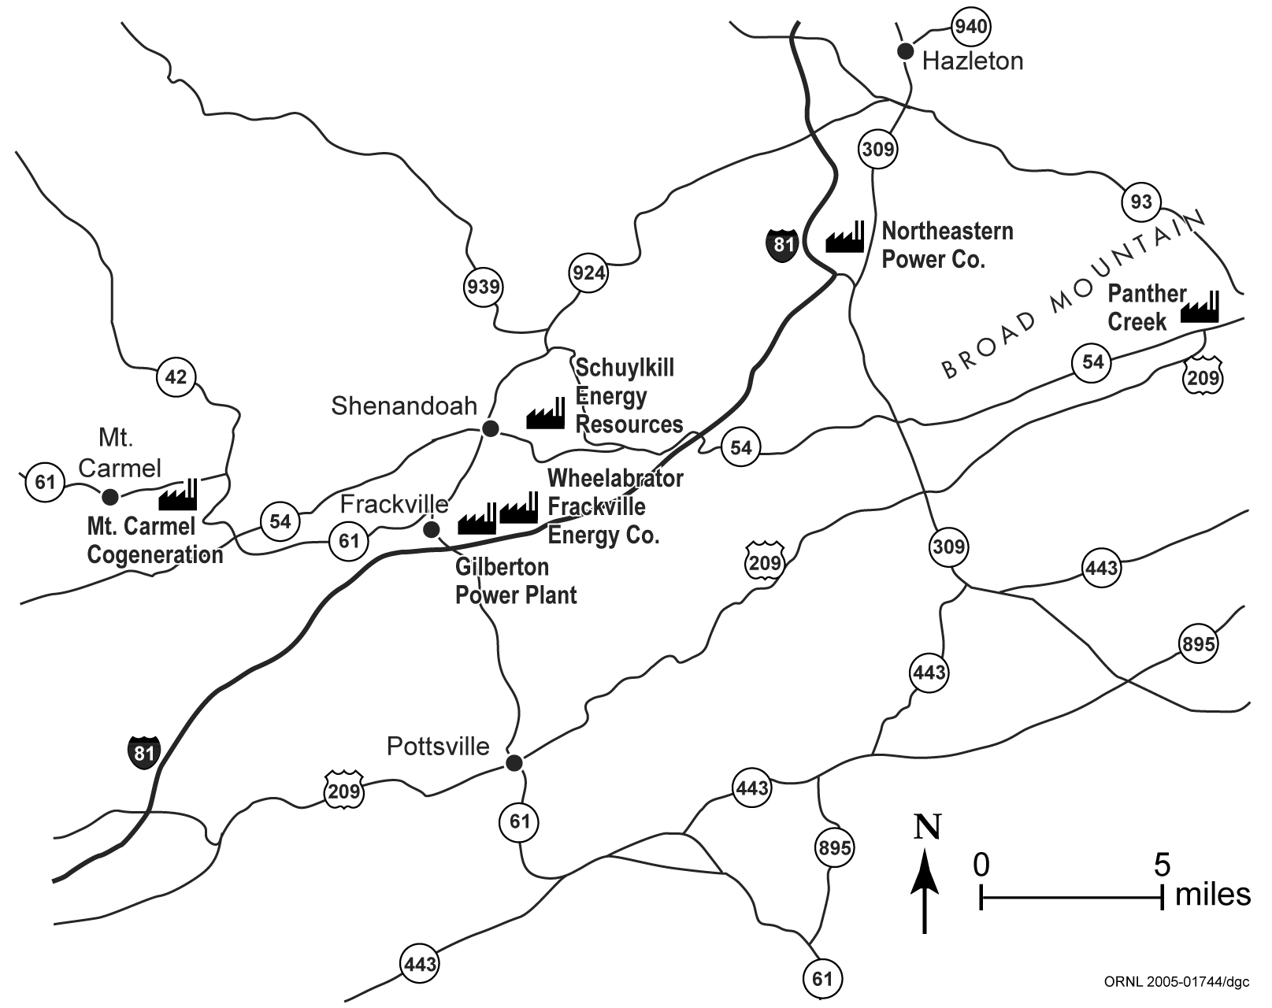
Figure 3.1.1. Power plants in the region of the proposed facilities.

3.2 CLIMATE AND AIR QUALITY

3.2.1 Climate
The proposed site is located in the “ridge and valley province” of Pennsylvania, in which parallel forested ridges and cleared valleys are aligned in a west-southwest to east-northeast orientation. The regional climate, which is classified as humid continental, is influenced by the passage of multiple types of air masses. Cold, dry air frequently arrives from the northern interior of the continent, while winds from the south and southwest transport warm, humid air from the Gulf of Mexico and adjacent subtropical waters. These two air masses provide the dominant characteristics of the area’s climate. A third type of air mass occasionally flows inland from the Atlantic Ocean to produce cool, cloudy, and damp weather conditions.
Winters are generally long and cold, with an average of about 140 days per year with temperatures below 32°F and an average of 5 days per year with temperatures below 0°F. In January, the daily maximum temperature is about 32°F, on average, while the daily minimum is about 16°F. Average annual snowfall is about 45 in. Summers are pleasant, with an average of only 2 days per year with temperatures above 90°F. In July, the daily maximum temperature is about 80°F, on average, while the daily minimum is about 60°F. Average annual precipitation is about 45 in. (including melted snowfall). The distribution of precipitation is fairly uniform during the year, ranging from around 3 in. during the winter months to around 4.5 in. during the summer months. On an annual basis, nearly half of the days are cloudy, and during the winter over half of the days are cloudy. Since 1881, twelve tornadoes have been reported in Schuylkill County. Although no wind data have been archived from a location near enough to be representative of the proposed site, including from any of the power plants in the area, an examination of wind data from surrounding locations (i.e., Harrisburg, Scranton) about 50 miles away suggests that prevailing winds are likely to be from the west-southwest, paralleling the ridge and valley orientation.

3.2.2 Air Quality
Criteria pollutants are defined as those for which National Ambient Air Quality Standards (NAAQS) exist (Table 3.2.1). These pollutants are sulfur dioxide (SO₂), nitrogen dioxide (NO₂), ozone (O₃), carbon monoxide (CO), lead (Pb), and particulate matter less than or equal to 10 μm in aerodynamic diameter, designated PM-10. The U.S. Environmental Protection Agency (EPA) has also promulgated NAAQS for particulate matter less than or equal to 2.5 μm in aerodynamic diameter (PM-2.5) (62 FR 38652), and a new 8-hour NAAQS for O₃ to replace the 1-hour O₃ standard
(62 FR 38856).
The NAAQS are expressed as concentrations of pollutants in the ambient air; that is, in the outdoor air to which the general public has access [40 CFR Part 501(e)]. Primary NAAQS define levels of air quality that EPA deems necessary, with an adequate margin of safety, to protect human health. Secondary NAAQS are similarly designated to protect human welfare by safeguarding environmental resources (such as soils, water, plants, and animals) and manufactured materials. States may modify NAAQS to make them more stringent, or set standards for additional pollutants. Pennsylvania has adopted the NAAQS as the state standards without modifications and has also set ambient air quality standards for beryllium, fluorides, and hydrogen sulfide. The Pennsylvania beryllium standard is 0.01 μg/m³ for a 30-day averaging period, the fluorides standard is 5 μg/m³ for a 24-hour averaging period, and the hydrogen sulfide standards are 0.005 ppm for a 24-hour average and 0.1 ppm for a 1-hour average.
Schuylkill County is in attainment with NAAQS and state ambient air quality standards for all pollutants, including the recently implemented PM-2.5 and 8-hour O₃ standards (Arleen Shulman, Pennsylvania Department of Environmental Protection, personal communication to Robert Miller, ORNL, August 31, 2004). Schuylkill County was formerly designated as nonattainment for the 1-hour O₃ standard, based on “incomplete data” (the least severe of the classifications), but EPA revoked the 1-hour O₃ standard on June 15, 2005, relying solely on the 8-hour O₃ standard as of that date.
Attainment status for NAAQS is determined primarily by evaluating data from ambient air quality monitoring stations. The nearest SO₂ and CO monitoring stations are located in Shenandoah, about 2 miles north of Gilberton. The closest NO₂, PM-10, PM-2.5, and O₃ monitoring stations are located in Reading, about 35 miles south-southeast of Gilberton. A Pb monitoring station is located in Laureldale, immediately north of Reading.

Table 3.2.1. National Ambient Air Quality Standards (NAAQS) for criteria pollutants
 | Primary (Health related) |  | Secondary (Welfare related)
Pollutant | Averaging period | Concentration | Averaging period |  | Concentration
CO | 8-hour ª | 9 ppm (10 mg/m³) | No secondary standard
CO | 1-hour ª | 35 ppm (40 mg/m³) | No secondary standard
Lead | Maximum quarterly average | 1.5 μg/m³ | Same as primary standard
NO₂ | Annual arithmetic mean | 0.053 ppm (100 μg/m³) | Same as primary standard
O₃ | Maximum daily 1-hour average ^{b} | 0.12 ppm (235 μg/m³) | Same as primary standard
O₃ | 4th highest 8-hour daily maximum ^{c} | 0.08 ppm (157 μg/m³) | Same as primary standard
PM-10 | Annual arithmetic mean ^{d} | 50 μg/m³ | Same as primary standard
PM-10 | 24-hour ^{d} | 150 μg/m³ | Same as primary standard
PM-2.5 | Annual arithmetic mean ^{e} | 15 μg/m³ | Same as primary standard
PM-2.5 | 98th percentile 24-hour ^{e} | 65 μg/m³ | Same as primary standard
SO₂ | Annual arithmetic mean | 80 μg/m³ (0.03 ppm) | 3-hour ª | 1,300 μg/m³ (0.50 ppm)
SO₂ | 24-hour ª | 365 μg/m³ (0.14 ppm) | 3-hour ª
ª Not to be exceeded more than once per year.
^{b} This former standard (revoked on June 15, 2005) was attained when the expected number of days per calendar year with maximum hourly average concentrations above 0.12 ppm was equal to or less than 1, as determined according to Appendix H of the Ozone NAAQS.
^{c} The 8-hour standard is met when the 3-year average of the annual 4th highest daily maximum 8-hour O₃ concentration is less than or equal to 0.08 ppm.
^{d} The annual PM-10 standard is attained when the expected annual arithmetic mean concentration is less than or equal to 50 μ/m³ (3-year average); the 24-hour standard is attained when the expected number of days above 150 μg/m³ is less than or equal to 1 per year.
^{e} The annual PM-2.5 standard is met when the annual average of the quarterly mean PM-2.5 concentrations is less than or equal to 15 μg/m³, when averaged over 3 years. If spatial averaging is used, the annual averages from all monitors within the area may be averaged in the calculation of the 3-year mean. The 24-hour standard is met when the 98th percentile value, averaged over 3 years, is less than or equal to 65 μg/m³.

In addition to ambient air quality standards, which represent an upper bound on allowable pollutant concentrations, national air quality standards exist for Prevention of Significant Deterioration (PSD) (40 CFR Part 51.166). The PSD standards differ from the NAAQS in that the NAAQS specify maximum allowable concentrations of pollutants, while PSD requirements provide maximum allowable increases in concentrations of pollutants for areas already in compliance with the NAAQS. PSD standards are therefore expressed as allowable increments in the atmospheric concentrations of specific pollutants. Allowable PSD increments currently exist for three pollutants (NO₂, SO₂, and PM-10). One set of allowable increments exists for Class II areas, which cover most of the United States, and a much more stringent set of allowable increments exists for Class I areas, which include many national parks and monuments, wilderness areas, and other areas as specified in 40 CFR Part 51.166(e). Allowable PSD increments for Class I and Class II areas are presented in Table 3.2.2. The PSD Class I area nearest to Gilberton is Brigantine Wilderness Area in New Jersey, about 130 miles to the southeast.

Table 3.2.2. Allowable increments for Prevention of Significant
Deterioration (PSD) of air quality
Pollutant | Averaging  period | Allowable increment (μg/m³)
Pollutant | Averaging  period | Class Iª | Class IIª
Sulfur dioxide (SO₂) | 3-hour  24-hour  Annual | 25  5  2 | 512  91  20
Nitrogen dioxide (NO₂) | Annual | 2.5 | 25
Particulate matter less than 10 μm aerodynamic diameter (PM-10) | 24-hour  Annual | 8  4 | 30  17
ª Class I areas are specifically designated areas in which the degradation of air quality is to be severely restricted. Class II areas (which include most of the United States) have a less stringent set of allowable increments.

Contaminants other than the criteria pollutants are present in the atmosphere in varying amounts that depend on the magnitude and characteristics of the sources, the distance from each source, and the residence time of each pollutant in the atmosphere. In the ambient air, many of these pollutants are present only in extremely small concentrations, requiring expensive state-of-the-art equipment for detection and measurement. Measurements of existing ambient air concentrations for many hazardous pollutants are, at best, sporadic. Regulation of these pollutants is attempted at emission sources based on the National Emissions Standards for Hazardous Air Pollutants (40 CFR Part 61; 40 CFR Part 63).

3.3 GEOLOGY AND SOILS

3.3.1 Physiography
The proposed project site is located in the Anthracite Upland section of the Ridge and Valley physiographic province of the Appalachian Mountains (Sevon 2000). The regional landscape is characterized by a series of northeast-trending linear ridges and valleys, reflecting the structure of the underlying folded and faulted bedrock. Stream drainage has a trellised pattern defined by major streams that follow linear courses in the valleys, fed by tributaries that flow down the slopes of ridges. The elevation difference between ridges and adjacent valleys ranges from 500 to 1,000 ft. The landscapes of many of the valleys and ridges have been extensively altered by surface and underground mining of the underlying anthracite coal. Landforms created by past mining include water-filled mine pits, coal refuse piles, and spoil banks.
The proposed main plant would be located on the crest of Broad Mountain at an elevation of about 1,700 ft above mean sea level (amsl). Broad Mountain is an east-northeast trending ridge with steep flanks and a broad, flat to gently rolling crest. Topographic relief across the main plant site is about 40 ft. Other project-related facilities and activities, including coal preparation, rail transfer, extraction of groundwater, and discharge of wastewater, would occur on the northern slope of Broad Mountain and in the valley of Mahanoy Creek north of Broad Mountain, which has an elevation of about 1,150 to 1,200 ft amsl. Topographic features of this valley have been extensively altered by past strip mining.

3.3.2 Stratigraphy and Structure
The site area is underlain by sedimentary rocks of Mississippian and Pennsylvanian age (about 290 to 360 million years old) deposited primarily in rivers, swamps, and bogs. The oldest geologic unit mapped in the area is the Mauch Chunk Formation, which was deposited in Late Mississippian and Early Pennsylvanian time. This formation consists of shale, siltstone, sandstone, and some conglomerate. Above the Mauch Chunk is the Pennsylvanian age Pottsville Formation, which consists of conglomerate and sandstone interbedded with siltstone, shale, and anthracite coal. The Pottsville Formation has a total thickness of up to 1,600 ft. Above the Pottsville Formation, the Pennsylvanian age Llewellyn Formation consists primarily of sandstone and siltstone, interbedded with shale, conglomerate, and anthracite coal. In Schuylkill County, the Llewellyn Formation is as much as 4,400 ft thick and includes as many as 40 mineable coal layers.
Regional bedrock structure is very complex. Multiple cycles of regional deformation resulted in an east-northeast-trending system of folds and thrust faults, within which are complex sets of subsidiary folds and faults. In the vicinity of the proposed project site, coal-bearing formations typically are exposed in synclinal structures that form valleys.
At the proposed main plant site on top of Broad Mountain, bedrock units are the Mauch Chunk Formation and the overlying Tumbling Run Member, which is the basal unit of the Pottsville Formation. The Tumbling Run Member, which consists primarily of sandstone and conglomeratic sandstone, is stratigraphically below the coal layers in the Pottsville Formation. These geologic units are relatively erosion-resistant and form several prominent ridges in the area.
Broad Mountain is the topographic expression of an anticline formed by the Mauch Chunk Formation and other geologic units stratigraphically below the coal-bearing formations. The axis of the anticline lies a short distance south of the site of the proposed main plant. At the site, bedrock dips approximately 26° to the north-northwest.
The Mahanoy Creek valley north of Broad Mountain occupies a broad syncline. Several subsidiary folds and faults are within the syncline. Rock units stratigraphically above the Mauch Chunk Formation, including the Pottsville Group and the Llewellyn Formation, are exposed in the Mahanoy Creek valley and on the north slope of Broad Mountain.
Coal-bearing units of the Pottsville Group and Llewellyn Formation also are exposed south of Morea in an east-west-trending syncline outcropping along the south flank of Broad Mountain. This exposure is truncated on the south by a fault.

3.3.3 Mineral Resources
The region surrounding the proposed project site is rich in anthracite coal. The anthracite coal-bearing rocks of eastern Pennsylvania cover about 484 square miles within a 3,300 square mile region in Carbon, Columbia, Dauphin, Lackawanna, Lebanon, Luzerne, Northumberland, Schuylkill, Susquehanna, and Wayne counties, and are estimated to have originally held 22.8 billion tons of coal (Edmunds 2002), representing most of the United States’ anthracite coal resources.

The region has a long history of coal production. Some mining and use of anthracite occurred before 1800. Large-scale mining began early in the 1800s, primarily in underground mines using the room-and-pillar mining method. In this method, large “rooms” of coal are excavated and intervening “pillars” of coal are left to hold up the roof. Mine spoil known as “culm,” including coal that did not meet size or purity standards for commercial sale, was deposited on the surrounding landscape. As early as the late 1800s miners began extracting coal from this old waste material by excavating culm deposits on the land surface (called “culm banks”) and dredging rivers and streams for coal that had been deposited in them. Strip mining also began to supplement underground mining and increased in prevalence during the 20th century. The peak year for anthracite production in the region was 1917, when about 100 million tons were mined, almost all from underground mines (USGS 1968; PDEP 2000). Underground mining activity declined through the middle years of the 20th century, and most deep mines were eventually forced to close due to the difficulty of mining in steeply dipping and faulted rocks and the high cost of pumping increasing volumes of water out of the mines. For example, the mine served by the Gilberton Shaft in Gilberton was abandoned in 1967 when dewatering operations were terminated (Yaccino 1976). Annual production of anthracite from river dredging and culm banks has fluctuated over time in response to market conditions, peaking at more than 10 million tons per year during World War II and declining to as little as 500,000 tons per year during the 1980s. Strip mining peaked in 1948, when more than 13 million tons were produced by this method (USGS 1968; PDEP 2000). In recent years, annual production from mines has generally been less than 3 million tons, while culm utilization rates (which include some non-coal material that is mixed with the coal) have been variable (Figure 3.3.1). In 2002, 40% of the region’s anthracite output came from Schuylkill County (PDEP 2003).
In total, more than 5.5 billion tons of coal have been produced from the anthracite region (Milici and Campbell 1997). Much of the coal remaining in the ground cannot be mined (for example, because it forms the pillars in old room-and-pillar mines). The Energy Information Administration (1999) has estimated the demonstrated reserve base of anthracite as 7.2 billion tons, but most of the potentially mineable coal is inaccessible or cannot be recovered. Based on Energy Information Administration estimates of accessibility and recovery factors, only 788 million tons of recoverable anthracite remained in the ground, including 485 million tons recoverable by surface mining methods and 303 million tons recoverable by underground mining. Authoritative estimates are not available for the total quantity of potentially recoverable anthracite culm remaining on the land surface in eastern Pennsylvania, but the quantity is considered to be very large. WMPI controls 65 million tons of surveyed culm reserves plus an estimated 85 million tons that have not been surveyed. Accordingly, a conservative estimate of the amount of locally available culm is 100 million tons.

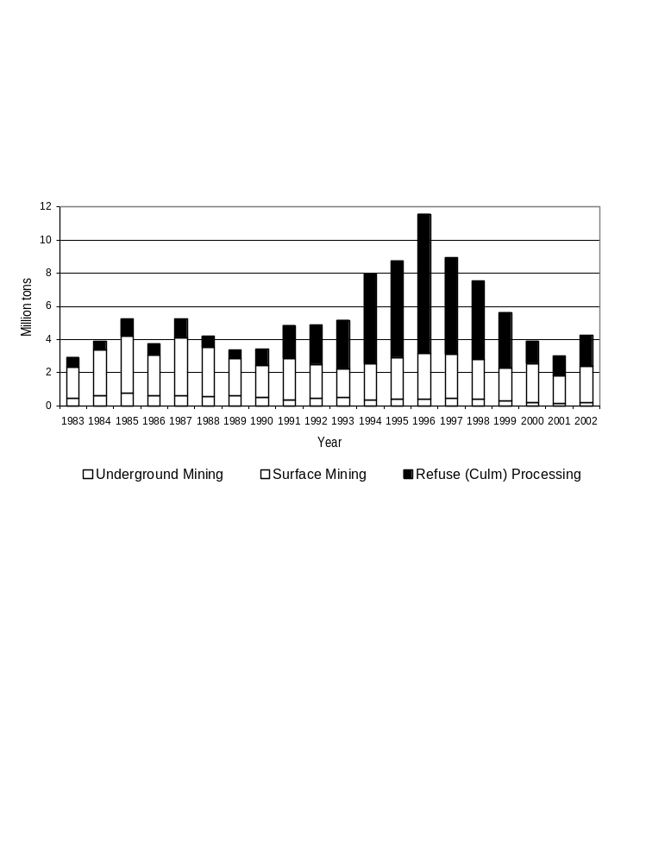
Figure 3.3.1. Anthracite coal production in Pennsylvania, 1983-2002. Culm processing reflects the total amount of culm material produced, including noncoal waste materials. Source: Pennsylvania Department of Environmental Protection, Office of Mineral Resources Management, Annual Reports on Mining Activities.

3.3.4 Soils
The proposed main plant site on top of Broad Mountain has residual soils formed from weathering of the underlying sandstone bedrock. Soil thickness in the site vicinity ranges from 2 to 14 ft, with rock fragments frequently encountered in the deeper layers. The soil is generally a silty fine to coarse sand with some clay and gravel. Site soils are classified in the “Hazleton-Clymer soil association, gently sloping to sloping.” These units are described as consisting of deep, well drained, permeable, stony soils formed in sandstone, siltstone, and shale residuum on uplands. The “Buchanan extremely stony loam” soil series is also present in one area of the site. This is a deep, moderately well to somewhat poorly drained soil formed on upland colluvium derived from sandstone, siltstone, and shale. None of these soils are classified as prime farmland or Pennsylvania farmland of statewide importance.
Soil classifications in the valley north of Broad Mountain reflect the area’s history of disturbance. The predominant soil map unit in the valley is “Udorthents, strip mine,” a classification that indicates mined land and mine spoil in which no evidence of natural soil development exists. Other areas in the valley are mapped as “mine dumps,” “coal waste dumps,” and “urban land.”

3.3.5 Geologic Hazards

3.3.5.1 Mines
Subsidence of underground coal mines is a significant potential hazard in all portions of the project area that are underlain by active or abandoned mine workings. Damage can result from either sudden collapses or gradual subsidence. One particularly severe event in the region was the collapse of an underground coal mine in Wilkes-Barre (about 35 miles northeast of the proposed project site) in 1954 (von Hake 1973). This collapse damaged hundreds of homes, broke gas and water mains, and caused streets and sidewalks to buckle and collapse. Many older buildings in the valley of Mahanoy Creek have structural damage resulting from gradual subsidence of abandoned underground coal mines. Dewatering of mine pools (man-made aquifers resulting from a network of voids produced during underground mining activities) can lead to surface subsidence because the presence of water helps to support the overlying rock. However, the state of Pennsylvania has not observed any mine roof collapses or other subsidence related to pumping from the mine pools at Gilberton or other locations in the region (Buckwalter 2004; Veil et al. 2003).
Abandoned mines and mining waste also are potential fire hazards. Fires in culm banks and underground mines can be ignited by surface fires, mining activities (such as welding or use of explosives), or spontaneous combustion of coal fines or combustible trash materials mixed in with the culm (Stracher et al., undated). Once started, these fires can be very difficult to extinguish and may become long-term hazards to public health and safety. Underground fires in coal seams emit carbon monoxide and other toxic gases that can migrate through cracks and voids and enter buildings. Also, ground surface subsidence often occurs above burned-out coal seams. The borough of Centralia, about 8 miles west of Gilberton, has been permanently evacuated due to an underground coal fire that has been burning since 1962. Fires in culm banks threaten the safety of people occupying the area and degrade air quality by the uncontrolled release of smoke. Long-lasting smoldering fires in culm banks were common in the region in past decades, but have nearly been eliminated by improved fire-suppression capabilities.
The site of the proposed main plant is located over rock units that do not contain coal. Therefore, the site is not subject to hazards associated with past coal mining.
Extensive underground mining has occurred in the Mahanoy Creek valley, where some buildings have visible damage due to subsidence. Culm banks also are present in the valley.

3.3.5.2 Seismic Activity
The proposed project site is in a region of relatively low earthquake risk. It is included in Seismic Risk Zone 1 of the Uniform Building Code (ICBO 1994). Under the newer International Building Code (International Code Council 2002) most types of structures would be assigned to Seismic Design Category B. No earthquakes centered in Schuylkill County have been recorded. Southeastern Pennsylvania has a history of seismic activity, however, and is rated as having somewhat higher seismic risk than the area of the project site. The largest seismic event measured in southeastern Pennsylvania was a magnitude 4.6 earthquake in January 1994 at Wyomissing Hills in Berks County, about 40 miles south of the proposed project site. Seismic activity in southeastern Pennsylvania is associated with two different source areas: (1) a north-south trending zone in Lancaster and Lebanon Counties and (2) the margins of a Triassic-age rift basin that crosses southeastern Pennsylvania (including Wyomissing Hills) and New Jersey (Scharnberger 1989 and 2003).
The U.S. Geological Survey (1996) estimates that a peak ground acceleration of 0.12 g due to seismic activity has a 2% probability of occurring at the proposed project site during a 50-year period. Ground accelerations above about 0.1 g can cause damage to residential buildings that were not designed to resist earthquakes (USGS 1996), but significant earthquake damage is generally not expected unless ground accelerations exceed 0.15 g (Scharnberger 2003).

3.4 WATER RESOURCES
Pennsylvania has a humid climate, with precipitation distributed relatively evenly through the year. In the area of the proposed facilities, the average annual precipitation of about 45 in. (Section 3.2.1) substantially exceeds the average annual evapotranspiration, which is estimated to be about 26 in. (Fleeger 1999), leaving nearly 20 in. as average annual runoff. Rates of evapotranspiration are typically lower and runoff correspondingly higher on mined land with little or no revegetation. Statewide, approximately 12 to 15 in. annually, or about one-third of the precipitation, is estimated to infiltrate to the groundwater system, with the remainder of the runoff going directly to surface waters (Callaghan et al. 1998).

3.4.1 Surface Water
Broad Mountain forms a watershed boundary, dividing the Susquehanna River watershed to the north from the Schuylkill River watershed to the south. The Susquehanna River flows south and southeast, entering Chesapeake Bay at Havre de Grace, Maryland. The Schuylkill River flows southeast to Philadelphia and the Delaware River, which flows to Delaware Bay.
The north slope of Broad Mountain drains to Mahanoy Creek, which flows 50 miles westward from headwaters east of Mahanoy City to the Susquehanna River, entering the river about 10 miles south of the city of Sunbury. The southern side of Broad Mountain is in the watershed of Mill Creek, which enters the Schuylkill River near Pottsville. No streams are located on the sites for the main plant or ancillary facilities, but old strip mining pits and artificial ponds in the Mahanoy Creek valley and on the southern side of Broad Mountain collect precipitation, stormwater runoff, and other wastewater. Because most activities associated with the proposed facilities would occur in the Mahanoy Creek watershed and facility effluent discharges would be directed into the Mahanoy Creek watershed, Mahanoy Creek is the focus of the remainder of this discussion.
Mahanoy Creek drains a watershed (Figure 3.4.1) with an area of approximately 157 square miles (PDEP 2002a). At Gilberton, the creek has a surface watershed area of less than 18 square miles (NWISWeb accessed September, 2004; site 0155521140).
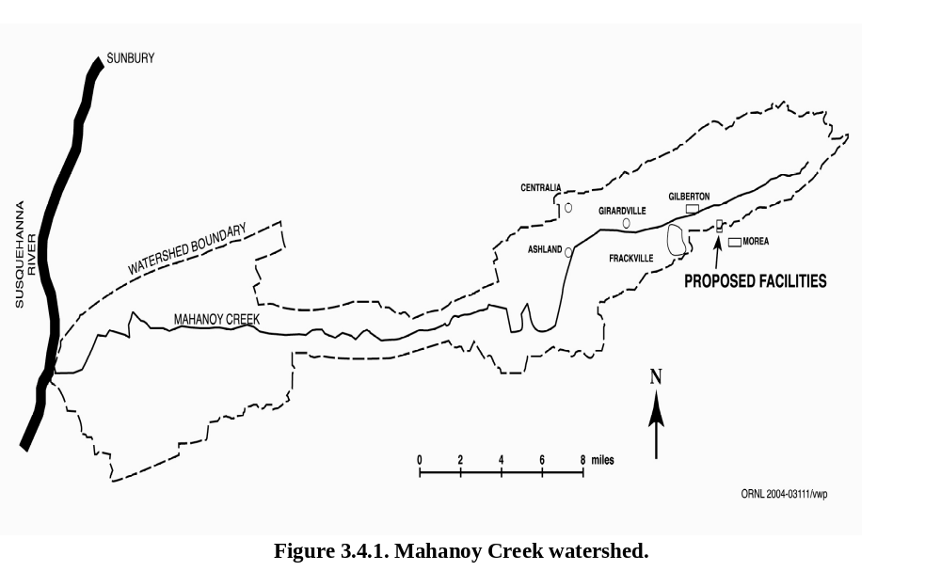
Past mining in the region has altered both surface and groundwater hydrology on a large scale. Mine workings and other underground openings act as large drains or sinks for groundwater. During active underground mining this water was removed by pumping and by tunnels that provided gravity drainage to nearby streams. After mining ceased, the underground openings flooded. The interconnected mine shafts, tunnels, gangways, and other workings now collect and divert both groundwater and surface streams, forming highly transmissive man-made aquifers that in many instances transfer water between surface watersheds. Disturbance of the land surface by surface mining, deposition of coal waste, and collapse of underground openings also has altered hydrology by modifying stream courses and forming artificial ponds where surface water collects and infiltrates into the man-made aquifer system. Numerous seeps, boreholes, and mine tunnel discharges enter Mahanoy Creek and its tributaries. The creek segment near the proposed project area receives mine-water inflow from pumping of the Gilberton mine pool (Section 3.4.3) and from several uncontrolled mine-water discharges upstream from Mahanoy City (PDEP 2002a).
Limited flow data are available for Mahanoy Creek in the proposed project area (USGS NWISWeb). In August 2001 creek discharge at Gilberton was measured as 2.8 ft³/s. About 3 miles downstream at Girardville, below the entry point for discharges from the Girard Mine, measured stream discharge on the same day was 7.8 ft³/s. About 2 miles farther downstream at Ashland, discharge that day was 50 ft³/s. Other flow measurements at Girardville range from 4.8 to 32 ft³/s, and other measurements at Ashland range from 40 to 88 ft³/s. For the purpose of water quality calculations, the Pennsylvania Department of Environmental Protection (2002a) assumed an average discharge at Girardville of 9.5 ft³/s (6.15 million gal per day). Measured discharges at Gilberton and the assumed average discharge at Girardville are much smaller than the average annual discharges of 27 ft³/s and 31 ft³/s, respectively, calculated from the watershed sizes and estimated annual runoff of 20 in. At Ashland, however, observed stream flow compares reasonably well with calculated stream flow of 63 ft³/s. The discrepancy between observed and calculated stream flow at Gilberton and Girardville may indicate that some runoff generated within the upper Mahanoy Creek watershed normally bypasses the stream in the area of these communities, probably as groundwater that emerges farther downstream.
Water quality in Mahanoy Creek is considered to be severely impaired from the source to the mouth (Edwards 1998). The principal cause of water quality degradation is acidic mine drainage. Aquatic life is severely diminished due to low pH conditions and high concentrations of dissolved metals. Sewage also is reported to contribute to water quality degradation in the upper watershed (where the proposed facilities would be located), but sewage effects are largely masked by the effects of mine drainage. Water quality has improved over time, possibly due to reclamation of abandoned mines, but does not meet the water-quality objectives established for the creek, which are based on a designated use as warm-water fish habitat (PDEP 2002a).
Table 3.4.1 presents two sets of results from water quality sampling of Mahanoy Creek near the proposed project site. State water quality criteria applicable to the creek also are shown. The water is acidic (indicated by the measured values for pH and acidity) and has elevated levels of sulfate and metals (aluminum, iron, and manganese) that are typical of waters affected by acid mine drainage. Water quality factors adverse to fish habitat are the acidity, which promotes release of metals such as aluminum and lead in forms that are toxic to aquatic life and the elevated manganese and iron levels which can cause deposition of metal oxide precipitates that physically degrade streambed habitat.
The Pennsylvania Department of Environmental Protection (2002a) has published preliminary calculations of the total maximum daily load reductions required in Mahanoy Creek above Girardville (which includes the stream segment in Gilberton) in order to achieve water quality criteria in the creek at least 99% of the time. The agency estimated that reductions of 69 lb per day of manganese (73% less than the current load), 32 lb per day of aluminum (78% less than the current load), and 657 lb per day of acidity (63% less than the current load) would be needed. The agency did not estimate a load reduction for iron in this segment of Mahanoy Creek because the targeted reduction in iron would be achieved at other stream locations.

3.4.2 Groundwater
Groundwater is present at relatively shallow depth throughout the site area, in intergranular pore space, fractures, and man-made bedrock voids. Recharge to groundwater is primarily from infiltration of precipitation. The Mauch Chunk and Pottsville Formations are productive sources of groundwater throughout the region, storing and transmitting water primarily in interconnected fractures. Saturation is continuous at depths below the water table, but discrete water-bearing zones are identified in these aquifers where wells intersect well-connected fracture zones. Productive water-bearing zones are most commonly found at depths between 50 and 300 ft. Wells finished in these aquifers and developed for maximum production have a median yield of 75 gpm, with some wells in the Mauch
Table 3.4.1. Water quality data for Mahanoy Creek near Gilberton
Analyte | Concentration (mg/L, except as noted) |  | Applicable water quality criteria^{b,c} (maximum except as noted)
Analyte | U.S. Geological Surveyª | Pennsylvania Department of Environmental Protection^{b}
pH (field; pH units) | 5.0 | --^{d} | 6.0 - 9.0 (range)
Oxidation-reduction potential (mV) | 440 | -- | --
Dissolved oxygen | 6.7 | -- | min. 5.0 (daily average)
Silica | 9.5 | -- | --
Specific conductance (μS/cm) | 660 | -- | --
Acidity, as calcium carbonate | 11 | 16.25 | --
Alkalinity | -- | 16.50 | --
Cations
Aluminum | 0.3 | 0.75 | 0.75
Calcium | 61 | -- | --
Iron, total | 0.63 | -- | 1.5
Iron, dissolved | 0.41 | 5.18e | 0.3
Lead, dissolved | 0.0004 | -- | --
Magnesium | 26 | -- | --
Manganese | 1.8 | 2.5 | 1.0
Nickel, dissolved | 0.049 | -- | --
Potassium | 4.3 | -- | --
Sodium | 25 | -- | --
Strontium | 0.38 | -- | --
Zinc | 0.17 | -- | --
Anions
Chloride | 26.9 | -- | --
Fluoride | 0.1 | -- | --
Nitrate, as nitrogen | 1.95 | -- | --
Sulfate | 320 | -- | --
ªMeasured August 20, 2001. Source: NWISWeb.
^{b}Source: PDEP (Pennsylvania Department of Environmental Protection) 2002a.
^{c}Pennsylvania Code Title 25, Environmental Protection, Section 93.7, Specific water quality criteria.
^{d}Not available.
^{e}Not identified as total or dissolved.

Chunk aquifer yielding several hundred gpm. Most of the smaller wells in both aquifers yield sufficient water to supply a household. A specific yield (the fraction of the aquifer volume that consists of drainable void space) of 0.034 has been calculated for the Mauch Chunk aquifer in the region (Becher 1991). This value is characteristic of an unconfined (water-table) aquifer in which groundwater is stored primarily in fractures. The zone of influence around pumped wells is much larger parallel to bedrock strike than perpendicular to bedrock strike, and may extend to a distance of 1,500 ft or more from a high-capacity production well (Becher 1991).
Under natural conditions, groundwater flow is from upland areas, such as Broad Mountain, laterally and downward toward natural discharge sites in springs and seeps in valleys, such as the valley of Mahanoy Creek. Groundwater flow patterns generally mirror the topography. However, the influence of bedrock structure on subsurface flow may cause groundwater divides to be located updip from surface water divides. Downward flow gradients would typically be observed in the uplands, which are net recharge areas. Upward flow would occur in valleys, which are net discharge areas, and might have artesian conditions under which deep wells flow at the ground surface.
Previous underground mining activities, which created extensive networks of voids that are now filled with water, have substantially altered natural groundwater systems. Abandoned mine workings function as highly permeable man-made aquifers, known as mine pools. Because mining removed much of the rock that once impeded upward groundwater flow, the higher groundwater heads that existed at depth under valleys are now expressed at the ground surface. The valley mine pools function similarly to large artesian wells, often producing upwelling groundwater at the ground surface and causing flooding in the valleys. The Mahanoy Creek valley in the area of the proposed facilities is underlain by an extensive system of mine pools (Section 3.4.3).
Particularly during active mining, underground mines also act as groundwater drains or sinks, and could possibly cause lower water levels in upgradient portions of a groundwater flow system. However, valley mines in the proposed project area have not been reported to affect groundwater levels in uplands.
The quality of groundwater is generally good in the Mauch Chunk Formation and portions of the Pottsville Formation that are not affected by mining. Water from both aquifers is low in dissolved solids content. Median concentrations of total dissolved solids are 80 mg/L in the Mauch Chunk Formation and 53 mg/L in the Pottsville Formation. Water from the Pottsville Formation is soft (median hardness of 15 mg/L, as calcium carbonate), while the Mauch Chunk Formation produces water that is soft to very hard (median hardness of 90 mg/L) (Becher 1991). Some wells in the region naturally produce water with undesirably high levels of iron and manganese, and contamination is reported in some wells due to nearby septic systems, underground storage tanks, and other localized sources (Becher 1991, Edwards 1998).

3.4.3 Mine Pool
An extensive system of mine pools (man-made aquifers resulting from a network of voids produced during underground mining activities) exists under the Mahanoy Creek valley in the vicinity of the proposed project site. Inflow comes from groundwater that would naturally discharge in the valley, seepage of surface water from Mahanoy Creek (the water elevation in the mine pools is generally lower than that of the creek), and seepage from tailings ponds in the valley.
The Gilberton mine pool consists of water-filled underground mine workings located beneath the borough of Gilberton and connected with the Gilberton Shaft. The mine extended as deep as 1,200 ft, to an elevation of -66 ft amsl (Parulis 1985). The underground mining operation closed and dewatering stopped in 1967, after which the workings filled with water (Yaccino 1976). The water-filled volume of the mine pool has been estimated at 1.868 billion gal (Parulis 1985). The Gilberton pool has been reported to be interconnected with the Lawrence and West Bear Ridge mine pools to the west and with the Boston Run, St. Nicholas, and Tunnel Ridge mine pools to the east (Parulis 1985). Together, these pools have been estimated to hold over 7.1 billion gal of water (Parulis 1985). Hydraulic testing demonstrated a direct interconnection only with the Lawrence mine pool (Leaver 1976), which has an estimated volume of 2.127 billion gal. However, water from the three mine pools east of the Gilberton pool probably flows as groundwater into the Gilberton pool.
Based on records of pumping during active mining, the Gilberton mine pool and other interconnected mine pools were estimated to have average inflow of about 6,200 gpm (13.8 ft³/s or 3.25 billion gal per year). Parulis (1985) estimated the inflow to be about 8,200 gpm, based on pumping rates for a 29-month period in the early 1980s.
An underground pump supplies water from the mine pool at an average rate of 1,500 gpm to use as cooling water at the Gilberton Power Plant. An additional 1,667 gpm are withdrawn for use in the existing culm beneficiation plant. Evaporation and other losses consume almost all of the cooling water and some of the culm preparation water. About 1,280 gpm (100 gpm from the power plant and 1,180 gpm from the culm beneficiation plant) are discharged as treated wastewater to a tailings pond in the Mahanoy Creek valley.
The Pennsylvania Department of Environmental Protection operates another subsurface pump to control the mine pool elevation in order to prevent flooding in Gilberton. This pump, with an estimated capacity of 11,300 gpm, is run as needed to keep the water elevation between 1,096 and 1,113 ft amsl (Jack Buckwalter, Pennsylvania Department of Environmental Protection, personal communication to Ellen Smith, ORNL, May 17, 2004). This protects the lowest basements in Gilberton, which extend down to about 1,117 ft amsl. The pumping operation began in 1972, five years after underground mining operations ended (Yaccino 1976). The pumping rate varies. During dry periods, the pump may operate just a few days a month or not at all, but during wet periods it may run continuously. Annual pumpage over the 12-year period 1992 to 2003 averaged more than 2.5 billion gal, which equates to almost 4,800 gpm (11 ft³/s) (Jack Buckwalter, Pennsylvania Department of Environmental Protection, personal communication to Ellen Smith, ORNL, May 17, 2004). The pumped water is discharged directly to Mahanoy Creek and is a source of mine-drainage contamination in the creek. The site where pumped water enters the creek is stained with iron precipitate.
Mine pools in the anthracite region typically are chemically stratified into “top water” with near-neutral pH and “bottom water” with low pH and much higher concentrations of dissolved metals, sulfate, and other constituents associated with acidic mine drainage. Top water is believed to reflect shallow groundwater circulation and relatively short residence times, while bottom water is drawn from greater depths and has longer residence times (Brady et al. 1998). The chemical analysis of the mine pool water withdrawn for use at the Gilberton Power Plant (Table 3.4.2) exhibits the characteristics of acid mine drainage. A grab sample of water withdrawn by the Pennsylvania Department of Environmental Protection had pH 5.9 and an iron concentration of 30 mg/L, all in the divalent ferrous form (Jack Buckwalter, Pennsylvania Department of Environmental Protection, personal communication to Ellen Smith, ORNL, May 17, 2004), which is more soluble than the trivalent ferric form. The near-neutral pH of these samples is consistent with top water, but the high concentrations of iron, manganese, and sulfate are more typical of bottom water. The chemistry of water pumped from the mine pool is likely to vary.

Table 3.4.2. Chemical analysis of Gilberton mine pool water
Analyte | Concentration (mg/L, except pH)
pH (at 25°C) | 6.3-6.4
Silica | 13
Total dissolved solidsª | 966
Cations
Magnesium | 19.4
Manganese | 9.3
Sodium | 14.5
Calcium | 47.6
Potassium | 2.0
Strontium | 0.0
Iron | 43.0
Anions
Chloride | 12
Fluoride | 0
Nitrate | 0
Sulfate | 723
Bicarbonate | 95
ªDetermined from sum of individual parameter concentrations.

Treated wastewater from the existing Gilberton Power Plant is discharged to a 6-acre tailings pond in the Mahanoy Creek valley. Pond capacity is approximately 156 million gal. Water seeps from the pond into the underlying mine pool. Discharge to the pond is regulated by Pennsylvania NPDES industrial wastewater discharge permit 278784, issued in 1997. No violations of permit requirements have been recorded.

3.4.4 Water Supply
Schuylkill County’s water supplies are obtained from a combination of surface water and groundwater sources (PDEP 2002b). About 56% of the population is supplied from surface reservoirs operated by public water supply systems. The remaining 44% use groundwater. Most groundwater users are supplied by public water systems, but about 9% of the population is served by private wells. Surface reservoirs and wells used for public drinking water supply are located in upland areas and receive inflow from watersheds that are unaffected by past mining.
The proposed project site is not in the watershed of any surface water supply reservoirs. A small reservoir on Broad Mountain about 1 mile southwest of the site is in the headwaters of Stony Creek (a tributary to the Schuylkill River), which does not receive flows from any area where project activities would occur.
Several active groundwater supply wells are within a 1-mile radius of the proposed facilities. For a source of sanitary water, the Gilberton Power Plant maintains two 440-ft-deep wells, both completed in the Mauch Chunk Formation, near the southern perimeter of the proposed project site. One of the two wells is pumped intermittently at 70 gpm, while the other well serves as a backup source. The pump operates about 15 hours per day on average to withdraw approximately 63,000 gal per day.
The Morea Citizens Water Company, which serves a population of 350 in the village of Morea, obtains water from a 380-ft-deep well located about 1,000 ft southeast of the proposed project site. This well is completed in the Pottsville Formation (Becher 1991). Average daily water use of 20,500 gal (about 14 gpm) compares with an estimated safe yield of 144,000 gal per day (100 gpm) (PDEP 2002b). Two nearby wells include a well that the Morea water company maintains as a backup source and a well used by a state police facility. At least four domestic wells are located west and south of the proposed project site at distances between about 1,200 ft and one mile of the site. These wells, which supply residents and small businesses, are completed in the Pottsville Formation or the upper portion of the Mauch Chunk Formation and extend 70 to 90 ft below ground surface. Other water users in the area, including the Mahanoy State Correctional Institution east of the proposed project site, are supplied by municipal water systems that obtain supplies from surface water reservoirs.
Schuylkill County’s public water supply systems are estimated to have a total safe yield of more than 48 million gal per day. This substantially exceeds current average daily usage of about 23 million gal, current peak demand of almost 31 million gal, and projected future demand, which is expected to be less than current usage due to population decline (PDEP 2002b). However, concerns about the adequacy of water supplies have been raised in past drought periods (Becher 1991) and some water suppliers have problems with water treatment and distribution systems (PDEP 2002b).
The Morea water utility’s source of water is judged to have adequate capacity, but the utility has experienced difficulties in maintaining adequate water pressure through its distribution system. Other water supply utilities that operate near the proposed project site have been identified as having sufficient unused capacity to serve additional customers in Morea and the Broad Mountain area (PDEP 2002b). An analysis prepared for the Pennsylvania Department of Environmental Protection (2002b) recommended that the Schuylkill County Municipal Authority, which serves nearly 32,000 county residents from surface water sources, supplying more than 4.4 million gal per day on average, could acquire the Morea Citizens Water Company in order to improve water service in Morea. Also, a consultant to the Pennsylvania Department of Environmental Protection recommended that the Mahanoy Township Authority could extend its service area on the top of Broad Mountain (PDEP 2002b). This utility supplies water to about 6,500 people in Mahanoy Township, Gilberton Borough, and Mahanoy City, using both surface water sources and wells. Another public water supplier in the site vicinity is the Pennsylvania American Water Company, Frackville Division, which serves 5,700 people in Frackville Borough and parts of Butler and Mahanoy Townships from five wells that supply about 507,000 gal daily.
In addition to the Gilberton Power Plant, existing industrial water users in the area include several other cogeneration plants that use water for cooling and for steam. Agricultural water use is minimal in the vicinity of the proposed project site.

3.5 FLOODPLAINS AND WETLANDS

3.5.1 Floodplains
The proposed site for the main plant area is a nearly level plot of 75 acres atop Broad Mountain at an elevation of 1,700 ft amsl, which is above the Federal Emergency Management Agency’s delineated 100- and 500-year floodplains (FEMA 1983, 1986). The new culm beneficiation plant, or expansion of the existing facility, would be located to the north and across Mahanoy Creek from the main plant area. The location would be above the Federal Emergency Management Agency’s delineated 100- and 500-year floodplains (FEMA 1983, 1986).
Certain project support facilities (i.e., product transportation, culm preparation, water intake) would be connected to the main plant area by (1) product rundown lines to a railroad siding, (2) an expansion of the coal conveyor from the culm beneficiation plant, and (3) a mine pool water source line. These structures would cross above the level of the Federal Emergency Management Agency’s delineated 100- and 500-year floodplains, which are centered along Mahanoy Creek (FEMA 1983, 1986), by using an existing trestle.

3.5.2 Wetlands
Wetlands do not occur on or within about 1,000 ft of the proposed site for the main plant area. No natural wetlands are known to occur in the valley below in the vicinity of the proposed culm preparation and conveyance facilities, although some of the tailings ponds and other collection basins in Mahanoy Creek valley may provide some wetland functions.

3.6 ECOLOGICAL RESOURCES

3.6.1 Terrestrial Ecology
Under Bailey’s (1995) classification system for the ecoregions of the United States, the proposed project site and environs lie in the Northern Ridge and Valley Section of the Central Appalachian Broadleaf Forest – Coniferous Forest – Meadow Province. The Northern Ridge and Valley Section comprises about 23,000 square miles, or 47% of the total area of the province, and about 0.9 % of the total area of the United States (McNab and Avers 1994). Most, if not all, of the proposed site lies within the lower Susquehanna River subbasin, the most developed of the six subbasins of the Susquehanna, particularly in terms of hydropower, industry (including coal mining), and agriculture (SRBC 1998).
Since the die-off of the formerly dominant American chestnut, oak-hickory and oak-hickory-pine forests have become the dominant forests of otherwise undisturbed areas of the Northern Ridge and Valley Section (McNab and Avers 1994). Maple, beech, and birch also are fairly widespread in the section (USGS 2003a). The region is dominated by second- and third-growth forest that has regenerated since the extensive logging of the 1800’s. These forests are typically mixed oak communities, with an abundance of northern red oak, chestnut oak, white oak, sycamore, yellow birch, red maple, white ash, and tulip poplar, and a scattering of eastern hemlock and white pine. Forest understories often include black locust, dogwood, spicebush, mountain laurel, rhododendron, blueberry, and serviceberry. Ferns, grasses, and forbs comprise the ground cover in these forests. Deer, black bear, turkey, grouse, squirrel, and chipmunk are common inhabitants of the woodlands.
The proposed main plant site is on a ridge top covered by a 25- to 30-year old, even-aged forest of chestnut oak, white oak, hickory, cherry, pine, red maple, dogwood, sassafras, and birch. The tallest trees are about 45 ft in height, and up to about 1 ft in diameter at breast height. Common understory species include early low blueberry, highbush blueberry, witch hazel, downy serviceberry, and mountain laurel. Scattered hawthorns, wintergreen, greenbrier, blackhaw, and nannyberry are also present. Herbaceous species present on the site include ferns (e.g., bracken, interrupted), colt’s foot, spotted knapweed, thistle, dock, common plantain, primrose-leaved violet, common mullein, common cinquefoil, goldenrod, broomsedge, and other grasses. Mosses and lichens occur on most trees and rocks within the proposed project area. Soils are generally very poor, dry, and rocky (Section 3.3.4), with large rocks scattered on the ground.
The site is flanked by the Gilberton Power Plant to the west and the Mahanoy State Correctional Institution to the east. Land in the valleys to the north and south has been strip-mined. With the exception of a few road cuts and utility crossings, the site is almost entirely wooded and does not appear to have ever been strip-mined.
Since the elimination of the mountain lion, gray wolf, woodland bison, and elk in the nineteenth and early twentieth centuries by hunting and habitat destruction or alteration, the only large vertebrates naturally occurring in the region are the black bear and the whitetail deer. Other mammals, all considerably smaller, include weasel, deer mouse, meadow jumping mouse, fox squirrel, gray squirrel, and bats (McNab and Avers 1994).
Wildlife using the site is consistent with that described for the region. Black bear, red fox, coyote, whitetail deer, gray squirrel, red squirrel, grouse, and turkey have been reported by employees that work at the adjacent Gilberton Power Plant. Bird species seen include blue jay, American crow, turkey vulture, downy woodpecker, hairy woodpecker, rufous-sided towhee, black-capped chickadee, chipping sparrow, black and white warbler, palm warbler, yellow-rumped warbler, black-throated blue warbler, and several additional unidentified warblers. The site lies in an important migration route for raptors such as red-tailed and red-shouldered hawks, and great horned owls (PDCNR-State Parks 2004); although these species have not been reported on the site, they may pass through. Bird species activity and diversity are moderate and probably characteristic of higher elevations within the region.
One of the eight segments of Weiser State Forest lies approximately 1.8 miles to the east of the proposed site, adjacent to Locust Lake State Park (USGS 1969). Weiser State Forest provides a number of recreational opportunities including hunting, fishing, hiking, and picnicking (PDCNR-State Forests 2004). Immediately adjacent to Weiser State Forest, heavily forested Locust Lake State Park offers hiking, camping, hunting, fishing, and boating. Among the more than 100 species of birds observed at Locust Lake State Park are 16 birds of prey (i.e., raptors) including ospreys, merlins, red-shouldered hawks, red-tailed hawks, great-horned owls, and screech owls. Important game species include ruffed grouse, wild turkey, woodcock, doves, ring-necked pheasants, rabbits, squirrels, and white-tailed deer (PDCNR-State Parks 2004). Many of these same species likely also occur on or near the proposed site. The nearest state game land lies about 8 miles northeast of the proposed site, and numerous state game lands can be found in almost any direction within 20 miles (USGS 2003b).

3.6.2 Aquatic Ecology
The proposed site lies on a fairly flat ridgetop that forms the divide between the Susquehanna and Schuylkill River watersheds. The north side of the ridge drains to upper Mahanoy Creek, a 56-mile tributary of the Susquehanna River to the west, while the south side drains to one or more small impoundments and Mill Creek, a tributary of the Schuylkill River.
No surface waters are on or in the immediate vicinity of the proposed site. However, tailing ponds and other collection basins are located along upper Mahanoy Creek in formerly strip mined areas. A tailings pond lies near, and is associated with, the culm preparation and conveyance facility that currently serves the Gilberton Power Plant. This pond would also serve the proposed facilities.
The proposed site drains to Mahanoy Creek watershed. Mahanoy Creek water quality and aquatic ecology have been substantially altered by acid mine drainage; due to the low pH and alkalinity and high acidity and concentrations of dissolved metals, aquatic life is absent or severely reduced (SRBC 1986, 1994). Efforts are currently underway to improve water quality, particularly by a project sponsored by the Mahanoy Creek Watershed Association to convert a large tract of land to wetland to treat acid mine drainage passively (Schuylkill County 2005).

3.6.3 Threatened and Endangered Species
Except for occasional transient individuals, the proposed facilities are not located within an area that is the habitat of an endangered, threatened, candidate, special concern, or rare species of bird, mammal, reptile, amphibian, fish, aquatic invertebrate, or plant recognized by the state or federal government (PNDI 2003; PFBC 2003; PGC 2003; Appendix A). Although the endangered Virginia big-eared bat and the endangered Indiana bat occur in the region (McNab and Avers 1994) and the
U.S. Fish and Wildlife Service includes adjacent Luzerne County (to the north) within the area of distribution of the Indiana bat (Appendix A), neither species is likely to reside in the immediate vicinity of the proposed site because suitable habitat is not present. No caves or abandoned mine shafts, which are necessary to provide winter habitat for the Indiana bat and both winter and summer habitat for the Virginia big-eared bat, are known to be present on the project site. Riparian habitat used extensively by Indiana bats in summer is also lacking. Neither species has been sighted in the project area.

3.6.4 Biodiversity
Biodiversity is a general term broadly defined as the variety and variability of life, or the diversity of genes, species, and ecosystems (CEQ 1993). Presence of rare species and habitat types increases local biodiversity. The proposed site consists of about 75 acres of second-growth forest habitat typical of the region. The habitat is not noted for rare species.

3.7 SOCIAL AND ECONOMIC RESOURCES
This section contains data on the social and economic resources most likely to be affected by construction and operation of the proposed facilities. Most of the data are for Schuylkill County, but data for Mahanoy and West Mahanoy townships and Frackville and Gilberton boroughs are provided where available. Data are also included for the city of Pottsville, which is the largest city in Schuylkill County and would likely be the destination of any workers relocating to the area for project construction or operations.

3.7.1 Population
Table 3.7.1 provides population data for Schuylkill County, Mahanoy and West Mahanoy townships, Frackville and Gilberton boroughs, and the city of Pottsville. Between 1990 and 2000 (the most recent year for which complete U.S. Census Bureau data are available), each of these jurisdictions experienced a population decrease except for West Mahanoy Township, which experienced a population increase of 35.8%. The U.S. Census Bureau’s 2003 population estimate of 147,944 for Schuylkill County (other jurisdictions are not available) indicates that the county continued to experience a population decrease (1.6% from 2000 to 2003).
The population increase in West Mahanoy Township was primarily due to the opening of the Mahanoy State Correctional Institution in 1993. As an indication of how the prison's inmate population figures affect West Mahanoy Township's total population figures, the inmate population in December 2000 (1,984) represented over 32% of the township's total population (PDC 2001).

Table 3.7.1. Population data for Schuylkill County and selected communities
 | 1990 population | 2000 population | Percentage change  1990–2000
Schuylkill County | 152,585 | 150,336 | -1.5
Mahanoy Township | 1,273 | 1,113 | -12.6
West Mahanoy Township | 4,539 | 6,166 | 35.8
Frackville Borough | 4,700 | 4,361 | -7.2
Gilberton Borough | 953 | 867 | -9.0
City of Pottsville | 16,603 | 15,536 | -6.4
Sources: U.S. Census Bureau 2004a; U.S. Census Bureau 2004b

3.7.2 Employment and Income
Table 3.7.2 provides employment and income data for residents of Schuylkill County in 2000. The unemployment rate in Schuylkill County (6.0%) was slightly higher than that in Pennsylvania (5.8%), but lower than that in the United States (6.6%). Schuylkill County's per capita income ($17,230) was lower than that of both Pennsylvania ($20,880) and the United States ($21,587) (U.S. Census Bureau 2004b).

Table 3.7.2. Employment and income data for Schuylkill County in 2000
Location | Labor force | Number employed | Number unemployed | Unemployment rate (%) | Per capita income ($)
Schuylkill County | 67,989 | 63,902 | 4,087 | 6.0 | 17,230
Source: U.S. Census Bureau 2004b

Table 3.7.3 provides data on employment by industry or economic sector in Schuylkill County in 2001. The employment data in Table 3.7.3 differ from the data in Table 3.7.2 because Table 3.7.3 provides information on the number of employees in Schuylkill County regardless of their residence, while Table 3.7.2 provides information on the number of Schuylkill County residents employed regardless of work location.
The largest sectors in Schuylkill County are manufacturing, retail trade, health care and social assistance, and accommodation and food services. The largest employer in Schuylkill County is Alcoa Engineering Products in Cressona (1,000 employees). Other employers in Schuylkill County with more than 400 employees include the Good Samaritan Regional Medical Center in Pottsville (926), J.E. Morgan Knitting Mills in Tamaqua (625), Guilford Mills in Pine Grove (530), Quaker State Farms in Klingerstown (450), and St. Luke’s Miners Memorial Hospital in Coaldale (425) (NEPaA 2004a).
WMPI is the largest employer in Gilberton, with 150 employees at the existing Gilberton Power Plant (NEPaA 2004a). Most of these current power plant employees reside in Schuylkill County. Total employee payroll at the Gilberton Power Plant was over $7.6 million in 2004.

Table 3.7.3. Employment by industry or economic sector in Schuylkill County in 2001
Industry | Number | Percentage
Manufacturing | 13,146 | 30.3
Retail trade | 7,765 | 17.9
Health care and social assistance | 7,215 | 16.6
Accommodation and food services | 2,624 | 6.0
Other services (except public administration) | 1,929 | 4.4
Wholesale trade | 1,625 | 3.7
Construction | 1,371 | 3.2
Finance and insurance | 1,332 | 3.1
Transportation and warehousing | 1,131 | 2.6
Auxiliaries (except corporate, subsidiary, and regional management) | 987 | 2.3
Administrative, support, waste management, remediation services | 853 | 2.0
Professional, scientific, and technical services | 839 | 1.9
Information | 560 | 1.3
Mining | 551 | 1.2
Educational services | 416 | 1.0
Real estate, rental, and leasing | 318 | 0.7
Utilities | 272 | 0.6
Arts, entertainment, and recreation | 230 | 0.5
Management of companies and enterprises | 219 | 0.5
Forestry, fishing, hunting, and agricultural support | 29 | 0.1
Unclassified | 28 | 0.1
Total employment | 43,440 | 100.0
Source: U.S. Census Bureau 2004c

3.7.3 Housing
Table 3.7.4 provides housing data for Schuylkill County, Mahanoy and West Mahanoy townships, Frackville and Gilberton boroughs, and the city of Pottsville. Schuylkill County's vacancy rate (10.7%) is slightly higher than that of Pennsylvania and the United States, both of which are around 9.0%. The housing stock in Schuylkill County is relatively old, especially in Mahanoy Township and Gilberton where 68.4% and 67.7% of the housing units, respectively, were built before 1940. Also, the median values of owner-occupied housing in both townships and in the borough of Gilberton are far lower than the median value of owner-occupied housing in Schuylkill County. Related factors associated with environmental justice are addressed in Section 3.7.7.
Twenty-eight hotels and motels with a total of 2,046 rooms are located within 35 miles of the proposed project site. The hotels closest to the project site are the Econo Lodge (39 rooms; 1.9 miles from the project site) and the Holiday Inn Express and Suites (64 rooms; 2.6 miles from the project site) in Frackville.

Table 3.7.4. Housing data for Schuylkill County and selected communities in 2000
 | Schuylkill  County | Mahanoy  Township | West Mahanoy  Township | Frackville  Borough | Gilberton  Borough | City of  Pottsville
Total housing units | 67,806 | 488 | 1,503 | 2,094 | 474 | 7,343
Occupied units | 60,530 | 436 | 1,307 | 1,914 | 385 | 6,413
Vacant units | 7,276 | 52 | 196 | 180 | 89 | 930
Vacancy rate (%) | 10.7 | 10.7 | 13.0 | 8.6 | 18.8 | 12.7
Median value,  owner-occupied ($) | 63,900 | 34,500 | 45,200 | 57,000 | 23,800 | 57,200
Median monthly rent,  renter-occupied ($) | 379 | 397 | 441 | 394 | 336 | 324
Units built before 1940 (%) | 52.9 | 68.4 | 59.5 | 61.2 | 67.7 | 60.8
Source: U.S. Census Bureau 2004b

3.7.4 Water and Wastewater Services
Residences and businesses in Schuylkill County obtain their water from two main types of sources, reservoirs (56%) and wells (44%). The water is supplied by a variety of community, private, and self-suppliers. Water usage in Schuylkill County is estimated to average 33 million gal per day (mgd) (PDEP 2002b).
The Mahanoy Township Authority, which services the immediate vicinity of the proposed facilities, provides approximately 1.9 mgd and has about 5 million gal of reserve capacity in reservoirs (PDEP 2002b). The Schuylkill County Municipal Authority, which provides water to the city of Pottsville, is the largest water supplier in Schuylkill County (approximately 4.6 mgd). According to the Pennsylvania Department of Environmental Protection (2002b), the Schuylkill County Municipal Authority services many different parts of the county with no limitation on its extent of growth.
Wastewater disposal in rural areas near the proposed facilities is provided by individual septic systems. In more urbanized nearby areas, wastewater disposal is provided by the Frackville Area Municipal Authority and the Mahanoy City Sewer Authority.
Wastewater disposal in the city of Pottsville is provided by the Greater Pottsville Area Sewer Authority, which divides the city into two sewer districts—West End and Main. The West End Treatment Plant’s current permitted capacity is 0.5 mgd. At present, the plant cannot handle peak flow, particularly during rainfall events of normal intensity and duration. Due to this problem, the Pennsylvania Department of Environmental Protection initiated a moratorium on new connections to this portion of the system (City of Pottsville 2001). The city's Main Treatment Plant has a permitted capacity of 4.5 mgd and average flows of around 3.6 mgd. The Main Plant also exceeds its capacity during peak flow rainfall events, although not to the degree of the West End Plant. Due to this problem, and the probable need to upgrade mechanical equipment at the Main Plant, the Pennsylvania Department of Environmental Protection also initiated a moratorium on new connections to this portion of the system (City of Pottsville 2001). In 2002, the Pennsylvania Department of Environmental Protection approved the Sewer Authority's plan for improving its system and discharge. The plan calls for closing the West End Plant, upgrading the Main Plant from 4.5 mgd to 8.2 mgd, separating 37,000 ft of combined stormwater and sanitary sewer lines, and replacing 24 combined sewer overflow structures (PDEP 2002c). Implementation of the plan is allowing the Sewer Authority to connect new residential and commercial customers to its system.

3.7.5 Public Services

3.7.5.1 Police Protection
In Schuylkill County, police protection is provided by a combination of local and state police forces. The Schuylkill County sheriff's office provides police protection for the entire county with 14 full-time officers (Dennis Kane, Schuylkill County Sheriff’s Office, personal communication to James W. Saulsbury, ORNL, June 14, 2005). Many of the less populated boroughs and townships with limited or no local police service also rely on the Pennsylvania state police (Schuylkill County 2004). In Schuylkill County, the Pennsylvania state police operate stations in Frackville and Schuylkill Haven.
Near the proposed project site, the West Mahanoy Township police department has four officers, the Frackville Borough police department has seven officers, and the Gilberton Borough police department has two officers. Currently, Mahanoy Township does not have a police department and is covered by the Pennsylvania state police (Dennis Kane, Schuylkill County Sheriff’s Office, personal communication to James W. Saulsbury, ORNL, June 14, 2005). The police department in the city of Pottsville has 31 full-time officers (City of Pottsville 2005).

3.7.5.2 Fire Protection and Emergency Medical Services
Fire protection and emergency medical services in Schuylkill County are provided by volunteer fire departments located in or near the small towns and boroughs and within the city of Pottsville. Gilberton Borough has two fire stations, Continental Fire Company in Gilberton and American Hose Company in Mahanoy Plane. Frackville Borough has three fire stations, Balliet Street, Frack & Broad Mountain, and Friendship Fire Company. There are also fire stations located throughout Mahanoy City and West Mahanoy Township. In addition to fire protection, many of these stations provide emergency medical services throughout their coverage area (Schuylkill County 2004).
The Pottsville fire department provides fire protection and emergency medical services to residents of Pottsville and has mutual aid support agreements with the surrounding communities. The department is comprised of eight individual volunteer fire companies equipped with nine fire engines, one 100-ft aerial ladder, one 75-ft aerial ladder, one heavy rescue truck, six squad/utility vehicles, and two four-wheel-drive vehicles. Special equipment includes two multi-gas monitors and five thermal imaging cameras (City of Pottsville 2005).

3.7.5.3 Schools
During the 2002–03 school year, Schuylkill County had 13 public school districts and 24 independent schools. The proposed facilities would be located within the Mahanoy Area School District, which in the 2002–03 school year had a kindergarten–8th grade enrollment of 809 students and a 9th–12th grade enrollment of 402 students. Schuylkill County anticipates that the Mahanoy Area School District's enrollment will decrease by more than 39% for all grade levels by the 2012–13 school year (Schuylkill County 2004).
The Pottsville Area School District had a kindergarten–8th grade enrollment of 1,908 students and a 9th–12th grade enrollment of 1,209 students during the 2002–03 school year. Schuylkill County anticipates that the Pottsville Area School District's enrollment will decrease by 5% for kindergarten–8th grade and by 23% for 9th–12th grade by the 2012–13 school year (Schuylkill County 2004). The Pottsville Area School District, which reports that its facilities are in excellent condition, has no immediate plans for any major renovations or construction efforts (Pottsville Area School District 2005).

3.7.5.4 Health Care
In Schuylkill County, health care is provided by four regional health care facilities: Good Samaritan Regional Medical Center, Pottsville Hospital and Warne Clinic, Ashland Regional Medical Center, and St. Luke’s Miners Memorial Hospital. Good Samaritan Regional Medical Center, which is located in Pottsville, is a 174-bed, full service, acute care hospital with emergency services in its 15-bed emergency department. Also located in Pottsville, the Pottsville Hospital and Warne Clinic is a 200-bed, full service, acute care hospital, which includes an emergency department.
The Ashland Regional Medical Center is an 86-bed, private, not-for-profit medical center located in Ashland. The center features a 40-bed long-term care unit. St. Luke’s Miners Memorial Hospital, located in Coaldale, has 61 acute care beds and 53 geriatric care beds.

3.7.6 Local Government Revenues
In 2002, Schuylkill County had over $89 million in total revenues, with over $18.6 million coming from property taxes and $0.5 million coming from the county's hotel and per capita taxes. Schuylkill County had expenses of over $90 million during the same period, but had net assets of over $22 million at the end of 2002 because of carryover funds totaling $23 million from 2001 (Schuylkill County 2003).
In 2004, the existing Gilberton Power Plant paid $116,000 in property taxes to Schuylkill County, West Mahanoy Township, and the Shenandoah Valley School District.

3.7.7 Environmental Justice
Table 3.7.5 lists the percentages of the total population that are classified as "minority" and "below poverty" for the United States, Pennsylvania, Schuylkill County, and the nine census tracts (small, relatively permanent statistical subdivisions of a county) that are wholly or partly within 3 miles of the proposed project site. Schuylkill County and eight of the nine census tracts evaluated have lower minority percentages than the United States and Pennsylvania. As reported by the Census Bureau, Census Tract 7 has a much higher minority percentage than Pennsylvania, Schuylkill County, or any other census tract near the proposed facilities.

Table 3.7.5. Environmental justice data for the United States, Pennsylvania, Schuylkill County, and the nine census tracts within 3 miles of the proposed facilities
Place | % Minorityª | % Below poverty^{b}
United States | 30.9 | 12.4
Pennsylvania | 15.9 | 11.0
Schuylkill County | 4.0 | 9.5
Census tracts within Schuylkill County^{c}
Census Tract 1 (Union Township) | 0.8 | 6.9
Census Tract 4 (Mahanoy Township, Ryan Township) | 0.8 | 10.2
Census Tract 5 (Mahanoy City) | 1.7 | 17.4
Census Tract 6 (Shenandoah Borough) | 0.4 | 20.1
Census Tract 7 (West Mahanoy Township, exclusive of boroughs) | 29.3^{d} | 6.4e
Census Tract 8 (Frackville) | 1.9 | 7.4
Census Tract 9 (Butler Township, Englewood) | 1.2 | 8.7
Census Tract 14 (New Castle Township) | 12.6 | 11.3
Census Tract 24 (Blythe Township) | 0.8 | 10.3
ªIncludes all persons who identified themselves as not “White alone,” plus those who identified themselves as both “White alone” and “Hispanic or Latino.”
^{b}Represents individuals below the poverty level as defined by the U.S. Census Bureau.
^{c}Of the 39 census tracts in Schuylkill County, the 9 census tracts listed in this table are those located at least partially within 3 miles of the proposed project site.
^{d}U.S. Census population data in Census Tract 7 include inmates at the Frackville and Mahanoy State Correctional Institutions.
^{e}U.S. Census poverty data in Census Tract 7 do not include inmates at the Frackville and Mahanoy State Correctional Institutions.
Source: U.S. Census Bureau. 2004b

The unusually high minority population of Census Tract 7 is due to two Pennsylvania prisons, the Mahanoy and Frackville State Correctional Institutions. While these prisons are listed in Census Tract 7 because their mailing addresses are in Census Tract 7, the prisoner facilities are located in Census Tract 4. Frackville State Correctional Institution is located just south of Interstate 81, a short distance east of the intersection with State Route 61. Mahanoy State Correctional Institution, which is located adjacent to the eastern property boundary of the proposed main plant, has the highest concentration of minority persons in the vicinity of the proposed facilities. This institution, which is a medium-security facility for male inmates, has an operational bed capacity of 1,900 but housed 2,174 inmates in 2004. About 60% of the inmates are minorities.
Schuylkill County's percentage of persons living below the poverty level is lower than that of Pennsylvania and the United States. Census Tracts 5 and 6 have relatively high proportions of people living in poverty, 17.4% and 20.1%, respectively. Census Tract 5 encompasses Mahanoy City, a small unincorporated urban area about 3 miles east-northeast of the proposed facilities. Census Tract 6, about 1 mile north-northeast of the proposed facilities, encompasses Shenandoah Borough.

3.7.8 Transportation

3.7.8.1 Roads
Road access to the proposed project site is from Interstate 81 (Figure 2.1.1) via State Route 61 and State Route 1008 (Morea Road) (Figure 2.1.2). Annual average daily traffic (ADT) on the segment of State Route 61 near the proposed project site is 10,186 vehicles (both directions combined). ADT on the segment of State Route 1008 that provides access to the proposed project site is 4,486 vehicles (both directions combined). The Pennsylvania Department of Transportation does not calculate level of service or volume/capacity ratio figures; however, these ADT figures (especially for State Route 61) represent “heavy traffic on two-lane highways going through such a small town” (Dave Gruber, Pennsylvania Department of Transportation District 5, personal communication to James W. Saulsbury, ORNL, May 26, 2004). The Pennsylvania Department of Transportation has no current or planned road construction activities for Interstate 81, State Route 61, or State Route 1008 in the vicinity of the proposed facilities (PDOT 2004).

3.7.8.2 Railways
The railroad siding closest to the proposed project site is about 1 mile away near the borough of Gilberton. National rail access to the area is provided by Norfolk Southern and CSX railroads, which connect with the Reading Blue Mountain & Northern Railroad Company.

3.7.9 Cultural Resources
The Pennsylvania Historical and Museum Commission's Bureau for Historic Preservation, which serves as the State Historic Preservation Office (SHPO), reports no historic or archaeological properties that are listed or eligible for listing on the National Register of Historic Places in the area of the proposed facilities (Appendix B). In Schuylkill County, 19 properties are listed on the National Register (NPS 2004). The National Register property closest to the proposed facilities is St. Paul's Union Church and Cemetery, located in Ringtown, about 6 miles northwest of the project site.

3.8 WASTE MANAGEMENT
The region is served by several commercial municipal solid waste landfills. Statewide, the disposal capacity of Pennsylvania landfills exceeds the state’s own needs. As a result of abundant landfill capacity, low disposal fees, and proximity to states with a shortage of disposal capacity, Pennsylvania receives more out-of-state solid waste for disposal than any other state. In 2003, about 10.5 million tons of solid waste from out-of-state sources were shipped to Pennsylvania for disposal, representing nearly half of the solid waste disposal in the state and 23.5% of all interstate waste shipments in the nation (McCarthy 2004).
The three commercial municipal solid waste landfills nearest the proposed project site are the Commonwealth Environmental Services facility in Foster Township, Schuylkill County; the Pine Grove landfill in Pine Grove Township, Schuylkill County; and the Delaware County Solid Waste Authority’s Rolling Hills landfill, in Earl Township, Berks County (PDEP 2004a). In addition to household refuse and other municipal wastes, these facilities receive industrial wastes (which are classified as residual waste in Pennsylvania Department of Environmental Protection regulations) and construction and demolition wastes (PDEP 2004b). The Commonwealth Environmental Services landfill, which is currently permitted to receive an average of 2,100 tons of waste daily and a maximum of 2,400 tons daily (PDEP 2004e), received a total of 506,670 tons (about 1,600 tons per day) in 2003 (PDEP 2004b). The current 10-year permit for this landfill expires in 2007, but the operator has requested a new permit that would (1) add 250 acres of permitted area (including 165 acres of disposal area), (2) increase permitted average and maximum daily waste volume to 4,750 tons and 5,000 tons, respectively, and (3) add about 8 years of waste capacity (PDEP 2004e). Commonwealth Environmental Services owns additional land adjacent to the landfill (Bob Wallace, Pennsylvania Department of Environmental Protection, personal communication to Ellen Smith, ORNL, September 22, 2004) that could provide space to accommodate future expansion. The Pine Grove landfill was formerly approved to receive 1,500 tons of waste per day and received nearly 1,200 tons daily as recently as 2002 (PDEP 2004b), but reached its permitted capacity in 2004 and stopped receiving waste. In 2004, the Pennsylvania Department of Environmental Protection denied an application for a small expansion of the facility (PDEP 2004e) but, in the future, the operator could seek a permit for a larger expansion that would allow resumption of operations (Bob Wallace, Pennsylvania Department of Environmental Protection, personal communication to Ellen Smith, ORNL, September 22, 2004). The Rolling Hills landfill also is a high-volume facility, receiving over 600,000 tons in 2003, but operating records show that it does not normally receive waste from Schuylkill County sources (PDEP 2004b).
The state also authorizes landfills exclusively for construction and demolition waste. No landfills of this type are located near the proposed facilities; however, the Pennsylvania Department of Environmental Protection has received an application to establish a new construction and demolition landfill in Blythe Township, Schuylkill County (PDEP 2004e). The nearest landfills exclusively for construction and demolition waste are located in Lancaster, Lackawanna, and Montgomery Counties (PDEP 2004a).
Most coal combustion products from the electric power generation facilities in the region are beneficially reused in accordance with requirements of the Pennsylvania residual waste management regulations (25 Pennsylvania Code Chapter 287). Current and past uses of coal-combustion ash from the Gilberton Power Plant include construction aggregate, non-skid material for application to roads during winter weather, and fill material for mine reclamation. Currently, fine ash and water treatment sludge from the power plant are placed in a disposal area in Mahanoy Creek valley that is permitted for disposal of coal byproducts under refuse reprocessing permit 54850202, issued by the Office of Mineral Resources Management in the Pennsylvania Department of Environmental Protection. Culm processing and site reclamation operations under that permit are inspected monthly by the agency. Inspections during the three-year period from 2002 to 2004 resulted in 11 environmental violations for which the operator paid penalties totaling $5,775. Specific violations included failure to employ adequate air pollution controls; failure to properly design, control, or maintain erosion and sedimentation controls; failure to post signs and markers; discharge of water not meeting water quality limits; and other unspecified violations of permit conditions or regulatory requirements.
The Pennsylvania Municipal Waste Recycling, Planning and Waste Reduction Act (Act 101 of 1988) mandates recycling programs in the state’s larger municipalities. Recycling and composting are encouraged statewide. According to the Pennsylvania Department of Environmental Protection, composting facilities that accept land-clearing debris are located in Robesonia (Berks County), Bethlehem, and the Philadelphia area.

3.9 Human Health

3.9.1 Air Quality and Public Health
The quality of ambient air plays an important role in the health of the public. Exposure to pollutants is associated with numerous effects on human health, including increased respiratory symptoms, hospitalization for heart or lung diseases, and even premature death. The air breathed in many U.S. cities is polluted by vehicle exhaust emissions; particulate emissions from tires and roads; burning coal, oil, and other fossil fuels; and manufacturing chemicals. These activities add gases and particles to the air people breathe. Hazardous air pollutants are those that the EPA has confirmed or suspects cause cancer or other serious human health effects such as damage to the immune system, neurological and respiratory damage, and other health effects. These chemicals include volatile organic chemicals, chemicals used as pesticides and herbicides, inorganic chemicals, and radionuclides.
The Clean Air Act required the EPA to set National Ambient Air Quality Standards (NAAQS) for pollutants considered harmful to the public health and the environment. Primary standards set limits to protect the public health, including the health of sensitive populations such as asthmatics, children, and the elderly. The EPA set standards for six principal pollutants, which are referred to as criteria pollutants. Section 3.2.2 describes the existing air quality in the region.
Children are particularly vulnerable to environmental influences because of their narrow airways and rapid respiration rate. Compared to adults, children’s fast metabolism, ongoing physical development, and daily behavior place them at increased risk from exposure to environmental pollutants. Moreover, exposures that may not harm adults can cause permanent damage in children (Children’s Environmental Health Network 1997). Asthma is a condition that disproportionately affects children and minorities. Over 5.3 million American children less than 18 years of age have asthma (American Lung Association 1999). Indoor and outdoor air quality is believed to be a major contributor to pediatric asthma.
Pennsylvania has a slightly higher rate of asthma-related pediatric admissions than the nation as a whole (Table 3.9.1). County-level pediatric admission rates were not available.

Table 3.9.1. Hospitalization rates for pediatric asthma in Pennsylvania (1997–2001)
and the United States (2001)
 | 1997 | 1998 | 1999 | 2000 | 2001
Pennsylvania | 27.8 ª | 21.7 | 28.3 | 24.7 | 26.7
United States | — | — | — | — | 21.4
Source: Pennsylvania Department of Health 2003. Family Health Statistics for Pennsylvania and Counties, 2003 Report, Bureau of Health Statistics and Research, Harrisburg, PA.
ª Admissions per 10,000 persons under 18 years of age.

For both Schuylkill County and Pennsylvania, the leading causes of death by age group are the same (Pennsylvania Department of Health 2004). However, for malignant neoplasms, cerebrovascular disease, chronic lower respiratory disease, and accidents, the average death rate is higher for Schuylkill County than for the state and nearby counties, and the death rate from heart disease is higher for Schuylkill County than for the state (Figure 3.9.1).

3.9.2 Electromagnetic Fields
Over the past two decades, some members of the scientific community and the public have expressed concern regarding human health effects from electromagnetic fields (EMF) during the transmission of electrical current from power plants. The scientific evidence suggesting that EMF exposures pose a health risk is weak. The strongest evidence for health effects comes from observations of human populations with two forms of cancer: childhood leukemia and chronic lymphocytic leukemia in occupationally exposed adults (NIEHS 1999). A National Institute of Environmental Health Sciences report concluded that “extremely low-frequency electric and magnetic field exposure cannot be recognized as entirely safe because of weak scientific evidence that exposure may pose a leukemia hazard” (NIEHS 1999). While considerable uncertainty still exists

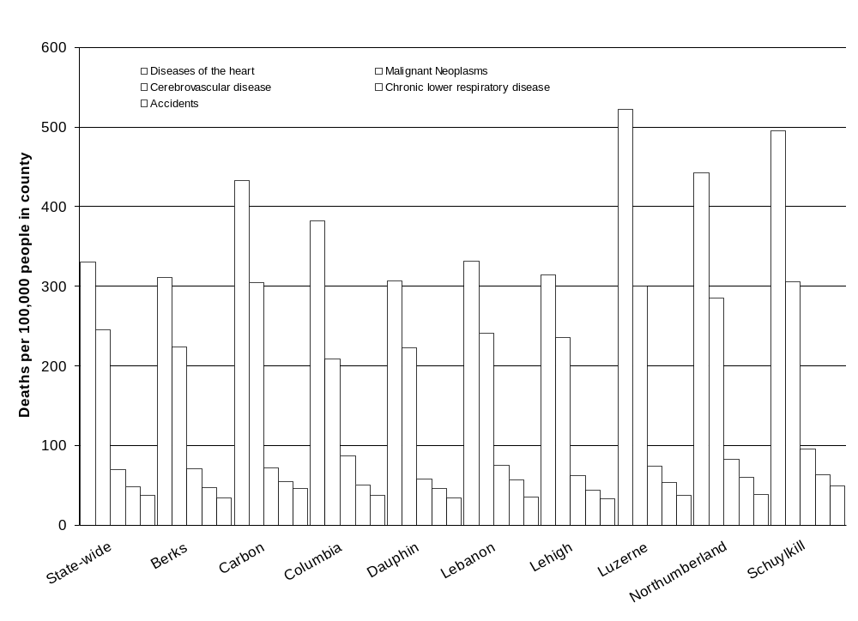
about the EMF health effects issue, the following facts have been established from the available information:
Figure 3.9.1. Rates of death by cause in Pennsylvania, and Schuylkill and surrounding counties. Source: Pennsylvania Department of Health 2004. Pennsylvania Vital Statistics for 2002, http://www.dsf.health.state.pa.us/health/cwp/view.asp?a=175&q=236162.
- Any exposure-related health risk to the exposed individual would likely be small.
- The types of exposures that are most biologically significant have not been established.
- Most health concerns are about the magnetic field.
- The measures employed for field reduction can affect line safety, reliability, efficiency and maintainability, depending on the type and extent of such measures.
No federal regulations have been established specifying environmental limits on the strengths of fields from power lines.

3.9.3 Worker Health and Safety
The Bureau of Labor Statistics annually reports on the number of workplace injuries, illnesses, and fatalities in the United States, and includes the number of fatalities in individual states. Such information is useful in identifying industries with high rates and/or large numbers of injuries, illnesses, and fatalities. The results of the annual reports can be used by industry organizations and private companies to start or revise worker safety programs that hopefully will reduce, and ultimately prevent, workplace injuries, illnesses, and fatalities. The Bureau of Labor Statistics (2003a) defines a work-related injury as “any wound or damage to the body resulting from an event in the work environment.” In 2003, the construction industry reported 408,300 nonfatal injuries and illnesses in the United States among 6,672,000 workers, while the utilities industry reported 24,500 injuries and illnesses among 576,000 workers (Table 3.9.2).

Table 3.9.2. Number of nonfatal occupational injuries and illnesses in the United States (2003)
Industry | Total recordable cases | Cases with days away from work | Cases with job transfer or restriction | Other recordable cases
Construction | 408,300 | 155,400 | 62,500 | 190,300
Utilities | 24,500 | 6,600 | 5,600 | 12,300
Source: U.S. Department of Labor, Bureau of Labor Statistics 2003. Bureau of Labor Statistics News – Workplace Injuries and Illnesses in 2003. http://www.bls.gov/news.release/pdf/osh.pdf.

The Bureau of Labor Statistics (2003b) defines a fatality as “a death that results from a traumatic occupational injury,” where injury is defined in this case as “any intentional or unintentional wound or damage to the body resulting from acute exposure to energy, such as heat, electricity or kinetic energy from a crash, or from the absence of such essentials as heat or oxygen caused by a specific event, incident, or series of events within a single workday or shift.” In 2003, the construction industry reported 1,126 fatalities in the United States, while the utilities industry reported 32 fatalities (Table 3.9.3). In the state of Pennsylvania, 39 construction fatalities and no utilities industry fatalities were reported.

Table 3.9.3. Number of fatal occupational injuries (2003)
Industry | Number of U.S. fatalities | Number of Pennsylvania fatalities
Construction | 1,126 | 39
Utilities | 32 | 0
Sources: U.S. Department of Labor, Bureau of Labor Statistics 2003. Bureau of Labor Statistics News – National Census of Fatal Occupational Injuries in 2003. http://www.bls.gov/news.release/pdf/cfoi.pdf.
U.S. Department of Labor, Bureau of Labor Statistics 2003. Bureau of Labor Statistics News – Pennsylvania Workplace Fatalities, 2003. http://www.bls.gov/news.release/pdf/cfoi.pdf.

3.10 Noise
Noise can be defined as unwanted sound. Annoyance occurs when noise is loud enough to be heard above the usual background sounds to which people have become accustomed. Background levels, in turn, vary with location and time of day. Sound levels are measured in decibels (dB); measured values are normally adjusted to account for the response of the human ear, in which case they are expressed as decibels as measured on the A-weighted scale [dB(A)].
The proposed project site is located in a primarily rural area in Mahanoy and West Mahanoy Townships adjacent to the existing Gilberton Power Plant (Section 2.1.1). A mixture of industrial, commercial, and residential land use exists in the vicinity. The borough of Gilberton is located approximately 1 mile west-northwest of the project site, and the borough of Frackville lies approximately 2 miles west-southwest of the project site. The site is about 1 mile north of Interstate 81 and 2 miles east of State Highway 61. The center of the Mahanoy State Correctional Institution is 2,600 ft east of the center of the proposed main plant. The distance to the nearest residence is 3,600 ft southeast of the proposed project site (Suresh Chandran, Philip Services Corporation, e-mail to Cheri Foust, ORNL, September 20, 2004).
Sound levels at the Gilberton Power Plant are similar to those at other industrial plants surveyed by Goodfriend and Associates (1971). However, recorded data on noise levels at the Gilberton Power Plant were unavailable. The relatively steady noise resulting from the plant is augmented by the presence of other sound sources in the area, including other industrial activities, vehicular traffic, and nearby passing trains. For example, sound levels may exceed 100 dB(A) within 50 ft of a train passing on one of the nearby railroad tracks.
None of the municipalities with jurisdiction over the site for the proposed facilities have ordinances regarding noise.
A noise survey was performed around the perimeter of the proposed project site in March 2003 (Suresh Chandran, Philip Services Corporation, e-mail to Robert L. Miller, ORNL, May 30, 2004). Noise measurements were taken using a Bruel & Kjaer Precision Sound Level Meter, Model 2209. Noise levels were measured in 11 different locations around the perimeter of the proposed site (Figure 3.10.1). The highest noise level measured 55 dB(A). For comparison, 55 dB(A) is the approximate level of a quiet subdivision during daylight hours. This level is also specified by EPA as a guideline upper limit with an adequate margin of safety for protection from activity interference and annoyance during the daytime in outdoor locations “in which quiet is a basis for use” (EPA 1974).

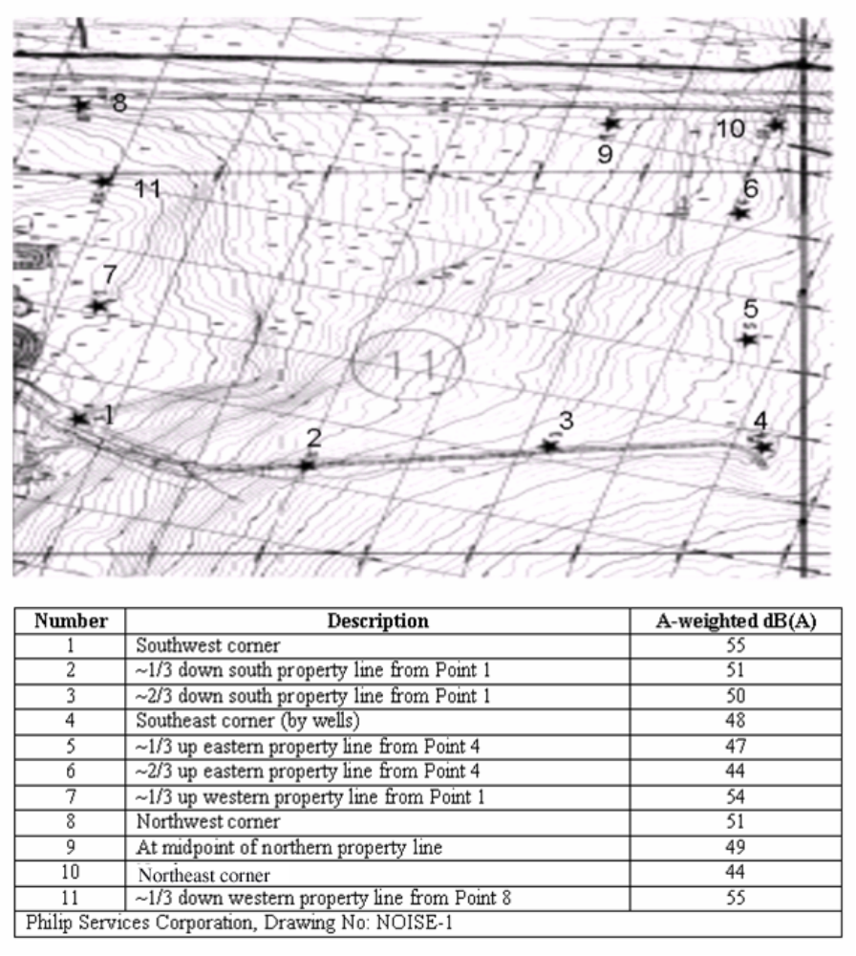
Figure 3.10.1. Proposed project site noise measurement locations.

12% of the acceleration of gravity
http://www.dep.state.pa.us/efacts/
http://www.dep.state.pa.us/wm_apps/CompostingPrograms/default.asp

