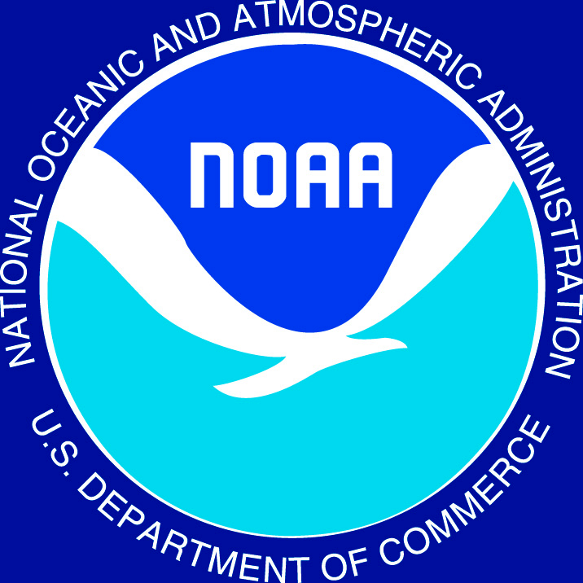

Science, Service, Stewardship

NOAA
FISHERIES
SERVICE
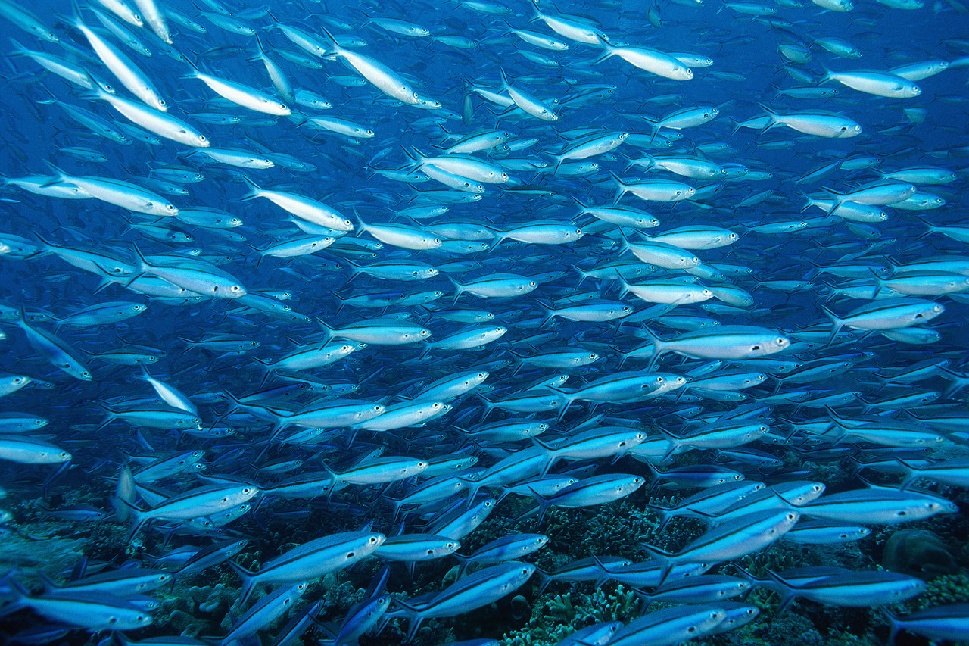
The Sustainable Fisheries Division provides stewardship of living marine resources through science-based conservation and management and the promotion of healthy marine ecosystems.

Implementing the Magnuson-Stevens
Reauthorization Act of 2006

On January 12, 2007, President Bush signed into law the Magnuson-Stevens Fishery Conservation and Management Reauthorization Act of 2006 (MSRA). The new law (P.L. 109-479) is groundbreaking in several respects: it mandates the use of annual catch limits and accountability measures to end overfishing, it provides for widespread market-based fishery management through limited access programs, and it calls for increased international cooperation.

NOAA’s National Marine Fisheries Service (NOAA Fisheries) is working to fully implement the MSRA. The MSRA requires a variety of new reports, studies, Secretarial determinations, and other activities to be completed by specific dates. There are also many required provisions that do not have specific due dates, but must be implemented. The Office of Sustainable Fisheries (SF) has been tracking the implementation of all these activities. For tracking purposes, SF has divided all tasks associated with implementation of MSRA into 3 priority levels:

- Priority 1 – Time constrained – date-specified in the Act
- Priority 2 – Required to be implemented but no specific date
- Priority 3 – Action is authorized, but not required

This report documents the status of all tasks related to the implementation of the MSRA.

Additional details on individual tasks can be found on the NOAA Fisheries MSRA implementation website at:

http://www.nmfs.noaa.gov/msa2007

Science, Service, Stewardship

Implementing MSRA

Status

The following Priority 1 tasks were due within the first 12-months.
Within 30 days (February 12, 2007)
- Framework 42 Report (Section 215(b)) – Completed 
Within 60 days (March 12, 2007)
- Secretarial determination of Federal and State consistency related to groundfish management in New England and Hawaii (Section 110) – Completed 
Within 90 days (April 12, 2007)
- Define the term “illegal, unreported, or unregulated fishing” (Section 403) – Completed 
- Amend the FMP for Bering Sea Aleutian Islands King and Tanner Crabs (Section 122a) – Completed 
- Establish a process for monitoring and certifying contractor performance regarding any contract to construct or deploy tsunami detection equipment (Section 804) – Completed 
Within 6 months (July 12, 2007)
- Develop a recovery plan for Klamath River Coho salmon (Section 113(b))– Completed 
- Develop a training course for new Council members (Section 103(g)) – Completed 
- Promulgate regulations to establish an expedited, uniform, and regionally-based process for issuing Exempted Fishing Permits (Section 204) – Pending
  - A proposed rule published December 21, 2007 and accepted public comments through March 20, 2008. A final rule is under development.
- Report on the impacts of Hurricanes Katrina, Rita, & Wilma on commercial and recreational fisheries in the states of Alabama, Louisiana, Florida, Mississippi, and Texas (Section 213) – Completed 
- Report on the impacts of Hurricanes Katrina, Rita, & Wilma on fisheries habitat in the states of Alabama, Louisiana, Florida, Mississippi, and Texas (Section 213) – Completed 
- Propose revised NEPA-MSA procedures for compliance with NEPA (Section 107)
  - A Proposed rule published May 14, 2008. Public comments are accepted until August 12, 2008.
- Report on the state of science for integration of ecosystem considerations in regional fisheries management (Section 210) – Pending
  - The report is expected during the fall of 2008.
Within 8 months (September 12, 2007)
- Assess Post-Baccalaureate education in fisheries sciences (Section 217) – Pending
  - This report is currently under review within the agency.
Within 9 months (October 12, 2007)
- Report on Council Management Coordination (Completed by MAFMC) (Section 216) – Completed 
Science, Service, Stewardship
Within 1 year (January 12, 2008)
- Conflict of Interest Report to Congress (January 1, 2008) (Section 103(i)(4) – Completed 
- Develop IFQ referenda guidelines (Section 106(a)) – Pending
  - A proposed rule was published April 23, 2008, and is open for public comment through June 23, 2008 (see 73 FR 21893).
- Develop revised NEPA-MSA procedures (Section 107) – Pending
  - A proposed rule was published May 14, 2008, and is open for public comment through August 12, 2008 (see 73 FR 27998).
- Deep Sea Coral Report to Congress – Completed 
- Excess Harvesting Capacity Report to Congress (112(a)(8)) – Completed 
- Establish a Bycatch Reduction Engineering Program (Section 116(a)) – Completed 
- Joint report to Congress on vessel monitoring systems, with USCG (due August 2008) – Pending

The following Priority 1 tasks are ongoing and are due within 2 or more years.

Within 2 years (January 12, 2009)
- Establish a program to improve recreational fisheries data.
  - A proposed rule to establish the process and requirements for anglers and for-hire vessels to register with NMFS if they fish in the EEZ was published on June 12, 2008, with comments accepted through August 11, 2008.
  - Pilot projects for 2008 have been selected.
- Publish the 1st Illegal, Unreported, or Unregulated (IUU) Biennial Report, procedures, & certification. This report will be issued biennially after its initial issuance.
  - A proposed rule on a procedure for certifying IUU fishing flag states and a procedure for certifying flag states whose fishing vessels are responsible for unacceptable levels of bycatch of protected living marine resources is expected in the summer of 2008.
- Designate a Senate-confirmed, senior official within NOAA to perform the duties of the Secretary with respect to international agreements involving fisheries and other living marine resources.
- Pacific Fishery Management Council will develop a proposal for an appropriate rationalization program for the Pacific trawl groundfish and whiting fisheries, including the shore-based sector of the Pacific whiting fishery.
- Report on recovery progress and actions taken to implement the Klamath River Coho salmon recovery plan. January 12, 2009, annual report thereafter.
Science, Service, Stewardship
  - The recovery plan was completed and made available to the public.
  - Actions are being taken under the plan, and a report is being drafted.
- Implement data-sharing measures accessible by enforcement agencies (October, 12, 2009)
- Report to the Congress evaluating the current status of tsunami detection, forecasting, and warning (1/31/10)
- Report to Congress tsunami technology transfer (1/12/10)

Beyond 2 years (2010 and beyond)
- Amend all fishery management plans to meet annual catch limit (ACLs) requirements. ACLs are required in fishing year 2010 for stocks subject to overfishing and in fishing year 2011 for all others.
  - A proposed rule to revise the guidelines for National Standard 1 providing guidance on how to comply with new ACL and accountability measure (AM) requirements was published on June 9, 2008. Comments are accepted through September 8, 2008.

In Summary, during the first year and a half of implementation:

- 15 Priority 1 tasks are Complete 
- 10 tasks are on track for completion by statutory deadlines or are in final stages of completion.
- 5 tasks are delayed
Science, Service, Stewardship
The agency is also implementing, to the extent practicable, other tasks under the MSRA that are either required or authorized. Below is a summary of those tasks, identified as Priority 2 (required) and Priority 3 (authorized).

Priority 2 tasks (44) & Priority 3 tasks (6) – Summary as of June 12, 2008

24 tasks are complete or require no specific action to be effective (for instance, are self-implementing under the law or are statements of intent).

- CDQ Bycatch limitations
- Cooperative Research and Management Program
- Council Coordination Committeee
- Economic impacts – Revises text with regards to analyses
- Emergency regulations - Extends the second emergency period from 180 days to 186 days.
- Fisheries Hurricane Assistance Program - Establishes an assistance program for the Gulf of Mexico commercial and recreational fishing industry
- Guidance to U.S. Commissioners to International Fishery Management Efforts
- Habitat Restoration due to Hurricane Effects on Shrimp and Oyster Fisheries and Habitats
- Joint Enforcement Agreements – Revises JEAs
- Observers - Revises observer requirements for foreign fisheries in the Pacific Insular Area.
- Oregon and California Salmon Fishery - 2006 fall Chinook salmon fisheries eligible to receive direct assistance
- Summer Flounder Rebuilding - Allows Secretary to extend the time for rebuilding of summer flounder under certain conditions
- Western Pacific Sustainable Fisheries Fund - Requires certain fines and penalties be deposited into the Western Pacific Sustainable Fisheries Fund
- Findings with illegal, unreported, and unregulated (IUU) Fishing – Congress finds that international cooperation is necessary to address IUU fishing
- International Overfishing and Domestic Equity- requires us to immediately take appropriate action at the international level to end overfishing
- Northern Pacific Halibut Act - Amends the Northern Pacific Halibut Act to increase penalties.
- Prohibited Acts- adds prohibitions to the law
- Puget Sound Regional Shellfish Settlement – implements the settlement
- Regional Ecosystem-based Management & Research
- SEAK Capacity Redux – Appropriations - For SE Alaska Fisheries Communities Capacity Reduction
- Shark Feeding - Prohibits feeding of sharks to attract sharks for purposes other than harvest in the EEZ off Hawaii
- Data Collection – Authorizes collection of proprietary and economic info
- Reauthorization of other fisheries acts
- Western Pacific Fishery Demonstration Projects – revises requirements

Science, Service, Stewardship
- 1 task is in final review

  - Fisheries Conservation and Management Fund

- 16 tasks are in progress.

- Access to Certain Information - Revises provisions specifying access to confidential information.
- Community-Based Habitat Restoration Program
- Council SOPPs Revisions – Incorporates various changes from MSRA that impact Council SOPPs
- Deep Sea Coral Research/Management - Establish a Deep Sea Coral Research and Technology Program & submits information to the appropriate Councils
- Fishery Impact Statement Requirements - Revises text with regards to analyses
- Fishing Capacity Reduction – Revises provisions under which a FCR can operate
- Implementation of Western and Central Pacific Fisheries Convention
- Investment in Seafood Processing – a project plan is currently being developed
- Multi-Year Research Priorities – Requires regularly updated research priorities
- Pacific Whiting - Implements the Agreement between the Government of the United States and the Government of Canada on Pacific Hake/Whiting signed in Nov. 2003.
- Peer Review – Authorizes establishment of a process that satisfies IQA
- Regional Disaster Relief and Evaluation – establishes a regional economic transition program
- Rockfish Demonstration Program - Amends program from 2 years to 5 years.
- Technical Revisions to 50 CFR 600
- WP and NP Community Development - Establishes regionally-based pilot programs
- Use of Fishery Finance Program for Sustainable Purposes – amends USC

- 4 items currently have no funding associated with them, so no activities are being conducted for them at this time.

  - Restoration study - Authorizes a study to update scientific information and protocols needed to improve restoration techniques for coastal habitat.
  - Study on the acidification of oceans
  - Impact of TEDs on Shrimping
  - Herring study

- 4 tasks are waiting or delayed. Revised schedules may be developed to implement these projects at a later date.

  - Hurricane grants
  - North Pacific Fisheries Convention
  - LAPPs – Provides guidance on the implementation of limited access privilege programs
  - Stipends – payment of a stipend to SSC members under certain restrictions

Required without a due date
Authorized, but not required

