USDA Foreign Agricultural Service
GAIN Report

Global Agriculture Information Network
Template Version 2.09

Voluntary Report - Public distribution
Date: 1/23/2009
GAIN Report Number: TW9001
TW9001
Taiwan
Organic Products
Update on Taiwan’s New Organic Regulations and Labeling Requirements
2009

Approved by:
Keith Schneller, ATO Director
American Institute in Taiwan
Prepared by:
Katherine Lee, Agricultural Marketing Specialist

Report Highlights: The Taiwan Council of Agriculture (COA) plans to implement the new regulations for “Imported Organic Agricultural Product and Organic Agricultural Processed Products” as of January 29, 2009. According to the latest notification on January 22,2009 on Taiwan’s Executive Yuan web site (see appendix 1) http://gazette.nat.gov.tw/EG_FileManager/eguploadpub/eg015016/ch07/type2/gov62/num35/Eg.htm, products manufactured before January 31, 2009 will be exempt from the new labeling requirements until July 31, 2009. For products manufactured after January 31 2009, imported raw or processed organic agricultural products must be sourced from COA recognized countries of equivalence and must comply with new labeling requirements. The importers are required to apply for authorization on a batch basis for their products to comply with new labeling requirements. Otherwise, they will be barred from claiming “organic” on their packaging in either Chinese or English.

Includes PSD Changes: No
Includes Trade Matrix: No
Annual Report
Taipei ATO [TW2]
[TW]

Summary
The Taiwan Council of Agriculture (COA) plans to implement the new regulations for “Imported Organic Agricultural Product and Organic Agricultural Processed Products” as of January 29, 2009. According to the latest notification on January 22,2009 on Taiwan’s Executive Yuan web site (see appendix 1) http://gazette.nat.gov.tw/EG_FileManager/eguploadpub/eg015016/ch07/type2/gov62/num35/Eg.htm, products manufactured before January 31, 2009 will be exempt from the new labeling requirements until July 31, 2009. For products manufactured after January 31 2009, imported raw or processed organic agricultural products must be sourced from COA recognized countries of equivalence and must comply with new labeling requirements. This report summarizes the application process and labeling requirements for organic products based on the recent web site announcement and presentation made by the chief of the COA’s Agriculture and Food Agency at a recent AmCham workshop.

Application Requirements
To obtain the required approval for organic claims on the packaging, the importer must submit an application for AFA’s review. The required documentation is stipulated in Article 4 of the new regulations (see below). This documentation must be issued by the accredited certification agency providing the traceability information stated as referenced in Article 5. An example of the USDA TM11 export certificate form can be found below.
Article 4
When an agricultural product or processed agricultural product is to be imported and sold as organic, the importer shall complete an application form and attach the following documents in duplicate and apply to the central competent authority for review prior to sale:
1.A photocopy of business registration certificate;
2.Documents demonstrating that the imported agricultural products or processed agricultural products have been granted organic certification;
3.Related quarantine documents of the imported agricultural products or processed agricultural products;
4.Chinese product labeling; and
5.Other documents required by the central competent authority.
Traceability Certification
In Article 5, the required information below corresponds to the USDA TM11 export certificate form found to the right. >>>>>>

- The name and address of the factory/farm (the final certified farm/co-packer, not the trading company)
- Name of the importer (buyer)
- The product name and its batch number (“batch” refers to “lot number” of the final certified farm/processor where the products are from.)
- % of organic raw materials (must equal to or greater than 95% of organic ingredient and doesn’t need to disclose the formula)
- Weight or volume of the product
- Name and address of the certification body
- The date of issuance (no more than three months prior to the date of receipt of the application form to COA AFA.)
- Other items required by the central competent authority

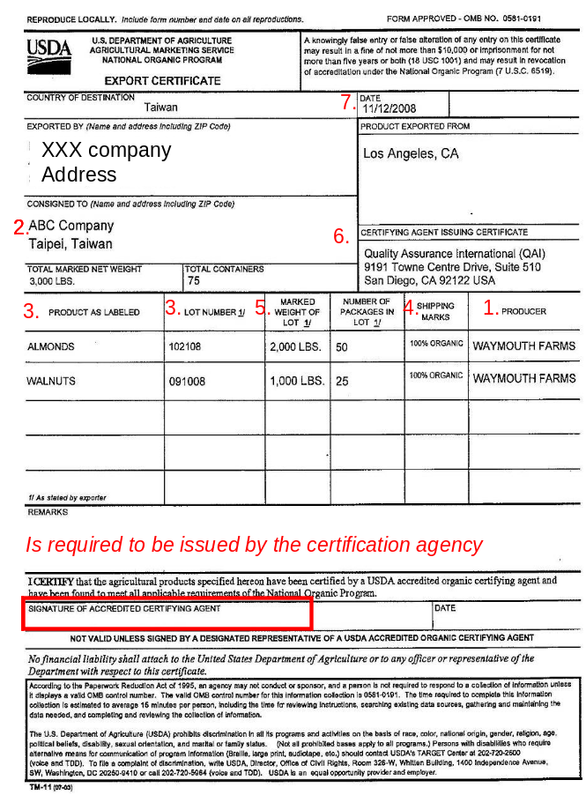
Labeling Requirements
According to Item 6 of Article 8, the products are required to carry a “serial” number approved by the AFA on a batch basis for every organic product shipment to Taiwan. The AFA will authorize the importers to create their own “serial” number for the organic products they bring into Taiwan. The number must include 16 digits as follows (XXX-XXXXXXXX-XXXXX): code #1-3 represents the Taiwan calendar year, code #4-11 represents the importer company’s ID number, code#12-16 represents the non-duplicated sequential number the importer applies for starting from 00001. PLEASE NOTE: Taiwan’s official calendar year is 11 years behind the international calendar year. For example, the current international calendar year of 2009 is 98 in Taiwan’s official calendar year. Therefore for code #1-3, the importer should state 098.
Article 8
The central competent authority shall issue an organic labeling approval document to the applicant when the imported organic agricultural products and processed products pass the review.
The organic labeling approval document mentioned above shall state the following items:
1.The name and address of the importer;
2.The name of the factory (farm) in foreign countries;
3.The name and batch number of the products;
4.The weight or volume of the products;
5.The name of the certification body; and
6.The number of the organic labeling approval document.
Appendix 1: Translation of the execution guidelines of Article 27
The original notification which was posted in Chinese on January 22, 2008 can be found at: http://gazette.nat.gov.tw/EG_FileManager/eguploadpub/eg015016/ch07/type2/gov62/num35/Eg.htm )
This is the ATO’s unofficial translation of the posting: Agricultural Production and Certification Act: the execution guidelines of Article 27
Category of Case | Procedures | Remark
Any agricultural product operator who sells organic agricultural products without complying with the paragraph 1 of article 5 or paragraph 1 of article 6. | Phase 1.  1. Enforcement period: January 31, 2009-July 31, 2009  2. Fine applies to: any raw or processed organic agricultural products manufactured after January 31, 2009 and selling with organic claims.  3. The violator will be fined according to subparagraph 2 of paragraph 1 of article 23.  Phase 2.  1. Enforcement period: from August 1, 2009  2. Fine applies to any raw or processed organic agricultural products with organic claims  3. The violator will be fined according to subparagraph 2 of paragraph 1 of article 23. | 1. To identify the product manufactured after January 31, 2009, the manufacturing date on the product labeling is used as proof. If the product is not labeled with the manufacturing date, the business operator is required to provide the related information as proof.  ２、 According to article 25, if the fine is confirmed and applied, the central competency authority is allowed to announce the name and the address of the agricultural product operator, the name of the agricultural products, and the violation details.
Any agricultural product operator who sells products with organic claims but the products are not certified to be organic or not allowed to use the organic seal (fake labels). | 1. From January 31, 2009  2. Fine applies: any raw or processed organic agricultural products sell with organic claims  3. The violator will be fined according to subparagraph 2 of paragraph 1 of article 21.
Any agricultural product operator who sells products with organic claims but does not comply with the labeling requirements stipulated in paragraph 2 and paragraph 2 of article 6. | Phase 1.  1. Enforcement period: January 31, 2009-July 31, 2009  2. Fine applies to: any raw or processed organic agricultural products manufactured after January 31, 2009 and selling with organic claims  3. The violator will be fined according to subparagraph 1 of paragraph 1 of article 24.  Phase 2  1. Enforcement period: from August 1, 2009  2. Fine applies to：any raw or processed organic agricultural selling with organic claims  3. The violator will be fined according to subparagraph 1 of paragraph 1 of article 24.
Any agricultural product operator who sells products with organic claims and does not comply with the requirement of no use of chemical pesticides, manure, livestock medication or any other chemical compounds (in article 13) | 1. Enforcement period: From January 31, 2009  2. Fine applies: any raw or processed organic agricultural products selling with organic claims  3. The violator will be fined according to subparagraph 4 of paragraph 1 article 24.
Appendix 2: Copy of USDA’s Agricultural Marketing Service TM-11 form which is used to accompany organic product exports from the United States.



