
United States Department of Agriculture



Version: SEPTEMBER 2005

Prepared by:
Office of Procurement and Property Management
Procurement Systems Division
Table of Contents

Page
SECTION I. INTRODUCTION I-1
Accessing the software I-1
System Requirements I-1
PCMS Login Instructions I-1
Add to Favorites I-4
PCMS Main Menu I-5
Menu Bar I-5
Cardholder I-5
Change Password I-6
Reports I-6
Window I-7
Bulletin Board I-7
Command Bar I-7
System Edits I-8
Using Forms I-8
Forms Menu Bar and Pull-Down Menus I-8
Moving Through a Form I-10
Executing a Query I-10
Listing Valid Field Values I-11
Using the Wildcard (%) with the [Find] Function I-11
Acknowledging Edit Alerts I-12
SECTION II. Cardholder Maintenance II-1
Cardholder Menu II-1
Purchase Card II-2
Querying a Cardholder Record II-3
Card Transactions II-4
Query and View Transactions II-5
The date the transaction was approved by the Cardholder. II-5
The Zip code where the Merchant is located. II-5
View Purchase Details II-7
Reconciling Transactions II-9
The Document Identification of the original transaction, until the document is sent to FFIS. II-9
Steps to Reconcile a Card or Check Transaction II-10
Guidelines to Reconciling Transactions II-10
Modifying Lines of Accounting II-11
Disputing a Transaction II-11
Resolving Disputes II-14
Profile Accounting II-15
Querying Records II-17
Updating Records II-17
For FFIS Users Only II-18
Reconciling Transactions with the Pcms/Ffis Interface II-19
SECTION III. Oversight tools III-1
Cardholder Reports III-1
Query Tool Software III-1
uSer Messages III-2

INTRODUCTION

Accessing the software
Web PCMS is a web-based application. Use an Internet browser to access the application via the USDA website.

System Requirements
Before accessing the software, be sure your computer has the following:
- Windows 95 or higher (Windows 3.1 is not supported.)
- Minimum of 16 MB RAM
- Minimum of 100 MB available on the hard drive
- Monitor Resolution of 800 x 600
- Windows Internet Explorer, version 6.0 or higher

PCMS Login Instructions
- To Log in to the PCMS Web application, access the USDA PCMS web page at http://www.nfc.usda.gov/corporate/PCMS.htm

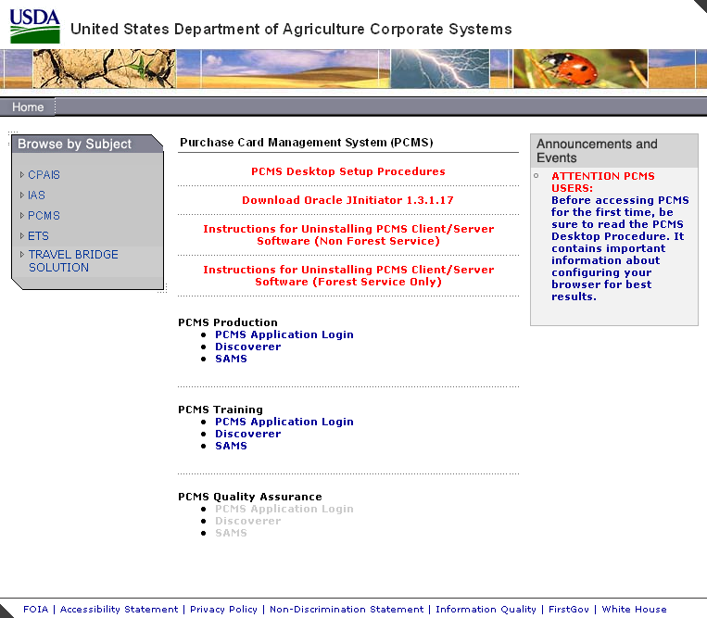

- Click the active PCMS Application Login link under the PCMS Production heading.
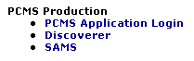

An Oracle Forms Runtime window will open in another browser.

Note: You may need to update your version of Oracle JInitiator to access the PCMS Web application. If a message displays asking to download JInitiatior, click Yes.

Or

If no page loads when you click on the link, use the back button to return to the USDA PCMS web page and click the link to Download Oracle JInitiator 1.3.1.17.

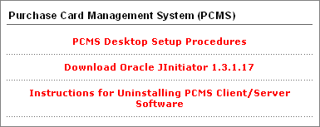

- Click on the security message.
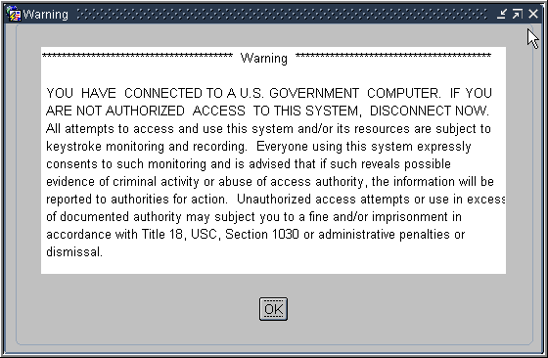

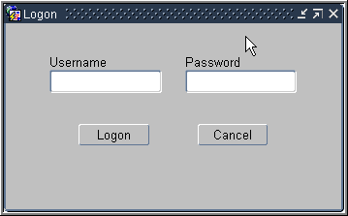
The Logon dialog box opens.

- Enter your Username and Password and click [Logon]. Your LAPC will provide you with this information. Use your mouse or press [Tab] to move between fields.

Fieldname | Description
Username | Alphanumeric field, maximum of 20 positions  (e.g., FS4003)
Password | Alphanumeric field (must begin with an alpha character), minimum of 6 characters  (e.g., PCMS123)

After you successfully log on, the PCMS Main Window appears.

Every 90 days your password expires and must be changed. For instructions on changing passwords, refer to Change Password in this section.

Note: If your password is within five days of expiring, a notification message will appear every time after you log in to PCMS up until the expiration date.

To exit PCMS, click [Exit PCMS] from the Main Menu.

Add to Favorites
These instructions will explain how to add the PCSM login page to Favorites in your Internet Explorer browser.

NOTE: You will still need to complete the steps to login to the application.

Create a new shortcut:
- Open an Internet Explorer browser.
- Enter the URL in the address field: http://www.nfc.usda.gov/corporate/PCMS.htm.
- Click Favorites on the toolbar.
The Favorites navigation pane opens on the left side of the browser.
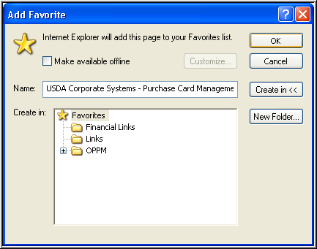
- Click Add in the navigation pane.
The Add Favorites dialog box opens.

Make available offline. Specifies that you want the content from the selected web page available when your computer is not connected to the Internet.
Name. The name that will display in the Favorites navigation pane for the link to the web page. Accept the name as displayed or create your own name for the link.
Create In Pane. Where you want the link to appear. If you do not select a folder, the link will appear in the main pane. If you select a folder, the link will appear within that folder.
Create In Button. Toggle button to display or close the Create In Pane
New Folder. Click to create a new folder in which to place the link.
- Click OK.
The Add Favorites dialog box closes and the link is added to the navigation pane.

PCMS Main Menu
After logging onto PCMS, the PCMS Main Menu appears:

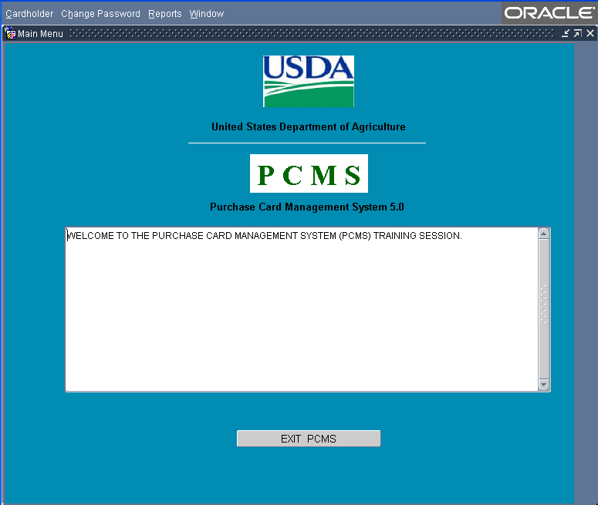

Menu Bar

Cardholder
Used to view purchase card/cardholder data; reconcile purchase card transactions; and add, modify, and view cardholder profile accounting data. Refer to the Cardholder Maintenance section for complete details in using all sub-options listed under Cardholder.

Change Password
This option allows you to change your system password.
From the PCMS Main Menu, click Change Password on the main menu at the top of the window. The following dialog box opens:
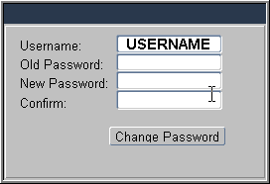

Your assigned username is displayed. Type your old password and then your new one.

The following are the requirements for the password:
- A password must be at least 6 alphanumeric characters in length
- Must start with a letter
- Must include at least one number
- Cannot contain spaces
- Must be different by at least 3 characters from the previous password (e.g., PCMS123, PCMS456)

Type the new password once again to confirm you've entered it correctly. Note that the passwords will appear as asterisks. Click . Your new password will be in effect the next time you log on to PCMS.

Contact your Local Agency Program Coordinator (LAPC) to reset your password if any of the following situations occur:
- The 90 days has expired and you didn't change your password
- Entered your username and password three times unsuccessfully
- Receive message that username and/or password are invalid

Reports
The Reports menu is used to generate the Cardholder Report, which generates a listing of all transactions for that cardholder’s account for a specified time period. Refer to the Oversight Tools section for complete details.

Window
This menu allows you to customize the window display, and navigate between open PCMS windows.

Bulletin Board
The bulletin board, located in the center of the main menu screen, provides up-to-date news about PCMS (e.g., notifications of system downtime, location of new system documentation of USDA’s web site). The Departmental Program Coordinator (DPC) is responsible for the posting of all messages to the bulletin board.

Command Bar
The command bar displays a row of command buttons that are used to initiate or confirm actions in PCMS. In PCMS these command buttons are located at the top of each screen.
Below is a description of each command button on the command bar.

Clear Form |  | Clears all data in the form.
Save |  | Saves changes to the database.
Print |  | Prints the screen.
Edit |  | Edit a field.
Clear |  | Removes the transaction information from the screen. Any unsaved changes will be lost. A cleared record is not deleted from the database.
Remove |  | Removes a line of accounting in the Profile Accounting screen.
Insert |  | Inserts a new record after the current record.
Find |  | Search functions.
Help |  | Displays a brief message about the current field.  Note: The Help function is not available at this time.
List |  | Opens a dialog box for selecting valid field entries. The text, “List of Values” appears in the status bar at the bottom of the screen when your cursor is in a field that accepts list values.

System Edits
All entries in the system are subject to front-end system edits. If an error occurs, or if required data is omitted, an edit error message is displayed at the bottom of the window. All errors must be corrected before the database is updated.

Using Forms
PCMS also uses data entry screens that are referred to as forms. Forms consist of an array of fields that are used to enter, update, and query data in the database.

Fields may appear in any type of window. Editable fields are white; non-editable fields are shaded gray.

Date fields in PCMS use the mm-dd-yyyy format (e.g., 09-30-2004).

Forms Menu Bar and Pull-Down Menus
Most forms windows display a common menu bar that provides options with pull-down menus for performing data query and entry functions. Each option on the menu bar is listed below with a description of each pull-down option.

Action
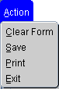 | Clear Form | Clear all records from the current block and creates a new record.
 | Save | Save new or modified data to the database.
 | Print | Print the current screen.
 | Exit | Exit the current form and return to main window.
Edit
 | Cut | Cut selected text.
 | Copy | Copy selected text.
 | Paste | Paste copied text to current cursor location.
 | Edit | Display a popup window where you can edit a field.
Block
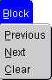 | Previous | Move the cursor to the previous form block that contains a text field.
 | Next | Move the cursor to the next form block that contains a text field.
 | Clear | Clear all records from the current block and create a new record. This only removes records from the workspace – it does not delete records from the database.
Field
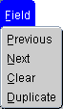 | Previous | Move the cursor to the previous field in the current record.
 | Next | Move the cursor to the next field in the current record.
 | Clear | Clear the content of the current field beginning
 | Duplicate | Copy the field value from the same field of the previous record into the current record.
Record
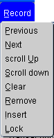 | Previous | Move the cursor to the previous record in the current block.
 | Next | Move the cursor to the next record in the current block.
 | Scroll Up | Shift the window up.
 | Scroll Down | Shift the window down.
 | Clear | Remove the record from the current block, reversing any uncommitted changes made to the record. A cleared record is not deleted from the database.
 | Remove | Remove the current record from the database. Records are not permanently deleted until you commit your changes to the database.
 | Insert | Insert a new record after the current record.
 | Lock | Used to lock a record so that another user cannot change the record while you are updating it. [Lock Record] does not allow you to enter or change any data in a field that is protected against entry or update.
Query
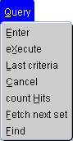 | Enter | Used to clear the current block and allows you to enter query criteria.
 | Execute | Used to clear the current block and retrieve all the records from the database table referenced by the block.
 | Last Criteria | Used to display the query criteria last used.
 | Cancel | Used to terminate query processing.
 | Count Hits | Used to clear the current block and display on the message line the number of rows that a query would retrieve if executed.
 | Fetch Next Set | Used to retrieve the next set of records into the current block from records that satisfy an active query.
 | Find | Used to clear the current block and allows you to enter query criteria.
Help
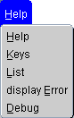 | Help | The Help function is not available at this time.
 | Keys | Lists available function keys.
 | List | Displays values for List Fields.
 | Display Error | Displays full error message.
 | Debug | Debugs error.

Window
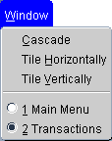 | Cascade | Display windows in a cascading style.
 | Tile Horizontally | Display multiple windows below each other.
 | Tile Vertically | Display multiple windows side by side..
 | Menus | Toggle between open windows.

Moving Through a Form
Moving From Record to Record. After you retrieve records from the database, you can use Record>Next, Record>Previous, or use the mouse and the scroll bar to the left of the screen to scan the records.
Moving From Field to Field. To move the cursor from one field to another, use Field>Next, Field>Previous, or press [Tab], [Shift]+[Tab] to go back, or use the mouse to place the cursor in the desired field.

Executing a Query
Retrieving information from the database is called executing a query. You can enter a query using the features described below.
Retrieving All Records. Click the Find button twice to query all records attached to the user id used to log into PCMS. Use the scroll bar to the left of the screen to view scan records.
Retrieving Specific Records. Click the Find button , type the value you want to match in the appropriate field(s), and click the Find button again. If more than one record is found, the scroll bar to the left will be activated. Use the scroll bar to the left of the screen to view each record.

Listing Valid Field Values
Some fields in the PCMS entry windows have lists from which the user may select valid field entries (e.g., Cardholder name). If <List of Values> is displayed in the status bar in the lower left corner of the window, there is a list available for the field in which the cursor is currently located.
To access the list, click the List button on the command bar. A list popup window appears displaying all appropriate choices for the specific field. Refer to the screen below.

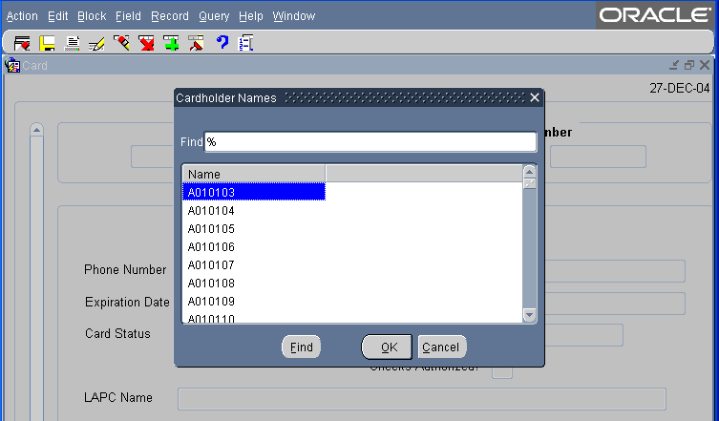

Scroll to highlight the item you want to enter and click . The value appears in the applicable field. Other related fields will also be populated based on your selection.

Using the Wildcard (%) with the [Find] Function

The wildcard allows you to search for a partial value. For instance, if you are not certain how a name is spelled when searching on Merchant Name, use the wild card to replace single or multiple letters or numbers.

For example, when searching for the Merchant Name “Toshiba” replace “oshiba” with the % to return all records beginning with “T”. You can query with the wildcard three different ways, for example: %oshiba, Tos%, or %osh%. The window will populate with all records matching your search criteria.

Acknowledging Edit Alerts
PCMS edit alerts appear as two types of popup windows that partially overlay the current window. To respond to the first type of edit alert, select the appropriate answer (Yes, No, or Cancel). For the second type, for which [OK] is the only response, you must click [OK] to acknowledge that you have read the message.

Cardholder Maintenance

Cardholder Menu
The Cardholder menu provides options for PCMS cardholders to reconcile accounts and perform related functions.

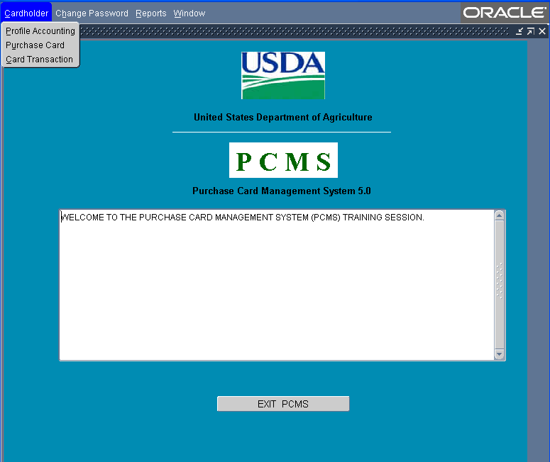

Below is a brief description of the Cardholder menu sub-options:
Profile Accounting: For Cardholders to view, add, and modify their profile accounting data.
Purchase Card: For Cardholders to view their purchase card account data.
Card Transactions: For Cardholders to reconcile, and dispute, their purchase card transactions.

Purchase Card
The Purchase Card screen is used to provide a quick view of the cardholder’s purchase card data. This is a view only screen.
When this sub-option is selected, the Purchase Card screen appears.

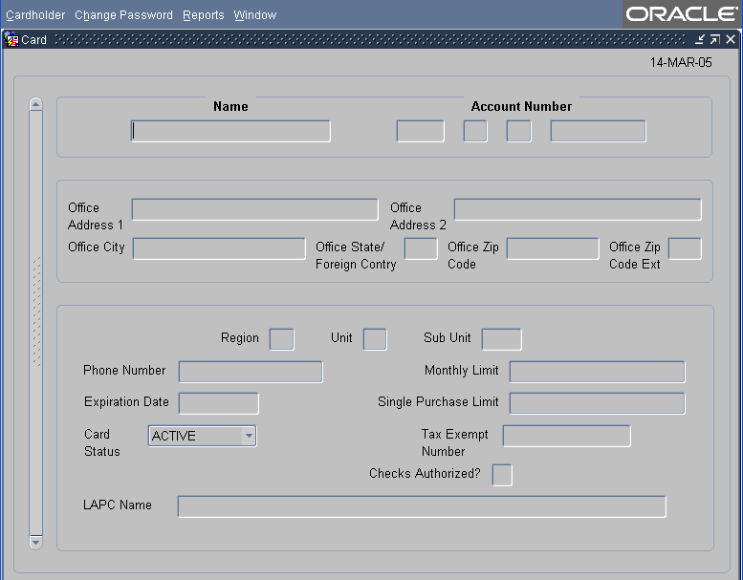

The following is a brief description of each field:
Fieldname | Description
Name | The cardholder’s name as it appears on the card (i.e., the person authorized to charge to the account).
Account Number | This field contains four parts:  - The cardholder’s program code  - The cardholder’s department code  - The cardholder’s agency code  - The last 10 digits of the purchase card account number  (Each part of this field can be queried.)
Office Address 1 | Cardholder’s primary work location.
Office Address 2 | Cardholder’s secondary work location.
Office City | City where Cardholders primary work location is.
Office State / Foreign Country | State abbreviation where Cardholders primary work location is.
Office Zip Code | Zip code of Cardholders primary work location.
Office Zip Code Ext | Zip code extension of Cardholders primary work location.
Region | The second position in the agency organizational structure code for that cardholder. (Query field.)
Unit | The third position in the agency organizational structure code for that cardholder. (Query field.)
Sub Unit | The fourth position in the agency organizational structure code for that cardholder. (Query field.)
Phone Number | The cardholder’s business phone number.  (Query field.)
Monthly Limit | The cardholder’s monthly limit. The maximum amount the cardholder can spend in one month.  (Query field.)
Expiration Date | The expiration date of the cardholder’s account.
Single Purchase Limit | The cardholder’s single purchase limit.  (Query field.)
Card Status | The card status:  Active  Deleted  Inactive
Tax Exempt Number | The tax exempt number for the department.  (Query field.)
Checks Authorized? | Indicates whether the cardholder is authorized to have checks.  Y = Yes  N = No
LAPC Name | The Local Agency Program Coordinator’s name attached to the cardholder’s record.

Querying a Cardholder Record
The system will automatically query the cardholder record attached to the user id that was used to log into PCMS.

To return to the PCMS Main Menu, select Action>Exit.

Card Transactions
The Transaction screen provides a summary of all transactions attached to a specific cardholder along with the accounting charged. This includes transactions on cards that have been reported as lost or stolen. Cardholders reconcile and dispute their own transactions. From the Transactions window the Cardholder can query and reconcile transactions, or initiate a request to dispute a transaction.

When this sub-option is selected, the Transactions screen appears.

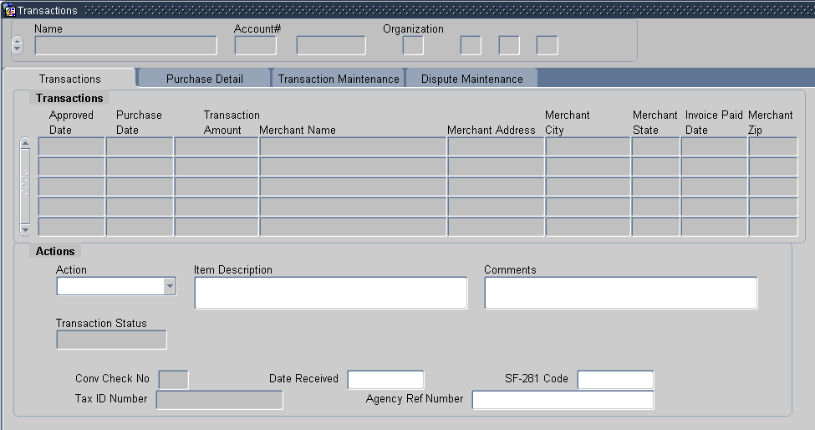

The Cardholder identification information will be populated in the following fields:
Fieldname | Description
Name | The cardholder’s name as it appears on the card (i.e., the person authorized to charge to the account).
Account Number | This field contains two parts:  - The cardholder’s program code  - The last 10 digits of the purchase card account number
Organization | This field contains four parts:  - The cardholder’s department code  - The cardholder’s agency code  - The cardholder’s unit code  The cardholder’s sub unit code

Query and View Transactions
View transaction information from the Transactions tab.

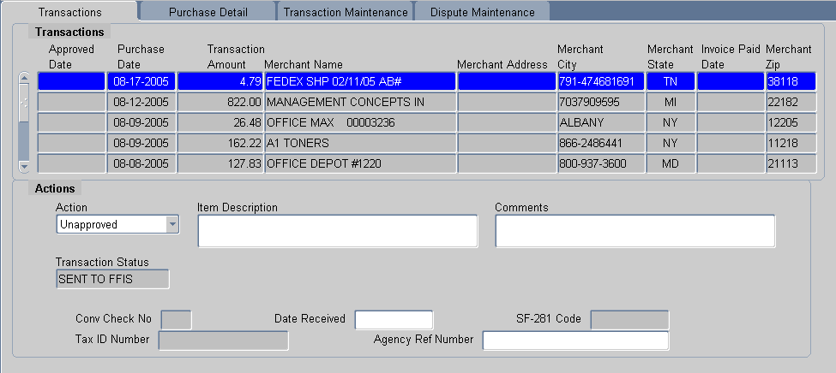

Fieldname | Description
Card Transactions
(Any of the following fields can be queried on. Use the scroll bar to view all the fields.)
Approved Date | The date the transaction was approved by the Cardholder.
Purchase Date | The date the purchase was made.
Transaction Amount | The amount of the purchase.
Merchant Name | The name of the Merchant from whom the procurement was made.
Merchant Address | The street address where the Merchant is located.
Merchant City | The merchant’s city name.
Merchant State | The abbreviation for the merchant’s state and county.
Invoice Paid Date | ►This field will be blank because it is not currently being used.◄
Merchant Zip | The Zip code where the Merchant is located.
Action | The current action on the transaction:  A = Approved Q = Questionable  D = Disputed U = Unapproved  R = Resolved  (Dropdown menu)
Item Description | Description of the item purchased.
Comments | Enter any comments.
Transaction Status | Displays the current transaction status in FFIS. Not editable by the user.
Conv Check no | The convenience check number (if used).
Date Received | The date the goods were received by the purchaser.
SF-281 | SF-281 code for purchases over $2500. A <List of values> is available for this field.  See the Definition of SF-281 Codes document at http://www.usda.gov/procurement/card/guide.htm under the ‘Miscellaneous’ section for additional information.  Note: the SF-281 code is only required for transactions over $2,500. The field will be grayed out if not required.  (Alpha, 2 positions)
Tax ID Number (TIN) | Merchant's tax ID number or employee's SSN. A <List of values> is available for this field.  Note: The TIN only requires data entry if the purchase was made using a convenience check. It is the Cardholder's responsibility to obtain this information from the Merchant if a check is used. If the purchase is made using a card, the TIN will be entered by the Bank.  (Numeric, 10 positions)
Agency Reference Number | The agency reference number.  (Alpha, maximum 32 positions)

When you first access the Transactions screen, it is already in the query mode. Use one of the following processes to query transactions:
- Querying all transactions.
- Click the FIND button to generate a list of all transactions for the current Cardholder account;
- The current Cardholder account details will appear in the top part of the screen;
- If previous accounts exist the scroll bar will become active and a particular account can be selected. The corresponding transactions will display for the specific account selected;
- Querying for specific transactions.
- Click on the command bar to generate a list of all transactions for the current Cardholder account;
- Ensure you are have the correct account selected, if you have multiple accounts;
- Position cursor in any field in the Transactions tab area and click . The account information will remain but the field values in the Card transaction area will clear;
- Any field in the Card Transaction area can now be queried on. Place the cursor in any of these fields and enter a value you wish to search on and click ;
- The query results will appear;
- Range operators such as < or >, and wildcards such as %, can be used in queries;

View Purchase Details
View Level 3 details of the transactions from the Purchase Details tab.

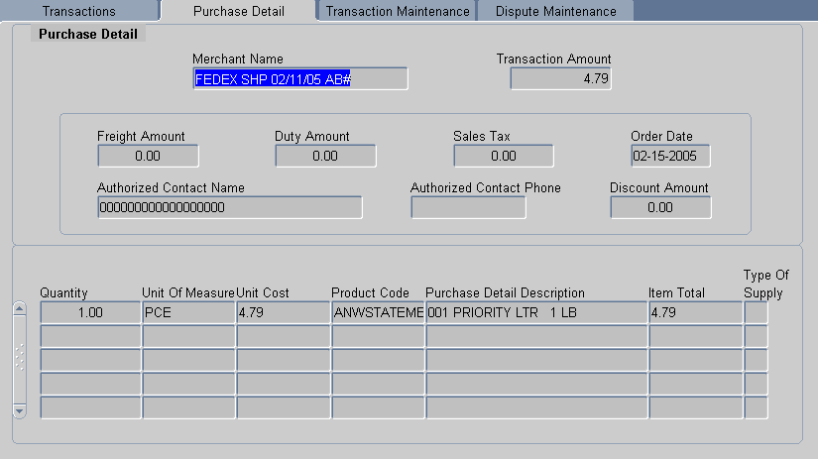

Fieldname | Description
Merchant Name | The name of the Merchant from whom the procurement was made.
Transaction Amount | The cost of the purchase.
Freight Amount | The cost of freight to send the item.
Duty Amount | Duty amount applied to the transaction.
Sales Tax | The amount of sales tax for the item.
Order Date | The date the item was ordered by the Cardholder.
Authorized Contact Name | Name of authorized Merchant contact.
Authorized Contact Phone | Phone number of authorized Merchant contact.
Discount Amount | Amount of discount applied to the transaction.
Quantity | Number of items purchased.
Unit of Measure | Item unit of measure.
Unit Cost | Cost per item.
Product Code | Item Product Code.
Purchase Detail Description | Description of item purchased.
Item Total | Item Total.
Type of Supply | Type of Supply.

Reconciling Transactions
Reconcile Transactions from the Transaction Maintenance tab.

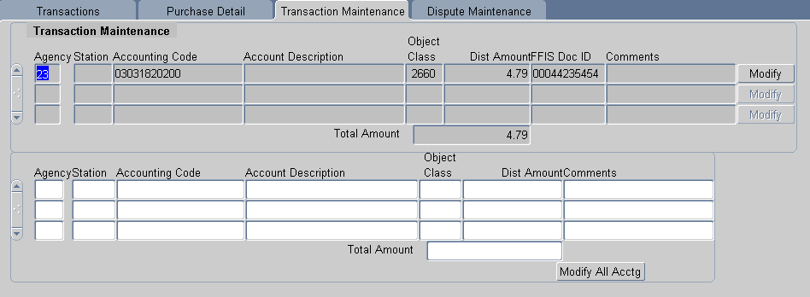

Fieldname | Description
Agency | The agency code.
Station | The accounting station code.
Accounting Code | The accounting code against which this portion of the transaction is to be charged.
Account Description | The description of accounting code.
Object Class | The BOCC. This code defines the nature of the services or goods being obligated. A <List of values> is available for this field.  Note: It is important the accurate BOCCs are used to ensure accurate 1099 reporting. Only service BOCCs will generate a 1099 tax report at the end of the financial year. For example, Janitorial Services BOCC 2511 will generate a 1099, but Supplies BOCC 2507 will not.  (Numeric, 4 positions)
Dist Amount  (Required) | The amount of this transaction being applied to this accounting code.  (Numeric, maximum 9 positions)
FFIS Doc ID | The Document Identification of the original transaction, until the document is sent to FFIS.
Comments | Additional information concerning the line of accounting.
Total Amount | The total amount of the transaction
 | Click this button to modify the individual line of accounting.
 | Click this button to modify all accounting information.

Steps to Reconcile a Card or Check Transaction
- View the transaction on the Transaction Maintenance tab in PCMS
- Verify the transaction details are correct against paperwork and ensure all details are correct
- Select an Action Code
- Enter comments and dates
- Modify lines of accounting if necessary (including account codes and BOCC’s)
- Save transaction

Guidelines to Reconciling Transactions
- If the Total amount of the transaction is greater than $2500, the SF-281 code becomes white and this code is required after the transaction has been approved.
If the Total amount field is gray, the transaction amount is less than $2500 and the SF-281 code is optional.
- Retail Credit/Debit Adjustments. When the posting process for transactions in PCMS ends abnormally, only a portion of the transactions are posted properly. In an attempt to correct the posting problem the original transaction is reversed and re-posted. This scenario is reflected when “Retail Credit Adjustments” and “Retail Debit Adjustments” appear in your list of transactions. Approve the debit and credit that cancel each other out and reconcile the second credit using the normal reconciliation process.
- Policy requires that transactions MUST be reconciled at least every 30 days. In Practice, Cardholders are requested to reconcile on a daily basis, to assist with 1099 processing.
- The same process is used to reconcile transactions that were made using Convenience Checks that is used to reconcile transactions made with a Purchase Card, with the following differences:
- The Cardholder must obtain the Merchant’s TIN at the time of purchase;
- The Merchant Address, Merchant City, Merchant State, and Tax ID Number will appear white, indicating that the Cardholder is required to enter this information when the transaction is approved;
- The check number will be entered by the bank and appear in Item Description;
- If the check is made out to a foreign merchant, enter the city, country, and zip code in the Merchant State field, two zeroes in the State field, and leave the Zip field blank. Currently, this screen does not permit foreign addresses.

Modifying Lines of Accounting
When a transaction is entered into PCMS the default accounting information defined in Profile Accounting is associated with it. You can easily modify the accounting information for individual transactions if during reconciliation:

- To modify a line of accounting that is currently attached to the transaction, click at the end of the line you want to change. The field values for that line are copied to the bottom part of the window, except the Account Description, where you may change the data as needed. Repeat these instructions for each line to be modified;
- To modify all the current lines of accounting, click in the lower portion of the window. All the current lines of accounting are copied to the bottom part of the window. Change the data as needed;
- Click on the Command Bar to update the database;

Disputing a Transaction
View or enter dispute information from the Dispute Maintenance tab.

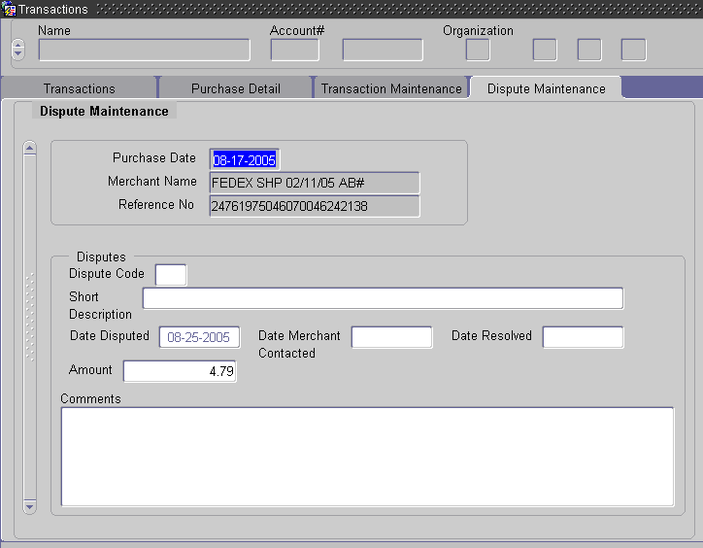

Fieldname | Description
Purchase Date | The date the purchase was made.
Merchant Name | The merchant's name.
Reference Number | The number assigned to the transaction by the input source.
Dispute Code | The code that identifies the type of dispute.  1 – Unauthorized mail or phone order  2 – Duplicate processing  3A – Merchandise or service not received in the amount of  3B – Merchandise or service not received in the amount of  4 – Merchandise returned in the amount of  5 – Credit not received  6 – Alteration of amount  7 – Inadequate description / unrecognized charge  8 – Copy request  9A – Services not received  9B – Services not received  10 – Not as described  11 – None of the above  (Alphanumeric, maximum 3 positions)
Short Description | A brief description associated with the dispute.
Date Disputed | Actual date the dispute was initiated. Defaults to the current date. Type over if actual dispute date is different.  (Date, 8 positions, format mm-dd-yyyy)
Date Merchant Contacted | Date the merchant was contacted.  (Date, 8 positions, format mm-dd-yyyy)
Date Resolved | Date the dispute was resolved.  (Date, 8 positions, format mm-dd-yyyy)
Amount  (Required) | Amount in dispute.  (Numeric, 11 positions)
Comments | Additional information to be added to the record. Additional comments are required if Dispute Code 11 (None of the Above) is selected.  (Alphanumeric, maximum 240 positions)
Transactions must be paid before they can be disputed. The cardholder must contact the vendor and try to resolve any dispute before processing it through PCMS. If the dispute with the vendor cannot be resolved, the cardholder is to contact the bank for assistance. The cardholder has 60 days to file a dispute.

NOTE: Checks cannot be disputed.

If the dispute cannot be resolved, then process it through PCMS. Go to the Dispute Maintenance screen by selecting Card Transaction>Maintain Disputes from the menu bar.

      - On the Transaction tab, select the transaction by placing the cursor in one of the fields on the line.
      - If the dispute is over merchandise not received, leave Date Received blank until the merchandise is actually received
      - Go to the Transaction Maintenance tab and provide the appropriate reconciliation information.
      - Go to the Dispute Maintenance tab.

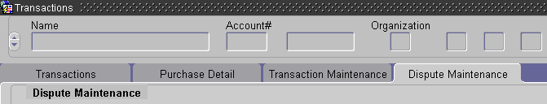

NOTE: If the transaction is a check, a pop-up window is displayed with the following warning:

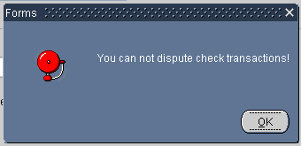

      - Enter details of the dispute on the Disputes Maintenance tab:

PCMS will populate Purchase Date, Merchant Name and Reference Number based on the existing transaction information.

      - Enter details on the Disputes section of the screen
      - Click the Save button .

Resolving Disputes
A dispute is resolved when the cardholder receives a credit from the bank. This credit will appear as a transaction on the cardholder’s Transactions screen. The credit will balance the dispute.

To resolve the dispute, query the transaction and go to the Dispute Maintenance tab.

  - Enter the Date Resolved
  - Go to the Transaction Accounting tab and update accounting information, if necessary
  - Go to the Card Transaction tab and change Action Code to Resolved
  - Click .

NOTE: If you changed the accounting in the disputed transaction, you must also change it in the credit transaction. Accounting must be the same.

Profile Accounting
The Profile Accounting screen allows the cardholder to modify the existing profile accounting associated with their purchase card.

NOTE: If the profile accounting for a cardholder record is changed too frequently, an alert will be sent to the LAPC.

When this sub-option is selected, the Profile Accounting screen appears.

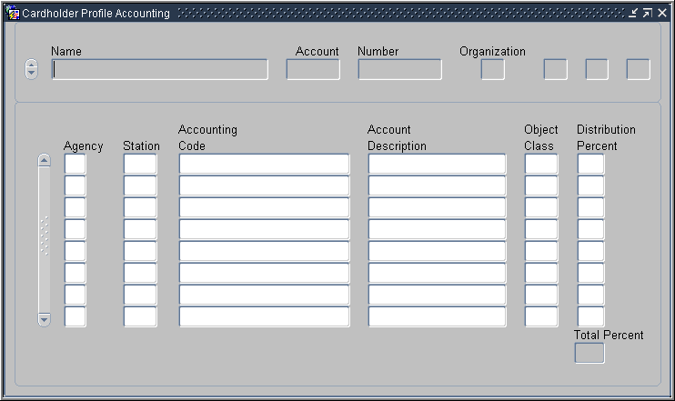

The following is a brief description of each field on the Profile Accounting screen. Fields not requiring data entry are noted.
Fieldname | Description
Name | The cardholder’s name as it appears on the card (i.e., the person authorized to charge to the account).
Account Number | This field contains two parts:  - The cardholder’s program code  - The last 10 digits of the purchase card account number  (Each part of this field can be queried.)

Organization | This field contains four parts:  - The cardholder’s department code  - The cardholder’s agency code  - The cardholder’s unit code  - The cardholder’s sub unit code  (Each part of this field can be queried.)
Profile Accounting
(The accounting codes that purchases are to be charged against.)
Agency | Indicate the agency code that the purchase is to be charged against.  (Optional, numeric, 2 positions)
Station | Indicate the station code that the purchase is to be charged against.  (Optional, numeric, 4 positions)
Accounting Code | Indicate the accounting code against which this portion of the transaction is charged.* NOTE: The cursor may hesitate for a moment while the accounting classification code is being validated. If the code is valid, the cursor will move to the Account Description field. If it is not valid, the appropriate message will be displayed.  (Required, alphanumeric, maximum 25 positions)
Account Description | Type the account description of the accounting code.  (Alpha, maximum 20 positions)
Object Class | Indicate a valid BOCC. Type in the BOCC or press [List] to select a code. Refer to the Budget Object Classification Codes document at http://www.usda.gov/procurement/card/guide.htm under ‘Miscellaneous’ for a complete BOCC listing.  (Required)
Distribution Percent | Indicate the percentage of this account to be applied to the transaction amount.  (Required, maximum 3 positions)
Total Percent | Non-entry field. The total percentage to be applied to the transaction amount. This field must equal 100 percent.

*If you press [Save] and an error message appears indicating incorrect accounting information, place your cursor on the line of accounting that needs changed and press [Remove]. This line of accounting will be removed allowing you to enter the correct accounting.

Querying Records
When you first enter the Profile Accounting screen, the fields are blank. Click on the Command Bar to query the profile accounting attached to your purchase card. Upon completion of the query the fields will be populated with account and profile accounting details.

NOTE: A Cardholder has rights to query profile accounting for their purchase card only.

Updating Records
Once the accounting information is displayed on the screen, apply one of the following as necessary:

Add:
To add a line of accounting, enter the new accounting details on the next available line. Remember to balance the Distribution Percent across the lines of accounting - the Total Percent must equal 100.

Remove:
To remove a line of accounting, place the cursor in any field on the specific line and click on the Command Bar. The entire line of accounting will be deleted.

Change:
To change information in one of the accounting fields, you must remove the entire line and add a new line with the corrected information.

Use the following guidelines in updating each of the accounting fields:
- Agency (optional) – Enter a valid agency code or leave it blank. If this field is left blank, the agency code that appears in the top region of the screen will be used when validating the accounting classification code. If an agency code is entered, it will be used for validation.

NOTE: When using an accounting code that belongs to another agency, the agency code must be entered in order for the accounting classification code to validate.

- Station (optional) – Enter a valid station (region + unit) or leave it blank. For agencies that use a station, this will be used to validate the accounting classification code. If left blank, the region and unit located in the top region of the screen will be used for validation.
- Accounting Code (mandatory) – Enter a valid accounting code and press [Tab]. As soon as [Tab] is pressed, the system will validate the code before advancing to the next field. For agencies using NFC’s Central Accounting System (CAS), the code will be validated against the MASC table. For those using the Federal Foundation Information System (FFIS), the code will be validated against the FFIS table.
- Distribution Percent (mandatory) – Enter a valid number from 1 to 100. This amount indicates the percentage of each transaction to be posted against the code.

Note: The total distribution percent must equal 100. You may not enter a combination of CAS and FFIS accounting.

After updating the appropriate fields, press .

NOTE: If you do not wish to save the changes made, click Action > Exit and the system will ask if you want to save the changes you made. Press [No].

TIP:
Scenario: You remove the accounting information in preparation to update it then decide you want to leave the record as it was originally.

Problem: Your fields are blank, you can’t remember the original accounting information to re-enter it and the system wont allow you to simply click Action > Exit because your Total Percent distribution does not equal 100.
Solution: Place the cursor in an accounting field and click . A message will appear asking if you want to commit the changes. Answer No and you will return to query mode. Click again and the original data will display. You can now click Action > Exit to close the window.

For FFIS Users Only
FFIS agencies have a new process for reconciling transactions. Once transactions are loaded into PCMS, within a short period of time the new interface runs and sends them to FFIS. The interface locks each transaction sent to FFIS until the transaction completes the FFIS/PCMS reconciliation. It could be between 12 to 48 hours or more depending upon completion of the FFIS processing before the transaction is unlocked and available for reconciliation/adjustment by the cardholder. Cardholders can run the Cardholder Report in PCMS to view the accounting status that indicates what transactions are locked. The following guidelines will aid cardholders on how to reconcile their transactions with the new PCMS/FFIS interface. A complete overview of the PCMS/FFIS interface will be provided in the near future on the procurement web site at http://www.usda.gov/procurement/.

Reconciling Transactions with the Pcms/Ffis Interface
- Daily, Monday through Friday, new transactions from the bank are loaded into PCMS between 11:30 am and 12:00 pm CST. The accounting on these transactions can be changed between 12:00 pm and 8:30 pm CST (window of opportunity).
- At approximately 8:30 pm CST, the interface runs that sends new transactions to FFIS to be paid. The interface locks every transaction sent to FFIS to prevent further changes and possible out of balance situations. When they try to change the accounting on a locked transaction, they will get the following message: "Accounting changes cannot be made until this transaction completes the FFIS/PCMS reconciliation."
- When the transactions have been accepted by FFIS, they are sent back to PCMS and PCMS unlocks the transactions. Thus, the cardholder could change the accounting on the transactions. The account description field next to the accounting will say "Accepted by ffis.”
NOTE: During a normal cycle where a file is passed to FFIS and FFIS returns a file to PCMS, the transactions would be locked until the next day. If a file is passed from PCMS to FFIS and FFIS does not process the file, the file would not get picked up until the following day. The transactions would remain locked until they are successfully processed and accepted by FFIS. Bottom line is it could be between 36 and 48 hours or more depending up completion of the FFIS processing before the transaction is unlocked and available for reconciliation/adjustment by the cardholder.
- If the cardholder reconciles the transaction before the interface runs, the cardholder can change the accounting attached to the transaction.
- If the transaction rejects in FFIS, the transaction will remain locked until the FFIS user clears the reject and FFIS subsequently sends the acknowledgement back to PCMS.
- Cardholders do not "fix" rejected transactions; the FFIS user as designated by the unit completes that. Cardholders do need to cooperate with the FFIS user if information is needed about the transaction. The name of the cardholder is part of the transaction file that passes to FFIS.
- Cardholders can run the cardholder report in PCMS, which has been updated to include the accounting status that indicates what transactions are locked. The following alpha characters are used to indicate the accounting status:
O = Obligated
P = Paid By FFIS
L = Locked*
N = New (not obligated and not paid)
*When running Discoverer reports you will see that transactions with a status code of “R (Rejected)” have been rejected by PCMS when they returned from FFIS due to changes made by FFIS. NFC will send these transactions back to FFIS to resolve. The cardholder handles these transactions in the same way as “L” transactions. The accounting transactions with a status of “R” cannot be modified until the status is something other than “R”. When the user attempts to change the accounting on a transaction with a status of “R” the following message will appear: Accounting changes are not allowed due to FFIS processing.

Oversight tools

Cardholder Reports
The Reports window can be accessed from the PCMS Main Menu. This option provides a Cardholder Report sub-option that is used to generate a standard cardholder report showing all purchase card transactions for an account in a specified time period.
After you select the Cardholder Report option, the following window will be displayed.

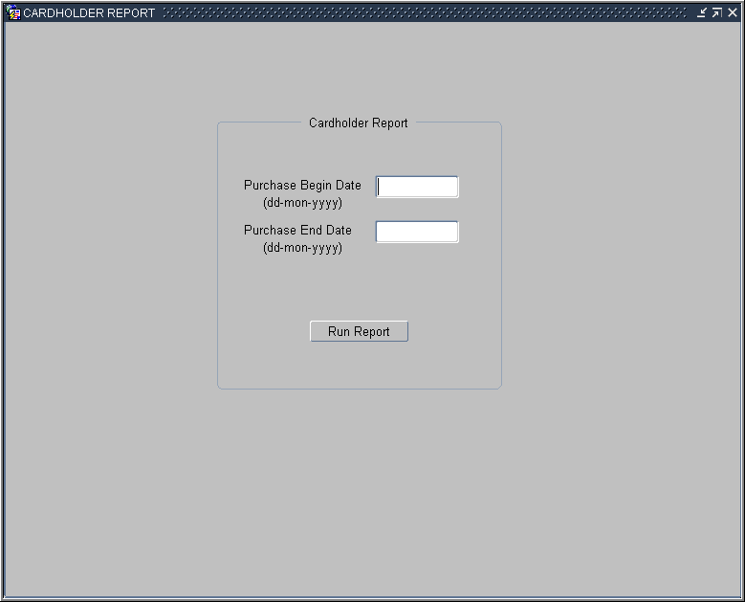

- Enter a date range and click ;
- The report will run and open in a new browser window;

Query Tool Software
The Discoverer query tool software is used by LAPC’s and APC’s to run ad hoc reports that provide oversight to purchase card accounts and purchases including, but not limited to, management reports to monitor purchase card transactions and accounting reports to review the accounting information entered into the PCMS database.

Discoverer user materials are not included in this documentation and will be provided as a separate package at the time of training for this software.

uSer Messages
As part the USDA’s policy preventing fraud, waste and abuse LAPC’s receive Alerts and User Messages to regularly monitor Cardholders accounts and transactions. Cardholders themselves do not receive any User Messages.

