IIIB. Energy Measurements
The energy of a particle can be destructively detected by initiating a series of reactions whereby the total particle kinetic energy is deposited in the detector. This technique is called calorimetry. The energy is locally deposited so that the particle position is measured to a degree of accuracy specified by the transverse fluctuations in the energy deposition. The particle energy is measured to a level of accuracy specified by the uniformity of the detector medium (the “constant term”) and the level of active sampling of the detector with respect to total volume (the “stochastic term”). Thus, the calorimetric technique provides a measurement of 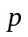, as defined in Fig. I.1. However, particle identity is lost so that subsequent redundant measurements are not possible.

11. EM Calorimetry
“A hen’s only an egg’s way of making another egg.”....Samuel Butler
“It grows - it must grow; nothing can prevent it.”....Mark Twain
In this Section we will begin the discussion of calorimetry by looking at electromagnetic showers. The reason to begin with the electromagnetic processes is that they are somewhat better understood and better modeled than the strong interaction processes which we will study in the subsequent Section. Calorimetry itself refers to the destructive detection of the energy of an incident particle. Its root comes from the Greek word for heat. The idea is to absorb all the energy in a detecting medium and by that means to record the energy of the incident particle. We can make redundant measurements of charged particle momenta by first tracking them in a magnetic field and then absorbing them in a calorimeter. This redundancy is often very useful in cleaning up the backgrounds which are always present in the study of a rare process. Detection in a low mass medium allows for a measurement of the velocity (Sections 2, 3, 4), momentum (Sections 5 through 8) and secondary decay vertex (Section 9) of a charged particle. Subsequently the energy can be absorbed in the calorimeter.

11.1 Radiation Length and Critical Energy
The underlying physics of electromagnetic calorimetry has been touched on previously. The radiative process for electrons is defined by the Bremsstrahlung cross section and the characteristic length for that is the radiation length, X_{o}. (See Section 10.)
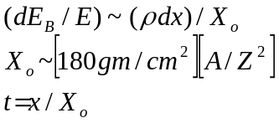 (11.1)
The radiation length in gm/cm² goes as A/Z². We characterize the depth in material by expressing it in radiation length units, t. Note that we implicitly do “particle identification” by observing radiative processes, since at energies <100 GeV only electrons and photons are sufficiently relativistic to emit significant radiation (see Section 13).
The other quantity, which is vitally important for describing the electron energy loss mechanism, is the critical energy, E_{c}.
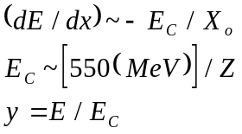 (11.2)
The critical energy is that energy above which radiative processes dominate. We discussed E_{C} in Section 6, showing loss mechanisms in lead as a function of energy and the 1/Z dependence of the critical energy. We define the electron energy in units of the critical energy, y. As an example, in lead the radiation length is 0.56 cm, the critical energy is about 8 MeV, and the minimum ionization loss is 1.13 MeV gm/cm2 (Table 1.2). The ionization energy losses are expected to be effectively universal, (see Section 6).
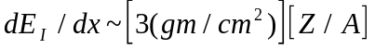 (11.3)
Minimum ionizing particles should lose about 1.5 MeV gm/cm² in all elements.

11.2 The EM Cascade
Now consider the cascade process which occurs when a high energy electron hits a block of material. The incoming electron will first Bremsstrahlung. If the energy of the Bremsstrahlung photon is sufficiently high it will, in turn, produce an electron-positron pair. The pair partners will then each Bremsstrahlung. Clearly, the processes of Bremsstrahlung and pair production imply that a run away “shower” process will occur leading to a rapid, geometric, increase in the number of particles with depth.
This “cascade” process will continue until the secondary particles are no longer energetically capable of multiplying. At that point the maximum number of shower particles, N_{max}, exists. Beyond the depth of “shower maximum”, t_{max}, the number of particles dies away due to ionization range out (Section 6) in the case of the electrons and Compton scattering (Section 10) and photoelectric absorption (Section 2) in the case of the photons.
A “cloud chamber” photograph of an electromagnetic cascade developing in lead plates spaced by a gaseous detection medium is shown in Fig. 11.1. We can see the shower begin in the upper plates, build up to shower maximum, and then begin to die away. This is a visual realization of the words just used to describe the cascade.

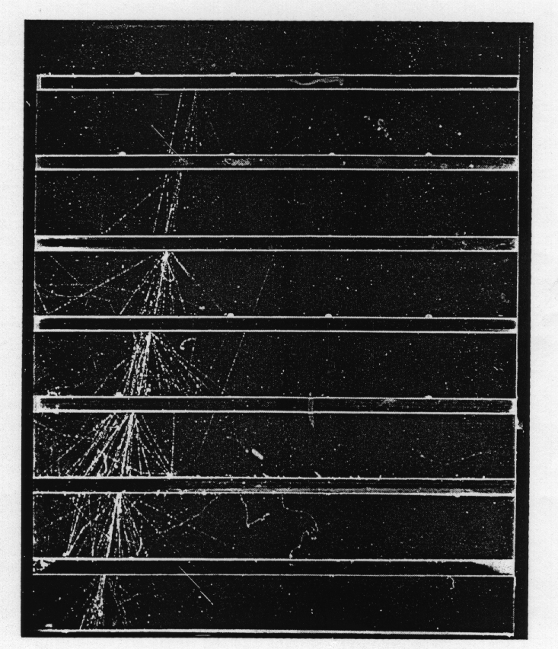

Fig. 11.1: Cloud chamber photograph of an electromagnetic cascade developing in spaced Pb plates. (From Ref. 13, with permission.)

A very schematic view of an electromagnetic cascade is shown in Fig. 11.2. The horizontal axis is the depth of the shower in radiation length units, t, which is, as we said the characteristic scale. In reality there are fluctuations in the interaction points. We use the mean which occurs at one X_{o} into the material for the first interaction and, on average, at depths spaced by one X_{o} for each subsequent interaction. We also show the number of shower particles, N, as the cascade develops as a horizontal scale and the fractional energy per particle, 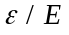, in the cascade where E refers to the incident energy.
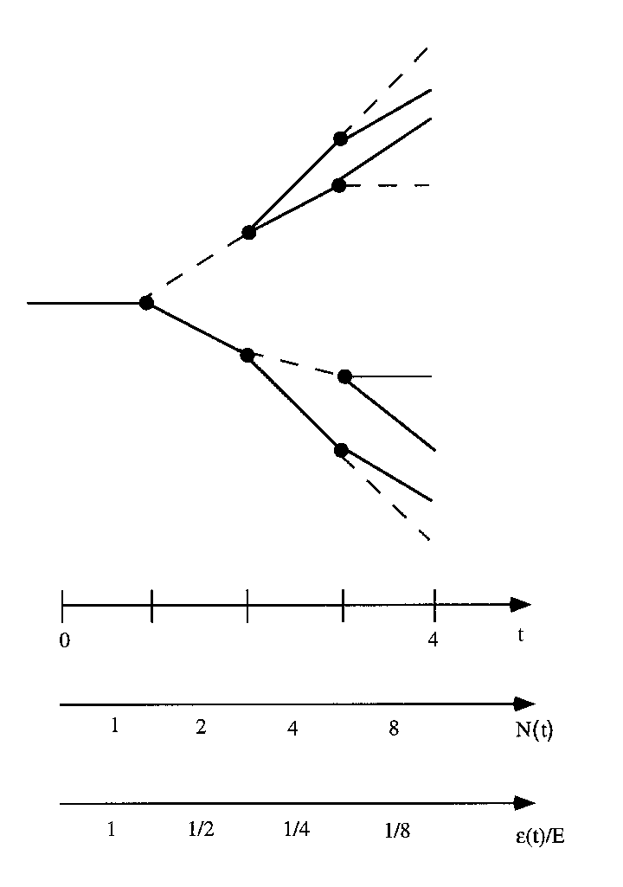
Fig. 11.2: Schematic of an electromagnetic cascade for the first 4 generations indicating depth t, number in the cascade N, and fraction of the incident energy carried by each particle. Electrons and positrons are indicated as -, while photons are represented as ---.

As the number of particles increases, their energy decreases. For example, in Section 10 we showed the energy spectrum for electrons in pair production. Since it is basically uniform from zero to the photon energy, we again ignore the fluctuations and assign the mean energy of 1/2 the photon energy. A similar approximation is made for Bremsstrahlung. The fluctuations both in the interaction points and in the secondary energies are ignored in the interest of clarity.
Let us explore the “decay” kinematics very briefly. Consider a particle of mass M, energy E, momentum p, which “decays” into massless particles. The relativistic transformation from the CM (starred) frame to be lab frame is; 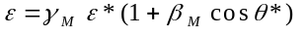, where 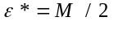 is the daughter CM energy, and 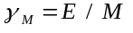. For isotropic decay, 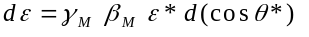 = constant. The energy distribution of the daughter is uniform. Clearly, and is distributed uniformly from 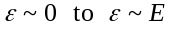. This discussion should serve to motivate the model which appears in Fig. 11.2. Other kinematic details are given in Appendix A.
We observe that the number of particles 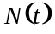 in the cascade grows geometrically with the depth in the cascade. In what follows 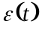 and are the symbols used for the particle energy and number of particles as a function of depth.
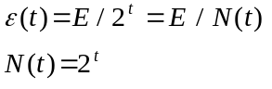 (11.4)
The multiplication processes go on until the mean energy of the particles in the cascade is equal to the critical energy. As the energy falls below the critical energy multiplicative processes are no longer possible and the maximum number of particles is reached. Beyond that depth the cascade dies off.
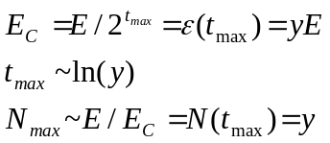 (11.5)

For example, a 3.2 GeV shower in Pb has shower maximum at a depth of t = 6. At shower
maximum there are about 400 particles in the cascade.

11.3 Energy - Linearity and Resolution
The depth at which “shower maximum” occurs, t_{max}, increases logarithmically with the scaled incident energy y. The number of particles at shower maximum, N_{max}, increases linearly with energy, with a scale factor equal to the critical energy. Therefore, if the response of a “calorimeter” is proportional to the number of shower particles, we expect that the calorimeter is a linear device.
This is not a completely trivial statement. Human beings do not have linear sensory tranducers. Our ears and eyes respond logarithmically to the sound and light levels of our environment respectively. This method of response allows us to perceive a large dynamic range at the expense of non-linear sensitivity. For example, the volume control on a radio appears to be linear, but is simply the dial label; the actual power level is logarithmic.
Note that the length needed for full shower containment, t_{max}, goes as ~ ln(E) while for tracking the length required for fixed measurement error rises linearly with energy (dp/p = ap). This fact explains the preferred use of calorimetry in applications requiring the measurement of very high energy particles.
We now find a “total path length”, L, for all generations in the shower by converting the sum of all particles in the shower to an integral. We assume that each particle in the shower goes one X_{o} in depth before interacting. We find that the total path length in the shower is proportional to the incident energy.
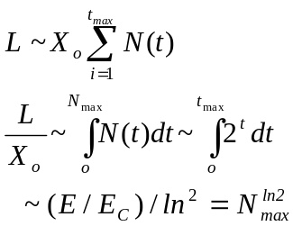 (11.6)
The number of particles in the shower N(t) is strongly peaked at shower maximum. Hence it is not too surprising that L is ~ X₀ N_{max}. This result can be thought of as the N_{max} particles of the last “generation” going one final X₀ in depth before they range out by losing energy E_{c} to ionization. We assume that the detected energy signal is proportional to L.
Fluctuations in the shower development lead to fluctuations in the number of particles in the shower. Thus, the path length, L, exhibits stochastic fluctuations since the cascade is a random process. Therefore, the fluctuation in the number of particles should go as 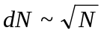 (see Appendix J). We expect that a measurement of the energy contains a “stochastic term” due to those fluctuations and consequently that the fractional error in the calorimeter energy measurements should go as 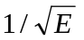.
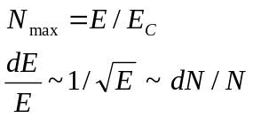 (11.7)
For a 3.2 GeV shower in Pb, there is a 5% fluctuation in the 400 particles which exist at shower maximum.
This behavior of the error is in distinction to gaseous tracking devices, which have fractional error, dp/p ~ p. Therefore, the fractional momentum error degrades linearly with momentum in a tracking device of fixed length whereas the fractional energy error for a calorimeter, in principle, improves with energy. This is another basic reason why detectors of very high energy particles focus on calorimetry since it is one of the few detectors whose performance actually improves with increasing energy.

11.4 Profiles and Single Cascades
In Fig. 11.3 is shown the longitudinal energy distribution of six individual 170 GeV electron showers. This particular device consists first of a stack of forty lead plates, each 1/8", 0.57 X₀, thick interspersed with scintillator (see Section 2) as the active sampling element. Each depth segment is read out independently.
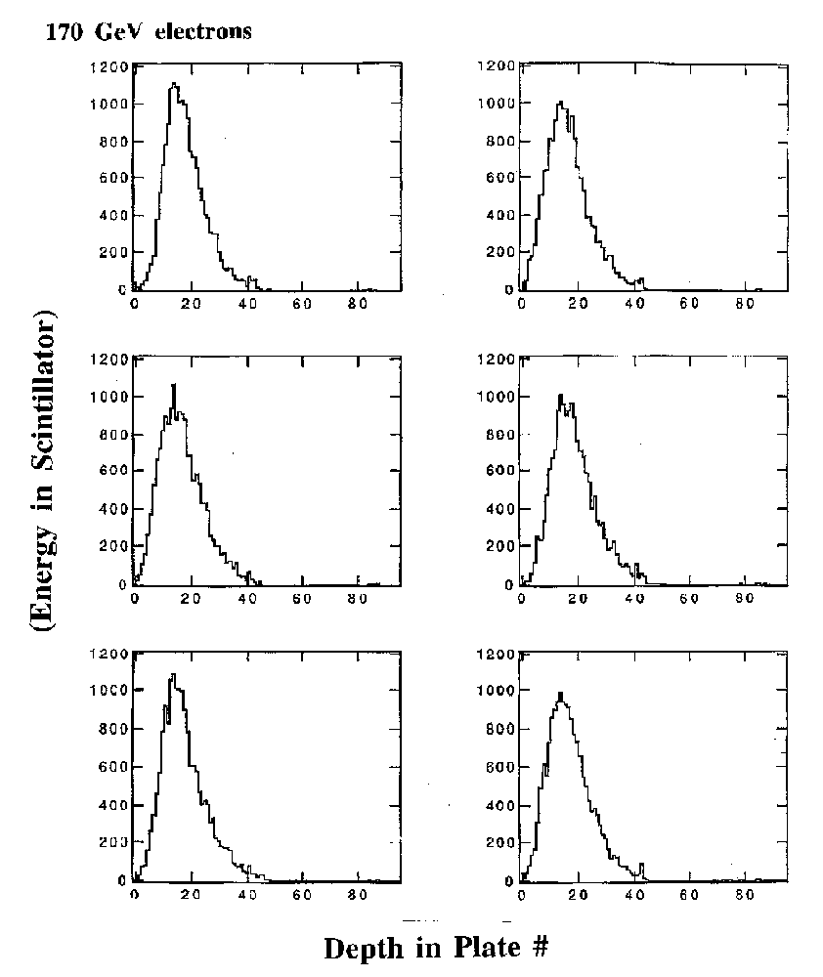
Fig. 11.3: Longitudinal energy profiles of 6 individual 170 GeV electrons incident on a stack of 40 Pb plates of 1/8" interspersed with scintillator active elements.

What is striking about these individual electron showers is that the shower development has few fluctuations. The shape in depth is essentially the same for each shower reflecting the large number of particles in the cascade, N_{max} ~ E/E_{c} = 170 GeV/8 MeV ~ 21,250. We know there is a fluctuation in the first interaction point. Given the exponential nature of the distribution of free paths, Section 1, we know that the rms fluctuation in the path length to the first interaction, t₁, is X₀, while the mean first interaction point occurs at a depth X₀, i.e. <t₁> = 1, <σ_{t1}> = 1. Looking at the events shown in Fig. 11.3 we see that the main fluctuation, on an event by event basis, is just the fluctuation in the interaction point which is roughly ± 2 plates. The shower shape at high energy has both energy sharing fluctuations and interaction point fluctuations of the first and subsequent generations. However, the shower contains so many particles that the latter are washed out.
These observations of real electromagnetic showers lead us to a one-dimensional parameterization of the longitudinal behavior of the shower.
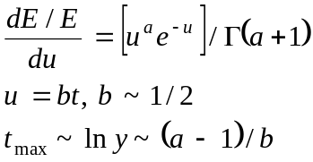 (11.8)
The depth t is defined with respect to the initial interaction point. In the shower parameterization the variable u is, up to multiplicative constants, t. The variable a is proportional to ln(y). The variable b is weakly energy dependent and weakly dependent on material. The power law behavior, uª, implies a fast geometric rise in the energy deposition due to the multiplication process in the cascade, whereas the exponential fall off, e^{-u}, is expected at larger depths beyond shower maximum where the mean particle energy is less than the critical energy. The gamma factor is there only to normalize the total shower energy to the incident energy, E.
The shower maximum location, t_{max}, moves to greater depths as the energy increases. For example a 3.2 GeV shower has t_{max} ~ 6, while t_{max} ~ 9 for a 64 GeV shower. It is also weakly dependant on the critical energy which goes as 1/Z, Eq. 11.2. Thus, the depth in radiation length units of the location of shower maximum is somewhat dependent on the type of material of which the calorimeter is made, t_{max} ~ ln y = ln (E/E_{c}) ~ ln (ZE). As a numerical example for shower development in lead, with the critical energy of 7.5 MeV, a photon with ε = E_{c} has a mean free path of 10 gm/cm2, see Section 1. Since the radiation length in Pb is 6.4 gm/cm², see Table 1.2, the mean free path of a photon near the critical energy is about 1.6 radiation lengths. That explains why the exponential fall off given in Eq. 11.8 is basically in units of radiation lengths up to a numerical factor of order 1. The range of an electron with 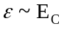, is also roughly ~ X₀.

11.5 Sampling Devices
Since the calorimeter is an energy measuring device, its most important physical characteristic is the energy resolution. Let us consider a “sampling calorimeter” where the shower is developed in high Z plates where most of the energy is lost. The shower energy is sampled in thin plates of low Z material such as scintillator plastic or liquid argon. The small fraction of the energy which is actively sampled should be proportional to the total absorbed energy. The basic model for the sampling calorimeter is that the shower develops in the inert high Z material and is sampled in the active low Z material.
If we assume that the shower evolves rapidly, i.e. that there are high Z sampling plates with thickness > X₀, then there is no correlation between consecutive active sampling layers. Thus the total number of particles traversing the active layers, N_{S}, is the total number in the shower or the total path length, L = E/E_{c}, (Eq. 11.6) divided by the thickness of the inert layers, 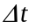, placed between the active samples. The geometry is shown schematically in Fig. 11.4.
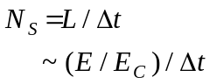 (11.9)
The particles traversing the sampling layers are presumed to all register, either directly by charged particle ionization or indirectly with photon Compton or photoelectric absorption accompanied by recoil ionization. The error due to fluctuations in the fraction of the energy appearing in the active sampling layers, dE, should be the fluctuation in the total number of sampled particles, N_{S}. It is customary to define what is called the “stochastic coefficient” in the energy resolution, a_{samp}. The stochastic term, due to sampling fluctuations, depends on the thickness of the inert plates and scales as 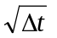. Obviously, if the plates become very thick, the sampled energy is not a good representation of the full shower energy and the fluctuations are increased.
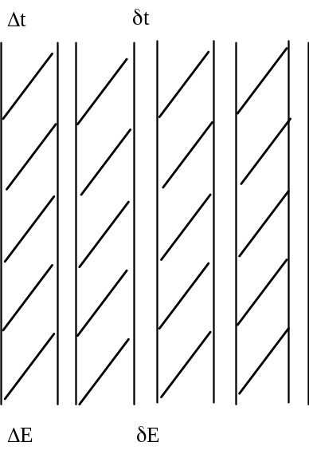
Fig. 11.4: Definitions for sampling calorimetry with active samples, of thickness 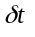and sampled energy 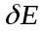, and passive absorber, with 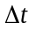, .

The energy deposited by ionization, ΔΕ, in going through a plate of thickness Δt at the critical energy E_{C} is just E_{C}Δt. Clearly low E_{C} means more shower particles, N_{max} ~ E/E_{c}, which implies a smaller stochastic term.
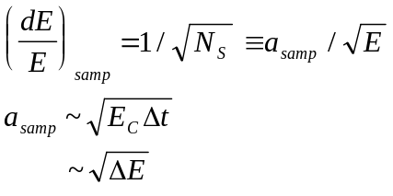 (11.10)
As a simple example, a 1 GeV electron with a critical energy of 7.5 MeV, has a maximum number of shower particles, N_{max} = 131. With 1/2 radiation length sampling for the thickness of the plates, Δt = 1/2, we find the total number traversing the active layers to be 262 which yields a sampling stochastic term of 6.2% due to fluctuations in the sampling of the number in the shower. This will later be shown to be a reasonable scale for the errors observed in typical sampling calorimeters constructed to measure electromagnetic showers (see Fig. 11.5).

11.6 Fully Active Devices
There are other effects that we need to consider in going to a situation with very fine sampling. The logical extension of fine sampling is the “fully active” calorimeter where the shower developing medium is itself active. Examples of this type of calorimeter are crystals, such as BGO, lead tungstate (PbW0₄), or lead glass.
We have assumed previously that counts in the different active layers were uncorrelated. A photon of low energy which is in the cascade will Compton scatter (Section 10) or photoeffect (Section 2) as these are the two largest cross sections at low energies. Below about 1 MeV in lead the photoelectric effect dominates. To set the scale, the mean free path for a 1 MeV photon in lead is about 3 cm, or about 6 X₀. If we go to fine sampling, in order to reduce the stochastic term which goes as ~, the photon can and does cross several sampling layers invalidating our assumptions.
Another assumption we made was that the shower development took place entirely in the absorber, while the detection took place in the thin active layers. Now, clearly, if we go to very fine sampling this assumption also begins to break down, since significant energy is deposited in the active medium, , rather than the inert absorber, .
In addition, we have been considering the shower development to be a one-dimensional problem. In fact, we know that we have multiple scattering of the shower particles which becomes increasingly important as their number increases and their energy decreases to ~ E_{c} at shower maximum. The scattering angle may become very large since E_{C} is comparable to E_{S} = 21 MeV. The path length then exceeds the one dimensional path length at normal incidence, 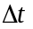, since particles traverse the sampling layers at finite angles. A rough estimate of the increase is
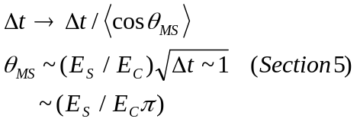 (11.11)
The multiple scattering angle is large, causing a substantial path length increase and therefore a stochastic coefficient increase.
The changes due to fine sampling and multiple scattering are incorporated in a theoretically motivated phenomenological formula for the sampling coefficient.
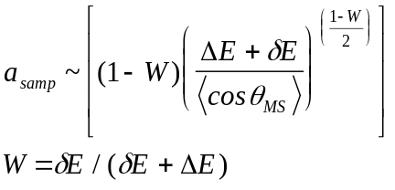 (11.12)
The ratio of the sampled energy to the total energy lost in a layer is a parameter, W. Clearly as the parameter 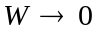 we are ignoring the effects of the active sampling layers, and Eq. 11.12 collapses to Eq. 11.10 modified by Eq. 11.11. In the limit 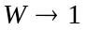 we have a fully active detector and a_{samp} 0. This unrealistic limit occurs because in this particular formulation the only errors that are being considered in the measurement of the energy are those of a stochastic nature. We will discuss other sources of error later.
Data on a_{samp} taken with different levels of sampling, W, in calorimeters are shown in Fig. 11.5 where the vertical axis is the stochastic coefficient in percent. We see that indeed a 2% stochastic term can be achieved for fine sampling detectors which are of order 80% active. If the sampling fraction becomes 10% there's a rapid increase to a ~8% stochastic coefficient. The lines drawn on Fig. 11.5 are just Eq. 11.12.
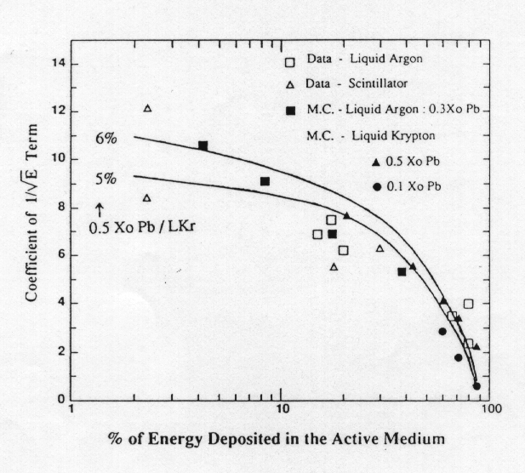
W
Fig. 11.5: Stochastic term coefficient as a function of sampling fraction W for a number of calorimeters. (From Ref. 9, with permission.

A photograph of a typical R&D sampling calorimeter, in this case installed in a test beam, is shown in Fig. 11.6. This object has lead plates interspersed with scintillator in its electromagnetic section and iron plates, rather thicker, interspersed with scintillator in the following section which is used to intercept strongly interacting particles or hadrons (see Section 12 and Section 13). The data plotted in Fig. 11.3 come from the initial 40 lead plates of the most “upstream” part of this detector. Each layer has independent photomultiplier (Section 2) readout in order that shower development can be studied. In contrast, a photograph of a fully active homogeneous calorimeter medium using lead glass is shown in Fig. 11.7. This is a transparent medium with high density with respect to ordinary glass. Other homogeneous media are other glasses and crystals such as BGO.
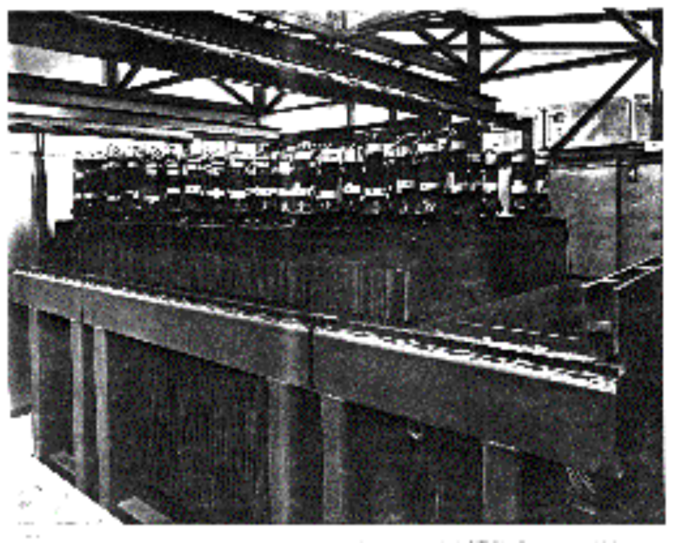

Fig. 11.6: Photograph of a typical sampling calorimeter showing interspersed Pb and scintillator (EM) and Fe and scintillator (HAD) planes. (Photo - Fermilab.)

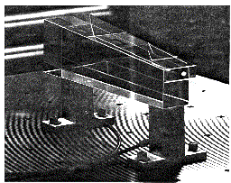
Fig. 11.7: Photograph of a fully active homogeneous calorimetric medium (Pb glass). (Photo - Fermilab.)

An energy level diagram for a “generic” crystal detector is shown in Fig. 11.8. Energy deposit by ionization causes an electron to be excited from the valence band (VB) to the conduction band (CB). The electron is quickly trapped by an impurity level 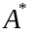 and a radiative transfer causes the subsequent emission of a photon of energy, 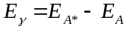. Note that this photon energy is < E_{g} so that it exits the crystal without absorption. . The crystal is thus transparent to its own impurity state emission. An example is “thallium activated” (i.e. 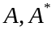 states) NaI. In NaI the band gap is E_{g} = 6 eV so that visible light, since it has energy less than the gap energy, is not absorbed. The thallium impurity state has a decay time 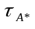 ~200 nsec and the emission 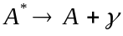 has a spectrum of photons peaked near 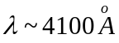 or 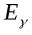 ~ 3.1 eV.

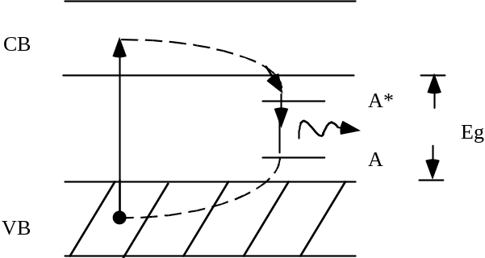
Fig. 11.8: Energy level diagram for a crystal detector.

11.7 Transverse Energy Flow
The shower has, so far, been considered a one-dimensional object, which is roughly correct. The physics defines the transverse momentum scale and in this particular case the physics has to do with atomic electrons. The characteristic transverse momentum in these collisions is the mass of the electron, m_{e}. If we are early in the development of a high energy shower, typical angles are a few milliradians, ~ m_{e}/ε ~ 0.51 mrad at ε = 1 GeV. However, as we get deeper in the shower the cascade particles become softer as they share the parents energy among themselves. In this case the shower rapidly becomes more isotropic.
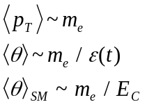 (Eq. 11.13)
The typical angle of a particle at a depth t is defined by the energy of the particles in the shower at that depth, 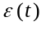. At shower maximum the typical energy is the critical energy, so that the typical angle of a particle at shower maximum is ~ m_{e}/E_{C}. For example, in lead, the pair production angle at shower maximum is about 4o.
In fact, multiple scattering dominates the transverse shower development rather than finite production angles since E_{S} is >> m_{e}. Hence, we expect multiple scattering to give the dominant contribution to the transverse size of a shower (see Eq. 11.11).
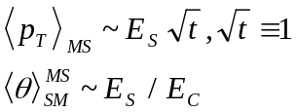 (11.14)
It is traditional to define a transverse size, the Moliere radius, which can be thought of as the transverse distance that a particle at the critical energy goes in traversing the last radiation length before it dies off.
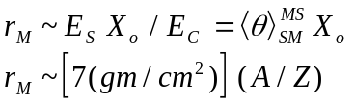 (11.15)
The Moliere radius, 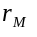, depends on E_{S}, the multiple scattering energy (Section 5), E_{C} the critical energy (Section 6) and X₀ the radiation length (Section 10). Referring to previous Sections for numerical constants, we find that the Moliere radius is fairly constant expressed in gm/cm2. For most of the periodic table, where A/Z ~ 2, we have a Moliere radius of about 14 gm/cm2. Denser materials have physically smaller Moliere radii.
A shower distribution of transverse radius in Moliere units is shown in Fig. 11.9. In this plot the entire shower has been integrated over in depth. Comparing Monte Carlo model (Appendix K) results with measurements on aluminum, lead and copper, we see that the shape in r_{M} units is approximately universal and that 90% of the energy is contained within about 1 Moliere radius while 95% is contained within about 2 Moliere radii, which, for example, is about 2.3 cm in lead.
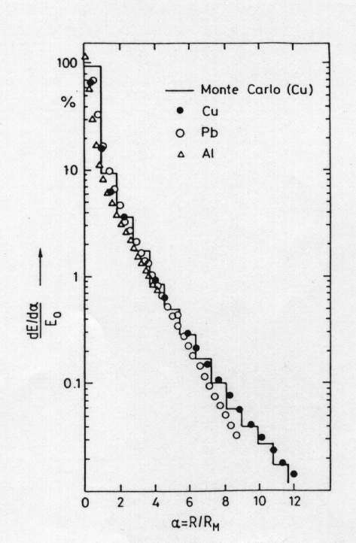
Fig. 11.9: Transverse electromagnetic cascade energy distribution as a function of the number of Moliere radii from the incident e direction. (From Ref. 10, with permission.)
The radius for energy containment clearly depends on where your are in depth in the shower. In Fig. 11.10 is plotted the transverse electromagnetic shower energy distribution in a Monte Carlo model as a function of the depth in the shower. We see that there is a sharp peak extending out to a depth of ~(0.1 - 0.3) radiation lengths which broadens as we go deeper in the shower. This is a logarithmic plot so that even at a depth of 9 radiation lengths there is containment within x_{T} ~ 0.5 X₀ because 90% of the energy occurs within that radius.
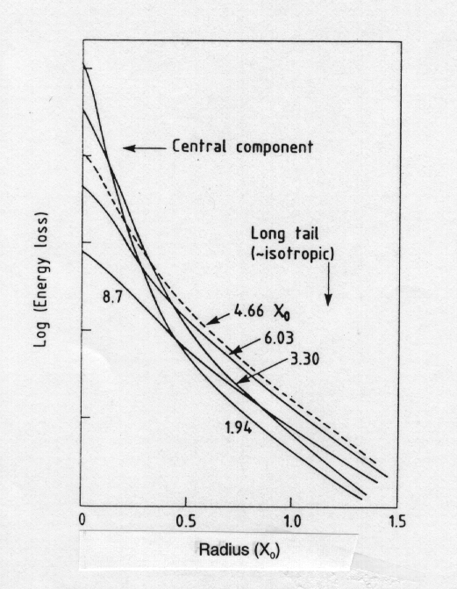
Fig. 11.10: Transverse electromagnetic cascade energy distribution in arbitrary units as a function of the number of radiation lengths from the incident e direction. Curves are shown at different depths in the shower, displaying the broadening of the shower as the depth increases. (From Ref. 10, with permission.)

There are other subtle effects due to multiple scattering. As we follow particles down in energy, we find that ~ 30% of the energy in a shower is deposited by electrons with energies less than 1 MeV for high Z absorbers. These particles at the end of the shower are almost isotropic in angle due to multiple scattering; as many go backwards as forwards. Therefore, it is important in making computer models of showers (see Appendix K) to keep track of particles with quite low energies, as they are important to the total energy deposition mechanism in calorimeters.
In addition to the multiple scattering increase in the path length there are also delta rays, which we considered in Section 5. They lead to ionization fluctuations. This effect may dominate over the sampling fluctuations. It is clearly most important for thin active layers. For example, if we were sampling with a gaseous detector instead of a plastic or a liquid, and if the thickness of the sampling layer were only 10-3 gm/cm2, (~1 cm of gas), we would have a 40% increase in the stochastic coefficient, a_{samp}, due to the track length fluctuations caused by the delta rays. In general, small sampling fractions are dangerous (if inexpensive).

11.8 Calibration Methods
Finally there's the practical question of the energy calibration of a calorimeter. How is that performed? In Fig. 11.6 we showed an unrealistic device, since this is an R&D detector, where each sampling layer is individually read out. Data taken with that detector, 40 layers of lead followed by 55 layers of 1” thick iron, for incident muons are shown in Fig. 11.11. Remember that muons at energies well below the critical energy simply ionize the material and deposit the minimum ionizing energy. We need to take into account the relativistic rise that we discussed previously (Section 6) and the ray fluctuations (Section 5), but these are small effects. Data shown in Fig 11.11 were obtained with 15 GeV incident muons and with 50 GeV incident muons. The energy deposit per layer is effectively the same at those two energies as we expect since the of the has only changed a factor of 3 and we derived a soft logarithmic dependence on as part of the relativistic rise, (see Section 6).

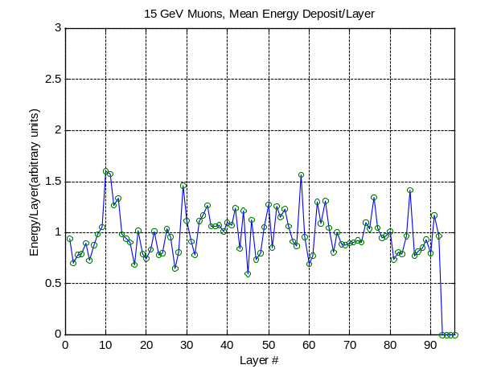
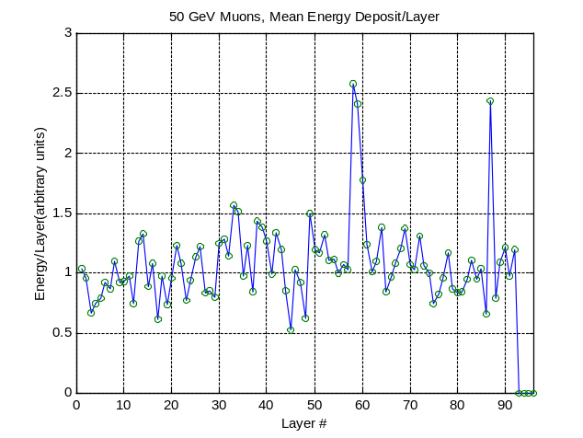

Fig 11.11: Response of each sampling layer of the calorimeter shown in Fig. 11.6 to incident muons indicating the potential use of muons as a means of calibration. a) 15 GeV muons, b) 50 GeV muons.

We could adjust the gain of each photomultiplier tube in the individual samples to calibrate this detector. If we put a minimum ionizing particle into the detector, we would then get out the same signal in all layers. That is one way in which we could use external particles to calibrate the detector. Note that for financial reasons we normally construct a homogeneous detector, optically sum the sampling layers (light pipe, Section 2) and use only a few phototubes or other transducers.
We could also expose the detector to electrons of different known energies using a beam of particles prepared by momentum analysis in magnets (Section 7). Thus we can map out the energy response, resolution, and linearity of the device using “test beams”. The use of muons would then monitor the initial beam calibration and insure that the system response is time independent. Recall that muons are available as the largest component of sea level cosmic rays. (See Table 6.1.)
Electromagnetic calorimeters are major subsystems of all collider detectors, because photons and electrons are thought to be pointlike fundamental particles (see Section 13). There-fore, the energy and position of these particles should be recorded (Fig. I.1). For both photons and electrons, the EM shower can be localized transversely to a size which is of order r_{M}. This localization with energy improves as 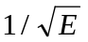 since it is basically an energy centroid measurement limited by sampling fluctuations, 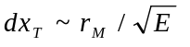with E in GeV
The total energy is measured with an accuracy which goes as ~ until limitations in the uniformity of the detector construction are encountered. At that point a constant fractional error dE/E ≡ b dominates the energy resolution. Hence, for use at arbitrarily high energies an EM calorimeter should be built to have as uniform a response as possible leading to as small a constant fractional energy resolution, b, as possible.

References
Section 11: EM Calorimetry

[1] High Energy Particles, B. Rossi, Prentice-Hall, Inc. (1952).
[2] Proceedings of the Calorimeter Workshop, M. Atac, Fermilab (1975).
[3] Tristan eP Working Group Report, S. Iwata, Nagota University, DPNU-3-79 (1979).
[4] Crystal Calorimeters in Particle Physics, G. Gratta, H. Newman, R.Y. Zhu, Annual Review of Nuclear and Particle Science, 44 453 (1994).
[5] Liquid-Argon Ionization Chambers as a Total Absorption Detectors, W.J. Willis, V. Radeka, Nucl. Inst. Meth., 120 221 (1974).
[6] Calorimetry in High Energy Physics, D.F. Anderson, M. Derrick, H.E. Fisk, A. Para, C.M. Sazama, World Scientific Publishing Co. (1991).
[7] Fluctuations in Calorimetry Measurements, U. Amaldi, Physica Scripts, 23 409 (1981).
[8] D.F. Crawford, H. Messel, Phys. Rev., 128 2352 (1962).
[9] “Performance and Limitations of Electromagnetic Calorimeters”, T.S. Virdee in Calorimetry in High Energy Physics, Capri, Italy (1991) World Scientific.
[10] T. Ferbel, Experimental Techniques in High Energy Physics, Addison-Wesley Publishing Co., Inc. (1987).
Table of Contents
IIIB. Energy Measurements 1
11. EM Calorimetry 2
11.1 Radiation Length and Critical Energy 2
11.2 The EM Cascade 3
11.3 Energy - Linearity and Resolution 6
11.4 Profiles and Single Cascades 8
11.5 Sampling Devices 10
11.6 Fully Active Devices 11
11.7 Transverse Energy Flow 16
11.8 Calibration Methods 19
References 21

