U.S. Fish and Wildlife Service

Tewaukon Fire District Report
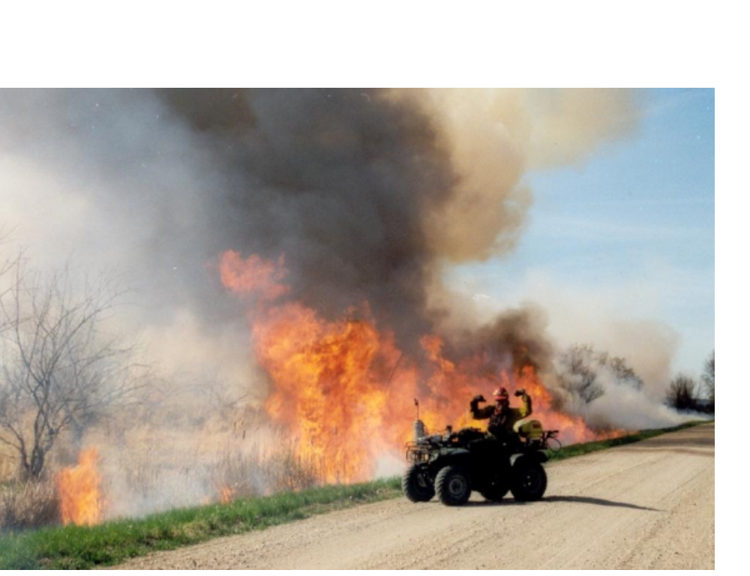

FISCAL YEAR 2002
ANNUAL FIRE REPORT



INTRODUCTION

Fiscal Year 2002 was a monumental year of change for the U.S. Fish and Wildlife Service Fire Management Program located at the Tewaukon Fire District. As a means of establishing a better organized and coordinated fire management effort within the fire district, a number of changes occurred at the end of FY2001 and the beginning of FY 2002.

A new “District Fire Management Officer” position was established in the Tewaukon Fire District (in June 2001) headquartered at the fire base station at Tewaukon NWRC. The Tewaukon Fire District consists of four different complexes: Tewaukon NWRC, Waubay NWRC, Sand Lake NWRC, and the Kulm WMD. The Tewaukon Fire District staff is responsible to plan and implement all fire management activities (for both wildland and prescribed fire missions) within the district.

The mission of the U.S Fish and Wildlife remains the same: "Our mission is working with others to conserve, protect, and enhance fish, wildlife, and plants and their habitats for the continuing benefit of the American people."

District goals and objectives include the enhancement and maintenance of waterfowl/wildlife resources through species management, hazardous fuel reduction through prescribed burning practices, habitat management, wetland /habitat preservation and restoration and environmental education.

The Tewaukon Fire District participates in a

wide range of activities to accomplish its mission and
objectives. In the following pages are brief descriptions
and actual accomplishments attributable to the
fire program during fiscal year 2002 which began
October 1, 2001 through September 30th, 2002. The report begins with a summary of cooperative
interagency assistance between other stations and interagency organizations during the fiscal year.
INTERAGENCY
COOPERATIVE ASSISTANCE

Prescribed Fire Modules: During the month of May, two NPS Fire Use Modules (the Black Hills and Zion Fire Use Modules) assisted Waubay NWRC, Tewaukon NWRC, and Kulm WMD in achieving the following prescribed fire accomplishments.

USFWS and Black Hills Fire Use Module accomplishments in Kulm WMD and Tewaukon NWRC from
May 17th thru the 24th:

1). Rx burn units in Kulm WMD:
- Lehr WUI 160 acres
- Schmidt WPA 80 acres

2). Rx burn units in Tewaukon:
- Hartleben WPA 940 acres
- Mann Lake 100 acres
- Sprague Lake Unit C 100 acres.

USFWS and Zion Fire Use Module accomplishments in Waubay NWRC from May 2nd thru the 17th:

3). Rx burn units in Waubay:
- Jensen WPA 500 acres
- Horshoe Roe WPA 300 acres
- Hagen WPA 100 acres
- Gerber WPA 130 acres
- Olson WPA 160 acres
- Spring Lake WPA 120 acres

This comes to a total of 11 prescribed burn units completed for 2,690 acres in 23 days with assistance from these two NPS modules. The Tewaukon fire staff is planning to assist the Wind Cave, Theodore Roosevelt National Parks, and the Fort Pierre National Grasslands (USFS) with fall 2002 burns in North and South Dakota.

BIA and BLM Assistance

The sharing of resources across agency boundaries has and will continue to play an important role in achieving targeted prescribed acres in the Tewaukon fire district. The building of this relationship during the year has given the Tewaukon fire district the ability to accomplish:

1).Multiple prescribed burns completed in a given day and the ability to prescribe burn in multiple areas within the fire district simultaneously.

2). Large normal complexity burns (i.e. Gunness WPA) completed.

3). Interagency training and experience opportunities for various Tribal Agencies, Bureau of Indian Affairs.(The Sisseton Wahpeton-Sioux Tribe), and the BLM.

U.S.F.W.S. Assistance

Internal cooperation between National Wildlife Refuges, and Wetland Management Districts continues to build solid support for the fire management program in the Tewaukon fire district. This direct and/or indirect cooperation was associated with the Tewaukon fire program and contributed to the following benefits:

1). Tewaukon fire staff assisted Huron and Des Lacs refuge complexes with a WUI and Rx HFR burns for 500 acres completed.

2). Tewaukon also assisted USFWS region 3 (Big Stone NWR) with two prescribed burn units for 300 acres.

3).The Tewaukon fire district instructed S-130/190 for seven South Dakota RFDs around the Milbank S.D. area in January 2002. Approximately 24 volunteer firefighters successfully completed both fire courses and passed their WCT to receive their respective red cards from the state of South Dakota. This also promotes cooperation from these red carded firefighters to assist with the prescribed burn activities on Waubay NWRC.

4). The Tewaukon Fire District assisted the Brown County Emergency Management Team (S.D.) near Sand Lake NWRC. Brown county experienced a spring wildfire season that totaled more than 48 wildfires burning over 42,000 acres within the county. The USFWS stopped all prescribed burning at Sand Lake to promote cooperation with these local communities in the Brown and Edmunds county burn bans.

FIRE MANAGEMENT

The Tewaukon Fire District has 6 (six) separate but interdependent responsibilities that address fire management and suppression.
The five functional program areas are:

1). dispatch and logistic support,
2). fire management and prescribed fire
3). fire prevention and training,
4). fire suppression,
5). fire coordination,
6). interagency cooperative assistance.

Wildland fires occur as unscheduled emergency events. Planning for fire suppression is distinctly different from planning for other management activities. It is different because there is no way the workload can be scheduled. In fire suppression, there is no choice of doing the work when it’s convenient. Planning for fire suppression requires that skilled experienced personnel and sufficient equipment are available; that individuals know what is expected of them and fit into the team and that the system (teamwork) can be activated at a moments notice, function immediately, and respond to the needs of the incident as the fire grows in size and complexity.

FIRE SUPPRESSION

During the fiscal year 2002 (October 1, 2001 to September 30, 2002), the Tewaukon Fire District was involved in 6 wildland fires that burned 326 acres within the fire district. The wildland fire activity is broken down by the four complexes within the fire district as a whole.

WILDFIRE ACTIVITY YEAR TO DATE

Agency Human Lightning Number of
or Unit Caused Caused Fires Burned acres
Tewaukon 2 0 71
Waubay 1 0 2
Sand Lake 2 0 250
Kulm 0 1 3
Total 6 Total 326

The Tewaukon Fire District also dispatched resources from the fire district to assist in national fire suppression efforts in Arizona, New Mexico, Colorado, Montana, North and South Dakota, Utah, and Wyoming on 10 separate incidents, from both dispatch centers in North and South Dakota.(NDC and Custer). Qualified and trainee positions that were dispatched are as follows: ICT3, DIVS(t), HCWN, TFLD, STCR, STEN, EMTB, EDRC(t), ENGB, FFT1(t), FFT2.

PRESCRIBED BURNING

The philosophy of common ground and

shared responsibilities, is necessary when it
comes to prescribed burning in the Tewaukon
Fire District. Many firefighting agencies
and cooperators do not have the ability to
achieve fire management accomplishments
unless resources are shared.

In FY 2002, the Tewaukon Fire District wrote 45 (with assistance from the BLM in

Lander Wyoming.) prescribed fire burn plans. The objectives varied but can best be summarized into5 categories; training, wildland urban interface prescribed burn projects, hazardous fuel reduction, resource management objectives to improve range conditions, and wildlife habitat enhancement. Prescribed burning also offers an excellent opportunity to test and train in new fire fighting techniques and technologies. The Tewaukon fire staff utilizes these prescribed fire operations to train for suppression missions involving local, regional, and national levels. The prescribed fire activity within the fire district is as follows:

PRESCRIBED FIRE ACTIVITY YEAR TO DATE

Station Number of burns Acres
Tewaukon 22 3,313
Waubay 12 1,669
Sand Lake 3 147
Kulm 2 240
Total 39 5,369

TRAINING

The U.S. Fish and Wildlife Service at the Tewaukon Fire District is currently cooperating with two organizations called the South Dakota and North Dakota Fire Councils to share training instructors, and establish priorities on courses that are offered each year. By organizing training courses on an interagency basis, a substantial amount of duplication in training efforts is prevented. Other training courses offered varied from wildland firefighting evolutions to wildfire investigations.

The Tewaukon Fire District staff provided approximately 88 hours of wildland and prescribed fire fighting training to firefighters. The district fire staff instructed in 6 training sessions at various locations in North and South Dakota are as follows:

Training Session Number of Trainees Location/Agency
S-234 15 Sullys Hill GP (FWS)
S-130 24 Milbank S.D RFD (FWS)
S-190 24 Milbank S.D. RFD (FWS)
LCES 21 Tewaukon NWRC (FWS)
S-130 40 Washburn, N.D. (TNC)
S-190 40 Washburn, N.D. (TNC)

INFORMATION AND EDUCATION

Range Fire Prevention

During fiscal year 2002, a total of 30

burning permits were issued on private
lands within the fire district. These
include permits to rejuvenation wetlands,
and native grasses, clean-up debris and
to reduce fire hazards. The issuance of
these permits is under the management
of the Tewaukon, Waubay, Sand Lake,
and Kulm Project and Assistant Project Leaders.

The Tewaukon Fire District is also currently developing efforts to; acquire equipment, monitor
the rangeland and forest fire indexes, and warn the public when the fire danger reaches the very high
and extreme levels in eastern South and North Dakota. In addition, efforts to inform and educate the public about the role of fire; and unwanted wildfires, is a major emphasis of developing our program.

MISCELLANEOUS INFORMATION

During 2002, several other miscellaneous program highlights occurred. They include:

-establishing an assigned fire cache to store and house critical fire equipment and supplies at the Tewaukon NWRC.

-Initiating and implementing additional fall and late summer prescribed burns to achieve resource management for the Tewaukon and Waubay complexes within the fire distict. This will include Sand Lake and Kulm complexes later in FY 2003.

-The District FMO joined the regional fire staff in developing the Region 6 Fire Use Module in November of 2001. The District FMO
also attended the NPS Fire Use Module workshop in Las Vegas to represent
Region 6 USFWS for its module development.

-The District FMO participated in
training as a helicopter manager
(HCWN) at the Grand Canyon
Helicopter Training Academy in June
of 2002 to become the only helicopter manager in Region 6.

-The Fire Program Technician at Tewaukon detailed to the Tetonka Interagency Hotshot Crew
in September of 2002 for 10 days. This crew is located in the Black Hills USFS (South Dakota). This was a first for the fire staff to detail our personnel to the excellent training and experience opportunity with this Type I firefighting organization.
Summary

The accomplishments outlined throughout this document identify specific fire management achievements the Tewaukon Fire District completed during it’s first year of having a newly established fire district. This report does not capture all accomplishments but is designed to provide a brief description and summary of accomplishments attributed to the fire program throughout the fiscal year.

The opportunities for continued success will depend on support, leadership, direction and the tools provided. Continued improvements in program developments, improved efficiencies and interagency cooperation will provide opportunities to increase the accomplishments achieved during this and upcoming fiscal years. The primary key to the success of the Tewaukon Fire District fire management program is total integration not separation of all refuge operations and fire management.


